
Internship Report
On
Managing and Marketing Event Management Services:
A Study on Inpace Management Services limited

Submitted to:
Muhammad Hasan Al-Mamun
Assistant professor
United International University

Submitted by
Afra Siyara
ID: 111 151 184
BBA (Major in Marketing)
United international University


Internship Report
On
Managing and Marketing Event Management Services:
A Study on Inpace Management Services limited

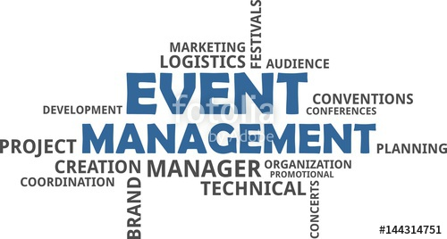

Acknowledgement
First of all, I would like to thank the Almighty for giving me the knowledge. After that I would like to thanks to my honorable Supervisor Muhammad Hasan Al-Mamun, for his guidance during the preparation of the internship report, who has made me capable and helped me throughout the completion of my internship report on “Managing events for clients, a study on Inpace Management Service Limited. I have been consistently under his supervision and guidance to complete my report perfectly.
I would like to express my gratitude to Hasan Al Banna, Sr. manager, Client service, whose cooperation and guidance have made this project as proximate to perfection. I would also like to thanks my organizational colleagues for their sincere cooperation during the completion of my internship.
I would also like to express my appreciativeness to Md. Firoz Kabir Sir and Masum Ahmed Sir at Inpace. My sincere thanks goes to various personnel I had contacted for completion this internship report.
Finally, I am very fortunate to have my friends and family who have provided unbiased help and supports in the preparation of this report with their assistance and provide sources of information. Their helping hands were truly unparalleled.

Letter of Transmittal
September 04, 2019
Muhammad Hasan Al-Mamun
Assistant Professor, United International University
Dhaka
Subject: Submission of Internship Report
Sir,
I am glad to submit the internship report on the topic you have assigned me which is “Managing and Marketing Event Management Services: A Study on Inpace Management Services limited”. While preparing this report I tried my level best to follow your and my organization’s supervisor’s instructions.
This entire report is based on the practical knowledge I have gained from my 3 months of internship program while working in the Inpace Management Service Limited. The knowledge I have gained from here will add a huge advantage to my career.
I would like to express my heartiest gratitude for your kind cooperation and guidance in making this project paper informative and time oriented. It would be highly grateful if you kindly receive this report and I will be pleased to answer to any of your queries regarding this report.
Sincerely Yours,
Afra Siyara
ID: 111 151 184
BBA Program
School of Business and Economics
United International University

Executive Summary

Inpace Communication Bangladesh was established in the year 1997. It has been outstanding for being the most reliable and inventive organization in Bangladesh. Their unparalleled endeavors in structuring client connections has made them equipped for overseeing exchanges that ensure fulfillment of their customers’ demands and expectations in a noteworthy degree. They personalize the services provided to accommodate the clients’ requirements regardless of the spent amount by each client.
The adaptability of abilities and experience among the workers at Inpace is the thing that makes them a prominent organization in the industry. Building client connections is the principal motto of Inpace. The organization claims, 'We tune in and continually re-address the regularly changing needs of our clients to guarantee that we are constantly on top of things'.
The main objective of this report is to analyze how Inpace communication focus on building their connections with their clients and how do they find their clients and how do they full fill their client demands by managing the events for them.. Their main focus is to address the ever changing technological needs of their customers. Inpace communication is an international organization which is working with tech products to make life stress free.

Key Words: Managing Events

Table Of Content

Contents
Introduction 1
1.1 Topic in Hand 1
1.2 Context of the study 2
2.0 Organizational Background 6
2.1 Organizational History 6
2.2 Organizational Overview 6
2.3 Service Offerings: 7
2.4 Mission & Vision 9
2.5 Inpace’s Client 10
2.6 SWOT Analysis 11
2.7 Inpace’s Competitors 13
2.8 INPACE PROVIDE 14
2.9 Inpace Management Services Limited 15
Final Approval Presentation (Client’s presentation) 19
Controlling 20
3.0 Industry Perspective 21
4.0 Objectives 23
5.0 Methodology 24
6.0 Finding of the study 24
7.0 Recommendations 25
8.0 Conclusion 25
9.0 References 26

Introduction

1.1 Topic in Hand
Event Management
Event management companies will help to organize a number of different and very special events that an organization may be interested in hosting. They manage ceremonies, celebrations, product launches and product presentations, workshops, company inaugurations, conferences and events where an organization will invite the public.

How does organization find their clients and how they point out there wants-?
The fundamental part is dealing with clients and persuade them. Usually the preferred outcome is to drive client behavior with respect to commercial proposing. Here organization is generally done by a third party activity.

Types of activity whereas organization manage their client-
- Through a reference.
- Recommendation from satisfied client.
- Through the tender.
- Distribution partner house suggestion.
- Follow up with network.
- Executive search firms
- Competition with other agency and betting challenge.
- Run a campaign.

As an advertising agency’s work commonly dependent on client request and work like as outsider. An agency organization is a facility based business focused on creating, determining, and controlling advertising for its clients. An agency can likewise hold generally marketing and branding techniques and sales promotion for is clients.

Through the reference:
A customer reference is a positive story their clients can share about an effective delivery of product or service, used to make demand and sell sway, so that through a reference here organization deal with their maximum with their portion.

Recommendations from satisfied client:
Organization’s main principles are good customer services. The key to good customer service is building good relationship with the customers. Expressing gratitude toward the customer and promoting a positive, accommodating and agreeable condition will guarantee they leave with an incredible impression. At the point when a client feels glad they will return them a suggestion to other organization.

Through the tender:
Sometime organizations manage their client through a tender.

Distribution partner house suggestion:
Distribution channels have become a critical component of the strategy in the business to business marketing portfolio. A successful delivery channel can be a source of strategic competitive advantage for company.
Competition with other agency and betting challenge:
Competitive position is about, how an organization will separate your offering and create value for a market. It's about making a sense of a spot in the focused scene, putting your stake in the ground, and winning mindshare in the marketplace. So by betting challenges to manage customer is one of the procedure in this organization.

Inpace Management Services Limited
Inpace Management Services limited is one of the biggest promoting organizations in Bangladesh. Inpace Management Services Limited develops highly inventive answers to marketing problems on a worldwide basis. Its service includes brand positioning; brand arranging; inventive improvement; and production different artwork and creative work. It is also planning to upgrade a new generation of management.

1.2 Context of the study
Organizational Objective

- Directing examination through field work.

- Examining the conditions.

- Giving clear arrangement

- Giving long haul arrangement.

- Setting up and propelling measures.

- Preparing and improvement of HR.

Core qualities

- Keeping up the ethical standard of tech-related issues.

- Giving and utilizing genuine information while investigate.

- Improving IT establishment of the association.

- Furnishing fitting planning with vital hardware and guidelines.

Core intensity

- Continuous Development.

- Polished approach.

- Proper utilization of utility

Inpace has been executing following ten noteworthy projects in its working zones.
1. Management Consulting
2. Human Resource Management
3. Project Management
4. Event Management
5. Computer Graphics and DTP
6. Market Communications
7. Brand Management
8. Media Consultancy and Services
9. Public Relations
10. Corporate Promotions

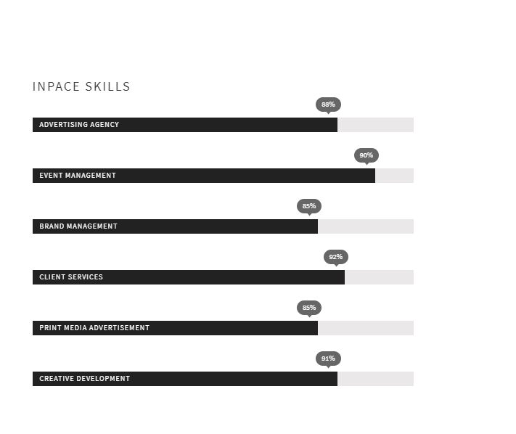

At Inpace they endeavor to be the most dependable and innovative occasion organization in Bangladesh, continually conveying an elevated requirement of value and incentive for cash to their clients. They work in close association with their clients to offer an administration that sets new principles in occasion the executives. Every occasion is a custom task, independent of size or spending plan. This is the thing that it makes them unique. The various aptitudes and significant experience inside the faculty at Inpace is the thing that truly enables them to emerge from the group, and they can guarantee that their occasions do likewise. Connections are vital to the Inpace rationality, and in view of this they focus on building solid associations with their clients. They tune in and continually re-address the regularly changing necessities of their clients to guarantee that they are constantly on top of things.

2.0 Organizational Background

2.1 Organizational History
The history of Inpace dates back to December, 1997 when Inpace Communications was shaped to fulfill the consistently expanding interest for Computer Graphics and DTP, Direct Marketing, Fulfillment Services, IT Enabled Services, Management Consultancy, Market communication, Event Management and PR Management services. The essential objective was to explore the market for computer education, printing management, corporate promotion, logistics support service, graphics design and event management. Inpace Management Services Limited was enrolled on first August, 2004 to differentiate its business and serve the clients in a progressively organized and proficient way. Over the last 16 years Inpace was gaining significant progress in accomplishing its essential objectives. While doing this, the organization step by step extended its business into Fulfillment Services, Lead Generation, Direct Marketing and T Enabled Services for the greater part of the eminent worldwide IT organizations present in Bangladesh. At present, Inpace has got its name as an expert place of satisfaction and outsourcing activities for major MNCs and local corporations.

2.2 Organizational Overview
Inpace situated at Concord Tower, Suit-601 and 1401, 1402 Bangla motor, Dhaka-1209, is an orgaization that works with tech items concerned about making life simpler. It is a global organization started in 1997. The explanation for establishing this was making Bangladesh all the more technologically imaginative giving the expression, 'Digital Bangladesh' its value. As far back as its foundation, this association prepared more than 270 experts. This organzation is situated towards the tech-based items identified with various global brands, for example, Cisco, HP, and Dell and so forth. All in all, Inpace Bangladesh contains basically of 39 staff devoted to managing, sorting out, allotting as well as on the overall activities of all of its centers. At present, Inpace Communications has stretched out its activities to numerous new advanced products. The Government of Bangladesh is giving monitory help both as money and gifts. Also, research and scholarly foundations, firms and other global organizations have approached to make a commitment in taking care of any sort of issues which is acting as a boundary to current technology in this nation. Inpace has been compensated with different national and worldwide acknowledgments.
At Inpace they endeavor to be the most dependable and innovative occasion organization in Bangladesh, continually conveying an elevated requirement of value and incentive for cash to their clients. They work in close association with their clients to offer an administration that sets new principles in occasion the executives. Every occasion is a custom task, independent of size or spending plan. This is the thing that it makes them unique. The various aptitudes and significant experience inside the faculty at Inpace is the thing that truly enables them to emerge from the group, and they can guarantee that their occasions do likewise. Connections are vital to the Inpace rationality, and in view of this they focus on building solid associations with their clients. They tune in and continually re-address the regularly changing necessities of their clients to guarantee that they are constantly on top of things.

2.3 Service Offerings:
Inpace is meaning to fulfill the expanding need of marketing support, promotions and PR activity of IT based organizations in Bangladesh Inpace guarantees most reliable and imaginative partenr in advertising, delivering most astounding standard of value and best estimation of cash to the customer.
The fundamental services that Inpace is renowned for: Management Consulting, Human Resource Management, Project management, Event Management, Computer Graphics and DTP, Market Communication, Brand Management, Media Consultancy and administrations, Public Relations and Corporate Promotions. Business Advertising is a technique of marketing communication used to inspire, energize, or impact a group of people to make or keep on taking some move. Most normally, the favored outcome is to drive customer behavior with respect to a business proposing. Advertising is the non-personal correspondence of data generally made up for and normally convincing in nature about items, administrations or thoughts by distinguished sponsors through the various media. Promoting is typically done by an outsider known as advertising agency. An advertising agency is a service based business focused on creation, estimating, and control promoting for its clients.
Inpace Management Services provide a wide scope of altered service including however not limited to:

Integrated Marketing Support-
1. Creative Development- offering uniqueness and flexibility
2. Brand Management - improving brand value
3. Print media promotion- improving brand value
4. Market Intelligence- strategic choice made easy and simple
5. Direct Marketing - when you need direct reactions
6. Lead Generation- initiation of customer intrigue
Promotion Services –
1. Event Management- noteworthy each minute
2. Point of sales management- selling quick and selling smart
3. Product Launch- make an impression
4. Road show-we go anyplace and all over the place
5. Fair and display exhibit and show of choices

Media and PR management-
1. Media coverage and counseling - what is righ for you
2. Media purchasing and booking - best rate and best calendar
3. Ad following and reporting- how well you is cash spent
4. Contact Management- keeping them informed

Sorts of advertisement offices are-
1. Full service offices
2. Creative offices
3. Specialized offices
4. In-house offices
5. Digital offices or new media offices.

This report is thoroughly talking about digital or new media organizations. There was a time when television was the most famous standard for marketer to promote, walkover mindfulness and produce pieces of information for their items however at this point the tendency has changed and Digital media has had its spot.

2.4 Mission & Vision
To develop market communications with professional excellence, quality service, cultural enlightenment enhanced by a diverse cognizant creativity to protect and promote the interest of our clients.
To be the market leader in marketing and promotion service industry in Bangladesh by consistently exceeding client expectations and continually striving for excellence.

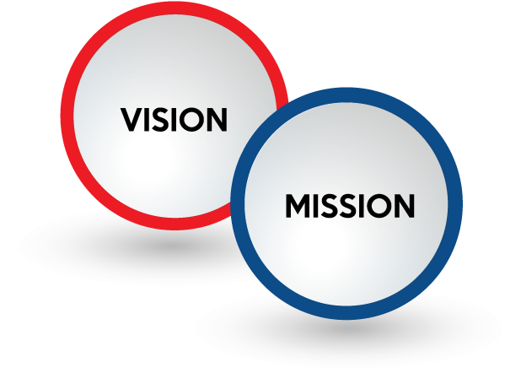

2.5 Inpace’s Client















2.6 SWOT Analysis

Strength
- Easy to point and contact more audience at an economy cost.
- Campaigns basically adjusted and more focused as per our business necessities.
- As the world is increasingly reliant on the web, it benefits the business to spread out with the general population on a more prominent scale.
- Ability to provide best production value on creative execution.
- The choices are not bound to one or two, there are numerous alternatives and individuals can change from one to the next if “Plan A” does not work and does not charge an excessive harm of money.

Weakness
- A task to reach the population which is still not expending the web.
- Keeping pace with new patterns and innovation.
- Need of deep understanding of modifying human conduct and necessities.
- Data analysis is yet an extraordinary concern not very many individuals are master in it as relatively few can understand what information really says.
- The cost is very expensive to clients (due to higher personnel cost).
- If their image or brand is not showing the clients need, at that point the casual of getting bad criticisms in public is very high and it might damage their reputation.

Opportunities
- More and increasingly nearby organizations are getting into promotional stage.
- It will help our Bangladesh Government Organizations to end up advanced.
- The dream of making “Advanced Bangladesh” can turn out to be genuine.

Threat
- If it does not work properly then odds of blowback is more prominent for an example it may hurt the brand name.
- Advent of an enormous number of agencies in the market is making a value weight on bigger agencies.
- Many MNC customers have centralized their communication activities and consequently lessening the scope for work of associating local agencies.

2.7 Inpace’s Competitors

2.8 INPACE PROVIDE

2.9 Inpace Management Services Limited
Inpace Management Services Limited is one of the leading Marketing agencies in Bangladesh. IMSL is an organization that works with tech products concerned with making life easier. It is an international organization originated in 1997. The reason behind establishing this was making Bangladesh more technologically innovative giving the phrase, ‘Digital Bangladesh’ its worth.
The Departments Working Within IMSL
There are basically five departments in IMSL. One of them work around the production of advertisement and other ensures smooth functionality of the organization. In the following figure all the departments of IMSL.
The mission of these departments is to produce quality advertisements for their clients. As a result, the advertisements should drive sales, create an increased in awareness, and the firm's profits should go up.

Client Services Department
The basic function of the client service department is to maintain relationship with the clients and prospects. They communicate the thought of both the parties between two parties. They are one of the most important parts of IMSL because they are the persons who find out the things customer needs and finding the need is one of the most useful ways to keep the customers happy. This department is the blood circulation of the whole organization and it co-ordinates within the functions of the various department in the agency.
This department of IMSL is also important for research purpose. This gives some important information to the IMSL authority, like
- Effectiveness of the campaign
- Market power of the subject product
- Customer reaction about the product or the ad campaign
- Finding out the reasons that makes a product fails to have more sale or gain more sail.
- Market background of the product
This information helps IMSL authority to take decisions like
- Whether IMSL works for the client or not
- What type of promotional campaign is needed to help develop the market condition?
- What was the success of the campaign?
- What change is needed in the campaign?
- What changes are expected by the buyers in the product? etc.

Media Department
Now a day number of full service agency is getting lower and lower every day. GREY is one of the few full service agencies in Bangladesh. That’s why they have to select the media they are going to use to publish or to show any certain advertisement. The media department of GREY finds out the most profitable way from the combination of coverage, cost and product type to air the advertisement. The media department also finds out the programs that a client can sponsor. Media timing is also one of the important functions of the media department.
The media selection method is a little bit hard-hitting here in Bangladesh. In case of TV broadcasting media, the important factors considered by the GREY are:
- Coverage of the network (BTV has the highest coverage)
- Type of product (some products can’t be advertised in national TV before 10)
- Cost
- TRP rating (In case of sponsorship, agencies follow a rating called television rating point, TRP.)

In case of Print Media selection, the important factors are
- Type of the newspaper or magazine
- Circulation
- Cost

Creative Department
This is the engine of the organization because it is them whom make IMSL popular and effective to the clients. They perform certain acts. Some of them are given below.
- Developing theme for a TV commercial
- Developing headlines, sub-headlines and body messages for an advertisement to be printed on papers.
- Designing the look of the artists in a commercial
- Visualizing the idea
- Preparing jingles
- Finalizing layout etc.

Accounts & Finance Department
The finance department of IMSL functions like finance department from any other business organization. The extra thing it does is the budgeting for any advertisement campaign or product promotional campaign.
HR Department
This department helps to find out the best people, who can suits with this organization. This department also motivates the employees in various ways.
- Recruiting of new employees are their concern.
- Training and development of the interns are going in a good way is also their concerns.
- Compensation, employee benefit, leave and service rules program and upgration
- d. Placement and performance appraisal of employees
- Preparing related reports
- Reporting to the Executive Committee/ Board on related matters.

Marketing Services
This department holds the key of execution. Executes any kind of events and activation for marketing solutions for clients.
Activities of this department
- Planning for a marketing solution for direct market
- Working on cost and budget for the activities
- Estimation of execution time and finding feedback from it
- Hiring of required outsorced HR for execution of the plan
- Co-ordinating HR support for sound execution
- preparation of final cost sheet for the activation

When IMSL Works for a client?
There are certain conditions that are pre requisite that IMSL will be working for the organization. Some of them are;
- If the product line is not conflicting to the lines already handled by IMSL.
- Good Quality of the product
- Availability of funds for researching
- Market position of the product has to be possible to be developed.
- Creative and working freedom
- Trust and partnering

Working process between client and IMSL
The communication process between the client and the ad agency is quit delicate and the following section presents this delicate process of communication.

Clients Problem
At first the client communicates and fixes a meeting with the IMSL officials and they express their problem and the type of remedy (if they have an). In the long years of doing business the common problems IMSL hear from the clients are
- Sales is getting low
- Arrival of new competitor
- Launch of new brand
- Market rumor etc.
The agency needs to understand the client’s business and have a good knowledge of the dynamics of the market in which the client operates. Equally, the agency should also be aware of the motivations and decision-making processes of end consumers. A new product or service, new situation or changing market conditions may provide the starting point for a new role to be performed by advertising, direct marketing, personal selling, sales promotion, event sponsorship, or internet marketing.

Internal Briefing by Account executive
Account executive, the head for managing the activities related to a certain brand, communicates with the client and gets hold of their problem. Then he briefs to the departments related to the planning of the promotional campaign. A group is assigned to the problem. The group briefed generally contains,
- Media planners
- Creative directors
- Finance Department
- Client service department

Conducting Research
Client service department conducts a research about the product in the market. The main objective of conducting this research is to;
- Gather information about the image of the company and product,
- Gather information about current promotion
- Gather customer complaints
- Gather customer prescriptions.

Planning the campaign
It’s a juggernaut work to plan for a promotional campaign. Generally the members of the above mentioned group take part in the planning process. The things they generally plans are,
- Goal of the campaign
- Type of promotion, ATL or BTL
- Type of advertisement, printed or TVC
- Budget of the advertisement
- Media planning
Here ATL means above the line promotional campaigns like TVC, Paper advertisement etc. on the other hand BTL means sampling, posters etc.
Reaching presentation
Although it is named as the client’s presentation but actually the presentation is presented by the account executive. They present the outline of the plan they have prepared.
A sample plan for HP, by IMSL was like this
- The goal of the campaign is to communicate with all kinds of people with a new product.
- Both ATL & BTL promotion will be applied.
- Several TV advertisements and RDC will be aired every day in almost 6 channels.
- Press ad of HP was also a concern of IMSL. Their target will the top reading newspapers and magazines of Bangladesh

Final Approval Presentation (Client’s presentation)
After performing all the planning works the agency has to take the final approval of the client. The agency presents the detail campaign plan to the client and asks for work order on that plan.
Achieving censorship certificate
In case of broadcasting in the national TV or Radio, the scripts have to be approved by the television and radio authority. Then the work of production can be started.

Producing the advert(s)
After getting approval from all the parties the agency call the respective department related to respective works. The creative department design the layout of the advertisement, they will design the slogans, texts, images for the paper and the total outline including, dress, background, script, cinematography for a TV Commercial. The production department then produces the banners, posters, billboards etc. On the other hand client service department of IMSL contacts with the director and get into negotiation about the compensation of the director and they also explains the total visualization of the advertisement. Then the director asks for casts and crews and shoots the total advertisement. After that the shoots are edited and converted to three type of advertisement (in case of huge advertisements). They create three different versions for the three different phase of the campaign which are,
- Introduction
- Memorizing
- Promotional

The campaign appears
The time span between the briefing of the account executive by the client and the campaign appearing can be as little as six or eight weeks for a simple photographic newspaper execution, to twenty weeks plus for an animated TV commercial, personal selling drive, sales promotion campaign, event sponsorship, public relation activities.

Controlling

Like all management process advertising also has a controlling sphere. In this stage the performance of the campaign is judged after 1 month, 3 month and 6 month of the launch of the campaign. Then the result is compared with the perceived result. If the result is positive then generally the campaign stops else the research department again performs a research to find out the reason of the failure of the campaign.
After finding out the problem, the agency prescribe some action to the client and if permitted than works accordingly.

Compensation methods used by IMSL
IMSL generally uses three different types of compensation system. They are as follows,
- Commission Based
- Retainer fee
- Account Based

Commission Based Compensation
In this system IMSL charges at least 7% commission on the total promotional budget+ 15% vat on the commission charged. Thus it differs from client to client
Retainer fee
Now some organizations like Akij and some other organizations are arranging for corporate tenders for a certain amount of promotion. In this case IMSL quotes a price and it wins the deal if it is the lowest.
Account Based
This sort of advertising accounts occurs generally in case of clients gained through affiliation. These clients pay certain amount money against a certain amount of work which doesn’t changes with the amount of work done by the clients.

3.0 Industry Perspective
There are some competitors like us such as:
- Asiatic Experiential Marketing: Asiatic is one of the main advertising correspondence firms of Bangladesh. Asiatic Experiential Marketing Limited is one of the wings that are a definitive answer for all correspondence needs of Asiatic 3sixty. The organization began its task in 1966 and now has developed to progress toward becoming nation’s one of the main publicizing organizations, doing over 35% of country’s all out correspondence need, that implies all showcasing and social correspondence. In Bangladesh, Asiatic has been working in the business condition in the course of the most recent four decades. The gathering comprises of 13 organizations that encourage its customers with Communication, Activation, PR, Audiovisuals Production, Media consultancy and Broadcasting. Today, Asiatic has more than 875 workers and it invests wholeheartedly in being one of the favored managers in Bangladesh. The organization is always expanding upon its portfolio and has worked with in excess of 50 brands including Unilever, BATB, Grameenphone, HSBC, BCCP, Nestle, BRAC, UNFPA, Nokia, Unicef, UNDP, Airtel, Transparency International Bangladesh, PepsiCo, etc. Asiatic Marketing Communication Ltd. a publicizing firm that gives altered arrangement in practically all fields of promoting including Billboard, Magazine, Newspaper, Television, Radio and some more. Asiatic Experiential Marketing Limited’s job is to guarantee that more individuals invest more energy with its customers' brands and its motivation is to make thoughts that individuals need to invest some additional time with. They have a conviction that the better the thought the additional time individuals will go through with it.

- Creinse Limited: Creinse Limited works in the all circles of promoting correspondence, social exercises, computerized stages, music and sports, at whatever point and any place there is another pathway to grasp and another test to take on. Creinse tries to investigate and achieve a thing, which hasn’t been thought of. Creinse is a company that cannot be confined in a definition. The variety of Creinse is only exceeded by its inventive thirst to think and create projects that have never done before in Bangladesh. With the motto of the will amaze themselves and amaze others, they aspires to explore and accomplish things, which has not been thought of or have been ventured into by any.

- Trend Tracker: Trend Tracker is an event management firm that manages International Trade Fair event sorting out with their event title ‘Made In Bangladesh’ to build up the strong association between exhibitors and clients just as conveys attractive measure of brand items in National and International markets. From the time of foundation, it has sorted out and managed numerous events and Exhibitions with collaboration of different coordinators under their Event Title ‘Made in Bangladesh’. Trend Trackers will work intimately with you to help make yours a triumph. They give full support. Their experienced agents will be accessible at the each show to help the Exhibitors with any issues that could influence your interest in the occasion. Pattern Trackers Management group is profoundly talented in the creation and arranging of effective displays all inclusive.

- REEMS: Rainbow Exhibition and Event Management Services Ltd. (REEMS) is a group of youthful and vigorous experts from the area of Event and Exhibition Management. They are enthusiastic about them and think about every one literally. Their enthusiasm and devotion, joined with the experience of their in-house occasion pros empowers them to surpass customer desires. They make it their need to comprehend their customer's destinations, working close by customers from idea to finish to make a novel and critical occasion. They once in a while observe a customer just once. A large portion of their customers goes to them over and over, empowering them to build up a strong comprehension of their business destinations. Practically all new clients touch base by close to home suggestion.

- E3 Solutions:E3 Solutions has gained a large wide professional expertise in the event and exhibition management industry and yet is committed and dedicated to provide perfect environment to get the topnotch business deal and contacts to their clients and exhibitors to restore dormant and emerging markets, creating profile and highly targeted business and customer exhibitions. It has organized more than hundred events along with couple of expositions with enormous success. This company has established a brand name in the industry of event and exhibition management with high dedication and client centric approach.

- Creato: Creato in a combination of specialist outfits to desire needs of clients in the multi-faced and strong arena of communication. They ensure that the solution they deliver and the activations they handle create a positive impact. They motivate their audiences and clients. Their motive is to meet their clients’ business objectives by thinking strategically and creatively. Their central goal is to make and fabricate suffering affinity with all partners by giving inventive arrangements. Their services spectrum are corporate event & activation, brand/product communication, market activation, television and radio event, road show, wedding, sports, entertainment, local & international artists concert, high profile event and party.

4.0 Objectives
The main objective of this report is to analyze how Inpace Management Services Limited focuses on building their relationship with their clients in the field of digital marketing. Their main focus is to address the ever changing technological needs of their clients and to eliminate every barrier in delivering technological advancement to their clients. It is an international organization which is working with tech products to create life easier. Theother objectives are as follows:

▪ Analyzing their advertising methodologies, approaches, projects and practices.

▪ Analyze how they give better answer for their customers with respect to incorporated showcasing and advancements.

▪ Analyzing how their group supports to accomplish the business objectives and goals consistently.

▪ Analyzing how they are helping the Bangladesh Government in making 'Computerized Bangladesh'.

▪ Analyzing the worker work framework.

5.0 Methodology
I have used both primary and secondary data to make this internship report.
Primary Data
The Primary data has been collected by discussing with Inpace’s employees, my co-worker, and also clients.
Secondary Data
The secondary data has been collected from the annual report of Inpace communication, online articles and websites, periodical statement of Inpace communication, client records, documentary fines, training materials and some related academic books, documentary fines, training materials and some related academic books such as, “The Art of Digital Marketing”, “The New Rules for Marketing & PR” etc.

6.0 Finding of the study
After 3 month of my internship at Inpace communication, I can say that Inpace communication is one of the biggest organizations in the sector of IT event Management Companies.Additionally Inpace Communication is one of the biggest commercial firms around yet regardless of I issues grabbed my eye which are The Followings-

Lack of Self Marketing and Self Branding-Inpace Communication is surely a big agency which has been serving it agency for more than 20 years but in one department they are lacking is self-rapid marketing of their own organization. Inpace Management promotes their Client product and services but hardly they promise their own services and capabilities to General Public through mass marketing. As a result many people are oblivious about the existence of the agency.

Lack of Time -In my season of Internship in Inpace Management I have confronted this issue ordinarily. At times it was hard to finish a given assignment with-in time. For a model once I was approached to arrange for an occasion which was following day. So I had so little time to get ready.

Work Environment –Work Environment is great however some of the time it becomes busy and boisterous.

7.0 Recommendations

Inpace Management can upgrade their very own marking by following these techniques-
- Online Advertisement

- Billboard Advertisement

- TV, Radio Advertisement

- Social Media Advertisement

- Inpace Management can develop an accurate time management system and creates a systemic approach to inform employees about upcoming event and duties. So that employees can get ready for upcoming commitment and responsibilities.
- Inpace Management can provide individual desk for employees and also provide better quality of internet speed so that employees can use at their highest limit.

8.0 Conclusion
It's been only 37 years of freedom and 31 years of publicizing. In the most recent decade we have figured out how to think in an unexpected way. Our human asset is growing exceptionally quick. They are presently progressively learned and talented. It is without a doubt that in the event that these individuals get some scholastic exercises on promoting, at that point they will unquestionably perform great sooner rather than later. This report can be finished up with the accompanying choices, such as Bangladesh needs some exceptionally imaginative individuals and that is the reason it needs a spot to instruct publicizing, government and some rich associations should assist the offices with acquiring advances which will build up the nearby aptitudes and furthermore spare remote monetary standards, regular rivalries ought to be held to energize new comers, a genuine TRP rating ought to be organized.
This investigation has helped me to know the inside and out of office exercises, chances to improve further in drawing in clients with brands, future business openings in the market. Fundamentally, a promoting office is included with the action of publicizing, brand advancement, marking and planning, retail arrangements, database the board, PR, specific occasion the executives and arrangements. In this way, we have taken in a ton from every one of these exercises and we trust our proposals will help Inpace to upgrade its inner exercises, between departmental cozy relationships. At long last, we trust Inpace will take legitimate activities to persuade the workers to possess his/her obligations and claim Inpace.

9.0 References
Creato. (n.d.). We amplify ur thoughts with creativity.Retrieved from http://creatobd.com/about
Creinse. (n.d.). Meet Creinse. Retrieved from
https://www.creinse.com/meet_creinse.php
E3 Solutions. (2015). Retrieved from
https://www.e3solutionbd.com/about-us/
Sarker, S. (2017). Retrieved from
https://www.inpacebd.com/our-team.html

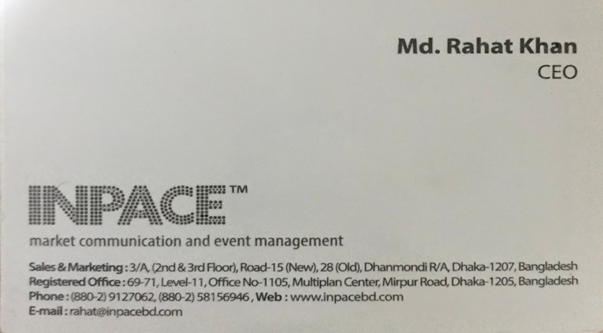
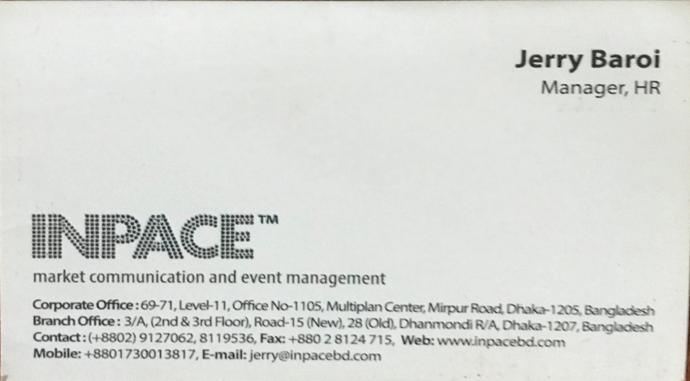
Appendix

