6/6/2018
SAMIRA TABASSUM
ID – 121 122 011
NGOs Role in Women Empowerment

Table of Contents
Abstract: 3
Introduction: 4
NGOs Role: 6
Literature Review: 7
Methodology: 9
Data Analysis: 10
Participation: 10
Decision Making: 11
Socio-Economic Status: 12
Productivity: 13
Control Over Income: 14
Opportunity: 15
Intervention Programs: 16
Skill of Work: 17
Profitability: 18
Training Program: 19
Income Generating Activities: 20
Nutrition: 21
Per Capita Income: 22
Per Capita Expense: 23
Well-Being: 24
Social Awareness: 25
Living Standard: 26
Social Awareness: 27
Social Understanding: 28
Motivational Framework: 29
Intensity in productivity: 30
Micro Credit: 31
Quality of Productivity: 32
Educational Based Programs: 33
Motivational Advertisement: 34
Encouragement in Empowerment: 35
Solutions: 37
Conclusion: 38
Reference: 39
Questionnaire for Role of NGOs in Women Empowerment 40

Abstract:

Women have attained a great deal in the past few years but there are still areas of discrimination which exists. Non-governmental organizations are playing a significant role in developing the empowerment process of the underprivileged women. They have been the source of motivation to encourage the deprived women to up-rise against systematic discrimination. NGOs have supported the hard work of the women. It has enlightened and created awareness in the society. It has helped to build up a platform for the women to stand their own. It engaged women in various socio-economic actions, microcredit activities, vocational training and capacity building programs. NGOs have dedicatedly been the medium to promote the empowerment of the women in front of the prejudiced society. It is believed that providing the capacity building programs to women has a socio-economic and a positive effect in the economy. Thus, this study will assess the impact of NGOs interventions focusing on the empowerment, capacity building and economic welfare of women. Furthermore, to understand how the NGOs were able to provide a platform to the women beneficiaries. The study will also find out the demographic variables (age, education, monthly income and years of affiliation) influences the level of empowerment and capacity building of the beneficiaries.

Introduction:

Empowerment is a dynamic and multi-dimensional process that enables women to understand their full uniqueness and supremacy in all domains of life. Power is not a commodity to be executed nor can it be given away. Power has to be acquired and once it is acquired it needs to be exercised, sustained and preserved. Before the emergence of microcredit, women in rural Bangladesh were not empowered. They had little or no access to the formal employment market and they did not have the necessary funds to engage in income generating activities.

The position of Women is considered in terms of their legal rights, education, economic independency, and empowerment, age at marriage, health, age at fertility, and the roles she plays in her family as well as in the society. The status of women is compared with the status of men in Bangladesh.

In the time of 1980’s women’s status in Bangladesh persisted minor to that of men. Majority of the women lived in rural areas. The common rural women were small cultivator, tenant and landless households. Many of them worked as laborers part time or seasonally, usually during the post-harvesting period and received payment in meager cash wages. Other mostly in poor landless households, dependent on the casual labor, gathering, begging and other irregular sources of income, typically their income were essential for household survival. The remaining women were engaged in professional activities, trading activities, or were in large-scale landowning categories and they were monotonous to work outside the home.

Many subjects have high influence on women’s education and worthwhile opportunities. Extreme poverty is pointed as the key factor behind women’s lack of education in a developing country like Bangladesh. Families dealing with extreme poverty has less chances to enroll their girls in schools and many of them withdraw them before finishing the stage of primary level. In most cases the enrollment of a girl in a primary school is treated as unnecessary compared to a boy in the same family. It is a common thought that the girl children should be at home to perform the daily household duties.

In the rural area of Bangladesh, the girls are forced to get married at a very tender age that hampers their psychological and physical health as well. Parents living in rural areas of our country has lack in interest and mostly are openly antagonistic to provide formal education of their daughters. The surprising reasons related to lack in education is the typical social and religious norms of our country which are in general and to marriage prospects in particular. Again, people with superstitious mentality both in urban and rural areas belief that education will spoil a girls’ character and demoralizes her to fulfill her typical traditional role. Early marriage and the importance of preserving a girls’ good reputation in the society has led to widespread withdrawal of our girl children from school.

Women’s are deprived of their rights in many ways. They are asked for dowry and get harassed in their In-laws house. They are even forced to give birth and get praised for giving birth to a male child instead of a female child. In this birth giving period most of the women also suffer for the lack of nutritious food and this leads them to give birth to a child suffering with malnutrition. Poor birth giving process also leads them to unfortunate fatality.
In the urban area most of the women are victim of gender inequality in the society and also in the workplace. They suffer to balance both their respective household and place of work. The increasing expenses, high living standard and changing trends leads many women to suffer from anxiety and depression.

NGOs Role:

In 1971, there were only a few NGOs who operated their curriculum in the then East Pakistan, which is now known as Bangladesh. The campaign organized by the NGOS in Bangladesh began just after the liberation war when a number of NGOs emerged in our country. During this period NGOs came up with tackle relief project and rehabilitation activities to improve the situation of the war-torn Bangladesh. Since the Government organizations were enough to face the crisis NGOs played an active role to meet up the challenges.
The welfare orientation programs organized by the NGOs prolonged till 1974. Thereafter, NGOs extended their field of development activities. The came up with community development approach to help the deprived society. During the time NGOs emphasized food production with the use of modern firming technologies. In 1976, some NGOs started to adopt their new strategy and also administered their programmers and services to benefit the poor. This diverse strategy developed by the NGOs are now known as the target group approach. In this approach the poor participants with similar economic interests were grouped together. NGOs are also mobilizing the disadvantage groups to provide various support and services ranging from training, credit, income generation, health and many more to developing the capacity of the poor and the economic empowerment.

Literature Review:

This study will give a review on the NGOs role in women empowerment in context to Bangladesh economy. The study took a closer look at the NGOs intervention programs for the women to understand the overall improvement in empowerment.

Earlier poverty has been the greatest obstacles in the path of the women of our country. They were deprived of their legal and political rights. They had no sense about the importance of health or education. They had to suffer from deficiency of nutrition. The women of our country lacked much behind than the male counterpart. People suffering with hard core poverty had no choice but to live a life in misery. They live from hand to mouth for their daily survival. Many women in the rural area of Bangladesh get segregated from the income generating activities because of religious norms and social disbelieve. In our country we also have female child labor. They are used as off the book employees. Female students get dropped out of the school at a very tender age because of poverty. Early marriage is also a great problem for the women of our country to enhance their wings of ideas and education. They had no decision-making power as well.

The different safety net programs arranged by the NGOs have deliberately supporting women to engage in diverse activities. They came up with new ideas to help the underprivileged women. They have arranged a number of on the job and of the job training programs for the disadvantaged group of the society. Late night schooling programs helped them to learn different methods of earning. They have helped them by capacity building programs. The most important role of NGOs was to create a platform for the women to come out of their respective shelter and take part in socioeconomic activities to generate income, promote savings and spread social awareness.

The study involved the participants in to a face to face interview that helped to understand the real-life situations and their unbiased opinion about their working experience with NGOs. Today the productivity of the women has increased. They are now aware of their rights and have achieved decision making power on important issues regarding household and place of work. They have gain minimum social status. They are contribution is 34% to the GDP growth of Bangladesh which still needs improvement. The aim is to ensure participation of women in every sector of the economy up to 40% by 2021 and 50% by 2050. NGOs are working to achieve maximum participation for a balanced economic condition.

Methodology:

This thesis is based on qualitative field research data. I have taken a sample of fifty household. My idea is to collect qualitative data by using a moderate questionnaire to understand the NGOs role in women empowerment. I have also done face to face interview. This Interviews increase the interaction between the researcher and the participants, which eventually helped me to reconfirm any information provided during the course of the interview. These further enabled me to observe my respondents and build rapport with them. The questionnaire will assess the impact of NGOs interventions focusing on the empowerment, capacity building and economic welfare of women along with the demographic variables of the remote areas of Chadpur Sadar Upazilla. The study will evaluate the present condition of the underprivileged women.

Data Analysis:

The data analysis process will be done by using the summary statistics of fifty households. The study will also calculate the mean, median and mode of the sample. I have also use the pie chart and bar diagram to show the result of the interview and statistical data.

Participation:

The participants were asked about their involvement at the work place. The mean value was found 3.92 with a SD of ±0.85, which indicates most of the participants agreed with the fact that NGOs training programs has increased their skills of work. The micro credit program has given them the opportunity to vision beyond the traditional concept. The diverse program has enabled them to engage in activities outside their household for example: Poultry, Farming, Crafting, Small industry, Knitting, Packaging etc.

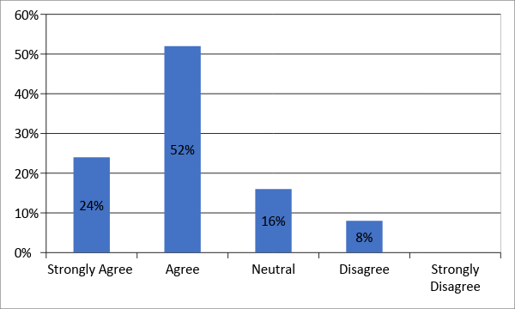

Decision Making:

The participants were asked about their involvement in the household decision making power as well as in the work field. The mean value found from their interview was 3.82 with a SD of ±0.87, this indicates the participants have agreed that NGOs program have make them sufficient enough to partially participate in the decision making process in both household and in the work place. Although traditionally male get the prior opportunity to take decision on behalf of the whole family.

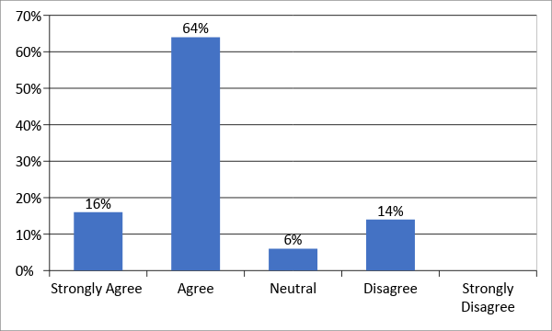

Socio-Economic Status:

The participants agreed that the role of NGOs have changed them socioeconomically as the mean value of the data was 3.8 and the SD was ±0.86. Today they understand the value of education. They are now much concern about their place of work and learned to protest against any sort of harassment. They now have almost equal access to property right compared to men. The standard of living has been changed over the time. Their knowledge for nutrition has increased over the time. The income generating activities are working as a positive motivation behind their socioeconomic status.

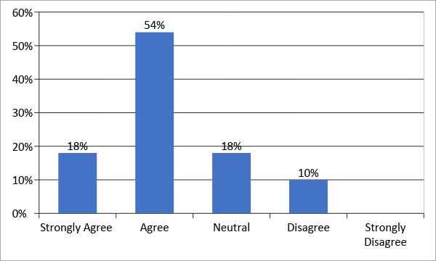

Productivity:

The participants were asked of their increase in the level of productivity. The mean value was 3.86 with a SD of ±1.11 which indicates they agreed that NGOs have helped to improve their productivity over the time. Today women are the most significant drivers of revolution in development. NGOs have given main concern to women's economic engagement to achieve SDG on women empowerment in the 7th Five Year Plan. NGOs have created surroundings to unleash the potentials of women in the labor and capitalist sector. Twenty-seven percent of our budget is allocated for women's social and economic empowerment activities. NGOs have been the key to increase this productivity of the women specially the women struggling with vulnerable condition in the economy.

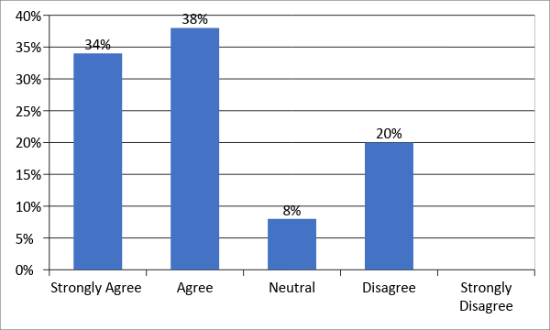

Control Over Income:

The participants were asked about their control over income, the mean value was 4.02 with a SD of ±0.87. This indicates that most of the participants have agreed that the NGOs intervention programs on women empowerment have changed their control over income. Today women are able to contribute to their family expenditure head to head with men. They have also learned about savings for future uncertainties.

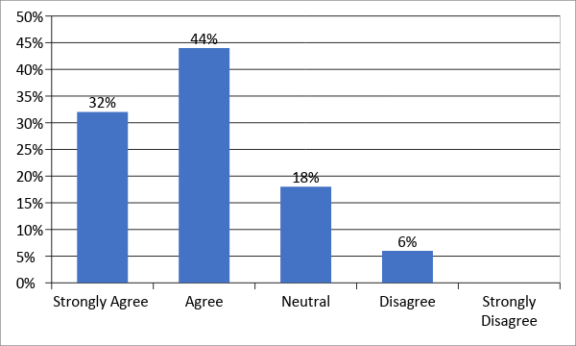

Opportunity:

The participants were asked about if the intervention programs have created sufficient opportunities for them. The mean value found from the data was 3.08 with a SD of ±0.88 which indicates that they are neutral about the opportunities created by the NGOs. Bangladesh is a small developing country with a huge population. The job opportunities are still insufficient to provide for everyone. In this male dominating environment NGOs are trying their best to support and create job opportunities for the vulnerable women folks of our country. They have arranged on the job and off the job training facilities, night schools, seminar on health and nutrition, Seminar on learning new methods, introduced them with new and improved Technologies, Maternity Facilities, Seminar on importance of Breast Feeding, Childcare, Birth Control, seminar on environment control, Micro Credit Facilities to start small business etc.

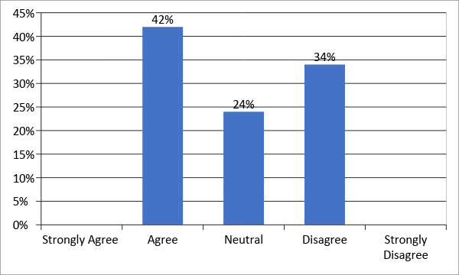

Intervention Programs:

Participants were asked if the intervention programs have increased the number of female participation in the work field. The mean value found from the data was 4.06 with a SD of ±0.84 which indicates that most of the participants agreed to the fact that diverse programs held by NGOs have increased their participation in the work field. Programs arranged by the NGOs are enriched with educational value. Many programs offer lucrative opportunities to work as a team leader. These have also made them to learn how to work as a team. Other conveniences like: Childcare day care service, Nutrition, Breast feeding privacy has given them the scope to work independently without any sort of hesitation. The training programs have given them a chance to learn under expert supervision.

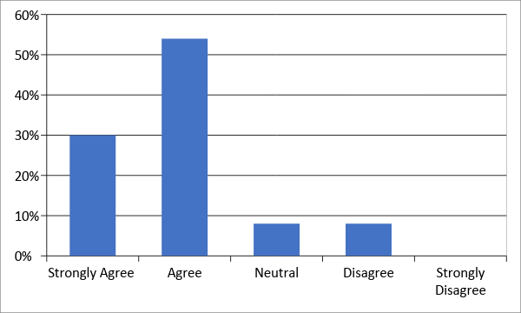

Skill of Work:

The participants were asked about their skill off work. The mean value found from the data was 3.98 with a SD of ± 0.17 which indicates that the participants agreed that their skill of work has improved because of NGOs miscellaneous programs. The training programs have made them learn different techniques of exertion. The vocational training programs in Bangladesh added a new dimension in the female labor force. Women’s participation skills have also improved in activities like: poultry and livestock and a verity of rural non-farm activities and using micro credits facilities for generating additional income.

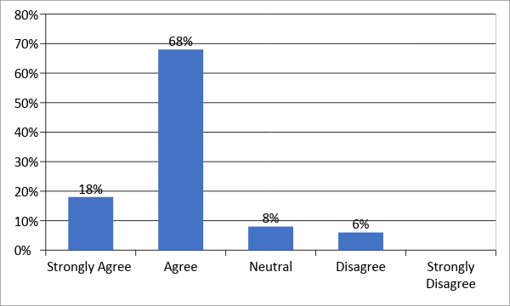

Profitability:

The participants were asked about their profitability opportunities in the work field. The mean value found from the data was 3.7 with a SD of ±1.05 which indicates that they have agreed that NGOs are working successfully with the women participants. They have been the key source to bring the underprivileged women under income generating activities. Their support through micro credits have been the biggest contribution for the disadvantaged women to become self-sufficient.

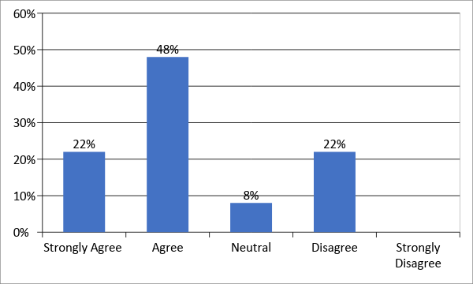

Training Program:

The participants were asked about the training programs arranged by the NGOs. The mean value found from the data was 3.48 with a SD of ±0.89 which indicates that they are expression were neutral about the NGOs training programs. The NGOs are trying their best to support the underprivileged women to make them self sufficient through the diverse training programs. They have been the activists who are trying to reach the most remote area of Bangladesh with a vision to expand the women’s participation in the work force. They are training programs are designed to formulate an environment adequate for women to participate and stand equal to men. The different programs like: On the job and off the job training courses, Skills development and awareness building courses, Agricultural workshops, Micro Credit workshops, Aquaculture workshop , Micro finance, Alternative income generating activities, poultry, dairy and apicultural farm management training, Industrial management projects, Tailoring and decorative quilt making projects, wood working and decoration management, Environmental pollution and protection projects etc.

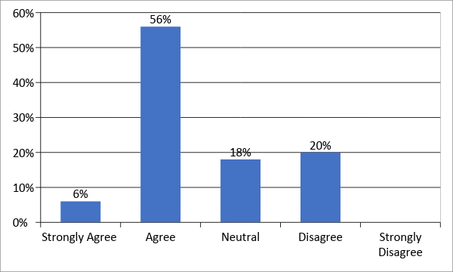

Income Generating Activities:

The participants were asked about the increase in the income generating activities by the NGOs intervention programs. The mean value found from the data was 3.88 with a SD of ±0.39 which indicates that the participants agreed that their income generating activities have increased over the time. Before the emergence of NGOs most of the women were small tenant, cultivator and a large number of them were engaged in households related to unpaid works. Scores of them worked as labors part-time or seasonally, generally throughout the post-harvesting stage and expected compensation in insufficient cash wages. Other mostly in poor landless households, dependent on the casual labor, gathering, begging and other irregular sources of income, typically their income were vital for household endurance. Today NGOs have made them sufficient for upholding with their rights in the society. They are now aware of any sort of injustice next to them. NGOs programs have made them learn new methods of generating income with their diverse activities. They have made them to learn the importance of savings for the future and health related issues as well as education for a bright active new generation.

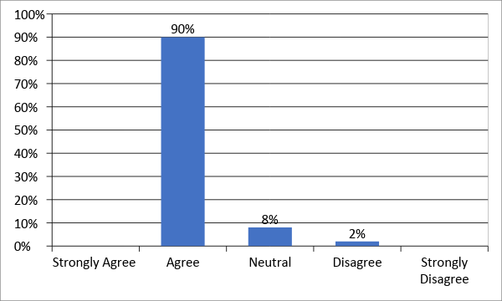

Nutrition:

The participants were asked about their health and nutrition. The mean value found was 4.1 with a SD of ±0.71 which indicates that the participants have agreed that the NGOs programs have improved their health and nutrition. Different programs and health seminars arranged by the NGOs have made the participants aware of regular health care, safe sanitation, safe sexual health, child care, Safe maternal health, breast feeding, food value etc.

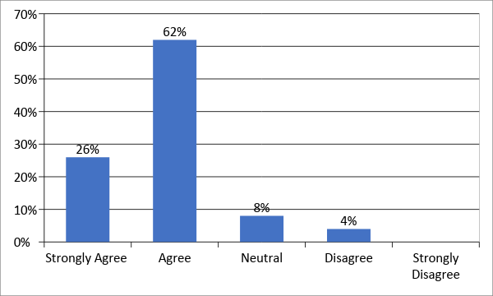

Per Capita Income:

The participants were asked about the increase on their per capita income. The mean value found from the 3.72 with a SD of ±0.88 which indicates that the participants have agreed that their per capita income has increased over the time. The diverse vocational on the job and off the job trainings have made them earn more. The new methods of learning have a positive relation with the earning of an individual.

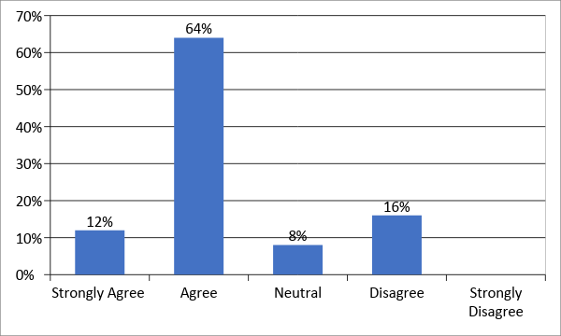

Per Capita Expense:

The participants were asked about their per capita expense. The mean value found from the data was 4.42 with a SD of ±0.50 which indicates that the participants have agreed that their per capita expense have increased over the time with the increase in earning.

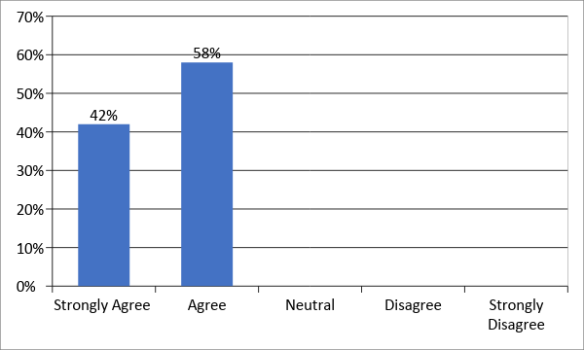

Well-Being:

The participants were asked about the overall well-being achieved by them. The mean value was 3.8 with a SD of ±0.61 which indicates that the participants have agreed that they have a positive change in their status of well-being. Today with the increase amount of earnings the living standard of the women has increased. They are capable to take responsibility of work and manage household at the same time. They are able to stand for themselves and for the society as well.

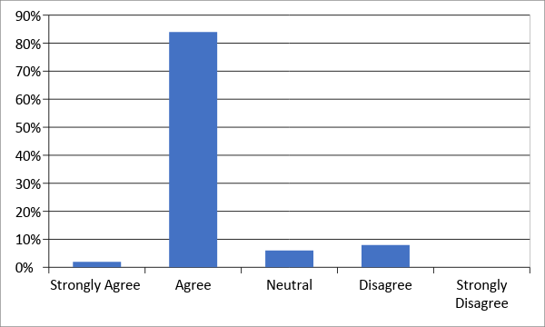

Social Awareness:

The participants were asked about the increase of social awareness. The mean value found from the data was 3.66 with a standard deviation of 0.75. Most of the women are now aware about the laws that could protect them, introduced with various social institutions and they can play active role in social gatherings in the study area. One of the leading NGO motivated women to take their own responsibility whether it is for loan and savings or education and even decision for marriage of their children in some cases.

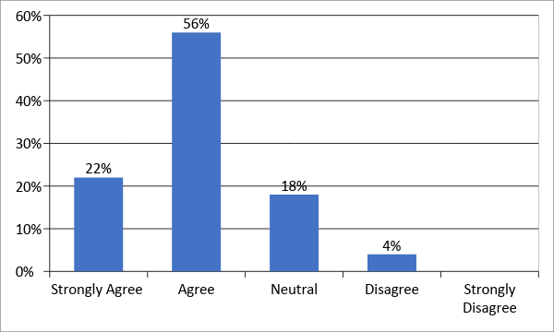

Living Standard:

3.82 (±0.87) was the mean value when women were asked about the improvement of their living standard. Women, in the study area lives at the vicinity of the upazila sadar and they are now a day improving their living standard not only by buying non-renewable assets like TV, Refrigerator etc., but are also contributing in expensive items, for e.g., boat and net for their husband, repairing the house, taking lease of the char land etc.

Social Awareness:

In the aspect of raising social awareness, Majority of the participants agreed with the fat that NGOs working in the village raised social awareness among them. They have strong knowledge about dowry, education, health and other relevant social issues. In addition, they know how to participate in social welfare meetings conducted by the NGOs and also take part in various social activities. The mean value for the criteria was found to be 3.96(±0.83).

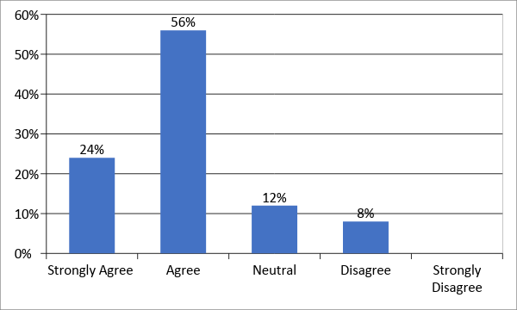

Social Understanding:

In the aspect of raising social awareness, Majority of the participants agreed with the fat that NGOs working in the village raised social awareness among them. They have strong knowledge about dowry, education, health and other relevant social issues. In addition, they know how to participate in social welfare meetings conducted by the NGOs and also take part in various social activities. The mean value for the criteria was found to be 3.96(±0.83).

Motivational Framework:

In case of creating motivational framework, most of the women agreed to the fact that they were highly motivated through NGO activities. Successful women entrepreneur in the villages shares their success stories and ideas during general meeting and this encourages others to take a step forward. The mean value was found to be 3.82(±0.44).

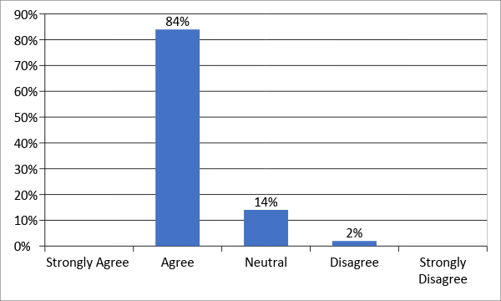

Intensity in productivity:

The level of productivity over time is increased with NGOs work and motivation and mean value of 3.92(±0.85) completely supports the fact. Women, even the men in village are ignorant about new and convenient technologies and NGOs are doing this for them. Even NGOs are working as a linkage builder, in some cases, and they are helping women quite a lot to improve the level of production in a sustainable and environment friendly way.

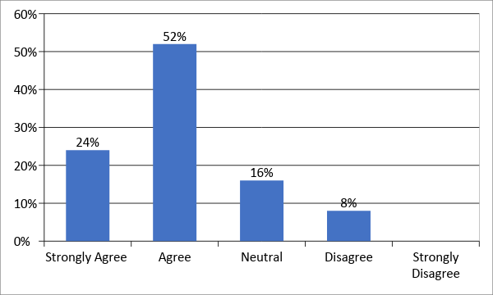

Micro Credit:

Micro credit plan has improved women’s’ condition and mean value of 3.82(±0.87) supports this. Women are given brief training on microcredit concept and later on they are given need-based training and refreshers training on their alternative income generation activities.

Quality of Productivity:

Mean value of 3.82(±0.87) was found when respondents were asked about the quality of product after NGO intervention. The respondents were very positive about the capacity building trainings that were very effective to improve the product quality. Goat rearing, tailoring and handicrafts were the major training items and women are confident after these training and have the technical know how about quality control of the finished products.

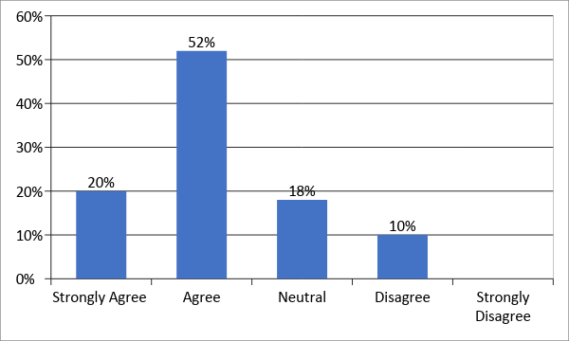

Educational Based Programs:

Education based programs has moderate impact on the lives of rural women and the mean value was 3.86(±1.11). Women are not that much interested in educational trainings covered by NGOs, instead their point of interest is in loan and credit related activities.

Motivational Advertisement:

When the participants were asked about the impact of motivational advertisement to improve their condition, the mean value was found 3.70(±1.01). Most of the responses were neutral in the case because they hardly get time to enjoy recreational activities and watch motivational advertisements.

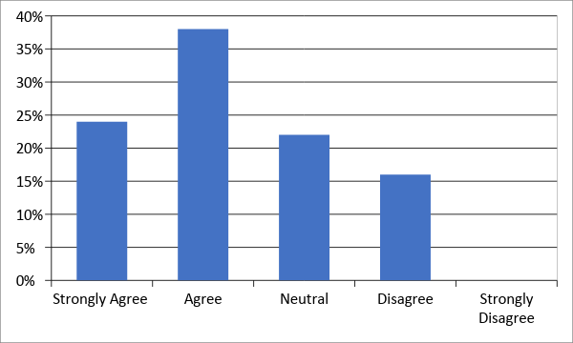

Encouragement in Empowerment:

When the respondents were asked if the NGOs encourage the women in productivity, mean value was found 4.10(±0.79). Women highly agreed to the fact that they did not knew how to make profit from small enterprises, and now some of them are well known about the marketing channel and other amenities.

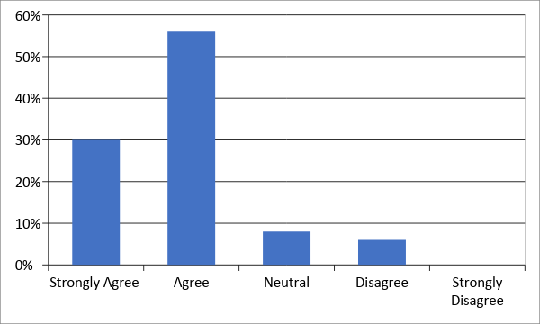

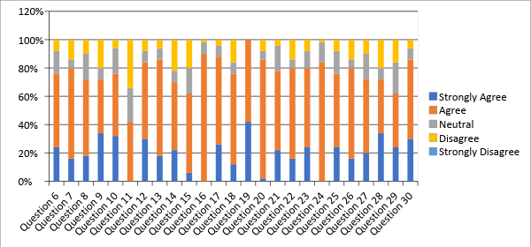

Solutions:

Interpersonal Communication:
It is important for the NGOs to build a formal and informal justice linkage with the female participants. Many women of our country still feel uneasy to work with men because of religious values and other social norms. A justice linkage with the participants may help them to understand the diverse programs and make them aware of gender equity issues. It will also help them to exchange information as well as verbal and nonverbal messages which will improve face to face communication among the participants.

Advocacy:
NGOs should come forward with advocacy to built public awareness. The female participants of our country need public encouragement from the society to stand in this competitive world. They need supportive measurement to ensure their legal and political rights. NGOs can be a good platform to take initiative for these underprivileged women of our country.

Condition for Credit:
NGOs should moderate the terms and conditions for taking micro credits for the female participants of our country. They should provide incentives for the women to encourage participation. They should relax the loan repayment system to promote empowerment.

Technology:
NGOs should introduce the female participants with up to date technologies. These will increase their skills of work and make them more confident. New technologies will also make them time efficient.

Motivational Campaigns:
Weekly or monthly based motivational campaigns should be arranged for the participants. They should give extra effort on campaigns related to health, education, sexual abuse, gender discrimination, skill development, entrepreneurship skills and so on.

Female Labor Force Participation:
Although the female labor force participation (FLFP) is increasing still there is fluctuation in the growth rate which was 36.3% in fiscal year 2016-17 in contrast to men which is 80.5% in the economy. Currently 56.9% of the women age between 15 and 65+ belong to the NEET ( not in education, employment and training) which can be a boosting opportunity if Bangladesh uses the potentiality.

Conclusion:

Women empowerment is a complex process in context to this male dominating society of Bangladesh. Although NGOs are working hard and soul to provide a multidimensional plat from for the women still there exist economic, social, cultural and political barriers. Traditional and religious norms kept women inside of their households for a very long period where they only faced discrimination. Lack of knowledge made them deprived of the light of a better future for themselves and their families and children. Now a day’s women are much aware of their rights. NGOs campaigning programs have made them overcome the fear of working outside of the home. They are now confident to take any new challenges. They are now adopting themselves with new methods of working and improved technologies. The educational training programs have spread their knowledge on various fields like farming, poultry, nutrition, day care, night schooling, capacity building, savings, micro credit, crafting, alternative income generating activities etc. need based training programs would be very effective

Reference:

- http://www.daily-sun.com/printversion/details/307762/2018/05/10/Women%E2%80%99s-contribution-to-country%E2%80%99s-GDP-20pc:-CPD
- https://dailyasianage.com/news/86916/womens-contribution-to-gdp-growth-34-pm
- http://www.bangladeshstudies.org/files/WPS_no23.pdf
- http://www.ilo.org/wcmsp5/groups/public/---asia/---ro-bangkok/---sro-new_delhi/documents/publication/wcms_250112.pdf
- http://www.bbs.gov.bd/
- http://www.ilo.org/dhaka/lang--en/index.htm

Questionnaire for Role of NGOs in Women Empowerment
Demographics of the Respondents:
- Gender:
- Male
- Female

- Kindly state your age:
- Under 20
- 20-35 years
- 36-50 years
- 51-65 years

- Monthly income
- 0 – 10000
- 10000 - 20000
- 20000 - 30000
- 30000 – 40000
- 40000 – 50000
- <50000

- Education Background
- Primary
- Secondary
- College
- Bachelor
- Master’s

- Religion
- Islam
- Hinduism
- Buddhist
- Cristian
- Other

- Did NGOs improve the participation of women in the work field?

- Strongly Agree
- Agree
- Neutral
- Disagree
- Strongly Disagree

- Did women achieved decision making power?

- Strongly Agree
- Agree
- Neutral
- Disagree
- Strongly Disagree

- Did NGOs improve the socioeconomic status of the women in the society?
- Strongly Agree
- Agree
- Neutral
- Disagree
- Strongly Disagree
- Did the productivity of the women have increased?

- Strongly Agree
- Agree
- Neutral
- Disagree
- Strongly Disagree

- Did women achieve control over income?
- Strongly Agree
- Agree
- Neutral
- Disagree
- Strongly Disagree

- Did NGOs enlarge the scopes for women?

- Strongly Agree
- Agree
- Neutral
- Disagree
- Strongly Disagree

- Does NGOs intervention programs help to increase participation of women?

- Strongly Agree
- Agree
- Neutral
- Disagree
- Strongly Disagree
- Does NGOs intervention programs help to improve the skills of women?
- Strongly Agree
- Agree
- Neutral
- Disagree
- Strongly Disagree

- Did NGOs create lucrative opportunities for underprivileged women?

- Strongly Agree
- Agree
- Neutral
- Disagree
- Strongly Disagree

- Is NGOs training programs sufficient to promote empowerment of women?

- Strongly Agree
- Agree
- Neutral
- Disagree
- Strongly Disagree

- Does women's income generating activities has improved over the time?

- Strongly Agree
- Agree
- Neutral
- Disagree
- Strongly Disagree

- Did the nutrition value of women increased?

- Strongly Agree
- Agree
- Neutral
- Disagree
- Strongly Disagree

- Did per ca pita income of women increase?

- Strongly Agree
- Agree
- Neutral
- Disagree
- Strongly Disagree

- Did per ca pita consumption of women increased?

- Strongly Agree
- Agree
- Neutral
- Disagree
- Strongly Disagree

- Did NGOs improve the overall well-being of the women in the economy?

- Strongly Agree
- Agree
- Neutral
- Disagree
- Strongly Disagree

- Did NGOs bring changes in the socioeconomic profile of a women?

- Strongly Agree
- Agree
- Neutral
- Disagree
- Strongly Disagree

- Did the living standard of women improved over the time?

- Strongly Agree
- Agree
- Neutral
- Disagree
- Strongly Disagree

- Did NGOs improve the social awareness of women?

- Strongly Agree
- Agree
- Neutral
- Disagree
- Strongly Disagree

- Did NGOs improve the motivational framework for women in the society?

- Strongly Agree
- Agree
- Neutral
- Disagree
- Strongly Disagree

- Did NGOs change the level of productivity of the women over the time?

- Strongly Agree
- Agree
- Neutral
- Disagree
- Strongly Disagree

- Did micro credit plans helped women to improve their conditions?

- Strongly Agree
- Agree
- Neutral
- Disagree
- Strongly Disagree

- Did the training programs by the NGOs improved the quality of productivity of women?

- Strongly Agree
- Agree
- Neutral
- Disagree
- Strongly Disagree

- Can educational based programs help the women to increase productivity?
- Strongly Agree
- Agree
- Neutral
- Disagree
- Strongly Disagree

- Can motivational advertisement increase the quality of productivity of the women?

- Strongly Agree
- Agree
- Neutral
- Disagree
- Strongly Disagree

- Did NGOs encourage the involvement of the women in productivity?

- Strongly Agree
- Agree
- Neutral
- Disagree
- Strongly Disagree

