THE IMPACT OF SOCIAL MEDIA ON CONSUMER BUYING BEHAVIOUR: A STUDY ON RESTAURANTS IN DHAKA CITY

THE IMPACT OF SOCIAL MEDIA ON CONSUMER BUYING BEHAVIOUR: A STUDY ON RESTAURANTS IN DHAKA CITY

Submitted To
S.M. Asif-Ur-Rahman
Assistant Professor,
School of Business & Economics,
United International University

Submitted By
Md. Anisur Rahman Sabuj
ID: 111 142 195
United International University

17 November, 2019

Letter of Transmittal
November,2019

S.M. Asif-Ur-Rahman
Assistant Professor (Marketing)
United International University

Subject: Submission of the internship report.

Dear Sir,
A prerequisite for my graduation on ‘The impact of social media on consumer buying behaviour: a study on restaurants in Dhaka City is successfully finished and I have the pleasure to submit my Project-paper report. All my effort has been used to make this report informative, practical, trustworthy and related as possible.
To make this report, you give your precious advice, cooperation, tolerance and recommendations, which will absolutely support me to go ahead as a wonderful guideline is respectable.
This report will give the clear idea about the purposes of social media beside with some difficulties that I have challenged in their activity. Hope this report you will find as worth all the labour and effort what has given to complete the report.

Sincerely,
Md. Anisur Rahman Sabuj
ID: 111 142 195
United International University
Acknowledgement

For completing the report I’m very grateful to my respectable Faculty, S.M. Asif-Ur-Rahman for giving me the chance to complete my Project-paper under his supervision and at the same time I’m also really grateful for his step by step guideline and his kind patience that he has shown me during this trimester which led to the completion of this report. During my project period what I needed and when I needed, I’m getting all kind of help from my honourable supervisor and his friendly behaviour, heartiest cooperation and other services. For all of this I would like give thanks to my respectable supervisor.
Table of Content
- Introduction ……………………………………………………………1-2
- Objective of The Research ……………………………………………...3
- Literature Review ……………………………………………………...4-6
- Scope and Limitation ………………………………………………….7-8
- Research Methodology ………………………………………………….9
- Findings and Analysis ……………………………………………….10-22
- Suggestion and Recommendation ……………………………………..23
- Conclusion ………………………………………………………………24
- Questionnaire ………………………………………………………….a-b
- Reference and bibliography …………………………………………….c

Executive Summary
A new miracle recognized as social media has changed the route of our lives over the previous few years. Now-a-days social media create affect in all the aspects of our live, inclusive of the restaurant industry also. The research objective is to understand the influences of social media on consumer decision making process through the social media in Dhaka City. Sample population 125 has taken to find out the importance of aspects and the influence of consumer decision making process in restaurant of Dhaka City through questionnaire. The outcome discloses the impact of word-of-mouth, online reviews, comments, blog posts etc. and product and service quality to fascinate consumes. At the same time this paper will give the restaurant owners to achieve their marketing objectives and will give them better understand of the importance of social media as a promotion of their businesses.

Introduction
For consumer decision making, social media has become a significant force, regarding such areas as growing awareness, forming opinions and attitudes, sharing information, purchasing and evaluating post-purchase experience. In particular, when consumers plan a trip or make a hotel or restaurant reservation, they commonly depend on online reviews for information and many depend on the internet to choose a restaurant.
The pressures at work life along with time limitations have resulted in a growing range of buyers opting for food restaurants in Dhaka City. One learn about of the market lookup and evaluation group packaged records published that around one- third of buyers felt they lack the time to prepare healthy meals, ensuing in food being bump off rapidly at work or in the car. For this reason these identical human beings have actually replaced many of their ingredients with snacks and speedy meal. Consumers have changed. The consumer’s attitude about the economy, their lifestyle, financial planning and buying habits and eating conduct – it has all changed. Why?
Due to busier patron life-style and dual-working households with children, emphasis increasingly more being locations in speedy meal solution. In the closing five years’ fast growth of the fast meals restaurant in Dhaka city start the necessity of the study. The boom of the quick meals market has been an effect of societal development.
Nowadays social media becomes important part of an individual’s life. Social media like Facebook, Twitter, Instagram and LinkedIn use various type of person and increasing day by day. Communication through social media has determined have an effect on client choice making and advertising strategies also. Consumer socialization principle predicts that communication among shoppers affect their cognitive, affective and behavioural attitudes. Consumers tend to make purchases or behaviour enterprise on social media.
Another trouble is now-a-days female in Dhaka city that they do now not remain at home for carrying out household tasks, for compensated work in determined nearer to equal opportunity and economic independence instead of an additional option. The meal, as a view meaning the allocation of unique kinds of food, has been substituted by prompt breaks of individual ingesting (sometimes referred to as grazing), and many young humans do not have normal ingesting instances or habits in terms of breakfast, lunch, and dinner.
There has been extremely good shift in eating habits and patron desire in Bangladesh as availability of food joints and eating places are in plenty. We get to see a range of restaurants and joints focusing on quite a number of aspects like cuisine, ambience, place and themes. These aspects provide to a large vary of customers of one-of-a-kind segments.

Objective of The Research
OVERALL OBJECTIVE
To understand the impact of social media on consumer buying behaviour in Dhaka City is the overall objective of this research. To find out the impact of social media of what consumers’ behaviour like attitudes, perception of foods and customer service quality in that restaurants in Dhaka city, is the aim of this study.

SPECIFIC OBJECTIVES
More specifically the research objectives are to find out different aspects of social media that influence the customer opinion about restaurant and to identify the relationship between consumers and customer services in the restaurants food in Dhaka City.
From different journals and articles the literature review part is described. Then methodology part is pointed out by research design and research hypotheses. After that discuss the collected data in the findings & analysis part. Finally, shows the opportunity for future research, limitation of current research and summarizes the findings and analysis in the conclusion part.
Literature Review
Over the past few years we have seen the growth of social media and its impact (Tiago et al., 2015). In today’s world, every day in every 60 seconds on Facebook 510,000 comments are posted, 293,000 statuses are updated, and 136,000 photos are uploaded. Google now processes over 40,000 search queries every second on average, which translates to over 3.5 billion searches per day and every second, on average, around 6,000 tweets are tweeted on Twitter which corresponds, over 350,000 tweets sent per minute, 500 million tweets per day and around 200 billion tweets per year. Dhaka, being the third most densely populated city in the world, with 23,234 people living per square km area, in a recent survey was ranked second in terms of the most active Facebook users in the world. Bangladesh has a population of 164 million among which 63.3 million are internet users. And among those 63.3 million, 26 million are active social media users.
Situate of the study. The growth of the restaurants market has been an effect on societal development. Like the western world, now a day, female in Bangladesh in particular in Dhaka metropolis do now not stay at home carrying out family tasks, however as a substitute opt for remunerated work in striving closer to equality and financial independence. The meal, as a notion meaning the sharing of unique kinds of food, has been replaced by rapid breaks of individual ingesting (sometimes referred to as grazing), and many young humans do not have normal ingesting instances or habits in terms of breakfast, lunch, and dinner.
An important aspect driving delight in the provider environment is provider quality. In the restaurant industry, only a part of the supplying carrier is intangible and heterogeneous, and where the production and consumption of the product cannot be separated. The technique to check client delight for provider industries based on five widespread dimensions; tangibles, responsiveness, reliability, assurance and empathy. ‘Product offering’ for a full service restaurant is a probably to assessed by evaluating an authentic product (by meal) and with the aid of the place it is delivered (physical place); higher bodily design of the restaurant, the higher level of consumer satisfaction. The fee of the objects on the menu can also notably influence clients due to the fact rate has the functionality of attracting or repelling them, mainly considering the fact that charge functions as an indicator of product quality.
Food has become very popular today. Eating habits are shaped in initial years and become the exercise life is unchangeable. From the family and society children analyze the whole thing. This study did not consider the aspects that affect the gratitude of children, only considered the food and nonfood item. When children are going out with their parents, they consume and examine about one-of-a-kind types of meals other than speedy food. Family make the adolescents familiar with the ingredients thinking about elements like nutrition, age, status, convenience, speedy, money, taste, surroundings of the save due to the fact they impact the choice making process. The household choice making technique can change because of the other factors like income, age. When they mature day via day they will take choice regarding food thinking about exceptional factors that their mother and father gave them already. Day by day attitudes of teenager’s exchange as time passes and mum or dad can have an effect on less gradually.
Thus the result, for the necessity of quick service for food offering social plays an important role at that time. They use different types of media like Facebook, Instagram, LinkedIn, Twitter etc. for order. Because this social media helps them a lot. They easily check about the restaurants or foods or services through their friends or connections that which will be better for them.
The influence of social media on buying behaviour can be in any services or products depend on its quality, brand, advertising and pricing. In 2003, Western Kentucky University used a sample of 249 consumer’s purchases to analyse the type of the product and the cost of item. The result of this research present that consumers are buying either inexpensive or expensive items, and are doing so based on recommendations from social media by their contacts or friends on social media.
As a result, most of the time consumers take decision what their friends or connections suggests on his/her posting through social media. Consumers choose this item through quality, cost, service and so on. The number of reviews and guests is the reflection of a restaurants popularity. (Zhang et al., 2010). For some tourist cities, good reviews work as the main means of their promotion (Pantelidis, 2010). It is the quality of service and food that motivates the diners to leave comments (Longart, 2010). According to Lang (2011), guest satisfaction depends on the friendly behavior of the waiting staﬀ and how they welcome and interact with the guests, hygiene, outcome of service encounter, and the price that leaves a print of the restaurant on the mind of a customer which motivates them to say good things about it.
According to the sagepublications, many research studies also focus on social media’s word of mouth (WOM) effect, in particular, online reviews and travel blogs. According to Cornell Hospitality Quarterly, using the WOM framework, Kim, Mattila, and Baloglu (2011) investigated the different influences of gender and levels of expertise on consumers’ motivations on reading online reviews. Regardless of the differences among groups, consumers in general consider “convenience and quality assurance” an important factor of eWOM. Consumers join in the online reviews to know about that what is different in the market in count to receiving support of others. Jeong and Jang (2011) examined the relationship between restaurant service (food quality, service quality, atmosphere, and price fairness) and consumers’ motivations of positive eWOM (concern for others, expressing positive feelings, and helping the restaurant company). They found that food quality, service quality, and atmosphere can trigger positive eWOM in different ways. Pantelidis (2010) used a content analysis approach to analyze about 2,500 online reviews of 300 restaurants in London. On balance, the comments were fair and favorable, with comments on food, service, ambience, price, menu, and décor (in descending order of frequency).

Scope & Limitation
With regard to the objectives, conducting the lookup from the point of view of shoppers would be a notably appropriate approach. The researcher realizes that there are many on hand reports and research which instead ambitions to help companies to attain a better understanding in social media marketing however not to help consumers to identify reasons that social media has modified their selection making process. Since the cause of advertising and marketing is, in sum, about consumer; therefore, by way of having the starting factor from the appreciation of consumer, and by means of collecting facts from consumers’ point of view, fresh insights can be gathered. The lookup also targets to serve as an indicator to achievable readers (companies) of how they can tab into the selection making manner by way of social media sites.
Moreover, in order to furnish a more complete viewpoint regarding the choice making process, the researcher has discussed the five-stages shopping for mannequin and the records processing theory, because the former concept explains the stages in decision making system honestly whereas the latter one denotes the psychological factors all through the process- they are closely linked with one some other based on their objectives.
Social media advertising and marketing is no longer a new aspect, and but it is still drastically a developing and evolving theme in the field. With a speedy literature scan on the related topic, certainly there are significant amount of journals and articles, but with few scientific/academic lookup and classical literatures about social media advertising and marketing associating with modifications of client behaviour. Thus, this would be some other dilemma of the lookup that the dialogue on the subject matter is as a substitute in a customary manner.
For conducting the research first collect large sample group in different areas in Dhaka City and therefore to understand the buying attitude and behaviour of the maximum food consumers in Dhaka City, this study helps me a lot. Findings has the ability to understand the recent scenarios of the food industry in Dhaka City and also effective for focusing on to improve the overall experience of the food consumers through the identifications of various factors.

Research Methodology
Research methodology or graph is very necessary now not solely for research workers but also for readers of lookup studies. Every research finds out about has to be nicely deliberate to preserve away from waste of efforts however nonetheless make sure legitimate answers. The learn about must have enough however most excellent number of subjects to provide 80-90% power to arrive at dependable legitimate conclusion. Number of topics should now not be extra than that required on the grounds that it quantities to waste of assets like money, time of the researcher and skill. A research methodology is a logical and systematic layout organized for directing a research study. Research methodology is the plan, structure, approach of investigation conceived so as to acquire answer to lookup questions and it constitutes the blue print of collection, management and evaluation of data.
The objectives of this research are two kinds – first to locate out the elements and variables concerned in selection making process; second to pick out the changes that social media has delivered to the choice making process, in which, in really by way of elaborating the difference between advertising through the usage of social media and by means of traditional ones. This research strives to grant a clearer, and perhaps a higher appreciation to both consumers and companies of why, when, and how social media has impacted on decision making process. It may additionally moreover also supply possible insights for companies to discover the pitfalls and possibilities in the new advertising and advertising era.
In research design formulation primary data is collected through survey that are the methods of collecting quantitative data. Because survey research method is the most popular form of collecting the quantitative data. And data is collected through personal interview. And secondary data is collected from different journal, websites and blogs. For conducting the research sample size 125 individuals are collected and non-probability sampling technique is used in this research. Data is collected through questionnaire method by 5-point Likert scale and some yes/no question. Data analysis made on the data collected from the questionnaire. Since the survey was sent out to 125 individuals and the number of individuals were 125, therefore the total percentage of responses was 100%. In total the questionnaire contains 12 questions.

Findings & Analysis
In order to attain exact and related data that were needed to find out the purpose of this study, a questionnaire has been tactically designed. With the questionnaire, a survey has been accompanied on a random sample of 125 people identifying that find out the influences of social media for their decision making process towards their aspects and ingestion behaviour. The questionnaire imitative the information that is exact and partiality free. The people those who were involved in the sample population were very useful in concisely pointing out their favourites and potentials with recognize to the purpose of this project. The random sample population has been chosen from the students of different university and some service holder. During this time a lot of relevant information was gathered and hence analysed. The analysis record and findings of this project would be resourceful and favourable to the concerned.

- Gender of The Surveyed

Gender | Frequency | Percentage | Cumulative Percent
Male | 90 | 72 | 72
Female | 35 | 28 | 100
Total | 125 | 100

Figure: 1.1

Analysis
For conducting this survey, it’s come out that (72-28) = 44% of male tend to consume more than females. This is not actually the consume scenario of food industry in Dhaka City but the outcome of this survey. Because job holder was the potential customer for this research but lack of contacting with them, can’t find the real scenario.

- Shopping Food from Online

Shop food from online | Frequency | Percentage | Cumulative percentage
Yes | 75 | 60 | 60
Yes often | 25 | 20 | 80
No | 25 | 20 | 100
Total | 125

Figure: 1.2

Analysis
The collected data shows that on average (60+20) = 80% people shop food from online. It’s indicate that social media has great influence on buying behaviour. Social media has great opportunity in the food industry as well. Based on uses of social media such as Facebook, Instagram etc. is easy to shop food from online.

- Important to Choose Healthy Food
Choose healthy food | Frequency | Percentage | Cumulative percentage
I don't know | 13 | 10.4 | 10.4
Yes | 105 | 84 | 94.4
No | 7 | 5.6 | 100
Total | 125 | 100

Figure: 1.3

Analysis
As this survey states based on the above data, most of the population (84%) think that it is important to choose healthy or hygienic food. Maximum people are health conscious. As a result, they like to choose healthy food when shop food from online. Fewer thinks different when shop food from online.

- When Food Shopping Which Consider as Important

Consider as important | Frequency | Percentage | Cumulative percentage
Saving money | 20 | 16 | 16
Origin of food | 20 | 16 | 32
Convenience/ease to purchase | 35 | 28 | 60
The quality of ingredients | 40 | 32 | 92
Other | 10 | 8 | 100
Total | 125 | 100

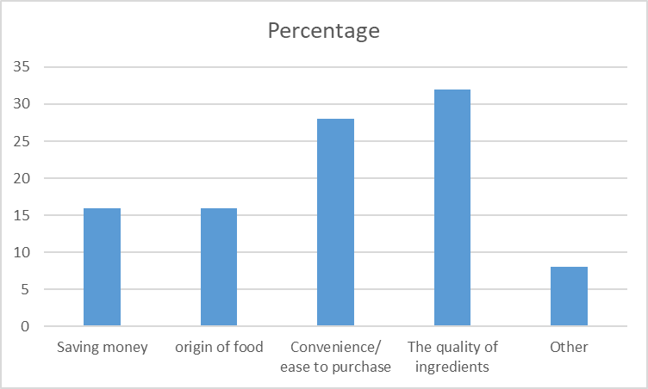
Figure: 1.4
Analysis
People today are more health conscious and they look for quality food when order food from online. The above data shows that the sample population not only looks for quality food but also convenience/ease to purchase is important to them when they want to shop food. For ordering saving money and origin of food is also little bit important to fewer sample population.

- Buying behaviour ever been influenced by promotions of social media

Influenced buying behaviour | Frequency | Percentage | Cumulative percentage
Yes | 80 | 64 | 64
No | 35 | 28 | 92
Other | 10 | 8 | 100
Total | 125 | 100

Figure: 1.5

Analysis
Now-a-days most of the people use social media for shopping clothes, beauty necessity, food, buying ticket or travel and also pay their utilities. Thus most of the company try to promote their product/service by social media. As per the survey, most of the sample population agree that their buying behaviour has been influenced by promotions of food chains on social media. At the same time, one-third sample population oppose that.

- Social media make decision more complex

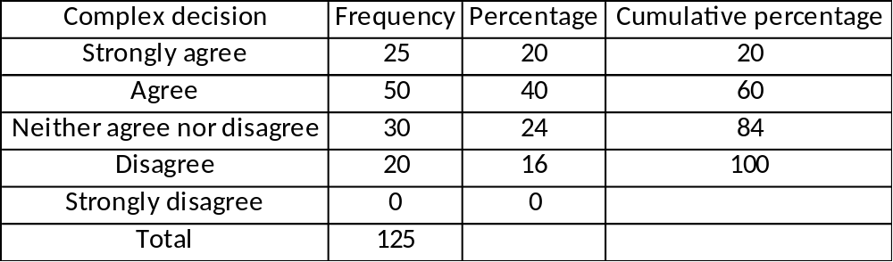

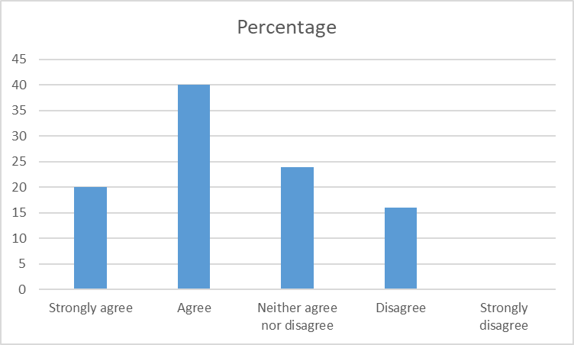
Figure: 1.6

Analysis
From this survey, most of the sample population think that the process of social media is more complex for making decision of buying. Because the relationship between social media and customer decision-making present that social media influences advertising attitudes, company attitudes, and buying intentions of consumer. Social media can build brand attitudes that have an effect of decision making on consumer buying behaviour.

- Consuming only meat in restaurant

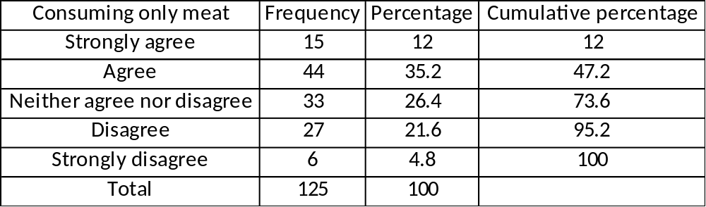

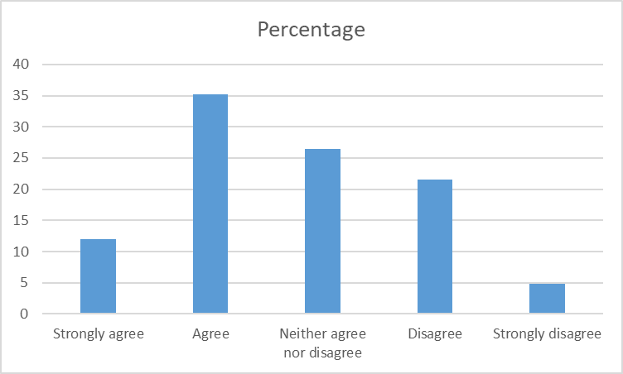
Figure: 1.7

Analysis
The above table states that most of the sample population order or shop meat item from online. On the other hand, rest of the population order fast food or different snacks item. Availability of a wide range of food enables people in Dhaka City to order or shop from social media whatever they like to eat for their breakfast, lunch or dinner. Because most of the time they think that it is easy for them and also time consuming.

- Did the food come out fast enough?

Food come out fast | Frequency | Percentage | Cumulative percentage
Yes | 60 | 48 | 48
No | 65 | 52 | 100
Total | 125 | 100

Figure: 1.8

Analysis
Its indicate the service quality of food chains. Now-a-days service has a reciprocal relationship with the food industry. As per the survey, almost half of the population has good idea about service of food delivery and other oppose that.

- Rate the value of food surveyed

Rate the value of food | Frequency | Percentage | Cumulative percentage
1(Poor value) | 6 | 4.8 | 4.8
2 | 7 | 5.6 | 10.4
3 | 55 | 44 | 54.4
4 | 40 | 32 | 86.4
5(Great value) | 17 | 13.6 | 100
Total | 125 | 100

Figure: 1.9

Analysis
The data shows that the value of food is not so high and not so low. Its indicate the average value of food that ordered in the online. Because sometimes they chit with the customers those who are involved with the service system. Customer can’t get the proper item that they order from online.

- Overall satisfaction level is high through online service

Satisfaction level high | Frequency | Percentage | Cumulative percentage
Strongly agree | 5 | 4 | 4
Agree | 57 | 45.6 | 49.6
Neither agree nor disagree | 47 | 37.6 | 87.2
Disagree | 12 | 9.6 | 96.8
Strongly disagree | 4 | 3.2 | 100
Total | 125 | 100

Figure: 1.10

Analysis
Mainly satisfaction depends on different attributes like service, quality of food etc. The collected data shows that half of sample population are satisfied and other has different opinion or dissatisfaction. To get high satisfaction level online service need to be increase service quality and food quality also.

- Like to share after comments/reviews/blog post etc. via social media after purchase

Like to share after purchase | Frequency | Percentage | Cumulative percentage
Always | 10 | 8 | 8
Often | 30 | 24 | 32
Sometimes | 58 | 46.4 | 78.4
Seldom | 27 | 21.6 | 100
Total | 125 | 100

Figure: 1.11
Analysis
Though the social media has impact for making decision of consumers buying behaviour, the above table shows that maximum sample populations (78.4) are likely to share comments/reviews/blogs posts/related article etc. to peers or friends through social media after a purchase. Consumers want to get previous experience for making decision about a product or service from their peers or friends. Then he/she also give the feedback about the product experience. Today this process is easily happened by the social media.

- Like to buy again from online app?

Like to buy again | Frequency | Percentage | Cumulative percentage
Yes | 100 | 80 | 80
No | 25 | 20 | 100
Total | 125 | 100

Figure: 1.12

Analysis
In a previous service related question surveyed half of the people argued the positive attitudes about the online service quality. The above data shows that maximum population (80%) want to buy again from online. This indicate the necessity of online food service today in Dhaka City, though the service quality is not so good. It gives us information that the food industry has a great scope to improve service quality and food quality also.

Suggestion & Recommendation
This research gives rationalization on how buyers are attending, processing, and determining on the facts on social media until now than a purchase. The findings indicated that customers pursue a lively function in data search on social media. Since research has disclosed that customers do now not feel stimulated to generate the phrase of mouth by social media, and this indication may additionally moreover mean that entrepreneurs would have to elevate out sure actions in order to provoke these conversations. Businesses has great opportunity to develop their online actions for serving the consumers to assurance quality food, better service and quick online feedback as well.
Conclusion
The research objective was to find out or understand the impact of social media on consumer decision making process. To initiate with, social media has delivered deep adjustments each the shoppers and marketers. Availability of extensive vary of meals permits humans in Dhaka City to order or shop from social media what they like to eat for their breakfast, lunch or dinner. Because most of the time they think that it is easy for them and also time consuming. And at the same time company want to sell more and more of their products. For this reason, they advertise their products through the various type of social media and give different benefits, decrease price, sometime product wise benefit, sometime bundle package to attract the customers and service related benefit also. For this necessity of both consumers and businesses, social media plays an active role.
Another trouble is now-a-days female in Dhaka city that they do now not remain at home for carrying out household tasks, for compensated work in determined nearer to equal opportunity and economic independence instead of an additional option.
Social media also has great impact to know about a product or service past experience from their nobles or friends through social media before a purchase. Many of the consumer now give feedback to share comments/reviews/blog posts/related article etc. about their product experience. So that their peers, friends or other customers could be aware about that product and their delivery service as well. It may create a great impact to the customers for making decision before a purchase.
For the purpose of this survey data and findings were point out for customer first choice towards quality food, better service quality the food industry in Dhaka City. Businesses has a wide scope to development and growth in terms of quality food and better service quality of online service. If marketers give their attention for increasing this quality, it would be a profitable industry in near future.

Questionnaire
On
The impact of social media on consumer buying behaviour: A study on restaurant’s in Dhaka City
Dear,
I’m Md. Anisur Rahman, student of United International University & department is BBA (Marketing). Your opinion will help me a lot by this survey to complete my project paper.
1. What is your gender?
- Male
- Female
2. Do you ever shop food from online?
- Yes
- Yes often
- No
3. Do you think it is important to choose healthy food?
- I don’t know
- Yes
- No
4. When food shopping which do you consider as important?
- Saving money
- Origin of food
- Convenience/ease to purchase
- The quality of the ingredients
- Other
5. Has your buying behaviour ever been influenced by promotions of food chains on social media?
- Yes
- No
- Other

6. Social media make your decision making more complex?
- Strongly agree
- Agree
- Neither agree nor disagree
- Disagree
- Strongly disagree
- Would you enjoy consuming only meat preparation in restaurant?
- Strongly agree
- Agree
- Neither agree nor disagree
- Disagree
- Strongly disagree

- Did the food come out fast enough?
- Yes
- No

- How would you rate the value of food? (Great value to Poor value)
- 1 (Poor value)
- 2
- 3
- 4
- 5 (Great value)
- Your overall satisfaction level is high through online service.
- Strongly agree
- Agree
- Neither agree nor disagree
- Disagree
- Strongly disagree
- How often you are likely to share comments, reviews, blog posts, related article etc. to friends and family through social media after a purchase?
- Always
- Often
- Sometimes
- Seldom
- Would you like to buy again from online app?
- Yes
- No

Thank You
Reference & Bibliography

- http://cqx.sagepub.com/content/early/2012/09/24/1938965512458360
- (http://creativecommons.org/licenses/by-nc-nd/4.0/).
- Longart, P. (2010). What drives word-of-mouth in restaurants? International Journal of Contemporary Hospitality Management, 22(1), 121-128. doi:10.1108/09596111011013516
- Pantelidis, I.S., 2010. Electronic meal experience: a content analysis of onlinerestaurant comments. Cornell Hospitality Q. 51 (4), 483–491.
- Zhang, Z., Ye, Q., Law, R., & Li, Y. (2010). Th e impact of e-word-of-mouth on the online popularity of restaurants: A comparison of consumer reviews and editor reviews. International Journal of Hospitality Management, 29(4), 694-700. doi:10.1016/j.ijhm.2010.02.002
- URL: http://dx.doi.org/10.5539/ijbm.v8n6p128
- www.emeraldinsight.com/0025-1747.htm
- http://dx.doi.org/10.1016/j.ijhm.2016.03.001 0278-4319/©
- www.emeraldinsight.com/1066-2243.htm
- http://www.google.com.bd/
- http://www.sagepublications.com
- http://faculty.ischool.syr.edu/byu/CHQ-2012.pdf
- https://www.researchgate.net/publication/258130306_Spreading_Social_Media_Messages_on_Facebook_An_Analysis_of_Restaurant_Business-to-Consumer_Communications

