Evaluating the Impact of Advertising on Product Sales: A case study on ACI Coil

Sakawat Hossen

This report is submitted to the School of Business and Economics, United International University as a partial requirement for the fulfillment of Bachelor of Business Administration Degree.

Evaluating the Impact of Advertising on Product Sales: A case study on ACI Coil

Submitted By
Sakawat Hossen
ID: 111 132 239
BBA Program
School of Business & Economics,
United International University

Supervised by
Dr. Kawsar Ahmmed
Associate Professor
School of Business & Economics
United International University

Date of Submission: October 30, 2018

Letter of Transmittal
October 30, 2018
Dr. Kawsar Ahmmed
Associate Professor
School of Business & Economics
United International University
Madani Avenue, Badda, Dhaka -1212
Subject: Submission of Internship Report
Sir,
It is a pleasure to take the opportunity to submit this report, which has been prepared as per the requirement of Internship. This report has been created in accordance to your requirements as well as the requirement of the host organization.
The internship program, which is of three months, helped me to learn a lot. It also enabled me to gain practical knowledge on dealing with customers and to perform different tasks using specialized software. This report is based on an overview of the organization and the experience I have gained during my internship program at ACI Limited.
Despite the difficulties I faced while preparing this report mainly due to time constraints, I have tried to be as critical and analytical and the information provided are accurate to the best of my knowledge.
Sincerely,
SAKAWAT HOSSEN
ID: 111 132 239

Acknowledgment
First of all, I would like to thank Almighty Allah for giving me the strength to complete my internship with attachment to ACI Limited for three month period. I would like to thank Almighty for guiding me for the timely completion of this internship report. I would also like to thank my parents for their continuous support during the toughest three months of my undergraduate life without which I would be unable to successfully complete my internship.
Next, I would like to thank all the people who had significant contribution in helping me throughout my internship and in fulfilling the requirements for the internship program at united international University. Firstly, I would like to thank my faculty advisor Dr Kawsar Ahmmed for guiding me and helping me continuously for the past three months for the successful completion of my internship.
I would like to thank my Supervisor, Md.Zakir Hossain Sarker, Consumer Brands Manager for supervising me and providing various key information and giving me the path to write a fruitful report also Business Analyst Officer Abu Hana Khaledn Mostofa and Assistant Manager, Sales Administration Md. Samusr Rahman Rimon to give a great guidance to me to make a faithful report and it is really very pleasure to me that he makes a correction of my report and give the correct solution always. I also thank him it was a great opportunity to do internship in such an organization like ACI Limited. I always felt that I was under guidance of highly qualified and experienced personnel. The experiences I have gathered will be very beneficial in my career.

Table of Contents
Letter of Transmittal i
Acknowledgment ii
Executive Summary iii
CHAPTER 01 5
INTRODUCTION 5
1.1 Introduction to the Report: 6
1.2 Research Aims 7
1.3 Research Objectives: 7
1.3.1 Broad Objective: 7
1.3.1 Specific Objective: 7
1.4 Scopes of the report: 7
1.5 Methodology: 8
1.5.1Primary sources: 8
1.5.1 Secondary sources: 8
1.6 Limitation of the Report: 9
CHAPTER 2 10
ORGANIZATIONAL OVERVEW 10
2.1 Background of the Organization: 11
2.1.1 Important dates and milestone dates of ACI Limited: 12
2.1 Different Business Units of ACI: 13
1. Pharmaceuticals: 14
Consumer Brand and Commodity Products: 15
2. Subsidiaries: 17
3. Joint Venture: 18
2.2Corporate Information: 18
2.2.1 Corporate Information of the organization at a glance: 18
2.3 Mission and vision of ACI Limited: 19
2.3.1 Company Mission 19
2.3.2 Company Vision 19
2.4 Company Values: 20
2.5 Fundamental Departments of ACI: 20
CHAPTER: 3 21
Literatures on the Impact of Advertising 21
2.1 Sales performance: 22
2.2 Promotional Mix: 22
2.3 Elements of Promotional Mix: 22
2.1.1 Advertising: 22
• Types of advertising: There have several types of advertising. 23
1. Newspaper: 23
2. Magazine: 23
3. Radio: 24
4. Television: 24
5. Directories: 24
6. Outdoor and transit: 25
7. Direct mail catalogues and leaflets: 25
8. Online: 25
• Setting Advertising Goal or Objective 25
Informative advertising 26
Persuasive advertising 26
Reminder advertising 26
Reinforcement advertising 27
• Objective of Advertising 27
• Important of advertising 28
2.1 Marketing Mix: 28
1. Product: 29
Household Insecticides: 29
• ACI Aerosol 29
• ACI Mosquito Coil 30
2. Price 31
3. Place 31
4. Promotion: 31
• TV Ads 32
• Activation 32
• Billboard 32
• Conference Program 32
• Events 33
• Display promotion in Super shop 33
5. Process: 33
6. Packaging or Physical Evidence: 34
7. People: 35
CHAPTER: 4 36
Work Experience at the ACI Ltd. 36
4.1 Actual Task Part: 37
4.2 Internship program: 37
4.3InternshipActivities: 37
(1)Official Activities: 37
(2) Field Activities: 37
4.5 Internship Position: 38
4.5.1 Primary Learning: 38
4.5.2 Secondary learning: 39
CHAPTER: 5 41
Research Methodology and Findings 41
5.1 Problem Statement: 42
5.2 Background of the Problem: 42
5.3 Research Methodology: 42
5.3.1 Research Approach: 43
5.3.2 Type of research: 43
5.3.3 Research Instrument: 43
5.3.4 Data Sources: 43
5.4Develop Independent Variables & Dependent Variables: 44
Diagram 5.1 44
5.5 Questionnaire Scale: 45
Table 5.1 45
Table 5.2 45
5.6 Graphical Representation and Findings: 45
5.6.1 Sales Volume: 46
5.6.2 Media: 47
5.6.3 Loyalty: 47
5.6.4 Competition: 48
5.6.5 Finance: 48
5.6.6 Product: 49
5.6.7 Market: 49
5.7 Conclusion: 50
Bibliography 51
Books 51
Appendix 52
Survey Research Questionnaire 52
6.3 Abbreviation: 55

Executive Summary
This internship report is based on practical experience at ACI Limited. This report deals with a clear understanding of Advertising, marketing mix, and promotional mix. This report consists of 7ps and five major parts with a different task and tried my level best to make a standard report based on this topic. Before working or doing my Internship program I was very interested to know about the sales, marketing and promotion activities of an FMCG company. ACI Limited is one of the largest conglomerates in the country with businesses in pharmaceuticals, agriculture, consumer products etc. ACI was called Advance Chemical Industries. ACI Limited is one of the most popular corporate names in Bangladesh. It is the most trusted brand as well as ensured quality product supplier. This report is designed basis on my theoretical knowledge and Practical experience also. It is designed to have a practical knowledge while passing through the theoretical understanding. The report is the result of three months working with ACI Limited Consumer Brand Sales

The objective of this report titled “Evaluating the impact of Advertising on product sales. A study of ACI Coil” is focused on the overall Marketing mix, sales performance and improving the promotional mix of ACI Coil. Because their Mosquito Coil’s products performances is weaker than their other products. The company needs to focus on developing the sales as well as they need to promote their product through the radio, television, newspaper, outdoor advertising and through other strategies that will help to increase their coil sales.

At the end of my Report, I have mentioned the findings in the research part. There I have also mentioned some recommendations for ACI Coil about what activities they need to follow to increase their coil’s sales. I hope they will be benefited from those recommendations and the overall conclusion is given according to my point of view.

Keywords: Advertising, Product Sales, Performance, ACI Coil, Bangladesh

CHAPTER 01

INTRODUCTION

1.1 Introduction to the Report:
This report is an Internship Report ready as an obligation for the achievement of the BBA program of the Bachelor of Business Administration (BBA), UNITED INTERNATIONAL UNIVERSITY. The key area of the internship is to provide a job experience to the students and a chance for conversion of academic beginning in real life situation. Undergraduates are positioned in creativities, organizations, research institutions as well as development projects. The program concealments a period of 12 weeks of organizational accessory and 2 to 3 weeks of report finalization work. After the achievement of four-year academic BBA program, the period of my organizational part was, by policy 12 weeks, starting from February 01, 2018. I was placed in ACI Limited, Dhaka for the internship program. As a requirement for the completion of the program, I need to submit a report, which includes “Evaluating the Impact of Advertising on Product Sales. “Basically, the report is made based on primary data, secondary data and information about the company. The procedure and findings of the study are mainly exhibiting my volume for some creative and original approach to solving practical problems in today’s business. The report has been prepared in partial fulfillment of the requirement for the degree of Bachelors of Business Administration (BBA) at UIU (United International University), one of the best and largest Private University in Bangladesh. The present report has been prepared on the basis of experience obtained throughout the internship period. My area of specialty is marketing and the area for this study is especially ACI Limited, Novo Tower, 270, Tejgaon Industrial Area, Dhaka-1208.

  - Research Aims:
The aim of my research is to Evaluating the Impact of Advertising on Product Sales of ACI Consumer Brands.

1.3 Research Objectives:
The Research objective of the report can be viewed in two forms:
- General or Broad Objective
- Specific Objective

1.3.1 Broad Objective:
The Broad objective of this report is to Increasing Sales Performance by Improving Advertising of ACI Consumer Brands.

1.3.1 Specific Objective:
Specific objective is to gather information from probable sources and analyze the selected scopes sited below the following aspects:
- To analyze the stages of Sales development strategies of ACI Consumer Brands.
- To analyze the sales performance of ACI Consumer Brands.
- To analyze the advertising and related activities.
- To find out the pricing strategy.
- To find out ACI advertising strategy.
- To know the Customer Satisfaction of ACI Consumer Brands.

1.4 Scopes of the report:
The scope of the report covers the organizational overview and structure, background, objectives, basic functions, sales performance , Products analysis, Sales promotion, competitor analysis, trade marketing through push and merchandising items for market research of international packaging with unique through the Sales and Marketing department of ACI Consumer Division. And for that reason, that information was very much restrictive within the organization as this brand are going a very much completive Brands. I am really pleased to all the member of all departments for constant assistant and inspiring me during Internship period.

1.5 Methodology:
Methodology is the process, technique or method of observation, survey and analysis. For
Smooth and accurate study everyone has to follow some rules and regulation. The study assigns
Were collected from two sources:

1.5.1Primary sources:
- I have collected the primary data by interviewing different executives of ACI Ltd.
- Practical desk work.
- Face to Face conversation with sales representative, Retailers, Distributors, Area Sales Manager and Zonal sales manager etc.
- Direct observations.

1.5.1 Secondary sources:
- Annual report of ACI Ltd.
- Files & Folders.
- Daily diary (Containing my activities of practical orientation in ACI Ltd.)
- Various Field visit.
- Website.
In my report I tried to minimize the usage of secondary data as much as possible. I have used secondary data only in the cases where it was not possible for me to use primary data.

1.6 Limitation of the Report:
ACI Limited is really a great place to gain practical knowledge. Though I have given extreme effort to prepare this report, but during my report, I had to appearance some difficulties. They are as follows–
- The main problem that I found in doing this report is inaccessibility of information because much information is confidential.
- As we know that the internship’s duration is only 3 months. This is a very small time for doing any kind of study, which was not enough.
- While doing an internship, in manyparts of my inquiry, my performance was stuck by some lacking in experience.
- As I have done this type of report for the first time so it was difficult to organize the report in a simple manner.

CHAPTER 2

ORGANIZATIONAL OVERVEW

2.1 Background of the Organization:
ACI was established as the subsidiary of Imperial Chemical Industries (ICI) in the then East Pakistan in 1968. After independence the company has been incorporated in Bangladesh on the 24th of January 1973 as ICI Bangladesh Manufacturers Limited and also as Public Limited Company. This Company also obtained listing with Dhaka Stock Exchange on 28 December, 1976 and its first trading of shares took place on 9 March, 1994. Later on, 5 May, 1992, ICI plc divested 70% of its shareholding to local management. Subsequently the company was registered in the name of Advanced Chemical Industries Limited. Listing with Chittagong Stock Exchange was made on 22 October 1995.
Bangladesh is a nation which is little in size yet expansive in population. ACI Limited is a standout amongst the most well-known corporate names in Bangladesh. It is the most confided in brand and also guaranteed quality item provider. ACI Ltd assumes a critical job as a supporter of national economy. Alongside this, they have left their strides in worldwide stage through remote speculations, joint ventures and brand affiliations. ACI has been acknowledged as an establishing individual from the network of Global Growth Companies by the World Economic Forum which is the most renowned business organizing association.

Logo:
The logo of ACI Ltd is very fascinating. It is green in color and there are waves in the logo.
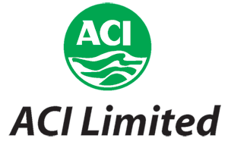
Figure 2.1: Logo of ACI Ltd.

2.1.1 Important dates and milestone dates of ACI Limited:
Date | Event
1968 | Imperial Chemical Industries Pakistan Manufactures Limited (ICI Pakistan) was established in the then East Pakistan.
24 January, 1973 | Incorporation of ICI Bangladesh Manufacturers Limited.
24 January, 1973 | Commencement of Business
5 May, 1992 | Imperial Chemical Industries Pakistan Manufactures Limited divested 70% of its shareholding to local management.
5 May, 1992 | The name of the company changed to Advanced Chemical Industries Limited from ICI Bangladesh Manufactures Limited.
9 March, 1994 | Listed with Dhaka Stock Exchange.
22 October, 1995 | Listed with Chittagong Stock Exchange.
Table 2.1: Important dates and milestone dates of ACI Limited

2.1 Different Business Units of ACI:
The figure below illustrates the different Business units of ACI Ltd.
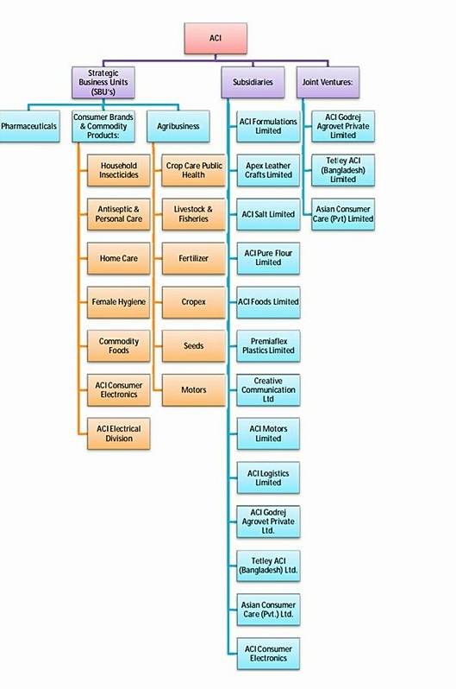
Figure 2.2: Business Unit of ACI Limited

- Strategic Business Units:
My particular department exists under the ACI Consumer Brands Department.
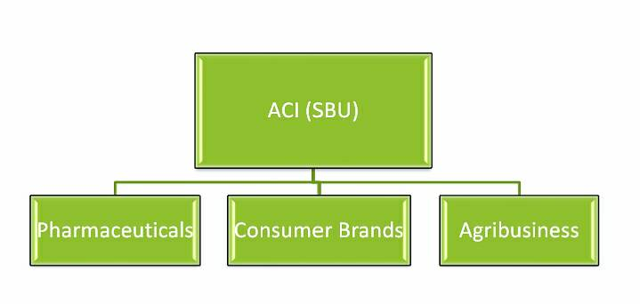
Figure2.3: SBUs of ACI Ltd.
- Pharmaceuticals:
ACI conveys the heritage of ICI-incredibly famous British Multinational in furnishing the general population of Bangladesh with quality pharmaceuticals and social insurance items. Its best in class pharmaceutical plant speaks to Bangladesh's journey for a really world class fabricating office. ACI's rich legacy prompts development and higher esteems included details.
The far reaching item scope of ACI pharmaceuticals incorporates items from all significant remedial classes and in different measurement shapes like tablet, container, dry powder, fluid, cream, gel, treatment, ophthalmic and injectable. ACI Pharma likewise has cutting edge plant on Novel Drug Delivery System (NDDS). It produces world class Modified Release medication and prescription to provide food the necessity of pharmaceutical maker of local and worldwide market. It trades superb pharmaceuticals to a decent number of nations of Asia, Africa and South America.

- Consumer Brands:
ACI Consumer Brands were initiated in 1995 with two major brands of the company – ACI Aerosol and Savlon. These are two of the most prestigious products which are enjoying the leadership position in the market. The division started to take new businesses through off shore trading as well as local manufacturing. In this process ACI Consumer Brands launched many new products and also bonded with Joint Venture business relationships with ‘Dabur India’ and ‘Tetley UK’ and attained international alliances with world renowned companies. The Consumer Brands Division boasts in having an unequivocal presence in consumers' heart with the market leading brands like ACI Aerosol, Savlon, ACI Mosquito Coil & ACI Pure Spices and Flour. With close to 80% market share in own categories, ACI Aerosol and Savlon are the persistent performers in keeping the household clean and free from germs and harmful insects.

Consumer Brand and Commodity Products:
I. Household Insecticides.
II. Antiseptic and Personal care.
III. Home Care
IV. Female Hygiene
V. Commodity Foods
VI. ACI Electronic Division


Figure2.4: Consumer Brand and Commodity Products of ACI Limited

- Agribusiness:
ACI Agribusiness is the largest Integrator in Bangladesh in Agriculture, Livestock and Fisheries and deals with Crop Protection, Seed, and Fertilizer, Agaric machineries, and Animal Health products. These businesses have glorified presence in Bangladesh. CC & PH supply, crop protection chemicals, Seed supplies Hybrid Rice, vegetable and Maize seeds, Fertilizer Supplies Micronutrient and Foiler fertilizer, Agric machineries supplies Tractors, Power Tiller and Harvester and Animal Health supplies high quality Nutritional, Veterinary and Poultry medicines and vaccines. ACI provides solution to the farmers through a large team of scientists & skilled professionals.
I. Crop Care Public Health.
II. Livestock and Fisheries
III. Fertilizer
IV. Cropex
V. Seeds
VI. Motors

Figure 2.5: ACI Agribusinesses

2. Subsidiaries:
- ACI Formulations Ltd.
- Apex Leather Crafts Ltd.
- ACI Pure Salt Ltd.
- ACI Pure Flour Ltd.
- ACI Foods Ltd.
- Creative Communication Ltd.
- ACI Motors Ltd.
- ACI Electronics Ltd.
- ACI Logistics Ltd.
- ACI Godrej Agrovet PVT Ltd.
- Tetley ACI Bangladesh Ltd.
- Asian Consumer Care Ltd.

Joint Venture:

- ACIGodrej Agrovet PVTLtd.

- TetleyACIBangladesh ltd.

- Asian ConsumerCareLtd.

2.2Corporate Information:
ACI Plc of UK had a pharmaceutical business in Bangladesh. In 1992 the business was sold to management and the name of the Company changed to Advanced Chemical Industries (ACI) Limited. ACI inherited the rich ICI culture of product quality, customer service and social responsibility and continues to nurture. ACI is the first company in Bangladesh to obtain certification of ISO 9001 Quality Management System in 1995. ACI is also the first Company in Bangladesh to get certification of ISO 14001 Environmental Management System in 2000. ACI employees are proud of their work culture, business ethics and environmental consciousness.

2.2.1 Corporate Information of the organization at a glance:
Company Name | Advanced Chemical Industries Limited
Nature of business | Manufacturing, Processing, Retail, Service
Founded | 1968
Location
  ACI Center, 245 Tejgaon Industrial Area, Dhaka 1208
Headquarters | Dhaka
Fax | 880 2 8878619 & 8878626
E-mail | info@aci-bd.com
Logo | 
Directors | - Dr. ArifDowla- Group Managing Director  - Mr. Azmal Hossain- Executive Director, Trade  - Dr.F.H.Ansarey- Executive Director, Agribusinesses  - Mr. Syed Alamgir- ExecutiveDirector, CB

Table 2.2: Corporate Information of ACI Limited

2.3 Mission and vision of ACI Limited:

2.3.1 Company Mission
ACI's Mission is to enrich the quality of life of the people through responsible application of knowledge, technology and skills. ACI is committed to the pursuit of excellence through world-class products, innovative processes and empowered employees, to provide the highest level of satisfaction to our customers.

2.3.2 Company Vision
To achieve the mission ACI will,
➢Provide products and services of high and consistent quality, ensuring value for money to our customers.
➢ Endeavour to attain a position of leadership in each category of our businesses.
➢ Develop our employees by encouraging empowerment and rewarding innovation.
➢ Promote an environment for learning and personal growth.
➢ Attain a high level of productivity in all our operations through effective utilization of resources and adoption of appropriate technology.
➢ Promote inclusive growth by encouraging and assisting our distributors and suppliers in improving efficiency.
➢ Ensure superior return on investment through judicious use of resources and efficient operations, utilizing our core competencies.

2.4 Company Values:
The core values of ACI are:
➢ Quality
➢ Customer Focus
➢ Innovation
➢ Fairness
➢ Transparency
➢ Continuous Improvement

2.5 Fundamental Departments of ACI:
• Administration Department
• Financing and Planning
• Commercial Department
• MIS
• Distribution
• Training and Development
• HR

CHAPTER: 3

Literatures on the Impact of Advertising

2.1 Sales performance:
Sales performance uses raw data concerning the number of customers a sales associate speaks to compared with the number of actual sales. By reviewing the sales performance of an employee, a sales performance manager can determine his strengths and weaknesses.

2.2 Promotional Mix:
The Promotional Mix refers to the blend of several promotional activities used by business to create, maintain and increase the demand for a product. (Business Dictionary)
The Promotion Mix is the integration of Advertising, Personal Selling, Sales Promotion, Public Relations and Direct Marketing. The marketers need to view the following questions in order to have a balanced blend of these promotional tools.

2.3 Elements of Promotional Mix:
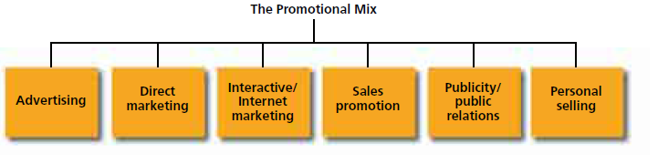
Figure 3.1: Elements of the promotional mix

2.1.1 Advertising:
Definition of advertising:
The word advertising comes from the Latin word "advertere meaning” to turn the minds of towards”.
According to William J. Stanton, "Advertising consists of all the activities involved in presenting to an audience a non-personal, sponsor-identified, paid for message about a product or organization.
“According to American marketing Association "advertising is any paid form of non- personal presentation and promotion of ideas, goods and services by an identified sponsor".
Advertising is used for connecting business information to the present and forthcomingcustomers. It usually offers information about the advertising firm, its productpotentials, place of convenience of its products, etc. Advertisement is vital for both the sellers and the buyers. &however, it is more important for the sellers. In the recent age of large-scale production, manufacturers cannot think of forceful sale of their products without advertising them.

Types of advertising: There have several types of advertising.

Newspaper:
Newspaper advertising can promote your business to a wide range of customers. Display advertisements are placed throughout the paper, while classified listings are under subject headings in a specific section.
You may find that a combination of advertising in your state/metropolitan newspaper and your local paper gives you the best results.

Magazine:
Advertising in a specialist magazine can reach your target market quickly and easily. Readers (your potential customers) tend to read magazines at their leisure and keep them for longer, giving your advertisement multiple chances to attract attention. Magazines generally serve consumers (by interest group e.g. women) and trade (industry/business type e.g. hospitality).
If your products need to be displayed in color then glossy advertisements in a magazine can be ideal - although they are generally more expensive than newspaper advertisements.
Magazines do not usually serve a small area such as a specific town. If your target market is only a small percentage of the circulation, then advertising may not be cost-effective.

Radio:
Advertising on the radio is a great way to reach your target audience. If your target market listens to a particular station, then regular advertising can attract new customers.
However, sound has its limitations. Listeners can find it difficult to remember what they have heard and sometimes the impact of radio advertising is lost. The best way to overcome this is to repeat your message regularly - which increases your costs significantly. If you cannot afford to play your advertisement regularly, you may find that radio advertising does not generate strong results.

Television:
Television has an extensive reach and advertising this way is ideal if you cater to a large market in a large area. Television advertisements have the advantage of sight, sound, movement and color to persuade a customer to buy from you. They are particularly useful if you need to demonstrate how your product or service works.
Producing a television advertisement and then buying an advertising slot is generally expensive. Advertising is sold in units (e.g. 20, 30, 60 seconds) and costs vary according to:
the time slot
the television program
whether it is metro or regional
If you want to buy spots on multiple networks.

Directories:
Directories list businesses by name or category (e.g. Yellow Pages phone directories). Customers who refer to directories have often already made up their mind to buy - they just need to decide who to buy from.
The major advantage of online directories over print directories is that if you change your business name, address or telephone number, you can easily keep it up to date in the directory. You can also add new services or information about your business.
If your target market uses print and online directories, it may be useful to advertise in both, although print directories are being used less.

Outdoor and transit:
There are many ways to advertise outside and on-the-go. Outdoor billboards can be signs by the road or hoardings at sport stadiums. Transit advertising can be posters on buses, taxis and bicycles. Large billboards can get your message across with a big impact. If the same customers pass your billboard every day as they travel to work, you are likely to be the first business they think of when they want to buy a product.
Even the largest of billboards usually contain a limited amount of information; otherwise, they can be difficult to read. Including your website address makes it easy for customers to follow up and find out more about your business. Outdoor advertising can be very expensive especially for prime locations and supersite billboards.

Direct mail catalogues and leaflets:
Direct mail means writing to customers directly. The more precise your mailing list or distribution area, the more of your target market you will reach. A direct mail approach is more personal, as you can select your audience and plan the timing to suit your business. A cost-effective form of direct mail is to send your newsletters or flyers electronically to an email database. Find out more about direct mail.
Catalogues, brochures and leaflets can also be distributed to your target area. Including a brochure with your direct mail is a great way to give an interested customer more information about your products and services. Learn more about leaflet marketing using letterbox drops and handouts.

Online:
Being on the internet can be a cost-effective way to attract new customers. You can reach a global audience at a low cost. Many customers research businesses online before deciding whom to buy from.
A well-designed website can entice customers to buy from you. There are a number of ways you can promote your business online via paid advertising or to improve your search engine rankings. Learn more about doing business online.
Other ways to advertise your business online include promoting your products or services on social media sites, blogs and search engines and other websites that your target audience visits. Find out more about social media.

- Setting Advertising Goal or Objective:
An advertising goal (or objective) is a specific communications task and achievement level to be accomplished with a specific audience in a specific period of time:
Advertising objectives can be classified according to whether their aim is to inform, persuade, remind, or reinforce. They aim at different stages in the hierarchy-of-effects. When ACI Limited promotes advertising then they must follow:
Informative advertising aims to create brand awareness and knowledge of new products or new features of existing products. It’s used heavily when introducing a new-product category. In this case, the objective is to build primary demand.
Customer value
Building a brand and company image
Telling the market about a new product
Explaining how a product works
Suggesting new uses for a product
Informing the market of a price change
Describing available services and support
Correcting false impression
Persuasive advertising aims to create liking, preference, conviction, and purchase of a product or service. It becomes more important as competition increases. Here, the company’s objective is to build selective demand.
Structure product fondness
Inspirational moving to a product
Shifting buyer perceptions of product value
Encouragement trades to buy now
Conversion clients to take a sales call
Undoubted customer to tell others about the brand
Reminder advertising aims to stimulate repeat purchase of products and services. It is important for advanced products; it helps to keep customer contacts and retain consumers thoughtful about the product.
Keeping buyer relationships
Repeating customers that the product may be needed in the near future
Reminding shoppers where to purchase the item
Protection the brand in client’s awareness during off- seasons
Reinforcement advertising aims to convince current purchasers that they made the right choice. Some persuasive advertising has become comparative advertising (or attack advertising), in which a company directly or indirectly compares its brand with one or more other brands.
The advertising objective should emerge from a thorough analysis of the current marketing situation. If the product class is mature, the company is the market leader, and brand usage is low, the proper objective should be to stimulate more usage. If the product class is new, the company is not the market leader, but the brand is superior to the leader, then the proper objective is to convince the market of the brand's superiority.

- Objective of Advertising:
The fundamental purpose of advertising is to sell something a product, a service or an idea. In addition to this general objective, advertising is also used by the modern business enterprise for certain specific objective:
- To introduce a new product by creating interest for it among the prospective customer.
- To support personal selling program. Advertising may be used to open customer’s door for sales.
- To reach people inaccessible to salesman.
- To light competition in the market and to increase the sales as seen in the fierce competition between ACI and Unilever.
- To enhance the goodwill of the enterprise by promising better quality products and services.
- To improve dealer relations. Advertising supports the dealers in selling the product. Dealers are attracted towards a product which is advertised effectively.

- Important of advertising:
Advertising plays a very important role in today’s age of competition. Advertising is one thing which has become a necessity for everybody in today’s day to day life, be it the producer, the traders, or the customer. Advertising is an important part. Let’s have a look on how and where is advertising important:
Helps in increasing the sales.
Promotion goods, services, Ideas and Events.
Maximize the profit of an Advertiser.
Create consumer awareness.
Advertising demands creativity.
Element of marketing mix.
Demands Monitoring of demand and supply.
Builds Brand’s image.

2.1 Marketing Mix:
The marketing mix is the set of controllable, tactical marketing tools that a company uses to produce a desired response from its target market. It consists of everything that a company can do to influence demand for its product. It is also a tool to help marketing planning and execution.

To market the products every company needs to create a successful mix of right product at right price at the right place through the right promotion. Thus, marketing mix made up to 7Ps: product, price, place, and promotion, process, physical evidence and people.ACI Consumer brands has also created a good marketing mix to market their product and most importantly all the Ps are interrelated to each other. Now I will discuss about the 7Ps of ACI Consumer brands.

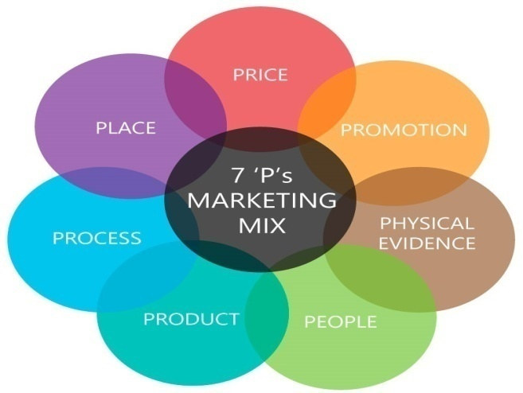
Picture 3.1: Marketing Mix

Product:
Products are the key elements for the ACI Limited. ACI Limited is proud of the products that consist the part of the Consumer Brands division. The Consumer Brands Division boasts in having an unequivocal presence in consumers’ heart with the market leading Commodity Products like. Household Insecticides, Antiseptic and Personal car, Home Care, Female Hygiene ,Commodity Foods, ACI Electronic Division. But I am going to described only the part of household insecticides products.

Household Insecticides:
ACI Limited is proud of the home care products of the Consumer Brands division. These products are: ACI Aerosol, ACI Mosquito Coil and ACI Cockroach Spray.
- ACI Aerosol:
ACI Aerosol is one of the prestigious products of this country which has been enjoying the market leadership position since its marketing in 1967. ACI Aerosol has been the number one choice of consumers in Bangladesh. The effort to ensure the highest quality has helped ACI to be THE MOST EFFECTIVE MOSQUITO KILLER. To meet the requirement of consumers of different socio-economic group, ACI Aerosol is available all around the country in four different pack sizes. They are: 800 ml, 475 ml, 350 ml and 250 ml.
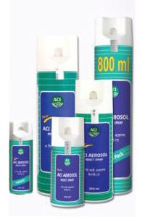
Picture 3.1: Different size of ACI Aerosol

- ACI Mosquito Coil:
ACI Mosquito Coil is another important product of the Home Care category of ACI Consumer Brands. ACI Mosquito Coil has different Brands based on different shape, color and fragrance and price. ACI Mosquito coil has the following brands:
- ACI Hi Power.
- ACI Super.
- ACI High Booster and
- ACI black fighter
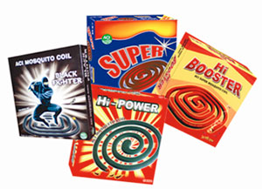
Picture 3.2: ACI Mosquito Coil

  - Price:
Price has a major role in developing a product. It’s also an important element in marketing mix because it is directly related to the revenue generation and all other parts of marketing mix. Pricing decisions are influenced by many objectives like profit, costs, organizational and marketing objectives and so on. To set the price of the Aerosol, Coil and Cockroach Spray ACI follow the product carton-based pricing strategy. Though ACI is providing better quality Mosquito Coil, Aerosol and Cockroach Spray than anyone in Bangladesh, they impose the same price for the customers. So, it makes them able to grab the highest market share in the country. However, the trade price differs based on the market demand of the product in various locations of the country.
The new product will launch for the mass market and thus price competitiveness may vary from other brands as ACI Consumer Brands is planning to focus and build their pricing strategy based on the products SKU size which may create competitive advantage for the brand and the organization.

  - Place:
The place is connected with making available the products at a place where the clients demand. Thus, it is worried with the stores or vendors where things will be exhibited and sold. ACI Limited has a distribution channel throughout the country. ACI Limited has their distribution points in almost every district. And every regional distribution point has their sub depots through which products are distributed to the retailers of the nearby areas.

Regional Distribution points are: Dhaka, Savar, Dinajpur, Faridpur, Jossore, Rangpur, Bogra, Rajshahi, Maymensingh, Tangail, Gazipur, Chittagong,Comilla,Bandarban, Maijdi, Coax’sBazar, Narayangang, Comilla, Kustia, Khulna, Sreemangal, Sylhet, Chandpur etc.

Promotion:

Promotion relates to communicating with customers it will provide information to assist them in making decision to buy the products. The cost associated with promotion often represents a sizeable proportion of the overall cost of producing an item. However, a successful promotional strategy helps to build long term relationship with increased sales due to promotion; costs are spread over a larger output. ACI Limited has TV Ads, Activation, Event, Conference program, corporate publication, social media and corporate advertising process to make the promotion of their brands.

- TV Ads:
Television Ads is a span of television programming produced and paid for by an organization which conveys a message, typically to a market a product or service Limited made TV based on their products. ACI try to publish their product through the Advertising.

- Activation: ACI limited use the product promotion activation method to bring a brand message to life through a strategic, integrated campaign that leverage the full potential of a wide range of marketing communication tools in order to maximize results and provide the greatest return on their customer marketing investment. ACI Limited does different kinds of activation like- Market Activation, corporate activation etc.

- Billboard:
ACI also publicizes their products through the billboard advertising. it works well for promoting their product in specific geographic areas.

- Conference Program: A typically meeting of people with a shared interest, typically one that takes place over several days. Actually, it’s an idea sharing forum and conservation that includes experts who advice how to species in captivity. On last 19th February ACI Consumer Brands arranged CB Sales and Marketing conference with their sales peoples and employee. They are also going to be held press conference. The news show on the GTV Channel.

- Events:
ACI Limited also arranged different types of Events based on occasion.

- Display promotion in Super shop:
ACI stresses a lot on different forms of trade promotion. ACI pushes the product to retail stores, Super shop and offers discounts and other forms of promotional offers. These have been quite successful as retailers readily display coil, Aerosoland other brands from ACI. During the market audits that I conducted, it was seen that the promotional offers work and stock availability of ACI products was quite high. ACI recently conducted a wet market activation program in different wet markets across Dhaka City. This encouraged the retailers to keep more of products in market.
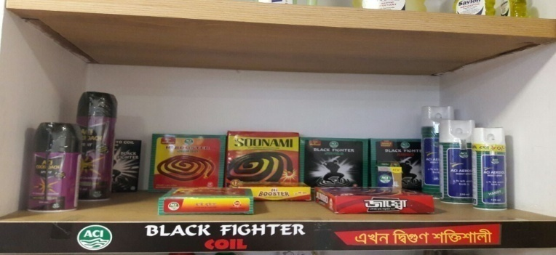
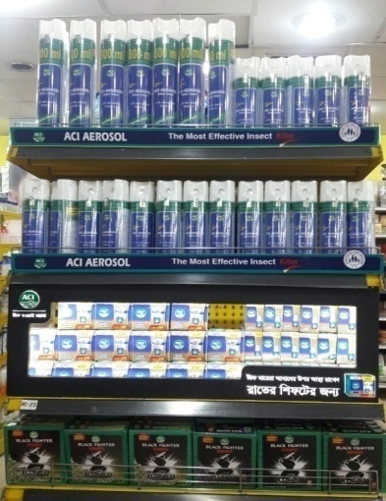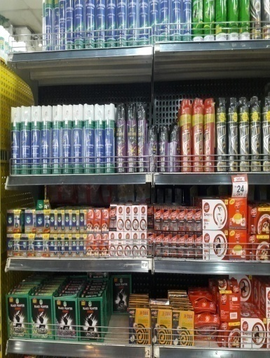

Picture 3.9: Displaypromotion in Super shop

5. Process:
This element of marketing mix looks at the systems used to deliver the service. It means all services need to be underpinned by early defined and efficient process. Because of that customer can identify the effectiveness of the company.
The items are first fabricated in the industrialfacility, from manufacturing plant half of the items are sent straightforwardly to the dissemination focuses to the retailers through some leased vehicles and half of the items are sent to the stops and after that to the appropriation indicates and after that the retailers. This procedure is done through some leased vehicles and some organization claimed vehicles.
The distribution process flow is shown by a flow chart below. And the distribution channel process is shown by a map bellow-
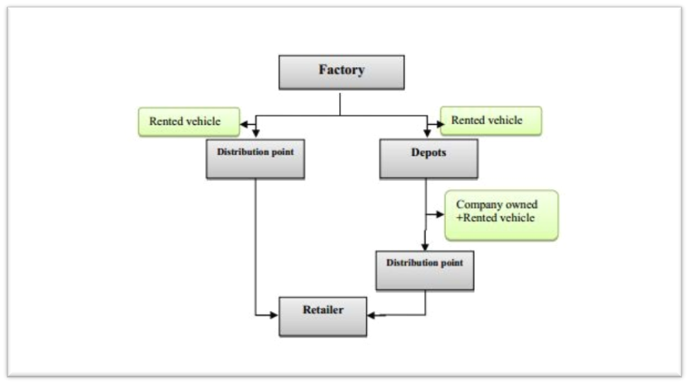
Flowchart 3.1: The distribution process flow of ACI Limited

6. Packaging or Physical Evidence:
Developing an eye-catching packaging for a product is one of the biggest challenges a marketer faces. As days passing by, marketers focus more on packaging thus consumers attract towards their products. There are varieties of soap packaging both traditional and creative available in the market.
As the physical evidence they maintain their factories and distribution centers which have lots of machinery cleanly and friendliness manner for employees. And they also provide t shirt and cap for their brand promoters.

7. People:
People are essential in the marketing of any product or service. From a marketing management perspective, it is important to ensure that employees represent the company in alignment with broader messaging strategies. In the Consumer Brand sales department of ACI Limited their have more than 100 people are working in different area of the Bangladesh to represent the company. When they are hired in the company then they are train by their supervisor to deliver superior service to the clients. The marketing people are always ready to give better services to the customer. CB Sales division tries to maintain good relationship with their valuable customer by providing high quality products along with a moderate price. Also handle to all the territories sales people and sales coordinators at together. They monitor the performance of all the sales peoples and sales coordinators and ensuing that processes are followed or not. They are also expected to supervise the shopkeepers as well as distributors.

CHAPTER: 4

Work Experience at the ACI Ltd.

4.1 Actual Task Part:
This report has been done as per the requirement for successful completion of the Internship program. Exposure to the business world and acquiring practical work experience was the primary objective of this report. According to the requirements, of course fulfillment I joined in ACI Limited as an internee on the date of 1st February, 2018. I have worked for three months in Sales admin department. In the period of my three months’ internship program, I have learned so many things. Although it’s a Private organization all the stuffs of the organization were very friendly and helpful.

4.2 Internship program:
I did my Internship at ACI Limited which is situated at Novo Tower, 270, Tejgaon Industrial Area, Dhaka-1208, Bangladesh from 1st February to 30th April 2018.My department was sales admin department under Consumer Brands division. In the time of internship period, I worked both in office and go to field work under the supervision of Md. Zakir Hossain Sarker, General Manager of ACI Sales. They have structure, space and opportunities for working of internship students. So my main object is to understand there system of working in the marketing division.

4.3InternshipActivities:
As worked both in office and field during my internship period, they divided my duties into two parts: 1) Official activities and 2) field activities.

(1)Official Activities:
In office, my duties are to maintain and observe about collecting Consumer brands sales activities data, Primary and secondary sales data entry in MS Excel sheet, making incentive sheet, create presentation based on ACI sales related topics. I always keep contact with area managers and territory managers to observe their requirements and stock. Attending ACI Sales and Marketing conference program 2018 held in Bashundhara Convention City.

(2) Field Activities:
During my internship period, I went to field to visit distributer points. Within this period, I visited different distributer points like Gulshan, Uttara, and Mohammadpur under Dhaka area and collecting information. I talked with ASM (Area Sales Manager) and SR (Sales Representative)face to face conversation about total sales, product problem, the promotional activities, quality of the products, reasonable price, brand image, ECO percentage and product availabilities.

4.5 Internship Position:
I have worked for three months with different sections. During my Internship period of ACI Limited I was gathered more knowledge which is related to my topic and I also knew the information which is not related to my topic. Actually, Internship project work is very important to the BBA students to grow knowledge and it helps to create more capabilities and Confidence of works in any situation or any business. Three months Internship is not enough time to learn everything of any business situation or anything; on the other hand, it is very effective course of a student to learn more. So, in a sentence I can say that, it is nothing but everything if I can learn or want to learn. Now, I would like to divide my all those learning into two categories. These are given below-
1. Primary learning
2. Secondary Learning

Here, a short description about those learning is given below for your kind perusal:

4.5.1 Primary Learning:
In primary learning I just learn about some basic things like:
- Organizational culture.
- How to behave with Colleagues, Clients and others.
- How to make a good relationship with another.
- Time management.
- How to deal with clients in Business conference.
- Contact with company’s employees.
- Maintaining rules and regulations.
- How to deal with ZSM, ASM & SR.
- How to deal with Brand promoters.
- What are the sales department do.

4.5.2 Secondary learning:
My internship organization ACI Limited is the private multinational organization, so there are huge activities and lots of work on various departments, so called they do all kinds of working task under sales departments. In this organization there are some departments to work like marketing department, Brand department, Finance department, HR department. My supervisor assigned me to handle and task of sales admin department. I worked different kind of section of ACI Limited. All working activities are not possible to show up because my working activities are depending on different situation. So, some exact working activities are shown below which was in my regular activities-
- Distributer point visit:
During my internship period, I went to visit distributer points. Within this period, I visited different distributer point like Gulshan, Uttara, and Gazipur under Dhaka area and collecting information about total sales, product problem, the promotional activities, quality of the products, reasonable price, brand image, product availabilities and automation system.
- Market Visit:
I have visited the different departmental stores and super shop to see the market position of ACI Consumer Brands product and also other brands relative products. I tried to gather information as much as I could regarding the competitors and their future goal that helped in so many ways to make ACI Limited brand stronger than other and also complete my report.

- Sales Analysis:
During my internship period I have analyzed the sales record of 2017- 2018 and tried to find out the present situation of sales and the possible way of develop the sales.

- .Maintaining internal and external relationship:
I had to maintain some internal and external relationship with ASM, ZSM, SR, and SS. As, I had to contact them before visiting the place under their territory.

- Preparing sales related presentation:
Sometimes I prepared sales related presentations based on Consumer brand products, comparison between 2016 and 2017 achievement and upcoming plan.

- Preparing Incentive Sheet:
Sales Incentive is a formal scheme that used to promote or encourage sales manager by getting incentive price. If sales manager or sales coordinators achieve their targets then company gives incentive to them. And I listed out the everyday GP, SP& CP sales all regions and territories to find out the incentive achiever.

- Attending Sales Conference:
ACI sales Consumer Brand arrange sales conference program 2018 held at Bashundhara Convention City. All the sales people and marketing and brand team attend that program. In this conference sales people are motivated by their respective managers to develop their skills and it will help them to achieve their targets and goals. As I was here three months, for this I was get opportunity to attend that Conference.

CHAPTER: 5

Research Methodology and Findings

5.1 Problem Statement:
From my observation experience I have found the problem in their advertisement sector. “Lack of advertisement decreases the sales of ACI Consumer Brands”.

5.2 Background of the Problem:
This report is based on “Evaluating the impact of Advertising on product sales”. The focus of the study is to analyzing the current market acceptance of ACI Limited based on the increasing sales performance, sales promotional Mix and also developing the advertising for market position. During my internship program at ACI Limited I had observed a major issue which was more sensitive to give close attention. As ACI Limited is popular brand but there are few products which are not popular in market Like Coil. Because of poor sale promotional actives like less powerful and effective advertising. Lack of less promotional mix and advertising (Social media\ Tvc ads, Newspaper, digital marketing and outdoor advertising) fall their sales. But now ACI Coil trying to overcome their lacking.
My objective of the research is to find out developing sales performance and sales promotion of ACI Coil and feedback of the market about their brand position.

5.3 Research Methodology:
While I was conducting the study, I have collected various types of primary and secondary data. Data has been collected through different sources like by taking interviews to the customers. The questionnaire contained only Liker scale. Secondary information has been collected through different journals, books, research publications and organizational website.

5.3.1 Research Approach:
- Survey

5.3.2 Type of research:
- Quantitative.

5.3.3 Research Instrument:
- Questionnaires with Structure question.

5.3.4 Data Sources:
I collected my whole data based on two sources. These sources are given below

Primary Data:
By observing three months Internship project time of period I collected the primary data from the Employee and Clients of ACI Limited Through Structured Questionnairs. How I collect my Questionnairs from them is given below-

- Talk with my Spervisor
- Discuss with the managers and staffs
- Face to face conversation with the customers.
- Conversation with the other people
- Personal discussion with Salespeople and office employee.

Secondary Data:
Secondary data had been collected from various report like-
- website of ACI Limited
- prospectus
- Published documents
- Some important files.

5.4Develop Independent Variables & Dependent Variables:

Dependent Variables
Independent Variables

- Social Media
(e.g. Facebook& Company website)

2. Radio /TVc
Will increase the sales performance ACI Coil

- Newspaper

- Celebrity Ads
(e.g. Movie & Drama celebrity)

5. Outdoor Advertising
(E.g. Billboard)

Diagram 5.1: Independent Variables & Dependent Variables

5.5 Questionnaire Scale:
In order to analyze the responses a 5-point Liker Scale has been used.
Options to Respond | Weight
Strongly Disagree | 5
Disagree | 4
Neutral | 3
Agree | 2
Strongly Agree | 1
Table 5.1: Questionnaire Scale

Gender | a) Male | b) Female
Age Distribution | a) Below 25 years | b) 25-35 years | c) Above 45 years
Designation | a) Manager | b) Head of Department | c) ASM, ZSM or Executive
Qualification | a) MBA | b) BBA | c) HSC or Others
Year(s) Experience in the company | a) Below 2 years | b) 5-10 years | c) Above 10 years
Table 5.2: Respondent Details

5.6 Graphical Representation and Findings:
Here we will discuss some graphical representation of Advertising which has some impact on product sales. The survey is divided into seven categories; Sales volume, Media, Loyalty, Competition, Finance, Product and Market.

Here we can see that the average sales volume is 3.45 which indicate that Advertising has lower impact on sales of a product. Media is another variable of Advertising. The average result of media, loyalty and competition is 2.38, 1.7 and 1.98 consecutively. This result illustrates that those variables of Advertising has positive impact on product sales. The finance bar chart is bigger followed by Average price and market. So finance variable has also little impact on product sales. In contrast Advertising has more impact on pricing and market. In conclude, we can say that all advertising variables have positive impact on product sales without sales volume and finance.

5.6.1 Sales Volume:
Here the first question is Advertising increases organization target market and product sales. The result is 1.76 which indicates that advertising has positive impact on sales volume. The second question is negative ended question. So the more percentage shows the more impact of advertising. To the end, we can say there is a positive significant relationship between Advertising and sales volume of a product.

5.6.2 Media:
The total average of Media is 2.38 which indicates that media has an impact on product sales moderately. Here the first question is most advertisements are misleading and false. The result is 4.13 which illustrates that most of the respondents disagree with it. Selection of Advertising media is also a primary concern for any organization. Consumers buy what they have seen or listen from media. So Media is an important Advertising variable that has impact on product sales.

5.6.3 Loyalty:
Another Advertising variable is loyalty which has positive impact on product sales. An identified brand means safety and consumer’s loyalty can be further guaranteed through consistent advertising. Here all the result is below 2 which indicate that loyalty variable of advertising has great impact on product sales.

5.6.4 Competition:
Competition is another variable of Advertising. No product can survive in the competitive market without intensive advertisement. The result is 2.00 which mean most of the people agree with this statement. Advertising target often includes the firm entire target. So competitive advertising variable also has an impact on product sales.

5.6.5 Finance:
Finance is needed for Advertising. The average result of finance variable is 3.02 which indicate that finance has moderate impact on Advertising of a product sale. An organization must consider its financial status before starting on Advertisement. Here the result is 1.55 and everyone agree with this statement. Advertising helps to minimize the production cost. Any organization can start their advertising.

5.6.6 Product:
Advertising helps to sell any product quickly. Advertising creates product differentiation and it will help to customer for choosing the right one they have needed. The average result of product variables is 1.83 which illustrate that Advertising has a great impact on product sales.

5.6.7 Market:
The impact of advertising can be changed as market grows older. So organization should change their policies when market changed. Great advertising is the creative expression of understanding the market needs. Here the result is 1.55 which means the statement gives positive result. In conclude we can easily say Advertising has an important role of a product sale in a market.

5.7 Conclusion:
ACI Limited Bangladesh is popular Brand. But their Mosquito Coil products performances are weak than other products. Because of some lacking in promotion, competitors, quality etc. But now they are try to improve their products. The reason behind their success can be described through their efficient marketing strategy. This strategy is described separately in the order of product, pricing, placing, production and promotion in this report. ACI Coil should relentlessly strive elevate the brand to become the number 1 consumer brands company in Bangladesh. Their aim is also to offer the people convenience through establishment of a large and extensive dealer network throughout the country. ACI Coil is continuously increase distribution channels improving standard quality, through maintain high standards and commitment to creating outstanding opportunities for professional growth so that associates can achieve their highest potential. They are now focusing on developing their sales and promotional mix in the market. They are now following some marketing strategy. Ultimately, their goal of doing these activities to persuade to increase their sales. They need to promote their products in various ways. In order to become the market leader, they must develop their Advertising strategy. However, ACI limited also faces many challenges in the near future. Specially they big plan for their Coil products as it is giving highest market share. Though they are doing some promotional activities for Coil but they should come up with even more ideas for their promotional mix. The company need to focus on develop the sales as well as they need to promote their product through the radio, television, newspaper, outdoor advertising and through other strategy. If ACI Coil is able to overcome all the difficulties mentioned above, there is no doubt that within a short period time, the company will have insurmountable advantages in the market. That’s the way ACI Coil achieve their Success day by day.

Bibliography

Books
- Kotler. Philip, Keller, K.L., Koshy, A. & Jha, Mithileshwar, (2008), “Managing Business-to Business Customer Relationships”, “Marketing Management” 13th edition, Pearson Education, Pearson, India, page no: 94, 95,102, 327, 366, 375, 381, 382, 389, 475, 476, 477, 516, 518, 529
- Naresh k. Malhotra &Satyabushan Dash. (2010) “Marketing Research: An Applied Orientation”. 6th edition. Authorized adaptation from the United States edition publishing as Prentice Hall.
- WHEELEN L. & HUNGER J. (2012) “Strategic Management and Business Policy. Towards Global Sustainability”, 13thedition, Pearson Education, Inc., Prentice hall
- George E. Belch & Michael A. Belch (2003) “Advertising and promotion an integrated Marketing Communication perspective”6th edition. Authorized from The McGraw−HillCompanies.

Appendix

Survey Research Questionnaire

Evaluating the Impact of Advertising on Product Sales

Dear Respondent:
I am a student of BBA program at the United International University doing internship on “Evaluating the Impact of Advertising on Product Sales: A Study on ACI Mosquito Coil” as a partial requirement for the fulfillment of the BBA degree. For preparing my internship report, I am collecting data from the respected respondents.

This is not a test. Don’t worry or puzzle on individual question. Response quickly and record your immediate thoughts. The information you provide will be treated as strictly confidential. All analyses will be conducted on an aggregate level with no reference to individual responses.

If you have any questions please contact my supervisor Dr. Kawsar Ahmmed (E-mail: kawsar@bus.uiu.ac.bd, Phone: +8801915078285).

Sincerely yours,
Name: Sakawat Hossen
ID: 111132239
Major: Marketing

Gender | a) Male | b) Female
Age Distribution | a) Below 25 years | b) 25-35 years | c) Above 45 years
Designation | a) Manager | b) Head of Department | c) ASM, ZSM or Executive
Qualification | a) MBA | b) BBA | c) HSC or Others
Year(s) Experience in the company | a) Below 2 years | b) 5-10 years | c) Above 10 years

 | SECTION B | (1) Strongly Disagree | (2) Disagree | (3) Undecided | (4) Agree | (5) Strongly Agree
1 | No Product can Survive in the competitive market without intensive advertisement
2 | Advertising increases organization target market and product sales
3 | Advertising target often includes the firm’s entire target
4 | Advertising program of the company has no impact on the sales volume of its product
5 | Most Advertisement are misleading and false
6 | Advertising creates product differentiation
7 | Selection of advertising media is a primary concern to an organization
8 | An organization must consider its financial status before starting an advertisement
9 | Advertising enables producers to minimize their production cost
10 | The impact of advertising can be changed as market grow older
11 | There is no positive and significant relationship between advertising and sales volume of a product
12 | Consumers buy what they have seen or listen from medias
13 | Advertising gives space for product comparison.
14 | No advertisement has the chance of being believed completely if its major objective is to change customers mind
15 | Great advertising is the creative expression of understanding of the market needs.
16 | An identified brand means safety
17 | Advertising is a power tool capable of reaching and motivating large audiences.
18 | Consumer's loyalty can be further guaranteed through consistent advertising
19 | Advertising justifies its existence when it is used in the interest of the public
20 | Advertising is non-personal but yet effective.
21 | It is only the rich organizations that can advertise their products or services
22 | The expensive nature of advertising programs make it not ideal for small firms
23 | Advertising increases the number of hours worked per day for employee
24 | Only the organization with good capital base and large customer network can start on advertising.
25 | Advertising activities increase the product life cycle in the market place

6.3 Abbreviation:

ABBREVIATIONS | ELABORATION
UIU | United International University
BBA | Bachelor of Business Administration
Pvt. | Private
ACI Ltd | Advanced Chemical Industries Limited
SR | Sales Representative
ZSM | Zonal Sales Manager
ASM | Area Sales Manager
SS | Sales Supervisor
ISO | International Organization for Standardization
GP | General Product
SP | Special product
CP | Cleaning product
DP | Distributor Price
TP | Trade Price
MRP | Market Price
SKU | Stock keeping Unit

