Internship Report

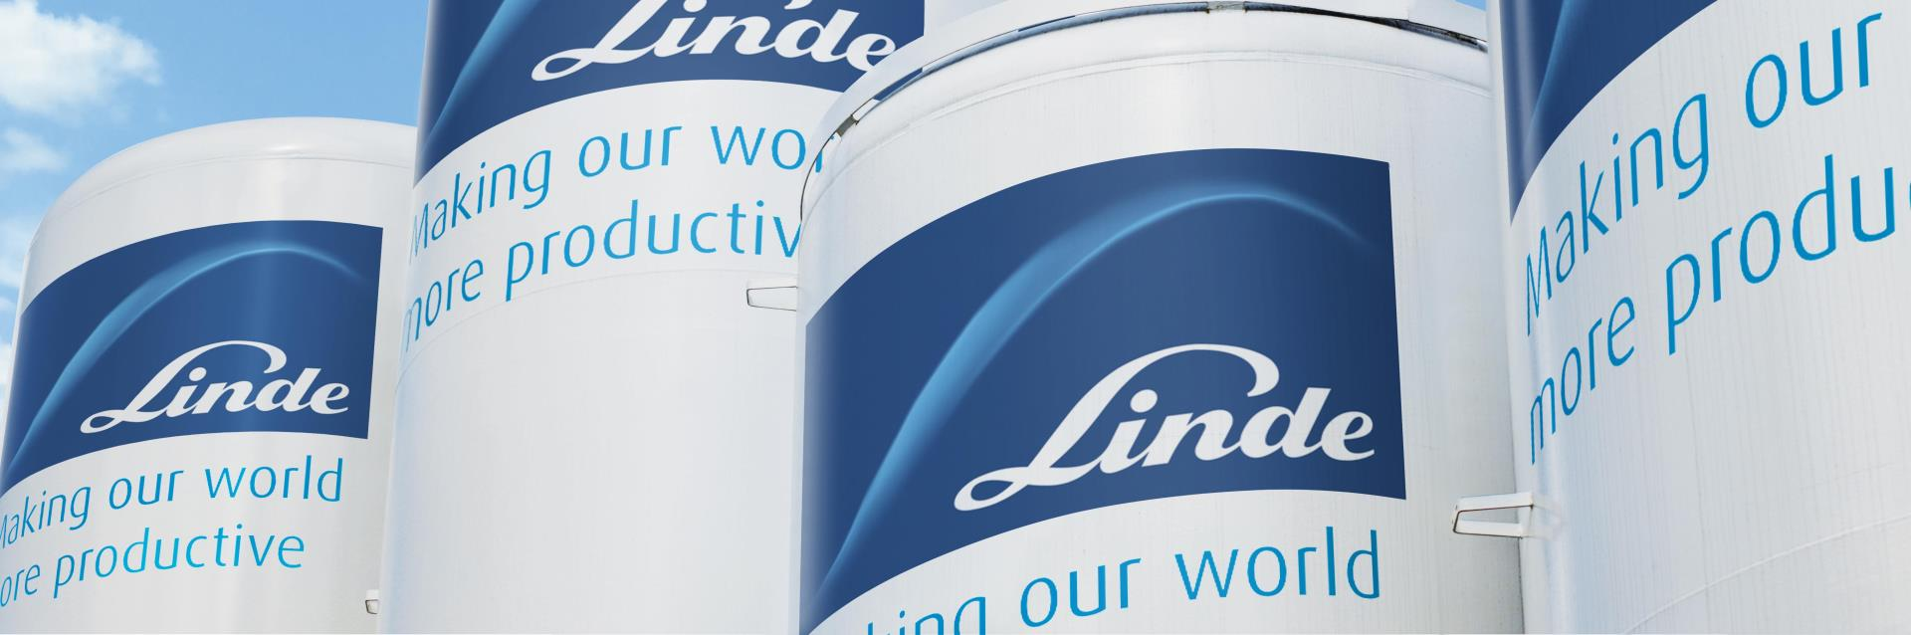

Internship Report on

“Talent Management Project Applied By Linde Bangladesh Ltd.”

Submitted To:
Md. Abul Mohaimen
Assistant Professor
School of Business and Economics
United International University

Submitted By:
Humaira Tasnuva
ID: 111 141253
School of Business & Economics
United International University

Date of Submission: 5th January, 2019



Internship Report On
Talent Management Process Applied By Linde Bangladesh Ltd

Submitted To:
Md. Abul Mohaimen
Assistant Professor
School of Business and Economics
United International University

Submitted By:
Humaira Tasnuva
ID: 111 141253
School of Business & Economics
United International University

Date of Submission: 5th January, 2019

In

Letter of transmittal

May 12, 2018
Md.Abul Mohaimen
Assistant Professor School of Business and Economics (SoBE)
United International University

Subject: Submission of the internship report of BBA program on Talent Management Process applies by Linde Bangladesh.

Sir,

Here is the internship report on Talent Management Process applied by Linde Bangladesh which you have got appointed me so as to urge a transparent understanding on Talent Management method. I've got tried my utmost to assemble all sort of relevant and helpful data by that it might offer you a complete image of this composition. I hope that it'll suit your minimal expected customary. I've got enjoyed plenty whereas making ready this Internship report. Especially, the paper work relating to this method helped me plenty and created the toil very terribly easier and sander. I'm submitting this Internship report for your kind thought and thanking you for your constant help and steerage.

Sincerely yours,
Humaira Tasnuva
ID- 111 141 253

Acknowledgement
At the verily starting, I might prefer to acknowledge the huge blessings and vivid kindness of Almighty Allah. Some individuals, particularly Mr. Ahmed Fuad (Talent Management manager) has created such an incredible and important contribution in getting ready this report. His insights, recommendation and suggestions helped me plenty. And fortunately, I'm more than happy to successfully completed my internship report on Talent Management method and that I effectively learn plenty of things like what's Talent Management method, however an organization attracts talent, however an organization remission and compensate talent to retain them, Succession Plan set up etc. I've got garnered such an expertise that has had a profound impact on my profession decisions and has helped me to understand what's essential and requisite for accomplishment within the company world.

So, I am obliged to my honourable faculty Md.Abul Mohaimen .

Finally I am going to submit my internship report on a “Talent Management Process applied by Linde Bangladesh”. We have discussed here how Linde attracts, compensate and retain their talent and some pros and cons of their current process.

Executive Summary
To recognize a human inherent skills, traits and temperament talent management implies in a very proficient so that it may provide an identical job to an employee.
Both the organization and workers feel that this is very useful to them. The organization get some advantages from multiplied productivity and capability; a higher linkage between individuals' efforts and business goals; commitment of valued employees; reduced turnover; multiplied bench strength and a higher match between people's jobs and skills. Higher motivation and commitment; career development; multiplied data regarding and contribution to company goals; sustained motivation and job satisfaction are some of the benefits which helps an employee to get benefited from this method.
Talent Management is capable to be learned and develop within the face of latest challenges and cope with the changing situation. Talents are those who will be the future potential instead of past diary. Therefore talent tends to be measured in terms of having certain attributes, like a willingness to accept risks and learn from mistakes, an affordable (but not too high) level of ambition and competitiveness, the power to concentrate on ‘big picture’ problems, and an acquaintance of their own strengths, limitations and impact on others. So, to have a healthy workplace, it is important to have a scope for several talent management processes need to be placed on a strategic level in order to ensure its success. Such processes include talent identification of talent, , retention, orientating to strategic goals so as to spot the long run leadership of the organization, compensation for outstanding performance, career development through training, learning management, compensation, succession planning etc.

Table of Contents
Chapter 1: Introduction…………………………………………………………………………………………………………………….10
1.0 Talent Management……………………………………………………………………………………………………………………11
1.1 Origin of the report…………………………………………………………………………………………………………………12
1.2 Statement of the report………………………………………………………………………………………………………….12
1.3 Objective of the report……………………………………………………………………………………………………………13
1.4 Scope of the study………………………………………………………………………………………………………………….14
1.5 Restrictions of the study…………………………………………………………………………………………………………14
1.6.1 Methodology and Data Collection Techniques of the study………………………………………………….15
1.6.2 Sampling……………………………………………………………………………………………………………………………16
1.7 Abbreviation…………………………………………………………………………………………………………………………..16
Chapter 2: Company Profile………………………………………………………………………………………………………………17
2.0 Company Overview…………………………………………………………………………………………………………………18
2.1 Introduction………………………………………………………………………………………………………………………..18
2.2 Vision Statement…………………………………………………………………………………………………………………20
2.3 Values…………………………………………………………………………………………………………………………………21
2.4 Principles…………………………………………………………………………………………………………………………….21
2.5 Activities of the company……………………………………………………………………………………………………21
2.6 Organogram……………………………………………………………………………………………………………………….22
2.7 Product and Services…………………………………………………………………………………………………………..23
2.8 Future Plan…………………………………………………………………………………………………………………………24
Chapter 3: Literature Review …………………………………………………………………………………………………………..25
3.0 How to attract talent? ...............................................................................................................26
3.2 How to compensate talent? ...................................................................................................29
3.3 How to measure talent? .........................................................................................................33
3.4 How to retain talent? .............................................................................................................34
Chapter 04: Analysis and Interpretation……………………………………………………………………………………….38
4.0 Graph and Chart……………………………………………………………………………………………………………………….39
4.1 Interpretation…………………………………………………………………………………………………………………….46

Chapter 5: Recommendation and Conclusion………………………………………………………………………………..47
5.0 Recommendation……………………………………………………………………………………………………………………..48
5.1 Conclusion…………………………………………………………………………………………………………………………….49

Appendix and Bibliography………………………………………………………………………………………………………………..50
Sample…………………………………………………………………………………………………………………………………………..51

Chapter: 01

Introduction

- Talent Management
In this total report, I've got shortly mentioned concerning Talent management method. It’s a method that suggests recognizing somebody's innate skills, traits, temperament and conjointly giving him/her an appropriate job. All and sundry includes a distinctive talent helps to suit with a selected job profile. Otherwise the other position can be the cause of discomfort and issue. It's a mandatory task of the management, particularly the HR Department, to position appropriate candidates who had specific vision and caution. A wrong match can be the end of any types of hiring, re-training and different extravagant activities. For both the organization and the staff, it is very favorable to all. From redoubled productivity and capability an improved cohesion between individuals' efforts and business goals; commitment of valued employees; reduced turnover; redoubled bench strength and an improved unify between people's jobs and skills, staff get advantages from higher motivation and commitment, career development and contribution to company goals, preserved motivation and job satisfaction are some of the reasons that helps an organization become benefited.
Now-a-days, on this extreme competitive world, wherever the solely perpetual issue is modification, it's very necessary to develop the foremost vital resource of all - the Human Resource for a corporation. Solely Human Resource will give a corporation a competitive finish in this extend world that results of underneath the new trade agreements and technology which will simply be transferred from one country to a different and when it’s about low cost finance, there's no scarceness for sources. However to trace terribly arduous, it's the foremost qualitative personnel.
Talent helps to indicate a capability to be told and uplift within the phase and face of recent challenges. Talent is concerning about future chances instead of past track records. Thus, to be measured in terms of getting sure characteristics, talent needs to be speculated, like disposition to require risks and learn from mistakes, an affordable(but not too high) level of target, effort and aggressiveness, the power to concentrate on ‘big picture’ problems and an acquaintances of their own strengths, limitations and influence on others.
There are various talent management processes that must be placed on a higher strategic level so as to make sure its success. during this method it includes talent identification, correct observation and assessment, ability management, performance and learning management, career development, compensation, succession designing and then on. Talent management has many numbers of advantages to supply like retention, worker engagement, redoubled productivity, orientating to strategic goals so as to spot the longer term leadership of the organization, culture of excellence and plenty of additional.

1.1 Origin of the report

This report was ready to associate as an internship report to fulfill the program completion demand of the BBA Program at United International University. The report was finished on the projected topic “Talent Management Process applied in Linde Bangladesh”.
The purpose was to get some real life expertise by working in a practical environment. The placed (internship) supervisor was Ahmed Fuad, Talent Management Manager of Linde Bangladesh Limited and the faculty advisor was Md.Abul Mohaimen, Assistant Professor; School of Business & Economics; United International University.

1.2 Statement of the problem
Around 88% of employees’ adieu their jobs for reasons apart from pay because of the current talent management process which is used all over the companies. However, it is assumed by 70% of managers that employees adieu chiefly for pay-related reasons and there are total 7 reasons why employees’ adieu a company:
- Employees feel that their expectation and the work or job place isn’t matched properly.
- They find a mismatch between the task and person.
- There amount of coaching and feedback is deficient.
- When it’s about improvements and progress opportunities the amount are too few.
- Employees remain to feel unrecognized and very low.
- From overwork employee very low and become to face a work/life discrepancy.
- When it about belief and confidence on senior leaders, there is a decrement on employees mind.

All of these things are highly depended on a beneficial Talent Management.

1.3 Objective of the study
Since sensible orientation is an undivided part of the BBA program, I've got tried to reveal the reality expertise (talent management process) of Linde BD by doing internship there, so making ready this report.

In order to arrange this report, I've got come upon with many info of Linde BD. From the collected info, I ready to perceive that this company encompasses an immense contribution in Gas trade in Bangladesh. I expect that this report can meet all the wants of BBA program and supply a transparent image regarding the most activities and different multi-national company’s effort within Bangladesh. The main objective of the internship program is to pursue real life business situation to business graduates so that I can utilize my theoretical learning in the real life situations. It helps me as internee student to complete my four years academic learning with real life business problems. For this particular report, the specific objectives are:

- To analyze and evaluate Linde Bangladesh Limited’s present Talent Management Process.
- To know about Linde Bangladesh Limited.
- To spot the measurable standards of every activity.
- To know the Talent Management Process’s whole procedure.
- Knowing the Talent Management Process’s needs
- Review the workforce quality and employees’ behavior by talent management process.
- Counseling Talent Management process’s attainable improvement.

1.4 Scope of the study
This report is totally fitted up the Talent Management Process for the theoretical purpose and therefore the probable use. The total study will permit learning, compensate, retaining, trendy or modern techniques and models accustomed to create it a lot of efficient. The study can facilitate to be learned the practical procedures followed by different leading organizations. Moreover the study will help to differentiate between the applied and therefore the theories that direct to understand how the organization will flourish their Talent Management Process.

1.5 Restrictions of the study
This study has few limitations that confined the research analysis. They are shown below:

- To complete the whole study, time allocation is too short and limited
- There are some unavailability topical records and information in the organization which is a major constrains.
- No earlier study has been done in this section, so very less number of documents is available.
- In providing confidential information, some of the respondents were frightened of and some of them also showed less interest on such assignment and in a few of the target group willingly avoided of providing information

After all within a limited time, it is impossible to learn and understand all the activities of a company like Linde Bangladesh Ltd.

1.6.1: Methodology and Data Collection Techniques of the study:

For availability and accessibility of information and for the purpose of my internship, I have chosen to work on HR department of Linde BD. I have decided to focus on their Talent Management Process. The origin of such information was in the field of Linde BD as I worked there. In addition information will be collected from my supervisors.

Methodology
In order to evaluate the existing talent management process in Linde Bangladesh, I have used several methods to collect data. Mainly I used two types of data for this purpose-

1. Primary data
2. Secondary data
Data Collection Techniques
Primary data: This report has been ready through mass use of primary information. It has been gathered from group of individuals who are connected with this Organization. The subsequent strategies are used in collecting primary info. They are-

a) Personal communication: I’ve collected datum through personal face to face conversation with the managers, supervisors and executives of Linde Bangladesh.
b) Survey method: I toddled to each department of Linde Bangladesh and did a survey about their opinion on Talent Management Process.

Secondary data: The already revealed materials are known as secondary sources. I’ve tried a lot to gather secondary information from the subsequent sources-

1. Numerous official documents Personnel departments of Linde BD.
2. Some revealed analysis report, books, journal, articles and their website.
3. Numerous forms of official documents.
4. Some books, file and magazine study on Talent Management Process.

1.6.2: Sampling
- Population: There are 56 employees in the corporate Office of Linde Bangladesh. I took all the 56 management employees for my survey.
- Sampling Unit: There are nine different departments in Linde where these 56 employees work in a very good manner. These departments are: HR & Admin, SHEQ, CS, Finance, Procurement, Sells & Marketing, Operations, Distribution and IT.
- Sample Frame: Among all departments I would like to choose HR & Admin and Procurement department where I got most of my excess and where employees are quite flexible to share information.
- Sampling Design: I set a questionnaire for easy going survey. I have put both negative and positive questions to know the actual fact regarding the current process and also placed a blank space for further suggestion to develop the process.
- Sample Size: From all 56 employees, I choose 50% of the total for analysis.
- Research Question: I would like to submit the questionnaire which I have been used for my survey, attached here with for your consideration.

1.7 Abbreviations
HR= Human Resource Management
CS= Customer Service
SHEQ= Safety, Health, Environment & Quality.
IT= Information Technology

Chapter: 02

Company Profile

- Company Overview:

As a pioneer in industrial gases in Bangladesh, Linde encompasses a history and proud heritage - its roots return to 1950’s, even before the independence in 1971.
With a modest look, afterwards, at the start, Linde Bangladesh's products are currently part and parcel of all the industrial and economic activities of the country. Today, the turnover of the company has exceeded BDT 5.75 billion.
Linde Bangladesh Limited is a member of the Linde Group that has been present in Bangladesh for over 50 years with continuous growth in operations and business.
As a pioneer multinational company within the gases business, Linde Bangladesh has three major locations / installations at Tejgaon, Rupganj and Shitalpur. Besides, it’s18 sales centers unfold throughout the country serving a client base of over 35,000. The company is currently capable of manufacturing 80 tons of liquid ASU gases per day and 23,100 MT of Welding Electrodes each year. Its product folio and services include liquid and gaseous Oxygen and Nitrogen, Argon, Acetylene, Carbon Dioxide, Dry Ice, Refrigerant Gases, Lamp gas and other gas mixtures, Medical Oxygen, Nitrous Oxide, Entonox, medical equipment and accessories, Welding Electrodes, gas and arc welding equipments and accessories, welding training and services.
Linde Bangladesh Limited is committed to quality of its product & services. Our motto is to ensure optimum conditions in health, safety and also the atmosphere for its employees, customers and stakeholders.

2.1: Introduction

The Linde cluster includes a history of over one hundred thirty years engineered on a heritage of innovation with a robust specialize in technology. The company’s founder, Carl von Linde, fabricated refrigeration technology and pioneered a method of air separation. Today, we are a global market leader in gases and engineering solutions.
Linde Bangladesh Limited, a member of the Linde Group, has been contributory towards the event of developing the nation as a sleeping partner. A strong in–built culture with work values strengthened and developed Linde Bangladesh over the years that are mirrored within the performance of its employees for above 50 years with continuous growth in operations and business.
We sell our products around 35000 customers from a large spectrum of industries running from chemicals and petrochemicals to steel. Our team of around 400 trained, intended and skilled members manages 24 hour operations at three major locations across the country to support our customers.
In Linde Bangladesh Limited, we have a tendency of committed to the standard of our product & services. Our expression is to confirm optimum conditions in health, safety and therefore the atmosphere for employees, customers and stakeholders. Linde Bangladesh Limited (Formerly BOC Bangladesh Limited) is led by Mohsin Ahmed, the Country Head and Managing Director of the company. The Company organogram is enclosed within the report.
The Board of Directors shoulders the responsibility of company’s welfare and shareholders’ interests.

Board of Directors
Ayub Quadri | Chairman
Erphan Shehabul Matin | Country Head & Managing Director
Moloy Banerjee | Director
Desiree Bacher | Director
Md. Iftikhar-Uz-Zaman | Director
Latifur Rahman | Director
Milan Sadhukhan | Director
Parveen Mahmud | Independent Director

Linde as an Employer: Their vision is to become the leading global gases and engineering group, admired for our people, who provide innovate solutions that make a difference to the world.

I. People Excellence: They try to be a high performance organization in each respect. This needs glorious folks that are dedicated and motivated to achieving our vision of turning into the leading global gases and engineering company, admired for its folks build a distinction to the world.
People Excellence is at the highest of their agenda. It encompasses all aspects of individuals’ performance, development and, of course, recognition.
At Linde they see largely people excellence as an excellence opportunity for them as an organization and for each individual. Folks that are able to grab new challenges are the guts and soul of a flourishing business, particularly within the demanding and fast-changing world during which they operate.
The consent to stilly learn, amendment and improve is what they require to work out in their folks. They mirror this with a comprehensive suite of development opportunities to unleash the potential and capabilities of every employee. Human Resources, with the proper set of tools, systems and processes in situ, could be a key enabler to drive this agenda. This stretches from management career planning about to extremely specialized technical career ways.
As a truly multinational company they worth our cultural and gender diversity. It serves as a vibrant breeding ground for innovative and creative thinking. They nurture this potential which provides a decisive competitive era delivering solutions that add worth to their customers. People Excellence is a core part of the culture and spirit they have created at The Linde Group: glorious folks that try for top performance and are proud to be a part of an excellent company.
II. Company Culture The Linde Group mixes a permanent heritage with the drive for continuous improvement, innovation and high performance. Their vision is to turn out the leading global gases and engineering company, appreciated for its folks that create a dissimilation to the world.
Accompanied by our values and principles, a performance mentality and an emphasis on personal development are deeply reliable in our company culture. Here at Linde, all of them is instituted to achieving our joint vision and to living up to the values and principles they need to set for themselves, day by day.
Relating to our Code of Ethics and Compliance in the least times is another necessary part of their company culture. We tend to treat one other and also the atmosphere with integrity and respect. Safety and sustainability are thus major priorities to us as we tend to live up to our corporate responsibility.

III. Leadership Competencies: Their leadership competencies emphasize their commitment to Linde's basic principles of safety, integrity, sustainability and respect. They determine our day-to-day activities and help us achieve our goal of becoming Leading Company.
IV. Linde Worldwide: The Linde Group is a world leading gases and engineering company with nearly 48,000 employees operating above 100 countries worldwide. In global projects, you have got the chance to figure with folks from a diversified cultures and to form valuable for your life.

2.2: Vision Statement

We shall be recognized as the leader in all the business sectors in which we compete in Bangladesh.

2.3: Values
- Passion to excel: Linde has the commitment and drive to pursue ever higher standards of excellence and it celebrate success
- Innovating for customers: Relentlessly Linde has pursued some new ways to add values for our external customers and clients to attain success in market.
- Empowering people: People are given the space to contribute and grow.
- Thriving through diversity: Diversity results in enriched collaboration and enhanced solutions.

2.4: Principles
- Safety: The Linde Group will avoid harming people and society.
- Integrity: Linde’s actions are honest, fair and ethical.
- Respect: Every human being deserves to be treated with respect
- Sustainability: We are focused on today’s success but accept our responsibility for future generation.

2.5: Activities of the company
Corporate Responsibility of Linde BD:
Corporate responsibility within the interpretation of ecological and social sustainability is the highest priority for Linde. We have a tendency to perceive a powerful sense of responsibility towards all of our stakeholders: business partners, employees, our society at vast and the surroundings. This commitment extends across all of our business areas and locations.
Safety, Health, Atmosphere & Quality (SHEQ), Effective management of safety, health, surroundings and quality (SHEQ) might be a key priority for Linde and is embedded in our company culture. They have a SHEQ vision: ‘At the Linde Group, we don’t wish to wreck folks or the atmosphere.’ This vision guides our actions in all told problems concerning SHEQ and evokes to create the appropriate decisions, grab the acceptable measures and behave in a responsible manner. It ensures that at Linde, individuals always stand first.
Not damaging the environment indicates that over merely adhering to legal tips and internal corporate standards. It comprehends actively doing everything attainable to alleviate any ecological loss succeeding from our business activities. That’s why Linde, as a corporation, is engaged to decreasing its carbon footprint by rising efficiency and using resources in a very responsible manner.

2.6: Organogram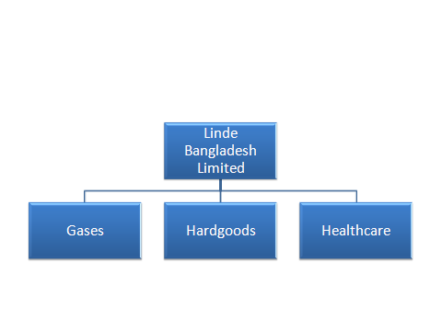
Figure 01: The graphical content of Linde Bangladesh Ltd business operation in market

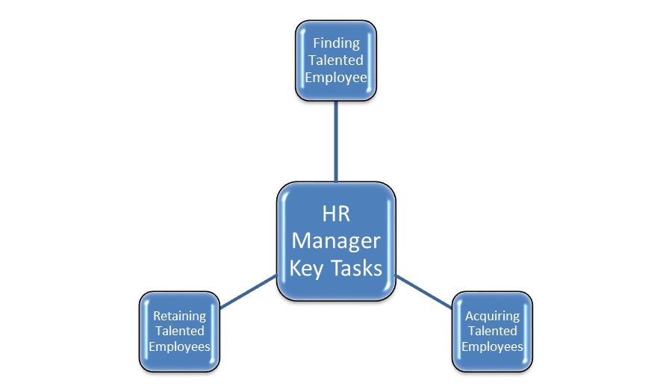

Figure 02: Talent Management from HR point of view.

2.7: Products and services
The company’s principal functions are manufacturing and provide of industrial and medical gas, welding products and equipment’s and accessory equipment. The Company put together earns rental from cylinder used by the shoppers and from vacuum insulated evaporators place at customer’s premises.
Gases: Linde Bangladesh is capable to produces all kind of industrial gases. It has both liquid and compressed formulations. It also undergoes with five suppression systems. E.g. Co2 (used in beverages like coke, Pepsi etc.)
Hard goods: Hard goods are most offered and produced product of Linde Bangladesh. The overall production is conducted for the increasing and high demand of hard goods among customers in industrial areas. Within this sector the most mentionable items are welding electrodes, GPMS-general purpose mild stainless steels, SSP- stainless steel and Cast iron. Various welding electrodes are described below

Mild Steel all-purpose electrodes:
- Ferro speed.
- Vortic Marine.
- Zodian Universal.
- Bolarc 1400.
- Bolwel.
- Bolcraft.
- Ferro craft 7016.
- Ferro craft 11.
- Ferroweld 1.
- FerroCraft 61.
- Ferroweld 2.
- Duroid 350R.
- HandCraft 650B.
- MANGCRAFT.

Stainless Steel Electrodes:
- STAINLESS CRAFT 308L-16.
- STAINCRAFT 316L-16
- STANCRAFT 309 Mo
- STAINCRAFT 308-16.

Cast iron Electrode:
- FERROLOID 1
Healthcare: Healthcare business unit focuses on producing medical gases and medical equipment’s. From this segment mostly services are conducted for hospital and medical
According to business operations proportionally hard goods generates 70%, industrial gas generates 20% and finally healthcare generates the rest 10% outcomes.

2.8 Future Plan:
The future plan of Linde Bangladesh regarding Talent Management Process includes:
- Heightened competition for skilled workers.
- Ensuing retirement of the baby boomers.
- Low levels of employee engagement.
- Acknowledgement of the high cost of turnover.
- Designing the importance of succession.
- Aptitudes off shoring and outsourcing.

This requires new and innovative thinking and a new mission to attain business success. These help to combine with the necessity to classify folks directly with company goals. These are extremely force the HR to evolve from policy creation, price reduction, method potency, and risk management to driving a new talent attitude within the organization.
The manifestation of the distinction between tactical HR and strategic talent management is one of the vital distinction. Transactional HR activities are managerial overhead. The best gradual method and best hands for your business is Talent management.
Instead of being the owners of processes, forms, and compliance, HR becomes the strategic enabler of talent management processes that entitle managers and employees whereas making business worth in this new process. Talent management could also be outlined with this view because the depiction of integrated strategies or systems designed to develop processes for recruiting, developing and retentive folks with the specified skills and aptitude to fulfill current and future organizational desires.

Chapter: 03

Literature Review

3.0 How to attract talent?
In Linde, to attract it’s talents they usually follow 4 different ways. They are
- Job Fair.
- Technical Session.
- Industrial Attachment Program.
- Trainee Catalyst Program.
- Referred

Job Fair: An event where employers, recruiters and universities provide information about challenging position to potential employees. Churned out of the universities both the graduates and the postgraduates are found to be ill-equipped to handle the challenges of the workplace. With only the theoretical aspects they are mostly equipped of the issues and lack the application part. Linde is always try to hire those fresh blood. So, they always try to participate in different job fair or career expo to get some potential personnel. Most of the cases they attend different universities job fair to obtain some fresh graduates.

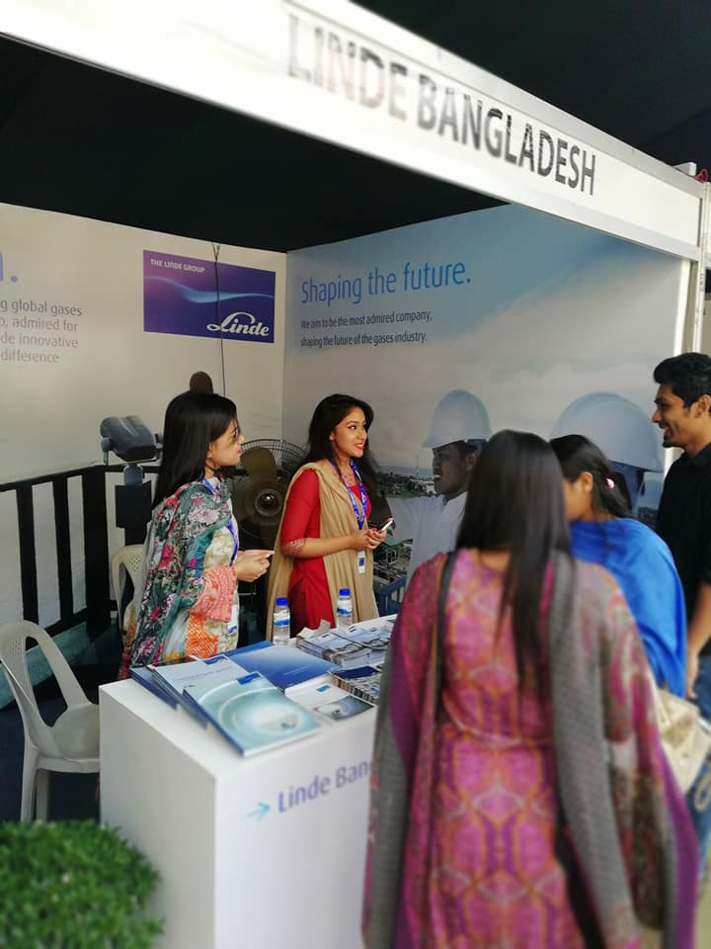
An image from a Job Fair at Independent University Bangladesh.

Technical Session: A session where different technical aspects are given to its potential employees. Linde arranges different technical session for its employee to enhance their growth in workplace. Very often they arranges training on safety issue, SAP, leadership competency, quality control and assurance, quality management system, customer service, project management skill, welding quality assessment and so on. They arranges a full day session where selected employees attend to get vast knowledge on that specific topic. Sometimes some session will set up for more than one day. For those sessions usually they hire skilled trainer from abroad to have a successful session.

Industrial Attachment Program: A program where practical knowledge is provided through different industrial visit. Linde very often arrange such industrial attachment program. It always give opportunities to its employees to gather more knowledge about changing industries. To acquire new industrial plant, new equipment, new technology, new process, recent changes such program such program occurs. Usually it takes place for a whole day or 2/3 day according to the nature of the program.

Trainee Catalyst Program: It’s a program where employees are rotate among different departments at different time to see which department and which position is suitable for that employee. In Linde there is a 12 month catalyst program where employees are deeply observed and from that observation Linde impose responsibilities to the employees Rotations across different departments and locations will ensure the big picture( growth and develop professionalism). Moreover, experienced guides will be on hand to support throughout the journey.

Referred: It’s a method wherever skilled talents are fascinated through reference. Originally, this reference is executed through internal employee. Additionally recruiting new employees is becoming harder and terrible in the developing countries like us, wherever the HR department has to plan out thousands of applications for a handful of position. Searching out the right candidate for the right job becomes a very difficult procedure. It conjointly involves terribly high price to conduct the recruitment and selection process for such an outsized population of candidates. In many case, to cutting the cost, higher management propose such reference to recruit the specific candidate so that they can get their beloved or known person to be recruited. Along with such reference, the competition become very low in the recruiting time because the referred person is highly focused in front of the interview board. In Linde, this thing can be seen very often. The referred personnel is highly attracted to the authority and its number is huge.

Figure 03: The ways of attract talents.

Attracting the Best Talent:
There is another challenge. The best available talent is not just motivated by the name and fame of the organization. They have a new set of motivators like - challenging work, conducive work environment and freedom from bureaucratic structure. So, Linde is trying to focus on this matter now.

3.2 How to compensate talent?
In Linde, they don’t follow any specific mechanism to compensate its employees. But there are some certain terms which is followed strictly, such as: WPPF, Gratuity, Bonus and so on.
But in some instant they provide two benefit system among employees. They are-
- KEB (Key Employee Benefit).
- Award and recognition system.
- Spot Award.
- Excellence Award.
- Safety Spot Award.
- Long term service award.

KEB: Key Employee Benefits are those special benefits that are given to the employees to join, stay in the company for a longer period. In Linde a fixed big amount (monetary benefit) is given to retain the employees. Health insurance is one of that. 100% of medical, dental and vision insurance are covered by Linde. They also provide job security to their employees.

Award and Recognition: These awards and recognition are given both in team and individual way. Sometimes it can be monetary award (money, gifts, gift vouchers, and so on) or sometimes it can be non-monetary award (award, certificates, specific recognition). These things based on 3 categories.

- Spot Award: This award is given for specific task or program or project which will up to the mark. Only outstanding performances deserve such award. The performance of each employees from different departments has been observed and then each department nominated some employees to get that award. And after certain judgement the best one awarded. The employee has been awarded by a monetary benefit which is 200 pounds and certificates. A sample is given in next page:

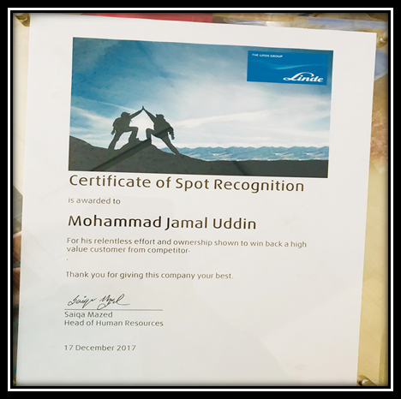
Certificate of Spot Recognition

- Excellence Award: This award is given according to some Linde enlisted criteria and guidelines. He/she who performed according to these, they will be rewarded an amount of 500 pounds.

Award Category | Exemplary characteristics of application
- Customer Focus | - Improved customer experience  - Improved product or service quality  - Avoided customer loss, regained confidence  - Developed customer-tailored solutions & services  - Enhanced ease of doing business with Linde
- Process Excellence | - New process introduced or significantly modified resulting in positive impact for Linde or customers  - Measureable impact achieved  - Sustainable character of realized benefits  - Systematic but pragmatic approach  - Roll-out evaluated and supported
- Ability to Execute | - Implemented productivity measures that delivered profit and margin improvements  - Contributed profits above expectations  - Pro-actively managed headwinds  - Established organization/process to ensure sustainable results  - Results followed through and delivered on time & on budget
- People Excellence | - ‘One” who made the difference  - Demonstrated entrepreneurial or \Can do” attitude  - Actively identified “need for change” and followed through to ensure change happened  - Overcame barriers to succeed  - Lead by example to inspire Linde colleagues
- Safety | - Exemplary SHEQ Leader/Team (Visible Felt Leadership)  - Most improved SHEQ Performance (country)  - Evidence of SHEQ being driven by Line  - Evidence of sustainable BSHEQ program  - Active sharing of BOP (Communication)

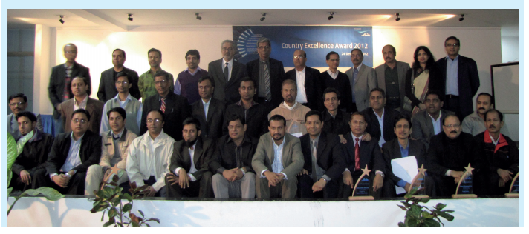

An image of top performers who received Country Excellence Award 2017.

- Safety Spot Award: Linde is such a company which is very aware about its safety issue. They are very conscious about every factors; from working place to till finished work along with every employee’s safety. So, whenever any of the employee shows remarkable performance along with safety maintenance rules & norms (SHEQ norms), they are being awarded. It can be both monetary and non-monetary award.

- Long service award: Long-service awards are thought of one of the foremost necessary types of recognition. For so, they reward employees for their utmost loyalty to the business. In Linde, the purpose of the Long Service Award is to recognize those employees who have dedicated themselves to the service of this Authority for a continuous period of 10 years or more, subject to meeting the some eligibility requirements. Such as:

  - Traditional awards, gift vouchers, prize bonds, travel vouchers and luxury brand name products.
  - To encourage and interact employees whereas reinforcing the aphorism of rewarding loyalty, employers should provide a presentable award which is significantly meaningful to the individual.

A sample of long service award is given below:

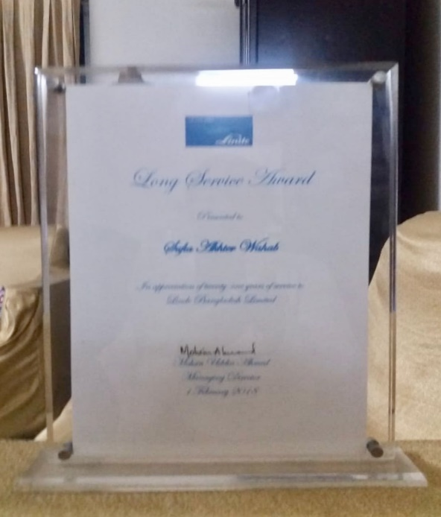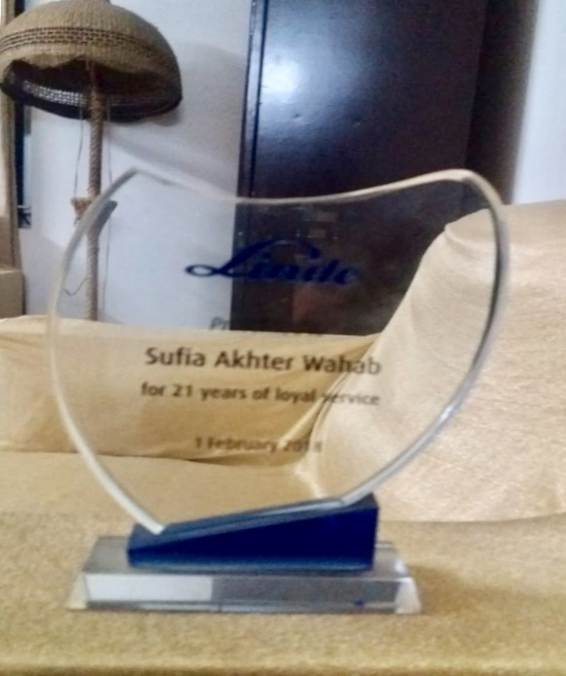

Certificate & Award of Long Service Award

3.3 How to measure talent?
Performance Management Process: To measure each employee’s performance, Linde always prefer to use qualitative methodology. It usually contains human observations which is done by HR manager’s without any statistics or metrics to pull from. Some human resources professionals spend time silently observing employees and recording information about their behaviors, work habits and the types of obstacles that employees must overcome to perform their jobs effectively. To eliminate bias in the reporting, there are three managers (Reward and System Manager, Talent Management Manager and Asst. Admin Manager) to assess the performance of each employee.

KPI (provide specific project task or target): KPI is a measure of whether an employee's, team or business unit's agreed performance goals or results in targets have been achieved or met. So, to measure the talent, sometimes Linde provides specific project task or targets to its employee. By the number of achievements, (sales target) they are being measured to know their growth level and how much beneficial they are for the company.
Example of a performance statement from their measure book:

Accountability: After Sales activities
Objective: Increase the proportion of client satisfaction concerning the product and services.
Standards: 60% Poor, 61-69% Satisfactory, 70-84% Good, 85+%- Excellent
Target: Win a median of 87% over the subsequent quarter with the purchaser.
KPI: Reaction and explanation to our annual customer satisfaction report

HR always try to deliver accurate information and measurement of every single data about an employee which is collected and analyzed from a given task or project. The accurate efficiencies and standards are applied as performance exhibitors. They additionally provide proper feedback on the staff performance and action of a selected goal so that they are being encouraged to perform better in further future.

3.4 How to retain talent?
Indirect embodiment of Talent Management in Linde Bangladesh Ltd., through these steps:
Performance appraisal

Career Planning

Training and Development

Succession Planning

Retaining the current workforce is one of the most consequence to Linde as the company would have already incurred a marginal costs within the variety of coaching, training and development. Currently if the organization needs to search out for a replacement for the employee who has already left, it involves lots of costs like -costs of hiring, cost of training and costs of induction.
Also it inquires slowly for the new employee to regulate to the new work environment. Throughout this point of time, the productivity of each employees will going to be low. The HR department must have to match the new employee into a correct role within the organization. Except inflicting the company a financial loss and breaks in their daily operations, erosion contributes to knowledge disposal that is a huge loss and adversely invades business.
As an MNC, Linde follows some direct tactics and programs that is working to keep top employees on board and the majority don’t involve bumping up employees’ pay. Here are some effective methods of Linde which is utilized to remain employees delightful and make them feel as an important component of their organization in-spite of looking for employment convenience elsewhere.

Training & Mentoring: Through various training programs, employees enhance their wisdom of standard. Through training, employers facilitates employees win particular goals and make sure that they need a strong intellect of their job needs.
A mentoring program integrated with a goal-oriented feedback system that delivers a formed mechanism for growing strong relationships among a company and may be a strong base for employee retention and growth. Along with a mentoring program, a company braces somebody more matured and established in a very discipline with somebody less expert in a very similar field, with the goal to exhibit particular efficiencies, give performance feedback and layout an individualized profession improvement scheme.

Instill a positive culture: A company ought to set up a bunch of values because the foundation for culture like attitude, respect, teamwork, honesty and excellence. A company which generates the exact culture can have a plus once it involves attracting and rearing sensible employees.

Use communication to build credibility: Linde is a flat organization but whatever the scale of the organization, communication is the middle to assembling and maintaining reliability. Several employers have rapport to “flow up” by a workers’ consultative council (or similar group) that implores and/or receives employees’ conception and suggestions and moves them on to higher management. It’s conjointly necessary for employees to grasp that the employer is admittedly obeying and reacts to employee input.

Show appreciation via compensation and benefits: Providing some attractive offerings such as promotion, competitive salaries, long term service award, gratuity, provident fund and health insurance (in-patient & out-patient) and paid time off, paternity leave provides a strong message to employees regarding their necessity at the workstation. The rewards conferred to employees should be purposeful so as to influence their perception of the organization and thus have a marked impact on its retention endeavor. Over and above, if a company guarantees a souvenir, it ought to keep that commitment.

Encourage referrals and recruit from within: Having present employees supply referrals may facilitate to minimize disorder of job expectations. Present employees may realistically narrate a place or condition and therefore the atmosphere to the individual he/she is referring. Otherwise an employer may reduce the outcome of turnover is to hire from among, present current employees have already been uncovered that they are a decent propriety in the organization.

Provide growth opportunities: A company ought to give software (SAP) or different tools to assist employees enhance their understanding of themselves and what they actually need from their careers and broaden their goal-setting attempts. It’s necessary to supply employees with enough job challenges that may enlarge their knowledge in their particular sector. In keeping with Right Management, employees are more likely to remain assigned in their jobs and instituted to a company which creates huge investments in them and their career development.
Make employees feel valued: Employees can go the additional mile if they perceive accountable for the consequences of their work, have a way of value in their jobs, believe their jobs and try to use all skills, and accept recognition for his/her contributions.

Lower stress from overworking and create work/life balance: It’s necessary to associate work/life advantages to the wants of employees. This might be within the kind of providing nontraditional work schedules (like a compressed work week, telecommuting, and flextime) or additional holidays. Once work-life balance is formed properly, employee and employer conjointly emerge ahead. For example, the employer can expertise a lot of productivity within the workplace as employees are little stressed, healthier, and thus, a lot of productive. Encouraging employees to line a particular life goals, like passing as much as time with their kids, communicates which you extremely do wish them to possess a life outside of the work and acquire a healthy work/life balance.

Foster trust and confidence in senior leaders: Exhibit cogent relationships with employees from the beginning to create belief. Employees must trust that higher authority is suitable which the organization will eminent. An employer should always be ready to motivate this confidence and create decisions that fortify it. An employer cannot say a topic and do other. Linde believes, an employer shouldn’t converse about attribute and so push employees to try to do a lot of work in a shorter period. Additionally, employers have the interaction and encouragement for employees through initial policies which portrays they trust them, like obtaining eliminate authoritarian type of management.

Succession Plan: In Linde’s succession plan, it takes attempt to reveal talent to exchange executive, leadership or different key employees after they alteration to a different role, leave the company, are retire, fired or else die. The planning process is intended to establish a talent pipeline of successors which may keep the organization moving with a few to no barriers once irresistible workers changes occur. Through this kind of plan, measurement of staffing wants rise and making long-term goals and strategic methods to handle those voids along with leadership development. On the opposite, the succession planning make sure the provision of the correct type of the management folks at the appropriate time and within the right position to supply the continued organizational vigor and power.

The HR department of Linde, is often a key operator in the succession planning that is typically noted as replacement planning, though assistance from higher leadership and different stakeholders is crucial to success. For so, HR’s staffing plans are needed to be augmented properly on an individual basis for all expected requirements in the immediate year ahead and conjointly for key limbs. The business plans should be viewed to visualize the effects on managerial needs. Succession planning is the serious functions of the higher management. After all, the direct duties of the chief executive and the higher management group.

Succession plans have to replicate long-term organizational goals and strategic methods. Linde continuously offers a reflective opinion not only to the plan's structure and implementation. However conjointly maintaining the process over time. As ways and goals shift, therefore, Linde has to hire, encourage and develop the force, its future success would demands a well-designed cross coaching to instill the supreme knowledge and skills success within the company desires. Having this method into the workplace is important to the prosperity of the company as the people defined in the scheme will eventually be accountable for making certain the company is ready to set out future challenges. These 'high potential' candidates should be cordially chosen and then offered training and development which provides them skills and foresight required for tomorrow's business atmosphere.

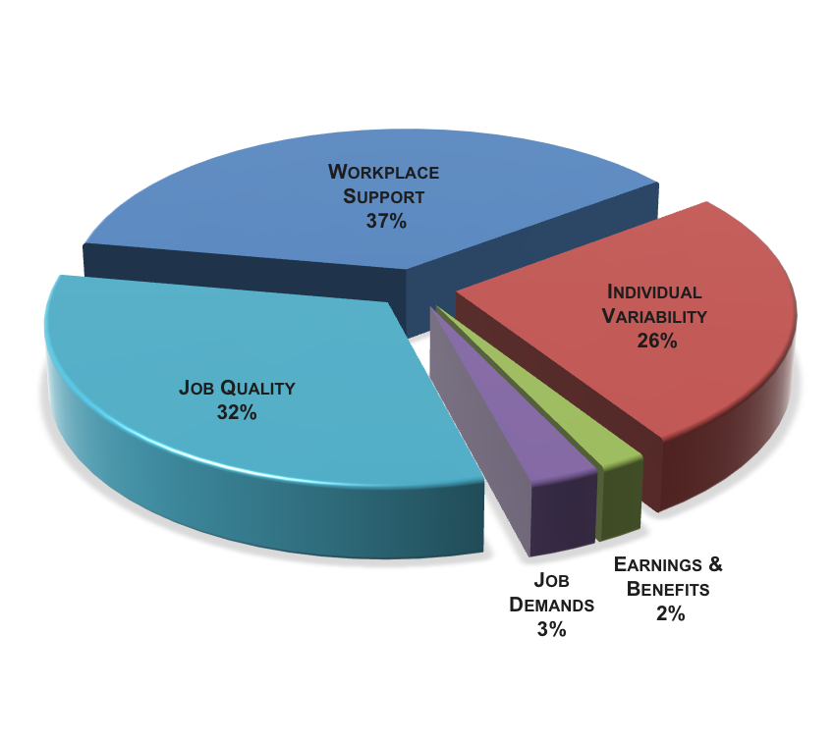
Figure 04: Employee satisfaction from the job along with retain process.

Chapter 04

Analysis and Interpretation

4.0: Graph and Chart
Introduction of Data Analysis: The word Analysis means the method of breach of a tangled set of facts into easy component while explanations stands for the reasons that analyzed the narrations and conjointly figure out or evolve the meaning of artistic and creative work.
Analysis and Interpretation are made accordingly the entire, department wise and according to questionnaire. This analysis and Interpretation will certainly facilitate to the organization for further future strategies. The following figure is the analysis and interpretation of the total results.

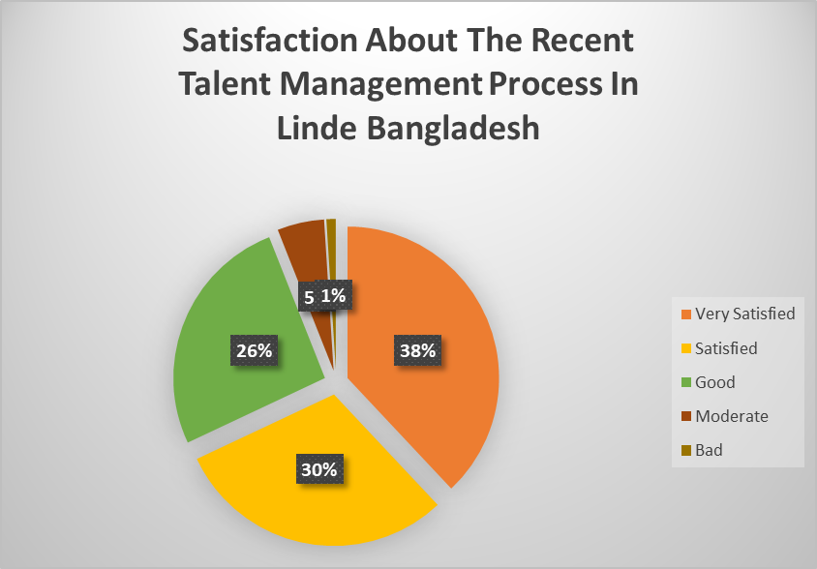

Figure 05: Employees satisfactory amount.

The above pie-diagram indicates that the total of 38% employee of Linde Bangladesh are highly satisfied with the Talent Management process. Rest of 30% are satisfied, 26% are good, 5% are moderate and lastly 1% are dissatisfied. Hence, we can say that the entire folks of Linde Bangladesh is quite positive with their existing process.

To make it more clear I want to show the total figure individually (departments)
- Business Department (Hardgoods, Medical Gases, Industrial gases)
- Finance Department
- Procurement Department.
- HR & Admin Department.

      - Weigh in department of Business:

Options | Reactions | Percentage
Yes | 70 | 70
No | 30 | 30

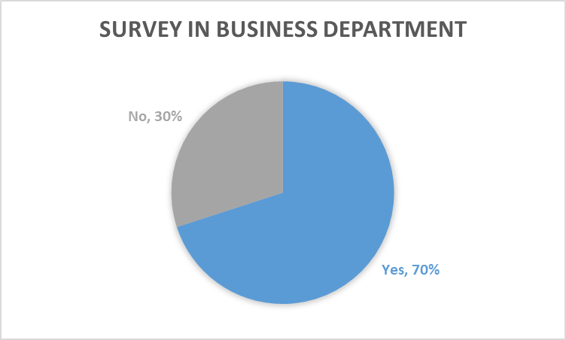

Figure 06: Survey questionnaire (primary data)

The above pie-diagram states that 70% of employees of business department are highly satisfied with the existing Talent Management process. Hence, we can remarks that in Business department talent management is effectively applied for employee as well as organization.

      - Weigh in department of Finance:

Options | Reactions | Percentage
Yes | 75 | 75
No | 25 | 25

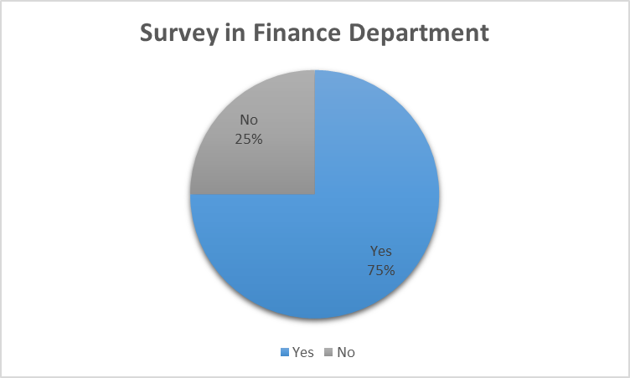

Figure 07: Survey questionnaire (primary data)

In Finance department, we can notice that 75% of employee from finance department are answering ‘Yes’ as they are getting emergence to express their talent in Linde. And 25% employees are answering ‘No’. It means, here talent management is very much effective and employees are quite happy with it.

      - Weigh in department of Procurement:

Options | Reactions | Percentage
Yes | 65 | 65
No | 35 | 35

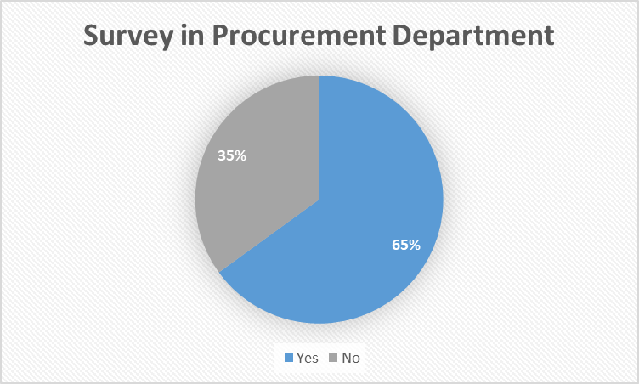

Figure 08: Survey questionnaire (primary data)

The above pie-diagram dictates that 65% of employees from procurement department are satisfied with the current Talent Management process. Whereas, 35% of employees are not that much satisfied with the process. Hence, we can only say that in Procurement department, talent management is not up to the mark rather than other departments.

      - Weigh in department of HR & Admin:

Options | Reactions | Percentage
Yes | 90 | 90
No | 10 | 10

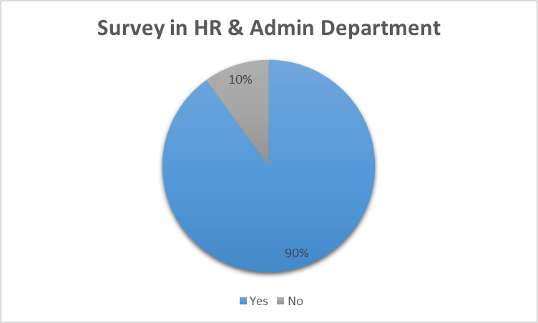

Figure 09: Survey questionnaire (primary data)

In HR & Admin department, we can notice that around 90% employee are answering ‘Yes’ as they are getting chance to expose their talent in Linde. And rest of 10% employees are answering ‘No’ which means talent management process is applied in an outstanding level in this department.

Employee’s performance in the beginning of implementation of Talent Management idea:

Department | Good | Bad
Procurement | 02 | 03
Finance | 16 | 04
Hardgoods | 14 | 02
Gases | 07 | 05
Industry | 05 | 05
HR & Admin | 03 | 02

Figure 10: Employees situation before implementing the Talent Management Process.

Employee’s performance afterwards of implementation of Talent Management idea:

Department | Good | Bad
Procurement | 04 | 01
Finance | 18 | 02
Hardgoods | 14 | 02
Gases | 09 | 03
Industry | 08 | 02
HR & Admin | 05 | 0

Figure 11: Employees situation after implementing the Talent Management Process.
In above both diagram, we can compare performance of all department, before implementing concept of talent management and after implementing concept of talent management. We can observe that, performance of all departments is increase after implementing talent management concept.

4.1: Interpretations
In my survey, I have used 68 employees’ data through a face to face conversation and a minimal amount of my general observation. In my total survey I have found a strong memoire of that organization where each employees lives in a healthy environment and work without any over load. They seems very happy while working and talking to each-other. The current talent management process that is followed by Linde Bangladesh, is a very strong and clear process. The HR department run the total process very smoothly and effectively. Each and every single employees are very much satisfied with their current process. They expressed, the way Linde helps to improve their performance through different training programs and rewards that is spectacular. Most of the employee express that they want to work here till their retirement period and the most fascinating scenario of that company is each employees working period is more than 3 years. An employee who is working here about 2 decades expressed that the total process is still developing because Linde always cares and values about its employee’s welfare.
So, simply I can say, each employees are very much pleased with Linde’s Talent Management Process.

Chapter-05

Recommendations and Conclusion

5.1 Recommendations
- Organization should make research to avoid talent drain.

- HR Department should interact more and more and also expose inbound employee.

- Perform various task to motivate employee for work, because various employee cannot work with motivation they just do it, because organization pay for them.

- Appreciation must be given for every outstanding performance that is done by the employees.

- For employees recreation the number of fun programs or picnic must be increased.

5.2 Conclusion:
Companies are featured with tremendous emulation, scarce resources and fast technological substitute. This has intended that companies should be driven in like a way that not only is their direct survival warranted however conjointly their long- term future improvement is confirmed. However, as within the case of any business or industry, in a very extremely competitive atmosphere and in a very rising economy, only the fittest will endure.

For the HR Community talent management is a chance for HR professionals to improve in their areas of experience and careers. A strong HR Community assistance to produce a powerful public service. The goal of talent management is to perceive our individuals within the HR Community therefore we can help professional and career improvement and classify individual desires and goals with the HR business focus. We have a tendency to conjointly confirm that we as a Community have the swiftness to improve and develop individuals for so we may corresponding the upcoming desires of the government and our clients and community. This initial large spur of the Community gives a base on that to confirm leadership continuously, information transfer and job continuity. The primary execution resulted in a variety of significant human resource priorities and techniques like leadership, performance management, management development, retention and attraction, employee development and learning culture, all of that are endured by the HR Strategy. The essential afterwards step within the method is that the execution of the Talent Management arrange plan for the HR Community. Community members, individually and managers must work conjointly to move frontward individual career improvement plans. The HR Community should work conjointly to flourish a talent management mindset, dedicate to supporting improvement as a professional group, and fulfill talent management into the daily material of running business.

- Recruitment: We perceive it to facilitate of making sure the appropriate people are attracted to the organization.

- Retention: We comprehend it to facilitate of developing and implementing practices that reward and support staff.

- Employee development: Talent Management guaranteeing continual informal and formal learning and development.
- Performance management: Talent Management is a particular process which teach and support performance, including provide feedback.
- Workforce planning: It helps to create planning for business and general changes as well as the older manpower and current/future skills of folks.

Appendix
1. Survey Questionnaire
2. Analysis Sheet
3. Hall of Fame (Linde Talent Magazine)
4. Linde Organram.

Bibliography
- http://www.linde.com.bd/en/index.html
- Internship report of Nafiza Farzana
- https://www.google.com/imgres?imgurl=http://www.whatishumanresource.com/_/rsrc/1472783158880/talent-management/talent%2520management.png&imgrefurl=http://www.whatishumanresource.com/talent-management&h=282&w=391&tbnid=SARU3RVbfo52DM:&q=talent+management+in+hrm&tbnh=154&tbnw=214&usg=AI4_-kQkm7rWiFBPdSVCEhjhJM3nIEMdAw&vet=12ahUKEwiJ1ePJ7MzfAhWZWX0KHfvGCScQ9QEwAHoECAgQBg..i&docid=41DpESydj-2oMM&hl=en&sa=X&ved=2ahUKEwiJ1ePJ7MzfAhWZWX0KHfvGCScQ9QEwAHoECAgQBg#h=282&imgdii=SARU3RVbfo52DM:&tbnh=154&tbnw=214&vet=12ahUKEwiJ1ePJ7MzfAhWZWX0KHfvGCScQ9QEwAHoECAgQBg..i&w=391
- https://en.wikipedia.org/wiki/Talent_management
- https://www.thebalancecareers.com/top-ways-to-retain-your-great-employees-1919038
- Talent Management Handbook by Lance A. Berger & Dorothy K Berger.
- https://resources.workable.com/tutorial/source-of-hire
- http://www.linde.com.bd/en/images/Linde%20probaho%20January%202013_tcm391-90072.pdf

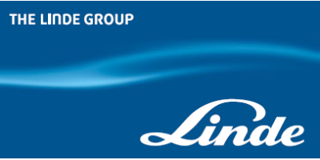
Questions to improve processes:
This questionnaire includes bureaucracy, salary/rewards, performance management, career mobility/development, transparency, clear expectations/goals, motivation/recognition, development opportunities/coaching and how Linde’s employees feel about their culture, values and psychological safety

Employee Name: ……………….. Department: …………………..
Gender: …………………………. Duration of employment: …….

No | Statement | Very Satisfied | Satisfied | Good | Moderate | Bad
1 | Do you feel company processes help or hinder your work?
2 | Do you feel there is enough transparency in company wise decision-making processes?
3 | Do you feel salary and benefits are fairly distributed?
4 | Do you feel our current performance management process is effective?
5 | Do you feel you can develop your career at Linde?
6 | Do you know what’s expected of you at work?
7 | Does your manager help you set effective goals?
8 | Does your manager provide you with the coaching and guidance you need?
9 | Do you know how your work contributes to the company’s overall objectives?
10 | Do you receive sufficient praise and recognition for your achievements?
11 | Do you feel comfortable giving feedback to your team?
12 | Do you feel your voice is heard and respected?
13 | Do you feel you can suggest new ideas/question ways of doing things?
14 | Do you feel we’re living our company values and mission?
15 | Would you recommend Linde as a great place to work?

