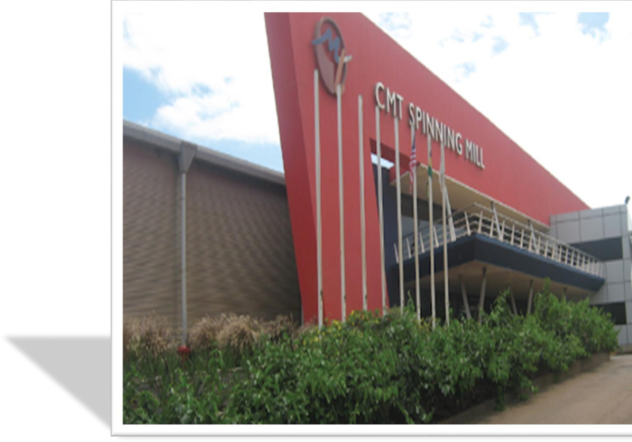


Internship Report On

RMG Operation Anatomy of
“Consumer Knitex ltd”.


Internship Report On


RMG Operation Anatomy of
“Consumer Knitex ltd”.

Submitted To-

Nusrat Farzana
Assistant Professor
United International University
School of Business and Economics

Submitted By-
Mohammad Shakil
ID- 111 172 054

Date of submission: 19 May 2023

To
Letter of Transmittal

Nusrat Farzana Assistant Professor
United International University

Subject: Submission of internship report.

Dear Madam,
I have finished my internship report as required by the BBA program. I've made an effort to adhere to all the recommendations and directions you've given me throughout our chats in this report.
I have developed a strong network in addition to a variety of skills and expertise throughout my current internship time. I've gained insight into how businesses operate thanks to my employment here. I made sure to follow UIU norms and regulations when writing the report and to rely on reliable sources to back it up. I am submitting my report now.
Sincerely,

Mohammad Shakil

ID- 111 172 054

United International University

School of Business and Economics

Declaration of the student

After completing a three-month internship at Consumer Knitex Limited, I, Mohammad Shakil, hereby certify that the report on the RMG Operation Anatomy of "Consumer Knitex ltd." that is being given is entirely original.
I additionally declare that there is no alternative reason and that the paper was written only to satisfy my academic duties.


(Signature)

Mohammad Shakil
ID: 111 172 054
School of Business & Economics
United International University
School of Business and Economics

Acknowledgement

I'd want to begin by thanking Almighty Allah for helping me go this far and for providing me the chance to work for one of Bangladesh's top development organizations. Second, I want to express my deep gratitude to Mrs. Nusrat Farzana, my academic adviser, for her insightful advice that made it possible for me to finish my report. I really admire him.
In addition, I want to thank Jabir Abir, my organizational supervisor, for always encouraging me to pursue my academic objectives and for assisting me in taking on numerous tasks and upholding the organization's normal operations. I also want to thank Sajjad Hasan Chowdhury, the head of the finance, accounts, and administration department, for his assistance and for providing me with the direction I needed to successfully finish my three-month internship. I am appreciative of the assistance my coworkers provided me with throughout my internship.

Executive Summary

The textile and apparel industry is significant to Bangladesh's economy. Bangladesh has 4621 garment industries, which have a significant economic impact on our nation.One of the greatest sector in export department consist of of RMG and textile for foreign exchange gains. The study focuses on Compagnie Mauricienne de Textile Ltee (CMT) which is actually the mother company of Consumer Knitex Limited (CKL).Bangladesh's general operations RMG Bangladesh, and CMT's financial statement examination. Our country's RMG and textile industries contribute significantly to GDP (Bangladesh). This study has improved my understanding of how a firm may carry out its entire operations superbly and increase its financial strength as a recent business graduate.
This paper discusses the framework, strategy, goal, timeline, and deliverables needed to successfully conduct the investigation into the RMG and textile industries. Additionally, a description of the CMT Bangladesh,its total manufacturing activity, and its departments. The report finishes with a financial statement analysis to analyze CMT's (Bangladesh) financial performance and give advise on how to improve operational effectiveness in general.
This report's major goal is to provide a better knowledge of the CMT's (Bangladesh) operations and reveal how well those activities operate as a whole. This research also focuses on the CMT's (Bangladesh) financial performance and how it affects its profitability.
On the other hand CMT mainly exits in Mauricio’s, they expanded their textile sector in Bangladesh with the name of Consumer Knitex Limited(CKL).They keeps their information confidential so this report company name would be Compagnie Mauricienne de Textile Ltee (CMT).

Table of Content

Chapter 1: Introduction 6
1.1 Background of the Report 7
1.2 Objectives Of the Report 7
1.2.1 Broad Objective 7
1.2.2 Specific Objective 7
1.3 Motivation of the report 8
1.4 Scope and limitations of the report 8
1.4.1 Scope 8
1.4.2 Limitation 8
1.5 Methodology of the report 9
Chapter 2: Company and industry preview 10
2.1.1 Economic factors 11
2.1.2 Technological factors 12
2.1.3 Barriers to entry 12
2.1.4 Supplier power 13
2.1.5 Buyer Power 13
2.1.6 Threats of substitute 14
2.2.1 Industry analysis 14
2.2.2 Specification of the industry 16
2.2.3 Size Trend Maturity of the industry 17
2.3.1 Company Analysis 18
CMT Dhaka Office Organizational Structure 20
2.3.2 Trend and Growth 22
2.3.3 Customer Mix 22
2.3.4 Product/Service Mix 23
2.3.5 Operation 25
Chapter III: Financial statement analysis and finding 28
Year to year comparative ratio analysis: 28
3.1 SWOT ANALYSIS 33
3.2 Ready Made Garments Export Condition 34
3.2.1 Comparing the Export Performance Analysis of MS Knit Design Ltd. Factory and Consumer Knitex Limited 36
Chapter IV: InternshipExperience 37
4.1 Position, Duties & Responsibility 37
4.1.1 Description of the job 37
4.1.2 Specific responsibility of the job 37
4.1.3 Internship Experience 38
4.2 Training 38
4.3 SkillsApplied 41
4.4 New SkilledDeveloped 41
4.5 Application of academic knowledge 42
Chapter V: Conclusion and key fact 43
5.1 Recommendation for improving departmental operation 43
5.2 Key Understanding 43
5.3Conclusion 44
Reference 46

Chapter 1: Introduction

The economic foundation of Bangladesh is agriculture. Bangladesh's garment industry (RMG) has developed into the nation's primary source of foreign exchange revenue. This industry supports 4.2 million jobs and has a major economic impact. Maximum employees of Bangladesh's readymade garments (RMG) sector are the youth and females of urban areas.
Development of Bangladesh's economy is significantly influenced by the RMG industry there. Since few years, the RMG and textile industry is said as key drivers of Bangladesh's exports to other countries. South Asia has a significant presence in this industry, which is the third largest in the world for garment manufacturing. More than 80% of Bangladesh's total exports come from this sector, which generated US$27.16 billion in 2016–17.This industry supported commerce and added 12.36 percent to Bangladesh's GDP in 2016–17. This commerce nonetheless thrives despite occasional damaging or odd incidents, and its cessation has a major impact on our gross domestic product. Currently, this sector accounts for 83 percent of all export revenue for the nation.
A global company called CMT (Compagnie Mauricienne de Textile Ltée) started doing business in Bangladesh in 2011 with the name of Consumer Knitex Limited (CKL) by buying two companies of textile field. The several operations of CMT, an entirely export-focused company, have a considerable positive impact on Bangladesh's economy. In this study, I focus on CMT Bangladesh's entire operations and use ratio analysis to analyze the financial statements.

1.1 Background of the Report

This research focuses on operations and financial statement analysis (CMT) (Bangladesh). Both the RMG and textile industries makes major part in GDP and economy of the nation. This study's main objective is to gain a better understanding of CMT (Bangladesh) operations and how they affect overall operational effectiveness. This study also discusses the CMT's financial performance and its impact on profitability. Bangladesh. This research has helped me comprehend how a corporation may succeed across the board while also improving its financial situation as a fresh business graduate. The research shows focus on CMT Bangladesh's whole operations.
The manager, who constantly check on my work and suggest any steps that can be taken to comprehend the errors that occurred throughout my investigation, will closely supervise how my inquiry is carried out.

1.2 Objectives Of the Report

1.2.1 Broad Objective

The major goal of this report is to outline CMT Bangladesh's overall operations and to conduct a financial analysis of the company's financial performance using ratio analysis.

1.2.2 Specific Objective

• To offer a better knowledge of all of CMT's operations.
• To give insight into how CMT's actions contribute to the economy.
• To examine CMT's financial performance.
• Interpret the financial ratios' results and provide recommendations on how to improve their overall activity
• Make recommendations on how they might improve their financial performance.

1.3 Motivation of the report

Due to the significant contribution of the RMG sector to the country's socioeconomic growth, it requires particular attention from all sectors that are reliant on or benefit from it.As the primary source of foreign currency earnings, a research addressing the potential and problems is in great demand at the moment. The study's disclosure of the genuine picture of potentials and constraints may further orient the industry toward core sector improvement.

1.4 Scope and limitations of the report

1.4.1 Scope

- Improved knowledge of how CMT (Bangladesh) conducts its entire operations.
- Providing a succinct overview of the CMT's several areas (Bangladesh).
- Ratio analysis result interpretation.
- Recommendations to the corporation on how to enhance their entire operations in order to achieve organizational objectives.
- Suggestions to strengthen the company's financial position.

1.4.2 Limitation

I utilize ratio analysis to examine the financial accounts in this research and concentrate on CMT Bangladesh's overall operations.
My academic manager will keep a close eye on my work and advice on any measures that can be implemented to understand the mistakes that happened throughout my investigation. My inquiry will be carried out under her strict supervision.
The study's data was also only collected up until 2016, hence the report lacked current information.

1.5 Methodology of the report

The word "approach" refers to a deliberate, hypothetical review of the practices involved in a field of study, which entails evaluating a strategy, benchmarks associated to certain area. It has stages like, a worldview, a fictional model, and quantitative or arbitrary process. Numerous sorts of essential and optional information are needed to build the report. The information was appropriately formatted at that point.
• Data Collection- data about the company's general operations and all departments is gathered from the company's website, while financial data is gathered from the company's annual report.
• Statistics Types- This report makes use of information regarding the company's general operations and financial data.
• Microsoft excel is used to analyze the company's financial statements, while Microsoft word is utilized to create graphs and charts.
This study examines CMT Bangladesh's overall operations.

Chapter 2: Company and industry preview

The textile and apparel sector in Bangladesh is essential to the nation's economy. In Bangladesh, there are 4621 garment factories, and they have a substantial impact on national economic development. Major markets for Bangladeshi RMG include the United States, United Kingdom, Australia, and the European Union. Textiles and apparel made up 78% of Bangladesh's overall exports of goods in 2016, according to RMG. The World Bank estimates that Bangladesh's GDP expanded from US$6.28 billion in 1972 to US$172.78 billion in 2014, with export revenue accounting for US$32.18 billion, or more than 83% of GMR. The industry, which mostly operates in South Asia, is ranked third in the world for producing garments. After China, Bangladesh is the second-largest producer of RMG. Bangladesh is the second-largest exporter of western apparel in the world. The majority of clothing firms in Bangladesh are held by local investors, with foreign investors holding about 5% of the businesses.
Building a secure and long-lasting clothing industry in Bangladesh is a goal of the Bangladesh Garments Manufacturers and Exporters Association (BGMEA). According to the Bangladesh Institute of Development Studies, 85.9% of industrial buildings have authorized floor plans, 80.8% have approved structural designs, 92% have approved fire safety permits, and 55% have electrical generators outside the facility. The "TREES" (Toward Resource Efficiency and Environmental Sustainability) initiative is being worked on by several stakeholders in the garment industry. Encourage them to implement energy-efficient technology, waste management practices, cogeneration, waste heat recovery practices, and environmental management systems. Recently, the creation of certain clothes got a little bit closer to being carbon-free.
By designating 470 acres of land in Baushia, Munshiganj for the construction of a manufactured garment industrial park and USD 6.5 million for labor development efficiency, the government has taken action to impact the RMG sector.

2.1.1 Economic factors

Economic considerations are facts in a market which influence a company's performance. Such factors are frequently taken into consideration when projecting how a corporation will perform. Investors evaluate the value of a company or investment using economic factors.
Economic factors are outside factors that affect the business climate and the worth of an investment. For an investor to predict how well an investment will do, they must also be aware of such factors.
Similarly, Compagnie Mauricienne De Textile Ltée (CMT) examines a variety of economic elements in order to forecast a company's long-term future. This research focuses on to understand issues that may influence business environment and broader market.
Both a direct and indirect effect of economic factors on the business environment may be seen. To begin with, they are recognized to have an impact on supply and demand, that mainly affects the free flow of goods and services in an economy.
External Factor Affecting Business 75% or thereabouts of exports overall The most important factor driving people to shop in Bangladesh is cheap prices, according to recent surveys by the consulting firm McKinsey and the accountancy firm KPMG. Future pricing levels will remain highly competitive due to significant efficiency increases that will counteract rising labor costs.
Along with cheaper labor costs and favorable duty rates, Bangladesh also offers more affordable raw materials and real estate. Without a doubt, Bangladesh gains from a variety of preferential trade accords that let it enter certain countries tax-free.
• Social: Since our fashion and design were mostly geared toward young people, our business was impacted by the fact that there were more older citizens in the community.
• Economic: Lowering the amount of money that consumers must spend as a result of a higher income tax.
• Political: choice to increase spending on public services such as health and education, stability of the political system, and monopolistic control. levying of taxes, as an example.
• Technological: Impact of Internet Use.

2.1.2 Technological factors

They offer innovative materials, equipment, and business process support to Compagnie Mauricienne De Textile Ltée (CMT). The following is a mention:
- Product design,
- New distribution channel,
- Pricing innovation
- Technology's impact on product design, manufacturing, distribution, pricing, and consumption

2.1.3 Barriers to entry

Conditions that make it difficult or impossible for new businesses to join a market are known as entry barriers. Entry barriers make a market less competitive and less competitive. The market is less competitive the lower the entrance barriers. High entry barriers are a feature of monopolistic marketplaces.
Building a powerful brand image may help to establish consumer loyalty and prevent incursion. If a company has a strong brand image, it must spend a lot of money on advertising, which is a sunk cost and barrier to entry. Some businesses are so resilient that no promotion can result in a departure.
Prices need to be as low as possible. When a business sets its pricing so low as to deter competitors, this occurs. Limit pricing may be used by a monopoly because, despite declining profits, it wishes to maintain low prices to stave off competition. The topic of economies of scale is included.
A lot of people working together may raise output while decreasing average expenses, resulting in economies of scale, which is a particular sort of economics. As a consequence, new businesses with low production levels will struggle to compete since their average costs will be greater than those of established businesses that enjoy economies of scale. People may be discouraged from enrolling if they anticipate typical price hikes.

2.1.4 Supplier power

When placing orders with vendors for inputs, Bangladesh always leads. Bangladesh just has a little supply of native raw resources. They are mostly international. This has the drawback of making it harder to start a backlink, however. Supplier power thus rises. Bangladesh is still paying worldwide rates to its suppliers for the commodities it needs. However, shareholder motivation and growth potential in terms of success and riches will always be the most crucial aspects of Bangladesh's export industry. As more local businesses emerge, Bangladesh's domestic supplier strength is gradually but steadily growing. They are working on an integrated supply channel management system that will lighten the job of the manufacturer. Local suppliers, who are also in charge of importing the raw materials and parts required for production, are more likely to get orders from businesses. It was a sensible decision to enter the supply chain. Bangladesh provides suppliers with a significant scale advantage due to the industry's intense geographic concentration.
Bangladesh's solid international reputation allows it to compete on pricing with both domestic and foreign providers. Despite having a competitive edge over Bangladesh, suppliers see Bangladesh as a trustworthy source of payment, and Bangladesh has been able to guarantee timely delivery of raw materials because to this reputation.

2.1.5 Buyer Power

Consumers are more powerful than Bangladeshi businesses realize. Bangladeshi producers and suppliers have to be on their toes since China is pushing India to the top. Bangladesh has a large selection of providers, both in terms of price and quality. It provides the best craftsmanship at the lowest possible cost of manufacture. due to the great possibility for client switching. Bangladesh often has to provide or let the client prevail. Bangladesh seeks to position itself as the most lucrative option for customers.

The fact that many firms in Bangladesh are either franchised or supported by the government is crucial. Local companies are pushing Bangladesh as the #1 outsourcing location worldwide alongside them. Bangladesh is where many well-known businesses outsource their goods to guarantee the highest quality at the most affordable price.
Furthermore, freshmen will be at an advantage compared to Bangladesh, which has annual growth of around 20% even after MFA. As a consequence, Bangladesh would have less trouble from a newcomer. Right now, Bangladesh's major advantage is its inexpensive labor force. Low-cost labor will be available as long as the starting value stays the same. Workers will continue to pay low salaries till that time in order to shield Bangladesh from foreign competitors.

Bangladesh investment by foreign investors and businesses is unpopular. This is a chance for Sri Lanka and other little Latin American nations to draw in Bangladeshi shoppers.

2.1.6 Threats of substitute

In terms of substitutes, Bangladesh serves as both a victim and a chance. Bangladesh's consumer base is expanding more quickly than China's and India's combined. Due to Bangladesh's poor national brand image and limited ability to sway consumer preferences, people may choose China or India over the country.
Additionally, Bangladeshi goods are being supplanted because of supplier weakness and the government's reputation. Bangladesh is likely to be replaced by China or India as a result of the lack of interest from businesses, consumers, and investors in Bangladesh as a result of the nation's precarious political position. Additionally, moving to a Chinese or even Sri Lankan manufacturer won't cost you too much money.

2.2.1 Industry analysis

RMG is the most significant industry in Bangladesh. It is essentially a labor-intensive industry. The history of how ready-made clothing started off as a modest non-traditional export in the late 1970s is the key to understanding Bangladesh's garment industry's success. In 1998–1999, this industry exported 4019.98 million US dollars, or 75.67 percent of all exports (in 1995). Bangladesh's exports of ready-to-wear clothing have surpassed even the most optimistic expectations during the past 20 years. In 1997, Bangladesh surpassed the United States to become the world's 18th largest exporter, and it is currently the sixth largest exporter to the United States. T-shirts are now the most popular item exported from Bangladesh to Europe. The impact of the export market for ready-made clothing is one of the most significant social and economic transformations in contemporary Bangladesh.

Every nation now knows about the outstanding achievements of the RMG industry. Despite these great accomplishments and the likely obstacles ahead, the sector's prospects for additional development and growth remain bright if properly managed. There are still some serious dangers in this industry, but Bangladesh has the capability to overcome them. In terms of foreign currency revenues, job creation, and poverty reduction, Bangladesh's readymade garment (RMG) sector plays a critical role in the country's economy. Currently, the RMG industry earns the most foreign money in Bangladesh. Aside from contributing to significant foreign currency revenues, the RMG business has become the major employer.

In Bangladesh's RMG business, around 2 million individuals are now employed, with 90% of them being distressed women. Furthermore, a conservative estimate reveals that the sector presently generates roughly US$ 2 billion in domestic economic activity due to linkage effects, making the RMG business Bangladesh's most significant sector.

In 2000-2001, it accounted for 75.14 percent of the country's overall export revenues. As of June 2000, around 1.5 million employees, 90 percent of whom are distressed women, were employed in approximately 3200 garment manufacturers. It is the country's biggest manufacturing industry, accounting for around 5% of GDP. However, the RMG industry is presently encountering certain difficulties, particularly after 2004. Bangladesh's readymade garments sector is still in its infancy in terms of volume manufacturing. In our nation, we still have issues with the creation of high-quality items. Also unsatisfactory is the standard. Korea, Hong Kong, Taiwan, and other nations' readymade clothing are significantly better than ours in quality.

2.2.2 Specification of the industry
Bangladesh has exported ready-to-wear clothing to more than 132 nations over the last three decades, placing it second in the world. Bangladesh's overall exports surpassed $30.18 billion for the first time, a 13.83% increase from the prior fiscal year. There were 30 factories in the business in 1980, while there were more than 6,000 in 2014. Women make about 80% of the 4.4 million persons who are directly working in the RMG industry. This industry directly and indirectly employs more than two crore people.

By generating foreign currency, a number of industries have raised the country's gross domestic product. Clothing, jute and related items, leather and related products, frozen foods, and many more sectors will be highlighted. On the other hand, the majority of Bangladesh's export revenue is presently generated by the RMG sector. This industry accounts for 81% of all export revenue for the nation.

There are already more than 4,000 RMG businesses in Bangladesh. With a few foreign corporations operating in areas with a focus on export processing, more than 95% of businesses are locally owned. Most of the RMG industry is based in Dhaka, Chittagong, and Dhaka Industrial Hub.

Knitted and crocheted clothing are the two types of clothing that are most often produced in Bangladesh. The most popular knitted products are shirts, t-shirts, and slacks, whereas the most popular knitted items include underwear, socks, stockings, t-shirts, sweaters, and other casual and soft clothes. Knitwear accounts for the bulk of the nation's garment export revenue. Knitted clothing has grown in significance since the early 1990s and now represents more than 40% of all RMG export revenue for the nation. The majority of the nation's clothing is produced in a select few categories, such as shirts, t-shirts, slacks, jackets, and sweaters. Economies of scale for farm and large-scale production subject to export limitations in the relevant industries are the major causes of this restricted product concentration.

2.2.3 Size Trend Maturity of the industry
It is difficult to overstate the importance of the RMG industry in our economy. Our RMG export sector has been steadily growing for at least the previous decade and a half, but it has taken a turn for the better in the last few years. Bangladesh's backbone of export profits is still the readymade garment industry (RMG). This industry accounts for over 76% of Bangladesh's total export revenues. Exports from the RMG sector were US$ 5,686.06 million in FY 2003–04, US$ 6,417.67 million in FY 2004–05, US$ 7,900 million in FY 2005–06, and US$ 9,220.1 million in FY 2001. US$10,699.80 million for FY 2006–07, US$7,900 million for FY 2007–08, and US$12.35 billion for FY 2008–09 were the exports for the next three fiscal years.
Share of back to back L/C
80
63.01 60.51
66.42
68.33
60
56.25
55.04
47.74
44.13 45.1
40
Share of back to back L/C
20

0
FY92 FY93 FY94 FY95 FY96 FY97 FY98 FY99 FY01

The most popular items in Bangladesh are those that are knitted or crocheted. The most popular knitted products are shirts, t-shirts, and slacks, whereas the most popular knitted items include underwear, socks, stockings, t-shirts, sweaters, and other casual and soft clothes. Knitwear accounts for the bulk of the nation's garment export revenue. Knitwear has gained prominence since the early 1990s and now contributes more than 40% of the nation's overall RMG export revenues (BGMEA website). Despite the fact that the nation produces a vast range of clothing, the majority of it may be divided into a few groups, including shirts, T-shirts, slacks, jackets, and sweaters (BGMEA website; and Nathan, 2001). Economies of scale for farm and large-scale production subject to export limitations in the relevant industries are the major causes of this restricted product concentration. Ready-to-wear manufacturing, the biggest industry in the nation, contributed 13% of the GDP in 2010 and more than half of all exports.

2.3.1 Company Analysis

Introduction to CMT

CMT a pioneer in the fashion business for its jersey-wear, has its headquarters in Mauritius and various distribution offices across the globe, including the United Kingdom, France, and the United States. It is known for its extensive investment and innovative operations, as well as having the largest production units.
It specializes in the design and development of fastfashion jerseywear clothes for the greatest vesture brands and fast fashion stores. CMT is one of Mauritius' most prominent firms, with a revenue of $200 million and a workforce of over 10,000 employees.

CMT Bangladesh

In collaboration with the investment company CMI LTD., CMT (Bangladesh) launched its worldwide business in Bangladesh in 2010. In January 2011, they purchased Dignity Textile Mills Limited (DTML), which CMI had bought in 2011. A second DTML unit (APEX) was established in July 2015 a short while later. In July 2016, CKL Unit 2 became operational as part of CMT's expansion. (Trishal).


CMT head Office

The five divisions that make up the head office of CMT are Sales Department, Accounting & Audit Department, General Orders Department, Accessory Purchase Department, and Human Resource Department. To accomplish organizational objectives, all departments collaborate, and senior management as a whole makes key business choices as a team.

CMT Dhaka Office Organizational Structure


Francois Gilles Tam Fat Woo Shing Hal

Managing Director


Sazzad Hassan Chowdhury

Senior manager Account and finance
Umme Sadia Islam

Department head accessories and purchase
Anwar Hossain Manager Commercial
Ambar Teeruthchand Hurry

Country Director
Amir Hamza
In charge HR & Procurement

Sadiqur Rahman Account, Finance and admin

Objective of the company

CMT (Bangladesh) is a global textile corporation based in Bangladesh. The CMT's key goals are outlined below:
1. Identify a more effective path for business expansion. to both the client and the company.
2. Maintain a healthy cash flow to avoid temporary insolvency.
3. In order to be a successful business and take the lead in the industry, CMT assures the highest level of customer satisfaction.

4. In addition to operating well in Europe, CMT also intends to expand to other regions of the world in order to boost revenues.
5. CMT wants to improve customer happiness in order to grow sales volume.
6. CMT develops a successful delivery strategy to guarantee customer satisfaction during the handover period.
7. CMT offers product information to win the trust of the consumer.
8. Improve the networking infrastructure to make commercial transactions easier.
9. Examining the consumer's purchase decision to provide a better solution.

Mission Statement
By using cutting-edge technology and offering top-notch training and development to our staff, we will continue to be a pioneer in the production of high-quality jersey textiles and clothing.
By reassessing our roles as educational institutions, we will help the nation's social and economic development. We are the ultimate manufacturing team!

Vision Statement

- A cost-efficient, ethical, and ecologically conscientious business partner is CMT Bangladesh Ltd.
- The business's goal is to become the industry leader.

Goal

The primary goal of the business is to deliver high-quality products by reducing procedures, expanding expertise, and improving quality all around.
• To minimize to the absolute minimum the risks associated with employee safety and health problems.
• To safeguard property for next generations and to preserve the environment.
• To develop talent and leadership abilities based on ability, personal objectives, and therefore, corporate demands.
The tagline of this corporation situated in the kingdom is "total customer pleasure."

2.3.2 Trend and Growth

Growth of RMG industry

The graph shows that between 2005 and 2016, employment and growth in the manufacturing sector rose. Due to fire and safety concerns, factory growth decreased from 4,328 in 2013 to 4,222 in 2013, but is presently rising steadily with employment. Rate 4,000,000. Many individuals still rely on the RMG industry for their livelihood, despite the fact that growth has slowed during the previous three years. Approximately 4 million people are employed in Bangladesh's garment industry, 86% of them are women.

Bangladesh's Top 10 Garment Industries

Bangladesh produces a lot of clothing, which has a big impact on the country's ready-to-wear industry. The top 10 companies represented in this article among these factories are:

1. Posh Garments
2. Ha-Meem Group
3. Beximco
4. Square Fashions Limited
5. DBL Group of Industries
6. Opex Sinha Group
7. Fakir Garments Limited
8. Epyllion Group
9. Standard Group
10. Asian Apparels Limited

2.3.3 Customer Mix

Understanding and evaluating consumers' behavior is essential to successful marketing. It includes all bodily, psychological, and emotional functions as well as any associated behavior that may be displayed prior to, during, and following each purchase of goods and services. This convinces us that if we want a strategy that works for both the marketer and the customer, we should encourage this kind of activity. Beginning in the late 1970s, Bangladesh's ready-made garment (RMG) industry swiftly expanded to make a substantial economic contribution.
Knitted and crocheted clothing are the two types of clothing that are most often produced in Bangladesh. The most popular knitted products are shirts, t-shirts, and slacks, whereas the most popular knitted items include underwear, socks, stockings, t-shirts, sweaters, and other casual and soft clothes.For the purpose of gathering information from 120 respondents using the random sample method, a single questionnaire was developed.

The major findings of the study show that five factors—price, style, comfort, quality, and availability—have an influence on consumers' purchasing decisions. From the start to the completion of this study, an attempt was made to understand emotionally or intellectually what pulls people into buying ready-made clothing. Additionally, a connection has been shown between a number of demographic and psychological characteristics.

2.3.4 Product/Service Mix

Bangladesh is well recognized for its exports of knitwear. The knitting industry is now expanding quickly in Bangladesh. The most popular export product for the textile sector right now is knitwear. The top 10 categories of knitted textiles are as follows:
• T-shirts and other cotton vests that have been knit or crocheted.
• Knitted or crocheted waistcoats, sweaters, pullovers, and similar clothing constructed of textile materials.
• Cotton shirts for boys and men that are knitted or crocheted.
• T-shirts and other vests made of non-cotton knit or crocheted materials.
• Cotton underwear and panties made by knitting or crocheting for ladies and young girls.
• For ladies and girls, cotton knitted or crocheted shirts, blouses, and blouses.
• Pants, suspender overalls, underwear, and shorts made of cotton or crochet for women or kids.
• Briefs, shorts, and suspender overalls for men and boys made of knit or crocheted cotton.
Bangladesh also exports a range of woven clothing in addition to these. Products made of nonwoven and clothes are sent to other country.

Value of Total appeal Export:

Year | Woven | Knit | Total
10-11 | 8432. | 9482 | 17914
11-12 | 9603. | 9486 | 19090
12-13 | 11040 | 10476 | 21516
13-14 | 12442 | 12050 | 24492
14-15 | 13065 | 12427 | 25491
15-16 | 14116 | 13459 | 27575

14000
12000
10000
8000
6000
4000
2000
0
knit
2010-11 2011-12 2012-13 2013-14 2014-15 2015-16

Main items of export from Bangladesh

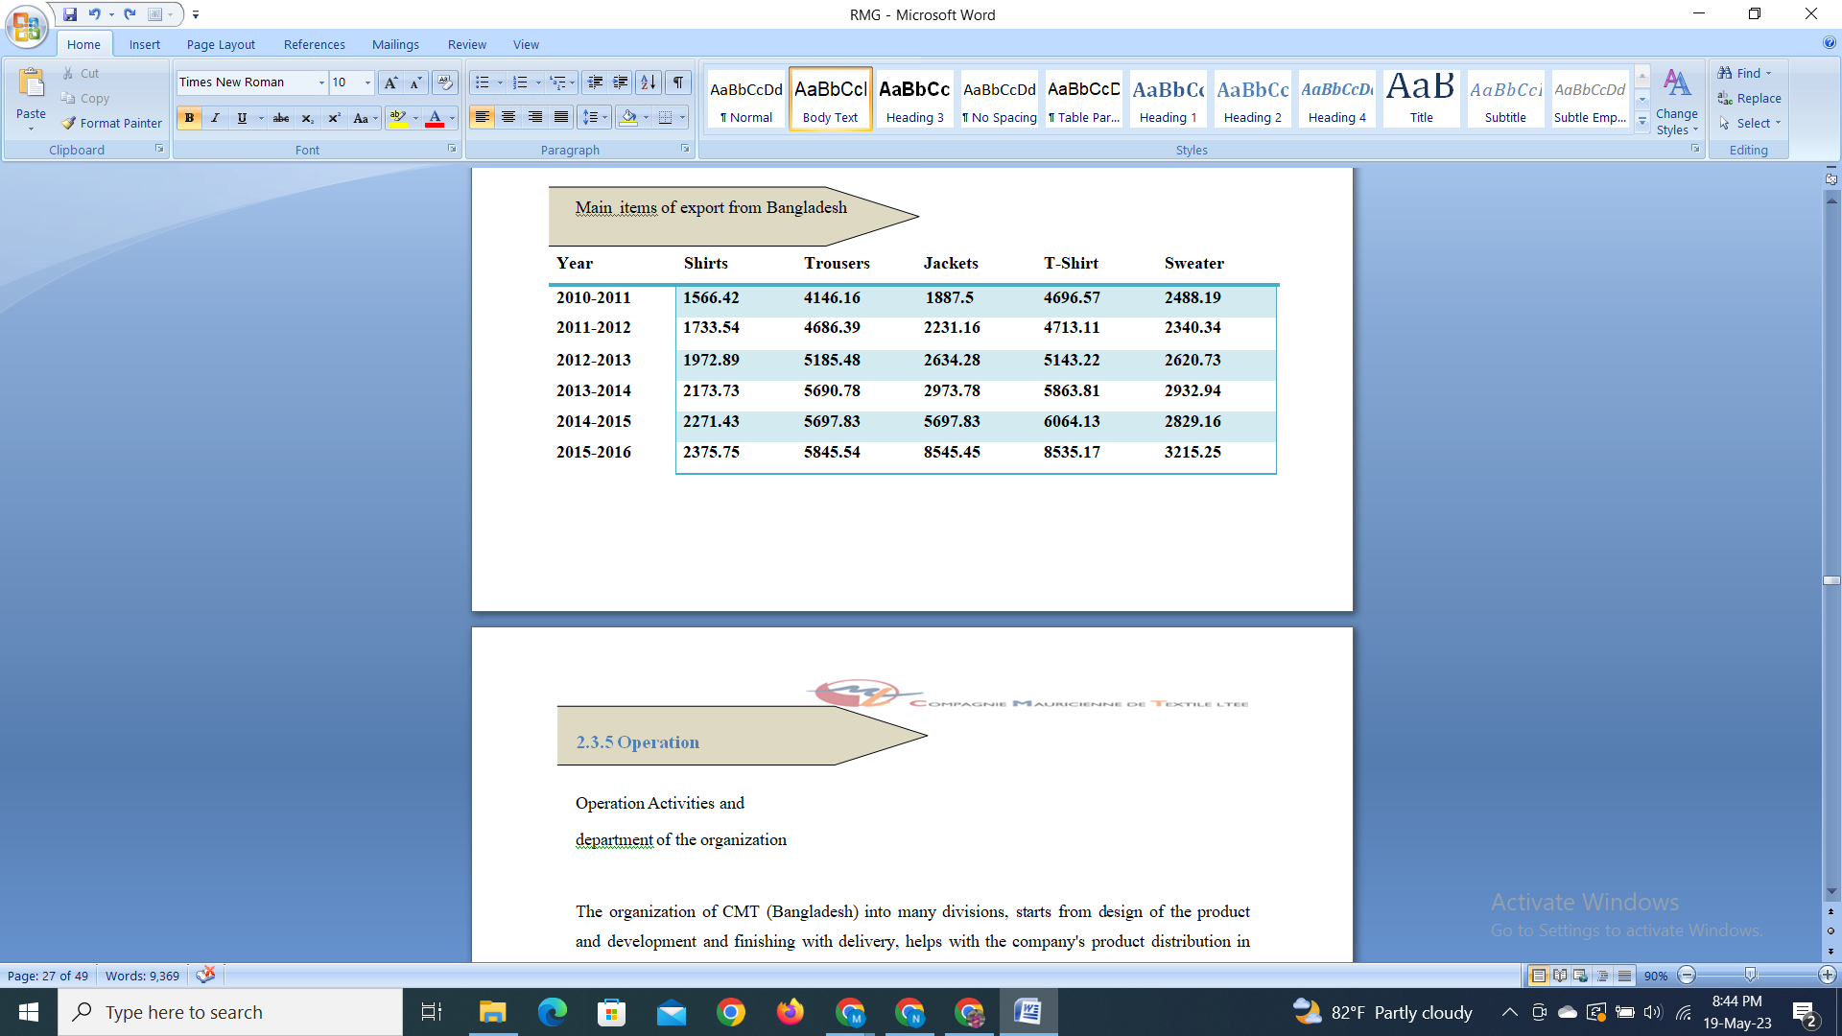

2.3.5 Operation

Operation Activities and department of the organization

The organization of CMT (Bangladesh) into many divisions, starts from design of the product and development and finishing with delivery, helps with the company's product distribution in Europe and the US. CMT (Bangladesh) guarantees the best product quality throughout the whole production process with a combination of cutting-edge technology, expertise, and a top-notch management team. To produce a better product, more than 6000 individuals put in countless hours in five different departments. The diagram below shows the functioning organization..
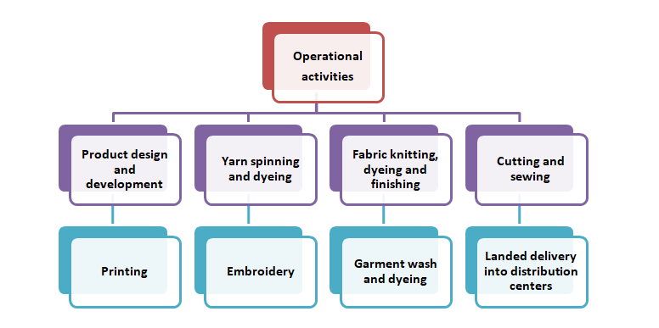

The best raw materials, primarily cotton, are spun first, then the garments are knitted, dyed, finished, cut, and stitched, and lastly washed and ready for shipping. Throughout the whole production process, they guarantee the highest quality. Vertical integration is used throughout the whole production process, which is methodically planned to produce high-quality goods and fulfill orders on schedule. A production unit picture helps to understand the organization's activity of production since it displays whole production unit's operations.
Department of CMT Bangladesh
1. The Finance, Accounts, and Audit Department of CMT is in charge of handling all financial transactions for the company. The other departments of the CMT are likewise protected by this department's integrity (Bangladesh).
2. Commercial Department: The commercial department is under the direction of Mr. Anwar Hossain. All processes and activities pertaining to export-import transactions are under the control of this department. In the CMT's Dhaka office, five determined individuals lead this crucial department (Bangladesh).

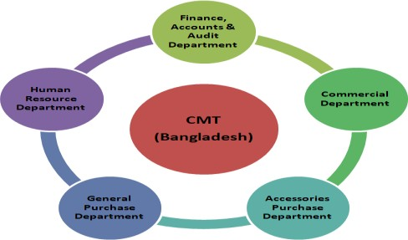

3. General Purchase Department: To support CMT's ongoing production and operation, the General Purchase Department largely purchases all manufacturing supplies and machinery (Bangladesh).
4. Accessory Purchase Department: This division is in charge of purchasing goods that are needed by the factory during the production process.
5. Human Resource Department: The human resource department is in charge of administrative functions, such as payroll, recruiting, and communication, via the use of a management information system.

Chapter III: Financial statement analysis and finding

By examining the information of finance, we may get knowledge about a company's managerial control, overall performance, and operational effectiveness. Examining a company's financial accounts is the most common way to assess its financial health. In this study, I use a variety of measures to assess effectiveness, profitability, and solvency of the CMT (Bangladesh) utilizing the financial statements of both Consumer Knitex Limited (CKL) and Dignity Textile Mills Limited (DTML).

Year to year comparative ratio analysis:

Current Ratio
cash ratio
6

4

2
cash ratio
0
12
13
14
15
16

Comments: The ratio exhibits a cyclical pattern. It reached its peak in 2014 and its absolute low point in 2012. However, this tendency does not reflect the true situation with reference to absolute current assets and liabilities. Current Asset was around 20321539779 in 2016 compared to approximately 3194154551 in 2014. However, CMT (Bangladesh) has been able to fulfill its current obligations during the past five years.

Acid Test Ratio
Acid test Ratio
2

1
Acid test Ratio
0
12
13
14
15
16

Comments: Acid Test Ratio has stablility over time. This ratio shows how well CMT (Bangladeshcapacity) can meet its short-term obligations by combining cash with its most liquid assets, such as marketable securities and account receivables. According to the year-over-year ratio, CMT (Bangladesh) only has a little quantity of liquid assets left over to pay for its current commitments.
Collection Period

Comment: The collection period is the amount of time needed to collect accounts receivable. The firm will have more money the shorter this time is. But that depends on the regulations of market competitors. According to estimates, the 2016 collection period will be approximately 28.39, much less than in previous years. This can be as a result of having more duties right now than in previous years.
Collection Period
200
150
100
50
0
Collection Period
2012 2013 2014 2015 2016

Days to sale inventory
Day to sale inventory
10
8
6
4
2
0

Day to sale inventory
2012 2013 2014 2015 2016
Comment: A statistic called "days to sell inventory" measures how long it takes to sell products. This ratio is used by CMT (Bangladesh) to calculate its working capital needs. This ratio illustrates the evolution of the trend over time. However, the variations are not significant. CMT (Bangladesh) sells their products quickly. There are approximately 5.54 days left in 2016.

Long term Debt Ratio

Comment: CMT (Bangladesh) did not acquire any long-term debt prior to 2014. 2016 shows the high amount of ratio than 2015, 2016 carries the long-term debt. The greater absolute amount of equity in 2016 is what accounts for this mismatch.

Time interest earned

Comment: The capacity to pay interest depends largely on the company's obligation to produce positive operating cash flows both immediately and over time. Thus, time interest generated demonstrates how easily the business ought to be able to pay interest if income patterns remain constant. In 2013 and 2014, the firm did not take on any long-term debt, hence the time interest earned was higher. As a result, the debt-to-equity ratio was high and the interest rate was low.

Major Finding of this study
For proving great service by all the departments they have been build up, the number of departments are 5 in total, and CMT (Bangladesh) provides excellent working conditions that aid to boost productivity.
• CMT analyzes the customer's purchasing choice to offer them a great solution by analyzing the ones who supplies and their activities to improve the quality of the product.
• To survive in the field by holding up the place CMT ensure the satisfaction level of the consumers in order to achieve the success aiming for.
• CMT uses a conventional pay and incentive structure, which greatly inspired the employee.
• Ratios provide a good explanation for operational effectiveness, profitability, and solvency during the chosen five years.
• To create high-quality products and guarantee on-time order fulfillment, the whole manufacturing process is a vertically integrated operation.
• To address its cash shortages, CMT (Bangladesh) must improve a few particular ratios.
• CMT (Bangladesh) uses cutting-edge technologies to enhance the quality of their products.
• CMT (Bangladesh) distributes its goods globally via efficient channels of distribution.
Or
• CMT (Bangladesh) offers excellent working conditions, which boosts productivity;
• Providing great service is the main reason of maintaining all the departments.
• CMT analyzes the customer's purchasing choice to give a better solution for them and also analyzes the supplier's activities to enhance product quality.
• CMT analyzes the customer's purchasing choice to solve it in a good way, also to improve product quality analyzing the ones who are supplying. This helps the company succeed and maintain its dominant position in the market.
• The employee was greatly motivated by CMT's usual award and payroll procedures.
• Ratios adequately describe operational effectiveness, profitability, and solvency during the chosen five years.
• Manufacturing procedure is planned to manufacture high-quality goods and guarantee prompt order fulfillment.
• CMT (Bangladesh) has to improve on a few particular percentages to make up for its cash shortages.
• To improve the products quality, CMT (Bangladesh) uses technology of cutting-edge.
• CMT (Bangladesh) uses efficient channels of distribution to market its goods globally.

3.1 SWOT analysis
- Strength
- Weakness
- Opportunity
- Threats

A company may enhance the situation, product quality, risk management, and open prompting by doing a SWOT analysis. It can also uncover its competitive edge. Additionally, it helps a business understand where it stands in the industry. To help you better understand how the firm is incorporated, below is the SWOT analysis of CMT (Bangladesh).

Strength
- Compagnie Mauricienne DE Textile Ltée (CMT) process of managing is continually devoted by exceptional service.
- CMT employs group of workers who are honest and accountable.
- CMT keeps upper management and workers in civil relationships.
- The foundations and rules could not be upheld in line with recognized law because of government intervention.
- CMT employs cutting-edge information systems.
- CMT keeps senior management and employees in close contact.
- The security mechanism at CMT is robust.
- CMT's office is well furnished.
- As a result of government interference, it was difficult to keep the rules and regulations running in the right direction.
- Only senior management may make decisions.
- Inadequate government policy.
- Bangladesh's markets are underserved

Opportunity
- Increasing service quality compared to competitors
- Increasing service quality compared to competitors
- Increasing client satisfaction by offering high-quality products
- Seizing the chance to make a significant profit
Threats
- An increase in international purchasers.
- Government regulations halt the process of progress.
- Increasing manufacturing costs.
- The laws and regulations of the BGMEA are quite complicated.
- The village politics in the vicinity harasses the project regions.

3.2 Ready Made Garments Export Condition

Bangladesh Garment Producers and Exporters Association (BGMEA) is the country's sole recognized trade association that represents the country's export-oriented garment manufacturers and exporters. Struck by the political turbulence in Sri Lanka and price increases in other Asian nations in the 1970s, foreign textile purchasers investigated the possibilities of the newly established Bangladesh. Fortunately, with appropriate government policy assistance, entrepreneur skill and efforts, and labor from the workforce, the ready-made garment (RMG) business was able to prosper and purchasers gained confidence in it. Its current growth rate is 20% each year on average. With a large supply of low-cost labor, the country's economic circumstances support development in this comparatively low-capital, high-labor-intensive industry. Beginning in the late 1970s as a modest atypical export sector. By 1983, ready-made garment (RMG) had developed as a viable export generating sector for the country. Bangladesh lacked a non-government trade group devoid of conventional bureaucracy at the time to assist the industry in increasing the country's foreign exchange revenues.In the years following independence, businesspeople and the government recognized and stressed the critical need to create non-traditional exportable goods to support the faltering economy. As a result, Bangladesh Garment Manufacturers and Exporters' Association was founded in 1977. (BGMEA). The BGMEA has developed into a powerful and active organization since its modest beginnings with just nineteen (19) garment producers and exporters. Today, it proudly states that more than 2700 producers and exporters of clothing are registered members. Out of the total 2700 units, 1932 of them are garment manufacturers in Dhaka, while the remaining 155 and 415 are in Naryanganj and Chittagong, respectively. While roughly 155 and 415 factories, respectively, are situated in Naryanganj and Chittagong, factories are situated in Dhaka. The 2700 garment manufacturers, which employ around 1.5 million people, generate 73% of the nation's total foreign exchange. This industry directly employs about 15 million people. The garment business has contributed to the expansion of the country's banks, insurance, hotels, and other industries. In a nutshell, the country's economy has centered on the clothing sector. However, the main goal of BGMEA is to create a favorable business climate for tight, mutually beneficial relationships between producers, exporters, and importers, so assuring a constant increase in the country's foreign exchange revenues. To this purpose, the BGMEA has been actively leading the sector in coordination with the government.
Export analysis by BGMEA.
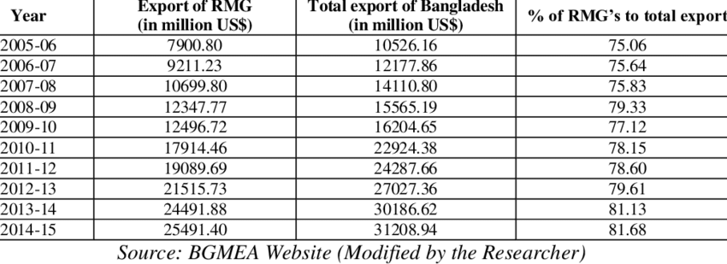

3.2.1 Comparing the Export Performance Analysis of MS Knit Design Ltd. Factory and Consumer Knitex Limited
Fiscal Year | Export in MS KNIT (Million) | Export of Consumer Knitex ltd
2011-2012 | 148 | 90
2012-2013 | 160 | 95
2013-2014 | 190 | 105
2014-2015 | 209 | 130
2015-2016 | 250 | 170

Total export on MS Knit Design Ltd. factory in 2012 to 148 million USD and it increase in 2016 to 250 million USD. Total export on Consumer Knitex Ltd. factory in 2012 to 90 million USD and it increase in 2016 to 170 million USD. Here we can see local company is ahead of foreign company but the increasing rate is very high of Consumer Knitex lit. MS Knit should focus more on the development of its export so that foreign company uses more tactics on taking more orders and does more exports.

Chapter IV: Internship Experience

4.1 Position, Duties & Responsibility

4.1.1 Job description

I started working in a position of intern with Consumer Knitex Limited in the department of rewards and talent acquisition and the finance, accounting, and audit department. The primary duties of Compagnie Mauricienne de Textile Ltée's Accounts and Finance Department are recovery and financing for the necessary projects (CMT). In essence, right investment takes care of both financial and non-financial profits given to CMT BD Ltd personnel. As an intern, I perform certain routine duties including processing checks, verifying invoices, handling the business's finances, and maintaining the accounts for new projects frequently. Being a part of the talent acquisition team, I have gained knowledge about the procedures used when dealing with applicants that perfectly match the job specifications.

4.1.2 Specific responsibility of the job

Every organization nowadays aims to maintain a computerized system for keeping track of its data. Due to the freedom it enables them to recode information, summarize that information, and report transactions to senior management, many organizations choose straightforward accounting software. Following rest of the companies, CMT (Bangladesh) utilized famous accounting application SAP. Parents The CMT firm in Mauritius is the main user of this software. The main users of this software at CMT are the purchasing and accounting departments. Every purchase is tracked by the CMT buying department, who also inserts it into the software. Utilizing the program, the CMT Purchase Department generates a PURCHASE ORDER (PO). Moreover, I looked after it during the period of internship by carefully reviewing each Purchase Order (PO) and other expenditure.

4.1.3 Internship Experience

Starting internship in a role of an individual responsible of CMT's Reward & Talent Acquisition Team (Bangladesh). The CMT guarantees a great workplace environment, and all of the employees are quite friendly. While I'm working as an intern, they teach me a lot of practical applications of what I learn in school. Every section is extremely well structured, and the company headquarters is nicely decorated. A tremendous triumph for me has been working with this really competent team. Everywhere you go, the working environment is supportive of nature.

4.2 Training
During my three months of employment, I was assigned for arranging people in a meetings, planning, coordinating and discussing about the task that was provided to me. All the people treats an individual as a constant representative, which makes it difficult for me to move quickly and learn about the real state of the business sector. The environment is fantastic, and the employees are kind.
I was involved in a variety of activities as an intern. My main duties among them are listed below:
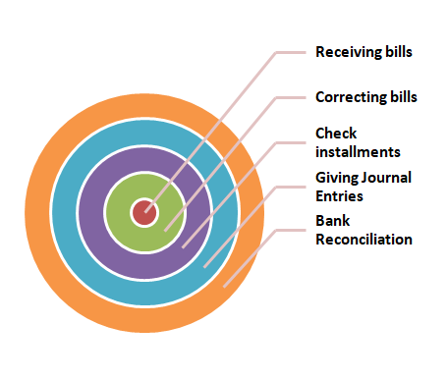
Receiving Bills
Numerous invoices with varying textures, frills, and objectives arrive daily from various sources. These invoices must be accompanied by a few important documents that Baxter Security Service and the material checking focus must join and check. The Invoice, P.O. (Buy Order) of the supplies, and the MRIR are the documents that must be connected (Material Receiving and Inspection Report). Mention of particular people is needed under the laws. One bill should carried after the verify and connectivity of required things The invoice is changed then submitted for installment.
Correction of Bills
Next thing is to work with the bills after getting it on hand. Coordination of the quantity received with the organized quantity, recognition of the MRIR (Material Received and scrutiny Report) quantity received and receipt quantity, removal of the rejected materials from the actual bill, and a second review of the problem-solving process all contribute to the system of bill adjustment. After correction, these invoices are provided for any kind of installment process.

Checking payments

In CMT, we must be required to pay our suppliers since we must acquire raw materials and equipment from several vendors. We must thus pay particular attention to each supplier installment. We take great care to preserve all payment records. The payment to vendors is recorded using SAP. We pay our suppliers using a unique method that makes it easier for them to comply with American business regulations.


Bank Reconciliation

We document every aspect of our bank transactions, including cash and credit card deposits as well as money withdrawals, in the bank reconciliation process. It quickly gives us information about our bank balance, enabling us to have enough on hand to protect our financial activities.
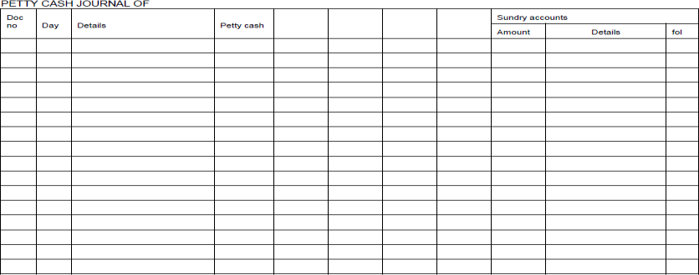

Scanning
I also do scan since the accounts and money department was responsible for it. I scanned the papers that had been on hold for the previous year.
- Document scanning will save us time and money, among other things. If any documents or invoices must be seen without being scanned then looking for the boxes will be a time consuming process and that needs to be done.
- The desired information must be find out by scanning; for example, if you needed any invoice range, you would just need to look at the scanned picture to get your information.
- Document scanning is necessary to save storage space. The document can not be kept along all the time, same to how you won't be able to transfer the documents by scanning in computer.

Uploading on accounting portal

Along with a brief explanation of each document, I also submit the scanned copies to the CMT's accounting site, which is directly connected to the Mauritius headquarters. With SAP, which is instantly integrated to the CMT accounting portal, all company paperwork and bookkeeping are tracked (Bangladesh).

4.3 Skills Applied
As an intern, I also did well in tasks like market visits and market assessments. Auditing tasks include going to the market and attempting to determine the true market price of the goods or its quality, among other things. I've also had success in a lot of other industries because to my understanding of finance and marketing.

4.4 New Skilled Developed
Problem Solving Skills
The ability to solve difficulties grows as a result of your exposure to real-world workplace issues during an internship.

Work Ethics
Until you are in a true working setting, the fact of working ethically can not be learned. In college, we are used to providing justifications for things like late assignments and inconsistent attendance. However, developing occurs after working ethically and practically in any sector.

Adaptability Skills
Not everyone has the ability to adjust right away. You may even choose not to be such throughout your internship experiences, but you will still lose. Being readily adaptable to your circumstances is one of the most valuable soft talents, vital for your own development as well as appealing to employers. In order to develop some adaptation skills while you are there, make the most of your internship experiences.

Communication Skills
Can the value of communication skills ever be adequately expressed when discussing soft skills? One of the top abilities highlighted by recruiters in a CV, it may take you from the bottom to the top. You may develop the talent of effective communication via your internship experiences.

Responsibility
Being accountable is an essential ability for the job, yet it is occasionally overlooked on lists of soft talents. After internship the responsibility and decisions of life should be fulfilled properly.
Time Management
It is no less significant but the final thing. In the past, you could simply miss a course if you had commitments outside of school. When you are in an internship, which is essentially the beginning of your career, you cannot consistently disclose your absence.

Learning the time management leads to maintain balance in two things personal and professional life.

4.5 Application of academic knowledge
With my previous experience, I was able to complete the many MS Word and MS Excel tasks that were required of me in the role of intern in Consumer Knitex Limited’s finance sector. For my scholarly understanding, I've taken courses in corporate finance, financial statement analysis, etc. I have learnt a lot of useful Excel skills.

Chapter V: Conclusion and key point

5.1 Recommendation for improving departmental operation

The recommendations are for CMT (Bangladesh) so that their performance based on financial terms gets better. These recommendations assist CMT (Bangladesh) in achieving its objectives while assuring better service.
1. To enhance profits, raw material costs should be decreased. To do this, a strong marketing plan must be used to raise sales volumes.
2. Give the employee the right training so that they can keep up with the sector's shifting trends.
3. Improvements in ordering procedures, delivery systems, and manufacturing technologies.
4. The least amount of period to flip the inventory in money and make sure receivables are collected quickly.
5. The least amount of period to flip the inventory in money sales.

5.2 Key Understanding

Bangladesh's (RMG business plays a vital role also it is profitable. The vital role that Bangladesh has played from 1978 in RMG. The earning that is earned in clothing and textile sector of Bangladesh is 85% in total and the sector of appear covers 75% of it., that primarily creates knit and woven shirts, blouses, slacks, skirts, shorts, jackets, sweaters, sportswear, as well as a wide range of other everyday and trendy items. Nearly 1.5 million individuals are employed in the sector at present, the majority of them are women from underprivileged socioeconomic backgrounds.
One of the top vertically integrated apparel producers worldwide is CMT. The company's mission is to "compete with the leading market of inside and outside the country. Making everything by train and support employees to develop. investment in technical part keeping fashion ahead of They will aid in the social and economic growth of our nation by turning into a center of learning. Beyond our wildest aspirations, our desire will carry us! a dedication to fashion and a passion for excellence. In 1986, the company was founded by two driven entrepreneurs with the help of 30 workers, with the straightforward goal of producing high-quality goods and offering first-rate customer service. Numerous workers who have been with CMT from the beginning have helped it develop into a reputable and dedicated employer of choice.

5.3 Conclusion

The economic development of nation is effected by the industry of RMG located in Bangladesh. The RMG and textile industries have contributed significantly to Bangladesh's exports during the last four years. In the industry of fashion mainly known for the wears like jersey are investing in the market by the company named (CMT)
How well and how far RMG marketers can manage the risks brought on by local and global uncontrolled elements will determine the industry's viability and potential for expansion. It will be a significant task for Bangladesh since there are many internal uncertainties relating to political and governmental norms and regulations. Additionally, unexplored international markets need careful consideration and intense planning that hasn't previously been seen in that approach. The sorts of textile and apparel items that will be relatively favorable for Bangladesh must be determined as a result of the required preparation. The countries economy is making contribution in overseas economy and in home economy as well by reducing poverty by generating employment, particularly for women workers directly and indirectly through the development of various linkages industries. In the field RMG is the biggest focusing factor for the market of Bangladesh. Since 1981, the RMG's exports have grown by 24 percent annually, reaching US$4 billion. Bangladesh has a three-pronged strategy to become competitively strong. Initially, to enhance the general operational effectiveness and technical advancement.

Finally, expanding the product line and looking for fresher export markets. The development of effective strategies and the execution of policies are essential to success. Future expectations from this industry shouldn't be negative, given its existing performance and contribution to the process of economic growth. Instead, business and government must make all-out efforts to provide foreign marketers with the tools they need to succeed by addressing any uncertainty and seizing any possibilities.

Reference
https://www.bgmea.com.bd/home/about/AboutGarmentsIndustry
http://www.bgmea.com.bd/home/about/Economy
https://en.wikipedia.org/wiki/Textile_industry_in_Bangladesh
https://www.educarnival.com/contribution-of-rmg-industry-in-bangladesh-economy-and-mfa-phase-out-effect/
http://www.cmt.mu/the-cmt-way/
Bibliography
(n.d.). Retrieved from wikipedia : https://en.wikipedia.org/wiki/Textile_industry_in_Bangladesh
(n.d.). Retrieved from Bangladesh germents manufacturer and expoters assosiation : https://www.bgmea.com.bd/home/about/AboutGarmentsIndustry
(n.d.). Retrieved from Edu Carnival: https://www.educarnival.com/contribution-of-rmg-industry-in-bangladesh-economy-and-mfa-phase-out-effect/
(n.d.). Retrieved from compagnie maurieie de textile ltee: http://www.cmt.mu/the-cmt-way/

