Social media or social networking system makes young generation lonely and unsociable!


Research Topic: Social media or social networking system makes young generation lonely and unsociable.

Submitted To
S M Asif Ur Rahman
Assistant Professor
School of Business & Economics
United International University

Submitted By
Sabrina Siddiqua
ID: 111 161 271
Bachelor of Business Administration (BBA)
Major: Marketing

Date of Submission
30th October, 2020

Letter of Transmittal

30th October, 2020
S M Asif Ur Rahman
Assistant professor
School of Business and Economics
United International University.
Subject: Submission of Report on “Social media or social network system makes young generation unsociable and lonely”

Dear Sir,
With due respect Sir, I prepared a report based on my research topic. I tried my best to prepare the report with necessary and suggested proposals. If the report has any mistakes such as some grammatical mistakes and other staff, please do forgive that.
I did all the activities in a concise and comprehensive manner. I hope that this report will fulfill the expectations.

Sincerely,
Sabrina Siddiqua
ID: 111 161 271
Bachelor of Business Administration (BBA)
United International University

Table of Content

Executive Summary vi
Chapter 1 1
“Introduction” 1
Background of the report 3
Objective of the report 4
Scopes of the report 4
Limitation of the report 4
Methodology 4
Literature Review 6
Chapter 2 7
“Finding and analysis” 7
Age 8
After waking up I touch my phone within 5 minutes 10
Most of the time I spend on social media without any reason 13
I think I am too much addicted on social media or social network 15
I feel very much uncomfortable to talk with unknown person in real life 18
I always so much busy to post my activities in stories or news feed rather than enjoy it in practically. 20
Most of the time I feel upset and bore 22
I spend more time on social media or networks and get bore and again I continue because I have no option without it 24
On study time I always touch my phone 25
I prefer to play games rather than gossiping with others 27
I sleep at late night and the reason is social media 29
Whenever I watch others post I feel jealous 31
Social media is one of the major reason to distract the goal 33
I feel like no one understand me 34
I always worry about my posts to know about how much likes I get 35
I feel like my relationships with my friends are bounded in social media 37
Too much spending time on social media I become unproductive 38
Sometimes I feel headache by spending too much time in social media 40
I should control myself to spend time on social media 42
Chapter 3 43
“Suggestion & Recommendation” 43
Positive effects of social media in human life 44
Negative effects of social media in human life 45
To control the use of social media 46
Ensure the good or effective use of social media 47
Brands can ensure the righteous thought to their customers 48
Chapter 4 49
“Conclusion” 49
Reference A
Questionnaire C

Executive Summary

This report I divided into four chapters and in chapter one I focused the objective of the research and in chapter two I described the survey results and also in chapter three I gave some suggestions that how can young generation people overcome from this issue. In last the conclusion part I described the ending note in a short.
The research basically on the young generation who are attached with social media and too much using this, it makes them unsociable and lonely which is very harmful for their mental and physical health and also it effects the next generation. I do survey over 100 people about this topic. In the survey I put some words which is daily life basis activities. I collect the thoughts of them, what actually they think and they are actually addicted on social media or not and the ratios are mostly positive that means they are addicted on social media use. It effects their mental and physical health and also it makes them unsociable and lonely.
In chapter three I provided the details that how can the youth or young people overcome from this issue and do a right use of social media. I also mentioned others such as families, brands, and so on, they have also the responsibility to help the youth from this issue.

Chapter 1

“Introduction”

Today’s world is digitalized world! Everyone is so much updated and walk with the flow of digitalization. Technologies are more advance than before, which reduces the pressure of work for human also provide free time to enjoy their life in different ways. Modern generation people are too much connected with their technological stuffs. Day by day people are getting more attached with the technological stuffs. Now people are more comfortable with the technologies rather than people but the interesting thing is people makes those technologies! In these digitalization based world one term is very much acceptable to the people and that is “Social Media or Social Networking System”. These social networking system or social media has uncountable good things or benefits but also have so much bad things which are affecting to the young generation! In whole world the people are doing so many thing through social media even their studies too but in generally they are alone in real life or getting depressed because of using too much social networking system or social media. They become more lazy and unsociable. They take it too much serious the virtual life rather than real life. People are like to conversation in social media but in real life people haven’t any time to close with others. Most of the time people or young generation people are busy to post everything in newsfeed or story updates, even friends are connecting through social media rather than real life.
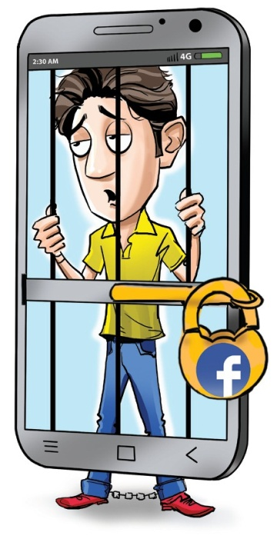
As an example - in birthday we can see friends are wishing in news feed or story with attached picture but not wishing through call or meet. Same case happen in different functions of the people and people always try to be happy in virtual life rather than real life.
In these way they become more lonely and unsociable also get depressed. Whenever the depression become higher then they have no sense about what is she or he going to do, is it right or wrong they haven’t any sense and ultimately they choose suicide. Now in modern society we are facing these issue and we have to do something to save our young and future generation! Doctors and psychiatrists are claiming that too much attached with social media or social networking system is harmful for health and it makes people more lonely and unsociable. In one study found that limiting social media use to 30 minutes per day can reduced feelings of depression and lonely (Haridy, November 13, 2018). People more advance and updated but another side social media or social networking system makes young generation unsociable and lonely. So people should to use those stuffs with proper balance otherwise it can destroy their life.

Background of the report

In these modern world people are attached with the technologies and through technology they are connected with people all over the world. Social media or social networking system is the major reason behind it. In young generation most of the people are more comfortable in social media rather than real life. It makes them unsociable and lonely which is very much dangerous for them and upcoming generation. Based on that issue i do study on it and find out more information to know about it in depth also I do survey on 100 plus people to know about that what actually they thinks. Then I applied my institutional study and took help of my respectable faculty to clarify some sort of issues and finally I find out my results and it gives me righteous thought about it and enhance my skill also knowledge. I also applied my major subject based courses such as consumer behavior, strategic marketing and so on.
By doing this task I learned so many things which will be helpful for me in near the future, doing these report I learned about that how to do a research paper and also interact with people to know more. By doing this research I gain a great learning experience and I thankful for it.

Objective of the report

- To know about young generation that how does social media or social networking system negatively impact their life.
- To reach the final result and find out solutions to cure the issue of social media or social networking system.
- To assemble the institutional knowledge and major subjects based knowledge.
- To learn about how to do a research paper and find out the information in details

Scopes of the report

- By doing this research it will be helpful to me to publish it in near the future.
- It enhance my knowledge and my confidence which will be needed in the future to do any research.
- By doing this research I can relate my institutional knowledge also my general knowledge to make it reliable.
- It gives me a valuable work experience and increases my communication skills through survey.

Limitation of the report

- Lack of collecting information through physical way.
- Lack of proper knowledge.

Methodology

- Research type: This research is casual comparative based research where I used qualitative and quantitative process. We only know about the benefits of social media but don’t aware about the harshness about it. This research paper focused on that issue and find out the solutions about how to cure it from our modern society.

- Data type: In this research paper I used two types of data collection method which are primary data and secondary data. In primary data collection I did survey among 100 plus people and they all are mostly young age based people because I focuses on young generation. Another side I took help of different journals of outside based countries also publications of different universities and magazines, and so on.

- Sample size: The survey has been done among 100 over people. Most of them are young age based. This research paper focused on the issue about social media which makes young generation lonely and unsociable.

- Sampling technique: The result of the survey is positive and it focuses that young generation feel it that they become unsocial, lazy, and lonely because of too much using social media or attaching with social networking system. In that perspective I would like to say that it is reliable. Probability most of the people agree with this issue and they want to overcome it.

- Data collection method: In the research paper I used two types of data collection method. One is primary data collection method and another one is secondary data collection method. In under primary data collection method I did survey on 100 over people and they are mostly young. In secondary data collection method I took information from different publication of different universities, magazines, articles and so on.

- Data analysis method: The research is based on qualitative information and the content of report or research topic is different, for that reason I did survey based on some real life based questions which are familiar with our daily activities. By focusing on that thing I used content analysis process. Basis on those questions I interpreted and analyzed the answers.

- Data presentation method: In these report I put all the information through graph and charts and also In detail words to clarify the data.

Literature Review

In the world most of the people are connected with social media or social networking system even people are now-a-days doing most of the work in these platform but the fact is people are not aware about that they are addicting day by day or depending on it too much. Without it people doesn’t want to imagine a single day and because of it people are not that much concern on that issue. Now a days young generation are too much addicted on it and it makes their health worst. Many researchers investigated on that issue and they find that social media not only the reason of loneliness and unsociable it also makes a person physically weak. Because of that issue some has eye problems , some has headache, and so on. If we look around our outside or inside then we will notice that everyone is so busy to connect or active on social media or social networking system. People are so busy to represent them in social media that how much they are happy but end of the day they all are find to tal with other people and feel loneliness and that is the reason of the first step of depression. Even if we notice inside our home then we see that there are many children or little member are also busy to watch YouTube cartoons or videos. In these way parents are also doing the wrong thing. Even most of the parents now thinks that if their child not attach with social media then their children are not smart. In these way overusing or over depending makes the generation more lonely also unsociable. Now-a-days children are not that much free to engage with people because they find their comfort in video games or social networking system. Most of the girls are so much busy to post their pictures in social media rather then gossiping with their friends. Even now a days people help the poor or needy person and take a picture to post on social media. Young generation people are also doing the same thing. Many universities publishes or research on this issue also many newspaper or journals publishes articles on that issue. People are now lead their life in unhealthy way, Most of the young people sleep at late night because of social media. In these way the young generation makes their health worst also feel lonely and unsociable. Many researchers said that if they control the limit of uses of social networking system then it will make their life more fresh and healthy. Young generation people should maintain the uses of social media otherwise it will be very much difficult for them to handle their physical and mental health.

Chapter 2

“Finding and analysis”

“Social media or social networking system makes young generation unsociable and lonely” based on this topic i prepared some questions behalf on that issue to know about more that what actually people or young generation thinks about it and collected information about it from them to analysis on it that the above statement or topic actually acceptable truth or not. The survey done through online basis because of Covid-19! It is very much risky to go outside and collect information about it in that reason I choose to collect data through online. I prepared Google survey form to collect information from people. Although I can collect information from different age based people but I focus mainly the young age based people because the topic very much relatable with it and my major concern about them. In this survey I prefer mail account rather then their name because it is much easier for further research to contact with them through mail to know about more. Based on this topic i made the survey questionnaire and get results from more than 100 people and now I analysis the result that how does they actually think.

Age

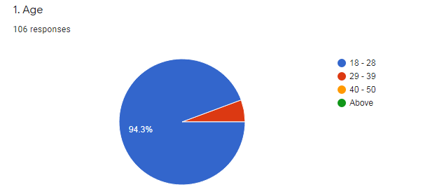
I already said that I mainly focus the young age based people and most of the participants a are between 18 to 28 age based people. That is the reason of 94.3% out of 100% are young people and in the chart also see that the responses are 106 people and also rest of portion of the chart are 29 to 39 age base people. The topic of the research is based on young aged people in that reason most of the responses are 18 to 28 age basis. In modern world the young generation are very much smart and very much advance with the technology and also affected through it the most. It is easy to me to get information from them rather than high aged based people because older age base people mostly not that much active in social
media or social networking system and some people are not that much understand that issue. Based on all that issue I choose to work with this age basis people.

After waking up I touch my phone within 5 minutes

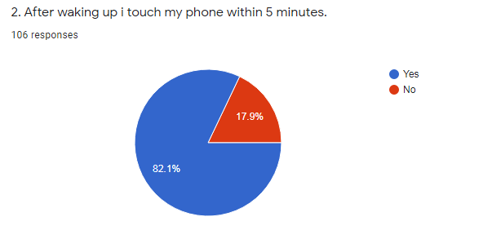

The second question of my survey was above one and the responds mostly goes on yes and the ratio is 82.1% which is very much higher than no ratio. If we see the ratio of no that is 17.9% which is low but it is nice to hear that some young age people not touch in the beginning of the day their phone. Most of the people touch their phone after waking up and it is very much harmful for them and once a person enter the social media or social networking system then they don’t understand that how their time flies! Many scientists said that after waking up a person need to refresh their mind through exercise or talk with human and it is very much harmful to the people to touch first their phone and scroll in social media based networking sites, it damages the brain activity. Many universities publishes about it. In the technology or electronics which we are using in our daily life such as computer, mobile, laptop, tablet and so on these all stuffs are very much harmful for our eyes because it gives us the blue light reflection which we are not seeing but the color is blue but we see it white (Peters, October 5, 2019). This blue light reflection is very much dangerous for health and our eyes. In many researchers find out that young generation based people are using too much these all stuffs and their eye power day by day decreasing and it is not far that it is the reason of the blindness of the eye. Many researchers claim that when a person touch their

phone or lap[top or something else to check out the mails or enter social media , they stay more than 5 minutes and so much things or news they discover. It gives them the news or knowledge but mostly gives them the mental pressure and that is very much harmful for their health and brain. People are not aware about it and daily they do it because it becomes their habit but it is very much harmful for their mental and physical health. Some are argue about that it is very much helpful because it has the alarm function and they can wake up in their time but most of the young people after off the alarm they enter the social networking system or social media to know about that who messages them or check the Instagram news feed , Facebook news feed also check the messages of mail or notifications and also scroll more than five minutes continue and not get up in a sudden way and that is harmful for health. After waking up they see the blue light reflections and they take the pressure first rather than clean their self and take fresh air or exercise (Kathleen E. West, Michael R. Jablonski, 1 March, 2011). In these way the body or the fresh energy losing from their body and they failed to build it and the day spending with laziness. That is the one major reason to make them addicted with social media because day by day it becomes their strong habit and it makes them unsociable and lonely. In the morning everyone has the positive energy and with it they can start their day in a better way with full of energy but they take the first wrong step and social media or social networking system is quiet interesting place and it kills the time but person didn’t get aware about it. In the first portion of the day it has to be refreshing and healthy activities based not harmful based. According to science after waking up people should to take fresh air and exercises which can provide the energy and refreshments to work in full day.

Most of the time I spend on social media without any reason

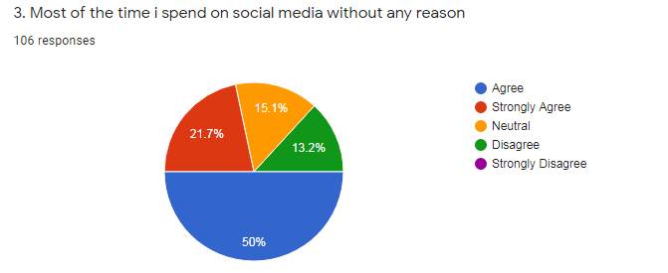
Here in this chart shows that 50% people are doing that and 21.7% people strongly agree with this issue that means 71.7% people are agree with this statement. 13% people are disagree about it which is very good for them and 15.1% people are confused about it or not to tell about it. Most of the young people are doing that without any reason for pass their time. If we see around our side we can see that young people or students are always busy with their phone even in bus or in restaurants and so on places. They are vey much attached with the social media and very busy to post their life based activities. I asked my relatives or cousins they told me that they have nothing to do except it, sometimes they watch movie, series, even vlog but they said that they are always active in social media because it is the place where they can connect with people and also enjoy the entertainment platform. In social media they can gather about different type of knowledge that are based on cooking, makeup based things and so on. After use the social media then they have nothing to do that much or they lose the interest to do something in practical life for that reason they choose again to go in social media and time flies and they don’t notice about it. Some people are claim that it is the best site to pass their time whenever they have nothing to do but some are claim that it is an addiction that too much connected or using social media. Most of the teenager has their own phone or laptop or tablet and they play different types of video games and in those video games sometimes some abusive something or negative advertising happens and it damages their thinking capacity and push them to involve in it which is very harmful for their up growing stage. If we see other side we can see that parents are also giving their children the gadgets to play and don’t focus on that actually what are he or she doing and it may cause the negative impact of that child. Now-a-days people are very much involve in social media and it is the reason of depression. According to a recent poll on result published that 22% teenager are log in their favorite social media more than 10 times in a day which is very much disappointing because once an enter in social media it kills so much times and it is about 10 times (O & Keeffe, April,2011). It decreasing their thinking capability also understand ability. It is very much important to gossip or talk with people in real life and communicate their close persons also very much important to do the activity of daily life in a proper way but people are so much busy in social media and they realize that it is fine place but it hampers their work also their health. That is one of the most crucial reason of depression and many of them understand that life is meaningless and then they go for suicide attempt which is happen In our modern generation because it decreases the thinking capability. Blue whale is a game where person once enter then their last stage is die! It is not accepting in our modern society. Modern is needed to our work easier or we can do work in a smart way but we are now-a-days getting trapped in this social media or social networking system.

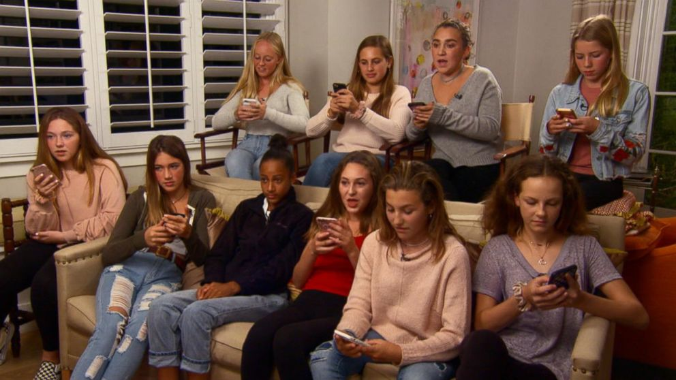

People are too much using their smart phones or laptops not only for work but also check out in social media. People are said that social media is a platform where they can stalk out many people and connect with them and also without any issue they can connect with others also can enjoy different type of videos, memes and so on.

I think I am too much addicted on social media or social network

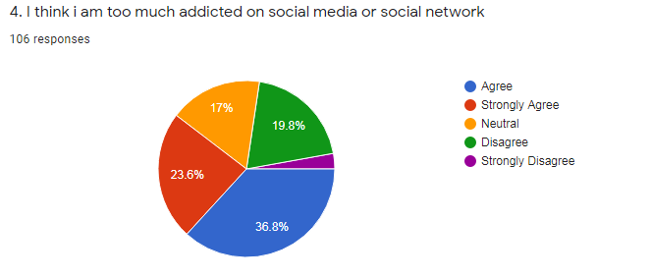
Here the chart shows that 23.6% people are strongly agree with this and 36.8% people are agree with this that means more than half of portion agree with this statement and also we are seeing this picture in our society. People are very much addicted on social media because they think that it is the best platform for entertainment also time pass. Many young boys are crazy about video gaming or online gaming also girls are too busy to post their pictures or so on. Even young generation are think that too much active in social media is smartness but it is harmful that is they can’t understand or understand but not concern on it. The children are also enjoying Youtube videos or doing Tiktok and video games also which is very harmful for their mental and physical health. It is damaging their thinking capability and also makes them unsociable. Whenever they get older then they don’t want to talk with people because they are not practicing it. Social media or social networking system makes young generation lazy. The use of time in social media they can use it by doing exercise and profitable task. This addiction also effect negatively on their education and so on such as:
- Reducing learning capabilities
- Reducing research capabilities
- Reducing creative learning skills
- Reducing command over language use age
- Time consuming
- Reducing their institutional grades
- Losing motivation
- Effecting their health
These all things are happen when a people or young people getting addicted on social media or social networking system. Students are now attaching with social media and they get easily the information and they are not doing hard work to know about the information and this thing reduces their capabilities of learning. The student are time spend more on social media and that is the major reason they can’t interact with others easily but in modern business world it is very important to talk face to face with people otherwise no one can get satisfaction and for that issue now the businessman are very disappointing that new graduates has not the capability to talk with other person with confidence (W. Akram, 30, October, 2017). The people are also using slang words and shorten words in their typing which is not acceptable in business or corporate world. Sometimes teachers are facing these type of issues in the exam script of their students. It is increasing day by day and the reason is too much spending on social media and social networking system. Student gets low grade because of copy the data through internet and directly do copy paste which is not good for them. Taking help through internet is acceptable but totally copy is not acceptable and finally they get low grades and get depressed. By using social media or social networking system they lose motivation and totally depend on social media this is very much harmful their inner mental health. It effects their physical and psychological wellness. By social networking system not only people but also society facing trouble such as:
- Cyber Harassing
- Hacking
- Addiction
- Fraud and scans
- Reputation hamper
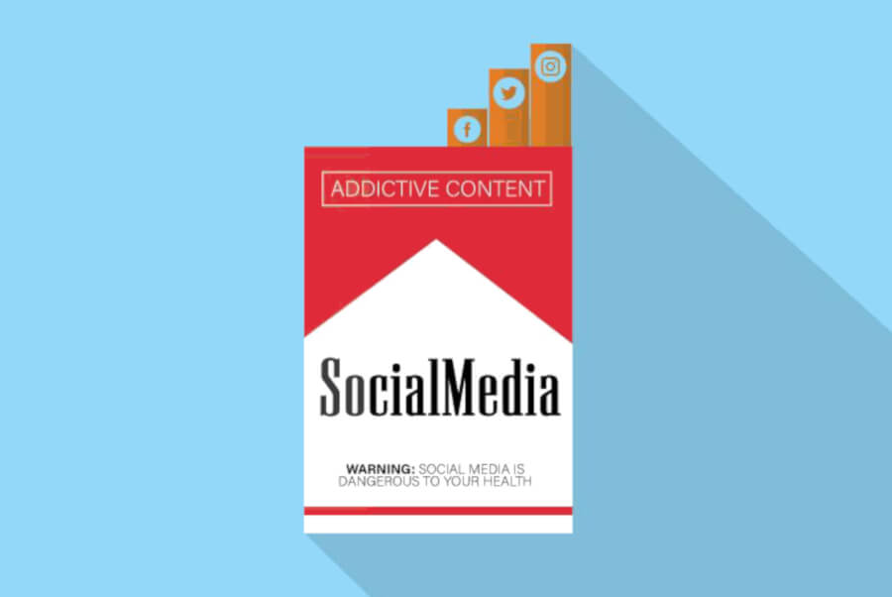

In social media so many hackers has and their work to do harm to people. If we see around us then we can focus that the young people are caught or trapped and their negative pictures some hackers posted their newsfeed by hacking their websites or social media related portal. Kids are not that much aware about it and they get trapped when they click on games related advertisement and so on. The social media has lack of privacy and victim not aware about it. These sort of things make young generation more depressed and lonely. They become unable to share those sort of things and in last they do suicidal attempt. In modern generation the death is about one death is happen in every four teenagers. Social media is the second leading cause of death.

I feel very much uncomfortable to talk with unknown person in real life

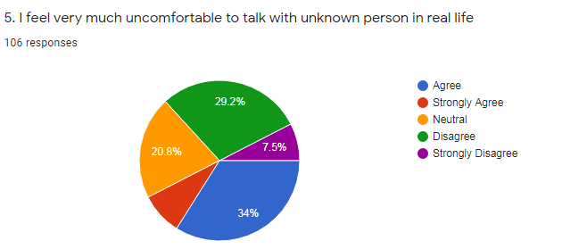

The ratio of agree is 34% and disagree ratio is 29.2% that means again the agree ratio is higher than the disagree ratio. Now-a-days young people are very much active in social media and they get lots of entertainment platform in there and that is the big reason to spend a lot of time in social networking sites. The Youtube, Facebook, Instagram, Video games portal, Twitter and so many programs. In above statements we can see that the addiction of social media in our generation increasing day by day. Every teenager or adult or even students has their own smart phone, laptop, tablet and so on things and that makes easy for them to connect with the social networking sites or social media. Connected others in virtually can’t makes people interactive and communicative. If we see around us then we can notice that if the child has no connection of internet for a few moments then she or he becomes very much frustrated and feeling lazy or unhappy. It reflects their inner feelings that how much they are lonely and unsociable without it. The reason of social media people are like to connect virtually and they have no worry or wish to meet a person or even if he or she has then they don’t try to manage or other person not interested to meet, in these way our generation too much dependent on social media and now-a-days businessman are not find out their desire person because the generation are smart only in virtually, in real life they have no confidence or interest to talk with other people or to know about people. Everyone is busy with their social media use. Even children are also not that much show interest to play with other children. They are busy to play in virtually video games or watching animated movies and so on, which is very harmful. In future they will not like to interact with others and can’t easily communicate or share with their feelings to others and finally it makes them unsociable and lonely and it makes our society sick. Social media is a platform where person once enter then they don’t notice that how much their times goes. Today’s young generation is very much affected through using social media or social networking platform. Too much using the social networking sites or social media student or young generation are getting affected by social phobia (Dr. Shirin Hasan, August, 2018). Many child specialist claim that this issue or this mental sickness happen because using too much social media. In social phobia a child or a young person can interact with their family person and close friends but they are very much uncomfortable to talk with others and they feel very shyness and the inner fear works on them. The thing is very easy to talk with others but they feel very uncomfortable and get very much nervous to talk and also it decrease their communication power also confidence as well. It is very important to young generaton to build their communication skill strong because they are the future leader in the world. If they lose their skills in this stage then it will be very difficult to them to recover it. Modern society or modern world needs smart person who has excellent creative thinking skills, communication skills, interpersonal skills, creative workings Style and so on but the present children or student or even young people are too much busy with their unproductive activities and it makes them lazy, depressed, also less confidence.

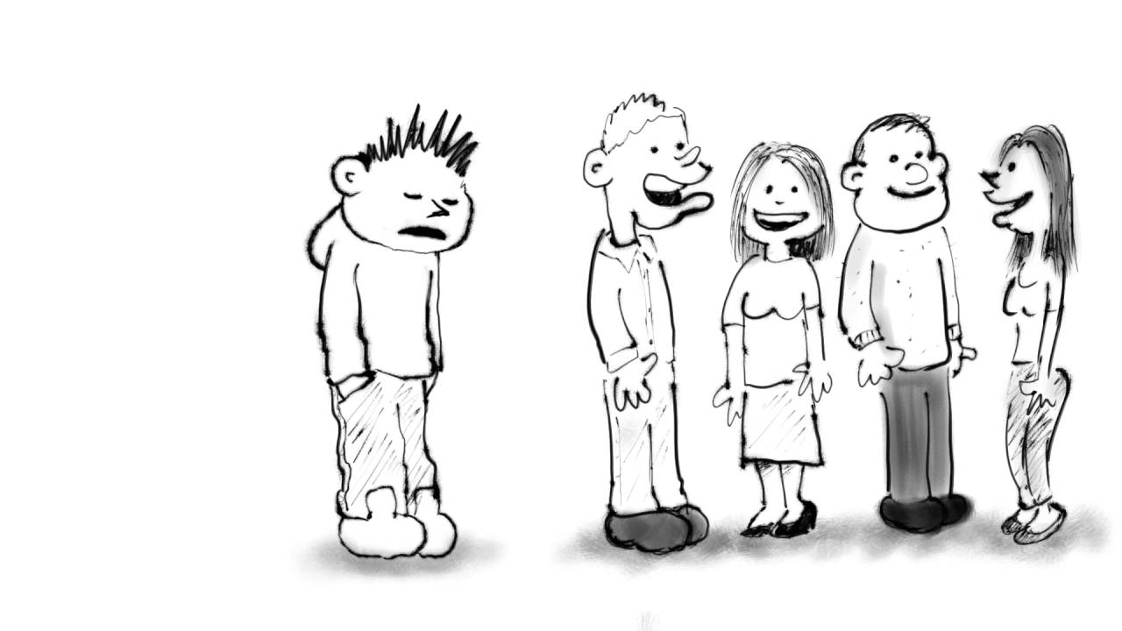
If the young generation based people not control their habit about social media then it will be very difficult for them to recover their loses. So they should control their self to using social networking sites or make sure the using is beneficial for them. The society now – a-days thinks that without using social media people are not smart and they also claim that without social media the previous time generation was very much enjoyable. If we want then we can make this generation enjoyable too by using proper time management of using social media or make sure the using social media is in our control. If the social media out of our control then it will make us unproductive, lazy so every young generation should focus on that issue.

I always so much busy to post my activities in stories or news feed rather than enjoy it in practically.

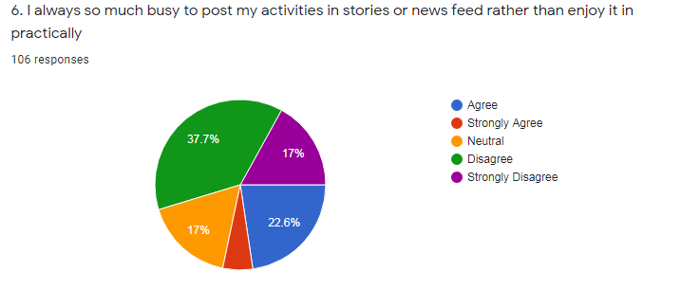
In these chart the different case shows and that is the disagree ratio is higher than the agree ratio. The disagree ratio is 37.7% and the strongly disagree ratio is about 17% and in total is 54.7%. It is greater than the agree ration and it also shows that the people has interest to enjoy anything in practically rather than virtually. This is a good sign of our society that the people or young generation want to enjoy their activities in practically rather than virtual way. But the fact is every people or students or young people are bounded in their home and they have no option to refresh their mind except doing hangouts in any restaurants or some other places. Tour always is not possible for them and many of them are students and they are busy with their study and for entertainment perspective they choose the social media platform. There they can play with their friends different type of games such as Ludo , basket ball and so on. But if they have the opportunity to enjoy all those things in practically then they are very much showing interest and try to fully enjoy it in practical way. If we talk about the agree portion of young people then one thing we can notice that they are busy to post their activities in social media to collect likes or comments. The things are mostly done by the girls. They post their pictures or videos to get likes and comments and the positive comments will increase their satisfaction. But it hampers their privacy because social media is a public based platform and there has very much lack of privacy and anyone can use those pictures and videos to harm of that individual. Now a days girls harassment increasing day by day and some people are hack their profile and uplodes unwanted things in the social media also some are threatened to the younger people. Specially girls are victim of it very much. To post about everything in social networking sites it is not acceptable because no one know what will be happen in the future with these sort of pictures or videos. If wee see about some vlogs or status then we can see some people are died in our society because of their status or written words. Everyone has the right to expose their feelings in words but in social media is not the right place to express all sort of things because it has no security issue and it’s a big platform where a wrong step can happen anything.

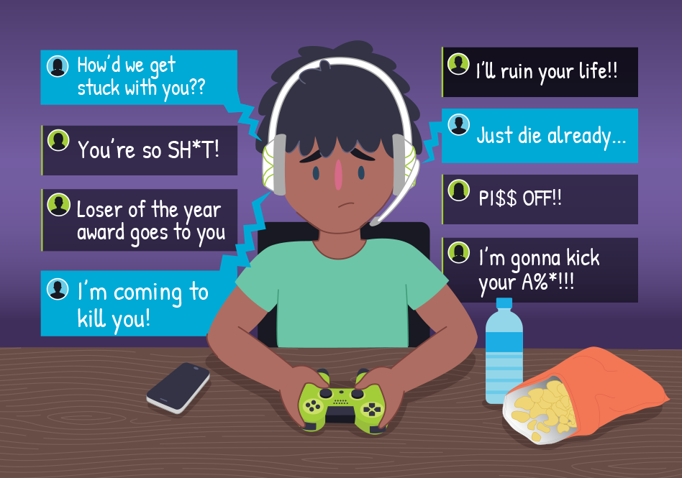

The people take too much serious about social media and post everything to prove themselves that they are happy with their life but actually are they happy! This is not important to post each and every thing in social media, if we see then we can notice that social welfare concern people are also showing that they are helping the people, it is good because it encourages others. Another side the helping amount is small but people focus themselves in a big frame which is not acceptable in society.. We should to help not for showing other, we should to help others because they need our support, our warm consideration. finally say that who are disagree about this statement they are in safe site about using social media rather than who are agree about this statement. Everyone or mostly young people should to understand social media is not everything where they need to share their daily life basis things. This is the place where people spend time for entertainment purpose. They should use it in a productive way then they can enjoy it more and also it will be worth time utilizing for them.

Most of the time I feel upset and bore

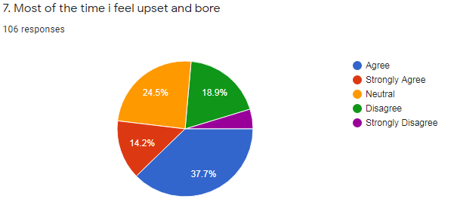
The chart shows that most of the young people are feel upset and bore. The agree ratio is 37.7% and the strongly agree ratio is 14.2%. That means most of the people are agree with this statement. This is very negative point that our young generation feel upset or bore. Social media is one of the reason behind it because it makes their mind centric and most of the time they spend their time on social media that is the major reason behind their upset and bore. Above statements shows that many of the people thinks that social media is only a platform for their entertainment. Most of the young people touch phone after wake up in the morning. They have no option for their entertainment. Social networking system is a mixed combination of entertainment and it has different functions or types of entertainment that is the reason people easily trapped here and spend a lot of time without their concern. It makes young generation lazy and unsociable. People don’t want to go outside to refresh their mind also they play games in house through social media. They are busy to post their photos or videos also sometimes share different type of memes. watching movies in Netflix or watch series. It kills their time a lot. They become lazy and lose their thinking capability and communication skills and so on. These all are the reason make them bore and upset day by day and decrease their confidence to work or to do study. One study find out a result that who are spend on social media or internet more than 8 hours in a day they become angry, lazy, bored, outcast, disconnected from the world or feel like something is missing when they realize that unable the internet connection or not connected in social media(Kurniasih, 2017).Many study find out that female are in more vulnerable situation of using social media because most of the time they are stay in home and easily can access in social media(Al-Menayes, Jnuary 30, 2015). It makes them more lazy and more uncomfortable to do their regular work. In modern generation most of young people are more connected in Twitter rather than Facebook because in Facebook they have connected with their family or parents as well and in another side in Twitter they can attached with many things also follows their favorite celebrities. These sort of things they are doing and end of the day they feel bored and upset and think that they have nothing to do in the whole day but they have a lot of work to do but the social media makes them lazy and unproductive which they failed to recognize. They should control themselves to use the social media otherwise it will be very dangerous to our young generation as well as near the future generation.

I spend more time on social media or networks and get bore and again I continue because I have no option without it

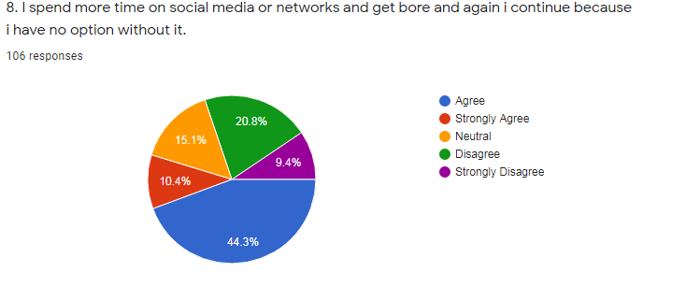
The above chart shows that 44.3% people are agree with this statement and strongly agree is about 10.4% people. Which is huge portion. Now-a-days if we see around us then we can notice that people are getting so much centralized even children are not go to play in playground in the afternoon time. Most of people are addicted with social media that they fail to find another option to choose their entertainment. They used social media limitless that is the reason they become addicted and without it they feel something is missing. Social media addiction is day by day increasing. Some young people claim that they have nothing to do for entertainment except this because most of the family are nuclear family and parents are busy to do their work and in town has not that much park or outing place. Most the restaurants now-a-days become a hangout place and young people are becoming lazy and they don’t like to do hard work. Over using of social media they are addicted with it. Even some young people or students said that their hobby is facebooking. How horrible is this! The society is gong the darker road where the young generation people are in danger zone. They have nothing to do in their in house and everything is related more or less social media. To doing this thin again and again this become their habitual fact. Without this they feel like they have nothing to do or have no option which is better than this. Whenever thay tired by using social networking system then few minutes take rest and then again continue with the same. In between their rest time they feel like nothing have to do without it and they don’t want to do their productive work. In that way they become more addicted and depend on it and without it they don’t want to focus about anything which is very much productive or important than this.

On study time I always touch my phone

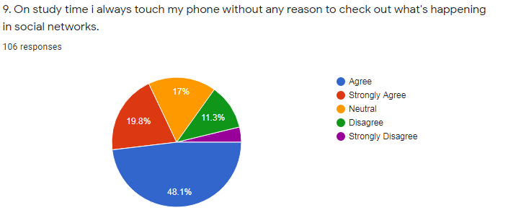
On study time students or young generation people touch their phone to check out what is going on in social media. Above the chart shows that 48.1% people are agree with this statement and 19.8% people are strongly agree with this statement. More than half of the people are agree with this statement. This is happen because those people are always touch or using their phone or laptop, tablet. They are always connected with these stuffs. This is their addiction or habitual fact. Most of the students claim that whenever they go to study that time they feel like the curiosity about what is going or about the posts or how much likes or comments they get, so on. In last they touch their phone and that time they feel more interest because they don’t like to do study but they need to do and another side attaching with social media is their favorite thing and it becomes their habit so then they choose to doing social media use and kick out from doing their productive work. By using this they lose their positive energy. positive thinking, communicational skill, confidence, valuable time. Sometimes it is very difficult for people to avoid something which is their habitual fact. To avoid those things they need to be very targeted and very goal oriented. They first have to understand about right or wrong that their habit is good or not also it effects their daily life basis work (productive work) or not. Then they have to find out what will be she or he has to do to come out from this otherwise it will be very difficult for them to out from this. Even their parents and teachers can do a vital role by giving advice to them or some techniques which can help them to recover it then it will be easier for them to come out from this issue. If we see the class room then we also notice that many students are not listened their lectures or don’t give their attention on their class study, they always busy in social media through mobile phone. Even some are don’t like tom talk with others , they used social media platform which means day by day the generation going in the worst situation and effected with different type of mental and physical health issue. To recover it first of all they need to control themselves first then their surrounding can help them otherwise it will be very dangerous for them. Those who has not this habit they can talk with them who has this habit. A friend can understand another friend in a better way. If their friend come to their side and makes them aware to come out from this then it will be easier for them to control this issue.

I prefer to play games rather than gossiping with others

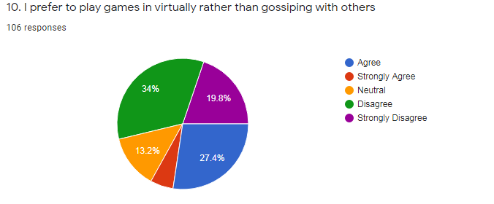
In above chart shows that most of the people are not agree with this statement. 34% of people are disagree about this statement and 19.8% people are disagree about this statement. Which means more than half portion of people are disagree about this statement that means they wants to talk with other rather than play in virtual games but in modern society everyone busy with their technological stuff and people thinks that everyone are doing the same thing. Everyone are busy with their daily or office work and they have no long time to talk or meet with the people and the shortness of time they choose social media to their refreshment. If they have the time or opportunity to talk with people then they do so. If we talk about the another portion of people who are agree with this statement that means those group or those people are very much addicted with their virtual games, that means they are very much comfortable with gaming zone rather than human being. It is happening because of two things. First one they are introvert and second one is they are really love to play game or like gaming more than human attachments. The agree portion is huge which is 27.4% ! The ¼ of people are crazy about gaming rather than human being. It is not good for our young generation. If wee around us then we can see most of the children or teenager are wearing glasses because of too much time spending on their phone or tablet or computer and they play video games for a long time and that makes their thinking ability down and makes their health worst. It damages their eyes too. In childhood age they are wearing power full glasses and the power will be increasing by increasing their age. Some parents are giving their little children smart phone or tablet and they watch cartoons for a long time or play games for a long time. Parents are doing this thing because if they give them this stuff then they feel comfortable for some times. They don’t concern about that, it makes the child dull also damages their health too. In today’s world a big portion of people are crazy about gaming and lots of games are launched day by day and those all are very eye catching for the young generation. Such as PUBG and so on. Some dangerous game also has such as BLUE WHALE and by playing this game many young people also teenagers committed suicide.
Video games are important to refreshment but whenever it’s control some people life then it must be avoidable. In Russia 150 over children are died by playing blue whale game in 2015 to 2016 ( Gemma Mullin, 2 November, 2019).In UK and so many countries children are died by playing this game. By playing this game they don’t want to talk with others and do activity by their own space. By focusing all of this issue video games is an entertainment based things so people should control to playing all these otherwise it will ruin their life too early.



Basically male people are more addicted on video games rather than girls. They always find out the new version or new series of games from their friends or cousins. Video games played through mobile phone, tablet or laptop and it also make them addicted and makes them unsociable and lonely. They find their comfort zone in their own space and it quiet difficult for them to communicate to others or talk with others. It makes them lazy also they affected sometimes many kinds of sickness such as headache, eye power loses and so on. Some people are claim that video games are good but actually it effects on people life.

I sleep at late night and the reason is social media

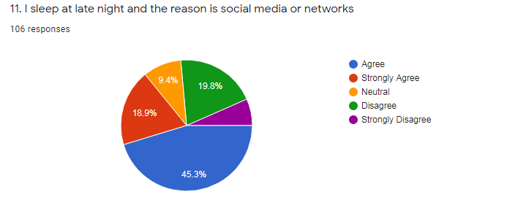

The chart shows that most of the people are agree that they sleep at late night and the reason is attaching with social media or social networking system. In the chart 45.3% people are agree about it and 18.9% people are strongly agree about it. Which means above half of the portion of the people are relating that their sleeping problem arises because of late night using social media or social networking sites. Most of the people are free in the night and that time they check out in their laptop or phone to know about actually what is going on in people’s life or in the world. Some people are using social media for refreshing their mind. Mostly young generation people are free in late night, they play video games or chat with their friends and also they spend a lot of time to scroll up and down in the newsfeed. Doing all these stuffs they getting late for sleeping and it is very much harmful for their health because after work or whole day pressure makes our body tired and we need sleep to boost our energy and refreshment or freshness to work in the next day. So people need a proper sleep but the young people don’t do this they waste their time and get addicted with social media and it effects their mental as well as physical health. It effects their brain activity also their eyes and also their behavior. Sleep is very important for everyone. without proper sleeping human body day by day lose their energy of doing their work and people affected by different diseases. Whenever people don’t sleep early they get depressed in silly matters. In science, every person needs minimum 6 hours of sleep otherwise it will effects our physical and mental activity. Lack of sleep or late night sleep puts people at risk of serious medical conditions, including obesity, heart diseases and diabetes and so on (Ashley Marcin, May 11, 2019).
Such as:
- People gets sick
- The heart damages happen
- The risk of cancer increases
- The thinking ability loses
- People forgets
- libido diminishes happen gaining weight.

It shortens people life expectancy. Late night sleep is the reason of taking decision wrong. Young people not understand about it , sometimes they understand but they are trapped into it and fail to come out. They should come out from this addiction otherwise it will ruin our young people or future healthy world.

Whenever I watch others post I feel jealous

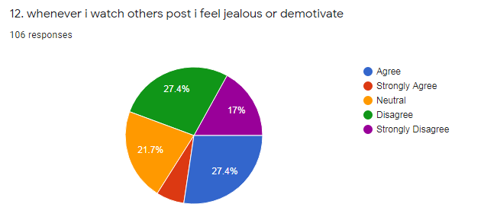

In the chart 27.4% people are agree about this statement and 27.4% people are disagree about it. Most of the people not agree about this statement because some people are strongly disagree about it which is 17% of people. In young generation people are busy with the trends Trend changing day by day and if any young people not follow those trend then other persons are not that much give priority that individual. In that way young people follow trendy things in their practical life as well as their virtual life. In social media people are showing that they are enjoying a lot by attending party, hangouts. By focusing these things other people want to do the same thing or they get unhappy and think about that they are so happy. Actually they are happy or aren’t no one knows about it but understand ii in a positive way. By watching this all things they do the same and exposes those moments or other things which makes them happy . is it fake or true it doesn’t matter for them. They just want to focus that they are happy in social media and they are not backdated. In this way they prove themselves by focusing other people things. Who have not that much opportunity or not that have things to walk with other people they get demotivate and sometimes feel jealous and they think that they are not classy or smart.
Sometimes younger people uploads picture whenever they do hangout and upload their picture but in reality they were busy to capture all the moments through their phone or other stuffs.

They are so busy to expose themselves them in social media that they are happy but actually they are not that much enjoy. Other people when they watch those things they feel jealous or they feel not happy and losing their confidence and doing misbehave with their close people. Facebookers or other users who uses different kinds of social media sites or social networking sites always express their thoughts in their newsfeed or sometimes, sharing updates, showing off, teasing others. These all are trigger feeling of jealousy, hate, annoyance, demotivation, inferiority and sadness. In these case girls are doing these of things more rather than boys, It effects other peoples mind too.

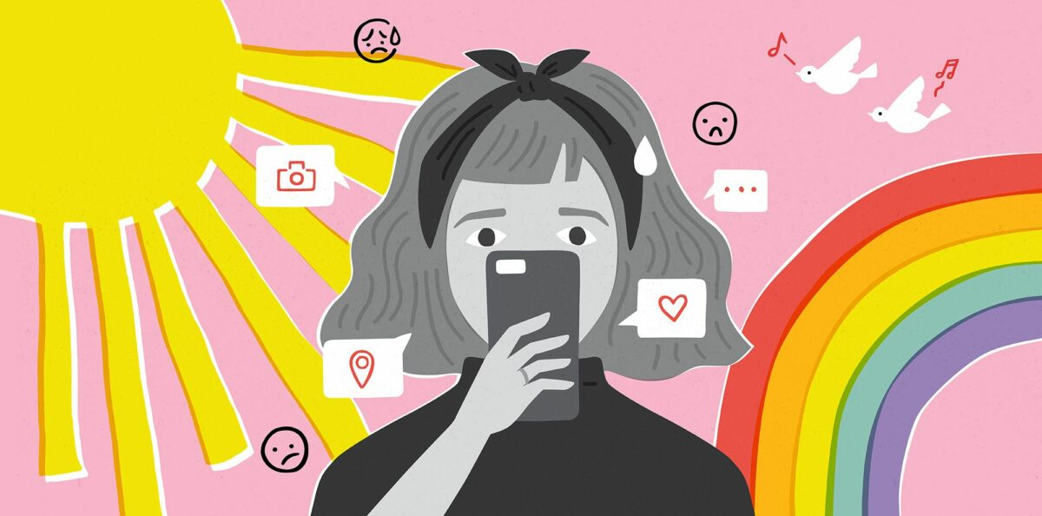

Social media is one of the major reason to distract the goal

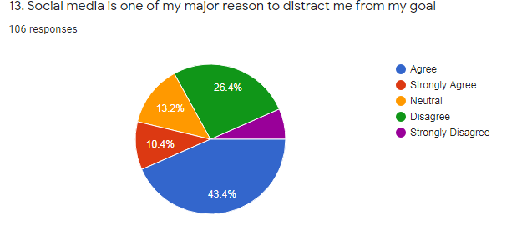
In the chart shows that 43.4% people are agree about this above statement. 10.4% people are strongly agree about this statement too. More than half of the people are agree about this statement that social media is one of the reason to distract them from their goal.
In young generation young people are too much active in social media and they always express their feelings or updates in social media platform and try to walk with the flow of trends. People are so much busy to show off their lifestyle and make understand other that they are very much happy with their life but actually in reality they are not. They feel lonely and helpless because of too much using social media. By using social media or active the whole day make them feel like they are busy but actually they are not busy. They are busy to doing unproductive works which move them from their goal or purpose of life. Every younger people have their own goal or their purpose of life but too much involving in social media makes them lazy and move them from the work which are they should to do to reach their goal. Many young students doing unproductive work for a long time such as posting pictures or memes and so on which are meaningless or waste of time. Using social media too much makes them lazy, reduces thinking ability and finally they distracted from their goal and also in finally they think that they have no creativity and get depressed. It effects on their behavior too. Whenever they understand that they were doing wrong things and by giving time on social media is worthless then they realize all the things but the tome goes a lot. Every country’s young people are facing this issue. In our country young people or graduate students are facing the same problem. A big portion of people are unemployed not only the reason that our country has lack of jobs but also the students fail to prepare themselves for the competitive market world market. If they not concern now then it will be disaster for their life also in a country because technology advances, business advances, all are updating day by day and to take place in this competitive world students or young people should have to gain knowledge and experience and for it they need to spend time on these things not on social media. Social media is a learning platform but not professional platform. So people should understand about it and make their time the right utilization

I feel like no one understand me

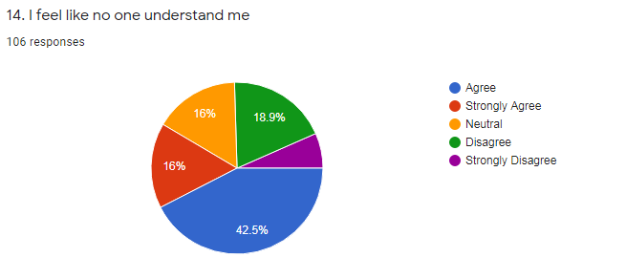
In the chart, 42.5% people are agree with this statement and 16% people are strongly agree about this statement. People understand that no one understand them or they do feel like it. Why actually they feel like it/ Because they most of the time attached with their phone or laptop and they spend a lot of time with others and also they don’t give time to their family members. In the world family members are our closet person than any other but young generation people they don’t understand it or they don’t want to understand the truth. They give priority to their friends or other person who are attaching with them in social media. But in real life they forget that not all friend are helpful for them and in every situation family members are come and support them. By using social media platform they creates a gap between them and their family and whenever they talk about something to their friends they have no time to understand them and those young people are not comfortable to share with their words to their family members because they have the gap and they think that if he or she say then they don’t understand them and blame them. In these way they think that no one understand them or don’t care about their feelings. Using too much social media they become unsociable, they don’t like to gossip with their relatives, they don’t like to gossip with their cousins, sometimes all are cousins seat together but they al have phone and they are busy with their phone. Even some are not interested to go their family function. This is how they detached from others and feel like they are lonely, no ne have for them to understand them and also understand their words. In later they become so uncomfortable to be close with others because using social media or attaching with social media makes them virtually extrovert not in reality. Most of the university students do using mobile or social media in their travel or journey, they don’t talk to others, in class also they use their mobile or tablet to check out what is going on in others life or in social media. This type of thinking makes young generation mentally and physically ill, unproductive also hopeless (Marche, May, 2012). It is a very negative issue that our young people who are the property of our world they think that no one understand them and by feel it they will be depressed mostly in near the future.

I always worry about my posts to know about how much likes I get

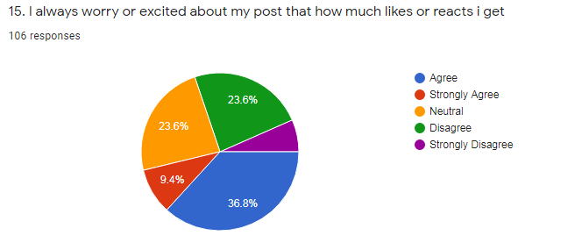
The chart shows that around 36% people are agree with this statement or above the words. Using the social media networks or social media sites means always curious or busy about something which are in social media. Young people are energetic and fresh energy basis people, they always try to modern trends or want to walk with the flow of trend. Because of that issue they are always busy to present themselves in social media through post pictures, videos, showing off, so on. Some people pictures are so much cool or dramatic and those things are eye catching for others. One type of hidden competition happen in social media and people are try to prove in the competition that they have the blissful life or they are happy. Some are too much busy to get more likes, followers or comments in social media because it makes them famous in social media and people follow their activities and appreciate them. People they don’t think about that much that those thing are helpful for others or not, Everyone more or less exposed themselves that they are happy with their life. The one step can bring their life change or darker. Because it is the platform were many people know about us or know about our thoughts, it also has the lack of privacy and has chances something negative happen. So by focusing these sort of things people should prepare or smart or even expose themselves in reality which is helpful for them and also helpful their practical life. In social media perfection is not that much important than the reality. Another platform has in social media and that is TikTok and this app is very much famous among children and teenager or students. This app has sound of different movies, songs, dialogues and people make it through singing, acting, sometimes they do challenges work which is harmful for others and those who are done that they also offer to others to do the same thing. Tht type of influencing is happening now in this world. Parents has not clear idea about it and their children do all sort of things and move from unproductive work. This site can be used as a entertainment purpose but whenever people take it more than their practical life then it will be worst for them. This sickness spread in our modern society also celebrity are doing the same and people are also follow them and copy them. As a renowned persons they should do dome appreciable work which will be helpful for the society and for the people. Otherwise they are one of the reason behind this issue.

I feel like my relationships with my friends are bounded in social media

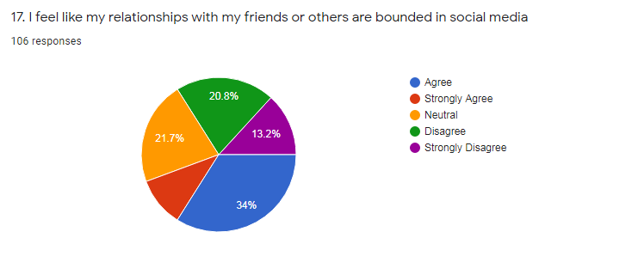

In the chart 34% people are agree with the statement and 20.8% people are disagree about this statement and also 13.2% people are strongly disagree about this statement. 21.7% people are chose to neutral option.
Now-a-days young people are so much tired because of working pressure and students are tired because of study, coaching and also university students are also busy because more or less people do part time job or do tution class. People are connected in social media platform. Some are busy so they don’t have that much time to talk or meet in practically. Some people are lived in abroad so it is hard to possible to go there and meet with them in reality. By focusing of those things some are said that their relationship with their friends is limiting on social media. Some people claim that they have no opportunity to meet with their friends in reality and everyone is busy in his or her own way so apart of these they are agree about it. In this case girls get less chance to meet their friends than boys because always we see that boys have the preferences to go outside but girls can’t do that because of security issue. Mostly young generation people or the youth are using social media platform most and it become their habit and some has chance or opportunity to hangout or gossip with their friends but they are too addicted with the platform and they choose to select social media to connect with people. If they even go or hangout out with their friends then the reason to uploads their pictures in social media platform to make sure others that he or she happy. By using too much social media they become social media addicted. Their happiness means the perfection of social media platform. It makes them more unrealistic and more abnormal day by day. Without it they feel like they have nothing or hopeless. Without attaching social media life become boar for them. They should to do control it.
Social media is a platform where people connected with others and time spend for their refreshment but when it will be their habit then it will be very tough to control or move out from it.

Too much spending time on social media I become unproductive

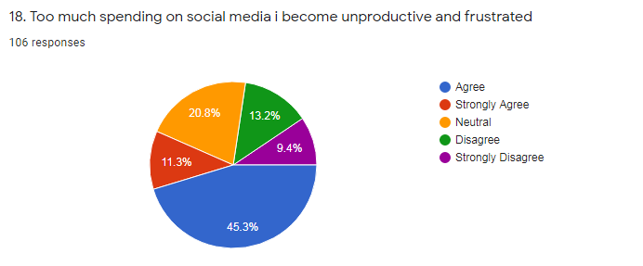
The chart shows that 45.3% people are agree with this statement and 11.3% people are strongly agree. In another side 13.2 % people are disagree and 9.4% people are put strongly disagree which is good.
45.3% people are think that they become unproductive and frustrated because of too much using social media platform. They are agree about it that they spend too much time on social media. Survey responses are come from young aged base people who are university students or college students. They spend their time on social media and busy with the contents of it and that is their habit and also without it they feel like they are hopeless. They think that without it they have no best option which is interesting. Without it they even don’t concentrate on any work. If we look before the questions then we can notice that people after wake up within five minutes they touch their phone or laptop to know that what actually happening in social media. By focusing all of those statements we can understand it that the attaching with social media platform not only a habit but also an addiction which destroy our youth life. By using too much social media it reduces the thinking capability of the people even It makes them unsociable and lonely, it hampers their mental and physical health too. They even forget a little things and lose interest to doing any productive work which is good for them. In study time they also touch their phone or laptop to connect in social media. Many researches or university publisher published about the consequences that how brutally it hampers our youth or future solders life destroyed. Many doctors are claim that it makes our generation unproductive and if it is going in these way then our future also doing the same things and people become unproductive day by day. Young people should use their time to doing productive work and gain experiences or skills which will be helpful to do a job in this competitive business world. A right decision can make a life beautiful and a wrong decision can destroy a life and it effect other too. If young people understand this that social media is the reason of their frustration then they should necessary steps to come out from this disaster.

Sometimes I feel headache by spending too much time in social media

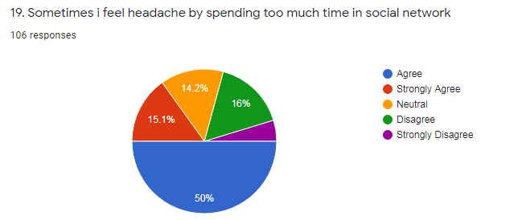

In the chart 50% people are agree with this statement and 15.1% people are strongly agree. In another side 16% people are disagree about it and 14.2% people are confused about it.
People feel headache by spending too much time in social network. This survey done by young people and they feel or think that their headache happen because of spending too much time on social media. In the young age people have the positive energy and fit to work, in this age the headache happen because of working pressure and so on valid reason which is normal. But in our youth they claim that they spend a lot of time in social media and because of that they get sick of different type of pain which is eye related, head related, shoulder related. Which makes them lazy and sick and because of it they can’t do any work or lose interest to do a work and take rest. After taking rest they again continue go on social media platform and spend time a lot because of their regular habit. One thing is clear to them that they are using social media platform which is good but only for little amount of time. If anyone continue for a long time then it is quiet difficult to move out from it. Many researchers and health specialist claim that too much spending on social media is very dangerous for all.

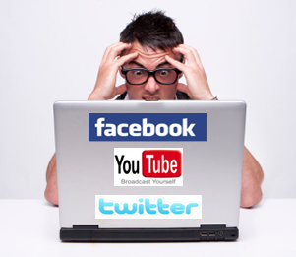

It damages people thinking ability, peoples creative thinking, reduces positive energy and also people day by day loses their eye power. And also get depressed. Headache is happen normally when lack of sleep happens, for stressful mind, and so on and these all things happen when people using too much time on social media.

I should control myself to spend time on social media

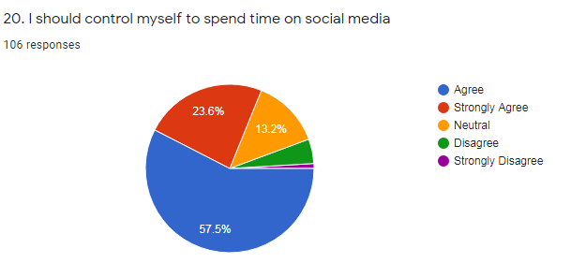

Here the chart shows that 57.5% people are agree and 23.6% people are strongly agree. All young people want to control themselves to using social media or spend time on social media.
Social media is a source where people connect with other people and knows about information also share their feelings but whenever they spend time on this for a long time then it wouldn’t be acceptable. People have a lot of work to do but whenever they addicted to use it for a long time then they become addicted or it will become their regular habit. That habit is not good for mental and physical health. It destroys life also It hampers positive power of people. But people know about that what they are doing and that is not good for them but also they are doing because it becomes their habit. They wanted to control themselves to not spending too much time on it. If they try or has strong intention then they can overcome it . It would be difficult for them but not impossible.

Chapter 3

“Suggestion & Recommendation”

In analysis section we see that different types of statements and public responses that how much they are agree or disagree about those statements. The statements are related to people’s practical life. By focusing those responses most of the people are agree about those statements and they want to control themselves to using social media or attaching with social networking system. Many researches and publishes focus on that issue, our young generation people or the youth are using too much social media and it makes them unsociable and lonely. In the survey form we put some words such as opinion section, where people can write about the positive effects also negative effects of the social media in their life. They all put their opinion or words which actually they are thinking.

Positive effects of social media in human life

Based on the survey forms, I get some answers what are they thinks that how social media impacts on their life in a positive way. Given below the responses that they are thinking based on their sense of humor.
- Some are said that social media doesn’t helpful for them
- Some people claim that through it they can communicate with people, pass their times, knowing about the current situations of the people.
- Some are said that they can express themselves in public place, instantly can communicate with others if they needed.
- Some people claim that they can buy things through online shopping, they know about the world basis news, they makes new friends, also see good things which are impossible to see in real life for them
- Some people claim that this platform is excellently helpful for the teaching and learning sources., amazing platform to showcase their talent
- Some are using it for their entertainment needs, make them confident ,learn new ideas
- Easy to connect people who are not in touch in real life or for busyness they can’t contact with them
- Some are claim that they can do online seminars or webinar which is for them to do, some are get new opportunity, they can play games also they can work also can do many works at a time.
- Some are said that this is the best way to wish people’s birthday, easily get information from different source, some are do business
- Some people said about this is the place where different types of people are working to develop social awareness, some are said that many motivational speech they can listen and gather positive energy to start anything.
- People said that they can learn new recipes or new religion basis words.
- Some are said that that is a mixed of different things and that makes them or feel good. So on.

Negative effects of social media in human life

Based on the survey forms, I get some answers what are they thinks that how social media impacts on their life in a positive way. Given below the responses that they are thinking based on their sense of humor.
- Some people said that this social media is totally waste of time
- Peoples jealousy , laziness and rumours increasing day by day by using this platform
- Some people said that peoples mind can divert anytime with a new matter, people get virtually threatened and harassed
- Some people said that by using this platform people getting depressed, frustration and also over thinking
- Some people claim that people has no sense they easily hurt others without any thinking
- People feel nozy, it is time consuming, by using it people easily gets addicted with it, it also hampers their study a lot
- Some people said that their eyes hurts too much and that is happen because of using social media.
- Some people said that that makes people unsociable and lonely
- People get fake information and happens also cyber bulling
- People said that tat makes people anxiety, distract from valuable work, sometimes people get depressed to see some posts
- It makes people virtually dependent
- Some people said that by using social media they sleep at late night and different types of health issue they are faced now
- Some people are become so much lazy and said that it is the reason that reduces their physical exercises or physical activity
- Some people showing off and makes other upset
- People also said it makes their child or little sister and brothers bad because sometimes unwanted things are showing in this platform
- It makes people hopeless and home oriented
- Some people said that by using it they feel pain in their neck. It also makes the less connection with relatives because of following trendy things.
- It damages the once people privacy within a second
- It keeps away from healthier life or real life basis experiences
- Some post makes worry the people.
- By using it people distract from the study
- It makes people introvert that makes people mentally sick and so on.

These all the reasons they are facing in real life because of using social media or attaching with social networking system. On an average a person or a young people touches their phone for 67 times in a day . Without it people feel that something is missing and then they again touch their phone. If this is going in this way then the future youth will be hamper by social media. Technology day by day updated and this updated done by people. Whenever they are addicted on their creation then it is not acceptable in modern world.
Study shows that, heavy social media use people feel depressed 71% and feel anxiety 93%. By focusing all of these things I provide some suggestions which can help the people to reduce their use of social media or attaching with social networking system.

To control the use of social media

People can follow some steps to control the use of social media and these all are given below.
- At first they need to take promise themselves first they should to reduce the use of social media.
- People can set their alarm in clock, then it will be easier for them to not touch in the morning their mobile after wake up and by this way they can’t enter the social media at the beginning of the day.
- Many people go to sleep at late night because of using social media through their mobile in that case if they use to read books or magazines or even comic books then it will be helpful for them to get a healthy sleep.
- People should finds out their hobby, what they are love to do without other forces, if they find out their hobby and work on it then they can detached or make distance from their social media addiction.
- People should use computer for using social media because if they use social media through their phone then it will be easier for them to addiction with it easily and another side they can’t move computer one place to another places and it reduces the use of social media.
- They can put long passwords in social media related sites or in their phone and by doing this thing it makes them less interest to put long passwords in those websites to log in and they don’t log in.
- People can use darker light in their phone or computer it makes all the thing darker and it feel less interest to the people to click on it.
- Delete all the unnecessary apps which are needless because if those apps stay then the notifications also the advertisements will pop up and distract the concern of the people to their phone and people will get trap on the social media addiction.
- Sometimes they need to switch their phone silent in important cases or in important time such as in study time or in office meeting. It will help them to work with full of concern and attentively.
- People can off the notification which makes them interest, such as Facebook, Instagram, YouTube and so on.
- People sometimes take to challenges but forget to do that in real life so in that case they should to write al those things and remind themselves that they need to do those things.
- People can go for workout or can go for gym to makes their life healthy.
- Make posters with the bad effects of using social media and attached in the wall can make the mind alert that it is not useful to us.
- People can do different type of physical activities such as debate or attaching with social welfare group which make them smart one rather than useless one.
- People do prayers and yoga for their mental peace and a healthy starting for their new day.

Ensure the good or effective use of social media

People do different types of unnecessary works in social media which is time wasting also makes them addicted. If people doing something good in social media then it would be great for them. Many young people do business through social media and the cost is low rather than in practically because the cost of shops and the maintenance cost not needed in online platform. People just need knowledge to open a page and can sell their product with the help of strategic marketing. Without strategic marketing they can not run for the long time in this competitive business world. If we see around us then we can notice that many young people doing business to make sure the right use of social media as well as build their Carrier. Many young ladies doing business such as makeup, clothes, designs and so on. Even who has not that much money to purchase product and sell to the customers they also doing business by providing advices or tutorial videos such as how to do Make-up or how to cook any dishes, how to do other things and so on. In another side boys are also doing business or try to be an entrepreneur. They do different types of business such as selling unique design based t shirts, watches, gift accessories, shoes, panjabis and so on. The young generation people doing business in online platform and makes profit also go to their desire goal. Ultimately they are entering the marketing world without knowing and doing business in a strategic way. They provide offers or discounts to attract their customers also provide greatest service to ensure the satisfaction of their customers. They also consult with their customers through online to help them to understand what actually they need to buy. If our young generation do these sort of things in social media then it is appreciable and they can gain the positive energy and make sure about right using of the time. Some people open pages for doing social welfare based activities which is appreciable. Our country has s many poor people or poor child who can’t eat properly and also they live in a slit and also so many old people not get proper treatment because of shortness of money. By focusing on those issue people can open a page in social media platforms and can collect donation from people and by the help of others poor people can live in a better way. So many ways has if people want they can start with a little of amount. They just need a good intention to do better for all and by the help of this intention they can reach the desire place. Everything has both side which is good and bad. People have to choose pick one and if people choose the good one then all are benefited by his or her initiative. The youth have to understand that they are not smart if they follow the trendy things. They have to be smart by doing something good which is beneficial for all and that is called smartness and that makes the trend in a new highest level. In our country the unemployment rate getting higher day by day. If the graduated people do something for their own initiative then they haven’t to wait for a job, they can do their own business and employment opportunities will be increases. Government should also focus on that things and they should provide the guideline also short amount of loan facilities which makes our young generation more confident and more responsible about their work. By doing these all things people can do good things through
social media and other people also the economy also society will be benefited by their initiative.

Brands can ensure the righteous thought to their customers

In the world so many renowned brand has who are doing business all over the world and known to everyone. They can do to tell about positive words or take initiatives to tackle this issue which is increasing day by day among the youth. Many renowned brands doing this things and help to the youth to come out from the addiction of social media. Facebook, Instagram also provide the access to do business without pay any kind of bill. Also many brands tell about their success also share about their business stories and strategies which are very much helpful to our young generation to startup their own businesses. TATA Motors, Unilever, Nestle, Grameen phone and so on reputed brand has they are doing so many initiative for their young generation to do something better through online. Fair & Lovely launched a program in social media which can help to the young ladies to get a job (Mainwaring, 2011). The owner of renowned businesses, they share their stories also do webinar session to provide ideas about to do businesses or how to understand the customers in a better way. They also launched different types of programs and also provide certificates which enhance the work ability of the people or the youth. If the other brands do these sort of activities then their regular customer or die hurt fans involve those things and continue those activities also enhance their knowledge and skills which can they use to build their businesses. In another side, Governmental initiative also needed to change the use of social media among the youth. If all are come to solve this solution then it wouldn’t be tough for the youth to overcome this addiction. They can live their life in healthy and peaceful way where they don’t feel lonely and unsociable.



Chapter 4

“Conclusion”

Technology is very important to make human life easier and better but when technology controls human or human totally addicted on technology then it will harmful to the human. Social media is a platform where people can spend their time for entertainment, connected with people and some are doing business or social work too. Today’s generation has their own mobile phone and laptop. They all are easily can access in social media and different types of application has in it and that makes young generation more attracted on it. In these way they become addicted on it and without it they feel like something is missing and they always busy to pretend themselves that they are happy in real life but actually they don’t. Addiction of social media makes young generation unsociable and lonely. They don’t want to communicate with their family members and whenever they feel lonely then they can’t tell about their problem to their close one or family members because of too much using social media makes distance from their relatives. By focusing this issue it’s very important to come out from this addiction and it is possible whenever we all are with them. We all together do a nice change among the youth which makes our future youths life healthier and happier.

Reference
- Gemma Mullin. ( 2 November, 2019). What is Blue Whale suicide game and how many deaths are linked to the challenge? The Sun .
- Al-Menayes, J. J. (Jnuary 30, 2015). Dimensions of social media addiction among university students. Kuwait: Science Publishing Group.
- Ashley Marcin. (May 11, 2019). when you lose sleep, 10 things happen to your body. Healthline .
- Dr. Shirin Hasan. (August, 2018). Social Pahobia. Florida: Nemours, TeensHealth.
- Haridy, R. (November 13, 2018). Health & WellBeing. Social and Clinical Psychology .
- Kathleen E. West, Michael R. Jablonski. (1 March, 2011). Blue light from light - emitting diodes elicits a dose - dependent suppression of melatonin in humans. Journal of Applied Physiology .
- Kurniasih, N. (2017). Internet Addiction, Lifestyle or Mental Disorder? Phenomenological Study on Social Media Addiction in Indonesia. Indonesia: Knepublishing.com.
- Mainwaring, S. (2011). We first: How brands and consumers use social media to build a better world. St. Martin's Press .
- Marche, S. (May, 2012). Is Facebook Making Us Lonely? The Atlantic Monthly .
- O, G. S., & Keeffe, K. C.-P. (April,2011). The impact on social media on children, adolescents, and families. The American Academy of Pediatrics .
- Peters, L. (October 5, 2019). What happens to your brain when you check phone first thing in the morning. The Journal of Neural Transmission .
- W. Akram, R. (30, October, 2017). Astudy on positive and negative effects of social media on society. India: International Journal of Computer Science and Engineering.

Questionnaire

- After waking up I touch my phone within 5 minutes
- Yes
- No

- Most of the time I spend on social media without any reason
- Agree
- Strongly Agree
- Neutral
- Disagree
- Strongly Disagree

- I think I am too much addicted in social media or social network
- Agree
- Strongly Agree
- Neutral
- Disagree
- Strongly Disagree

- I feel very much uncomfortable to talk with unknown person in real life
- Agree
- Strongly Agree
- Neutral
- Disagree
- Strongly Disagree

- I’m always so much busy in posting my activities in stories or news feed rather than enjoy it in practically
- Agree
- Strongly Agree
- Neutral
- Disagree
- Strongly Disagree

- Most of the time I feel upset and bored
- Agree
- Strongly Agree
- Neutral
- Disagree
- Strongly Disagree

- I spend more time on social media and get bored and again continue because I have no option without it.
- Agree
- Strongly Agree
- Neutral
- Disagree
- Strongly Disagree

- During study time I often touch my phone without any reason to check out what’s happening in social media or social networks
- Agree
- Strongly Agree
- Neutral
- Disagree
- Strongly Disagree

- I prefer to play games in virtually rather than gossiping with others
- Agree
- Strongly Agree
- Neutral
- Disagree
- Strongly Disagree

- I sleep at late night and the reason is social media or attachment with social networks
- Agree
- Strongly Agree
- Neutral
- Disagree
- Strongly Disagree

- Whenever I watch others’ posts I feel jealous or demotivate
- Agree
- Strongly Agree
- Neutral
- Disagree
- Strongly Disagree

- Social media is one of my major reason to distract me from my goal
- Agree
- Strongly Agree
- Neutral
- Disagree
- Strongly Disagree

- I feel like no one understands me
- Agree
- Strongly Agree
- Neutral
- Strongly Disagree

- I’m always worried or excited about my post that how much likes or reacts I get
- Agree
- Strongly Agree
- Neutral
- Disagree
- Strongly Disagree

- I feel like my relationship with my friends or others are bounded in social media
- Agree
- Strongly Agree
- Neutral disagree
- Strongly Disagree

- Spending too much time on social media I become unproductive and frustrated
- Agree
- Strongly Agree
- Neutral
- Disagree
- Strongly Disagree

- Sometimes I feel headache by spending too much time on social networks
- Agree
- Strongly Agree
- Neutral
- Disagree
- Strongly Disagree

- I should limit time spent on social media
- Agree
- Strongly Agree
- Neutral
- Disagree
- Strongly Disagree

- 3 good effects of social media networking in my life:________

- 3 bad effects of social media networking in my life:________

Thank You

