Internship Report On
Evaluation of Credit Rating Methodology process of
Credit Rating Agency of Bangladesh Limited (CRAB)
Submitted To:
Dr. Salma Karim
Professor of Accounting Dept.
United International University

Submitted By:
Mohammad Nishat
ID: - 111-132-026
Program: BBA
Major in Accounting
Department of Business Administration;



Date of Submission

28 April 2019



Evaluation of Credit Rating Methodology Process of,
Credit Rating Agency of Bangladesh Limited (CRAB)

Letter of Transmittal

Prof. Dr. Salma Karim
Accounting Department
United International University (UIU)

Subject: Submission of an internship report on “Evaluation of Credit Rating Methodology process of Credit Rating Agency of Bangladesh Limited (CRAB)”

Dear Ma’am,
This is my extraordinary joy to present the entry-level position report as a feature and the satisfaction of the BBA program. The report underscores "Evaluation of the Credit Rating Methodology process of Credit Rating Agency of Bangladesh Limited (CRAB);

I, therefore, hopefulness that this report will deliver the necessary information and a clear figure about the credit rating methodology process of The Credit Rating Agency of Bangladesh Ltd. I have given my best effort to make this report with proper information and guidelines. I hope that you will consider if there is any mistake or error in an eligible way. Thank you.

Sincerely,

---------------------------------------------------------
Mohammad Nishat
ID: 111-132-026
Major in Accounting
Department of Business Administration
Acknowledgment

To prepare the report, I got full co-operation & support from my faculty that was a great advantage for me. I would like to thanks the Credit Rating Agency of Bangladesh Limited (CRAB) who helped me sincerely from every aspect on my internship period. I am also grateful to my superior advisor, and my workmates, for their kind recommendations, submissions, directions, co-operation and their alliances.

I would like to thank my honorable teacher Prof. Dr. Salma Karim. She was always ready to help me by giving the necessary advice & support for the preparation of this report.

This report suffers from many shortcomings; nevertheless, I have exerted my best efforts in preparing this report. I seek the excuse for the errors that might have occurred despite my best effort.

So lastly, I would like to thank you from the bottom of my heart for providing the theoretical knowledge and valuable guidelines related to report.

Letter of Approval
This to certify that Mohammad Nishat; ID# 111 132 026, Program BBA, Major in Accounting is a regular student of The Department of Business Administration, I, Faculty of Business and Economics, United International University (UIU). He has successfully completed his internship program at Credit Rating Agency of Bangladesh Limited. He has prepared this internship report under my direct supervision. His assigned internship topic was “An Evaluation of Credit Rating Methodology Process of Credit Rating Agency of Bangladesh Limited (CRAB)”. I think that the report is worthy of fulfilling the partial requirement of the BBA program.

I wish his happiness and every success in life.

…………………………………
Prof. Dr. Salma Karim
Department of Accounting
United International University

Executive Summary
Credit positions for being monetary responsible and ranking viewpoints for the symbolic outcome. The fusion of these words defines something greater than the definitions;
Internationally this notion introduces a massive recognition than the financial catastrophe just started. Usually, financial corporations are recognized in the case of lending or giving credit currency, which is deposited to them. And when a depositor flops to repay returned each the bank/Financial Institution with that creditor undergoes and dedicated to bankrupt. In step, a country can bankrupt as the most association section in economics and normally the banking area got avoidances. From this factor of view, some businesses named Moody’s, Fitch and Standard &amp; Poor had developed and remained practicing the idea of deposit ranking from more than 200 years back. Growth in the incidence of the monetary credit score squeeze, the practice of CR used to be practicing over the world as countries have been turning into the way in economic insolvent. Credit Rating is two types; International deposit rating and National credit score rating.
At first, its utility was mandatory on Bank, FIs and NBFIs. Time to time, it used to be applicable to corporate businesses and SMEs too. A Country’s ranking is additionally quintessential for public finance dollars and foreign useful resource sanctions. In CRAB, the chain of command from pinnacle to backside method is mandatory to preserve in the Credit Rating process. At first CRAB’s analyst does a formal meeting with present client and collect information. Then an element evaluation is executed on clients’ commercial enterprise model, monetary condition, industry risk, operation risk, management, background, and credit facility. After that a team of savings price makes with a discussion and decides a suitable ranking keeping all the codes of conduct. An award letter and credit score rating record must be submitted citing the rating to its client. In this file I’ve mentioned about savings rating, credit score rating in Bangladesh, tools of ranking in Bangladesh, about CRAB, important points discussion on the credit score rating system at CRAB, rating methodology, a quick discussion on the financial ratios, grading. In my internship report, I have accomplished an evaluation on The New Lion Steel Re-Rolling Mills Pt. Ltd. And make the ranking on surveillance of CRAB.
Overall, there are some references on CRAB and its ranking process.

Table of Contents:
Introduction 9
Credit Rating Definitions 9
Credit rating in Bangladesh 10
Types of Credit Ratings 12
Requirements for the Credit rating in Bangladesh 14
Overview of the Credit rating Agency of Bangladesh Ltd. (CRAB) 15
Targets of CRAB 16
Code of Behaviours 16
Objective part 17
Credit Rating Services of CRAB 18
Credit Rating Administrations 18
Grading Administrations 18
Advisory and Consultancy Administrations 19
Information Administrations 20
Credit Rating process analysis of Credit Rating Agency of Bangladesh (CRAB) 21
Implementation of Basel II 21
Impact of BASEL II 22
Credit Rating Process of CRAB 23
Exploration 26
Course of events 26
Credit Rating Methodology 27
Credit Rating Methodology Process of CRAB 28
Rating Methodology of CRAB’s Corporate Unit; 29
Financial Variables Earning and Profitability Ratio: 33
The Grading system of CRAB 35
Credit Rating Report on the New Lion Steel Re-Rolling Mills Ltd. 38
Problems and solutions: 45
Literature Review 48
Scope of Report 49
Methodology of Report 49
Limitations 50
Findings and Analysis 51
Conclusion 52
References 53

Introduction

Credit Rating Definitions
This is a joined clarification specifically shaped absolutely on the parity and demonstrates the urgent credit danger for a given divulgence. It builds up a number/letters in order/picture as the most crucial specific pointer of risks going with a money-related investment funds subjection. This hazard rating is a prevalent part of developing terms. It surveys the store reviewing the appropriateness of an account holder identity primarily a venture or a legislature. This is a qualification that used to be made by method for the ability of a store rating organization. To find out the indebted person's probability to restore the obligation. It is resolved and evaluated through rating offices. The financial investment funds positioning shows up for the cr organization's assessment of subjective and quantitative information for an undertaking or experts including non-open actualities information are sold with the guide of the utilization of the examiners' FICO assessments are never again exclusively chosen principally dependent on scientific recipes. Rather than offices utilize their reasonable judgment and encounters in deciding. Some open and private records are on issues in a rating strategy to a venture or government. The positioning utilizes for people or for different substances that regularly buy the bonds which are issued with the asset of firms and governments. To decide the peril that the specialists pay on bond necessities. A terrible positioning demonstrates an organization's confidence that the enterprise or experts have a staggering shot of winding up defaulter and relying upon the office's investigation of the element's former records with an assessment of long haul financial prospects. Appraisals for account holders are mainly founded absolutely on excellent because of commitment conduct by means of the utilization of the offices. The cr bunches need to take a reasonable perspective on the borrower's budgetary country of undertakings with the capacity to reimburse the credit. The cr has an opposite contact with the perfect chance of default. From the sentiment of the organization, an unbalanced rating recommends that the borrower has a low likelihood of getting default on the obligation. Equally a low budgetary reserve funds rating proposes an unreasonable plausibility of default. Rating organizations set letter evaluations to bring up appraisals. To apportion standard poor case there has a scale which is going from AAA incredible and AA+ the whole distance and d. an obligation instrument with a positioning underneath BBB-is a theoretical evaluation or a garbage bond. Rating alterations can have a fundamental to affect financial commercial centers. For a person's substance rating is conveyed by methods all capacity of a numerical score which is overseen through the use of Equifax experience and unmistakable credit-revealing offices. An intemperate investment funds rating demonstrates to be a more noteworthy reasonable reserve funds profile and it will and the large final product in lessening leisure activity charges charged by method for account holders.
Credit rating in Bangladesh
Bangladesh CR enterprise began its countdown with the obligatory necessities of having a ranking score for all public debt tools. Credit Rating Information &amp; Service Limited (CRISL) commenced it labored as the first registered credit score ranking organization of Bangladesh in 2002. After that as a 2nd ranking agency, Credit Rating Agency of Bangladesh Limited (CRAB) viewed to its operation in 2004. Risk Grading Manual of Bangladesh Bank was coursed through Bangladesh Bank vide BRPD Circular No. 18 on the date of December 11, 2005.
For the implementation of the Credit Risk Grading Manual which is exceptionally in use for evaluating the credit score risk grading earlier than a financial institution lends to clients. The banking regulator recently determined to use it obligatory for banks and other economic establishments to publish credit score rating reviews within six months after the approval of accounts. Following the case of the Bangladesh Bank, the insurance plan regulator additionally determined to make deposit rating obligatory for all insurance agencies each 12 months and for the existence insurance plan institutions bio-annually. The Dhaka Stock Exchange, while issuing the direct checklist regulations, made the deposit rating required earlier than an employer follow for a direct listing. The above act of regulation created an enabling surroundings for a rating in the country’s capital and financial market places.
The concept of client rating by using the ranking corporations to care capital adequacy of the banks came up in view of the want for implementation of Basel II capital adequacy framework with the aid of the Central Bank of Bangladesh. According to the Basel II framework, BB indicates a standardized strategy for the following savings risk. In which the offerings of Credit ranking groups had been wanted underneath sure sturdy phrases and conditions. Bank purchaser rating is very touchy trouble considering most of the non-public area companies, taking part in banking facilities, are no longer keeping trendy financials for terrific evaluation.
Above all elements are accurately rated via region basis research and the ratings are geared up to give false signals. Security and Exchange Commission of Bangladesh (SECB) approves a 2% default rate of the credit score ranking agencies. There is a one of a kind class of penalties in case the default charge goes extra than 2% along with it can be the cancellation of defaulter ranking enterprise license as the best possible penalty given with the aid of SECB. According to the record of the Association of Credit Rating Agencies of Asia, Bangladesh has a big quantity of CR companies. India; one of the biggest economies of Asia has solely two credit score rating groups in total. On the other hand, China, another largest economic system is sustaining a financial boom with a single deposit ranking agency. In Bangladesh, the ranking enterprise is now mirrored to be a guardian-less industry.
The conduct of the policymakers in the direction of sustaining this enterprise does not show up to be well reasoned. The groups are nevertheless protected via the SEC regulations as a funding councilor company. This was consistent over a lengthy period and this paid-up capital residue at Tk. 5million (50 lakh), and this is up to begin a rating enterprise by any team of sponsors/investors.

Types of Credit Ratings
- National Ratings:
These appraisals measure the reliability of guarantors or inconveniences with respect to every one of a kind backer or inconveniences inner the equivalent nation and as opposed to CI's particular scores are never again expected to be comparative over the span of nations. national appraisals are utilized in nations whose sovereign funds rankings are some path underneath 'AAA' on CI's worldwide positioning scales and the region there is satisfactory interest from capital market patrons for such evaluations. National evaluations Permit the scores of capacity in every nation to be bargain out all through a strong positioning scale from 'AAA' to 'd' in this manner empowering tremendous money related investment funds separation that may likewise be conceivable beneath universally comparing positioning scales.
- International Ratings:
Two the supplier for CR for government’s money related and venture organizations aggregate up to a substance's standard financial soundness. Its usefulness and readiness come to meet its financial affliction as they currently do all through worldwide fringes. Various parts of appraisals that can likewise additionally be doled out are given underneath.
- Sovereign credit ratings:
Sovereign financial assessment positioning is the CR of a sovereign element for a national government. The sovereign budgetary reserve funds positioning recommends totally the opportunity level of the contributing stipulations of a country and it is utilized by means of utilizing brokers who hoping to make ventures abroad. It usually considers political perils.
- Banks and other Monetary Organizations:
- Long and transient nearby money appraisals.
- Long and momentary outside money evaluations.
- Financial quality appraisals (It's a sentiment of remain solitary money related wellbeing)
- Support evaluations (For an appraisal of a bank, it would get outer help if there should be an occurrence of money related issues)

- Corporate:
- Long and transitory neighborhood abroad cash appraisals.
- Long-and momentary outside cash evaluations.
- Issue Credit Ratings:
Bonds offers and stand-out monetary gadgets are the choices of an identity substance's capacity and readiness to respect its budgetary obligations with praise to a remarkable bond or to unmistakable obligation instruments. The scores relegated to the obligation inconveniences of money related foundations and firms.

Requirements for the Credit rating in Bangladesh
- As per the Directions in 1996 issued by methods for the Securities and amp; Trade Commission order on the accompanying units be positioned preceding making components and that the records on the positioning are coordinated with the outline of giving archives:
• Public gifts of all obligation instruments: bond, debenture, business paper, organized account (resource/contract sponsored securities) and want shares.
• The public inconvenience of offers including some hidden costs.
- SEC through its Securities and Trade (Rights Issue) law, from 2006 it requires the rating of the followings:
• All rights issues at Premium.
- The SEC principles in 2004 require the rating of an advantage pool to be securitized with the non-necessary necessities of the store of the originator.
- Bangladesh Bank by means of the brochures which requires an obligatory rating for the followings:
• All planned Relies upon a yearly premise.
• All financial organizations on account of Initial public offering.
• Bank exposures.
- Boss Controller of Protection requires initially CR for the accompanying issues:
All standard protection plan organizations on a yearly premise of all presence protection organizations on a biennial premise.

Overview of the Credit rating Agency of Bangladesh Ltd. (CRAB)
This is the top situating relationship of our state which is giving a Rating/assessing, cautioning and experiences commitments for Government or cash related establishments. The Association has twisted up guaranteed as an open compelled supervisor under the Selection focal point of the Joint Stock business office in August 2003 and it secured a confirmation for the opening of the business in November 2003. CRAB was pound to get the grant by the Securities and Exchange Commission (SEC) of Bangladesh for set off as speculation subsidizes rating situating relationship in February 2004. The formal opening of CRAB used to be held tight 5 April 2004. CRAB has been seen as an Outside Credit Assessment Foundation (ECAI) with the guide of the technique for National Bank of Bangladesh in 2009, which stands gives by using it and come to be fit the bill to furnish the situating of bank cash related save subsidizes exposures on risk-weighted capital competency for figuring. CRAB is a freethinking and ace endeavor that is trapped with a specific joint exertion with ICRA Ltd of India. CRAB is the fundamental supporter of any financing files and rating organizations in Bangladesh. CRAB's financial specialists embody individuals and each and every unprecedented association containing the Theory Organization of Bangladesh (ICB) and IDLC.
ECAI Status;
Bangladesh Bank approved CRAB as an External Credit Assessment Establishment (ECAI) in April 2009. Under the standardized system for figuring danger weighted things toward assets score possibility, the FICO rating situating is to be settled mainly subject to the risk profile reviewed with the guide of the use of the ECAIs. Banks will use the scores of the ECAIs and relating risk weight for finding out RWA for credit peril under the regulated technique.
Mission;
CRAB's focal objective is to influence crucial giving toward identifying with the advancement of the money and capital markets for the improvement of the straightforwardness of monetary information. Also, moreover, on the legitimacy of the corporate part in Bangladesh for supporting in the make more prominent of the endeavor.

Targets of CRAB
- To execute distinctive commitment equipment of credit rating as like Business papers, Securities and Debentures, Islamic securities, shares, Esteem instruments, Rights trouble paper, Normal store units, etc.
- To give the situating assessment of a combination of foundations like banks, Non-banking financial associations, assurance plan structure associations, organizations, non-undertakings, social requests, trusts or of us or their purchasers for features referenced buyers or required through authorities.
- To gather, way and give records benefits inadequate locales for the use of affiliation and buyers at different measurements.
- To outfit consultancy and cautioning organizations in wide regions to our customers at indisputable measurements.
- To go about as trustees of any debentures, securities, securities, mechanical papers or some different commitments and to work out the powers of the operator, executive, recipient, treasurer, a guardian in acknowledge of such cash owed and securities.

Code of Behaviours
CRAB consents to certain standards as favor underneath the FICO evaluation Associations Standards and insurance plans of the Securities and Exchange Commission. The Arrangement of acknowledged standards focuses on going with;
• Responsibility and Trust.
• Integrity and Ability.
• Quality of Rating.
• Confidentiality.
• Independence.
• Avoidance of Hopeless conditions.
• Transparency and Reasonableness of Rating Disclosure.

Objective part
- The Credit Rating services on CRAB.
- The Credit Rating process of Credit Rating Agency of Bangladesh Limited.
- The Rating Methodology processes and Methodology of Corporate Unit CRAB.
- Grading System of Rating on CRAB ^{(Latest updated)}
- Some problems and possible solutions on rating process of CRAB.
- Prepare ‘The New Lion Steel Re-Rolling Mills Ltd.’ Company’s Rating report from Credit Rating Agency of Bangladesh Limited (CRAB)

Credit Rating Services of CRAB

Credit Rating Administrations
Appraisals generally show as images that are straightforward and direct for helping the investor to settle on the local mind on speculation choices in various refuges. It is including obligation and value instruments dependent on their hidden quality. Rating of value instruments demonstrates the present assessment on situations of come back from the value. The FICO score of obligation actualize demonstrates the present judgment of the overall capacity of the guarantor to its obligation commitment in an auspicious, with the last comment about the instrument being evaluated. Along these lines, the rating is centred on liaising to the monetary specialists, the general positioning of the default dropping likelihood for speculation, in examination with another survey instrument. The obligation rating is established upon the relative ability and eagerness of the backer of the instrument to support the obligation commitments (both chief and enthusiasm) according to the terms of the agreement.
Other than value and obligation instruments rating is the scope of rating that has extended to another region, for example, element rating (estimating the quality of an organization), money related quality rating of insurance agencies, corporate administration and partners merit rating, and so on.

Grading Administrations
CRAB is prepared to offer particular examination procedures calling elite and zone explicit prerequisites under the umbrella of evaluating redesign. The administrations are intended for assessment of various exercises and substances are acknowledged by multi-concern businesses. CRAB's evaluating administration gives layouts to give a goal, believable and unpredictable sentiment on the state of elements being analysed with explicit reference to necessities and issues the segment/sub-part. Development and land improvement adventure, medical clinics and analytic administrations are instances of such area/sub-divisions. CRAB plans to set up a key relationship with legitimate and concentrated bodies related to the segment/sub-division to create and offer specific reviewing items.

The accompanying evaluating philosophies will outline the extension:
A. Real Bequest Engineers Reviewing: It is concocted to make the financial specialists mindful of the dangers which are engaged with the designer's capacity to pass on according to indicated terms and states of value parameters and furthermore the interchange of possession on schedule. Additionally, give the office inside the general growth of the land part by giving the engineers directing and motivating forces to adjust to legitimate necessities and reasonable exchange performs.
B. Health Care Organizations Reviewing: It assesses the capacity of the analytic and treatment suppliers to convey quality consideration from the client's (patient's) point of view. This reviewing is intended to check the two most basic elements of keep control, specialized and relational mothering, reflecting both organization offices and procedures.
C. Other Evaluating Administrations: CRAB is working in building up extra reviewing administrations to the next related area and it is prepared to structure new administrations upon indicated prerequisites of the customers.

Advisory and Consultancy Administrations
This Administrations will offer outskirt rang of the executives warning administrations which incorporate key advising, rebuilding arrangements, budgetary practicality, and money related organizing/demonstrating, customer explicit need-based inquiries in the banking and monetary administrations, corporate and other centre parts. Warning administrations are additionally appropriate for task readiness, assessment, and execution. These warning administrations are helpful for various kinds of customers, as corporate substances, administrative administrations, monetary administration associations, industry affiliations, government associations, and multi-side offices.
A. Banking and Protection:
Hazard the board through to planning and executing hazard models and in territories of Credit, Portfolio, Subordinates, and Resource Risk Coordinating, and so forth.
• NPL the board
• Strategy Advancement
• Process and Authoritative Rebuilding
B. Corporate:
• Financing structures and demonstrating
• Financial plausibility of developments or rebuilding
• Need-based assignments
C. Projects:
• Feasibility Surveys of the undertaking which incorporate specialized budgetary plausibility, supply/request contemplates, official consistence, hazard distinguishing proof and alleviations, and so forth.
• The monetary structure of venture financing.
D. Power Part:
• Price and duty setting, assessment of agreements, business strategy and plan detailing, administration costing, limit building. What's more, Undertaking Attainability Concentrate with Specialized and Money related Reasonability Hazard evaluation.
• Financial Organizing and Game plan of Assets.

Information Administrations
CRAB gives data administration as a database, budgetary examination, advertise investigation, and markets study, and so on. The government is tweaked to give the organisation of the particular needs and issues of the customers.

Credit Rating process analysis of Credit Rating Agency of Bangladesh (CRAB) ^{(Source)}
Implementation of Basel II
Basel II is the recommendatory structure for banking supervision, issued by the Basel Advisory group on Banking Supervision in June 2004. The goal of Basel II is to achieve a global combination of capital estimation and measures in the financial framework. The Basel Board of trustees individuals who concluded the arrangements are principally delegates from the G10 nations, yet a few nations that are not spoken to on the advisory group have additionally expressed their expectation to embrace this system. In December 2008, Bangladesh Bank issued rules on the New Capital Ampleness Structure (BRPD Round 09, dated 31.12.08) to banks working in Bangladesh, in view of the Basel II system. These rules advise that BB proposes the usage of Basel II with the accompanying methodologies:
  - An institutionalized methodology for computing RWA against credit hazard;
  - An institutionalized methodology for ascertaining RWA against Market Hazard;
  - Fundamental pointer approach for computing RWA against Operational Hazard.
Under the institutionalized methodology for estimating credit hazards, the hazard grades are resolved dependent on appraisals allowed by the ECAIs.
Mapping of BB Rating Grade with ECAI Rating:
Long Term Rating Category Mapping

Claims on Corporate  (excluding equity) | Bangladesh Bank Rating Grade | Equivalent Notch/Notation of  CRAB | Risk Weight
 | 1 | AAA  AA₁, AA₂, AA₃ | 20%
 | 2 | A₁, A₂, A₃ | 50%
 | 3 | BBB₁, BBB₂, BBB₃ | 100%
 | 4 | BB₁, BB₂, BB₃ | 100%
 | 5 | B₁, B₂, B₃  CCC₁, CCC₂, CCC₃  CC | 150%
 | 6 | C, D | 150%
 | Unrated |  | 125%

Short Term Rating Category Mapping

Bangladesh Bank Rating Grade | CRAB Grade | Risk Weight
S 1 | ST-1 | 20%
S 2 | ST-2 | 50%
S 3 | ST-3 | 50%
S 4 | ST-4 | 100%
S 5 | ST-5 | 150%
S 6 | ST-6 | 150%
Impact of BASEL II on banks in Bangladesh
Under BASEL II framework, banks will need to provide capital for credit risk based on the risk associated with their loan portfolios. If a bank has high-quality credit exposures (e.g. if most of its credit exposures are in the ‘AAA’ and ‘AA’ categories) it will save capital because credit risk; the difference is apparent in the illustration below. Conversely, a bank with relatively lower rated credit exposures will need to provide more capital. Additionally, banks will have to provide incremental capital for market risk and operational risk. Capital for operational risk was not part of the previous regulatory framework.

Illustration of capital-saving potential by banks on a loan of Tk. 1000 Million

 | BASEL, I |  | BASEL II
Rating | Risk Weight | Capital required Tk. mn | Risk Weight | Capital  required Tk. mn | Capital saved (Tk. mn)
AAA,AA₁, AA₂, AA₃ | 100% | 100 | 20% | 20 | 80
A₁, A₂, A₃ | 100% | 100 | 50% | 50 | 50
BBB₁-BBB₃,  BB₁-BB₃ | 100% | 100 | 100% | 100 | 0
B₁ and below | 100% | 100 | 150% | 150 | -50
Unrated | 100% | 100 | 125% | 125% | -25

*Capital required is calculated as Loan Amount x Risk Weight x 10%

Credit Rating Process of CRAB
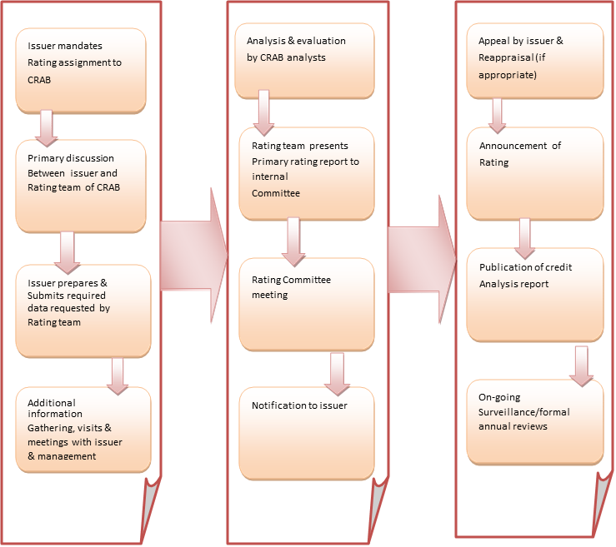
Figure: Credit Rating Process of CRAB (Source: CRAB Corporate Broacher)
Rating is a community-oriented procedure with a forthcoming way. It includes a progression of steps. The principle steps are portrayed as pursues:
- Rating Solicitation: Appraisals in CRAB are normally begun off on formal methodology demand from the arranged Backer. An endeavour is additionally acquired by a Taka 150 non-legal Stamp Paper before the beginning of a Rating task; which illuminates the terms and states of the commitment of the FICO assessment office.
- Team: The Rating group, as a rule, involves two individuals. The structure of the group depends on the ability and aptitudes required for assessing the matter of the Backer. The group is driven by the pioneer of the expert group with a satisfactory perception of the important instruments to be evaluated.
- Role of the Lead Investigator: The pioneer among the examiner, as a rule, orchestrates to conclude the Rating report and convey the report to the Rating Board of trustee’s individuals. The lead examiner makes an introduction before the Rating Board of trustees held to support the Rating. The lead investigator will promise that all the vital basic material issues that may affect the credit nature of the underwriter (counting, yet not constrained to those which are identified with the program being appraised) are introduced before the Rating Board for discourse. The lead investigator will guarantee correspondence of the Rating choice to the Guarantor and start all the important activities ensuing to the response of the backer relying upon the conditions.
- Information Prerequisites: Guarantors are given a rundown of data necessities and a wide structure for dialogs. These necessities are gotten from the experience of the Guarantors business and extensively adjust to every one of the perspectives, which have an orientation on the rating.
- Secondary Data: CRAB draws on the auxiliary wellsprings of data incorporating its own in-house research and data acquired through gatherings with the Backers' financiers, inspectors, clients and providers among numerous other significant market members. CRAB additionally has a board of industry specialists who give direction on explicit issues to the Rating group.
- Management Gatherings and plant visits: Rating requires the consideration of various relating factors with an estimation of things to come income desire for the Guarantor. This requires escalated associations with the Guarantors' administration explicitly with the end goal of understanding the marketable strategies, future-focused position, and financing arrangements, and so on.
- Other Gatherings: The CRAB investigator group may likewise choose to meet the reviewers, financiers/loan specialists, legal counsellors (if there are significant cases pending that may have genuine effect using a loan quality), worker's guild head's key administrators just as a couple of speculators and providers, contingent on the situations for an input from various partners.
I. Meeting with the Guarantors' Chief/CFO:
This would be a significant gathering (for the most part, the last gathering) when the Rating group would talk about all the basic issues/discoveries that may affect the Rating choice with the President/CFO of the Backer (without Chief/CFO, with a senior official assigned by the Guarantor for this reason).
II. Internal Audit Advisory Group Meeting:
When the draft report is set up by the Examiners group, it is set before the Inward Survey Board of trustees Meeting. The council includes senior experts. The board of trustees audits and judges the draft FICO assessment report and investigators are up to do the examination of the report.
III. Rating Advisory Group Meeting:
The expert is set for Appraisals to pursue a protected law in the Rating Board of trustees of CRAB. The Rating reports convey by the examiner group to the Rating Council individuals. The introduction about the Guarantors profession is made by the mean of the Rating group to the Rating Panel at the gathering. All the key issues and matters are perceived and talked about amid the gatherings about pertinent issues, which impact the Rating are impressive. The distinctions are if any commitments emerge amid the exchange are observed. At last, a Rating is allocated either by an accord of chiefs or by the dominant part number of votes.

Exploration
It is statutory with respect to CRAB to screen and got the acknowledgment of Appraisals over the ownership of the Evaluated devices or till any sum is extraordinary under the program which is evaluated. The Backer is bound despite the consent to convey data to smooth such checking. In the event that the Backer does not co-work by Method for giving data, and so forth. CRAB may without anyone else does for the observation on rich endeavors dependent on the accessible data and it is conceivable to connect in the wake of having the sufficient notice which is mentioning backer to co-work. The Evaluations are commonly checked on consistently except if the conditions of the case warrant a prior audit because of changes in conditions or real improvements that were not foreseen/figured in the Rating Choice. The FICO scores can be held or can be overhauled/Downsized after the observation program. The President, at his sole attentiveness, may give one chance to the Guarantor to speak to his case in the event that he isn't happy with the Rating choice after the reconnaissance procedure. Be that as it may, the Guarantor would not have the alternative of not tolerating the Rating after the observation.

Course of events
Around multi-week in the wake of getting data; and could be longer relying upon the ampleness of the exchange with the administration and the data given by the customer.

Credit Rating Methodology
CRAB has grown much-institutionalized rating systems for various instruments and substances. The strategies have been created considering all the applicable elements influencing the future money age limit of the guarantors. These variables grasp like industry attributes, aggressive position, and operational capacity, controlling quality, loyalty to dole out new tasks, other partner organizations, and future subsidizing approaches of the backer. A more extensive examination of the past budget summaries wants to use to get evaluate the real business execution. The investigation considers the future profit under different helplessness situations line up and makes an assessment against the future responsibility that requires upkeep over the instrument being appraised. The rating procedure intends to evaluate the solace dimension of the guarantors to get help and give administration against the commitments. It is a mirror in the rating of obligation instruments. On account of value instruments, the rating mirrors the future winning abilities with reference to the flexibility to perform in antagonistic circumstances.
A. Banks and Budgetary Organizations
CRAB's appraisals survey the reliability of monetary foundations, for example, business and vendor banks, non-bank money organizations, lodging account organizations, and so on. Evaluations of budgetary foundations centre on the dangers that can influence the activities of such an organization - working dangers, monetary dangers, and the board dangers.
B. General and Extra security
CRAB appraisals of Insurance agencies evaluate the capacity of the backup plans worried to respect policyholder cases and commitments on schedule. The rating gives an assessment on the budgetary quality of the safety net provider from a strategy holder's point of view, which may go about as significant info affecting the customer's decision of insurance agencies and items. The examination likewise incorporates an appraisal of an organization's possession quality, productivity, liquidity, operational and money related influence, capital sufficiency, and resource/Risk the board strategy.
C. Corporate
CRAB's corporate rating strategy is produced for the examination of non-budgetary associations working in assembling, gathering, administration part, and so forth. The conventional elements are regular for all elements/guarantors, while paradigm explicit for various ventures are utilized for rating. There are discrete Rating standards for the rating of the element in various enterprises.

Credit Rating Methodology Process of CRAB

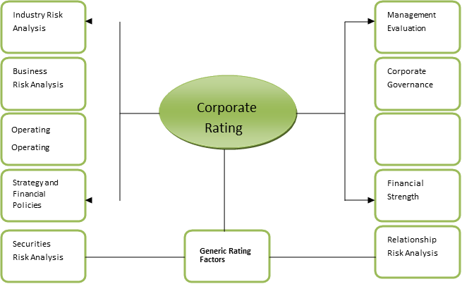



Figure: CRAB’s Corporate Rating Methodology

Rating Methodology of CRAB’s Corporate Unit;
Now for the corporate rating division of CRAB, the rating co-ordination is unique among the corporate substances including a gathering of the association and SME. Corporate enteritis could be from any industry aside from the Banking and Protection industry. In the positions and shapes of ranking for various corporate elements, CRAB pursues the accompanying rating procedure.
• Operation/Business Hazard Examination
• Industry/Market Hazard Examination
• Management Hazard Investigation
• Credit Office and Security Hazard Investigation
• Relation Hazard Investigation
• Financial Hazard Investigation
1. Operation/Business Hazard Investigation:
In this segment Investigators essentially breaking down the organization's capacities and dangers identified with Task exercises. By breaking down working danger CRAB discovers any Organization's quality presence which originates from the activity. Components that are considered here are recorded underneath.
- Production or exchanging scale
- List of top five Clients
- Raw material quality
- Pricing
- Product decent variety
- Raw material acquisition methodology
- Relationship with a client
- List of top five Providers
- Cost Proficiency
- Adequacy of Assets
- Technological headway
- All-out benefit of the existing machine of the Institute
- List of apparatus; brand names & the nation source of those sorts of hardware
- Quality duty and quality arrangement
- Quality of imported crude material
- Quality of items created.
- Business Model.
- Investment in the remodel.
- Investment in marking and advertising.
- Utility supply, particularly power.
- Gas supply, a gas-based generator to get the surety for constant power supply, likewise brand name and limit.
- Pump for providing fundamental water for the production line.
In light of trade to trade, these parts may change as far as dissecting any business execution.
2. Industry/Market Hazard Investigation:
CRAB's industry hazard investigation offers thoughtfulness regarding the quality of industry expectation, alongside that the aggressive variables applying the business. Behind this, the reason is to think about the present execution of chose associations with the business to make reference to regulate whether the organization is performing fittingly or not. Components which are considered here are given underneath.
- Industry prospects for development, security or decrease the example of the business cycle
- Investment plans of the real players in the business
- Demand and supply of the item
- Price patterns
- Change in innovation
- International/residential elements
- Capital force
- Corruption
- Existence or potential for substantial tax collection and Guideline, passage obstructions.
3. Management Hazard Investigation:
This Hazard Investigation area judges if there is any take-off in the supervisory group which may cause ups and down in the organization's day by day keep running of the business. A few variables saw here are appeared as follows:
- Shareholders' position and level of offer
- Type of The board Pecking order
- Number of Representatives
- Process of Revealing
- Degree and Capability of a representative
- Employees' security measures corporate administration
- Types of Procedure taken and portrayal
- Foreign Advertisers
4. Credit Office and Security Hazard Investigation:
CRAB puts additional load on security if there should arise an occurrence of the rating of instrument commitments. The rating of advance commitments centres around one income contrasted with the bond. Guarantee hazard implies chance related to the coverage which has been given to the Panel or any budgetary organization for any obligation taken by the organization. A few Variables have been considered here which are appeared as follows:
- Types of guarantee; Present moment or long haul
- If, the Insurance is long haul like land, at that point a full portrayal of the land is to be given
- Available security and guarantee
- Quality of guarantee
- Adequacy of guarantee
- Additional credit improvement for example as certification, protection
- The legal danger of the guarantee.
5. Relation Hazard Examination:
To assess the financial soundness of an organization, this is unavoidable to evaluate the financial relationship of the appraised foundations. Rating cast back the readiness alongside the capacity of the communal to sustenance through its commitments. It is important to gather "Financier's Classification Report" from every one of the brokers of the corporate. For that CRAB built up a standard configuration of the report which incorporates;
- How, long has the subject been your client? Are the dealings with the subject and its sister organizations attractive?
- Has, the intrigue and essential instalment from the subject been opportune? Have there been any defaults by the subject or its sister organizations? On the off chance that indeed, if it's not too much trouble give the subtleties for one year.
- Need a depicted profile of the subject's money related interrelation between the providers and clients amid the most recent one year.
- The credit subsidized, non-financed and others, sum authorized/limit, the sum dispensed and Overdrawn (assuming any) as of the present date.
6. Financial Hazard Investigation:
CRAB takes an organization's three to five years evaluated fiscal reports, the book kept by the administration, the measure of fare and import, brokers' criticism and customer’s record while surveying of money related hazards for the organization. Variables that are considered are recorded beneath.
- Earnings and Benefit:
- Gross Net revenue
- Net-Net revenue
- Capital Structure and Obligation Inclusion Position:
- Cash Stream from Activity (CFO)
- Borrowed Store to Value
- Borrowed Reserve to EBITDA
- CFO/Obligation
- FFO/Obligation
- EBIT/Intrigue
- Liquidity Position and Working Capital Force:
- Current Proportion
- Quick Proportion
- Receivable Gathering Period
- Inventory Preparing Period
- Cash Change Cycle
- NWC/Raven.

Financial Variables Earning and Profitability Ratio:
- Gross Profit Margin:
Gross Profit Margin =
Gross Profit= Sales – the Cost of Goods Sold Net Sales= Gross Sales - Sales Return
Higher Gross Overall revenue means that the firm has a decent gainfulness circumstance.
- Net Profit Margin:
Net Profit Margin =
Higher Net Overall revenue shows the standard execution of the business.
Capital Structure and Debt Coverage Position:
- Cash Flow from Operation (CFO):
Cash Flow from Operations (CFO) = (a) Net Income + (b) Depreciation & Amortization +/-
C) One-Time Adjustments +/- (d) Change in Working Capital
Over the long haul income from tasks must be certain for the organization to stay dissolvable.
- Borrowed fund to Equity:
Debt to Equity = 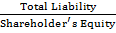
A proportion of 1 or 1: 1 is perfect. A high obligation/value proportion, for the most part, implies that an organization has been forceful in financing its development with the obligation.
- Borrowed Fund to EBITDA:
Debt to EBITDA =
A high commitment/betide extent suggests that a firm will be unfit to help its commitment in an appropriate manner and can result in a cut-down credit rating. Of course, a low extent can prescribe that the firm may need to expect more commitment if vital and it every now and again warrants a tolerably high fico evaluation.
Liquidity Position and Working Capital Intensity:
- Current Ratio:
Current Ratio=
The ideal current Ratio is 2:1
- Quick Ratio:
Quick Ratio=
The ideal Quick Ratio of 1:1 is satisfactory.
- Cash Conversion Cycle:
Cash Conversion Cycle = Days Inventory Outstanding + Days Sales Outstanding- Days Payables Outstanding;
Days Inventory Outstanding =
Days Sales Outstanding = Days
Payables Outstanding = Days
The lower the Money Transformation Cycle the better. It changes from industry to industry. These are the cash identified with extents that are researched by an association before giving the FICO evaluation. To get AAA an association must achieve all of these criteria. In like manner, an association's arrangements must be more noticeable than Taka 10 Billion. The impact position should be around 1.5. Afresh, if the impact comes more critical than 2 or 3 yet is supported up by extraordinary assistance then moreover the association can achieve an AAA rating. The lesser the Receivable Get-together Time span, Stock Planning Period and Cash Change Cycle the better evaluating an affiliation will be allowed. In any case, these move from industry to industry. Normally, the industry can have a higher Receivable Social occasion Period, Stock Getting ready Period and Cash Change Cycle. Everything considered, paying little respect to whether different days are a lot for instance 200 days, the association will get an AAA. Moreover, the Smart extent must be more conspicuous than one.
The Grading system of CRAB ^{(Source)}
CRAB RATING SCALES AND DEFINITIONS –Long Term (Corporate)
Long Term Rating | DEFINATION
AAA  Triple A | Organizations appraised in this class have a very solid ability to meet money related responsibilities. These organizations are made a decision to be of the most noteworthy quality, with insignificant Credit hazards.
AA₁, AA₂, AA₃*  Double A | Organizations evaluated in this class have an extremely solid ability to meet money related responsibilities. These organizations are made a decision to be of exceptionally brilliant, subject to extremely low Credit hazard.
A₁, A₂, A₃  Single A | Organizations appraised in this class have a solid ability to meet money related duties yet are helpless to the unfavorable impacts of changes in conditions and financial conditions. These organizations are made a decision to be of fantastic, subject to low credit chance.
BBB₁, BBB₂, BBB₃  Triple B | Organizations evaluated in this class have sufficient ability to meet money related responsibilities yet progressively defenseless to unfriendly financial conditions or evolving conditions. These organizations are liable to direct credit chance. Such organizations have certain Theoretical attributes.
BB₁, BB₂, BB₃  Double B | Organizations appraised in this classification have insufficient ability to meet budgetary responsibilities. Have major continuous vulnerabilities and presentation to unfriendly business, monetary, or financial conditions. These organizations have theoretical components, subject to a Generous credit chance.
B₁, B₂, B₃  Single B | Organizations appraised in this class have a feeble ability to meet monetary duties. These organizations have theoretical components, subject to high credit chance.
CCC₁, CCC₂, CCC₃  Triple C | Organizations appraised in this class have an extremely frail ability to meet money related commitments. These organizations have powerless standing and are liable to exceptionally high credit hazards.
CC  Double C | Organizations evaluated in this classification have an amazingly feeble ability to meet money related commitments. These organizations are exceedingly theoretical and are likely in, or close, default, with some prospect of recuperation of chief and intrigue.
C  Single C | Organizations appraised in this classification are profoundly defenseless against non-installment, have installment arrearages permitted by the terms of the reports, or subject of the liquidation request, yet have not encountered an installment default. Installments may have been suspended as per the instrument's terms. These organizations are normally in default, with little prospect for the recuperation of key or intrigue.
D  (Default) | D rating will likewise be utilized upon the recording of an insolvency request or comparative activity if installments on a commitment are endangered.

Note: CRAB affixes statistical converters from 1 to 3 for each regular ranking portrayal from AA from end to end CCC. The modifier 1 exhibits that the elective group positions in the higher end of its nonexclusive rating arrangement; the transformer 2 demonstrates a mid-broaden situating, and the transformer 3 specifies situating in the inferior end of that ordinary rating class.
LONG-TERM RATING: LOANS/FACILITIES FROM BANKS/FIS (All loans/facilities with original maturity exceeding one year)

RATINGS | DEFINITION
AAA (Lr)  (Triple A) Highest Safety | Credits/offices appraised AAA (Lr) are made a decision to offer the most noteworthy level of security, with respect to the auspicious installment of money related commitments. Any unfriendly changes in conditions are probably not going to influence the installments on the advance office.
AA (Lr)*  (Double A) High Safety | Advances/offices evaluated AA (Lr) are made a decision to offer a high level of wellbeing, with respect to the convenient installment of money related commitments. They vary just insignificantly in security from AAA (Lr) evaluated offices.
A (Lr)  Adequate Safety | Advance/offices evaluated A (Lr) is made a decision to offer a satisfactory level of wellbeing, with respect to the opportune installment of money related commitments. Be that as it may, changes in conditions can antagonistically influence such issues more than those in the higher rating classifications.
BBB (Lr)  (Triple B) Moderate Safety | Credits/offices appraised BBB (Lr) are made a decision to offer moderate security, with respect to the auspicious installment of money related commitments for the present; be that as it may, changing conditions are bound to prompt a debilitated ability to pay the premium and compensate central than for issues in higher rating classes.
BB (Lr)  (Double B) Inadequate Safety | Advances/offices evaluated BB (Lr) are made a decision to convey insufficient wellbeing, with respect to the auspicious installment of money related commitments; they are more averse to default in the prompt future than instruments in lower rating classes, however an unfavorable change in conditions could prompt lacking ability to make the installment on monetary commitments.
B (Lr)  High Risk | Advances/offices appraised B (Lr) are made a decision to have a high danger of default; while as of now money related commitments are met, antagonistic business or financial conditions would prompt an absence of capacity or eagerness to pay the premium or vital.
CCC (Lr)  Very High Risk | Credits/offices appraised CCC (Lr) are made a decision to have factors present that make them all around exceptionally helpless against default; convenient installment of money related commitments is conceivable just if ideal conditions proceed.
CC (Lr)  Extremely High Risk | Advances/offices appraised CC (Lr) are made a decision to be incredibly powerless against default; auspicious installment of money related commitments is conceivable just through outside help.
C (Lr)  Near to Default | Credits/offices appraised C (Lr) are as of now very defenseless against non-installment, having commitments with installment arrearages permitted by the terms of the reports, or commitments that are subject of a chapter 11 appeal or comparative activity yet have not encountered an installment default. C is normally in default, with little prospect for the recuperation of primary or intrigue. C (Lr) is commonly in default, with little prospect for the recuperation of essential or intrigue.
D (Lr)  Default | Credits/offices appraised D (Lr) are in default or are relied upon to default on planned installment dates.
Note: CRAB affixes statistical converters from 1 to 3 for each regular ranking portrayal from AA from end to end CCC. The modifier 1 exhibits that the elective group positions in the higher end of its nonexclusive rating arrangement; the transformer 2 demonstrates a mid-broaden situating, and the transformer 3 specifies situating in the inferior end of that ordinary rating class.
SHORT-TERM CREDIT RATING: LOANS/FACILITIES OF BANKS/FIS (All loans/facilities with original maturity within one year)
RATINGS |  | DEFINATIONS
ST-1  Highest Grade | This rating indicates that the degree of safety regarding timely payment on the loans/facilities is very strong.
ST-2  High Grade | This rating indicates that the degree of safety regarding timely payment on the loans/facilities is strong; however, the relative degree of safety is lower than that for issues rated higher.
ST-3  Adequate Grade | This rating indicates that the degree of safety regarding timely payment on the loans/facilities is adequate; however, the issues are more vulnerable to the adverse effects of changing circumstances than issues rated in the two higher categories.
ST-4  Marginal | This rating indicates that the degree of safety regarding timely payment on the loans/facilities is marginal; and the issues are quite vulnerable to the adverse effects of changing circumstances.
ST-5  Inadequate Grade | This rating indicates that the degree of safety regarding timely payment on the loans/facilities is minimal, and it is  Likely to be adversely affected by short-term adversity or less favorable conditions.
ST-6  Lowest Grade | This rating indicates that the loans/facilities are expected to be in default on maturity or is in default.

© Copyright 2018, FICO appraisal Association OF BANGLADESH Compelled ("CRAB"). All rights held. ALL Information CONTAINED In this IS Guaranteed BY COPYRIGHT LAW AND NONE OF SUCH Information MAY BE Imitated OR For the most part Copied, REPACKAGED, FURTHER TRANSMITTED, Traded, Scattered, REDISTRIBUTED OR Traded, OR Set away FOR Coming about USE FOR ANY SUCH Reason, IN Whole OR To a restricted degree, IN ANY Structure OR Way OR Utilizing any and whatsoever methods all, BY ANY Person WITHOUT CRAB'S Prior Formed Consent.
Credit Rating Report on the New Lion Steel Re-Rolling Mills Ltd.
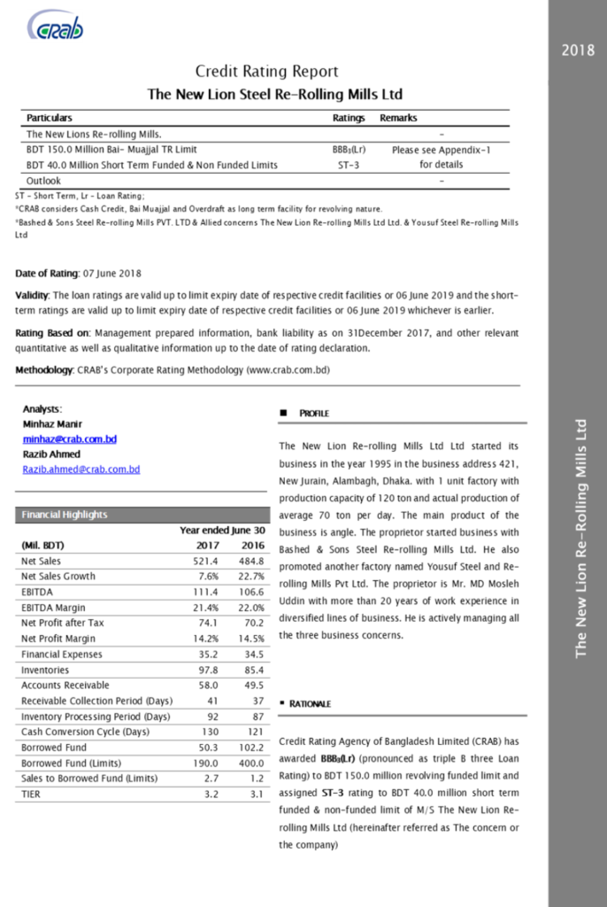
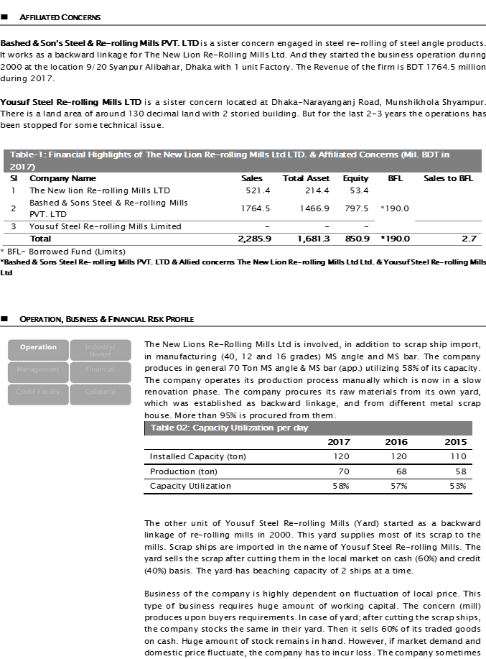
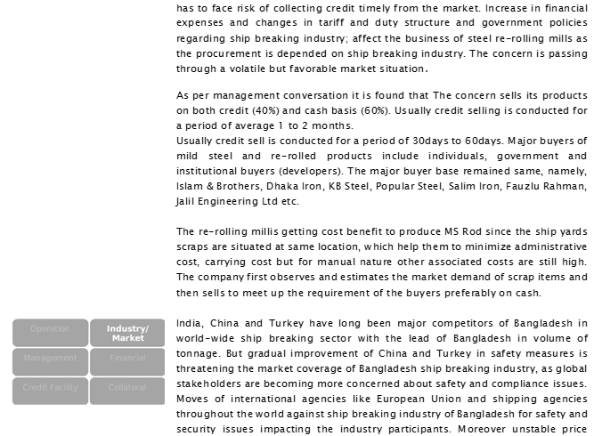

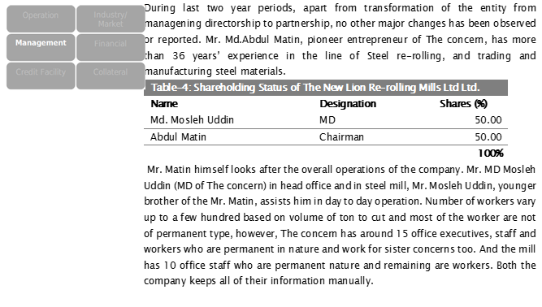

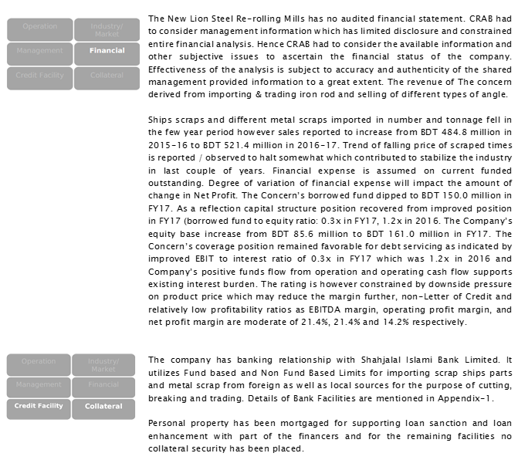

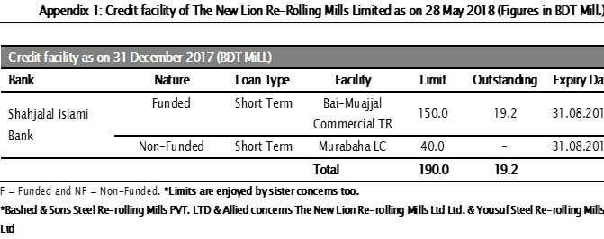
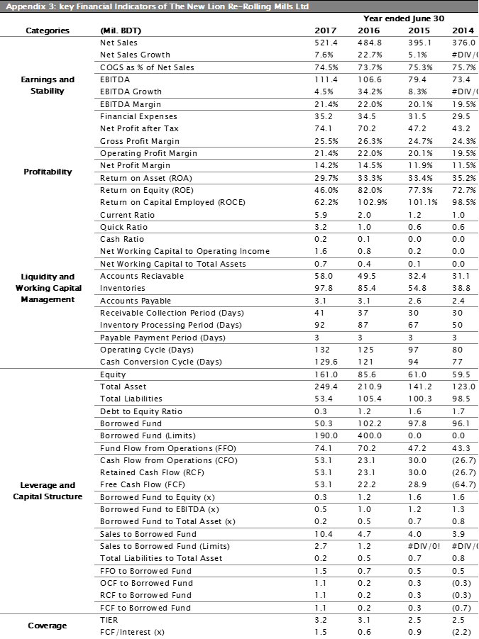
**Full report is not allow to publish in any other contents**
The New Lion Steel Re-Rolling Mills Ltd. (Visit Part)




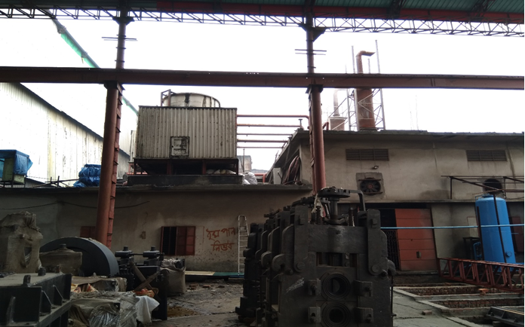

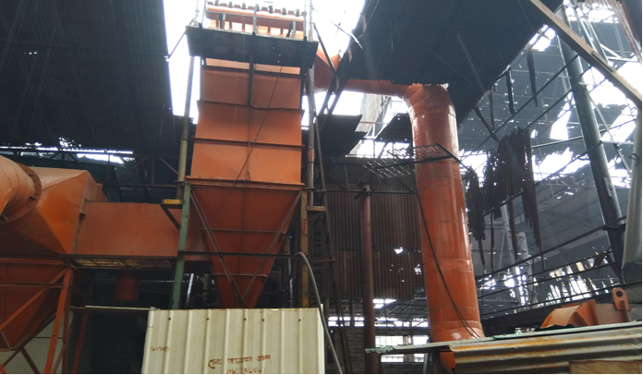

Source: Personal visit to”The New Lion Steel Re-Rolling Mills Ltd.” _{Date: 21 May, 2018}

Problems and solutions:
- Problems of the credit rating process of CRAB;
- Most of corporate customer comprehend the need of the rating however a SME customer think they have all thought regarding their business and no need any business partner or rating. There is inaccessibility of market or industry data. In Bangladesh individuals don't give data legitimately that is the reason it straightforwardly influences rating report. Customer has no clue why rating is essential. They think its additional expense and superfluous, investor and rating industry working individuals are likewise in charge of it. They are not clarified nor have deficiency of learning and they can't give appropriate data what's the advantage of rating.

- High expense charge is another primary issue for SME customer. The majority of the rating organization charge high cost for rating that is the reason SME customers are not keen on installment.

- The Most troublesome boundaries and hindrances to interest in Bangladesh is the political vulnerability. Nonattendance of discourse and trading off propensity among the gatherings has made the circumstance increasingly mind boggling. Without having a stable and really equitable express, the venture atmosphere won't update. Then again, neighbourhood financial specialists will go for a venture of their cash to abroad or someplace reasonable.

- Long procedure of rating is another factor which sway direct on the business, when business advancement completed an arrangement with customer he/she ensure they give administration inside 15 working days yet when an investigator beginning with work he faces loads of issues like unviable data, correspondence issue bunches of factor which legitimately sway on working and it is preparing time long.

- Bangladesh is a creating nation, so loads of bank and money related organization giving advance for making new business visionary however some organization don't offer consideration regarding gather the budgetary or other substance's information and don't keep up any database. Along these lines, it's a noteworthy issue to break down budgetary and other serious issues of market which will straightforwardly influence different examiners to report the FICO score.

- Possible Arrangements on the FICO assessment procedure of CRAB;

- From the talks and the affirmation about FICO assessment of CRAB, I might want to prescribe the accompanying components for the Organization, Mass individuals ought to be given the fundamental information about FICO score benefits through courses, Notices or by including a portion of the instructive investigations.

- More approaches and guidelines issued from the administrative bodies, Bangladesh Bank and SEC. The administrative bodies should keep reasonable screen on all the FICO score Offices in Bangladesh. In 2014 all the enlisted FICO score offices, Bangladesh Bank and SEC have made an affiliation, Relationship of FICO score Organizations of Bangladesh, ACRAB, to direct the FICO assessment offices. ACRAB should intently screen the exercises of every one of the eight organizations in Bangladesh; how moral they are working, what expenses they are charging, regardless of whether they are charging expenses underneath the benchmark or not. They should approach to kill the ascending of the "Cost and Rating Shopping". Banks should be severe about the legitimateness of the report just before affirming it. Some eminent banks/money related establishments and Bangladesh Bank consent to acknowledge the FICO score report just from CRAB. In any case, every single other bank ought to be mindful about others firms.

- More budgetary executes ought to be set up in Bangladesh for Rating Office to grow up. The more monetary items (like security showcase, common reserve) will increment in Bangladesh the additionally requesting, affluent and alluring FICO score offices would turn into. A security rating expense could be charged around Taka Five Million, what's more shared store rating could be charged around Taka Ten Million.

- CRAB's managerial costs ought to be diminished. A few customers sadly turned out to be contradicted before the agreement is marked as CRAB normally charges a high expense. This is on the grounds that to keep up a standard CRAB pays high compensation to its Officers and Monetary Investigators. Additionally, the Investigators assemble detail data, completely break down them, and make plant visits too every one of the customers each time observation is done and in the underlying rating. These bring about loads of costs, which thus builds the expense structure. Besides, when CRAB investigates morally with genuine information and regularly the evaluations become very low. However, different offices may act deceptively and make contracts with customers to build the FICO score. By this other rating organizations exploit the current value war between the offices by offering nearly low charge for rating. As customers improve rating at a lower charge which is incredibly gainful for customers in getting advance from banks, so they once in a while change to other FICO assessment offices. What's more, in certain conditions, organization's execution amazingly weakens which eventually makes them defaulter. In this way, they consequently stop the rating.

There is no database in Bangladesh that is openly accessible of the business or market circumstance. The rating offices deals with several associations of a similar industry. CRAB itself has chipped away at right around five hundred to six hundred associations of a similar industry of all industry segments. Base of the data, CRAB has enough assets to examine the present business circumstance, pattern of industry, commercial centre and current market situation. They should plan to make a database of every industry through which they can perform pattern investigation of businesses and market. CRAB needs to contract industry specialists who can help them in this work and in the investigation. Every one of the Examiners ought to keep up and practice moral acts and good standards.

Literature Review
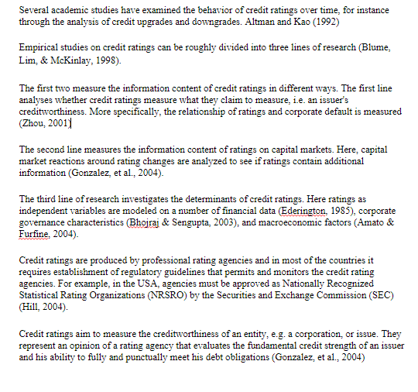
- Authors:
- Altman and Kao, 1992
- Blume, Lim and McKinlay, 1998
- Zhou, 2001
- GonZalez, el al., 2004
- Amato & Furfine, 2004
- Hill, 2004
- Gonzale, et al., 2004

Scope of Report
Any scholastic course of the examination has incredible esteem when it has a commonsense application, all things considered. Just a great deal of hypothetical information will have little significance except if it is pertinent in a useful life. In this way, we have to apply an appropriate utilization of our fundamental information about rating to get some profit by our hypothetical learning in our functional life. Building a solid base of functional information is conceivable through working someplace for all intents and purposes. At the point when hypothetical ramifications are gained from a course of study, which is the main minor method for the topic. The temporary position suggests the full use of the techniques and the arrangement of ventures by procuring recognizes of the topic and that can have a generative connected in our day by day life.

Methodology of Report
The strategies which are pushed off in this report are chiefly carried out the responsibility in an elucidating nature. Both essential and auxiliary information are utilized to break down and chose as the fundamental research strategy.
Primary Information Gathering:
- The essential information has been gathered from:
- Interviewing the key people of the organization.
- Face to confront discussion with officers and staffs;
- Related documents, Broacher, books to contemplate are given by the officers concerned and expert;
- Sharing the pragmatic learning of authority lead.
Secondary Information Accumulation:
Some specific information for this report has been separated from referenced auxiliary sources since the graphic idea of strategies are utilized to set up this report may call for existing actualities and data assemblage.
The sites are utilized on account of information accumulations and framed the report referenced in the References segments.

Limitations
I have experienced a few issues while setting up this report, for example,

- Unavailability of Information: Some part of the information was inaccessible in the sites and printed data was additionally difficult to gather.
- The incorrectness of information: It was hard for me to discover the solid wellspring of information among every one of the sources.
- No review of adequacy should be possible on account of private information.

Notwithstanding, I unequivocally trust that I have endeavored to beat my issues and finished this report getting it done.

Findings and Analysis
Findings:

- CRAB introduced with some of the problems along with their services. In grading and other services, some analysts don’t pay enough attention and don’t maintain the grading policy. And by this, the output of the results comes in poor quality.
- Still, Crab is up to implement the policies of Basel I, II record for the Credit rating process.
- In some majority cases, the financial terms and tools don’t meet the quality results of ratings.
- Previously the Grading meters were not accurate.
- Some problems are mentioned about The Credit Rating process of CRAB in the body part and possible solutions are also given following by.
- The credit rating report on ‘New Lion Steel Re-Moving Factories Ltd’ doesn’t contain full information for some confidential purposes.
Analysis:
- In the objective part of some problems and solutions, I have mentioned briefly about how to improve CRAB’s grading and other services in a quality manner.
- I will recommend applying Basel III in terms of use Basel I, II for better-upgraded results in CRAB Ltd.
- As every financial tool in rating, process methodology indicates differently, so analysts should be more careful before collecting numerical data and using ratio and other instructions.
- I have mentioned the latest Grading policy of CRAB. (Updated Chart of December 2018)
- Solutions are given along with the objective part of Problems and solutions.
- I have included the full report on ‘New Lion Steel Re-Moving Factories Ltd’ along with the mail for your better observations.

Conclusion
CRAB is a free and corporate association built up in specialized joint effort with ICRA Ltd (Hyperlink) for charging FICO assessments in Bangladesh. It is a legitimate supplier of venture data and rating administrations. Despite the fact that different organizations are not so much potential about making the FICO assessments, so still CRAB is driving a higher position among other FICO score Offices in Bangladesh. It tends to be said that the significance of FICO assessment is expanding step by step. A decent appraising can spare a nation from getting to be indebtedness. What's more, CRAB normally keeps up the FICO score approach to make any evaluating.

I have effectively finished my temporary job program in CRAB. It was extremely an extraordinary encounter for me to work with budgetary experts of CRAB. My essential obligations and duties were gathering authoritative information, make helping for money related investigators, learning the rating procedure, breaking down budget summaries, getting ready FICO score reports and information input, and so forth. The best possible methodology of FICO score has been talked about extensively in this paper. Some different variables are likewise referenced in this report like the rating techniques, reviewing strategy, some budgetary terms and proportions, and so on.

I have likewise incorporated the short report of "New Lion Steel Re-Moving Factories Ltd" Using a credit Rating which arranged by CRAB observations. What's more, it was evaluated in Long haul Advance, (BBB3) and in Transient Advance, (ST3) which characterize it has a solid ability to meet money related responsibilities.

Generally speaking loads of applicable and approved data are incorporated into this paper. For better examination and learning about “Evaluation of Credit Rating Methodology Process of CRAB," a few references are likewise including toward the finish of this report.

References
Online content:
https://crab.com.bd
http://crab.com.bd/basel-ii/
https://en.m.wikipedia.org/wiki/Credit_rating_agency
http://www.assignmentpoint.com/business/finance/credit-rating-method-of-credit-rating-agency-of-bangladesh.html
https://www.investopedia.com/terms/c/creditrating.asp
http://dx.doi.org/10.1561/0500000048
Book and journal:
- CRAB (Corporate Broacher)
- Credit Ratings: Methodologies, Rationale and Default Risk, Edited By Michael K. Ong
- Journal of Financial Regulation and Compliance ISSN: 1358-1988
Subject Area: Accounting, Finance & Economics.

