

Project on
FINTEC APPLICATION OF THE LISTED BANKING INDUSTRIES IN BANGLADESH

Project supervisor;
Dr. Mofijul Hoq Masum, FCMA
Associate Professor - AIS
School of Business & Economics
United International University

Submitted by;
Shakil Ahmmed
ID: 111 162 121

Date of submission: 28/03/2026

Letter of acknowledgement
I'm profoundly thankful to the Almighty for granting me the strength and occasion to complete my design, "Operation of Fintech in the Listed Banking Industry in Bangladesh."
I extend my deepest thankfulness to my director, Dr. Mofijul Hoq Masum, for his inestimable guidance, stimulation, and support throughout this trip. His moxie and perceptivity have been necessary in shaping this design and have inspired me to strive for excellence.
I would also like to express my sincere thanks to the faculty members and executive staff who handed backing and access to coffers vital for my exploration. Their cooperation and stimulants have been a constant source of provocation.
Likewise, I'm thankful to my family and musketeers, whose unvarying support and stimulants have been my pillars of strength throughout this shot.
I want to express my gratitude for the valuable contributions of all individuals and organizations who provided data, insights, and perspectives that enhanced this project. Without their input, this work would not have been possible.
I appreciate every one of you for being a part of this journey.
Sincerely,
Shakil Ahmed

Letter of Transmittal
Date: 28/03/2026
Dr. Mofijul Hoq Masum, FCMA
Associate Professor, School of Business & Economics
United International University
United City, Madani Avenue, Dhaka 1212
Sub: Submission of Project Report on "Application of Fintech in the Listed Banking Industry in Bangladesh"
Dear Dr. Masum,
I am pleased to submit my project report titled "Application of Fintech in the Listed Banking Industry in Bangladesh" as part of the requirements for the completion of my academic program. The purpose of this report is to provide a detailed analysis of how financial technology is transforming the operations and efficiency of listed banks in Bangladesh.
Throughout the project, I have made an effort to incorporate pertinent data, case studies, and theoretical frameworks to ensure a comprehensive review of the subject. Your invaluable guidance, constructive feedback, and encouragement have played a crucial role in completing this work, and I am extremely grateful for your support. My sincerest hope is that this report meets your expectations and provides valuable insights into the subject matter. I am eager to receive any feedback or suggestions you may have to improve.
I am grateful for the opportunity to work under your supervision and for your ongoing mentoring throughout this project.
Sincerely,
Shakil Ahmmed
ID: 111 162 121

Declaration
Date: 28 /03/2026
To Whom It May Concern,
I am Shakil Ahmmed, a student of Bachelor of Business Administration, at United International University, hereby declare that the project titled "Application of Fintech in the Listed Banking Industry in Bangladesh" is an original piece of work carried out by me under the guidance of Dr. Mofijul Hoq Musum.
To complete my academic program, I have to complete this project as a partial requirement. I verify that the information, data, and findings contained in this project have been gathered and presented in accordance with academic and ethical standards. All references to prior research or sources have been acknowledged and cited appropriately.
This project's goal is to explore the role, impact, and potential of financial technology (Fintech) in the banking sector in Bangladesh, with a specialized emphasis on listed banks. From my perspective, this research will offer valuable insights into the evolving financial ecosystem and the strategic adoption of technology in the banking industry.
The statement I make is based on good faith and to the best of my knowledge.
Sincerely,
Shakil Ahmmed
ID: 111 162 121

Table of Contents
1. Introduction 6
1.1: Brief introduction of the concern field: 6
1.2: Background of the study: 6
1.3: Significance of the study: 7
2. Objectives of the study 8
2.1: Broad objectives: 8
2.2: Specific objectives: 9
3. Methodology of the study 9
3.1 data design: 9
3.1.1: secondary data: 9
3.2 Sample design: 9
3.2.1: Sampling techniques: 9
3.2.2: Sample size: 10
4. Literature review: 10
4.1 Theoretical Development: 11
5. Findings and analysis of the study: 11
5.1: Number of ATM, CRM, Agent banking outlets (Individually): 14
5.2: Number of ATM (Combinedly year basis): 35
5.3: Number of CRM (Combinedly year basis): 40
5.4: Number of agent banking outlets (Combinedly year basis): 45
Conclusion 51
References 52
Appendix 54

Abstract
Numerous new wheels in the modern economy are responsible for the current era's prosperity. Without a doubt, one of those is financial technology. These digital financial services are the foundation of the new cashless economy (Benazir Rahman, 2021). The overall ecosystem, difficulties, and opportunities of fintech in Bangladesh's banking sector are similar to this study. Banks in particular have recently become more reliant on these high-tech services. According to the study, these technologies will benefit users as well as the expansion and service diversification of the banking industry. The study describes the characteristics of fintech that are common in Bangladesh and the obstacles that prevent the banking sector from expanding.. For the study, the data has been collected from listed banks website and annual report by using census data collection technique. The study covered sufficient bar chart comparison of ATM, CRM and agent banking individually for each bank and also there some understandable implication of each of them. For the study, year basis combinedly bar chart of ATM, CRM and agent banking outlets also included which indicates the overall performance through each year for banks, there also some of easily understandable implication has been given.

Keyword: Fintech, banking industry, Bangladesh, digital transformation, financial inclusion.

Introduction

1.1: Brief introduction of the concern field: Financial technology (Fintech) has revolutionized traditional banking and financial services in the global financial landscape, resulting in a paradigm shift. Digital payments, blockchain, mobile banking, and artificial intelligence are just a few of the innovations in fintech that aim to improve operational efficiency, improve customer experience, and promote financial inclusion. The integration of Fintech with the banking sector is gaining momentum in Bangladesh, where it plays a crucial role in the nation's economic development. Fintech solutions are becoming more and more popular among listed banks in the country to streamline processes, improve service delivery, and cater to a tech-savvy customer base. The increase in smartphone penetration, internet connectivity, and regulatory initiatives that promote digital finance has further accelerated the shift towards digitalization. Despite its promising potential, Fintech in Bangladesh's banking industry is confronted with numerous challenges, such as regulatory constraints, cybersecurity risks, and barriers to customer adoption. To sustain a sustainable Fintech ecosystem in the country, it is crucial to comprehend these dynamics. The role of fintech in transforming Bangladesh's listed banking industry is examined in this study, with emphasis on its impact, challenges, and future prospects. It aims to provide actionable insights for policymakers, financial institutions, and other stakeholders to harness the power of Fintech for a resilient and inclusive banking system.
1.2: Background of the study: Bangladesh's economic growth has relied heavily on the financial sector, with the banking industry playing a crucial role in facilitating trade, investment, and financial inclusion. Due to the rapid pace of technological advancement, it is necessary to change from traditional banking practices to more innovative and customer-centric solutions. Fintech, also known as financial technology, has become a transformative force in the global banking industry, providing seamless transactions, efficient resource allocation, and enhanced accessibility for customers. In the context of Bangladesh, Fintech adoption has gained traction over the past decade, supported by the increasing penetration of mobile and internet connectivity, the proliferation of smartphones, and government initiatives aimed at digital transformation. The banking experience has already undergone a change due to the emergence of mobile financial services (MFS), online banking platforms, and digital payment systems. The listed banking sector in Bangladesh continues to face challenges in fully integrating Fintech, including regulatory compliance issues, cybersecurity threats, and customer readiness for technological adoption. Given the importance of listed banks in the country's financial ecosystem, it is critical to understand the application and impact of fintech. These organizations not only stimulate economic activity, but also set standards for technological adoption in the financial industry. Investigating how Fintech affects operational efficiency, service delivery, and market competitiveness might provide significant insights into the banking sector's future trajectory in Bangladesh. This study looks into the benefits and problems connected with Fintech adoption in Bangladesh's listed banking industry. The research intends to add to the larger conversation about how Fintech may be effectively used to enhance innovation, efficiency, and financial inclusion in the country by assessing current practices, legal frameworks, and customer behavior.
1.3: Significance of the study: Financial technology (Fintech) is altering the global banking scene by providing innovative solutions to increase efficiency, improve consumer experiences, and broaden financial inclusion. Understanding the consequences of Fintech is especially important in Bangladesh, where the banking industry drives economic growth. This study is useful for various reasons:
- Improving Operational Efficiency: The study focuses on how Fintech technologies can streamline operations, reduce costs, and increase overall efficiency in Bangladesh's listed banks. These insights can help banks optimize their operations and remain competitive in a continually changing financial world.
- Enhance Customer Experience: The study investigates the influence of Fintech on customer-centric financial services and makes actionable recommendations for increasing accessibility, convenience, and satisfaction, particularly among underprivileged and rural groups.
- Leading Regulators and Policymakers: The findings of this study provide important insights into the regulatory obstacles and opportunities related with Fintech adoption. Policymakers can utilize these insights to create frameworks that combine innovation with stability and security in the banking industry.
- Promoting Inclusion in Finance: Fintech has the ability to bridge the gap between traditional financial institutions and unbanked or underbanked people. This study looks at how listed banks in Bangladesh might use Fintech to broaden their reach and promote inclusive economic growth.
- Adding to Industry and Academic Knowledge: The study serves as a reference for upcoming scholarly research and industry practices by adding to the little body of literature on Fintech applications in the banking sector of Bangladesh.
This study intends to establish a sustainable, innovative, and customer-focused banking sector in Bangladesh by examining the usage of Fintech in listed banking. Its conclusions should ultimately help the country's economic development in the digital era by helping banks, regulators, legislators, and consumers alike.

Objectives of the study

2.1: Broad objectives: The purpose of the study is to investigate how financial technology, or Fintech, is used and what effects it has on Bangladesh's listed banking sector. Analyze the sorts of technology and services being used, as well as the present level of Fintech adoption in Bangladesh's listed banking sector. Project aim was to cover the field of fintech adoption in the listed banking industry in Bangladesh. How many of them adopted fintech easily by short time of period. What consequence faced by competitors who could not adopted earlier or yet and their shortage of performance. How much listed banks adopted fintech and how much their performance boosted.

2.2: Specific objectives:
- To determine the range of fintech solutions used by listed banks: Examine the Fintech applications used by Bangladesh's listed banks, such as mobile banking, artificial intelligence, and digital payment solutions.
- To Analyze Enhancements in Operational Efficiency: Learn how Fintech adoption has enhanced banking operations, such as cost savings, faster service delivery, and streamlined processes.
- To Evaluate the Effect on Financial Performance: Determine the impact of Fintech on the profitability, competitiveness, and market positioning of Bangladesh's listed banks.

Methodology of the study

data design:

3.1.1: secondary data: After selecting listed banking industry for my project research, I have found in total 36 listed banks on Dhaka stock exchange website. From each of 35 listed banks website and annual report, I gathered all of the fintech information, corporate characteristics, corporate performance, boards attributes, ownership attributes. I could not collect data for Pubali Bank PLC, because of their annual report could not open or responsive for external users. Couple of annual reports has been missing such as National Bank LTD annual report 2023 and Trust Bank PLC annual report 2021. Information of annual reports and websites made and published by bank for different kinds of stakeholders. I have collected lots of numerical data from each of listed bank websites and annual reports which can be analyze statistically.

3.2 Sample design:

3.2.1: Sampling techniques: For data collection, I used Dhaka stock exchange websites for find out listed banks in Bangladesh. After that, I have downloaded all of the annual reports one by one for each of listed banks and also used each of their websites which refers to the census sampling techniques. Because of I have been collecting data from each of the listed banks annual reports and websites in Bangladesh. This sampling techniques provides accuracy of my research result.
3.2.2: Sample size: Since, I have collected data from 35 listed banks web site and their annual reports from 2019 to 2023. Sample size is 35. After conducting all of 35 banks fintech information, corporate characteristics, corporate performance, boards attributes, ownership attributes, it will provide the final result of efficiency, accountability, adjustment along with the fintech technology.

4. Literature review: In my project, the focus is on the application of financial technology (FinTech) in the listed banking industry in Bangladesh. Since I was focusing on Bangladesh's banking sector, I looked for research articles, reports, and papers that discussed how FinTech is being applied in banks, particularly in the context of Bangladesh. After identifying 35 listed banks, the next step is to review of them and extract key themes. These might include the impact of FinTech on customer experience, the role of mobile banking, digital payments and how these innovations are being adopted by banks. I have gone through all of 35 listed banks annual reports and their websites and found out each of their number of ATM, CRM, Agent banking outlets along with their other fintech information such as corporate characteristics, corporate performance, board attributes, ownership attributes. When I will complete research on application of fintech in the listed company on Bangladesh, I will use relevant chart, graph, table that can be easily identifiable and useable for anyone who wants. I will using 35 listed banks relevant information on table, chart, graph.
4.1 Theoretical Development: The theoretical development in my project will involve applying relevant theories to understand how FinTech is affecting the banking sector in Bangladesh. Some key theories given below:
Technology Acceptance Model (TAM): This model helps explain how users come to accept and use new technologies. According to TAM, perceived ease of use and perceived usefulness are key factors that influence whether consumers and businesses adopt FinTech solutions. This theory can be used to explore how Bangladesh's banking customers and employees perceive and adopt FinTech innovations.
Innovation Diffusion Theory (IDT): This theory explains how innovations spread within a social system. It focuses on factors like the perceived advantages of innovation, the compatibility of the innovation with existing practices, and how easily it can be adopted. This theory could help explain why some banks in Bangladesh have adopted FinTech solutions faster than others.
Resource-Based View (RBV): The RBV theory suggests that a company’s resources (like technology, capital, and knowledge) are critical for gaining a competitive advantage. For Bangladesh’s banks, the resources they invest in FinTech could determine how well they can compete in a rapidly digitalizing financial market.
Service-Dominant Logic (SDL): SDL focuses on how businesses, especially service-based industries like banking, can create value through collaboration and the exchange of resources. In the context of FinTech, SDL could explain how banks use technology to enhance their service offerings, such as through better customer interactions, personalized services, and increased efficiency.

Findings and analysis of the study:

The banking sector is facing a set of challenges and opportunities due to the current digital transformation. As the banks go through the complexity of this digital frontier, they face regulatory challenges, cybersecurity and protection issues, and technical issues to provide a smooth transition for their diversified client base. On the bright side, these issues provide unique opportunities for innovation, increased efficiency, and the development of new financial products and services (Saqee, 2024).
Automated Teller Machine (ATM): An automated teller machine (ATM), sometimes referred to as an automated banking machine (ABM) or cash machine, is a computerized telecommunications device that enables customers of a financial institution to conduct financial transactions in a public setting without the help of a bank teller or cashier. A plastic card—also referred to as an ATM card with a magnetic stripe or a plastic smart card with a chip—that has a unique card number and some security information, like an expiration date, is used to identify a customer in the majority of contemporary ATMs. The customer enters a personal identification number (PIN) to provide authentication. Using an ATM, customers can access their bank accounts in order to make cash withdrawals, credit card cash advances, and check their account balances as well as purchase prepaid cell phone credit (Md. Motahar Hossain, 2013). The regression analysis demonstrates a significant negative impact of ATMs on both return on equity (ROE) and return on assets (ROA) which indicates ATMs have a significant relationship with bank profitability, supporting the hypothesis HA. The ATMs’ coefficients in Model I (Random Effects) are -0.0037 (t = -2.55, p < 0.10) for ROE. These findings suggest that ATMs may not be as profitable 36 THE COST AND MANAGEMENT ISSN 1817-5090, VOLUME-52, NUMBER-04, JULY-AUGUST 2024 in the short run because of the costs involved, including installation, maintenance, and operating charges. Similar to this, Model II (Pooled OLS) shows that the results of the random effect are credible with coefficients of -0.0660 (t = -4.98, p < 0.10) for ROE and -0.0050 (t = -4.16, p < 0.01) for ROA. Additionally, Jegede (2014) and Singh et al. (2021) discovered a negative correlation between ATM usage and bank profitability. ATM deployments must be in line with long-term profitability objectives through a well-balanced investment strategy that takes potential revenue, operational expenses, and user demand into account (Md. Al-Amin, 2024).
A single cassette is used for both cash withdrawals and deposits on contemporary ATMs, formerly known as recycle ATMs but now known as cash recycling machines (CRM). A CRM is a one-stop banking solution that can assist customers with their financial transaction activities. This includes making deposits and withdrawals without using a bank teller. By reducing the expense and error of cash processing, CRMs have enhanced cash management and assisted banks in raising their profit margins. Additionally, banks have been able to increase customer bases, mobilize deposits, and boost profitability through lower operating costs thanks to CRM's reach into previously under-served rural areas. CRM has gained popularity in Bangladesh as well as throughout the world. The regression results show that Cash Recycling Machines (CRMs) have a significant negative influence on both return on equity (ROE) and return on assets (ROA), which supports the hypothesis HB that there is a strong association between CRMs and bank profitability. The coefficient for CRMs in Model I (Random Effects) is -0.0229 (t = -1.94, p < 0.05) for ROE and -0.0018 (t = -1.73, p < 0.10) for ROA. The findings of Hasan (2019) corroborate these results, which indicate that the expenditures of CRMs, including installation and maintenance, may outweigh their immediate financial benefits and negatively affect profitability. The comparable conclusions are also confirmed in Model II (Pooled OLS). This suggests that although CRMs can lower cash handling expenses and improve operational efficiency, their financial impact needs to be carefully considered. Banks ought to think about making the most of their current CRMs and assess whether making more purchases of these devices would be financially prudent. It is crucial to weigh these expenses against possible operational savings to match CRM installations with overarching profitability targets (Md. Al-Amin, 2024).
Profitability is positively and statistically significantly connected with the number of deposit accounts and agent banking outlets. Rural residents must be integrated into the system in order to improve their economic and living circumstances, and agent banking can be very beneficial in doing so. Additionally, Bangladesh's agent banking sector had a very steady growth rate both before and after the coronavirus pandemic. According to Bangladesh Bank, agent banking is the practice of providing limited banking services to members of the underprivileged class of society by substituting agents selected by legal agreement for tellers or cashiers. The regression analysis, which demonstrates a significant detrimental effect of agent banking on both Return on Assets (ROA) and Return on Equity (ROE), supports the hypothesis HC, which proposes a significant relationship between the number of agent banking outlets and bank profitability. In Model I (Random Effects), the coefficient for agent banking is -0.0001 (t = -0.08, p < 0.01) for ROA and -0.0010 (t = -0.13, p < 0.01) for ROE. These findings suggest that the costs connected with expanding agent banking services may outweigh the immediate financial benefits, leading to reduced profitability in the short term. Similarly, Model II (Pooled OLS) also confirms these findings. This emphasizes the necessity for banks to assess the financial viability of growing their agent banking networks. Although agent banking can expand financial inclusion and service reach, its impact on profitability must be carefully evaluated. Banks should focus on optimizing their current agent banking processes and ensuring that potential revenue and customer engagement increases outweigh the costs of expansion. (Md. Al-Amin, 2024).

5.1: Number of ATM, CRM, Agent banking outlets (Individually):

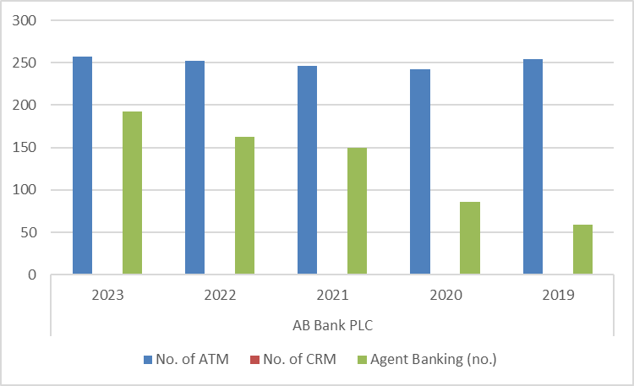
As we can see, AB Bank PLC had the most ATMs and agent banking locations in 2023—257 and 197, respectively. Between 2019 and 2023, the number of ATM and agent banking locations grew annually. I was unable to locate the existence of their CRM machine or the total cost. (ABBL, 2019–2023)

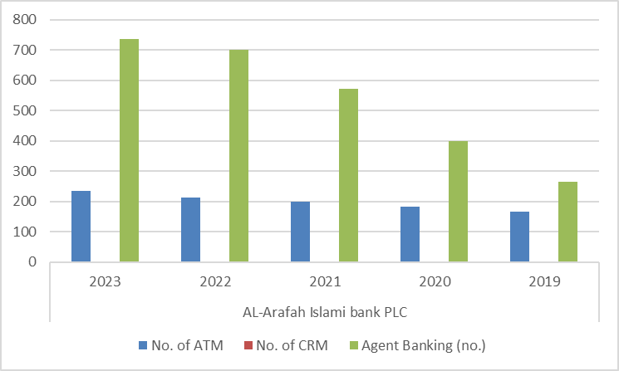
I have found AL-Arafah Islami bank PLC, also an increasing trend. Their number of ATM and Agent banking outlets increased over the year from 2019 to 2023. Their highest number of ATM and Agent banking outlets was 235 and 737 respectfully in 2023. Their CRM amount was nil. (AIBL, 2019-2023)

In comparison to the number of ATMs and CRM machines, Bank Asia PLC has the most agent banking outlets. The number of ATMs and agent banking locations peaked in 2022. They began introducing their CRM machines in 2021, and by 2023, they had established a total of four CRM machines. (Bank Asia, 2019–2023)

Brack Bank PLC has the increasing trend for the Agent banking outlets. On the other hand, their ATM was in declining trend. They started introduce their CRM machine on 2022, by the end date of 2023 they have total amount of 10 CRM machine. (Brack Bank, 2019-2023)

Between 2019 and 2023, City Bank PLC expanded the number of agent banking locations overall, but the total number of ATMs decreased. They started offering CRM machines to their customers in 2022, and by the end of 2023, they had ten CRM machines in total. (City Bank, 2019–2023)

Dhaka Bank PLC could not focus on Agents baking and establishing outlets. As a result, they have zero agent banking outlets over the year of 2019 to 2023. Their number of ATM was in increasing trend and peak amount of ATM was in 2023. They have started establish CRM machine on 2023, end of 2023 they have got total 7 CRM machine for their users. (Dhaka Bank, 2019-2023)

As of right now, Dutch Bangla Bank PLC has the most ATMs, agent banking locations, and CRM machines. In general, the number of ATMs, CRMs, and agent banking locations was rising. Having the greatest number of ATMs in 2022 and the greatest number of agent banking locations and CRM machines in 2023. (Dutch Bangla Bank, 2019–2023)

Eastern Bank PLC has the rising trend for ATM, CRM, Agent banking outlets over the year from 2019 to 2023. They initiate their CRM machine on 2022 and end of 2023, they had 38 CRM machine. Their highest amount of ATM and Agent banking outlets was in 2023 respectfully. (EBL, 2019-2023)

Export Import (EXIM) Bank PLC has the elevation trend for ATM over the year from 2019 to 2023. They have got peak amount of ATM was in 2023. They had zero CRM machine. They have launched their Agent banking outlets operation in 2021, though growth was steady. (Exim Bank, 2019-2023)

Over the course of the year, First Security Islami Bank PLC's ATM and agent banking locations have grown significantly. In 2023, they had the greatest number of ATMs and agent banking locations—230 and 105, respectively. Although the process is slow, they introduced a CRM machine in 2022. They had 20 CRM machines in total for their users by the end of 2023. (First Security Islami Bank, 2019–2023)

Global Islami Bank PLC had the initiate of ATM machine over the year from 209 to 2023. They have got nil CRM machine up to 2023. They have started Agent banking outlets operation in 2021, by the end of 2023 they had total 20 agent banking outlets. (Global Islami Bank, 2019-2023)

ICB Islamic Bank Limited website and annual report shows they had overall zero ATM, CRM, Agent banking outlets through the year of 2019 to 2023. (ICB Islami Bank, 2019-2023)

IFIC Bank PLC has the declining process of ATM. As we can see their peak amount of ATM machine was in 2019 which was 93. After that ATM machine reduce over the year and end of 2023 was 49 ATM machine. They have got nil CRM machine as well as Agent banking outlets so far 2023. (IFIC Bank, 2019-2023)

Islamic Bank Bangladesh PLC has substantial growth on ATM, CRM and Agent banking outlets throughout the selected year of 2019 to 2023. Their highest quantity of ATM, CRM, Agent banking outlets was in 2023 respectfully 2189, 800, 2771. (Islami Bank Bangladesh, 2019-2023)

Jamuna Bank PLC had steady growth on ATM machine over the year. Highest total ATM exist in 2023. They have started CRM operation on 2023 and they provide all of 2023 ATM into CRM. They also started Agent banking outlets in 2021, by the end of 2023 they have got total 50 Agent banking outlets. (Jamuna Bank, 2019-2023)

Mercantile Bank PLC had slow growth in ATM machine throughout the year but they had fast growth in Agent banking outlets. Highest aggregate was in 2023 for both ATM and Agent banking outlets. They had zero CRM machine so far in 2023. (Mercantile Bank, 2019-2023)

Midland Bank PLC had steady climb on total number of ATM and Agent banking outlets. Highest in total was in 2023 for both ATM and Agent banking outlets respectfully 65 and 131. They did not put in place CRM machine so far 2023. (Midland Bank, 2019-2023)

Mutual Trust Bank PLC had slow growth of ATM. By the end of 2023, total amount was 320. They had pretty good growth in Agent banking outlets up to 2021, after that result was declining a small portion in total. By the end of 2023 they had total 197 Agent banking outlets, in 2021 the amount was 201. They never introduce their CRM machine so far of 2023. (MTB, 2019-2023)

National Bank LTD annual report of 2023 could not find in their official website. They did not start CRM machine and Agents banking operation till 2023. Their total ATM machine was almost same throughout the years. (NBL, 2019-2023)

National credit and Commerce Bank PLC had slow increase rate of ATM machine from 2019 to 2023. Peak total ATM machine was in 2022 and 2023 which was similar. They did not introduce CRM machine and started Agent banking operation so far of 2023. (NCC Bank, 2019-2023)

NRB Bank PLC had almost similar of slow trend of growth in ATM and Agent banking outlets throughout the selected year of 2019 to 2023. Their highest total ATM exist was in 2023, amount of total 53 ATM. Their peak amount of Agent banking outlets was in 2020, in total 316 outlets. (NRB Bank, 2019-2023)

NRBC Bank PLC had similar amount of ATM and CRM machine throughout each year. Growth of ATM and CRM was slow. Highest ATM and CRM shows in 2023 respectfully 81 both. They have started agent banking operation in 2022, by the end of year 2023 they got total 630 agent banking outlets. (NRBC Bank, 2019-2023)

One Bank PLC had slow growth on ATM increasing but they had fast growth on Agent banking outlets within the selected years. Their highest total ATM was in 20222 and 2023, amount was 172. On the other hand, their peak amount of agent banking outlets was in 2023, amount of 227. They never introduced their CRM machine to their users so far of 2023. (One Bank, 2019-2023)

The Premier Bank PLC had moderate increase rate for both ATM and Agent banking outlets throughout the year of 2019 to 2023. Highest number of ATM recorded in 2023 and highest number of agent banking outlets recorded in also 2023. They did not bring in CRM machine for their users. (The Premier Bank, 2019-2023)

Prime Bank PLC had exactly same amount of ATM and CRM machine through the selected each year of 2019 to 2023. For ATM and CRM, growth rate was decrease through selected years. Best year for ATM and CRM was 2019 and 2020. Agent banking outlets extension was pretty good manner though in 2023 was downgrade the total. Best year for the agent banking outlets was 2022. (Prime Bank, 2019-2023)

Rupali Bank PLC had sustainable extension of their ATM section. Highest total was in 2023. They did not launch CRM machine and Agent banking outlets operation for their users thus far of the selected years of 2019 to 2023. (Rupali Bank, 2019-2023)

SBAC Bank PLC had the smallest growth on their ATM section all around the selected years. Highest result was in the 2023. They did not start their CRM operation yet of 2023 for their users. They started their agent banking operation in 2022 for their users and highest total agent banking outlets record in the 2023. (SBAC Bank , 2019-2023)

Shahjalal Islami Bank PLC had slow development of ATM machine thus far the selected years. Highest total recorded in 2023. They never established CRM machine for their users. Their agent banking outlets increased gradually over the years. Highest amount of agent banking outlets recorded in 2023. (Shahjalal Islami Bank, 2019-2023)

Between 2019 and 2023, Social Islami Bank PLC experienced a significant increase in the number of ATM and agent banking locations. 2023 saw the highest total for ATM and agent banking locations. They never provided their users with a CRM system. (SIBL, 2019–2023)

Southeast Bank PLC had the rapid growth rate in ATM, CRM and agent banking outlets operation through the selected years. Their highest total of ATM, CRM, Agent banking outlets founded in the 2023. (Southeast Bank, 2019-2023)

Standard Bank PLC had slow growth rate for ATM through each year of 2019 to 2023. Peak total ATM recorded in 2023. They never launched CRM machine for the users. Their agent banking amount decrease a small portion through the years. Highest total agent banking outlets recorded in 2019. (Standard Bank, 2019-2023)

I could not found Trust Bank PLC annual report of 2021. Their ATM extensions was steady and almost similar through the years. Highest total ATM recorded in the 2023. They did not introduce CRM machine and agent banking operation for their users. (Trust Bank , 2019-2023)

United Commercial Bank PLC had same amount of ATM and CRM foe each year. I guess their all of the ATM machine is also CRM machine. Growth for ATM and CRM was in very good manner. Peak total ATM and CRM noted in 2023. Their agent banking outlets increasing rate was also pretty good specially in the 2022 to 2023 which was remarkable. Highest total founded in the year of 2023. (United Commercial Bank, 2019-2023)

Union Bank PLC had slow extension rate of ATM. Highest one recorded in the 2023. They never established CRM machine and agent banking outlets for their users. (Union Bank , 2019-2023)

Uttara Bank PLC had unhurried extension of ATM section throughout the selected years of 2019 to 2023. Highest total ATM founded in 2023. They did not introduce CRM machine and agent banking operation for their users. (Uttara Bank, 2019-2023)

5.2: Number of ATM (Combinedly year basis):

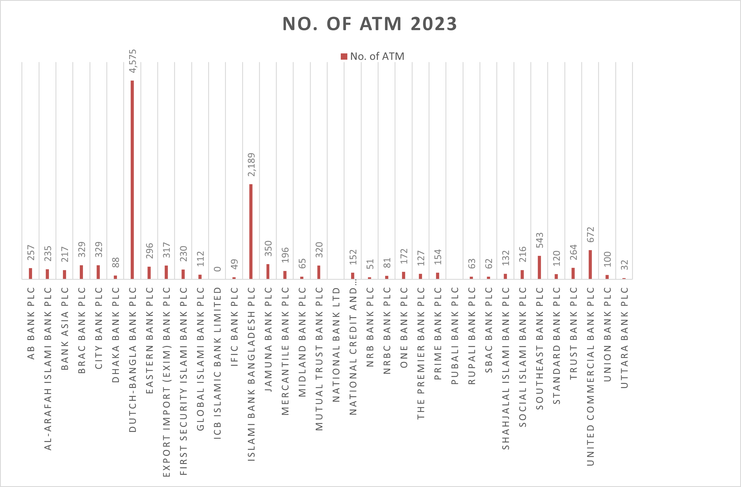
In 2023, I noticed that Dutch Bangla Bank PLC had the most ATMs. In terms of the total number of ATMs, Islami Bank Bangladesh came in second. A few banks had much fewer ATMs that year, while the majority of the rival banks were in a moderate range.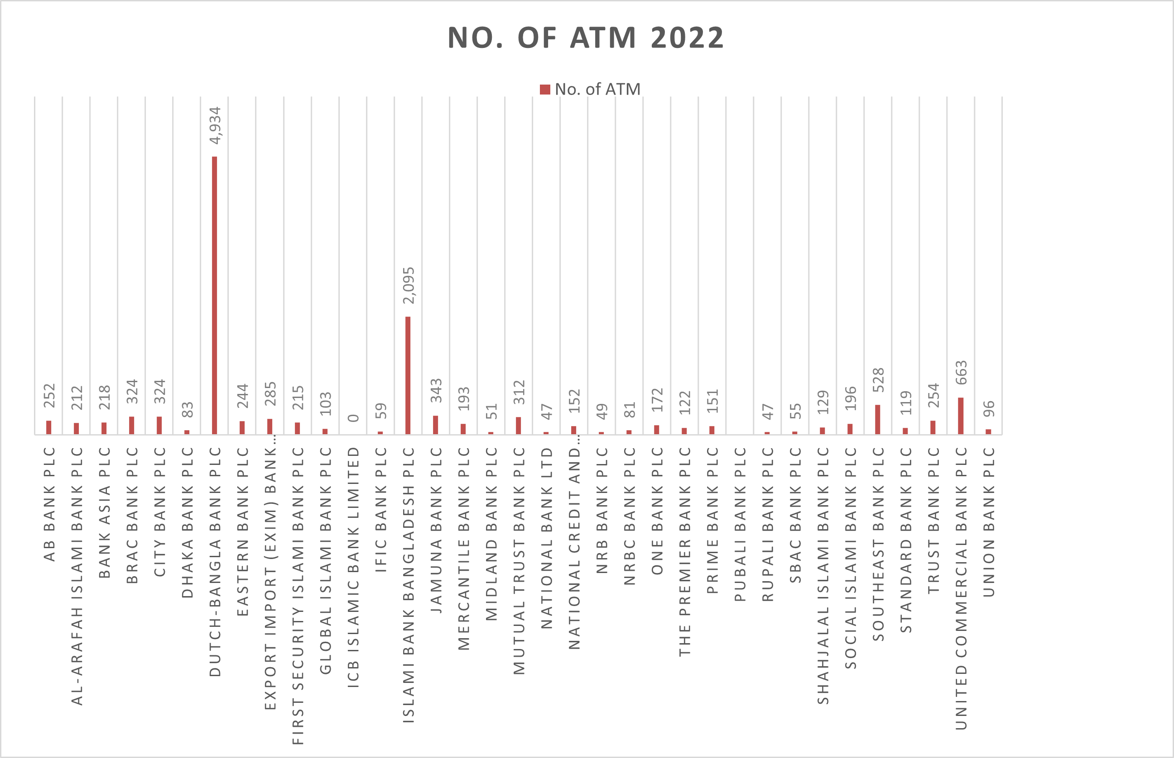
Additionally, Dutch Bangla Bank PLC had the most ATMs in 2022. In terms of total ATM availability, Islami Bank Bangladesh came in second. While a few banks had relatively low ATM counts, the majority of competitors stayed in the middle range.
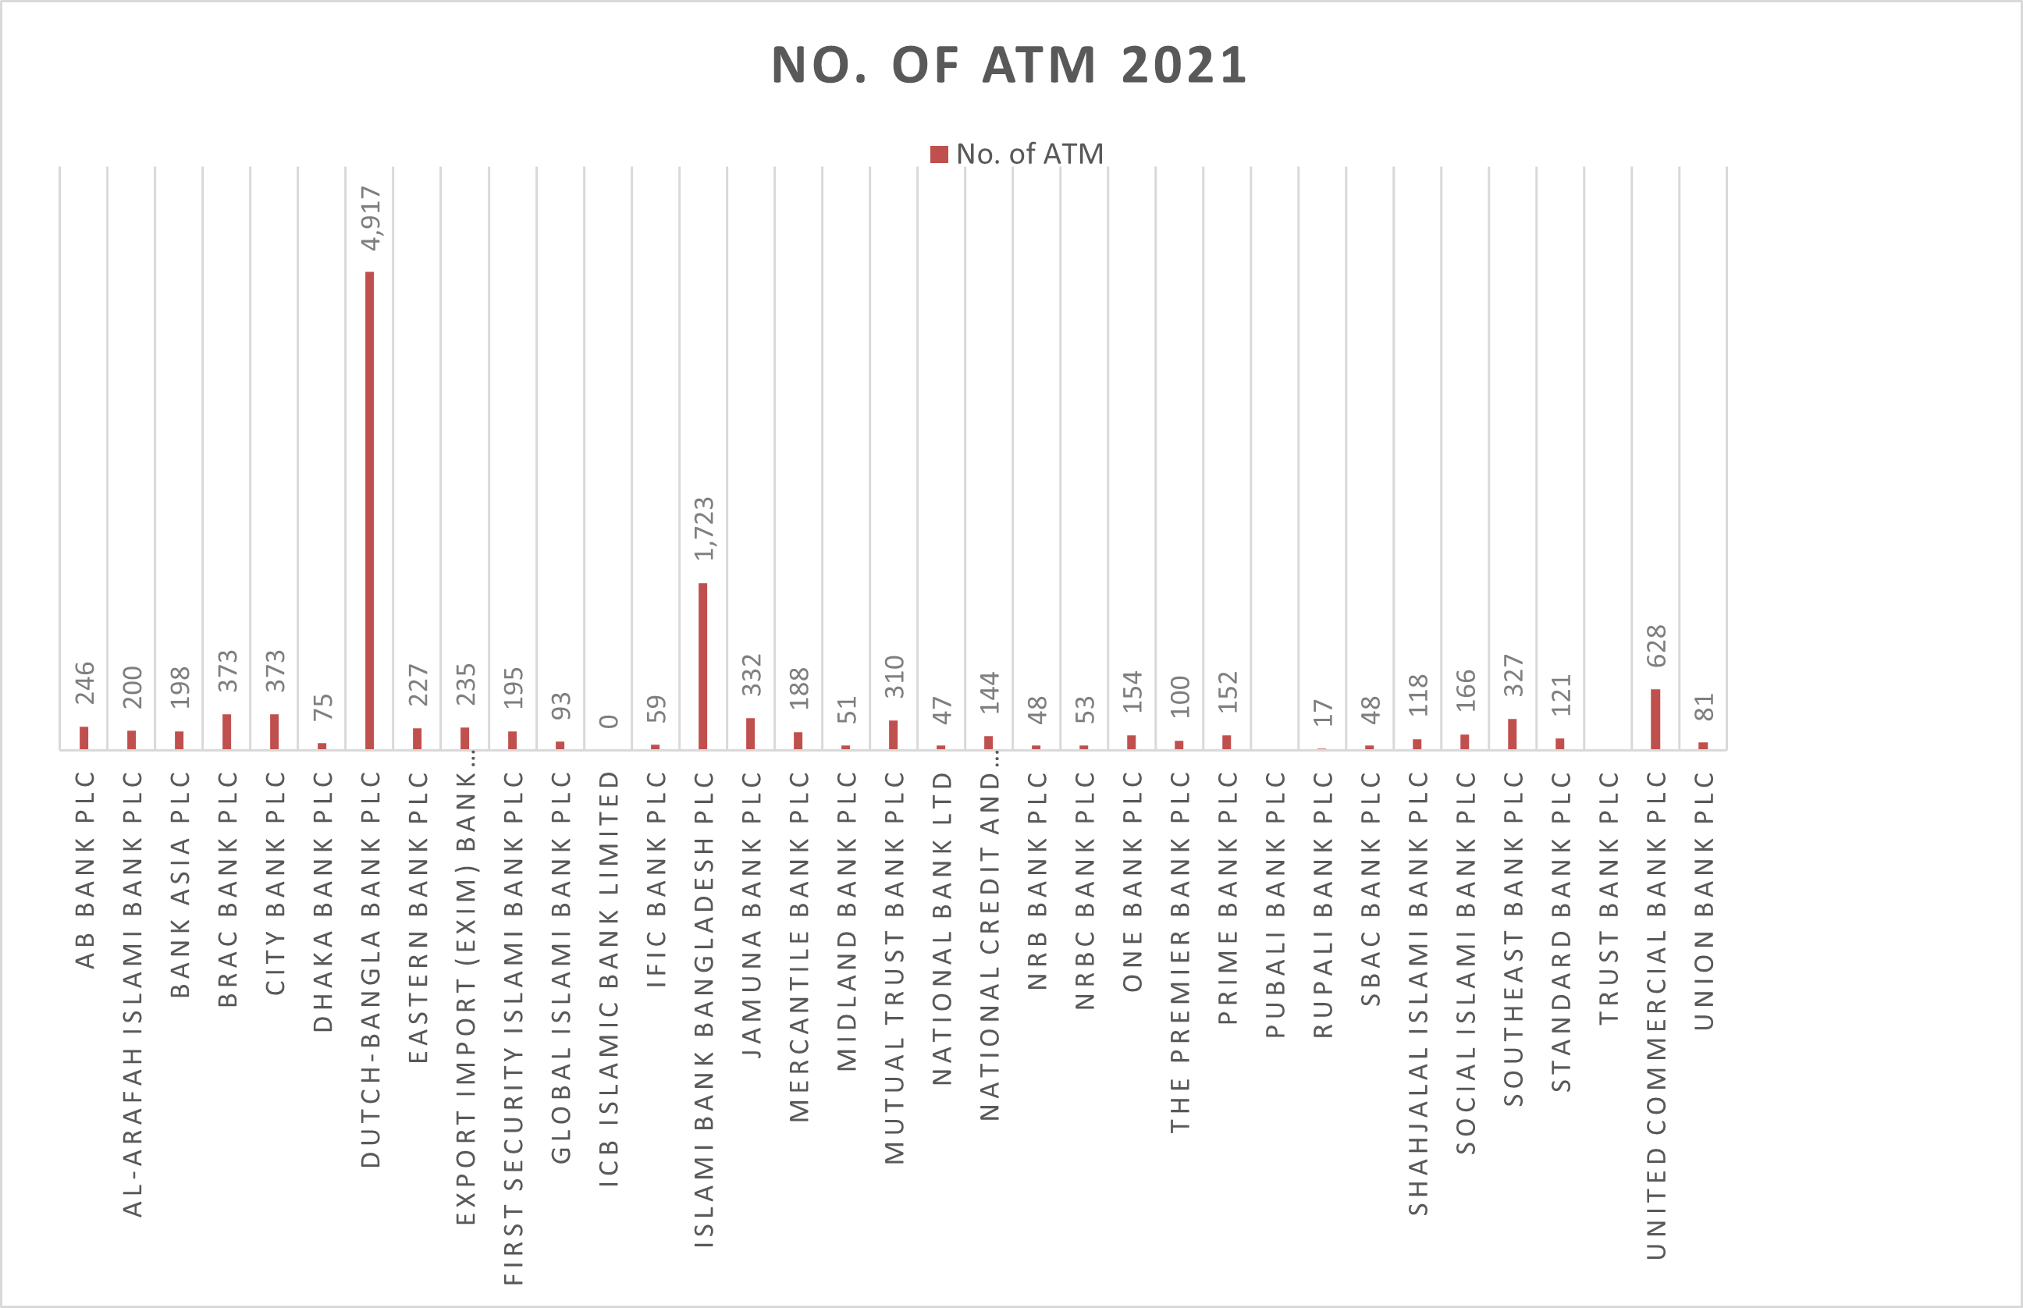
Dutch Bangla Bank PLC had the most ATMs in 2021, according to my research, which demonstrates the bank's robust network growth and service coverage in that year. In terms of the total number of ATMs, Islami Bank Bangladesh came in second and continued to have a significant market share. The majority of the rival banks were in a moderate position, meaning that the distribution of ATMs among them was average. In contrast to the top banks in 2021, a few rivals received extremely low scores, indicating that their ATM network was relatively small.
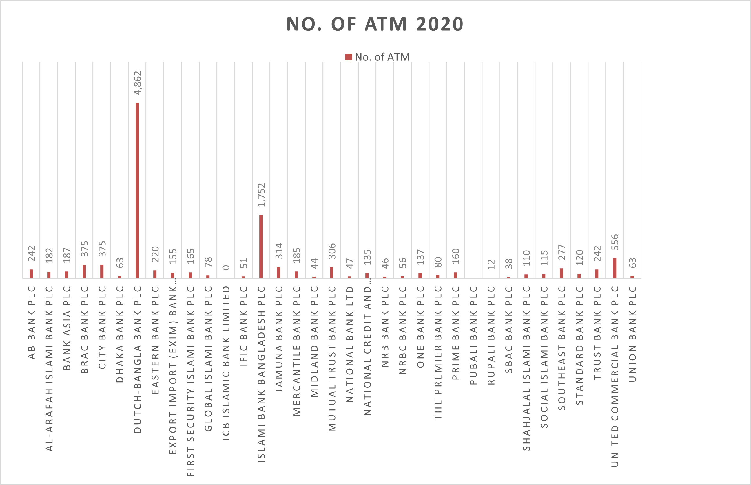
According to my research, Dutch Bangla Bank PLC had the most ATMs in 2021, indicating the bank's strong network expansion and service coverage during that year. Islami Bank Bangladesh maintained its substantial market share and ranked second in terms of the total number of ATMs. The distribution of ATMs among the competing banks was average, as most of them were in a moderate position. A few competitors scored incredibly low compared to the top banks in 2021, suggesting that their ATM network was comparatively small.
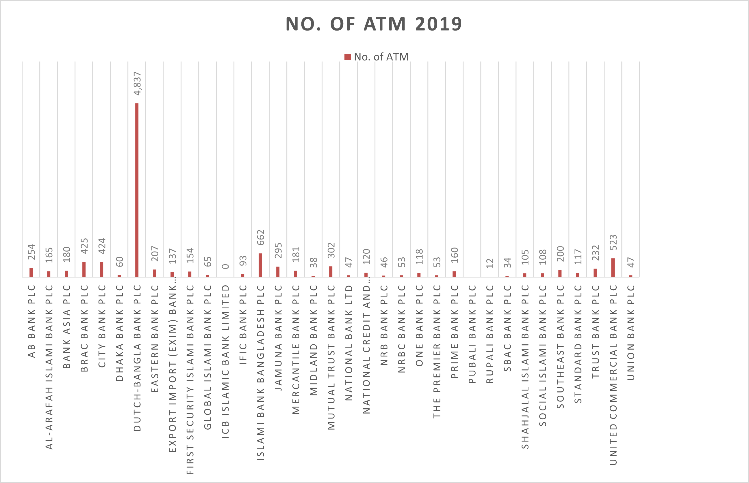
I discovered that Dutch Bangla Bank PLC had the most ATMs in 2019, which is indicative of its strong emphasis on maintaining a broad service network and increasing banking accessibility. In terms of the total number of ATMs, Islami Bank Bangladesh came in second, indicating a strong market presence. The majority of rivals fell into the moderate range, suggesting that most banks have an average level of ATM distribution. A few rivals, however, received extremely low scores, indicating that their ATM network was relatively small in comparison to the top banks in 2019.

5.3: Number of CRM (Combinedly year basis):

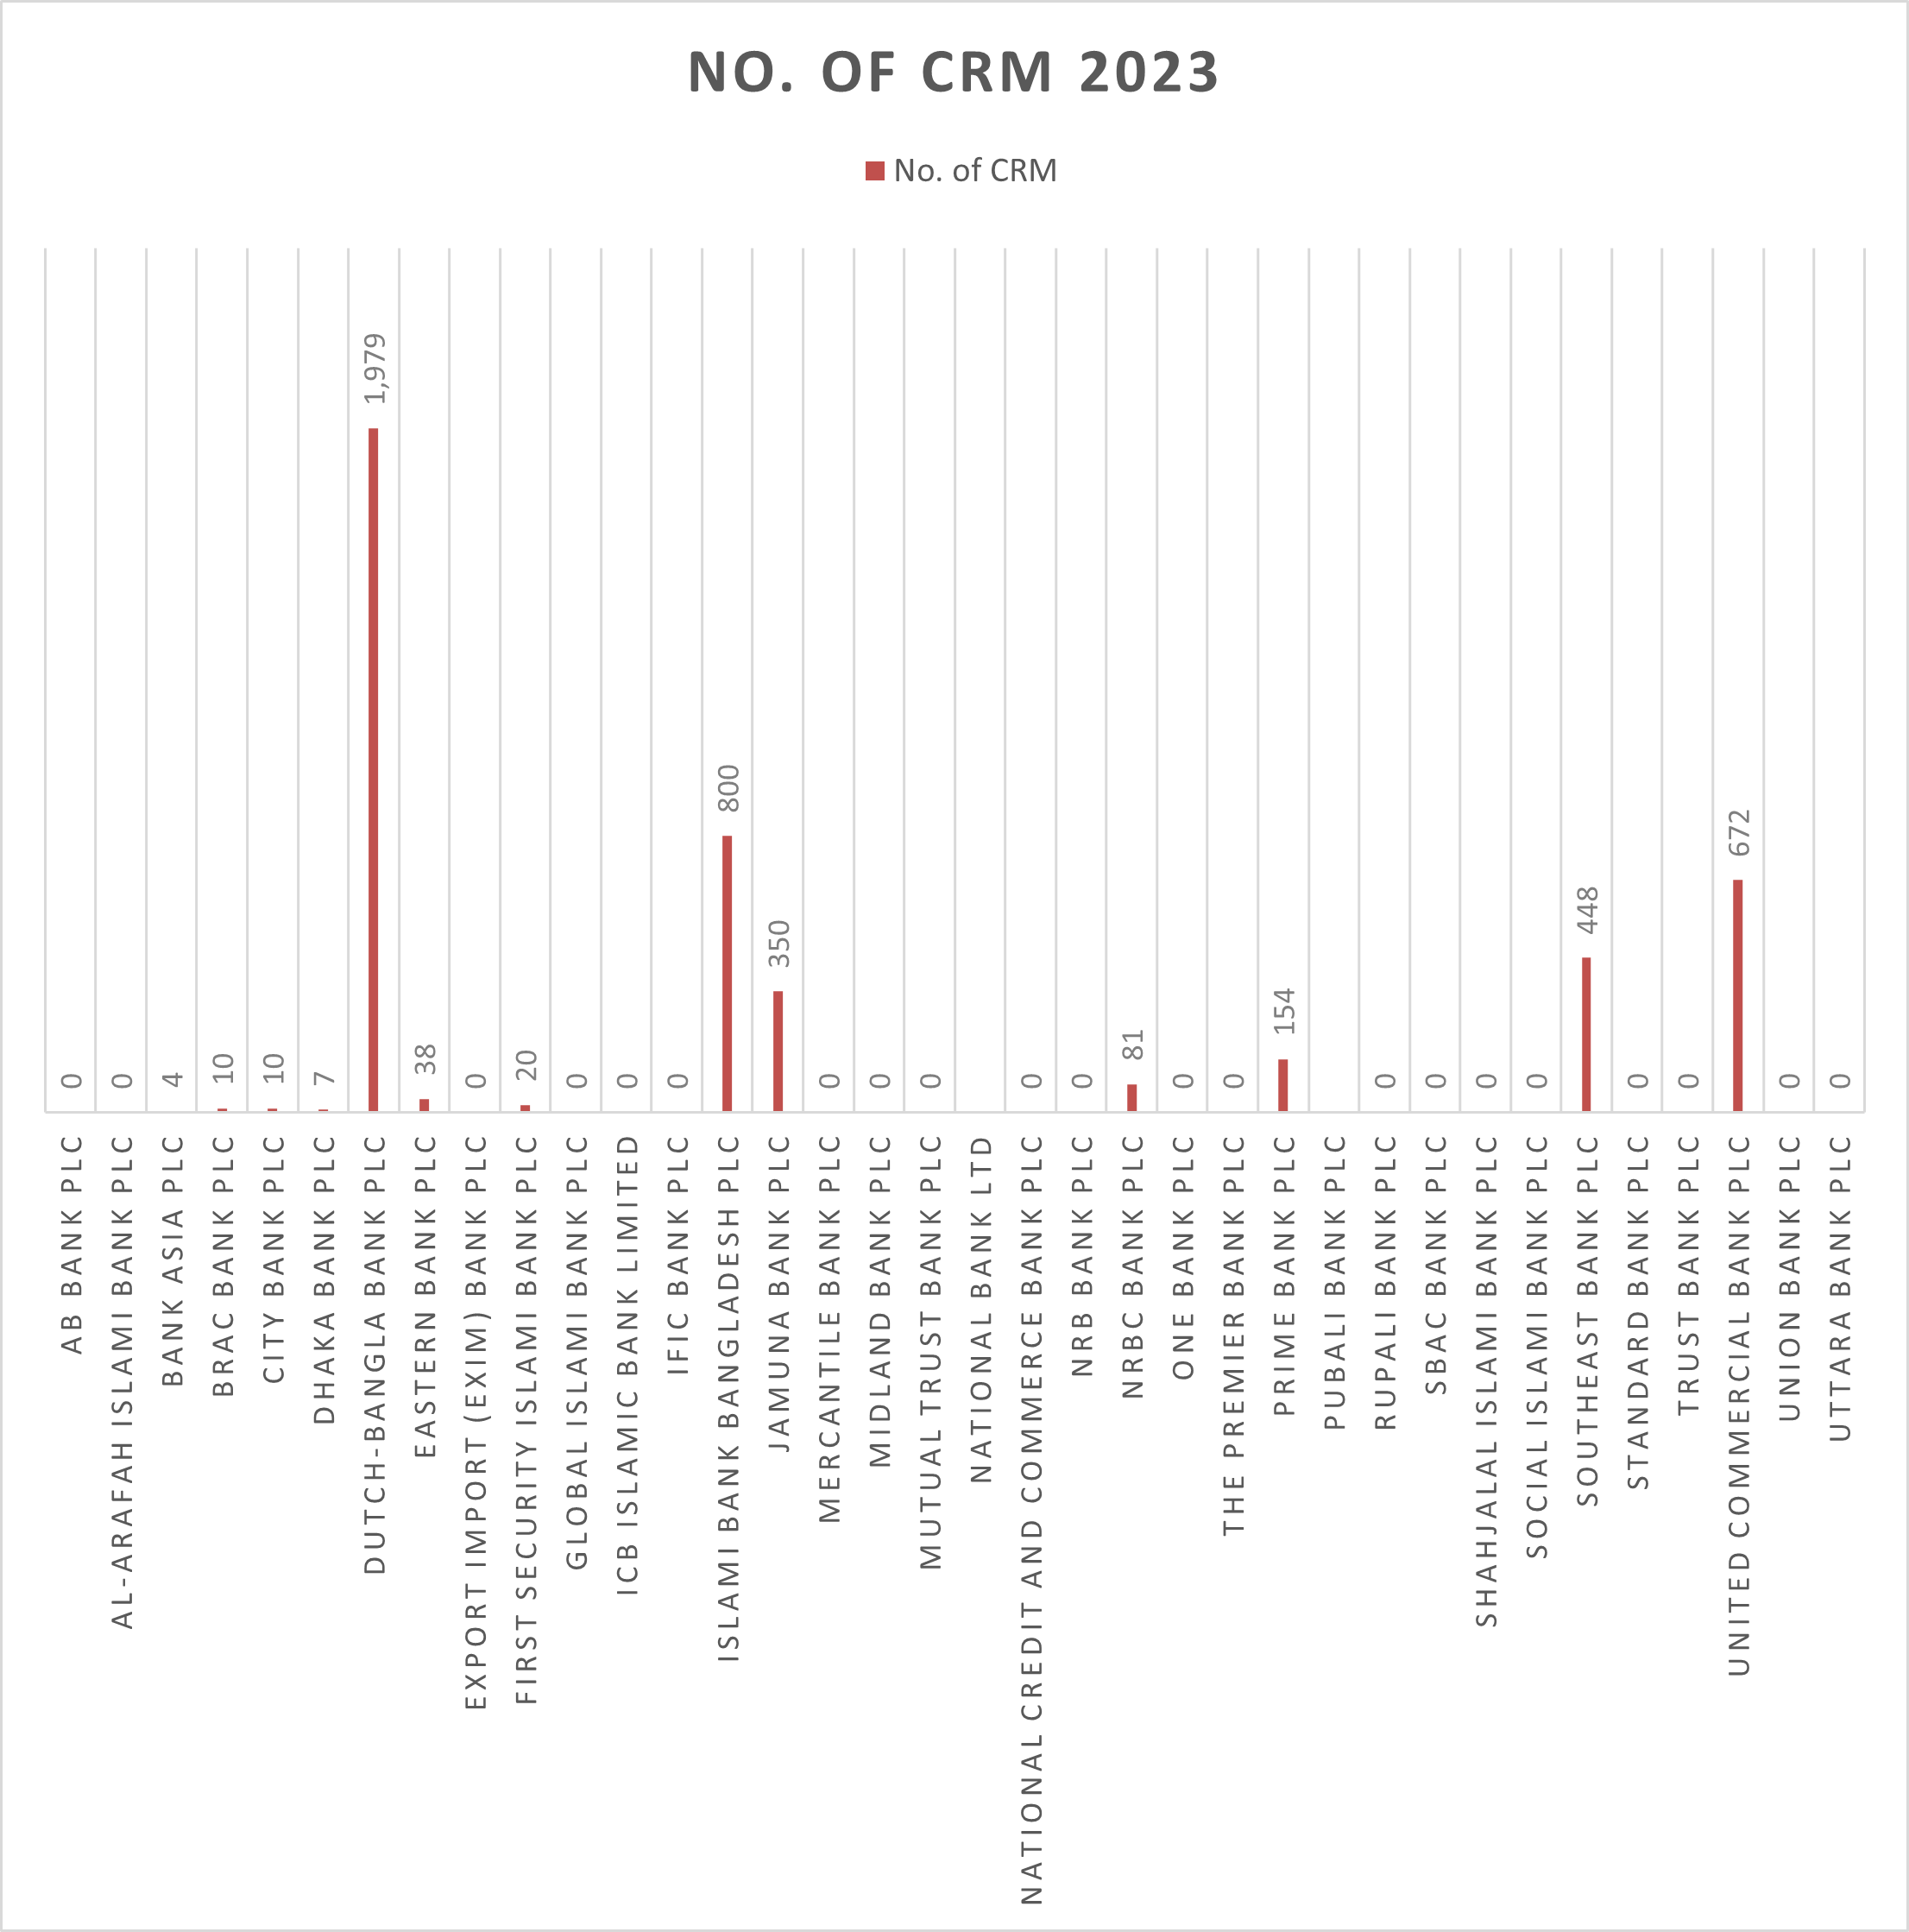
In 2023, Dutch Bangla Bank PLC had the most CRM machines, indicating its steadfast dedication to cutting-edge banking technology and client convenience. With a sizable number of CRM machines for their clients, United Commercial Bank PLC and Islami Bank Bangladesh PLC shared second place. Southeast Bank PLC and Jamuna Bank PLC were in a moderate position, suggesting a growing but not dominant CRM network. The presence of the remaining rivals was adequate, but some banks had not yet provided CRM machines for their customers, indicating a slower rate of technological adoption.
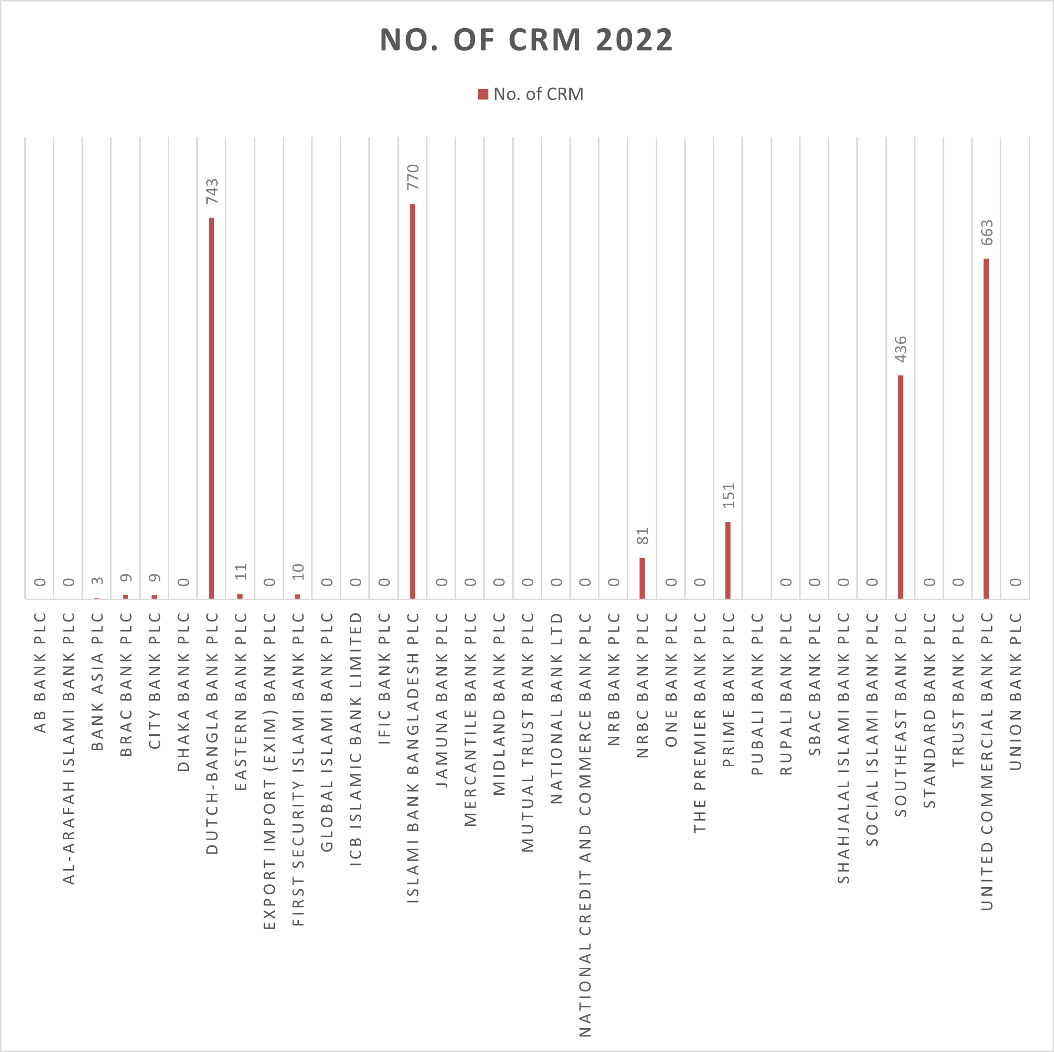
The top three banks with the most CRM machines in 2022 were Dutch Bangla Bank PLC, Islami Bank Bangladesh PLC, and United Commercial Bank PLC, demonstrating significant advancements in automated banking services. In second place were Southeast Bank PLC, Prime Bank PLC, and NRBC Bank PLC, all of which kept a sizable number of CRM devices for client use. While some banks had not yet introduced CRM machines, indicating a gap in service modernization, the remaining competitors showed encouraging performance in this area.
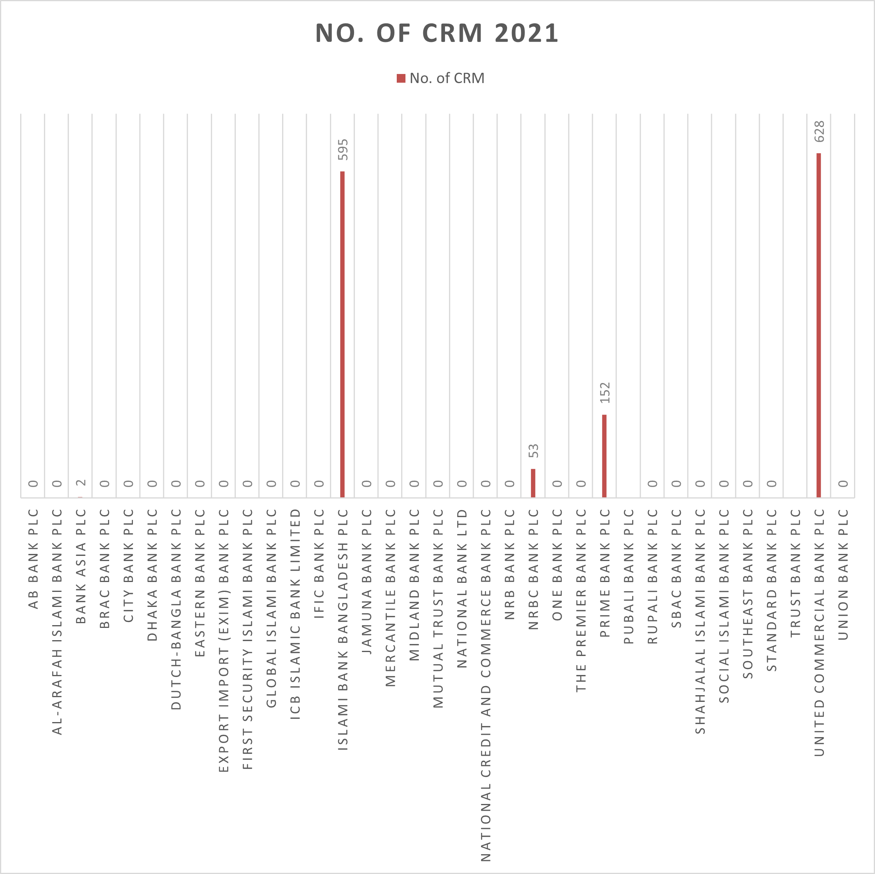
In terms of automated banking services, Islami Bank PLC and United Commercial Bank PLC had the most CRM machines as of 2021. Prime Bank PLC and NRBC Bank PLC ranked second, with a strong but slightly lower number of CRM machines. Bank Asia PLC was in a promising position, indicating potential growth in CRM services. However, most of the other competitors showed limited interest in offering CRM machines to their users, suggesting slower adoption of this technology during that year.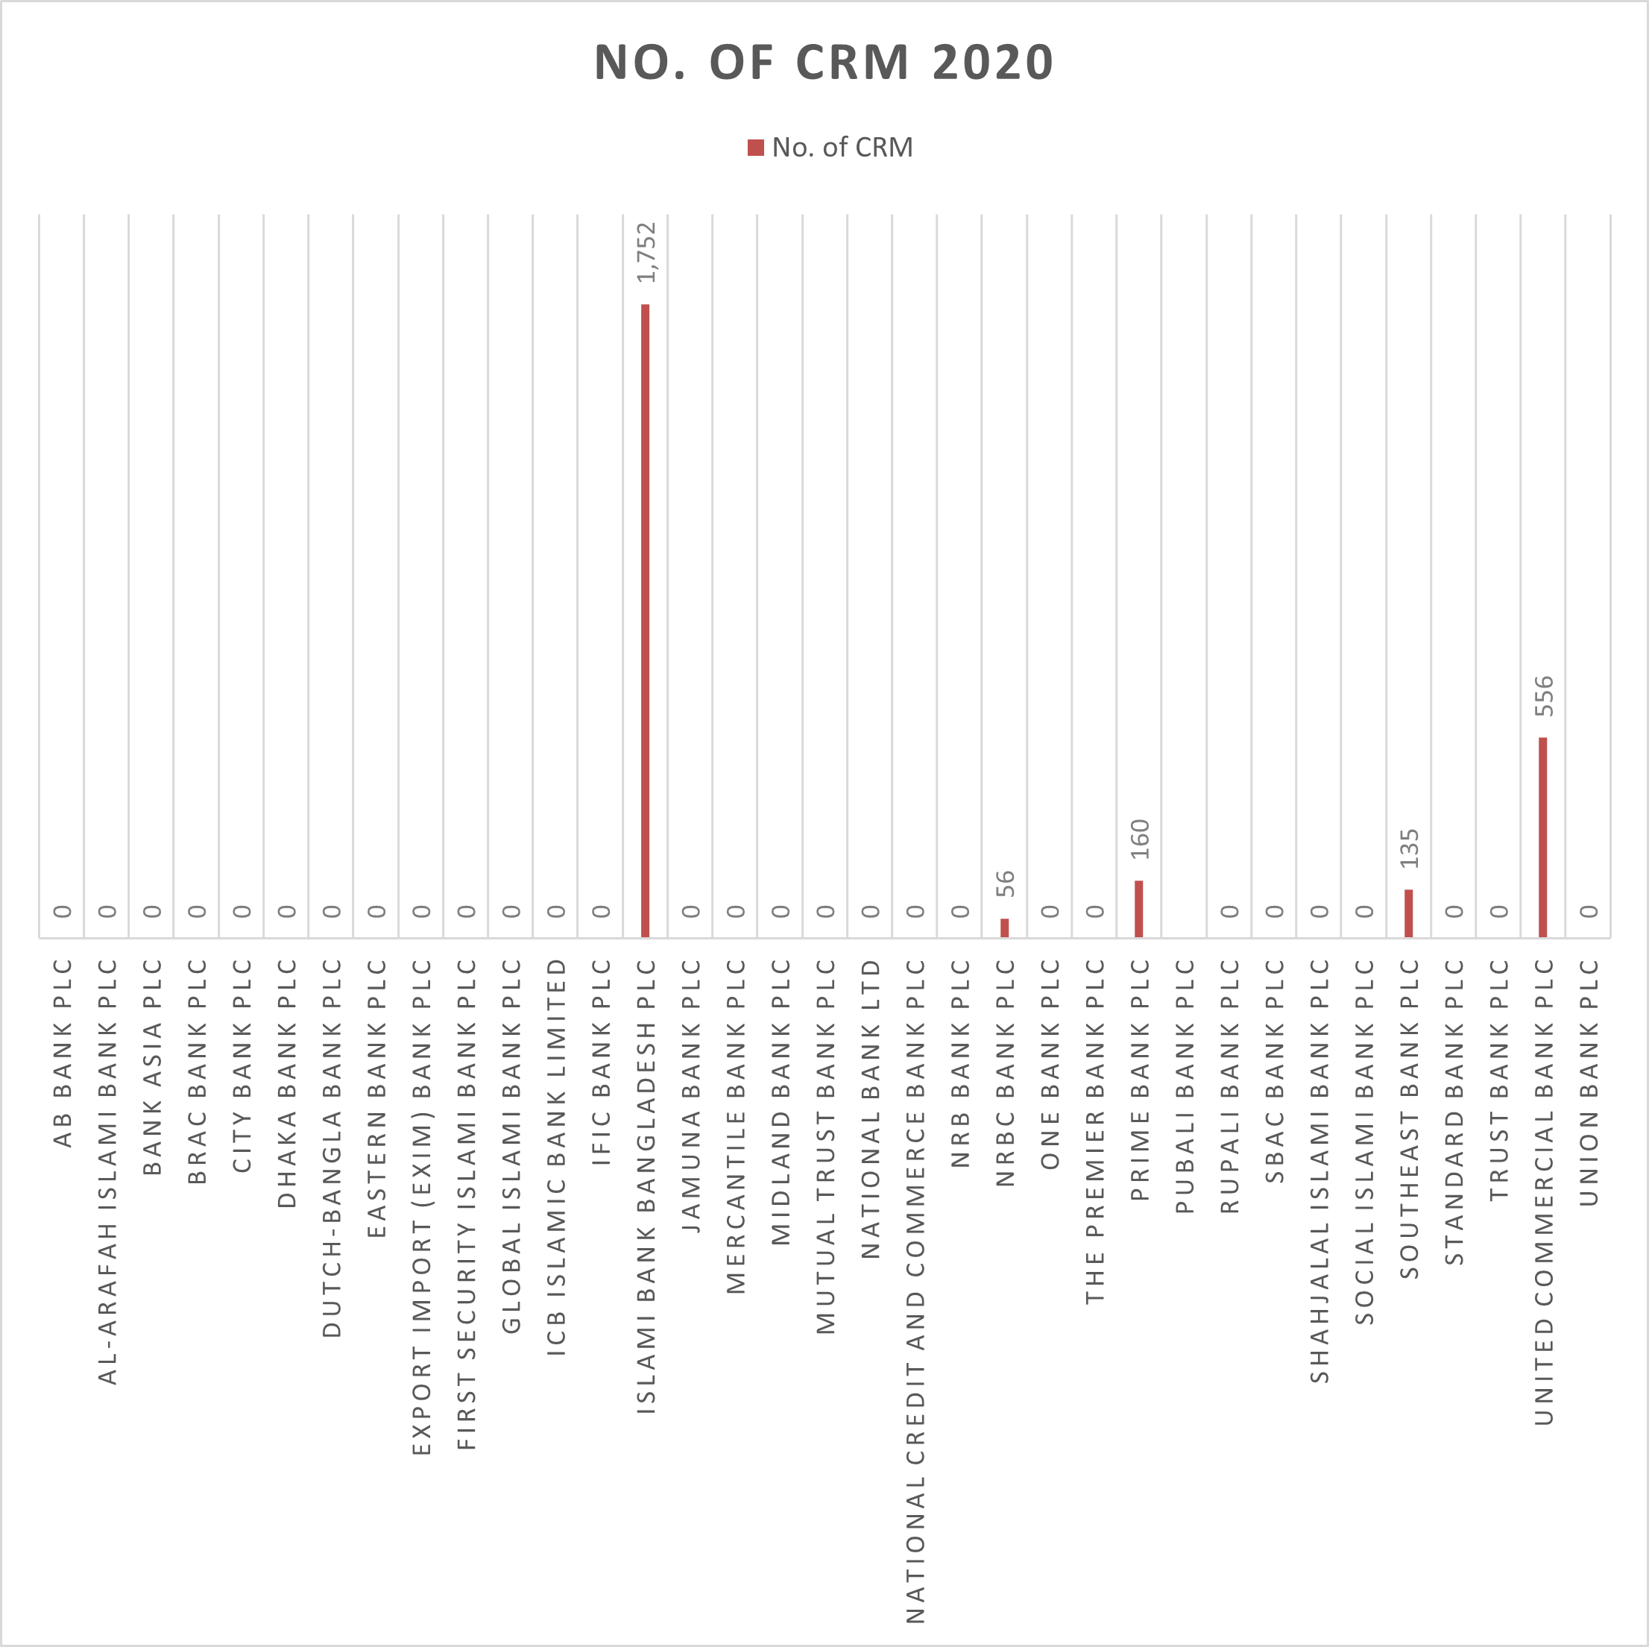
Islami Bank PLC had the most CRM machines in 2020, demonstrating its early adoption and emphasis on automated banking services. With a sizable number of CRM machines accessible to its customers, United Commercial Bank PLC took second place. With the introduction and expansion of CRM services for their clients, Prime Bank PLC, Southeast Bank PLC, and NRBC Bank PLC were in promising positions. But at that point, the remaining rivals had not yet introduced CRM systems, suggesting a slower transition to contemporary banking technology.
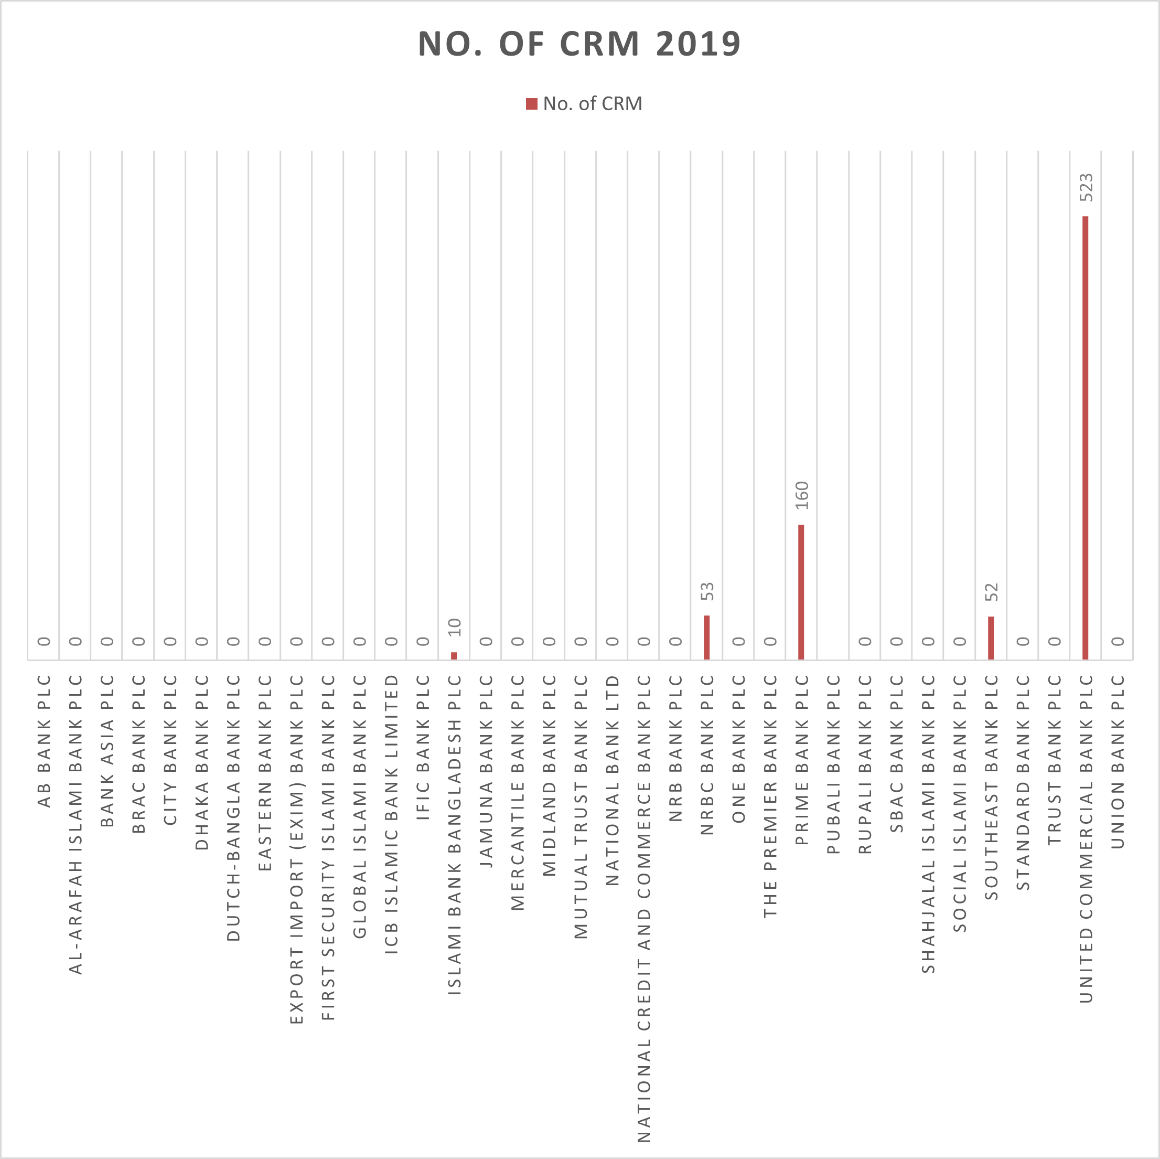
As of 2019, United Commercial Bank PLC had the most CRM machines. With a CRM system for their customers, Prime Bank PLC secured the second spot. By offering CRM machine services to their customers, Southeast Bank PLC, NRBC Bank PLC, and Islamic Bank Bangladesh PLC demonstrated a promising position. The remaining rivals have not yet introduced CRM systems.

5.4: Number of agent banking outlets (Combinedly year basis):

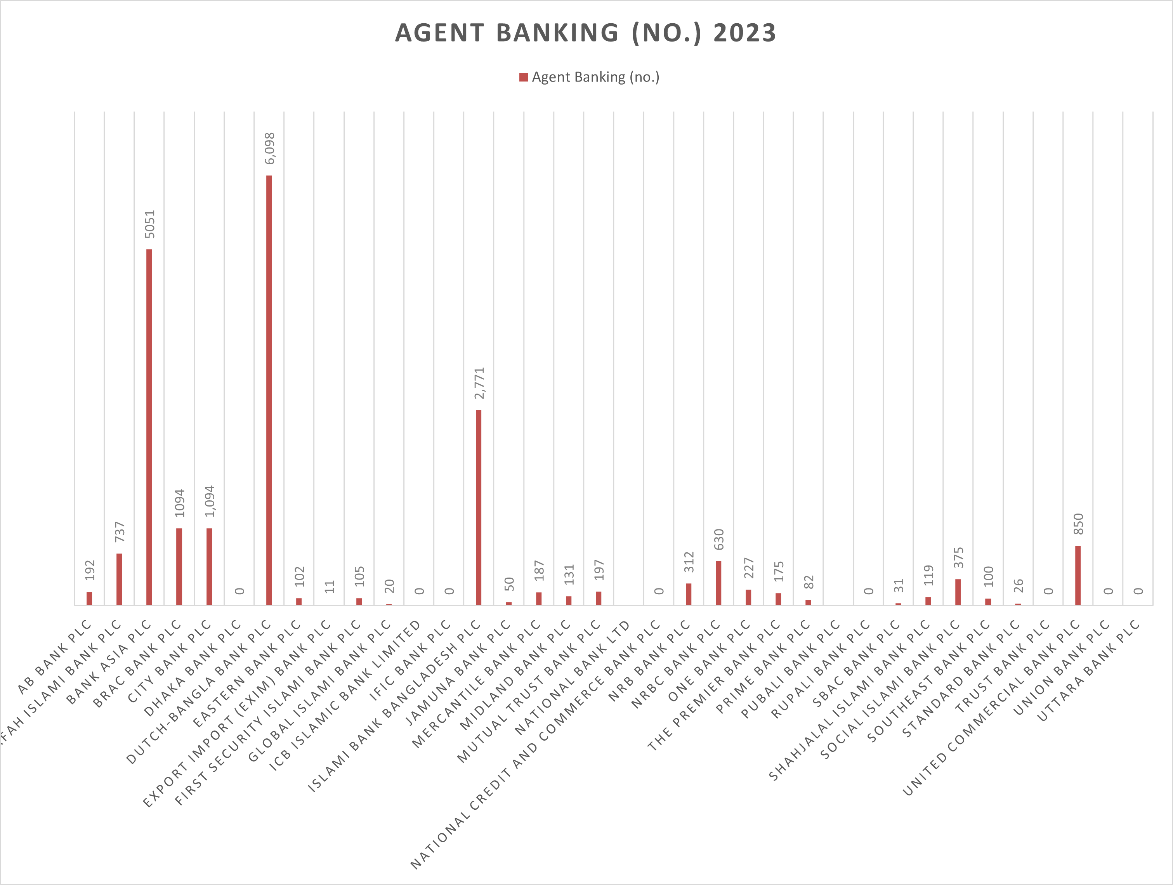
Dutch Bangla Bank PLC had the most agent banking locations in 2023, demonstrating its commitment to increasing financial inclusion and reaching clients in rural areas. In terms of the total number of agent banking outlets accessible to customers, Bank Asia PLC came in second, and Islami Bank Bangladesh PLC came in third. An average level of participation in agent banking services was indicated by the large number of competitors in the moderate range. Concurrently, a number of banks demonstrated encouraging advancements by progressively expanding their network of agent outlets. A few rivals, however, had not yet launched agent banking services, indicating a slower rate of adoption in this field.
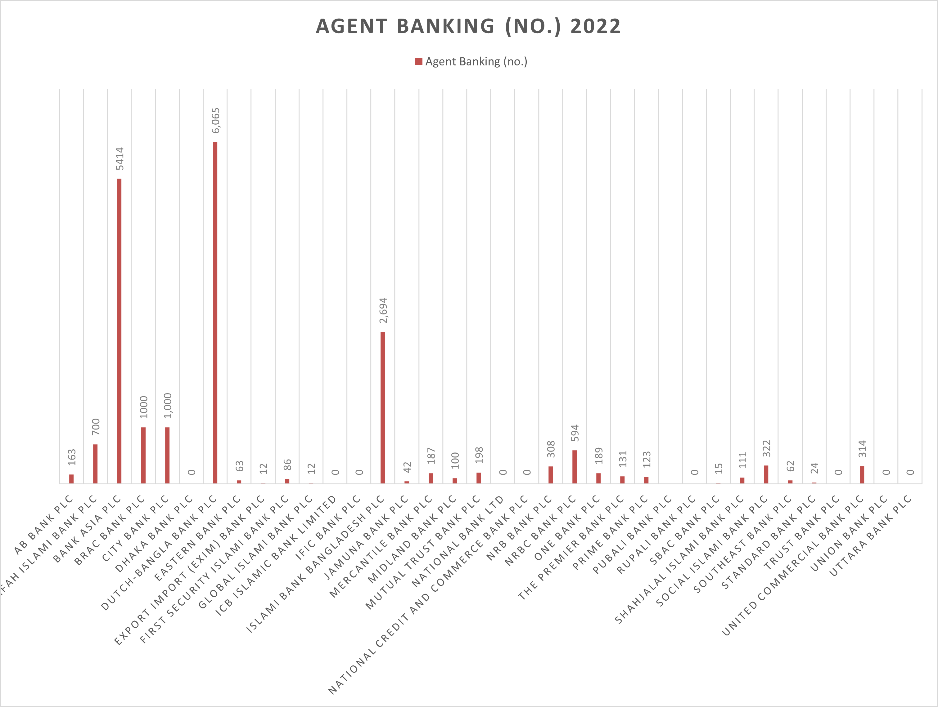
Dutch Bangla Bank PLC demonstrated consistency in its outreach strategy in 2022 by holding the top spot with the greatest number of agent banking outlets. Based on the number of agent banking outlets, Bank Asia PLC continued to be in second place, with Islami Bank Bangladesh PLC coming in third. With an average degree of growth in agent banking services, many of the rival banks were placed in the moderate category. Additionally, because they were actively expanding their presence through agent outlets, a number of banks were in a promising position. There was little activity in this market, though, as some rivals had not yet introduced agent banking services that year.
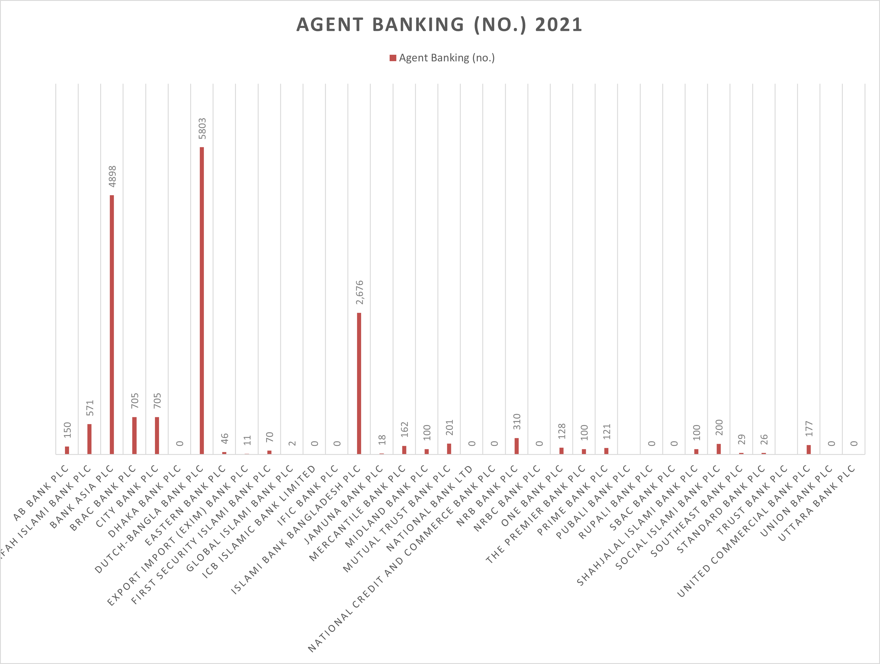
Dutch Bangla Bank PLC had the most agent banking locations in 2021, which is indicative of its strong emphasis on increasing financial accessibility and providing services to clients in larger geographic areas. Based on the total number of agent banking locations accessible to customers, Bank Asia PLC took second place, and Islami Bank Bangladesh PLC took third. While some competitors demonstrated a promising growth trend by progressively growing their agent networks, many others were in a moderate position, indicating average engagement in agent banking services. Slower adoption in this market is evident in the fact that some banks have not yet introduced agent banking services for their customers.
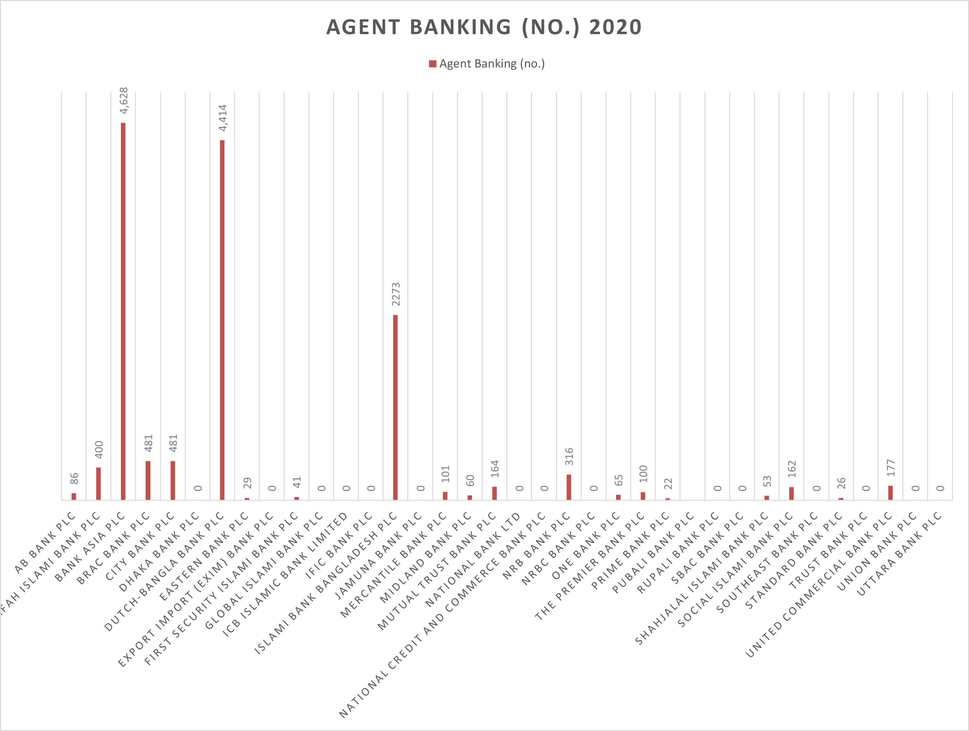
As of 2020, Bank Asia PLC had the most agent banking locations. With the most agent banking outlets for their customers as of 2023, Dutch Bangla Bank PLC came in second, and Islamic Bank Bangladesh PLC came in third. Many competitors achieved a moderate position, while many others demonstrated a promising position by operating agent banking outlets. Some of them have yet to provide their customers with agent banking services. 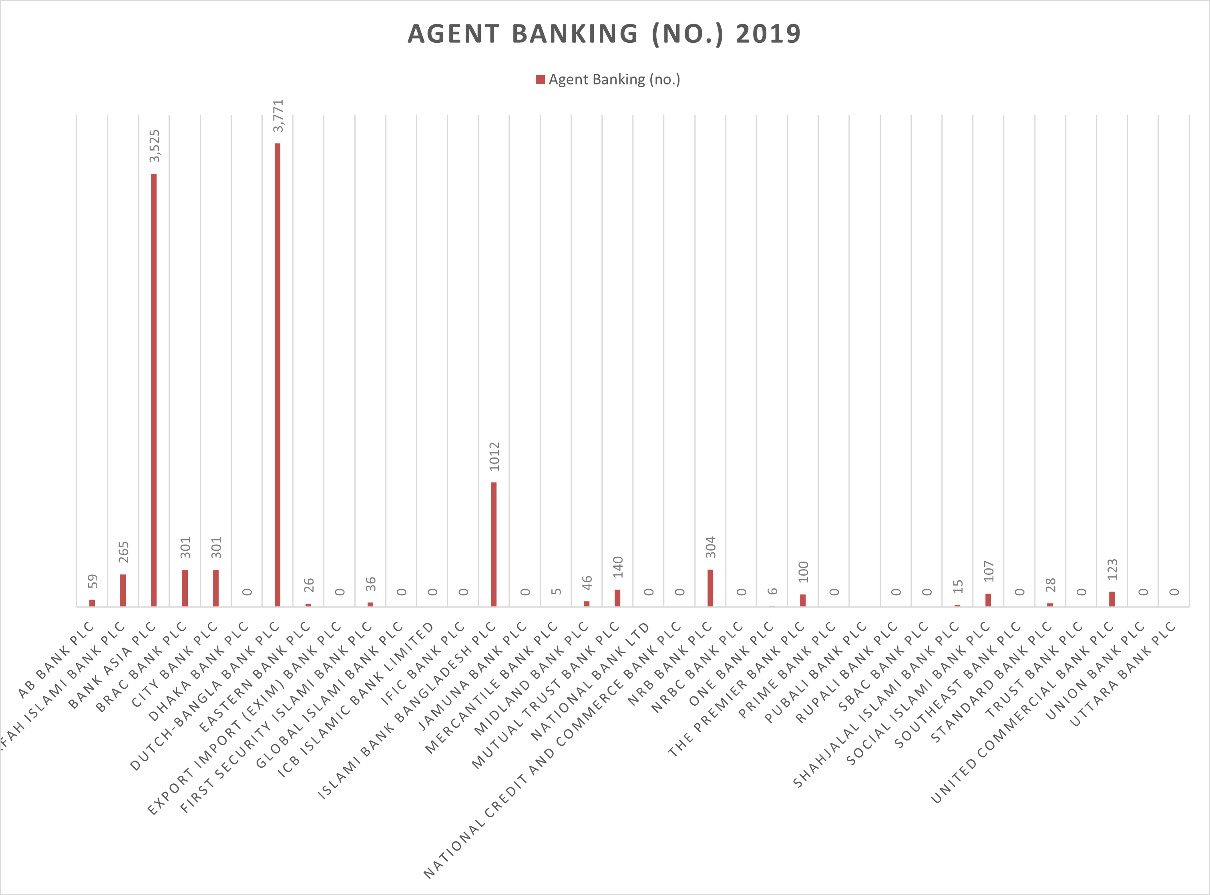
Dutch Bangla Bank PLC had the most agent banking locations as of 2021, which is indicative of its diligent efforts to increase financial access for a larger clientele. Bank Asia PLC secured the second position, while Islami Bank Bangladesh PLC ranked third in terms of agent banking outlets available to users. Many competitors were positioned in the moderate range, indicating average engagement in this sector, whereas several others showed a promising trend by gradually increasing their agent networks. However, some banks had not yet introduced agent banking services for their customers, demonstrating slower adoption of this service.

Conclusion

I have completed data collection process from listed banks websites and their annual reports. My aim was to identify how efficiently listed bank adopt fintech and what will be the effect of their performance. From 2019 to 2023, the selected year I have gathered data which will be evident that the banking sector in Bangladesh has undergone through significant changes. Some entities easily adopt fintech and provide support for their users. They also gaining more profit through the years. Others could not gain profit by adopting fintech, because of it has some cost. Some entities did not adopt all of the fintech and some others entities did not adopt at all fintech side.
My project report provides overall scenario of financial performance of listed banks, from 2019 to 2023. Others can easily get an instant idea by watching my report and data set, others also can use further research purposes to use it. It also provides listed banks others key terms from 2019 to 2023 such as gross revenue, total assets, tobin`s q ratio, liquidity and leverage ratio, listing history, Islami banking existence, boards of attributes as well as ownership attributes. Which can offer overall wide range of idea of listed banking industry in Bangladesh. Finally, I should say it that I have enjoyed my project work with an outstanding title of the project research.

References
ABBL. (2019-2023). Annual report. Retrieved from www.abbl.com: https://abbl.com/investor-relations/
AIBL. (2019-2023). financial-statement. Retrieved from www.aibl.com.bd: https://www.aibl.com.bd/
Bank Asia. (2019-2023). annualreport. Retrieved from www.bankasia-bd.com: https://www.bankasia-bd.com/
BankAsia. (2019- 2023). annualreport. Retrieved from www.bankasia-bd.com: https://www.bankasia-bd.com/
Benazir Rahman, S. S. (2021). Fintech in Bangladesh: Ecosystem, Opportunities and Challenges. International Journal of Business and Technopreneurship, 73-75.
Brack Bank. (2019-2023). investor-relations. Retrieved from www.bracbank.com: https://www.bracbank.com/en
City Bank. (2019-2023). annualreports. Retrieved from www.citybankplc.com: https://www.citybankplc.com/home
Dhaka Bank. (2019-2023). financial-statements-reports. Retrieved from www.dhakabankltd.com: https://dhakabankltd.com/
Dutch Bangla Bank. (2019-2023). investor-relations/financial-statements. Retrieved from www.dutchbanglabank.com: https://www.dutchbanglabank.com/
EBL. (2019-2023). annual-reports. Retrieved from www.ebl.com.bd: https://www.ebl.com.bd/
Exim Bank. (2019-2023). Annual_Reports. Retrieved from www.eximbankbd.com: www.eximbankbd.com/
First Security Islami Bank. (2019-2023). annual_report. Retrieved from www.fsibplc.com: https://fsibplc.com/
Global Islami Bank. (2019-2023). annual-reports. Retrieved from www.globalislamibankbd.com: https://www.globalislamibankbd.com/
ICB Islami Bank. (2019-2023). financial-statement. Retrieved from www.icbislamic-bd.com: https://icbislamic-bd.com/
IFIC Bank. (2019-2023). annual-report. Retrieved from www.ificbank.com.bd: https://www.ificbank.com.bd/
Islami Bank Bangladesh. (2019-2023). financial-report. Retrieved from www.islamibankbd.com: https://www.islamibankbd.com/
Jamuna Bank. (2019-2023). financial-highlights. Retrieved from www.jamunabankbd.com: https://jamunabankbd.com/
Md. Al-Amin, S. M. (2024). FinTech Adoption and Its Impact on Bank Profitability:. THE COST AND MANAGEMENT, 27-40.
Md. Motahar Hossain, D. I. (2013). Electronic-Banking Services: A Study on Selected Commercial Banks in Bangladesh. Asian Business Consortium, 53-61.
Mercantile Bank. (2019-2023). annual_reports. Retrieved from www.mblbd.com: https://www.mblbd.com/
Midland Bank. (2019-2023). annual_report. Retrieved from www.midlandbankbd.net: https://www.midlandbankbd.net/
MTB. (2019-2023). annual-report. Retrieved from www.mutualtrustbank.com: https://www.mutualtrustbank.com/
NBL. (2019-2023). annual-report. Retrieved from www.nblbd.com: https://www.nblbd.com/
NCC Bank. (2019-2023). annualReports. Retrieved from www.nccbank.com.bd: https://www.nccbank.com.bd/
NRB Bank. (2019-2023). annual-report. Retrieved from www.nrbbankbd.com: https://www.nrbbankbd.com/
NRBC Bank. (2019-2023). reports. Retrieved from www.nrbcommercialbank.com: https://www.nrbcommercialbank.com/
One Bank. (2019-2023). annual-reports. Retrieved from www.onebank.com.bd: https://www.onebank.com.bd/
Prime Bank. (2019-2023). annual-reports. Retrieved from www.primebank.com.bd: https://www.primebank.com.bd/
Rupali Bank. (2019-2023). notice_jquery. Retrieved from www.rupalibank.com.bd: https://rupalibank.com.bd/
Saqee, M. M. (2024). Digital Transformation in the Banking Sector of Bangladesh:IBBPLC Perspective. Dhaka: Brac University.
SBAC Bank . (2019-2023). investors-relations. Retrieved from www.sbacbank.com: https://www.sbacbank.com/
Shahjalal Islami Bank. (2019-2023). Financial_Statements. Retrieved from www.sjiblbd.com: https://sjiblbd.com/
SIBL. (2019-2023). financialreports. Retrieved from www.siblbd.com: https://www.siblbd.com/
Southeast Bank. (2019-2023). annual_reports. Retrieved from www.southeastbank.com.bd: https://www.southeastbank.com.bd/
Standard Bank. (2019-2023). AnnualReport. Retrieved from www.standardbankbd.com: https://www.standardbankbd.com/
The Premier Bank. (2019-2023). financial-reports. Retrieved from www.premierbankltd.com: https://premierbankltd.com/pbl/
Trust Bank . (2019-2023). annual-reports-and-statements. Retrieved from www.tblbd.com: https://www.tblbd.com/
Union Bank . (2019-2023). annual-reports. Retrieved from www.unionbank.com.bd: https://www.unionbank.com.bd/
United Commercial Bank. (2019-2023). investor-relations/annual-report. Retrieved from www.ucb.com.bd: https://www.ucb.com.bd/
Uttara Bank. (2019-2023). annualreports. Retrieved from www.uttarabank-bd.com: https://www.uttarabank-bd.com/

Appendix

- AB Bank PLC
- Al-Arafah Islami Bank PLC
- Bank Asia PLC
- BRAC Bank PLC
- City Bank PLC
- Dhaka Bank PLC
- Dutch-Bangla Bank PLC
- Eastern Bank PLC
- Export Import (Exim) Bank of Bangladesh PLC
- First Security Islami Bank PLC
- Global Islami Bank PLC
- ICB Islamic Bank Limited
- IFIC Bank PLC
- Islami Bank Bangladesh PLC
- Jamuna Bank PLC
- Mercantile Bank PLC
- Midland Bank PLC
- Mutual Trust Bank PLC
- National Bank Ltd
- National Credit and Commerce Bank PLC
- NRB Bank PLC
- NRBC Bank PLC
- One Bank PLC
- The Premier Bank PLC
- Prime Bank PLC
- Pubali Bank PLC
- Rupali Bank PLC
- SBAC Bank PLC
- Shahjalal Islami Bank PLC
- Social Islami Bank PLC
- Southeast Bank PLC
- Standard Bank PLC
- Trust Bank PLC
- United Commercial Bank PLC
- Union Bank PLC
- Uttara Bank PLC

