Internship Report
On
Impact of Modern Trade Channels on Beverage Sales in Bangladesh – A Case Study on PepsiCo
This report is submitted to the school of Business and Economics, United International University as a partial requirement for the degree fulfillment of Bachelor of Business Administration (BBA).
Submitted to:
Md. Kaium Hossain
Assistant professor
School of Business and Economics
United International University
Submitted by:
Mohammad Abir Hossain
ID: 111 171 179
Major: Marketing

School of Business and Economics
United International University
Date of Submission: May 16, 2022

Impact of Modern Trade Channels on Beverage Sales in Bangladesh – A Case Study on PepsiCo
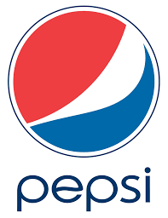

Letter of Transmittal

16th May 2022
Md. Kaium Hossain
Assistant professor
School of Business and Economics
United International University.
Subject: Submission of Internship Report on “Impact of Modern Trade Channels on Beverage Sales in Bangladesh – A Case Study on PepsiCo.”
Sir,
With due respect, I’m writing to notify you that I’ve completed my 12 weeks Internship period along with a perfect collaboration and attachment with Modern trade & emerging channels sales team in Transcom beverages limited(Pepsi-Co). The aim of making this report is to show the importance and contribution of modern trade and emerging channels in overall sales in this new era.
It has been a great and informative experience for me having my internship in this organization with some experienced and energetic personalities whom I got as my team member in sales field. Through this report I’ve looking forward to share my experience & other corresponding concern as per your requirements.
I hope this report will meet your proper expectations. I will be happy to provide any clarifications if required on any of the relevant matters.
Sincerely,


Mohammad Abir Hossain
ID: 111 171 179

Declaration

I do hereby declare that this internship report tittle “Impact of Modern Trade Channels on Beverage Sales in Bangladesh – A Case Study on PepsiCo.” The report is based on my original work except for quotations and citations that have been duly acknowledge. I also declare it has not been previously or concurrently submitted for any other degree at UIU or other institution.

Mohammad Abir Hossain
ID: 111 171 179
Batch: 171
Major: Marketing
School of Business and Economics
United International University.

Acknowledgement

First of all, I would love to express my gratitude and thanks to Almighty Allah for granting me good health and a sound mind, which helped me complete this Internship report. I am very much grateful to my supervisor Md. Kaium Hossain, Assistant Professor School of Business and Economics at United International University, gave me valuable and practical support, Kind guidance, proper advice, and suggestions throughout my internship period. I would love to express my sincere gratitude to my reporting boss Mr. Mostofa Sadique, Manager (Modern trade and Emerging channels) at Transom beverages limited. Under his supervision and guidance, I’ve successfully grabbed that opportunity to learn about modern trade businesses and completed my internship report.
Secondly, I'd like to thank Transom beverages limited (PepsiCo) for providing me the chance to learn sales job responsibilities at their organization and for continued support from the first day. They kept inspiring me to work hard and understand the actual sales market in both modern trade & corporate sales. This company helped me understand real business from local and international perspectives.
I shall be forever grateful to all these mentioned people for their much-needed contribution; despite having a busy schedule, genuinely, they helped me a lot to complete my report.

Executive Summary

People are moving towards modern trade from traditional to enjoy the top-notch buying experience. Being an FMCG company, PepsiCo also started thinking about this highly potential market of Bangladesh. This report has been prepared to fulfill the internship program, a requirement to complete the BBA program. This report consists of chapters titled introduction, company and industry preview, methodology, analysis and findings, internship experiences, and recommendations and conclusion. The main objective of this report is to know the impact of modern trade channels on PepsiCo’s sales in Bangladesh. Both primary and secondary data were used in this descriptive type of report. Findings highlighted that modern trade has a favorable and vital impact on sales. It is almost compulsory to conduct business with modern trade to meet today's market demand, considering the intense competition for the beverage brands. Premium customers move towards modern trade to meet the standardized lifestyle and best buying experience. PepsiCo should have a uniform sales team hierarchy, and it needs to move more trade pricing to keep up with the competition. Thus, the report will provide insight and detail into the rapidly increasing modern trade, particularly for beverage companies in Bangladesh.

Key Words: Modern Trade; Traditional Trade; PepsiCo, Bangladesh.

Table of Contents

Letter of Transmittal i
Declaration ii
Acknowledgement iii
Executive Summary iv
List of Abbreviations vii
CHAPTER I: INTRODUCTION 1
1.1 Background of the Report 2
1.2 Origin of the Report 3
1.3 Objectives of the Report 3
1.4 Scope of the Report 4
1.5 Limitations of the Report 4
CHAPTER II: COMPANY AND INDUSTRY PREVIEW 5
2.1 Overview and History of Transcom Beverages Limited 6
2.1.2 Vision and Mission 7
2.1.3 Organizational Structure 8
2.1.4 Brand List and Attributes 9
2.1.5 Departmental Activities 11
2.1.6 SWOT Analysis 14
2.2 Industry Analysis 15
2.2.1 Specification of the Industry 16
2.2.2 Size, Maturity and Trend of this Industry 16
2.2.3 Barriers to Entry 18
2.2.4 Threat of Substitutes 19
CHAPTER III: METHODOLOGY 20
3.1 Introduction 21
3.2 Research Design 21
3.3 Sampling Design 22
3.4 Questionnaire Development for Primary Data 22
3.5 Data Collection 23
CHAPTER IV: ANALYSIS AND FINDINGS 24
4.1 Background of Modern Trade 25
4.2 Findings of Survey Questionnaire 26
CHAPTER V: INTERNSHIP EXPERIENCES 33
5.1 Positions, Duties and Responsibilities 34
5.2 Contribution to Departmental Activities 36
5.3 New Skills Development 37
CHAPTER VI: RECOMMENDATIONS AND CONCLUSION 39
6.1 Recommendations 40
6.2 Conclusion 41
References 42
Appendix 43
Intern completion Certificate 45

List of Abbreviations

PJP: Permanent journey plan.
GRN: Good Receipt note
CPC: Consumer promotion claim.
FSU: Free Standing Units.
PSS: Primary sales solution.
RSM: Regional Sales Manager
ASM: Area Sales Manager.
FD: Floor display.
MOD: Mount to date
GRB: Glass refined bottle
PSR: Primary sales representative
SKU: Stock keeping Units.
KPI: Key performance Indicators.
FMCG: Fast moving consumer goods.

CHAPTER I: INTRODUCTION

1.1 Background of the Report

Transcom Beverages Limited (PepsiCo) was founded with the goal of achieving long-term success in Bangladesh and become the leading beverage company. They began bottling and selling just original (cola-flavored) Pepsi many years ago (2002). TBL has recently made numerous flavored drinks under 6 brands (Pepsi, 7up, Mountain dew, Mirinda, Slice and Aquafina water by PepsiCo available in the country to fulfill the changing beverage needs of consumers.
With so many products accessible, maintaining a balanced amount of products on outlets shelves of Modern trade to meet consumer demand is becoming quite difficult. This is where TBL's Modern trade & corporate team efforts come into considerations.
As the importance of Modern trade & channels contribution have been increasing & lucrative day by day. Companies are taking various initiative to build this channels more effective by taking the advantages of doing business in modern trade and creating the brand value to the optimum level. Modern trades and channels not only the important for boost up the sales volume but also to create the better brand implementation and brand position, there is no such alternative as like this channels. For the tremendous contribution on beverage companies via this channels always encourages the management to invest more and more.
All students pursuing a BBA degree from the Department of School and Business must complete an internship. One of the prerequisites for completing the BBA internship program is to submit this report. The main purpose of an internship is to expose students to the corporate environment so that they can relate theoretical concepts into practical experience.
Transcom Beverages Ltd gave me the chance to work as an intern in the sales departments where I got to learn. How to boost up sales based on some strategic initiative, how to influence Corporate houses/Modern trades to buy our products, how to create specific brand value in the mind of consumers, how to manage a whole team etc.

1.2 Origin of the Report

An internship report prepared as a mandatory requirement for the completion of the BBA program. The primary goal of this internship is to provide an “on the job” experience /exposure to the student and an opportunity for translation of theoretical studies in real business situations.
To fulfill this requirement, I was sent to Transcom Beverages limited (PepsiCo). As an intern in this regard under the supervision of two supervisors. One is internal from the institution and another is from the organization for three months.
The report title “Impact of Modern trade channels on beverage sales in Bangladesh- A Case Study on PepsiCo” On the basis of working experiences for this period I have prepared my internship report under supervision and guidance of Md. Kaium Hossain, Assistant Professor School of Business and Economics at United International University.

1.3 Objectives of the Report

Broad Objective:
- To know the impact of modern trade channels on beverages sales in Bangladesh.
Specific Objectives:
To accomplish this broad objective, I tried to classify those into some specific objectives:
- To assess the current growth of Modern trade along with general trade of PepsiCo.

- To visualize the opportunity of branding in Modern trade of PepsiCo.

- To know the impacts of MT and channels on consumer behavior of PepsiCo.

1.4 Scope of the Report

Because sales job is interrelated with nearly every department. Different departments contribute differently to boosting/increasing sales; I tried to stay inside the boundaries of the Brand team, sales strategy team, and trade marketing team, logistics and MIS team. Because the product Pepsi and other brands are known as (FMCG), the main focus on sales to serve consumers and retailers. As primary target is related to distribution house and the overall process is runs via Distributors house. I used to invest my more time in distribution/logistics and supply chain house to understanding the overall process.

1.5 Limitations of the Report

Although my focus was very much clear when I joined to my work as an Intern in Transcom beverages limited (PepsiCo). I have to face some challenges & barriers while collecting the data and creating the report as well as.
- Lack of accessibility to information and resources. As PepsiCo is a very prestigious brand around the world. They strictly follow the rules and regulations. They are very much concerned about sharing company’s information. Because of that some resources weren’t active or accessible for me as I wasn’t permanent employee there.

- As we’ve been going through Covid 19. PepsiCo International strictly notify to sales team to ignore visiting head office unless any emergency help needed from other teams in Head office. That is why I used to pass my more time in field and distribution house along with my modern trade team mates. I got less opportunity to collect information from HQ (Head Qatar).

CHAPTER II: COMPANY AND INDUSTRY PREVIEW

2.1 Overview and History of Transcom Beverages Limited

One of the most inspiring business tycoon Mr Latifur Rahman founded TRANSCOM group in 1973. Although it originated with tea plantations in 1885. Transcom has been called one of the biggest diverse & innovative corporate house in Bangladesh with Its officially listed 13500 employees. With the legacy and history of 130 years this corporation operates its business in 20 countries with 9 different sectors.
Mr. Latifur Rahman established Transcom Group in 1973. In 1885, it commenced with tea plantations. Transcom has about 13,500 employees and is one of Bangladesh's major manifold corporate houses. With a 130-year history, the corporation conducts in 20 countries and 9 sectors. This group includes the following businesses.
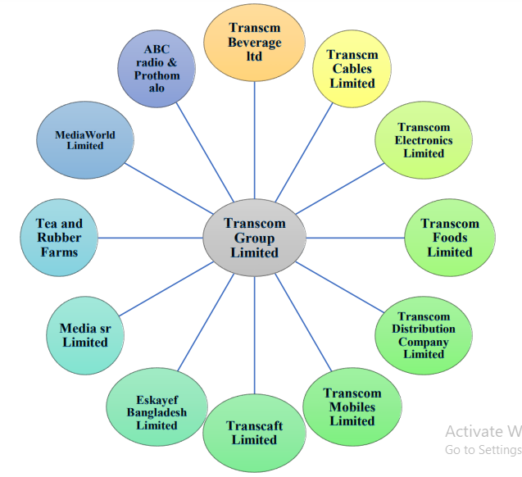

All Business portfolio of Transcom Group

Transcom Beverage Ltd (TBL) is Bangladesh's solely PepsiCo franchisee. TBL has contemporary bottling factories in Dhaka and Chittagong that bottle well-known soft drink brands as Pepsi, 7UP, Mirinda, Slice, Mountain Dew, Pepsi Diet, and 7UP Light. The company's mission is to provide sustained enhancement in Bangladesh and to become an imperious beverage company, charming and nourishing every Bangladeshi by best meeting their everyday beverage needs, and to delight and cherish stakeholders by providing performance with motive, through ingenious people. TBL had a marvelous year in 2009, achieving various honors as PepsiCo's exclusive bottling partner in Bangladesh. TBL has gained numerous major national and international rewards for its identical and worthy venture via nobility.

2.1.2 Vision and Mission

Transcom Beverages Limited’s core values are influenced our steps and how we lead ourselves in our everyday operations. The Core Values can demonstrate us in improving the diverse culture that TBL wishes to nourish throughout the company. We also involve PepsiCo's vision of "Performance with Purpose" to confirm that our joint endeavors are focused on granting value to our social partners. With regard to basic values, we are devoted to our six guiding morals:
- Care for our customers, consumers, and the environment.
- Find the balance between the short and long term.
- Be worshipful of others and work simultaneously to gain success.
- Honesty in our daily actions and transactions.
- We strive for perfection in whatever we do.
- Taking new initiatives and thinking ahead and out of the box.

Mission:
As the country's prime CSD beverage manufacturer, our mission is to deliver consumers with pleasant, hygienic, accessible, and convenient beverages while fostering the segment's maximal market share.
Vision:
To be the major beverage company in Bangladesh, delighting and nourishing every Bangladeshi by providing the best daily beverage resolutions and distributing performance with motive.

Objective:
The goal is to conduct the business accordance with best practices, consent, and moral standards so that durable and profitable growth through the usage of efficient and competent people.

2.1.3 Organizational Structure
Quality control Management
Project management
Production & Assistant Manager
System management and sales team
General Manager (Hr.)
General Manger (Sales)
General Manager (plant)
Deputy Managing Director
Managing director

2.1.4 Brand List and Attributes

Transcom beverages limited (Pepsi-Co) Brand list & Attributes:
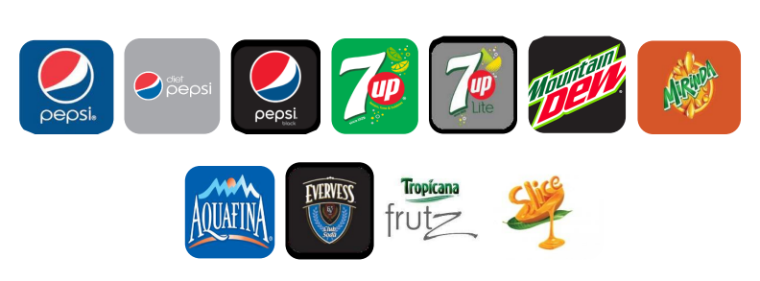
Transcom beverages hold the one & only exclusive beverages franchisee in Bangladesh. The products that are currently being manufactured and bottled by TBL fall under the classification of CSD (Carbonated Soft drinks, Water, Fruits drinks and Club soda).

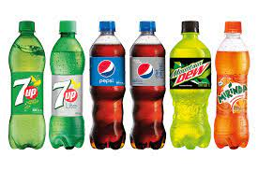
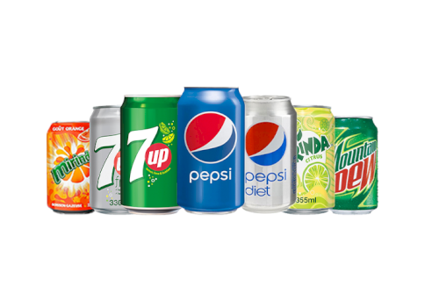
:
Some of the CAN bottles Brand:
Some of the PET bottles Brand:

PepsiCo beverages Brand and Stock keeping Units (SKU) List:
Brand name | Brand logo | Category | Flavor | Category
Pepsi | 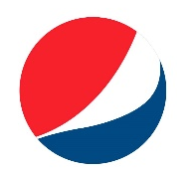 | CSD | Cola | 2.25 Litter pet bottle  1 Litter pet bottle  600 M.l pet bottle  250 M.l pet bottle  250 M.l Can Bottle  250 M.l RGB bottle
Pepsi diet | 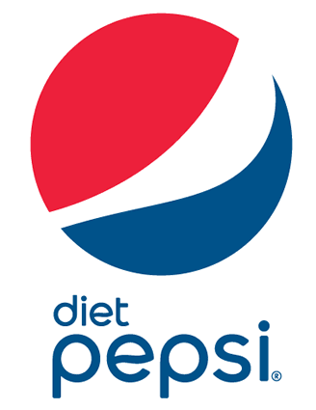 | CSD | Cola | 600 M.l pet bottle  250 M.l pet bottle  250 M.l Can Bottle
7up | 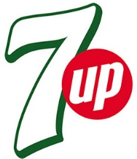 | CSD | Lemon | 2.25 Litter pet bottle  1 Litter pet bottle  600 M.l pet bottle  250 M.l pet bottle  250 M.l Can Bottle  250 M.l RGB bottle
Mountain Dew | 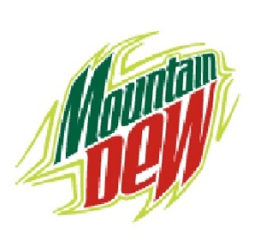 | CSD | CITRUS | 1 Litter pet bottle  600 M.l pet bottle  250 M.l pet bottle  250 M.l Can Bottle  250 M.l RGB bottle
Miranda | 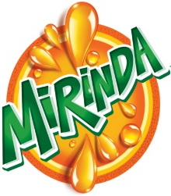 | CSD | Orange | 1 Litter pet bottle  600 M.l pet bottle  250 M.l pet bottle  250 M.l Can Bottle  250 M.l RGB bottle
Slice | 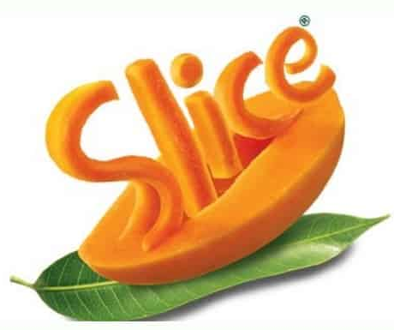 | Juice | Mango | 250 M.l pet bottle  250 M.l RGB bottle
Aquafina | 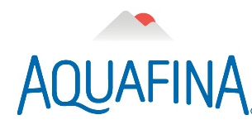 | Water | Mineral | 1500 M.l Pet bottle  1000 M.l Pet bottle  500 M.l pet bottle
Evervess Soda | 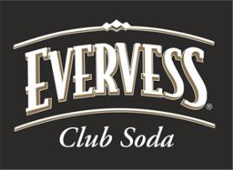 | Soda | Club soda | 600 M.l pet bottlw

2.1.5 Departmental Activities
Transom beverages has its own diversified departmental activities. All the department works together to meet the ultimate goals with efficiency & effectively of work. In the organization structure I already mentioned the hierarchy of departments by a proper frame work.
As I have been working for sales team. Sales team is internally connected with some specific department. Describing those departments wise:
- Traditional / General trade.
- Department of Sales Operation
- Department of Brand
Traditional trade or retails
This is the most important departments of sales as per the market sales volume. More than 80% sales contribution comes from this team. As we all know the biggest market for FMCG industry is retail market. This team works under the one head and subsequently the hierarchy is:
-RSM: RSM stands for (Regional sales manager). Whole Bangladesh has been divided by 8 parts. Each parts have one RSM. All the retails sales operation under each parts controlled by Specific /appointed RSM.
-ASM: ASM stands for (Area sales manager): Each region has been divided by more than 10 areas. Each area has One specific Asm to operate the sales operation under divided area. All ASM under specific Region has to report to RSM about the activities.
-SE: SE refers (Sales executive). Area Sales executive monitors the field sales representative and reports to ASM. SE’S have to execute all the activities that planned by RSM’S and ASM’S accordingly.
-PSR’S: PSR’s stands for primary sales representatives. They have to visit all the retail chain under Region and area. Their KPI is to collect order by retails shop and report to the SE’s.
Department of Sales operations:
This department is related to the operations of sales. How the sales operations run smoothly under this competitive market is planned and execute by this team? Under this department there are specific two team:
One is key accounts / Modern trades: Modern trade and key accounts directly work under this team. Although this is a part of direct sales like B2B sales /Institutional sales / commercial sales. But The contribution of this department has its own impact.
This department has two parts:
Key accounts: The big institutions / hotel / restaurants / hospitals /universities etc. have been serving by this team.
Modern trade / emerging channels: I worked for this team in my whole internship period. This department has been called modern trade as the modern customers are moving towards to retails shops to big /modern super shops. Under the operation of modern trade, we serve the all super shops across Dhaka like Shwapno, Meena bazar, Agora, Unimart, Daily super shops, Ashta super shops, Amana big bazar, Lavender, Trust family needs, Daily shopping etc. Ecommerce and Emerging channels like Pandamart, Pathao food, Meena click, Shwapno.com, Pick and pay, Chaldean etc. etc. we are serving those mentioned clients via this channels.
Another is MIS (Management Information system): In this era of tachonoginal drives there is no other alternative except technology to run the business smoothly. MIS stands for Management Information system. This team works for the automation software. Though the automation the overall sales process running on under one apps / systems.
Department of Marketing:
Marketing departments has two parts. One is Marketing itself another one is Brand.
The contribution of marketing and brand is undoubtedly important for the sales operation. In this highly completive industry where the competition in coca cola. Marketing and brand department have to work very hard and precisely to create the brand perception very specific in the mind of customers.
Marketing department: Marketing department is responsible for Brand management, trade promotion, Retail promotion, consumer promotion, trade marketing. All the budgets have been made under marketing department. Then allocated under all department for approved and run various campaign. Either it can be for retailers/Distributors or end customers.
Brand team: Brand team works for specific Brand. Like PepsiCo has some established brand such us Pepsi cola, 7 up, Mirinda, Slice, Mountain dew etc. etc. This all have a good brand perception in the mind of customers. Brand team works for the plan that how this brand value will be same as constantly in the mind of consumers. Their specific task is to communicate with existing or new customers if anything brands come up the market with some changes or any new brand comes to market newly.

2.1.6 SWOT Analysis

Weakness:
The biggest weakness of Pepsi is the distribution process and consumer preference in somewhat. In Dhaka market Pepsi has less demand than coca cola because of the consumer preferences. In a survey of USA found that in the city area people likes the taste of coca cola instead of other brands.

Strengths:
The strength of Pepsi is in this beverage market only Pepsi and coke are international brands where others are local brand. Pepsi has its exceptional customers base in Bangladesh for the local people of here and for the foreigner as well as. Pepsi has 21 number of Skus (Stock keeping units) with 7 established brand which is highest that one company can provide in a single market.

Threats:
As we all know that it’s been 100 years both of the brands coke and Pepsi have been competing each other’s in the same stage. This is considered as most intense rivalry in business of all time. The same scenario exists in Bangladesh as well as. The biggest threats of Pepsi in Bangladesh is coco cola and how the coca cola international investing money in Bangladesh. This can be creating an ultimate threats for pepsi
Opportunities:
As CSD (Carbonated Soft drinks) is not the fundamental needs of people. The sales depend on the city life’s and weather. In Bangladesh the numbers of population are increasing day by day and the life is becoming busier. In 9 months out of 12 months there is a huge demand increase of soft drinks. that can be considered as an opportunity for CSD drinks in Bangladesh

2.2 Industry Analysis

Industry analysis is used by the companies as a market assessment technique tool to assess the competitiveness of a specific industry. External elements have an impact on the zone, including the credit policy system, high-tech advancements and how they are affecting the future, other competing industries, the level of competition within any type of organization, and supply and demand statistics. TBL employs an excellent scanning strategy that allows them to gain insight into the competitive beverage market, as well as the shortcomings of competing beverage brands.
TBL, according to my knowledge, employs one of the most effective methods for analyzing the beverage sector, which is:
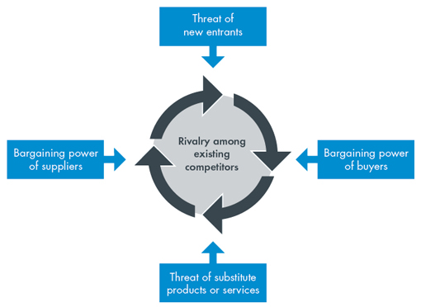

Porter’s 5 forces model

2.2.1 Specification of the Industry

Bangladesh's beverage industry is a long-standing yet under-developed sector. Before a long time, the only commodity in this market was carbonated beverage or carbonated soft drink (CSD). The sector is rapidly super growing.
New modish beverages with various designer packaging have entered the beverage business in this new era. Customers of all ages have developed a passion for beverage drinking. Young people prioritize different types of beverages, whereas senior persons have their own beverage preferences. Another significant issue is the impact that beverage collecting has had on health-conscious people. The following are some deity specifications:

- Asset Value increase
- Achieving Power, Suitability and effectively goal
- New trends and customization of beverage goals.
- As the industry grows in importance, it has improved worker security and empowerment.

2.2.2 Size, Maturity and Trend of this Industry

The beverage sector in the twenty-first century has risen to prominence in the corporate world. Soft drink consumption is no longer harmful, hence it has become a popular industry.
Carbonated soft drinks had a market size of TK 1,400 crore in Bangladesh, which has grown at a rate of 15% per year. However, the market size in 2011 was 1,500 crores, with a 20 percent annual maturity rate. Consumers in the soft drinks market now account for 79 percent of urban consumers and 21% of semi-urban consumers. And, in terms of soft drink demand, rural and semi-rural areas account for 65 percent of total customers, while metropolitan areas account for 100 percent, which is exceptional.
If we're talking about a trend, we're talking about a significant trend that has changed CSD's incorrect valuation.
Now, if we're talking about maturity, I'd say Bangladesh has flourished.

External Economic Factors
PepsiCo BD's performance is inextricably related to the economy. The impact of economic conditions on hamlets or the macro-environment of company is stated in this PESTLE/PESTEL study document. The following are the political and economic factors that are linked to PepsiCo:
- The economic stability of the most important markets, which is a rare occurrence; The rapid growth of development economics, which provides a chance for a huge, young working population. As people's purchasing power grows, their lifestyles become more fashionable, which may have an impact on the amount of beverages that PepsiCo BD sells.
- While inflation and taxes have an impact on PepsiCo, they are mainly within their control. However, since so many of their supplies are acquired overseas, it becomes more difficult.
- Gasoline price obsession is an important potential because fuel is used as a prelude in the generation plant.

2.2.3 Barriers to Entry

Brands, bottling, and distribution capacities, as well as shelf space, make it difficult for newcomers to break into the soft drinks business.
Despite the fact that Transcom Beverages Limited (PepsiCo BD) has a long history in the beverage sector, the barriers to arrival issue does not apply to them. PepsiCo BD has long controlled those hurdles, making it the leading beverage business in Bangladesh, with a 35 percent market share over Coca-Cola, which is another major franchisee in the country.
If I evaluate a new brand's entry into the beverage sector, the barriers to entry will be as follows:

- Because of the significant capital requirements for developing a new bottling system in Bangladesh, investors are unable to enter the business. This financial barrier could be a significant deterrent for newcomers.
- High Cost of Advertising, PepsiCo spends around $54 million over the course of five years to advertise Coca-Cola products in the news media. They go with a high-quality banner and a vibrant color scheme. This makes it extremely difficult for a newcomer to compete with the incumbents and establish any awareness, brand image, or confidentiality.
- Bangladesh is a country in South Asia, and PepsiCo is the oldest brand. TBL has been marketing PepsiCo products in Bangladesh for the past 50 years. PepsiCo BD has enriched history of potential advertising that has earned them a lot of brand value and obedient consumers all over the world by using the power celebrity, nevertheless for new entry this is very arduous to do.
Suppliers Power:
In the battle to create the finest commodity in the beverage industry, companies are attempting to secure the best things from suppliers. Every company has a trade secret of its own. There isn't much of a competitive pressure on suppliers. Bottling companies and packaging companies are two examples. Because it is so easy to switch suppliers, suppliers have a lot of bargaining power in this situation.
PepsiCo suppliers have mediocre bargaining power; let’s have a look at them based on the exotic factors- This is also a powerless force for suppliers with minimal forward integration. This is an average force of individual suppliers on a moderate size.
Buyer Power: Consumers are listed as one of PepsiCo's top goals in its mission statement. The impact of customers on the firm's industrial environment is addressed in this section of the Five Forces analysis. External factors that contribute to PepsiCo's strong negotiating leverage among consumers/buyers include:
- Low switching costs, which I must admit, is a powerful force. The fact that customers can simply switch from one company to another emphasizes their potential to influence PepsiCo.
- It's also a powerful force because of the high availability of replacements. Substitutes, on the other hand, provide buyers even more reasons to avoid PepsiCo products.

2.2.4 Threat of Substitutes

Depending on consumer preferences and other factors, PepsiCo products could be substituted. Cola-Cola is the most common substitution for Pepsi, whereas sprite is the most common substitute for 7up. Fanta is Miranda's favorite alternative. As a result, this part assesses the impact of replacement on the firm's business and industrial environment.
The bulk of PepsiCo's commodity alternatives are allowed due to superior substitute quality. People can enjoy natural fruit juices and handcrafted coffee items instead of Pepsi or Tropicana fruit juice. Furthermore, PepsiCo customers can easily convert to these substitutes, which are widely available in supermarkets and other stores.
Another strong force is the high availability of replacements.

CHAPTER III: METHODOLOGY

3.1 Introduction

The procedures or strategies used to find, select, process, and analyze information about a topic are referred to as research methodology. The methodology portion of a research article allows the reader to critically examine the study's overall validity and dependability. The methods section addresses two major issues: How was the information gathered or generated? How was it investigated?
A research methodology gives research credibility and results that are scientifically valid. It also includes a precise plan to keep researchers on track, ensuring a smooth, efficient, and controlled procedure. The technique of a researcher assists the reader to comprehend the strategy and procedures utilized to obtain findings.

3.2 Research Design
The majority of research falls into one of three categories: exploratory, descriptive, or causal. Each has a distinct function and can only be utilized in specific ways.
- Exploratory: Any marketing or strategic plan should include exploratory research. Rather than collecting statistically precise data, it focuses on the discovery of new ideas and insights. It is most typically used to clarify company concerns, possible growth areas, and alternate courses of action.
- Descriptive: Because of its quantitative structure, descriptive research makes up the majority of online surveying and is considered conclusive. In contrast to exploratory research, descriptive research is organized and structured so that the data gathered may be statistically inferred on a population.
- Causal: Causal research, like descriptive research, is quantitative and preplanned and structured in design. As a result, it is also regarded as conclusive research. The goal of causal research is to explain the cause and effect relationship between variables. This is in contrast to descriptive research's observational style, which uses experiments to determine whether a relationship is causal.
I used “Descriptive research method”. Descriptive research refers a reach design that aims to obtain information through survey / any source to systematically describe statements. I basically set a survey question form through which I collected the valid information from the beverages industry personnel and expertise to justify that Modern trade has a great impact on beverage sales.

3.3 Sampling Design

As my descriptive research is fully dependent upon the survey results. It is quite difficult to collect the data from each and every sales people in my company. I set a proper sample plan through which I can come up with perfects descriptive analysis feedbacks.
Non probability sample design: Non probability sample is a sampling method in which not all members of the populations have equal chances of participation. I select this design because Modern trade is a very small sector compared to retails. As my research topic related with all around Modern trade. I surveyed only on the sales people related in Modern trade and emerging channels rather than overall sales forces of PepsiCo Bangladesh.
From various types of Non probability samples I dependent on convenience sample. As my internship period was not for the very long time period. Through convenience sample design I was quite easier and related to collect the data from my team members and peer members.
Sample size: I have selected “35” participants on my survey in related with Non probability approach and convenience sampling method.
Through this approach I collected the information in such a way that reflects a proper strategic primary data research.

3.4 Questionnaire Development for Primary Data

Based on the descriptive research strategy I’ve developed a questionnaire with 10 questions which has been attached in the Appendix part of this report. The purpose of those questionnaires is to make an effective descriptive research. I focused on the variable like “Modern trade and emerging channels, sales impact through modern trade, competitive analysis in modern trade, Comparison between retail trade vs modern trade, PepsiCo’s business opportunity in modern trade, Consumer focus in modern trade, Future impact of emerging channels etc.

3.5 Data Collection
As my data collection sources were both (primary & secondary) Mentioning information’s sources for both of my approaches:
Secondary sources:
- Website of transom beverages limited (PepsiCo).
- Newspaper.
- Sales report
- Trend analysis
- Annual reports
- Online journal, research paper on internet.
Primary sources:
Creating the survey questionnaire and collect the data from:
Pepsi Bangladesh employees off Modern trades, Peer team member, Subordinates field forces, Top managements of Modern trade, Executives of Modern trade, peer members and Research personnel of emerging channels etc.

CHAPTER IV: ANALYSIS AND FINDINGS

4.1 Background of Modern Trade

Modern trade involves a more planned and organized approach to distributions and logistics management. Modern trade includes the larger player such as supermarket chains, hyper market chain. This involves aggregation of demand across a
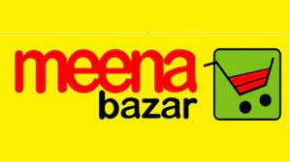Diverse product range.



The functional differences between traditional trade and modern trade
Traditional Trade | Modern trade
Traditional trade refers the retail distribution/trade. This is the biggest market for FMCG brands. | Modern trade is newly growing market. Which is supermarkets and hypermarket.
Located at every concerns in the world. | Located by ignoring rural area and usually focusing on Metro market.
Target market is all types of customers. | Target market is higher class and middle class customers.
Contribution on companies overall sales is more than 75 %. | Modern trade contributions can be considered as 15-25 % on company’s total sales.
Boost up/Increase the sales is the focus target/purpose of retail chains. | Creating the better brand value in the mind of consumers is the focus objective of MT channels.

4.2 Findings of Survey Questionnaire

Question number 1
Nowadays, Modern trade and emerging channels have a significant impact on sales along with retail chains?
Analysis: 100 % respondents are agreed that Modern trades and emerging channels like (Shwapno, Agora, Unimart, Panda mart, Meena clicks, Pick & pay. These channels have a great impact on sales apart from retail chains for this beverages brand Pepsi.

Question number 2
Do you agree with this statement “In this highly competitive beverage market where our competition is Coca-Cola, Doing business in Modern trades & emerging channels is Mandatory to fulfill the market demands?”
Analysis: 90 % of respondents are agreed that Pepsi should do business in modern trades. So that they can achieve the sales revenue along with coca cola that have been generating from this industry.

Question Number 3
Do you agree that a large portion of PepsiCo's customers (Premium customers) are moving toward Supermarkets and e-commerce platforms instead of retail markets to fulfill their beverage needs?

Analysis: 60 % respondents are disagreed with this statement. They believe people are moving towards general trade(Retail) to Modern trade. But not for fulfilling their beverage needs. Still in Bangladesh this kind of customer base market is very few who can buy 3,4 cases of pepsi,7up, dew, Mirinda etc. People are more willing to buy 1 or 2 bottle of beverages from retails.

Question number 4
Do you think modern trade channels are more effective than the retail market in interacting with the target customers?

Analysis: 100 % of respondents are agreed with this statements. As one of the fundamental of doing business in modern trade is every companies product are separately displayed in one separated place (Self talker). That is the reason the interaction level in between Pepsi and targeted customers is very high and interactive.

Question 5
Do you think that ensuring the footsteps and availability in modern trades and channels is an excellent opportunity for Pepsi to create a premium brand position in the mind of customers?

Analysis: 80% respondents agreed and believe with this statement. To create a premium brand position in the mind of customer, Modern trade is a best option to do that.

Question 6
Modern channels like e-commerce platform (Panda Mart , Daily shopping, Meena clicks, Shwapno.com ) has the potential to contribute to sales volume. Please note down your valuable opinion here.
Analysis: as this a questionnaire about written statements. I’m summarizing all the answer I got from respondents. All the respondents convey this messages that in this new Era, Emerging channels has the highest potential channels that can boost up the sales volume more than 40 % than traditional channels.
Question 7
What do you think? Approximate contributions of Modern trade /Institutional sales to overall sales of Pepsi in Bangladesh?
Analysis: More than 80% agreed with the option 1 (5-25%), 20 % respondent’s agreed with option 2 (25-50%) and No respondents goes with the option 3. According this results we can conclude the contribution of modern trade / institutional sales contribution is 5 to 25 % in total sales.
Question 8
Which of the following brand SKU is comparably most selling in the modern trades?
Analysis: According the responses. The conclusion comes in a shape where I found (Pepsi &7up) Can be considered as highest selling SKUs, Then Mountain due in lemon flavors, In the water segment Aquafina has been conserved as market leader all the time. In juice category, Slice can be considered a good segment as well as.

Question 9
Which of the following category segment has the Highest Contribution to sales in Modern trade?

Analysis: About more than 90 % respondents agreed with the option of PET (polyethylene terephthalate). Modern trade is not a place to sell RGB (Refine glass bottle). Some respondents are agreed with the option “Can” bottle and PMX glasses.

Question 10:
Which consumer category (Societal class) should be the target market for Modern trade?

Analysis: Almost all the options that I had given (High, Medium, Low, Youth and students). Respondents are thinking all the segments are attractive for modern trade and emerging channels.

Findings
- Modern trade has a very favorable and important impact on sales.
- It is almost compulsory to conduct business in modern trade to meet market demand, considering the intense competition for the beverage brand Coca-Cola.
- All premium customers are moving towards modern trades to meet the standardized lifestyle and best buying experience.
- There is a direct communication opportunity to the customer via modern trade.
- To create a premium brand positioning in the minds of customers, feasibility and visibility are crying needed nowadays in the modern trade.
- Modern channels and e-commerce sectors are growing, and the sales projection is getting higher and higher in this booming industry for beverages.
- The highest selling SKUs are Pepsi and 7up, whereas mountain dew, Mirinda, and Aquafina sales volume are average, and slice and evolve can be considered slow-moving.
- As per modern trade’s customer demands, the PET segment is the highest-selling segment.
- All segmented customers can be targeted to boost the sales in modern trade.

CHAPTER V: INTERNSHIP EXPERIENCES

5.1 Positions, Duties and Responsibilities

I have been working as an intern of Modern trade & emerging channels. Modern trade is the key focus of the overall key accounts team. As I mentioned the hierarchy of overall key accounts team.
Modern trade is the main objective or focus of B2B/Corporate sales. As I was involved in the overall b2b operations of sales. In my first 4 weeks I’ve experienced a proper training of sales operation task. After completing my training, I had given specific task which was quite similar the task of a sales executive.
The tasks that I have been doing after completing my training seasons:

Job responsibilities | Explanation
Generates sales | The major KPI of sales team is to generate sales from existing accounts and new accounts as well. In every month the higher authority set a specific target of sales in (Quantity and value). Every sales executive has to follow up the target considering the target value. I was also being concerned to follow up the target of my modern trade team. Initially I was guided to visit the accounts of modern trade and analyst the sales trend.
Collection of PO (Purchase order ) | PO stands for purchase order. Our client sends us the PO as per their demand as per their demand. This is the initial responsibility to follow on.
Input Po to automation software | After getting the PO our task was to input those (PO) to the automation that operates the overall sales operation.
Checking the balance of party | Pepsi Bangladesh doing their business here based on the credit balance based on each party has. Before decided to deliver the products accordingly we must have to check whether the party has credit limits or not.
Manage the delivery process | Pepsi runs the distribution process through third party. We have to communicate to the third party whenever we need to deliver the products to our customer based on the Po we received .
Monitoring all Market development office(Merchandiser ) | In the team of key accounts, we have 16 merchandisers across the Dhaka city. In every area we have some outlets of modern trade. They are the primary representative of Pepsi in those assigned territory. In every (Po receive and payment collection) they are the primary communicators with the party. They have to reports to the sales executive. I had to communicated and work with them for any issue. Sales executives have assigned the target of them.
Making the GRN | GRN is a very popular term of modern trade. After completing the delivery to the specific outlets. They send us the GRN (Good receipt Note) As per the delivered products. In the month ends we have to collect those and input the value in money we delivered. Based on that we have to create a file and send back to the outlets for payments.
Report to the My line manager | I had to report to my line manager about every operation and decision I decided to go through.

5.2 Contribution to Departmental Activities

Being sales professional, every sales people needs to work with every department related to sales. I also contributed to the departmental functions when I was assigned to do. Although I was dedicated to serve Modern trade team, but in some cases I had to collaborated with Key accounts team and marketing team.
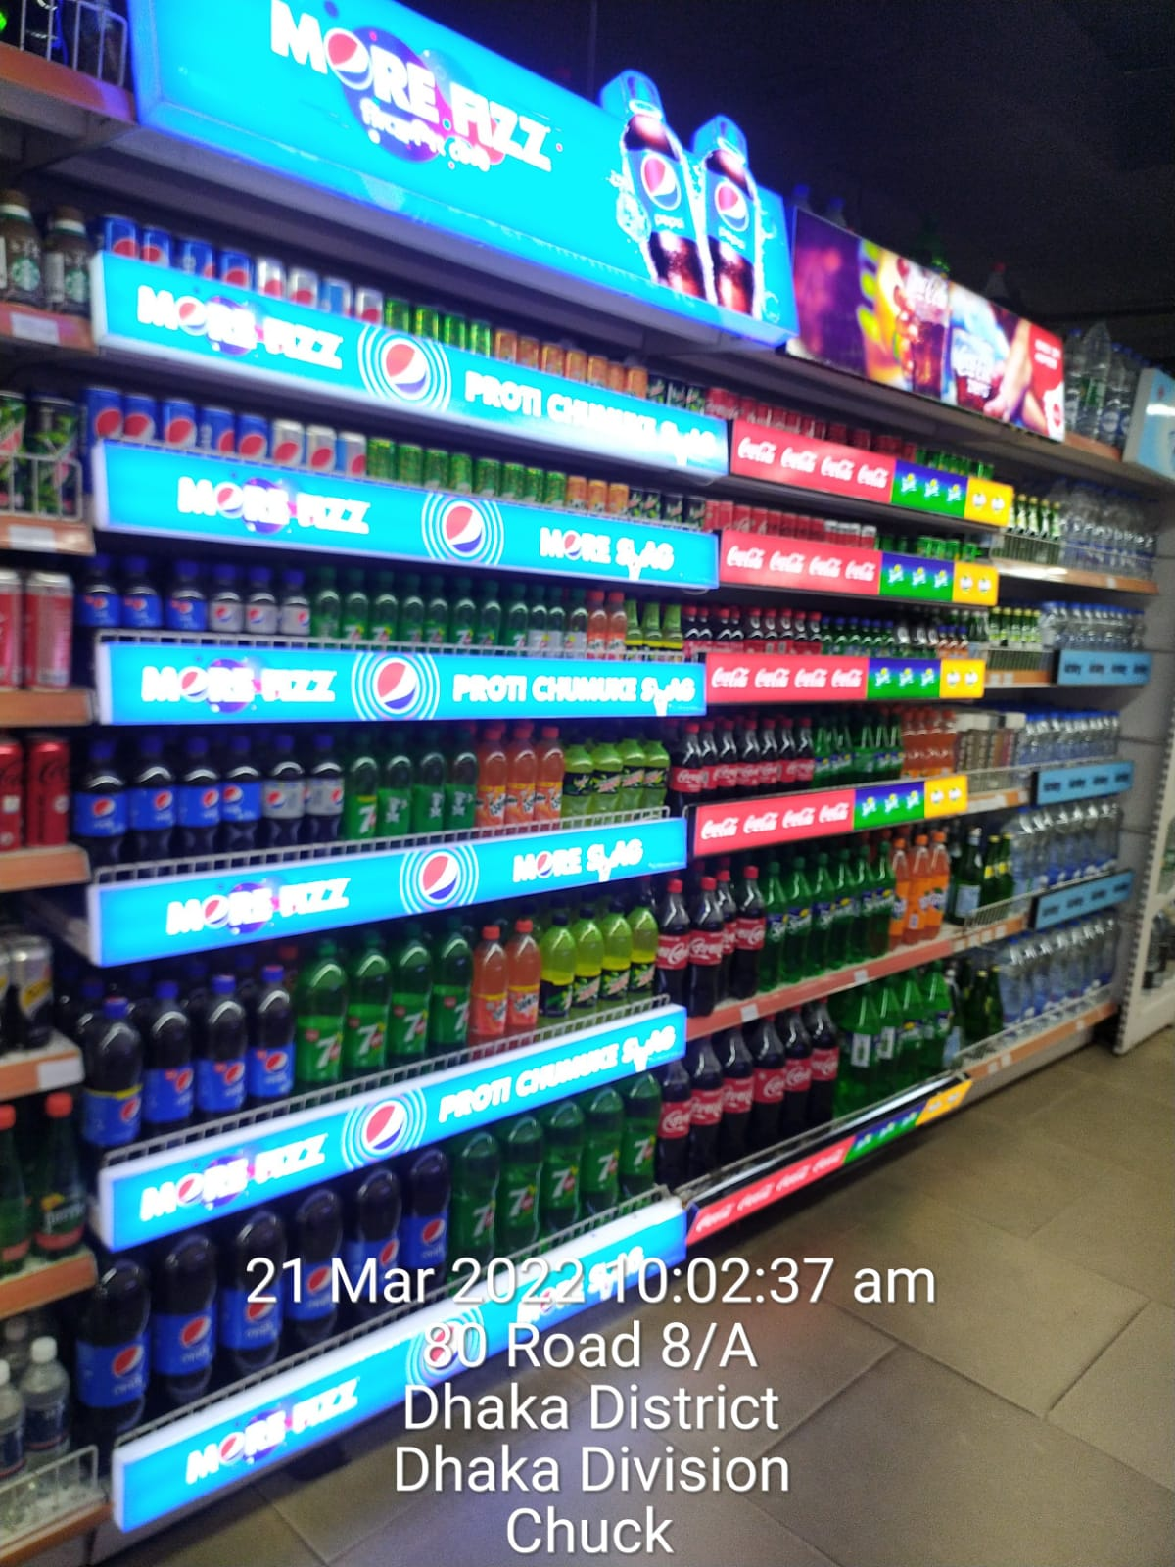
I am mentioning some of my great contribution in Modern trade:
LED self-talker: With the collaboration of Marketing team and my peer modern trade team. We Lunched this “New LED Self talker”. I was directly involved to this execution (Planning and deployed). The purpose of doing this was very clear. As I mentioned earlier Modern trade is a place where a brand can communicate directly with the customer to create a better brand positioning in the mind of customer. We tried to focus on it with the tagline of “Proti chumuke swag”

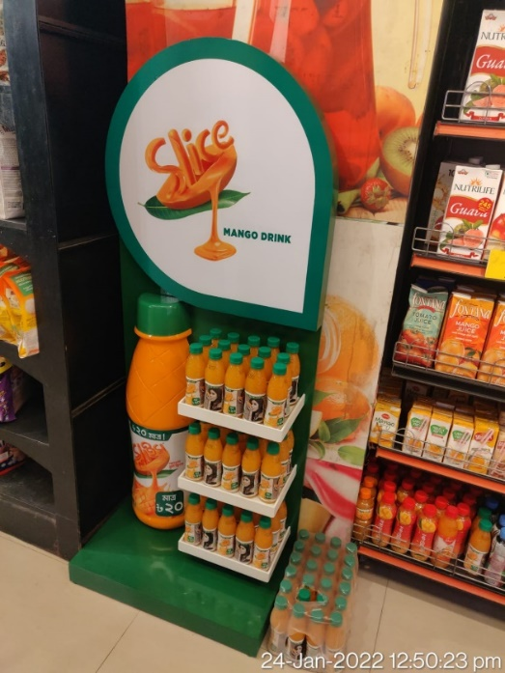

FSU of Slice in Modern trade channels
FSU (free standing unit) deployment: Once slice was a very popular brand in juice market. Due to manufacturing problem Pepsi was decided to off operation in Bangladesh. In 2022 They decided to launch again considering the market demand. To create the brand positioning again we were assigned to deployed this FSU to all modern trade. I was directly involved to this project and successfully deployed in every modern trade outlet.

5.3 New Skills Development

Apart from all departments there is some extra privileged of doing job in Sales. As sales is correlated with all the departments, the learning opportunities of acquire skills are higher and bigger than any other departments. As I’ve completed my learning period with the Corporate and modern sales team, I tried to grab all the learning opportunities I’m mentioning below to build up my own skills:

- How to meet up with primary and secondary target.
- How an organization runs via one automated software?
- The professional use of Excel in corporate life.
- How to manage a group of team?
- The professional Communications skills / way.
- The proper way of PJP (permanent journey plan) of visiting market.
- How to create GRN (Goods receipt Note).
- The professional was to launch any branding campaign.

CHAPTER VI: RECOMMENDATIONS AND CONCLUSION

6.1 Recommendations

After completing my Effective 3 months here. I’ve found/Noticed some drawback here of Modern/ corporate/ Institutional sales team. I think they should be taking this issue into considerations:
- The sales team hierarchy must be more unified. A chain of command is a must to run an organization more appropriately. The merchandisers who are the front employees shouldn’t be reported to all sales executives. Rather than they can be classified among the sales executive. So that they can understand their task more specifically.

- Trade marketing activities should be more attractive and aggressive. However, Transcom Beverages Limited has been doing aggressive trade marketing activities in the retail market. But somewhat feel the lack of interest in doing the same things in modern trade and emerging channels. To boost the sales, this is also needed in Modern trade.

- PepsiCo needs to shift more trade pricing to stay ahead of the competition. Trade price (TP) refers to the price given to the distributions and retailers to buy the products and sell them to the end consumers. In this intense competition with Coca-Cola, the effects of TP price are undoubtedly crucial to grad the market share. Somewhat I found Pepsi always focuses on MRP and the price cut for consumers. In contrast, Coca-Cola is focusing on both MRP and TP price. They believe, Distributors are creating the pools between the company and consumers. So, Transcom beverages Limited (PepsiCo) should focus more on TP rates and price cuts.

6.2 Conclusion

Transcom beverages limited (PepsiCo) holds the largest market share among the all beverages brand in Bangladesh. The beverages market is continuously increasing intern of consumer’s demand, customization of products, Standardization of products etc. Along with the retails market Modern trade, Corporates sales, Alternate channels market are also growing 10-20% per fiscal years. With the vast changes of technology, the consumer buying behaviors are also changes in FMCG industry. Based on that attraction, expert is considering modern trade and emerging channels are in the top. Indeed, there is no point in ignoring these channels; instead, companies invest more to build up these channels to grab the market share. I feel privileged to get the opportunity to work in the Modern trade and emerging channels sales team. I’ve learned many corporates and job skills throughout my intern journey that I can implement in my future workstations.

References

https://www.pepsico.com/

Transcom Beverages Ltd - Transcom Limited. (2022). Retrieved 2 April 2022, from http://www.transcombd.com/transcom-beverages-ltd.html

Sales effects of promotions in the grocery retail trade. (1996). International Journal Of Research In Marketing, 13(3), 298. doi: 10.1016/0167-8116(96)85009-9

Kotler, P., Pilarczyk, B., & Mruk, H. (2005). Marketing. Poznań: Rebis.

Au, K. (2017). Food &amp; Beverage Market Place, 2017 (17th edition). Reference Reviews, 31(5), 17-17. doi: 10.1108/rr-01-2017-0015

Research, B., Categories, A., & Beverage, F. (2022). Bangladesh Beverages Market Research Reports & Analysis page 1. Retrieved 2 April 2022, from https://www.marketresearch.com/seek/Beverages-Bangladesh/165/1213/1.html

Appendix

1. Nowadays, Modern trade and emerging channels have a significant impact on sales along with retail chains?

Strongly agree Agree Neutral Disagree strongly disagree

2. Do you agree with this statement “In this highly competitive beverage market where our competition is Coca-Cola, Doing business in Modern trades & emerging channels is Mandatory to fulfill the market demands?”
Yes No
3. Do you agree that a large portion of PepsiCo's customers (Premium customers) are moving toward Supermarkets and e-commerce platforms instead of retail markets to fulfill their beverage needs?
Strongly agree Agree Neutral Disagree strongly disagree

4. Do you think modern trade channels are more effective than the retail market in interacting with the target customers?
Yes No

5. Do you think that ensuring the footsteps and availability in modern trades and channels is an excellent opportunity for Pepsi to create a premium brand position in the mind of customers?
No doubt on it.
Consumer already Considering Pepsi as a premium brand
There is somewhere doubt on this statement

6. Modern channels like e-commerce platform (Panda Mart , Daily shopping, Meena clicks, Shwapno.com ) has the potential to contribute to sales volume. Please note down your valuable opinion here.
Short answer___________________________________________.

7. What do you think? Approximate contributions of Modern trade /Institutional sales to overall sales of Pepsi in Bangladesh?
5 – 25%
25 - 50 %
More than 50 %

8. Which of the following brand SKU is comparably most selling in the modern trades?
Pepsi
7up
Mountain dew
Mirinda
Aquafina
Tropicana
Evervess Soda
Slice

9. Which of the following category segment has the Highest Contribution to sales in Modern trade?

Pet RGB Bottle CAN bottle PMX Glass

10. Which consumer category (Societal class) should be the target market for Modern trade?
High Medium low Students youth

Intern completion Certificate
