INTERNSHIP REPORT
FACTORS AFFECTING THE FEATURES OF SAVINGS ACCOUNT: THE CASE OF PREMIER BANK

Supervised By
Muhammad Rehan Masoom
Assistant Professor
School of business & Economics
United International University
Prepared By
Humayra Karim Gift
ID: 111 133 095
School of Business & Economics
BBA Program
United International University

Date of Submission
13th September 2019
Letter of transmission

To,
Muhammad Rehan Masoom
Assistant Professor,
School of business and economics,
United International University.

Subject: Submission of internship report on “Factors Affecting the Features of Savings Account: The Case Of Premier Bank”.

Sir,
It is a pleasure to inform you that I have completed my three months long internship program from the Premier Bank of Bangladesh as well as I have finished preparing my internship report on the topic that you had approved and was suggested to perform by my branch. The title of my internship report is “Factors Affecting the Features of Savings Account: The Case Of Premier Bank.”
Each of the existing companies is facing intense competition all over the world, so it is complicated for customers to make ropes. But no business can succeed in reaching the highest point without marketing. It must also market and introduce the best products on the market so that customers can buy them.
For banks, savings accounts are a ubiquitous product/service offered to customers. Not only does a bank need continuous maintenance by providing added value to savings accounts, but it must also market additional features for its potential customer so that the bank's savings accounts can be of interest to them. This is the motivation to prepare a report for a particular title.
However, I highly appreciate the time and effort that you have given to me while preparing the report. I want to ensure you no information is directly copied from an article, and all data are accurate and relevant to my topic.
Sincerely yours,
Humayra Karim Gift
ID: 111 133 095
BBA Program
United International University

Preface

At the very starting of my internship report, I want to thank and show my gratitude to my Almighty ALLAH for supporting me till now, and without their help and support I surely could not finish my under graduation program from United International University.
I would like to thank my honorable internship instructor and course faculty Muhammad Rehan Masoom, Assistant Professor, School of business and economics, United International University for helping me and sharing his valuable time to prepare my report. The report was hard to finish without the guidelines and suggestions I had received from him.
Furthermore, I want to thank Abdullah Hamid, Senior Executive at Premier Bank Limited for suggesting the topic that is also going to be a part of the bank for further analysis. All the effort he had given was highly essential to collect information for this report. He also helped me by providing several documents that are related to the savings accounts information of Premier Bank Limited.
Additionally, I want to thank my co-workers at Premier Bank and friends from United International University as they supported me and make me able to understand several concepts of marketing impacts. All of them helped a lot to complete the internship program successfully.

Executive Summary

The internship report is an analysis of marketing impacts on new features of the savings account of Premier Bank Limited. Marketing is a broad term and not means promoting a product only. Spending time and effort in implementing a lead management process that generates the most qualified leadership can have a direct impact on marketing revenue. This means that the marketer must collect the data (digital behavior) on the potential customer and interact with it. This offers marketing professionals the opportunity to pass to the leaders of a company team that has shown some interest in the products or services they offer. Furthermore, the marketing department must also help potential customers who are not yet ready to purchase. Instead of ignoring questions or concerns directly from a website so that sales teams do not neglect or waste time, marketers can keep these potential customers interested and prioritize the company name so that when you are ready for business Purchase, think about your business first.
Therefore, to analyze the marketing impacts on a new feature of savings account, a consumer survey has been conducted to identify the consumer perception towards the Premier Bank’s savings account. The respondents are mostly general account holders of the bank and have potential to be the savings account consumers. The survey found that consumers, primarily students who want to open the bank account as the bank’s initial payment for savings account is found quite well to them. On the other hand, the interest rate on balance payment of savings account was found less attractive to the consumer. At the end of the study, there are few suggestions given to improve the savings account feature and make the features appealing to the consumer.

Table of Contents
Chapter one: Introduction of the report
1.1 Background of the report 2
1.2 Objectives of the report 2
1.3 Methodology of the report 2
1.3.1 Data collection process: 3
1.3.2 Data Analysis 3
1.4 Scope of the report 3
1.5 Limitation of the report 4

Chapter two: Premier Bank Profile
2.1 Background of Premier Bank 6
2.2 Mission, Vision, Values 6
2.2.1 The Vision of Premier Bank Limited 6
2.2.2 The Missions of Premier Bank Limited 6
2.2.3 Principles of Premier Bank Limited 7
2.3 Product and Services of Premier Bank 7
2.4 Organogram of Premier Bank 10

Chapter three: Impacts of new features on savings account of Premier Bank Limited
3.1 Savings account of Premier Bank 12
3.2 Types of Savings account 13
a. Premier Esteem Savers account: 13
b. Premier Excel Savers Account: 14
c. Premier Remittance Savers Account: 14
d. Premier Bank Monthly Savings Account: 15
3.3 Consumer responses on savings account 15

Chapter four: Findings, recommendations, and conclusion
4.1 Findings 24
4.2 Recommendations 25
4.3 Conclusion 26
Reference
Appendix

Chapter one: Introduction



1.1 Background of the report
The internship program of BBA in United International University offers a complete process of managing all aspects of a business to improve the growth and stability of a market. The BBA internship strengthens the theoretical, analytical and applied knowledge of a business administration student. Besides, it is one of the most sought programs that students must follow during or after graduation, depending on their evolution.
The title based on what I have prepared my internship report is “Marketing impacts on new features of savings account of Premier Bank Limited (PBL)”. As we all know that marketing has a big impact on any type of business, whether it's a health care institution, educational institution or a financial institution, marketing is a great strategy to increase sales. The new features that are recently added to the savings account of Premier Bank are also marketed to the consumer to attract them. The report is made to analyze the impacts of this marketing and responses from the consumer.

1.2 Objectives of the report
The report objectives are usually separated into two parts in the internship report. These are discussing below:
- Primary objective: the primary reason of preparing this report is because the submission of this report is a pre-requirement of attaining the BBA certificate from United International University.
- Specific objective: The specific objective means these goals are report related. They are:
- To analyze the Premier Bank Limited
- To analyze the savings products of Premier Bank Limited.
- To prepare a customer survey to find out the marketing impacts.
- To recommend few ideas so that the products marketing can be improved by PBL.

1.3 Methodology of the report
The Methodology section describes the actions undertaken to study research questions and the theoretical bases for the application of specific procedures or techniques to identify the choices for understanding the problems, to process and analyze the information, thus allowing the reader to critically evaluate the effectiveness throughout the study. The methodology of this report is given below:
1.3.1 Data collection process:
Information that are utilized in this report are aggregated from few sources. Some sources are primary, where some are secondary.
a. Primary sources of Data:
- From informal and formal communication with the consumer and bank personnel of Premier Bank Limited.
- From the financial statement of Premier Bank.
- From my own internship and theoretical knowledge.

- Secondary sources of Data:
- From the leaf-lets and brochures of the bank.
- From several books written on marketing impacts to conceptualize the information.

1.3.2 Data Analysis
The report is an exploratory one, but utilized both quantitative and qualitative data. 50 potential customer of Premier Banks were randomly chosen who were aware about the promotion of the savings accounts. And then according to their responses, the overall marketing impacts are being analyzed.

1.4 Scope of the report
Marketing is necessary to promote the economic situation of a company. All financial institutions use marketing strategies to promote business. There are two types of marketing: offline and online. Marketing creates notoriety and recognition of your business.
As for the sales of banking products, a personalized advertisement can help to present the bank's products and services to the consumer. Marketing ensures sales through communication with customers. Today, social networks also increase brand awareness. On this way, measuring the customer perceptions on the promoted product is also very important for a bank to know is the communication is done correctly or not. The impacts of the marketing strategy make the clear bank information about selling a product.
Therefore, the report is going to be a valuable one for all banks manager and particularly for Premier Bank's Marketing department. It will also help any reader to know about the bank and its savings products. Higher grade students and faculties can also be aware of my practical experiences.

1.5 Limitation of the report

The limitations are the difficulties that I had passed while I was preparing the report. The limitations are mentioned below:
- Short time period.
- It was hard to manage time to collect data besides performing my internship responsibilities.
- Several compulsory information could not be added because of their confidentiality.
- Clients were so busy that most of them were not happily provided the survey answers, few of them left few questions black in a hurry.

Chapter two: Organizational Overview

2.1 Background of Premier Bank
In order to clarify the spirit of the 21st century, Premier Bank Limited began its successful journey in 1999 with the motto of “Service First” and became a well-known financial service provider. This policy reflects the Bank's focus on customer satisfaction, flexibility, responsiveness, and productivity. Premier Bank Limited's services are not only for the client, but for the community, not only for profit, but also for the government, not just for supply, but also for ensuring liquidity, discipline, and responsibility.
According to the company law of Bangladesh Bank, Premier Bank Limited was established as a banking company in Bangladesh on June 10, 1999. According to Banking Law, the Central Bank of Bangladesh issued a banking license on June 17, 1999. Premier Bank Ltd. officially began its formal business on October 26, 1999, with an authorized capital of 1.8 million US dollars and a paid-up capital of 222.2 million US dollars. Premier Bank Limited is headquartered in Banani.
Premier Bank Limited's Board of Directors consists of five directors. Dr. H.B.M Iqbal is the chairman of the board of directors. The board of directors of the bank is highly respected. They come from a successful organization and a group of industries in Bangladesh. One of the members is from Taiwan. Each board member out of 14 plays an important role in the socio-economic field of the country.

2.2 Mission, Vision, Values

2.2.1 The Vision of Premier Bank Limited
The bank has a clear vision of the final destination: to become one of the main financial institutions.

2.2.2 The Missions of Premier Bank Limited
The mission statement of Premier bank are several. They are listed below:
- Actively adopt operating technology at all levels to improve efficiency and reduce costs per transaction.
- Guaranteeing constant growth by increasing the value of shareholder investments.
- Become the most considerate and friendly financial services provider, creating opportunities for more people in more places.
- Create an appropriate environment for the bank to attract a qualified staff member.
- Guarantee a high level of transparency and ethical standards for all banking transactions.
- Based on the company, the bank committed to promoting equality in life by making an effective contribution to national development.

2.2.3 Principles of Premier Bank Limited

2.3 Product and Services of Premier Bank
To serve the various types of needs and demands of customer, Premier Bank facilitates them with several kinds of product and service packages. A consumer can choose between them according to their requirements. The Products and services of PBL are shared in the chart below:

Chart: Product and service packages of Premier Bank (Source: Bank’s Website)
As, the Retail Banking of Premier bank has a lot of service products. They are listed here below:
- Current Account  - Savings Account  - Premier Esteem Savers Account  - Premier Excel Savers Account  - Premier Remittance Savers  - Foreign Currency (FC) Account  - Non-Resident Foreign Currency Deposit Account (NFCD)  - Resident Foreign Currency Deposit Account (RFCD)  - Premier Payroll Account | - Term Deposit  - Fixed Deposit  - Monthly Savings Scheme  - Monthly Income Scheme  - Double Benefit Scheme  - Interest Rate  - Shwapno (One Year Monthly Deposit Scheme)  - Registered Retirement Deposit Plan
- Loan  - Home Loan  - Auto loan  - Personal Loan  - Home Loan for Freedom Fighter | - Agent Banking  - Remittance Service  - Locker Service  - Interest Rate Matrix  - Student File Service  - Elite Banking  - School Banking  - Premier Genius Account  - Education Savings

2.4 Organogram of Premier Bank
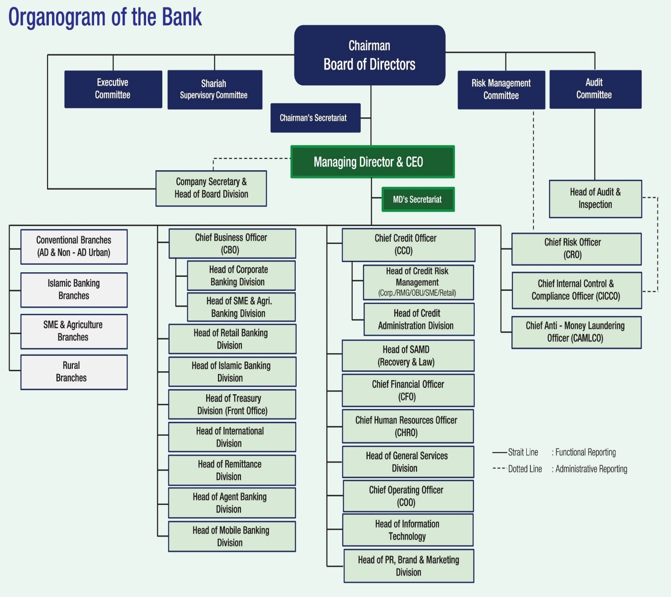
Chart: Corporate Organogram of Premier Bank (Source: Bank’s Website)

Chapter three: Impact of new features on Savings account of Premier Bank Limited

3.1 Savings account of Premier Bank
The Premier Bank Savings Account gives its customers the opportunities to conduct their banking transactions in a straightforward way. The savings accounts offer a competitive interest rate on the outstanding balance. Moreover, each of the account holders receives a MasterCard/ VISA, ATM, and debit card for twenty-four-hour banking facilities. The initial balance required to open the savings account is Taka 1000. The interest of the savings account is payable semi-annually.
The features of Savings account that Premier Bank is offering toward its customer are:

- Fast and Easy Processing: Premier Bank offers fast and easy processing to open its savings account. Anyone who is citizen of Bangladesh and above 18 years of age and open filling up an application form and depositing the initial amount of 1000 Taka.
- Unlimited transactions allowed: The customers of the savings account can deposit and withdraw from their accounts multiple time whenever they need.
- Online Banking Service: A new feature for the Premier Bank is its increasing online banking facilities to its customers. Recently the bank has offered to use the online banking facilities to its savings accounts holder. Through online Banking system, any customer of Savings account can deposit and withdraw their necessary amount of money from ATM Booths without visiting the bank’s branch.
- Electronic Statement of account on regular basis: After using the online banking services, customer will receive an electronic statement on behalf of their transaction and each month consumer will get an electronic monthly balance after calculating all the transaction made by the consumer on that particular month.

3.2 Types of Savings account
The Premier Bank Limited is offering its consumer four types of savings account and the name and description of the savings accounts are described below:

Premier Esteem Savers account:
Premier Esteem Savers "is a savings account offering the most attractive advantages, flexibility and other values ​​to clients with the highest level of income of any other savings account offered by Premier Bank.
- Required documents to open the account are:
- Photocopy of Valid NID/Passport/Driving License
- Photograph of A/c holder – 2 copies
- Copy of Utility Bill
- Photograph of Nominee – 1 copy

- Main Characteristics of this account are:
- BDT 5.00 Lacs & above : 5.00% p.a
- Interest will be credited semi-annually.
- BDT Less than 05 Lacs: NIL
- Account opening balance is BDT 5 Lac.
- Higher interest Rate*
- 25% off on Locker Service.
- No Cash foreign currency endorsement Fee on the passport.
- Free Master Card/VISA Debit Card.

Premier Excel Savers Account:
The 'Premier Excel Savers account' is actually a savings account that offers the flexibility, benefit, and other more delightful values ​​to middle class to high-class clients compared to any other savings account, with the exception of Premier Esteem Savers "offered by Premier Bank. The eligible consumer should be Bangladeshi citizen and above 18 years of age.
- Required Documents to open the account are:
- Photograph of A/c holder – 2 copies
- Copy of Utility Bill
- Photocopy of Valid NID/Passport/Driving License
- Photograph of Nominee – 1 copy

- Main Characteristics of this account are:
- BDT 1 Lake and more: 5.00% p.a.
- Higher interest rate *
- 10% discount on the locker service.
- Interest will be credited every six months.
- No annual fee and ATM limit extended on debit card at 50,000 BDT / day.
- BDT less than 1 lake: NIL
- No foreign currency approval fees in cash on the passport.
- Free Master Card / VISA, debit card.
- The opening account balance is 2 BDT Lac.

Premier Remittance Savers Account:
"Premier Remittance Savers" is a savings account that provides flexibility, appealing advantages, and other values ​​to remittance customers. The account can be opened by both the Islamic bank and the conventional bank of Premier Bank. The eligible consumer of the account should be a Bangladeshi Citizen and above 18 years older.
- Required documents for opening the account:
- Photocopy of Valid NID/Passport/Driving License
- Photograph of A/c holder – 2 copies
- Photograph of Nominee – 1 copy

- The characteristics of this account are:
  - Account opening balance is: BDT 1000
  - Interest will be credited Semi-annually.
  - Free Master Card/VISA Debit Card.
  - Special waiver on Account Maintenance Fees
  - 50% discount on a foreign currency endorsement Fee on the passport.
  - Free Duplicate Statement

- Premier Bank Monthly Savings Account:
This monthly savings account helps its customers to save their small amount of money and to grow a significant figure of the amount over time.
- The documents needed to open this account are:
- Photograph of the holder A / C - 2 copies
- Photocopy of valid ID /passport/driving license
- Report required for CASA connection for all MSS.
- Candidate Photo - 1 copy

- The characteristics of this account are:
- A client can open multiple schemas
- The monthly payment deposit starts from Tk. 500 and beyond.
- No initial deposit required.
- Automatic rate transfer function.
- Flexible content of 3, 5, 10 and 12 years.

3.3 Consumer responses on savings account
To analyze the marketing impact on new features of Savings account of the Premier Bank Limited, a survey has been conducted where 50 bank accounts holder were chosen randomly who shared their perception. There were 52% or 26 male and 48% or 24 female out of 50 respondents are there who responds in the survey. Most of the accounts holders in these 50 respondents were found student and most of their monthly income was below 10000 taka as Premier Bank is offering to open their savings account’s initial payment is 1000 taka. It is become very easy for students to open the savings account and save their retain earnings there.
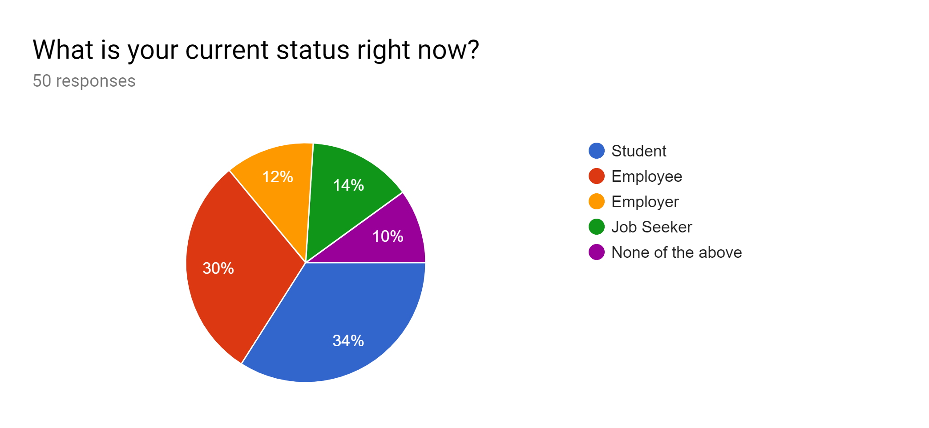
Interpretation:
As mentioned earlier, most of the respondents out of the 50, were students. There are 17 students, 15 employee, 6 employer, 7 job seeker, and 5 done nothing who participated in the survey as respondents. It can be said that the savings accounts initial payment 1000 taka to open the savings account can be proved very attractive to the student and all other as well.
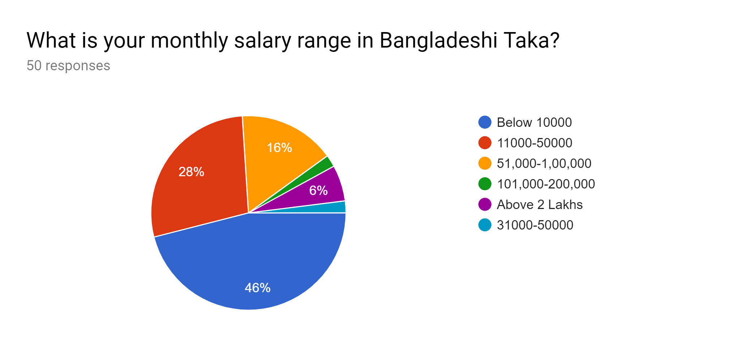
Interpretation:
There were 23 (46%) respondents were there who earns below 1000 taka each month and 14 (28%) is in the range of 11000-50000 BDT, 16% or 8 respondents were there whose monthly income is in the range of 51000-1 lakh BDT and 3 (6%) earn above 2 lakh BDT. Therefore, offering Premier Esteem savers and Excel Savers for this top earning people can be profitable and as most of the respondents are earning below 50000 taka, the initial amount can be proved very attractive for the rest of them.
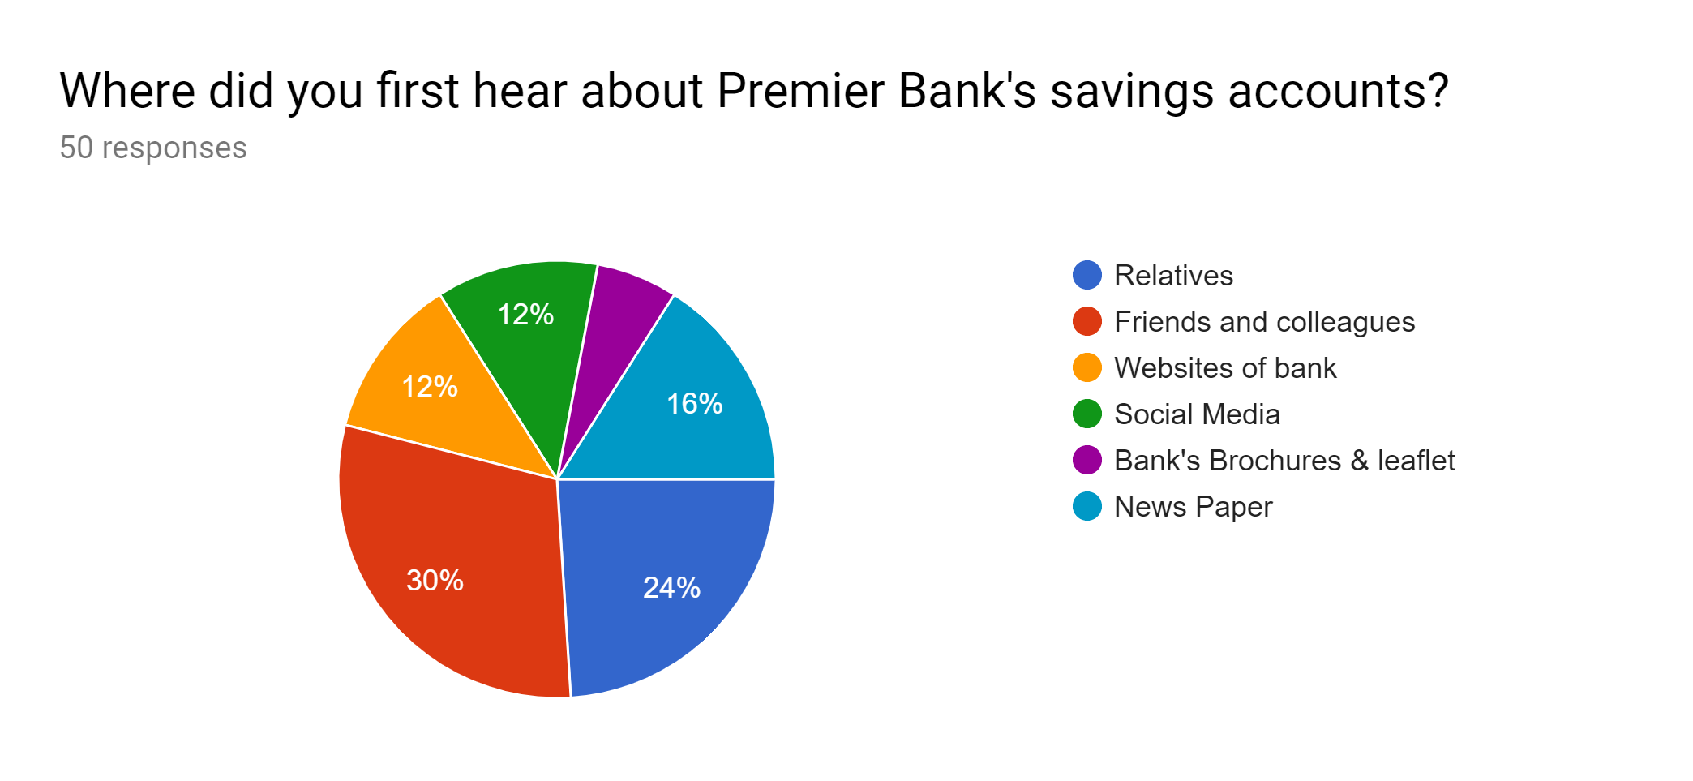
Interpretation:
This question was asked to know about which media is working fast to spread the marketing or promotion activities of Premier Bank Savings accounts. Most of the respondents are heard about the scheme from their own friends, relatives and colleagues. Few of them open bank account in Premier Bank by seeing the advertisement from the newspapers and other media as well.
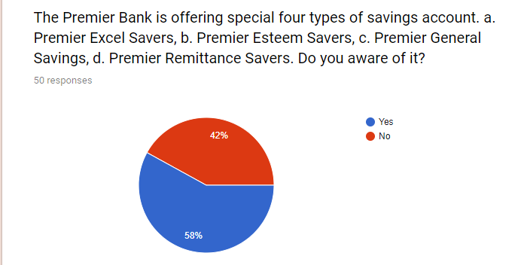
Interpretation:
To know the consumer awareness of Premier Bank savings account services, the question was asked and 29 (58%) responded that they are aware of the sub-products of the savings accounts. There are also 21 respondents there who never heard of it.
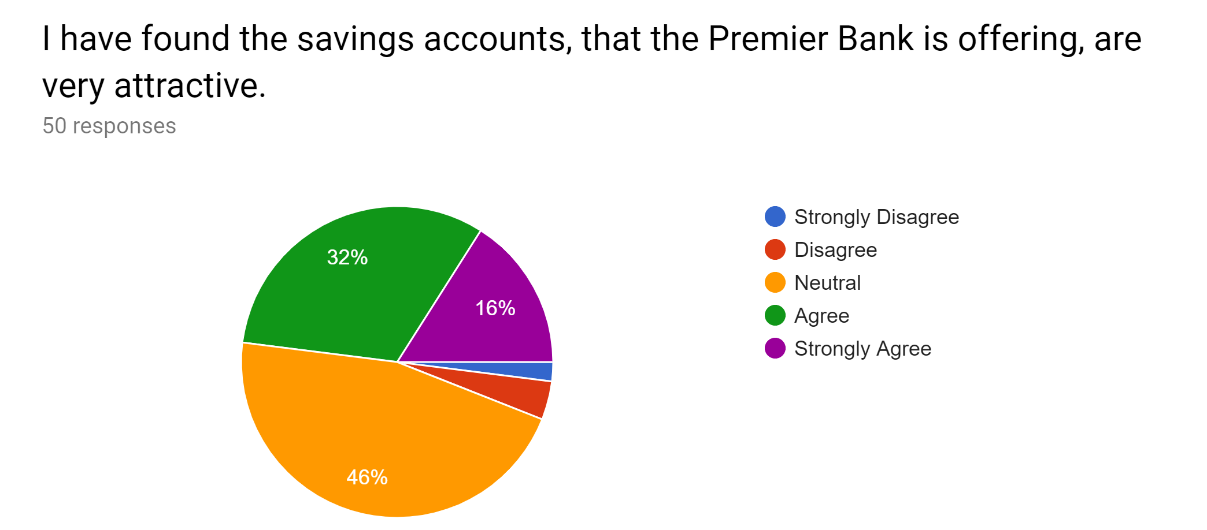
Interpretation:
To identify the attractive of products of savings account, the question was asked and among 50 respondents, the majority didn’t response the question which can be prove alarming situation for the bank and though there are 16 (32%) and 8 (16%) respondents said the savings accounts are attractive to them.
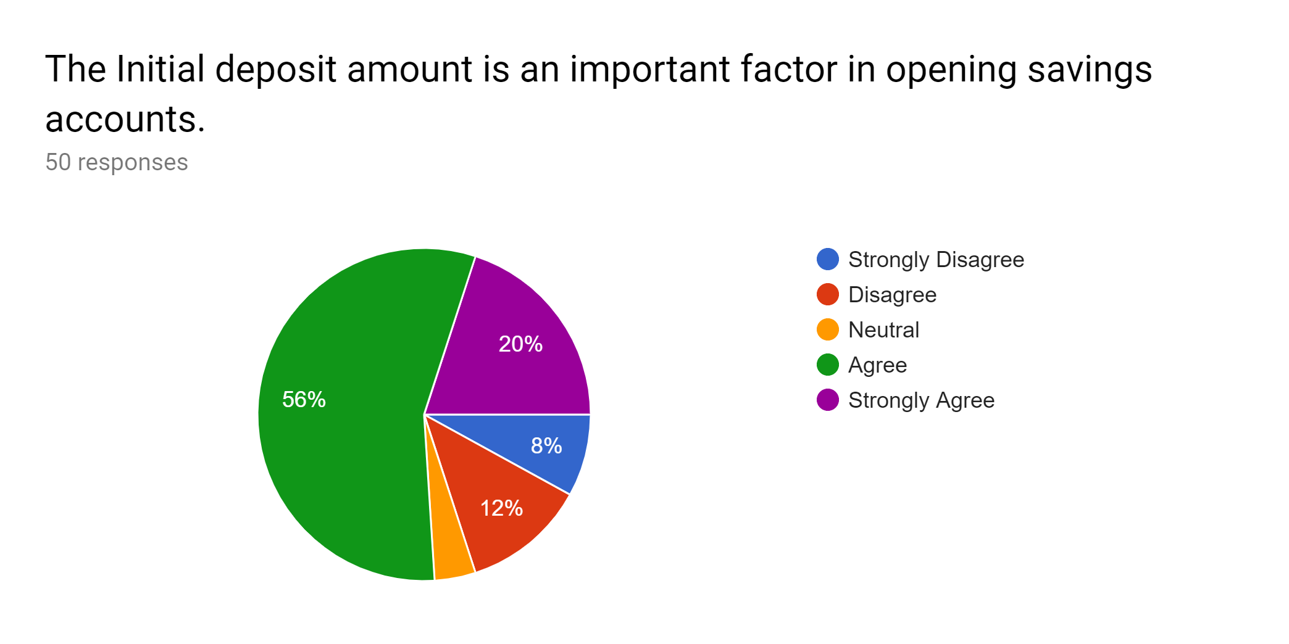
Interpretation:
Among 50 respondents, 56% or majority of the respondents think that the lower initial amount is an important issue to open the savings account there. 20% or 9 respondents replied that they were strongly agreed to the statement. It can be said the initial amount of 1000 taka was a good choice made by the bank.
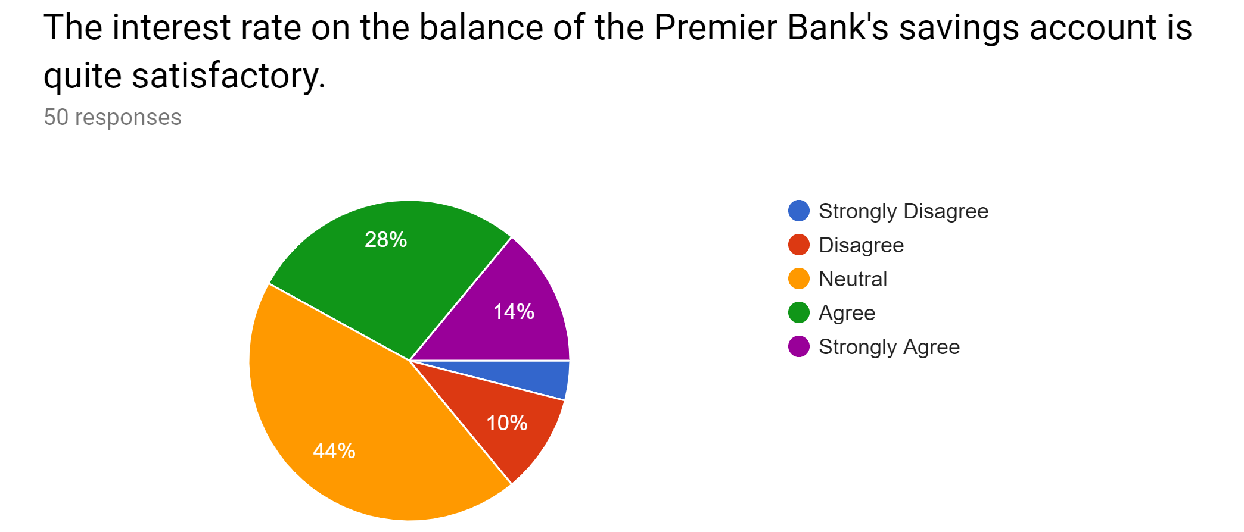
Interpretation:
Among 50 respondents who replied the statement, majority of the respondents were denied that they are happy with the interest rate that are offering by the bank. Though there are only 14 and 7 in total 21 respondents were there who either agreed with the statement or strongly agreed.
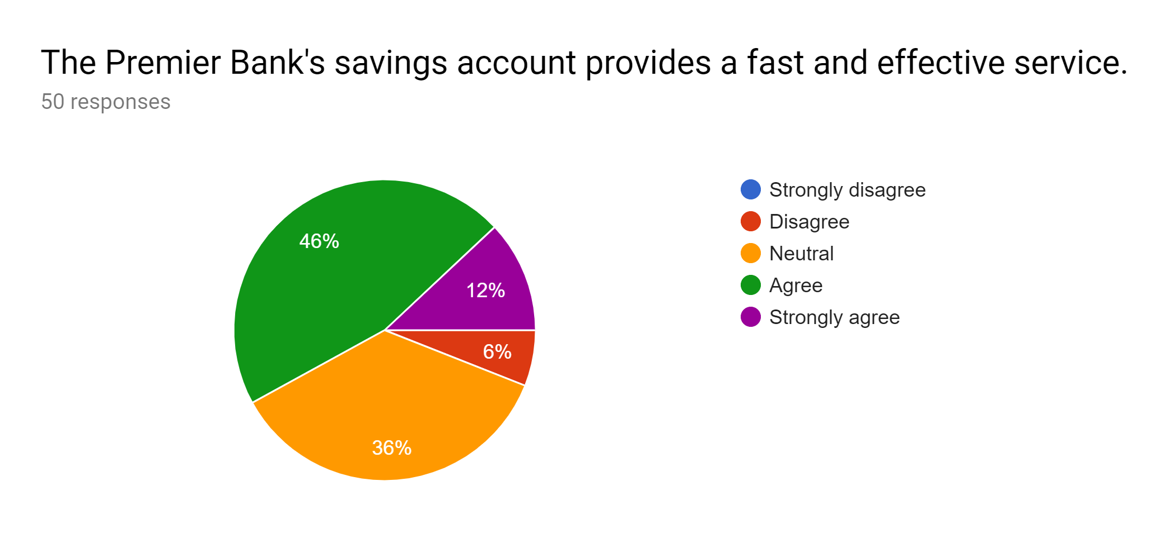
Interpretation:
Most of the respondents out of 50 respondents were either agreed (46%) or strongly agreed (12%) to the statement that Premier Bank savings account to provide fast and effective service to their clients. Though a lot of respondents were neutral at this statement can be shown as dissatisfied at the banking service.
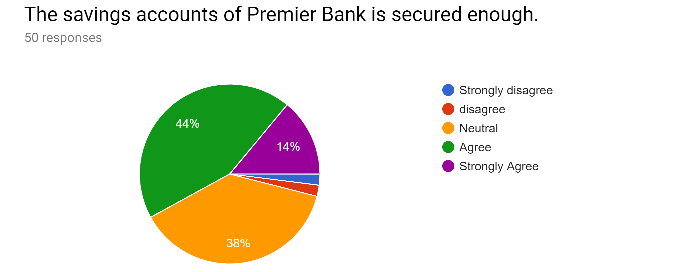
Interpretation:
Most of the respondents feel that the savings account of Premier bank are secured enough and are less risky for future savings or investments. 38% respondents were replied neutral at this statement that neither they are agreed to the statement nor disagreed.
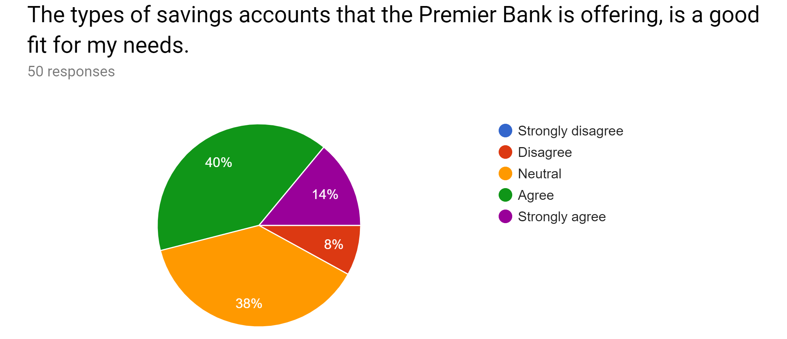
Interpretation:
Most of the respondents think that the types of savings account the Premier Bank is offering to them are good fit according to their needs. There were also 38% and 8% respondents who were neutral and disagreed with the statement consecutively.
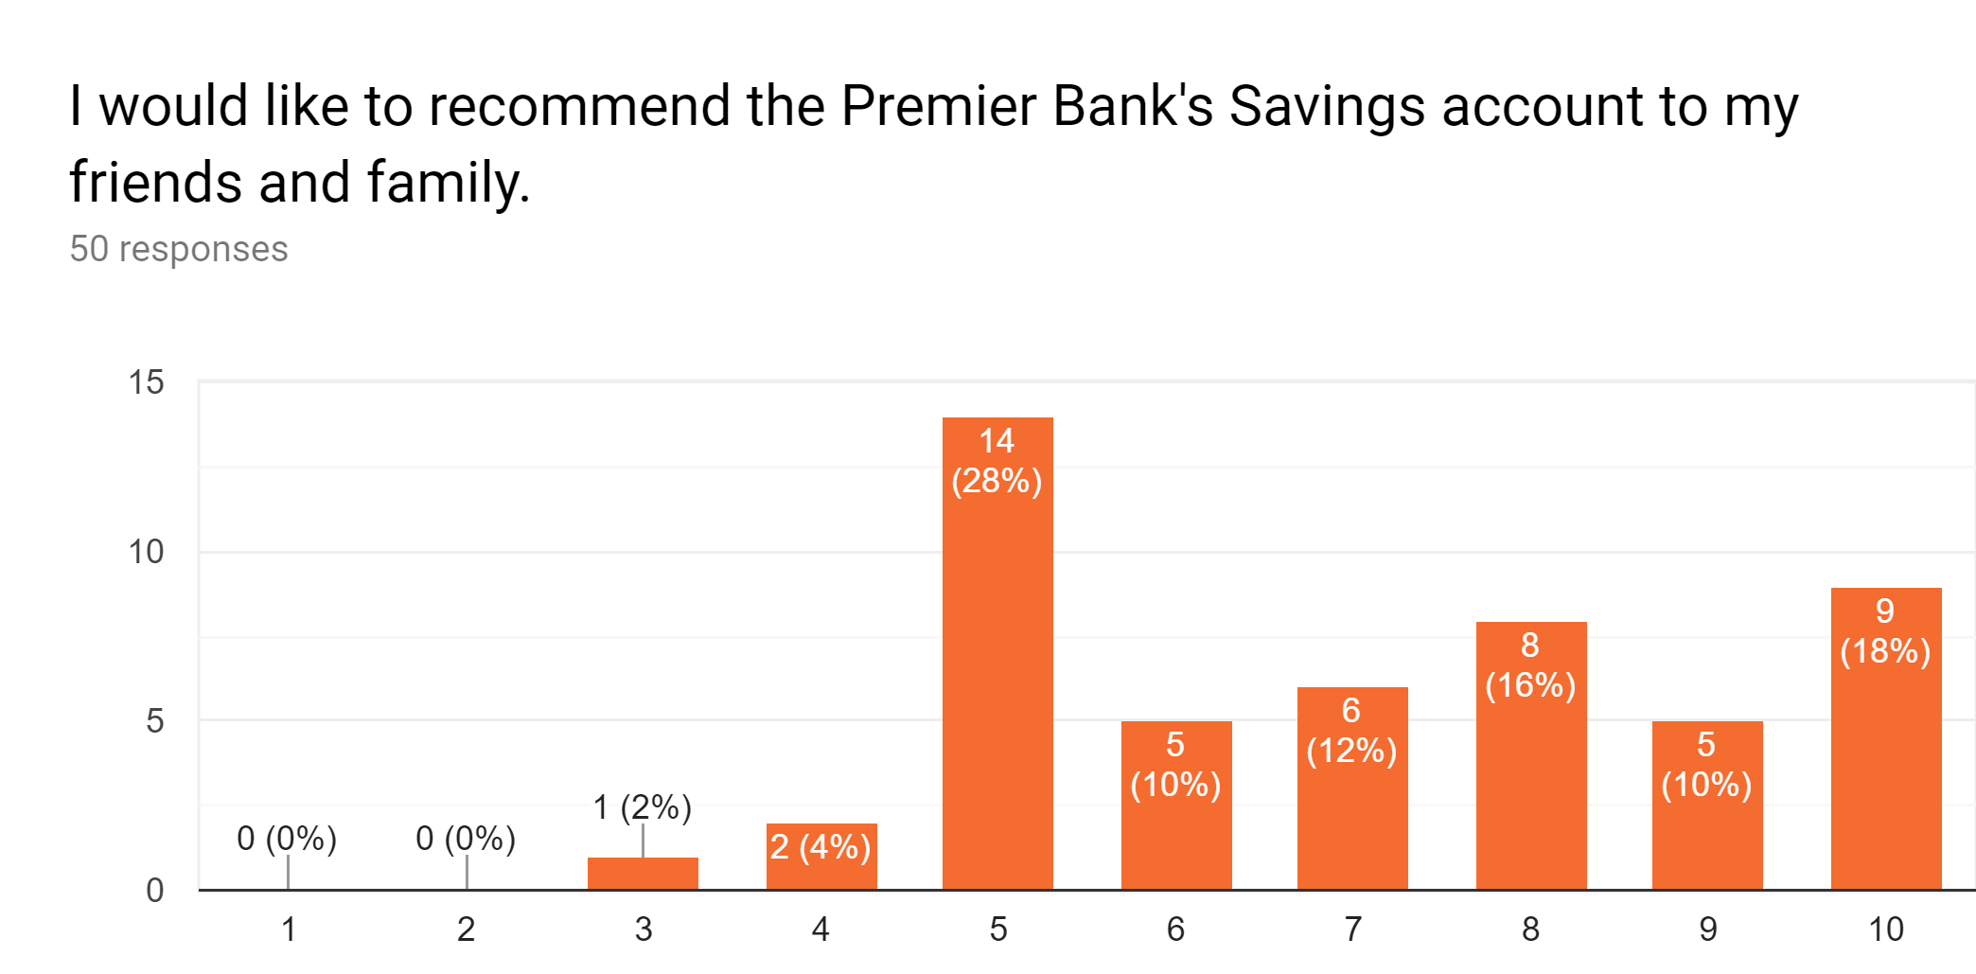
Interpretation:
The bar chart above shows the familiarity and friendly relationship between the consumer and the bank. It was asked to know how much the 50 respondents are interested in sharing their experience with Premier bank to their family members, friends, and relatives as we had found the promotion of the products are mostly done through oral communication among these family members, friends, and relatives. Most of the respondents who replied in the statement are willing to recommend the banking service to their relatives and friends as their response is in the range of 5-10. There were very few respondents who were below five range.

Chapter four: Findings, Recommendations, and Conclusion

4.1 Findings
After performing the analysis of marketing impacts on new features of the savings account of Premier Bank Limited, we can see that there are a lot of students who are opening the savings account of Premier Bank as the initial payment is low. All of the findings are listed below:
    - Each of the savings accounts holders receives a MasterCard/ VISA, ATM, and debit card for twenty-four-hour banking facilities. The initial balance required to open the savings account is Taka 1000. The interest of the savings account is payable semi-annually.
    - The new features of savings account are fast and easy processing, unlimited transactions allowed, Online banking service and Electronic statement regularly.
    - There were 8 respondents who earn 51000-1 lakh and 3 respondents who earn above 2 lakh. Therefore, it can be said that offering Premier Esteem Savers and Excel Saver are quite right for the bank as the bank already have these enormous salary earning members. On the other hand, there were 23 respondents who earn less than 10000 taka and 14 respondents who earn 51000-1 lakh taka, both of these two types of respondents are qualified to maintain the monthly savings account.
    - Most of the consumers heard about the Premier Bank services from their friends, relatives or colleagues. There are very few respondents who were aware of the services from the newspapers/social media advertisement/ or other promotional activities that are performed by the Premier Bank. So, it is quite clear that the bank’s promotional activities are not providing satisfactory results.
    - In terms of the consumer awareness of Premier Banks Products and services, the analysis showed that around 58% of consumers are aware of the services and 48% were unaware of these savings services.
    - The interest rate of the savings account does not satisfy most of the consumers yet.
    - Most of the consumer believe that the premier bank savings service is providing fast and effective service and the savings service is also secured enough.

4.2 Recommendations
According to findings, it is seen that there are few major improvements are required to improve the savings account services of Premier Bank Limited. In this part, few suggestions are given below so that the bank can improve the features of their savings account.
- The initial payment is entirely satisfactory, but the interest rate on balance the bank is offering to its savings account cannot satisfy its consumers. The Bank should re-check and re-adjust the interest rate so that every one of the account holders can enjoy the benefits.
- The Premier Bank’s promotional activities should be raised as it cannot bring satisfying results. The Bank needs to hire online marketing professionals and SEO analysts who can promote banking products to its target market and potential customers. Additionally, SEO refers to Search Engine Optimization involves increasing the quality and quantity of website traffic by increasing the visibility of a website or web page for users of a web search engine.
- The grass is not always green on the other side, but sometimes it's useful to see what's happening in your neighbor's lawn. Premier Bank should analyze its competitors on how its competitors offer their savings accounts so that the bank can know its own strengths or weaknesses.
- The bank is required to develop the research section so that it can improve it promotion activities and existing products.
- A lot of Premier Bank customers want to know more about the banks, and the bank is the expert in terms of teaching them about their services. Very few banks inform their clients in Bangladesh about the proper use of banking services. Therefore, Premier Bank can start as a holder and educate its consumers, online and offline, about personal finance, emergency savings, how to finance and manage a small business and much more.

4.3 Conclusion
Every institution has few strengths and weakness of their products or it can be said there are very few products that are accurately fit with the consumer need. The reason behind this unfitness with the need might be the changes of needs of consumers over time. We know from the earlier discussion that Premier Bank Limited began its successful journey in 1999 with the motto of “Service First” and became a well-known financial service provider in Bangladesh. This policy reflects the Bank's focus on customer satisfaction, flexibility, responsiveness, and productivity. But the features that Premier Bank is offering for its savings account are good enough and still few problems were found when we analyzed the marketing impacts of the consumer through this study. The initial payment was found an attractive feature and the interest rate on balance and promotional activities are found less attractive to its potential clients. The interest rate is payable semi-annually which can be also found less attractive as majority of the consumer demand quarterly interest from the savings account.

Reference
(1) The Premier Bank Organogram, Available at: http://premierbankltd.com/pbl /category/about-us/corporate-organogram/
(2) The products and services of Premier Bank, Available at: http://premierbankltd. com /pbl /category/retail-banking/
(3) The savings account of Premier Bank Limited, Available at: http://premierbankltd .com/pbl/savings-account/
(4) Announced interest rate chart of the scheduled banks (deposit rate of savings account), available at: https://www.bb.org.bd/fnansys/interestdeposit.php
(5) Capon, Noel and James M. Hulbert (2001). Marketing Management in the 21st Century, Upper Saddle River, New Jersey: Prentice-Hall.
(6) Pitt, Leyland, Pierre Berthon, and Jean-Paul Berthon (1999). Changing Channels: The Impact of the banking products on the Distribution Strategy, Business Horizons, March-April, 19-25.
(7) Hoffman, Donna L. and Thomas P. Novak (2000). How to Acquire Customers on the Web, Harvard Business Review, May-June, 179-188.
(8) Edeling, Alexander & Fischer, Marc. (2016). Marketing's Impact on banking products: Generalizations from a survey analysis. Journal of Marketing Research. 53. 515-534. 10.1509/jmr.14.0046.

Appendix

Survey Questionnaire on
Customer responses on the savings account of Premier Bank Limited
