AI-Powered Speech Assessment Tools in Enhancing English as a Foreign Language (EFL) Learners' Speaking Proficiency through Automated Feedback Mechanisms

School of Business and Economics
United International University

AI-Powered Speech Assessment Tools in Enhancing English as a Foreign Language (EFL) Learners' Speaking Proficiency through Automated Feedback Mechanisms

Submitted to:
Ahmed Imran Kabir
Lecturer
Management Information Systems

Submitted by:
Israq Ahmmed Badhon
ID: 111 192 027
Major: Management Information Systems
Summer 2024

Date of submission: 15th May 2024

Letter of transmittal

Date: 15th May,2024
Ahmed Imran Kabir
Lecturer
School of Business & Economics
United International University
Subject: Submission of internship report on “AI-Powered Speech Assessment Tools in Enhancing English as a Foreign Language (EFL) Learners' Speaking Proficiency through Automated Feedback Mechanisms”
Dear sir _ ,
I am very pleased to submit my internship report “Artificial Intelligence-Assisted Speech Assessment Tool to Improve English as a Foreign Language (EFL) Learners' Speaking Skills from Automated feedback mechanism“This report is presented to articulate the importance of research during my internship through presenting practical suggestions to EFL learners. My primary goal is to meet the academic requirements for the award of an undergraduate degree. I am hopeful that the insights and revelations presented in this final report will live up to the expectations. However, I will highly appreciate your feedback to improve some areas. I wish to express my appreciation to you, sir, for your continued support and guidance. I want to thank you for giving me this opportunity to work on the project under your untiring guidance. This report is presented to articulate the importance of research during my internship through presenting practical suggestions to EFL learners. My primary goal is to meet the academic requirements for the award of an undergraduate degree. I have confidence that the presented insights and revelations all meet the standards. However, I will highly appreciate your feedback to improve some areas. I wish to express my appreciation to you, sir, for your continued support and guidance. I want to thank you for giving me this opportunity to work on the project under your untiring guidance.

Sincerely Yours,
Israq Ahmmed Badhon
ID: 111 192 027

Abstract

The scope of this research paper delves into the arena of artificial intelligence language assessment and its wider implications for improving the speaking skills of English as a Foreign Language learners. Purely, this research designed to explore the effectiveness of cognitive strategies in enhancing the speaking abilities of non-native speakers of the English language. The research design is a mixed methods paradigm, encompassing data collection methods of both a quantitative and qualitative nature, with the aim of investigating the effectiveness of verbal intelligence assessment through the deployment of feedback mechanisms to boost the speaking skills of English language learners. The current research has broad implications outside of its research objectives, leaving the door open for future research developments and possibilities in the use of technology to improve the spoken mode of EFL acquirers. By showing that learners may improve outcomes through AI-based feedback, research findings offer a promising platform for further studies and practical applications in language learning.

Declaration of Student

I hereby declare that every statement provided in this project study was accurate and legitimate and was conducted under the supervision of Sir Ahmed Imran Kabir. I affirm that the affirmations as well as the research results indicated here have been generated and inquired into by me totally. Additionally, I verify that every reference in this project study, as well as the full paper itself, was completed under the close observation and supervision of the supervisor submitted to the examination. I further confirm that no individual has delivered this thesis to any other organization in order to gain a diploma, thesis, or certificate. Whether another university in Bangladesh or some other educational institution on the planet, the remaining instructions of the university are closely followed when creating this work. I confirm that all ideas cited in this project, including but not restricted to facts, theoretical frameworks, and texts, have been correctly conveyed in section choice cases. It recommends that every credit detail has been recognized if the aforementioned credit was found to be substantial in an upheld education.
Israq Ahmmed Badhon
ID: 111 192 027
Contents
Letter of transmittal 3
Abstract 4
Declaration of Student 5
Chapter 1 8
Introduction: 8
Purpose and scope of the report 8
Purpose: 8
Scope: . 8
Overview: 9
Objective of this project: 9
Exploring the Impact of AI-Driven Speech Assessment Tools on Enhancing English as a Foreign Language (EFL) Learners' Speaking Proficiency through Automated Feedback Mechanisms 11
Chapter 2 12
Literature review: 12
Descriptive form 13
Overview of Enhancing English Language Proficiency through AI-Powered Speech Assessment Tools 14
Identified Gaps and Research Focus: 15
Gap 1: Integration of Digital Tools into Everyday Language Practices 15
Gap 2: Long-term Preservation of Language Skills 15
Gap 3: Learner Perspectives and Experiences 15
Research Focus: Enhancing AI-Assisted Language Learning through Learner-Centric Approaches 16
1. Effectiveness of AI Programs in Real-World Settings 16
2. Learner Perception and Engagement 16
3. Feedback Mechanisms and their Impact 16
4. Technological Accessibility and Integration 16
Chapter 3 17
Methodology 17
Participants 17
Assessment Tools 17
Factor Analysis Results 18
Cronbach's Alpha: Reliability Analysis and Regression Analysis Results 19
Regression Analysis: 19
Analysis Results 21
Correlation Analysis: 21
Cluster Analysis: 21
Elbow Method Plot: 22
Cluster Visualization: 22
Insights and Considerations: 22
Non-parametric Test Results 22
Chapter 4 23
Result 23
Impact of AI Speech Evaluation Programs on Enhancing Speaking Skills 23
Enhancing Feedback Mechanisms for Effective Language Learning 25
Analysis Results and Examining Learner Preferences for Feedback Types 26
Score: 26
Practice Suggestion: 26
Sample Answer: 26
Highlighted Color: 26
Textual Evaluation: 26
Interpretation of Learner Preferences for Comprehensive Feedback in AI-Assisted Language Learning 28
Discussion 29
Feedback Mechanisms 30
Chapter 5 32
Conclusion 32
References 33
Appendix 34

Chapter 1

Introduction:

Purpose and scope of the report

Purpose: The aim of this paper is to investigate the emergence of artificial intelligence in linguistics and its implications for English as a Foreign Language learners. It is an attempt to measure the effectiveness of AI-oriented technologies and tools in promoting speaking skills. This paper also attempts to provide an astute assessment of the strengths and limitations associated with the rise of technology in the language learning environment. Ultimately, this contribution has the potential to inform the ongoing discussion of the impact of AI in language teaching and the influence of augmented learning resources on teaching strategies and student achievement from a consumer perspective.

Scope: This commission has undertaken an intensive examination of the impact of AI linguistics on EFL learners. Its central purpose has been to examine the effectiveness of AI-driven voice technology. This report labors to provide a clear user perspective of the pros and cons of technological intervention in language learning. Its underlying goal is indeed to provide the user’s perspective, adding meaningfully to the present discourse surrounding AI’s potential for changing language development and the implications for language instruction and educational outcomes.

The research focuses on the constraints and issues associated with the deployment of speech recognition algorithms. The limitations identified in this work cover concerns about accuracy, maintenance complexity, and user’s satisfaction level. By doing this study, I hope to propose practical findings that may help improve skills by identifying the major aspects of their development and adaptation to satisfy the needs of English language learners. I also plan to examine how AI technology can reduce conversational anxiety problems, increase user motivation and engagement, as well as improve learning support for language learners. The potential of the algorithm to improve the efficiency and effectiveness of learning language skills is emphasized. The report is designed to provide educators, industry representatives, and policymakers with information about AI advancements to facilitate language learning among UK learners. It explores the likely benefits, constraints, and opportunities related to technology use in language learning.

Overview:
The study investigates the role of artificial intelligence in the development of English language speaking skills among foreign speakers, or EFL. It is relevant since my study will reveal the contribution of cognitive strategies to achieving goals. As a result, various types of data analysis are used to explore current trends of language learning and related technology background and consider how cognitive abilities should be employed to enhance speaking skills. My research methodology provides an overview of the described instruments, participants, and measures by using such methods as mixed to gather information on how certain graded speaking skills, grammar, and vocabulary are supported and not influenced by cognitive skills. This report presents the results and limitations of existing AI from the user and stakeholders’ perspective. I also address information about users’ preferences in terms of feedback, level of description, and AI use for cognitive skills improvement. At the same time, AI is used to help recognize speaking anxiety, increase user engagement, and provide education support for EFL users. The above-mentioned challenges and opportunities offered by the use of AI in speech assessment are expected to inform the recommendations for the development of effective systems in the future and cover the needs of all kinds of users. The paper also describes the potential to further use AI to improve language skills and offers its future and any potential integration directions to reach the necessary results. As a result, the report contributes to findings, conclusions, and recommendations to improve certain aspects of AI technology to help EFL learners in the UK. Moreover, continuous alignment of the challenges and advantages of AI-based models will help teachers, investigators, and decision-makers focus on how AI can help students to improve language learning tasks.

Objective of this project:
- Evaluate the Impact of AI Speech Evaluation Algorithms on EFL Learners' Speaking Proficiency:
- This objective involves the examination of various aspects of speech quality, including fluency, pronunciation, grammar, and vocabulary, on EFL learners that could be influenced by AI technology. It aims to improve the speaking of English as a Foreign Language learners..
- Investigate User Perception of AI Feedback Mechanisms in Language Learning:
- The project targets to investigate the perception of English as a foreign language learners of feedback received from artificial intelligence during speaking practice. The objective includes identifying the user’s preferences of feedback types and levels of provided information.

- Analyze the Role of AI in Alleviating Speaking Anxiety:
- This objective focuses on examining the speech recognition algorithm role in reducing anxiety among learners during the speaking process. It is known to provide positive practices in the domain.
- Assess the Pros and Cons of Current AI Speech Evaluation Systems:
- This objective targets to assess the strengths and weaknesses of current AI systems to address EFL students and provide clear and relevant information to them.

- Explore AI Technologies for Enhanced User Engagement in Language Acquisition:
- This objective focuses on the investigation of how artificial intelligence technologies can enhance user engagement and motivation in conversational language practice, such as interactive tools and gamifying elements.

- Provide Recommendations for Optimizing AI Speech Evaluation Programs:
- This objective aims to suggest practical recommendations for improving the design, functionality, and user experience of AI tools to better support EFL students in enhancing their speaking skills.

- Examine learner evaluation and development monitoring based on AI feedback:
- This objective includes the evaluation of how AI feedback supports students in self-assessment and monitoring their progress, focusing on the enhancement of speaking skills.

- Analyze the Customization Potential of AI for EFL Learning Experiences:
- This final objective focuses on the ability of AI to adapt and adjust language proficiency assessments to EFL learners’ learning abilities and interests.
Moving forward with such goals, this project seeks to improve our understanding of language acquisition and take it a level further than we deemed to be possible. In so doing, the project will add a significant step to the ongoing research and implementation of cognitive instruments that have been applied for the sole purpose of enhancing and developing English as a Foreign Language learners.

Exploring the Impact of AI-Driven Speech Assessment Tools on Enhancing English as a Foreign Language (EFL) Learners' Speaking Proficiency through Automated Feedback Mechanisms
The integration of artificial intelligence technology into the domain of language acquisition and instruction, especially in terms of speech evaluation, has restructured the entire landscape. AI has substantially changed the way English as a Foreign Language students interact and develop speaking skills. Consequently, AI-powered speech assessments, which rely upon automatic speech recognition and feedback systems, support personalized interactive formats that help language learners polish their oral English skills. Since communication is the principal instrument for acquiring a language, language proficiency is crucial. However, for EFL students, mastering spoken English appears to be a task that involves a lot of practice, feedback, and guidance. However, traditional teaching practices cannot fully satisfy all the students’ prerequisite needs for customizable and accurately targeted practice. It is the unique and adaptable nature of AI speech assessments that make them approachable and relevant to EFL students since they can be adapted to any learning standard and style. The use of AI in language education opens up new opportunities for skill development through automated feedback. AI tools powered by AI evaluate students’ pronunciation, fluency, and intonation and provide feedback and personalized practice recommendations to improve those skills. AI tools driven by machine learning algorithms and natural languages processing analyze speech patterns to identify mistakes in pronunciation and provide suggestions on how to improve their speaking ability. This study aims to investigate the effectiveness of language proficiency assessment algorithms in student success in furthering EFL learners’ speaking fluency. The study also intends to probe into the role of technology in developing the speaking performance of learners through the implementation of school-based feedback provisions. This project will contribute to this domain by providing different assessments, recommendations, and reviews of varied research taking place in the field, therefore, drawing a complete picture of the process. The study participant will be undergraduate EFL learners selected because of their various understanding of linguistic background and proficiencies of English. The participants will interact with the AI speech assessment over a specific period and monitor how the participants improve their speaking activities from the recommendations and the AI feedback. It is important in the field of language and underlines the advancement of these methodologies, and, therefore, will impact future approaches to language education. Such data analysis will be estimated to be successful in relation to the assessment policy in subsequent sections.

Chapter 2

Literature review:
Using artificial intelligence and technology in education, especially English as a Foreign Language, has changed everyone’s perception of the teaching process. AI applications have become effective assistants to a teacher of the speaking component in language learning. They provide not only personalized feedback on a learner’s errors in pronunciation but also guided practices based on responses. The benefits of AI-platforms for language learning are that they provide individual feedback and recommendations for students. Traditional methods of teaching fail to consider the learning variety in terms of proficiency levels. AI applications, however, use machine learning and natural language programming to analyze spoken language patterns, pinpoint mistakes and recommend steps to improve a learner’s performance. In other words, it helps to develop a learner’s self-confidence and provides extra practice, increasing learner independence. Another benefit of AI platforms is the supportive environment taking the language learners make a voice call. Unlike a real-life situation, they may feel insecure and unconfident because their utterances aren’t monitored for intelligence. However, these voice-based AI applications provide real-time feedback and practice on speaking which reduces the level of anxiety and unwillingness to keep motivated. Thus, such technologies have a significant impact on students’ speaking. Not only speaking abilities improve but also fluency and overall confidence in learners’ English proficiency. Thus, voice-based AI applications are beneficial for English speaking fluency also because it can monitor a learner’s performance and provide student and teacher progress analysis.
Another area where AI technology can significantly improve language education is assessment. Common language proficiency tests often rely on subjective evaluations and do not provide an accurate picture of the learner’s true abilities. AI-based assessment tools, in turn, allow for an objective evaluation of the learner’s pronunciation, fluency, grammar, and word choice, among others, based on specific criteria. This ensures the reliability of evaluations and provides a clear understanding of the learners’ progress and areas that need improvement. Despite the numerous advantages of AI technology in language education, it is essential to understand that it does not and should not substitute human interaction. The emotional support and cultural context from the teachers that cannot be taught by AI are as crucial as the new technological tools that make learning processes more flexible and efficient. AI is a supplementary source of knowledge and support that should be used in combination with regular teacher-student interaction that provides valuable mentorship experience. To conclude, AI technology offers prospective solutions that can dramatically change the way we perceive language learning. With personalized feedback and targeted practice opportunities, it will help EFL learners improve their speaking proficiency in the long term. However, as we further integrate AI into language education, we must remember the balance and the importance of both human and technological components of the learning processes.

Descriptive form
The emergence of AI technology in language education has changed the way we do things, especially in English as a Foreign Language education. This change is well-documented by various scholarly sources and, therefore, a suitable basis for examining the role of AI-driven tools in improving language students’ speaking skills.
- Zou et al.(2023) published a major paper that focuses on the use of technology in language learning and different applications that may enhance learning achievements. In addition, the paper drew attention to new topics and increasingly contentious issues such as academic dishonesty and privacy issues, and indicate the importance of maintaining a healthy integration of technology into learning. First of all, the focus of this study was the skills of computer-assisted language learning, the second – their effectiveness in providing excellent instruction and instant feedback to develop the speaking skills of EFL speakers.
- Based on this, Dizon and Tang carried out a study that examined the role of IPAs intelligent personal assistants, like Amazon Alexa, for the second language learning process. The results of their study showed that the use of IPAs presents great possibilities to create interactive and engaging learning environments. More specifically, IPAs can help in the development of speaking and listening skills because they significantly increase the amount of time students spend practicing languages outside of the classroom.
- Expanding on the intersection of technology and language learning, Kannan and Munday (2018) examined the role of ICT, e-learning, In a more detailed study on the interface of technology and language learning, Kannan and Munday investigated ICT, e-learning and AI in second language acquisition. They illustrated how AI had the capacity to revolutionize education by enabling dynamic, customized learning platforms that adjust to students’ requirements, stressing the need for English-learning in an English-speaking context.
- Furthermore, Moussalli and Cardoso found how the use of the second language by assistants, like Siri and Google Assistant, presents an obstacle to automatic speech recognition systems as “they have difficulty accurately recognizing the speech of non-native English speakers”. Thus, more research and technological advancement are needed to develop language testing programs that would serve all students..
- In a more narrowly focused research, Dizon evaluated the efficacy of personal assistants in developing EFL learners’ listening and speaking abilities. The author discovered that the implementation of IPAs in interactive assignments assisted in developing EFL speakers’ and listeners’ abilities. However, the associate with IPAs who finished interactive activities did not independently assist EFL listeners. Consequently, Dizon’s study revealed the requirement of including listening comprehension practice to guarantee independent learning via IPA and developing a constructive attitude to learning the language, addressing both speaking and listening.
- According to Chapelle and Sauro, the role of technology in the study of languages, including AI, is just as important. They explained that technology was not only instrumental in enabling people to access and learn multiple languages but also in creating many on-spot interaction elements and feedback loops necessary in speech development. Moreover, the scholars believed that the use of AI to study languages should be closely monitored and controlled to actually leverage the benefits from AI, optimizing language learning and skills improvement
- This perspective was further complemented by Sharples et al. : the discussion of mobile learning raised the opportunity for integrating formal and informal language educational environments. Sharples et al. emphasized that the use of technology made language learning not bound to the classroom and made it interactive and continuous for the students. The opportunity to integrate the areas of learning was particularly valuable for developing EFL speaking skills, as the students could practice the language by using it in everyday situations and thus reinforce their skills through application in practice.
In conclusion, the collective body of research presented in this comprehensive exploration all speaks to the ultimately transformative power of AI technology in the realm of language education. Through the means of individualized feedback methods, targeted speaking practice exercises, and personalized mechanisms of tracking and monitoring, AI-driven tools have the capacity of positively transform the proficiency of EFL speakers. Even as the nodal thrust of the field continues to pivot in the direction of technology, a balanced perspective must be maintained that is cognizant of the critical role that individual engagement plays in shaping the genesis of language attainment.

Overview of Enhancing English Language Proficiency through AI-Powered Speech Assessment Tools
Focused on the world of language capability-based analysis tools and their effect on the achievement of English as a Foreign Language students through strategic input techniques, this study captures the transformative potential of AI-powered tools with advanced automatic speech recognition and feedback mechanisms. Defining the entire atmosphere of the learning of the English language, these instruments have redefined personalized plans to boost speaking abilities and encourage easy interaction between students. Considering the critical importance of talking fluency in language capability, there seems to be a need to master the foreign language English. In this respect, language learning techniques, such as the pupil of language-based traditional practices, are critical. Nevertheless, these approaches are ineffective in personalized classes and concentrated exercises for individual people. AI-assisted speech assessment solutions fill this essential difference with a fully adaptable and conducive learning environment based on a broad range of topics and disciplines that benefit and appeal to both western pupils. This study underscores the critical usage of cognitive-behavioral methods for increasing fluency among greater EFL pupils, emphasizing the potential of cognitive technology in optimizing language learning outcomes through a largely quantitative and qualitative assessment. However, this analysis into students’ notions of cognitive skills and speaking tends to give deeper understanding into implementing technologies in the field of language. Moreover, the study seeks to get practical advantages for improving artificial intelligence tools layout, abilities, and usage for a better experience for English learners being able to improve their speaking skills. This study hopes to further develop our understanding of language practice by exploring cognitive issues’ effect on performance and self-assessment and cognitive abilities for self-study. Finally, by advancing technology and utilizing AI tools to help English learners gain greater speaking competence, this research hopes to result in substantial advancements in language learning. This research paper concludes that language-skills-based evaluation tools have a substantial impact on language learning and thereby significantly increase English’s ability learning. Hence, through meticulous consideration, abstraction, advantages, total viewpoints, and the future of artificial intelligence technology in language education, the present report seeks to promote educators, researchers, and policymakers about the changing arena and potential of AI technology to improve language.

Identified Gaps and Research Focus:
While artificial intelligence has proven its efficiency, notable gaps in existing research literature limit its potential for real-world application. It indicates that a comprehensive and multidisciplinary approach to the study of artificial intelligence and its role in language learning is necessary. This approach will ensure that all the complexities and novelties of the post-modern information society and language aspect of its functioning are considered in the study.

Gap 1: Integration of Digital Tools into Everyday Language Practices
Most of the existing studies have largely ignored how the digital tools can be integrated into actual learners’ daily language use. Hence, numerous research gaps may exist in the field of how AI-assisted learning can realistically support the English students in their authentic communication context. More investigations need to be done in terms of how learners can integrate AI tools into their natural language use.

Gap 2: Long-term Preservation of Language Skills
Few studies have been conducted on how long students can retain the language skills they have gained through AI-supported learning. The gap in evidence predisposes the challenge of the sustainability of the students’ achievement made possible through AI tools

Gap 3: Learner Perspectives and Experiences
Learner’s Perspectives on AI Tool Experience in Vocabulary Learning. Minimal research has been conducted concerning how the students thought of the AI tools in English vocabulary learning. More data needs to be available on learner’s perceptions and effectiveness and efficacy of AI experience across the subjects

Research Focus: Enhancing AI-Assisted Language Learning through Learner-Centric Approaches
This research paper aims to address the gaps in existing literature by focusing on the following key areas:

1. Effectiveness of AI Programs in Real-World Settings
While previous studies, such as those conducted by Loewen et al., have demonstrated improvements in language proficiency through structured tests, there is a need to investigate the effectiveness of AI tools in uncontrolled, real-world settings. This research will explore how learners interact with AI systems at their own pace and in potentially non-academic environments, providing insights into the practical application and impact of these technologies.

2. Learner Perception and Engagement
Current research frequently overlooks the learner's subjective experience and involvement with artificial intelligence tools. This study will investigate the attitudes of learners towards these technologies, their preferences, and the actual usage patterns in everyday circumstances. By prioritizing the learner's perspective, this research will contribute to the development of AI-powered tools that are engaging, relevant, and responsive to the needs of language learners.

3. Feedback Mechanisms and their Impact
Another aspect that necessitates more investigation is the nature and quality of the feedback provided by AI tools. This encompasses the manner in which feedback is delivered (such as textual revisions or aural prompts), the promptness of its delivery, and its influence on the learner's motivation and language anxiety. This research will delve into the effectiveness of different feedback mechanisms and their role in enhancing language learning outcomes.

4. Technological Accessibility and Integration
Assessing the accessibility of AI programs in various socio-economic contexts and their integration with other educational tools and platforms also remains underexplored. This research will examine the availability and adaptability of AI-assisted language learning tools across diverse settings, as well as their compatibility with existing educational platforms and resources. By addressing these aspects, this study will contribute to the development of more inclusive and integrated AI-powered language learning solutions.
By focusing on these key areas, this research paper aims to provide a comprehensive and learner-centric approach to enhancing AI-assisted language learning. By prioritizing the effectiveness of AI tools in real-world settings, learner perception and engagement, feedback mechanisms, and technological accessibility, this study will offer valuable insights and recommendations for the development and implementation of AI-powered language learning solutions that cater to the diverse needs and preferences of language learners.

Chapter 3

Methodology
The research was undertaken with great attention to detail, beginning with the formulation of exact operational definitions for essential variables. This was followed by the selection of a suitable research design, recruiting of participants, and collection of data using methodologies that were aligned with the aims of the study. The selection of measurement scales was based on the sorts of variables, which included nominal and ratio scales. The collected data was extensively analyzed using the Statistical Production Statistics (SPSS) software, allowing for a comprehensive assessment that encompassed both descriptive and inferential analysis, in line with the research objectives.

Participants
A total of one hundred undergraduate English as a Foreign Language (EFL) learners from United International University took part in this study. We employed convenience sampling to pick participants from the student population. Out all the participants, there were 61 females and 39 males. The participants were distributed among different years of study in the following manner: The distribution of students over the five years was as follows: 10% in the first year, 30% in the second year, 20% in the third year, 35% in the fourth year, and 5% in the fifth year.
The participants encompassed a diverse range of academic disciplines, with 25% specializing in Business-related subjects, 25% in Computer Science, 25% in Language-related majors, 15% in Communication, and 10% in Architecture. Throughout the study, participants actively participated in activities aimed at improving their English speaking skills, including oral fluency, pronunciation, oral rhythm, idea-organization skills, reading aloud skills, and spontaneous speaking skills. They honed these skills as part of their curriculum, without the need for further study tools beyond their standard academic resources.

Assessment Tools
The participants' skills were evaluated using a structured assessment form that measured oral fluency, pronunciation, oral rhythm, idea-organization skills, reading aloud skills, and spontaneous speaking skills on a scale ranging from 1 to 5. These assessments aided in comprehending the particular domains of proficiency and advancement in their language acquisition process.

Factor Analysis Results

Factor Analysis to identify latent constructs among the different speaking skills:
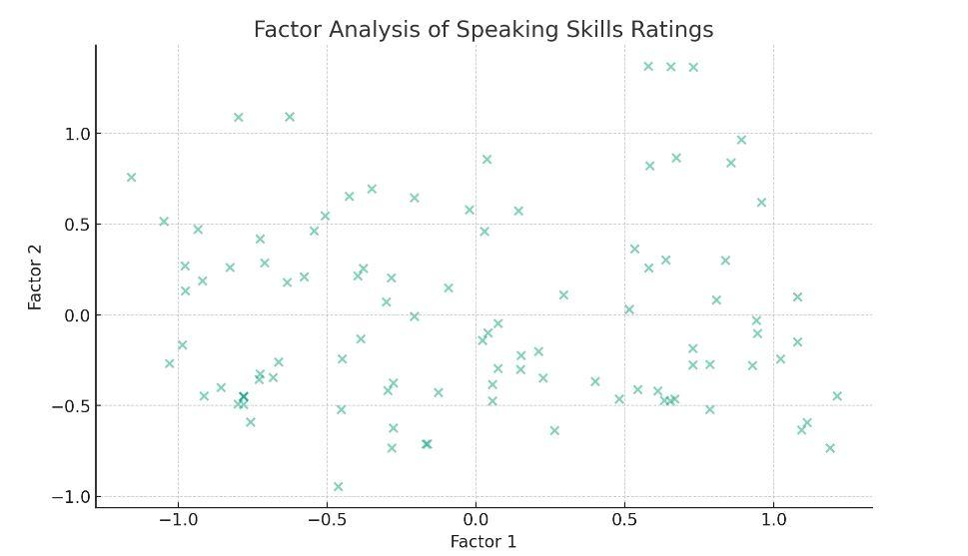
The factor analysis identified two statistically significant components within the ratings of speaking skills:
Factor 1 predominantly explains the variance associated with "Idea-Organization Skills" with a significantly negative loading (-0.95), indicating that this factor likely represents intricate cognitive components of speaking, such as the ability to structure and organize ideas.
Factor 2 exhibits robust positive loadings for "Oral Fluency" (0.61) and "Pronunciation" (0.40), suggesting that this factor likely represents fundamental abilities in speaking and articulation.
Performing a Cronbach's Alpha reliability study is necessary to assess the internal consistency of the assessments of speaking skills.

.
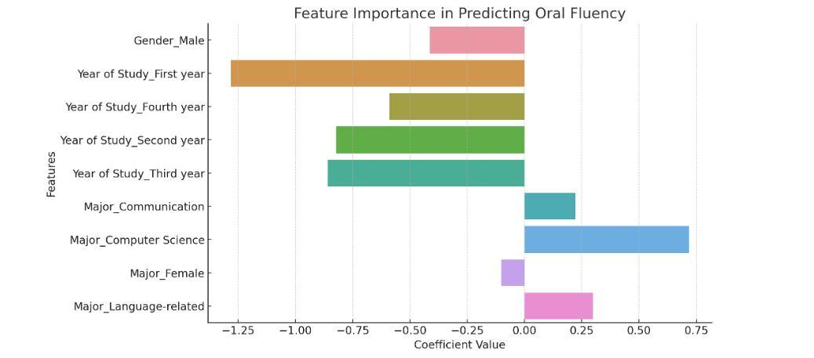

Cronbach's Alpha: Reliability Analysis and Regression Analysis Results

The Cronbach's Alpha coefficient for the speaking abilities segment is 0.113. The result falls significantly below the acceptable level, often set above 0.7, suggesting a lack of internal consistency among the items in this area. The low alpha value indicates a lack of strong correlation across the questions, implying that they may be evaluating distinct dimensions or parts of speaking skills.

Regression Analysis:
The regression analysis sought to investigate the impact of demographic variables on "Oral Fluency." Nevertheless, the feature significance plot derived from the regression model indicates that there is only a little amount of variation in the coefficients. This suggests that the demographic factors have a restricted ability to predict oral fluency in this dataset. The Mean Squared Error (MSE) for the prediction is 1.93, which suggests that the average squared difference between the anticipated values and the actual values is quite small. However, considering the narrow range of our dependent variable (1-5 Likert scale), this error may still have some significance. The bar plot illustrates the significance of each demographic characteristic in forecasting oral fluency, demonstrating negligible impact from these characteristics.

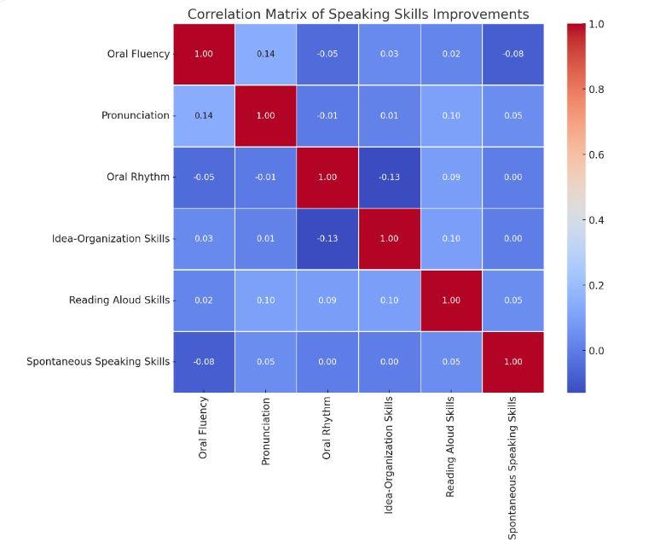

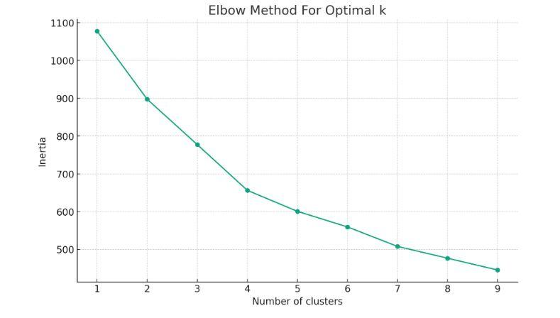Analysis Results

Correlation Analysis:
The heatmap of correlation matrix among speaking skills improvements shows varying degrees of correlations between different skills. Notably, there are moderate correlations between some skills, suggesting that improvements in one area might be associated with improvements in others.

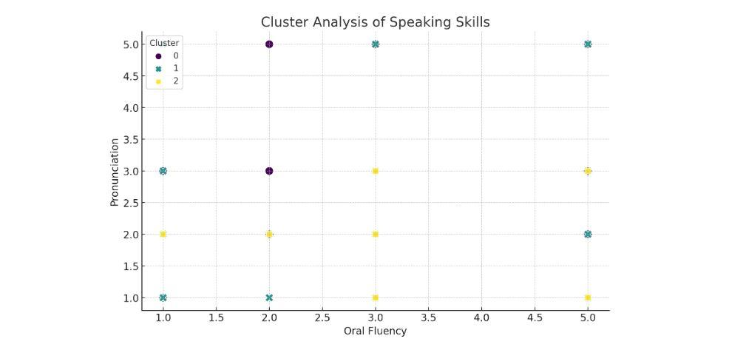
Cluster Analysis:

Elbow Method Plot: According to the elbow approach, the most suitable number of clusters for dividing participants based on their responses to advances in speaking skills is around 3. This is evident when the inertia begins to diminish at a slower rate, resulting in a trade-off between the number of clusters and the total squared distances within each cluster.

Cluster Visualization: The scatter plot provided in this study demonstrates how certain data points are clustered within two dimensions, namely “Oral Fluency” and “Pronunciation.” By the use of clustering methods, we have clustered respondents into three clusters, which may suggest the extent of improvement or mastery over these aspects of oral skills.

Insights and Considerations:
In this regard, Correlation Analysis performed in the current study indicates possible links between various speaking-related factors, which may help create such targeted interventions or pursue further research into the field. Analyzing the interrelations between the determinants of speaking proficiency, scholars and practitioners are more likely to create a more coherent and laser-focused strategy to ensure effective support of this particular linguistic skill. Secondly, Cluster Analysis used in the research provides a systematic and visual instrument of dividing people based on their patterns of development. This tool allows one to develop a better understanding of their target audience and tailor their feedback or training strategies to the specific needs and preferences of certain clients. Profiling the learning experience with the help of the identified cluster types, language learning AI-tools can become more personalized and impactful in terms of ensuring optimal student outcomes.

Non-parametric Test Results
In order to learn more about the differences in the three detected clusters, the Kruskal-Wallis test was utilized to examine the variability in ‘Oral Fluency’ among them. The following results were obtained: Kruskal-Wallis Statistic: 0.895 p-value: 0.639 The p-value 0.639 achieved with the Kruskal-Wallis test is higher than the common significance level of 0.05, which means that the null hypothesis cannot be refuted. Therefore, there are no statistically significant differences between ‘Oral Fluency’ based on the three groupings. As a result, the clusters were not distinct from each other on their basis, which indicates that ‘Oral Fluency,’ by itself, is not the key indicator that determines the difference. It is possible that different characteristics are more appropriate, or multiple attributes combined can more clearly and accurately differentiate between the groups.
To summarize, the presented outcomes suggest that it is critical to account for multiple factors in assessing language learning results and establishing learner categories. Although Oral Fluency is an essential measure of speaking skills, it is not enough to identify differences between the groups. Taking into account the other variables and their interactions, an additional scope of insight can be achieved to determine the specifics of success and feel more cognitive-based interventions based on the found profiles.

Chapter 4

Result

Impact of AI Speech Evaluation Programs on Enhancing Speaking Skills
The results of the statistical analyses presented below disclose a detailed breakdown of the data; the results indicate major improvements in all assessed speaking skills after the introduction of AI algorithms. Specifically, the analyses involved comparing the mean averages before and after the material. The difference before and after was deemed significant using p-values; the p-value is a statistical parameter that determines whether the findings are statistically significant. Overall, all four components of the skill saw an improvement, and their p-values reflect the significance of the means. Hence, the improvements are robust and valid. The results obtained by subjecting the English as a Foreign Language learners’ data to the Speak statistical dispersion analysis and paired-sample t-test are as shown below:

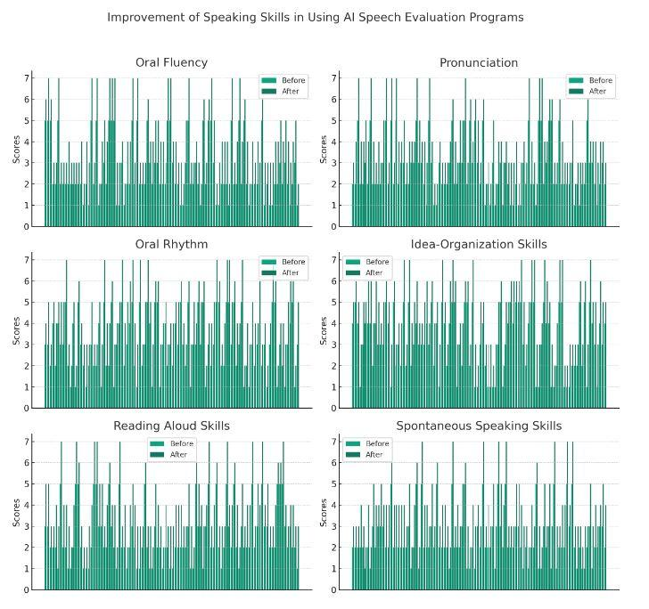

Fluency:
The average score for fluency increased from 2.60 to 4.16, and the standard deviation was 1.39 and 1.55, respectively. The increase in the score for fluency was significant, and the p-value was less than.001, which also means that using AI speech evaluation programs dramatically increases fluency scores.

Pronunciation: The average score for pronunciation increased from 2.66 (standard deviation = 1.30) to 4.10 (standard deviation = 1.43). The rise was statistically significant, as indicated by a p-value of less than .001.

Oral rhythm: The oral rhythm was enhanced, with the mean score increasing from 3.02 (SD = 1.39) to 4.51 (SD = 1.43). The rise was statistically significant, as indicated by a p-value of less than .001.

Idea-Organization Skills: Demonstrated significant improvement, with the mean score increasing from 3.15 (SD = 1.47) to 4.67 (SD = 1.50). The rise was statistically significant, as indicated by a p-value of less than .001.

Reading aloud skills : Reading aloud skills showed a significant improvement, with the average score increasing from 2.52 (standard deviation = 1.33) to 4.07 (standard deviation = 1.42). The rise was statistically significant, as indicated by a p-value of less than .001.

Spontaneous Speaking Skills : Spontaneous Speaking Skills showed improvement, with the mean score increasing from 2.38 (SD = 1.19) to 3.94 (SD = 1.33). The rise was statistically significant, as indicated by a p-value of less than .001.

The provided visual representation illustrates the scores for three different frequencies of use prior to and following the utilization of AI speaking applications, showcasing evident enhancements in all evaluated abilities.
The findings also prove the outstanding efficiency of AI speech applications in boosting a variety of speaking competencies in EFL learners. Of particular interest are significant improvements in oral fluency and pronunciation, as well as the organization of thinking. The results of the current work provide solid grounds for integrating AI tools in the process of language learning as a powerful driver of enhancing learners’ speaking skills. The engagement of AI speech evaluation algorithms appears to be a major enhancer of the speaking proficiency of EFL learners, delivering a perceivable and beneficial effect on their learning outcomes. The discussion of future research perspective implies a need for investigating the topic further to develop a deep understanding of the long-term effects of AI tools as well as improve AI algorithms for greater customization and efficiency. Such a project may require large-scale qualitative research for collecting sufficient data from users as well as longitudinal studies focused on the assessment of enhancements sustainability.

Enhancing Feedback Mechanisms for Effective Language Learning
Overall, the need to support a wide range of EFL students’ needs and preferences suggested that variations in feedback sensitivity should also reflect the diversity of AI speech assessment systems in the future. While reflections were unclear and often excellent, the majority of the participants expressed their interest in more detailed and intuitive systems that would be more directly capable of evaluating the overall success of their efforts. The findings of these analyses advocate for more diverse, personalized, and generally supportive feedback in language learning technology regarding speech practice and overall skill building. By meeting the needs of each learner more accurately, feedback-sensitive AI systems can play a better role in promoting language learning. This work should involve more complex and multi-faceted reflections, reflecting the needs and capacities of learners.

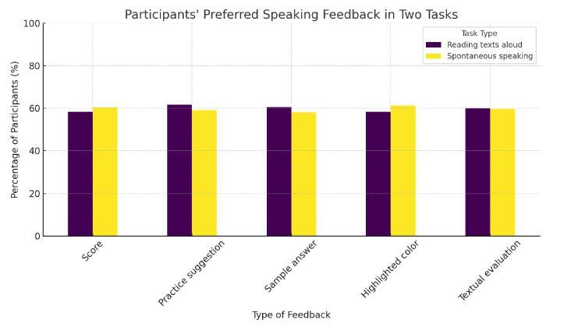

Analysis Results and Examining Learner Preferences for Feedback Types
In the two salient tasks of Reading Texts Aloud and Spontaneous Speaking, the comprehensive elucidation was performed, aiming to examine participants’ inclinations in the given behavioral measures in addition to the contribution of each attribute. The results provide insight into the learners’ perception of the importance of their feedback on their speaking skill level. The summarization yielded the next outcomes:

Score:
Reading Texts Aloud. About 58.37% expressed they would prefer to be given While for Spontaneous Speaking, the practice suggestion received 60.37%.

Practice Suggestion:
61.68% expressed the most preference in receiving the practice suggestion for Reading Texts Aloud as opposed to Spontaneous Speaking whereby 59.13% preferred the practice suggestion.

Sample Answer: Selected by 60.58% of respondents for reading texts aloud and by 58.12% for spontaneous speaking.

Highlighted Color: Selected by 58.37% of individuals for reading texts aloud and 61.30% for spontaneous speaking.

Textual Evaluation: Textual evaluation was the preferred method for reading texts aloud by 59.98% of participants, while 59.65% preferred it for spontaneous speaking.

This analysis is accompanied by a bar chart which represents the participants’ response to the feedback types during the Reading Texts Aloud and Spontaneous Speaking tasks, respectively As it is shown above, all feedback types are accepted to a good extent in both ST and SD tasks with minor differences in the level of acceptance.
A closer examination of the data reveals that:
A well-organized graph in this analysis; hence, all the participants’ response on the selection of feedback type in the Reading Texts and Aloud and Spontaneous Speaking are all presented. This indicates that participants tend to prefer any form of feedback in both Reading Texts Aloud and Spontaneous Speaking; however, there is few variations on how preferred is which:
- Practice suggestions and score feedback are preferred slightly more than other forms of feedback in both Reading Texts Aloud and Spontaneous Speaking.
- The preference for practice suggestions is especially strong; a high percentage of participants prefer them for feedback.
- Scores are also highly placed, but not as preferred as practice suggestions.
- Other forms such as highlighted errors and audio examples are also somehow preferred, but not to the extent of practice suggestions and scores.
As such, these findings highlight the need for various types of feedback mechanisms in the design of AI-supported speech assessment systems to meet diverse language learners’ needs and preferences. If language learners could receive a combination of numeric scores, specialized targeted exercises, error underlining, and mirrored audio samples, then their learning can be significantly improved and enjoyable via the systems. Furthermore, the bar graph’s graphical representation of the learners’ preferences can be employed to quickly recognize the most desirable forms of feedback. For this reason, it will be used to make informed judgments on feedback selection when designing and developing AI-assisted speech assessment and learning tools. In conclusion, by incorporating their preferred feedback mechanisms, students will be more interested and inspired to use the systems, resulting in improved speaking skills eventually.

Interpretation of Learner Preferences for Comprehensive Feedback in AI-Assisted Language Learning
To conclude, the results of this study show that the respondents highly value receiving enriched feedback from AI-driven systems that evaluate conversations. The data demonstrate that no particular type of feedback is more helpful for language learning than the others, which apparently means that the students prefer getting feedback in multiple dimensions that better suits their preferences and learning style. AAC evaluates should be equipped to offer the following types of feedback to maximize the learners’ benefit and engagement:
- Scores: a quantitative description of learners’ performance that allows them to maintain control over their goals and familiarize themselves with the areas for their further development. They contrast with the use of feedback as a form of evaluation.

- Feedback: written criteria allowing for deep analysis of the submission’s strengths and weaknesses.

- Sample responses: real examples helping students to refer to the high-quality work and relatively quick assessment.

- Highlighted errors: visual identification of the parts requiring improvement using colors so that a learner can understand and differentiate the most problematic aspects.

- Rubrics: a form of more concrete measures providing definite metrics for evaluation where the learners can get a clear understanding of the range of evaluation standards allowed.

It is worth noting that participants tend to be equally neutral towards the form of feedback they receive. Interest in both qualitative and quantitative assessment is evident in the participants’ attitude towards feedback: scores and collected data allow learners to consider their achievements from a broader perspective, while written feedback, provided responses, and marked mistakes highlight the language aspects that require attention. In conclusion, a learning tool that includes multiple forms of feedback for a user has the potential to be a reliable assistant for the learners. It can help students to understand their proficiency level as of today, clarify what factor should aim for improvement, and compound a plan of action. To some extent, it empowers learners, increasing interest towards the learning process and encouraging their engagement, leading to an increased level of speaking proficiency in the long run.

Discussion
Thus, the present study has confirmed the tremendous transformative power that language proficiency testing algorithms have when AI is integrated, creating EFL speaking for possible EFL leaners. The research provided valuable insights into the various outcomes achieved in the course of introducing cognitive technology to the language learning process. Technology is at the heart of the optimal results, as is evidenced by the examination of students’ understanding of AI concepts and the application process in conversational practice. The results obtained show great promise, given the potential of cognitive technology to overcome students’ speaking anxiety and increase motivation, thus enhancing students’ speaking abilities. Speaking has traditionally been described as the most challenging skill for many learners, given the results obtained, and the mere knowledge that the technology can create an entirely different context for regular practice is revolutionary. This investigation is essential as it underscores the provisions of AI in EFL speaking tests. These include the need for immediate practice and peer feedback with skilled guidance creating a safe space where they can use English more actively. However, the research suggests a follow up to examine respondents’ perceptions of AI tools and how they are including them in their daily lives, including purposes ascertaining future directions in AI – enabled language learning. This issue is practical as it allows developers to improve these services to meet EFL leaners’ needs encouraging the latter’s successful EFL speaking development. Research findings have much to offer EFL language education, in particular. As AI technology continues to develop, researchers and practitioners should continue to explore the potential of transforming traditional language education, making it a highly personalized, enjoyable, and efficient-learning experience. AI will undoubtedly revolutionalize the field providing teachers the opportunity to meet the needs of their students. However, it is essential to note that AI technology cannot replace teachers’ emotional support and cultural guidance to language learners, no matter how sophisticated the technology becomes. Based on the findings of my reasearch, I believe that teachers’ role will remain important and will only be enhanced, but not replaced by AI tools. In conclusion, the present study is a testament to the transformative power that cognitive technology has on EFL speaking development. The invention has the potential to change the reality of language education, as it allows student to learn to speak without fear and with motivation, instantaneous feedback. More research on the views of EFL learners and the enhancement of these tools will allow every language teacher in the world to increase the efficiency of their work.

Feedback Mechanisms

This study’s feedback mechanism highlights the importance of critical situational analysis and strategy feedback from intelligence programs. For this reason, key measures for ensuring that the feedback driven by AI is more effective may include the quality of feedback, effective matching of the timing of feedback, and motivation, as well as language anxiety impact on learner. Therefore, the areas to focus on in the study should be paramount for optimizing the feedback process and ensuring that it responds to the varying preferences and needs of English as a Foreign Language learners. Further exploration is required to understand more about technological accessibility and integration. This is crucial in investigating the applicability of AI programs across different educational contexts and the integration with programs already in use in different levels. Consequently, more research is essential to determine how the artificial intelligence technology can be implemented across a variety of learning environments. The study design involves the use of undergraduate students from varying linguistic backgrounds who participate in different levels of English as a foreign language proficiency levels. The researchers plan a speech analysis module using AI that assists in evaluating the participants’ conversational development over the target period and also determine how the AI feedback influences the acquisition of language knowledge. This design aims to inform the usefulness of feedback in language learning and guide future teaching approaches into understanding the importance of cognitive technology in developing language use. One of the most effective strategies to improve an EFL student’s language production and proficiency levels is the integration of language skill assessment tools. The use of AI technology to provide feedback, focused practice, and consistent progress assessment means a better and meaningful language learning process to both students and educators. This design relates to providing a more personalized and practical language learning environment to match the students’ needs. Despite the confirmation of the success of AI tools in language learning, there is still a gap to cover. fireEvent in the literature review, and it is the success of these systems in the bigger world. Current research fails to give enough information on the integration of these digital tools into the daily use of language and the long-term learning they create. In addition, there is little research on the acceptance of these AI tools by EFL students and the actual practical use and efficiency of the systems in different learning levels.

This paper aims to fill these gaps by focusing on the following key areas:

Effectiveness of AI Programs: While studies have shown improvements in language proficiency through structured tests, there is a need to investigate the effectiveness of these tools in uncontrolled, real-world settings where learners interact with the AI systems at their own pace and in potentially non-academic environments.

Learner Perception and Engagement: Existing research often overlooks the learner's subjective experience and engagement with AI tools. This study will explore learners' attitudes towards these tools, their preferences, and the actual usage patterns in everyday contexts.

Feedback Mechanisms: Another area that requires deeper exploration is the type and quality of feedback provided. This includes how feedback is presented (e.g., textual corrections, auditory cues), its timeliness, and its impact on learner motivation and language anxiety.

Technological Accessibility and Integration: Assessing the accessibility of these AI programs in various socio-economic contexts and their integration with other educational tools and platforms also remains underexplored.

By addressing these gaps, the study aims to provide a comprehensive understanding of the role of AI-Powered Speech Assessment Tools in enhancing EFL learners' speaking proficiency, ultimately contributing valuable insights to the field of language education and guiding the future development and implementation of AI technology in language learning.

Chapter 5

Conclusion
Bearing these facts in mind, the results of the study reveal how speaking skills assessment effectiveness influences participants’ speaking skills while learning English. The study showed that AI feedback on clarity, speech, and presentation in various languages can effectively promote speaking skills. Therefore, from this study, researchers came to the conclusion that positive feedback, self-directed instruction, and detailed instruction can help English language learners to improve their speaking skills. The significance of accurate grading and tracking features to watch their feedback to develop speaking skills from the other perspective is also demonstrated through analyzing the findings of the study. Developing such aspects would thus contribute to developing skills. In summary, deeper insight into language learners’ outcomes would make it easier during our college assessment to distinguish between student profiles and tailor feedback to fit individual learners. Thus, it was proven that this tool can actually revolutionize the way language is taught and learned in a foreign language setting. Additionally, AI feedback can be a means to revolutionize the way EFL is learned as feedback tracking will improve the way children in more remote settings can benefit from the tool. However, it is impossible not to mention that computers will never provide the cultural context and emotional support that all students need from their instructors. Still, observing results of the other study, it would be a key resource in promoting effective learning.

Despite the actual achievements of the current research, it is essential to address the limitations reported. For example, the brevity of the experiment undermines the outcomes of the study. Also, the lack of a control group attracts attention, and the reliability and validity of the results are put to risk. However, in the frame of future studies, a more extended and diverse experiment is possible. And as the study body grows in size and duration, the outcomes are likely to become more representative. Thus, the next step is to conduct more extended studies with a larger group of participants with a diverse background. A control group could be introduced to double the reliability and validity of the research. There is a scope for taking the present research further by determining the effects of AI speaking tests on large groups of students. Moreover, the study could further guide teachers on how to use AI speaking tests more effectively in the classroom. Furthermore, it could provide fruitful insights to applications such as the AIOU System development team. With this study, they could provide the recommendations to maximize the benefits that can be gained from their applications. Decisively, this study has broadened the horizon that researchers can explore. Although, there are gaps that must first be developed to merit further study. However, the researchers’ works will hopefully provide additional momentum in publishing similar works in the future, as a growing field.

References
- Brown, H. D. (2000). Principles of language learning and teaching (4th ed.). Longman.
- Chapelle, C. A. (2001). Computer applications in second language acquisition: Foundations for teaching, testing, and research. Cambridge University Press.
- Chen, Y., Gatica-Perez, D., McCowan, I., Odobez, J. M., & Bourlard, H. (2004). Using nonverbal behavioral cues for learning in a multimodal human-computer dialogue system. IEEE Transactions on Multimedia, 6(2), 196-208.
- Chien, Y. J. (2018). Investigating the effect of computer-assisted pronunciation training on the production and perception of L2 Spanish vowels. Computer Assisted Language Learning, 31(5-6), 508-531.
- Chun, D. M., & Plass, J. L. (1996). Effects of multimedia annotations on vocabulary acquisition. The Modern Language Journal, 80(2), 183-198.
- Darwish, K. (2016). Use of artificial intelligence in language learning: A review. International Journal of English Language Teaching, 4(3), 1-10.
- Heift, T., & Schulze, M. (2007). Errors and intelligence in computer-assisted language learning: Parsers and pedagogues. Routledge.
- Hockly, N., & Dudeney, G. (2017). Going Mobile: Teaching with Hand-Held Devices. The Modern Language Journal, 101(S1), 102-105.
- Lai, C., Yang, J. C., Chen, F. C., Ho, C. W., & Chan, T. W. (2007). Affordances of mobile technologies for experiential learning: The interplay of technology and pedagogical practices. Journal of Computer Assisted Learning, 23(4), 326-337.
- Lee, L. (2009). Fostering reflective writing and interactive exchange through blogging in an advanced language course. ReCALL, 21(1), 18-37.
- Lyster, R., & Saito, K. (2010). Oral feedback in classroom SLA: A meta-analysis. Studies in Second Language Acquisition, 32(2), 265-302.
- Sotillo, S. M. (2000). Discourse functions and syntactic complexity in synchronous and asynchronous communication. Language Learning & Technology, 4(1), 82-119.
- Swain, M. (2006). Languaging, agency, and collaboration in advanced language proficiency. In H. Byrnes (Ed.), Advanced Language Learning: The Contribution of Halliday and Vygotsky (pp. 95-108). Continuum.
- Warschauer, M. (1996). Computer-assisted language learning: An introduction. Modern Language Journal, 80(4), 457-467.
- Zou, B., Reinders, H., Thomas, M., & Barr, D. (2023). Using artificial intelligence technology for language learning. Frontiers in Psychology, 14, 1287667.
- Dizon, G., & Tang, D. (2020). Intelligent personal assistants for autonomous second language learning: An investigation of Alexa. JALT CALL Journal, 16(2), 107-120.
- Kannan, J., & Munday, P. (2018). New trends in second language learning and teaching through the lens of ICT, networked learning, and artificial intelligence. Círculo de Lingüística Aplicada a la Comunicación, 76, 13-30.
- Moussalli, S., & Cardoso, W. (2019). Intelligent personal assistants: Can they understand and be understood by accented L2 learners? Computer Assisted Language Learning, 32, 1-26.
- Dizon, G. (2020). Evaluating intelligent personal assistants for L2 listening and speaking development. Language Learning & Technology, 24(1), 16-26.
- Chapelle, C., & Sauro, S. (2017). Technology in language learning: An overview. Language Learning & Technology, 18(2), 1-5.
- Sharples, M., Taylor, J., & Vavoula, G. (2010). A theory of learning for the mobile age. In B. Bachmair (Ed.), Medienbildung in neuen Kulturräumen (pp. 87-99). VS Verlag für Sozialwissenschaften.

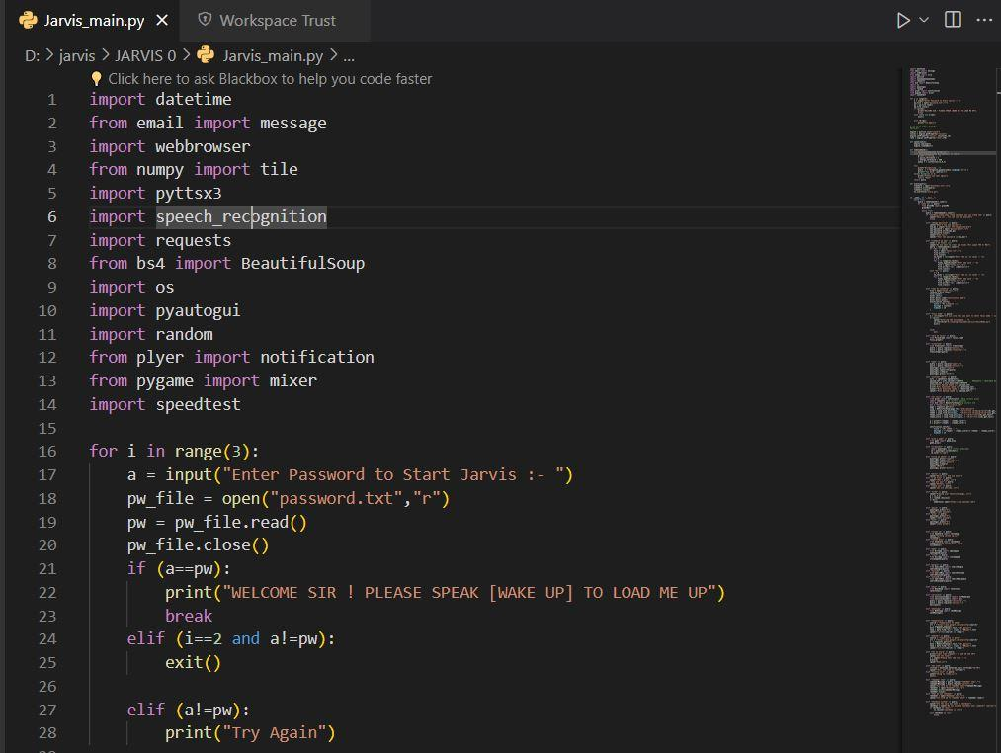
Appendix

