Marketing of Bank Products:
Innovative Suggestions for NCC Bank

Sumiya Aziz Prome

This report is submitted to the School of Business and Economics, United International University as a partial requirement for the fulfillment of Bachelor of Business Administration Degree.

Marketing of Bank Products:
Innovative Suggestions for NCC Bank

Prepared By
Sumiya Aziz Prome
ID: 111152154
BBA Program

Supervised by
Kawsar Ahmmed, Ph.d
Associate Professor
School of Business and Economics
United International University

Letter of transmittal

To,
Kawsar Ahmmed, PhD.
Associate Professor,
School of Business and Economics
United International University
Subject: Submission of Internship Report.
Dear Sir,
You will be pleased to know that I have recently completed my internship from National Credit and Commerce Bank Limited (NCC Bank) and meanwhile of my internship program at NCC Bank, I have prepared my internship report on the topic we had discussed to attempt named “Marketing of Bank Products: Innovative suggestions for NCC bank”
It was a great opportunity for me to get the internship opportunity at my home district ‘Sylhet’ and it was highly affordable and comfortable for me to work in this Sylhet, NCC bank branch. The job responsibilities here helped me to understand the current and practical scenario of the banking sector as well.
The effort and time you have provided for my internship program is highly appreciated. The report topic that you had given to me, proved highly important to apply my theoretical knowledge into the current work perspective. I would like to ensure you, the information I have given in this report is not directly copied to others and data that are being used, are relevant and accurate to several extent.
I, therefore, pray and hope that your honor would be kind enough to accept my internship report and oblige there by.
Sincerely yours,
Sumiya Aziz Prome
ID: 111152154
BBA Program
United International University
Acknowledgement
The study is going to start thanking my Almighty Allah and my parents for making me to complete this long term four years of BBA program successfully and for giving me the opportunity to work in the NCC Bank as an intern that helps me lot to improve my work experience.

At first, I want to show my gratitude to my honorable internship supervisor and course faculty Kawsar Ahmmed, Associate Professor, School of Business and Economics, United International University for giving me the opportunity for working on the title that is highly relevant to my field of study. All the time, effort and advice, I had received from him was highly valuable and helped me to complete the internship report successfully.

Secondly, I would like to thanks MR. Faisal Ahmed, Senior Vice President & Head of HR, NCC Bank, for approving me as an intern in Sylhet branch. I received a lots helped when I had found any task difficulties. He had shared a lot of information for this report on the bank as well.

Last but not the least, I want to thanks all my UIU friends and bank colleagues who helped me to understand the title and several concept that are related to the title properly. For all their effort, the report has been finally completed and could be a well written piece of study.

Summary
Banks increasingly compete outside their countries of origin and operating environments often differ greatly from one country to another, both in terms of financial markets and credit risk. Some sophisticated market research techniques, such as multidimensional scaling, commonly used in the generation of ideas for new consumer products, have not been widely applied to generate ideas for new banking products. Under the well-founded hypothesis that there is at least a latent demand for improvement in the search for needs. This depends mainly on the commercialization of banking products. But sometimes banks fail to market their products properly.

Despite numerous significant bank improvements, national banks in Bangladesh are lagging behind in many areas compared to foreign commercial banks with a wide range of capitalizations, overseas networks, modern management skills, technological advances, etc. quality of products delivered to customers by national banks. The administration of the National Bank now focuses on improving the quality of service to create a positive image of the growing profits. Reputation plays an important strategic role in the commercialization of banking products. The commercialization of banking products to customers is important for the success and existence of the current economic banking sector. Therefore, it is important that all banks in Bangladesh understand the needs of their customers and sell their products to them.

The NCC Bank Ltd. has earned a commendable reputation by providing personalized and sincere service to its customers in a technology-based environment since its inception. The Bank has put in place a new funding standard in the industry, trade and currency sectors. Its various deposit and credit products have also attracted clients, both private and public officials, who feel comfortable doing business with the Bank. The bank could achieve a slightly satisfactory result in recent years, which has contributed to its continued steady growth against all major indicators, i.e. deposits, advances and profits, etc. During the year, the bank focused on a range of areas in which revenues increased, such as SME financing, remittances, and so on.

The study of this internship report is mainly focused on sharing few innovative and creative marketing ideas for promoting the products of NCC Bank and consists of five broad chapter. The first chapter is a description of the report that includes background, scope, objectives, limitations and methodologies of the report. The second chapter is on the organizational details of NCC Bank and the third chapter as well the main chapter of the report is analysis and findings chapter, that discuss how the NCC bank need to attract their consumer, how to satisfy them and finally, I have proposed few current marketing strategy that are being applied by a lot of banks outside Bangladesh. The application of these ideas can provide market strength to the NCC Bank Limited.

Keywords: Bank service, Innovation, Quality, NCC Bank, Bangladesh
Table of Contents
Chapter one: Introduction of the study
1.1 Background of the study 2
1.2 Scope of the study 2
1.3 Objectives of the study 2
1.4 Methodology of the study 3
1.5 Limitations of the study 3
2.1 Background of the NCC Bank limited 5
2.2 Mission, vision and objectives of the bank 5
2.2.1 Corporate Mission of NCC Bank 5
2.2.2 Corporate Vision of NCC Bank 5
2.2.3 Corporate objectives of NCC Bank 6
2.3 Products and services provided by bank 6
2.4 Competitors of NCC Bank 7
2.5 Recent financial overview 9
3.1 General Discussion on Marketing of Banking Products 14
3.2 Designing marketing Strategy for NCC Bank 16
3.2.1 Transforming consumer need into emotional attachments 16
a. Analyzing the customer need: 16
b. Properly design products to meet the needs: 16
c. Ensure customer satisfaction 16
d. Superior customer service: 16
e. Extra benefits and rewards: 17
f. Segment wise marketing: 17
g. Create emotional attachment with the products: 17
3.3 Innovative marketing ideas for NCC Bank 18
3.3.1 Location-based advertising 19
3.3.2 Migration of websites and social messages to artificial intelligence (AI) 20
3.3.3 Emphasize emotional commitment 20
3.3.4 Highlight the successes of NCC Bank 20
3.3.5 Making Partnership with Colleges and Universities 21
3.3.6 Develop Strategic Partnership among group of organizations 21
3.3.7 Affiliate Marketing 21
3.3.8 Guerrilla Marketing 21
3.3.9 Offering gamification via mobile apps 21
3.3.10 Being interactive 22
3.3.11 Personalization and Customization of Products 22
3.3.12 By Arranging Flash Mob 23
3.4 Recommendations 24
3.5 Conclusion 25
Reference 26

List of Figures

Chart Number | Chart Name | Page Number
Chart 1 | Products and services of NCC Bank | 6
Chart 2 | Competitors of NCC Bank | 7
Chart 3 | Customer Satisfaction | 8
Chart 4 | Financial Highlights of NCC Bank | 14

Chapter one
Introduction of the study


1.1 Background of the study
The study is being conducted for the pre-requisite to complete my BBA program from United International University. Each of the students of BBA program has to complete their degree by going through the process of either preparing a thesis paper or competing the internship program. Usually students prepare their thesis paper based on their observations on any particular organization or any sector as a whole. On the other hand, in an internship program students have to join in an organization as an intern and work there for three months. The intern has to prepare an internship report titled “Marketing of Bank Products: Innovative suggestions for NCC bank” during aside of their job responsibilities as well.

1.2 Scope of the study
The report is going to propose few innovative ideas on marketing products that are going to help NCC bank as well as other Bangladeshi banks to improve their product marketing process to cope with the current market demands and competition. Any reader of the report can get an elaborate idea on NCC Bank and the products that they are offering to the mass people. Banks products and services are highly required to go through continuous improvement to sustain in the marketplace and meet the demand of the consumers and without innovative ideas, any bank can lose its customer anytime. Therefore, marketing strategies need to be strategically chosen by the banks. Additionally, University students can compare their university theoretical knowledge with my work experience from this report.

1.3 Objectives of the study
The objectives are the goals that are going to be attain through the report. There are two objectives are included in preparing the internship report.
- Primary objectives: Attaining the Bachelor of Business (BBA) degree is the primary objectives of preparing the report.
- Specific objectives: This objectives are more specific and relevant to the topic. They are:
- To analyze the NCC bank Limited
- To find out the product marketing shortcomings of NCC Bank Limited.
- To propose few ideas on the product marketing of NCC Bank.

1.4 Methodology of the study
Methodologies are the methods that are used to aggregate and collection of the information in the report. The methodologies can be separated in two parts given below.

1.4.1 Data Collection procedures: data collection procedures are divided into two subsection:
- Primary sources of data:
- Through formal and informal communication with the personnel of NCC Bank.
- From practical work experience of working as an intern.
- From the website and annual report of NCC Bank.
- Secondary sources of data:
- From published online journals and articles.
- From the brochures and leaflets of various popular bank of Bangladesh.
- From blogs and several books written on product marketing strategies.
1.4.2 Data Analysis: The report is an exploratory one where qualitative data’s are being used to describe the innovative ideas of marketing banking products.

1.5 Limitations of the study
The difficulties that I have noticed due to working in the bank and preparing the report at the same time is given below:
- Secrecy and confidentiality of gathering data: there are strict rules of using banking information in any public platform. The banking official requested me not to share few shortcomings that I have observed working in the bank and could be valuable for the report.
- Short period of time: The internship program is only for three month of duration. In this short period of time performing the job responsibility, observing and collecting information for the study at the same time was very difficult.
- Work pressures: The work pressure was found very much that concentrating on other parts were very difficult.
Chapter Two
Organizational Overview
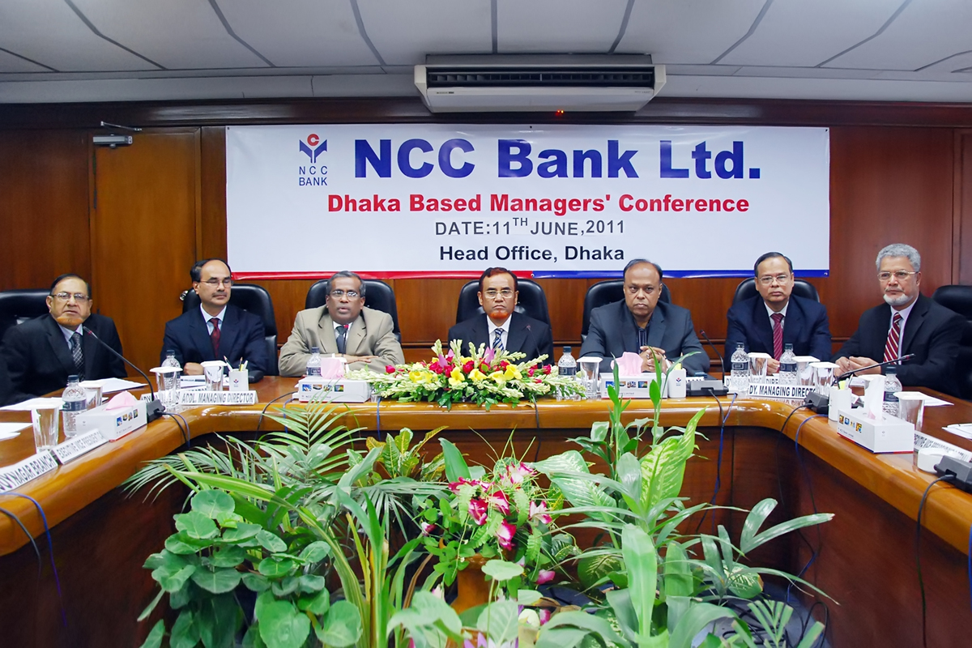

2.1 Background of the NCC Bank limited
The National Bank of Credit and Commerce has its own story. In 1985, the organization began its journey in the country's financial sector as an investment bank. The company's goal was to mobilize and invest in internal resources to develop the country's industrial and commercial sector and act as a catalyst. Also in the formation of the capital market. His affiliation with browse has helped society a lot in this regard. The company operated until 1992 with 16 branches then, with the authorization of the Central Bank, transformed into a real private commercial bank in 1993 with Taka’s paid-up capital. 39.00 Crore to serve the nation from a larger platform.
Since its inception, NCC Bank Ltd. has earned a commendable reputation by providing sincere personalized service to its customers in a technology-based environment. The Bank has set a new funding standard in the industry, trade and currency sectors. Its various deposit and credit products have also attracted clients, both private and private, who feel comfortable doing business with the Bank.

Mission, vision and objectives of the bank

2.2.1 Corporate Mission of NCC Bank
"Mobilize internal and external financial resources to contribute to the development of the agricultural, industrial and socio-economic sector of the country and play a catalytic role in the formation of the capital market".

2.2.2 Corporate Vision of NCC Bank
"To become a bank of choice to serve the nation as a progressive and socially responsible financial institution, bringing credit and trade together for profit and sustainable growth".

2.2.3 Corporate objectives of NCC Bank
No information has been publicly disclosed regarding the short and long term strategic or financial objectives of the banks.
NCC Bank believes in its uncompromising commitment to meet the needs and satisfaction of its customers and become their first choice in the banking sector. Inspired by its esteemed clientele, the bank intends to pave the way for a new banking era that marks and embodies its prestigious brand "where credit and trade come together".

2.3 Products and services provided by bank
The products and services offered by NCC Bank Limited are showing in the chart below:

Chart 1: Products and services of NCC Bank

2.4 Competitors of NCC Bank
According to the CAMEL rating assessment, the NCC bank is of a satisfactory level or class B. The other banks in category B compete with the NCC bank. NCC Bank's competitor are-

Chart 2: Competitors of NCC Bank

2.5 Recent financial overview
All amounts are in million
Particulars |  | 2014 |  | 2015 |  | 2016 |  | 2017 | 2018
 |  | Taka |  | Taka |  | Taka |  | Taka | Taka
Balance Sheet
Authorized capital |  | 10,000.00 |  | 10,000.00 |  | 10,000.00 |  | 10,000.00 | 20,000.00
Paid up capital |  | 8,029.25 |  | 8,832.1 |  | 8,832.1 |  | 8,832.18 | 8,832.1
Statutory reserve |  | 4,783.51 |  | 5,224.0 |  | 5,927.5 |  | 6,545.22 | 7,238.0
Other reserve (including general & assets revaluation rese |  | 394.2 |  | 432.46 |  | 366 |  | 545.54 | 478.52
Retained earnings (Profit & Loss Account) |  | 1,042.17 |  | 1,165.9 |  | 1,416.4 |  | 1,151.05 | 1,127.8
Shareholders' equity |  | 14,249.14 |  | 15,654.64 |  | 16,542.20 |  | 17,073.99 | 17,676.61
Deposits |  | 105,703.61 |  | 112,722.2 |  | 132,800.38 |  | 159,988.45 | 191,343.7
Loans and advances |  | 90,920.77 |  | 104,854.7 |  | 126,003.48 |  | 146,633.84 | 173,866.7
Investments |  | 26,568.66 |  | 21,457.59 |  | 23,958.16 |  | 29,403.28 | 33,471.28
Fixed assets |  | 2,573.25 |  | 2,628.1 |  | 2,500.1 |  | 2,486.89 | 2,617.1
Total assets (excluding contra items) |  | 135,159.52 |  | 146,369.9 |  | 172,706.23 |  | 202,309.46 | 240,528.1
Total assets (including contra items) |  | 169,681.09 |  | 180,622.8 |  | 214,046.51 |  | 256,665.41 | 316,706.8
Capital
Total risk weighted assets (RWA) |  | 112,720.56 |  | 122,752.6 |  | 147,483.46 |  | 158,051.15 | 186,830.6
Tier-I capital |  | 13,865.10 |  | 15,232.35 |  | 16,113.80 |  | 16,431.92 | 17,128.19
Tier-II capital |  | 1,262.32 |  | 1,361.8 |  | 1,532.8 |  | 1,763.50 | 6,452.9
Total capital |  | 15,127.42 |  | 16,594.15 |  | 17,646.60 |  | 18,195.41 | 23,581.16
Tier-I capital adequacy ratio |  | 12.30% |  | 12.41% |  | 10.93% |  | 10.40% | 9.17%
Tier-II capital adequacy ratio |  | 1.12% |  | 1.11% |  | 1.04% |  | 1.11% | 3.45%
Capital to Risk Weighted Assets (CRAR) |  | 13.42% |  | 13.52% |  | 11.97% |  | 11.51% | 12.62%
Asset Quality
Amount of non-performing loans & advances |  | 6,735.52 |  | 7,409.95 |  | 7,274.01 |  | 8,490.07 | 10,091.88
Non-performing loans & advances as % of total loans & advances |  | 7.41% |  | 7.07% |  | 5.77% |  | 5.79% | 5.80%
Specific provision against classified loans and advances |  | 2,705.15 |  | 3,169.66 |  | 3,312.15 |  | 3,853.44 | 4,216.99
General provision against un-classified loans and advance |  | 724.95 |  | 862.87 |  | 1,004.11 |  | 1,143.07 | 1,813.93
General provision against off-balance sheet items |  | 345.22 |  | 345.22 |  | 413.4 |  | 543.56 | 760.61
Percentage (%) of net classified loan |  | 4.43% |  | 4.04% |  | 3.14% |  | 3.16% | 3.38%
Interest suspense balance |  | 1,488.80 |  | 1,719.3 |  | 1,923.5 |  | 1,710.94 | 1,658.5
Foreign Exchange Business
Import |  | 51,308.41 |  | 49,995.21 |  | 56,406.85 |  | 83,722.55 | 101,943.8
Export |  | 14,354.30 |  | 17,137.57 |  | 16,720.86 |  | 25,893.60 | 48,577.16
Remittance |  | 18,703.40 |  | 15,371.00 |  | 17,316.47 |  | 27,012.09 | 29,492.80
Financial Performance
Interest income on loans and advances |  | 12,019.78 |  | 11,146.34 |  | 11,272.07 |  | 12,714.10 | 17,702.08
Interest paid on deposits and borrowings |  | 9,339.23 |  | 8,056.17 |  | 7,281.26 |  | 8,102.79 | 12,012.33
Net interest margin |  | 2,680.56 |  | 3,090.17 |  | 3,990.81 |  | 4,611.32 | 5,689.75
Net interest margin (%) |  | 2.56% |  | 2.48% |  | 2.80% |  | 2.85% | 2.97%
Income from investments |  | 2,672.99 |  | 2,678.5 |  | 2,015.4 |  | 2,024.94 | 2,793.1
Total income |  | 15,961.79 |  | 15,006.91 |  | 14,850.84 |  | 16,805.55 | 22,429.93
Total expenses |  | 12,214.99 |  | 11,140.65 |  | 10,359.62 |  | 11,882.93 | 16,211.20
Operating profit |  | 3,746.80 |  | 3,866.2 |  | 4,491.2 |  | 4,922.62 | 6,218.7
Provision for loans & advances and other provisions made during the year |  | 1,246.32 |  | 1,663.5 |  | 973.8 |  | 1,834.25 | 2,754.7
Profit before tax |  | 2,500.48 |  | 2,202.71 |  | 3,517.41 |  | 3,088.38 | 3,464.03
Provision for tax |  | 999.15 |  | 838.89 |  | 1,439.3 |  | 1,324.92 | 1,648.1
Profit after tax |  | 1,501.33 |  | 1,363.82 |  | 2,078.11 |  | 1,763.45 | 1,815.84
Profit available for distribution |  | 1,042.17 |  | 1,165.9 |  | 1,416.4 |  | 1,151.05 | 1,127.8
Shareholders' Information
Earnings per share (EPS) |  | 1.7 |  | 1.54 |  | 2.35 |  | 2 | 2.06
Price earnings (PE) ratio (times) |  | 6.59 |  | 5.89 |  | 5.36 |  | 8.85 | 7.73
Dividend: Cash (%) |  | - |  | 12.75% |  | 16% |  | 13% | 5%
Bonus (%) |  | 10% |  | - |  | - |  | - | 5%
Right Share |  | - |  | - |  | - |  | -
Net asset value (NAV) per share |  | 16.13 |  | 17.72 |  | 18.73 |  | 19.33 | 20.01
Net operating cash flow per share |  | 1.97 |  | 2.75 |  | 4.85 |  | 1.72 | 5.75
Particulars |  | 2014 |  | 2015 |  | 2016 |  | 2017 | 2018
 |  | Taka |  | Taka |  | Taka |  | Taka | Taka
Market value of share |  | 11.2 |  | 9.1 |  | 12.6 |  | 17.7 | 15.9
Market capitalization |  | 8,992.77 |  | 8,037.28 |  | 11,128.55 |  | 15,632.96 | 14,043.17
Number of shares |  | 802,925,458 |  | 883,218,003 |  | 883,218,003 |  | 883,218,003 | 883,218,003
Number of shareholders (Nos.) |  | 88643 |  | 76045 |  | 62411 |  | 51223 | 45924
Financial Ratios
Credit Deposit Ratio (CDR) (%) |  | 77.41% |  | 83.57% |  | 83.92% |  | 83.56% | 82.90%
Return on equity (ROE) (%) |  | 10.87% |  | 9.12% |  | 12.91% |  | 10.49% | 10.45%
Return on assets (ROA) (%) |  | 1.16% |  | 0.97% |  | 1.30% |  | 0.94% | 0.82%
Cost of fund (%) |  | 10.81% |  | 9.84% |  | 8.37% |  | 7.83% | 8.66%
Cost income ratio (%) |  | 42.64% |  | 44.38% |  | 40.67% |  | 43.44% | 40.31%

Chart 3: Financial Highlights of NCC Bank
Chapter Three
Analysis and Findings -
Proposed ideas for marketing the products of NCC Bank Limited

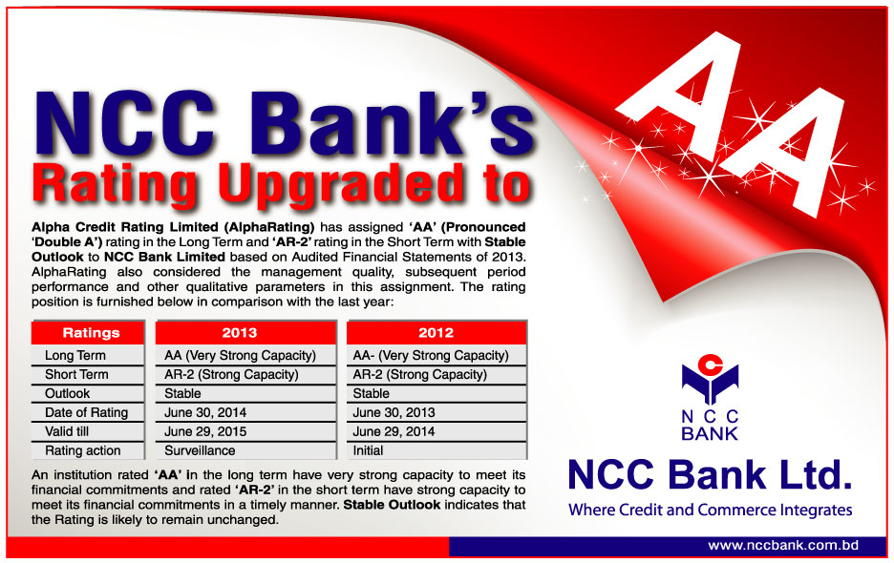

3.1 General Discussion on Marketing of Banking Products
Farina Yasmin and Mahmud Nasrin, Financial analyst of Bangladesh Bank, briefly introduce the retail banking system and its products through commercial banks in Bangladesh. They analyze various commercial banks for providing their reports to major products and activities. They also say that the retail banking sector is becoming popular in Bangladesh. In addition, they also show how the banking system contributed to the economic system of Bangladesh, contributing to the global economy.
Rajeev Seth sets the direction of marketing this way. Marketing adaptation is basically a banker's attitude that inspires him to expect the customer's needs and to meet those needs. They have been divided into three categories: the traditional banking era (up to 1969), the evolution of banking era (mid-1970s in the 1970s) and banking period (after mid-1980s). They defined that marketing different ways. They talk strategically and 4 Ps market. Before marketing, they also need to understand the market and customer requirements for specific areas and then go to the product. In the same situation, the legal system is not the same in all the regions of the country and will continue to be marketing through the marketing system.
Banks are one of the most important financial services in the Bangladeshi economy. If we look around, we find that many banks already exist with foreign commercial banks. Now each bank faces fierce competition in the financial market. Therefore, they must think of marketing their products through various means and marketing according to different strategies. Behind television and the Internet, you've made a lot of changes. With this type of marketing, it is easy to reach any of the organization's local and international customers. As a successful marketing strategy, give an opportunity to an organization to do remarkable things. And the strategic main market and the ability to predict the needs of the customers will succeed only if successful. If they are able to meet the customer's needs, it will eventually be satisfied and the growing profitability of the profitable organization will increase. Look at a chart for the concept of customer satisfaction -
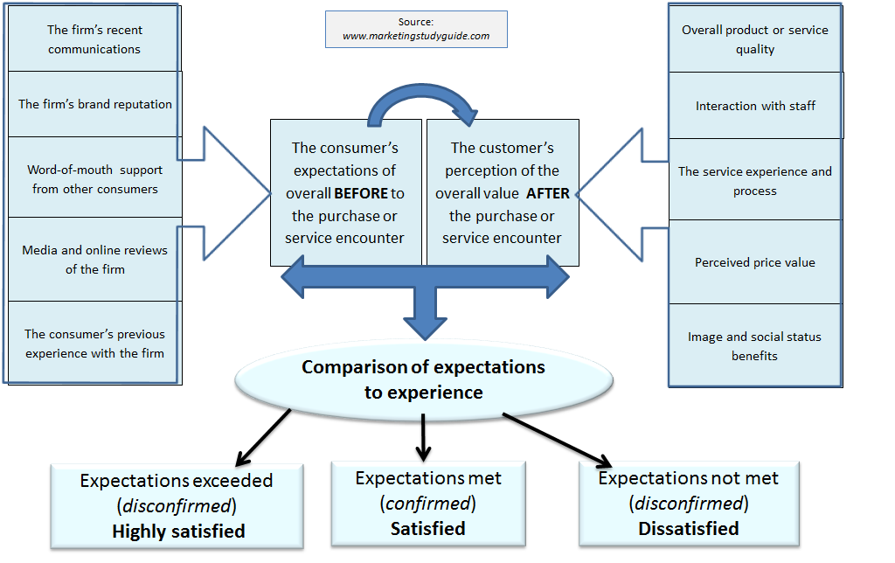
Chart 4: Customer Satisfaction
Today, segment marketing is very important. If we closely observe human facts, we can see that different people want different things. If you want, satisfaction is changed from person to person. In this case, 4P for marketing is very important. 4P represents the Product, Price, Place, and Promotion. But given the modern situation and updates, I want to add people to 4Ps. Because marketing strategist must predict current and future markets, so he must develop a strategy. They must choose the right person and the right place for their business, as well as the right promotion for each product. Although an organization has traded heavily, it was considered to be legal issues. If an organization is able to distinguish itself from others, it is more interesting. Nowadays, we use a different bank card. The use of a credit card is not only the structure provided by a bank, but people think that the bank card can represent a status. When the organization comes to the market in its commodity market, it represents its product in such a way that it considers profitable and is specially designed for a person.

3.2 Designing marketing Strategy for NCC Bank
To design marketing strategy for NCC bank, three section of process must be followed. They are:

3.2.1 Transforming consumer need into emotional attachments
Analysis of consumers need plays very vital role for any service organization. Usually, Consumers need varies with consumer to consumer. Identifying the basic need and analyzing the core competitor’s product NCC Bank can introduce the new strategies to retain and gain consumer for their products. The steps of consumer need analysis varies, and I think, the process should be performed that help NCC Bank to transform the need of consumer into creating the emotional attachment with the consumer. Therefore, the successful marketing operation for NCC Bank ought to be follow the following steps:
- Analyzing the customer need: The analysis of customer needs is the process of identifying customer requirements for the bank's product or service. It is used in a variety of brand and product management environments, including concept development, product development, value analysis, and customer value or end-of-average analysis.
- Properly design products to meet the needs: Before launching new products, NCC Bank need to consider four criteria. They are:
- Research target consumers.
- Develop product and service message.
- Plan products promotion strategy.
- Plan post-lunch strategy.
- Ensure customer satisfaction: At this stage develop how to the product will provide the actual satisfaction to its consumer, so that consumer eagerly but the products.
- Superior customer service: One of the best ways to define superior customer service is to understand that NCC banks must outweigh the customers' expectations during each interaction. To achieve this, NCC Bank will first need to understand what its customer’s need, for which the market needs research and study. The bank may allow its representatives to make administrative decisions at that time if it means to maintain a client's business. A satisfied customer is a regular customer.
To provide Superior service NCC Bank can follow the following steps:
- Make the first impression count.
- Establish regular follow-up.
- Solicit ideas and suggestions from the representatives.
- Improving the products according to the suggestion received.
- Extra benefits and rewards: Extra benefit and assistance has a greater impact on the consumer satisfaction that can generate a loyalty and attachment to the consumer with the bank. Few incentives can also be provided to the consumer who deposited huge amount of money in the name of yearly bonus or half yearly bonus and so on.
- Segment wise marketing: Segment marketing is playing very vital role in the Bangladeshi banking sector. If we closely observe human facts, we can see that different people want different things. If you want, satisfaction is changed from person to person. In this case, 4P for marketing is very important. 4P represents the Product, Promotion, Place, and Price. But given the modern situation and updates, I want to add people to 4Ps. Because marketing strategist must predict current and future markets, so he must develop a strategy. So, NCC Bank can divide the Bangladeshi region into several part and provide financial service according to the need of a particular segment. Through segment marketing NCC Bank can generate sales of its various products as well that are not running well in the Dhaka or Chattogram city area.
- Create emotional attachment with the products: Finally, The NCC Bank requires to create an emotional attachment with their products through their products and service. To generate emotional attachment through bank products, there are several ways that can be applied.
The MBLM marketing agency has developed a model that measures emotional attachment at the brand level and assigns a relationship of intimacy to the brand. A first step is to create strong emotional connections with the customer. This can be achieved by investing in any of the six archetypes or characters of the bonds. These are:
- Identity: NCC Bank can create an image of aspiration that resonates deeply with consumers. Customers identify themselves as a group and feel that the brand represents them.
- Compliance: Meet the needs of a customer beyond their expectations. This positions NCC Bank as one that offers more.
- Ritual: Try to attain the banks product part of the consumer’ daily routine. Think of the blog consumer read every day and consider how they feel about the brand. Of course, the connection is much more intimate than a blog they visit at random.
- Continuous Improvement: helping customers to be better, smarter and more capable of using their product. This strengthens the NCC Bank’ reputation and makes consumers even more connected to the bank.
- Indulgence: NCC Bank can create a relationship based on fun and rewarding experiences. Considering its activities pending in their moments of happiness and reflect on the products they interact with.
- Nostalgia: evoking the memories that customers have of their brand is a sure way to deepen the connection. This is particularly effective if a brand is part of a client's childhood.
Some other important factor that have influence creating emotional attachment are:
- NCC Bank should practice empathy.
- The products that the bank is offering should be realistic and authentic.
- Clear procedure of how to purchase the service or products for general clients’ in both Bengali and English.

3.3 Innovative marketing ideas for NCC Bank
Banking marketing has evolved over the years and marketers, who were previously suffocated by rigid creative constraints, have discovered that financial marketing can be innovative and at the same time maintain that thin line of conservatism.
In general, banks offer similar products: current accounts, savings, money markets, loans, and lockers, just to name a few. Marketers find that they have to create different ways to promote the same products over and over again while maintaining the same voice of security and solidity.
Furthermore, a marketer must identify what makes their bank's products different from the competition to attract potential customers to their bank over the bank. The banking market is extremely competitive, so marketers must be particularly creative.
Fortunately, thanks to the Internet and a large number of channels available to sellers, banks have no problem in reaching almost all the demographic or mass markets within reach. In fact, traditional media, such as radio, television, and newspapers, are slowly being replaced by e-mail bursts, direct mail, and Internet banners.
There are a lot of innovative ways we can see that the competitor banks of NCC Bank are utilizing and few other ways are here that foreign banks are using. Therefore, NCC Bank can follow this marketing strategies to improve marketing of their products.

3.3.1 Location-based advertising
Regardless of the size of the NCC's bank, physical location is an important part of the banks' marketing and advertising. Although the options vary depending on the NCC's audience, budget, and technological capabilities, the bank can do a lot with its mere physical presence.
For example, in 2008, HSBC launched a personal banking awareness campaign in Australia. At that time, most people did not know that HSBC was a brand or a personal bank. HSBC used a creative advertising idea in the form of a collapsible origami concept. The result made people talk and encouraged the bank's commitment.
Additionally, the NCC Bank can also utilize other creative advertising to generate interest and increase sales of its products. For example, offer consultations and information in the field. Banks like Virgin Money in the United Kingdom offer lounges where everyone can come and relax to attract customers. It is also important to take simple steps to get away from ATMs and turn to digital self-service through ATMs and smarter computers. This will help reduce the cost of a physical presence, reduce the size of bank branches and, therefore, offer more sites and more value. Banks such as JP Morgan Chase and Bank of America are already taking these steps, which translates into a greater banking commitment since consumers do not wait for an ATM.

3.3.2 Migration of websites and social messages to artificial intelligence (AI)
For customers of the banking and financial sectors, there are more frustrating things than waiting for answers about your money. But now, thanks to artificial intelligence tools (also called "chat-bots") such as Drift and Intercom, this is no longer necessary: ​​current live chat tools can be powered by artificial intelligence, so good customers will not know that they are chatting with robots, to provide immediate and accurate answers to their questions about the NCC Bank products, through their website chat, social media chat, and other sources.

3.3.3 Emphasize emotional commitment
Instead of focusing on the transactional aspect of the typical relationship between NCC bank and its consumer, the bank should change the way of thinking based on the financial and emotional path: which experiences, phases of life and other points of contact in the customer's life cycle? to lead people to NCC Bank and its financial products?
Focus on these moments: graduation, marriage, family enlargement, savings, remodeling, retirement: all the emotional, exciting and concrete experiences that guide customers through the doors of their bank. From there, NCC bank should develop their marketing campaigns on these contact points to create targeted marketing campaigns, storytelling initiatives, and other commitments.

3.3.4 Highlight the successes of NCC Bank
The older NCC bank becomes, the more likely it is to experience a series of success stories to use in its marketing campaigns. Above all, the bank should ensure whenever it lends money, grants a mortgage, create a Current deposit (CD) or other structures and savings bonds, it must be in the interest of the client. The purpose of collecting these stories and highlighting them as part of a marketing campaign is to promote the bank, build trust and show that the bank really cares about consumers. Allstate's "Worth Telling" campaign highlighted the success of individual clients, sharing interviews, client testimonials and other information about real people who had done so because of a loan or loan help from NCC bank.

3.3.5 Making Partnership with Colleges and Universities
A strong presence on campus is an excellent way to get new ideas. Think about it: students finally take financial responsibility for themselves. By blocking them at the beginning, you have a good chance of keeping them. Get ATMs at nearby campuses, attend trade shows, sponsor popular events and make your bank visible.

3.3.6 Develop Strategic Partnership among group of organizations
Push a specific product such as mortgages? NCC Bank does not have to do all the work itself. Join real estate agents that are ready to recommend the Banks' services or share the banks' printed materials on open days. Focus on car loans? NCC Bank should join the local car dealers and discover how they can work together.

3.3.7 Affiliate Marketing
Whatever NCC Bank does, it should not forget its relationships with other organizations. Publishing signs or posters are an excellent way to attract passers-by who may not be customers.

    - Guerrilla Marketing
NCC Bank can follow the rules and colors of the lines, but in marketing, it's the bank' chance to think outside the box. It can try guerrilla marketing or billboards that draw attention and reveal a bit of personality. Messaging can certainly help bank products to excel.

3.3.9 Offering gamification via mobile apps
Today's consumers expect and even require apps and digital experiences, creating the perfect opportunity for fun marketing. Gamification is a simple and creative way to engage consumers, where they apply the principles and mechanics of the game to attract and motivate consumers.
Most banks incorporate gamification to promote desired behaviors, such as savings and budget. The examples of gamification in financial services are ubiquitous. Wells Fargo uses the Daily Change app as part of its banking business to promote money-saving options, such as preparing lunch at home. Once users have participated in a challenge, they accumulate their savings, which are then transferred directly to a savings account. PNC's virtual portfolio uses a similar concept, incorporating popup windows to allow customers to direct their funds to accounts with specific goals, such as savings. Emirates NBD used a different form of gamification to increase deposits. The company has launched a fitness account synchronized with fitness trackers like Fitbit and rewards customers who follow a certain number of steps per day. With 12,000 passes a day, users can earn up to 2% interest on savings accounts per year, which is a strong incentive to make more deposits.

3.3.10 Being interactive
We live in the digital age where people can be stimulated at any time. Many newspapers are victims of antiquity and forget to keep up. Make sure everything is interactive and of great impact. Remember to create videos with songs reproducing advertisements and success stories. Organize contests and games in the mobile application; offer rewards for FourSquare records in the bank branches, or organize webinars/podcasts on topics of financial responsibility.

3.3.11 Personalization and Customization of Products
Digital marketing has pushed us out of the one-size-fits-all era in the age of personalization. The customer expects customized solutions based on lasers and, thanks to an advanced data analysis, is available to supply them. In fact, the customers of NCC Bank are looking for customized solutions for the banks' personal financial needs. And they want them in real time. With analysis, response technologies, customer information and other data-based marketing tools to track customers through the sales process, NCC bank can (and should) offer personalized communications and offers the possibility to meet the needs of its customers at a specific time.

3.3.12 By Arranging Flash Mob
Talking about finances 24 hours a day can be trivial. So how does NCC bank can evaluate and stand out from the competition? Flash mobs are an excellent way to reach a target audience and a younger audience. NCC Bank can watch what Wells Fargo did in Times Square.

3.4 Recommendations
In developing countries like Bangladesh, the banking sector is the best source of financing. Therefore, the banking sector itself promises significant growth for the banks that deserve it. The NCC bank can be one of the main competitor if it offers comparatively better products and service in an affordable rate attracting the customers through the shared marketing strategies. In this part, I would like to share few recommendations that are supposed to be useful for the betterment of improving the NCC banks current product marketing strategy.
- The business of today and tomorrow is much more difficult in the world. To deal with the challenges, bankers have to know various economic and commercial variables. Therefore, the NCC Bank must be appointed as a graduate business graduate, such as BBA and MBA holder, entering officer.
- Banks will have to set up a new short-term system for microfinance for the poor and urban population.
- 24-hour banking services like a credit card, ATM cards must be issued immediately.
- Banks must advertise on newspapers and television so that any initiative and special privileges of the bank can go to the clients.
- In order to attract more customers, the NCC Bank will certainly create a new marketing strategy that will increase the total amount of exports.
- Changes in industrial trends can directly affect the business, so it is no longer completely profitable. As a result, NCC Bank must maintain information about the environment of each sector where their clients work.
- Different types of training are highly requested for the bank managers.
- The attractive set of export exporters will contribute to increase exports and hence the reduction in the balance of the NCC Bank will be reduced.
- The foreign currency transactions of other banks take more dynamic and less time. NCC Bank will take the initiative to compete with these banks.
- The banking system and the latest communication devices are the most important components of this century. Therefore, for a solid and stable banking operation, NCC Bank has no alternative but modernization.

3.5 Conclusion
The National Credit Commerce Bank (NCC Bank) offers the market an almost complete range of services. As indicated by the number of branches, the NCC Bank still has few fixed activities in our country, but we must not forget that in the coming years no bank could be up to the NCC Bank. The bank follows a certain traditional marketing strategy and all is well. This marketing strategy is quite satisfactory for customers and has a positive impact on the performance of their profits. But with this modern era, the bank should improve its marketing strategy. If it improves its marketing strategy, it can attract more customers to this bank and have a more positive impact on the performance of its profitability.
The marketing strategy of NCC Bank is going quite satisfactorily well, but still we know that it couldn’t capture a large market share in Bangladesh. Therefore, the study has shown several innovative ideas of creative and innovative marketing strategy that are utilized by several renowned bank around the world. The study also suggest the NCC Banks top level executive to check capability of these ideas so that the bank can compete more with these competitive marketplace and capture more its market share.

Reference
- The NCC Bank Limited, Annual Report, Available at: https://www. nccbank.com.bd /index.php/nccbfinancialreports/annualreports
- Advance report of customer satisfaction of NCC Bank by Refat Ahmed Robin 3.
- J.M International journal of management research, D.A.V College. Malout (Panjub) 2.
- Farina Yeshmin & Mahmuda Nasrin, Enhancement of retail banking operation of commercial banks in Bangladesh (Volume-V, Issue-02, July-December, 2010) 5.
- Rajeev K. Seth Marketing of Banking Service, Macmillan India Ltd. New Delhi. 1997, p.22
- Jim Marous, marketing service leader and financial solution (7 common sense of marketing bank products) 4.
MBLM, An Innovative Marketing agency, brand level intimacy measurement, Available at https://www.business.com/articles/emotionally-connecting-with-customers/

