
United International University
QUEST FOR EXCELLENCE

Internship Report
On
Business Development Mechanism of Inpace Communication Limited

Submitted To
Muhammad Hasan Al-Mamun
Assistant Professor
School of Business & Economics
United International University

Submitted By
Eshrat Jahan
ID No: 111-132-186
School of Business and Economics
United International University

Date of Submission
19th December, 2018

BUSINESS DEVELOPMENT MECHANISM OF INPACE COMMUNICATION LIMITED

PREPARED BY
ESHRAT JAHAN
ID# 111-132-186

INTERNSHIP SUPERVISOR
MUHAMMAD HASAN AL-MAMUN
Assistant Professor, SOBE, UIU


SUMMER 2018 INTERNSHIP
INT 4399

DATE
DECEMBER 19th, 2018

UNITED INTERNATIONAL UNIVERSITY
School of Business & Economics



LETTER OF TRANSMITTAL

19th December, 2018

Muhammad Hasan Al-Mamun
Assistant Professor
School of Business & Economics United International University

Subject: Submission of Internship report on “Business Development Mechanism of Inpace Communication Limited”

Dear Sir,

I hereby submit you the internship report on “Busniess Development Mechanism of Inpace Communication Limited”. While doing the report, I believe I have been able to make an understanding of the subject matter and the important issues were required to obtain. To complete the report in a proper way despite having time limitation, I have gained a lot of experience and enjoyed myself in doing this report.
I sincerely hope that I tried my level best to make an applicable and feasible report so that it will be as effective as it was expected to be. Your valuable suggestion will inspire me further. There may be some mistakes due to various limitations for which I expect your kind consideration.

Thank You and Best regards .Sincerely yours,

………………….....
Eshrat Jahan
ID # 111-132-186

STUDENT’S DECLERATION

This is Eshrat Jahan, ID No. 111132186, the student of United International University (Major in Marketing and Minor in HRM), declare that the report on “Business Development Mechanism of Inpace Communication Limited” is prepared by me based on annual report and other practical information. In this report I have included all the information, which I have gathered during my internship period at Inpace Communication Limited at Head Office (Concord Tower, 113 Kazi Nazrul Islam Ave, Dhaka - 1205). I have written this report on the basis of my work experiences and observations during the internship period.
So, I also declare that, this report is original in nature and not submitted in any other university, college or any organization for an academic qualification or certificate.

………………………..
Eshrat Jahan
ID # 111-132-186
School of Business & Economics United International University

SUPERVISOR’S AUTHORIZATION

It is my pleasure to certify that the internship report entitled “Business Development Mechanism of Inpace Communication Limited” prepared by Eshrat Jahan, bearing ID No. 111132186 is a regular student of Bachelor of Business Administration (BBA) at United International University. Her internship has been completed successfully at Inpace Communication Ltd. Head office at Concord Tower, 113 Kazi Nazrul Islam Ave, Dhaka - 1205. The report has been carried out successfully under my supervision and guidance. She collected the required information in consultation with me.
As far I know she tried her best to conduct this report successfully. I think this will help her in the future to build up a dynamic career.
I wish her every success in life.

………………………….. Muhammad Hasan Al-Mamun Assistant Professor
School of Business & Economics United International University

ACKNOWLEDGEMENT

I would like to express my gratitude to everyone who supported me doing the report. I am thankful for their aspiring guidance, invaluably constructive criticism and friendly advice during the report work. I am sincerely grateful to them for sharing their truthful and illuminating views on a number of issues related to the selected topic.
First and foremost, praises and thanks to Allah, the Almighty, for showering blessings throughout the report and giving me enough strength to complete my report work. I would like to thank my course instructor, Mohammad Hasan Al-Mamun, Assistant Professor, School of Business and Economics, United International University for the valuable guidance and advice. He inspired me greatly to work hard on this report. His willingness to motive me contributed tremendously to my report.
I would like to take this opportunity to thank United International University for offering this internship opportunity. It gave me an opportunity to learn a great deal about Business Development Mechanism of Inpace Communication Limited.
I would also like to thank Md. Mahbubur Rahman, Manager, Client Services Department, Inpace Communication Limited for letting me complete my internship at Inpace Communication Limited. And also thanks to Dell team members who helped me throughout this internship program for their unprompted help and heart-felt assistance in making my journey really comfortable in the organization.
Honorable mention goes to my family and friends for their understanding and support in completing this report paper. Without them, I would face many difficulties while doing this.



BUSINESS DEVELOPMENT MECHANISM OF INPACE COMMUNICATION LIMITED

TABLE OF CONTENT
Topic | Page No.
Executive Summary | 1
Chapter One | 2 - 5
- Introduction
1.1 Purpose of The Report | 3
1.2 Background of The Report | 4
1.3 Methodology of The Report | 4
1.4 Limitation of The Report | 5
Chapter Two | 6 - 12
- Overview of Company
2.1 Overview of Inpace | 7
2.2 Overview of Inpace Communication | 8
2.3 Company Philosophy | 8 - 9
2.4 SWOT Analysis | 10
2.5 Service offered by Inpace | 11 - 12
2.6 Valuable Client Portfolio of Inpace | 12
Chapter Three | 13 - 31
- BUSINNESS DEVELOPMENT MECHANISM OF INPACE
3.1 Mechanism of Finding Clients | 14 - 15
3.2 Importance of understanding clients need and want | 15 - 17
3.3 Mechanism of execute the service | 17 - 18
3.4 Mechanism of collecting customer feedback | 19 - 20
3.5 Specification of the job | 21 - 22
3.6 My contribution in Inpace | 23 - 25
3.7 Execution of a well-organized event “Dell Service Camp” | 26 - 31
Chapter Four | 32 - 34
- FINDINGS AND ANALYSIS
4.1 Findings | 33 - 24
Chapter Five | 35 - 46
- RECOMMENDATIONS AND CONCLUSION
5.1 Recommendation | 36
5.2 Conclusion | 37
5.3 Reference | 38
5.4 Appendix | 39 - 46

EXECUTIVE SUMMARY

Inpace Communication Limited started its operations in December, 1997 to satisfy the ever-increasing demand for Computer Graphics & DTP, Direct Marketing, Fulfillment Services, IT Enabled Services, Management Consultancy, Market Communication, Event Management and PR Management services. It has been well-known for being the most consistently creative companies in Bangladesh. They have been supplying services of high standard when it comes to quality as well as value for money for customers for the last 21 years. Client service department (Dell team) has played an important part in the achievements of Inpace Communication Limited. Building customer relationships is the primary motto of Inpace. They are successfully serving their individual and institutional clients. Their unparalleled efforts in making customer relationships have got in them capable of handling transactions that meet the demands and satisfaction levels of their clients in a major degree. This report describes the experiences and practical learning from working in Inpace Communication Ltd. as an intern for four months. Firstly, I wrote a brief description about Inpace Communication Ltd. and I have included the range of services, then I tried to conduct SWOT analysis of Inpace, which was duly presented in appropriate section. After trying to express the business development mechanism of Inpace communication Ltd. and I also tried to explore their well- organized event activation execution process. Inpace is always looking for new market opportunities to build themselves as a renowned brand. Inpace now only deals with IT companies like Dell, HP, Lenevo, Acer, Oracle, VMware etc. Finally, I tried to present a pre-event execution proposal and a full event summary proposal & overall survey report of an event in appendix part.

Key Words: Business Development, Event Activation


1


CHAPTER ONE
INTRODUCTION


2

INTRODUCTION

An internship is the opportunity where a student gets a chance for a practical knowledge of the actual corporate world. In our BBA program, we were taught how the corporate life is and how to act in different places. Only in our internship period, we have the factual experience of all we have learnt in our BBA program. Internship assists a student to see his academic knowledge and instructing in the real corporate world. Intern student is efficient to see how really the corporate life acts and whether the things we have learnt works or none. BBA programs are now shifting towards a more applied side and Internship program certainly assists students to gain that practical knowledge.

PURPOSE OF THE REPORT

Broad Objective:

To get a clear idea about the Business Development Mechanism of Inpace Communication Limited.

Specific Objectives:

      - To express an overall idea of business development activities.
      - To explore the mechanism of finding clients.
      - To express the importance of understanding clients need and want.
      - To explore the process of executing the service.
      - To express the mechanism of collecting the customer feedback.
      - To explore a well-organized execution of an event activation.


3

BACKGROUND OF THE REPORT

I have been favored to work on this report, which has been designated by my supervisor Muhammad Hasan Al-Mamun. My report is grounded on “Business Development Mechanism of Inpace Communication Limited”. The report is basically consists of the overview of the company, their business development activities, event activation execution etc. This report also ambiances how the service deal within the market, which I personally acted at a very close contiguity and was my major job duty within the company and how it was able to better facilitate not only my unit but also the whole division.

METHODOLOGY OF THE REPORT

Sources of collecting data:

      - Primary Data: Primary data have been acquired by directing interviews. The executives of the client service departments of Inpace Communication Ltd. were interviewed to acquire a clear idea about their primary activities. Primarily, the interviews were oral and casual.
      - Secondary Data: The secondary data is collected from Inpace Communication Ltd.’s official web site, their annual report and others web site.


4

LIMITATION OF THE REPORT

Though I have attempted my best to develop this report with maximum possible effort and dedication, but still there are some limitations to complete this report, these are paid under:
    - The major limitation was a time restriction. I have learned a lot of things during my internship period. But it was not enough to read and produce knowledge about all the actions of the section. Hence, I was unable to conduct depth analysis and include that in my report.
    - Every organization maintains its own confidentiality that is not open to the outside universe. In Inpace, some of my superiors did not reveal adequate information for the sake of confidentiality of the company. And also in few cases I was not allowed to share sensitive information about Inpace like client database, budget of an event etc. due to company secrecy.
    - As my work is deployed in entry level and surrounded in field job and some of desk job, then I possess a lack of knowledge around the inner actions of the company.


5


CHAPTER TWO
Overview of Company


6

OVERVIEW OF INPACE

Inpace has been honored with several internal and global recognitions. The history of Inpace dates back to December, 1997 when Inpace Communications was formed to meet the ever- increasing requirement for Computer Graphics & DTP, Direct Marketing, Fulfillment Services, IT Enabled Services, Management Consultancy, Market Communication, Event Management and PR Management services. The main goal was to explore the marketplace for computer training, graphic design & printing management, corporate publicity, logistics support service and case management. Inpace Management Services Limited was registered on 1st August, 2004 to diversify its business and serve the customers in a more coordinated and professional manner.
Over the last 16 years Inpace was making significant progress in accomplishing its main ends. While doing this, the company gradually extended its business into Fulfillment Services, Lead Generation, Direct Marketing and IT Enabled Services for most of the renowned multinational IT companies present in Bangladesh. At present, Inpace has got its name as a professional house of fulfillment and outsourcing activities for major MNCs and local corporations.

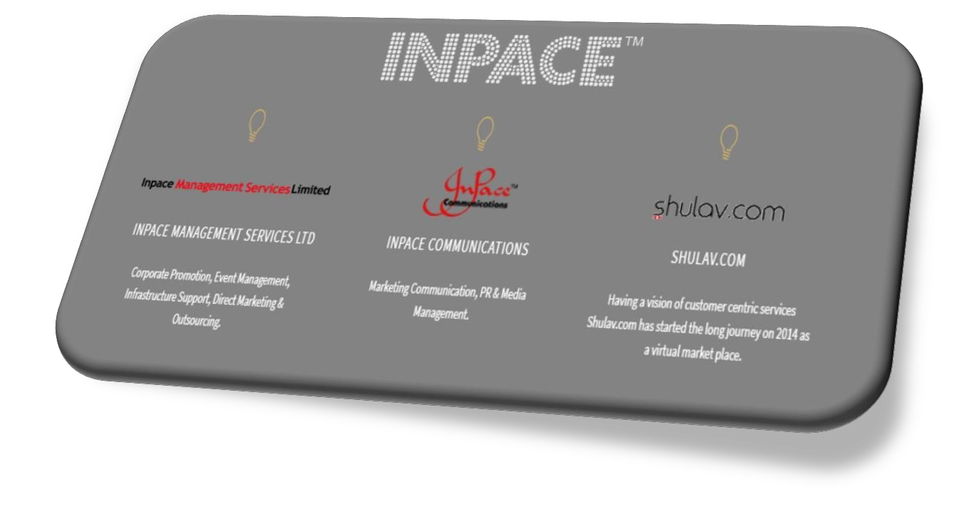

7

OVERVIEW OF INPACE COMMUNICATIONS

Inpace Communications Bangladesh, placed in Concord Tower, 113 Kazi Nazrul Islam Avenue, Dhaka-1000, is an organization that works with tech products concerned with making life easier. The reason behind launching this was making Bangladesh more technologically innovative giving the phrase, ‘Digital Bangladesh’ its worth. Ever since its establishment, this organization trained more than 270 professionals. This organization is oriented towards the tech-based products related to different international brands such as Cisco, HP, and Dell etc. As a whole, Inpace Bangladesh contains mainly of 39 staff committed to supervising, organizing, and allocating as well every bit on the overall actions of all of its meats. At present, Inpace Communications has expanded its activities to many new advanced products. By this time the company also focused on its promotional events and it also put out many internal journals in which the actually functions of the organization are compensated. It has also been forging on to become a platform to diminish the barrier between the rural and the urban people by offering the services regarding technological progress. The Government of Bangladesh is providing monetary support both as cash and donations. Moreover, research and academic foundations, firms and other international organizations have come forward to produce a contribution in helping resolve any sort of problems which is acting as a boundary of current technology in this rural area.

  - 3 C OM P A NY P H I L OS OP HY
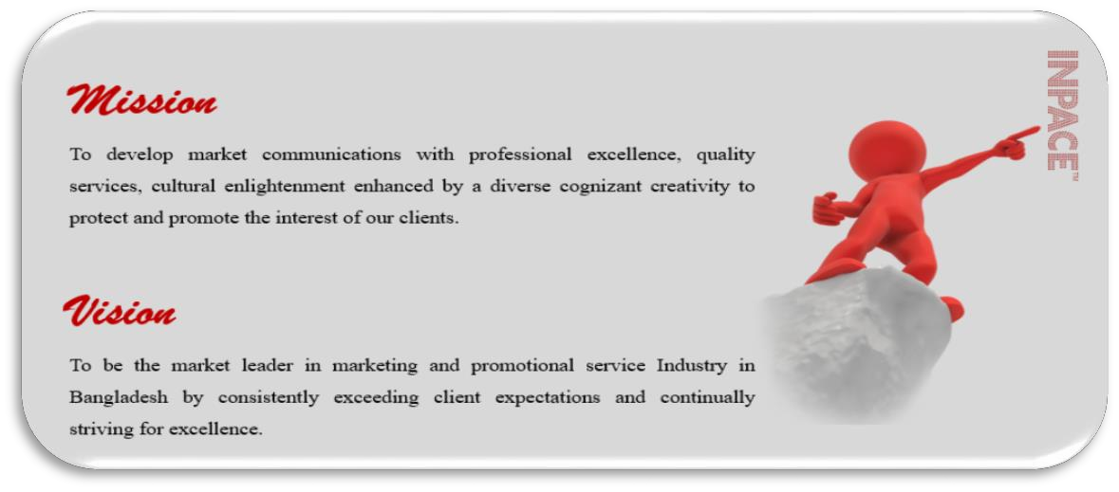


8

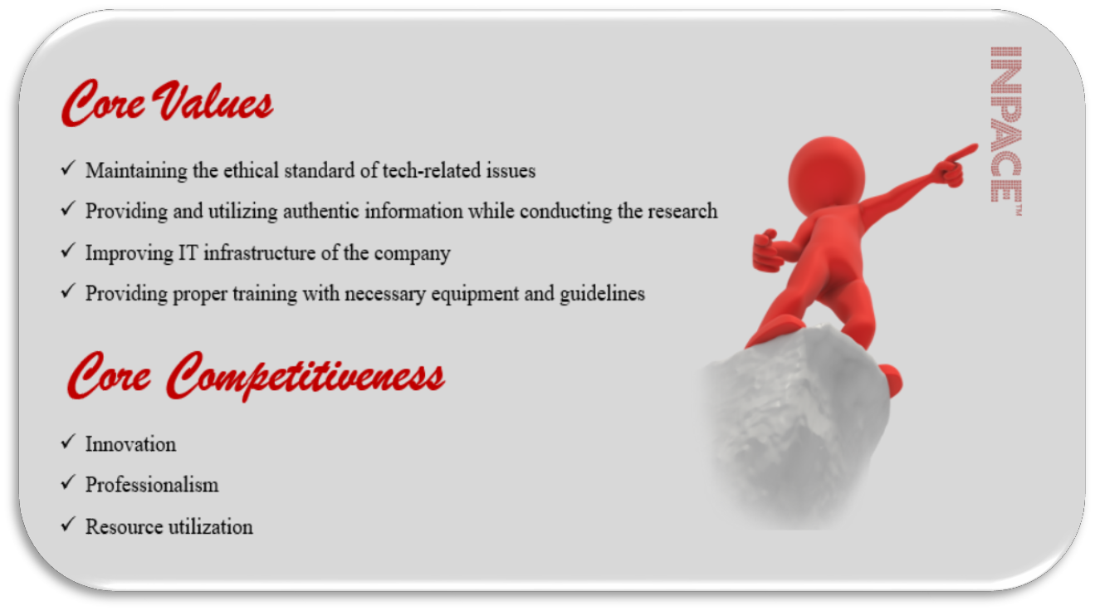

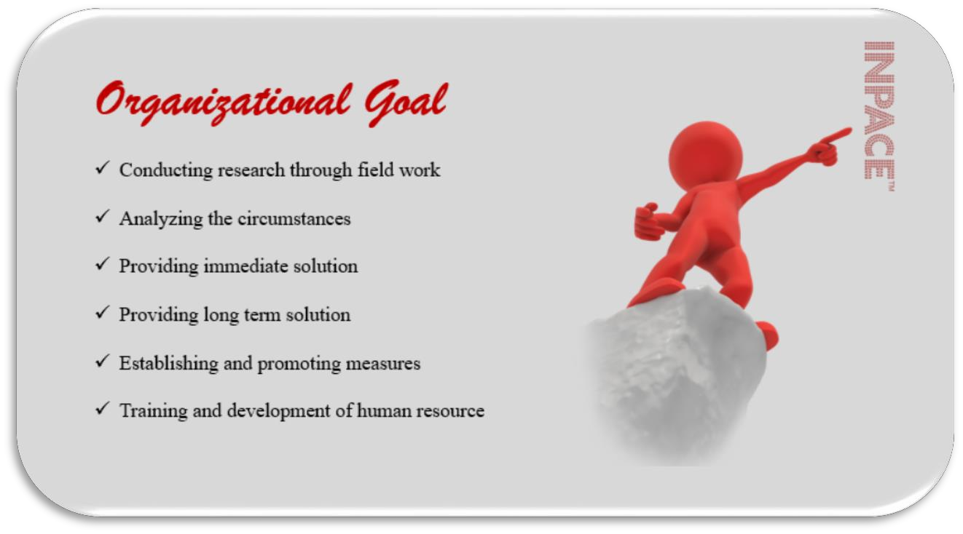


9

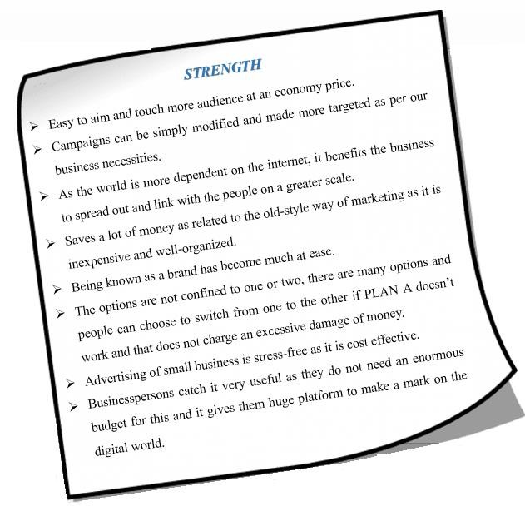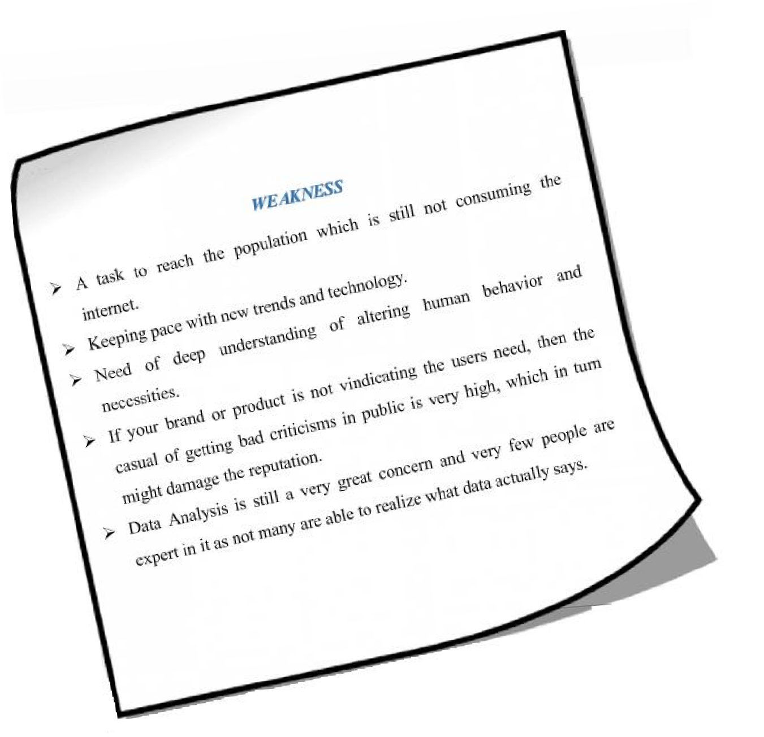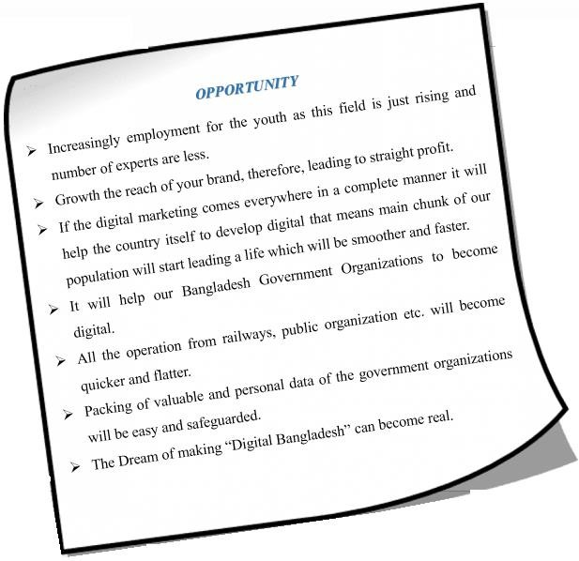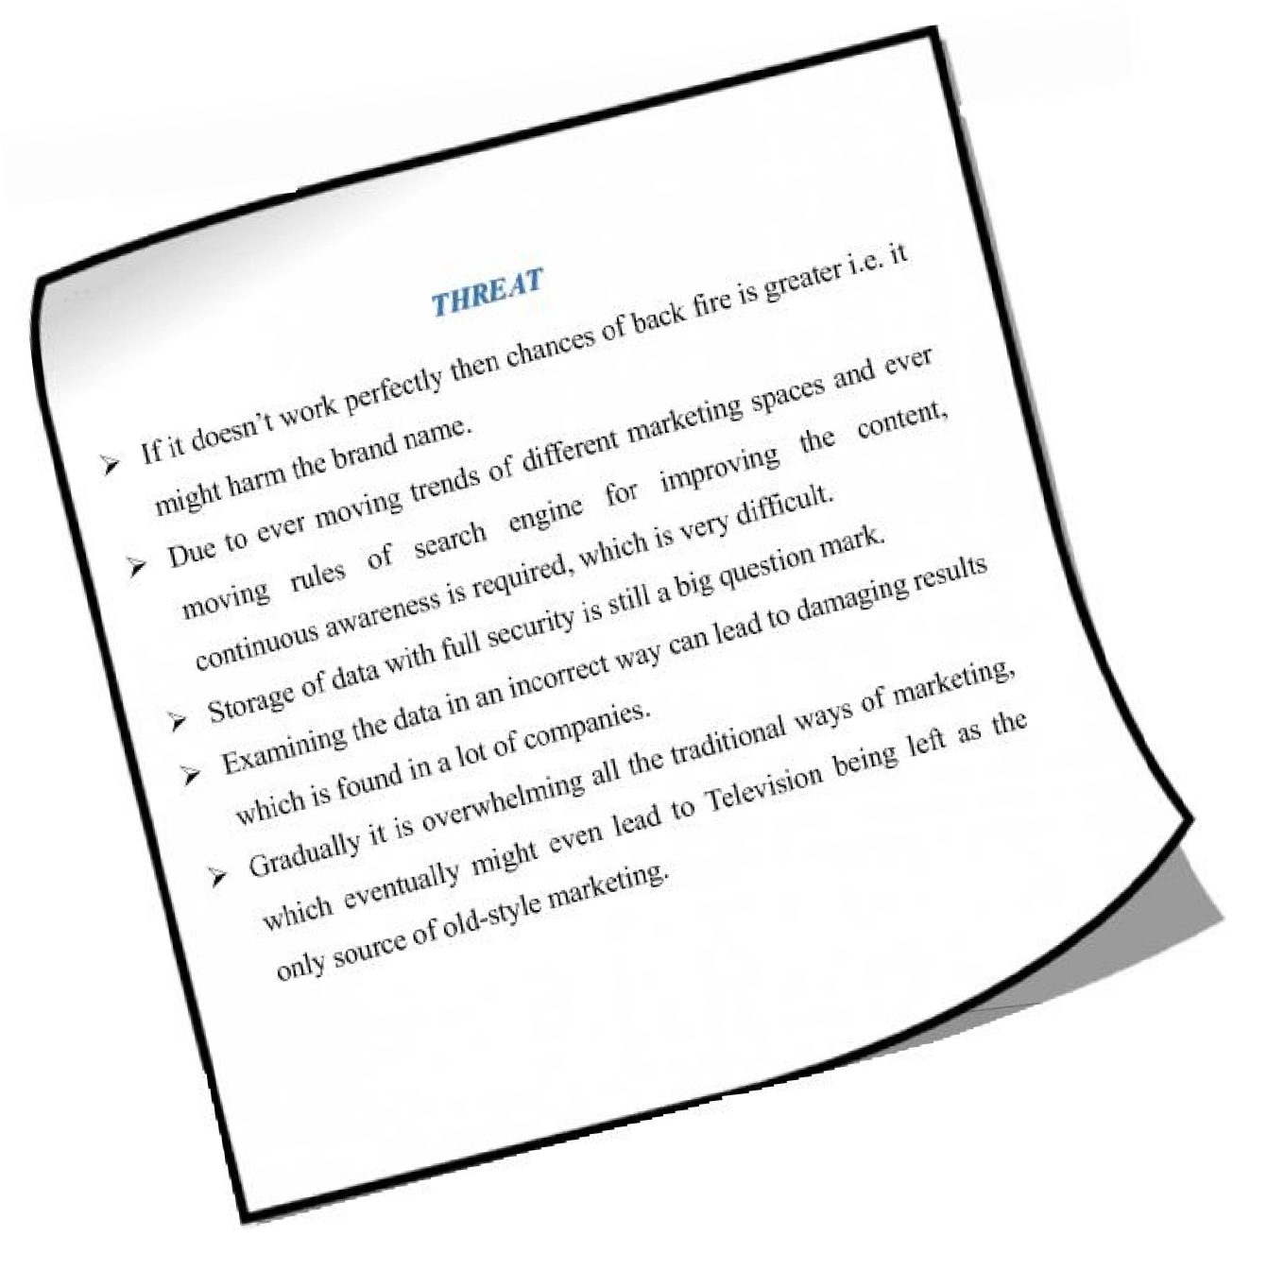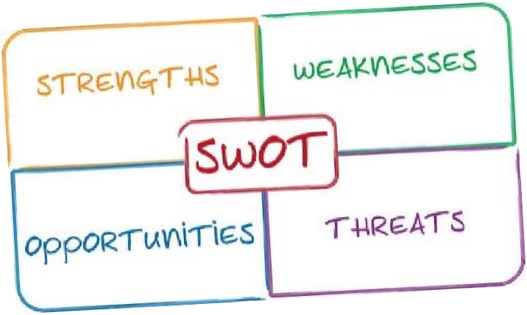
  - 4 SWOT ANA LYSI S

10

  - SERVICE OFFERED BY INPACE

Commercial Advertising is a method of marketing communication used to cheer, promote, or determine an audience to acquire or go forward to take some natural process. Most commonly, the preferred solution is to drive consumer behavior with respect to a commercial proposing. Advertising is usually done by a third party known as advertising agency. An advertising agency is a service based business dedicated to creating, calculating, and hold in advertising for its clients.
Advertising is defined by Richard F. Taflinger as “Advertising is the non-personal communication of information usually paid for and usually persuasive in nature about products, services or ideas by identified sponsors through the various media."
Inpace is aiming to satisfy the increasing requirement of integrated marketing support, promotions and PR activity of IT based companies in Bangladesh. Inpace ensures most reliable and creative collaborator in marketing, delivering the highest measure of quality and best value of money to the customer. Developed market communication with professional excellence, quality service and cultural enlightenment by diverse cognizant creativity to the client.
The main services that Inpace is renowned for: Management Consulting, Human Resource Management, Project management, Event Management, Computer Graphics & DTP, Market Communication, Brand Management, Media Consultancy and services, Public Relations and Corporate Promotions.
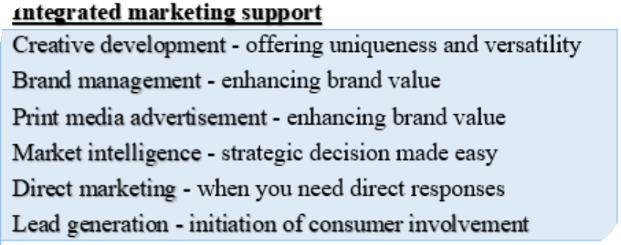Inpace Provide a full scope of customized service including but not confined to:

11

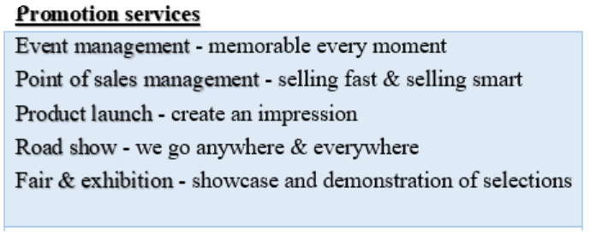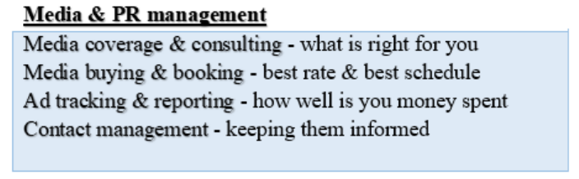

  - 6 V A L U A B L E C L I E NT P O R T FO L I O O F I N P A C E

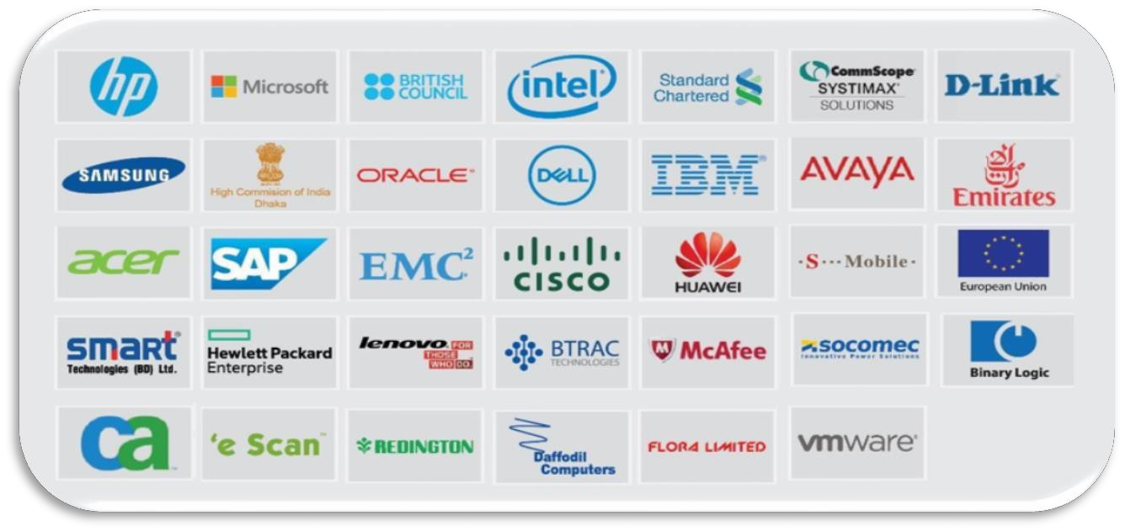



12


CHAPTER THREE
Business Development Mechanism of Inpace



13

  - Mechanism of Finding Clients

Essential part of this internship period is dealing with clients; motivate and inspiration them. Most broadly, the preferred solution is to drive customer behavior with regard to commercial proposing. Here organization is typically done by a third party activity.
Types of activity whereas Inpace manage their client:

- Through a reference
- Recommendation from satisfied client
- Through the tender
- Distribution partner house suggestion
- Follow up with network
- Executive search firms
- Competition with other agency and betting challenge
As Inpace communication ltd. is an advertising agency typically work based on client demand and work like as third party. An agency organization is a facility based business committed to creation, forecasting, and control advertising for it clients. Inpace communication ltd. can also contain overall marketing and branding schemes and sales packaging for its clients.

3.1.1 Through the reference:
A client reference is a positive news report for the client can share about a successful delivery of merchandise or service, used to create demand and sell impact. So that through a reference here Inpace communication ltd. manage their maximum of the portion.
3.1.2 Recommendation from satisfied client:
Inpace communication Ltd. principles is good customer service. The key to good client help is building right relationship with the clients. Thanking the client and promoting a positive, helpful and friendly surroundings will ensure they go away with a smashing feeling. When a customer feel happy they will return them an approval to other association.


14


3.1.3 Through the tender:
Sometime Inpace communication ltd. manage their client through a tender.

3.1.4 Distribution partner house suggestion:
Distribution channels have become the minimum glamorous strategy in the B2B marketing portfolio. An effective delivery channel can be a source of strategic advantage for company. In many cases through this partner houses reference Inpace communication ltd. able to manage their client.

3.1.5 Follow up with network:
In this organization maintain follow up with network for supporting their client. Through the follow up organization try to plug into or make new clients.
3.1.6 Executive search firms:
Sometimes client services executive search firm’s help to Inpace communication ltd. To find new clients.
3.1.7 Competition with other agency and betting challenge:
Competitive position is about, how Inpace will differentiate their offering and create value for marketers. It’s about figuring out a spot in the competitive landscape, putting their stake in the ground, and winning mindshare in the marketplace. So by betting challenges to manage client is one of the process in this constitution.

  - 2 I MP OR T A NC E O F U ND E R S T A ND I N G C L I E NT S N E E D A ND WA NT


The grandness of knowing customer, because building the right customer relationship is essential for any establishment. It not only increase trust and loyalty, which will result in more repeat business.

15


3.2.1 Need Recognition:
Providing superior customer service means meeting customer’s needs by providing them with the products and services they want or by providing effective solution to their problems.
3.2.2 Communicate and listening about topics:
Correctly communicate to customers and listening their needs is important for ensuring satisfaction and commitment. If Inpace fail to properly identify customers’ needs or if they are indifferent to customer demands, they will conduct their business elsewhere.
3.2.3 What client worried about and how they want to find a solution:
Clients want the answer, not the service. So that find out what actually clients worried and then briefly discussion about the issue how to find the solution.
3.2.4. Which area actually client want to increased involvement:
The client always has unique demands. So that find out which specific area, client wants to take. Putting on what a customer wants based on old guests can drive the client off.
3.2.5 After that understand client’s insights and asked them that related question:
Often, client either are not clear about what they need or they don’t truly recognize what they desire. Efficient client service representatives need to be prepared to ask the proper queries. Listen and tailor suggestions in order to assist customer satisfactorily.
3.2.6 Show them quantifiable advantages:
Show customer the evaluation and alternative of the service which fruitful for their organizational goal.

3.2.7 Discussion about budget:
Before beginning any negotiation, it is significant to know what Inpace are bringing to the board and what the other company already holds. And here never negotiate on price, just a scope. A full budget process involves those who are responsible for following to the budget and setting through the organization’s objectives in creating the budget.


16


3.2.8 Purchase and post purchase evaluation:
The purchase decision is the thought process that runs a consumer from identifying a need, generating option, and choosing s specific product and stain.
Post purchase behavior is all the activity and experiences that take after purchase are included in the post purchase behavior. Usually after making a purchase dissonance. Inpace sometimes regret their decisions made.
3.2.9 Final thought or discussion:
After filling in all discussion and requirement than Inpace communication Ltd. will run for final thought and discourse.

  - 3 MECHANI SM OF EXE CUTE THE SERV ICE

Coordinating and supporting client it is an extra sophisticated as an efficient way to establish a relationship with the consumer that has depth and meaning.
Inpace Communication Ltd. has a different department to arrange and do their final execution. An agency can also contain overall marketing and branding schemes and sales promotions for its clients. Types of agencies are working to set up and carry out the plan-
    - Full service agencies
    - Creative agencies
    - Specialized agencies
    - In-house agencies
    - Digital agencies or new media agencies

After making out the customer and understanding their demand, then Inpace Communication Ltd. giving way for final implementation which is finding vendor the negotiation with the vendor and then performing the plan or program.



17

So here generally Inpace Communication Ltd. arrange their element and execute their program
through this process, which is given below-

    - Explain the project to the main project planner and discuss its central element. A part of the project plan could be-
      - Define roles and responsibility
      - Hold a beginning meeting
      - Make list what necessary and vendor list
      - Finding vendor to collect element
      - Develop a scope of various vendor
      - Negotiation with vendor
      - Develop a scope standard
      - Develop the schedule and cost model
      - Analyze project quality and risk
    - Communicate - one important aspect of the project plan is the communication plan. This document states such things as:
      - Who will find the vendor
      - Who will communicate with the vendor
      - After that who will negotiation with the vendor
      - Who on the plan wants which reports, how often, in what format, and using what media?
      - How issues will be escalated and when
      - Who will collect element from vendor and
      - Who will deliver the element to the client
      - Review and approval plan
      - Finally, where all project information will be stored and who can access it.



18

4 MECHANI SM OF COL L ECTIN G CUSTOMER FE E DBA CK

The term feedback is employed to describe the helpful information or criticism about prior action or behavior of an individual, communicated to another mortal who can apply that data to adapt and improve current and future activities and conduct. Feedback occurs when a situation reacts to an action or conduct.
3.4.1 Importance of customer feedback:
Anyone who owns or runs an organization, whether it's large or small, knows the importance of customer feedback. Similarly, well-known is the difficulty involved in getting quality customer feedback.

- Feedback is effective learning:
Whether the feedback is done verbally or via a feedback survey, the person offering the feedback needs to know they have been understood and they need to recognize that their feedback provides some values.
- Feedback can motivate:

By probing for a reaction, it can actually motivate employees to do better. Employees wish to feel appreciated and appreciate being required to offer feedback that can help pass on business decisions. And feedback from customer, dealers, marketers, and stakeholders can be used to motivate to build better working relations.
- Feedback can improve performance:

Feedback is often incorrect for criticism. In fact, what is considered as negative reproach is actually constructive criticism and is the best find of feedback that can assist to formulate better decisions to improve and increase functioning.



19


3.4.2 How to get quality customer feedback:
- Through the survey
- Use email surveys for client
- Get feedback on live chat session
- Over the Call from client
- Use polls
- Create and online communicator
- In-App feedback
- Ask feedback after execution
In every organization collecting and responding feedback is a very important task, so that every organization tries to keep this project. Same here in Inpace Commnication Ltd. maintain this activity. Such way Inpace Commnication Ltd. gathering up their feedback-
✓
Through the questionnaire survey:
One of the best parts about surveys is that Inpace can seek information on the entire customer experience.
- Use email surveys for client:
On the other hand Inpace also follow email survey. Done this way customer can easily meet up their sight from anywhere and also show their negative or positive opinions.

- Use polls and surveys:
Campaigns can be an in effect way of seeking feedback due to their user-friendliness. Here Inpace conduct polls through a website or via emails. Here also bearing polling through social media sites.
So that collecting feedback has to be an integral component of a business operation. Becoming negative and positive feedbacks are as significant.



20

5 Spe ci fica ti on of the J ob

3.5.1 Nature of job:

During the internship in Inpace communication limited, the chore was to do client service as per the society immediately. Being the part of the execution team in event management there are additional tasks associated with the client service function.

3.5.2 Specific responsibility of the job:
The tasks of client service part start with the primary meeting. With the node where the objective and motive of the event or promotion activities are discussed. Later, planning and customer service managers sit in concert to plan out the stream and gives the budget to the node with a formal quote. After the purchase order is provided by the client then the execution part tarts and will the completion according to the docket of the event or promotional activities, manager send the bill to the customer.
3.5.3 Different aspects of job performance:
Being very specific industry, Inpace gets different tasks by several nodes at a time, the same manager needs to rescue services more than two guests at a time. In some examples, the different hierarchy needs to do the same tasks in case of exigency.

3.5.4 Interaction with customers/others:
In the field work I had to interact with the people around, mainly customers also to capture the neutral information about the research procedure. I accepted to behave in different sectors with four different respondents to find out how clients will be more encouraged to use technology products and what would cause them more willing to take in their life more digital. For carrying the data regarding market analysis, target customers and executing and monitoring promotional activities, I had to pull together information from other members like the head of the featured brands Inpace works with.



21


3.5.5 Organization Culture:
The demeanor of the employees in an organization is the observation of the organization’s culture. Inpace has the culture of cooperation and support to the employees. As an intern, I got word that whenever any employee called for any kind of support while practicing their task, the higher executives of the branch made sure to have given me that support properly. At one period of my internship program I became anxious of the overall activities of the study process, but later on the supervision of my coordinator made all these chores easier for me to reach. I made during my internship program that the organizational culture can suffer a negative or positive influence in ones work. It either turns the job into a comfortable one or makes it difficult if the organizational culture does not hold that much positivity as a whole. I was very fortunate enough to see the positivity throughout my internship.
3.5.6 Critical Reflection/Evaluation:
This internship program helped me to realize the field work practically. I feel myself lucky enough because I have experienced actual circumstances going though, and visualize the bridge between class work and work place. I received the chance to play as a team and learnt how to co- ordinate, follow and lead group of citizenry. It also added my knowledge to acquire an idea of executing a total event activation and experiences around the challenges that might pop up in the courses of action. It eventually led me to dispense with the hurdles efficiently and effectively by measuring and choosing best alternatives.



22

  - MY CONTRIBUTION IN INPACE

The internship opened a new chapter of my aliveness with the assemblage of fresh experiences. Unfold ideas and exceptional skills were key experience throughout my internship program. My experience has been enriching and extraordinary. From the very start of my internship days, I found an environment friendly air. The knowledge gained from the fieldwork and desk work of the internship period helped me know from the source level of the people very closely and also the knowledge of the corporate universe. My urge for running in the development sector helped increase more when started to go through closely into the internship works. I have learn lots of things which I received not earlier. I took the chance to spend time with the tech-workers as easily as my fellow interns through my internship. I came to know about their experience here and learned a good deal. The obstacles they experienced to face as working, how they overcome those hurdles and so on has helped me master my own difficulties very well.
I was assigned in Inpace Communication Limited by Dell Inc. department. This section works as wings of event activation for Inpace. I was assigned in several tasks by these departments. I began my internship with short term training provided by Dell Inc. for client service activities and helping in execute for successful event activation.

Duties/Responsibilities:

      - To maintain a healthy relationship with the company’s existing clients
      - Always be available to the client and providing necessary information related to services
      - To learn and perform the activities of an event adviser to the client
      - To prepare the proposal for an event & activations and deliver to the clients
      - Help to organize various successful events
      - To arrange corporate meeting with clients through a fixed call for adding value to the company

Training Session:

I joined Inpace Communication Ltd. on 1st August, 2018. As I had no knowledge about their services, and then they set up a training session around their services. As my primary business is


23

finding and communicate with fruitful clients, then coordinate their results and also gathering
client feedback. By those activities I encourage their services in the corporate sector, thus first week they offered a different type of preparation that was linked up to their services like how event activation execute, how preparing a proposal or quotation, how handle clients in different situation, how to express myself in the corporate sector for fruitful services and last but not least they are trying to groom me for a suit in the corporate universe. Throughout the whole internship period they provided different types of valuable preparation.

Job under supervisor:

From the 7th working day my main job was started. They put me with one supervisor under Dell Inc. After that I moved to different corporate sector related to event activation. At that time I noticed the natural actions of my supervisor how he goes so that I can employ it in adjacent time.

Job individually:

This internship was my very first experience of fieldwork. I used primary data for the research from the respondents. I just got wind about this information collection method in the academic books, but this time I had the real life opportunity to proceed through and experience the overall procedure of data aggregation. My main task was to collect background data of the responders. Data interpretation helped me more to understand the present position of the population’s technology knowledge and aid me to build a huge client based relation.
After passing under a supervisor, I started work one by one. At that time my supervisor assigned the field that I will call. After assigning the area I moved to that area and visited to different corporate sector in that area through fixed call meetings. I went to the people of corporate sectors and discussed with them about our services. I mainly discussed about their event activation services.
Through this internship period I made many proposals or quotation and also work-order for the customer. And then I need to fix up a meeting by telephone call. Lastly, I play in a different event activation program where I need to oversee the overall activities, then welcoming honorable guest, controlling brand promoters, helping to organize the event and then alone.



24

From August 1st, 2018 to till November 30th, 2018 was the time period of my internship
program and I have executed it successfully. I am glad that I have successfully helped to organize “Dell Service camp”, “Dell RSP Training Session” & “Salesforce Enablement Session” etc. Through this internship program I have able to constitute a huge and solid client base relationship. And likewise I am well introducing with the corporate world.

Learnings:

There is no age limit for learning. The rapport with the different people residing in my workplace environment as easily as field work helped me learn various sectors of life. It would not be possible for me if I had not found the scope to do my internship at this house. The new environment of working in the center was all about coordinating with people at a large of every sector. The internship program in which I am working under Dell Inc. team. Besides earning I have ascertained many things from my task. These are-
      - How to express myself in the corporate sectors
      - I have learned about the Advertising agency of Bangladesh
      - I gathered knowledge how to coordinate an event
      - I have obtained the opportunity to experience different types of agency wing activities
      - I have also gathered knowledge about creating a complete proposal, work-order for a customer
      - This job taught me how to take pressure
      - As my job is customer service oriented, so now I know how to perform in a client service oriented job
In conclusion I can suppose that this is the perfect job for an intern that will grant you a practical knowledge.

Observation:

Inpace Communication Ltd. is a really good place to work in. They treat interns as an employee. They leave the work decision of interns on themselves. Advisor assigns few responsibilities and regular employment which makes interns more responsible and dedicate to their workplace. They were very helpful when I was working this report.


25

  - 7 EXE CUTION OF A WELL ORGAN IZE D EVEN T “DE LL SERVI CE CAMP”

Successful results are about balance between planning and delivery, vision and budget, form and purpose. Creating and producing big scale issues which may include conferences, conventions, concerts, craft displays and ceremonies.
Inpace Communication strives to be the most honest and creative event company in Bangladesh. They are always delivering a high measure of character and value for money to their clients.
Firstly, customer service, team looking for prospective clients through several channels. After finding prospective clients, they are arranging a corporate meeting where that team proposed or offered their service based on client perspective. If the client has any plan for an event of their company’s service or product, then they will ask for a well-structure proposal or quotation within some deadline.
After then strategic team and client service team preparing a proposal using data analysis based on their client portfolio. Then the proposal checks by the hiring authority of Inpace Communication Ltd. In that proposal included venue of the event, total guest estimate, the concept of event, design of the stage, budget on an event, prospects of event, promotional activity, play activities, luncheon/dinner item and hence along.
This proposal sends to the client over mail and also provide hard copy by the client service team. If the requirement of the event is fully cleared in that proposal and the estimate budget match with their plan, then the client will issue the work-order to the Inpace Communication Ltd.
Based on work-order, Inpace Communication Ltd. coordinate the event for client as a third party agency. After successfully organizing the event, client service team provides proof of execution (PoE), press coverage, summary proposal of the final event to the client.



26

Inpace Communication organizes many events. In my internship program, I work with some
events. The execution components of “Dell Service Camp” here it is:

3.7.1 Event Introduction:
Dell Bangladesh has been consistently Organizing Dell Service Camp program for End consumer & Users. They had very successful camp outside Dhaka earlier as they provide free laptop servicing and customer care. With that consistency for the first time Dell is going to organize another service camp in Dhaka on 19th October, 2018 to 20th October, 2018 and 25th October, 2018 to 26th October, 2018. Mr. Mohammad Atiqur Rahman, Country Manager of Dell Bangladesh inaugurates the service camp at 11.00am. The Partners of BCS Computer City & ECS Computer City will present on that time. The inauguration took place at BCS Computer City, Agargaon, Dhaka on 19th & 20th October. And next service camp inauguration took place at ECS Computer City, Elephant road, Dhaka.

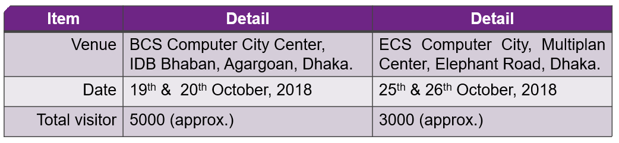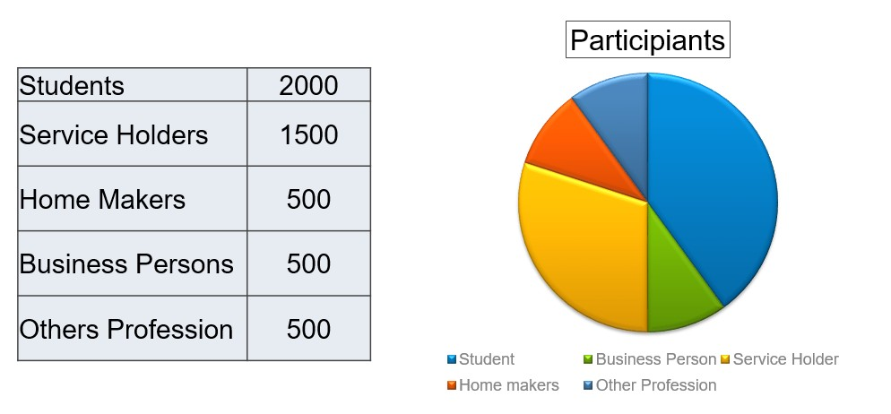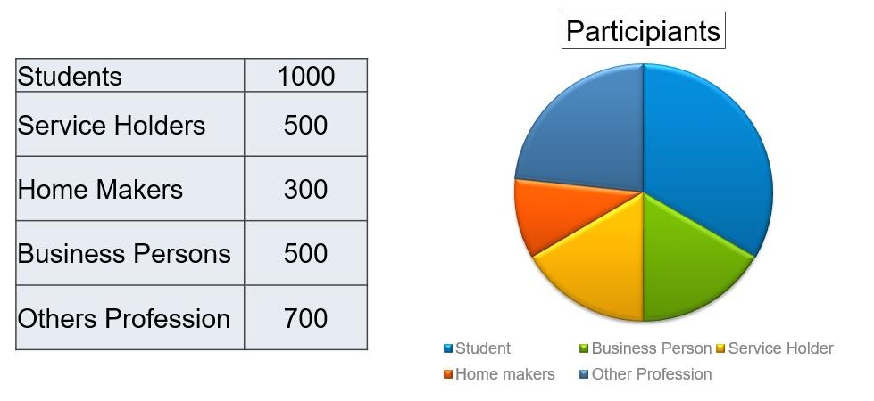Those camp will run from 19th to 20th October, 2018 & 25th to 26th October, 2018. Those Service Camp gives free service for Dell products user by professional engineers of Dell. There will be a
BCS Computer City
ECS Computer City


27

gaming section & quiz Contest for the visitors for customer engagement. Those Camp objective
is to improve customer relation & Satisfaction with Dell & Preventing Current issues. In those Dell service camp, total participants approx. 8000 in BCS Computer City & ECS Computer City. In both service camp events fully organized and decorated by Inpace Communication Ltd. They hire 20 brand promoter include male & female who help them to successfully promoting their campaign.
3.7.2 Branding & Fabrication:
BCS Computer City Center, IDB Bhaban: For branding Dell service camp in BCS Computer City
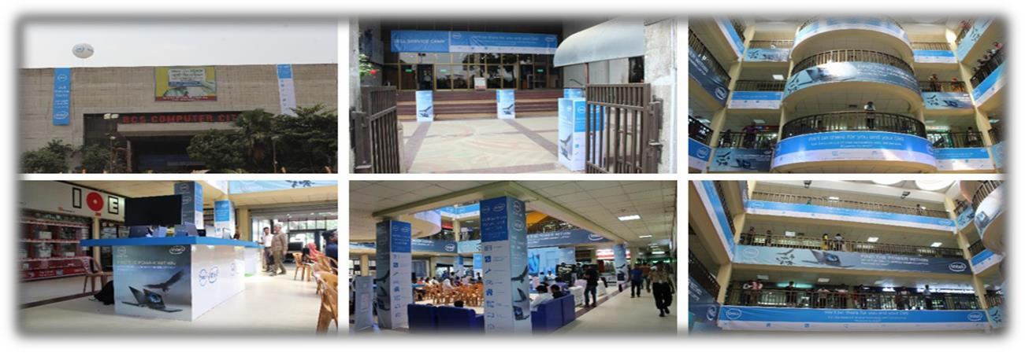
Center, Inpace printing two long banner through their printing-press agent which hang over in front of IDB Bhaban. And also printing poster, cut out, wall sticker and small banner to decorate whole IDB Bhaban. In Ground floor, build a service camp stage with 100 of sitting arrangement. Beside the stage, there are 6 booth where provide dell free service and branding dell product.

ECS Computer City, Multiplan Center): For branding Dell service camp in ECS Computer City Center, Inpace printing Wall sticker, long stand banner through their printing-press agent which hang over in front of Multiplan Center. And also printing poster, cut out, wall sticker and small banner to decorate whole Multiplan Center as same in BCS Computer City. In Ground floor, build a service camp stage with 40 of sitting arrangement. Beside the stage, there are 6 booth where provide dell free service and branding dell product.
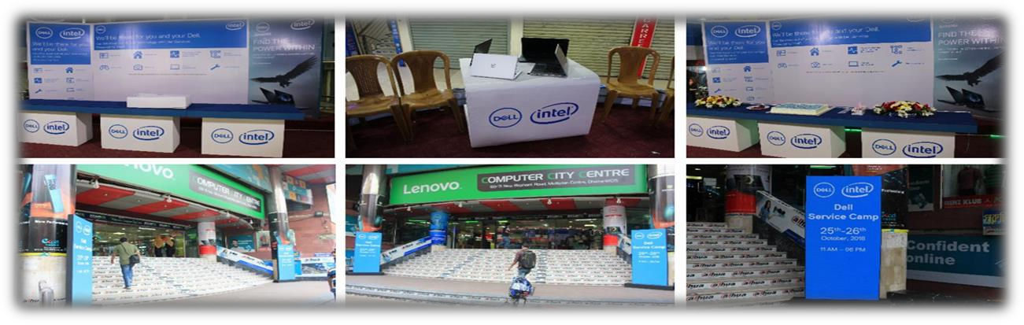
28


3.7.3 Promotional activity:
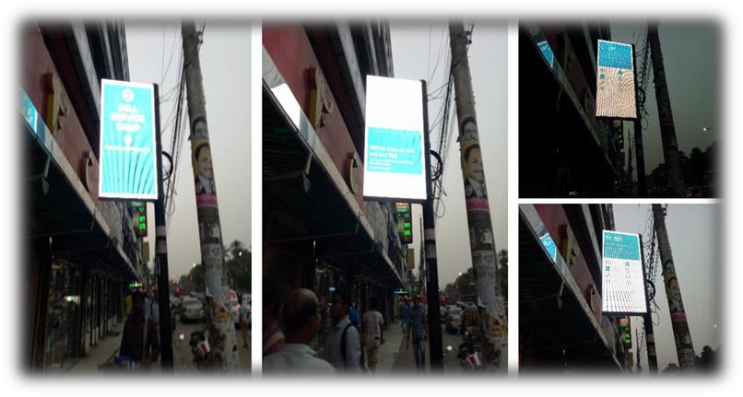
Promotion is a very important part of branding. To branding Dell service camp, Inpace Communication Ltd. make Computer graphic(CG) based PVC to play in LED Digital Light Board at Dhanmondi 27, Dhanmondi 7/A, pantho-path signal, science-lab in Dhaka with 30 second duration.
Digital light board specification:

- Digital Light Board Made of Aluminium Profile (Altetch/Alco) Pana Rivers Print
- Branded Electrical Item Tube light Transact
- Blast Add-co or LED Tube Light
- BRB Cable warring 23/76 & Main Line 3/22
- Electrical Materials 1Year Guaranty
- Pana Rivers Print 1 Years color Guaranty

3.7.4 Media Coverage:
Pre-Press Coverage: Before dell service camp events, there pre-press coverage to inform people about their events & services which covered by five online news media.
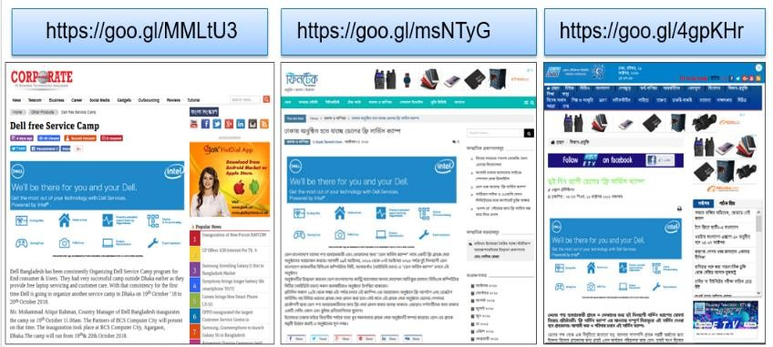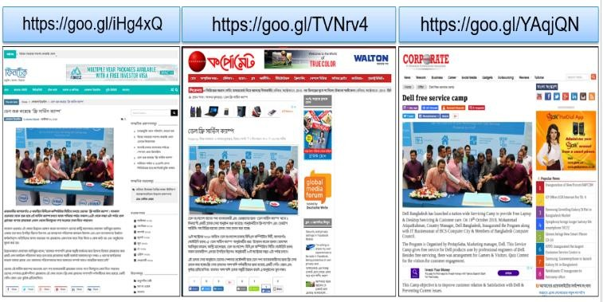Press Coverage: Media coverage is a proof of successful event execution. After organizing successfully dell service camp events, Inpace Communication Ltd. Invite journalist to media coverage & also provide them Press Release (PR) & some gifts.
Pre-Press Coverage
Press Coverage



29

3.7.5 Service Registration & Support – Event Summary:
Dell Inc. gets good response from Dell Service Camp. The service registration had successfully gone for four days. In service camp, segmentation divided into two category:
- Product segmentation
- Service segmentation
The product segmentation is divided into two part; one is desktop & another one is laptop. And service segmentation is also divided into four part; Hardware Problem, OS Problem, Physical Damage, Driver Problem.
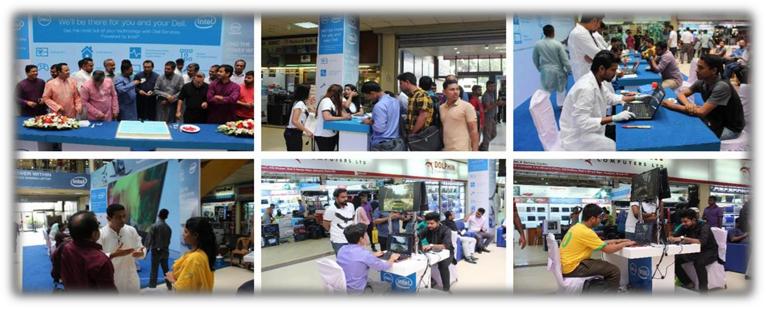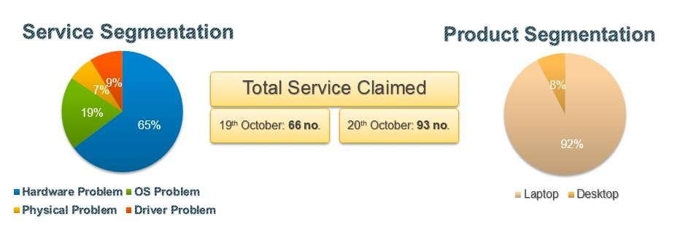BCS Computer City Center: Total free dell service claimed at IDB Bhaban was 159 person. In 1st day there was 66 number of service claimed & 2nd day there was 93 number of service claimed. There was 147 number of problem in laptop & 12 number of problem in desktop of dell product found. In dell service, there was 103 number of hardware problem, 31 number of OS
problem, 11 number of physical damage and 14 number of driver problem.



30

ECS Computer City: Total free dell service claimed at Multiplan Center was 54 person. In 1st day there was 32 number of service claimed & 2nd day there was 22 number of service claimed. There was 49 number of problem in laptop & 5 number of problem in desktop of dell product found. In dell service, there was 40 number of hardware problem, 10 number of OS problem, 3 number of physical damage and 1 number of driver problem.

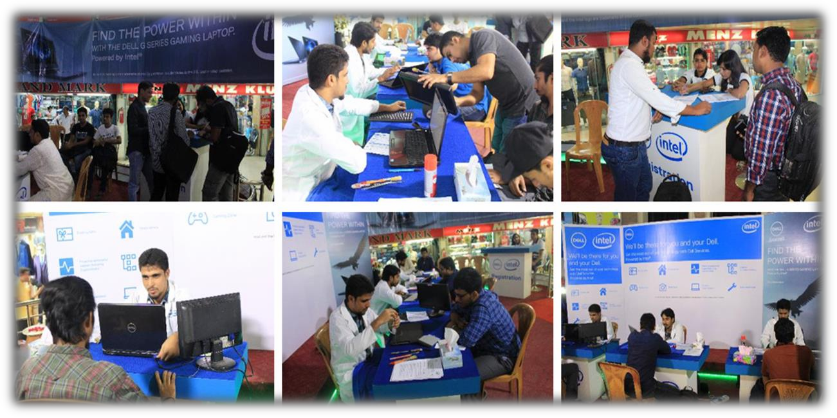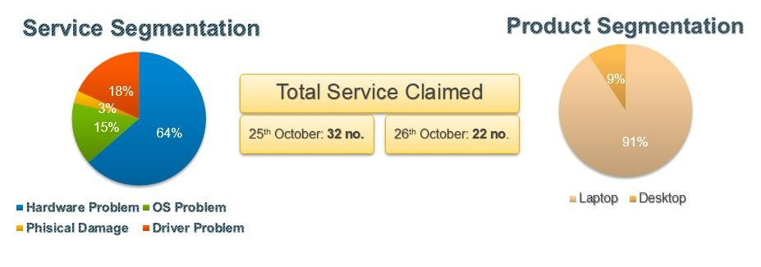



31


CHAPTER FOUR
Findings and Analysis



32

4.1 FINDINGS

I performed last four months as an intern in Inpace Communication Ltd. where I found some issues that need to be improve and can find them in a more comfortable place. These improvements may help both Inpace and their clients.
I likewise attempt to highlight a well structure events activation and business development mechanism of Inpace Communication Ltd. Later on my whole observation I found that:
- There is very competition between the advertising companies. As a result, to survive with reputation, Inpace maintain healthy relationship with their existing customers.
- In event execution budget plan information is not disclosed because of confidentiality.

- Inpace always trying to create relationship with new clients.

- Inpace is too much sensitive about their client information which never disclosed with outside of the organization.
- Inpace always looking for new market opportunities to build themselves as a renowned brand.
- On that point is so specific association or neighborhood for public disclosure of the brands so that real market position is non-visible in Bangladesh.
- Being committed to serve specific brand, it was very vague to obtain info on other makes.

- Day by day Inpace continuously increasing its market value to their clients.

- Inpace is also a growing adverting agency in digital marketing.

- Inpace provide advance prospective result for events to the clients.



33

I worked with a particular department (Dell Team) of Inpace Communication Ltd. Through Dell

Inc. is a renowned company but in recent days Dell Inc. operates some campaigns and event activities by Inpace Communication Ltd. which helps to increase the brand value of dell.
For their services of the Dell team, department I have some findings. Those are given below:

- Inpace Communication Ltd. don’t promote their service through digital channel or Press- Ad. They followed a direct marketing policy to promote them.
- Inpace only deal with IT companies like Dell, HP, Lenevo, Acer, Oracle, VMware etc.

- The training period for the internship program is too short.

- Inpace manage their customers through various method.

- To execute an event, Inpace always maintain a standard for their client.

- Inpace always focus on client relationship; as a result sometimes they offer free activation to their clients above maintaining profit margin.
- Inpace always get customer feedback which can serve to formulate better decisions to improve and increase functioning.
- Inpace always give first priority to their clients in realizing the need and wants of a customer.



34


CHAPTER FIVE
Recommendations & Conclusion



35

  - RECOMMENDATION

    - Inpace Communication Ltd. need to promote their services through various marking channel. Digital marketing needs to be preferred choice by which they can communicate with the potential customers.

    - If Inpace Communication Ltd. want to get the best performance from the internet they should extend the preparation period for the internship program.

    - Inpace Communication Ltd. should guide their employees properly; and so they will be able to use modernized products to make life easier which would benefit for their clients to commercialize their new advanced products to the masses.

    - Inpace Management Services Ltd. help to promote Inpace Communication Ltd. services. If Inpace Communication Ltd. wants to regard themselves as an individual brand they need to promote themselves individually.

    - Inpace Communication Ltd. need to provide mobile allowance to their internee for communicating with client. And also need to be increase the incentive amount for opening new business opportunities.

    - Inpace Communication Ltd. should more careful in preparing budget based on quote. To enhance their portfolio need to be flexible in estimating the budget.

    - Inpace Communication Ltd. need to have their own printing press to reduce the cost of printing.

    - The hire authority of Inpace Communication Ltd. should set on a weekly meeting with client service team. Because client service team is the core department for any adverting company who bring new business for the company.

36

CONSLUSION

I presented a large working experience for Inpace Communication Ltd. The environment and the friendly behavior of the employees in the job post is something that I will never forget. Academic scholarship and practical learning are totally different that I can find out in my internship period. I have found out a great deal of basic theories related to business administration, branding, adverting and event activation. Those theories have served me to gain my knowledge that I can use in the real corporate world. On the other hand, the practical learning is to find out through actual experience. During my internship period at Inpace Communication Ltd. I have made much practical learning experience. I had to get through a set of challenges during my internship program. I memorized how to master the challenges even in crucial places. I have gathered actual knowledge and I hope I will use it to get more adept at things I lack. The experience I accumulated throughout the internship will not only assist me in my further career development, but also will help me become a rational soul and through my ideas and thoughts it might be possible to produce a framework for the society in eradicating outdated methods of selling. The corporate world is competitive and therefore the experience will help me in my life to go forwards.



37

REFERENCE

1.3.1 Primary Sources:
- Md. Mahbubur Rahman Manager, Client Services Inpace Communication Limited

- Md. Rahat Khan CEO
Inpace Communication Limited

- Jerry Baroi Manager, HR
Inpace Communication Limited

Secondary Sources:
      - http://www.inpacebd.com/
      - Annual Report of Inpace Communication Limited.
      - Eagle, L., & Kitchen, P. J. (2000). IMC, brand communications, and corporate cultures: client/advertising agency co-ordination and cohesion. European Journal of Marketing, 34(5/6), 667-686.
      - Ryan, D. (2016). Understanding digital marketing: marketing strategies for engaging the digital generation. Kogan Page Publishers.
      - Parasuraman, A., Berry, L. L., & Zeithaml, V. A. (1991). Understanding customer expectations of service. Sloan management review, 32(3), 39-48.
      - Zeithaml, V. A., Parasuraman, A., Berry, L. L., & Berry, L. L. (1990). Delivering quality service: Balancing customer perceptions and expectations. Simon and Schuster.
      - Christopher, M., Payne, A., & Ballantyne, D. (1991). Relationship marketing: bringing quality customer service and marketing together.
      - Lütken, S. E., & Michaelowa, A. (2008). Corporate strategies and the clean development mechanism. Books.
      - Rainey, D. L. (2010). Sustainable business development: inventing the future through strategy, innovation, and leadership. Cambridge university press.



38

APPENDIX

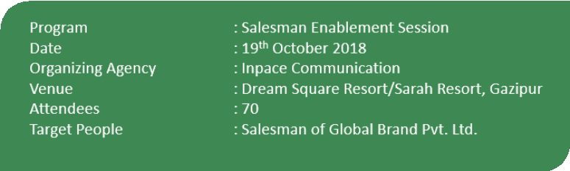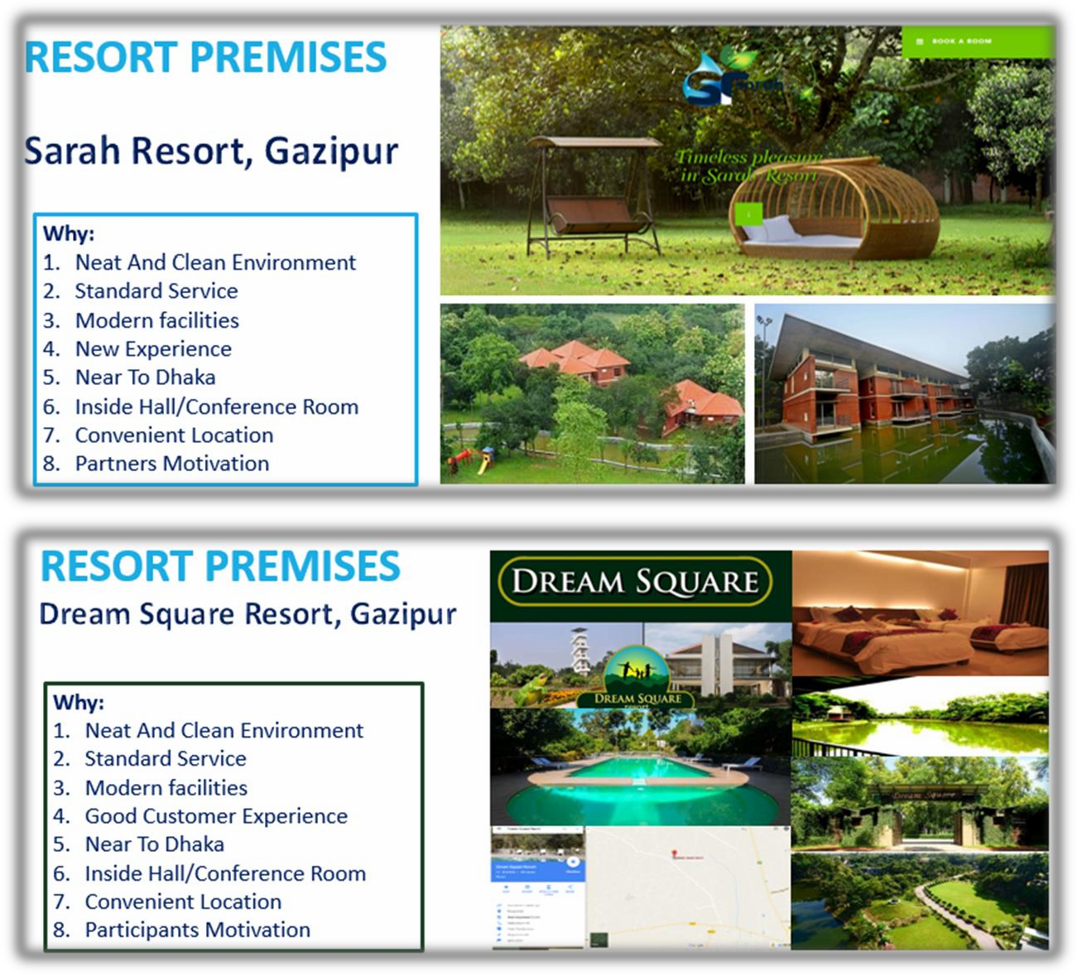39

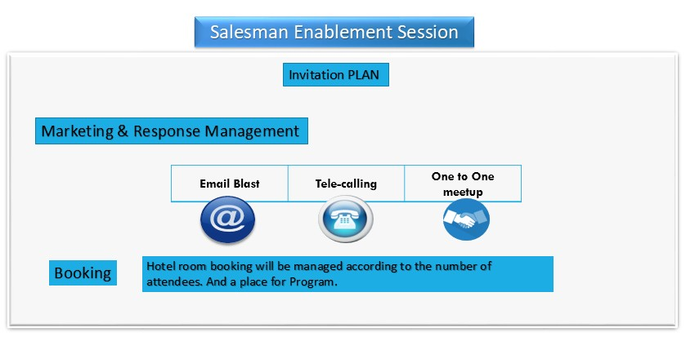
Event Days Plan:
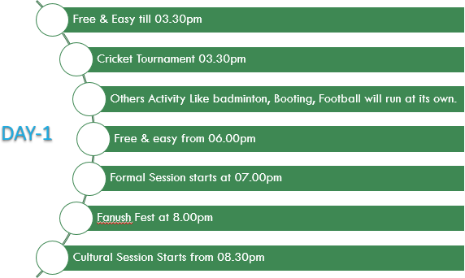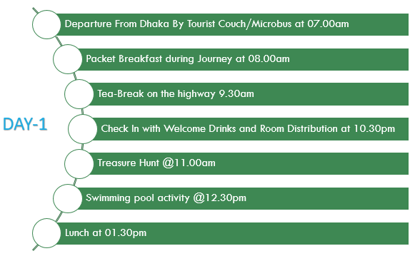
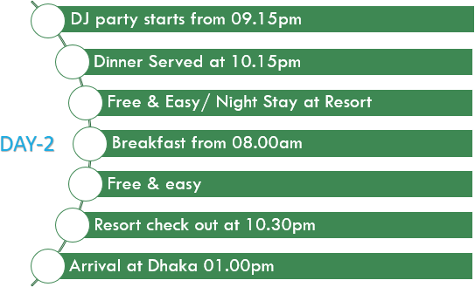



40

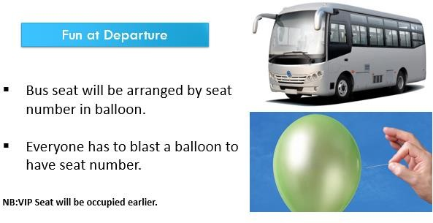




Activity Plan

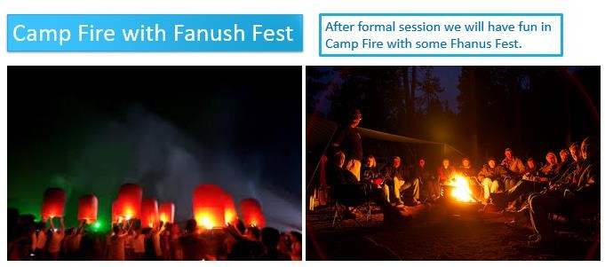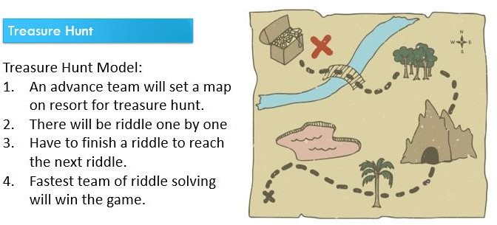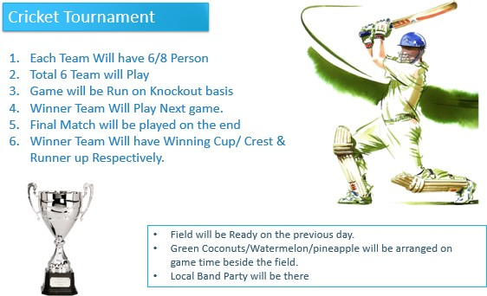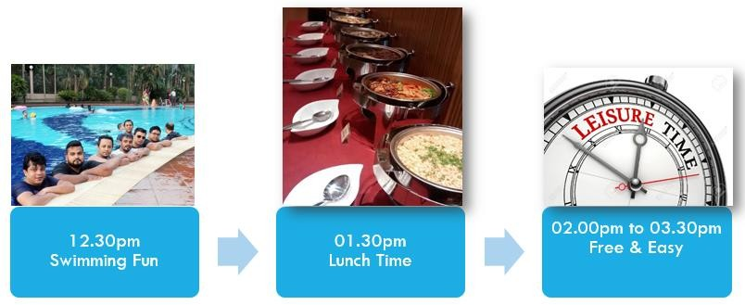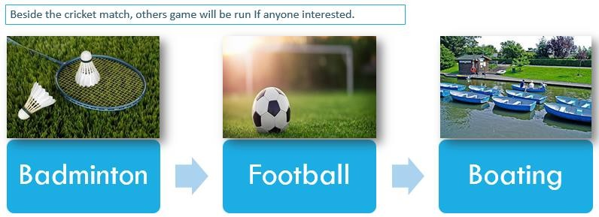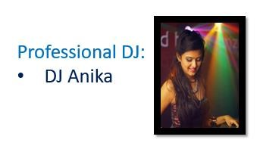
41




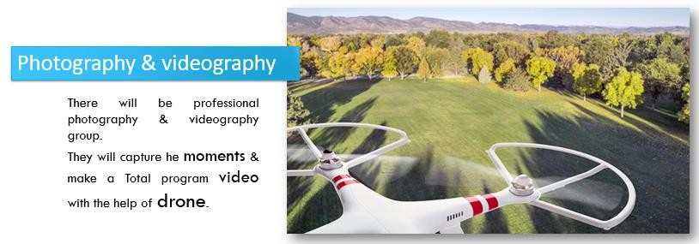
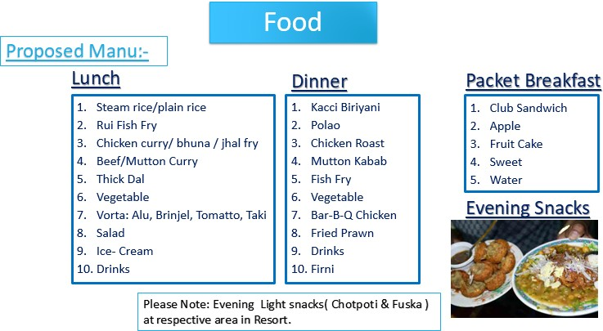
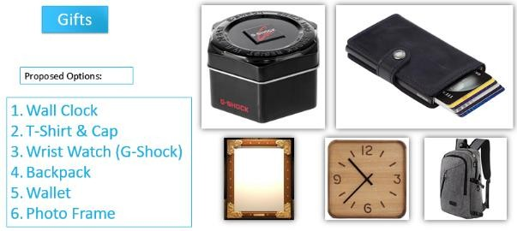
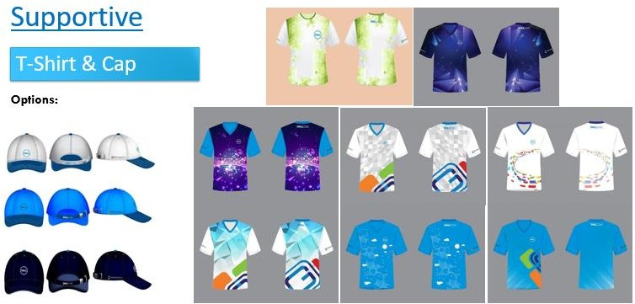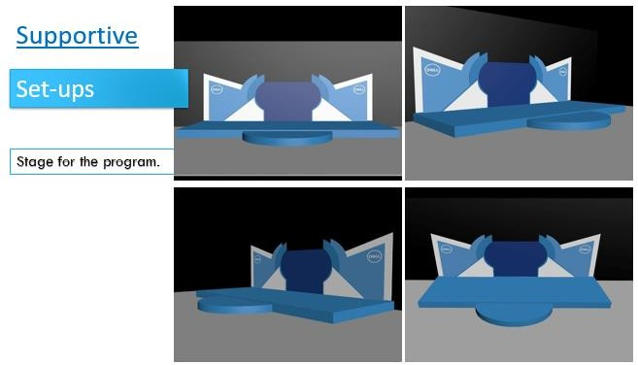



42

    - 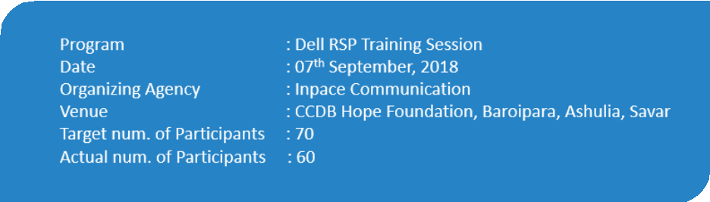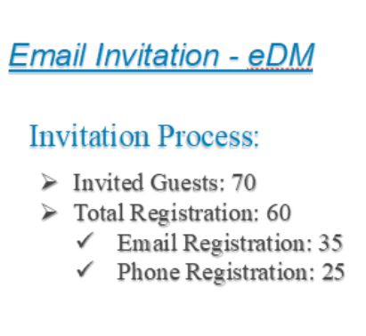 A proper Event Activation summary proposal of “Dell RSP Training Session”



43

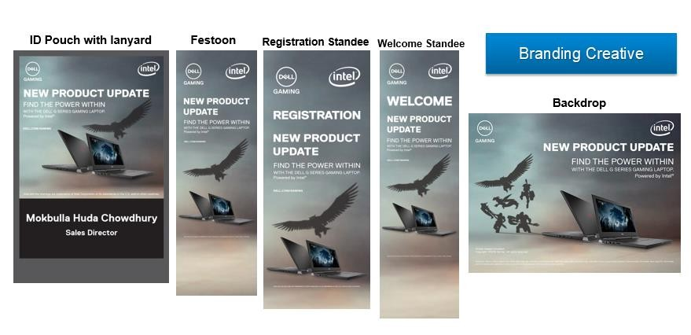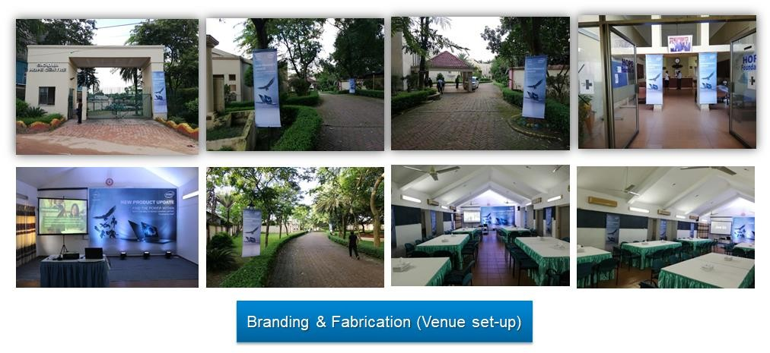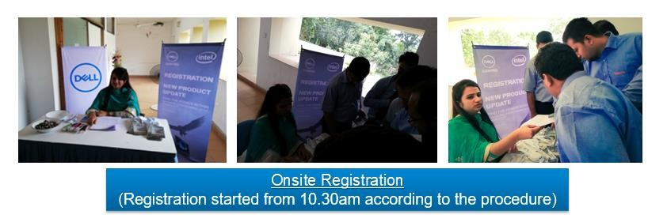



44

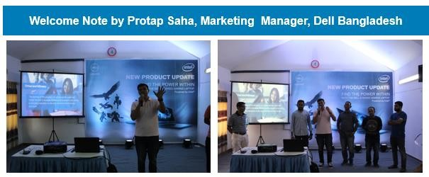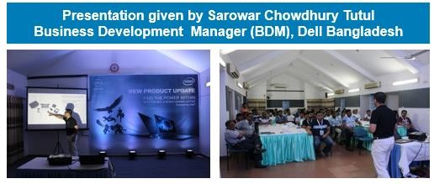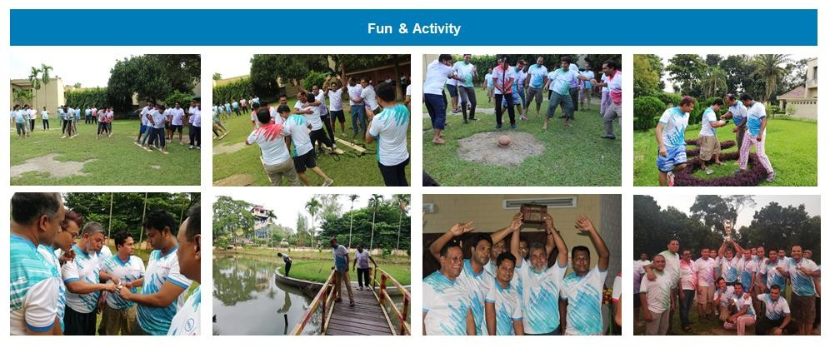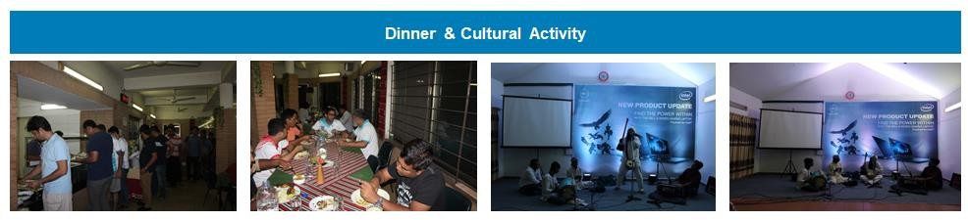

45

Overall Survey report of “Dell RSP Training Session” event conduct by total participants (60 person)
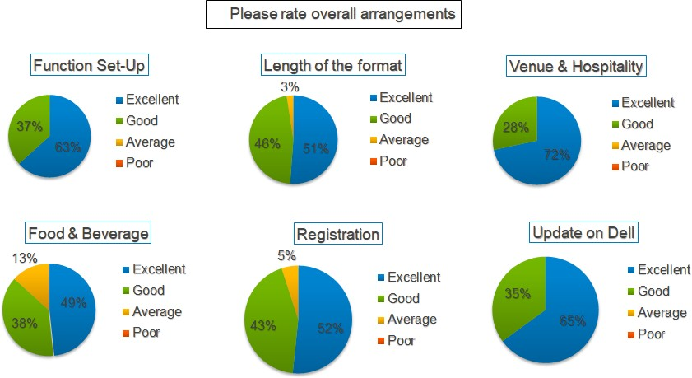

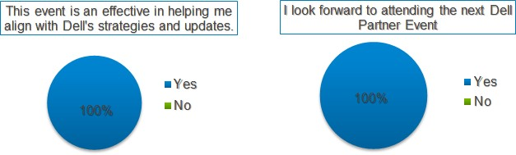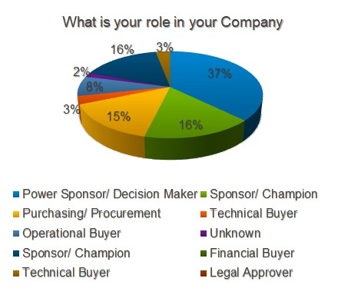

46

