Internship Report
On
Marketing of Brand Consultancy Services:
A Study on Third Eye Solutions Limited



Internship Report On
Marketing of Brand Consultancy Services:
A Study on Third Eye Solutions Limited

Submitted to:
Muhammad Hasan Al-Mamun
Assistant Professor
Department of School of Business & Economics
United International University

Submitted by:
Sharmin Sultana Sharle
ID No: 111 141 119
BBA Program
School of Business & Economics
United International University

Date of Submission: 13/04/2019



Acknowledgment
It gives me huge joy to thank a large number of people for their cheerful participation and supports, which have contributed immensely in setting up this report. In the first place, I might want to offer my thanks to my temporary position manager for his direction and input, which made the entire thing clear to me to complete this entire report.
Besides, I need to display my appreciation to my chief of Third Eye Solutions Ltd., Mr. Ashiqur Rahman Bipu, who enthusiastically assumed my liability and gave me part of time and imparted his working knowledge to me.
My heartfelt appreciation goes to a number of representatives of Business Development group, Account Management, Creative and Copywriting, Studio and Digital Services branch who helped me all through my work. Individuals from these offices helped me to increase additional functional data, which made my Internship experience more noteworthy productive.
An extremely particular appreciation goes to my Reporting Boss, Shafikul Alam Saif for his help and all around well-coordinated remarks and suggestions.

Letter of Transmission
13th April, 2019
Muhammad Hasan Al-Mamun
Assistant ate Professor, Marketing.
School of Business & Economics
United International University
Subject: Submission of the Internship Report titled “Marketing of Brand Consultancy Services: A Study on Third Eye Solutions Limited.
Dear Sir,
This is my pleasure to submit the internship report titled, Marketing of Brand Consultancy Services: A Study on Third Eye Solutions Limited prepared under your guidance, as a partial prerequisite for the fulfilment of INT 4399 (Internship) of BBA program.
This report tries to break down the learnings and encounters of my three months’ temporary position period at Third Eye Solutions Ltd. I am appreciative to you for your kind help and supervision, in the direction of the completion of this report. I endeavored to put my best efforts for the preparation of this report. However, on the off chance that any deficiencies emerge, it will be my pleasure to answer any question may come to your mind.

Expressing gratitude toward you.

Sincerely yours,

Sharmin Sultana sharle
ID No: 111 141 119
BBA Program
School of Business & Economics
United International University

EXECUTIVE SUMMARY

Internship is the position of a student or trainee who works in an organization, sometimes without pay, in order to gain work experience or satisfy requirements for academic qualification. In this report, I tried to include my involvements with Third Eye Solutions Ltd. particularly showcasing my efforts on administration and works related in this report. I needed to work with international and regional brands and worked in the area of markeing communication, more specifically in the area of Digital Marketing Communications.
Third Eye Solutions Limited is a full-service agency and a consultancy firm that started its journey at mid-2018. Third Eye Solutions specialize in the following areas: brand identity development and management, video production and product photography, digital marketing communication, web design and development, event management, strategic media planning, creative services and activation.
The report is mainly focused on marketing of brand consultancy services and more specifically how this aforementioned organization actually provides these services to various clients including BEOL; Tutti Frutti, Unilever, Pran-RFL Group, Walton, Suzuki, and so forth. Main competitors of Third Eye Solutions Limited include Analyzen, Cookie Jar, StrateGeek, and WebApple. At the end of the report, some recommendations were suggested for the purpose of improving the services of the organization and to remain competitive in the ever-changing market.

Key Words: Brand Consultancy Services

Contents
Chapter- 01 3
1.0 Marketing of Brand Consultancy Services: 4
1.1 What is Brand Consultancy Service? 4
1.2 Why Does It Matters? 5
1.3 Why opt for Consultants? 7
1.4 The importance of Brand Consultancy Service 8
1.5 Difference between advertising agencies and brand consultancy services: 8
1.6 Different types of advertising agencies: 9
1.7 Contribution of Marketing in Organization: 11
1.8 List of key concept Abbreviation, Technical Terms 13
1.9 Abbreviation 14
Chapter- 02 15
2.0 Organizational Background: 16
2.1 Company Profile: 16
2.2 Company Objectives: 16
2.3 Organizational Hierarchy: 17
2.4 How Do Third Eye Solutions Ltd. Work: 17
2.5 Some of the Works done by Third Eye Solutions Ltd: 18
2.6 Third Eye Solutions Ltd. Specialties: 20
2.7 The Business Model Canvas 20
2.8 The departments working within Third Eye Solutions Ltd.: 23
2.9 Key Market Rivals of Third Eye Solutions Ltd: 24
2.10 SWOT Analysis: 25
2.11 Industry Perspectives: 25
Chapter- 03 27
3.0 Objective of the report: 28
3.1 Methodology of the data collection: 28
3.2 Overview of data Collection & Used: 28
3.3 Limitation of the report: 29
Chapter- 04 30
4.0 Findings: 31
4.1 Role of an agency 31
4.1.1 Communication solution provider: 32
4.1.2 Understanding the consumer attitude: 32
4.1.3 Strategic partner: 32
4.2 Rule of the Trade 32
4.2.1 The brief: 33
4.2.2 The plan: 33
Chapter- 05 36
5.0 Recommendation for internal organization structure 37
5.1 Recommendation how they can increase client satisfaction 39
5.2 Conclusion: 43
Reference: 44

Chapter- 01
Introduction

1.0 Marketing of Brand Consultancy Services:

1.1 What is Brand Consultancy Service?
Moore (2018) posits that “Branding consultancy service provides the services of analysis, solutions, and general marketing expertise to help companies successfully sell their products. This actually works for consulting firm management or companies who work with advertisement and interact with client organization`s branding and marketing department”.
People aren’t experts. They don’t know about brands. They believe experts are capable of suggesting which they should opt for. That’s what branding consultants do.
”Brand consultancy firms deals mostly with company and product brands not with problems how to position first flight to the Moon. There are always some interests — financial or political — determining the thoughts of the population`s mind set and brand consultants are the ones who prescribes about the positioning in order to win the heart of consumers” (Kärreman & Rylander, 2008).
Strategic thinking with creativity and deep understanding of branding, marketing, advertising, copywriting, neuro marketing, psychology, design, sociology is combined by brand consultants to answer the following questions —
- How they need people to perceive the product/company so that customers react in a way they need them to react?
- How do they achieve this?
The main task of branding-consultant is to:
- Evaluate the situation
- Determine the problem
- Listen to client’s vision
- Assess real needs
- Finding and explaining the problems for the clients and prescribing the does to change how people perceive, think and act about particular brand.

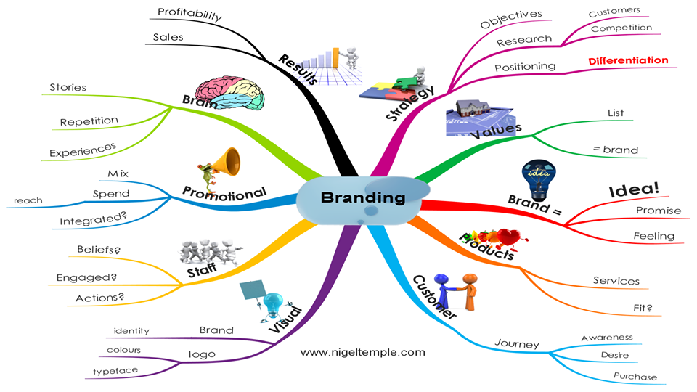

1.2 Why Does It Matter?
Branding is very important for every company to define its mission for both customers and employees and to set itself apart from the competition. It includes content, images, logos, marketing, website and other materials that might be used to define a brand in the eyes and minds of its target audiences. Brand consultancy firms try to keep that brands imager fresh to its target audiences.
There are few reasons why branding matters-
- Forms A Stronger Customer Bond:
Branding is the combination of marketing and advertising elements that form a cohesive image of a company. It is the first impression that a company can have on a prospect. A strong brand is able to express the importance of their products, mission, policies or services to their customer base with good branding. For this, most of the companies hire brand consultancy firms to conduct the best branding campaigns and providing unique ideas to make their product or services more understandable to their target audiences. In order to connect with the customer, a brand needs to be transparent and authentic. Without a good branding strategy, companies can never express their nature to their customer base. Branding gives values and benefits insight into a company, that helps both the company and the customer to form a bond. Customers care about a particular brand when they are acknowledged the direction of the company is and “buy-in” to the emotion that the brand portrays (Sharma, 2017).

- Creates Employee Advocates:
A company gets increased reach when its employees become advocates for the company. Employees are the most efficient source of spreading positive message by word-of-mouth recommendation if they feel proud of being a part of the company. With a transparent branding and supportive message, employees try to share content and become the advocate for brand. This motivates internal workflow and culture that enables employees to be a part of common stage and spread the message by rallying around (Proctor & Doukakis, 2003).
- Supports Marketing and Advertising Efforts:
Unique branding makes it easier for employees to do their jobs. With a company message that is clear and personality that is unique, branding makes the task of the marketing and communicating teams easier by providing a strong backbone for their efficient efforts. Strong communication and branding content bridges materials that could be used by the advertising team and sales procedure to support customer needs and improvements for generating new leads (Story & French, 2004).
- Drives a Higher Price Point:
Great branding makes a company more sensible to its target audience. A company like Apple or Starbucks is more valuable because of branding alone. While a product or service is important, it is the brand that makes the company stand out from the other companies in its industry. Good branding plan focuses on “why” an organization does “what” is done. If a company can present a solid case for why they are doing and what they do, then customer base is more likely to pay top-dollar for it (Kaul & Wittink, 1995).

- Builds a Loyal Customer Base:
When a customer finally chooses to convert and make a purchase, it is branding that will either make or break the relationship. If the customer has a good experience that doesn’t just end with the purchase decision, then they are more likely to return for future purchases. Loyal customers are more valuable, since a company only has to pay to gain the lead and get them through the sales funnel once. Great branding strategy makes customers brand loyal and then share their experience. Customer advocates are the most valuable marketing tools a company can use to change minds and influence leads (Griffin & Herres, 2002).
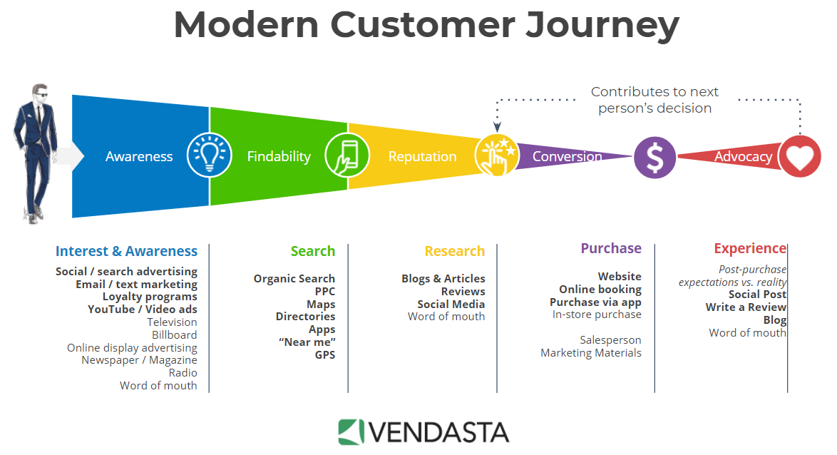

1.3 Why opt for Consultants?
There are five reasons to rely mostly on consultants for marketing. They are-
–achieving organizational purposes and objectives;
–solving management and business problems;
–identifying and seizing new opportunities;
–enhancing learning;
–implementing changes.

1.4 The Importance of Brand Consultancy Service
Brand consultancy can be an essential element of building a future strategy for a company. The right brand consultancy can help an organization to figure out exactly what a brand is going to become over the years. This helps to maintain a consistent face in everything they do, from website, to integrated marketing campaigns.
The value of brand consultancy begins to grow more obvious when companies recognise that branding is about more than adding a logo to a product. It’s about creating an identity for a company, and a position for itself that helps to stand out from the competitors (Moor, 2008).
With consultancy from a brand strategy agency, anyone can:

- Identify their brand
- Understand their clients and customers
- Recognize the strengths and weaknesses
- Leverage sustainable long-term solutions
The main questions a brand consultancy service needs to answer before starting the work for any brand. They are-

1.5 Difference between advertising agencies and brand consultancy services:

Basis | Brand Consultancy Services | Advertising Agency
- Focus | Rather than trying to interact with brands’ features and benefits, Brand Consultancy Services recommend understanding the minds of the target customers first and then try to “position” the brand in the mind. | Advertising Agencies focuses on the implementation of creative strategies.
- Basic Job | A branding consultant's basic job is to help you identify your branded image so that it resonates with your target market. | The basic job of an advertising agency is to make a message for marketing.
- Category | It can be categorized as strategy. | It can be categorized as tactics.

Example, if ads were clothes, a branding agent would be someone who knows fashion, knows customer and their purpose and could recommend how to dress better for who the customer want to be. An ad agent would go out and buy them the clothes. The ad agent might design outfits or ad strategies for customer.


1.6 Different Types of Advertising Agencies:
We know that, Agencies service and performance are generally varying,
According to the service and performance offer to the clients, ad agencies are following types:
- Full Services Agencies: A full service agency is one that handles all phases of advertising process for its clients: it plans, creates, produces and places advertisements for its clients. Additionally, it might serve other marketing services such as promotion for sales, trade shows, newsletters, exhibits and annual reports. One major point that actually helps differentiate a full service agency from the others is that the personnel work full time and the services provide are extensive.
- Limited Service Agencies: Some advertising agencies usually offer only one or two of the basic services. For example, some agencies that specialize in creative also offer strategic advertising planning service, their basic interest is in the creation of advertising.
- Creative Boutiques: It is an organization that specializes in the actual creation of advertisements. Generally, boutiques create some imaginative and interesting themes for advertisement and produce innovative and original interaction. Creative boutique companies have to contact and assign another agency to perform the planning, buying and administrative functions connected with advertising.
- In-House Agencies: Such agencies are owned and supervised by advertisers or the client organizations. In most cases in-house agencies follows organizational structure and functions that are similar to full service agencies in most cases. The advertising director of the company usually heads an in-house agency. The needs and requirements of the company shape the structure of the In-house agency.
- Specialized Agencies: There are many agencies, which take up only specialized advertising jobs. Fields like recruitment, finance, medicine, social advertising, outdoor advertising, etc. require specialized knowledge. Specialization occurs in such fields for a variety of unique reasons.
- Media Buying Agencies: It is an organization that specializes in buying television and radio air time slot and reselling it to advertisers and advertising agencies. The services sell air time to the advertisers, orders the spots on the various stations involved and monitors the stations to see if the ads actually run.
Advertising Agencies and Brand Consultancies both strive to create brand insistence – creating a ‘category of one’ brand with no substitutes.
From time to time each will work together for the good of the client.

Third Eye Solutions Limited is a brand consultancy firm as well as a full-service advertising agency with expertise in all marketing disciplines. They keep a close watch on emerging social media trends to present their clients with a marketing strategy that’s tailored to the client’s business objectives. In the Third Eye Solutions Limited website, they say it like this “The stage is set for brands to take a new turn to meet the needs of the changing times”.
- Full-Services Provided by Third Eye Solutions Limited for clients:

1.7 Contribution of Marketing in Organization:
Today’s large and small organizations are competing for the same market and the most innovative and proactive have emerging. Modern global economy realised the importance of no-large organizations and are continuously giving them support to sustain their growth which is need mostly. For that reason, a company’s sustainability is dependent on their wise marketing activities coupled by financial operations among other functions within their organization (Hunt & Lambe, 2000).
Competition has increased more than ever and social media avenues have been intruded by organizations seeking to capture the audience with their product and service offerings. Most of them actually attained much success and consumers are more informed than they were earlier.
Marketing function is also attached with branding of the organization, publicity activity participation, advertising and consumer interaction through feedback. Every product launch starts with marketing and an end with marketing where by the department establishes the needs of the consumers and after introducing the product, the department seeks to identify whether the customer’s needs were met.
Organizations are competing to be at the top of the customer’s mind and at the same time trying to protect their market share. Marketing is an effective tool for creating customer loyalty and retention of customers. As a result, the function carries out promotions, campaigns from time to time and this has been proved as a successful initiative in also attracting more customers (Hunt & Lambe, 2000).
Without marketing, brands will be confusing and organizations would be pale. Organization’s success is determined by the efficient application of funds to various investment portfolios as well as by the relationship established with the customers, which is a function of marketing.
5 important things marketing do for organizational success-
- Communicating with Customers: Organizations communicate with customers via the use marketing to. Though larger organizations may choose to segregate these activities later on, for most of the organizations marketing serves as a unit that presents public announcements or simply raises awareness of industry issues and company updates. Organizations can provide timely advice for customers considering multiple services while also informing them of upcoming products or roadmap features for such organizations. If your product is truly looking to meet the felt needs of your target demographic, marketing is an essential channel to not only communicate with but also to hear from customers (Fletcher & Melewar, 2002).

- Differentiating from Competitors: The way that business owners view their industry is a surprise. They feel that customers should already know that they are different from their competitors and often do not communicate these differentiating factors. In a market which is full of dry cleaners, burger and car washes, stands, marketing is the only way for an organization to distinguish itself. You can actually target certain type of person that your brand or image will resonate with by only using marketing as basement. Organizations looking for attracting trendy and lifestyle clientele, brand, design and experience all matter (Simkin, 2000).

- Marketing Helps People Find a Product or Service Affordably: One way to meet customers is to go to an industry tradeshow to demonstrate and speak directly with clients. Yet the acquisition cost of finding clients is significant with the need to pay employees time, travel expenses, and event costs. It is marketing that helps organizations gain and retain customers efficiently. Further, marketing helps an organization get found by distilling an issue or want faced by the people your team is focused on serving. The individual may be considering doing something about their useful or want or is simply unknown of what that they had one or that a solution existing, marketing serves a way for people who is unaware of your company before to engage and start solving problems. Organizations that are successful require this kind of marketing activity to inform, educate and engage the people they are looking to work with. Effective marketing is all about problem-solving and helping people discover products that are useful to others (Peter & Olson, 2010).

- Marketing Empowers a Customer Service Culture: Marketing that tries to inform and educate others is actually a precursor to consumer service. Informative, helpful content and articles can already be at the forefront of a customer relationship helping your team build an unshakeable trust with those you are hoping to work with. Organizations that have the best content and resources to offer their people of preference stand to be the first ones they contact when they are ready to take action (Vranesevic, Vignali & Vignali, 2002).

- Marketing Enables a Movement, Sales Generation, and Influences Culture: Whether you are an NGO looking to raise awareness about an epidemic or humanitarian crisis or an organization offering a stellar product that enables people get free from boring regular work, marketing helps you get the right individuals and empowers them for taking action. Marketing is an evolving field and the exciting part is that it is helping to inform and shape our culture today. Our clients typically face an uphill challenge when working to define the right balance between corporate performance and citizenship. We believe marketing can help enable companies to better reflect on the direction of their organization while also empowering them to find great ways to reach the people they need to. Whether it is likes, or referrals, purchases, marketing enables companies to go further than they've ever gone before (Fletcher & Melewar, 2002)..

1.8 List of key concept Abbreviation, Technical Terms
- Brand Consultant: Brand consultants provide analysis, solutions and general marketing expertise for companies to sell their products. They do this by analyzing the brand and see how it performs against competitors.
- Paid Media: Known as purchased media, an immediate instalment jumps out at a site proprietor or an advertisement arrange when they serve a promotion, a sponsorship or pay for a tick, lead or deal produced.
- Owned Media: Different types of online media controlled by an organization including their sites, websites, email rundown and web based life nearness.
- Content Marketing: "A key showcasing approach concentrated on making and appropriating important, applicable, and steady substance to pull in and hold a plainly characterized group of onlookers and, at last, to drive gainful client activity"
- Digital Marketing: The utilization of the Internet and related advanced innovations in con-intersection with customary correspondences to accomplish promoting destinations.
- B2B marketing: Business-to-business advertising, in some cases alluded to as "B to B", "B2B","business showcasing" or "mechanical promoting", is the act of people or association showcasing items or administrations to different organizations or associations.
- Above the line (ATL): Above The Line (ATL) alludes to limited time exercises done at full scale level. It is done at national, territorial or at greater region; level and mass gathering of people is canvassed in this sort of advancement. A brand picture is made about the organization and its item. Media, for example, TV, film, radio, daily papers, and magazines are utilized to make an effect about the organization and its item.
- Below the line(BTL): Below The Line (BTL) correspondence is offbeat in nature, done at smaller scale level and structures some portion of non-media correspondence. Measures incorporate direct mailing, dispersion of flyers, pamphlets, and utilization of sponsorships, advertising, tele promoting and purpose of offer.
- Through The Line (TTL):"Through the line" alludes to a promoting technique including both above and underneath the line interchanges. This vital methodology enables brands to draw in with a client at numerous focuses (for instance, the client will see the TV advertisement, hear the radio advert and be given a flyer in the city corner).

1.9 Abbreviation
- Ad = An advertisement
- B2B = Business-to-business
- B2C = Business-to-consumer
- PPC = Pay per click
- ROI = Return On Investment
- SEO = Search Engine Optimization
- SEM = Search Engine Marketing
- SMEs = Small and Medium Enterprises
- SERPS = Search Engine Result Pages

Chapter- 02
Organizational Background and Industry Perspectives

2.0 Organizational Background:

2.1 Company Profile:
“FUTURE IS NOW
We are the Time transformer”
Third Eye Solutions Limited is a full-service agency and a consultancy firm that started its journey at mid-2018.
It is a Private organization registered in Dhaka, Bangladesh. It stands out amongst the most devoted computerized promoting offices in Bangladesh and it flourish with helping different organizations turn into a significantly greater achievement. They give end-to-end arrangement beginning from your Business Consultancy to Branding. It provides Brand Building & Brand Management, Digital Identity Management, Creative Design & Advertising, Integrated Marketing and Data & Insight Analytics. Third Eye Solutions Limited. is centered around making activity through keenly planned computerized arrangements that expand client bases and develop existing associations with a one of a kind methodology.
Showcasing inventiveness, encounter and inside and out industry learning has enabled them to offer crisp, energizing efforts that lift our customer's online and offline nearness – so regardless of what the business goals are, understand the maximum capacity. Our empowered administrations for all day, every day reassure our clients mind which is the fundamental snare of our group.
They are a group of communication professionals who are committed to earning clients’ trust through outstanding execution and uncompromising dedication to their success ("Third Eye Solutions Ltd", 2019).

Mission: Passion & purity are the silent power of our progress. Our enthusiasm & honesty for clients and brands is our uniqueness in the advertising industry.

Vision: To provide end-to-end marketing solution starting from your Business Consultancy to branding which helps our clients to grow their businesses and realize their marketing goals.

2.2 Company Objectives:

Everything depends on the point of view. To us, Perception is the reality. Third eye angle vision is our priority, which gives us a different & zestful virgin vision to make a brand unique & successful. We basically focus on discovering the future destinations for our clients.
As a beginner, we have just started in a small range with a comprehensive hope. We are confident about our work for our honesty, admiration, dedication, seriousness, and affection which gives us the ability to cross the primary border line. So, with in a very short time; we morphed to a full-fledged communications agency to enlarge our possibilities.

A team of over 30 communication specialists & fresh energetic talents with full of creative courage who observes deeply and directly through the brand and pick up the exact extraordinary effective solution. Client satisfaction is our most desired achievement as an market consultancy agency.

2.3 Organizational Hierarchy:

Managing Director

Director of Operations
Director of Marketing
Creative Department
Graphics Designers
Content Creator
Video Editor
Head of Communications
Business Development Manager
Admin
Business Analyst Team
Business Development Executive
Customer Relationship Management
Logistics & Support
Human Resource

2.4 How Do Third Eye Solutions Ltd. Work:
They generally remain one-advance in front of the control. They keep a nearby watch on rising web based life patterns to give customers a promoting procedure that custom fitted to Client business goals. They set up a technique that attempts to create mindfulness help customer's deals and set up a colossal network of devotees. They have faith in limiting the eﬀort from the customer and augmenting the estimation of administrations conveyed.

2.5 Some of the Works done by Third Eye Solutions Ltd:

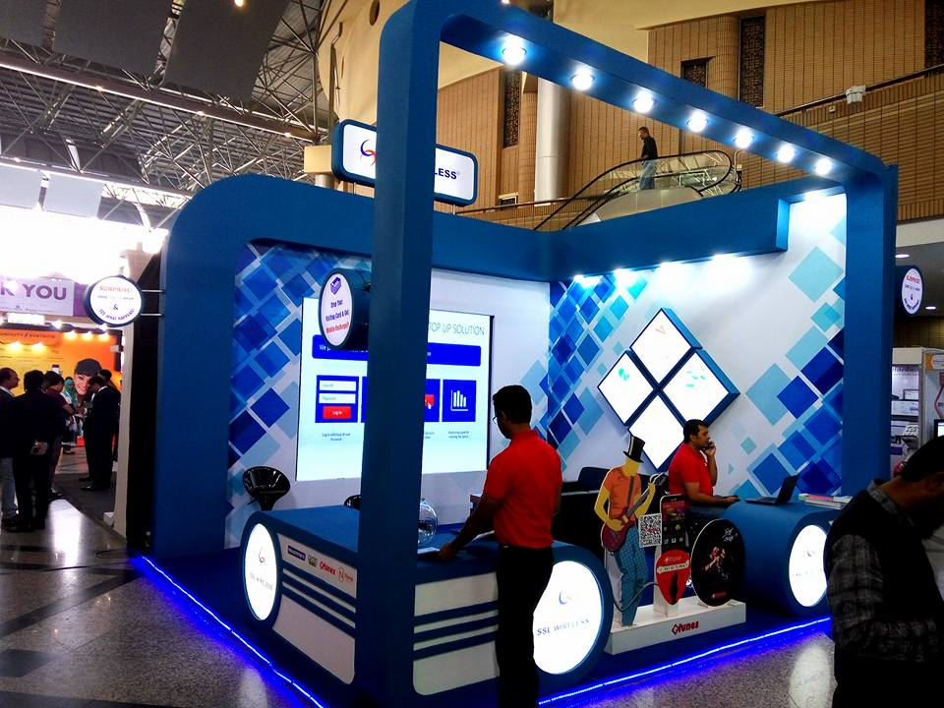 | 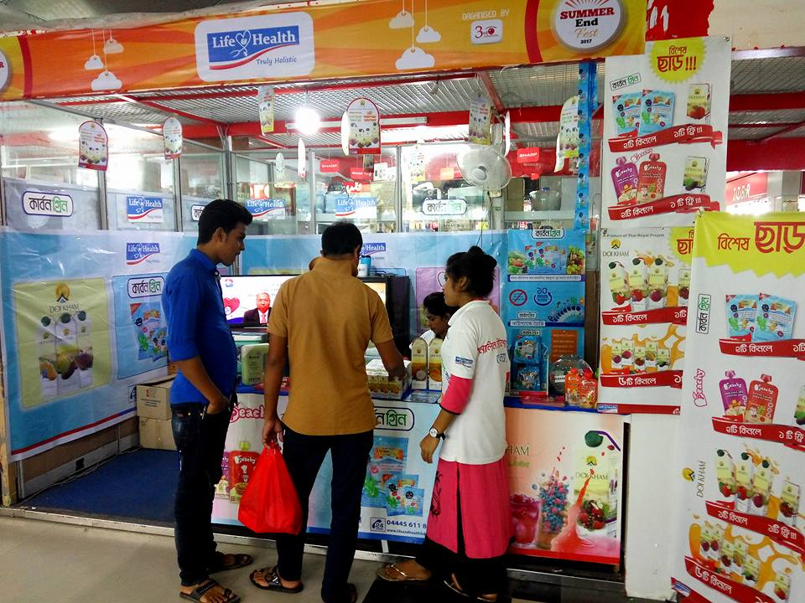

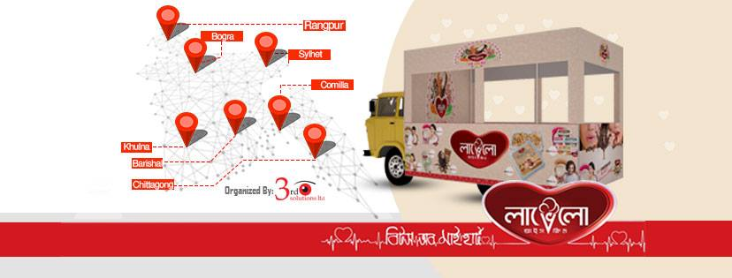

Videos:
- https://www.facebook.com/third.eye.solutions.bd/videos/1537999432963278/
- https://www.facebook.com/third.eye.solutions.bd/videos/1560116787418209/
- https://www.facebook.com/third.eye.solutions.bd/videos/297526257600051/
- https://www.facebook.com/third.eye.solutions.bd/videos/292116791482381/
- https://www.facebook.com/third.eye.solutions.bd/videos/364984701013779
- https://www.facebook.com/third.eye.solutions.bd/videos/335277893860985/
- https://www.facebook.com/third.eye.solutions.bd/videos/352734718916797/

2.6 Third Eye Solutions Ltd. Specialties:
- Brand Identity and Development: Let us build a comprehensive foundation for all your marketing efforts - discover your business goals, define keywords, strategy and the right mix of tactics for your business niche cost-effectively, targeted and with maximum ROI.
- Video Production and Product Photography: We provide every aspect of product photography and video production, writing, directing, camera operation, audio engineering, post-production and even assistance. Live streaming is our one of the most demanded video production services.
- Digital Marketing: Let our team create and optimize your social media accounts (Facebook, Twitter, LinkedIn, YouTube etc.) and as well as supercharge your Facebook Page with fan-gate/reveal tab, lead magnets and embedded mailing list signup.
- Web Design & Development: Our expert development team works on the cutting edge of technology and best practices to make your websites that is built for performances.
- Event Management: We will obviously achieve this pre-eminent position by offering a high quality corporate event management service, which must be consisted with reliable, efficient and unique working capability.
- Strategic Media Planning: We provide creative direction to build new brands and provide existing brands with refreshed, strategic platforms; engage your audience relevant content on websites, advertising, social media, PR and other brand materials.
- Creative Service: We create fresh, bold and commercially viable ideas for any company brands.
- Activation: Third Eye Solutions Ltd. has some assets in Bashundhara City Shopping Mall, where we provide the following branding opportunity-
- Outdoor Digital LED Wall.
- Indoor Digital LED Wall.
- Billboard- 1. Capsule Lift Door
2. Food Court Pillar
3. Star Cineplex Upper Beam
(Both Side)
- Mall Activation – Fair Fest Venue

2.7 The Business Model Canvas
The Business Model Canvas was proposed by Alexander Osterwalder based on his earlier book: Business Model Ontology. It outlines several prescriptions which form the building blocks for the activities. It enables both new and existing businesses to focus on operational as well as strategic management and marketing plan.
I had to make business model canvas for Third Eye Solutions Ltd. A business model canvas consists of several parts, where each part consist answer of several questions.

- Partners
- Who are your key partners/suppliers?
- What are the motivations for the partnerships?
- Key activities
- What key activities does your value proposition require?
- What activities are important the most in distribution channels, customer relationships, revenue stream…?
- Value Proposition
- What core value do you deliver to the customer?
- Which customer needs are you satisfying?
- Customer Relationship
- What relationship that the target customer expects you to establish?
- How can you integrate that into your business in terms of cost and format?
- Customer Segment
- Which classes are you creating values for?
- Who is your most important customer?
- Key Resource
- What key resources does your value proposition require?
- What resources are important the most in distribution channels, customer relationships, revenue stream…?
- Distribution Channel
- Through which channels that your customers want to be reached?
- Which channels work best? How much do they cost? How can they be integrated into your and your customers’ routines?
- Cost Structure
- What are the most cost in your business?
- Which key resources/ activities are most expensive?
- Revenue Stream
- For what value are your customers willing to pay?
- What and how do they recently pay? How would they prefer to pay?
- How much does every revenue stream contribute to the overall revenues?

KEY PARTNERS:  - Investors  - Universities  - Bashundhara City Shopping Mall  - Government Agencies  - Venues  - Sponsors | KEY ACTIVITIES:  - University Club Maintained  - Consulting  - Support Though Marketing Solutions  - Management  - Event Management  - Workshop  - Team Management  - Mall Activation |  | VALUE PROPOSITION:  - Establishment of Successful Branding Strategy  - Utilizing Funds of Clients  - One-stop Branding Solution  - Proposing New Ideas  - Research  - International Brand Relationship | CUSTOMER RELATIONSHIP:  - Investment  - Legal support  - Consultancy  - Training  - Research facilities | CUSTOMER SEGMENT:  - Startups  - Existing Business  - Ventures  - Youtube &Social media  - Mergers  - Club Members  - Mentors  - Investors  Nature:  - Existing  - New
KEY RESOURCES:  - Information  - Office Space  - Staffs  - Contracts  - Creative Support  - Bashundhara City Shopping Mall | CHANNELS:  - Universities  - Students  - Investors  - Media  - Sponsors  - Digital Media | COST STUCTURE:  - Staffs  - Utilities  - Convince  - Marketing  - Events  - Communication  - Advertisements  - Office Expenses  - Accessories and Maintenance |  | REVENUE STEAMES:  - Investments  - Social Media (YouTube)  - Events (Registration Fees & Sponsors)  - Billboard Rents at Bashundhara City Shopping Mall  - Print Ads.  - Digital Advertising

("Third Eye Solutions Ltd", 2019)

2.8 The Departments Working within Third Eye Solutions Ltd.:
There are mainly four departments in Third Eye Solutions Ltd. All the departments are interlinked with each other for the smooth functionality of the organization. The mission of the departments is to ensure quality service to their clients.
  - HR Department- This department is authorized to find out the best people for the best suitable place of the organization. They mainly function different task like-
- Recruiting new personals for the desired place.
- Training and development of the interns.
- Compensation management.
- Employee benefits ensuring.
- Motivating the employees to perform up to the mark.
- Performance appraisal of employees.
- Preparing daily reports of functions.

  - Finance Department- The finance department do budgeting for any online and offline communication campaign and contest as well as for online and offline promotion and advertisement campaign.

  - Digital Client Service Department- The main function of client service department is to maintain relationship with the clients and prospects. They are mainly the communicators between two parties where they exchange thoughts of each party. They are one of the most important part of TES because they are the persons who brings out customer needs and finds out the most useful ways to keep the client happy. This department is the heart of the whole organization and it co-ordinates within the functions of the various department in the agency. It is also important to have this department for research purpose. This gives some important information like-
- To determine the effectiveness of the digital communication campaign.
- To get the customers feedback and reactions about the digital campaign.
- To identify the reasons that could make the communication campaign fail and to have more reach or engagement and brand experience.

  - Creative Department- This department is the mind of the organization as they make TES popular and effective to its clients. They perform few acts like-
- Developing copy for client communication
- Developing weekly content, post, calendar etc. for communication
- Designing a post creatively for digital communication
- Visualizing the idea of campaign and delivering contest
- Finalizing layout of work
- Designing google advertisement, Facebook advertisement.

2.9 Key Market Rivals of Third Eye Solutions Ltd:
- Analyzen: It was started as a web and mobile application development company based in Dhaka, Bangladesh. Since their beginning, they have constantly grown and excelled in services like Web based software, android and iPhone based mobile applications, game development, social media marketing and digital strategy making. Not only is Analyzen the first ever Digital Media agency in Bangladesh, it is also the first Bangladeshi Digital Agency to go global (Analyzen Singapore). They have the biggest client base in Social Media Bangladesh such as- Samsung Mobile, Reckitt Benckiser, Unilever, Standard Chartered Bank, QUBEE, Dell, British American Tobacco, Pran, Berger Paints, Cats Eye, Banglalink, Radio Foorti, Global Brand Pvt Ltd, Rohto Acnes.

- Cookie Jar: Cookie Jar is a sister concern of Asiatic Ltd., skilled in Content Marketing, Content Creation, Campaign Management, Facebook Advertising, Google AdWords and Google Analytics and everything with Online Advertising and Campaign Management. Currently their clients are, Telenor, Samsung Mobiles, Banglalink, Robi, Recitt Benkiser.

- StrateGeek: StrateGeek Digital is an award-winning digital marketing agency based in Dhaka, Bangladesh, that takes pride in conceptualizing and delivering some of the most ground-breaking online campaigns in Bangladesh history. Officially established in 2014.StrateGeek was previously the digital wing of Maverick Studios. They are an independent SBU. As a result; they make profits from razor-sharp industry, while keep possession of the content- production and development capabilities by partnerships with its sister concerns, Maverick Studios (maverickbd.com) and Ice9 Interactive Ltd.

- WebAble: Based in Bangladesh, WebAble is a digital creative agency delivering brand experiences. With a team of passionate marketing technologists, WebAble aims to simplify digital interactions for a select pool of ambitious clients. WebAble’s select clientele in Bangladesh includes Kaspersky, Aarong, Bay Developments, Rahimafrooz, Bangladesh Brand Forum, British American Tobacco, Bitdefender, Akhoni.com and Dell. WebAble offers digital advertising, social media marketing, web development, design and digital strategy and analytics services.

- Magnito Digital: Magnito Digital and till now it is the local market leader in the country. Recently they have acquired the contract from GrameenPhone and becoming the Digital Marketing partner of GrameenPhone. This is a tremendous success as for the first time GrameenPhone gave 100% of their digital marketing section to a local agency, which was previously Grey Dhaka’s.

2.10 SWOT Analysis:

2.11 Industry Perspectives:
Consulting is the most challenging and difficult task for a firm. It is hard to say that when and where consultancy firms in Bangladesh started their business. Bitopy, East Asiatic, (Asiatic) started their business in 1967. Other consultancy firms entered into the business after independence (1971). The problem is, in Bangladesh Consultancy firms are not well structured. So it is difficult to collect data from them. People of Bangladesh are well known to ATL Category Advertisement (Magazines, newspapers, televisions radios and satellite channels). BTL Category advertisement is a newer concept in here. Only a few people is familiar with the term of in house advertising, event management, point of purchase etc. Here price of advertisement relays on popularity of medium. The government is the main customer of print media on the other hand multinational organizations bear advertisement than private national organizations. Legal aspect is solely controlled by the Ministry of Information and Ministry of Health.
The demand for advertisement has been increased. Here most of the advertisements are based on emotion than creative content. Maximum advertising firms pay more attention on product than the user benefits and good experiences are produced by the goods. Many of them represent vague information in their content of advertisement. Here advertising is not pre and post tested by consumers. They try to make link between product and content of advertisement. They leave that they might link among publicity, benefits, product attributes, culture, values, personality, and consumer. If we want to get relief from it, we need to start acquiring both practical and theoretical knowledge about it. If the students get up to date lab facility from educational institutes, then they might be able to provide effective advertisement. And this industry will be more appealing for career development. So each business institute should start advertising laboratory for accumulating practical knowledge. And that is expected to all of us. As it is an industry with potential.

Chapter- 03
Objectives and Methodology of the Study

3.0 Objective of the report:
- Broad Objective:
The Primary target of this report is to secure the jobs of computerized promoting and over the conventional highlighting from the buyer perspective to situate out how advanced advertising is helping customary publicizing process.
- Specific Objectives:

- To know the entire procedure of making proposition for clients.
- To know the adequacy of advanced promoting in this focused time.
- To know about the hugeness of computerized promoting for brands.
- To find out the major strategic choices Digital marketing.
- Find out which source organizations uses more for Digital Marketing Process.
- Comparing Client satiation in digital marketing at B2B service.
- To know how it contributes to the organizational success.
- To solve the arising problems of the organization, regarding Digital Marketing.

3.1 Methodology of the data collection:
System alludes to the far-reaching activities of research in my entry-level position report. To accomplish the expected outcomes to build up the target, a few strategies are utilized. This area will elucidate the techniques I used to do this task.
Techniques to accomplish the expected outcomes to set up the target two essential strategies were utilized-
- Qualitative Analysis: Though a less number of unstructured interviews were taken, in-depth interview of some of the key clients of Third Eye Solutions Ltd. was conducted to get proper insight on the roles of client satisfaction on digital marketing.
- Survey Questionnaire: To know the customer bits of knowledge on the jobs of customer fulfilment computerized promoting in their association, an overview survey was planned.

3.2 Overview of data Collection & Used:
To know the customer bits of knowledge on the jobs of customer fulfilment computerized promoting in their association, an overview survey was planned-
- Data Type: This report will be based both on Primary and Secondary data -
- Primary Data: The overview instrument or the study survey contained 20 questionnaires that included the goal of the examination. The review has been done on 10 distinct customers of Third Eye Solutions ltd.
- Secondary Data: The auxiliary information sources are:

▪ Third Eye Solutions Ltd. Accreditations 2018.
▪ Third Eye Solutions Ltd.’s inward reports, site and Facebook.
▪ Clients portfolio, site and Facebook page.
.
- Sample: For this entry-level position report, I have chosen an example size of 10 from the populace. As it was a customer base overview, the example was not haphazardly chosen. In this examination, the example is the customer who is taking administration from Third Eye Solutions Ltd. am utilizing essential information, as the data that have been accumulated are particularly for this exploration.
- Data Analysis: Information Analysis is the methodology of effectively applying quantifiable and sensible frameworks to depict, merge and recap, and survey data. This is one of the essential components of an exploration paper. I endeavoured to gather subjective information. Because of time limitation, Clients Forms used to gather and dissect the information on disconnected line stage. Later I will have deciphered those on verbal subjective research.

3.3 Limitations of the report:
- As this report, work conducted only for academic purpose that is why the main constrain was cost and time. For the in depth analytical purpose, adequate time is required. However, inadequate time was a major hindrance to prepare such an in-depth study.
- I got only 3 months’ experience with Third Eye Solutions Ltd. for which I couldn’t get excess to some resources which I have assume for this report.
- Resource problems: In digital marketing, every job depends on images. We cannot use every image. There are some legal issues. Sometimes we do not get the exact image what we want.
- Work limitations: There are many work limitations from client side. They have budget issues, which hamper our works.
- Communication gap: There are always communication gap between creative team and content team.

Chapter- 04
Findings of the Study

4.0 Findings:
Third Eye Solutions Ltd. is punctual to meet the timeline of its clients. They are committed to deliver the best output to their clients and to do internal research by their own. They do the research of the market regularly to know the level of their communication or effectiveness of their communication with the customers.

Another most important thing I found in Third Eye Solutions Ltd. is that, their organizational structure is very organized and well planned and there is no additional snag in any position of the structure. It becomes very easy to work in this type of management because in any other agencies in Bangladesh, at least nine or ten layers or level exists which creates communication gap between the top level and junior level.

Third Eye Solutions Ltd. always tries to satisfy their client with the appropriate timing but most common problem of our country is every client is running short of time with their project. As a result, they create immense pressure among agencies. Thus, large amount of workload is always there for each and every employee. In order to solve this, organizational administration can play a vital role, as they can make sure that no one use good advantage of anything to create problems to others.

In the advertising agency, employees are the product, and the agency sells the skills and experience of employees. Sometimes due to the flat organizational structure most of the organization fail to judge the experience by their designation. For example, in any other agencies it takes one and half year to become a senior executive from executive but in Third Eye Solutions Ltd. 2-3 years are easily gone remaining in the same position. To overcome this sort of problem, they can provide two sets of designation to all employees-
- According to the group.
- According to the industry standards.
However, most of the agencies in Bangladesh are facing some serious problem in their organizational structure. Third Eye Solutions Ltd. has very little number of negativity in their structure. This agency creates the fascination towards the fresh graduates because it is one of the best place to build the career.

4.1 Role of an agency
In this modern market it is really important to stand still among all the competitors. There is always an alternative available to customers. That’s why no matter what the company is local or global, companies always have a tough time to achieve the desire position. In this competitive market, it is not always possible for the companies to make their product or service unique or make them so appealing to the eyes of consumers and the advertising agencies provide the solution to this problem. An ideal agency works as a partner of all its clients and works towards the growth of their businesses together.

From different agency point of view here are some of the role an agency displays as well as, Third Eye Solutions Ltd. Follows are listed:
4.1.1 Communication solution provider:
Communication solution includes all sorts of medium with which the clients wants to communicate with its consumers and it is the primary role of an agency is to provide communication solution for its clients. As a communication provider, an advertising agency also needs to provide the supporting service as well.
4.1.2 Understanding the consumer attitude:
In order to sustain in this competitive market, it is very important to understand the customer needs, wants, and their attitude towards the product or service. An advertising agency helps its client to connect with the customers and to understand the consumer needs better. An advertising agency also works in collaboration with research agencies.
4.1.3 Strategic partner:
An advertising agency acts as a strategic partner of its clients. The client and the agency works as a strategic partner while building a brand, to create a better and more effective brand to ensure long term success. They are always committed to provide the best strategic plan to their clients for successful business functioning.
In this changing world and in a dynamic sector like marketing, an advertising agency always try to bring something new and unique to ensure the success of clients. The advertising agency business is like, if the clients succeed the agency will succeed automatically. On the other hand, if the clients fall in any plan taken by agencies it also creates the reason to fall from the industry.

4.2 Rule of the Trade
Every organization has their own procedure of work so does an agency have. It is very important to follow a set of structure to run an organizations work flawlessly. Here is the work flow that Third Eye Solutions Ltd. Follows:

This is just a broad view how an agency works so does Third Eye Solutions Ltd. There is a lot more detailing remains how an agency successfully communicates with the consumers and plays an important part in building a strong brand.

4.2.1 The brief:
The first step of an agency to start any work in a proper way is the brief. A brief is nothing but a communication challenge that an organization face. Brief can be specific as well as, open ended. It basically depends on the challenge that an organization is facing. Sometimes the challenge cannot be overcome through communication rather there are some other problem in the process or the product.

4.2.2 The plan:
Once a brief has been done then it reaches the through and organized process. It the end of which the client gets a successful campaign which solve his problem and leads to a strong brand creation. Below process has been followed in an agency as well as in Third eye solutions Ltd.:

- The internal brief:
The internal brief is a document where the client service department states the problem, with the available data at their disposal. This document is the first of any campaign. It comprises the target audience description; as well as the market data.
During the internal brief the client relation department also plans the program and it includes it in the internal brief.
- Consumer insight identification:
Consumer insight is a gleam for understanding the marketer which regards to the need in the marketplace which is undefined or unmet, or a new way to satisfy an existing need. It is not about a product or service it is about a consumer need that isn’t being met as well as it could be. The challenge for marketers is to recognize the insight, is to find a solution to capitalize on the thinking that identifies the need. That could have led to a producer or service, of course, but the insight is independence of the solution.
- Evaluating problem against consumer insight:
Generally, we get multiple insight in different dimensions and it is important to identify the insight of each customer. It helps to satisfy our consumer and simultaneously it helps to create our brand image over the competitions.
- Identifying communication solution:
After abbreviating the insight, it is important to identify the proposition or what we want to communicate with our clients and come up a receptacle through which we want to reach our consumers. These receptacles are often called touch point. It always been an important task to come up with a good communication mix so that the message we wanted to communicate is well communicated to our consumers.
- Creating communication materials:
After creating the communication message, we need to make sure that, we build the communication materials according to the purposeful communication material and give the appropriate message in the meaningful way. Finally, in this step we present the finish products of an advertising agency (TVC, RDC, Scripts, Print ad layout).
- Execution:
When everything is prepared appropriately, we need to execute our plan accordingly.
- Evaluation:
An equally important part for a campaign as execution is evaluation. Without conducting evaluation, we cannot be able to know how well the communication worked or did not worked.

Chapter- 05
Recommendations and Conclusion

5.0 Recommendation for internal organization structure
- Knowing the brand actually: Most critical and fascinating reality of working in office is knowing the brand by and by. To speak with brand's customer, they need exact and top to bottom information about the brand's items or administrations. In this way, they here get an opportunity to know diverse brands exclusively.

- Easy to recognize target group of onlookers (Clients): It is constantly important for an advanced promoting office to distinguish its objective customer first. Through this advanced showcasing, this errand ends up less demanding. From this given connection, we can without much of a stretch locate the personal conduct standard of our focused on group of onlookers, similar to; their statistic, area, likings, way of life, movement, buying design. Here are some personal conduct standards of my focused on gathering of people is given underneath. (Targeted group of onlookers 18-65+)
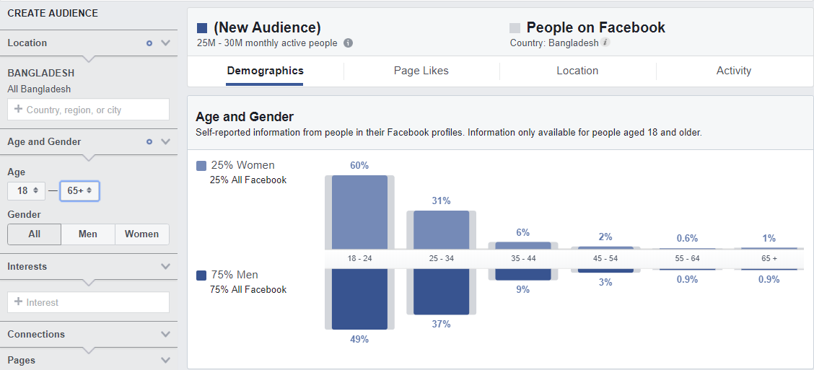
Figure- Percentage of Facebook user in 18-65+
S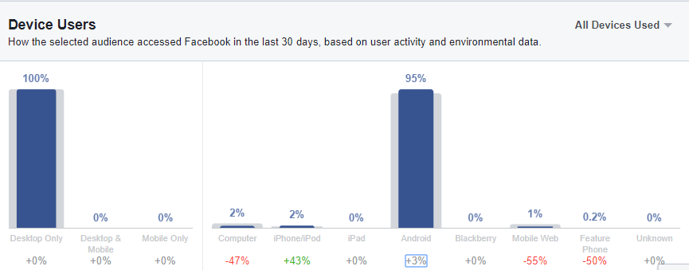
Figure - Percentage of Facebook using through different device.
From this above picture, we can see the percentage of Facebook user among men and women. Then, we can also find out through which device, they use Facebook
- Getting a chance of building up a brand through carefully: Here, customers are not new in market. Some of them are settled and for quite a while in business. In any case, despite everything they need to make their reality accessible through carefully on the grounds that it is currently simpler to get in contacted with individuals through along these lines. For instance, X links who has begun their business long time prior yet they need to enter in computerized showcasing only to build their opening rate of BO account. Accordingly, we gave them an arrangement through which they can set up their image name well in computerized task.
- Introductory Issues: When I initially have gone to the association, there was no appropriate early on session. A fresher like an understudy who will remain for a less period ought to have an appropriate enlistment or starting session, which will assist them with doing everyday works effectively, likewise assist them with getting to think about the earth rapidly.
- Workload Issue: The instalment structure of the assistants is less however the remaining burden is too high. Official work time is from 10 AM until 8.00 PM yet as I beforehand referred to in 'The activity initially' part, I alongside the other assistant of my area of expertise needed to work until 9.00 PM once in a while. Subsequently, work hour particularly for Interns ought to be checked and kept up.
- Late Night Work: Late night work is another issue that I have found in the representatives. Entirely, because of a portion of the representatives' close to home issues, they get off the workplace rapidly alongside customer end weight amid the late hours is the primary purpose for a few people's late night work practice and coming late to the workplace. This is not build the efficiency rather it is hurting their wellbeing. In this manner, the association should take a few measures to decrease this work on doing some operational auxiliary advancement.
- Client Demand: To satisfy the expanding necessities of the customers, the association needs more worker particularly Account Management and Creative and Art office needs more individuals as it winds up extraordinary for the current individuals to give powerful and greater quality administration.
- Training Facilities: More Training offices can be given from the TES which will spur the workers with worldwide information, which may make them more beneficial.
- Effective and Efficient HR Department: As it is an advanced promoting organization, they are more worry about different offices instead of HR division. It causes correspondence hole and demotivation among the utilizes. Along these lines, they have to enlist and show more worry about the HR office.

5.1 Recommendation how they can increase client satisfaction
As per the investigation and discoveries, there are some proposal for the customer fulfillment dependent on the under study-
- Marketing Consultancy should do something that can make the female entrepreneurs encouraged to use digital media, which may increase the number of female entrepreneur base in Bangladesh.
- Those businesses that are still thinking of doing only conventional marketing should start investing in digital media and make their communications more effective.
- Whoever doing businesses especially online shopping related businesses should take some important measures to make client information secure and give a good customer experience. Client’s Privacy and customer experience should be the concern of all agencies.
- Digital marketing communication is less costly than any other media but content management in digital marketing communication is very important. So agencies should give more emphasize on content management and integrate that with conventional media and invest effectively both in digital and conventional media.

Here this some guideline for B2B
Figure - Display–Google Display Network.

Figure - Pay-per-click – Google AdWords

Figure - Website streamlining
• Either increment mark mindfulness, Increase achieve, Increase site activity or Increase lead age.
• Single Image, Single Video, Carousel or Slideshow.
• Canva is a valuable apparatus to make visual substance.
• Base on area, socioeconomics, interests, conduct and associations.
Figure - Facebook – Facebook Advertising

Figure - Twitter – Twitter Advertising

Figure - EMAIL MARKETING

Figure- LinkedIn – Grow Network on Linked

5.2 Conclusion:
In the wake of finishing my temporary position program at Third Eye Solutions Ltd., it was my acknowledgment that I was so blessed to be a piece of one of the main promoting organization of Bangladesh. Filling in as an understudy and being a piece of the Third Eye Solutions Ltd. family was an amazing privilege for me. In addition, the information I have procured from such association will dependably be an exercise for me. I trust that such temporary job preparing will assist me with furnishing my future profession. All the learning in Third Eye Solutions Ltd. amid my entry-level position would surely advance my resume and increase the value of my aptitudes with the goal that I can seek after my profession in any industry. Composing this experience report has helped me find my abilities, and inadequacies. It helped me to center in my inadequacies and take in more exercises so I can reinforce my aptitudes and learning. All the gaining from substance branch of the Third Eye Solutions Ltd. has given me top to bottom learning about the how business is led in this part. Amid this time, I confronted a couple of detours, yet I have figured out how to defeat them by sorting out my works and limiting oversights in transit. Temporary job residency at Third Eye Solutions Ltd. has conveyed what I anticipated. I accomplished everything, which I anticipated that would, and the temporary position made my experience something other than the standard scholastics.

Reference:
Fletcher, R., & Melewar, T. (2002). The complexities of communicating to customers in emerging markets. Journal Of Communication Management, 6(1), 9-23.
Griffin, J., & Herres, R. (2002). Customer loyalty. Dallas: SUCCESS Media.
Hunt, S., & Lambe, C. (2000). Marketing’s contribution to business strategy: market orientation, relationship marketing and resource-advantage theory. International Journal Of Management Reviews, 2(1), 17-43.
Kärreman, D., & Rylander, A. (2008). Managing Meaning through Branding — the Case of a Consulting Firm. Organization Studies, 29(1), 103-125.
Kaul, A., & Wittink, D. (1995). Empirical Generalizations About the Impact of Advertising on Price Sensitivity and Price. Marketing Science, 14(3_supplement), G151-G160.
Moor, L. (2008). Branding Consultants as Cultural Intermediaries. The Sociological Review, 56(3), 408-428.
Peter, J., & Olson, J. (2010). Consumer behavior & marketing strategy. New York: McGraw-Hill Irwin.
Proctor, T., & Doukakis, I. (2003). Change management: the role of internal communication and employee development. Corporate Communications: An International Journal, 8(4), 268-277.
Sharma, R. (2017). Building Customer-based Brand Equity of Domestic Brands: Role of Brand Equity Dimensions. Metamorphosis: A Journal Of Management Research, 16(1), 45-59.
Simkin, L. (2000). Marketing is marketing – maybe!. Marketing Intelligence & Planning, 18(3), 154-158.
Story, M., & French, S. (2004). International Journal Of Behavioral Nutrition And Physical Activity, 1(1), 3.
Third Eye Solutions Ltd. (2019). Retrieved from http://www.thirdeyesolutions.org/
Vranesevic, T., Vignali, C., & Vignali, D. (2002). Culture in defining consumer satisfaction in marketing. European Business Review, 14(5), 364-374.

