Internship Report
On
“A Study on The Headhunting process of Grow N Excel”




Report On
“A Study on The Headhunting process of Grow N Excel”

Submitted To

Ishrat Sultana (IS)
Assistant Professor
School of Business & Economics
United International University

Submitted By

Md Sadiuzzaman Sony
Program: BBA
ID# 111 161 381
Major in Human Resources Management

Date of submission
Date: 10-07-2020

United International University
Letter of Transmittal

Ishrat Sultana (IS)
Assistant Professor
Schoolof Business & Economics
United International University
July, 2020

Subject: Submission of Internship Report.
Dear ma’am,
I want to thank you for your guidance and bolster you have given me over the span of this report. Without your assistance the internship report would have been difficult to complete. With profound gratefulness, I might want to acknowledge the assistance gave by Roby C. Gonsalves, Senior HR Associate, GNE for giving outright oversight during my time of internship in the association.
To build this report I have gathered what I assume to be the most pertinent data to make my report as logical and solid as could reasonably be expected. I have concentrated my prime exertion to accomplish the targets of the report and expectation that my exertion will fill the need. The information and reasonable ability I have obtained during my entry level position period will help me in my future expert profession.
Much obliged to you again for your help and resistance. Regards,
Sincerely,

………………………………………
Md Sadiuzzaman Sony
111 161 381
Acknowledgement
I might want to offer my profound thanks to each one of the individuals who have been engaged with the readiness of this entry level position report. I wish to place on records, my significant appreciation for the help, oversight, and direction in each aspect from, GNE officials, my faculty, and companions.
I might want to communicate my profound feeling of thankfulness to my hierarchical chief of this Internship Program, Roby C. Gonsalves, Senior HR Associate, GNE, for his tremendous assistance and limitless help all through the preparation time frame. To get ordinary with the idea of an altogether different industry was a significant challenge for me; without his guidance, it would not have been feasible for me to conduct and afterward end up with a successful entry level position.
I might likewise want to show my definitive appreciation to all the officials of GNE; specifically the groups that I have worked in and all the others groups in the Recruitment division. I might want to make reference to the name of Farheen Islam (HR Associate) for facilitating me with all the inside data that helped me to set up the company review and industry examination.
Finally, and most importantly, I would like to take a moment to thank my honorable faculty, “Ishrat Sultana(IS)”, Assistant Professor, United International University, for giving me the opportunity to complete my internship report with her valuable guidelines and suggestions that directed me to successfully complete my report on time.

Executive Summary

The report depends on the productivity and adequacy of scouting procedure of GNE, which is one of the main Human Resource Recruitment and Consultancy firm in our country(Bangladesh). The scouting and official pursuit office utilize their own database and security framework to satisfy the customer's request and keep up significant level of classification and unwaveringness. The enrollment procedure is distinctive to each other and its contingent upon the sets of responsibilities that are given by the customers.

RPO is extensively perceived and exceptionally conventional at this point. The report will take its perusers to an excursion through which the individual in question will have the option to see how GNE performs and executes the obligations and duties and satisfy the customer's requests in an opportune way. Through RPO numerous neighborhood and worldwide association has acquired adequacy and proficiency and had the option to pick up the ideal objectives and targets without any problem.

The report has been cultivated dependent on my 12 weeks of temporary position period in the Headhunting and Executive Search division of GNE. The exercises that are remembered for my report are the enrollment procedure, benchmarking, CV screening, calling, talk with meetings, and the various exercises and how it is finished.
Table of Contents
Chapter 1: Introduction 1
1.1Origin of the report: 2
1.2Problem and Purposes: 2
1.3Scope: 2
1.4Limitations: 2
1.5Historical Background: 3
1.6Sources and Methods of Collecting Information: 3
1.7Objectives of the Report: 3
Chapter 2: Company Overview 5
2.1Introduction: 6
2.2Mission of grow n excel: 6
2.3Vision of grow n excel: 6
2.4Services Offered by the Company: 6
▪ HR Planning and Strategy: 6
▪ Work Value Proposition: 6
▪ Comprehensive HR Process: 6
▪ HR Audit: 7
▪ Executive Search: 7
▪ Recruitment & Selection Services: 7
▪ Organization Restructuring: 7
▪ Performance management: 8
▪ Talent Management & Succession Planning: 8
2.5Organogram of Grow n Excel: 9
Chapter 3: Literature Review 10
3.0 Literature review: 11
3.1Need for recruitment: 11
3.2Purpose and importance of Recruitment: 11
3.3Recruitment Process: 12
3.4Executive search: 14
Chapter 4: Project 16
4.0 Headhunting Process of Grow n Excel 17
4.1Headhunting Departments: 17
▪ Headhunting: 17
▪ HR Outsourcing: 17
▪ HR Consultancy & Specialist: 17
▪ Training and Development: 18
4.2Headhunting Department’s Clients lists: 18
4.3HRIS Administration: 19
4.4Headhunting Process: 19
4.5Communication: 19
4.6Job Description: 20
4.7Resumes: 21
4.8Branding & Mapping: 22
4.9Recruitment Process Outsourcing (RPO) 26
▪ Role Profiling: 26
▪ Sourcing: 26
▪ Database Management: 27
▪ Screening: 27
▪ Written Test: 27
▪ Assessment Center: 27
▪ Interview: 27
▪ Reference and Background Checking: 27
▪ Joining Management: 27
Chapter 5: Analysis 28
5.1Time Frame for the Headhunting Process: 29
5.2Contribution of Grow n Excel in the job market: 30
Timeliness 30
Completeness 30
5.3Grow n excel and its competitors: 31
5.4Client’s Response and viewpoint 32
5.5The result of the survey: 33
Chapter 6: Findings 39
& 39
Recommendations 39
6.1Findings 40
• Task composition: 40
• Resources : 40
• Data management techniques : 40
• Office appearance: 40
• Supervisory backup: 40
6.2Recommendation: 41
Conclusion: 42
Appendix: 43
Survey Questions 43
Interview Questions: 44
References 45
Bibliography 45

Chapter 1: Introduction

1.1Origin of the report:

This internship report on ‘grow n excel’ prepared for the completion of the BBA program. The main goal of the internship was ‘on the job’ exposure and an opportunity to apply the theoretical knowledge in real life situation.

For achieving this goal, I was sent to ‘grow n excel’ as an intern under the supervision of two supervisors one is from the organization for three months who directly directed me for any kind of work and I was responsible to inform him for any kind of work completion or for any kind of problem and another is internal from the institute.

This report is on “Headhunting Process of GrownExcel”. On the basis of my three months working experience I have prepared my internship report under supervision and guidance of my honorable faculty ‘Ishrat Sultana (IS)’, Assistant Professor of United International University.

1.2Problem and Purposes:

I choose the topic of headhunting process of grow n excel for this report because it is one of the major components in corporate world. When any company need to hire employee for the vacant position, then they have to go through a long process to find out the right candidate for the right job and headhunting is the main part of that process.

The purpose of this report is to record my internship experience of working at a HR consultancy firm. Organizing all the information regarding my job duties and responsibilities, organizational activates and real-life HR practices.

1.3Scope:

The report is prepared only based on grow n excel related information and at the same time, this report does not have any scope for other consultancy firm. Also, in this report I have covered the overall process of headhunting with the confidential analysis but I did not cover the other processes in this company.

1.4Limitations:
As I have less experience of working on such a big plan & in the stage of learning, I tried my best for preparing this report professionally.
In spite of enjoying these three months I faced some problems while preparing the report. I had to deal with all sorts of problems when I was making the internship report. Also, I had to overcome those problems. The main problem I have faced is our current situation that means COVID-19. For this pandemic I could not communicate properly with my peer group on various issues. During this pandemic time, I completed my last month internship. However, maximum information I have collected before the pandemic started. Even after that, for some confidential reasons the information was not easily available for me. At the same time, it was difficult for me to understand who to ask for particular information. Since, I have completed this overall internship report during this pandemic, I faced a huge communication difficulty and for that it took a long to complete this overall report.

1.5Historical Background:
The CEO and Lead Consultant of grow n excel is M. Zulfiquar Hussain and he has over 12 years' understanding as Human Resources Director/Head of Human Resources in Citycell and Nestle. He presented different administration changes in Citycell. Before joining in Citycell, e was the Human Resources and Corporate Affairs Director of Nestle Bangladesh Ltd. where M. Zulfiquar Hussain filled in as Head of Human Resources for over 10 years. He settled down the HR work at Nestle just as assumed a significant job in building up Nestlé's activity in Bangladesh. As a feature of expert improvement programs, he took an interest in enormous number of preparing projects, classes and workshops in the zone of Human Resources Management, Leadership and Change Management in different nations. He additionally decidedly took part in different HR discussions of various exchange bodies and chambers. He is likewise instructing at the main business colleges (North South University, BRAC University) of Bangladesh. Mr. Hussain appreciates directing preparing programs all the time.

1.6Sources and Methods of Collecting Information:
The report is primarily based on the first hand discussion and observation of the members and the staffs of grow n excel. Informal and formal interviews were taken for the report purpose.
- Primary Data:
I have collected data from first hand sources and for this report I have collected the primary data by following the procedure mentioned bellow:
- Conducted a face to face discussion with the relevant members.
- Directly observed my co-workers while working in the company.
- Real exertion
- Interview with HR team.
- Secondary Data:
The secondary data of this company was collected in following way:
- I have collected few data from website and journal which published by others in the past.
- I have collected data from different publications of the company.

1.7Objectives of the Report:
The objective of the study is to apply my education in the area of Human Resource. Though I worked in a HR Consultancy firm so that I gained actual knowledge of Human Resources.
- Primary Objective:
- To learn about the overall activities of the grow n excel.
- To know about the HR practices in the market.
- Gain experience for better opportunity.
- Personal development.
- Secondary Objective:
- To implement the learning in future which attained from my internship.
- To know the present state of the company in the competitive market.
- To acquire the clear knowledge about the HR activities.
- To find out the difference between practical application of knowledge and theoretical learnings.

Chapter 2: Company Overview

2.1Introduction:
GNE is top GNE is top driving Human Resource Management firm which assume job on official pursuit and enrollment process redistributing. GNE has 3 more sister concerns Dynamic Resources, Smart Check Limited and Apparel Talent. The Dynamic Resources work on volume recruiting and finance. The smart check ltd give the consideration on all the confirmation procedure. The Apparel Talent deal with all the enrollment procedure of the articles of clothing businesses in Bangladesh. The journey of grow n excel started since 2008. GNE convey the best quality administrations to its customers through expertise on HR practices. GNE is a main Human Resource Management Firm in the nation which is dictated by its guiding principle for example energy, polished methodology and customer center. Grow n Excel consider the large number of potentials in our country and distinguish singular possibility to manufacture solid and created human capital by supporting their customers in upgrading capacities to address future difficulties.
GNE support its clients at all the time through a committed pool of assets with an enhanced foundation. To satisfy the desire for customers, GNE has profoundly experienced experts who are engaged with the procedure to conveyance top notch result. GNE understand the client’s projects and deliver the requirements within the deadline.

2.2Mission of grow n excel:
The mission of grow n excel is to help individuals and organizations by providing wide range of HR and Management consulting services.

2.3Vision of grow n excel:
The vision of grow n excel is to bringing up the talent of Bangladesh.

2.4Services Offered by the Company:

HR Planning and Strategy:
HR panning and procedure is one of the administrations that GNE gives to its customers. It's assists with building up proper qualities system for their customers which is significant for long-term accomplishment for any association. The organization conducted session with the administration to set vision for their association and furthermore comprehend their qualities and distinguish them through all around organized inquiries. The organization end up with a last introduction with the top administration where they discuss about the next steps and findings and aware them about execution of their arrangement for future.

Work Value Proposition:
Work value proposition is another service that grow n excel provides to its clients. WVP provides a of set of values, offering and an association which help employees to think positively and gives a reason to stay in an organization and achieve a competitive advantage for current and future employees. The structure of WVP helps an organization to attract new employees and retain their potential employees for long-time. It also provides several dimensions and each dimension has a group of attributes and the company find out the best combinations for an organization.

Comprehensive HR Process:
Comprehensive HR process refers the alignment of human resource process with organizational strategies. When organizational strategies are linked with human resource process it clarifies the strategies. Grow n excel works as strategic partners with the HR professionals where they help to establish the right link between organizational strategies and HR process to achieve the ultimate goal of an organization.

HR Audit:
HR audit team of grow n excel ensures the usefulness of HR operation system of an organization. Then they identify the drawbacks and loopholes of an organization and aligning HR process with the organizational strategies and objectives. Finally, the master review group direct far reaching HR review in the territory of ability procurement, execution the executives, preparing and improvement, pay and advantages, HR methodologies and process and authoritative qualities and culture. The overall audit helps an organization to cope up with the future challenges.

Executive Search:
Executive search is one of the main services grow n excel provides to their clients. Grow n excel has a strong network where they search right candidates who are suitable for their client’s organizations. Grow n excel knows the employment market very well and by using their understanding they can easily locate a right candidate with the right skill and knowledge in the right place. The team members are highly experienced about systematic process of recruitment and selection. They also use professional approach in search of right candidates for their clients in time. To fulfil this process properly the company, need to know about their client’s requirements, their business operation, organizational culture, work environment, future plan and so on. After that team members have to set a benchmark where candidates are short listed by the company’s data bank. These shortlisted candidates are interacted one to one and checking their abilities and skills whether they are suitable for this position or not. This overall assessment is conducted through a structured format. Then finally company assists in settle up a candidate with their expected salary package.

Recruitment & Selection Services:
Grow n excel also offers recruitment and selection services for their client’s regular placement or major recruitment by completing or suggesting whole process or partially. The company uses structured process and tools for particular recruitment & selection. After that they develop a profile role and design advertising for job posting in relevant media. Then they shortlist candidates based on the job description & other criteria and finally they conduct aptitude and written test and interview which is based on their competencies. So, attracting new people and selecting right candidates for the job are really important activity in an organization which requires a lot of time and cost. Here, grow n excel saves cost and time both for their clients and clients are highly benefitted. The company also increases the client’s choice of candidates for a given job.

Organization Restructuring:
Right organization structure is one of the main reasons for superior outcome. This also helps the organization to build a strong network, communication and efficiency. It also plays key role in case of making faster and accurate decision. Grow n excel provide greater support to our clients to set an appropriate organizational structure to fulfil their future and current requirements. For this reason, the company assess client’s current organizational structure, procedure and processes. After analyzing the data company recommends a restructure plan. For completing the process company has to designs roles to support restructured organization. At the time of audit company reviews employee’s strength for management review and advice clients to deal with legitimate and consistence.

Performance management:
Performance management ensure employees performance and increases overall efficiency level and effectiveness of the organization. Performance management is a set of process and it conducts various activity to make sure the performance level where all objectives are met efficiently and effectively. Grow n excel offers its clients appropriate approach to set and implement performance management process.

- Performance management Planning: Supporting departmental organizational objectives through mutual willingness on job objectives and targets.
- Managing: Continuous review of process & objectives.
- Appraisal: Conducting regular assessment for overall performance including discussion and willingness on possible development purposes.
- Developing: Implementing the developmental plans to make the employees more effective performers.

Grow n excel develop performance management pack by:
- Direction of performance management.
- Establish the process of key performance indicator or objectives.
- Conducting useful appraisal sitting.
- How to handling non performers
- Developmental consultation and coaching plan.

Talent Management & Succession Planning:
Leadership comes from identifying, retaining and developing employees and it is very important part for any organization. Every organization wants to retain their talents for long time. At the same time organization has to be ready for employment backup. But all these things are difficult to manage for an organization. Grow n excel provides both talent management & succession planning for their clients by following structured and consistent process.

- Grow n excel provides talent management services by:
- Establishing talent review instruction with right matrix.
- Help to identify talent pool according to their criteria.
- Evaluate talent pool and establish them.
- Formulate improvement interventions for talents.

- Grow n excel provide succession planning services by:
- Measuring business size, potential growth, complexity etc. and identifying key positions.
- Making star profile for selected positions.
- Depending on individual competencies and prioritization company review the succession planning process.
- Identifying all activates and formulate action plan to fulfil the gap.

2.5Organogram of Grow n Excel:
The main team of Grow n Excel is Headhunting or recruitment team. Headhunting team made up with highly trained, dynamic and experienced professionals. These members are very expert to take any challenges and outsourcing services. Headhunting team is very active team where all members are young professionals and they are highly dedicated and passionate to provide best HR services to the clients. The interns are also involved with headhunting team and they are encouraging to share their thoughts and work for better HR services. Grow n Excel most of the time retained their interns as a permanent employee after the completion of their internship.

CEO

Intern
Intern
Intern
HR
Trainee
JR. HR
Associate
(Executive
Search)
JR. HR
Associate
(Executive
Search)
HR
Associate
(Operation)
Head of Business Excellence& Automation
HR
Associate
Learning& Development

SR. HR
Associate
(Executive
Search)
HR
Associate
HR
Associate
(outsourcing)
HR
Associate
(Consulting)

Figure 1: Organogram of GNE

Chapter 3: Literature Review

3.0 Literature review:

Recruitment means to assess the obtainable vacancies and to create appropriate arrangements for selection and appointment. Recruitment can be referring as the process of searching for and obtaining applicants for the specific jobs.
Simply, recruitment is the process of finding and attracting right candidates for the employment. And this process starts when new recruits are sought and this process ends when their candidates are submitted. The result comes from the pool of candidates from which new employees are selected.

In case of recruitment, all information is collected from the suitable candidates. To collect this information various sources are used such as newspaper advertisement, employment exchanges, internal promotion, etc. Basically, recruitment constitutes the first contact that a company makes with the suitable employees.
As stated by EDWIN FLIPPO,” Recruitment is the process of searching for expected employees and proposing them to put in an application for jobs in the organization.” (Singh, Feb 11, 2017)

3.1Need for recruitment:
The need for recruitment may be rise due to the following reasons:
Vacancies due to promotions of any employee, transfer, retirement, termination of an employee, permanent disability, death and labour turnover.

Sometimes, new vacancies can be created due to the growth, expansion and diversification of business activities of an enterprise. Also, new vacant positions are possible due to job specification. (Singh, Feb 11, 2017)

3.2Purpose and importance of Recruitment:
- Recruitment helps to determine the present and future demand of the organization on conjunction with its personnel-planning and job analysis activities.
- Easily gain the pool of job candidates at lower cost.
- It helps to increase the success rate of the selection process by minimizing the number of visibly less qualified or overqualified job candidates.
- Fulfill the organization’s legal and social responsibility regarding the compositions of its work force.
- Helps to identifying and preparing potential job applicants accurately and he or she will be the appropriate candidates.
- Ensure the short-term and long-term effectiveness of organization and individuals as well. Also, estimate the effectiveness of several recruiting techniques.

Recruitment is a beneficial capacity where decree is given to the employments accessible in the association. It additionally, pulled in competitors are actuated to submit applications with the end goal of determination.
Recruitment speaks to the primary contact that an association makes with the potential workers. And through enlistment numerous people or applicants will come to know an organization, and in the long run chose whether they want to work for it. An all around arranged and very much oversaw enrolling endeavor will bring about exclusive requirement applicants, while, a poor and low standard exertion will bring about fair ones. (Singh, Feb 11, 2017)

3.3Recruitment Process:
Recruitment process is identifying and attracting job searcher so as to build a pool of qualified candidates. The process consists of five interrelated stages and these are given below:

Stage 1: Recruitment Planning:
Planning includes the interpretation of likely job vacancies & information about the nature of these jobs. Also, set the objectives or targets that specify the (1) Numbers and (2) Types of applicants to be contacted.
Numbers of contact: Maximum of the time, organization plan to attract more applicants than they will hire. Because, maximum of them will be uninterested, unqualified or both.
Types of contacts: Only concerned with the types of people to be informed about job openings who are expected to be qualified and experienced. And through job description and job specification all details are available.

Stage 2: Strategy Development:
In strategy development stage organization estimate that what types of recruitment and how many candidates are required then one has concentrated in some components and these are given below:
‘Make’ or ‘Buy’: Organisation must fix whether to hire less skilled employees and invest on him or her training, or to hire skilled & professional employees.
Technological Sophistication:The recruitment strategy development totally influenced by the available technology.
Where to look: It is important to choose the right markets to offer the required job seekers such as companies look in to the national market for managerial employees, regional markets for mechanical employees and native markets for the clerical and blue-collar employees.

Stage 3: Searching:
After conducting recruitment plan and strategy, the searching process can be started and it includes two steps- A) Source activation & B) Selling.

A). Source Activation: A well-planned sources and search methods can be the result in a flood of applications and resumes. All applications have to be screened and those who pass have to be contacted and invited for interview.

B). Selling:In case of selling the company, we need both the massage and the media deserve attention. Here, Message means the employment advertisement. At the same time, effectiveness of any recruitment message depends on the media, so selection of medium needs to be done with a lot of attention.

Stage 4: Screening:
Screening of candidates is an integral part of the recruitment process. Sometimes, many views it as the first stage in the selection process but the selection process will begin after the applications have been scrutinized and short-listed.

Stage 5: Evaluation and Control
Recruitment process incurred a considerable cost, so evaluation and control are very essential. The cost basically generated through the remuneration for recruiters, management and professional profile time spent on preparing job description, the charge of advertisements or other recruitment methods, that is, agency fees and so on. (Singh, Feb 11, 2017)

Sources of Recruitment:
Generally, sources of recruitment divided into two parts:
- Internal Sources
- External Sources

3.4Executive search:
It is additionally called headhunting which is an engaged enrollment administration where associations pay to discover and enlist high qualified possibility for senior-level and official employments over the activity advertise including charitable associations (e.g., President, Vice-president, CEO, and non-official chiefs). Headhunters may likewise search for and enroll other master or skilled positions in associations where a solid rivalry exists in the activity showcase for the ability, for example, senior information experts or software engineers.

The technique typically incorporates getting an outsider association or we can say an official hunt firm, however maybe an individual advisor or counseling firm to investigate the openness of required qualified up-and-comers working for contenders or related enterprises or associations. Having recognized a waitlist of qualified up-and-comers who coordinate the customer's prerequisites, the official inquiry firm may go about as a mediator to contact the certified individual and check whether they may be keen on getting into another position. The official hunt firm may likewise do beginning screening of the applicant, arrangements on pay and benefits, and setting up the work contract. In certain business sectors, there has been a move towards utilizing official quest for lower positions in view of the explanation that there is less contender for certain positions which may be lower than administrators. (contributors, 2020)

Executive search firms:
An official hunt firm is a one of the expert administrations firm that concentrates in enlisting administrators and other senior workers for their customer firms in different ventures. Official inquiry operators or experts who normally have a wide scope of individual contacts in their individual field with a progressively point by point and explicit information on the zone; and usually work at the most senior degree of official positions. Headhunters or official hunt experts are additionally including all through the enrollment procedure, conveying point by point meets and introducing possibility to customers specifically when they understand the up-and-comer meets all the predetermined necessities and would fit into the standards of the enlisting firm. Official hunt firms typically have durable associations with customers for a long time and in such cases the reasonableness of competitors is fundamental. It is additionally noteworthy that such firms work with an elevated level of proficiency and secrecy (contributors, 2020)

When an organization decides to hire an employee from a recruiting firm usually consists of two options –
- Contingency
- Retained.

Contingency implies that they possibly get paid if the association enlists a ccandidate it submits. There is no open responsibility or charge. Contingency enrollment specialists center around volume, and frequently flow their up-and-comers' resumes to numerous organizations without a moment's delay so as to expand their probabilities of making a situation. They fundamentally don't deal with the association's sake. (Stolle, 2015)

Retained recruiters offer an assistance where the customer pays a significant part of the charge forthright, and is typically non-refundable. The term 'retain' signifies to hold the quest firm to work for an association on a restrictive premise. The 'retainer' is intended to guarantee both customer and spotter duty to the enlistment venture which will be one of a kind for the two players and a dedication on the selection representative's part to interest in a careful, proficient and watchful enrolling process. Numerous tech organizations utilize held quest firms for basic official hunts in light of the fact that held selection representatives are exceptionally centered around explicit proficient jobs and are normally thought to deliver preferable outcomes over possibility firms when filling senior positions. The possibility approach is considered to work better for mid-level administration and individual supporter jobs. (Stolle, 2015)

Executive searches are expensive and tedious for the hunt firm or consultancy firm. They invest a great deal of energy recognizing and refining the best ones in different occupation capacities and businesses, becoming acquainted with their ranges of abilities, capacities, qualities and shortcomings. At the point when an association employs a pursuit firm, they are not searching for anybody just without anything to search for. The master enrollment specialists definitely know both the ideal admirers and not the capable ones.

These recruiters have a rundown of names to which they will transform into candidates for the job being referred to or to demand proposals inside the competitor's system. At the point when an association utilize a hunt firm, in addition to other things it is paying for profoundly marked systems. It is one of the significant difficulties to discover who has the best networks.
The association is paying them to be a "recruiter," or sales rep. The genuine selection representative's activity particularly the chipping away at association's benefit is to convince the candidate to take a look at the association's chance, when they as of now have an incredible occupation and this why it's called recruiting. Getting a prominent headliner to really consider a transition to a startup that despite everything has part of danger and unclearness in front of it isn't at all a simple assignment.
Retained search firms will generally consistently pass on doing contingent inquiries. Up-and-comer exploration and screening is over the top expensive and tedious. Search firms are normally little with restricted monetary records. They cannot meet the expense to incur uncompensated costs and time for a search that will take a lot of time to complete. The second thing is “certainty” plays an important factor. A retainer indicates significance and pledge to really make the enlistment. Assurance likewise impacts the level of battle in persuading a certified contender to take part simultaneously. Understanding executives realize that a retained search is genuine - a contingent one is theoretical and there may not be a firm employment opportunity. On the off chance that the up-and-comer is acceptable, they know to inquire. Numerous administrators and headliners additionally have associations with a few held inquiry firms. Unforeseen selection representatives frequently don't have the opportunity to concentrate on or fabricate a solid relationship with individuals they are not as of now putting. (Stolle, 2015)

Chapter 4: Project

4.0 Headhunting Process of Grow n Excel

4.1Headhunting Departments:

Headhunting department is one of the main departments of grow n excel. This department has several wings through which grow n excel directed its responsibility. The entire department consists of four wings that are Headhunting, HR Outsourcing, Third Party HR Consultancy, Training & Development.

Figure 2: Wings of Headhunting Department

Headhunting:
Headhunting is one of the huge wings of GNE. It began its excursion from the earliest starting point of the organization. The principle capacity of headhunting is to discover right candidate for the correct situation in right time. This procedure is called executive searching for our applicant and this procedure is led by headhunting team. In this procedure our customers share their set of working responsibilities of the situation with the group and headhunting group keeps each part of the association and applicant's potential as a top priority. After that the the team member discover the correct candidate for the activity position as given by the customer's set of working responsibilities. In the event that applicants coordinate with the imperatives standards, at that point the person is sent to the customer for additional consideration.

HR Outsourcing:
HR outsourcing is another significant part of the headhunting department. Grow n excel provides this service through the recruitment process where company find out the right candidate for the clients’ organization. Here, HR department of clients’ organization come to us for the help of overall recruitment process. Most of the time multinational companies’ HR department is remain busy coordinating with the other departments and it becomes hard to find out right candidate for their job position. So, it is very crucial part for any organization and from both sides it gets high preference to find out a right candidate. After all an inappropriate candidate can be a big loss for any organization and can create an unfavorable circumstance.

HR Consultancy & Specialist:
HR consultation is another service which is directly conducted by the Mr. M. Zulfiquar Hussain, CEO of grow n excel. On the other hand, Mr. Pankoj and Ms. Tania handle this service which is directly followed by the CEO. All candidates are welcome to explore their inner potential and abilities from the company’s HR specialist. Here all candidates can share their mind set and interests because sometimes most of candidates are get confused about their suitable position and they do not even know which job field is best for them. Through this HR consultation candidates can set their goal and can prosper in their corporate life. At the same time this consultation is also important for employers because they need to understand what he or she expect from the candidates while he or she is recruiting employee for a particular position and job responsibility.

Training and Development:
Training is very important part for employees and employer’s improvement. Grow n excel deals with all kinds of training for different organization according to their policy. The CEO and the lead consultant of grow n excel conducted the training. This training session allows candidates to express about themselves to their employers. On the other hand, through this training employers can make complete decision about the employee. It also makes clear about the job position for the employer.

4.2Headhunting Department’s Clients lists:
Grow n excel wants to establish well developed and highest level of HR practices in all over the country. At the same time grow n excel is working indefatigable to provide all rounded solution about HR to the country’s top-ranking companies.

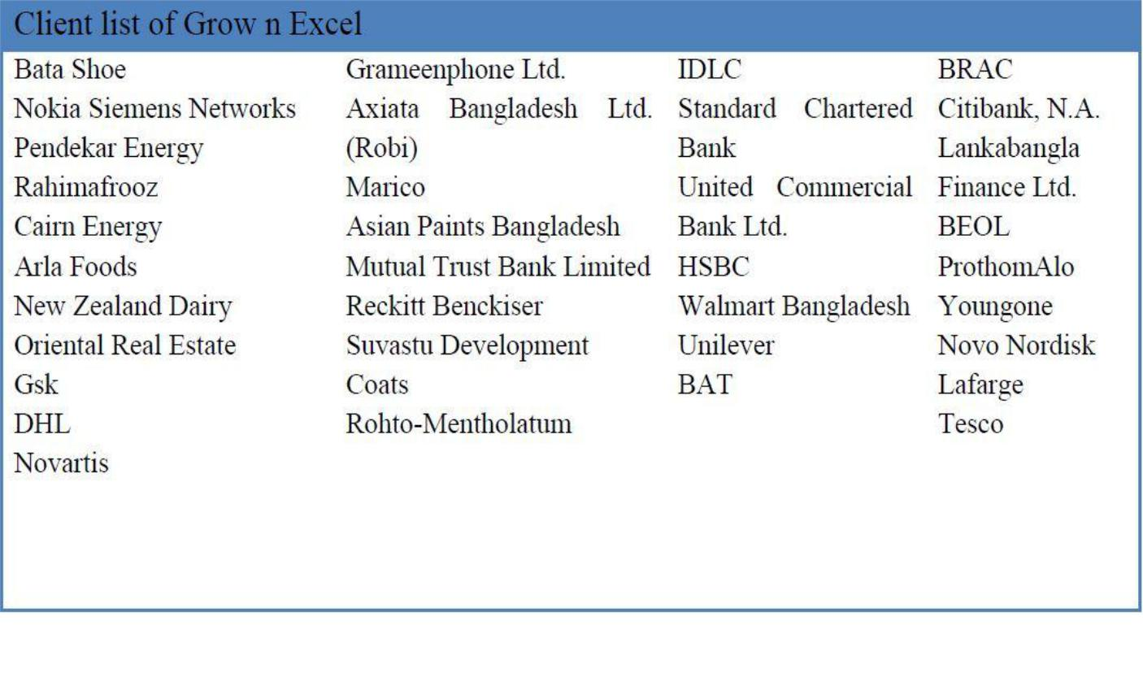

Figure 3: Clients List of grow n excel

Grow n excel known as a highly reputed HR firm in Bangladesh and it is quite clear because of their clients list. Most of the Multinational Companies and Large Local companies rely on grow n excel for all HR services.

4.3HRIS Administration:
HRIS is a private server of grow n excel. It is a branch where all valuable data are stored. In this server they stored all the resumes of people who are looking for jobs or who are looking for better opportunity. All resumes are stored in a segmentation wise and these segmentations includes Company wise segmentation, Industry wise segmentation, designation wise segmentation and department wise segmentation. One of the main products of grow n excel is resumes and this is very valuable asset for the company. For the protection of this server a professional computer engineer presents all the time and ensure the security and reduce the threats. All resumes are updated in a regular basis with the help of some trusted sources of the company which are Bdjobs.com and LinkedIn. When headhunting team wants to find out candidates for any job positions then they just log into the database and search for candidates. From this database they can find out a candidate who fulfills the required criteria.

4.4Headhunting Process:

The process of headhunting is quite similar compared to any other HR consultancy firm in the country. But for some reason grow n excel is one among many.

4.5Communication:
When an organization or client wants to take any service of Grow n Excel, they usually go to the company’s website where all the basic information is given. This basic information is company’s location, telephone number, services provided by them, clients list and reputation in the market. Though reputation of the Grow n Excel in the market is varied in a different way by their clients. Clients do not get the information about company’s in the website rather they get the information from other sources such as WOB- word of mouth, social media and individual client/ organization who has taken the service before and given a good feedback to others and company’s website as well. After that through hotline number they call and fix a meeting with company’s headhunting team leader. Then client representatives visit the office and they discuss in details about the services which they want to avail. Then company gives an offering to its client where all the necessary conditions and information are confined. If all the necessary terms and conditions are agreed by client then they are required to send a mail in official mail address where they agree all the company’s policy and want take the executive search service.

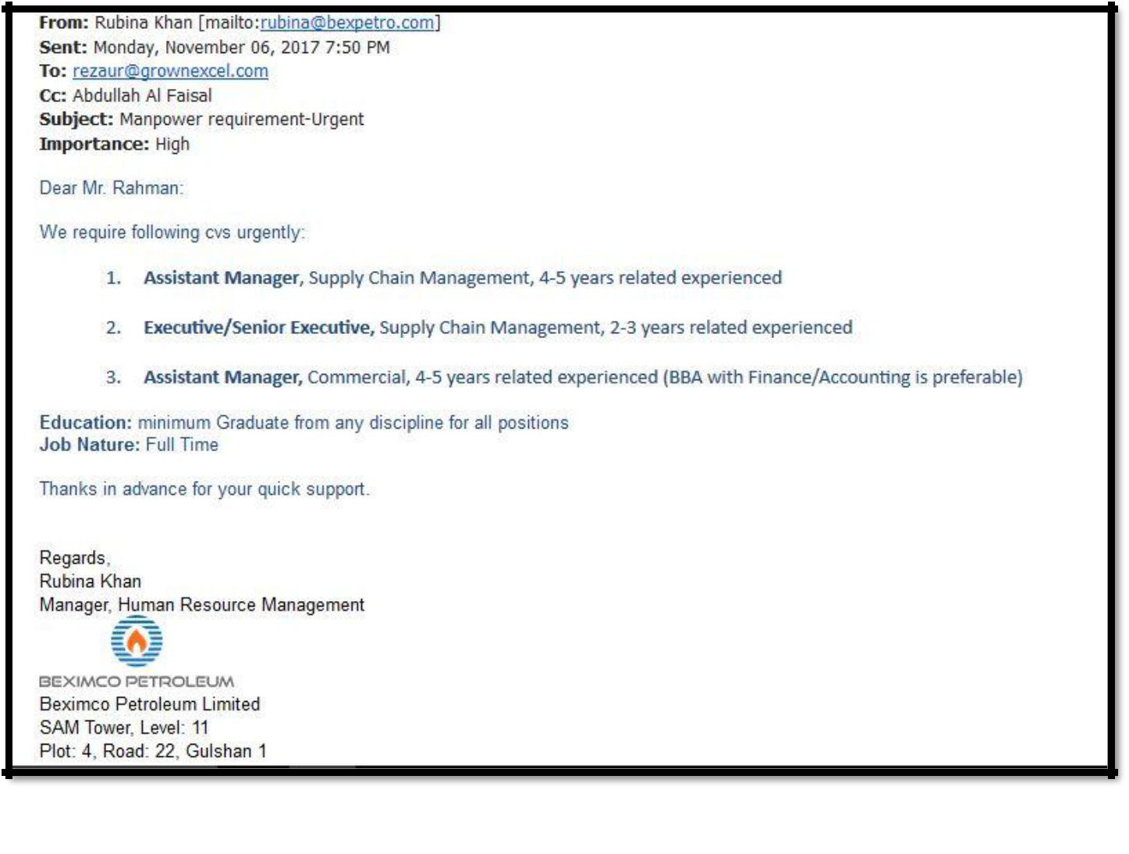

Figure 4: Client email for work order

4.6Job Description:
After that client sends the job description to the headhunting team for different positions and sometimes it can be one position or can be more than one. The team leader divided the work and assigned every member for different positions according to their expertise. Then everyone thoroughly studies each job position according to the job description they received. After that they set a benchmark for different positions. Every company has its own benchmark and everyone studies this benchmark through looking at profiles of the existing people who are currently or previously worked with this position. Along with this all other criteria are set first such as education, experience, current or previous company status, industry and etc.

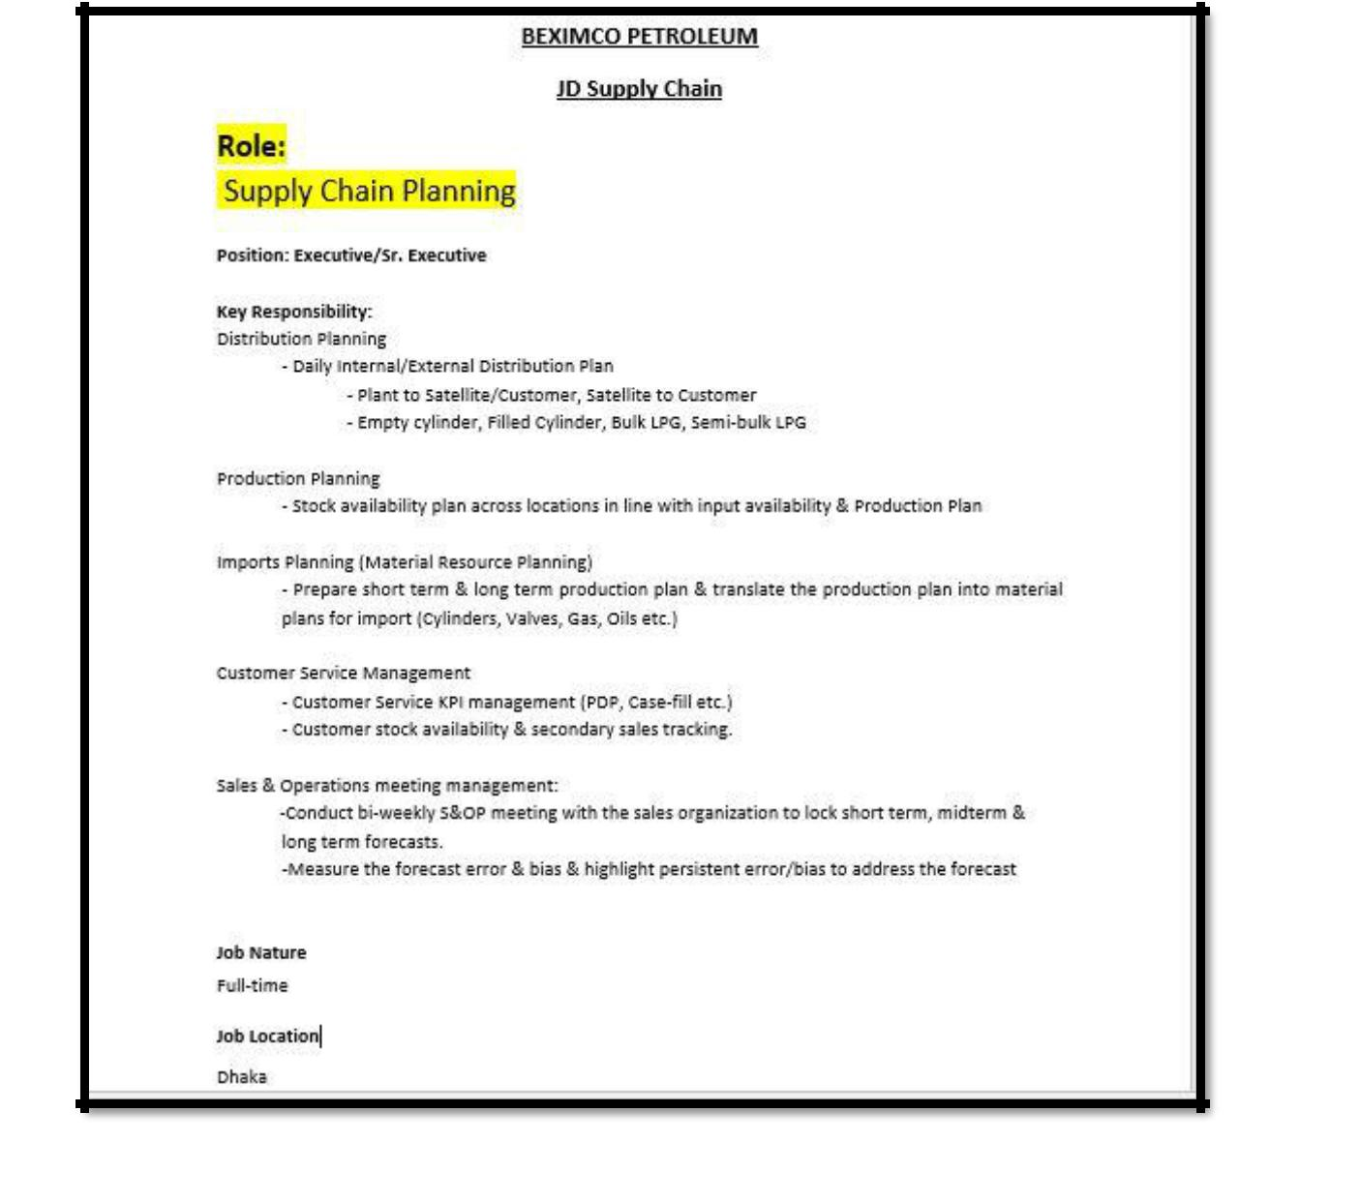

Figure 5: Job description

4.7Resumes:
When all indicators are set the members search for the resumes which are exact or 70 - 90% match with the job description. Most of the time it is difficult to search resumes which are 100% match with the job description they provide but sometimes few resumes’ match 100%. Because each member form headhunting team goes through 150-200 resumes for each position where they can match the resumes with the job description and find out the accurate candidate for the position. From these candidates, 25-45 resumes are shortlisted for review to the leader who gives the ultimate positive sign for approaches these shortlisted candidates. The team member approaches each of candidates by calling them and share the ideas regards the client and the company is working with and the job position. Then they share them the duties and responsibilities for the position, salary range, all other benefits as per organization. If candidates feel interested and agree with all the conditions then they are requested to send their updated resume in the official mail as early as possible. At the same time, they notified the candidate if he or she is applied for this position before such as within 1-1.5 years then he or she will not be allowed to apply on this position again. Eventually 10-15 candidates are agreed for the positions and send their resumes in the official mail.

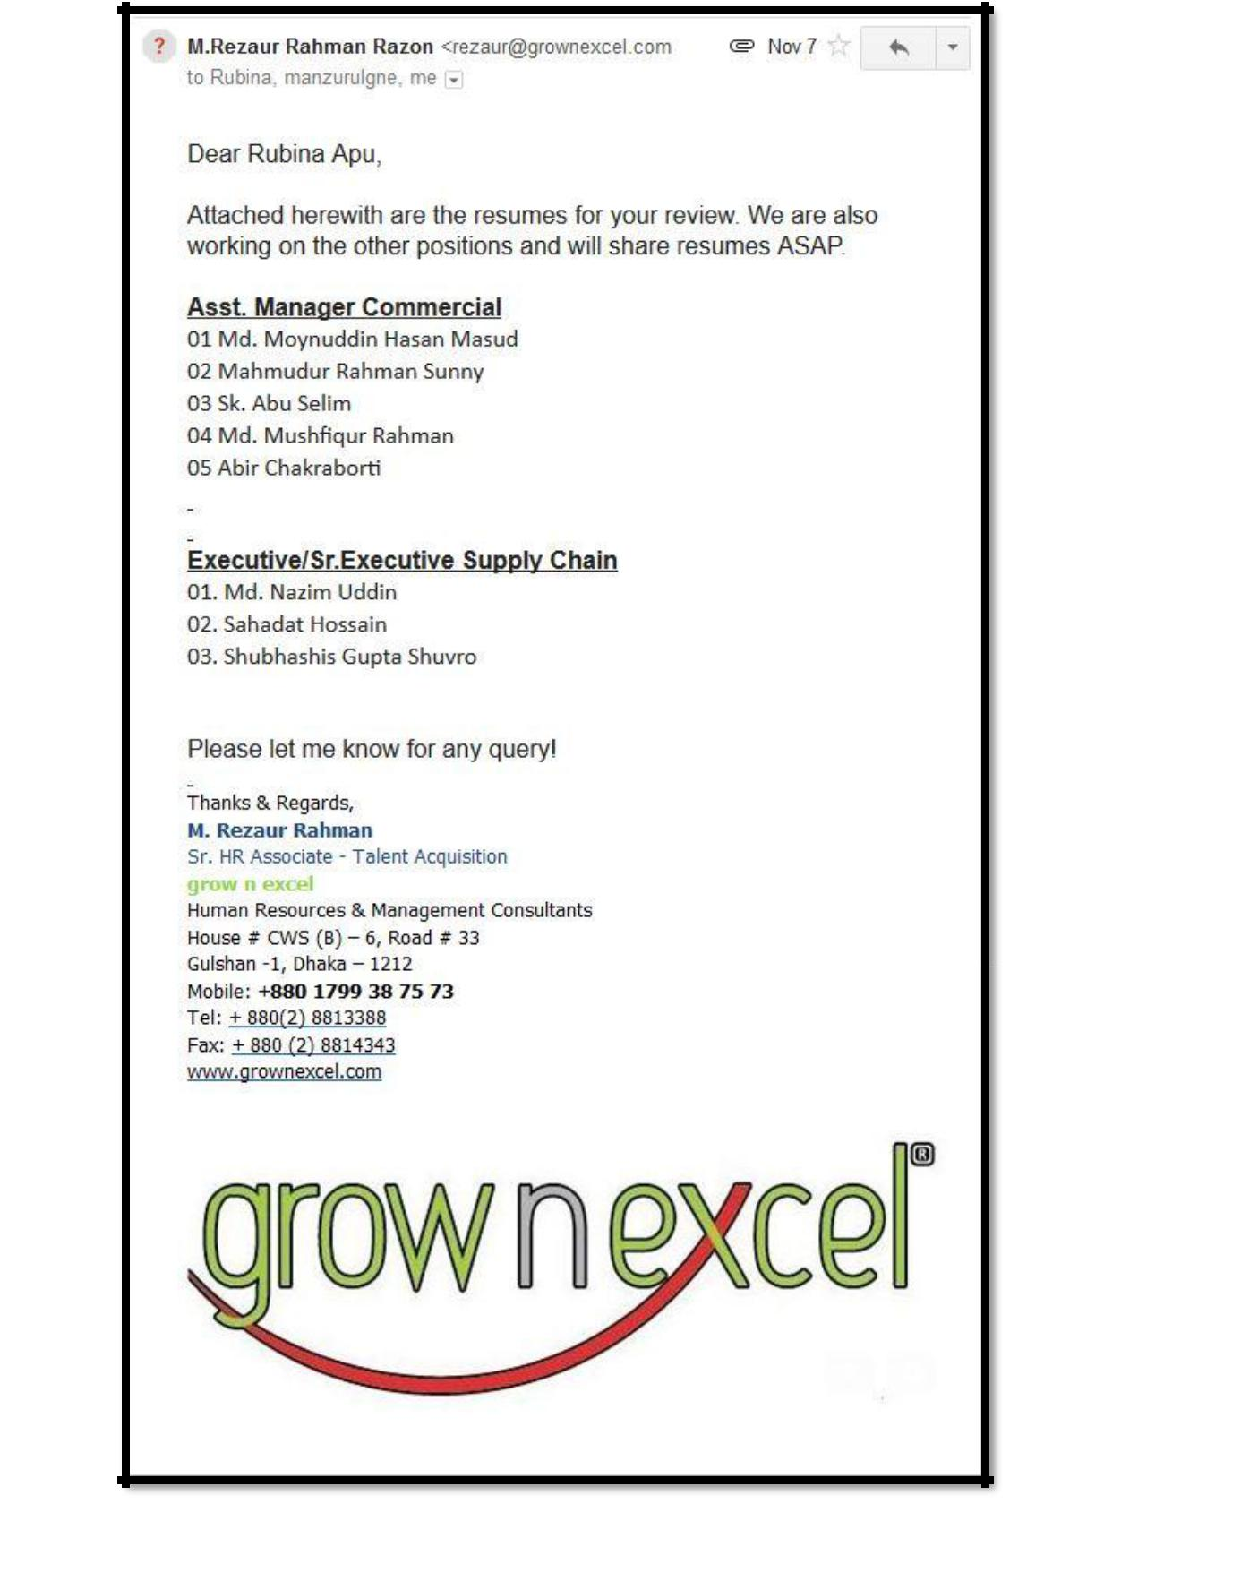

Figure 6: The Pool of CV’s send to the client

4.8Branding & Mapping:
All the selected resumes are finalized by the team leader and branding all the resumes. Branding is putting the company logo on the CV and deleting any unnecessary things and rank them according to their ranking percentage (Figure 7 is given below). Then all the resumes are attached in the official mail and sends them to the client. After getting all the resumes, client review all the resumes and if everything is good, they inform the company about the interview schedule (Figure 8 is given below). If client is not satisfied with the resumes then company has to send more resumes to the client and the entire process is repeated again. When client is finalized the pool of candidates then company makes the interview schedule where time and date are specified. With the consent of both client and candidates the team leader fixes the time and the place of meeting. Then all the candidates are called again to inform about the interview place and time. At the same time the interview schedule is sent to the client and clearly mentioned the starting time and ending time for each candidate and everything such as when each and every candidate is supposed to come. On the day of the interview each candidate is again notified through a mobile text as a soft reminder and call them before the interview take place. All the resumes are stored in a excel sheet where all the main information such as name, phone number, years of experience, company, industry, job position, education and this is called mapping (Figure 9 is given below). It is an effective database for the company’s future. After conducting the interview, the client selects the candidates and send a formal mail to the company regarding the interview feedback where they mentioned the selected candidates name. When all the positions are filled up, the client clear the payment according to the agreement. Finally, the company receives the feedback from its client. Adding a little more, sometimes the client has to take the interview session in the company’s office and the company has its own interview room where the client can easily conduct the interview session.

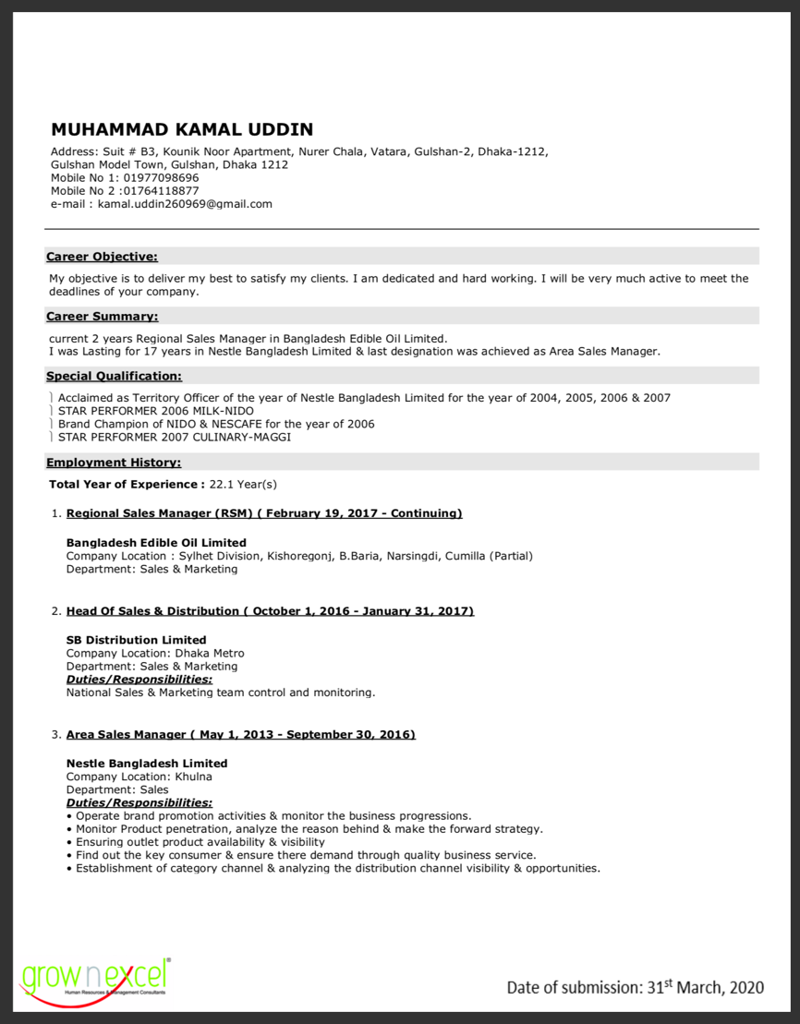

Figure 7: Branding

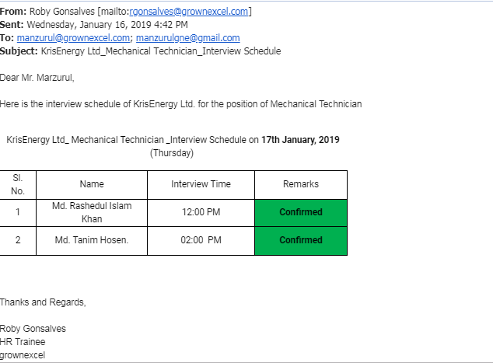
Figure 8: Interview Schedule for Clients
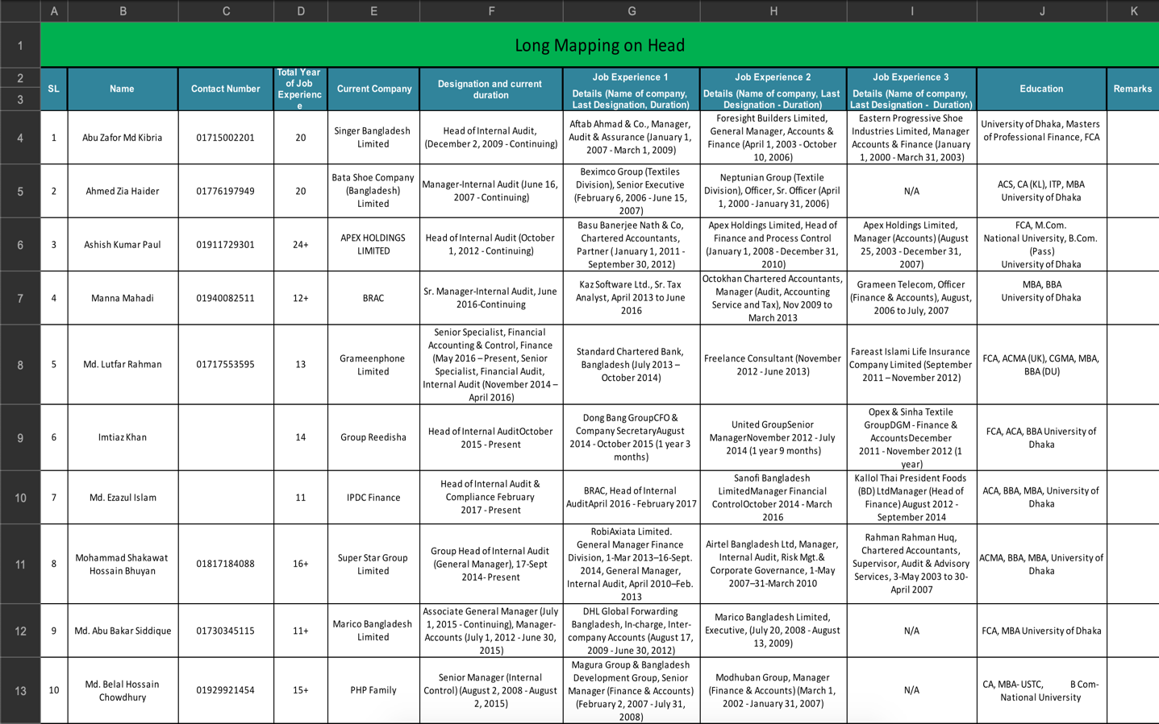
Figure 9: Mapping
Grow n Excel provides this headhunting or executive search service over the span of 10 years, it makes the company more bigger and stronger and now it is capable to place candidates form mid-level to top-level position such as CEO, CFO, CMO, CA, FCCA, ACCA, MD, GM, AGM, DGM, etc. Grow n Excel has placed all these top positions to multinational companies such as Marico, Unilever, International Beverage Private Limited, Citi N.A., to local companies such as Transcom Limited, Rangs Limited, etc. Grow n Excel is planning to take its function internationally by launching its operations globally.

4.9Recruitment Process Outsourcing (RPO)

Grow n Excel offers Recruitment Process Outsourcing to the clients where the company gives top to bottom recruitment solution. Grow n excel works as a third-party strategic recruitment partner from the beginning of the organization that is from the benchmarking till the employee joining in a particular position. A client organization can save their cost and time through this Recruitment Process Outsourcing (RPO). Apparently, it is very beneficial because it ensures the amount of highly maintained professionalism where a potential candidate is approached. Since, the company is very much concern about core requirements, so there is low scope for wrong recruitment. In addition, the client organization’s brand is portrayed clearly, so it helps to get a clear idea about the organization and position to everyone including candidates.

Grow n Excel has three form of RPO service and these are given below:
- End to End RPO: An organization’s total recruitment service is provided by the company.
- Project RPO: An organization’s short-term projects are provided.
- Partial RPO: An organization’s selected portion of recruitment service is provided.

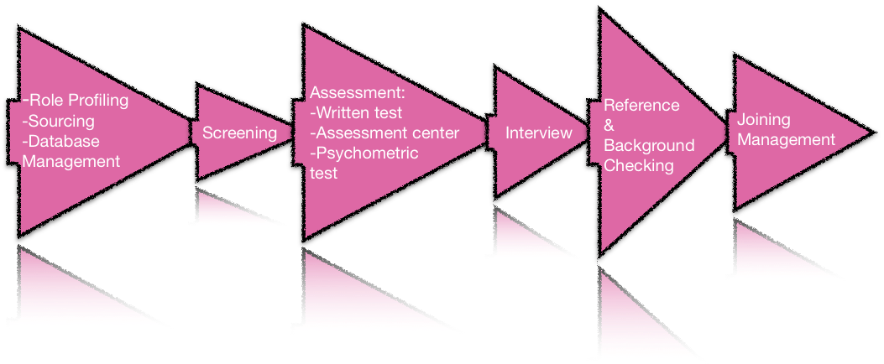

- Role Profiling: Role profiling starts when client share the job description with the headhunting team. Through JD the headhunting team clearly understand that which types of candidates they are looking for. The headhunting team also studies the profile of people who are already working in the organization and it helps to understand the quality of employees. After examine the job description and employee’s standard a benchmark is created where they also include the work experience, education, industry, functions, etc.
- Sourcing: When benchmark is done, the team members are started to searching the resumes or profiles who are fit for the position. They find out these resumes through own CV bank, social media, networking and phone calls. Sometimes, it is hard to match the resumes 100% with the expected requirements, but 80-90% is much common it that case. All the resumes are finally selected and discarded through the team leader and selected resumes will go the next process.
- Database Management: Grow n Excel maintains a well structed database management system where they store all the resumes. They stored these resumes in a format that includes necessary information such as name, current organization, previous organization (If available), education, experience and phone number.
- Screening: In this process, the team members closely match the resumes bases on different standard such as skills, extra-curricular activates, achievement, experience and other important standard set by the client. Sometimes, clients proffered multinational job background candidates or IBA background candidates. After shortlisted the candidates they are called for sharing about the job opportunity. If they are interested then they are informed about the written test and other details.
- Written Test: GNE steps through the composed examination in type of MCQs, survey, explanatory, science and English language. After conducting the composed test, they analyzed and distributed the outcomes and afterward welcomed the shortlisted contender for additional appraisal.
- Assessment Center: The shortlisted candidates are given real life situations such as case study and this case study is based on organizational functions and operational challenges. The candidates are judged based on how they deal with it. This assessment conducts through the group discussion, one to one interview, presentation and behavioral observation.
- Interview: According to authoritative approach GNE conducts competency-based meeting which implies the competitors have coordinated for required social pointers. The team is highly collaborated with the customer to comprehend the skills of the position.
- Reference and Background Checking: Grow n Excel provides this particular service to make organization more competitive. Because most of the time organization face huge amount of problem due to poor reference and background check.
- Employment Verification: Grow n Excel verifies the candidate’s job duties and responsibilities which ensures that he or she is employed in that position before. They also gather other feedback form the organization that he or she have been worked. All reports are then sent to the client.
- Education Verification: Grow n Excel verifies the candidates’ educational certificates and make sure that all the certificates are original. All the reports are then sent to the client.
- Joining Management: Finally, Grow n Excel handle all the important procedures for the candidates to join the organization. At the same time, they give all the important documents of candidates to the client.

Chapter 5: Analysis

5.1Time Frame for the Headhunting Process:
The Headhunting team follows a specific time frame for headhunting or executive searching. Because when a client wants to take this service from Grow n Excel, they also approach other headhunting companies to take the same service. So, there is a big competition available in the market. Every headhunting company or HR company wants their resumes of candidates to be accepted by the client. It is important to hit the right candidate in the right position in the right time because, the company’s profit depends on the number of hits i.e. number of candidates accepted by the client. All these resumes or candidates are collected from reliable sources such as linkedIn, Bdjobs.com and private database. But LinkedIn and Bdjobs.com are common because everyone can easily access but in case of Bdjobs.com it is bit difficult because without buying a membership it is impossible to get access in the CV bank. Though these sites are common so, many candidates become uninterested in sharing their resumes because other company already approached them. Then it is hard to find a right candidate within a short time. To measure a right candidate for a position they observe his or her education, experience, duties & responsibilities, current working company and industry. But most of the time all headhunting organizations are very much concern about the experience of an employee. Because candidates with higher experience, working on the similar industry and performing similar duties & responsibility lead to produce higher productivity and efficiency and organization can easily achieve their goals and objectives. The headhunting team member takes one- or two-week time to source, screen and deliver right candidates for the interview. Sometimes, it takes more than two weeks to get a right candidate for the position and in that case whole team gives a lot of effort to get a right candidate. But this kind of scenario is quite rare. Grow n Excel was able to provide quality service to its clients within the time frame for the past 10 years (Figure 10 is given below).

Figure 10: Graphical Representation of Time Frame for the Headhunting Process

5.2Contribution of Grow n Excel in the job market:
Grow n Excel is one of the leading HR firms and its reputation in the job market is significant. Grow n excel has been filling position in the job market from the very beginning of its journey. Most of the famed industries are relying on its service for many years. So, many MNC and Large Local companies come to avail its service for its high quality and timeliness. Grow n Excel follows a theory which known as TIC. This theory is formulated by leading consultants and everyone is bound to follow this theory in every steps of their job. It has been given below:

Timeliness refers that all the members of headhunting team take time for completing a task. Timeframe is important for headhunting or executive searching because there are many rivalries exist in the market and if they are failed to find out right person in the right time then the opportunity will go to the other competitors in the market. So, headhunting team members select right person within a timeframe by searching, sourcing and shortlisting of candidates.
The headhunting team members are always curious about their project they assigned for and this is called inquisitiveness. While headhunters are highly focused about their project for which they can ensure high quality services to the clients. When clients are highly satisfied with the services then they refer other organization to take the same services.
Completeness exposes the full quality services that provided by the GNE. When team members are working on a position and they filled the position then they have to ensure the high quality of services where clients are fully satisfied and received the full package.
GNE playing a gainful and effective job for as far back as four years. Simultaneously, they had the option to satisfy the customer’s request and this happened in view of the basic access to the database and preparing programs that the talent scouts needed to experience in the wake of joining the organization. As organization earned a decent notoriety, organization is getting huge measures of customers and employment positions to fill. In 2017 "Grownexcel" topped off around 120 places of 20 customers, though its rival HR Kites topped off around 75 positions. The organization was filling immense the quantity of occupation position throughout the following three years in view of the quality and effectiveness. In this circumstance, HR Kites couldn't adapt up to the consummation in the market and shut down its business from the market. Around then there was another rising firm known as Talent centric in the market that was a danger for grownexcel. It is as yet matching in the market straight on. In 2019, develop n exceed expectations was fit to fill in excess of 170 places of 35 nearby and global organizations. The organization accepts that the number will develop sooner rather than later. (Figure 11)

Figure 11: Contribution of Grow n Excel in the job market

5.3Grow n excel and its competitors:
Grow n excel runs its business with a high competition rate. Because there are a good number of competitors are running their business in the market. Also, headhunting business are becoming more commercial and popular in Bangladesh. Maximum organizations are doing outsourcing the recruitment process from various headhunting companies. And the outsourcing of recruitment process is becoming more frequent in many organizations because it saves a lot of time, money and extra effort. On the other hand, it increases the efficiency of the organization by placing the right candidates for the right position. The success rate of placing a right candidate in the right position is very high as the headhunting companies are specialized in the recruitment process. “Monowar Associate” is one of the primitive & toughest competitors in the market and they started their peregrination in 1992. They are toughest competitor to others because of their strong network in the market. As they have a strong network in the market, they charge a high amount of money than others to their clients for their services. Since, they charge a bit higher amount than others who are serving the same services, so many organizations do not prefer to take services from them as it increases the client’s cost. HR Bangladesh is another company who is competing in the market and becoming more dominating day by day which increases the amount of competition. But they charge less amount than other competitors but their services are not up to the mark. As a result, many organizations are not willing to take services from them. But nowadays, they are trying to upgrade their quality of services to attract and to retain their clients. Further, there are others competitors exists in the market such as, HR Connection BD, HR Kites, Talent Centric Ltd, HR services, Corporate Hub Ltd, HR Solution Bangladesh, Frontdesk Bangladesh (FBD) etc. Moreover, it is a pressure for grow n excel to continue their services up to the mark to their clients. (Figure 12)

Figure 12: Grow n excel and its competitors market share

5.4Client’s Response and viewpoint
It’s been a very quiet extensive period of time Grow n Excel has been serving the industry. Also known to all in the market for its virtuous and dynamic leadership in its respective field. As a sustainable reputation the clients trust them and rely on their productivity.
Now a days the most basic problem in this country is lacking of jobs. Though its not because there is immersive poverty of jobs rather the main difficulty is to finding out the right person for the right position. This lack of optimization this country has been facing for a quite long time and people knows that people are the problem here. What becomes more pandemic is recruiting candidates for a wrong position. As a result they fall off from performing well what they supposed to do.
Here Grow n excel had a lot of opportunity to do and they did. They provide their candidates suitable jobs matching with their qualifications, skills and expertise. They knows what they are good in and following that track line they achieved their goals with a visionary forecast plan. With their intensive help candidates are being abled to increase their efficiency and productivity.
A survey was done for the report on that segment to evaluate client’s feedback. Based on that some analysis and interpretation. The trusted and regular clients has been asked out for questioning. A total of 10 clients have participated.

5.5The result of the survey:

1 . Have you ever been under Grow n Excel’s consultancy?
- Yes
- No

Interpretation: 10 organizations took the services of Grow n Excel. Grow n Excel completed servicing those companies with proper extent. However, from this survey it can be determined that all organizations took the services of the company who are selected for this survey.

2. What is the frequency of your outsourcing using its recruitment process?

- Not very often
- Sometimes
- Occasionally
- Often
- Frequently

Interpretation: 10 company participated in the evaluation and among them 6 companies voted on NOT VERY OFTEN. It’s not because they used to go for other firm or any kind of issues. Its because they just don’t need employees frequently and they keep working on their existence employee’s performance. Four of them take frequent service as they outsource their recruitment most of the time and rely on Grow n Excel and its service capability.

3. How comfortable the outsourcing of the recruitment process of Grow n excel?

- Very uncomfortable
- Somewhat uncomfortable
- Neither comfortable nor uncomfortable
- Somewhat uncomfortable
- Very comfortable

Interpretation: By analyzing the survey it seems like four organizations are in a neutral level of outsourcing the recruitment process of Grow n excel. Also, can be seen that four of them are comfortable with the process but not that much because of their company’s confidentiality. And the rest of the two are highly comfortable with the process and completely satisfied.

4. Have you got the services in due time?

- Yes
- No

Interpretation: The survey says that the punctuality has been considered strictly here. Most of the cases has been handled before the deadline. Seven organization were satisfied with their on time delivery which increases their efficiency to a peak level. On the other hand there are some 3 organization who were not delivered properly because of their own internal complications.

5. Does the candidates who took Grow n Excels consultation got desired position?

- Yes
- No

Interpretation: Grow n excel has always been providing the best suited position for their candidates. From the survey the ratio of satisfied candidates proved that statement once again.

6. Does the services of Grow n excel could satisfy you ?
- Yes
- No

Interpretation: So lastly it is vividly observable that all the candidates are extremely satisfied by the service of Grow n excel. Their services helped the candidates to find out the best position available according their skills, knowledge and expertise. Grow n Excel eventually helped those fall off companies and boosted up their efficiency and productivity.

Chapter 6: Findings

&

Recommendations

6.1Findings
Though Grow n Excel is not a giant firm in the market but it carries a fantastic reputation. Not more than 40 employees are working here but all of them are performing their best to make this firm one of the leading firm in the industry. In my 12 weeks intern I have gone through many assignments given by them and I figured out some points which is going to be discussed in this part.

- Task composition: As already mentioned above that the total number of employees are not so big it sometimes making trouble to cover up the pressure of command. For example, If CEO order any employee to call up a candidate and decide to taking care of any exceptional case. Sometimes its becomes messy for an individual to cope with the changed order . Though its not a problem that cant be solved but working on it lately will cast hard in future.
- Resources : Though it has enough resources but some resources are outdated and not usable at all. It becomes difficult for those employees who’s performance is hampered by those lack of resources productivity. So its necessary to update those tools and technologies for the sake of better performance.
- Data management techniques : A change is needed in the database management system of Grow n excel. There are lots of candidates standing outside with a resume in hand also in their phone. Grow n Excel help those individuals who deserve a convenient position based on their capability. To make it more easy and hassle free Grow n excel should update its online resumes submission system . So that candidates can edit and update their data on real time. This will increase the quality of the candidates.
- Office appearance: Grow n Excel does not carry the up to the mark trending set up in its office premises. But it works out smoothly in its daily corporate activity. The office is specious and well decorated. For setting down and working on things comfortably for the individuals there are enough arrangement. For meeting purposes and interviews of organizations board rooms are available and it is very important as many are scheduled to happen in these places.
- Supervisory backup: Superior supports toward the subordinates is beyond expectation. They help the juniors on official and unofficial things as well. They help them learn techniques of LinkedIn and BDjobs.com. Also advice them how to use them properly. Those who is not that much tech savvy get to knows things which will be needed for them in near future. Superiors try not to make things work out by pressure rather they always clarify why the task is important and how the outcome will leave a mark on individuals KPI.

6.2Recommendation:
As I gathered an experience from grow n excel for 3 months,then I have seen a lot of things from which I found some gaps which need to fill up as soon as possible. Also, these recommendations can make the business process more effective and more efficient. The recommendations are given below:
1.The process of headhunting is quite traditional and old and they should upgrade the process of headhunting to be more effective.
2. There are less technical resources available and IT support is not satisfying which create an extra pressure for everyone. Also, maximum computers are not so fast as a result, time to deliver the service to the clients gets hampered. So, company should upgrade the total technical support.
3. In headhunting it is quite normal thing that searching resumes all the time for find out the best candidate for clients. To do this headhunting team maximum time source resumes though Bdjobs.com and there are outdated resumes available which is time consuming to filtering those resumes. If company makes a deal with Bdjobs.com then they can supply us with the updated resumes and it would be faster for executive searching.
4. Since, communication channels are important for headhunting, so each employee is given a personal phone number from the company. But the phone cards are not always available for use but it should be ensured that the cards are always available.
5. There are a lack of motivational tools and employees are not feeling motivated to work harder. So, top management should increase the motivational tools such as incentives and rewards for better outcomes.
6. Work environment should be upgraded. Employees are feeling less comfortable with the working environment because of inadequate light, dust, sitting arrangement and washrooms.

Conclusion:
As I mentioned it before, grow n excel is one of the leading HR consultancy firms and so far, it has held a better position than others. It’s been about 12 years since the journey began of this company and they completed this very successfully. The main target of this company is to reach beyond the border. During this pandemic, the company has done very well and they applied an appropriate practice of working from home. Also, the company has the experience of working with different multinationals and large local companies. FMCG, telecommunication, RMG, IT and etc. are also part of this experience. The company directly helps all the candidates to express their inner potential to the various multinationals and large local companies. On the other hand, all of their clients get advantage where they can hire right people in the right positions. Moreover, company wants to expand its wings overseas and complete internationally.

Appendix:

Survey Questions

NAME: Md Sadiuzzaman Sony
ID: 111 161 381
INSTITUTION: United International University
PURPOSE OF SURVEY: INTERNSHIP PROJECT
EFFICIENCY & EFFFECTIVENESS OF THE SERVICES PROVIDED BY GROW N EXCEL.
 PUT A TICK MARK IN THE CIRCLES BELOW.

1 . Have you ever been under Grow n Excel’s consultancy?
- Yes
- No
2. What is the frequency of your outsourcing using its recruitment process ?

- Not very often
- Sometimes
- Occasionally
- Often
- Frequently
3. How comfortable the outsourcing of the recruitment process of Grow n excel?

- Very uncomfortable
- Somewhat uncomfortable
- Neither comfortable nor uncomfortable
- Somewhat uncomfortable
- Very comfortable
4. Have you got the services in due time?

- Yes
- No

5. Does the candidates who took Grow n Excels consultation got desired position?

- Yes
- No

6 . Does the services of Grow n excel could satisfy you ?
- Yes
- No

Interview Questions:

1. How much time does the headhunting team of grow n excel take to source, screen and deliver right candidates for the interview?
- Figure 10

2. How much time does the competitor take to source, screen and deliver right candidates for the interview?
- Figure 10

3. How many positions are filled by Grow n excel for past 3 years?
- Figure 11

4. How many positions are filled by the competitor for past 3 years?
- Figure 11

5. How much market share the competitors have?
- Figure 12

6. How much market share does the gorw n excel has?
- Figure 12

7. How does grow n excel do CV sourcing?
- Section 5.1

8. How much contribution does grow n excel has in the job market?
- Section 5.2

9. Which theory grow n excel follows for headhunting?
- Section 5.2

10. Who are the main competitors of grow n excel?
- Section 5.3

References

Bibliography
Singh, R. (Feb 11, 2017). Recruitment Process. Gaurav Mehra.
contributors, W. (2020, july 9). Executive search. (T. F. Wikipedia, Producer) Retrieved July, 2020 from https://en.wikipedia.org/w/index.php?title=Executive_search&oldid=965355640
Stolle, B. (2015, September 17). Headhunting Basics (Part 1). Retrieved july, 2020 from www.forbes.com: https://www.forbes.com/sites/bryanstolle/2015/09/17/headhunting-basics-part-1-when-to-engage-a-professional-search-firm/#5fba43011c59
Hussain, M. Z. (2009, june 1). Grow n Excel. From Grow n Excel : http://www.grownexcel.com

