Internship Report on
Recruitment and Selection Practices of
Pakiza Knit Composite Ltd

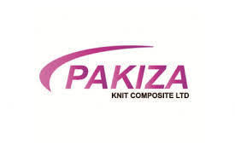



Course Title: Internship
Course Code: INT 4399

Prepared for
Piana Monsur Mindia
Assistant Professor
School of Business & Economics
United International University

Prepared by
Israt Jahan Eti
111 161 115

Submission Date: 21st December, 2020
Letter of Transmittal
Date: 21st December, 2020
Piana Monsur Mindia
Assistant Professor
School of business and economics
United International University
Subject: Submission for Internship Report on “Recruitment and Selection of Pakiza Knit Composite Ltd.”

Mam,
With great pleasure I am submitting my internship Report on “Recruitment and Selection on Pakiza Knit Composite Ltd” which is situated in Savar and this is a BBA program of United International University.
I have tried my best for doing the report well and creative though the information is collected both internally and externally. I hope you will find the report interesting and significance of the information which I put in it. With your proper guiding I have learned a lot from this report and provide a good opportunity to work with corporate environment name Pakiza Knit Composite Ltd I have found the study quite interesting, beneficial & insightful.
Finally, I would be wondering if you go through my report and give your assessment to my work considering my limitation.

Yours sincerely,
………………………
Name: Israt Jahan Eti
Id: 111 161 115
BBA Program (HRM)

Acknowledgement
At first, I would like to express my gratuity to the almighty to giving me the strength and blessing to complete my report. This report won’t be possible without my honorable mam and organization’s support.
I am very much thankful to my internship professor Piana Monsur Mindia, Assistant Professor, United International University to guide me throughout my internship period give me suggestions and motivate me to make the report standard and informative.
I would like to thank my immediate supervisor Omar Faruk to kept me informed about the operation and help me to complete this report and also Head of Human Resources Management for helping me to be a skilled internee and gave his honest opinion to improve my quality and provided me his experience and important information to get my report done.

Executive Summary
The report has done with my personal experience and my own point of view and I have tried my best which task I have been assigned to. The time was three month for my internship under the HRM department of “Pakiza Knit Composite Ltd.” And I have tried my best to know their policy and understand how their work is going on for completing my report. I have divided six chapters which I have known or from my experience thoroughly.
In the first chapter, I have included about the background, source of the data or information, and some restriction that I faced in the organization. In the second chapter I have given briefly discuss of about the company including mission, vision and the organization structure. And all of these parts I have done by taking help from the organization official website except organization structure. The third chapter has deeply discussed which I learnt about HR function of Pakiza Knit. And I have discussed all other data about function and the department related where I worked for. I have also added ORGANOGRAM of this organization. After that I have added some analysis from my point of view and five some recommendation which the organization can use or change for their better environment though I’m not an expert.

Contents
Acknowledgement iv
Executive Summary v
Chapter 1 8
1.1 Introduction 8
1.2 Origin of the Report 8
1.3 Objectives 8
1.4 Methodology 9
1.5 Limitations of the work 10
Chapter 2 11
2.1. Introduction of Pakiza Knit Composite Ltd. 11
2.2 History 11
2.3 Mission, Vision, Value Statement 12
2.4 Product and Services of Pakiza Knit Composite Ltd. 13
2.5 Organization Structure 13
2.5.1 ORGANOGRAM 14
Chapter 3 16
3.1 HR functions of Pakiza Knit Composite Ltd. 16
3.2 Recruitment and Selection 19
CV Sorting 20
Recruitment: 20
Selection: 20
3.3 Training and Development: 21
What is Training and Development? 21
ON the Job Training: 22
OFF the Job Training: 23
Chapter 4 24
Analysis of Data 24
Findings 29
Chapter 5 30
Recommendation 30
Conclusion 30
Reference 31
Bibliography 31
Appendix 32
Questionnaire 32

Chapter 1

1.1 Introduction
For completing the graduation Internship is the last step. I particularly involved with their ‘Recruitment and Selection’ where I have learned many things including how they are taking skillful and potential employees that increase the revenue of the company by them and how they can increase their sales. During my internship period every single step was crucial and by the time being I have overcome the entire process. This internship provides me lot of knowledge and help to boost my ability.

1.2 Origin of the Report
For the purpose of internship requirement of my Bachelors of Business Administration (BBA) program of United International University I have made the report and I have learnt various things of Human Resources Management by getting helped from Pakiza Knit Composite Ltd in Savar, Dhaka.
1.2.1 Scope of the Report
In this Corona Pandemic, for doing the report I have got so many limited and restriction. I have maintained some official formality also for the collection of some report data. Though there had so many restrictions but I got so many scopes to learn many things. So with this report there is a clear idea about the practice of Recruitment and Selection. With this, the report covers with their HR function, how they act when they need skilled people or about their training when they need.

1.3 Objectives
The main objectives of this report to prepare Recruitment and selection issue with the help of Pakiza Knit Composite Ltd. All the things I have included, this is for improving the employees of this organization.
The conclusive goal of Recruitment and Selection is to nurture and develop the internal workforce. It is worth mentioning that. Recruitment and Selection has improved the quality of not only the workforce but also the effect of good environment has seen all around the company.
The basic objectives are to find how employees are capable, skilful and satisfied to work in Pakiza Knit Organization and the process, methods or success of the recruitment and training by watching or observing employees work.
Some Primary Objectives:
- Developing Employees practices.
- Identifying some problems associated with the format.
- Analyze the current performance appraisal format and compensation.
- Employee Personnel practice.
Some Secondary objectives:
- Identifying inherent problems associated with the format.
- Propose changes mainly in the guidelines, format and management philosophy by keeping relevance with other processes.

1.4 Methodology
- Exact Scenario cannot be shown in accordance what I have collected from sources because of company’s confidentiality.
- There were so many challenges to cope up with various departments.
Primary sources:
I have done direct observation during the work and Practical work of daily basis.
Also there had face to face conversation with everyone. Human resource department was hesitant to provide information, because of difficulty in accessing sensitive data and information.
Secondary sources:
I have gathered information from official Websites of Pakiza knit Composite Ltd. And also from various reports, file folders, and Publications and different training materials. The secondary source of information was not enough to complete the report.

1.5 Limitations of the work
I got some Limitations for collecting the data. That can be for restrictions of Organizations policies or can be for the Pandemic situations. I give the information which I observe there, which got to know.
Also I put the information searching from their own website. There has lot of information’s for the Organizations. I was always sit in the desk and work which they give me the task. I also noted that information which they had given to me.
And I have submitted some information based on book.

Chapter 2

2.1. Introduction of Pakiza Knit Composite Ltd.
Pakiza Knit Composite Ltd(Mojidpur, Boro Bolimeher, Savar, Dhaka, Bangladesh), a knit fabric manufacturing giant, was successful in catching the early winds of the favorable enterprise in the world-class textile in Bangladesh and become standard of excellence in this sector.
Established in 2014, PKCL is now one of the largest knitting capacities within the country. PKCL never compromise with quality and drives timely production.

2.2 History
In 1982, Mr. Rafiqul Islam Khan, Chairman of Pakiza group start pakiza, a small retail store selling shares and printed fabrics. In 1984 they had started a local dyeing and printed factor, starts production. The factor at present dyes, print and finishes shares, salwar kamiz, shirting and printed fabrics. In 1991 high public demand was there. In 2001 and 2007 chairman becomes the director of City bank and Phonex Securities Ltd. And in 2013 Pakiza Knit Composite Ltd was established.
They got their official certificate from.
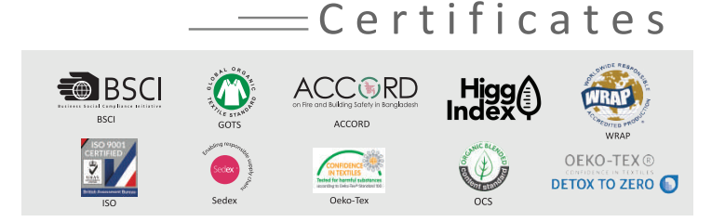
And their Customers are,
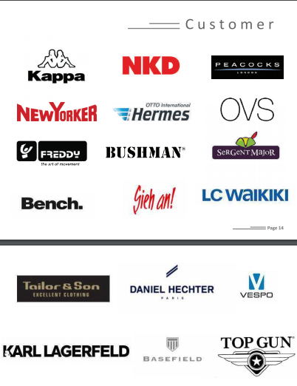

2.3 Mission, Vision, Value Statement
Our vision
In Pakiza our vision is to become a "standard of excellence" in product quality, business ethics and work environment.
Our Mission
To achieve our vision, our mission is to create a culture in Pakiza that supports our employees, so that they can provide excellent service to our customers.
Our Values
In Pakiza we take inspiration from Simon Sinek’s quote “Customer will never love a company until the Employees love it first.”

2.4 Product and Services of Pakiza Knit Composite Ltd.
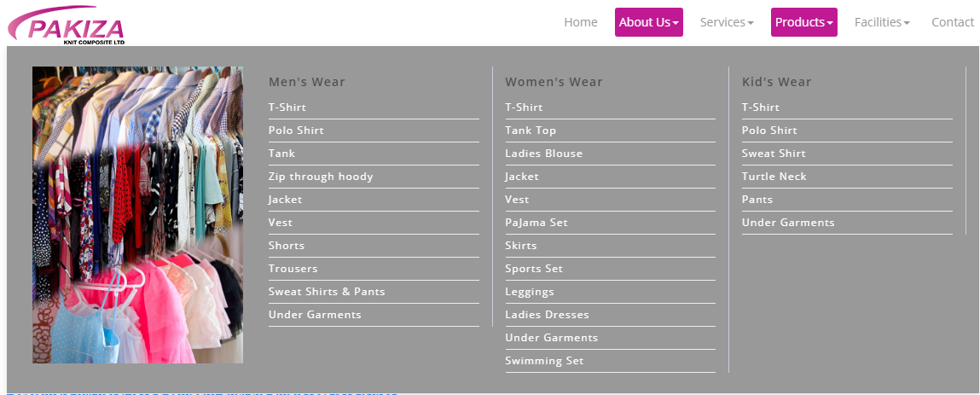
There also some other Services, those are:
- Sampling and CAD
- Knitting
- Dyeing
- Cutting
- Sewing
- Finishing
- Quality Assurance
- Printing and Embellishment

2.5 Organization Structure
The Pakiza Knit Composite Ltd is mostly based on “functional structure”. A functional structure starts with position with the highest levels of responsibility at the top and goes down from there. Primarily, though employees are organized according to their specific skills and their corresponding function in the company. Each separate department is managed independently.
Organizational Structure of Pakiza Knit Composite Ltd and Designation are in ascending order:

Top Management | Chairman Board of Directors  Board of Director  Managing Director
Executive Level Management | Vice President,  Senior Assistant Vice President,  Assistant Vice President
Mid Level Management | Manager,  Associate Manager,  Assistant Manager
Junior Level Management | Officer,  Junior officer  Trainee Assistant  Probationary Officer

2.5.1 ORGANOGRAM
We can see by this data that why this is based on functional structure.
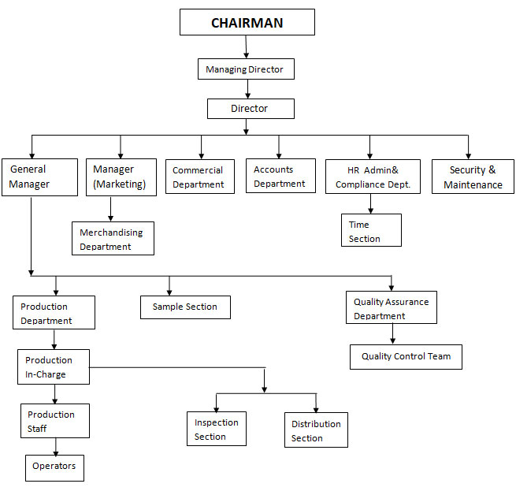

Chapter 3
Human Resources Management
Human resource finds the best employee to justify their work and make a good impact to the company. Without an appropriate person it is barely impossible to run a successful department without a good man power. They choose the best candidates and take care of employee’s benefits, compensation and others. They also observe the intern’s objectives.

3.1 HR functions of Pakiza Knit Composite Ltd.
There are so many functions for HR. As though I am doing report based on Pakiza Knit, so I am focusing some of the functions that I observe in the workplace. In below, I am giving some information’s about HR function based on Pakiza Knit.

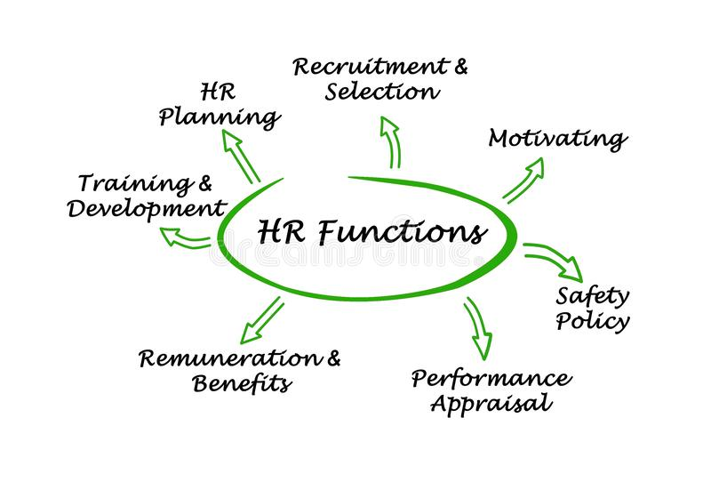

Pakiza Knit Composite Ltd has some function about HR; those are HR Planning, Recruitment and Selection, Motivating, Training and Development, Safety Policy, Rewards and benefits, and Performance appraisal. Though PKCL has functional basis Structure, HR work their best to give benefits to their Organization. Their following functions are:
- HR Planning: In HR planning, hr mainly plan about best people, that how many or what kind of organization need. Both focus on the where organization is now and what will effect in future for those plan.
For PKCL, they always plan for the best of best for their employee, organization. Pakiza plan is about their 1. Identify employee’s ability, 2. Then they develop the plan according to their employees, 3. Then they find the gap and increase the resources.
- Recruitment and Selection: This is all about selecting new and best skillful employees for the organization. If there is many skillful employees that will be advantage both for the employee and the organization.
For PKCL, they recruit and select some skilful employees by doing some mandatory steps that will be discussed below.
- Motivating and Compensation: There is positive term motivating which can help to improve the organization. If employees are not motivating enough, employees will not be competitive. And Compensation shall be exact for exact employees.
For PKCL, they always try to motivate employees by giving reward based on their work. Also they provide vacation for the upper level employee, but these are very rare.
And for employees, compensation pays 1, 8 and 9 date of every month. If in one month date 1 is Friday then the paid date will be 8 or 9.
- Training and Development: For developing employee’s skill, this is HR responsibility to train and develop every employee. For developing every gap between work and skill, training shall be needed.
For PKCL, if they feel that, the employee has potential the training and development will be there as organization policy. And if any employee feels that they need more training then that will go for probation for those employees.
- Safety Policy: HR plays an important role in creating and implementing health and safety regulations.
For PKCL, if there are 50% employees both upper and lower level of employee in a place, there will be safety issue for those employees. There will be a safety officer and safety assistant for ensuring that the safety is going on or not. And there will be a PC committee for a certain time under organization rules.
For example, in case of fire, they give some rules like not to lock the door where they are working or tools shall be there or training shall be given 1 time every 1 year.
- Rewards and benefits: No employees want to miss the reward or benefits which are given to them. Rewards which are including salary can help to grow their career opportunities, status, a good organizational culture and satisfying work-balance life.
For PKCL, they provide rewards who are well worker for their organization. They always provide maternity benefit for their employees. Their maternity benefit will go like “Total compensation/present*112 days/2” and the amount will get before leaving and it can be 56 days. The compensation can give 2 ways, total or half. And the woman will get leave before 56 days and her work will off. Also they provide 2 days leave if a employee works 3 month continuously.
- Performance appraisal: Performance management is important for measuring employee’s performance. That will produce best or good employees. There can be annual performance review or 360 degree feedback will be given by his/her manager.
For PKCL, They measure the employee’s performance under doing various methods like 360 degree or observing the employee. And they also maintain performance book

From this functions point of view, I only focused on the Recruitment and Selection, Training and Development of the Pakiza Knit Composite Ltd.

3.2 Recruitment and Selection


In this picture I have given slight information about PKCL that how they go through their recruitment process. Their process is,

In this process we can see, PKCL firstly published requirement for their needs in the organization. And then candidate will drop their CV according to their requirements. After that HR will select the best candidate and search that if there is any reference or not.
After that, candidate will come according to HR message. And they will wait to HR given place. And then if HR wants to recruit that employee they want medical report first for those employees. And after orientation and before joining national id, and some additional certificated necessary for entering the organization.

CV Sorting
CV sorting is the procedure to identify competent applicant using successively more elaborate test of the CV’s. The purpose of this process is to determine the candidates with proper qualifications for specific job. CV sorting helps to do slower the cost of taking an interview or taking exams. CV sorting also makes the process more effective and simpler.
Pakiza Knit also does CV sorting for choosing the right candidates among a cluster of candidates. Pakiza Knit normally give their requirements on websites like BDjobs.com. Pakiza knit also appreciates employees reference from current employees.

Recruitment:
PKCL recruit internally and externally:
- For Internally Recruitment PKCL prefers:
- Job posting
- Referrals from other departments.
- For Externally Recruitment:
- Advertisements
- Public or private agencies
- Field recruiting

Selection:
For selection, Pakiza’s HR focus about Employees,
- Attitude
- Knowledge
- Personal Ability (mental and Physical)
- Qualification
- Communication Skill
- Job Knowledge

3.3 Training and Development:


What is Training and Development?
Getting ready is highlighted indicating rapidly relevant data, aptitudes and mindsets to be used in a specific work. Planning may focus on passing on better execution in the present place of employment or to overcome future change.
PKCL always give training to their employees On the job Training and Off the job Training. Before that, Pakiza HR focuses some steps for Training Program.
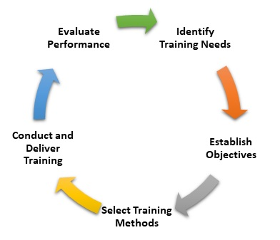
- Need Analysis:
- Specific job which is needed
- Search specific skill
- Task and Performance Analysis.
- Design: Search for information and gather objectives, media and description. Hr always makes sure that their component and materials clear to all.
- Methods: Introduce the training program.
- Implementation: Implement the training program.
- Evaluation: Reaction and Learning shall be there, if there is any problem rearrangement shall be there.

ON the Job Training:
Pakiza Knit HR gives training ON the job most of the time. Learner follows or observes the training physically in workplace then present what he/she has learnt. It is also quite inexpensive. And there is no need for place for learning.
- Job rotation
- Internship
- Seminars
- Assignments of special projects.

OFF the Job Training:
Pakiza Knit HR doesn’t apply OFF the job Training to their employees.

Chapter 4

Analysis of Data
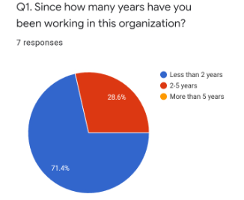
Q1. In this organization I got response mostly from who are less than 2 years. But not only have they guided me so well but also others who are working more than 5 years. Here we can see 71.4% are less than working 2 years and 28.6% are more than 2 years.

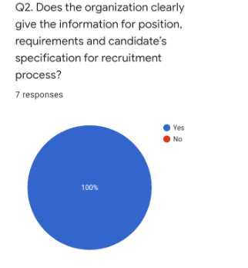
Q2. Here we can see 100% is saying that organization gave clear information about their requirement when they need employees.

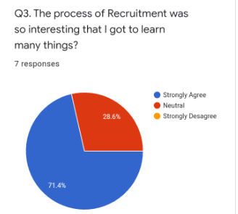
Q3. 71.4% is saying they are satisfied that the organization has very important and interesting equipment to learn many things. And others 28.6% maybe have lack of getting information.

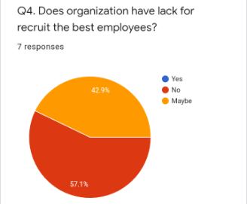
Q4. 57.1% is saying they are recruiting best employees for their organization and they are competitive. Others 42.9% are saying organization can also recruit or select best employees.

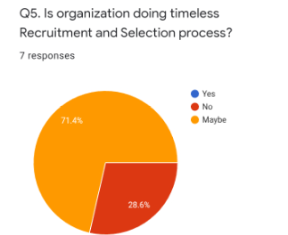
Q5. 28.6% think that, organization have their own time for recruiting employees. And 71.4% think that they recruit when they need the employees.

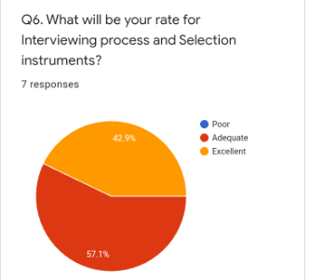
Q6. 57.1% is saying that, HR has enough instruments for examine the employees. 42.9% is saying HR has excellent equipment or methods are determining best employees. They examine the employee for getting the best employees.

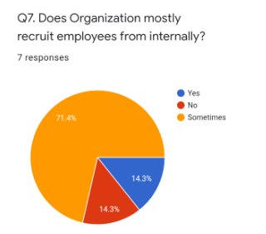
Q7. 71.4% think that sometimes HR recruit employees from internally, that can be reference or other activities.15.3% is saying that no, they recruit officially by forming their requirement. And others think that they actually recruit employees internally when needed.

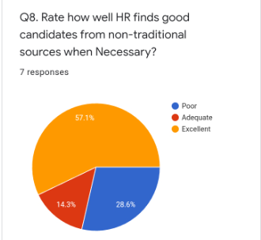
Q8. 57.1% is saying that they recruit employee non traditionally when necessary.

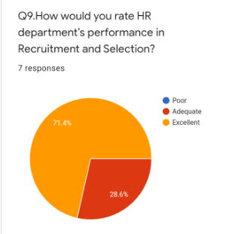
Q9. HR department performance is pretty good by seeing the survey. 71.4% think that they have excellent performance and employees like that.

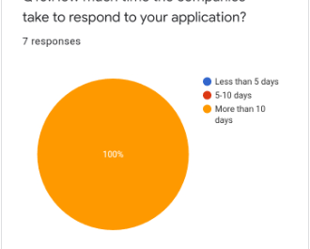
Q10. Here we can see that all of their respond is beyond 10 days. Employees got their answer after 10 days.

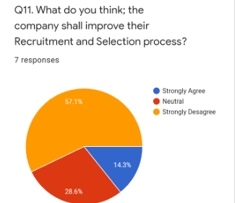
Q11. Though HR performance is pretty good, so many (14.3%) employees think that, their process can be main factor for recruiting. Though 57.1% is disagreeing about their opinion.

Findings
- Pakiza Knit employees are well educated, skilled, and always try to focus for learning new things.
- Pakiza Knit has valuable customers and they always want to communicate with new customers daily.
- Pakiza Knit is based on Functional Structure with highest level of responsibility.
- HR gives rewards and benefit based on their skill worker and they plan for the best.
- They prefer 360 degree for appraisal.
- Pakiza Knit always goes for direct and indirect compensation as the market condition.
- The evaluation of employee performance does properly.
- Organization is giving good working environment for all level of employees though upper level are strict.
- The relations of employees and upper level of manager is very good.
- This Organization service quality is very well.
- They all are well organized when communicate.
- Some employees think that training program is waste of time.
- They always try to recruit best employees.
- Their training program is based on who is capable in the organization.

Chapter 5

Recommendation
- The organization shall provide well communication to all level of employees.
- The entire HR department should be well informed regarding the employment personal.
- The organization should practice proper Alliance Capital guideline.
- HR should find more competitive employees and need assesment by recruiting with best way.
- To get effective and efficient employee, the organization should arrange proper training and development programs.
- In order to get competitive advantage and to deliver quality service, top management should try to modify the services.
- Proper training needed for ensuring efficient performance of the employees.
- Organization shall apply more different training program

Conclusion
From all above discussion it can conclude such a way that in every organization HR management is a continuously practicing issue so it is a significant role for us. For getting proper benefit, HRM shall be quite well for performing every task like HR planning, recruiting, and training to the employees. If their recruitment and training and other functions go well the organization will be competitive compare to others.
In fact, the true potential of an organization can only be realized when the productivity level of all individuals and teams are fully aligned. Thus the objectives of every company should be improving the desire of employees to stay in the relationship they have with the Company.

Reference
(AIHR DIGIDTAL)
(chand)
(Pakiza Knit Composite Ltd, 2014)
(Pakiza Knit Composite Ltd, 2014)
(Pakiza Knit Composite Ltd, 2014)
(Sadik Azam Sajib, August 7, 2017)

Bibliography
AIHR DIGIDTAL. 12 key functions of HR. digitalhrtech.com.
Any. (2001). Introduction. Chicago: Adventure works press.
chand, S. Method of training. YourArticleLibrary(The Next Generation Library).
Pakiza Knit Composite Ltd. (2014). About Us. Dhaka.
Pakiza Knit Composite Ltd. (2014). Mission, vision, value Statement. Dhaka.
Pakiza Knit Composite Ltd. (2014). Products and Services. Dhaka.
Sadik Azam Sajib, R. H. (August 7, 2017). Pakiza Group growing fast keeping quality and safety. Textile Today .

Appendix

Questionnaire
I have developed some questionnaire for Pakiza knit composite Ltd, those are:
Q1. Since how many years have you been working with this organization?
- Less than 2 years
- 2-5 years
- 5 or more years
Q2. Does the organization clearly give the information for position, requirements and candidate’s specification for recruitment process?
- Yes
- No
Q3. The process of Recruitment was so interesting that I got to learn many things?
- Strongly Agree
- Neutral
- Strongly Disagree
Q4. Does organization have lack for recruit the best employees?
- Strongly Agree
- Neutral
- Strongly Disagree
Q5. Is organization doing timeless Recruitment and Selection process?
- Yes
- No
Q6. What will be your rate for Interviewing process and Selection instruments?
- Poor
- Adequate
- Excellent
Q7. Does Organization mostly recruit employees from internally?
- Yes
- No
- Sometimes
Q8. Rate how well HR finds good candidates from non-traditional sources when Necessary?
- Poor
- Adequate
- Excellent
Q9. How would you rate HR department’s performance in Recruitment and Selection?
- Poor
- Adequate
- Excellent
Q10. How much time the companies take to respond to your application?
- Less than 5 days
- 5-10 days
- More than 10 days
Q11. What do you think; the company shall improve their Recruitment and Selection process?
- Strongly Agree
- Neutral
- Strongly Disagree

