Internship Report
on
Digital Marketing and Business Development Activities of MISTRI MAMA



Letter of Transmittal
May 28, 2019
To,
Dr. Mohammad Badruddozza
Associate Professor, SOBE
United International University
Subject: Submission of internship report
Dear Sir,
Right here it is my practicum document primarily based on digital advertising of a web startup service agency “MISTRI MAMA Ltd.” of incredible famous organization Super Star Group which have been assigned to me with the aid of my supervisor to submit as a partial requirement for the route BBA internship. This course gave me an actual taste of digital advertising and marketing sports which enriched my revel in in virtual advertising and marketing quarter.
I'm thrilled to submit this report which has been organized for the partial requirement of the internship software. I have accumulated a very good knowledge on digital marketing of MISTRI MAMA Ltd. I've attempted my best to bring out a significant perception to prepare this document.

You have my sincerest gratitude for your coopertation
Yours sincerely,
Tanvir Hasan
111143028
School of Business & Economics
United International University
E-Commerce Intern SSG (Super Star Group)

Acknowledgement

Initially, I would like to convey gratitude to “Allah” the Almighty, for guiding me and making me competent, giving me energy, power, and capability to finish a file. Then, I would love to carry my warm greetings, respect, praise and thanks to my honorable coordinator Mr. Badruddozza Sir for his honest willpower, guidance and help helped me to finish my internship report.
I give thanks to Mr. Shams Tibris Kushal, (Deputy Manager, Supply Chain, Super Star Group) for being my manager at the SSG and for his fantastic insights and precious hints in the completion of my internship application in addition to preparing the file. I would furthermore want to thank to Mr. Hasibur Rahman, (Deputy Manager, Marketing & Business Development).
I am humble by and grateful to all the officials of the outstanding big name organization for their kindness and helpfulness. The senior officers had aided me plenty for acquiring important statistics in time. I would additionally want to thank the Human Aid branch of the top notch megastar institution, that has been instrumental in making the environment welcoming for me.

Letter of Endorsements

This is to certify that Tanvir Hasan, ID: 111143028, college of commercial enterprise and Economics, United International University, has successfully completed the report based on his experience and learnings gained during his internship as one of the mandatory requirements of concluding the BBA (Bachelor of commercial enterprise administration) program.
In my understanding this record is based on the new sister concern of the reputed Star Group. “SSG corporate office”, UCEP Cheynee Tower (3rd floor), 25, Segun Bagicha, Ramna, Dhaka 1000.
Tanvir has constructed this report under my direct supervision that meets the standard of BBA internship document. Eventually, he has submitted the report by maintaining the due cut-off date.

I wish him every success in life.

________________________
Dr. Mohammad Badruddozza
Associate Professor, SOBE
United International University

Executive Summary
This report has been created based on my 3-months in a startup provider enterprise named “MISTRI MAMA”. This internship application helped me plenty to collect realistic understanding of commercial enterprise and the implementation of strategies for developing the company; the added knowledge that I had gained was of a startup which had the business model of an online service provider. Online on-call for home service marketplace is a dynamic & swiftly developing a nationwide solution to home needs. The startup is a sister concern belonging to the SSG conglomerate. The company began its operation in November 2018 beneath the brand call MISTRI MAMA. The primary core business model of the company is to be the link between the residents and technicians/repairmen in the country. The need for online service provider is developing rapidly, also the range of businesses is also growing simultaneously. Within the initial stages of the business enterprise, Mistri Mama plan to introduce electrical, AC, Plumbing, CCTV, Generator and Water Pump repairing, installing and upkeep services for both of the “industrial” business clients and “residential” direct customers and soon afterwards it'll introduce plentiful services based totally on marketplace’s demand. This record has been organized on the basis of my observations and collected directly from my duties as an E-trade intern within the agency. The company has many subsets and departments, but my focus was mostly on the marketing and commercial enterprise improvement (MBD) department of the new project of this organization as I was best suited to work in this department. This record portrays the imminent business of SSG and its current position in Bangladesh’s market, more specifically in the city of Dhaka. Moreover, the report is going to also be comprehensible after analyzing the content of the report the 5 forces of this new startup and the opportunities and boundaries of this business into Bangladesh. A study is carried out to draw an end on the premise of consumer’s mindset in the direction of the home service answer. The end result this is determined is pretty big. however brilliant big name group need to maintain progressing their paintings on MISTRI MAMA to make their consumer privy to the desires and benefits of online on demand domestic provider facilities. The outcome of this research is explained in detail in this record. After analyzing the situation of MSTRI MAMA in terms in their patron’s understanding and expectation, few suggestions got here up which I think might make a contribution to the development of the overall performance of the new enterprise of the agency.
Table of Contents
Letter of Transmittal 2
Acknowledgement 3
Letter of Endorsements 4
Executive Summary 5
Objective 8
Broad objective 8
Company Profile 11
Super Star Group’s Values, Vision and Mission 15
Topic Part 16
Role of Functional Departments of MISTRI MAMA Ltd 28
Human Resource Department 28
Research & Development 28
Finance, Accounting, Treasury & Audit Department 29
Information Technology Department 30
Marketing & Branding Department 30
Administrative Department 30
Major Activities and Job Highlights 31
Observations and Recommendations 33
The application of ‘Porter’s Five Forces’ for the digital on-Demand Home Service Marketplace: 37
Recommendations 42
Conclusion 45
Appendix 46

Objective
There were some goals that I wanted to achieve through this internship. The objectives of this internship are given below.

Broad objective
The broad objective of this report is to analyze the effectiveness of digital marketing to maximize customer engagement.

Specific objectives
- To understand how Search Engine Optimization will help
MISTRI MAMA LTD. to maximize customer engagement.
- To find out if Email Marketing will help MISTRI MAMA LTD. to maximize customer engagement.
- To understand how Social Media Marketing will help MISTRI MAMA LTD. to maximize customer engagement.
- To find out if Content Marketing will help MISTRI MAMA LTD. to maximize customer engagement.
- To recommend how Blog posting will help MISTRI MAMA LTD. to maximize customer engagement.

Scope of the report
Scope covers the organizational assessment and structure, heritage, objectives, number one features, and typical overall performance assessment of MISTRI MAMA LTD. The enterprise company supervisor divided the whole device into many additives. So, I was given the opportunity to paintings in advertising and marketing & enterprise improvement department and Operation department. with the intention to finishing the whole file, it changed into required to pay attention on the general ordinary overall performance analysis of the organization. In my record, the principle areas were protected in advertising and marketing department to research the effectiveness of virtual advertising and marketing to maximize client engagement.

Limitations of the report
I have tried my best to achieve the objectives of this report and make this report reliable and informative. There are some limitations that created obstacle in achieving my goals. These are;
- Time span – 3 months was not very sufficient for a report of this magnitude.
- Less time to work on as I came back from office at 9 pm and sometimes 9.30pm
- Confidentiality of the company to disclose some sort of information.
- Secondary sources of data are not available as much to serve my purpose.

Company Profile


Super Star Group is one of the leading manufacturers, shippers and distributors of equipment and electrical add-ons.
The business enterprise began its journey in 1994 through the construction of its first undertaking, which was the incandescent light plant situated at Narayangonj. The company provides a wide variety of lighting appliances and different electrical solutions for home use, business and each feasible necessity.
The organization has on offer, high-quality lighting fixtures for its extensive range of customers that are provided a premium service and this makes them primary in lighting fixtures enterprise of Bangladesh.
The product traces are as follows
- Compact Fluorescent Lamp (CFL)
- Incandescent Lamp (GLS)
- Light Emitting Diode (LED)
- Fluorescent Tube light (T8, T5)
- Switches and Sockets
- Fans
- Fluorescent lighting Fixture
- Insulating Tape
- Electronic Ballast
- Distribution Board

Moreover, the company is a high-quality wholesaler of Kawamura electric powered Inc. of Japan and Federal electric of Turkey and has been promoting their Circuit Breakers and other electrical compliances in Bangladesh.
They have also progressed into becoming the fine wholesaler of Khaitan Fan of India, in Bangladesh. the quality of the merchandise is assured and its durability and electricity is demonstrable. Each of these types of items has essential and appealing importance for which they are thrilled with, moreover they have ensured the sale of only first-class products to their esteemed business clients and consumers.
Super Star Group has a wide variety of sister concerns underneath the institution name which carries notable celebrity and several different worldwide exporters. The conglomerate includes 13 different concerns at present where they have initiated a variety of products and service line through the country. A recently started service advertising start-up is set to be released as a test project within 2019, the project intends to cover a large portion of Dhaka for each of the citizens and business customers.

Total Business Units of SSG (Super Star Group):
Super Star Electronics Ltd | SSG Engineering
Super Star Electrical Accessories Ltd. | SSG Properties
IR bulb Company Ltd. | Grupel Generator
Super Star Distribution Ltd. | SSG Agro
Professional Lightings | SSG Papers Ltd.
Super Star Renewable Energy Ltd. | MISTRI MAMA LTD

Corporate Information of Super Star Group
Name | Super Star Group (SSG)
Logo | 
Slogan | Future is Bright
Type of Business | Electrical and Electronics Accessories Manufacturing Company
Start Of Business | 1994
Location | 3rd floor, UCEP Cheyne Tower, 25 Segun Bagicha Rd, Dhaka 1000
Website | www.ssgbd.com
Email | info@ssgbd.com

MISTRI MAMA is one of the newly developed, fastest growing, innovative and potential service platforms of Super Star Group. It is an online based service platform in Bangladesh and it provides household fixing, installing, repairing, and plumbing related home services by verified professionals. MISTRI MAMA connect the Customers with the best repairing and installation professionals in their neighborhood through the webpage and through mobile phone call for quality repairing, installation, plumbing and many other customers driven home services. For removing everyday hassle of searching for an experienced and quality specialist for fixing your household tasks with quality service specialists and getting an after service supports.
MISTR MAMA Services are available from 8am to 8pm. It also provides services in any Emergency situation. It is serving whole Dhaka city. Soon, MISTRI MAMA will be launched its services in all divisional cities of Bangladesh. Customer can book services via website www.mistrimama.com or by a direct call to 09610-222-111.
We ensure quality service by providing training to our technicians which also emphasis on safety and behavioral aspects. Apart from the domiciliary service, MISTRI MAMA also provides one-time, periodical subscription for corporate houses. Our highly trained and professional technicians are always a CALL away to provide Electrical, Plumbing, Generator, AC, IT, CCTV, etc. servicing works at your doorstep. We are also open to provide our services during holidays, mid-nights or your (customers) free hours.

Name | Mistri Mama Limited
Logo | 
Type of Business | Online Based Home Service Platform
Start Of Business | 2019
Location | Sky View Ocean Tower (1st floor)  38 Segun Bagicha, Dhaka, Bangladesh.
Website | www.mistrimama.com
Email | info@mistrimama.com

Super Star Group’s Values, Vision and Mission

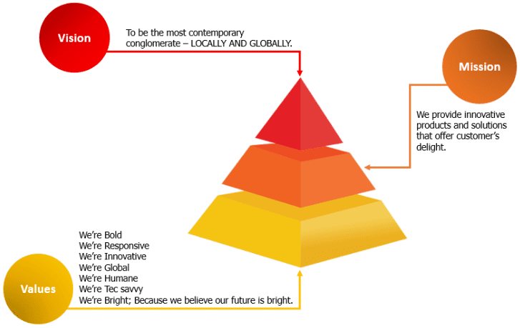

\

Topic Part

What Is Digital Marketing?
Virtual advertising is a broad term that refers to various and different promotional strategies deployed to attain clients through virtual technologies. Due to it being a smaller yet integral part of traditional advertising and marketing; it utilizes the internet to include things such as
- Brief Message carrier (SMS)
- Easy Notification carrier (SNS)
- Search engine optimization (SEO)
- Electronic or interactive billboards

and other online ads (which include banner advertisements) to promote goods and services. the crucial goal is to sell brands through numerous sort of digital media.
Digital Marketing Tools
The ideal virtual entrepreneurs have a clear understanding or framework of how every digital advertising and marketing campaign benefits their ambition. Furthermore, depending on the desires of their advertising approach, marketers might help a larger campaign through both loose and paid channels which they have at their possession.
Search Engine Optimization (SEO)
This refers to the system of optimizing a website in order to "rank" higher in the chosen search engine’s results pages, which in turn increases the amount of organic (i.e. free) website traffic that it receives. The channels that are at an advantage due to SEO include:
- Website
- Blogs
- Infographics

Content Marketing
This concept concerns itself with the promotion and making of content assets intended to generate brand awareness, website traffic growth, lead generation, and eventually customers.
The usual networks that can play a part in content marketing strategies include:
- Blog posts
- EBooks and whitepapers.
- Infographics
- Online brochures and look book

Social Media Marketing
This branch of marketing encourages a brand and its content on social media platforms to increase brand awareness, generate leads for a business and drives traffic.
The channels that are most commonly utilized in social media marketing include:
- Facebook
- Twitter
- Instagram
- LinkedIn
- Snapchat
- Pinterest
- Google+

Pay-Per-Click (PPC)
PPC is the system of bringing web traffic to a website by paying the owner of the ad every time their advertisement (often a pop up) is clicked. Google AdWords is perhaps one of the more popular PPCs that permits us to purchase (at a predetermined price, set by Google) the highest positions in the results provided by the search engine. Other channels where we can use PPC include:
- Paid ads on Facebook.
- Promoted Tweets on Twitter.
- Sponsored Messages on LinkedIn.

Affiliate Marketing
This is a form of performance-oriented promotion in which we obtain a “commission” for endorsing a third party’s goods and services on our website. The channels used in this type of marketing include:
- Hosting video ads through the YouTube Partner Program.
- Posting affiliate links from your social media accounts.

Email Marketing
Organizations utilize this process as the method to reach the intended target market. Direct emailing is useful in promoting content, offers and events; it also serves to nudge potential consumers to visit the company’s website. The types of emails we might send in an email marketing campaign include:
- Blog subscription newsletters
- Follow-up emails to website visitors who downloaded something
- Customer welcome emails.
- Vacation advertisements to “loyalty” card holders

Online PR
Online PR is the process of ensuring earned online exposure with digital publications, blog posts, and other content-based websites. It's much like traditional PR, but in the online arena. The networks we can use to maximize our PR efforts include:
- Reporter outreach via social media.
- Engaging online reviews of your company
- Engaging comments on your personal website or blog.

Marketing Automation
Marketing Automation is defined by the software that serves to automate our basic marketing operations. Many marketing departments can automate repetitive tasks they would otherwise do manually, such as:
- Email newsletters
- Social media post scheduling.
- Contact list updating
- Lead-nurturing workflows
- Campaign tracking and reporting.

What Digital Marketers Do
Virtual entrepreneurs are in rate of riding brand recognition and lead era via all of the virtual channels each loose and paid which might be at an organization's disposal. those channels encompass social media, the business enterprise's own internet site, search engine rankings, e-mail, show advertising, and the organization's blog.
The virtual marketer typically specializes in an exclusive key overall performance indicator (KPI) for every channel with a view to nicely degree the employer's performance throughout each one.
A digital marketer who is utilizing of search engine optimization, for an instance, will tend to evaluate their website's "organic site visitors" and will try to check the traffic generated by website visitors to see if they found the website through a google search or through other channels.

of that traffic coming from website visitors who found a web page of the enterprise's website thru a Google search.
Benefits of Digital Marketing
Digital marketing is useful to enterprises both small and large by providing them access to the largest possible audience at an affordable price. Unlike the rigidness that is found in TV or print advertising, digital marketing allows truly personalized marketing.
The most important benefit of digital marketing is that the intended demographics can be reached in a cost effective way and the impact of the ads can be measured. Digital marketing carries with it more advantages include encouraging brand loyalty and boosting online sales.
- Global reach
- Lower Cost
- Traceable, Measurable results
- Personalization
- Openness
- Improved conversion rates

Businesses Digital Marketing Work for
Digital marketing can be used by any company in any industry. The prime focus of digital marketing involves finding and highlighting the core personas of the consumers in order to identify our audience's needs, and creating valuable online content, irrespective of what a company sells. However, it should be noted that not all businesses implement the same marketing strategies.

B2B Digital Marketing
If our company is
The business-to-business (B2B) model tends to focus the digital marketing efforts to be centered on online lead generation. The primary objective being the person coming into contact with a sales person. Therefore, the purpose of our marketing strategy is to attract and transform the highest quality leads for our sales people via our website and supporting digital channels.

B2C Digital Marketing
When our organization is business-to-consumer (B2C), depending on the price point of our products, it's likely that the objective of our digital marketing efforts is to attract potential consumers to our website and have them actively consuming our products without ever needing to speak to a sales person.

Digital Marketing activities of MISTRI MAMA Ltd.
As MISTRI MAMA gives their services to both the businesses and the consumers, they perform both B2B and B2C digital marketing. But during my internship period of three months I found MISTRI MAMA Ltd. Is working in initial stage in digital marketing activities comparing to its competitors. They are progressing their activities in digital marketing just like almost all the business organizations are applying their promotional activities on the internet in this digital era. Without proper digital marketing any business can surely fall behind in this era of information technology. Some digital marketing activity of MISTRI MAMA Ltd. are given below

Social Media Marketing
For the remaining four months to till now MISTRI MAMA Ltd. is trying to sell their emblem in addition to their provider information thru fb. They created a fb page wherein they upload pics in their services and publish posts describing product information. However they try this on occasion which brings them no gain.
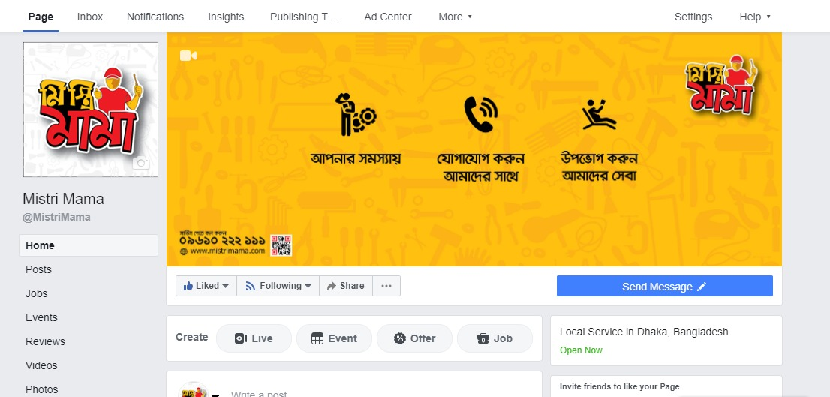
This is the official Facebook page of MISTRI MAMA.

Email Marketing
Email marketing is one of the vital tool of digital marketing to sell offerings and maintaining a great customer relationship. MISTRI MAMA has a little bit involvement in e mail advertising. They observe this tool most effective at some stage in the first phase of provider launch.

Search Engine Optimization
To apply search engine optimization a company needs to have internet site of its own. Then they can optimize their internet site in special search engine following a few algorithm to show their internet site in the first place of seek list. MISTRI MAMA has their own internet site and update their internet site time to time with the trendy statistics.
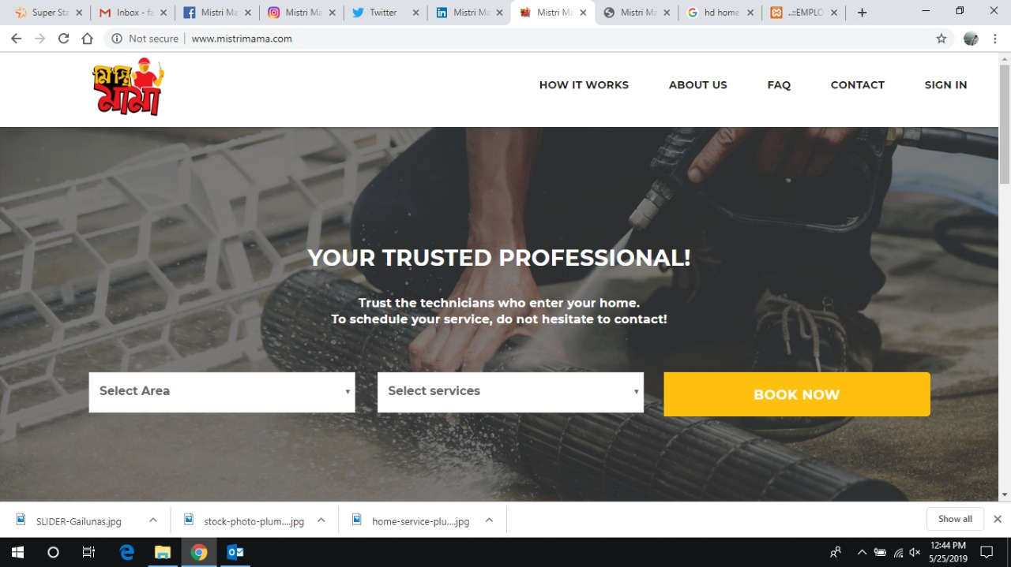

Instagram Marketing
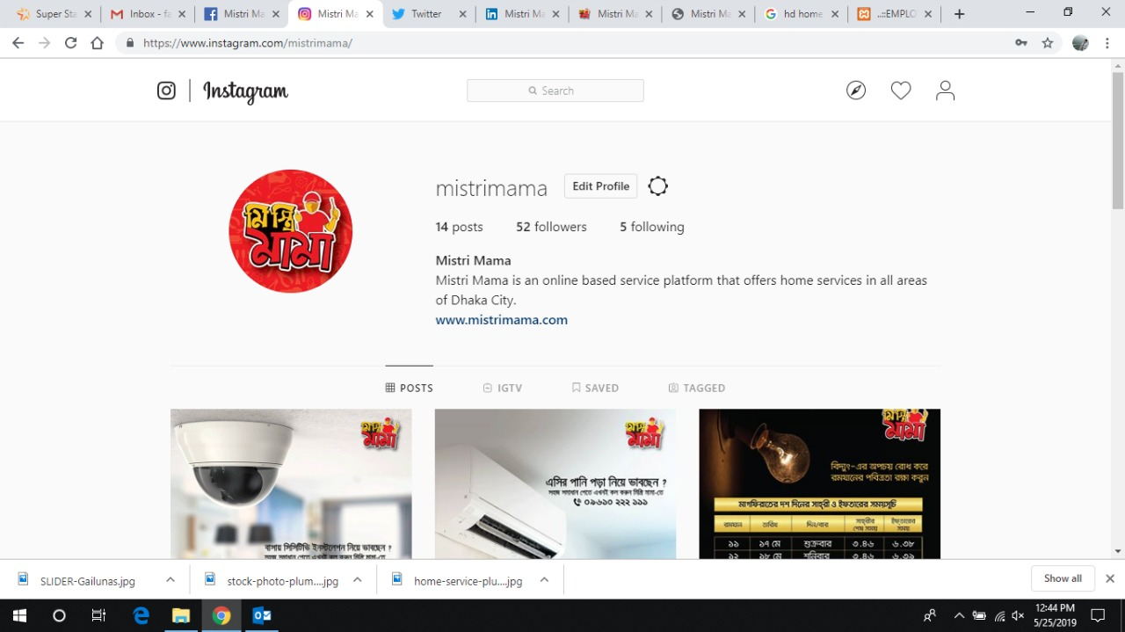
LinkedIn Marketing
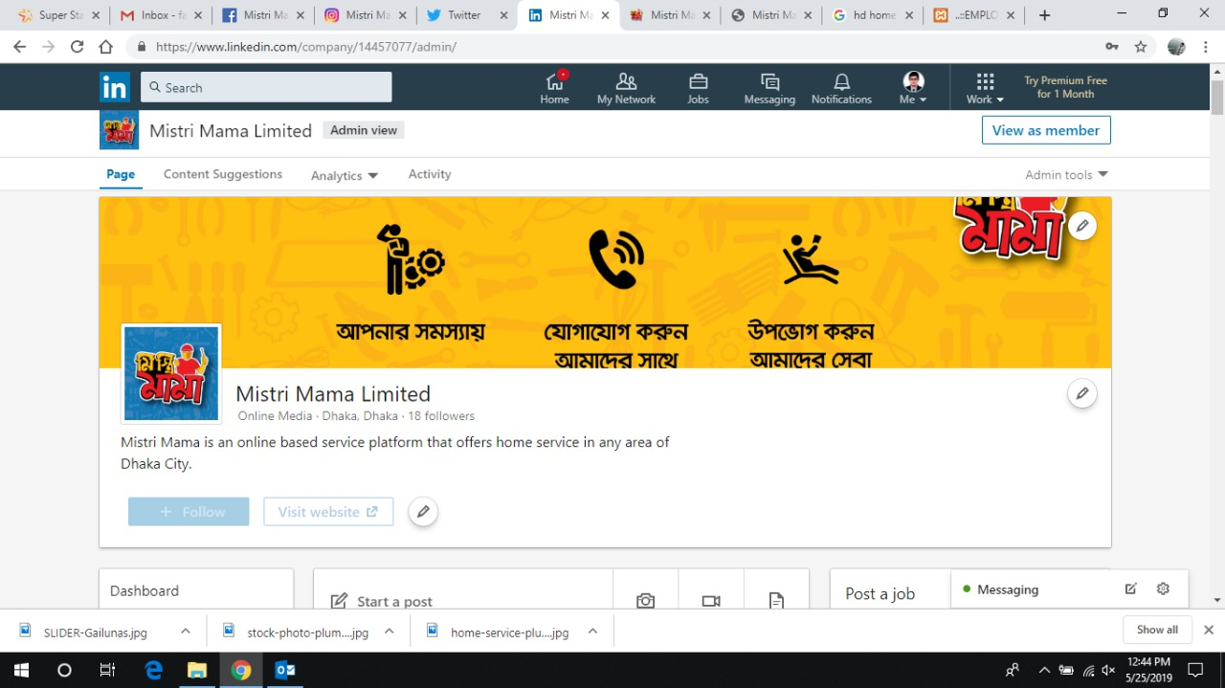
Twitter Marketing
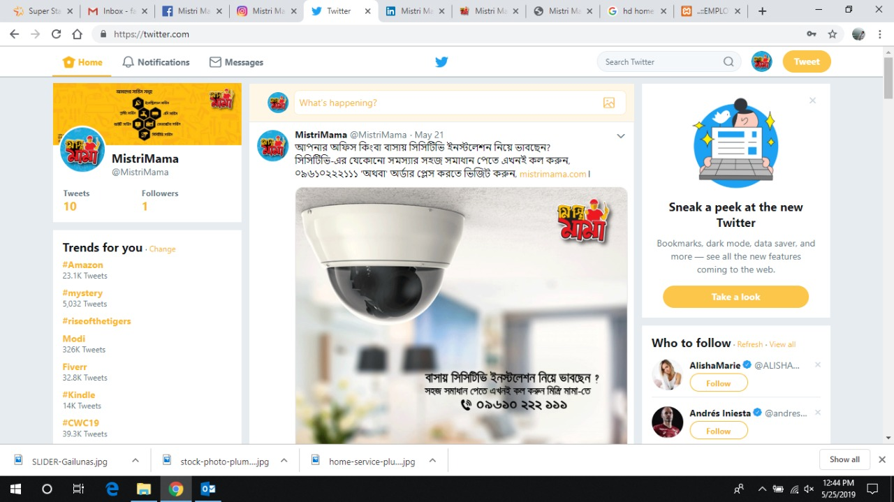

Role of Functional Departments of MISTRI MAMA Ltd

Human Resource Department
At MISTRI MAMA Ltd, the fundamental belief that they carry is that the employee is their treasured asset. The company invests in creating competent professional human resources. They push their employees to convert their ingenuity and passion into new products to satisfy their valuable customer. Mistri Mama tires to provide their human resource with the best possible working environment. Their Human Resource includes people from different discipline such as Chemistry, Engineering, Accounting, Administration and Finance experts. The grit, skillset and dedication of their people pushes MISTRI MAMA Ltd towards achieving their goals and objectives.

Research & Development
One of the driving forces of MISTRI MAMA Ltd is its highly skilled human resources. It is continuously striving to explore the core competencies of the employees to face the challenges of the competitive environment. The company needs to research a service element before launching it to the market. They need to train their in house technicians very professionally and MISTRI MAMA is already doing their different training sessions.

Finance, Accounting, Treasury & Audit Department
MISTRI MAMA Ltd has efficient finance, accounting and treasury & audit department. They cover day to day activities of monetary related transactions. They help the purchase department and for short or long term investment. They have to do cross function with vat officer of the factory. The core focus of these departments is to make sure that the organization maintains a positive cash flow which allows them to engage in everyday transactions with fluidity. In addition to this, they also maintain budgets, forecasting and other elements such as book keeping and payments.

Information Technology Department
MISTRI MAMA Ltd has a strong IT Department which is tasked with the provision of any assistance related to mechanized work. It creates rules for how the network operates and how each individual unit functions within those boundaries. It also provides assistance in data processing and storage, networks and support for the necessary program, as well as services for the accelerator complex and for the whole company and its users.

Marketing & Branding Department
MISTRI MAMA Ltd. marketing & branding department is responsible for advertising and promote the services of the organization. In some case, it may be integrated with the sales functions. It’s marketing & branding department involved in the few activities, such as designing & developing promotional materials, organizing marketing events, likely launches and campaigns, developing websites as a digital marketing system.

Administrative Department
MISTRI MAMA Ltd. also has a disciplined administrative department. Major activities of this department is; organizing meetings, keeping track of agenda and writing down the details of the meeting, any typing/clerical work, which constitutes of the daily work of an administrator.

Major Activities and Job Highlights

Major Activities
- Marketing research & feasibility studies of different FMCGs
- On spot monitoring different sponsored events
- Assessment of events sponsorship proposal by finding key factors
- Successfully assist, planning & ensuring proper POSM distributions
- Effective marketing data findings, analysis & survey activities conduct
- Ensure regular entry in ERP software for all types of receipts
- Assist for Brand Promoter interview, selection & scooting process
- Provide ideas for social media contests & promotion
- Ensure branding in the movie premier show & press conference though different POSM

Job Highlights
I was assigned to Marketing and Business department & I spent the whole three months in the department which was very laborious, and very fruitful. I had a wide variety of works, activities & responsibilities at MISTRI MAMA Limited. Some of those are;
- Continuous e-mail maintenance for accomplishing assigned tasks
- Assigned document process, writing and printing
- Assigned excel process, writing and printing
- Assigned power point slides process, writing and printing
- Prepare purchase requisition into the software & record that as soft copy & hard copy
- Prepare material receipt into the software & record that as soft copy & hard copy
- Necessary POSM process, manage & distribution
- Call the stakeholders to collect the necessary information
- Preparing the Bill & Invoice as required
- Receive the sample products from the factory for testing sessions
- Making copies of documents using the photocopy machine & printer
- Scan documents, bills & paper cuttings as assigned or asked
- Prepare courier packs with attaching the addresses as required
- Assist to collect signature from the bosses into the vouchers copy
- Collect competitors‟ information & their activities from the different areas market
- Provide ideas & resources for digital marketing campaign program
- Maintain the stock of marketing materials in the warehouse.

Observations and Recommendations
Observations

From the survey conducted, 24 participants had stated that the advantage of online residential service is saving precious time, 16 of those participants are provided the advantage of the ease of service processing, eleven participants had stated that online marketing reduces inconveniences searching for a repairman/mechanic on the internet, eight participants had stated (in their perspective) online marketing guarantees them the best facility, five of the participants would rather opt for online marketing due to the advantage of a non-fluctuating established price list which is better for them since they need not opt for haggling with repairmen. The following chart shows it in detail.

Quality Service No bargaining
Reducing
Hassle
Time saving Easiness
5
8
11
16
24
30
25
20
15
10
5
0
Q15. What are the main benefits according to you to take home services from online?

Remarks of the participants regarding the advantages of online on-demand home service marketplace:
Time sucker
Time saver
Exceptional facility
Solves my problems
Time saving
Not problematic
Really convenient

Never tried it
Provides variation
Experienced service providers
Easy access
No issues from my side
saves time, reducing hassles
quick

I haven’t found any benefits
Prompt
Reduces problems and makes life easier
Some level of doubt
Prevents any potential skirmishes
Saving Time

The issue that many participants (17) of the survey/service receivers was that the online aspect could not ensure security to them as unknown people would be coming to their home alone to provide the required services. 9 respondents mentioned that any form of system failure might disrupt the existing market and its operations given that the customers will grow attached to the online marketplace. 5 of the surveyed individuals mentioned that they did not believe in the quality of the work done as the service provider may not have proper understanding of being hasty and do good work independently. 3 people were concerned regarding the not-up-to standard behavior displayed due to them not being properly educated. 6 respondents had stated that they were afraid that unprofessional and untrained labor might end up causing hard to the goods rather than fixing it. Four participants mentioned that the extra cost seems to be a hindrance to people adopting the service because of the relatively higher price. Fifteen of the participants were not sure about the service because of the online nature of it, they believed that the requirement of logging in can be problematic for online marketing as the internet is necessary for online services. 11 respondents stated that both needing a proper device and logging in proved to be an issue as many of the employees didn’t have either. The following chart shows it in detail.

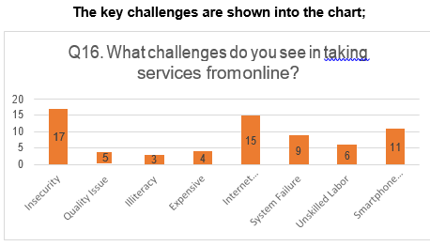

In the chart provided above, it can be observed, the distribution of people according to what percentage of extra cost are they willing to incur for online home services.

For example; if an electrician or ‘mistri’ from a local shop charges around BDT 1000 for replacing a ceiling fan and fitting it himself then the customers will pay BDT 1200 Taka, which is a 200-taka increase from the base price which is the profit margin of our company.

Here the respondents mentioned that how much they are willing to pay as an additional price for taking online service.

33 people said they are able to pay 10% extra charge where 13 respondents 15%, 10 respondents 20%, 6 respondents 25%, 5 respondents 30% and 1 respondent willing to pay 50% additional amount for taking services from online.

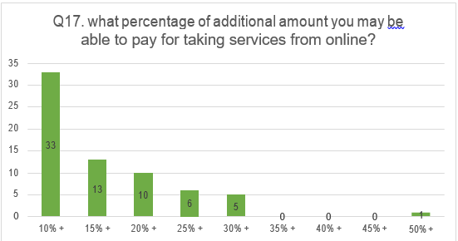

Key benefits to the growth of the service market;
- Reducing wastage of time by taking service from online
- Quality Services ensured by the verified service providers
- Reducing Hassles due to place order from online
- Convenience of time and location
- No Bargaining with the Technicians
- Easiness of placing order and receiving quality services

Key challenges to the growth of the service market-
- Insecurity due to allowing unknown persons inside home
- Quality of services may not be up to the mark
- Illiteracy issue of technicians affects customer satisfaction
- Internet connection for placing service order all the time
- Smartphone is required for both of the customer and technician
- System Failure may affect and divert customer’s mind to the competitors
- Unskilled Labor may harm the company image by providing poor services
- Expensive services from online is not affordable by most of the people

Leading vendors in the local online on-demand home services market in Bangladesh-
- Sheba.xyz
- Handy Mama
- Drooto

The application of ‘Porter’s Five Forces’ for the digital on-Demand Home Service Marketplace:
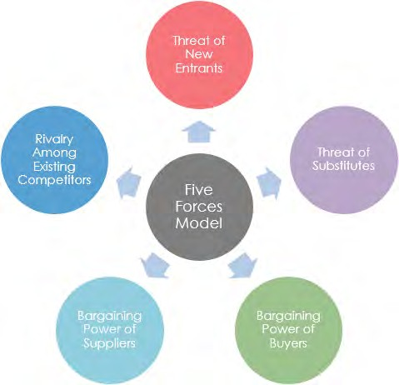

Threat of New Entrants:
The market for on-demand home services has proved to be lucrative enough that there are several companies are trying to enter the market thus they are an imminent threat to the business. Due to there being virtually no barriers imposed by the government, any small company with a limited start-up capital can set up shop in any location and hire the local technicians into their service plan.

Threat of Substitute:
The biggest red flag for the company is the fact that local consumers are not used to the concept that there are online service providers for such small tasks and they can be trusted; there is a large demography that has no such intention of availing such a service. Moreover, a large portion of potential customers are not yet tech savvy that they would rather consult with a local technician rather than an online service provider. Therefor the threat of substitution existed before the business was even introduced to the market.

Revelry among Existing Competitors:
The company faces all the drawbacks of being a late entrant to the market but in addition to that, the first mover “Sheba.xyz” has established strong market dominance that has cemented its brand value and has captured a large chunk of the market share. While the other competitors in the market follow cut-throat tactics to gain the upper-hand, it’s a fair game for anyone to emerge as the new market leader.

Bargaining Power of Buyer:
The primary reason for availing the services of such a company would be in order to accommodate a busy or luxurious lifestyle, thus the consumers of the services are usually from an affluent background. Not only does the services provided by the company save time, but it also saves people from the hassle of finding local technicians and as a result, the bargaining power rests with the service provider given that the consumers are willing to stay loyal to them; therefore, the buyer has moderate bargaining power.

Bargaining Power of Supplier:
Provider’s asking power is always strong in this scenario as they facilitate the enterprise in their neighborhoods and the majorities are used to transport direct to their stores or name them immediately whilst a handyman or preservation provider is wanted. Carrier vendors can offer home offerings from their current source which also permits the possibility of setting your own prices. In an internet provider marketplace, there may be typically a fixed fee listing primarily based mostly on man or woman Service Company’s choice. Moreover, service providers want to preserve terms and situations set by way of the corporation whilst giving services on behalf of them. As an end result, service providers may also change their selection to now not to paintings with any organization for ensuring their work flexibility and maintaining off regulations and rules set with the aid of the use of a commercial enterprise organization. but, provider companies might also trade their thoughts and switch to different business enterprise for extra advantages. So, the bargaining electricity of provider enterprise is usually high for a web domestic provider employer in Bangladesh.

Recommendations
All of my recommendations for the upcoming online home service concern of the SSG (Super Star Group) are based on the customer’s responses and opinions of senior employees of the company.
Due to the customers belonging to the niche, the recommendation of the highest priority would be to improve customer relations as the selected demography has the option to go to local technicians, and have the added disadvantage of needed to be involved with smartphones and the internet, the best bet for the company would be to engage with the customers on a regular basis for now. As the potential target market is millennial, we can only assume that it is only a matter of time that the market expands and the future of the business will be tremendous. Thus the business must adopt means of social media, conduct direct to the line marketing and should try their best to get the customers involved as much as possible.
According to a new study (Jungleworks.com), 56% of customers are involved either texting or direct calling to the service providers. Moreover, Facebook can be one of the most important tools in reaching and keeping in touch through the use of a Facebook page and somewhat regular advertisements.
An added suggestion would be to incorporate a rewards system as research states that customers tend to be satisfied by getting discounted prices or other benefits.
Tackling the issue posed by the respondents, the individual services should be priced competitively to an extent so that consumers do not feel as if they are being charged extravagantly or being charged a premium price which is higher than local prices.
A lot of users of the service were concerned with the aspect of quality thus the company should keep quality control managers or provide training and take other such measures to ensure quality and the company could also introduce a warranty period for services provided to provide a sense of security to consumers.
A behavioral issue comes up when asked, thus proper etiquette training should be provided on a mandatory basis to each employee under the company’s employment which allows proper goodwill to be established by the firm.
While the company does not keep unskilled employees, it is a concern from the side of the customers thus it should be rectified by ensuring standardized tests for the employees, i.e. they have to be at a high enough skill level before they begin providing services.
Customers need to be lured into the service and be made to stay so they should be incentivized to use the online services and on the other hand, the technicians should also be equipped with the knowledge of how the service works and how it’s important for their day to day job.
Another critical issue that may damage the company is the potential for any system failure, that includes app crashes, bad website design, unfriendly user interface and other such disturbances which might dissuade the users from jumping on the service, this can be solved through the hiring of a full time operator and other such key individuals to avoid system hazards.
Local consumers tend to view online services to be better in some aspects than the local alternative. Therefore, it can be highlighted and promoted as to what benefits they are receiving.
SSG needs to focus and put great emphasis on the branding aspect of its business to the extent that the company becomes a household name, similar to its competitors. Moreover, SMS, E-mail, Leaflet, Door name plate, caretaker uniform and many other branding strategies may give a good result for branding purpose.
A better strategic approach would be to partner up with local vendors which could serve to cover more ground and reach the appropriate demographic in the shortest possible time.
Keeping in line with the statements made by the business analyst, focusing on the caretakers of the households might be a better and quicker way of reaching a mass audience as they would through word of mouth, promote the business, which would otherwise not be as valued when heard through the mouth of a stranger. And this system allows the company to create a reward system for their service.

Conclusion
At the conclusion of this report on Mistri Mama, it could be stated that a number of advantages and disadvantages were found out in operating in the industry of online on-demand service provision. Mistri Mama is on the way of setting itself apart in the local market; while it has consistently played a large role in exports, it has yet to establish market dominance in the local region.
That being said, if the company innovates and establishes new marketing policies and proper customer relationships then it has a proper chance at gaining a larger market share. In addition to that, the company has to keep playing the long-term game as existing market research dictates that more online consumers will be jumping on the bandwagon and will start availing services online rather than going to local vendors and technicians as they become more tech savvy.
This trend can be observed from the emergence and continued usage of ride sharing apps and delivery apps which have established the fact that consumers are willing to order online, however a large portion of these consumers are from a younger demographic, whereas Mistri Mama’s target demographic is older. Thus the marketing approach needs to accommodate the inclusion of the younger target market as they will eventually make the shift from being interested in the service to making effective purchasing decisions.
Keeping these factors in mind, Mistri Mama is projected to be one of the leading pioneers of the market if it makes proper use of its resources and innovates, but it also has to keep track of the weaknesses that it needs to properly eliminate, which primarily focuses on the HR side of the company as they need to train and properly equip the employees to provide the best possible service, in order to establish itself as the household name that it wants to be.

Appendix
Survey Questionnaire
- Your Name / Email (Optional)
- Gender:
Male
Female
- Age:
- Income:
- What is/are the preferred online company you may want to take services from?
- Sheba.xyz
- Handy Mama
- Mistri Mama
- Drooto
- Other:

- Please Put Your Valuable Responses below (1-18)
- Searching for plumbers is more convenient through the app than going out and looking for one
- Definitely
- Yes
- Perhaps
- No
- Absolutely not

- Searching for cleaners is more convenient through the app than going out and looking for one
A) Definitely
B) Yes
C) Perhaps
D) No
E) Absolutely not

- Searching for technicians is more convenient through the app than going out and looking for one
A) Definitely
B) Yes
C) Perhaps
D) No
E) Absolutely not

- A proper catalogue of service provision interests consumers to switch to online services
Definitely
Yes
Perhaps
No
Absolutely not

- The unbearable traffic in the local region incentivizes for opting online services
Definitely
Yes
Perhaps
No
Absolutely not

- Modern urban lifestyles encourages acceptance of online services
Definitely
Yes
Perhaps
No
Absolutely not

- A great website might possibly attract consumers to avail services from there directly
Definitely
Yes
Perhaps
No
Absolutely not

- An online home services company ensures easy lifestyle by providing home services at reasonable price and consumers' convenience and time

Definitely
Yes
Perhaps
No
Absolutely not

- Consumer convenience on-the-online home services needs is contributing to the rise of online home service marketplace
Definitely
Yes
Perhaps
No
Absolutely not

- Consumer accessibility on-the-online home services needs is contributing to the rise of online on demand home service marketplace
Definitely
Yes
Perhaps
No
Absolutely not

- What do you do about finding any type of technicians for home services?
- What are the main benefits according to you to take home services from online?
- What opportunities do you see in online home service companies in Bangladesh?
- What challenges do you see in taking services from online?
- After realizing all the benefits, what percentage of additional amount you may be able to pay for taking the advantages of online on demand home service marketplace?
10% + 15% + 20% + 25% + 30% + 35% + 40% +
45% + 50% + Other:

- The busy urban lifestyle is inducing consumers to prefer online services, which will result in a surge in the online market’s growth in the coming years
Definitely
Yes
Perhaps
No
Absolutely not

- Time saving is a prime issue to decide taking services from online
Definitely
Yes
Perhaps
No
Absolutely not

