

AN INTERNSHIP REPORT ON
THE CHALLENGES AND POTENTIAL SOLUTIONS OF RECRUITMENT AND SELECTION PROCESS WHILE SCREENING RIGHT APPLICANTS IN NOVOCARGO SERVICE LIMITED

14th July 2020
UNITED INTERNATIONAL UNIVERSITY
DHAKA, BANGLADESH
An Internship Report On
THE CHALLENGES AND POTENTIAL SOLUTIONS OF RECRUITMENT AND SELECTION PROCESS WHILE SCREENING RIGHT APPLICANTS IN NOVOCARGO SERVICE LIMITED

SUPERVISED BY
MS. YEASMIN ISLAM
ASSISTANT PROFESSOR,
SCHOOL OF BUSINESS AND ECONOMICS
UNITED INTERNATIONAL UNIVERSITY

PREPARED BY
JEASMIN RAHMAN
ID: 111 151 083
BBA PROGRAM
UNITED INTERNATIONAL UNIVERSITY

UNITED INTERNATIONAL UNIVERSITY

Letter of Transmittal
To
Ms. Yeasmin Islam
Assistant Professor,
School Of Business and Economics
United International University
Subject: Submission of Internship Report on “The challenges and potential solutions of recruitment and selection process while screening right applicants in NovoCargo Service Limited”.

Dear Madam,
I am glad to inform you that I have successfully completed my internship from NovoCargo Service Ltd and have prepared my internship report on “The challenges and potential solutions of recruitment and selection process while screening right applicants in NovoCargo Services Ltd.”

As a human resource management student, I know that the recruitment and selection process is crucial for an organization to attract an effective workforce. It important because it determines the success of the business and will affect the management of the entire organization because one of the most valuable assets of any organization today is the employee.
NovoCargo Services Limited (NCSL) is the maternal concern of Novo Group, an international provider of logistics services for its potential clients worldwide. The company is following its parent company’s rules and guidelines of recruitment and selection procedures. Unfortunately, they are facing several issues regarding their recruiting and selection policies. Therefore, this internship report seeks to identify the challenges of recruiting and selection process of NovoCargo Services Ltd and suggests potential solutions that may help the company to resolve the problems.
I, therefore, pray and hope, that your honour would be kind enough to accept my internship report and provide your valuable feedback.
Your most obedient,

Jeasmin Rahman
ID: 111 151 083
BBA program
United International University

Acknowledgement

At first, I want to thank Almighty Allah and my parents for making me capable to complete my Bachelor of Business Administration (BBA) degree from United International University.
I want to thank and share my gratitude to my internship supervisor as well as my course faculty Ms. Yeasmin Islam, Assistant Professor, School Of Business and Economics, United International University for sharing valuable time to make my report an effective one. Moreover, it would not possible for me to complete such an extensive report within due time without the guidance and the report format.

I want to thanks two of very special person, Shelina Ruma, Manager of Admin & Freight department and Mahabub Hasan – Manager of IT & HR Department at NovoCargo Services Ltd. For guiding me in the internship period. Without them, understanding the human resources process and practical work culture would be very difficult for me. Moreover, they helped me with all the information that are very essential to complete the report.

I want to thank all my colleagues and friends who helped and cooperate me to pass the three months of my internship report. I got all the support from them whenever I had got stuck to understand any point.
Executive Summary

Rapid changes in the economic, social, and political environment, which have a significant impact on organizations, have resulted in multiple challenges and threats to the effectiveness of human resource management and human resource managers. The first and main challenge facing the human resources manager is to hire a suitable candidate for the job from a large number of candidates. In this hiring process, HR managers need to analyse the job position to prepare the job description so they can hire the right employee for the position. In the next step, they publish the announcement of vacancies in different media to attract potential candidates. They then collect the candidate's application and select the suitable candidates, then call them for the selection process. All these stages require time, financial resources, funds, and strategies. Occasionally they must make appropriate changes to the selection process and ensure that the candidate continues to meet the job requirements. If necessary, they organize training to enable the candidate to obtain quality results. However, while doing all these activities, HR managers face numerous problems and challenges that disrupt the hiring and selection process to hire the right employees. Understanding the importance of these challenges, the study is ready to identify and analyse the challenges of the recruitment and selection process of NovoCargo Service Ltd. The study consists of the recruitment and selection practices that are performed in the company, a survey questionnaire, and results to identify the challenges of the recruitment and selection process, numerous suggestions to improve the recruitment and selection process so that human resources managers can reduce the challenges and hire the right employees for the company.

Table of Contents

Chapter One: Introduction
1.1 Background of the report 2
1.2 Rational of the report 3
1.3 Scope of the report 3
1.4 Objectives of the report 4
1.4.1 Core Objectives 4
1.4.2 Specific Objectives 4
1.5 Methodology of the report 4
1.6 Sources of information 5
1.6.1 Primary sources of data 5
1.6.2 Secondary sources of data 5
1.7 Limitations of the report. 5

Chapter Two: Organizational Profile & HR Practices
2.1 Organizational Profile 8
2.1.1 Mission 8
2.1.2 Vision 8
2.2 Services provided by NovoCargo Services Limited 8
2.3 Recruitment and selection process in NovoCargo Services Limited 9
2.3.1 Recruitment Process Steps 9
2.3.2 Steps in the selection process 10

Chapter Three: Analysis and Findings
3.1. Analysis and Findings 13
3.2 Respondent's demographic information 13
3.3 Descriptive analysis 13
3.4 Findings of the study 20
3.5 SWOT analysis 21
3.5.1 Strength 22
3.5.2 Weakness 22
3.5.3 Opportunity 23
3.5.4 Threat 23

Chapter Four: Recommendations & Conclusion
4.1 Recommendations 25
4.2 Conclusion 26
Reference 27
Appendix – Survey Questionnaire

Chapter One

Introduction



1.1 Background of the report
Recruitment and selection is an important function of Human Resource Management, designed to maximize employees to achieve the employer's strategic goals and objectives. It is the process of sourcing, hiring, selecting, and interviewing the correct candidates for the required vacancies. Unfortunately, hiring today is very different from exactly 10 years ago, primarily because we are in a candidate-driven market where job-seeker expectations will have a greater impact on what hiring managers need to consider. Therefore, companies face several challenges in recruiting the right candidates. Of course, these challenges can unfold in several ways, depending on the size of the business, the need for hiring, and many other factors, but it does ensure that the market has it in some way.
Nova Cargo Services Limited (NCSL) is the primary concern of Novo Group, an international supplier of supplies to its potential customers worldwide. The company is following the rules and guidelines of its parent company in the recruitment and selection process. In carrying out the recruitment and selection process, Nova Cargo Services Limited (NCSL) has various problems and difficulties for several months. To identify these issues, the report, titled "The Challenges and Possible Solutions to the Recruitment and Selection Process in Selecting the Right Applicants at NovoCargo Services Ltd." It will analyse the recruitment and selection challenges of NCSL through the preparation of a survey questionnaire and after receiving the challenges, depending on the challenges, several suggestions to tackle will be given.

The internship report on "The challenges and potential solutions of recruitment and selection process while screening right applicants in NovoCargo Services Ltd." As the report is a prerequisite for obtaining a BBA degree from the United International University. Each student must complete 120 courses designed for business education, and at the end of 120 credit hours, the student must go through an internship or a project/thesis program. In the internship program, students generally join an organization as interns and work there for three months to accommodate practical business life. When completing the internship program, students must prepare and submit an internship report representing their course and internship knowledge. Therefore, my esteemed internship supervisor encouraged me to work on the subject and the report will provide a well-known overview of the challenges and possible solutions to the recruitment and selection process for NovoCargo Services Ltd.

1.2 Rational of the report
Recruiting and selecting employees for an organization is the most important task for any human resources manager. There is no doubt that the success of any organization depends on the quality of the company's human resources and talents (Cooper, 2003). If the wrong people are hired, the quality of the company's products and services will suffer. Therefore, effective recruitment is critical to the success of an organization's day-to-day operations and that the success of recruitment depends on finding people with the right skills, qualifications, and abilities to generate a positive contribution to the organization's goals and values.
If we compare NovoCargo Services Ltd. with a small company located in Bangladesh, we can see that both companies face some challenges in the recruitment and selection process. Although the small business has decided to fill the vacancies in its organization with friends and family, NCSL, a semi-large company, spends a great deal of time and money on screening applications in response to a media announcement.
In Bangladesh, most of all types of companies face different challenges in hiring and screening the right candidates, due to mounting pressure for the unemployment rate, the use of informal recruitment sources, government restrictions, lack of qualified personnel, lack of finances, lack of funds, experts, etc. Briggs (2007) found that these problems resulted from the inappropriate use of job descriptions and standard employee requirements in the recruitment process. At the same time, due to the decline of educational standards in Bangladesh, organizations often feel insecure to hire employees and, at times, have redesigned their recruitment and selection methods, conducting various trends and psychometric examinations during the selection process, resulting in which is also increasing the cost.

1.3 Scope of the report
Recruitment and selection scopes are very wide and consist of a variety of activities. Human resources are considered the most important resource for any organization. Thus, the most important aspect of hiring the right resources is that each company has its own type of recruitment according to its recruitment and selection policies and procedures. These methods are crucial in achieving the goals of any organization. When the right person is selected, the employee delivers fruitful results and stays with the company longer, thus, there will be less employee turnover. If the selection is not done carefully, the employee can make a mistake that leads to financial loss. Again the recruitment and selection process wastes the time of human resource managers to go through. On the other hand, if the procedures are not handled carefully, the companies may hire the wrong employees who cannot perform the required tasks, so all the organizations need to adequately measure and analyse their challenges in the recruitment and selection process.

1.4 Objectives of the report
The report outlines the challenges and solutions related to the recruitment and selection process of Nova Cargo Services Ltd. which has been compiled as a result of the survey, research, and analysis of data and issues. Furthermore, it covers a wide range of human resource management issues but focuses on delivering information to a specific audience with clear objectives. Therefore, the objectives of the report are divided into the following two parts.

1.4.1 Core Objectives
- To identify the challenges the NovoCargo Service Limited is facing in recruiting and selecting right candidates for their organization and provide solution based on the identified challenges.
- To submit the internship report to attain the BBA degree from United International University.

1.4.2 Specific Objectives
The specific objectives are the breakdown of the main or core objectives of the report. They are listed below:
- To analyse the challenges of the recruitment and selection process of NovoCargo Service Ltd. (NCSL).
- To prepare a SWOT analysis based on the HRM practices at NovoCargo Service Ltd. (NCSL).
- To suggest potential solutions based on the identified challenges.

1.5 Methodology of the report
The methodology section of any report generally describes in detail how the research was conducted, how the research methods were used, and the reasons for choosing those methods.
This report is produced based on a survey questionnaire (added in the Appendix part of this report) that is prepared to identify the challenges of NovoCargo Service Limited. The questionnaire was prepared using the Likert scale method. There are a total of ten (10) employees from the NCSL human resources department, randomly selected who answered the survey questionnaire. Based on your response, challenges are identified and interpreted using bar charts and/or pie charts. In addition, quantitative and qualitative data are used in the report according to the need for data presentation.

1.6 Sources of information
Data are collected from both primary and secondary data sources. The both sources are mentioned below:

1.6.1 Primary sources of data
- Through informal and email communication with the HR employees.
- Through personal experience while working as an intern in HR dept.
- Though the survey questionnaire listed in the Appendix part.

1.6.2 Secondary sources of data
- From the annual report of Novo Group.
- From published books and journal’s article of popular writers.
- From reliable online sites and blogs.

1.7 Limitations of the report.
The limitations of the study are the features or characteristics of a method that influence the interpretation of the results obtained from a study. It is the result of restrictions on generalizations and the usefulness of the outputs that an author/researcher chose to design the research and/or the method used to develop external and internal validity. The limitations of this reports are listed below:
- Lack of formal interviews: The preparation of this report were started in Mid-March, 2020 and completed in June, 2020. Due to the COVID Pandemic lockdown it was not possible to take face to face interviews with the employees to gather more understandings on the challenges the NCSL are facing in through their recruitment and selection procedures to screening the right candidates.
- Difficulties of collecting information: NCSL doesn't publish an annual report and the company websites have a lack of corporate and HR information that was essential to extending this report. Therefore, a lot of company and HR information are collected through informal communication from the HR employees and colleagues.
- Privacy and confidentiality: NCSL employees are not allowed to share any confidential information of NCSL. They also requested me not to share some of the information I received during my internship because that information was closely related to their reputation.

Chapter Two

Organizational Profile and HR practices of NovoCargo Services Limited


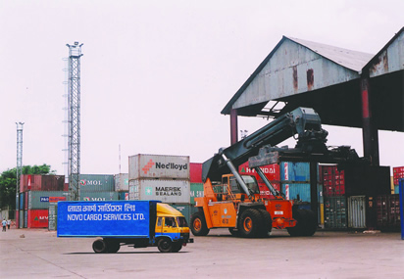

2.1 Organizational Profile
NovoCargo Services Ltd (NCSL) is the main concern of the Novo Group which provides international logistics services to its potential customers worldwide. NCSL is a member of some international and local commercial organizations such as FIATA, IATA, DCCI, SCB, ATAB CANCHAM BGCCI, AMCHAM, HHGFAA, BAFFA, PATA AMSA, JBCCI, etc.
The Novo Group was founded in 1989 with NovoCargo Services Ltd as an international freight forwarder in Bangladesh, which soon became one of the main freight forwarding companies. Now this group includes seven commercial concerns in the field of international freight transport logistics, energy solution, transportation, travel and tourism, consumer products, and education.
Over the years, NCSL has carried out various corporate social responsibility (CSR) activities. This CSR of NCSL includes winter blankets for the poor, health care, education funds, and even emergency aid in the event of natural disasters and other development-related issues.

2.1.1 Mission
NovoCargo Services Ltd's mission is to satisfy customers (exporters/importers) through the best possible service and the utmost care. Our main motto and goal are to improve the level of earnings of importers and exporters through commitment and dedication. Even entrepreneurs who are unfamiliar with export and import or people interested in entering this activity would receive from us adequate indications regarding the legal and appropriate procedures of this activity. We are always at your service to make your business simpler and more fluid.

2.1.2 Vision
The vision of NovoCargo Services Ltd is to strengthen the interest of local and foreign exporters/importers and entrepreneurs through our service and support as representative of the Government of Bangladesh.

2.2 Services provided by NovoCargo Services Limited
- Fairs and exhibitions: NCSL organizes and manages international fairs and exhibitions.
- International Family Moving: NCSL is an expert in packing and shipping personal effects and household items.
- International transport: air, sea, air, sea and air transport Export by sea from the ICD, from the port of Dhaka and Chittagong to the Far East, Middle East, Europe, Mediterranean ports, the United States of America and the west coast and western with transit time
- Project management in the energy and energy sector.
- Door to door service: NCSL provides door to door logistics services to its potential clients.
- Customs brokerage (C&F) at all customs entry points in Bangladesh
- Consolidation and logistics services.
- Import by air through Dhaka airport from any airport / country.
- Warehousing and Distribution: Management of professional warehousing and distribution services in Bangladesh. NCSL has been working in this sector since 1989 with our experienced and reliable team.
- Internal Transportation: NCSL provides internal transportation to any destination in Bangladesh, including port-to-port, port-to-factory, and factory-to-warehouse factories.
- NovoCargo has 8 branches located in Dhaka EPZ Savar, Adamjee EPZ, Chittagong EPZ, Comilla EPZ, Mongla Port Khulna, Benapole Land Port, Ishwardi EPZ and Burimari. NCSL look forward to building a strong business relationship between their esteemed companies.
- Provide the necessary logistics services for foreign investors for the establishment of the factory in Bangladesh.

2.3 Recruitment and selection process in NovoCargo Services Limited
To determine future human resource needs, the human resources department of NovoCargo Services Ltd. usually provides a request form to other departments and factories at the beginning of the year. From the information collected from this application form, the human resources department obtains an estimate of the human resource requirements of the department and the factories.

2.3.1 Recruitment Process Steps
NovoCargo Services Limited has taken the following steps to recruit qualified and qualified staff to achieve the company's goals by completing the job description:
a. Recruitment Request: As a general rule, the concerned department head raises the recruitment request using the prescribed recruitment request form along with the required information, then sends it to the HR department at the headquarters. The HR department at the head office then completes its formalities such as approval of the Director-General, approval of the human resource budget, etc.
b. Attracting Candidates: NovoCargo Services Limited generally uses internal and external recruitment sources to attract potential candidates. Employee referrals, since recommendations from current employees about someone, are the internal source of their recruitment. However, references to professional organizations (Accounts Associations, Unions, and Employers’ Associations) and job offers at bdjobs.com are external sources of their work. The advertisement on bdjobs.com includes the name of the position, nature of the job, age limit, qualifications, qualities and experience required for the job, job responsibilities and duties, expected salary, place of work, etc.
c. Receipt of Application: At this stage, potential and reliable candidates are invited to submit the application along with their CV, certificate, and other required documents within a time limit. The HR department then accepts all the CVs submitted by the candidates.
d. Sorting applications: The next step is a shortlist of CVs. As a rule, the human resources department is employed in the shortlisting. However, the HR department can delegate this step to the departments concerned for which the selection is in progress to save time. For the recruitment of experienced candidates, the CV can be selected from the unexpected CV collection received. Once potential candidates have learned about them, they are contacted and invited for an interview.
e. Inform the candidates: After selecting the right CVs and preparing the preliminary list, the candidates are informed and are invited for a written test (for a beginner's position) or an interview (for an experienced position of medium or senior level).

2.3.2 Steps in the selection process
The process of selecting the best from the number of candidates. The management team of NovoCargo Services Limited generally follows a standard model, ending with an initial selection, an interview, a presentation, and a final decision on employment.
- Group interviews: For a beginner level position, after a written test, candidates can meet two or more interviewers, allowing several other candidates to apply for the same position. Here, interviewers assess the individual for the same questions and answers and examine how the individual responds and responds individually to the candidates, as well as how he/she responds to his directed questions.
- b. Individual interview: This is usually a group interview where two or more interviewers conduct a structured interview. At this stage, questions are developed before the interview begins and each candidate is asked to test their skills, abilities, personal interests, adaptation to leadership, etc.
- Background Reference and Verification: When the talents match the skills profile, the human resource budget, then the educational documents match the previous job certificate and all other certificates, their team will be verified by human resources.
- Offer letter and Health Examination: At this stage, the management provides the job by informing the potential candidate about the job conditions, salary, and other benefits, as well as the expected time of his arrival. The NovoCargo Services Limited offers to participate on the first day of the month or on the fifteenth day of the month to facilitate the calculation of salaries. After that, they send the candidate for evaluation of treatment. Generally, the assessment consists of regular health check-ups including blood pressure, eye test, sugar test, blood group, etc. In this case, all expenses will be borne by the management of NovoCargo Services Limited.
- Final Selection and Appointment Offer: Candidates will be selected for the appointment on the basis of a positive report from the health centre and a positive reference check. At this stage, the selected candidate is offered a job in the NovoCargo Services Ltd. The recruiting authority of NovoCargo Services Limited sends appointment letters to the selected candidates. The appointment letter contains -
- Positions, grades/steps, and salary
- Nature of appointment
- Space for expression
- Department or department name
- Date of entry into recruitment application
- Pro test time, confirmation conditions and notice time
- Recruitment. Date of employment (Applicable for contract workers).
- The general conditions of NovoCargo Services Limited
Only the letter of appointment and job description will become valid after the signature of the human resources director and employees in the office.

Chapter Three
Analysis and Findings



3.1. Analysis and Findings
The unemployment rate in Bangladesh is increasing rapidly and it makes recruitment work difficult, therefore, human resource managers face recruitment challenges. At any time, the average recruiter will handle 5 to 15 jobs at a time and manage an average of 200 applicants per position (but sometimes more than a thousand!). Knowing how much essential talent will affect the success of a business depends on how they focus on the best people and manage a multi-step process from start to finish. In addition, they must protect the company’s employer brand in all steps.
The challenges of the recruitment and selection process of NovoCargo Services Ltd are identified through a survey questionnaire (Added in the Appendix part) prepared in Google Form. A total of 10 employees from NovoCargo Services Limited’s Human Resource department were selected to participate in the survey as respondents.

3.2 Respondent's demographic information
Of the 10 respondents, 8 were male and 2 were female. There are only two employees under the age of 30 who are junior human resources officers, and the two employees are in a probation period. The remaining 8 respondents were between 35-45 years old, including 1 head of HRD, 1 HR admin, and HR managers. In addition, all 8 employees between the ages of 35-45 have worked in NovoCargo Services for at least 5 years and have extensive work experience in the field of human resources. The questionnaire link was sent over their email address so that they can provide their response whenever they were free to answer.

3.3 Descriptive analysis
The survey aims to identify "the challenges of the recruitment and selection process of NovoCargo Services Limited". A structured questionnaire was prepared on a 5-point scale for the challenges of the recruitment and the selection process. In this case, a five-point scale from 1 to 5 was used, of which 1 refers strongly disagree and 5 refers strongly agree. However, it was difficult to describe the response variation through the table given below, so a pie chart has been created to reach a conclusion.

Result and discussion
Statements | 1 | 2 | 3 | 4 | 5
 | % | % | % | % | %
- Job Analysis
1.1 NovoCargo analyses the vacant position’s requirements adequately before advertising the vacancy announcement. | 30% | 30% | 0 | 20% | 20%
1.2 NovoCargo carefully chooses its advertising media to attract the right employees. | 30% | 30% | 0 | 30% | 10%
2. Attracting qualified candidates
2.1 NovoCargo usually gets the right applicants through their recruitment advertisement. | 0 | 70% | 0 | 20% | 10%
- NovoCargo usually gets mid-career candidates. | 0 | 40% | 40% | 20% | 0
3. Hiring Process
- The hiring process of NovoCargo is fair. | 0 | 40% | 0 | 30% | 30%
- The time NovoCargo invests in its hiring process is sufficient to complete the recruitment process. | 30% | 40% | 0 | 20% | 10%
4. Financial Investment In recruitment
- NovoCargo is investing sufficient funds for recruitment. | 20% | 50% | 0 | 10% | 20%
- The financial resources for recruitment is utilized wisely in NovoCargo. | 0 | 20% | 10% | 40% | 30%
5. Equality in the recruitment process
- NovoCargo provides equal opportunities for female and male applicants. | 50% | 10% | 0 | 20% | 20%
- For mid and upper-level vacant positions, NovoCargo always recruits internally instead of having more eligible candidates from external sources. | 10% | 30% | 0 | 40% | 20%
- NovoCargo prioritizes internal referrals in the recruitment process. | 10% | 30% | 10% | 40% | 10%

1.1
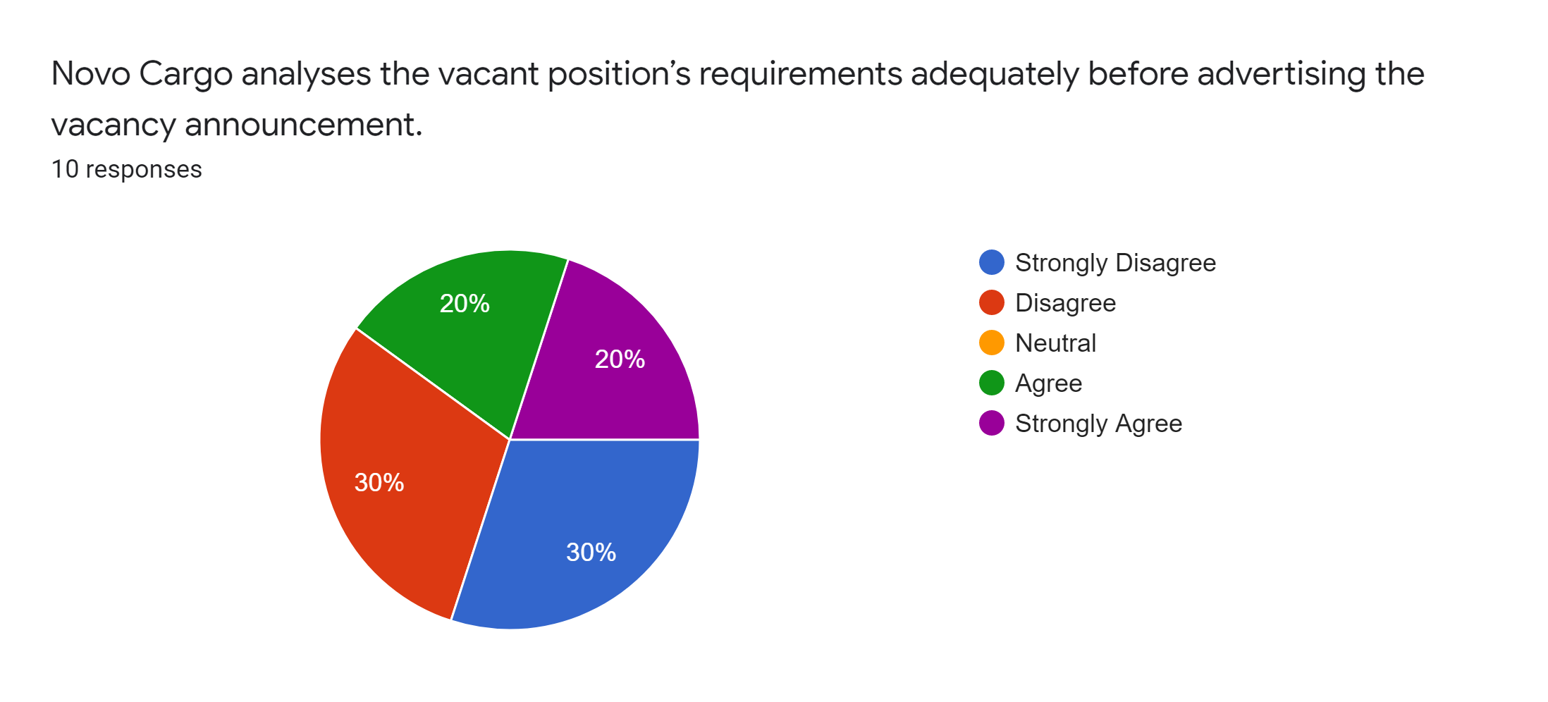
Interpretation: Out of 10 Human resource employees of NovoCargo, a total of six (6) employees were strongly disagreed (3) and disagreed (3). So it can be said that NovoCargo services don’t analyze the vacant positions adequately before advertising the vacancy announcement.

1.2
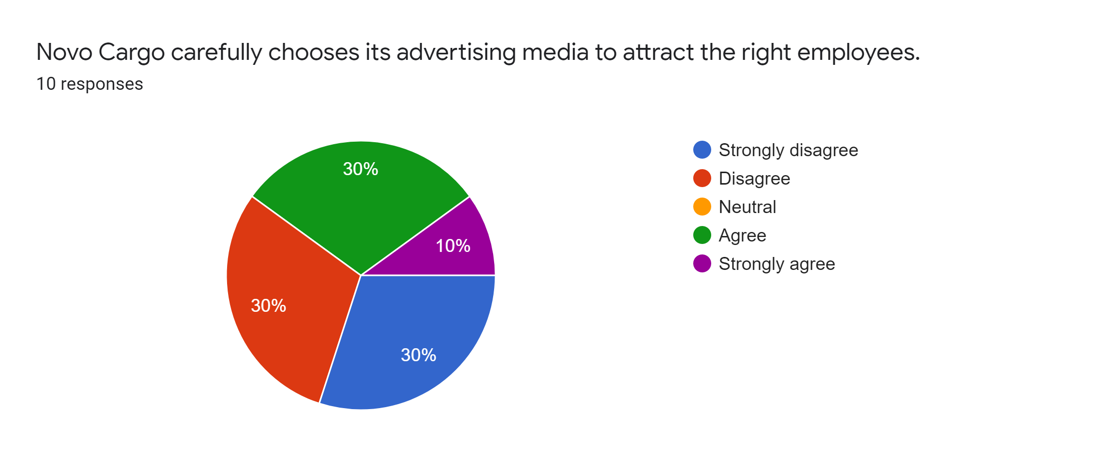
Interpretation: Total six (6) respondents out of 10 disagreed with the statement. And, on the other hand, 4 respondents agree with the statement that NovoCargo finds out the right media to advertise the vacancy post.

Attracting qualified candidates
2.1
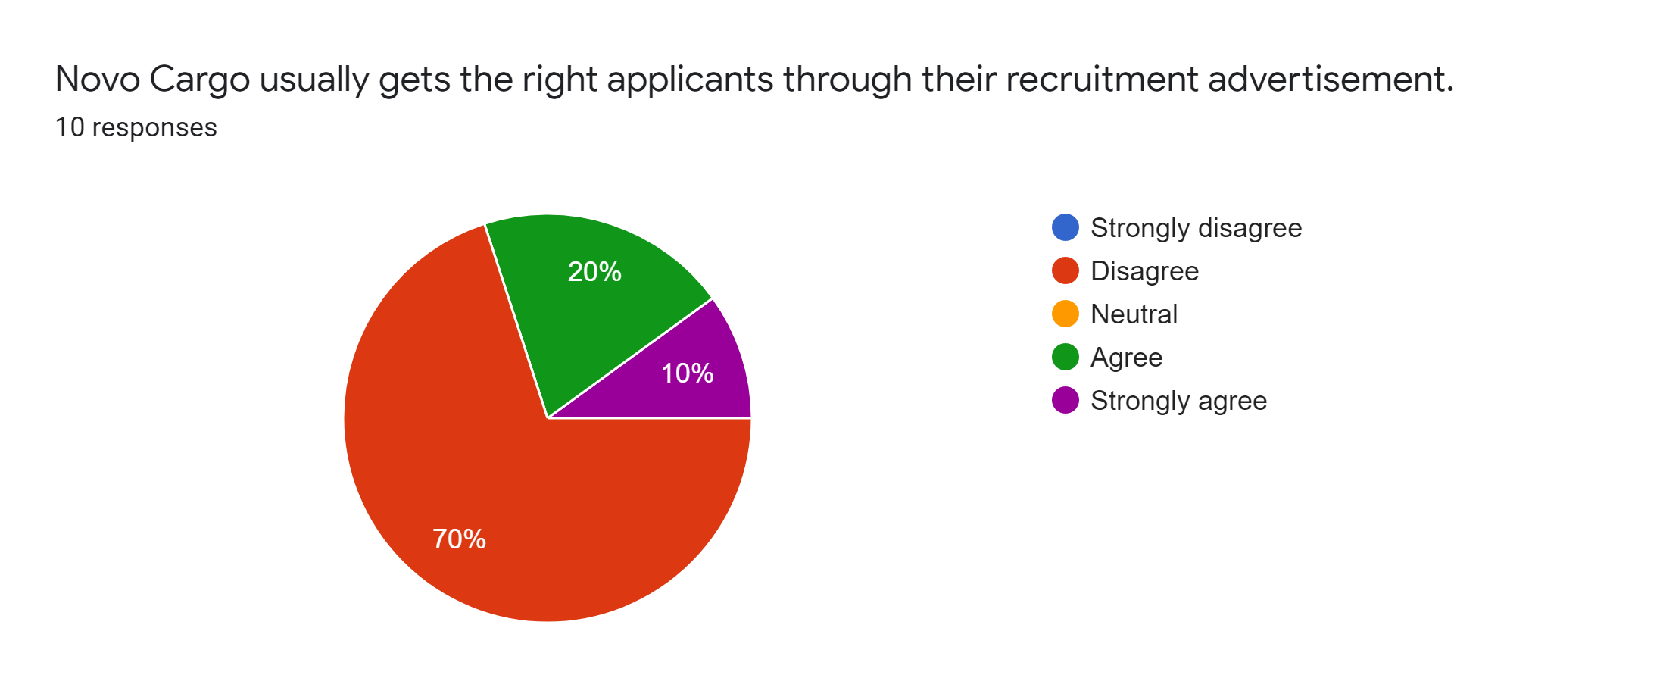
Interpretation: Out of 10 respondents, 7 disagreed with the statement that refers NovoCargo doesn’t the right applicants through their recruitment announcement. However, there are also 3 employees who agreed that the company gets the right applicant through their recruitment announcement.

2.2
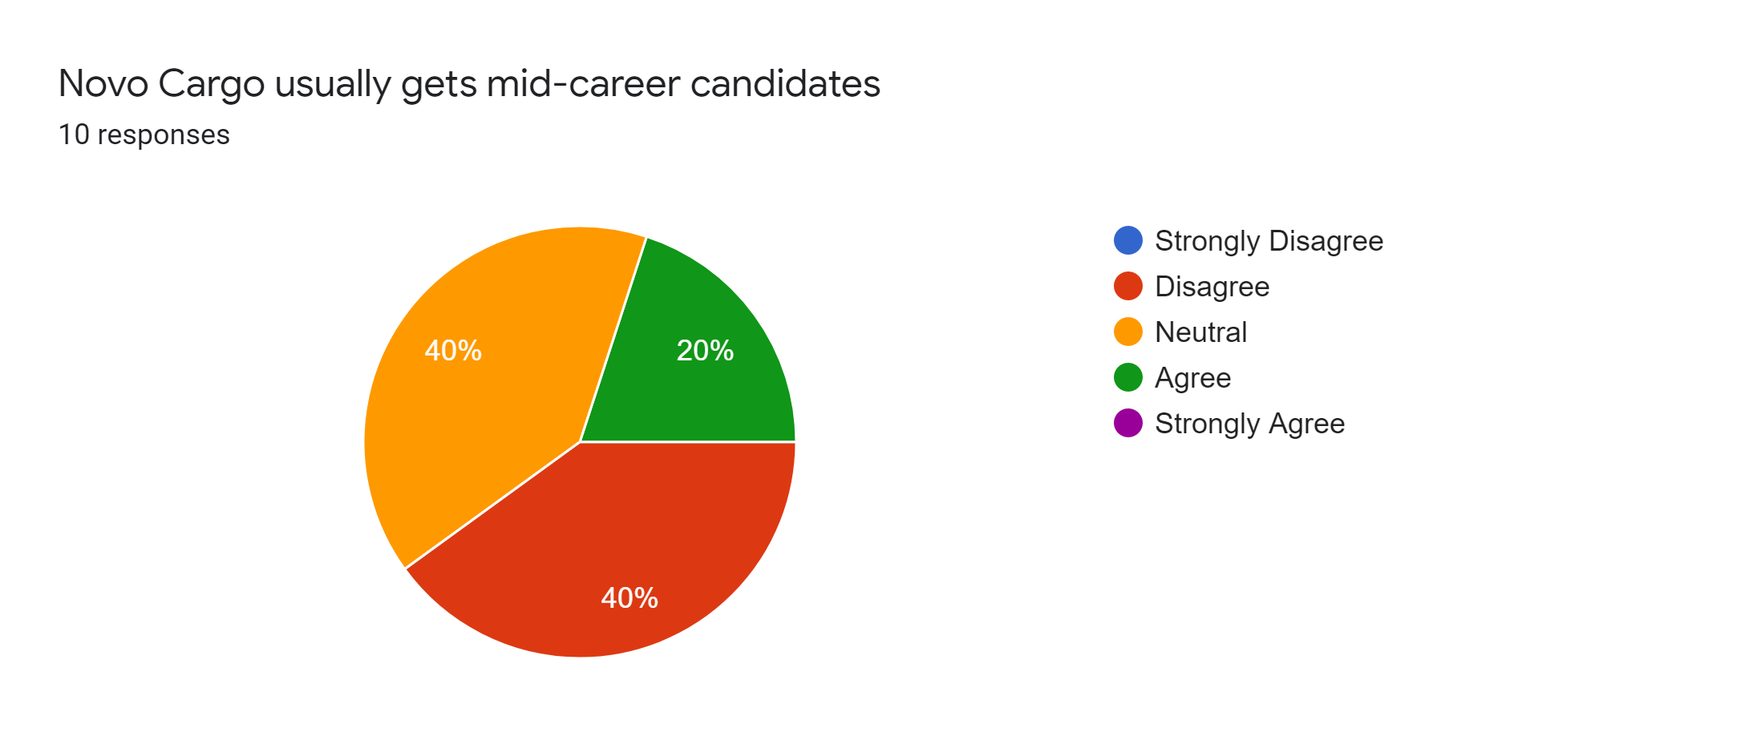
Interpretation: NovoCargo Services Ltd often fails to attract mid-career candidates since 4 out of 10 respondents disagree with the claim and 4 respondents were neutral (which is considered not to want to disclose). Only 2 respondents agree with the statement.

Hiring process
3.1
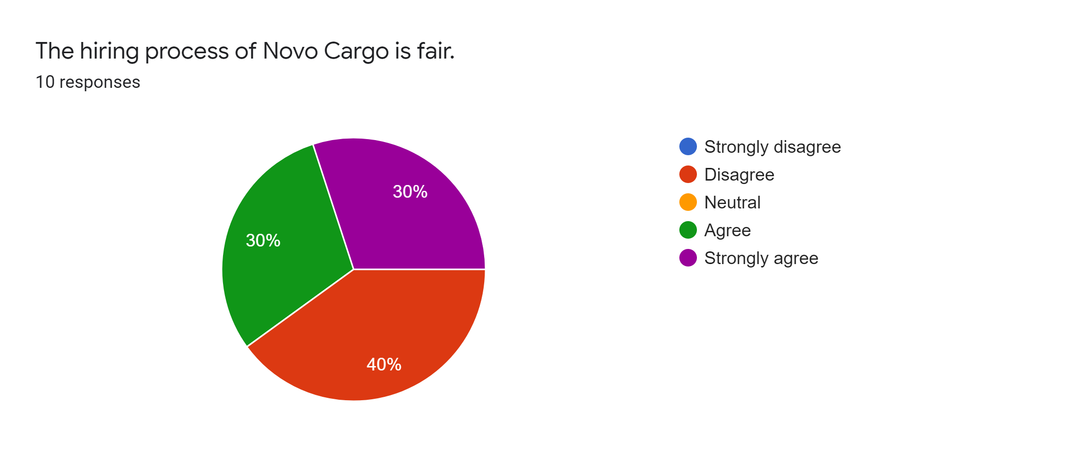
Interpretation:
The statement was provided to know whether the recruitment and selection process of NovoCargo is fair. Though 4 respondents disagreed with the statement but total 6 respondents replied that the hiring process of NovoCargo is fair.

3.2
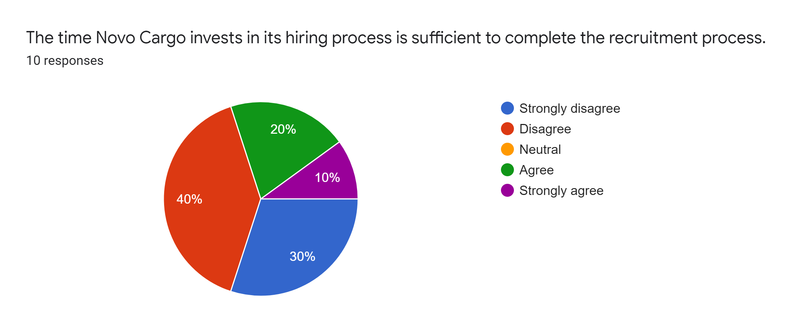
Interpretation: It is found that total 7 respondents disagreed with the statement where 4 respondents disagreed and 3 respondents strongly disagreed. On the other hand, only a total of 3 respondents agrees with the statement.

Financial investment in the recruitment and selection process
4.1
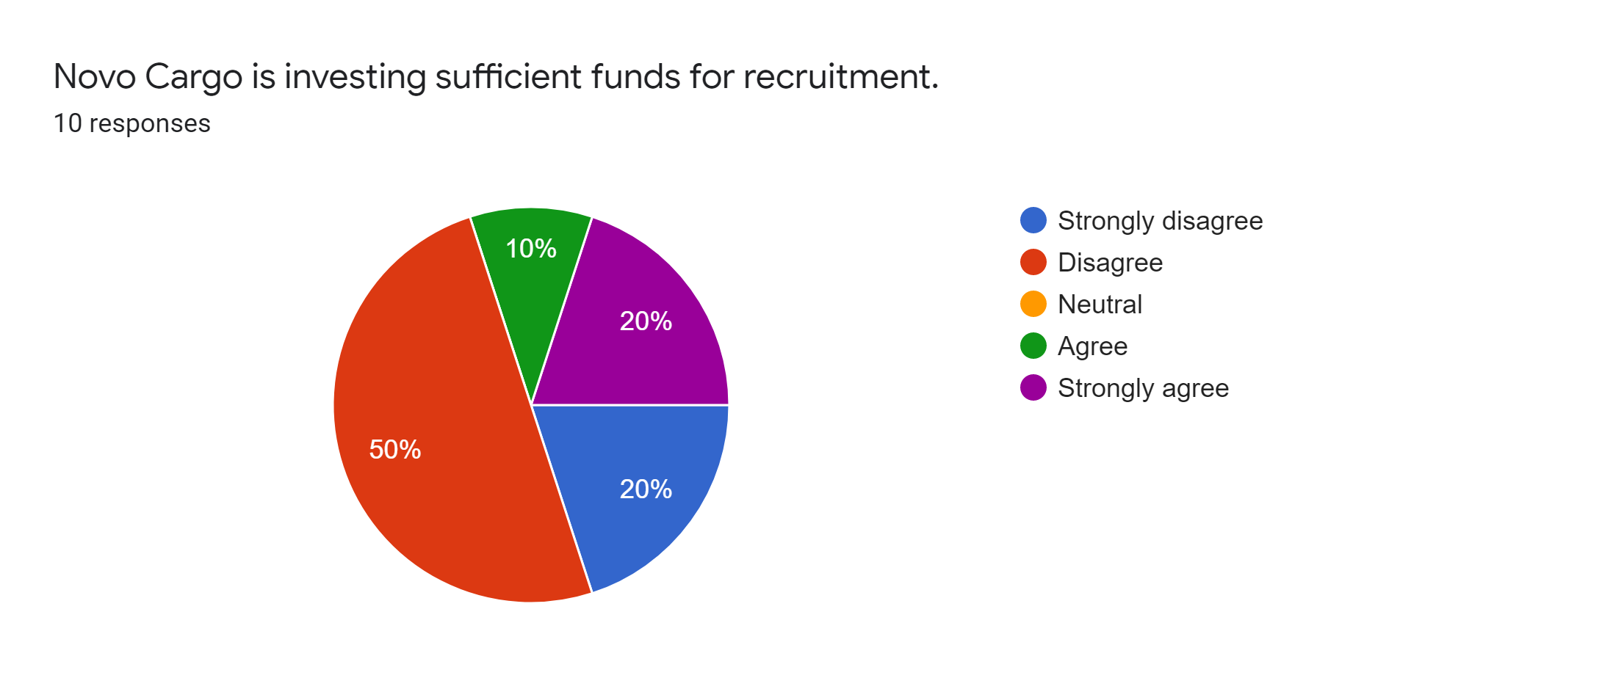
Interpretation: It is found that total 7 respondents disagreed with the statement where 5 respondents disagreed and 2 respondents strongly disagreed with the statement. Only a total of 3 respondents agreed with the statement.

4.2
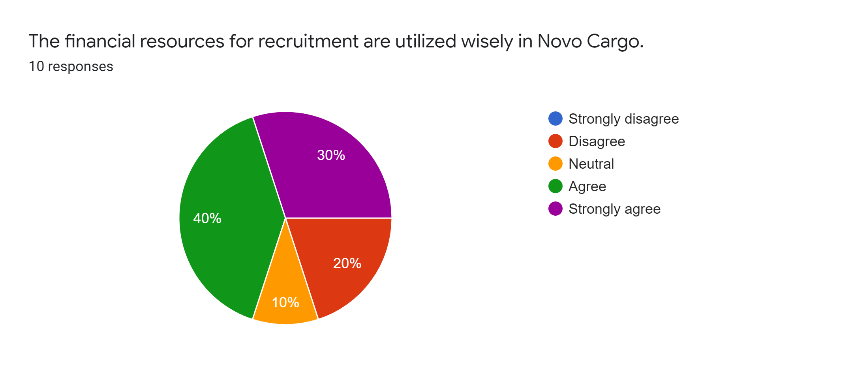
Interpretation: Out of 10 respondents, 7 agreed with the statement that the company utilizes the financial resources wisely. Only 2 respondents were disagreed with the statement.

Equality in the recruitment and selection process
As we know, male and female both are showing equally remarkable performance in the job sector. Therefore, this section were added to identify whether the NovoCargo Services Limited is offering equal opportunities to both gender as prioritizing only on one gender often difficult to get the right employees through the recruitment and selection process.

5.1
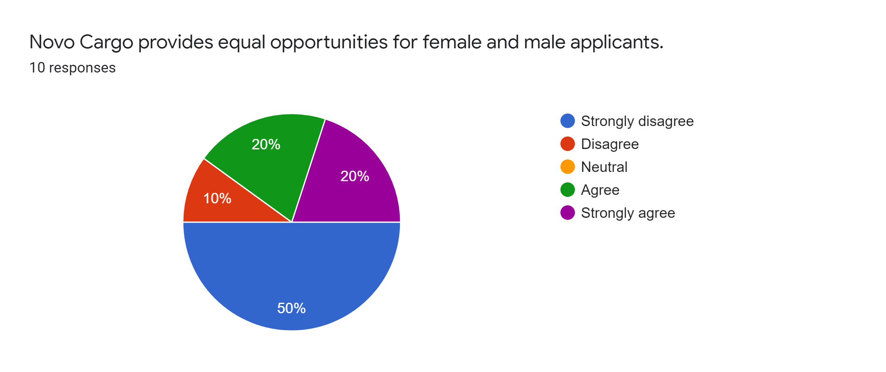
Interpretation: The statement states that whether the company is hiring and offering equal opportunities to both gender and it is found that 6 respondents out of 10, disagreed with the statement that clearly show that the company is not offering equal opportunities for both genders. However, 4 respondents also agreed with the statement.

5.2
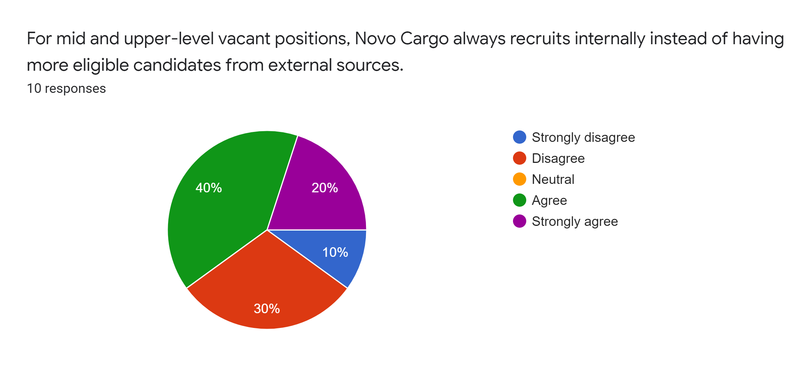
Interpretation: The pie chart shows that a total of 6 out of 10 employees agreed with the statement that their company recruits internal candidates for mid and upper level position, though a total of 4 respondents disagreed with the statement.

5.3

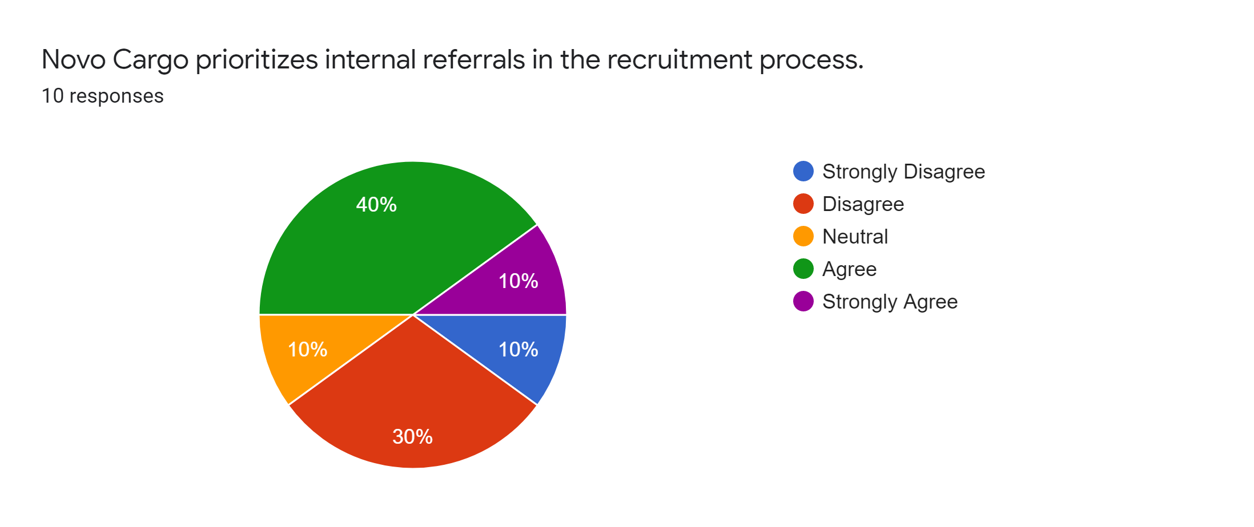
Interpretation: It is found that a total of 5 respondents agreed with the statement, 1 neutral and a total of 4 respondents disagreed with the statement. So it can be said that NovoCargo Services Ltd prioritizes its internal candidates over the external candidates.

3.4 Findings of the study
At this part, the survey findings are being listed based on the pie charts and their interpretation so that the challenges of recruitment and selection process of NovoCargo Services Limited can be easily understand:
- All jobs need to meet specific requirements. If these requirements are incorrectly evaluated, it is difficult to understand the skills, attributes, and qualities required for employees to qualify for a position. However, the survey results show that NovoCargo Services Ltd doesn't properly analyse the job requirements due to time restriction before publishing the vacancy advertisement.
- The vacancy advertisements are advertised on traditional media such as BDJobs.com and national newspapers but not on all the social media platform like LinkedIn, Facebook; it was found that NovoCargo Services Limited doesn’t choose or seeks the right media to advertise their vacancy announcements.
- Although it is observed NovoCargo Services Limited usually receives a huge number of job seekers applied for any post that is being published by the organization, most of the applications are being cancelled due to the inappropriate skills or lack of experience to perform the responsibilities for any particular position. The survey results show that the organization doesn't get the right employee by their vacancy announcement. In addition, NovoCargo Services Limited also fails to attract mid-career candidates through their vacancy announcement.
- The hiring process of NovoCargo Services Limited is fair but due to the lack of time invested in the recruitment and selection process the HR professionals can’t meet the hiring objectives.
- The financial resources and funds for the recruitment process are utilized wisely but budget of financial funds are insufficient to complete the recruitment and selection process effectively and efficiently.
- NovoCargo Services Limited seeks male employees mostly than the female employees and they mention it on the job description. The company selects internal employees for their mid and upper level jobs and doesn’t publish vacancy announcement for these posts. Moreover, often the company calls for application from internal and external candidates for any post and finally selects from internally referred candidates.

3.5 SWOT analysis
SWOT stands for strengths, weaknesses, opportunities, and threats. It is analysis and decision making based on these 4 metrics. Strengths and weaknesses are metrics related to the internal environment, to the company. Opportunities and threats relate to the external environment, to alert decision-makers to what they are facing.

Companies like NovoCargo Services Ltd face constant competition for talents. Being a reputed company, the competition is tougher due to the absence of purchasing power, branding, and even experience, amongst others. That is why NovoCargo Services Limited has to know themselves and the environment well before announcing any vacancy announcement or implementing talent acquisition strategies. Here, a SWOT analysis is prepared based on the human resource management, recruitment and selection process of NovoCargo Services Limited so that the company can easily understand the internal strengths and weaknesses, and external opportunities and threats.



3.5.1 Strengths
- A strong reputation of parent company in Bangladesh that helps to attract job candidates on each of the vacancy announcement.
- Highly professional HR employees who works hard to analyse vacancies, maintain current employees, gather and check resumes of employees and communicate with the applicant within due time.
- NovoCargo Services Ltd invests sufficient financial funds and resources for recruitment and selection purposes
- The dedicated Human Resource professionals makes the recruitment and selection process fair in the company.
- There is discipline around the segmentation of procurement efforts based on the criticality of the role and the availability of the sought-after talents on the market.

3.5.2 Weaknesses
- The company does not properly analyse vacancies because it spends insufficient time in hiring and selecting the right candidates.
- NovoCargo Services utilizes the traditional methods of recruitment and selection process which become very old and nowadays unable to get the right employees through the process.
- NovoCargo Services Limited lacks proper applicant tracking systems and other necessary tools and technologies that are critical to enhancing the ability to run the recruitment process.
- Although NovoCargo Services Ltd. uses its investment wisely, the amount of funds invested for recruitment is not sufficient to carry out all the recruitment and selection work adequately.
- The company does not advertise on all platforms about its vacancy announcement, from where it can easily attract applicants. For example, the company does not advertise on social media groups or pages.

3.5.3 Opportunities
- The talent pool of eligible candidates is increasing at a dynamic pace which is a great opportunity for NovoCargo Services Limited to choose suitable candidates for the company.
- NovoCargo Services Limited can expand its recruitment and selection process by launching an online platform to register potential applicants who want to work with the company in the future. Through the platform, the company can attract many job seekers who can register themselves with their CV and it helps the company to find the right candidate whenever the company needs it. Moreover, the company can employ more effective strategies as there will be an adequate supply of talents.
- The HR department of NovoCargo Services Ltd can organize volunteer programs in high schools and universities to generate a skilled talent pool.
- Modern technologies and equipment can be added in future to improve the recruitment and selection process.

3.5.4 Threats
- The right talent to meet the needs of the business is not always encouraged using the strategic mix of motivated channels. Often the NovoCargo Services Limited calls a lot of employees from internal and external sources and ultimately chooses one from internal referrals which can have a high impact on the reputation of the company.
- NovoCargo Services Limited may lose its future profits due to less-skilled workers as the company does not analyse the job position, invests insufficient funds, and time for the selection and selection process.
- Employee turnover maybe increased due to lack of motivation and less competitive work environment that offer less career growth.
- The company usually prioritizes male candidates and doesn’t allow female candidates to apply for several positions, when nowadays it is seen that women can equally perform the same responsibilities that male employees do. In most cases, referred female employees are allowed to apply for any position. Therefore, if the company discriminate or neglect the overall female employees, the company may lose its ethical value in future.

Chapter Four

Recommendations and Conclusions



4.1 Recommendations
After analysing the recruitment and selection process and survey results of NovoCargo Services Ltd., it is clear that the human resources department of the company has faced several challenges (e.g. financial resources), insufficient funds, equipment, and time while recruiting and selecting the right candidates. However, a number of recommendations for improvement of NovoCargo Services Ltd. have been provided to overcome the challenges given below.
- The company should analyse the position’s requirements from the existing employees and prepare the proper job description before announcing the vacancy.
- The vacancy announcement of NovoCargo should not only advertise on newspapers and bdjobs.com, but they can also advertise on several Facebook, Twitter, LinkedIn and other social media platforms as people usually spend more time on social media platforms and in most cases advertise on social media. Available for free. In addition, the agency can contact any large hunting organization to get an immediate response.
- NovoCargo Services Ltd should encourage mid-level employees from external sources by redesigning the compensation and benefit packages. The compensation packages should also be competitive among the other market competitors.
- NovoCargo is using a traditional recruiting process which is usually very manual and untargeted. Candidates who send requests to a general email address and recruiters who analyse hundreds of curious resumes are two situations that come to my mind. Relying on these 19th-century recruitment methods, it is almost impossible to find suitable job candidates. Moreover, this outdated process does not help, nor does it provide NovoCargo with the most promising candidates. Therefore, the company must adopt modern technologies and tactics in their recruitment and selection process. The company should also develop an online platform to gather talent pool who wish to work for the company.
- As we have seen, the Human Resources department employs staff fairly and uses financial institutions' investments wisely, but due to insufficient investment and time, the Human Resources department cannot get the right staff. Therefore, the company is recommended to reconsider its activities, funds, and time investments so that the human resources department can concentrate and obtain suitable candidates comfortably.
- As Bangladesh moves from a developing economy to an emerging economy, the expectations and values ​​of the people are also changing. In the last 20 years due to globalization and the information technology revolution, people have become more aware of the world’s civic structure, actions, and modern life. The previous generation was concerned about savings and job security, the new generation of workers was concerned about relationships, the balance between work and personal life, and the meaning of their work. Women are joining the labour market in increasing numbers and the number of working couples is also increasing. As professional women move into higher-level jobs, they face a challenge to balance work and personal life and career development in the traditional Bangladeshi society. Therefore, NovoCargo Services Limited should not discriminate women to enter in the company and only give preference to most male candidates, rather female employees should get the same benefits that are currently available to male candidates.
- NovoCargo has difficulty attracting and recruiting different candidates, and unconscious bias is often the reason. In addition to the company's legal obligations to guarantee equal opportunities, objective recruitment is positive for businesses, as it helps NovoCargo to hire the best person for the job without interfering with stereotypes. This will result in an inclusive work environment that will be successful for potential candidates who are meritocratic and beneficiaries of the positive effects of diversity.

4.2 Conclusion
The purpose of the study was to identify challenges of the recruitment and selection process of NovoCargo Services Limited and to recommend probable solutions to solve the challenges. Throughout the analyses it was seen that the company is practicing a traditional recruitment and selection process though it has efficient employees in their human resource department. While recruiting employees for any position, the company invest insufficient time and resources to attain the right candidates. In consequence, the HR professionals can’t properly analyse the job position’s requirement and uses common media to advertise the vacancy announcement what can’t attract and gather a talent pool. Moreover, although all HR professionals agreed that their hiring process is fair, but the company mostly prioritizes employees from internal referrals. The company also prioritizes male candidates over the female is another challenge. However, to solve all these challenges, the company should modify its investment decisions and organizational policies for recruitment, develop an online platform to gather potential candidates, adopt modern recruitment and selection techniques that are mentioned in the recommendation part.

Reference
(a) Company information, collected from the website: http://www.novogroup-bd.com/Novo-Cargo.
(b) Cooper, D. et al., (2003). Recruitment and selection: a framework for success, Australia; United States: Thomson
(c) Boxall, P., Purcell, J., & Wright, P.M. (2007). Human Resource Management: Scope, scope analysis, and significance. The handbook of human resource management. Oxford: Oxford University Press.
(d) Karim, M. (2007). Restoring the credibility of the Bangladesh Public Service Commission: main policy challenges and recommendations. Bangladesh e-Journal of Sociology, 4 (1), 1–12.
(e) Briggs, B.R. (2007) Problems of Recruitment in Civil Service: Case of the Nigerian Civil Service. African Journal of Business Management, 1, 142-153
(f) Okusanya, A.O.; Oseji, (2012), empirical analysis of solid selection and selection criteria as a tool for organizational efficiency. J. Res. Natl.
(g) ILO (2013). Bangladesh: search for better working conditions for better socio-economic results. Growth studies with Equity Report, ILO Dhaka Office, Bangladesh.
(h) Unknown, (2014), Strategy, structure, and guidelines of human resources policies: hiring and selection practices for employees in multinational branches. Asia Pacific Human Resources Journal. DOI: 10.111 / 1744-7941.12057
(i) PwC (2015). The world in 2050: will the shift in global economic power continue? London: PricewaterhouseCoopers
(j) Essays, UK. (2018). Challenges in recruitment and selection practices. Retrieved from https://www.ukessays.com/essays/management/challenges-in-recruitment-and-selection-practices-management-essay.php?vref=1
(k) Acikgoz, Y., (2019), Employee recruitment and job search: towards multi-level integration. Hum. Resour. Manag. Page 11–13.

Appendix
A Questionnaire on
Identifying the factors that create challenges for the recruitment and selection process of NovoCargo Services Limited
Please respond the following statements by selecting 1-5 score that best represent your opinion.
Here, 1= Strongly disagree, 2= Disagree, 3= Neutral, 4= Agree, 5= Strongly Agree
Statements | 1 | 2 | 3 | 4 | 5
- Job Analysis
1.1 NovoCargo analyses the vacant position’s requirements adequately before advertising the vacancy announcement.
1.2 NovoCargo carefully chooses its advertising media to attract the right employees.
2. Attracting qualified candidates
2.1 NovoCargo usually gets the right applicants through their recruitment advertisement.
  - NovoCargo usually gets mid-career candidates.
3. Hiring Process
  - The hiring process of NovoCargo is fair.
  - The time NovoCargo invests in its hiring process is sufficient to complete the recruitment process.
4. Financial Investment In recruitment
  - NovoCargo is investing sufficient funds for recruitment.
  - The financial resources for recruitment is utilized wisely in NovoCargo.
5. Equality in the recruitment process
  - NovoCargo provides equal opportunities for female and male applicants.
  - For mid and upper-level vacant positions, NovoCargo always recruits internally instead of having more eligible candidates from external sources.
  - NovoCargo prioritizes internal referrals in the recruitment process.

