Internship Report
On
“Retail Audit Practices of Vini Cosmetics Private Limited – An Analysis of Fragrance Industry of Bangladesh”



Internship Report
On
“Retail Audit Practices of Vini Cosmetics Private Limited – An Analysis of Fragrance Industry of Bangladesh”
An internship report presented to the faculty of business administration in partial fulfillment of the requirement for the degree of Bachelors of Business Administration

Submitted To:
Mofijul Hoq Masum
Assistant Professor
School of Business & Economics
United International University

Submitted By:
Ruhullah Mohiuddin Malek
ID: 111 142 041
Major in Accounting
School of Business & Economics
United International University


Date of Submission: 22/12/2018

Acknowledgement

I wish to acknowledge immeasurable grace and profound kindness of the Almighty Allah, the supreme ruler of the universe who enables us to make my dream in a reality.
My acknowledgement begins by thanking my honorable supervisor Mofijul Hoq Masum, Assistant Professor- Accounting, School of business and economics, United international university, who has provided me with suggestions for making this final internship report and also provided me the format for preparing this final report. I would also like to express my sincere appreciation to him for his whole hearted support and guidance. It was a great pleasure to prepare the internship report on “Retail Audit Practices of Vini Cosmetics Private Limited – An Analysis of Fragrance Industry of Bangladesh” under his supervision.
I am also grateful to the management of Vini cosmetics private ltd for selecting me for the three months internship program. The success of the study rests not only me but also on the contribution of all kind of employee of Vini cosmetics private ltd. My sincere gratitude goes to my internship mentor at Vini cosmetics private limited, Rubayat Sarwar Chowdhury (National Sales Manager) for his very kind attention and assistance on the report.
The practical experience I have gathered will undoubtedly help me in future to build my career and I believe that this work experience has prepared me for taking up new challenges ahead in my career. I have tried my best to complete this internship in an efficient manner.

Letter of Transmittal

December 22, 2018
Mofijul Hoq Masum
Assistant Professor
School of Business & Economics
United International University

Subject: Submission of Internship Report

Dear Sir,
I have prepared my internship report on “Retail Audit Practices of Vini Cosmetics Private Limited – An Analysis of Fragrance Industry of Bangladesh” under your kind supervision as a requirement for completing the degree of BBA program. I have tried my best to prepare this report with maximum standard under your direction.

I made every effort to disclose the actual insights in this report. I hope and pray that my all effort and work will fulfill your expectation.

Thanking you for your kind consideration and supervision.

Sincerely yours,
Ruhullah Mohiuddin Malek
ID: 111 142 041
Major in Accounting
School of Business & Economics
United International University
Declaration

I hereby declare that the internship report namely “Retail Audit Practices of Vini Cosmetics Private Limited – An Analysis of Fragrance Industry of Bangladesh” has prepared by me after the completion of inspection with Vini cosmetics private ltd and a comprehensive study of the existing activities of Vini cosmetics private limited.
I also declare that this report is fairly prepared and organized by me and prepared for academic purpose which is a part of my BBA program.

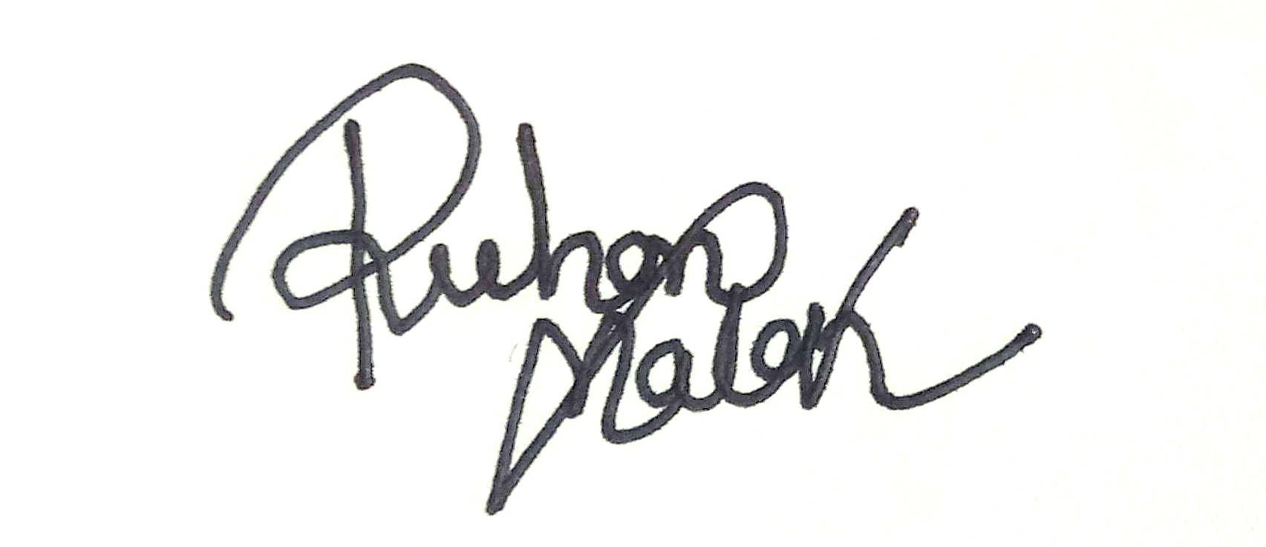
…………………………….
Ruhullah Mohiuddin Malek
ID: 111 142 041
Major in Accounting
School of Business & Economics
United International University
Date: 22/12/2018

Table of Content

SL NO. | Particulars | Page NO.
1 | Chapter One | 09-12
1 | 1.1 Introduction to the topic ,1.2 Introduction to the organization | 10
1 | 1.3 Objective of the study, 1.4 Rational of the Study | 11
1 | 1.5 Scope of the study, 1.6 Limitation of the study | 12
2 | Chapter Two | 13-15
2 | 2.1 Data design, | 14
2 | 2.2 Sample design, 2.3 Analytical tools | 15
3 | Chapter Three | 16-29
3 | 3.1 Industry scenario, 3.2 Historical Background of the organization | 17
3 | 3.2 Historical Background of the organization | 17-19
3 | 3.3 Operational activities of the organization | 20-22
3 | 3.4 Departments | 22-24
3 | 3.5 Financial Performance | 24-26
3 | 3.6 SWOT Analysis | 26-27
3 | 3.7 Retail audit | 28-29
4 | Chapter Four | 30-40
4 | 4.1 Analysis of fragrance industry of Bangladesh | 31-40
4 | Area wise market position of perfumes and body spray’s brand (Dhaka) | 31-35
4 | Area wise market position of perfumes and body spray’s brand (Rajshahi) | 35-40
5 | Chapter Five | 41-43
5 | Conclusion | 42
5 | Recommendations | 43
6 | Chapter Six | 44-45
 | Appendix | 45

Executive Summary
The concept of this report is to analyses the sales performance and auditing procedures of Vini cosmetics Private limited in Bangladesh. To check the performance whether the company is performing well or not. The sales performance and auditing procedures can be evaluated by doing retail auditing, checking sales related dealer point and retail outlet documents, analyzing and measuring the retailer sale officer performance, communication ability, understanding customer desire, satisfying the customers underlying the problems and identifying the solutions, maintaining interrelationship with the required personnel in proper manner. Its primary aims at learning the various factors that can help my evaluation process. I have tried to find out the reasons or grounds where it is lacking. I have also try to find out areas of improvement. In order to do the sales performance analysis and retail auditing procedure of Vini cosmetics private limited company in Bangladesh the various tools like product sales, market share position analysis has been used. In statistical tools I have used time series data, pie chat and bar chart etc. In chapter 1, I have introduced my topic of internship report. I have also given a brief description about Vini cosmetics private limited company, where I have been working as an intern and evaluating their sales performance and sales activities they hold. I have given the objectives of the study into two categories one is broad and another is specific objectives. I have also given the rational of the study, scope of the study and limitations of the study which I have faced during my internship period. In chapter 2, I have described about the methodology of the study starting with data design, types of data, sample design and analytical tools. In chapter 3, I have upholds the organizational background and industry perspective by industry scenario, historical background of the organization the mission and vision of the company, management structure, operational activities of the organization, products, departments, financial performance in terms of sales and profit, SWOT analysis, retail audit effectiveness and its benefits.
In chapter 4, I have described about the findings and analysis of the study of the Vini cosmetics private limited company according to the division’s wholesale outlets and retail outlets. I have also shown their market share in percentage comparing with its competitors. For showing the market share in percentage form I have used the statistical tools bar chart and pie chart. In chapter 5, I have reached into a conclusion of my report along with some recommendations. The recommendation holds my point of view of the improvement sectors and necessary steps the company should take in future for further growth.
List of Acronyms

- NSM National Sales Manager
- ASM Area Sales Manager
- SO Sales Officer
- BP Brand Promoter
- PVT Private

Chapter – 1
Introduction
  - Introduction to the topic
This report is the result of three months internship in Vini Cosmetics Private Ltd. The report is prepared with a view to provide a brief but complete idea about the sales activities & sales performance of Vini Cosmetics Private Ltd. The report also includes the problems and prospects of sales activities of Vini Cosmetics Private Ltd. This report was prepared to gather knowledge about the company's sales activities and overall performance. This report will help others to know about company’s current position in the market, company’s products, their operation, their management and some other areas. For making this report I have visited nearly 1000 retail outlets with closely 20 sales officers, also visited 50 wholesale outlets and 10 dealer points across the country. The information I have collected were based on my physical observation and retailer’s opinion. I have tried my best to collect all authentic and legit information for making this report.

  - A brief introduction of the organization
VINI Cosmetics is an entrepreneurial venture established by Mr. Darshan Patel, the DNA of Paras Pharmaceuticals Ltd., instrumental in creating great brands like Moov, D’Cold, Set Wet, Ring Guard and Dermi Cool of which most of them were leader in their respective categories. Vini Cosmetics Private Limited offers personal care and over-the-counter products. The company owns the brands Fogg, 18+ deodorants, and White Tone Talc. Vini Cosmetics Private Limited was incorporated in 2009 and is based in Ahmedabad, India
In Bangladesh, VINI has brands like FOGG, OSSUM, White Tone, Glam Up.

  - Objective of the study
The objective is divided into two parts and these are as follows:
1.3.1 Specific objective
- To know the sales activities of Vini cosmetics Private ltd
- To understand company’s operation
- To get a clear knowledge about its products
- To know their current position in the market
- To find out the actual differences in theory and practice by working directly in the company.
- To identify the problems that the company currently facing
- To find some action plans to reduce the risks
1.3.2 Broad objective
- To learn the overall activities of the organization
- To secure a good mark in my internship project.

  - Rational of the study
This internship program is a process of systematic recording, analyzing and gathering data about the subject or topic that the student is going to learn in the program. The aim of my internship report is to connect my theoretical knowledge with practical knowledge. A good outcome comes when people can implement their theoretical knowledge in practical working and can create a good balance between them.
In this regard I got an opportunity to carry on my internship project in Vini Cosmetics pvt ltd. The management of the company assigned me to work as Retail auditor.
During my internship program I didn’t face mush problems and obstacles by the grace of Almighty Allah. My superior and the total management team were too supportive and guided me a lot. With the help of everyone and specially my supervisor I have overcome all the obstacles and successfully prepared my report.

  - Scope of the study
This internship program provides opportunities to take real working experience and helps to understand how everything happens actually, how employees work, how management draws the plan and implement it. This program will also help me further in my life in doing other jobs.

  - Limitations of the study
- Company hardly discloses their financial data
- Company’s website do not provide sufficient data
- Company’s core information is very confidential and it can only be collected from the head office which is located in India.
- Different websites express the same topics in different way. Sometimes it creates confusion.

Chapter – 2

Methodology of the Study
2.1 Data design
2.1.1 Data collection process
As we know that there are many types of data collection process such as- Interviews, Focus Group, Questionnaire, Ethnography, Observation, Documents and Records etc. The processes I have used to collect information are-
Observation
I have visited many retail outlets, wholesale outlets, dealer points and collected data.
Documents and Records
I have also collected some data from journals, papers and annual reports.
Interviews
I have taken direct interviews of about 500 retailers and 20 sales officers.

2.1.2 Types of data
There are two types of data which I have collected and these are-
Primary Data
I have collected this types of data by visiting near about 1000 retail outlets in 10 territories across the country. So this data is totally based on my direct observation.
Secondary Data
I have also collected few data from websites and journals published by others in the past.

2.2 Sample design
As we know that there are many sampling designs are available but among all of them I have chosen stratified random sampling which involves dividing the whole population into sub groups or strata and randomly taking sample from each of the strata.
To get clear picture about the fragrance industry of Bangladesh it is not possible to visit each of the consumer and every retail shop. So here I have visited all major areas from a territory rather than visiting all areas and collected data. As I mentioned earlier that I have taken interview of 500 retailer and visited nearly 500 plus outlets.

2.3 Analytical tools
The analytical tool I have used in preparing my internship report is MS Excel. Throughout my internship I have used this tool several times to compare performance, show the differences, show the actual market picture and company’s actual position in the market.

Chapter – 3

Organizational Background and Industry Perspective
3.1 Industry Scenario
Background of the industry
Currently the fragrance industry of Bangladesh is very competitive and growing. There are lots of popular brands available in the market currently those are competing with each other to get top position and becoming the market leader. Some brands are well established, some are doing their business for last twenty years, some are recently emerged and some are trying to enter the industry. This industry is totally import based which is closely 99% and 1% is locally manufactured. Currently the industry growth is 8-10% yearly. Consumers need and demand for fragrance products have increased a lot now a days and it is helping the industry to grow more.
Contribution in the economy
Roughly their contribution in the industry is 200 crore taka and near about 4000 people are working in this industry. There are also 500 plus dealers those are working in this industry. This industry is surely creating many working opportunity and removing unemployment. This industry itself has the ability to contribute a lot in the economy.
This industry has already created many scopes and will definitely create many more scopes for business peoples and also for people who are seeking job.

3.2 Historical Background of the organization
3.2.1 Organization’s background
Prasad Pharmaceutical Company was established by the four brothers of Darshan patel. In 2006 the prasad Pharmaceutical company was sold, almost 450 crone amount was divided by the four brothers of Darshan patel fall into problem and want to established a new company along with his friend Depak Patel. They atarted to thinking about launching something new, After 4 year survey of the market they both agreed to established a new deodorant and perfume company and hence established Vini. As the people of India are too much concern about the price of the product rather than quality of the deodorant so they decided to launch a reasonable range of deodorant and perfume. Afterward they tried to identify the problematic areas that customers were facing for using deodorant for daily life. They go to the customers and retail shop to identify what types of fragrances the customers wants within a reasonable price. But the customers and retail shoppers were not concerned about the fragrance; they were concerned about the quantity of usage. Then Darshan and Depak patel decided to launch FOGG with maximum usage at a reasonable price, Also to understand the customers desired and make their Product no.1 deodorant in India. They decided to advertise their product in a normal way with general people as model and showcase their Products tag line “Ajkal keya chalraha hey? FOGG chal raha hey” That tag line denotes the long lasting ability of FOGG.
After two year research they finally launch FOGG in the market. After 3 years of launching FOGG, the deodorant become no.1 deodorant and Perfume consumer product in India, FOGG is also exported in 58 countries with great demand, FOGG is o gas deodorant and maximum use is up to 800 sprays for each bottle.
FOGG- Fragrance of good girls/guys.
Also when they decided to advertise FOGG, thy make the commercial add, in such a way which is family oriented not in sexual way. In that sense Darshan Patel describe FOGG as friends of Good Girls/Guys for providing a good and ideal knowledge to consumer about FOGG. In 2014 Vini cosmetics private limited has started their journey in 2014 in Bangladesh by holding the hand of their country manager Ahsan Parvez Khundker.
3.2.2MISSION
The Company provide differentiated products for people to smell, look, feel and do good – helping them to realize their aspiration & express their individual personalities to the fullest. This gives value to our business and to the working life of our employees.
3.2.3VISION
to become the leading personal care products provider globally

Management
Country Manager
ASM 4
ASM 3
ASM 2
ASM 1
ASM 4
ASM 3
ASM 2
ASM 1
RSM 2
RSM 1
ASM 2
ASM 3
ASM 4
ASM 1
National Sales Manager 2

National Sales Manager 1
E-Commerce Manager
Modern Trade Manager
HR Manager
Finance Manager
Marketing Manager
Sales

Figure: 3.1
*Each of the following Area sales managers (ASM) has 10 sales officers under them.
This is how the company’s management system runs from top to bottom.
3.3 Operational activities of the organization
3.3.1 Operation
Here in Bangladesh the company’s main operation is concerned with sales. Vini cosmetics do not have any production plant in Bangladesh yet. So the other operations are mostly performed by the Head office which is located in India. Here the company is only focused at their sales. They import the product directly from India through their distributor which is SB distribution. SB distribution is the sole distributor of this company’s products in Bnagladesh. By following the below channel company sells their product to their consumers-
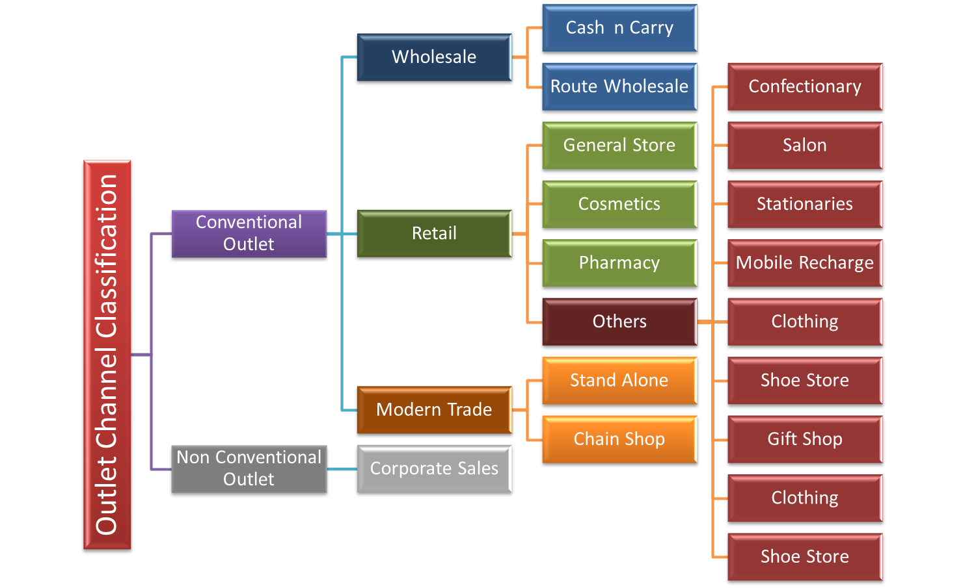
Figure: 3.2

3.3.2 Products
Smell Good Products:
- Perfumed Deodorant Body spray
- Eau de Perfume
- Body Mist
- Roll On
- Cologne
- Eau de Toilette
- Attar
Look Good Products:
- Glam Up
- White Tone
- Prepare
- Pretty24
Feel Good Products:
- Nufeel-Face Wash

All products those are available in Bangladesh are shown on the following pages. Vini cosmetics have some other products also those are available in India but not yet in Bangladersh. But soon those will also be available here and they have a plan to establish their production plant in Bangladesh in recent future.

Products list are as follows:
- Regular Body spray (Men)
- Regular Body spray (Women)
- Perfumed Body Spray Black Series (MEN)
- Perfumed Body Spray Black Series (Women)
- Roll On (Men)
- Roll On (Women)
- Fogg regular scent (Men)
- Fogg regular scent (Women)
- Fogg scent premium (Men):
- Fogg scent premium (Women)
- Fogg 50ml Perfume for men only
- Fogg fantastic series
- Fogg Blue Series
- Fogg Celebration series
- Fogg Perfumed Roll On
- Ossum Body Mist only for women
- White tone (70,50,30gm)
- Glam Up

3.4 Departments
This company is totally sales based specially in Bangladesh. As they have no production plant yet in Bangladesh so they are mostly focusing on sales activities. They also have other departments but they are not as big as sales department. Department are as follows:

Figure: 3.3
3.4.1 Sales
About 130 people are involved in sales. There are around 120 sales officers works in the sales department and report to their Area sales manager (ASM). Every ASM reports to their Regional sales manager (RSM) and they reports to the National sales manager (NSM). NSMs directly report to the Country manager (CM). Country manager holds the highest authority here in Bangladesh. S.B distribution is the sole distributor of vini products. S.B distributes the products to Wholesale outlets and dealer points all over Bangladesh. Then sales officer take the products from dealer points by following the direction from ASM and carry some of the sample of those products to retail outlets. If the retailer likes those products then sales officers take order from them and send those products from dealer points with the help of delivery man. This is so far the selling process in general. Sales has also two other sector which is modern trade and corporate sales.
3.4.2 Marketing
Marketing department is responsible for all the promotional activities related to sales and this department runs under the marketing manager. Marketing manager controls the modern trade activities.
3.4.3 HR (Human Resource)
HR manager is responsible for performing all those tasks related to human resource and those are such as recruiting, training, selecting employees.
3.4.4 Finance
Finance department runs with the direction of finance manager. And he is responsible for performing all those tasks related with finance and accounts. Such as salary, wages, incentives, bonuses, office supplies etc.
3.5 Financial Performance
As the company is not public limited so they do not provide any financial data to the public and also to their employees in some cases. Only the board of directors and top management have access to those data. They do not prepare annual report yearly. Their sales and profit report are as follows:
3.5.1 Sales:
Their last five years sales report is shown in the below table:
Table: 3.1
Year | Sales (taka)
2014 | 350000000
2015 | 480000000
2016 | 740000000
2017 | 920000000
2018 | 1020000000

Figure : 3.4

From the above table and column chart we can say that company’s sales has gradually increased a lot from 2014 to 2018. Very few years after launching their product the company has became the market leader and cureently holding the most amount of share in the fragrance industry. They have inreased their sales about 3 times in last five years.

3.5.2 Profit:
Their last five years profit report is shown in the below table:
Table: 3.2
Year | Profit (taka)
2014 | 52500000
2015 | 72000000
2016 | 111000000
2017 | 138000000
2018 | 153000000

Figure: 3.5
From the above table and column chart we can say that company’s profit has also gradually increased a lot from 2014 to 2018. Their profit has been increased about 3 times in last five years.
3.6 SWOT Analysis
SWOT Analysis is a study undertaken by an organization to identify its internal strengths and weaknesses, as well as its external opportunities and threats.

Strengths | Weaknesses
Opportunities | Threats
Figure: 3.6

3.6.1 Strengths
Strengths are the characteristics of the business that place the business or project at a advantage relative to others. The strengths of Vini cosmetics pvt ltd are as follows:
- Quality of the products are very excellent.
- Distribution channel is very strong
- Wide variety of products in every segment and excellent R & D
- Regular retail auditing and monitoring
- Currently holding leading position in the market
- More digitalize marketing system
- Reasonable price for consumer of any level of income
3.6.2 Weaknesses
Weaknesses are the characteristics of the business that place the business or project at a disadvantage relative to others. The weaknesses of Vini cosmetics pvt ltd are as follows:
- Shipping cost are high and increases the overall cost of the company
- Less variety of designs
- Yet to build a production plant in Bangladesh
- Sales officers need to be trained
3.6.3 Opportunities
- Huge opportunity to build a production plant here in Bangladesh
- High opportunity to extend their segment of product
- As a market leader they can achieve the economy of scale
3.6.4 Threats
- Production of replica products are currently most alarming threats
- Availability of similar products of other brands very high
- Random fluctuation of price
- High cannibalization
3.7 Retail audit
The company also runs retail audit, market survey and monitoring in regular basis. Here I worked as their retail auditor under the direction of NSM who is my supervisor in this three months of internship.

Retail Audit : In general sense, retail audit stands for a study of the selected sample of retail outlets about the specified firms or a company’s product and service, In boarder sense, for measuring the effectiveness, sales trends, sales volume of a product and service, retail auditor visit the markets or retail outlets to hold survey or collecting sampling information about the desired product and service and also carry accurate and efficient steps to solve the product and service related problem is called Retail Audit. Retail Audit also holds to evaluate the competition in the market, gather knowledge about product and service, getting the real time data and improving performance trends. For gathering the accurate picture of the every events at a retail shop and helps to carry out corrective or improving measures at that time, retail auditing process should be carried out at a real and appropriate time.

How to carry an effective retail audit
- Collect appropriate sample which representative to the real world sample.
- Set goals to carry out retail audits keeping those goals in mind.
- Proper set of questionnaire should be sited, so that the retail auditor can gather the information which they want to achieve through the retail auditing procedure
- Questions should be make in a way which is easily understandable and proper answer can be collected.
- The survey should be simple and terse, so that it is easily answered those questions and we can easily collect the data
- For efficient retail auditing procedure and for carrying out a survey a simple tablet or a phone can be used.
- Collected data must be processed to achieve the desired results.
Retail audit helps the company to find company’s strengths, weaknesses, opportunities and threats. It also helps to identify the problem design the action plan relative to those problems.
Benefits of retail audit
- Eliminating paper work as the retail data is fully synced or interconnected between field teams and the office
- Reducing data collection time and no time spent on reporting instant photo reports and route optimization holds hence increasing field productivity
- Preventing fraud by focusing on field activities using time tracking and GPS monitoring features boosting revenues through product catalogue and order tools.

Chapter – 4

Findings and Analysis of the Study
4.1 Analysis of fragrance industry of Bangladesh
Fogg is currently the leading brand in India and also in Bangladesh among all the brands in the fragrance industry with 38% market share which is higher than any other brand in Bangladesh. The Main USP of Fogg Deodorant is that it lasts longer compared to other deodorants in the consumer market.
The objective of my survey which I have conducted is to figure out the market position of all deodorant brands those are currently available in the market and operating their business. To conduct my audit on retail outlets I have visited about 600 outlets in Dhaka and 150 outlets in Rajshahi division.
- Dhaka:
Area wise market position of perfumes and body spray’s brand are as follows:
This survey is totally based on my direct observation and retailer’s opinion.
- Mirpur (Mirpur-1, Mirpur-2, Mirpur-10, Mirpur-11 & 12)
In this area I have seen lots of popular brand available in the retail outlets such as Fogg, Wild stone, Park Avenue, Hot Ice, Layer Shot, Nivea & Axe. These are the top brands among all. The brand that is currently leading the markets of this area is Fogg and it’s close competitor is Wild Stone. Ranking of these brands according to their market position are as follows:
- Fogg
- Wild Stone
- Axe
- Park Avenue
- Layer Shot and
- Hot Ice &
- Nivea

- Mohammadpur (Town Hall, Shatmashjid, Housing, Dhaka Uddyan & Mirpur road)
Top brands in the markets of this area are Fogg, Park Avenue, Axe, Layer Shot, Wild Stone, Nivea and Hot Ice. These are the top brands among all. Leading brand in this area is also Fogg but its close competitor is Park Avenue. Ranking of these brands according to their market position are as follows:
- Fogg
- Park Avenue
- Nivea
- Wild Stone
- Axe
- Layer Shot &
- Hot Ice

- Malibagh (Mogbazar, Mouchak, Siddheswari, Shantinagar & Baily Road)
Here we have seen a bit different scenario than the above two areas. Popular brands so far in this area are Fogg, Colour Me, Layer Shot, Park Avenue, Hot Ice, Wild Stone, Engage and Nivea. Leading brand in this area is also Fogg but it’s close competitors are equally Colour Me and Park Avenue. Ranking of these brands according to their market position are as follows:
- Fogg
- Colour Me & Park Avenue
- Nivea
- Wild Stone
- Hot Ice
- Engage &
- Layer Shot

- Paltan (Fokirapul, Motijhil, New Paltan, Kakrail, Baitul Mokaram)
Popular brands so far in this area are not very different than above three areas. Here I noticed some new brands emerged and started to cover the market such as Envy, Engage and He. Leading brand in this area is also Fogg but its close competitors are equally Colour Me, Envy and Park Avenue. Ranking of these brands according to their market position are as follows:
- Fogg
- Colour Me, Envy & Park Avenue
- Nivea
- Wild Stone
- He
- Engage &
- Layer Shot

- Sarulia (Demra, Staff Quarter, Basherpul)
As this area is located at the city side so the scenario is totally different from any other market located in Dhaka. Popular brands are Marquis, Havoc, Fogg, Nivea, Wild Stone, and Blue Lady & Layer Shot. Leading brand in this area is Marquis and its close competitors are accordingly Havoc ang Fogg. Ranking of these brands according to their market position are as follows:
- Marquis
- Fogg & Havoc
- Nivea
- Blue Lady
- Wild Stone &
- Axe
- Layer Shot

- Uttara (Jashim Uddin, Azompur, House Building, Ate para, Sector:9, 10 & 11)
Except Ate para the popular brands in this area is quite similar like the other areas in Dhaka. As we know that ate para is located at the city side so the market scenario is bit different. Except ate para Fogg is the market leader in Uttara area and its close competitor is Wild Stone. Ranking of these brands according to their market position are as follows:
- Fogg
- Wild Stone
- Nivea
- Park Avenue & Axe
- Layer Shot
- Envy &
- Engage
Based on all the above information the current market position of all brands in Dhaka as follows:

Figure: 4.1

Figure: 4.2
Here in the above chart we can see that Fogg is currently leading the market in Dhaka with 30% market share and its close competitors are Wild stone and Nivea.
- Rajshahi

- Rajshahi (RDA Market, Shaheb Bazar, New Market) :
Popular brands available in these areas are Fogg, Nivea, Wild Stone, Denver, Havoc and Park Avenue. These are the top brands among all. The brand that is currently leading the markets of this area is Fogg and its competitor is Nivea. Ranking of these brands according to their market position are as follows:
- Fogg
- Nivea
- Wild Stone
- Denver
- Havoc
- Park Avenue

Figure: 4.3
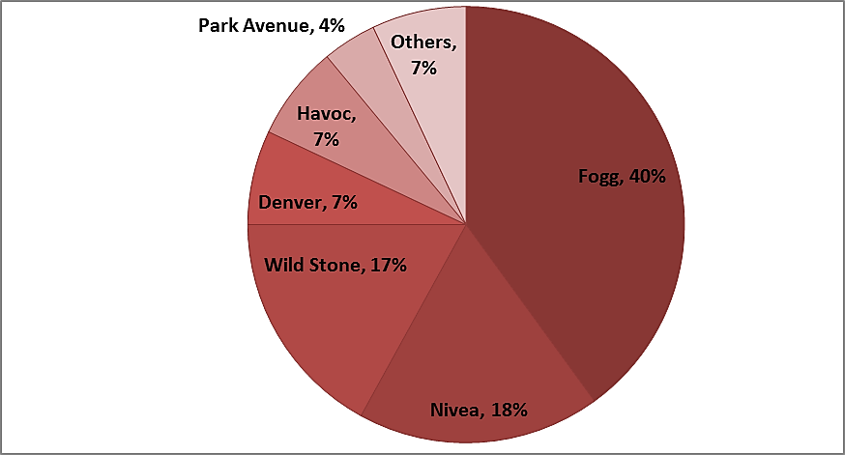
Figure: 4.4

In the above charts we can clearly see that Fogg is holding the maximum number of market share which is 40% closely in this area where other brands are very far from it.

- Bogra (Kahalu Bazar, New Market, Pukurpar Market, Churi Potti, Jolwesshari)
Top brands in the markets of these areas are Fogg, Wild Stone, Nivea, Axe, Set Wet and Layer Shot. These are the top brands among all. Leading brand in this area is also Fogg but it’s close competitor is Wild Stone. Ranking of these brands according to their market position are as follows:
- Fogg
- Wild Stone
- Nivea
- Axe
- Set Wet &
- Layer Shot

Figure: 4.5
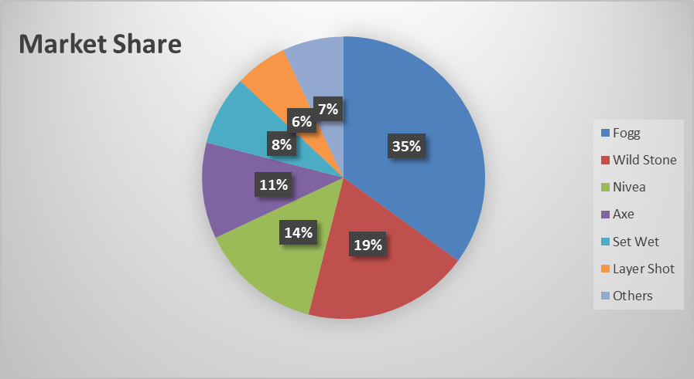
Figure: 4.6
The above charts show that in this area also Fogg is leading the market where others are far behind.
- Natore (Nicha Bazar, Uttara Plaza, Hall Road, Pilkhana Road & Alaipur)
Here we have seen that the popular brands so far in this area are Fogg, Nivea, Set Wet, Double Blue, Layer Shot, and Havoc & Wild Stone. Leading brand in this area is also Fogg but its competitor is Nivea. Ranking of these brands according to their market position are as follows:
- Fogg
- Nivea
- Set Wet
- Double Blue
- Layer Shot
- Havoc &
- Wild Stone
The difference what we have noticed in this territory is Wild Stone is less popular here. Even it failed to take position in the top five list.

Figure: 4.7

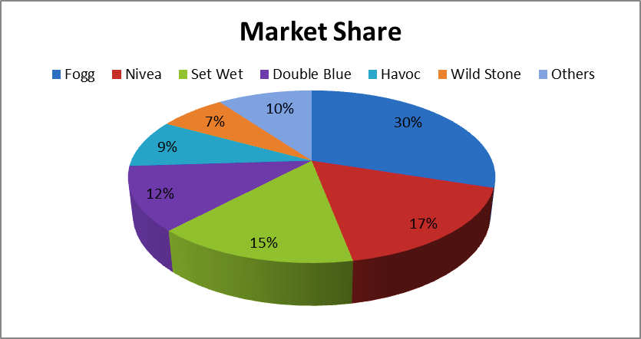
Figure: 4.8
From the above charts we can say that Fogg remains the leader in this area also and leading the industry with 30% share where others are obtaining 70% share together.
After all the survey and audit I can clearly say that no other brand in fragrance industry is as close as Fogg but they are working very hard to take the top position. All of them are good brands and working on every segment to become the most popular among all. Some new brands have emerged recently in the market and trying their best to give hard competition to others and they are also good.

Chapter – 5

Conclusion and Recommendations
Conclusion
Fragrance and perfume industry is one of the most promising industries in our country. The importance of the cosmetics sectors on fragrance and perfume industry revealed through its contribution in the economic growth of the country. The vini private limited company was first incorporated their operation of business in Bangladesh in 2014 as a private limited company under the companies act of Bangladesh 1994. Vini private limited company already has past 4 years of successful business operation in Bangladesh fragrance and perfume market. In deodorant and perfume sector fogg able to stand a successful position and grab a large portion of the market through customer satisfaction, marketing skills, product availability and efficient amount of retail and wholesale outlets. In the period of my internship I have learnt about the company general operation activities also I have learnt about their auditing activities procedures, their retail outlet auditing, visiting dealer points, checking their product sales related documents, dealing with their product related problems how to solve the problems and take measurable step to solve that problem through auditing procedures, observing the corporate sales procedure and how to deal with other corporate personal to give appropriate knowledge about the company's product. I have tried to give a clear picture about their sales auditing procedures and search performance of vini cosmetics private limited company in Bangladesh. I have also given a descriptive analysis about their products.
It can be said that if all things goes well and all maintaining their overall operational activities properly the company will improve their position better than now in deodorant and perfume industry in Bangladesh in addition by improving their position they can play a vital role in the development of our country's economy.

Recommendation
Necessary steps that should be taken to hold the leading market position and increase sale are as follows:
- Company must ensure that all the products are available in the dealer point. When the dealer fails to deliver the product in time then the retailer becomes annoyed and refuse to take products further.
- Company should at least provide a few fragrance testers to the sales officers and also to the retailers so that sales officers can show this to retailers and customers can smell it before purchasing from retailers.
- Company can provide displays at least to some retailers who are their big buyer.
- Almost every retailer said that, “If the company increases the MRP a bit then it will be easier for them to sell the product and they will order more products.
- Though, all sales officers are good but I still believe that they need few more trainings.
- In some of their routes company is still experiencing zero profit or break-even where the expense incurred by the sales officer is close to the average sales of that route.
- Company increase their number of brand promoters in modern trade outlets so that they increase the company’s sales.
- Company should regularly monitor and check their life style and modern trade outlets to ensure that others are not diverting or hampering their sales.

Chapter – 6

Appendix

- Websites
- http://www.viniinternational.com/
- www.facebook.com/search/top/?q=Vini%20International
- www.bloomberg.com
- www.repsly.com

- Books
- Marketing Management Global edition (15th edition) by Kotler and Keller
- Marketing Research An applied orientation (7th edition) by Naresh K Malhotra
- Auditing and Assurance Services (15th edition) by Alvin A. Arens, Randal J. Elder & Mark S. Beasley

