"Strategic Analysis of Al-Arafah Islami Bank Limited: Leveraging SWOT Insights for Enhanced Performance and Growth"


Prepared BY
AZMAIN AHNAF
ID:111 182 020
Bachelor of Business Administration
Submission date: 03/08/2023



"Strategic Analysis of Al-Arafah Islami Bank Limited: Leveraging SWOT Insights for Enhanced Performance and Growth"

Submitted BY
Azmain Ahnaf

Submitted To
Ahmed Imran Kabir
Lecturer
School of Business and Economics
Submission date: 03/08/2023

Letter of Transmittal

August 03, 2023
Ahmed Imran Kabir
Lecturer
School of Business and Economics
United International University

Subject Letter of Transmittal

Dear Sir,

I'm pleased to submit my internship report on" General Banking Conditioning of Al- Arafah Islami Bank Limited and the Effects I Learned in the Process" as part of my BBA program. This report was assigned to me, and I've put in my stylish sweats to give the necessary information and a suggested offer grounded on your guidance.
Throughout the internship period, I had to observe and share in colorful general banking conditioning at Al- Arafah Islami Bank Limited. This report reflects my literacy clients and the perceptivity gained during the internship.
I've made a sincere attempt to meet your prospects and fulfill the conditions of the internship report. I hope that the report meets your satisfaction and provides precious perceptivity into the general banking conditioning of Al- Arafah Islami Bank Limited.
I would like to express my gratefulness to you for your guidance, support, and precious feedback throughout the internship process. Your mentorship has been necessary in shaping my understanding of banking assiduity and enhancing my chops.
formerly again, I extend my sincere thanks to you for the occasion to complete this internship and for your nonstop support. Please don't hesitate to reach out if you have any further questions or bear fresh information.
Thank you.
Sincerely,
Azmain Ahnaf
ID; 111 182 020

Declaration

I Azmain Ahnaf, hereby declare that the presented report of my internship named" General Banking Conditioning of Al- Arafah Islami Bank Limited" has been prepared solely by me. This report was prepared after completing a three-month internship at Al- Arafah Islami Bank Limited, located at their Head Office in Paltan.

I confirm that this report is solely intended to fulfill my academic conditions and isn't intended for any other purpose. It shouldn't be used to serve the interests of any party opposing the pot.

Azmain Ahnaf
ID: 111182020

___________________
Signature

Acknowledgment

I would like to express my sincere gratefulness and appreciation to all those who have contributed to the completion of this report on my internship experience at the Al Arafah Islamic Bank Headoffice Branch. I extend my sincere thanks to the following individuals and associations Al Arafah Islamic Bank Headoffice Branch I'm thankful to the operation and staff of Al Arafah Islamic Bank Headoffice Branch for furnishing me with the occasion to take over my internship at their recognized institution. Their support, guidance, and warm hello have been necessary for my literacy and growth throughout the internship.
Internship Supervisor
I would like to express my deepest appreciation to my internship administrator for their precious guidance, mentorship, and nonstop support. Their moxie and perceptivity have significantly contributed to enhancing my understanding of the banking sector and Islamic banking practices.
Associates and Team Members
I'm obliged to my associates and platoon members at Al Arafah Islamic Bank Headoffice Branch who have been extremely helpful, friendly, and collaborative during my internship. Their amenability to partake in their knowledge, help me in colorful tasks and unite as a platoon has made my internship experience enriching and pleasurable.
University Faculty and Staff
I would like to thank the faculty and staff of my university for their constant stimulant, guidance, and support. Their commitment to furnishing quality education and easing practical literacy clients has been inestimable in shaping my professional development.
Friends and Family
Incipiently, I'm thankful to my friends and family for their unvarying support, understanding, and stimulant throughout my internship trip. Their belief in my capacities and provocation have been vital in prostrating challenges and achieving success.
I'm truly recognized to have been a part of the internship program at Al Arafah Islamic Bank Headoffice Branch, and I admit the collaborative sweat of all those who have contributed to the completion of this report. Thank you for your nonstop support and guidance.

Thank you.
Sincerely,
Azmain Ahnaf
ID; 111 182 020

shortened form:

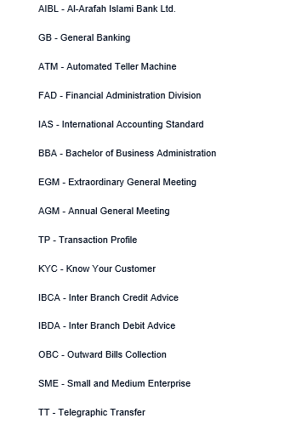

Executive Summary Al Arafah Islamic Bank Head Office Branch Internship

The internship at Al Arafah Islamic Bank Headoffice Branch offered a precious occasion for scholars to gain practical experience and make a career in the banking sector. Al Arafah Islamic Bank Headoffice Branch operates grounded on the principles of Al- Quran, and Sunnah, aiming to apply Islamic profitable and fiscal principles while furnishing banking services that contribute to the weal of the people. During the internship, the interns were assigned to the General Banking sector, which encompasses five sections Account Opening, Bills and Clearing, Remittance, Deposit, and Cash. The interns were responsible for aiding clients with account opening procedures, handling the concurrence of cheques, conducting background checks, managing deposits, and sharing cash operation conditioning. Through this internship, the interns acquired precious chops and knowledge. They developed proficiency in account opening procedures, client service, check concurrence processes, and Islamic banking principles. They also gained experience in conducting background checks and understanding fiscal record-keeping processes. The internship wasn't without its challenges. One notable challenge was faced when filling out forms for Individual, Institutional, and Government account opening forms mostly in Bengali, which wasn't easy for me as I am from an English medium background student. still, with perseverance and the support of associates, I was suitable to overcome this challenge and ameliorate their Bengali jotting chops. cooperation and collaboration were crucial aspects of the internship experience. The associates at Al Arafah Islamic Bank Headoffice Branch made me warmly and handed me guidance and backing throughout their internship. In one case, when faced with a significant workload, associates divided the tasks and coordinated effectively, illustrating the spirit of cooperation within the association. Overall, the internship at Al Arafah Islamic Bank Headoffice Branch handed me a precious literacy experience, aligning the interns' particular values as Islamic- inclined individualities with the practices and deals of the bank. It equipped them with essential chops and knowledge for a future career in the banking sector, while also emphasizing the significance of perseverance, practice, collaboration, and a probative work terrain.

Table of Contents
Letter of Transmittal 3
Declaration 4
Acknowledgment 5
shortened form: 6
Executive Summary Al Arafah Islamic Bank Head Office Branch Internship 7
Initiatives taken to prepare this report : 10
Limitations 10
Introduction and Background: 11
Mission of AIBL & Vision of AIBL : 12
The mission of AIBL: 12
Vission of AIBL: 13
Values and commitments 13
Values: 13
Commitments: 14
S.W.O.T Analysis of Al Arafah Islami Bank Head Office 15
CORPORATE INFORMATION 17
ECONOMIC VALUE- ADDED STATEMENT by the bank 17
Financial Value for the last 5 years 19
Information Technology 23
Overall Training Scenario in 2021: 24
Internship Objectives: 26
Support Objectives 26
Comprehensive Analysis of Al- Arafah Islami Bank Limited's Annual Report 26
General Banking Functions 28
Cash Department 28
Accounts Opening Section 28
Collecting information to open an account 29
Individual Account 30
Partnership Client Account 30
Latent/dormant Account 30
Cheque Clearing Section 31
Remittance Section 31
Foreign Remittance 32
Local Remittance 32
Clearing Department 32
Types of Cheques Collected by the Clearing Department 33
Local Bills Collection Cheques( LBC 33
Outside Bills Collection Cheques( OBC) 33
Transfer Cheque 33
Clearing House 33
Types of Clearing 33
Cheque Clearing 34
Inward Clearing Cheque 34
OBC( Outward Bills for Collection) 34
Clearing Cheque 34
Outward Clearing 34
Inward Bills for Collection( IBC) 34
Job Responsibilities: 35
Al- Arafah Islami Bank Limited AIBL’s Products and Services 35
Types of services 37
Investment types 38
Skills and Knowledge Gained: 38
Challenges and Learning Experience: 39
Teamwork and Collaboration: 39
Conclusion: 39
Reference: 40
Intern Monthly Progress Report 41

Initiatives taken to prepare this report :

The information for the study is primarily collected from secondary data. The sources include applicable papers and publications, departmental textbooks, websites, periodic reports, sanctioned records, academic handbooks, training accouterments, and publications related to banking functions.

After collecting the raw data, it'll be reused and edited using computer packages similar to MS Word and MS Excel. Data analysis will be conducted using a relative study approach. The focus of the study is on Al- Arafah Islami Bank Ltd., one of the 58 private banks in Bangladesh. Data from the bank's periodic reports and branch reports for the times 2017 to 2021 will be collected. A relative analysis will be performed between the bank's overall performance of Al Arafah Islamic Bank. Tabular and graphical analysis styles will be used to present the findings of the study.

Limitations

This program aimed to provide a practical display to students. However, the research conducted for this report encountered certain limitations and shortcomings, which are as follows:

- Data Confidentiality: The bank maintains strict confidentiality of its data, limiting access to certain information.

- Limited Availability of Data: Obtaining data and information related to the topic proved to be challenging and not easily accessible.

- Insufficient Practical and Contemporary Data: There was a lack of availability of more practical and up-to-date data for analysis.

- Narrow Data Range: The data collected for analysis was limited in scope, potentially affecting the comprehensiveness of the findings.

- Insufficiency and Reliability of Data: The available data appeared to be insufficient and may have lacked reliability to some extent

- Communication Gap: There were instances of communication gaps between myself and the relevant officials, which could have impacted the research
- Inconsistencies in Data from Different Sources: The data collected from various sources on the same subject showed discrepancies.

- Lack of Cooperation: Due to the hectic schedules of bank officials, it was difficult to obtain full cooperation, thus limiting the scope of this report.

- Confidentiality Constraints: Due to the management's confidentiality policies, certain shortcomings or issues may not have been fully disclosed in the report.

Please note that these limitations and shortcomings were unavoidable during the research process.

Introduction and Background:

At Al Arafah Islamic Bank Headoffice Branch, the internship program provides students with practical experience and an opportunity to build a career in the banking sector. Al Arafah Islamic Bank operates based on the principles of Al-Quran and Sunnah, aiming to implement Islamic economic and financial principles while offering banking services that contribute to the welfare of the people.

It was established in September 1995 and is a well-known Bangladeshi bank that's listed on the stock exchange. It's based on the principles of Shariah, which is the strict observance of Islam. It's a popular banking system in over 70 countries, and it's found its way into Bangladesh through a variety of institutions. It's become well-known for its efficient operations and strict adherence to Shariah.

The essential strength of Islamic banking lies in the following aspects:

- Deposit holders admit a fixed chance of investment income, motivating the bank to manage its investment portfolio efficiently and induce advanced returns for depositors.

- The bank covers its operation costs from a portion of investment income and service charges, emphasizing the need for effective client service and portfolio operation. Unlike conventional banks, depositors in Islamic banks can not calculate their interest income in advance, which prevents them from making fiscal opinions grounded on anticipated interest rates and helps check inflationary pressures.

- Islamic banks mainly focus on investing in Islamic finance, like Mudaraba or Musharaka, which helps people get into business and give them a sense of ownership.

- Islamic banking rigorously adheres to Islamic principles in backing modes like Murabaha, Bai- Muajjal, and Izara, icing finances are used for their intended purposes and not diverted away.

- Islami Bank places great emphasis on the development of its mortal coffers. The bank provides discreet training to its workers, a practice that sets it piecemeal from conventional banks that may not prioritize hand development.

Mission of AIBL & Vision of AIBL :

The mission of AIBL:

- Fulfilling the satisfaction of Almighty Allah in both the present life and the hereafter.

- Promoting the relinquishment and growth of Shariah-grounded banking practices.

- furnishing high-quality fiscal services by incorporating the rearmost technology.

- Delivering presto and effective client service.

- Upholding a strong commitment to business ethics and maintaining high norms.

- Achieving balanced growth in all aspects of the bank's operations.

- Make sure you're consistently getting a good return on your shareholders' money.

- Providing cutting-edge banking solutions at affordable rates.

- Bring in and keep the best and most experienced employees.

- Furnishing competitive compensation packages to the bank's pool.

- Demonstrating an establishment fidelity to the overall growth of public frugality.

- Adding involvement in micro and SME backing, supporting small businesses and entrepreneurship.

Vission of AIBL:

- Leading the way in Islamic banking in Bangladesh and making a significant donation to the country's profitable growth.

- Enhancing the relationship between the bank and its clients by perfecting client service.

- Creating new and innovative products and services by combining technology, programs, and principles.

Values and commitments

Values:

Excellence: In a largely competitive request, we strive for excellence in all that we do. We understand that our clients have numerous options, and we aim to surpass their prospects.

Integrity: Trust is essential to our success. Our clients and society as a whole anticipate us to uphold high moral principles and professional norms unwaveringly.

Client focus: We place a strong emphasis on understanding the requirements of our clients. By conforming our products and services to meet their conditions, we aim to give the most stylish possible experience.

Meritocracy: We believe in offering openings and advantages to our workers grounded on their capacities. Meritocracy is at the core of our approach to mortal resource operation.

Currentness: We believe in driving societal progress by embracing enlightened working practices, innovative products and processes, and an entrepreneurial spirit. We strive to contribute to the advancement of society as a whole. In a largely competitive request, we strive for excellence in all that we do. We understand that our clients have numerous options, and we aim to surpass their prospects.

Integrity: Trust is essential to our success. Our clients and society as a whole anticipate us to uphold high moral principles and professional norms unwaveringly.

Commitments:

- Al- Arafah Islamic Bank is a client-centric and ultramodern Islamic bank that has endured steady growth in deposit rallying and quality investments, establishing itself as a leading Islamic bank in Bangladesh.

- Their primary idea is to give fiscal services that feed the different requirements of our guests, including retail guests, small and medium-sized enterprises, and commercial realities. With our expansive branch network throughout the country, we're devoted to delivering substantiated and gladdening banking clients.

- They continuously acclimatize our business strategies to align with the evolving artificial and business geography, icing that our products and services remain applicable and salutary to our guests.

- At Al- Arafah Islamic Bank, we prioritize value creation for our guests, aiming to exceed their prospects through innovative fiscal results and exceptional service.

- They also, maintain a chastened approach to threat operation, operating in well-defined threat forbearance situations to guard the interests of our stakeholders and maintain the stability of our operations.

S.W.O.T Analysis of Al Arafah Islami Bank Head Office

SWOT Analysis is a strategic planning framework used to assess the strengths, weaknesses, opportunities, and threats involved in a business or organization.

Strengths

- Strong brand character Al- Arafah Islami Bank has established a strong brand image and character in the banking assiduity, known for its adherence to Islamic banking principles.
- Expansive branch network The bank has a wide branch network, allowing for accessible access to banking services for guests across the country.
- Robust Islamic banking products and services Al- Arafah Islami Bank offer a comprehensive range of Shariah-biddable banking products and services, feeding the specific requirements and preferences of its guests.
- Endured and professed pool The bank has a devoted platoon of educated professionals with moxie in Islamic finance and banking, icing the delivery of high-quality services to guests.
- Emphasis on client service Al- Arafah Islami Bank places a strong emphasis on furnishing excellent client service, seeking to meet and exceed client prospects
.

Weaknesses

- Limited transnational presence Compared to some other banks, Al- Arafah Islami Bank has a fairly limited transnational presence, which may circumscribe its capability to tap into global requests.
- Reliance on homemade processes The bank may calculate on homemade processes in certain areas, which could lead to inefficiencies and detainments in operations.
- Limited technological advancements While the bank has made progress in espousing technology, there may still be room for enhancement in terms of digital banking structure and innovative technology results.
- Limited product diversification Al- Arafah Islami Bank's product portfolio may be fairly limited compared to some challengers, potentially limiting its capability to attract a wider range of guests.

Opportunities

- Growing demand for Islamic banking With adding mindfulness and demand for Shariah-biddable banking services, Al- Arafah Islami Bank can subsidize the growing request for Islamic finance.
- Expansion of digital banking The bank can work on technological advancements to enhance its digital banking immolations, furnishing guests with accessible and effective banking results.
- Fiscal addition enterprise By targeting underserved and unbanked populations, Al- Arafah Islami Bank can contribute to fiscal addition sweat and expand its client base.
- Expansion of transnational operations There may be openings for Al- Arafah Islami Bank to expand its transnational presence and valve into global requests, particularly in regions with a significant Muslim population.

Threats

- violent competition The banking assiduity in Bangladesh is largely competitive, with both original and transnational banks fighting for request share. This poses trouble to Al- Arafah Islami Bank's growth and profitability.
- profitable volatility oscillations in domestic and global frugality can impact the bank's operations and fiscal performance.
- Regulatory changes Changes in regulations and compliance conditions, both domestically and internationally, can produce challenges for Al- Arafah Islami Bank in terms of conforming to new nonsupervisory fabrics
- Cybersecurity pitfalls The bank faces the threat of cybersecurity pitfalls, including data breaches and fraudulent conditioning, which can undermine client trust and affect fiscal and reputational damage.

.

CORPORATE INFORMATION
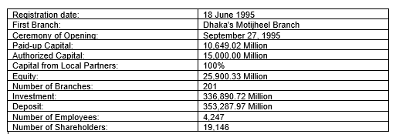
Source: https://www.aibl.com.bd/wp-content/uploads/2022/08/AIBL-Annual-Report-2021-Final-Edited.pdf

ECONOMIC VALUE- ADDED STATEMENT by the bank

The Economic Value Added( EVA) is a way of measuring how much money a company makes. It's the amount of money they make that suddenly goes over or below the minimum amount of money they need to make for their shareholders. considering the position of threat involved. In the case of the Bank, the EVA for the time ending on December 31, 2021, was BDT 3,184.67 million, compared to BDT 2,862.36 million in 2020.

The crucial factors of the EVA computation are as follows
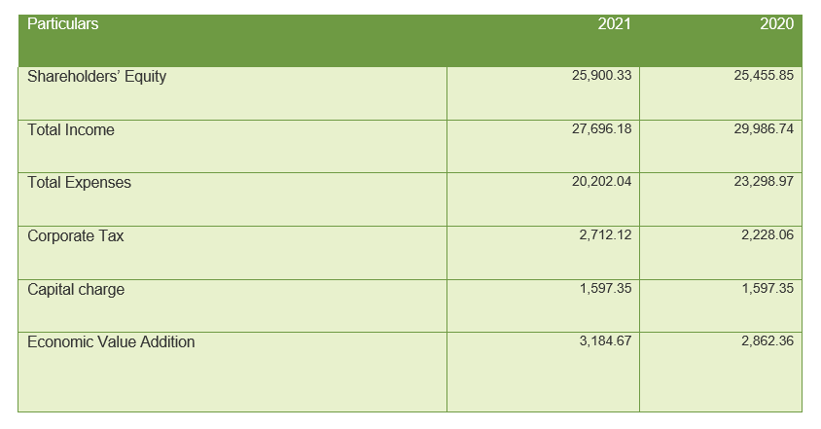

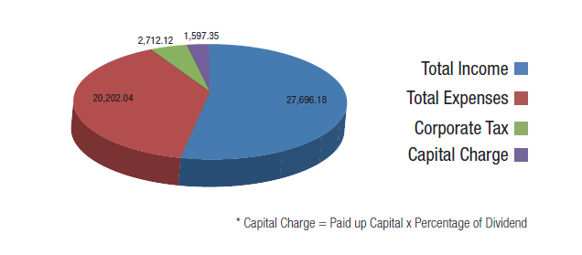
Source: https://www.aibl.com.bd/wp-content/uploads/2022/08/AIBL-Annual-Report-2021-Final-Edited.pdf

The Economic Value Addition for the respective times is calculated by subtracting the aggregate charges, commercial duty, and capital charge from the total income. The performing numbers are as follows
2021 BDT 3,184.67 million
2020 BDT 2,862.36 million
This indicates that the Bank generated positive profitable value in both times, with an increase in EVA from 2020 to 2021. It showcases the Bank's capability to induce gains that exceed the needed return for shareholders, contributing to its overall fiscal performance and value creation.

Capital charge refers to the cost of capital or the minimal return anticipated by shareholders for the threat associated with their investment.

Financial Value for the last 5 years

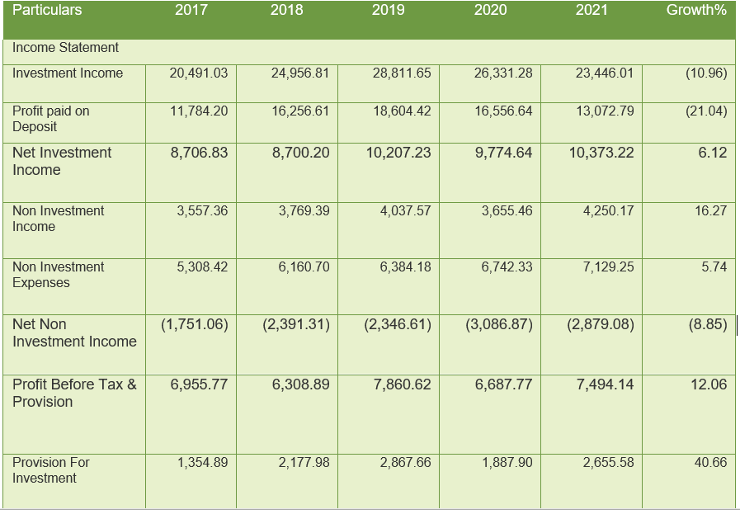
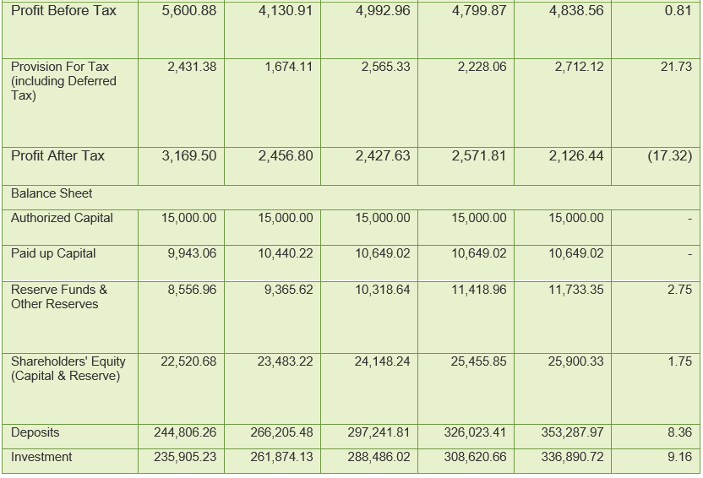
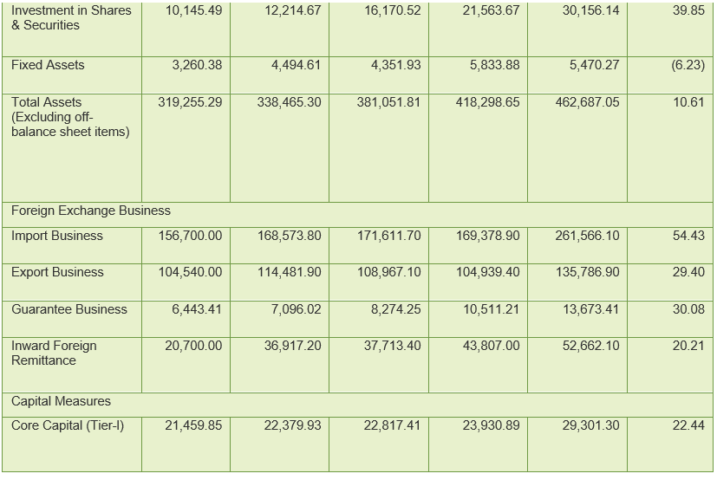
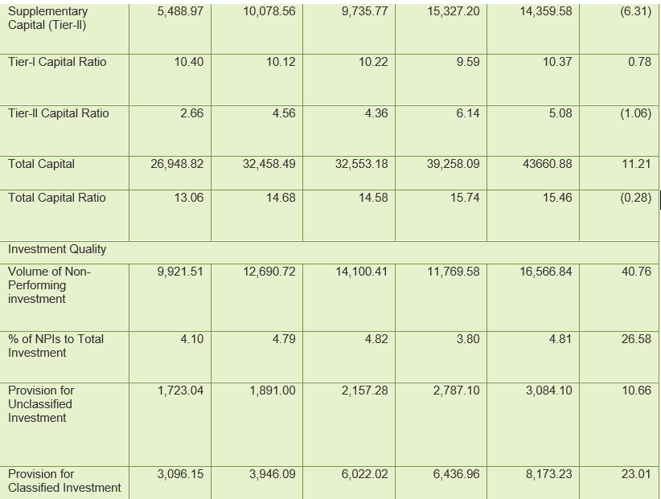
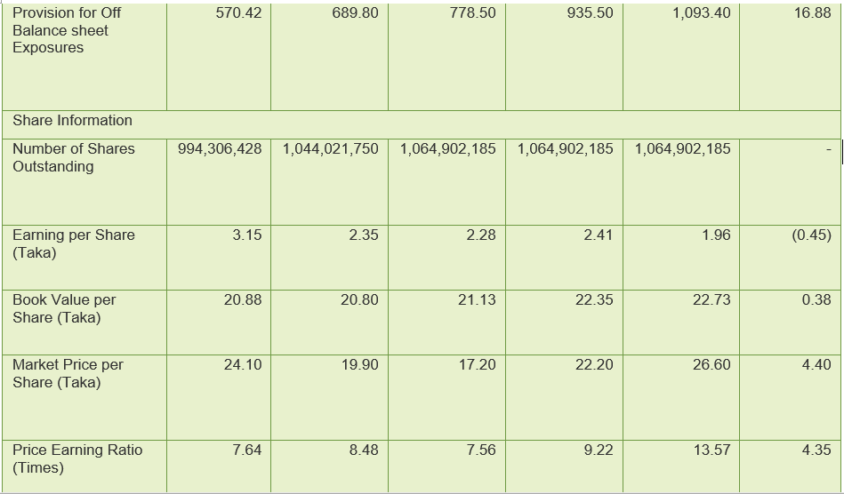
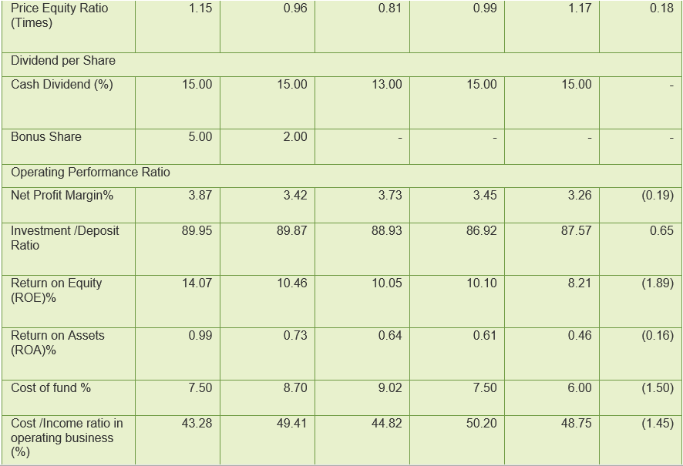
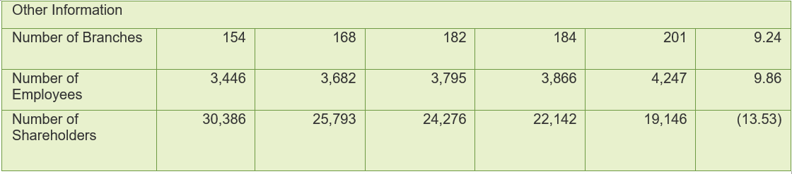

Source: https://www.aibl.com.bd/wp-content/uploads/2022/08/AIBL-Annual-Report-2021-Final-Edited.pdf

Information Technology

Technology has revolutionized the banking sector, transforming it from traditional paper-grounded systems to digital and network-grounded services. This shift has significantly reduced fraud and enhanced security for bank guests. Banks are heavily investing in digital banking technology, offering guests the convenience of penetrating services through mobile, web, and digital platforms. Artificial intelligence results, similar to chatbots, help guests with simple tasks like making payments. These technological advancements enable banks to ameliorate business processes, make informed directorial opinions, and enhance collaboration, giving them a competitive edge in dynamic and arising husbandry.

Al- Arafah Islami Bank Limited( AIBL) has embraced technology to automate and streamline its operations. Since 2008, AIBL has enforced an online operation system, supported by colorful tech-grounded services. These services include Real- Time Gross agreement( RTGS), Bangladesh Electronic Finances Transfer Network( BEFTN), Bangladesh Automated Clearing House( BACH), Internal Suspicious Deals Report( ISS Report), Business Process Robotization ( BPA), Credit Information Bureau( CIB), Anti-Money Laundering and Combating the Backing of Terrorism Reporting( goAMLCTR), Risk Intelligence and Tracking( RIT Reporting), internet banking( i- Banking), Human Resource Management System( Sylvia), Our services include agent banking, utility bill collection, sanction screening, foreign account tax compliance Act (FATCA) compliance, swifts, asset management, centralized anti-virus management, correspondence garçon, offshore banking unit (OBU), treasury, ATM service, mobile ATM service, debit card, credit card, SMS alert, and more.

AL Arafah Islamic Bank has recently unveiled its Shariah-compliant mobile fiscal service, Islamic Wallet, which puts security at the forefront of its operations., compliance, and nonsupervisory conditions, offering innovative and accessible services in the mobile fiscal services assiduity of Bangladesh. It enables druggies to shoot and admit plutocrats securely and affordably, along with fresh features like a person- to- person deals, fund transfers, mileage bill payments, airtime top-ups, insurance decorations, loan inaugurations, trafficker payments, government-to-person payments( subventions, allowances, weal payments), person- to- government payments( levies, freights), marking services, and education figure payments.

To further enhance client service, AIBL has taken several technology-grounded enterprises, aiming to come one of the top three technologically advanced banks in Bangladesh within the coming three times. The bank is committed to icing 100 nonsupervisory compliance through strict ICT security measures. AIBL recognizes the significance of reaching the unbanked population and is laboriously uniting with government and non-government realities to expand mobile fiscal services across the country. also, the bank intends to establish a comprehensive network of Internet banking, electronic commerce, and payment services. Booth banking services will also be introduced in line with Bangladesh Bank guidelines.

These technological advancements and client-centric enterprise demonstrate AIBL's commitment to furnishing bettered services and getting a leading bank in Bangladesh's ever-evolving digital geography.

Overall Training Scenario in 2021:

Amidst the challenges posed by the Covid- 19 epidemic, AL ARAFAH ISLAMIC BANK TRAINING AND RESEARCH I successfully carried out a wide range of conditioning aimed at furnishing high-quality training to the bank's officers. AL ARAFAH ISLAMIC BANK TRAINING AND RESEARCH hosted 113 training courses between January and December 2021, as well as shops, ADMs, Lead Banks, Outreach Programs, and Foreign Training Programs, with 9,449 participants attending. These programs were conducted both online and in classrooms, with applicable health and safety measures in place.

Training Courses( TC) AL ARAFAH ISLAMIC BANK TRAINING AND RESEARCH conducted twelve courses designed to improve the professional abilities and expertise of officers in fields such as Shariah, Banking, Finance, and CMSME (Cabinet, Micro, SME)., microfinance, and client service development. These courses were delivered through both classroom-grounded and virtual platforms.

Training Workshops( TW) A series of 86 workshops were conducted to examine the current state of banking operations and the challenges they face. Topics discussed included international commerce and finance, the influence of financial technology (fintech) initiatives, the implementation of a National Integrity Strategy, the consequences of attestation crimes, the valuation of investment properties, the implementation of FATCA, and the prevalence of plutocrat-related money laundering and terrorist financing. Additionally, in-house discussions were conducted to improve the knowledge and skills of staff in the areas of Islamic Sharia and Islamic banking.
Executive Development Programs( EDP) AL ARAFAH ISLAMIC BANK TRAINING AND RESEARCH conducted three EDPs in 2021 to give directors, directors, director operations, and BAMLCOs( Bank'sAnti-Money Laundering Compliance Officers) with knowledge on plutocrat laundering forestallment and other topical profitable and fiscal issues. Because of the Covid-19 pandemic, these programs were implemented using the Microsoft Brigades platform.

Outreach Training Programs( OTP) AL ARAFAH ISLAMIC BANK TRAINING AND RESEARCH implemented 11 outreach training programs across five different locations, which were based on the bank's zone services. The purpose of these programs was to cultivate a sense of mindfulness among young and promising officers on topics such as Islamic Sharia and Banking, Environmental Threat Standing, Agent Banking, and Islamic Fiscal Knowledge.

Lead Bank Program( LBP) The Al Arafah Islamic Bank Training and Research Department of Al Arafah Bank, in collaboration with the plutocrat laundering and terror financing Prevention Department (MLTFPD) of the Bank, implemented a Lead Bank Programme on the Prevention of Plutocrat Money Laundering and Counterfeiting Activities in Khulna Zones. During the program, colorful sessions were conducted by Bangladesh Financial Intelligence Unit (BFIU) officers.
Al Arafah Islamic Bank Training and Research has established several programs for 2022, under the guidance of the Bank's Board of Directors. These programs will focus on the development of Certified Experts in Anti-Money Laundering and Counterfeiting of Terrorism (AML/CTT) to assist the Bank in its efforts to combat the proliferation of money laundering and terrorist financing. Additionally, a Program on Administrative Parchment for the Professional Development of Bank Workers in the Field of Islamic Banking & Finance will be introduced.
AL ARAFAH ISLAMIC BANK TRAINING AND RESEARCHI's Research Division will concentrate on conducting the exploration of innovative fiscal products and services to meet the growing demands of guests. The division will study different diligence to understand their position and donation, abetting the bank in making informed investment opinions and formulating contemporary programs.
also, Al Arafah Islamic Bank Training and Research will develop policy papers and critical notes on the medium and methodology of Islamic tax products. making suggestions for variations or developing new modalities. The institute will also produce and manage the AL ARAFAH ISLAMIC BANK TRAINING AND RESEARCH website and Training Database to grease effective access to training accouterments and information.
Through these enterprises, AL ARAFAH ISLAMIC BANK TRAINING AND RESEARCH aims to promote nonstop literacy and professional development among bank workers while situating itself as a knowledge-grounded Islamic bank in the country.

Internship Objectives:

The internship at Al Arafah Islamic Bank Headoffice Branch had two main objectives. Firstly, it aimed to provide interns with a comprehensive understanding of each sector within the bank, preparing them for future careers in the banking industry. Secondly, the internship allowed interns to align their values as Islamic-minded individuals with the bank's practices and transactions based on Islamic principles.

Support Objectives
- To gain practical experience and apply theoretical knowledge in a real work terrain. To understand the general banking system of AIBL( Al- Arafah Islami Bank Ltd.).

- To identify any issues or challenges in the GB conditioning of Al Arafah Islamic Bank.

- This document provides an overview of the standard operating procedures employed by the Bank in its overall banking operations.

- To assess the performance of AIBL's general banking conditioning.

Comprehensive Analysis of Al- Arafah Islami Bank Limited's Annual Report

The Annual Report 2021 of Al- Arafah Islami Bank Limited provides a detailed overview of the bank's profitable impact, tip distribution policy, and functional performance.
Starting with the profitable impact, the bank has both direct and circular goods on frugality. Direct impacts include job creation, duty payments, and wealth maximization for shareholders. circular impacts are seen through the bank's operations, similar to marshaling deposits and channelizing them to implicit investors, thereby addressing capital insufficiency in the frugality. This binary impact underscores the bank's significant part in stimulating profitable growth and development.

The bank's tip distribution policy for 2021 was a 15 cash tip, harmonious with the policy in 2020. This thickness indicates a stable return for shareholders. still, it's worth noting that the tipping policy has changed over the once decade, ranging from a 13.50 perk in 2013 to a 20 cash tip in 2016. This variability such clients that the bank adjusts its tip policy grounded on its fiscal performance and request conditions.
AIBL has 200 ATMs used by over 300,000 cardholders. The number of manly guests in Agent Banking is 262,697, with womanish guests totaling 231,533. The bank aims to increase its operating profit by roughly 19.62 by fastening on quality investment, controlling expenditure, and adding off-balance distance income. The target for 2022 is an operating profit of Tk 8,300.00 million.
The presence of 78 branches throughout the country and a strong ATM network of 200 machines showcase AIBL's availability and convenience for guests. The bank's nonstop sweats to expand its client base are reflected in the growing number of manly and womanish guests, with a notable increase of 70.38 in womanish guests compared to the former time.

The tip distribution policy of AIBL for 2021 remained harmonious with the former time, with a 15 cash tip for shareholders. This policy reflects the bank's commitment to awarding its shareholders and maximizing their returns on investment. Over time, AIBL has maintained a favorable tip distribution policy, furnishing harmonious returns to shareholders through a combination of cash tips and perk shares.

AIBL's fiscal performance in 2021 showcased positive growth and enhancement. The bank achieved an operating profit of Tk. 7,345.89 million, representing a growth rate of 10.28% compared to the former time. The increase in operating profit demonstrates effective operation and sound business strategies. also, the bank witnessed a rise in the number of depositors, investors, and total investments, indicating growing confidence in AIBL's services and immolations.
The bank's tip distribution policy ensures that tips are paid directly to shareholders' bank accounts, either through the Bangladesh Electronic Fund Transfer Network( BEFTN) or another honored electronic payment system. This system ensures effective and secure payment of tips. In cases where an electronic transfer isn't possible, the bank issues tip clearances transferred by post. This policy demonstrates the bank's commitment to furnishing accessible and dependable services to its shareholders.
In conclusion, Al- Arafah Islami Bank Limited's Annual Report 2021 reveals a positive profitable impact, a harmonious tip distribution policy, and strong functional performance. The bank's strategies and programs reflect its commitment to driving profitable growth, satisfying shareholders, and delivering exceptional client service. still, the variability in the tipping policy over the times such clients the need for shareholders to stay informed about the bank's fiscal performance and request conditions.

General Banking Functions

General banking refers to the front-side banking services handled by financial institutions. It involves conditioning related to accepting deposits from clients and furnishing colorful ancillary services. The principal departments of general banking include the cash section, accounts opening section, cheque clearing section, and remittance section.

Cash Department

The Cash Department is responsible for handling all cash deals within the branch. This department begins each day with an open cash balance in its vault, which is updated throughout the day based on bank statements and payments. The cash section maintains colorful registers to record cash deals and insure accurate cash balance computations.

Accounts Opening Section

The Accounts Opening Section plays a pivotal part in opting for clients and opening their accounts. It follows a standardized process, including taking filled operation forms, vindicating necessary documents, collecting client information through a crucial information system, and carrying the aspirant's hand and photos. The account opening process may vary for different types of accounts.

First part

- Acceptance of completed transactions in the specified form provided by the bank, indicating the type of account to be opened.

- The applicant is responsible for completing the form on their behalf.

- Two copies of existing passport-size photographs are produced, and in the event of an enterprise, photos of all associated individuals are also included.

- The officer receives data from the client via a key information system.

Second part
- Organizations are required to submit the requisite documents.

- operations have to subscribe instance hand distance and give accreditation

- innovator's hand and client a/c number- vindicated by an in-charge officer

Third-party
- It is necessary to complete and sign up for a Know Your Client (KYC) or Know Your Client subscription.

- This text discusses the process of stuffing and subscribing to the Owner Information Form.

Fourth part
- The authorized Officer accepts the operation

Fifth part
- You'll only get cash if you have a minimum amount of money in your account.

Final part
- The account has been set up and you'll get a cherry book as well as a pay-in-slip book.

Collecting information to open an account

When opening an account at Al- Arafah Islami BankLtd., the information collected varies depending on the type of account. Then's an overview of the information needed for each account type

Individual Account
- Name of the client
- Client’s Present address and permanent address
- Client's Date of birth and his/her age
- Nationality of client
- Tax Information Number( TIN), if available
- Passport of client-issued instrument
- a snap of the account holder
- An attested snap of the nominee( person nominated to inherit the account)
- Nominee protestation form
- plutocrat laundering pamphlet( to raise mindfulness about anti-money laundering measures)

Partnership Client Account
- All the client information needed for individual client accounts
- xerox of the cooperation deed
- Accreditation from the mates, specifying who'll operate the account
- Limited Company Account
- All the information needed for individual accounts
- Certificate of Incorporation
- A copy of the client's Memorandum and Articles of Association
- Clients Certificate of Commencement( if applicable)
- Xerox of the Board of Director's resolution authorizing the account opening

Latent/dormant Account
still, it's distributed as a Latent account, If the client account remains inoperative for further than one time. To operate similar accounts, the authorization of the bank director is necessary.

It's important to note that the specific attestation and conditions may vary grounded on the bank's programs, nonsupervisory guidelines, and the nature of the account being opened. clients are advised to communicate with the bank directly for detailed information regarding account opening procedures.

Account transfer within the same bank, from one branch to another, is an accessible option for clients. The process involves the following way

- Written operation The account holder submits a written operation to the director of the branch where the account is presently maintained. The operation serves as a request to transfer the account to a different branch.

- A request to transfer an account to the desired branch is sent by the Director of the current branch to the Director of the asked branch upon entering the operation, indicating the client's intent to transfer the account.

- Transfer of Account Documents The current branch sends the original account opening operation and the instance hand distance, along with the remaining balance in the account, to the director of the asked branch. These documents help in establishing the client's account details and ensure a smooth transition to the new branch.

- Account Opening at the Desired Branch Upon entering the account transfer request and applicable documents, the director of the asked branch proceeds to open a new account for the client. The client's account details, including the being balance, are recorded in the new branch's system.

By following this process, clients can accessibly transfer their accounts from one branch to another within the same bank. It's important to note that account transfer programs and procedures may vary slightly between banks, so it's judicious for clients to consult their bank or branch for specific instructions and conditions regarding account transfers.

Cheque Clearing Section
The Cheque Clearing Section handles the processing of cheques entered by the bank. This involves indicating the validity of the cheques, checking for any disagreement, and encouraging them to the payment counter for cash payment or deposit into the philanthropist's account. This section ensures effective and secure cheque concurrence within the banking system.

Remittance Section
The Remittance Section facilitates the transfer of finances between accounts within the bank and with other banks. It handles conditioning similar to issuing bank drafts, paying orders, and conducting fund transfers grounded on client instructions. This section ensures the smooth and timely transfer of finances, both domestically and internationally.

Overall, the general banking department plays a pivotal part in furnishing day-to-day banking services to clients. It involves cash running, account opening, cheque processing, and fund transfers. These functions are essential for maintaining client satisfaction and easing smooth fiscal deals.

Foreign Remittance
Dhanmondi branch is an anon-AD (Authorized Dealer) branch. However, it can accept and remit incoming foreign remittances in original currency via internationally authorized agents. Foreign remittances involve the transfer of plutocrat funds from one location to another outside the jurisdiction of the public.

Local Remittance
Local remittance involves transferring plutocrats from one location to another within the public boundary. Dhanmondi Branch of Al- Arafah Islami BankLtd. operates original remittance services. colorful ways are used for collecting local remittance, including Demand Drafts( DD), apothegmatic Transfers( TT), and Pay Orders.

Clearing Department
Al-Arafah Islami Bank Ltd.’s Clearing Section accepts cheques, Demand Drafts, and Pay Orders from their clients. Once they enter these instruments, the Clearing Section checks three kinds of payment scripts:
If the paying bank is situated in the Dhaka City area, the clearing department of Al-Arafah Islami Bank Limited, Dhanmondi branch, will dispatch an Inter Branch Debt Advice (IBDA) to the Head Office on the same date. The main branch takes the instruments to the clearing house the coming day. However, the head office sends an IBDA to the Al- Arafah Islami Bank Ltd, If the instruments are dishonored., Dhanmondi Branch.

If the paying bank is located within the branch network of Al-Arafah Islami Bank Limited., the clearing section of the Al-Arifah Islami BankDhanmondi Branch transmits Outward Bills For Collection(OBC) to the paying branch to accept an Interbranch Credit Advice(IBCA) from the paying bank. However, if the paying bank does not accept the OBC, it shall be returned to Al-Alfa Islami Bank Ltd. with an explanation of the reason for the non-acceptance.

Types of Cheques Collected by the Clearing Department

Local Bills Collection Cheques( LBC) These are cheques collected and paid by two different branches of the same bank located in the same megacity.

Outside Bills Collection Cheques( OBC) These are cheques collected and paid by two different branches of the same or different bank located outside the megacity.

Transfer Cheque These are the cheques issued and cashed at the same Al-Arafah Islami Bank Ltd. branch.

Clearing House
A clearing house is an arrangement where member banks meet through their representatives at a specific time and place to change instruments drawn on each other. The net quantum outstanding or receivable is settled through an account maintained with the controlling bank.

Types of Clearing

There are 2 types of clearing

- Inward

- Outward

When a branch accepts instruments drawn on its own and transferred to other member banks in the clearing zone for collection as part of a clearing arrangement, the transaction is considered to be outward clearing for the branch. On the other hand, When a branch accepts instruments drawn on and transferred for collection by other member banks, this is referred to as inward clearing.

Cheque Clearing
When any of the banks receive a cheque from a customer, it's necessary to endorse and cross it before processing it for clearing. There are different types of cheques and specific processes involved in clearing them.

Inward Clearing Cheque These are cheques entered from Al-Arafah Islami Bank Ltd's clearing house. The bank debits the party's account and credits, Al- Arafah Islami Bank Ltd.'s general account.

OBC( Outward Bills for Collection) These are cheques from other branches of Al- Arafah Islami Bank Ltd. within its clearing house area. The cheques are transferred directly to the separate branch and a request is made to send the Inward Bills for Collection Advice( IBCA). The cheque quantum is credited to the client’s account once it is entered.

Clearing Cheque These cheques are issued from other banks in the Al-Arafah Islamic Bank Ltd.'s clearing house area. The cheques are transported to the Clearing House via Al-Arafah Islamic Bank Ltd.’s Dhanmundi Branch. Upon acceptance of the cheques by the Dravwee Bank, the cheque deposit holders' accounts are credited.

Outward Clearing These are non-clearing cheques that are intended for a different bank. If there is an Al-Arafah Islami Bank Ltd branch in the clearing house of the drawee, then the cheque will be issued to that branch, and the IBCA will be issued to the same branch.

Inward Bills for Collection( IBC) These cheques are issued from Al-Arafah Islami Bank Limited's other branches. or other banks outside the clearing house area. These cheques are settled by debiting the depositor's account and crediting the sender's account.
In summary, the bank processes different types of cheques through colorful clearing procedures, including inward clearing, outward clearing, and bills for collection, to ensure the proper running of finances and deals.

Job Responsibilities:

During the internship, I was assigned to the General Banking sector, which encompassed five sections: Account Opening, Bills and Clearing, Remittance, Deposit, and Cash. My primary responsibilities and learned the following included:

- Assisting customers with account opening procedures and providing relevant information.

- Handling the clearance of cheques and verifying check transfers between accounts.

- Conduct background checks and verify the necessary documentation for account creation.

- Assisting in the deposit section to ensure proper recording and processing of deposits.

- Participating in cash management activities and ensuring accuracy in cash handling.

By actively engaging in these responsibilities, I contributed to the overall functioning and success of the Al Arafah Islamic Bank Headoffice Branch's general banking operations.

Al- Arafah Islami Bank Limited AIBL’s Products and Services

Al- Arafah Islami Bank Limited( AIBL) offers a wide range of products and services to meet the requirements of its guests. These include

General Banking
- Current Account( CD)

- Savings Account( MSD)

- Short Term Deposit( STD) Account

- Fixed Deposit Account( FDR/ MTDR) with different durations( 1 month, 3 months, 6 months, 12 months)
- Foreign Currency Account

Foreign Exchange
- Letter of Credit( LC) allocation
- Letter of Credit advice
- Foreign Talkie Bill Purchase( FDBP)
- Foreign Talkie Bill Collection( FDBC)
- Bill of Negotiation
- Foreign Remittance

Bank Services
- ATM Card Service
- Online Banking
- Locker Service

Frequent Services offered by AIBL
- Cash operation
- line transfer
- Automated clearinghouse( ACH) deals
- Bill fair and payment
- Balance inquiry
- finances transfer
- Downloading transaction information
- Loan operations
- Investment conditioning
- Other value-added services

These products and services feed colorful fiscal requirements, including deposit operations, foreign exchange deals, accessible banking services, and value-added services for guests' convenience.

Types of services

Al Arafah Islamic Bank Headoffice Branch offers a range of services to feed the fiscal requirements of its clients. These services include

Mudaraba Terms Savings Deposit Under this scheme, clients can deposit TK.300/- annually, TK.500/- for a period of 5 years, TK.1000/- for an 8-year period, TK.1500/- for a 10-year period, and TK.2000/- for a 12-year period. At the end of the term, the deposited quantum is withdrawn along with the accumulated profit. Yearly Profit grounded Term Deposit This scheme accepts deposits of Tk.1.00 lac and multiples thereof for a term of 5 times. The bank provides a yearly profit of Tk. 885 per lac, which is acclimated annually.

Yearly Haj Deposit clients can make yearly deposits ranging from 1 to 20 times under this scheme to accumulate savings with profit for performing Hajj passage. Onetime Haj Deposit Fixed quantities of yearly Hajj deposits are accepted from clients for a specific period. Profit is accumulated on the deposit each time, and when the deposit matures, the accumulated quantum is employed to cover Hajj charges. Guardians can also open Hajj accounts for their successors.

Savings Investment Deposit clients can make yearly deposits, and at the end of the term, the bank doubles the quantum and invests it in doable sectors grounded on the depositor's choice. No collateral security is needed, and the investment can be used for business gambles.

Marriage Savings Deposit Under this scheme, clients make fixed yearly inaugurations to cover marriage chargesThe bank permits individuals to invest up to twice the amount of their savings, or a sum of up to 30,000 takas, whichever is more advanced, in beautifying products, such as cabinets, to generate income. The repayment of the investment is spread out over 24 annual installments without the need for collateral.

Savings Bond Deposit The bank provides saving bonds in the following denominations and tours (T.K.10,000/, Tk.K.25,000/, and T.K.100,000/ for 3 times, 5 times, and 8 times independently). Upon completion of the term of the bond, the deposited amount is refunded to the client. The bank also provides colorful investment openings under Islamic Shariah principles.

Investment types

Two common modes of investment are Bai- Murabaha or Murabaha This mode involves the trade of goods with an agreed-upon profit. The buyer buys certain items from the seller at a price plus a percentage of the agreed-upon profit, which can be paid out either now or later, either in cash or through invoices.

Musharaka refers to a cooperation agreement where multiple entrepreneurs approach the bank for financing a design. The bank, in conjunction with other partners, provides the necessary capital for the design. gains are distributed grounded on an agreed rate, while losses have participated in proportion to the mates' donation. Al Arafah Islamic Bank Headoffice Branch aims to give banking services grounded on Islamic principles while meeting the different fiscal requirements of its clients.

Mudarabah is a contract in which one party gives you money and the other one gives you the courage to start a business. They agree to partake in the gains grounded on a mutually agreed-upon rate, while the provider of capital bears the responsibility for any losses.

Bai- Muajjal is a type of trade where the buyer purchases goods from the dealer on credit. The buyer agrees to pay the fixed price at a specified future date or during inaugurations. It's a contract between the buyer and dealer for the trade of goods with remitted payment terms.

Skills and Knowledge Gained:
Throughout the internship, I acquired valuable skills and knowledge, including:

- Proficiency in account opening procedures and an understanding of the documentation requirements.
- Customer service skills, including effective communication and problem-solving.
- Knowledge of the check clearance process and the importance of accuracy and verification.
- Familiarity with the principles and practices of Islamic banking.
- Experience in conducting background checks and adhering to banking regulations.
- Understanding the daily voucher analysis process and its significance in financial record-keeping
.
These skills and knowledge acquired during the internship have contributed to my professional growth and preparedness for a career in the banking sector.

Challenges and Learning Experience:

During the internship, I faced a significant challenge when I was assigned the task of filling out the Individual, Institutional, and Government account opening forms. The requirement to write in Bengali, which was not my strong writing language, initially caused difficulties and delays. However, through dedicated practice over two days and with the support and guidance of my colleagues at the bank, I was able to improve my Bengali writing skills. Eventually, I could complete the forms accurately and efficiently. This experience taught me the value of perseverance, practice, and the importance of a supportive work environment.

Teamwork and Collaboration:

Throughout the internship, I actively collaborated with team members and other employees at Al Arafah Islamic Bank Headoffice Branch. The bank's staff welcomed me warmly and were eager to share their knowledge and expertise.
One notable example of teamwork was when I was assigned to fill out 100 MSD forms. Two colleagues stepped in to help by dividing the workload and coordinating effectively. Their friendly approach and collaboration made the task more manageable, exemplifying the spirit of teamwork within the organization.
Another notable example was when I was in the clearing check section one day there were more than 100 outward cheques to be cleared and most of them were highly valued so the time was short and it was difficult for one person to clear them within the short period which was about 45 min as the high-value time was about to end by 11:45 am so I step up to help him he showed me how to put 3 seals on the cheque I applied and gave one copy to the client and kept another copy for clearing.

Conclusion:

The internship at Al Arafah Islamic Bank Head office Branch provided me with a valuable learning experience. Through active engagement in the General Banking sector, I gained practical skills, knowledge of Islamic banking practices, and insights into the daily operations of a prominent Islamic banking institution. The challenges I faced during the internship were overcome through perseverance and the support of my colleagues, further reinforcing the importance of collaboration and teamwork. Overall, the internship at Al Arafah Islamic Bank Headoffice Branch served as a stepping stone toward my career goals in the banking sector.

Reference:
- pdf-internship-report-on-general-banking-system-of-al-Arafah-Islami-bank-ltd_convert_compress
- Scribd.downloaders.com_internship-report-on-al-Arafah-islami-bank-ltd
- pdf-internship-report-on-general-banking-system-of-al-Arafah-Islami-bank-ltd_convert_compress
- Several Booklets and Newsletters from AIBL

Intern Monthly Progress Report
