
INTERNSHIP REPORT ON FINANCIAL OPERATIONS & ANALYSIS OF UNITED HOSPITAL


ARIFA HOSSAIN

This internship report is delivered to the school of Business and Economics of United International University with a requirement of completion the Bachelor of Business Administration degree.



Internship Report On
UNITED INTERNATIONAL UNIVERSITY
Financial Operations & Analysis of United Hospital Ltd.
SUBMITTED TO:
Dr. Mofijul Hoq Masum
Associate Professor
School of Business & Economics

SUBMITTED BY:
Arifa Hossain
ID: 111 171 085
Major: Accounting & HRM

Date of Submission: 18-01-2023

Acknowledgement

At first, I wish to praise Allah for enabling me to complete this report.
Specially, I want to acknowledge and give my deepest thank to my course instructor Dr. Mofijul Hoq Masum Sir, who helped me organize my report, with his stimulating suggestions, remarks, and recommendations. He inspired and motivated me throughout my academic career, and for that I am eternally grateful. He helped me finish my report and get it to the point where it is now because of his unfailing patience and excellent attention to detail. He gave me the advice I needed to prepare for my report and helped me truly. This report would not be feasible without his guidance and support since I would not have made the effort to increase my practical understanding of the actual issue.

Furthermore, I want to give a special thank the people of UHL who helped me with the preparation of this study by giving me important information. In particular, I want to thank Md. Alamgir Hossain, Md. Awal Hossain, and all the other members of the Finance & Accounts department who have helped me over these three months of my internship.

Finally, I wish to thank my parents and friends who have supported and encouraged me throughout my study.
Despite my best efforts, the report might contain some errors. I apologize for any errors that were not intentional.

Letter of Transmittal

January 10, 2023
Dr. Mofijul Hoq Masum
Associate Professor
School of Business and Economics
United International University

Subject: Regarding the submission of Internship Report on “Financial Operations & Analysis of United Hospital”.
Dear Sir,
This is my utmost pleasure to present you my internship report on “Financial Operations & Analysis of United Hospital.” During my internship, I had the opportunity to learn valuable knowledge and I've tried to uncover in my report what I learned. While I was completing the report, I’ve tried my best to comprise every topical details and also realized how useful and educational it is to me. It will surely help me further my career in the near future.
I wish to express my sincerest thanks to you for your constant guidance. It would be kind enough for me if you accept my report.

Sincerely


…………………………………
Arifa Hossain
111 171 085

Declaration

I, Arifa Hossain, declare that the internship report mentioned "Financial Operations & Analysis of United Hospital," was entirely formed by me following the fulfillment of my 3 months internship at United Hospital, which is situated in Gulshan 2.

I further declare that this report was prepared only to meet my academic obligation and not for any other reason. Any errors discovered should be disregarded because they were not done on purpose.

Arifa Hossain
ID: 111 171 085
BBA
School of Business and Economics
United International University

Table of Contents for Internship
Contents
Acknowledgement i
Letter of Transmittal ii
Declaration iii
Table of Contents for Internship iv
Abstract vi
List of Acronyms vii
CHAPTER 1 1
INTRODUCTION 1
1.1 INTRODUCTION TO THE TOPIC IN HAND 2
1.2 A BRIEF INTRODUCTION OF UNITED HOSPITAL LTD 2
1.3 OBJECTIVE OF THE STUDY 3
1.3.1 Broad Objective 3
1.3.2 Specific Objective 3
1.4 RATIONALE OF THE STUDY 3
1.5 SCOPE OF THE STUDY 4
1.6 LIMITATIONS OF THE STUDY 4
CHAPTER 2 5
METHODOLOGY OF THE STUDY 5
2.1 DATA DESIGN 6
2.1.1 Primary Source 6
2.1.2 Secondary Source 6
2.1.3 Types of Data 6
2.2 ANALYTICAL TOOLS 7
CHAPTER 3 8
ORGANIZATIONAL BACKGROUND & INDUSTRY PERSPECTIVE 8
3.1 INDUSTRY SCENARIO 9
3.1.1 Background of United Hospital Ltd. 12
3.1.2 Contribution in Economy 13
3.1.3 Scopes 14
3.2 HISTORICAL BACKGROUND OF UNITED HOSPITAL LIMITED 14
3.2.1 MISSION 14
3.2.2 VISION 15
3.2.3 MANAGEMENT AND FOCUS 15
3.3 OPERATIONAL ACTIVITIES OF UNITED HOSPITAL LTD. 17
3.3.1 Service Line 17
3.3.2 Departments and Areas of Specialization 20
3.3.3 Financial Performances 22
3.4 ANALYSIS OF SWOT 23
CHAPTER 4 24
FINDINGS AND ANALYSIS OF THE STUDY 24
4.1 FINANCIAL PERFORMANCE ANALYSIS AND FINDINGS 25
4.1.1 Net Profit Margin 25
4.1.2 Return on Asset 26
4.2 KEY ROLES OF THE ACCOUNTS AND FINANCE DEPARTMENT 27
4.2.1 Bookkeeping 27
4.2.2 Accounts Payables and Accounts Receivables 27
4.2.3 Financial Reporting, Financial Control and Budgeting 27
4.2.4 Tax and Compliance 28
4.2.5 Treasury 28
4.2.6 Financial Analysis and Strategic Planning 28
4.3 RATIO IMPLEMENTATION 28
4.3.1 Efficiency Ratios: 29
4.3.2 Profitability Ratio: 29
4.3.3 Solvency Ratios: 29
4.3.4 Financial Leverage Ratios: 29
4.4 INTERPRETATION 30
CHAPTER 5 31
CONCLUSION AND RECOMMENDATIONS 31
5.1 THE CONCLUSION 32
5.2 RECOMMENDATIONS 32
CHAPTER 6 33
INTERNSHIP EXPERIENCE 33
6.1 POSITION AND RESPONSIBILITIES 34
6.2 TRAINING 34
6.3 CONTRIBUTION WITHIN DEPARTMENT 34
6.4 INTERNSHIP PERFORMANCE APPRAISAL 34
6.5 NEW SKILL GAINED 35
6.6 IMPLEMENTATION OF ACADEMIC KNOWLEDGE 35
CHAPTER 7 36
APPENDIX 36
7.1 SOME MOMENTS AT UHL 37
7.2 REFERENCES 38

Abstract

The aim of this study is to describe financial operation and analysis of United Hospital Limited. To conduct this study various internal and external data sources are taken into consideration. The study tried to deliver the financial control by board members and analyzing the profit/revenue status to measure the organization’s position to its market. The study also revealed the Return on Asset (ROA), profit margin and leverage ratio calculation for hospital’s financial analysis. To determine the industry growth, the two part of financial analysis system are used. One is appeared with the vertical analysis and another one is horizontal analysis. The organization is better able to determine the direction of change in balance sheets and the size of that variation by comparing prior-period financial data with more recent financial figures. The findings of the study which present the hospital industries financial situation and its impact on performance, will absolutely inspire corporate people to make decisions that will ensure their continued survival. Additionally, these findings offer a fantastic potential for future studies to investigate the relationship between different board characteristic and grades of industry performance.
Keywords: Financial Operation, Financial Analysis, Hospital Industry, Organizational Performance,UHL.

List of Acronyms
UHL | United Hospital Limited
BBA | Bachelor of Business Administration
FA | Financial Analysis
Ltd | Limited
VIP | Very Important Person
EHR | Electronic Health Records
HR | Human Resource
ERP | Enterprise Resource Planning
GM | General Manager
DGM | Deputy General Manager
IGS | Image Guided System
TAVI | Trans Catheter Aortic Valve Implant
ISO | International Organization for Standardization
MRI | Magnetic Resonance Imaging
CHL | Continental Hospital Limited
CEO | Chief Executive Officer
EEG | Electroencephalogram
EMG | Electromyography
CCTV | Closed-circuit television
ICU | Intensive Care Unit
CCU | Critical Care Unit
CRRT | Continuous Renal Replacement Therapy
CSSD | Central Sterilization Supply Facilities
ACLS | Advanced Cardiac Life Support
PALS | Patient Advice and Liaison Service
ENT | Ear, Nose, and Throat
IHIS | Integrated Hospital Information System
COVID | Coronavirus Disease
GTL | Global Telesystems Limited
ROA | Return on Asset
GL | General Ledger
IHIS | Integrated Health Information Systems
EBIT | Earnings Before Interest And Taxes



CHAPTER 1

INTRODUCTION

INTRODUCTION TO THE TOPIC IN HAND
The paper was created as my final BBA submission and to describe my internship experience at United Hospital and financial operations of United Hospital with financial analysis. This report briefly describes United Hospital, my internship experience, and the skills I have acquired. I've done my best to communicate the majority of my experiences in a relaxed manner, even if it is impossible to talk about everything.

A BRIEF INTRODUCTION OF UNITED HOSPITAL LTD
United Hospital Ltd. was founded with the goal of offering the people of Bangladesh a comprehensive, all-inclusive healthcare solution. As the biggest private healthcare organization in Bangladesh, this hospital opened its doors in August 2006 and is located next to the lovely Gulshan Lake. The hospital includes 11 cutting-edge operating rooms to meet the needs of our diverse patient group, and it can accommodate more than 450 patients in a total included area of approximately 400,000 sf.
The top medical professionals in each of United Hospitals' pediatrics, orthopedic, gynecology, and cardiology departments. For instance, a quick glance at the cardiology department would show that we have performed more than 8300 angiograms and angioplasty procedures as well as over 2300 open heart surgeries too far. Since we began, we have performed an average of nearly 12 heart-related surgeries every day.
They work hard every day to stay at the top healthcare position in Bangladesh as well as in the Asia-Pacific, supported by friendly personnel, technology, and knowledge. The hospital structure was constructed specifically to house 450 beds in wards, cabins, emergency rooms, ICU, CCU, and other amenities. There are 6 patient elevators, 2 guest lifts, and 1 VIP lift in the facility. In order to provide attendance’s peace of mind when they see their relatives or when they visit for medical examinations, they also have secured parking spaces for approximately 350 vehicles.

OBJECTIVE OF THE STUDY

Broad Objective
- To complete my BBA graduation which is a compulsory.
- To further develop my knowledge, practical experience and adaptability in job circumstances.
- To know what type of FA system is practiced by United Hospital Ltd.

Specific Objective
- To describe the function in Accounts and finance, the procedures, the organization and the laws and regulations.
- To find out key details about FA system and the audit's internal and external environments about United Hospital Ltd.
- To find out the scope and limitation of FA in the United Hospital Ltd.
- To recognize how to improve Financial Operation effectiveness.

RATIONALE OF THE STUDY
The fundamental reason of this study is to discuss the Financial Operations & Analysis of United Hospital. This analysis metric used to identify, improve, and control a business's various functions and resulting outcomes. Research tactics use a variety of ways to eventually dissect data on a given subject. The information obtained during the process may come from primary or secondary sources, and the final analysis may be qualitative or quantitative. I used primary and secondary sources to compile the data for this research. The purpose of this study is to discuss the Financial Operations & Analysis that identifies, improves, and controls various functions and resulting outcomes of United Hospital.

SCOPE OF THE STUDY
The scope of the report is to get practical experience working at United Hospital Ltd., which aids in Financial Operations & Analysis. In this report, financial operations of UHL & analysis will be presented. Through conducting a performance evaluation during my internship, I had the opportunity to see how they maintain their account and finance department. This observation aids in my quest to learn a wide range of information and gain real-world experience.

LIMITATIONS OF THE STUDY
It is quite challenging to cover all of the information during the 3 months of my internship because the accounts and finance department is so extensive.
Even though the subject matter is broad in scope, much effort and hard work was put into the study to make it worthwhile and significant, yet there are still certain limitations. Many of the department's records were not permitted to be shared because of the department's privacy and secrecy. No authorization was given to use the confidential data.

CHAPTER 2

METHODOLOGY OF THE STUDY

DATA DESIGN
To eventually analyze data regarding a certain issue, research methods use a variety of techniques. The process may involve gathering data from primary or secondary sources, and the final analysis may be qualitative or quantitative. I used primary and secondary sources together to compile the data for the research. This report is being created to provide a general overview of United Hospital's operations, divisions, and roles.

Primary Source
- Direct conversation with the department's officers.
- Close communication with my supervisor.
- Direct communication with my colleagues and employees of UHL.
- Operational activities are closely inspected.

Secondary Source
- Annual report of United Hospital Ltd.
- Collected from the website of United Hospital Ltd.
- Various newsletters of UHL.
- Past financial status form of UHL.

Types of Data
United Hospital Ltd provides the information that is required in the right order to correctly and effectively justify the diagnostic, treatment, and outcome. Beside computerized provider order entry, they want to keep hard copy and electronic health records (EHR). In order to protect patient privacy and advance actual patient care, the Medical Records Department is in charge of maintaining, storing, and ensuring the efficient flow of patients' medical records. Some types of data that UHL used is given below-
- Administrative data.
- Patient’s data.
- Claims data.
- Patient disease registries.
- Hospital resource data.
- Clinical trials.
- Health surveys.
- Employees and Staff data.

ANALYTICAL TOOLS
After obtaining all the data, the department creates a financial analysis using Medisense, HR ERP and Microsoft Excel that shows their current status, financial statements, historical data and current position in the healthcare sector. They create a projected data set for upcoming analysis using the data that was collected.
I was guided by my supervisor to collect all the data and input those data in HR ERP software and submit a report to him. After checking, he submitted the report to GM Sir. All the financial and accounts related data are mostly operated through Medisense software. I had the opportunity to work with the external auditors for collecting asset data and input those in the Excel software using the below way-
Serial No. | Asset Name | Location | Asset Code

Our senior team member prepares financial data sheets and use line chart, pie chart and bar chart to demonstrate the financial status and performance of the hospital.

CHAPTER 3

ORGANIZATIONAL BACKGROUND & INDUSTRY PERSPECTIVE

INDUSTRY SCENARIO
Private hospitals often have connection with the hospital industry. Typically, there are just two groups in this area: those who provide wellness-related care and those who pay for it. To meet the needs of such a large population, our country lacks the readily accessible medical care. Because of this, exclusive emergency clinics are springing up next to accessible emergency rooms. In this case, people with minimal financial resources usually cannot afford private hospitals. They carry out biological research while providing excellent patient care. The private healthcare system differs from the public one because of the service. 3976 government institutions are accompanied by 975 private hospitals and clinics. The best hospitals and doctors represent patients in the private healthcare sector. More people are covered by the private healthcare system than the public one. (Hossain, 2016)
Both rural and urban areas of Bangladesh are served by a large medical network. In Bangladesh, there are 975 privately operated clinics and hospitals in addition to 3,976 government financed institutions. The country's healthcare delivery system is different compared to several Asian nations. The overall lack of medical services in Bangladesh is highly concerning for society, nevertheless. The Canadian Center for Global Epidemiological Training (CIET) conducted a study that found that 27% of treatment seekers in Bangladesh used private or non-governmental organizations, 60% used inefficient administrations, and 13% used taxpayer-funded organizations.
As time passes, these facilities adapt to new examination trends and offer international treatment in our country. Private medical care facilities are set up to provide superior medical care service in public areas.

Figure 3.1: Private and Public Hospital Growth in Bangladesh (1998 to 2018)
Figure 3.1 demonstrates the increase of private healthcare between 1998 and 2018. However, their numbers have been increasing in recent years.
The private medical care sector in Bangladesh is still in its early stages of development, according to the market lifespan. I observed the growth of the private healthcare sector in Bangladesh in recent years.
Economical Fact:
After the Corona Virus Pandemic, the elements have an impact on both the public and private healthcare systems. The demand from patients is comparatively strong in the private healthcare industry. As the Corona Virus globally hits, yet this aspect of international trade benefits the healthcare sector greatly.
Nevertheless, a number of for-profit institutions generated money by supplying bogus corona test results. The government firmly forbids hospitals that have a negative impact on the private healthcare industry. Low-income people thus bear a disproportionate amount of the repercussions.

In Bangladesh, there are 975 private medical facilities. There is undoubtedly market competition in this area.
Industry Position:
There is competition in the industry as a result of the variety of organizations with comparable legal entities. Hospitals compete for patients in this environment. Hospitals carefully consider who they admit as a result. Hospitals provide care for people. Some hospitals use special techniques and technologies to care for their patients. United Hospital Ltd. offers the best cardiac care, SQUARE Hospital provides the highest quality medical care, combining great clinical care with outstanding personal service. Anwara Private Hospital offers the best pharmaceutical care, and Apollo Hospital employs the most advanced technology.

Figure 3.2: Private and Public Hospital Position in Bangladesh (2011 to 2021)
Figure 3.2 demonstrates the position of private healthcare from 2011 to 2021. (Hospitals Internal Source)

Background of United Hospital Ltd.
This hospital, one of the biggest in the country's private healthcare sector, began operations in August 2006 and is located near to the Gulshan Lake. To fulfill the needs of their diversified patient group, United Hospital offers 12 cutting-edge operating rooms and can accommodate about 500 patients.
The leading experts in respective disciplines, including Critical Care, Neuroscience, Cancer, Renal, Cardiac, Mother & Child Health, and Surgical, work at their centers of excellence.
They have performed 61,000 executive health screenings, 39 kidney transplants, 250,821 hemodialysis sessions, 150,201 radiation therapy sessions, and 11,000 heart surgeries since their inception. They have also completed 380,000 cardiac investigations, 315,000 cardiac consultations, and 50,000 cardiac procedures.
Several records have been set by United Hospital, which has blazed new paths in a number of industries. The nation's only and first iGS 520 Hybrid Cardio-Neuro Cath lab as well as the first Trans catheter Aortic Valve Implant (TAVI) procedure for Aortic Stenosis patients were both performed at United Hospital Cardiac Centre. As the first hospital in the nation, the Pathology Laboratory of the hospital received ISO 15189:2012 accreditation. In addition to having the world's first and only True Beam Linear Accelerator, the hospital's comprehensive cancer care center also has the only Medical Cyclotron in the nation, which produces radioactive tracer isotope for use in all of the nation's facilities and the first-ever and only Medical Cyclotron in the world. For the first time in the nation, the United Hospital Renal Center has combined the Hemodiafiltration and Bio Impedance technologies for patients with renal disorders. The Radiology & Imaging Centre also houses the first 3.0T Signa Pioneer Wide Bore MRI in the nation.
The goal of United Hospital is to give its patients a secure and loving environment. Their mission, which places helping and healing people before all else, gives us courage. All of the caretakers for the patients are fully aware of the huge responsibility that comes with being entrusted with their most valuable asset their life. Their physicians, nurses, and other medical staff members are committed to providing their patients and their families with the right care at the right time so that they can find hope and healing.
United Hospital Limited was established with the goal of offering Bangladeshis an all-inclusive, comprehensive healthcare system. One of Bangladesh's largest private healthcare facilities, this hospital was built in August 2006 and is close to the lovely Gulshan Lake. With a capacity of more than 500 patients and a total enclosed area of more than 400,000 square feet, the hospital boasts 11 cutting-edge operating rooms to meet the needs of our diversified patient population.
The top experts in their disciplines work at the cancer, pediatric, cardiology, gynecology, orthopedic, and heart surgery departments. For instance, their cardiology department has carried out more than 5440 open heart surgeries, 22169 angiograms, and excessive angioplasty treatments. Since the outset, they have performed 4-6 cardiac operations on average each day.
Using their expertise, technology, and the support of their amiable staff, they strive each day to be the greatest healthcare provider in the Asia-Pacific region.

Contribution in Economy
Following the best practices in the world, United Hospital has already established a standard for healthcare in terms of emergency services, intensive care, outpatient care, in-patient management, and many other operations. Since the hospital offers high-quality services, people's perceptions about private hospitals have changed. They now understand that they will get value for their money. The hospital has made significant investments over the past 10 years to increase its ability to care for more patients, establish cutting-edge technology, and hire qualified physicians, nurses, and other healthcare professionals.
The hospital's yearly revenue growth is between 15 and 20%. The updated and expanded study' results clearly indicate that one of the region's major economic drivers is the hospital system. The hospital system contributes $1.5 billion to the $28 billion local economy, which equates to 6.7% of the region's overall economic strength being driven by the hospital system and its staff.
Financial Position
In Crore | 2015-2016 | 2016-2017 | 2017-2018 | 2018-2019 | 2019-2020 | 2020-2021
Growth In % | Growth in Revenue | -38% | 95% | 7% | 15% | 30%
Growth In % | Growth in Equity | -0.40% | 2.08% | -0.25% | 0.32% | -0.33%

Table 3.1: Growth in Revenue and Equity

Scopes
The scope of the report is engaged with getting the practical work experience in United Hospital Ltd. which helps in learning the Financial Analysis System. There are a lot of prospects of the FA system have been shown in this report. During my internship period, I got an opportunity to observe how they are maintaining and analyzing their financial system by conducting accounts and financial operations. This observation helps me in gathering vast knowledge with practical life experiences.

HISTORICAL BACKGROUND OF UNITED HOSPITAL LIMITED
Continental Hospital (Pvt.) Ltd, a private limited company that was founded on | 10/04/1985
Founders of Continental Hospital Limited | 10
The initial authorized capital of CHL | Tk. 1.0 crore
A project management contract with Indian Hospital Corporation and a contract with hospital architect CP Kukreja International Pvt. Ltd., both of which were signed on | In October 1993
A Management Agreement was signed with International Healthcare Group, UK, on | 23/09/1999
The United Group acquired the Continental Hospital on | 21/01/2004
Transformed into a private limited company from a public limited company | 29/08/2004
The business increased its authorized capital to | Tk. 200 Crore
United Hospital Limited replaced Continental Hospital Limited as the hospital's name on | 28/06/2005
Construction of the hospital building got under way in | October 2004
Official opening of the hospital | In August 2006

Table 3.2: Historical Background of UHL

MISSION
Their primary goal is to deliver us with top-notch medical care in a welcoming environment. They're sincere to provide-
- Quality
Maintaining the top standards of ethics and safety while showing daily improvement.
- Effectiveness
Choosing the best services to achieve the best health results.
- Integration
Clear paths can be formed by confirming cooperation, advice, and fruitful communication with healthcare specialists.
- Caring for the Community
Fostering health and treating patients with a commitment to their welfare.
- Caring for our staff
Personal development training, as well as looking after our employees' health and creating a trustworthy environment.
- Research and Training
Establishing a setting that encourages individual growth, learning, and research.

VISION
- To become Bangladesh's top preferred hospital for patients, doctors, and staff due to our top-notch patient care and educational initiatives
- To have a solid reputation as a technical innovator in Dhaka.
- To develop a solid reputation in the community as a provider of top-notch healthcare services and wellness initiatives to address the requirements of the local population.

MANAGEMENT AND FOCUS
Board of Directors of United Hospital
Name | Post
- Mr. Hasan Mahmood Raja | Chairman
- Mr. Ahmed Ismail Hossain | Vice Chairman
- Mr. Md. Faizur Rahman | Managing Director & CEO
- Mr. Khandakar Moinul Ahsan | Director
- Mr. Akhter Mahmud Rana | Director
- Mr. Faridur Rahman Khan | Director
- Mr. Abul Kalam Azad | Director
- Mr. Khaled S Ahmed | Director
- Maj (Retd) Dr. Rezaul Haque | Director
- Mr. Moinuddin Hasan Rashid | Director
- Mr. Abdul Awal Mintoo | Director
- Humayun Kabir | Director
- Mr. Saifur Rahman | Director
- Mr. Nasiruddin Ahmad Chowdhury | Director
- Mr. Md Badrul Ahsan | Director

Table 3.3: Board of Directors of UHL
The organization's main objective is to be "better by serving as a substantial source of high-quality healthcare and improving the health and socioeconomic situations of the people of Bangladesh and beyond."
- To make it easier to give healthcare services to the community, outpatients, and hospitals.
- To deliver a select few specialized services, like clinical pastoral care and physiotherapy, in order to significantly enhance patient care.
- To create a human resources strategy, plan with the goal of hiring, retaining, and training a sufficient number of qualified, contented, and committed workers.
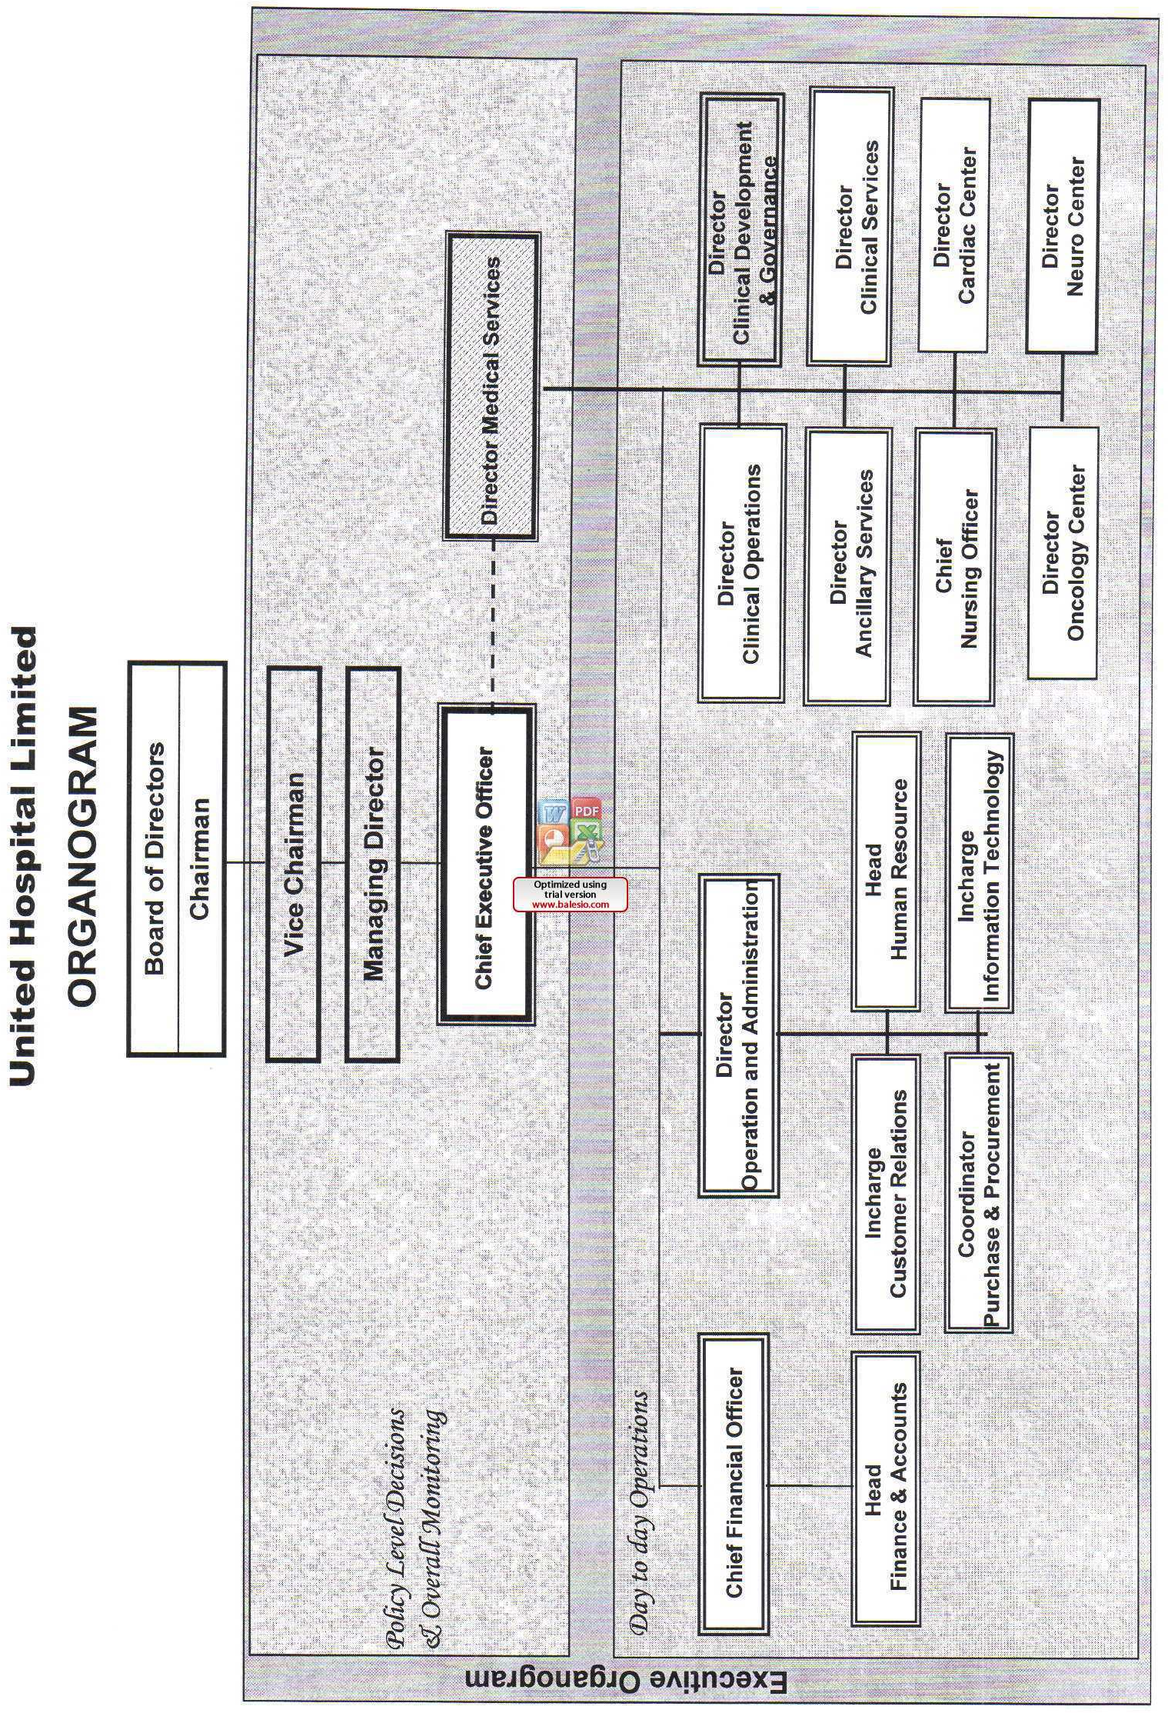
- To improve hospital operations and refocus them so that they are more concerned with providing high-quality care.
- Increasing the efficiency of services, as well as the systems for communication and health information.

OPERATIONAL ACTIVITIES OF UNITED HOSPITAL LTD.

Service Line
They value (i) quality, (ii) efficiency, (iii) integration, (iv) community service, (v) employee care, and (vi) research and training. Their primary goal is to deliver best-quality healthcare in a welcoming and friendly environment. The hospital has constructed the following major pieces of technology and made these services and facilities available to patients in order to provide "better than the best" care.
- 24/7 Ambulance Service  - 24/7 Angioplasty for Heart attack patients  - Cardiac Surgeries  - Kidney Transplant  - Brain and Spinal Surgeries  - Endoscopy Facility  - Digital Mammography  - Mobile X-Rays  - MRI System  - CCTV monitoring for the entire hospital  - Blood Bank Facility | - Flat Panel Digital Cath lab  - Modular Operation Theatres  - All Important Care Unit like ICU/CCU  - Fresenius 4008S Dialysis Units  - CRRT for critical patients  - PET-CT Scan  - Medical Cyclotron  - Linear Accelerator  - Spect-CT  - 500 Slice CT Scanner  - Central Sterilization Supply Facilities (CSSD)  - 24/7 Emergency Service  - 4D Portable Ultrasound

Table 3.4: Service Line of UHL

The cutting-edge Integrated Hospital Information System was created by United Hospital to track and monitor all activities as well as save patient data in digital format for convenient access and long-term preservation.
In 2009, postgraduate programs in cardiology and cardiac surgery may officially launch thanks to approval from the ministry of health. In 2009, it was a big deal when this happened. The opening of a nursing college that would grant a Bachelor of Science in nursing degree was also given the go-ahead in 2011 by United Hospital.

They are sincere to provide:
Quality
Maintaining the top standards of ethics and safety while showing daily improvement.
Effectiveness
Choosing the best services to achieve the best health results.
Integration
Clear paths can be formed by confirming cooperation, advice, and fruitful communication with healthcare specialists.
Caring for the Community
Fostering health and treating patients with a commitment to their welfare.
Caring for our staff
Personal development training, as well as looking after our employees' health and creating a trustworthy environment.
Research and Training
Establishing a setting that encourages individual growth, learning, and research.

United Hospital is proud to have established the standards for medical care and patient care service in Bangladesh in such a short space of time. They intend to keep working to better serve their community and won't stop at this point. Patients should go to United Hospital and expect the highest level of care and regard if they want the best treatment possible from the best specialists. Considering this, the hospital believes that "preserving your health today may have an impact on how fantastic you feel future."
In a few of Dhaka's busiest neighborhoods, United Hospital has set up helipads, helicopter services, and emergency ambulance booths to reduce traffic congestion. On-call specialists or doctors could be present inside the ambulance. Encouragement of "Health Tourism" in a nation with few well-known tourism sector offices may increase the value of its administrations. More mindfulness can be achieved by geological spread, as Apollo has done in Rangpur, Chittagong, Sylhet, and other areas. In order to address this, Chittagong and Sylhet Information Centers have been built by United Hospital. The 500 beds in the hospital's wards, cabins, crisis rooms, intensive care units, critical care units, and other amenities are all purpose-built structures. There are six patient elevators, two guest elevators, and one VIP elevator at the hospital. Additionally, they have their own parking lot with more than 350 spaces, which gives visitors confidence when visiting relatives or going to doctor's appointments.
Professional and Medical Services
- Intensive Care Unit: The intensive care unit aims to combine skills, equipment, and resources to provide a convergence of abilities, skill, and resources. Our medical services division's critical care nurses are committed to offering the highest standard of clinical care. They are very talented and well-trained, and they work under the supervision of physicians and with the assistance of other division staff members.
- Cardiac Rehabilitation: We can maintain a healthy lifestyle with the aid of the cardiac rehabilitation program. We will have the chance to learn more about the state of our own hearts to understand our risk factors better and discover the most effective forms of exercise after a heart attack or stroke.
- Cardiopulmonary: Certified medical professionals can identify and treat respiratory and lung conditions, as well as administer oxygen and breathing medications, and keep an eye on patients who need mechanical ventilation. Additionally, there is a pneumonic rehabilitation program and ECG and EEG tests accessible.
- Blood Bank: There are a lot of patients who are able to donate blood for their own use (also known as an autologous donation; the term refers to blood taken or transferred from the same person's body). To see if we are eligible to donate blood, we might check.
- Laboratory: The hospital provides an extensive assistance lab that is staffed seven days a week, twenty-four hours in a day for inpatient administrations. The research facility closes for outpatient administrations on Fridays and other days, with the exception of the emergency room.
Medical Records: Every person who receives care at the hospital has their medical records stored in both digital and paper versions. Medical records are maintained for our benefit, the benefit of the medical team, and the advantage of the institution.
- Emergency Services: The Emergency Services Department is committed to providing excellent crisis care and is open twenty-four hours in a day, seven days in a week. In specialist rooms, patients with cardiovascular disease, traumas, muscular wounds, and pediatric patients are also treated. Emergency nurses who have received Advanced Cardiac Life Support (ACLS) training assist our doctor (PALS).
- Radiology and Imaging Services: Our patients can receive mammography, diagnostic x-rays, ultrasonography, CT scans, and MRIs from the Radiology & Imaging Division.
- Maternity Centre: An amazing and life-changing experience is becoming a parent. Doctors and nurses at the Maternity Center are ecstatic to be able to provide us with such exceptional care at such a crucial time in our lives.
- Surgical Services: UHL provide a variety of inpatient, same-day, and outpatient therapies. Their team makes surely receives the proper care within treatment and hospital stay.
- Nutrition Services: Dietitians can help us with any questions or problems we may have regarding food. There are numerous nutrition treatments to pick from, all of which are customized to the patient's requirements.

Departments and Areas of Specialization

Current Departments for Services
- Laboratory | - Anesthesiology
- Oncology | - Rheumatology
- Nephrology and Dialysis | - Urology
- Neuro Surgery | - Cardiology
- Orthopedic Surgery | - ENT
- Hematology | - Obstetrics and Gynecology
- Gastroenterology | - Respiratory Medicine
- General Surgery | - Physiotherapy and Rehabilitation
- Medical Oncology | - Radiology and Imaging
- Internal Medicine | - Cardiac Surgery
- Neonatology | - Neurology
- Nuclear Medicine | - Ophthalmology
- Dermatology | - Psychiatry
- Dental | - Blood Bank
- Endocrinology | - Pediatrics

Table 4: Departments

Brief Descriptions of Few of the Departments
- Intensive Care Unit (ICU):
Every critical patient receives 1:1 cutting-edge specialized treatment from them, which is overseen by ICU doctors around-the-clock. Their intensive care unit (ICU) services and facilities are:
- Trained nursing staff available 24 hours for each patient.
- A cutting-edge vital sign monitor for each patient.
- A highly qualified consultant with 10 years of ICU experience abroad provides 24-hour supervision.
- The ability to insert a temporary pacemaker.
- An ICU portable X-ray machine.
- Nephrology:
To provide high-quality, affordable care to patients with renal disorders, the United Hospital Division of Nephrology works in conjunction with other specialists like cardiologists, endocrinologists, pharmacists, and nurses.
Numerous nephrology diseases are treated by UHL, including:
- Diabetic nephropathy
- Kidney failure
- Kidney stone disease
- Chronic kidney disease
- Critical care nephrology
- Mother and Child Care Center:
The Mother and Child Care Center ensures expert care under the direction of well-known, skilled, and certified medical professionals, ensuring that the infant is in great hands. The following emergency services are available twenty-four hours in a day, seven days in a week for obstetrics and gynecology, neonatology, and pediatrics:
- Phototherapy unit
- Nursery
- Parental nutrition
- Operation theatre with cutting-edge technology
- Follow up clinic for high risk newborns
- Neonatal & Pediatrics ICU
- Neonatal & Pediatrics cardiac care
- Cardiology:
- Cardiology at United Hospital first became operational in October 2006.
- Three Consultants, seven Specialists, numerous junior physicians, and other types of technicians are currently employed by the department.
- Over 22,000 intervention operations and over 15,000 patients have been treated by the department in the last 90 months.
- There are two Cath labs, one CT angio, and facilities for ECG, Echo, ETT, and Holter.
- The department contains 22 CCU beds besides regular beds.

Financial Performances
The Finance Department is the center of United Hospital. It is one of the most crucial departments, and the team members are giving it their all sustainable management and long-term growth. This division is responsible of raising capital, performance, managing it, and coming up with actual investment plans. This department assures that the company's operations adhere to efficient financial management and control systems.

ANALYSIS OF SWOT
Strength | Weakness
- It is founded by United Group, with proper administrative and monetary sustenance.  - Very huge premises with 500 beds.  - Modern and State-of-the-Art equipment.  - Offers advance day healthcare services.  - Uses Integrated hospital information system (IHIS).  - Possess own Blood Bank and Incubator facilities.  - Majority of the Doctors and physicians with foreign degrees.  - Has a different and premium customer base being treated on a regular basis. | - Not paying attention to the common public.  - Relative to the market's established competitors, this company is relatively new.  - The hospital's unfortunate prominence in the area.  - The website is not updated daily.  - As opposed to competitors, has not yet focused primarily on promotional activities.

Opportunities | Threats
- Comprehensive marketing efforts.  - Gaining knowledge of additional specializations, including microbiology, geriatrics, and eye care.  - Appointing physicians from abroad.  - The geographic expansion brought about by the addition of more information centers.  - Services for a contact center and helpline in multiple languages.  - More initiatives promoting social responsibility.  - Sessions for focused healthcare. | - Well-known competitors.  - Competitive pricing.  - The competitors' extensive promotional efforts.  - Restrictions on recruiting foreign doctors as well as guidelines for using local medical professionals.  - Diverse industry developments necessitate prompt answers in order to be sustainable.

CHAPTER 4

FINDINGS AND ANALYSIS OF THE STUDY

FINANCIAL PERFORMANCE ANALYSIS AND FINDINGS
The Finance Department is the center of United Hospital, as it is for any other organization. It is one of the most crucial departments, and the team members are giving it their all sustainable management and long-term growth. This division is responsible of raising capital, managing it, and coming up with actual investment plans. This department assures that the company's operations adhere to efficient financial management and control systems.

Net Profit Margin
Net profit margin demonstrates to analyze the amount of net profit. It is counted by:
Net profit/Total revenue
2019 | 2020 | 2021
10.5 | 10.8 | 8.1

Table 4.1: Net profit margin of past 3 years

Figure 4.1: Net profit margin of past 3 years
From the diagram, it can be determined that the net profit margin dropped starting in 2021, the diagram's final year. It is also evident that the cost of the sold goods resulted in a decrease in net profit. Worldwide spread of the COVID -19 pandemic was the cause of the sudden increase in foreign exchange rates. GTL suffered a setback since it never used a steady exchange rate for foreign currencies. Because of the immobility in many nations, which has been identified as the main source of lower profit, even inward currency transactions have been suspended.

Return on Asset
ROA actually demonstrates how the assets increase the profit. It is counted by:
Net profit/Total asset
2019 | 2020 | 2021
20 | 22 | 1.6

Table 4.2: Return on Asset of past 3 years

Figure 4.2: Return on asset of past 3 years
From the diagram, ROA has not been considerably more stable over the previous three years and that noncurrent assets have also remained constant throughout that time, but it was noted that the value of current assets has not. Current asset decline as a cause of an inadequate asset inventory. Furthermore, we are aware that both the weight fee and the cost of shipping increase. As a result, goods prices rise and net profits decline.

KEY ROLES OF THE ACCOUNTS AND FINANCE DEPARTMENT

Bookkeeping
Even though it may be one of the most fundamental financial activities, bookkeeping is done by an executive and is checked and overseen by the Asst. Manager, because all transactions are recorded by the bookkeeper and will have an impact over the Income Statement and Financial Statement. So, in order for them to get to the correct GL heads, all entries are validated and verified. The Chief Financial Officer (CFO), signs all the vouchers after they have been created and approved by the Deputy Manager, the Deputy General Manager (DGM), and the DGM.

Accounts Payables and Accounts Receivables
The finance department leaders meet to discuss the maturity of accounts payable and receivable at the end of each quarter. In order to ensure that the business runs smoothly, they evaluate and analyze the present situation and determine what steps should be made or put in place. The accounts payable payments are released in accordance with the credit period, and the appropriate suppliers are timely paid, thanks to the efforts of the deputy manager. Before finalizing supplier payments, he even checks to ensure that all necessary documentation have been submitted. The Finance Department also updates the status of their Accounts Receivable, keeps track of their maturing state, and checks to see if they have received any payments from them.

Financial Reporting, Financial Control and Budgeting
The United Hospital's bookkeeper and payment teams complete all the entries before the financial report is prepared. All of the payment and receipt vouchers are posted in the GL at the end of each month, which eventually affects the relevant GL heads. And after every quarter, the financial reporting team—which includes Mr. Syed Misam Abbas, an executive, and Mr. Bishajit Das, a deputy manager—works on data collection and organization in preparation for financial reports, which are then reviewed, examined, and approved by the DGM and CFO. These reports enable the implementation of plans for developing United Hospital's financial system. Additionally, they keep up with good budgeting and instantly adjust expenditure with planned expenditure. Each department submits a budget plan to the finance department, which works to keep them all within its budgetary constraints.

Tax and Compliance
Taxation is a crucial aspect of running a business. And there are a ton of complicated calculations required to pay those taxes. A tax manager, senior executives, are available at UHL to help with this. They both focus only on tax and compliance-related tasks, making sure that all payments and receipts adhere to tax regulations and that all government forms and files are completed promptly and sent to the appropriate parties on time. The CFO and GM often meet with the tax team to ensure that all of their needs are met and that their taxes are paid on schedule.

Treasury
The Treasury of United Hospital is similarly under the control and management of the Finance Department. Deputy Manager and Deputy General Manager actively monitor the Treasury to ensure that everyday cash received by the hospital is paid to the hospital account on time and with proper reconciliation to cash collection reports. In order to maintain control over the system and reduce crimes and frauds, they also regularly reconcile the money they receive from patients with the banks and IHIS.

Financial Analysis and Strategic Planning
The department creates a financial analysis after obtaining all the data that indicates their current position in the healthcare sector. They also produce forecasted data for further analysis using the data that was collected. Together with all of the managers, the DGM and CFO evaluate the data that has been forecasted and talk about the adjustments that must be made to achieve the long-term objective. They also compile performance evaluations for each of their employees, including the doctors, and develop a strategy for reaching the objective. To save costs and increase revenues, they have also put in place cost-effective measures.

RATIO IMPLEMENTATION
To assess and examine the hospital's performance, the finance department computes a few ratios. They use profitability ratios to evaluate how much money they are making relative to their expenditures and the overall health of the hospital, solvency ratios to evaluate how solvent they are and how much cash they have to pay their long-term debts, efficiency ratios to examine the outcomes and level of efficiency, and financial leverage ratios to evaluate how much equity they have in relation to their liabilities.
The Ratios are used by the Accounts and Finance Department of United Hospital are given below:

Efficiency Ratios:
Fixed asset turnover = Sales / Net fixed asset
Total asset turnover = Sales / Total asset
Operating efficiency ratio = Operating expense/ EBIT
Inventory Turnover Ratio = Cost of Goods Sold / Average Inventory

Profitability Ratio:
Return on Total Assets = Net profits after taxes / total assets
Return on common stock equity = Net income / Common stock
Net Profit margin = Net profit after tax/sales
Gross Profit margin ratio= Gross profit/sales

Solvency Ratios:
Cash Ratio = Cash / Current Liabilities
Current Ratio = Current assets /Current liabilities
Quick Ratio= (Current Assets-Inventories)/Current Liabilities
Basic Earning Power Ratio=EBIT/Total Asset
Operating Profit Margin = Operating profits / Sales

Financial Leverage Ratios:
Asset to Equity Ratios =Total Asset / Total Equity
Debt to equity ratio= total liabilities/ shareholders' equity
Debt Ratio =Total liabilities / Total assets

I have calculated the Ratios below that are used by the Accounts and Finance Department of United Hospital from the year 2018 to 2022:
Particulars | 2018-2019 | 2019-2020 | 2020-2021 | 2021-2022
Efficiency Ratios:
Inventory Turnover Ratio = Cost of Goods Sold / Average Inventory | 8.44 | 8.41 | 9.21 | 13.12
Fixed asset turnover = Sales / Net fixed asset | 0.20 | 0.21 | 0.22 | 0.23
Total asset turnover = Sales / Total asset | 0.19 | 0.20 | 0.20 | 0.21
Operating efficiency ratio = Operating expense/ EBIT | 4.18 | 3.82 | 4.85 | 5.87
Profitability Ratio:
Net Profit margin = Net profit after tax/sales | 10.5% | 10.8% | 8.1% | 8.7%
Gross Profit margin ratio = Gross profit/sales | 28.9% | 31.9% | 28.6% | 30.6%
Return on Total Assets = Net profits after taxes / total assets | 20% | 22% | 1.6% | 20%
Return on common stock equity = Net income / Common stock | 3.3% | 3.7% | 28% | 30%
Operating Profit Margin = Operating profits / Sales | 28.9% | 31.9% | 28.6% | 31.6%
Basic Earning Power Ratio=EBIT/Total Asset | 3.2% | 3.6% | 26% | 29%
Solvency Ratios:
Current Ratio = Current assets /Current liabilities | 1.60 | 1.02 | 1.02 | 1.09
Quick Ratio = (Current Assets-Inventories)/Current Liabilities | 1.16 | 1.68 | 0.80 | 1.10
Cash Ratio = Cash / Current Liabilities | 0.02 | 0.02 | 0.03 | 0.04
Financial Leverage Ratios:
Debt to equity ratio = total liabilities/ shareholders' equity | 3.8% | 5.0% | 5.8% | 6.6%
Debt Ratio = Total liabilities / Total assets | 4.3% | 5.6% | 6.4% | 6.3%
Asset To Equity Ratios = Total Asset / Total Equity | 1.04 | 1.06 | 1.07 | 1.08

Table 4.3: Ratios Calculation of past 4 years

INTERPRETATION
According to their Efficiency Ratios, the Hospital was the most efficient in 2021–2022, and they are improving over time.
According to their Profitability Ratios, we can determine that their overall profit has grown over time.
According to their Efficiency Ratios, the Hospital was the most efficient in 2021–2022, and they are becoming better with time.
According to their Financial Leverage Ratios, we can infer that they have been in a stable position therefore they should work to reduce their debt in the future and maintain or enhance those ratios.

CHAPTER 5

CONCLUSION AND RECOMMENDATIONS

THE CONCLUSION
Financial Analysis is a wise way to conduct the all monetary activities in any organization. It can find out the weakness, opportunity, threats and strength of the organization and what needs for the development of the organization to perform best by giving continuous analysis. It can motivate the employees and makes them satisfied and reach achieving the goal. It helps the supervisor to maintain everything timely and find out the performance of the organization and if they find any gap there they can also fix that accordingly and it helps them to find out the best way to reach the goal. So it can be said that financial analysis is indisputable for the organization to be successful.
I've tried to explain my internship experience, the lessons I learnt from it, as well as all the significant features of United Hospital in my report. I feel really lucky to have been a member of this business and to have worked closely with managers and DGMs. I have learned a lot from this place. I'll take advantage of the many opportunities the hospital has offered me while I complete my internship.

RECOMMENDATIONS
Following suggestions are prepared for UHL:
- Should invest in more profitable financial sectors like investment banks if it wants to pay off its debt.
- Should give more concern in the analytical part for their financial betterment.
- Need to develop various training sessions to up skill their employees which will ultimately increase the overall productivity of the hospital.
- Should use Modern tools and technology in the asset tracking.
- Might ensure transportation service for all the staffs so that they can enter on time and also it will be benefited for the distant staff.

CHAPTER 6

INTERNSHIP EXPERIENCE

POSITION AND RESPONSIBILITIES
I work as an intern at United Hospital Ltd. Due to my job, the work load was lower for the first month. I accomplished a lot of other things besides creating invoices. I have done the task of fixed asset counting, asset coding, asset tagging and inventory counting for all the departments. And include all those data in the Excel and Medisense software I have a range of jobs to accomplish throughout my internship. Preparing payments for vendors was one of my responsibilities at work, and I had to interact with them regarding payment details. The manager assigned additional necessary tasks. I arranged and kept track of other payments.

TRAINING
On-the-job experience is the main focus of the training. They engage in one-on-one practice sessions with me during working hours.
One of the top hospitals in our nation is United Hospital Ltd. I thought it was good that I had finished my internship there. I've learnt a lot from the unified family and seen a lot of new things since the first day of my three-month internship. Before giving me the task, my senior gave me two days of hands-on training. They delivered me all the information I require, after that they instructed me on what I needed to know. Each department had a distinct contribution. I can now say that I truly understand how hospitals operate as a result of what I learnt from them, which is also referred to as informal teaching. I developed my ability to communicate with a variety of people in a range of settings during my internship. I may therefore say that my internship experience served as some sort of training.

CONTRIBUTION WITHIN DEPARTMENT
I was recruited by United Hospital Ltd to work in their accounting and finance department. I have a number of departmental duties to perform. For the sake of my job, I had to stay in touch with the other departments. I also offered support to other group members.

INTERNSHIP PERFORMANCE APPRAISAL
They provided me with a descriptive and unplanned evaluation of my job. Both the manager I worked with the DGM of the finance department evaluated my internship's performance. I began by making typical rookie mistakes. I quickly, however, realized my mistakes. The mistakes I made there helped me learn. The Manager who oversaw my work showed me how to interact with customers and their financial transactions. She was remained positive and taught me how to handle the office setting. Additionally, she assesses my aptitude for learning new topics.
I was still on time for work. My soft talents and communication prowess have been evaluated. Sometimes DGM will quiz me on my knowledge. All of my employees and my team members appreciated my efforts.

NEW SKILL GAINED
Working in a new environment with new colleagues is certain to pick up a ton of new knowledge and abilities. They gave me a lot of experience and taught me a lot of new abilities.
• They taught me how to behave in a corporate environment and the standards of that environment, and I developed those skills through daily practice.
• Working under pressure is another proven skill there. I worked for United Hospital Ltd. under a number of different managers. I learnt a lot of new Microsoft Excel rules and methods, which increased skills. As a result, I'm expected to finish various tasks within a set period of time.
As I mentioned before, I gain a wide range of knowledge and abilities from them. I'm hoping those skills and experiences will be useful in the future.

IMPLEMENTATION OF ACADEMIC KNOWLEDGE
My major is Accounting and HRM. I was able to leverage my knowledge of accounting and HRM in this instance. I have to record my payments in a database and maintain track of them. Some accounting courses, such financial accounting and principles of accounting were quite helpful in preparing me for that environment. Some departments made use of my academic experience. But for the most part, I applied my understanding of accounting and HRM.

CHAPTER 7

APPENDIX

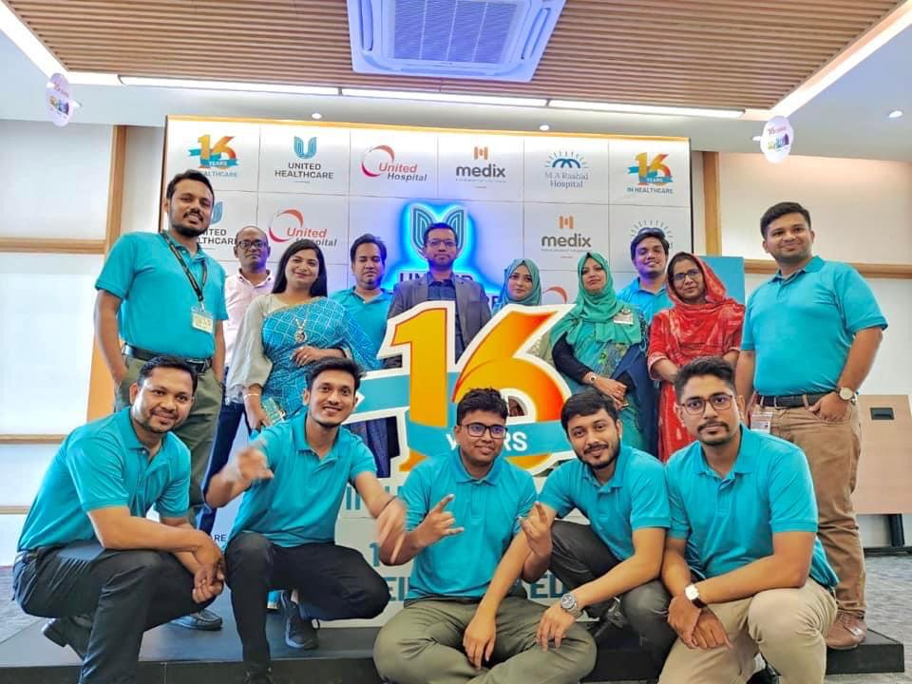 SOME MOMENTS AT UHL

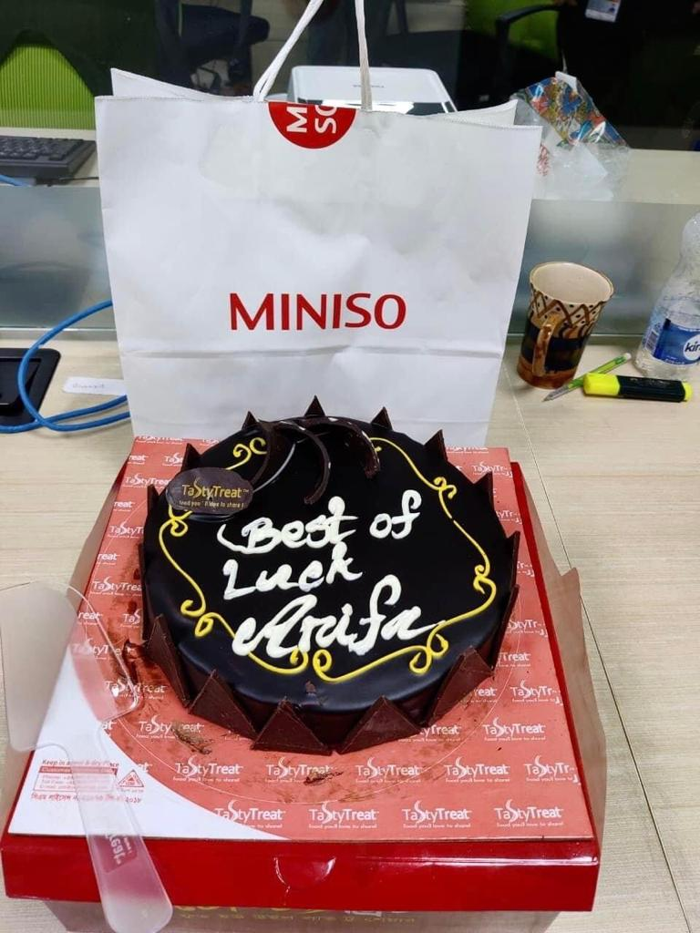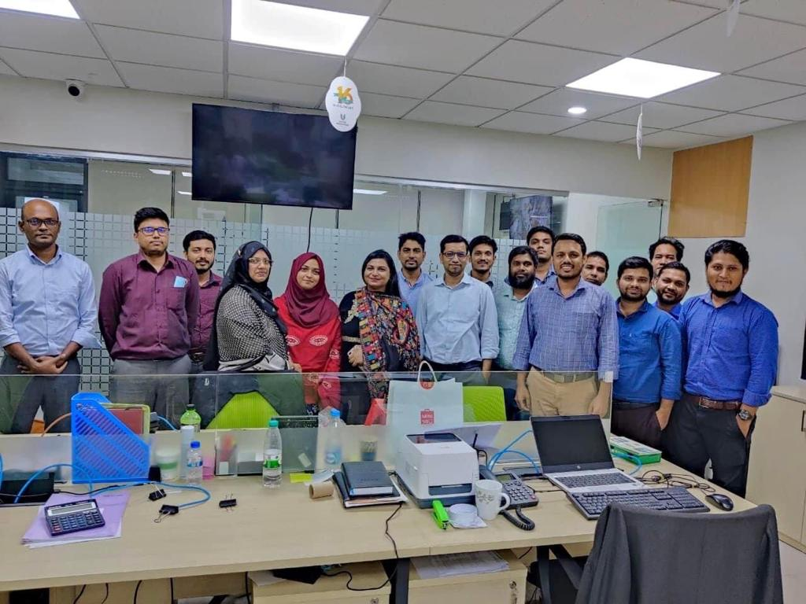

REFERENCES
Rahman, N. (n.d.). Internship Report on United Hospital Limited (Nazmur Rahman, October to December, 2012). Scribd. Retrieved April 5, 2021, from https://www.scribd.com/doc/140370687/Internship-Report-on-United-Hospital-Limited-Nazmur-Rahman-October-to-December-2012
Best Hospital in Bangladesh - United Hospital. (n.d.). Copyright © Uhlbd.Com. Retrieved August 15, 2021, from https://www.uhlbd.com/
United Group. Retrieved August 15, 2021, from https://united.com.bd/

