

United International University
Quest for Excellence

THE IMPACT OF FOREIGN DIRECT INVESTMENT (FDI) IN BANGLADESH

DATE: 2nd APRIL, 2020

SUBMITTED TO:
MOSABBIR AHMAD
ASSISTANT PROFESSOR,
FACULTY OF BUSINESS AND ECONOMICS

SUBMITTED BY:
TASNIM BINTE AFSAR
ID# 111 141 374
BACHELOR OF BUSINESS ADMINISTRATION

United International University

Project Report On

The Impacts of Foreign Direct Investment in Bangladesh

Letter of Transmittals

Date: 2 April 2020
To,
Mosabbir Ahmad
Assistant Professor
Faculty of Economics and Business
United International University
Subject: Submission of the project report.
Dear Sir,
You will be glad to know that I have completed my project report on the topic "Impact of foreign direct investment in Bangladesh". We all know that Foreign direct investment (FDI) is a powerful weapon of economic development, especially in the current global context, enabling capital-poor countries like Bangladesh to raise physical capital through creating employment, technology transfer and co-operation, enhance the skills of the local manpower, develop productive capacity, helps to integrate national and global economies. Therefore, analyzing the actual impacts of FDI is highly important for Bangladesh.
However, the report has been prepared based on historical FDI information of FY2008-2018. All the information used in the report are taken from valid sources. Moreover, the report has been prepared following the guidelines I received and tried my best to follow each steps of the report format.
It will be highly appreciated if you kindly accept my project report and oblige thereby.

Sincerely yours,
Tasnim Binte Afsar
ID: 111141374
BBA- Finance
School of Business and Economics.
United International University

Student’s Declaration

I am Tasnim Binte Afsar, student of BBA, ID: 111 141 374, Major- Finance, declaring that the dissertation titled ‘‘Impact of Foreign Direct Investment in Bangladesh’’ is unique and solely prepared by me.

I also confirm that the dissertation is prepared only for my academic requirements, not for any other purposes.

Tasnim Binte Afsar
ID: 111 141 374
BBA-Finance
United International University

Acknowledgment
At the beginning of the report, I would like to start with thanking Almighty Allah for making me capable to complete all my under graduation courses successfully, giving me the ability to prepare the report and providing me such generous parents who encouraged me a lot through financially, mentally and physically to complete my Bachelor of Business Administration (BBA) from United International University.

I want to share my sincere appreciation and thanks to my finance faculty as well as my project supervisor, Mosabbir Ahmad, Assistant Professor, SoBE, United International University. It would be very difficult for me to complete this report without his kind guidance and supervision. Throughout the study period, his constant encouragement and efforts were the greatest incentive for me and directly promoted the completion of the task. I also want to show my sincere appreciation to all the teachers in my department who have transmitted all the necessary knowledge and information that have allowed me to successfully complete my project report and have offered me the opportunity to evaluate myself in the practical situation.

At the same time, I also want to show my appreciation and gratitude to all my classmates and to the people who love me and helped me to understand difficult concepts regarding Foreign Direct Investments that help me to finish the report successfully.

Supervisor’s Declaration

This is to demonstrate that Tasnim Binte Afsar, a BBA student in finance, United International University presented the project report entitled "The impacts of Foreign Direct Investment in Bangladesh" to partially meet the requirements of the BBA degree.

This request can be accepted in terms of quality and farm.

…………………………………………………….
Mosabbir Ahmad
Assistant Professor,
Faculty of Business and Economics,
United International University

ABSTRACT
Foreign direct investment (FDI) is an investment made by an entity located in another country in the form of a majority stake in a country's operations. The source of the investment does not affect the definition of foreign direct investment: when buying an asset in the country of destination, the investment can be made "inorganically" or it can be invested "naturally" to expand existing business activities in the country. The main objective of this research is to evaluate the impact of foreign direct investment (FDI) on the economic development of Bangladesh. Economic indicators also reflect economic scenarios that show the real situation in countries like Bangladesh. Therefore, it can be defined as foreign direct investment in this sense and can represent Bangladesh as one of the development indicators in terms of development structure. The purpose of the study was to focus on the state of FDI in Bangladesh and its problems and remedies. Indeed, the study found that the contribution of FDI from developed and developing countries to Bangladesh is not as high due to some uncertainties, such as the disparity in the relationship between savings and investment, low GDP and trade deficits, political unrest, etc. To develop the FDI scenario in Bangladesh, this study describes some recommendations.

Table of Contents
Chapter One: Introduction
1.1 Introduction 1
1.2 Purpose of the study 2
1.3 Research hypothesis 2
1.5 The methodology of the study. 3

Chapter Two: Literature Review
2.1 The Concept of FDI 4
2.2 Methods of FDI 4
2.3 The positive impact of foreign direct investment on economic growth 5
2.4 The effectiveness of foreign direct investment 6
2.5 Types of Foreign Investment 6
2.6 Types of Foreign Direct Investor: 7

Chapter Three: The consequences and impacts of Foreign Direct investments in Bangladesh
3.1 Bangladesh Foreign Investment and its history 8
3.2 Beginning of FDI in Bangladesh 8
3.3 Current Situation of FDI in Bangladesh 10
3.4 The Sector-wise FDI growth till now 10
3.5 Overflow of FDI inflows 15
3.6 Foreign direct investment inputted by component 15
3.7 FDI Inflows in EPZ and Non EPZ Areas 16
3.8 Foreign Direct Investment contributed by Major Sectors 17
3.9 FDI inflows from major countries 20
3.10 FDI of Bangladesh among South Asian Countries 21
3.11 Foreign direct investment between Bangladesh and SAARC countries 21
3.12 Survey of foreign direct investment inflows in SAARC countries (in millions of dollars): 22
3.13 SAARC countries classified in terms of attractiveness of FDI: 23
3.14 Ten major industries that attract more foreign direct investment in the SAARC region: 24
3.15 Sources of foreign direct investment in SAARC countries: 26
3.16 Reduction of foreign direct investment in recent years 26

Chapter Four: The prospects and problems of FDI in Bangladesh
4.1 Prospects for Foreign Direct Investment in Bangladesh 31
4.2 Bangladeshi government structures that provide foreign investors 32
4.3 The problems of Foreign Direct Investment in Bangladesh 33
Findings of the study 35
Recommendations and Conclusion: 40
Conclusion 43
Reference

Chapter one
Concepts and Definition

1.1 Introduction
The impact of foreign direct investment (FDI) on economic growth is a matter of debate in dominant academic circles. According to a number of studies, a strong positive correlation was found between foreign direct investment and economic growth. It has been suggested that foreign direct investment is essential in developing countries to promote capital formation, transfer of knowledge and technology, and to create employment that can have a direct and positive impact on economic development. Furthermore, Sylvester (2005) points out that foreign direct investment affects domestic investment, which further stimulates the economic development of the welcoming country.

Some experts also point out that foreign direct investment can have a negative impact on the economic development of the recipient countries (Hermes and Lensink, 2003). In case of loss of profits by foreign companies, the recipient countries have the potential to damage the balance of payments (balance of money; Kentor, 1998). Fry (1999) argues that foreign direct investment has reduced national savings rates, domestic investment and economic growth in several developing countries. The third view is that FDI can only be related to education, technology, infrastructure, human capacity, and political stability. From the above discussion, it is clear that the experts differ significantly in the impact of FDI on the economic development of the guest countries. The report sought to determine whether direct investment from overseas had a significant impact on economic growth by examining empirical evidence from Bangladesh.

Purpose and methodology of the report.

1.2 Purpose of the study
The study aims to evaluate the impacts of Foreign Direct Investment in the economicalprocedure of Bangladesh. So, it is possible to manage a historical and applied mathematical analysis of the link between the trend of FDI inflows and its impact on scientific indicators such as Balance of Trade (BOT), gross domestic product (GDP), and Interest Rate (IR).

1.3 Research hypothesis
Many reports show that experts are strongly alienatedthe impacts of Foreign Direct Investment o#in the economic expansion of the host country. The project aims to address this issue with relevance to the experimental evidence of the Asian nation. Therefore, this study may consider the following assumptions as:

Hypothesis 1: There is a strong positive correlation between FDI and GDP growth in Bangladesh.
Hypothesis 2: There is a strong negative correlation between FDI and interest rates in Bangladesh.

1.4 data source
Primary/ Main Data Source and Secondary Sources are used to execute this plan:
- Main Data Source: The main data source is used to integrate from the following source:
- Bangladesh Bank (BB);
- Bangladesh Board of Investment;
- Bangladesh Export Processing Zone (EPZ);
- Bangladesh bureau of statistics, etc.

B. Secondary data: Secondary data was gathered from the following sources:
Sixth various reviews and case studies.
- Internet& blogs;
- Bangladeshi newspaper named ‘Daily star’;
- Books published on FDI of Bangladesh;
- Financial Express.

1.5 The methodology of the study.
The project report will focus on historical data of foreign direct investment in Bangladesh in the ten years of 2008-18. To test the above three hypotheses, multiple regression analyzes were used to identify FDI as independent variables and on the other hand, the dependable variables are Gross Domestic Products, CPI inflation, and Balance of Trade (BOT). The central bank, known as Bangladesh Bank (BB), is responsible for foreign direct investment and exchange of macroeconomic information. Thus, the increase in foreign direct investment flows, historical data (2008-18), GDP, consumer price index and trade balance inflation rate was obtained from Bangladesh bank announced by the Bank. Bangladesh Bank uses a book review and surveys reporting system to collect and display its key information. However, since Bangladesh Bank is a microeconomic data and FDI input data platform, any irregularities in data production will be reduced.

Chapter two
Literature Review

The aim of this section is to study theory and research on the impact of foreign direct investment in the economic growth of Bangladesh. The definition of foreign direct investment (FDI) will be the beginning of this section. Thus, we will introduce the FDI approach to summarize the positive and negative relationship between FDI and economic growth and those who believe that the effectiveness of FDI depends on its ability to absorb FDI. The third part of this section of the beneficiary country will introduce different types of investors (countries) who invest in Bangladesh.

2.1 The Concept ofFDI
Foreign Direct Investment (FDI) plays the role of strengthening of management capacity, employment generation, export expansion, equitable work, transfer of scientific knowledge and growth. FDI will expand the size of the core principal to fund the country's new development plans while providing access to social control, new technology, and advertising, regardless of market efficiency and national taxes (regardless of country/region).
Foreign Direct Investment is a global investment that reflects the goals of the residential entity in an economy that has a sustainable interest in those working in another economy. Many IDE Interaction Companies are called Multinational Companies or Multinational Companies. Traditionally, foreign direct investment involves the export of real capital from the country of origin to the host country. The host country of Bangladesh has invited foreign direct investment in promoting industrial development. Companies in the manufacturing and transportation sectors are welcome to sell their products in the United States and export to countries outside the United States.
FDI is no longer simply a switch of possession as it generally includes the transfer of elements complementary to capital inclusive of management, technological and organizational skills.

2.2 Methods of FDI
Investors can make foreign investments directly by expanding their business overseas. In addition to reinvesting the profits of foreign regulatory agencies, intra-corporate loans to foreign branches are considered a foreign direct investment. Finally, domestic investors have multiple ways of voting in foreign companies. Here are some examples:
- The branches of domestic companies are established abroad;
- Joint venture with a foreign company;
- Merger & Acquisition;
- Acquisition of shares with voting rights in foreign companies.

2.3 The positive impact of foreign direct investment on economic growth
The modernization theory emphasizes that foreign direct investment can make a positive contribution to the economic growth of developing countries. In theory, foreign direct investment can meet the capital-raising needs of developing countries through investments that promote economic growth. In many developing countries, foreign investment is a key factor in reducing the gap between rich and poor. Immediately: by raising funds, foreign direct investment led to economic growth in South Asia and East Asia. Furthermore, foreign investments have effectively established physical infrastructures such as roads and factories, as well as improved infrastructure, which has increased the absorption of host countries and could attract more foreign direct investment in the region.
The modernization theory also shows that foreign direct investment can transfer knowledge, technologies, management skills and ideas that contribute to the economic development of the beneficiary countries. Foreign investment promotes economic growth by transferring technology and knowledge to developing countries. Foreign investments encourage domestic investments. In a survey of developing countries, foreign direct investment in developing countries has increased domestic investment, contributing to the growth of the modern economy. Other studies claim that foreign investment has a positive impact on domestic investment in Asian countries.
It was found that foreign investments have a positive impact on economic growth by improving exports. Foreign direct investment has increased the number of exports, increasing foreign exchange earnings and can be used to repay loans with external salary advances. A study conducted in 2006 showed that foreign investment stimulated Chinese economic growth by increasing exports.
As a result, foreign direct investment appears to have increased gross domestic product, gross national product and purchasing power parity. Foreign direct investment also plays a role in reducing internal savings spreads, exchange rate differentials, balance of payments deficits, unemployment rates, inflation rates and poverty levels. Foreign direct investment is also linked to proposals for corporate social responsibility (CSR), export diversification and the development of financial institutions.

2.4 The effectiveness of foreign direct investment
External observers believe that the impact of foreign direct investment on economic growth depends on the retention rate of recipient countries. If the economic, political and social conditions of the host country reinforce each other, the foreign direct investment will be useful for economic recovery. However, if a country does not have a sufficient business environment to facilitate the transfer of, for example, technology and management skills, the foreign direct investment can have a negative impact on economic recovery. For example, for countries in East Asia and Latin America with a higher level of development than in sub-Saharan Africa, the two countries will have greater foreign direct investment in economic growth than developing countries. Moreover, the benefits of FDI are based on qualified human resources, developed infrastructure, improved technology, open trade policies, macroeconomic and institutional reforms and policies to support foreign direct investment. For example, studies in 46 countries have found that foreign direct investment has a greater impact on economic growth when the workforce of the host country is more educated. In another study, it was noted that trade liberalization, through the capital structure, increased exports, and reduced unemployment, exacerbated the impact of foreign investment on economic growth. In addition, corruption and lack of transparency often inhibit foreign investment.

2.5 Types of Foreign Investment
Foreign direct investment is generally divided into vertical, horizontal or Conglomerate investments.

- Vertical foreign direct investment: Vertical investment refers to activities that are established or acquired in a foreign country in addition to the main activities of the investor, such as the acquisition of shares in a foreign company that supplies coins or from raw materials to a manufacturing company. Manufacturing companies are required to manufacture their products.
- Horizontal direct investment: Horizontal direct investment refers to investors who operate the same business abroad as they do in their home country, such as a US mobile phone provider with a store in the United States in China.

- Conglomerate foreign direct investment: Another type of foreign direct investment is Conglomerate where a business or individual that makes foreign investments in activities that are not related to existing activities in the country of origin. Because this type of investment involves entering an industry with no investor experience, it usually takes the form of a joint venture with a foreign company already active in the industry.

2.6 Types of Foreign Direct Investor:
Actually anyone who takes the permission to invest in another country are the foreign investor for that recipient country. Such as:

Chapter three
The consequences and impacts of Foreign Direct investments in Bangladesh

3.1 Bangladesh Foreign Investment and its history
Bangladesh located in South Asia which is a country full of commercial potentials. For the last two and a half years, it has grown at a rate of 6% to 7% per annum without any major government incentives, therefore, the country can be considered as a country of opportunity. Moreover, the country has natural resources, a huge population, and cheap labor. The most promising investment sectors of the country are jute products, electricity, leather goods, coal, oil and gas, fishery products and tea exports for certain export products. From many years of tradition, however, the fields of investment have now appeared in the following areas: tourism, agro-industry, telecommunications, light machinery industry, aviation, software development, electronics, agriculture, data entry, and data processing.
In the era of globalization, Foreign Direct Investment (FDI) is increasing substantially. It is considered as an important contribution to the economic process of developing countries. The investment environment and privatization encourage the environment to attract foreign investment in Bangladesh. On the contrary, Bangladesh has been a speculative investment destination, despite the fact that British companies have dominated for 200 years. After independence in 1971, Bangladesh started nationalizing. However, this was done to demonstrate the privatization approach for engaging with globalization.

3.2 Beginning of FDI in Bangladesh
The inflows of FDI in Bangladesh have increased very little in the 1980s to more than $ 300 million at the end of the 1990s; in the year 2005, it was approximately $ 692 million; and in 2017 it was around $ 2580 million, which demonstrates the upward trend in FDI inflows in Bangladesh:

Figure 1: Inflows of FDI in Bangladesh
FDI (Current USD in Million)
3000
2500
2000
1500
1000
500
0
1984 1987 1990 1993 1996 1999 2002 2005 2008 2011 2014 2017

FDI ( Current US $ in Million )

There are a lot of variables that have led to this dramatic increase and to better understand them, it is necessary to discuss the history of economic policy implemented by the Bangladesh Government since, after the birth of the sovereign nation, the new government sought to create a socialist state and adopted the 1972 order for nationalization to encourage the process. The government managed 86% of the economic sector, including key industries such as jute, sugar, and cotton. The first five-year establishment took place between 1973 and 1978 and moved to a state-run economy.
Moreover, the nationalized industrieswere inefficient and the growth of the economy was also weak. The losses were covered by the public sector in general and its tightly-created state-owned enterprises have created a build-up of political pressure, and the government has also launched a large number of capitalist measures to encourage a greater role for the private sector. As a result, Bangladesh has undertaken a series of policy reforms aimed at creating a more capitalist economy by gradually increasing the allocation of funds to the private sector; These reforms include the 1978-1980 biennial configuration, the configuration of the second year 1980-1985, the configuration of the third year 1985-1990 and the configuration of the fourth year 1990-1995. Due to the lack of financial capacity, knowledge, and administration within the promising economy of a new nation, the government could not rely solely on the domestic financial market for its economic growth. While other low-income countries recorded a growth of 3.8 percent of GDP per capita, Bangladesh experienced difficulties at 0.4 percent per annum until 1985.
To accelerate the economic situation, FDI has become a major concern. Because of this concern, the Bangladeshi Parliament passed the Foreign Private Investment Law in 1980. However, foreign direct investment has barely increased due to trade restrictions, and the Investment Commission was established through the Investment Law of 1989, with the main objective of attracting and promoting foreign investment. Figure 1 shows that the economy of Bangladesh reflects the efforts of the Investment Committee, especially during the 1990s, when foreign direct investment inflows increased. It is important to emphasize that in 1995-1998, through all these, FDI traffic has increased dramatically.

3.3 Current Situation of FDI in Bangladesh
FDI reached $64,000 due to their enormous impact on the economy, which led to economic growth in beneficiary countries through the formation of physical capital, the disintegration of science and the hyperbolic completion of homes. With the increase in foreign direct investment over the last ten years, there have been many changes in global trade and capital flows. Although this is the current reality, since Bangladesh has adopted multiple measures to establish favorable investment infrastructures for the private sector abroad, some basic factors have improved the safety of overseas investors in the country; Development of the energy sector; Assistance and assistance in the creation of the sector; And loosening of regulations, trade and exchange liberalization, conversion of contemporary accounts, emphasis on the development of private sector leaders, the liberalization of investment agreements and, above all, the interests and interests of foreign buyers and telecommunications. In the last ten years, the number of foreign direct investment (FDI) entering the country has almost tripled. Furthermore, the private sector takes responsibility for the short, medium and long term foreign debt.
For an amount of US $ 60-70 million per year, which increases interest in foreign currency and capital payments, as well as public debt obligations withmultilateral and bilateral agencies.

3.4 The Sector-wise FDI growth till now
FDIproducesfinancial development for the receiver countiesby fantastic economic influences of US $64,000 for the formation of physical capital, the dispersion of science and the hyperbolic house completion of the economy. Bangladesh will get these inflows as long as it is willing to divide and effectively manage these activities, while maintaining visible commitments in terms of financial gains and outflows. Foreign Direct Investment inflows were not actually encouraging from an early agein Bangladesh. Only a few industries like; garment industry, Tea export industry; fascinated the majorquantity of foreign companies and joint ventures. The consumer product is the first number of volumes supported by the list. The entiresum of FDI units established between 1947 and 1971 was only 22 and was largely controlled by sectoral partslike medicines, pharmaceuticals and electrical appliances.
CEIC expands the history of FDI quarterly. Bangladesh Bank provides FDI in BPM6 USD with support. Foreign direct investment before the third quarter of 2011 is based on MBP5. According to the latest reports from Bangladesh, the current account recorded a deficit of $ 362.2 billion in July 2018. Bangladesh's foreign direct investment increased by $ 7.1 million in June 2017. Investments in the foreign exchange portfolio increased by $ 137.6 million in June 2017. In June 2018, Bangladesh's nominal GDP was recorded at 274.0 billion dollars.
FDI in Bangladesh improved by $548.0 million in June 2018, compared to an increase of USD 495.0 million in the net flow of the previous quarter of USD 1 million. , available from September 2003 to June 2018. The data reached a record of $ 1.0 billion in December 2016 and a record of -119.0 million dollars in December 2005.
The country had primarily embraced a nationalization strategy for all big and moderate sized industries. As a result, it was not until 1977 that there were no new FDI inflows into the country. Subsequent governments attempted various industrial policies, but due to the highly tentative political situation in the country, the inflow of FDI was still negligible until 1993. Only 220 units were registered. Foreign direct investment in Bangladesh from 1977 to 1993, but later, foreign direct investment has recorded fairly strong annual growth. From 1996-99, the number of shares registered by IDE in the country was 425. The total planned investment of these companies is Tk. 288.8 billion. These have created job opportunities for over 94,000 people. The increase is mainly due to economic policies are relatively stable, thus creating a better political, social and economic environment.
Over time, the geographical derivation of the Bangladesh FDI flows has changed dramatically. Before independence, the original leaders were advancedmarketplace economies such as the United Kingdom, Japan, and North America. In the 1970s, India,Singapore, Thailand, and Hong Kong began to take part in foreign direct investment in Bangladesh, while Asian countries like Pakistan, Malaysia, China, and South Korea initiated investing in Bangladesh. In the 1990s the percentage was higher. However, industrialized countries continue to dominate foreign direct investment in Bangladesh, with the exception of the United Kingdom, the United States and Japan, the main sources of foreign direct investment in the country are the European countries, the Federal Republic of Germany and the countries of North America.
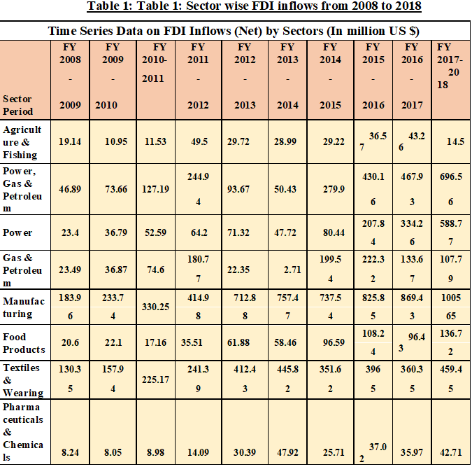
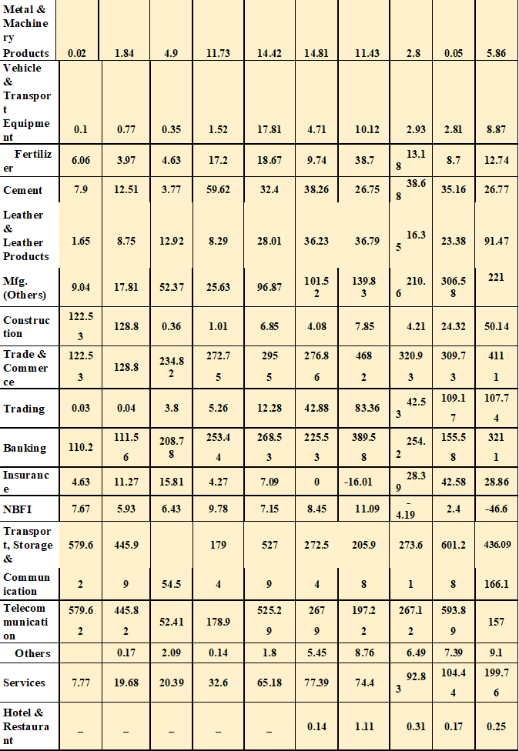
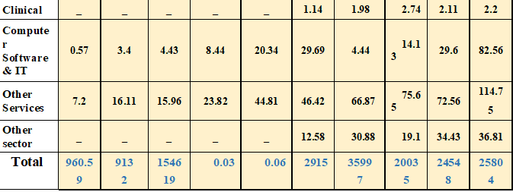

Industries that now attract more foreign direct investment are manufacturing sectors, fishing and agriculture, telecommunications, gas and oil, trade and commerce, electricity, food, restaurants and hotels, petroleum & energy, leather products, chemical and pharmaceuticals, IT software, mobile apps, and information technology, textile and apparel, and banking have become areas of interest for many foreign investors.
The quantity of foreign direct investment in the first years was limited by small investments, while the benefits were very rapid. This year, they have shown high-tech and intensive capital projects in an appropriate range and priorities in typical sectors and subsectors. However, the share of agriculture, construction, storage and communications is still at historically low levels, representing less than 3% of total direct foreign investment.
Despite the favorable government FDI policy and a culture of welcoming foreigners, the number of FDI projects implemented remains frustrating associated with the officially recorded projects. Among 366 FDI registered in 1996-98, only 72 were put into production at the end of 1999, 27 were in the practice of application and the remaining 266 were only used as archives.
Bangladesh offers joint ventures to make foreign direct investments, such as technology license agreements, marketing assistance, TBT negotiations, management agreements, general contracts,co-production agreements, and Contract Management. In the coupling, in medicines and prescription drugs (with UK companies), in electronics (with Korean companies), in standard coatings (with Thai companies) and in other departments, the impact of regional technical cooperation units is very obvious. Tea and clothing industry. The license agreement mainly refers to the chemical and pharmaceutical sectors. Many local companies manufacture TNC brand products with authorization, but without ownership participation.

3.5 Overflow of FDI inflows
According to the data from the Bank of Bangladesh, the country received $961 million in 2008-2009, while foreign direct investment inflows in the past two years increased to $2.4481 billion, or 155.44%. According to the latest data from Bangladesh Bank (BB), from 2016 to 2017 years, the country received $2,707.4 million in July and May between 2017 and 2018 years, accounting for 5.58% of foreign investment. According to stakeholders, regulators, and economists, Bangladesh can attract more and more foreign direct investment through sustained political support from the government.
The total income department includes all inward investment by non-resident investors in the hedging economy. The divestment contains reverse investment, repayment of housing capital, intra-group loans to the parent company, and loans to the parent company. Net inflows are total inflows minus divestments. The total outflow is foreign direct investment by residents of the reporting economy. The net outflow is the total outflow minus the divestment.

Gross FDI inflows in 2017 amounted to USD 2681.69 million. The amount of divestment (containing repayments of intra-corporate loans to parents, reverse investments, repatriation of capital, and loans to parents) reached USD 530.13 million in 2017, equivalent to 19.77% of gross FDI inflows. As a result, net FDI inflows into Bangladesh amounted to $ 2151.56 million in 2017. Gross Foreign Direct Investment inflows in the quarters from January to March, from April to June, from July to September and from October to December 2017 were $ 652.59 million, $ 643.97 million, $667.03 million and $ 718.10 million respectively.
On the other hand, disinvestment of time from January to March, April-June, July-September and October-December 2017 amounted to $ 156.75 million, $ 152.72 million, $ 159.88 million and
60.78 million Respectively.
From July to December 2017, total foreign direct investment (net) inflows reached US $ 1,164.7 million, an increase of US $ 173.8 million or 17.97 from January to June 2017 (US $ 987,090,000) in FDI inflows (net) % From January to June 2017, foreign direct investment (net) inflows decreased by the US $ 480.63 million or 32.75% compared to July-December 2016, and decreased by 60.72 million compared with July-December 2016. USD or 69.68%. - June 2016.

3.6 Foreign direct investment inputted by component
In the last period of the 2016-2017 financial year, the total inbound FDI of the country increased by 125.63 million US dollars or 5.12% in the fiscal year 2017-2018 (fiscal year).
Although capital inflows decreased significantly by 38.93% in FY2017-FY18, reinvested earnings and intra-enterprise loans increased by 0.04% and 265.12%, respectively.
  - Intra-company loans expanded by US$517.17 million or 265.12% in the 2017-2018 financial year to US$712.24 million, compared with US$148,466 million or 43.22% in the 2016-2017 financial year (Table: 2)
  - Reinvested earnings in FY2017-FY18 expanded by US$0.44 million or 0.04% to US$1253.44 million, compared with US$98.55 million or 7.87% in the previous period of FY2016-2017 (Table 2)
  - In FY2017-FY18, FDI inflows reduced equity by $319.8 million or 38.93% to $647.6 million, compared with $511.9 million or 99.14% in the previous fiscal year 2016-2017 (Table: 2)

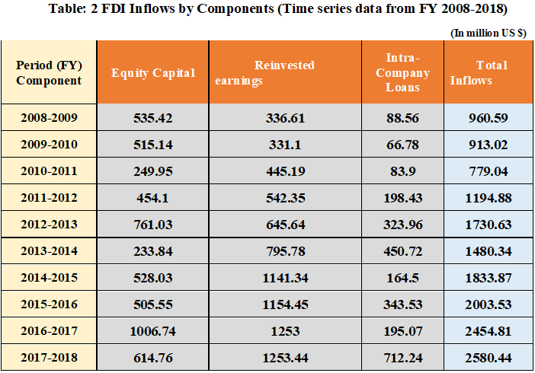

3.7 FDI Inflows in EPZ and Non EPZ Areas
- In the export processing area (EPZ), FDI inflows for the fiscal year 2017-2018 amounted to USD 450.41 million, an increase of USD 66.95 million or 17.46%, compared to 44, 18 million USD or 10.34% in the last fiscal year 2016-2017 (Table 3).
- During the reporting period, total FDI inflows from non-exported processing areas increased by $ 58.86 million, or 2.383%, to $ 2130.03 million, compared to $ 494.6 million, or 31.44% in the previous year (Table 3).
- In the fiscal year 2017-2018, FDI inflows from non-export processing areas were USD 2130.3 million, which represents 82.55% of total revenue. In the fiscal year 2016-2017 of the previous fiscal year, the figure was $ 2071.35 million, which represents 84.38% of total income. On the other hand, FDI inflows into the ZFI area for the 2017-2018 fiscal year were the US $ 450.41 million, or 17.45% of total revenue. In the previous year 2016-2017, the figure was $ 383.46 billion, or 15.62% of total revenue.

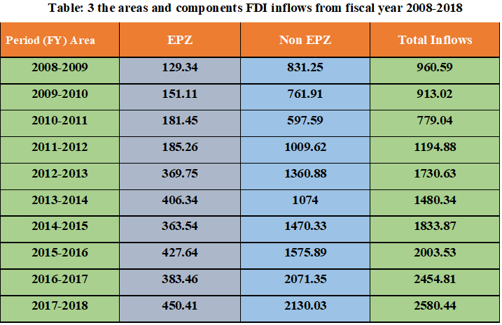

3.8 Foreign Direct Investment contributed by Major Sectors
The sectors that attract the largest amount of Foreign Direct Investment (net inflows) for the fiscal year 2017-2018 include energy ($588.77 million), textiles and clothing ($ 459.45 million), banking ($ 321.01 million dollars). Food products (USD 136.72 million) & Telecommunications (USD 157.00 million), respectively 22.82%, 17.81%, 12.44%, 6.08% and total contribution of 5.30% Foreign Direct Investment. The sectors that attract the largest amount of FDI (net inflows) for the fiscal year 2016-17 include the textile and clothing sector ($ 421.68 million), banking services ($ 278.86 million), telecommunications (€ 229.64 million), energy ($ 163.51) and food products ($ 107.27 million), 19.60%, 12.96%, 10.67%, 7.60% and 4 respectively, 99% of the contribution of total FDI inflows (net). For the fiscal year 2015-2016, telecommunications (572.76 million dollars) amounted to 24.55%, textiles and clothing (364.44 million dollars), or 15.62%. , Energy (267.97 million dollars), 11.49%, Gas and oil (166.34 million dollars), 7.13%, Banking (166.07 million dollars), 7.12% for the total contribution FDI inflows (net).

- FDI Inflows through the Textile and Garments sector
Net FDI inflows in the textile and usury sector reached the US $ 221.34 million in January-June 2018, down by the US $ 16.77 million, or 7.04% from July to December. 2017 (USD 238.11 million). While in July-December 2017, FDI inflows (net) increased by USD 54.54 million, or 29.71% compared to January-June 2017, and increased by USD 6.79 million or 3, 84% between January and June 2017 compared to July to December 2016 and decreased by the US $ 10.88 million or 5.80% between July and December 2016 compared to January-June 2016 (USD 187.66 million). While in January-June 2016, net FDI (net) decreased by $ 20.73 million or 9.95% compared to July-December 2015 and decreased by $ 26.14 millionor 11, 15% between July and December 2015 compared to January-June 2015.

- FDI Inflows through the Telecommunications Sector
From January to June 2018, the net inflow of FDI into the telecommunications industry was $59.61 million, a decrease of $37.78 million or 38.79% from July-December 2017 ($97 million). Compared with January to June 2017, FDI inflows (net) from July to December 2017 decreased by $34.86 million, decreased by 26.36%, decreased by $332.9 million, and decreased by 71%. During June it was 35%. 2017 is compared with July to December 2016. From July to December 2017, the net inflow of foreign direct investment in the telecommunications industry reached $97.39 million, a year-on-year decrease of $34.86 million, or 26.36%. From January to June 2017, net FDI inflows decreased by $329.39 million or 71.35% compared to July-December 2016, an increase of $35.52 million or 315.44%.

- FDI Inflows through the Electricity sector
Foreign Direct Investment inflows (net) in the energy sector reached $ 506.15 million between January and June 2018, with an increase of $ 423.53 million or 512.62% from July to December 2017 (82, 62 million dollars). While in July-December 2017, Foreign Direct Investment inflows (net) increased by 1.73 million dollars or 2.14% estimated to January-June 2017 and decreased by 172.48 million dollars or 68.07% in January-June 2017 by comparison with July-December 2016 and increased by USD 238.77 million, which corresponds to 1635.41% between July and December 2016 compared to January-June 2016 (USD 14.60 million). In the January-June period, net FDI inflows in 2016 decreased by $ 178.64 million, or 92.44% from July to December 2015, and increased by $ 138.72 million, or 254%. $ 44 million % between July and December 2015 compared to January-June 2015.

- FDI Inflows through the Banking sector
Foreign Direct Investment inflows (net) to the banking sector reached $ 144.53 million in January-June 2018, a decrease of $ 31.95 million, or 18.10% since July December 2017. ($ 176.48 million). While in the months of July to December 2017, Foreign Direct Investment inflows (net) enhanced by USD 74.10 million, equal to 72.38% estimated to January-June 2017, and improved by 49.18%. million dollars or 44% between January and June 2017 compared to July-December 2016 and a decrease of 59.67 million dollars, or 52.87% between July and December 2016 compared to January-June 2016.

- FDI Inflows through the Business Sector
Net FDI in the commercial sector reached $ 67.90 million in July-December 2016, up $ 47.41 million or 231.38% from January-June 2016 ($ 20.49 million). While net FDI inflows dropped by USD 1.55 million or 7.03% compared to July-December 2015 and dropped by USD 36.88 million or 62.62% in July - December 2015 compared to January -June 2015.

- FDI inflows in the commercial sector
Commercial (net) FDI trade was $ 67.90 million in July-December 2016, an increase of $ 47.41 million or 231.38% from January-June 2016 (USD 20.49 million). While net FDI inflows decreased by 1.55 million dollars or 7.03% compared to July-December 2015 and 36.89 million dollars or 62.60% between July and December 2015 compared to January June 2015

- FDI Inflows through the Oil and gas sector
The net Foreign Direct Investment inflows in the gas sector reached USD 87.479 million between July and December 2016, or USD 8.64 million or 10.96%, compared to January-June 2016. While in January-June 2016, net FDI inflows (net) decreased by USD 64.63 million, or 45.04% over July-December 2015, and dropped by USD 38.90 million or 21, 33% between July and December 2015 compared to January-June 2015. FDI inflows (net) in the commercial sector reached $ 67.90 million in July-December 2016, an increase of $ 47.41 million USD or 231, 38% compared to January-June 2016 (20.49 million USD). While net FDI inflows decreased by USD 1.55 million or 7.03% compared to July-December 2015 and decreased by USD 36.89 million or 62.60% in July - December 2015 compared to January -June 2015.

3.9 FDI inflows from major countries
FDI inflows (net) for the main countries for 2018, classified in descending order, are as follows: United Kingdom ($ 372.72 million), People's Republic of China (PR) ($ 506.13 million))) United States of America (170.57 million dollars). ), Hong Kong: Chinese SAR ($ 190.73 million), Norway ($ 135.39 million), Singapore ($ 158.48 million), South Korea ($ 125.32 million), India ($ 125.28 million), Malaysia ($ 97.16 million) ) and the Netherlands ($ 108.63 million)

Net FDI inflows (net) of the main countries in 2017 were ranked in descending order: United Kingdom ($ 312.98 million), Singapore ($ 202.73 million), Norway (194, 21 million), South Korea ($ 179.80 million), United States of America ($ 166.66 million), Hong Kong: Chinese SAR ($ 143.61 million), India (114, $ 65 million), the Netherlands (€ 113.90 million), Malaysia ($ 90.87 million ) and China ($ 90.12 million), 14.55%, 9.42%, 9.03%, 8.36%, 7.75%, 6.67%, 5.33%, 5.29%, 4.22% and 4.19% respectively Total net contributions to FDI Net FDI inflows ( net) of the main countries in 2016 United Kingdom ($ 330.32 million), Singapore ($ 673.05 million), Hong Kong ($ 98.46 million), United States ($ 217.74 million) dollars, Norway (160.26 million), Korea South ($ 151.33 million), Netherlands ($ 88.87 million), India ($ 79.20 million), China ($ 61.40 million) and japan ($ 48.26 million).

3.10FDI of Bangladesh among South Asian Countries
According to the World Investment Report 2019 published by the United Nations Conference on Trade and Development (UNCTAD), Bangladesh received $ 3.61 billion in FDI last year. Bangladesh's foreign direct investment increased 67.94% in 2018, up from $2.15 billion in 2017, the report said. Bangladesh reached the highest level in the country's history. China has become a major investor, investing $ 1.03 billion in Bangladesh. The country is the 103rd best country in the world among the 140 countries in the Global Fighting Report 2018 published by the Earth Economic Forum. From 2007 to 2018, Bangladesh's competitiveness ranking averaged 106.67, reaching an all-time high of 118 in 2013 and an all-time low of 92 in 2007. In Bangladesh, FDI increased by 5, 1177% in 2017, during the 2018 financial year. Annual reports on FDI in Bangladesh are not enough. It has increased foreign direct investment from $ 3 billion to the maximum and investment growth from 32% to $ 5 billion to $ 6 billion annually to reach growth of 8% in the 2018-2019 fiscal year.

Investors are interested in investing in Bangladesh due to rising labor costs in China and Vietnam. Bangladesh still has a competitive advantage in terms of language, labor, and other support services. Many new investors are desiring to invest around Dhaka and Chittagong city. Due to the lack of alternative structures and high transport prices, they are even reluctant to go to the export processing zones of the north and south geographic areas. The number of export processing zones should increase compared to the existing eight to absorb investment offers. The government is taking various measures to overcome restrictions on foreign direct investment to make Bangladesh the most attractive investment destination in South Asia and the world.

3.11Foreign direct investment between Bangladesh and SAARC countries
The South Asian Association for Regional Cooperation (SAARC) is a regional intergovernmental organization and an alliance of South Asian national governments. The countries that SAARC contains are: Sri Lanka, Bhutan, Maldives, India, Afghanistan, Bangladesh, Nepal, and Pakistan. It was formally established on December 8, 1985. On July 1, 2006, the South Asian Free Trade Area (SAFTA) came into effect under the protection of SAARC. On the basis of this continuous platform, the SAARC Business Services Agreement will enter into force on November 29, 2012. However, the SAARC Agreement on Investment Promotion and Protection will be finalized and entered into force. By 2018, SAARC accounts for 3% of the world's total, accounting for 21% of the world's population, accounting for 3.8% of the global economy ($2.9 billion). SAARC has a population of 21% (1.7 billion) in the world, accounting for 9.12% of the world's wealth. The combined SAARC is the third-largest economy in the world. On the other hand, there are many poor people live in this area. With its diverse geomorphology and natural resource types, SAARC has the full potential to achieve economic development and reduce poverty in the shortest possible time. To achieve this goal, SAARC leaders must work to strengthen economic integration as part of this common platform. In this regard, job creation and business development may be a good weapon. In order to create jobs for a large number of people, a lot of investment is needed. Similarly, promoting investment within SAARC as a source of foreign direct investment (FDI) may be one of the most effective options. The SAARC Investment Promotion and Protection Agreement will enter into force as soon as possible. Currently, it is necessary to establish a central institution to increase foreign direct investment in SAARC countries, depending on the availability of various struggles, raw materials, skilled workers, etc.

3.12Survey of foreign direct investment inflows in SAARC countries (in millions of dollars):
In the past decade, the largest economy in SAARC is India, which has the largest foreign direct investment inflows, followed by Pakistan, Bangladesh, and Sri Lanka. Small tourism-based countries in the Maldives have attracted a small amount of foreign direct investment, followed by countries in the Afghan war, while landlocked countries such as Nepal and Bhutan scored very low compared to other small countries.

Table 4: Average FDI Inflows into SAARC countries 2008-2018 (USD in Million)
Country/ period | 2008-09 | 2009-10 | 2010-11 | 2011-12 | 2012-13 | 2013-14 | 2014-15 | 2015-16 | 2016-17 | 2017-18 | Avera ge
Bangladesh | 10863 | 700.2 | 913.3 | 11364 | 12926 | 15992 | 15513 | 22354 | 23327 | 21516 | 1499.9
Maldives | 181.3 | 158 | 216.5 | 423.5 | 228 | 360.8 | 333.4 | 298 | 465.6 | 517.5 | 318.26
Afghanistan | 46 | 197.5 | 54.2 | 57.6 | 47.2 | 37.6 | 43.5 | 163.1 | 85.7 | 53.9 | 78.63
Bhutan | 10.1 | 25.6 | 75.5 | 28.6 | 49.1 | 13.7 | 31.6 | 17.1 | -12.7 | 10.3 | 24.89
Sri Lanka | 752.2 | 404 | 477.6 | 955.9 | 941.1 | 932.6 | 893.6 | 676.7 | 897 | 13749 | 830.56
India | 471020.4 | 356330.9 | 274170.1 | 361900.4 | 241950.8 | 281990.4 | 345820.1 | 440640.1 | 444800.6 | 399160.1 | 3617819
Nepal | 1 | 38.5 | 86.6 | 95.5 | 92 | 71.3 | 30.2 | 51.6 | 106 | 198 | 77.07
Pakistan | 54380 | 23380 | 20220 | 11620 | 859 | 13330 | 18680 | 16210 | 24790 | 28060 | 2192.6

3.13SAARC countries classified in terms of attractiveness of FDI:
In terms of total foreign direct investment flows to the SAARC countries, India represents 87.8% of total foreign direct investment, followed by Pakistan, which represents 5.3%, and Bangladesh occupies third place, which represents only the 3.6%, except Sri Lanka, where foreign direct investment is only Represents 2% of foreign direct investment. The entries from other SAARC countries represent less than 1% of the total foreign direct investment that flows to the SAARC countries.
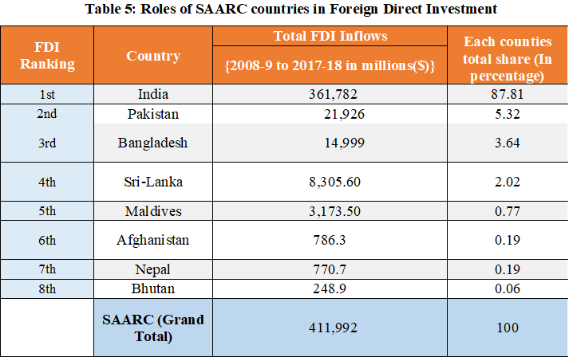
As the pace of economic recovery accelerates, FDI inflows into India may continue to increase since 2015. Motor trade can be an important part of the Indian economy. As we all know, India has integrated into key industries where it is likely to become a world leader. According to the information available to the Government of India, between April 2000 and November 2014, accumulated FDI in the automotive industry reached USD 11.4 billion. Between 2013 and 2014, most of the country's new investments were announced by international car manufacturers and major component suppliers to South Asia, including the 12 projects mentioned above 100 million US dollars.

The foreign direct investment provides light-emitting diodes for the emergence of several business groups in India, including the National Capital Region in the north (Delhi-Gurgaon-Faridabad), Maharashtra in India (Mumbai-Nashik) - Aurangabad). Chameli-Bangalore-Hosur is to the west and Chennai-Bangalore-Hosur to the south (Fig. 2). Despite the large differences in the formation of these groups, the foreign direct investment can play an important catalytic role. For example, the first entry of Suzuki (Japan) led to the development of industrial groups in the city center.

Bangladesh, Pakistan, Sri Lanka, and Nepal are smaller but larger and document new investment cases announced by foreign companies between 2013 and 2014. For example, in 2013, Mahindra & Mahindra (India) announced an investment of more than 200 million to build a factory in Bangladesh for the production of light trucks and commercial vehicles. The growing investment in the car trade in the Republic of India shows the potential for a positive "indirect effect" on capacity development across South Asia.

3.14 Ten major industries that attract more foreign direct investment in the SAARC region:
There are almost similar products in the export baskets of the SAARC countries. As a result, SAARC countries are trying to invest in the same industrial sector. For example, clothing, textiles, and fabrics are the industrial sectors common to almost all SAARC countries (such as Bangladesh, India, Sri Lanka and Pakistan). Similarly, in almost all SAARC countries, telecommunications, information technology, information and communication technology, and tourism are common sectors. For example, foreign direct investment in Bangladesh, Afghanistan, and India is highest among their respective telecommunications and ICT sectors. At the same time, Bangladesh, India, Nepal, Bhutan, Maldives, and Sri Lanka are working hard to promote their respective tourism and attract more tourists to their areas. In general, it is understandable that all SAARC countries are struggling in the same industry, but there are fundamental differences. Therefore, we must classify them according to their respective competitive advantages. Assign specialized departments to individual countries. We will not be competitors, but all countries will promote other industries, not supplements. For example, in Afghanistan, Bangladesh, Bhutan, Nepal, Pakistan, and India Mountain resorts are tourist attractions. However, it is not the same environment everywhere. Pakistan, Nepal, and India have a snowy mountain station, while the mountain station in Bangladesh is evergreen. There are ocean beaches in Bangladesh, Sri Lanka, India, and the Maldives, but not in Asian countries, Bhutan and Afghanistan. Therefore, they can promote the beauty of the ocean beach to visitors who have come to this mountain resort this year.
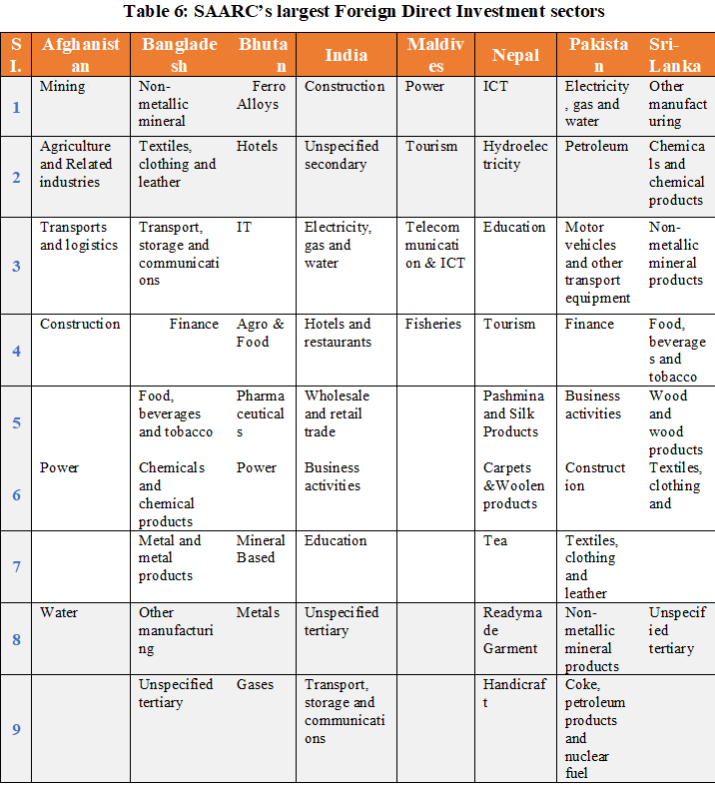

3.15Sources of foreign direct investment in SAARC countries:
With the exception of some Asian countries, most SAARC countries receive direct foreign investment from Western countries such as the United States and Europian Union member states. With the exception of the Republic of India, there is no internal investment in the SAARC countries. There are few regional investments such as Japan, China, Singapore, and India.
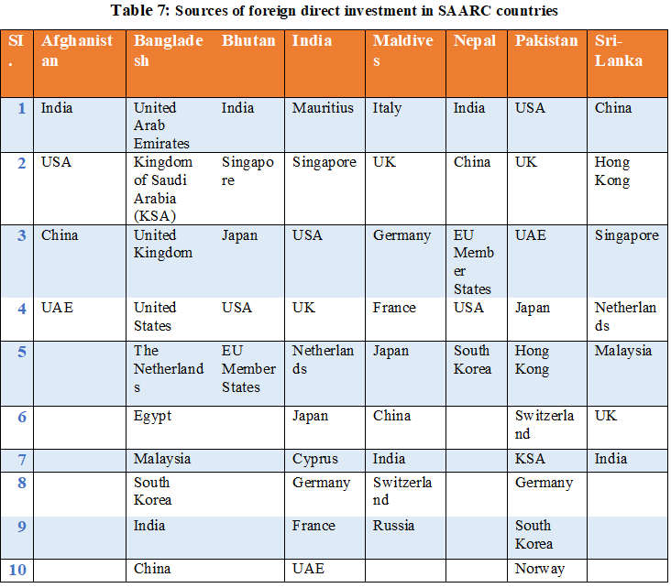

3.16Reduction of foreign direct investment in recent years
According to the Bangladesh Investment Development Board (BIDA), foreign direct investment in Bangladesh was 2.84 billion US dollars from January to November 2018, with an increase on an annual basis of 32.09%, compared to 21.5% of total foreign direct investment in Bangladesh. Billions of dollars. 2017. Oil, textiles and clothing, banks and food products attract more foreign direct investment. In 2017-2018, foreign direct investment (FDI) in Bangladesh increased by 5.1177%, mainly due to government, however, has reduced FDI inflows into NBFI in the sectors of telecommunications, warehousing, agriculture and fisheries, transport, construction, and communications. BIDA officials state that the fairness and reinvestment of existing foreign companies operating in the country are the two main sources of foreign direct investment, amounting to 2.84 billion dollars. They added that issues such as government policy reforms and sustained economic growth helped the country take full advantage of massive inflows of foreign direct investment. The government has taken steps to accelerate the business registration process by introducing integrated services designed to attract investment. Moreover, the government has spent a lot of money to eliminate the infrastructure shortages that have attracted investors to deposit funds in the country, making it the economic center of South Asia. This growth is considered a positive sign for Bangladesh, as the country has not seen such strong growth in foreign direct investment in recent years. Some private economic zones have begun to assign land to entrepreneurs, who in turn will attract more investment.

In Bangladesh, the number of IDE sectors in the banking sector has risen dramatically by 206.3311% to $ 320.1 million, compared to $ 155.8 million last year. In the energy sector, FDI inflows increased by 76.1513% in the 2017-2018 financial year to $ 587.7 million. The flow of textile products and use increased by 27.5010% per $ 454.5 million, $ 360.35 million for 2016-2017. However, in the telecommunications sector in 2017-2018, it fell by 7.35641% to $ 157 million. The 2016-2017 period was $ 5.9389 billion. In the areas of transport, storage and communications, FDI decreased by 72.3756% in 2017-2018 to $ 166.1 million, compared to $ 602.8 million in the previous year. It can also be noted that investments in the agricultural and fishing sectors decreased by 66.4817% compared to the previous fiscal year.

However, the cost of government-subsidized land for foreign direct investment (or domestic investors) may not make sense. Otherwise, we can foresee the problems faced by the TATA NANO project in West Bengal. A win-win solution is for investors to provide owners with equity in their company rather than pay the total land price in cash at the start of the project.

2018
2016
2014
2012
2010
0
3.71 3.76
3.64 3.7
3.64 3.73
3.5 3.55
10
20
30
40
50
51.34 52.08
60
Average point

Figure 2: Bangladesh Competitiveness Index

Bangladesh scored 52.08 points out of 100 on the 2018 Global Competitiveness Report published by the World Economic Forum. Competitiveness Index in Bangladesh averaged 11.66 Points from 2007 until 2018, reaching an all-time high of 52.08 Points in 2018 and a record lowest of 3.50 Points in 2009.
The most recent 2018 edition of world aggressiveness Report assesses a hundred and forty economies. The report is formed of ninety-eight variables, from a combination of data from international organizations as well as from the World Economic Forum’s Executive Opinion Survey. The variables area unit equipped into twelve pillars with the main quintessential including institutions; infrastructure; ICT adoption; political economy stability; health; skills; product market; labor market; the monetary system; market size; commercial enterprise dynamism; and innovation capability. With the 2018 edition, The GCI varies between one and one hundred, higher average rating ability greater diploma of competitiveness. With the 2018 edition, the World Economic Forum introduced a new methodology, aiming to integrate the notion of the 4th Industrial Revolution into the definition of competitiveness. It emphasizes the role of human capital, innovation, resilience, and lightness, as not solely drivers however additionally shaping options of economic success within the fourth historic period.
According to the Global Competitiveness Report 2018 released by the World Economic Forum, Bangladesh had scored 52.08 out of 100. Bangladesh ’s competitiveness index averaged 11.66 points between 2007 and 2018, had scored a record low of 3.50 points in 2009 which have earned the highest record 52.08 points in 2018.
The latest Global Competitiveness Report 2018 evaluated 140 economies of 140 countries in the world which consists of ninety-eight variables that are a mixture of data from international organizations and surveys conducted by World Economic Forum executives. A variable area unit with twelve pillars, the main essence of which includes institutions; infrastructure; the use of information and communication technologies; political and economic stability; health skills; product markets; job markets; market-scale monetary systems; the vitality of commercial companies; And innovation. In the 2018 edition, GCI varies between 100 and 100, with higher average assessment capabilities and higher competitiveness. In the 2018 edition, the World Economic Forum introduced a new approach aimed at incorporating the concept of the Fourth Industrial Revolution into the definition of competitiveness. He emphasized the role of human capital, innovation, endurance, and portability, not only as a driving factor but also as a model for the economic success model of the fourth historical period.

However, foreign investors are uncertain about the exact value of the current asset market. Instead, the owners of the land are uncertain about the future cash flow of the project. Mutual trust, reliable data, and the availability of independent brokers can make this structure effective.

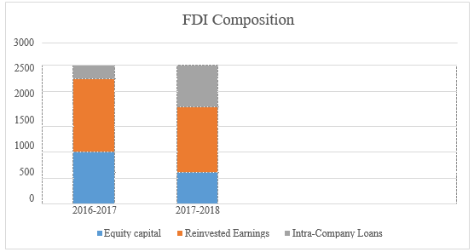
Figure 3: FDI composition (2016-2017) – (2017-2018)
In Bangladesh, the land acquisition process is very complicated. Local extortionists talk to government officials at every step, which can be a frustrating experience for those unfamiliar with Asian trade. Even if you get the land, you have to wait about a year to make a natural gas connection. Then enter the construction question. Bangladesh ranks 116th in “Construction License Processing” and has not changed in ranking compared to last year. The relative value of the number of procedures and surface units is compared to the average of South Asia. However, in Bangladesh, the entire process takes 231 days from collecting survey cards to connecting water and sanitation. The time in South Asia is 241 days, while the time in the OECD countries is 166 days. We believe that investors will not be too worried about costs. They are very worried about the timetable. This is an important area of ​​improvement, so we will turn a weakness into power.

Chapter four:
Prospects and problems of foreign direct investment in Bangladesh

4.1 Prospects for Foreign Direct Investment in Bangladesh
For more than 20 years, Bangladesh has been promoting foreign direct investment as part of South Asia's largest free investment and incentive management policy. Foreign direct investment in the private sector. In short, the 1980 law on non-public foreign investment (promotion and protection) guarantees equal treatment of local and foreign investors. The bill also provides for the legal protection of foreign investments in Bangladesh to prevent their nationalization and vanity. It also guarantees the restoration of capital and dividends. Over the past decade, Bangladesh's GDP has increased by over 5 percentage points on a regular basis and has experienced negative growth in the past. In recent days, Bangladesh has also continued to grow more than five critical points in the global recession. In 2009, Bangladesh recorded growth of 5.9% of GDP and took all necessary measures, such as the acceleration of export earnings, the record remittances of foreign workers, the rapid development of telecommunications services and the creation of various SMEs. Credit and organizational activities have been successful and fair measures have been taken to bring the economy to a higher level of growth. Its investment-friendly atmosphere offers foreign investors an attractive range of incentives, such as 100% ownership, tax exemption and tax exemption. In fact, Bangladesh ranks second among several developing countries in terms of incentives. Provide more incentives and commercial benefits for export-oriented industries. Government. An export processing area (EPZ) has been created to attract non-public investments. Government. Target foreign investors and hold positions in EPZ. The vision is to attract significant investments in key opportunities and unique opportunities in the areas of infrastructure development, energy, and electricity, production and knowledge. Bangladesh is the cheapest producer in the world with completely different and diversified positive factors such as regional ownership and global access, competitive incentives, solid local markets, and strong growth, an affordable workforce and its strategic location, low-value energy, try export wars, institutions of economic export zones and a favorable investment climate. In the Doing Business Environment 2010 report published by the International Bank for Construction and Development and the International Finance Corporation, Bangladesh ranks fourth in the SAARC region and 119th in the Simple Business Environment.

4.2 Bangladeshi government structures that provide foreign investors
FDI has been accepted throughout the economy, with the exception of 5 sectors:
4) Security printing
3) Defense team,
1) Energy,
5) Railways and
2) Tree plantation
Investors appreciate subsequent incentives to invest in Bangladesh -
- The associate capitalist will land in investments through an AGA call. Once a capitalist abroad has completed the necessary procedures to leave the country, he repatriates the profits from the sales when he guarantees the good authorization of the financial organization.
- Tax exemptions for capital gains on the sale of shares by the investment company.
- Tax exemption for interest-based external debt
- The reinvestment of reimbursable dividends would be treated as a new investment.
- Five to seven years of tax exemption for explicit sectors.
- There are no restrictions on the issuance of work permits for connected citizens and foreign personnel.
- Non-public public services benefit from the exemption for having increased their income over a period of fifteen years.
- Remittances of up to five percent of the salaries of foreigners used in Asian countries and the structures for the return of their savings and retirement pensions.
- The transfer of control of shares by foreign shareholders to indigenous investors.
- Exemption from royalties, technical knowledge, technical assistance costs and the benefits of returning to the country of origin.
- Return of capital services, profits and dividends in the country of origin.

Bangladesh does not distinguish between domestic foreign investors and non-public investors in terms of investment incentives or import and export policies. Asian governments regularly implement industrial policies to create additional foreign direct investment. Bangladesh can be a member of the Triangle Investment Guarantee Agency and can, therefore, be a member of a foreign non-public investment company (CIPO) that provides foreign investors with assurance against currency transfers, non-commercial risks, wars, and civil strife. The Foreign Non-State Investment (Promotion and Protection) Act of 1980 guarantees the country’s legal protection of foreign direct investment in order to avoid being nationalized and to guarantee the country’s repayment of capital and dividends. In addition, the different types of insurance services offered by state-owned companies and private associations seem to provide a comfortable service to cover operational risks.
Government industrial policy. Provide incentives and intensive facilities to attract foreign direct investment to Bangladesh. These include tax exemptions, financial capital and financial gains, machinery and equipment taxes, foreigner income and salary dividend returns, and tax exemptions. In these incomes, local taxes in the export industry can be waived, and up to 90 funds can be collected for the value of the export goods letter of credit. The government has liberalized trade management and has greatly reduced non-tariff restrictions. Foreign investors in Bangladesh can enter the national capital market to obtain capital in the form of loans from industrial banks and money development institutions. They can even use the country's stock services. Export-oriented "push" industry (toys, animal skin products, fir and diamond cutting, silk fabrics, letter paper products, artificial flowers, handbags and fashion, gifts, and orchid cuttings), engineering services and factory processes), squared measurement of venture capital, finance Incentives, and other various facilities. The establishment of the Export Processing Zone (EPZ) has been shown to be effective in attracting foreign direct investment in Asian countries, and the government’s approval to allow the establishment of individual own EPZs in the country has been welcomed.

4.3 The problems of Foreign Direct Investment in Bangladesh
Although the people of Bangladesh try to be as friendly as the attraction of foreign capitalists. To be solid, the country faces investment problems in the external sector. Government policies that are conducive to foreign direct investment. As well as a warm reception culture in foreign countries, this is a very positive measure of accepting foreign direct investment in Bangladesh. However, it is worrying that the country’s foreign direct investment record is frustrating compared to the officially registered income. By the end of 1999, only 72 FDI entries had entered the production phase, 27 of which used the method of achieving 365 FDI ​​entries recorded in 1996-1998, and the remaining 266 were for archival purposes only. The issues limiting the potential of foreign direct investment in the country are as follows:

Findings of the study

Applied mathematical results show that there is not a significant direct correlation between foreign direct investment and GDP growth, and there is a strong direct correlation between foreign direct investment and ratio, whereas foreign direct investment and larvae have a strong indirect relationship. Thus, the results obtained during this analysis indicate that the growth of FDI has nothing to do with the positive economic process of the People's Republic of Bangladesh. Related FDIs will increase rates and negative balances. As mentioned earlier, higher exchange rates reduce people's purchasing power and are condemned by economic stagnation. First, when a country's square import is at the top of the output, a negative equilibrium occurs, which creates a resource gap for developing countries. In particular, the foreign direct investment seems to have a positive effect on GDP growth, but it is not statistically significant.

Since the analysis found a negative correlation between foreign direct investment and the three economic science indicators, these results may also be a top priority for the government. The small capital of Bangladesh, the Republic of the Republic, cannot ignore the importance of foreign investment for real estate growth. There is evidence that the impact of FDI on economic processes depends on the ability of the beneficiary countries to consider factors such as various human resources, technology, infrastructure, foreign policy, institutional reforms, and political conditions.

There are some sides that can measure some of the factors that can be blamed for preventing foreign investment in achieving positive results in Bangladesh, such as poor quality of working-class nursing, poor infrastructure, slow privatization system, inefficient forms, political instability, and disaster. Corruption and lack of transparency exacerbate the problem of doing business in Bangladesh. Like many developed countries, the comparative advantage of Bangladesh lies in the basic elements of productivity, such as economic activity. However, by establishing a well-educated and versatile working class, the country should increase its market power and effectiveness. A skilled working class is considered a complex manufacturing problem and is probably needed for industrial initiatives and economic empowerment. Besides, the necessary reforms and political implications will also improve the effectiveness of Bangladesh's foreign investment. The benefits of FDI are not automatic. In order to establish a viable foreign direct investment, the government of Bangladesh must improve its ability to integrate the country through a well-educated class, advanced technology, favorable political stability, investment policies, strong infrastructure, and poor public service providers.

Prospects and competitive advantages of foreign direct investment in Asian countries
According to the World Bank report, Bangladesh ranks fifth among 150 countries in terms of general exchanges. This classification is based on thirty-nine indicators classified into ten categories. It recognizes Asian countries as the most suitable countries for doing business in South Asia and Asian countries.

In addition, the continued growth of foreign direct investment is the best proof of the prevailing good business environment in Asian countries. The total amount of foreign direct investment into Asian countries has increased from 14 to 42 million, which is the highest in all years since independence and the second largest expansion in South Asia. In terms of the FDI performance index, Asian countries are currently ranked sixth in the economies of both countries, and India is ahead of the FDI performance index, ranking sixth in the economy.

An analysis based on the elements of FDI inflows shows that about one-fifth of FDI arrives as capital and 19% is renewable, so the rest is inter-agency capital inflows of the high reconstruction rate indicates that foreign investors are full of confidence in the country's overall climate and investment struggle.

- The long-term interests of our foreign investors.
In recent years, foreign investors have positioned themselves in Asian countries with unexpected interest. In the 2012 to 2016 fiscal year, a large number of foreign investors adopted the Dhabi cluster in the United Arab Emirates, Microsoft in the United States, Orascom in Egypt, Singlet in Singapore and YKK in Japan.

In addition, various investment proposals involving tens of billions of dollars are being negotiated and/or approved. These countries are the Tata Group of Asian countries, the Lukeson International of the Republic of Korea, the Conservative Party of Japan, the Dortmund Group of Asian Countries, the Delta Pacific Mining of the United Kingdom, the Kingdom Group of Saudi Arabia, and accepted some The proposal comes from Saudi Arabia, China, Malaysia, Singapore, Australia, Kuwait, Malaysia, USA, Thailand, The United Arab Emirates, and India.

- Incentives for foreign investors.
Foreign investors can choose Bangladesh to make a joint investment agreement in Bangladesh as the country is offering double taxation and treaty activities to protect the interests of foreign investors in their next investment destination. Investors will also be happy with the reasons for subsequent investments in Asian countries.

- Tariff: no restrictions are imposed on local commercial exports. For different transactions, it is 5%.
- Exit: The capitalist assistance assistant will complete the investment by selecting the annual general meeting or the extraordinary general meeting. After the distant capitalist has completed the formalities of leaving the country, the proceeds of the sales can be returned to the country with the corresponding authorization of the financial institution.
- Tax exemption: generally five to seven years. However, the tax exemption period for energy production is 15 years.
- Tax Law:
- The tax exemption period for foreign employees in the sectors listed in the annex to the financial regulation is three years.
- For foreign investors, the idea of ​​a bilateral agreement can avoid double taxation.
- Property: foreign capitalists will fully launch venture capital with local partners.

- Other competitive advantages.
Market access: Asian countries have a population of around 140 million, which can provide foreign investors with a wider market to identify their products. They can also use Asian countries as a commodity product to supply products to nearby countries at an extremely low value.
In addition, in most developed countries, products from Asian countries can benefit from duty-free treatment without fees. The fact that Asian countries and foreign direct investment deviate from the political system of the simplest countries in South Asia has helped this opportunity to enter the world market.
- Human resources: we have more than 138.8 million people, UN agencies work hard and are often intelligent. Advanced health professionals can provide disciplined, easy-to-learn and low-cost energy for any industry that requires a lot of work.
- Natural resources: Asian countries are full of dense fossil fuels, water, and fertile soil.
- Language: Although Bengali is the official language, English is often used as a second language. Although the population is moderate, most people scan, write and speak in English.
- Social stability: Asian countries can be a free and democratic country, mainly a nation and a country of faith. Regardless of race or creed, people in this country have lived in harmony for thousands of years.
- Location: the location of the country is very convenient for international trade and is also very convenient for traveling to international seas and routes.
- Cost of company: the general value of the commercial activity in the country is highly competitive internationally.
- GSP facilities: Most Bangladeshi products can be enjoyed while enjoying full rates and unrestricted access to the EU, Japan, Australia, and the most developed countries and the US quota system. UU. However, despite the end of the quota, Asian national customs are still fascinated by the growing state and the enormous growth of the North American market.

- Sustainable competition
Considering the strength of Bangladesh, regardless of whether it is providing a large number of resources or cheap labor and the needs of the world market, foreign investors in the natural gas industry, data technology, frozen, and textile. Foods based on agricultural products, leather, ceramics, light industry.

Government industrial policy provides incentives and in-depth structures to attract foreign direct investment in Bangladesh. These include tax exemptions, reductions in car tariffs, returns on dividend profits, investments with capital and financial gains, salaries of foreign personnel and tax exemptions for these incomes, tax-free premises in industries that are familiar with taxes export and export products until the 1990s.The government liberalized the trading system and significantly reduced non-tariff restrictions. Foreign investors in the People's Republic of Bangladesh can obtain loans of the type provided by industrial banks and monetary development institutions from the national capital market. They can even use the services of the country's stock exchange. Industry-oriented and export-oriented industries that offer sectoral monetary incentives, capital, and convenience. The establishment of the EPZ program is an effective step to attract Bangladesh FDI and also the government's permission to create a personal FDI in the country is appreciated.

Recommendations and Conclusion:

From the global professional’s suggestions, based on Bangladeshi situation, the advantages of regional FDI units are extremely uneven and may be uncertain or negative. However, based on the donation characteristics, the Asian country can benefit from increasing foreign direct investment inflows. Therefore, for Asian countries, it is vital to ensure that their investment environment can attract more foreign direct investment to the country to successfully overcome the full key obstacles of the government. Asian countries and relevant agencies will effectively consider the following measures:

- Ensure good governance
Good governance will inspire economic and productive governments, carry out the necessary reforms of the judiciary, economic policies, infrastructure reforms and the elimination of corruption, paperwork and dishonesty, to induce simple people to obtain a considerable investment.

- Marketing investment opportunities:
Increase awareness of investment opportunities by hiring existing investors and knowledge sharing technologies such as the Internet. Existing investors play a vital role in attracting new investors to new investment locations, so policymakers must provide investment opportunities for each existing and potential investor.

- Sustainable economic development:
Maintain economic stability by maintaining acceptable financial and monetary policies, increasing quantitative investment / GDP ratios, increasing revenues, improving export performance, maintaining emission reduction growth, providing productive employment for workers and improving business environments and investment. Financial organizations must adopt a financial policy that reduces inflation and promotes greater growth by maintaining adequate credit flows for production activities.

- Improve port services
Despite recent improvements, the efficiency of improving port services can be improved through acceptable steps. Likewise, customs exemptions can be simplified by improving the work structure and improving the physical structure of the work management system.

- Coordination of Government agencies
To create a corporate environment and elegant and economical activities, integrated government agencies (departments, departments, restrictions, etc.) are required.

- Law and state improvement
Adequate reforms of enforcement and the rule of law should be improved through various measures. A social contract is needed to determine the rule of law, avoid political conflicts and reduce corruption.

- Development of diplomatic relations
Good relations with the developed countries of Bangladesh should be maintained, but in developing countries such as developing countries, significant foreign direct investment should be taken. Strengthening economic and commercial diplomacy may be the key consideration in attracting foreign direct investment in the globalization and globalization of enhanced competition. In this case, improving bilateral relations with potential capitalist countries may be the catalyst for increasing foreign direct investment in Asian countries. In addition, it is important not only to strengthen relations with already investing countries in Asian countries, but also to identify potential investors in different countries and to take appropriate measures to bring about conflict within the country. .

- Responsibility and transparency
It is recommended that in the area of ​​responsibility and transparency of operations, governments and limited companies have more power and authority over the investment work.

- Dynamic and independent government. Agency
A more dynamic government agency will promote investment in Asian countries. This is because the independence and vitality of state institutions (such as the Asian National Bank, Investment Promotion Agency, Asian National Investment Committee, etc.) are mainly focused on foreign investment in Asian countries.

- Trade liberalization:
Trade openness can demonstrate foreign policy and market policy commitments and improve business opportunities, thus attracting foreign investors who are well-positioned to take on new business opportunities. Government. Foreign direct investment policies should be relaxed and tax breaks and incentives should be scrutinized.

- To increase the brand image globally
Positive progress on the economy, society and future prospects of the country, as well as the existing hospitality investment environment and hence the structured arrangements for foreign investors should be effectively predicted abroad, especially in these countries. Potential investor. This "image sizing" effort is important to remove the negative images in the long run and prevent investors from returning to the market. In addition to the benefits, maintaining consistency in policies and actions is important for investors not to send any "wrong signals".

Conclusion
The purpose of this report is to analyze the impact of foreign direct investment on Bangladesh. Survey results show that there is no significant positive relationship between foreign direct investment and GDP growth, there is a strong relationship exist between foreign direct investment and trade balance, and there is a strong positive relationship between foreign direct investment and inflation. Thus, the results of this study indicate that direct foreign investment growth has nothing to do with Bangladesh's positive economic growth. Foreign direct investment is associated with rising inflation and trade deficit. As noted above, high inflation reduces people's purchasing power and is thought to be the cause of economic stagnation. Also, when a country's imports are higher than its exports, a negative trade balance occurs, which creates a resource deficit for developing countries. In contrast, the foreign direct investment appears to have a less positive effect on GDP growth, but this is not statistically significant. Since the survey found that FDI was negatively correlated with two of the three macroeconomic indicators, these results may be a cause for concern for the Bangladesh government. Small-capital countries like Bangladesh cannot ignore the importance of foreign investment for sustainable growth. Evidence suggests that the impact of foreign direct investment in economic growth depends on the absorption capacity of the recipient countries, which is institutional and political, considering factors such as infrastructure, technology, efficient human resources, trade policies, and political stability of the country.

References
- Ambler, T. (2003) Marketing and the Bottom Line: Creating the Measures of Success. London: Financial Times/Prentice Hall.
- Baker, C., Nancarrow, C. &Tinson, J. (2005) the mind versus market share guide to brand equity. International Journal of Market Research.
- George Christodoulides (University of Birmingham) and Leslie de Chernatony (Università Della SvizzeraItaliana, Lugano and Aston Business School),” Consumer-based brand equity conceptualization and measurement”.
- Carkovic, M. V., & Levine, R. (2002). Does foreign direct investment accelerate economic growth? U of Minnesota Department of Finance Working Paper.
- Alam, Q., Mian, M.E.U. and Smith, R.F. (2006), “Impact of poor governance on foreign
- Direct investment: The Bangladesh experience”, in Ahmad, R., ed., The Role of Public
- Administration in Building a Harmonious Society. Manila: ADB.
- Foreign Capital Inflow, Saving, and Economic Growth — A Case Study of Bangladesh by MohiuddinAlamgir
- Bangladesh Board of Investment (BOI) Annual report 2009-2010
- Bangladesh Board of Investment, Foreign Direct Investment in Bangladesh during 2004: The 4th FDI Inflow Survey. Dhaka: Board of Investment, 2004
- Baskaran, A., and Muchi, M. (2008): “Foreign Direct Investment of R&D: The case of BRICS economies’’, Conference Paper, ASIALICS International Conference, Bangalore, India.
- Brouthers, L.E., Gao,Y. and Mcnicol, J.P. (2008) “Research notes and commentaries corruption and market attractiveness influences on different types of FDI,” Strategic Management Journal, Vol.29, pp.673-680.
- The Bangladesh Economic Review [Vol. 2, No. 2 (April 1974), pp. 577-598]
- Foreign Investment & External Debt (FIED) Division, Statistics Department, Bangladesh Bank
- Abdin, M.J. (2015). Foreign Direct Investment (FDI) in SAARC Countries. Global Journal of Management and Business Research: c Finance. Vol.15, issue.8. ISSN:2249- 4588
- Alam, M.S (2012). Foreign Direct Investment in Bangladesh: A Critical Analysis, South East Asian Journal of Contemporary Business, Economics and Law, Vol.1.
- Chakraborty, C. and Basu, P. (2002). Foreign direct investment and growth in India: A cointegration approach. Applied Economics, 34(9), 1061-1073.
- Md. JoynalAbdin. An Analysis of SAFTA in the Context of Bangladesh. 28 Pages, Posted: 14 May 2009
- Md. Abdullah Kafi, Mohammad Main Uddin, M. Muzahidul Islam, Foreign Direct Investment in Bangladesh: Problems and Prospects, vol-4, no-1, Dec 2007
- Saarc Secretariat. Area of Cooperation: Economic and Trade, Cited at SAARC Secretariat's Website on August 9. Posted: 2015-08
- Abbes, S. M., Mostéfa, B., Seghir, G., &Zakarya, G. Y. (2015). Causal Interactions between FDI, and Economic Growth: Evidence from Dynamic PanelCounteraction. Procedia Economics and Finance, 23, 276-290
- Khan, S. (2007). Aid flow to Bangladesh and the question of accountability of CSOs at the national level to the people they serve. Retrieved from http://www.unnayan.org/news/files/CSO.pdf
- Kabir, R. (2007). Foreign direct investment and sustainable growth: A case study on Bangladesh. A thesis submitted to the faculty of Emory College of Emory University. Department of Economics. Retrieved from http://www.docstoc.com/docs/2380675/Foreign-Direct-Investment-and-Sustainable- Growth-A-Case-Study on
- Haque, A. N. (2007). Aid Addiction. The Daily Star, 5. Retrieved from http://www.thedailystar.net/2007/07/29/d70729020427.htm

