Credit Rating Assessment of CRAB: An Internship Experience on The Evaluation of Agromax International

Samsul Islam Usama

This report is submitted to the school of Business and Economics, United International University as a partial requirement for the degree fulfillment of Bachelor of Business Administration

Internship Report
On
Credit Rating Assessment of CRAB: An Internship Experience on The Evaluation of Agromax International

Submitted to:
Muhammad Enamul Haque
Assistant Professor
School of Business and Economics
Submitted by:
Samsul Islam Usama
111211067
Major: Finance & FinTech
252 - Summer 2025 (Trimester)


School of Business and Economics
United International University
Date of Submission: 1st December, 2025

Letter of Transmittal
Date: 1st December, 2025
To
Muhammad Enamul Haque
Assistant professor
School of Business and Economics
United International University (UIU)
Madani Avenue, Dhaka, Bangladesh

Subject: Submission of Internship Report on “Credit Rating Process and Financial Analysis: A Study on Credit Rating Agency of Bangladesh Limited (CRAB)”
Dear Sir,
It is with great pleasure that I submit my internship report entitled “Credit Rating Process and Financial Analysis: A Study on Credit Rating Agency of Bangladesh Limited (CRAB)” as a partial requirement for the completion of the Bachelor of Business Administration (BBA) degree at United International University.
I completed my three-month internship at Credit Rating Agency of Bangladesh Limited (CRAB) from 6th August 2025 to 6th November 2025 in the Rating Department under the direct supervision of Mr. Arif Hossain, Senior Financial Analyst. Throughout this period, I gained extensive practical experience in financial statement analysis, credit-rating methodology, and corporate risk evaluation, which has greatly enriched my academic learning.
This report reflects my sincere effort to connect theoretical understanding with professional practice. I have strived to ensure that the information presented is accurate, objective, and in accordance with organizational confidentiality policies.
I would like to express my heartfelt gratitude to you for your valuable guidance and continuous support during the preparation of this report. I shall remain grateful for your time, encouragement, and constructive feedback.
Sincerely,
Samsul Islam Usama
111211067
Major: Finance and FinTech
School of Business and Economics
United International University (UIU)

Certification of Similarity Index
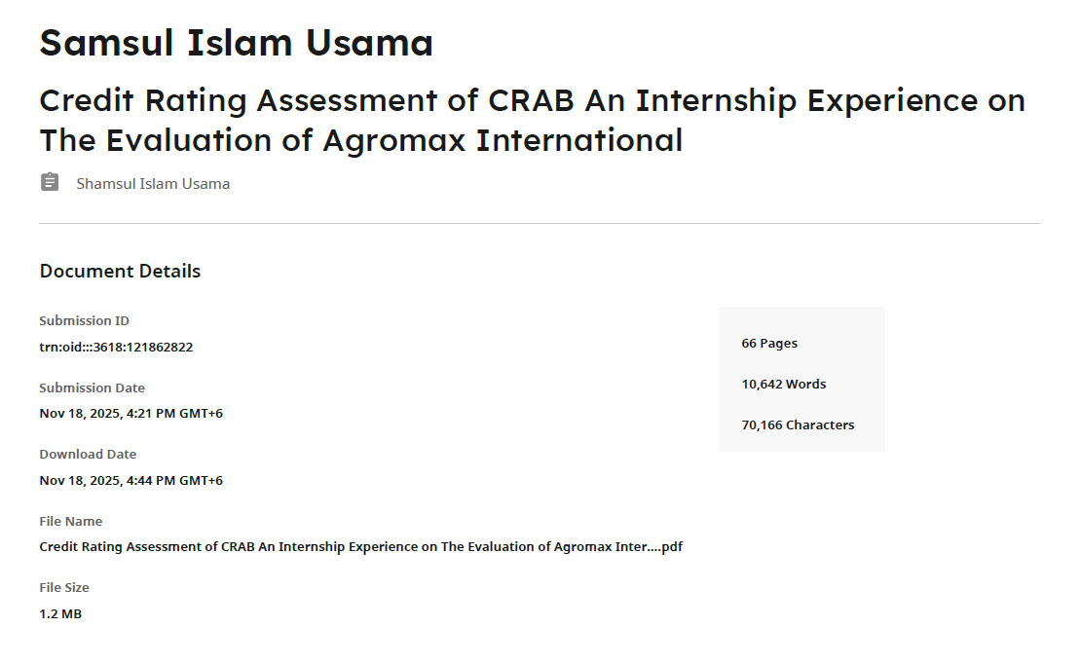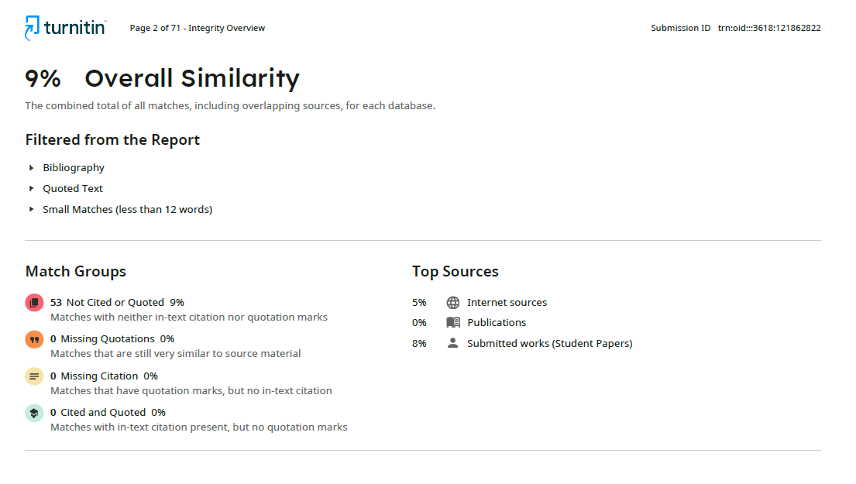

Declaration of the Student

I, Samsul Islam Usama, hereby declare that this internship report entitled
“Credit Rating Process and Financial Analysis: A Study on Credit Rating Agency of Bangladesh Limited (CRAB)” has been prepared by me as a partial requirement for the fulfillment of the Bachelor of Business Administration (BBA) degree from the School of Business and Economics, United International University (UIU).
I further declare that this report is my own work and has not been submitted to any other institution or university for any academic qualification or degree. All information, data, and references used in this report have been acknowledged properly.
I also confirm that the report has been prepared with complete honesty, sincerity, and adherence to academic ethics and guidelines provided by the university.


Name: Samsul Islam Usama
ID: 111211067
Major: Finance and FinTech
School of Business and Economics
United International University (UIU)
Date: 1st December, 2025

Corporate Evidence
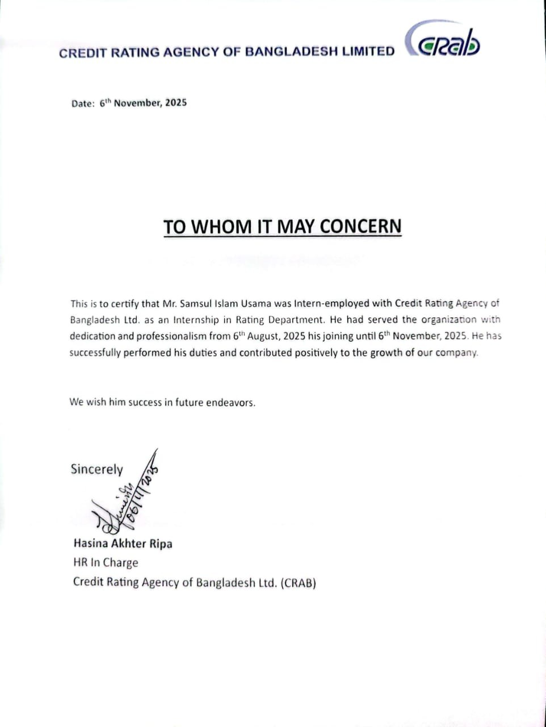

Acknowledgement

At the very beginning, I would like to express my sincere gratitude to Almighty Allah, the Most Merciful and the Most Beneficent, for granting me the strength, patience, and opportunity to successfully complete my internship and prepare this report. In the process of completing this report, I received immense cooperation and support from my faculty and supervisors, which greatly benefited me.
I would like to convey my deepest thanks to my honorable Academic Supervisor, Mr. Muhammad Enamul Haque, Assistant Professor at the School of Business and Economics, United International University (UIU). His guidance, valuable advice, and continuous encouragement were instrumental throughout this internship report. Without his thoughtful supervision, completing this work would have been extremely difficult.
My heartfelt thanks also go to the management and staff of the Credit Rating Agency of Bangladesh Limited (CRAB) for giving me the opportunity to work in their Rating Department and for providing practical exposure to the corporate environment. I am especially grateful to my organizational supervisor, Mr. Arif Hossain, Senior Financial Analyst at CRAB, whose guidance, mentorship, and insightful instructions helped me connect theoretical finance with its practical applications.
Furthermore, I owe sincere gratitude to my family and friends for their constant encouragement, patience, and inspiration throughout my academic journey and internship period. I would also like to extend my thanks to everyone who directly or indirectly contributed to the completion of this report.
Although this report may still contain some shortcomings, I have sincerely put forth my best effort to make it as comprehensive and accurate as possible. Lastly, I would like to express heartfelt appreciation to United International University (UIU) for providing me with the academic foundation and valuable guidance that enabled me to prepare this report successfully.

Executive Summary

This internship report is prepared as a requirement of the Bachelor of Business Administration (BBA) program at United International University (UIU). It summarizes my three-month internship at the Credit Rating Agency of Bangladesh Limited (CRAB), where I worked in the Rating Department from August 6 to November 6, 2025. The report highlights how academic concepts of finance, risk analysis, and corporate governance were applied in real credit-rating activities.
CRAB, licensed by the Bangladesh Securities and Exchange Commission (BSEC), plays a vital role in Bangladesh’s financial system by providing independent evaluations of corporate creditworthiness. During my internship, I gained hands-on experience in financial-statement analysis, ratio calculation, data verification, and preparing rating working-paper drafts. These tasks strengthened my analytical skills and deepened my understanding of CRAB’s rating workflow.
A key assignment involved contributing to the credit assessment of Agromax International. I collected two years of financial statements and calculated major financial ratios including liquidity, leverage, profitability, coverage, and working-capital indicators. Using CRAB’s internal rating model, I computed the quantitative score by standardizing ratios, applying weighted scores, and comparing Agromax’s performance with industry norms and historical trends. I then aligned these findings with qualitative factors—management strength, operational risks, and business outlook—to prepare an initial rating assessment.
Overall, this internship enhanced my technical, analytical, and communication abilities and provided valuable exposure to real-world credit-rating practices, supporting my long-term goals in finance, risk management, and financial technology.

Table of the Contents
Letter of Transmittal iii
Certification of Similarity Index iv
Declaration of the Student v
Corporate Evidence vi
Acknowledgement vii
Executive Summary viii
List of Figures xii
List of Tables xiii
List of Equations xiv
List of Acronyms & Abbreviations xv
Chapter 1: Introduction 1
1.1 Background of the Report 2
1.2 Objectives of the Report 2
1.3 Rationale of the Report 3
1.4 Scope and Limitations of the Report 3
1.5 Definition of Key Terms 4
Chapter 2: Company And Industry Profile 5
2.1 Company Analysis 6
2.1.1 Overview and History 6
2.1.2 Trend and Growth 6
2.1.3 Rating Services 7
2.1.4 Grading Services 8
2.1.5 Company Operations 9
2.1.6 SWOT Analysis of CRAB 13
2.1.7 CRAB Code of Conduct: 13
2.2 Industry Analysis 16
2.2.1 Specification of the Industry 16
2.2.2 Size, Trend, and Maturity of the Industry 17
2.2.3 Industry SWOT Analysis 19
Chapter 3: Internship Experience 21
3.1 Position, Duties and Responsibilities 22
3.2 Training and Development 23
3.3 Contribution to Organization / Operations 23
3.4 Evaluation of the Experience 24
3.5 Skills Applied and Lessons Learned 25
Summary of Chapter 3 26
Chapter 4: Credit Rating Assessment of Agromax International 27
4.1 CRAB’s Credit Scoring Model Overview 28
4.2 Company Profile – Agromax International 29
30
30
4.3 Quantitative Assessment (40 Marks) 31
4.3.1 Leverage 32
4.3.2 Liquidity 33
4.3.3 Profitability 33
4.3.4 Coverage 34
4.3.5 Operational Efficiency 35
4.3.6 Earning Quality 36
4.3.7 Total Quantitative Score 36
4.4 Qualitative Assessment (60 Marks) 37
4.4.1 Business / Industry Risk 38
4.4.2 Management Risk 39
4.4.3 Bank Relationship Risk 40
4.4.4 Financial Security Risk 41
4.4.5 Other Risks 41
4.4.6 Total Qualitative Score 42
4.5 Final Rating of Agromax International 43
Chapter 5: Conclusions And Key Facts 45
5.1 Recommendations 46
5.2 Key Understandings 47
5.3 Conclusion 47
References 49

List of Figures

- Figure 1: Types of Credit Rating
- Figure 2: Rating Verticals within CRAB
- Figure 3: Rating Process of CRAB
- Figure 4: CRAB’s Internal Committee Members list
- Figure 5: CRAB’s External Committee Members list
- Figure 6 : Code of Conduct
- Figure 7: Organogram of CRAB
- Figure 8: Role of Credit Rating Industries
- Figure 9: Financial Stability Pillar 1, 2 & 3
- Figure 10: Credit Scoring Model of CRAB
- Figure 11: Business Model of Agromax International

List of Tables

- Table 1: Company Profile

- Table 2: Leverage Score

- Table 3: Liquidity Score

- Table 4: Profitability Score

- Table 5: Coverage Score

- Table 6: Operational Efficiency Score

- Table 7: Earning Quality Score

- Table 8: Total Quantitative Score

- Table 9: Business/Industry Risk score

- Table 10: Management Risk score

- Table 11: Bank Relationship Risk Score

- Table 12: Financial Security Risk score

- Table 13: Other Risks Score

- Table 14: Total Qualitative Score

- Table 15: Total Credit Score of Sumaiya Enterprise

- Table 16: SME Rating Scale and Rating Definition of CRAB

List of Equations
- Total Liability to Total Equity = $\frac{Total Liability}{Total Equity}$
- Total Borrowed Fund to Total Equity= $\frac{Total Borrowed Funds}{Total Equity}$
- Total Borrowed Fund to EBITDA= $\frac{Total Borrowed Funds}{EBITDA}$
- Current Ratio= $\frac{Current Assets}{Current Liabilities }$
- Quick Ratio= $\frac{Current Assets-Inventories }{Current Liabilities }$
- EBITDA Margin= $\frac{EBITDA }{Revenue }×100$
- Gross Profit Margin =$\frac{Gross Profit }{Revenue }×100$
- Net Profit Margin= $\frac{Net Profit After Tax }{Revenue }×100$
- Return on Average Assets= $\frac{Net Profit After Tax }{Average Total Assets }×100$
- Return on Average Equity= $\frac{Net Profit After Tax }{Average Shareholders^{'}Equity }×100$
- FFO to Total Borrowed Fund=$\frac{Funds from Operations (FFO)}{Total Borrowed Funds}×100$
- CFO to Total Borrowed Fund=$\frac{Cash Flow from Operations (CFO)}{Total Borrowed Funds}×100$
- Interest Coverage Ratio=$\frac{EBIT}{Interest Expence }$
- Avg Inventory Period= $\frac{Average Inventory}{COGS}×365$
- Avg Receivable Period= $\frac{Average Receivable}{COGS}×365$
- Avg Receivable Period= $\frac{Average Receivable}{COGS}×365$
- Asset Turnover= $\frac{Revenue}{Average Total Assets}$
- Revenue Growth= $\frac{Current Revenue-Previous Revenue}{Previous Revenue }$

List of Acronyms & Abbreviations

ACRAA — Association of Credit Rating Agencies in Asia
BDT — Bangladeshi Taka
B2B — Business-to-Business
BBA — Bachelor of Business Administration
BSEC — Bangladesh Securities and Exchange Commission
CFA — Chartered Financial Analyst
CFO — Cash Flow from Operations
CMT — Chartered Market Technician
CRAB — Credit Rating Agency of Bangladesh (Limited)
CRISL — Credit Rating Information and Services Limited
EBIT — Earnings Before Interest and Taxes
EBITDA — Earnings Before Interest, Taxes, Depreciation, and Amortization
ECRL — Emerging Credit Rating Limited
ESG — Environmental, Social, and Governance
FFO — Funds from Operations
FMVA — Financial Modeling & Valuation Analyst
FSV — Forced Sale Value (used in collateral coverage)
FY — Fiscal Year
ICRA — Investment Information and Credit Rating Agency
IPO — Initial Public Offering
NBFI — Non-Bank Financial Institution
NCR — National Credit Ratings Limited
PLC — Public Limited Company
ROAE — Return on Average Equity
ROAA — Return on Average Assets
SE — CRAB SME rating grade code (e.g., SE-3)
SME — Small and Medium Enterprise
UIU — United International University

Chapter 1: Introduction

1.1 Background of the Report
The Bachelor of Business Administration (BBA) program at United International University (UIU) requires every student to complete an internship as part of the final academic trimester. The internship is designed to provide practical exposure to the real-world business environment and to help students connect theoretical knowledge with practical application.
I completed my three-month internship at the Credit Rating Agency of Bangladesh Limited (CRAB) from August 2025 to October 2025 in the Rating Department. This opportunity allowed me to understand how financial and non-financial information is analyzed to assess the creditworthiness of different organizations in Bangladesh.
The experience was both educational and professional. I observed how the credit-rating process operates, how analysts evaluate risk factors, and how financial reports are examined to determine a company’s capacity to meet its financial obligations. Through this internship, I have been able to bridge the gap between classroom learning—mainly in courses such as Financial Management, Corporate Finance, and Risk Analysis—and the practical world of credit evaluation.

1.2 Objectives of the Report
The purpose of preparing this report is to document my internship experience at CRAB and to highlight my learning outcomes, observations, and professional development. The report also aims to give readers an understanding of the organizational structure, work process, and analytical approach of CRAB.
The specific objectives of the report are as follows:
- To describe the structure, operations, and key functions of CRAB.
- To understand how credit ratings are conducted and how they influence investment and lending decisions.
- To link academic knowledge with practical understanding of financial statement analysis and risk evaluation.
- To reflect on my own contributions, skills applied, and lessons learned during the internship.
- To identify the challenges faced during the internship and the strategies used to overcome them.

1.3 Rationale of the Report
As a Finance & FinTech major, I have always been interested in understanding how financial data are used to evaluate organizational performance and risk. Working in a credit-rating organization was the most suitable platform to enhance this understanding. CRAB is one of the leading rating agencies in Bangladesh, regulated by the Bangladesh Securities and Exchange Commission (BSEC), and is widely trusted by banks, financial institutions, and corporate entities.
This internship allowed me to gain hands-on experience in analyzing financial statements, ratio trends, and risk profiles of various companies, particularly in the small-and-medium-enterprise (SME) sector. The rationale of the report is therefore to demonstrate how theoretical concepts—such as leverage, liquidity, and profitability—are applied in real-life situations to derive a credit opinion that affects business credibility and access to finance.

1.4 Scope and Limitations of the Report

Scope
The scope of the report covers the entire internship experience at CRAB, focusing on the Rating Department’s operations and analytical procedures. It includes the overview of the organization, its departments, credit-rating process, and the methodologies used to assess clients. The report also highlights the specific tasks I performed, my learning outcomes, and the challenges encountered.

Limitations
Although I tried to make the report as comprehensive as possible, several limitations exist:
- Some information is confidential and could not be disclosed due to CRAB’s data-privacy policies.
- The report is based on a three-month internship period, which limited my exposure to all aspects of rating activities.
- The findings are largely based on secondary data, observation, and experience within a specific department.
- Quantitative financial data used in the analysis were limited to the information authorized for academic reporting.

1.5 Definition of Key Terms
- Credit Rating: An independent opinion about an entity’s ability and willingness to meet its financial obligations on time.
- Credit Risk: The probability of a borrower defaulting on a financial commitment.
- Financial Ratio Analysis: A method of evaluating financial performance by comparing metrics such as liquidity, solvency, profitability, and efficiency.
- EBITDA: Earnings Before Interest, Taxes, Depreciation and Amortization—used to assess a firm’s operating performance.
- Creditworthiness: The level of trust lenders or investors place on an entity’s capacity to repay debt.

Chapter 2: Company And Industry Profile

2.1 Company Analysis

2.1.1 Overview and History
The Credit Rating Agency of Bangladesh Limited (CRAB) is one of the pioneering credit-rating institutions in Bangladesh, established in 2003 as a joint venture between local financial experts and international partners. The organization was licensed by the Bangladesh Securities and Exchange Commission (BSEC) to provide credit-rating services in accordance with the Credit Rating Companies Rules 1996.
CRAB operates as a private limited company with the primary objective of providing independent, reliable, and professional opinions on the creditworthiness of organizations and financial instruments. Over the years, the company has earned the trust of commercial banks, non-bank financial institutions, insurance companies, and corporates.
The organization’s mission is to promote transparency and stability in the financial system of Bangladesh through fair and unbiased credit assessments. Its services extend to rating long-term and short-term borrowings, corporate entities, SMEs, financial institutions, and various debt instruments such as bonds, debentures, and commercial papers.
Through its continuous improvement, CRAB has become one of the most respected rating agencies in the country, contributing significantly to the financial infrastructure that supports investment and credit decisions.

2.1.2 Trend and Growth
Since its inception, CRAB has experienced consistent growth in both the number of clients and the volume of ratings conducted. The company’s growth has been supported by Bangladesh’s expanding corporate sector and the increasing awareness of credit ratings among financial stakeholders.
In recent years, CRAB has diversified its portfolio beyond corporate ratings to include SME ratings, bank and NBFI ratings, and insurance company ratings. The adoption of advanced analytical tools and automation has also strengthened its operational efficiency.
As the credit-rating market matured, CRAB expanded its workforce of analysts and introduced advanced rating methodologies in line with international best practices. The growing emphasis by the central bank and BSEC on credit transparency has further enhanced the organization’s relevance and credibility.

2.1.3 Rating Services
The Credit Rating Agency of Bangladesh Limited (CRAB) delivers independent credit assessments for a broad spectrum of entities and financial instruments in line with local regulatory requirements. Its coverage includes manufacturing and service-sector companies, commercial and merchant banks, non-banking financial institutions, insurance firms, investment houses, and mutual funds.
The agency provides opinions on obligations of varying tenors—long-term debt such as bonds and debentures, medium-term deposit programs, and short-term products like commercial papers. CRAB also analyzes structured and project-based instruments across infrastructure, power, and telecommunications, ensuring that stakeholders receive transparent guidance on risk and reliability.
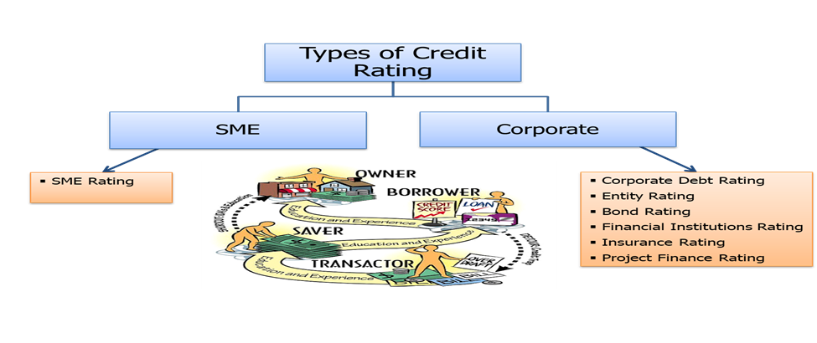
Figure 1: Types of Credit Rating

Major Categories of Ratings
- Entity Rating: Represents an organization’s overall financial strength and capacity to meet its commitments. It is often required for regulatory compliance and also helps firms demonstrate good governance and attract investors.
- Financial Institution Rating: Assesses the stability and operational quality of banks and other financial intermediaries by examining liquidity, asset quality, governance, and management efficiency.
- Corporate Debt Rating: Focuses on the likelihood that an issuer will honor principal and interest payments on time for a specific instrument; failure to do so is treated as default.
- Equity Rating (IPO / Rights Issue): Examines equity offerings based on profitability outlook, business risk, and capital structure rather than predicting share-price movements.
- Structured Finance Rating: Provides an opinion on whether securitized or structured instruments will meet contractual payment obligations under various scenarios.
- Insurance and Claims-Paying Ability Rating: Measures an insurer’s financial capacity to settle claims promptly, reflecting its solvency and policyholder protection strength.
- Mutual Fund Scheme Rating: Gives investors and fund managers an independent perspective on a fund’s portfolio quality, risk exposure, and historical performance.

2.1.4 Grading Services
Beyond conventional credit assessments, CRAB provides grading services tailored to different sectors. Each grading assignment uses industry-specific benchmarks to evaluate qualitative and quantitative aspects such as governance, service quality, and operational efficiency.
The grading framework is designed to supply an impartial and reliable measure of performance for organizations in fields like construction, real estate development, healthcare, education, and diagnostic services. To strengthen credibility, CRAB collaborates with recognized trade bodies and professional associations when developing new grading methodologies.
These products assist stakeholders—investors, customers, and regulators—in understanding sector standards and comparing institutional performance objectively.
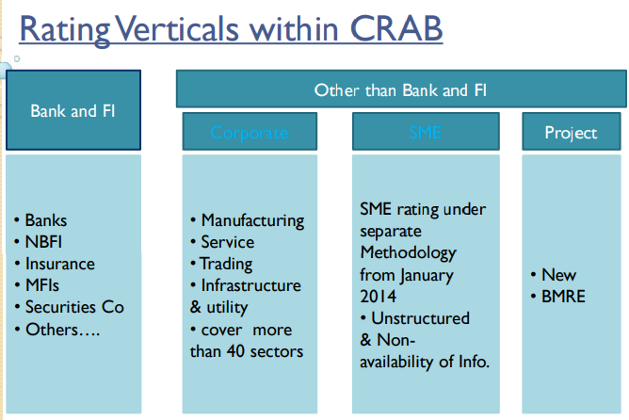
Figure 2: Rating Verticals within CRAB

2.1.5 Company Operations
CRAB’s day-to-day activities revolve around collecting verified data, conducting analytical evaluations, and producing independent credit opinions. The organization integrates both quantitative financial analysis and qualitative business assessment within a strict methodological framework approved by Bangladesh Bank and the Bangladesh Securities and Exchange Commission (BSEC).
Through these operations, CRAB supports transparency in the financial system and enables investors, lenders, and policymakers to make informed decisions.

Credit Rating Process of CRAB
The credit-rating procedure is interactive and evidence-based, ensuring consistency and fairness at every stage.
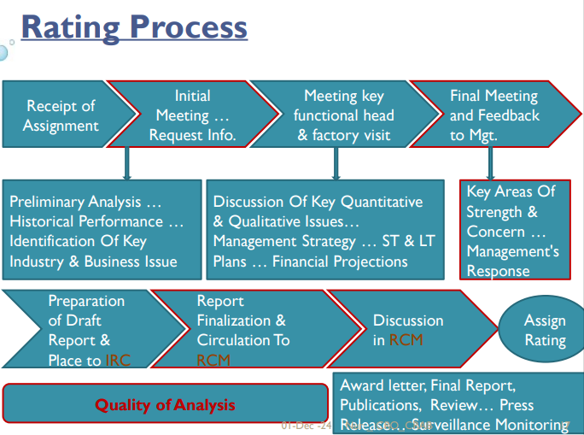
Figure 3: Rating Process of CRAB
- Mandate Initiation – The process begins when a client formally requests a rating. A legal agreement—executed on a non-judicial stamp paper—defines the engagement terms, confidentiality, and fee structure.
- Team Formation – A team of analysts is assigned based on the sector involved. One acts as the lead analyst responsible for coordination and report accuracy.
- Data Collection and Review – Analysts gather audited financial statements, operational data, and background information. Additional insights are obtained from bankers, auditors, and suppliers to verify reliability.
- Management Discussions and Site Visits – Analysts hold detailed meetings with company executives to understand strategy, risk management, and future plans, and they visit project or plant sites to validate information.
- Draft Preparation and Internal Review – The lead analyst prepares a draft report summarizing findings. Senior reviewers examine assumptions, data quality, and consistency before advancing it to the next stage.
- Rating Committee Deliberation – The final rating decision rests with CRAB’s Rating Committee. Members review the analysts’ presentation, discuss differing views, and assign a rating through consensus or majority vote.
- Communication and Publication – The assigned rating is communicated to the issuer. Once accepted, it may be publicly released according to BSEC guidelines.
- Surveillance and Ongoing Monitoring – CRAB continuously monitors each accepted rating for the entire validity period. Ratings are normally reviewed annually, but earlier revisions can occur if new information materially affects credit quality.
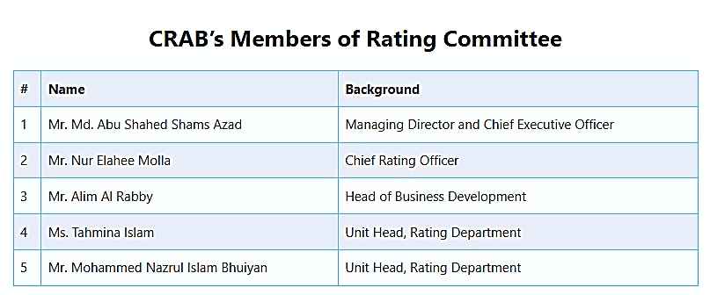
Figure 4: CRAB’s Internal Committee Members list

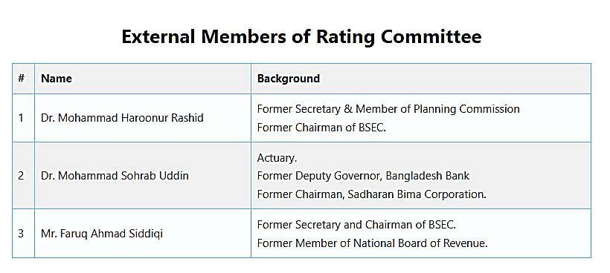
Figure 5: CRAB’s External Committee Members list
Surveillance and Ongoing Monitoring (cont. 8)
After a rating is issued, CRAB maintains active surveillance to confirm its relevance. The rated entity must regularly provide updated information; if it fails to do so, CRAB proceeds using available data and independent research. Depending on performance and external conditions, ratings may be upgraded, downgraded, or reaffirmed. The Chief Executive Officer may allow the issuer to appeal a decision, but refusal of a rating is not permitted under regulatory standards.
This disciplined process ensures that every rating reflects a balanced judgment combining financial rigor, professional independence, and regulatory compliance.

2.1.6 SWOT Analysis of CRAB
Strengths | Weaknesses
Reputed and licensed by BSEC, ensuring strong market credibility. | Limited market competition sometimes reduces innovation speed.
Highly skilled analysts with finance and economics backgrounds. | Dependence on client-provided data may affect data reliability.
Wide client base across multiple industries and financial institutions. | Limited global exposure compared to international agencies.
Transparent and standardized rating methodology. | Manual aspects of data verification still exist in some segments.

Opportunities | Threats
Increasing demand for SME and corporate credit ratings in Bangladesh. | New entrants and foreign collaborations may intensify competition.
Expansion of capital markets and regulatory reforms. | Economic instability or data falsification by clients could affect reputation.
Scope for automation and AI-driven rating tools. | Policy or regulatory changes may impact operational flexibility.

2.1.7 CRAB Code of Conduct:
The Credit Rating Agency of Bangladesh Limited (CRAB) maintains a well-defined Code of Conduct that guides its analysts, management, and staff in upholding the highest ethical and professional standards. This framework ensures that every credit rating is prepared objectively, transparently, and with full accountability to the financial market.
The Code of Conduct consists of seven core principles:
- Responsibility & Trust – CRAB promotes a culture of trust by ensuring that every analyst performs their duties with honesty, accuracy, and professional responsibility.
- Integrity & Competence – All analytical work is carried out with integrity and professional skill, ensuring impartiality and consistency in every rating decision.
- Quality of Rating – The organization maintains rigorous analytical standards and periodic reviews to ensure ratings are fair, consistent, and reliable.

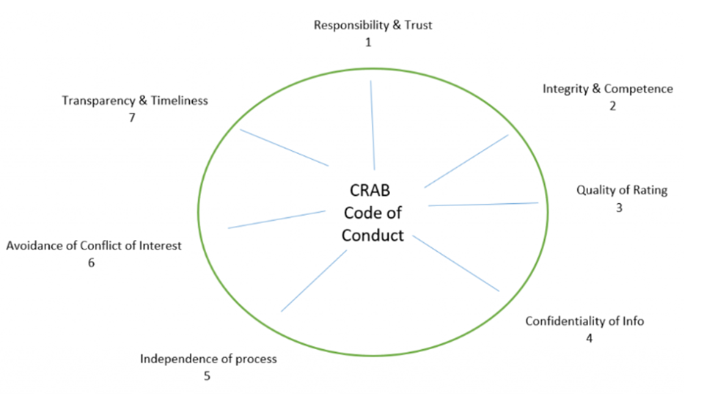
Figure 06 - CRAB code of Conduct
- Confidentiality of Information – All client data, financial statements, and internal documents are treated as strictly confidential and are not disclosed to unauthorized parties.
- Independence of Process – CRAB’s analytical and decision-making processes remain free from any external, political, or commercial influence, ensuring unbiased outcomes.
- Avoidance of Conflict of Interest – Employees are required to disclose and avoid any potential conflict that could compromise objectivity in analysis or rating outcomes.
- Transparency & Timeliness – CRAB is committed to transparent methodologies and timely publication of ratings, maintaining market confidence and accountability.
Together, these principles form the ethical foundation of CRAB’s operations. They reinforce the organization’s commitment to credibility, fairness, and professionalism—values that are essential to maintaining confidence in Bangladesh’s financial and credit markets.
Company Structure of CRAB:
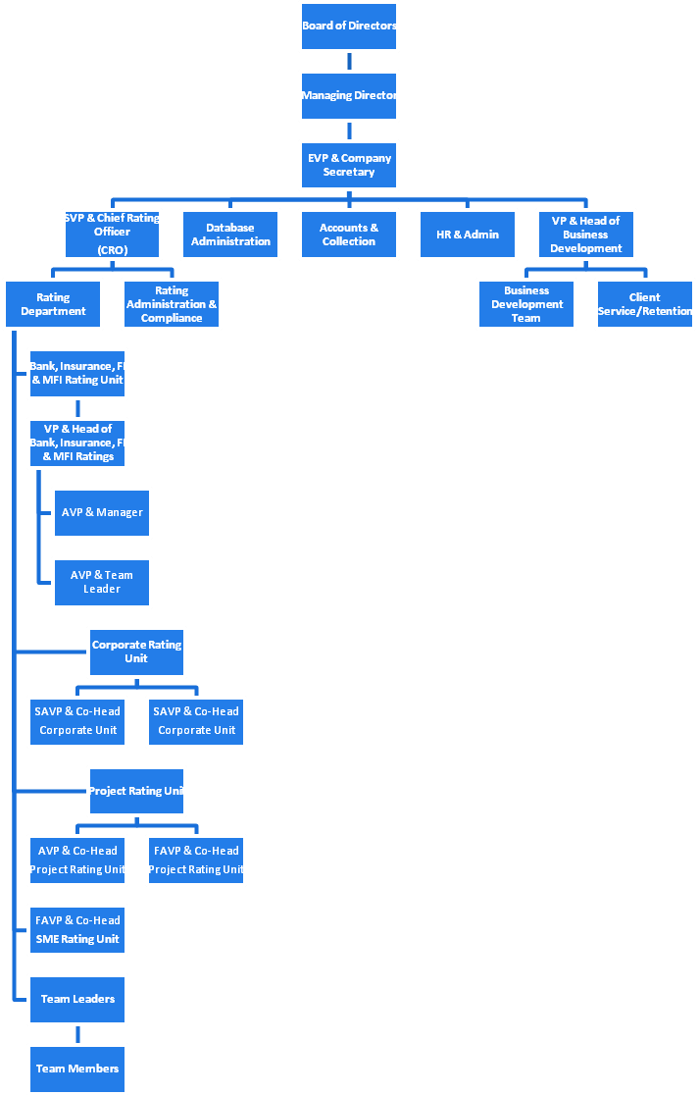
Figure 07- Organogram of CRAB

2.2 Industry Analysis

2.2.1 Specification of the Industry
The credit-rating industry in Bangladesh is an essential component of the country’s financial infrastructure. It acts as a bridge between borrowers and lenders by offering independent, professional opinions on the creditworthiness of organizations and financial instruments. The industry operates under the direct supervision of the Bangladesh Securities and Exchange Commission (BSEC), which licenses and regulates credit-rating agencies under the Credit Rating Companies Rules 1996.
At present, only a handful of licensed credit-rating agencies are active in Bangladesh, including Credit Rating Agency of Bangladesh Limited (CRAB), Credit Rating Information and Services Limited (CRISL), Emerging Credit Rating Limited (ECRL), Alpha Credit Rating Limited (Alpha), and National Credit Ratings Limited (NCR). Each agency follows its own analytical framework approved by BSEC, but the overall approach remains consistent with international norms such as those adopted by Standard & Poor’s, Moody’s, and Fitch Ratings.
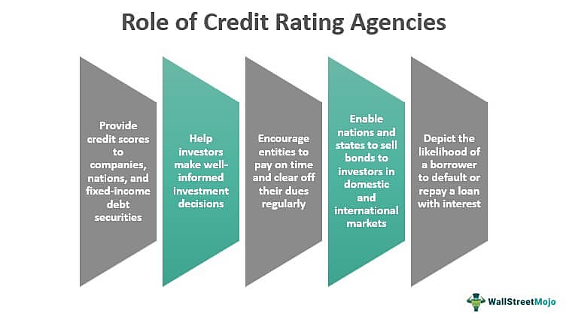
Figure 8: Role of Credit Rating Industries

Credit-rating agencies provide services to banks, non-bank financial institutions (NBFIs), insurance companies, public-limited firms, private corporations, and SME clients. The ratings produced by these agencies help financial institutions determine lending risk, influence the pricing of loans, and guide investors’ decisions in capital-market transactions.
Because Bangladesh is an emerging economy with an expanding SME base and capital-market reforms, the credit-rating industry holds immense importance in ensuring transparency, accountability, and investor protection.

2.2.2 Size, Trend, and Maturity of the Industry
The credit-rating industry in Bangladesh is relatively young but evolving rapidly. Prior to 2002, the financial sector relied solely on collateral-based lending. The absence of formal credit assessments created inefficiencies and higher default risks. After BSEC introduced licensing rules for credit-rating companies, a new era of structured credit evaluation began.
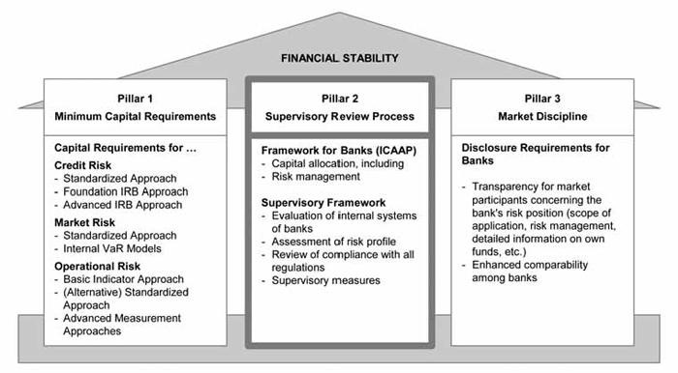
Figure 9: Financial stability Pillar 1, 2 & 3

A key driver of growth in Bangladesh’s credit-rating industry is the gradual implementation of the Basel II and Basel III regulatory frameworks.
- Pillar 1 requires banks to use external credit ratings when determining the risk weights of their corporate borrowers, which directly affects the level of capital they must maintain.
- Pillar 2 reinforces the supervisory review process by ensuring that banks hold adequate capital to cover all material risks identified through both internal and external assessments.
- Pillar 3 promotes greater market transparency by making rating information publicly available, enabling investors and other stakeholders to make more informed decisions.
Collectively, these three pillars have embedded credit ratings into the nation’s financial risk-management structure, making them a mandatory and integral element of Bangladesh’s banking and capital-market ecosystem.

Size of the Industry
At present, the collective rating output of all licensed agencies exceeds several thousand entities each year, spanning manufacturing, trading, service, and financial sectors. While precise numbers fluctuate, CRAB alone conducts hundreds of ratings annually, making it one of the top two players by market share. The overall market for rating services is valued in the hundreds of millions of taka per year, reflecting growing demand for independent opinions.

Industry Trends
- Regulatory Dependence:
The Bangladesh Bank and BSEC have made credit ratings mandatory for certain purposes, such as capital-adequacy calculation, IPO approval, and bond issuance. This has increased both the relevance and volume of ratings.
- Shift toward SME Ratings:
With SME financing becoming a policy priority, agencies have developed specialized models for small and medium-sized businesses. I personally observed that CRAB’s SME ratings often support banks in determining collateral substitution or working-capital limits.
- Adoption of Technology:
Rating agencies are gradually digitizing their operations—introducing ratio-analysis templates, data-validation software, and AI-based analytics to improve accuracy.
- Greater Public Disclosure:
Investors and banks now rely heavily on publicly available ratings to assess corporate debt quality. This transparency strengthens market discipline.

Maturity of the Industry
Although still developing, the sector is transitioning from an introductory to a growth-maturity phase. Continuous regulatory guidance, the rise of capital-market instruments, and competition among rating firms are improving methodological rigor. However, challenges remain: limited public awareness outside major corporates, insufficient verified data for SMEs, and occasional reliance on client-submitted information.
Overall, the industry is moving toward institutional maturity, where credibility, analytical independence, and data integrity will determine long-term sustainability.

2.2.3 Industry SWOT Analysis
Strengths | Weaknesses
1. Strong regulatory framework under BSEC licensing. | 1. Heavy dependence on client-provided  data can affect accuracy.
2. Increasing demand from banks and NBFIs for rating opinions | 2. Limited public awareness about the  value of credit ratings among SMEs.
3. Presence of experienced financial analysts and professionals | 3. Shortage of comprehensive industry  databases and digital infrastructure
4. Mandatory rating requirements for public issuances and bank exposures. | 4. Intense price competition among  agencies reduce profit margins.
Opportunities | Threats
1. Expansion into new sectors such as microfinance and green bonds. | 1. Economic slowdowns can reduce  corporate rating mandates.
2. Technological integration (AI, machine learning for risk models). | 2. Regulatory delays or policy changes  may impact industry operations.
3. Growing SME lending creates need for simplified rating models. | 3. Potential entry of foreign rating agencies may increase competition.
4. Rising capital-market development offers scope for bond ratings. | 4. Data manipulation risks and  ethical issues can damage trust.

The strengths of the industry lie primarily in its regulatory backing and growing institutional credibility. Mandatory ratings for corporate debt have made the practice an integral part of financial decision-making. The main weaknesses, however, stem from data quality and dependence on client transparency.
Opportunities are abundant in emerging segments such as SME ratings, green-finance assessments, and ESG (environmental, social, governance) evaluations. However, global competition and ethical compliance remain persistent threats.
From my personal observation during the internship, I realized that the future success of this industry will depend on the integration of technology, stricter ethical standards, and capacity building of analysts.

Chapter 3: Internship Experience

3.1 Position, Duties and Responsibilities
I began my internship journey at Credit Rating Agency of Bangladesh Limited (CRAB) on August 6th, 2025, and successfully completed it on 6th November 2025.
I was appointed as an Intern – Rating Department, which primarily deals with financial and non-financial analysis of client organizations for determining their creditworthiness.
During my internship, I was directly supervised by Mr. Monem Ahmed and Mr. Arif Hossain, both Senior Financial Analysts. They guided me throughout every stage of the credit-rating process and provided continuous mentoring to enhance my analytical and reporting skills.
My key duties and responsibilities included:
- Data Collection and Verification: Collecting financial statements, bank certificates, business profiles, and management information from assigned clients. I learned how to cross-verify data consistency between audited financials and supporting schedules.
- Financial Statement Analysis: Preparing ratio-analysis templates covering liquidity, leverage, profitability, coverage, and efficiency metrics. I frequently compared multi-year performance trends and benchmarked them against industry averages.
- Qualitative Assessment: Assisting analysts in evaluating management capability, corporate governance, operational strengths, and market position of rated entities.
- Credit Report Drafting: Compiling the initial analytical sections of rating reports, summarizing financial trends, and highlighting risk factors for committee review.
- Communication Support: Maintaining professional correspondence with clients to obtain missing information and clarifications.
- Documentation and Confidentiality: Organizing case files, ensuring that all materials were properly documented and handled with strict confidentiality.
Through these tasks I gained exposure to SME ratings, corporate ratings, and financial institution reviews. Every assignment deepened my understanding of how risk analysis is operationalized inside a regulated financial organization.

3.2 Training and Development
CRAB maintains a culture of structured learning for interns and analysts. At the beginning of my internship, I received an orientation program introducing company policies, rating methodology, confidentiality rules, and ethical standards.
I was then assigned to several practical training sessions led by senior analysts. These sessions included:
- Understanding Credit-Rating Methodology: I was trained on the full rating workflow — from client mandate acceptance to committee approval — and learned how quantitative ratios and qualitative factors are weighted in final scoring.
- Financial Ratio Calculation Workshop: Analysts demonstrated how to standardize data and adjust audited accounts to ensure comparability. I practiced computing ratios using Excel templates that reflected CRAB’s internal analytical models.
- Industry Risk Assessment Training: I was taught how macroeconomic indicators, market cycles, and sectoral outlooks influence risk gradings.
- Internal Review Meetings: I attended several rating committee presentations where senior analysts defended their findings before the committee. Observing those sessions improved my professional communication and critical-reasoning abilities.
Through these trainings, I developed an analytical mindset, sharpened my Excel skills, and gained confidence in presenting financial findings in a professional environment.

3.3 Contribution to Organization / Operations
Although I was an intern, I contributed meaningfully to the department’s operations. My contributions can be summarized as follows:
- Enhanced Efficiency: I prepared automated Excel templates for ratio calculation, which reduced repetitive manual work for the analysts.
- Data Integrity Support: By thoroughly checking financial data for consistency, I minimized minor computational errors and helped ensure smoother report submission.
- SME Case Assistance: I assisted in preparing preliminary credit summaries for several SME clients, which were later finalized by senior analysts.
- Knowledge Sharing: I compiled short reference notes on frequently used ratios and formulas for new interns joining after me.
Even though my role was entry-level, I realized that accuracy and timeliness are crucial to the overall efficiency of the rating process. My supervisors often appreciated my commitment and attention to detail.

3.4 Evaluation of the Experience
My internship experience at CRAB was transformative. It allowed me to witness how a financial-rating organization contributes to national economic stability. The exposure helped me link theoretical concepts—such as capital structure, cash-flow analysis, and risk management—to real-life decision-making.
Professional Growth:
I learned the discipline of working under tight deadlines, maintaining data confidentiality, and adhering to compliance standards. I also developed professional habits such as structured communication, analytical writing, and teamwork coordination.
Challenges Faced:
At the beginning, understanding complex financial models and analytical frameworks was difficult. However, consistent mentoring and self-learning helped me overcome these challenges. Another limitation was restricted access to confidential client data, which sometimes constrained deeper analysis, but this taught me how to handle sensitive information responsibly.
Feedback and Supervision:
Both Mr. Monem Ahmed and Mr. Arif Hossain provided constructive feedback regularly. They guided me in improving the quality of my written analysis and encouraged me to interpret financial ratios in context rather than mechanically. Their mentorship greatly influenced my personal and professional growth.
Overall, I would evaluate the internship as an excellent learning experience that built a solid foundation for my future in finance and risk analysis.

3.5 Skills Applied and Lessons Learned
The internship at CRAB significantly improved my technical, analytical, and interpersonal competencies.

Technical Skills
- Financial Analysis: Mastered calculation and interpretation of leverage, liquidity, profitability, and coverage ratios.
- Excel and Data Visualization: Developed strong proficiency in using Excel functions, pivot tables, and formula automation for financial analysis.
- Report Writing: Learned to summarize complex financial data into concise, decision-useful narratives suitable for rating reports.
- Analytical Judgment: Acquired the ability to identify trends and assess business sustainability using both quantitative and qualitative inputs.

Interpersonal and Professional Skills
- Teamwork and Collaboration: Learned to coordinate effectively with analysts, peers, and administrative staff.
- Time Management: Managed multiple tasks simultaneously, ensuring timely delivery of assigned work.
- Professional Ethics: Understood the importance of confidentiality, neutrality, and unbiased judgment in financial analysis.
- Communication: Enhanced both written and verbal communication through report discussions and client follow-ups.

Personal Development Lessons
- Analytical work demands patience, accuracy, and curiosity.
- Practical finance requires not only theoretical knowledge but also professional discipline and ethical responsibility.
- Real growth occurs when feedback is accepted positively and applied consistently.
This internship has strengthened my conviction to pursue a professional career in financial analysis and credit risk management. It also inspired me to continue learning advanced finance tools and certifications, including CFA and FMVA, to build a long-term career in this field.

Summary of Chapter 3
In conclusion, the three-month internship at CRAB was an invaluable phase of my academic and professional journey. I gained practical exposure to financial statement analysis, credit rating methodology, and professional ethics in action. The environment encouraged both learning and contribution. I realized that the accuracy of a single ratio or interpretation could affect a company’s rating and, consequently, its access to finance.
The combination of technical training, teamwork, and mentorship made this internship a turning point for me. It reinforced my passion for finance and equipped me with the necessary knowledge, discipline, and motivation to excel in my future career.

Chapter 4: Credit Rating Assessment of Agromax International

4.1 CRAB’s Credit Scoring Model Overview
Credit Rating Agency of Bangladesh (CRAB) uses a structured SME Credit Rating Model that integrates both quantitative and qualitative factors to assess a company’s financial stability, business strength, and repayment capability. This methodology helps stakeholders—such as banks, investors, and regulators—evaluate the creditworthiness of a firm with both objective financial metrics and subjective business insights.
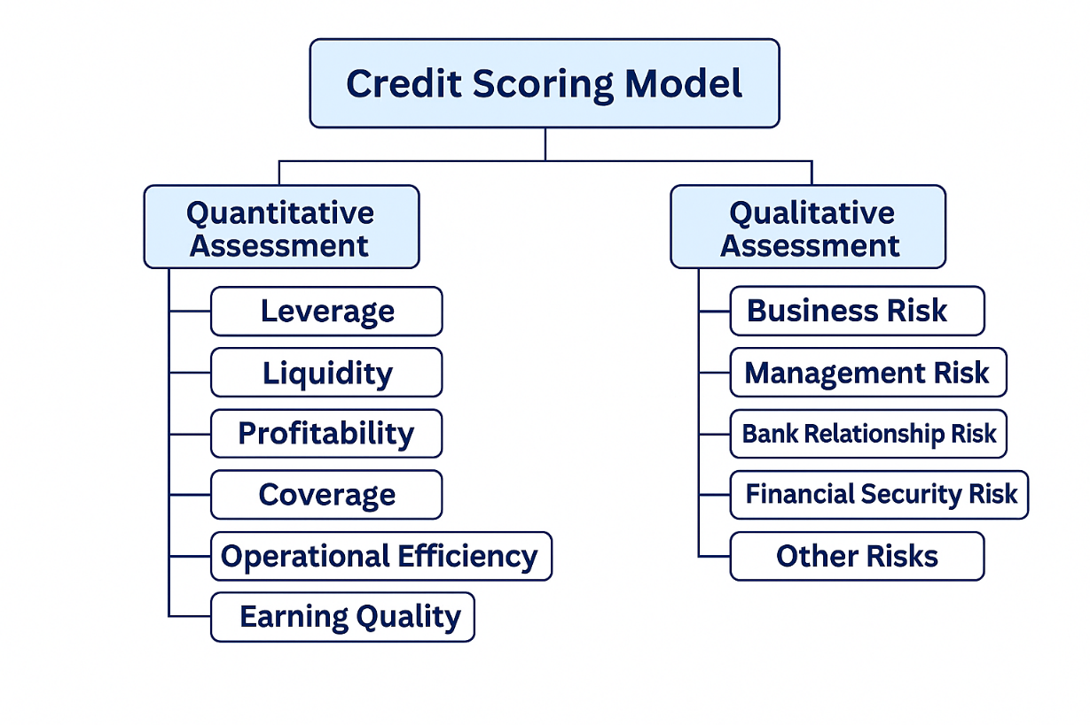
Figure 10: Credit Scoring Model of CRAB
Quantitative Assessment (40 Marks)
Quantitative analysis accounts for 40% of the total credit score. It focuses on the financial performance of the enterprise using key indicators like:
- Leverage – measures the extent of debt dependence.
- Liquidity – assesses the firm’s ability to meet short-term obligations.
- Profitability – evaluates operational and net performance.
- Coverage – gauges the firm’s ability to service interest expenses.
- Operational Efficiency – determines how efficiently assets and inventory are utilized.
- Earning Quality – reviews the consistency and reliability of profit and cash flow.
Each ratio is scored based on CRAB’s standard scale (e.g., 0–10, 0–6, etc.) where higher marks indicate stronger performance and lower credit risk.
Qualitative Assessment (60 Marks)
The qualitative component, which carries 60% weight, focuses on non-financial aspects such as management quality, business and industry risk, banking relationship, security risk, and corporate governance.
While quantitative assessment reflects “what has happened” through financial numbers, qualitative assessment reflects “what might happen” based on management, structure, and strategy.
The final rating (out of 100) combines both aspects to determine the overall CRAB SME grade (e.g., SE-1, SE-2, SE-3, etc.). This comprehensive approach ensures that both measurable performance and managerial capability are captured in evaluating the enterprise’s financial reliability.

4.2 Company Profile – Agromax International

Name | Agromax International
Establishment Year | 2012
Legal Status | Proprietorship
Proprietor | Mr. Md. Hasan Ali
Business | Trader of agricultural machineries and spare parts
Product Range | Destone Machine, Paddy Separator, Rice Sifter, Color Sorter, Boiler & Dryer, Rice Whitener, Rice Length Grader, Control Panel, etc.
Business Address | Chitholia, Khoyerchara, Poradah, Mirpur, Kushtia
Factory Address | n/a
Revenue (FY2025) | BDT 124.9 million
Net Profit Margin (FY2025) | 7.9%

Table 1: Company Profile

Agromax International is a Kushtia-based trading firm specializing in importing and distributing high-quality rice milling machinery and spare parts across Bangladesh.
Established in 2012, the firm has steadily grown under the leadership of Mr. Md. Hasan Ali, who has more than 13 years of experience in this industry. The business operates primarily on cash-based transactions (80% cash and 20% credit), resulting in stable liquidity and controlled leverage.
The company’s strategic relationship with foreign suppliers and its reputation for reliable customer service have enabled consistent growth, as evidenced by a 10% increase in revenue in FY2025 compared to FY2024.
Business Model

Demand Side
Supply Side

Agromax International

(Trader of agricultural equipment & spare parts)
- Importer Country
- China
- India
- Japan
- Local Importer & Suppliers

Local Rice Mill:

- Local Auto Rice Mills

Figure 11 - Business Model of Agromax International
Agromax International operates under a B2B (Business-to-Business) trading model that connects international suppliers of agricultural equipment and spare parts with local rice mills in Bangladesh. The model functions as an intermediary and facilitator between the supply side (foreign and local suppliers) and the demand side (domestic rice mill operators).

Supply Side
The supply chain of Agromax International consists of:
Importer Countries: China, India, and Japan — key sources of advanced agricultural machinery, spare parts, and automation technology.
Local Importers & Suppliers: Domestic distributors and vendors who provide complementary components, tools, and maintenance support for the imported equipment.
Agromax International’s Role
At the center of the model, Agromax International acts as a trader and intermediary, importing, stocking, and distributing agricultural equipment and spare parts. It ensures product quality, manages logistics, and provides after-sales services such as installation, repair, and maintenance support.
Demand Side
On the demand side, the company primarily serves Local Auto Rice Mills, which require continuous machinery upgrades, replacement parts, and technical support to maintain production efficiency. These mills depend on Agromax for reliable supply and technical expertise.
Summary
This model allows Agromax International to maintain a balanced flow of goods and services between international manufacturers and domestic users. By bridging global technology with local industry needs, the company creates a sustainable value chain that supports the modernization of Bangladesh’s rice milling sector.

4.3 Quantitative Assessment (40 Marks)
Quantitative assessment measures Agromax International’s financial performance based on numerical indicators derived from its management financial statements and CRAB’s analytical model.
Each category below includes the relevant ratios, their outcomes, the scores obtained according to CRAB’s internal scale, and the interpretation of results.

4.3.1 Leverage
Leverage measures the company’s financial dependence on borrowed funds relative to its equity and earnings. It indicates the extent to which debt is used to finance business operations and growth. A high leverage ratio reflects greater reliance on external financing, which increases repayment pressure and financial risk. Conversely, a lower leverage ratio signifies a healthier and more stable capital structure with reduced solvency risk.
The following table presents the scoring assessment of the Leverage criteria of Agromax International, highlighting the company’s debt position and overall financial stability:
Components | Ratio Outcome (FY2025) | Score Obtained | Scale
Total Liability to Total Equity (×) | 0.08 | 3.00 | 3.00
Total Borrowed Fund to Total Equity (×) | 0.07 | 3.00 | 3.00
Total Borrowed Fund to EBITDA (×) | 0.66 | 4.00 | 4.00
Total |  | 10.00 | 10.00

Table 2: Leverage Score
Agromax International exhibits an exceptionally low leverage profile, with a total liability-to-equity ratio of only 0.08× and borrowed fund-to-equity ratio of 0.07×.
This indicates that the firm is minimally dependent on debt, relying primarily on internal funds for operations. Such a capital structure significantly lowers financial risk and enhances the company’s ability to withstand market fluctuations, justifying the full score of 10 out of 10 in this category.

4.3.2 Liquidity
Liquidity assesses the firm’s ability to meet its short-term obligations through available current assets such as cash, receivables, and inventories. It demonstrates the company’s short-term financial strength and capacity to manage working-capital needs efficiently. A high liquidity ratio indicates that the company can comfortably meet its immediate liabilities, whereas a very low ratio may signal potential cash-flow difficulties.
The following table shows the scoring assessment of the Liquidity criteria of Agromax International, reflecting its ability to maintain adequate short-term solvency-
Components | Ratio Outcome (FY2025) | Score Obtained | Scale
Current Ratio (×) | 10.7 | 3.00 | 3.00
Quick Ratio (×) | 7.2 | 1.00 | 1.00
Total |  | 4.00 | 4.00

Table 3: Liquidity Score
The company’s current ratio of 10.7× and quick ratio of 7.2× highlight a strong liquidity position. These figures demonstrate that Agromax International maintains a healthy buffer of current assets to meet all short-term liabilities comfortably. Such results reflect prudent cash and working capital management, allowing the firm to operate smoothly even during slow business cycles.

4.3.3 Profitability
Profitability evaluates both the operational and net performance of the company by determining how effectively it converts sales into profit. It indicates management’s efficiency in cost control, pricing, and resource utilization. A higher profitability ratio is considered favorable, as it reflects strong earnings generation and financial sustainability. Lower profitability may suggest weak cost management or limited revenue growth.
The following table presents the scoring assessment of the Profitability criteria of Agromax International, illustrating its overall earnings performance-
Components | Ratio Outcome (FY2025) | Score Obtained | Scale
EBITDA Margin (%) | 8.2 | 1.66 | 2.00
Gross Profit Margin (%) | 16.2 | 2.00 | 2.00
Net Profit Margin (%) | 7.9 | 2.00 | 2.00
Return on Average Asset (%) | 10.3 | 1.50 | 2.00
Return on Average Equity (%) | 11.3 | 1.50 | 2.00
Total |  | 8.66 | 10.00

Table 4: Profitability Score
Agromax International demonstrates consistent profitability, with a net profit margin of 7.9% and a return on equity of 11.3%. These values indicate a moderately strong profit performance for a trading business operating in a competitive agro-machinery sector. Although profit margins could be enhanced through higher volume or efficiency, the overall outcome reflects solid cost control and effective pricing strategies.

4.3.4 Coverage
Coverage gauges the firm’s capacity to service fixed financial obligations, particularly interest expenses on debt. It reflects how comfortably the company can meet these payments from its operating profits. A higher coverage ratio indicates stronger debt-servicing ability and lower default risk, while a lower ratio may suggest potential strain on earnings to cover interest costs.
The following table shows the scoring assessment of the Coverage criteria of Agromax International, demonstrating its ability to service debt and interest commitments-
Components | Ratio Outcome (FY2025) | Score Obtained | Scale
FFO to Total Borrowed Fund (%) | 147.1 | 2.00 | 2.00
CFO to Total Borrowed Fund (%) | 32.9 | 2.00 | 2.00
EBIT to Interest Expense (×) | 94.5 | 2.00 | 2.00
Total |  | 6.00 | 6.00

Table 5: Coverage Score
The firm’s FFO-to-debt ratio of 147.1% and EBIT-to-interest ratio of 94.5× highlight a very comfortable debt-servicing capacity. These coverage levels confirm that Agromax International can easily meet its financial obligations, even under stressed conditions. CRAB awarded a full score (6/6) in this category due to the firm’s exceptionally strong coverage metrics.

4.3.5 Operational Efficiency
Operational efficiency determines how effectively the company utilizes its assets and inventory to generate sales and maintain profitability. It assesses management’s ability to convert resources into revenue while minimizing waste and idle capacity. A higher efficiency ratio signifies better utilization of assets and faster turnover, whereas a lower ratio may indicate inefficiencies in operations or inventory management.
The following table provides the scoring assessment of the Operational Efficiency criteria of Agromax International, highlighting how well it uses its resources to achieve productive output-

Components | Ratio Outcome (FY2025) | Score Obtained | Scale
Average Inventory Processing Period (Days) | 81 | 1.70 | 2.00
Average Receivable Collection Period (Days) | 129 | 1.30 | 2.00
Revenue to Average Assets (×) | 1.38 | 1.50 | 2.00
Total |  | 4.50 | 6.00

Table 6: Operational Efficiency Score
Agromax International’s inventory period of 81 days and receivable period of 129 days are typical for trading businesses operating in the agro-machinery sector.
While moderate, these indicators suggest that the firm maintains adequate stock to ensure availability but faces slightly longer collection cycles due to credit sales.
Overall operational performance remains satisfactory, scoring 4.5 out of 6, with room to improve credit management.

4.3.6 Earning Quality
Earning quality reviews, the consistency, reliability, and sustainability of the company’s profit and cash flow over time. It measures how closely reported earnings align with actual cash generation and whether profits are stable and recurring. A higher earning-quality ratio is favorable, as it reflects dependable performance and limited reliance on one-time or irregular income sources.
The following table presents the scoring assessment of the Earning Quality criteria of Agromax International, reflecting the stability and authenticity of its financial performance-

Components | Ratio Outcome (FY2025) | Score Obtained | Scale
FFO to Revenue (%) | 7.8 | 1.00 | 2.00
Revenue Growth (%) | 10.0 | 2.00 | 2.00
Total |  | 3.00 | 4.00

Table 7: Earning Quality Score
The firm’s 10% revenue growth alongside consistent cash-based operations reflects stable earnings quality. However, a relatively low FFO-to-revenue ratio (7.8%) suggests that cash conversion can be optimized. Still, with stable growth and reliable returns, the company maintains moderate-to-good earning consistency, scoring 3 out of 4.

4.3.7 Total Quantitative Score
The total quantitative score represents the overall financial strength of Agromax International based on the combined performance of all six key financial ratio categories—Leverage, Liquidity, Profitability, Coverage, Operational Efficiency, and Earning Quality. Each ratio is assessed according to CRAB’s standardized scoring model, where the assigned weights and scores collectively determine the company’s quantitative standing.
A higher total quantitative score indicates stronger financial performance, effective management practices, and a lower level of financial risk. Conversely, a lower score suggests weaknesses in financial structure, operational management, or profitability.
The following table presents the overall scoring assessment of the Quantitative Analysis of Agromax International, summarizing its financial position as per CRAB’s rating methodology
Components | Score Obtained | Scale
Leverage | 10.00 | 10.00
Liquidity | 4.00 | 4.00
Profitability | 8.66 | 10.00
Coverage | 6.00 | 6.00
Operational Efficiency | 4.50 | 6.00
Earning Quality | 3.00 | 4.00
Total Quantitative Score | 36.16 | 40.00
Table 8 : Total Quantitative Score
Agromax International achieved a quantitative score of 36.16 out of 40, which signifies excellent financial strength and very low credit risk. The firm’s outstanding leverage and coverage ratios demonstrate resilience, while profitability and liquidity remain robust.
Although operational efficiency and cash conversion could improve slightly, the overall quantitative assessment highlights a financially stable and sustainable enterprise.

4.4 Qualitative Assessment (60 Marks)
The qualitative assessment evaluates Agromax International’s management efficiency, business risk profile, banking behavior, and operational preparedness — factors that influence the company’s long-term sustainability. This portion contributes 60 marks to the overall CRAB rating score.

4.4.1 Business / Industry Risk
Business and Industry Risk assess the external operating environment of a firm, focusing on market size, competition, demand stability, and industry growth prospects. It helps determine how vulnerable or resilient the business is to economic and market fluctuations. A lower level of business and industry risk indicates that the enterprise operates in a stable, mature, and less volatile sector, which enhances its ability to generate consistent revenue and maintain repayment capacity.
Below table shows the situation of Business / Industry Risk of Agromax International based on CRAB’s evaluation model:
Components | Outcome (FY2025) | Score Obtained | Scale
Size of Business | Medium (BDT 100–250 million revenue) | 4.00 | 4.00
Business Age | 12 years | 1.50 | 2.00
Business Outlook | Stable | 1.50 | 2.00
Growth Compared to Industry | Slightly Above Average (10%) | 2.50 | 3.00
Market Competition | Highly Competitive | 1.00 | 4.00
Entry / Exit Barriers | Easy Entry, Moderate Exit Barriers | 1.50 | 3.00
Total Score |  | 12.00 | 18.00

Table 9: Business/Industry Risk score
Agromax International has been operating for more than a decade in Bangladesh’s agro-machinery trading sector — an industry with stable but competitive dynamics. While the company benefits from its reputation and experience, the ease of market entry and intense competition among local traders limit pricing power and market share expansion. Hence, the business earns 12 out of 18, indicating moderate industry strength with stable performance potential.

4.4.2 Management Risk
Management Risk evaluates the competence, integrity, and governance practices of an organization’s leadership. It focuses on the experience, technical knowledge, internal control systems, and decision-making capability of the management team. A well-organized and skilled management structure strengthens financial stability, ensures timely responses to market challenges, and minimizes operational risks. In contrast, weak managerial oversight or lack of formal planning can increase business uncertainty and credit exposure.
Below table shows the situation of Management Risk of Agromax International based on CRAB’s evaluation model.
Components | Outcome (FY2025) | Score Obtained | Scale
Track Record of Sponsor | Good reputation and business acumen | 2.25 | 3.00
Educational & Technical Experience | Post-graduate, 13 years industry experience | 2.50 | 3.00
Risk Tracking & Decision Ability | Proactive, experience-based | 1.75 | 2.00
Internal Control System | Average manual supervision | 1.25 | 2.00
Succession Planning | Absent | 1.00 | 3.00
Team Work & Staff Capability | Limited but effective | 1.25 | 2.00
External Audit Practice | Unaudited management accounts | 0.75 | 2.00
Total Score |  | 10.75 | 17.00

Table 10: Management Risk score
The proprietor of Agromax International personally supervises all business operations and demonstrates strong commitment and market understanding. However, the firm lacks a formal succession plan, external audit practice, and a structured internal control system, which limits transparency and long-term sustainability. Despite these weaknesses, the company’s hands-on management style and industry experience support consistent operational control, resulting in a moderate score of 10.75 out of 17 in this category.

4.4.3 Bank Relationship Risk
Bank Relationship Risk assesses the firm’s financial behavior and repayment discipline with its banking partners. It includes evaluation of loan repayment history, account regularity, covenant compliance, and overall credibility with lenders. A strong and transparent banking relationship indicates that the enterprise manages its financial obligations responsibly and enjoys the confidence of financial institutions. Consistent performance in this area reflects sound credit management and low default probability, which significantly enhances the firm’s creditworthiness.
Below table shows the situation of Bank Relationship Risk of Agromax International based on CRAB’s evaluation model:
Component | Outcome | Score Obtained | Scale
Adverse Classification History (3 Years) | None | 3.00 | 3.00
Loan Reschedule / Restructure History | None | 2.00 | 2.00
Current Loan Status | Regular, positive bank feedback | 4.50 | 5.00
Covenant Compliance | Fully compliant | 1.00 | 1.00
Payment Behavior to Suppliers | Timely | 1.00 | 1.00
Total Score |  | 11.50 | 12.00

Table 11: Bank Relationship Risk score
Agromax International maintains a strong and consistent relationship with its banking partner, Islami Bank Bangladesh PLC, Poradah Branch. The company has never faced any loan classification, rescheduling, or default issues, which reflects excellent repayment behavior. Its adherence to banking covenants and timely payment to suppliers further enhances credibility. Consequently, CRAB has recognized this aspect with a high score of 11.5 out of 12, reflecting exceptional banking discipline and low credit risk.

4.4.4 Financial Security Risk
Financial Security Risk measures the extent and adequacy of collateral coverage provided by a borrower to secure its financial obligations. It evaluates the nature, market value, and enforceability of securities such as land, buildings, or guarantees pledged to banks. A higher level of tangible collateral coverage offers lenders better protection and confidence, reducing exposure to potential losses. This criterion helps determine the degree of safety that financial institutions have in case of business default or adverse events.
Below table shows the situation of Financial Security Risk of Agromax International based on CRAB’s evaluation model:

Component | Outcome | Score Obtained | Scale
Primary Security Coverage | Registered Mortgage on Land & Building | 1.25 | 2.00
Collateral Coverage (FSV) | 71% Coverage vs Loan Limit | 1.25 | 2.00
Guarantee Type | Personal Guarantee of Proprietor | 0.50 | 1.00
Total Score |  | 3.00 | 5.00

Table 12: Financial Security Risk score
Agromax International’s short-term investment facility is backed by registered mortgage collateral comprising land and buildings valued at approximately 71% of the loan exposure. While this provides moderate security coverage, the reliance solely on the proprietor’s personal guarantee limits the overall strength of financial backing. The absence of diversified or institutional guarantees slightly increases credit exposure for the lender. Therefore, the company received a score of 3 out of 5, indicating moderate financial security strength.

4.4.5 Other Risks
Other Risks encompass the non-financial and external factors that may affect the firm’s stability or future operations. This category includes areas such as legal compliance, environmental responsibility, disaster preparedness, insurance coverage, and corporate governance practices. Assessing these elements helps determine the company’s overall risk resilience and ethical standards. A business that maintains legal compliance, insurance protection, and good governance tends to have lower operational vulnerability and greater long-term sustainability.
Below table shows the situation of Other Risks of Agromax International based on CRAB’s evaluation model:
Components | Outcome (FY2025) | Score Obtained | Scale
Legal / Environmental Issues | None Reported | 1.00 | 1.00
Disaster Preparedness & Insurance | No Formal Insurance | 0.25 | 1.00
Government Support / Tax Benefits | Not Availing | 0.25 | 1.00
Corporate Governance | Ethical, compliant | 0.75 | 1.00
Total Score |  | 2.25 | 4.00
Table 13 : Other Risk score
Agromax International operates within legal boundaries and follows general compliance standards, which minimizes regulatory risk. However, the firm lacks formal insurance coverage and disaster preparedness policies, exposing it to potential financial losses from unforeseen events. The company maintains satisfactory ethical practices but would benefit from implementing risk-mitigation frameworks such as insurance and contingency planning. As a result, it secured a score of 2.25 out of 4, reflecting basic compliance but limited preventive measures.

4.4.6 Total Qualitative Score
The Total Qualitative Score represents the overall non-financial performance of Agromax International based on five major areas: Business/Industry Risk, Management Risk, Bank Relationship Risk, Financial Security Risk, and Other Risks. This consolidated evaluation reflects the firm’s management capability, operational reliability, governance structure, and external compliance. A higher qualitative score indicates stronger business fundamentals, organizational discipline, and long-term sustainability beyond mere financial performance.
Below table shows the consolidated qualitative performance of Agromax International under CRAB’s SME Rating Model:
Components | Score Obtained | Scale
Business / Industry Risk | 12.00 | 18.00
Management Risk | 10.75 | 17.00
Bank Relationship Risk | 11.50 | 12.00
Financial Security Risk | 3.00 | 5.00
Other Risks | 2.25 | 4.00
Total Qualitative Score | 43.50 | 60.00

Table 14: Total Qualitative score
Agromax International obtained a total qualitative score of 43.50 out of 60, indicating a moderately strong qualitative position. The firm’s excellent banking relationship and sound industry experience positively influence its credit profile, while limited governance structure, lack of insurance, and absence of formal audit practices moderately constrain its overall rating. The results highlight that the company maintains adequate managerial and operational strength, consistent with CRAB’s final assessment under the SE-3 (Adequate Credit Quality) category.

4.5 Final Rating of Agromax International
The final rating combines both quantitative and qualitative assessments to determine the overall creditworthiness of Agromax International. While the quantitative portion (40 marks) reflects the company’s measurable financial performance—such as liquidity, profitability, leverage, and coverage—the qualitative portion (60 marks) represents its business risk, management quality, governance practices, and banking behavior. The cumulative score indicates the enterprise’s ability to meet financial obligations, sustain operations, and manage long-term risks, forming the basis for its assigned CRAB SME rating.
Below table shows the combined quantitative and qualitative performance of Agromax International under CRAB’s SME Credit Rating Model:
Category | Score Obtained | Scale
Quantitative Assessment | 36.16 | 40.00
Qualitative Assessment | 43.50 | 60.00
Total Credit Score | 79.66 | 100

Table 15: Total Credit Score Agromax International
CRAB SME Rating Scale:
CRAB Rating Scale | Score Range | Rating Definition
CRAB – SE 1 | 91 – 100 | Highest credit quality
CRAB – SE 2 | 81 – 90 | High credit quality
CRAB – SE 3 | 71 – 80 | Adequate credit quality
CRAB – SE 4 | 61 – 70 | Moderate credit quality
CRAB – SE 5 | 51 – 60 | Inadequate credit quality
CRAB – SE 6 | 41 – 50 | Risk-prone credit quality
CRAB – SE 7 | 31 – 40 | Poor credit quality
CRAB – SE 8 | 21 – 30 | Lowest credit quality
Table 16: SME Rating Scale and Rating Definition of CRAB
Agromax International achieved a total composite score of 79.66 out of 100, placing it under the CRAB SE-3 (Adequate Credit Quality) category. This rating signifies that the enterprise possesses strong financial fundamentals, reflected in high liquidity and minimal leverage, alongside sound repayment capacity and a positive track record with its banking partner. However, moderate governance structure, limited formal documentation, and lack of business insurance restrict the company from achieving a higher grade. Overall, the firm maintains adequate financial and managerial strength to meet its short-term and long-term obligations, with potential to move into a higher rating band through better formalization and operational efficiency improvements.

Chapter 5: Conclusions And Key Facts

5.1 Recommendations
Based on my observation and learning at CRAB, I would like to offer the following recommendations for both the organization and future interns:
Recommendations for CRAB
- Digital Integration: The organization can further improve efficiency by adopting advanced data-management and analytics tools to automate ratio analysis and report formatting.
- Training Programs: Conducting periodic training for interns and junior analysts would strengthen their understanding of new financial instruments and evolving rating methodologies.
- SME Database Development: Creating a centralized SME data repository would help improve analysis accuracy and reduce reliance on client-submitted information.
- Enhanced Research Division: Expanding research capabilities on industry-specific trends could add significant value to rating insights and strengthen CRAB’s market position.
- Communication Workshops: Soft-skill and presentation-skill sessions would help young analysts communicate analytical findings more effectively in rating-committee discussions.
Recommendations for Future Interns
- Learn Excel thoroughly before joining, as most financial analysis depends on spreadsheet modeling.
- Review key accounting and finance concepts to adapt faster to analytical tasks.
- Maintain a learning mindset and seek feedback regularly from supervisors.
- Uphold confidentiality and professionalism — two non-negotiable values in a credit-rating environment.

5.2 Key Understandings
Throughout this internship, I developed several key insights:
- Practical Application of Finance: Real-world financial analysis requires contextual judgment, not just formula-based calculations. Every ratio and trend must be interpreted in light of business reality.
- Importance of Data Integrity: Credit-rating outcomes depend heavily on data accuracy; therefore, auditors, analysts, and management must ensure transparency and reliability.
- Ethical Responsibility: A credit-rating agency’s credibility depends on impartiality, confidentiality, and ethical discipline.
- Professionalism and Communication: Team collaboration, presentation clarity, and adherence to deadlines are critical success factors in a corporate setting.
- Continuous Learning: The financial industry evolves rapidly; thus, continuous professional development through certifications such as CFA, CMT, or FMVA is essential for career advancement.

5.3 Conclusion
My internship at Credit Rating Agency of Bangladesh Limited (CRAB) was one of the most valuable experiences of my academic journey. It gave me the opportunity to apply the knowledge gained throughout my BBA program in a real-life corporate environment.
Through this internship, I learned how professional analysts evaluate a company’s creditworthiness using both quantitative and qualitative dimensions. I also experienced the challenges of working under pressure, handling sensitive information, and maintaining analytical integrity.
This experience has reinforced my desire to build a career in financial analysis and risk management, and it has inspired me to pursue advanced professional certifications and research in finance.
In conclusion, this internship was not merely a degree requirement — it was a transformative stage in my professional growth. The lessons, mentorship, and exposure I gained from CRAB will remain a guiding foundation throughout my future career.

References

- Credit Rating Agency of Bangladesh Limited (CRAB) – Official Website: www.crab.com.bd
- Bangladesh Securities and Exchange Commission (BSEC) – Credit Rating Companies Rules 1996
- Annual Reports and Internal Documents (CRAB, 2025)
- Class Lectures and Notes from United International University (UIU)
- Discussions with Senior Analysts at CRAB
- Internship Experience and Observation Notes (August–October 2025)

