Prepared by:
  - N U Ahmad Ullah Raka
  - 111 141 141
  - Bachelor of Business Administration
  - School of Business and Economics
  - United International University

Supervised by:
  - MD. Kazimul Hoque
  - Assistant Professor
  - School of Business and Economics
  - United International University

Date of Submission:
August 8, 2023

Letter of Transmittal
August 8, 2023
MD. Kazimul Hoque
Assistant Professor
School of Business and Economics
United International University

Dear Sir,
Attached is the report you requested, entitled: "Impact of COVID-19 on the Human Resource Management Practices of Bangladesh."
This thesis paper examines how the COVID-19 epidemic has affected HRM practices in Bangladeshi organizations. The research examines HR professionals' and organizations’ crises, strategic solutions, and HRM's future in Bangladesh.
To organize information, the thesis paper has numerous components. An overview of the study issue is followed by a review of relevant literature and theoretical frameworks for crisis-related HRM practices. The next sections examine COVID-19's effects on HRM's recruiting and selection, training and development, employee well-being, employee engagement, and organizational resilience.
The thesis paper uses case studies and examples from Bangladeshi organizations to demonstrate the research's practical applications. The study adds to the understanding of HRM practices in crisis circumstances and offers practical advice for HR professionals and organizational leaders in Bangladesh.
This thesis paper will help HRM professionals, organizational leaders, policymakers, and scholars understand how the COVID-19 epidemic affected HRM practices in Bangladesh. This report may help organizations manage the current crisis and plan for future interruptions.
I am grateful to everyone who helped me with my study. My thesis adviser, [adviser's Name], gave me great advice and support.
Thank you. I think my thesis work adds to the discussion on HRM practices in crisis management. Please contact me with any queries.

Sincerely,
N U Ahmad Ullah Raka
111 141 141
Bachelor of Business Administration
School of Business and Economics
United International University

ACKNOWLEDGEMENT
Bismillahir Rahmanir Raheem.

I would like to thank everyone who helped complete this research on the "Impact of COVID-19 on the Human Resource Management Practices of Bangladesh." Many people and institutions helped make this study feasible.

First, I'd want to thank our study's HR managers and experts from Bangladeshi companies. This study was shaped by their openness to share their important views and experiences.

My study supervisor, MD. Kazimul Hoque, has been a great help throughout the process. His support, criticism, and rigorous examination of our work have greatly improved our research.

I'd like to thank MD. Hazzaz Hossain Khan, Managing Director, Khan Brother's (MFG) Group for survey assistance. All workers took the survey.

I also thank United International University's teachers for helping me learn HR management. Our research skills are shaped by their academic brilliance and research-oriented thinking.

The United International University administrative personnel and librarians helped me find suitable materials and literature for the project. They helped us analyze the matter from several angles.

Finally, I would like to thank our friends and family for their continuous support and encouragement during this research adventure. Their faith in me has inspired me.

Sincerely,

N U Ahmad Ullah Raka
ID- 111 141 141
Bachelor of Business Administration
School of Business and Economics
United International University

EXECUTIVE SUMMARY

COVID-19 has had a global effect on organizations and HRM practices. This executive summary summarizes studies on COVID-19's influence on Bangladeshi organizations’ HRM practices. The research identified HR professionals' biggest difficulties, examined organizations’ strategic approaches, and examined HRM's future in Bangladesh.
The study found that the COVID-19 epidemic has disrupted HRM in Bangladesh. Social separation and travel limitations hampered recruiting and selection. Organizations have to adjust by using virtual interviews and evaluations and alternate recruiting channels to attract talent.
Second, classroom-based training and development programs have become unviable. Online learning platforms and virtual training sessions swiftly upskilled personnel and ensured professional progress.
Third, pandemic concerns included staff well-being. Organizations implemented programs to assist, guide, and resource employees' mental health. Employee support programs and wellness programs helped pandemic-stressed workers.
Remote work disturbed employee engagement and communication. Organizations struggled to keep staff connected. They used technology, virtual team building, and communication to boost participation and cooperation.
Finally, the pandemic required organizational resilience and flexibility. HR experts developed and implemented business continuity plans to help organizations through the crisis. This involved creating flexible work regulations, health and safety standards, and meeting employee demands.
HRM in Bangladesh faces serious consequences. The epidemic boosted remote work and digital HR. HR professionals must learn to manage remote teams, use technology for HR operations, and ensure employee well-being. Organizations must also create a resilient workforce, develop agility, and accept change.
In conclusion, the COVID-19 epidemic has greatly affected HRM practices in Bangladesh. This executive summary shows how HR professionals handled the issue. Flexibility, digitalization, and employee well-being are crucial to Bangladesh's HRM future.
Bangladeshi organizations should monitor and adapt to the changing scenario, using pandemic lessons to improve HRM practices and build resilience.

CONTENTS
BACKGROUND OF THE STUDY 1
PROBLEM STATEMENT OF THE STUDY 1
PURPOSE OF THE STUDY 2
THE SIGNIFICANCE OF THE STUDY 2
OVERVIEW 3
THEORETICAL FRAMEWORK 4
CRITICAL ANALYSIS OF PREVIOUS RESEARCH 6
IMPACT OF COVID-19 ON HRM PRACTICES IN BANGLADESH 7
CHALLENGES FACED BY ORGANIZATIONS IN MANAGING HR DURING COVID-19 9
RESEARCH DESIGN 10
DATA COLLECTION METHOD AND ANALYSIS METHOD 11
QUANTITATIVE DATA ANALYSIS 11
INTERPRETATION OF THE SURVEY RESULT 17
INTERPRETATION 32
IMPLICATIONS 34
CONTRIBUTIONS 35
LIMITATIONS 36
SUGGESTIONS 37
SUMMARY OF THE STUDY 37
RE-STATEMENT AND FINAL WORDS 38
Bibliography 40

Impact of covid-19 on the Human Resource Management Practices

of

Bangladesh

BACKGROUND OF THE STUDY

The pandemic caused by the COVID-19 virus has presented enterprises all around the globe, including those in Bangladesh, with difficulties that have never been seen before. As a direct consequence of this new reality, the practices of human resource management have been forced to evolve. As a result of the epidemic, businesses have been compelled to introduce innovative policies and practices in order to guarantee the health and safety of their workforce while also preserving the continuity of their operations. (Smith, 2020)
The objective of this research was to investigate the influence that Covid-19 has had on the human resource management practices that are used in Bangladesh. In particular, the purpose of the research was to determine the primary shifts that companies have made in the ways that they manage their human resources. These shifts include things like rules on remote work, employee safety measures, recruiting and onboarding, employee benefits and pay, and training and development.
In this study, a qualitative research approach was used, and it consisted of semi-structured interviews with human resource managers from a variety of organizations located in Bangladesh. The interviews focused on the difficulties that businesses have encountered as a result of the epidemic as well as the solutions that these businesses have developed to efficiently manage their workforces.
The results of the research may give insight into the efficacy of human resource management practices during a crisis and guide organizations on how to modify their practices to address the difficulties provided by the pandemic. The study was conducted by the Human Resource Management Association (HRMA). This study has the potential to add to the existing body of information on the management practices of human resources during times of crisis and serve as a foundation for further investigation.

PROBLEM STATEMENT OF THE STUDY

As a result of the pandemic, businesses have been compelled to adopt new practices and protocols in order to guarantee the health and safety of their workforce while also preserving the continuity of their operations. Because of this, the practices of human resource management in Bangladesh have been subjected to severe problems.
The issue statement for this research is to identify the important adjustments that organizations in Bangladesh have made to their human resource management practices during the pandemic, and to determine the efficacy of these changes. The purpose of this study is to understand the effectiveness of these changes. The purpose of this research is to investigate the difficulties that organizations encountered as a result of the pandemic and the solutions that they developed in order to efficiently manage their workforces.
In addition, the purpose of the research is to determine the possibilities that have surfaced as a direct result of the pandemic, such as the adoption of new technologies and practices, as well as the manner in which organizations have reacted to these chances. In conclusion, the purpose of the research is to provide insights into the efficiency of human resource management practices during a crisis and to educate organizations on how to modify their practices in order to address the difficulties given by the pandemic. (Rahman M. S., 2021)

PURPOSE OF THE STUDY

The objective of the research is to analyze the influence that Covid-19 has had on the management practices that are now being used in Bangladesh's human resources. In particular, the purpose of the study is to determine the primary adjustments that businesses in Bangladesh have made to their methods of human resource management as a result of the pandemic. These modifications may include remote work policies, employee safety measures, recruitment and onboarding procedures, employee benefits and compensation, as well as training and development programs. (Akhter, 2021) (Khan, 2021)
In addition to this, the research intends to investigate the difficulties encountered by organizations throughout the pandemic as well as the methods that these organizations have used to efficiently manage their workforces. In addition, the purpose of the research is to identify the possibilities that have surfaced as a direct result of the pandemic, such as the adoption of new technologies and practices, as well as the manner in which organizations have reacted to these chances. (Rahman M. A., 2020)
Overall, the purpose of the research is to teach organizations in Bangladesh on how they might adjust their practices to meet the difficulties provided by the pandemic as well as offer insights into the efficacy of human resource management practices that are implemented during a crisis. The study may also make a contribution to the existing body of information on the management practices of human resources during times of crisis and serve as a foundation for further investigation. Top of the Form. (Khan, 2021) (Akhter, 2021)

THE SIGNIFICANCE OF THE STUDY

The fact that the Covid-19 epidemic has had such a significant effect on the labor force as well as the way organizations function in Bangladesh is the primary reason why this research is so important. In order to ensure that personnel are successfully managed and that corporate operations are not disrupted, practices for human resource management have had to be modified to accommodate the shifting conditions brought about by the epidemic. This research intends to give insights into the unique issues faced by HR managers in Bangladesh at this exceptional moment, as well as the tactics they employed to overcome those challenges. The results of this research may enlighten and advise HR managers and organizational leaders in Bangladesh and other comparable settings in making choices on how to successfully manage their workforce throughout the epidemic and afterwards. These decisions can be made with the benefit of the information provided by this study. In addition, this research has the potential to make a contribution to the existing body of literature on HRM practices in times of crisis and to provide a more in-depth comprehension of the effect that the pandemic has had on organizations located in developing nations like as Bangladesh. (Haque, 2022) (Rahman M. A., 2020)

OVERVIEW

The strategic approach to managing the people working inside an organization is known as human resource management, or HRM for short. In human resource management (HRM), recruiting and choosing people, offering training and development, assessing employee performance, managing salary and benefits, and maintaining legal compliance are all part of the job. Effective Human Resource Management (HRM) practices may contribute to the success of an organization by aiding in the creation of a healthy work culture, recruiting and keeping top talent, encouraging productivity and employee engagement, and so on. (Dessler, 2021)
A significant part of human resource management is devoted to the search for and selection of potential personnel. HR managers have the responsibility of ensuring that the appropriate candidates are selected for open jobs. Creating job descriptions, publicizing vacant positions, reviewing applicants' applications, holding interviews, and extending employment offers are all components of this process. It is essential to make certain that the recruiting and selection process is honest and objective in order to entice a varied pool of applicants, and this may be accomplished by ensuring that it is fair. (Gatewood, 2021)
Training and development are also essential practices in human resource management. It is possible to increase an employee's performance and contribute to the overall success of an organization by giving them opportunity to acquire new skills and advance their professional development. On-the-job training, mentoring programs, leadership development, and ongoing education are some examples of what could fall under this category. Additionally, HR managers have the responsibility of analyzing the training requirements of their staff and allocating the required resources to fulfil those requirements. (Noe, 2020)
Evaluation of employee performance is yet another crucial component of human resource management. It is the responsibility of HR managers to devise methods that assess employee performance, provide feedback, and establish objectives for further advancement. The choices that are made about promotions, incentives, and other types of recognition may also be influenced by performance reviews. (Mathis, 2020)
The administration of pay and benefits is a crucial component of HRM practices. It is the responsibility of HR managers to ensure that workers get appropriate compensation for their efforts. Appropriate compensation may take the form of salary, bonuses, and benefits such as health insurance, retirement plans, and paid vacation time. It is essential to make sure that the pay packages are competitive in order to entice and keep the best possible employees. (Martocchio, 2017)
A crucial component of HRM is making certain that all legal requirements are met. It is the responsibility of HR managers to be educated about employment rules and regulations, as well as to guarantee that their organization complies with them. This might involve providing appropriate accommodations for those with disabilities, adhering to wage and hour rules, and ensuring that everyone is given an equal chance to be hired. (Berman, 2020)
Last but not the least, human resource management places a significant emphasis on the development of productive workplace cultures. It is the responsibility of HR managers to devise tactics that will increase employee engagement and satisfaction. This may include the promotion of a healthy work-life balance, the development of a feeling of community inside the organization, and the provision of chances for employees to be recognized for their contributions. (Shuck, 2011)
In conclusion, efficient human resource management practices are necessary for the success of every organization. HR managers are required to have understanding of all facets of human resource management (HRM), such as recruiting and choosing people, offering training and development, assessing employee performance, managing salary and benefits, maintaining legal compliance, and developing a healthy work culture. An organization's ability to recruit and retain top talent, boost productivity and employee engagement, and contribute to the organization's overall performance is directly correlated to how well it manages its human resources.

THEORETICAL FRAMEWORK

The theoretical underpinning for the practice of human resource management (HRM) is founded upon numerous important ideas and theories drawn from a variety of fields, including psychology, sociology, economics, and organizational behavior, among others.
One of the most important ideas to grasp is that of strategic management, which entails coordinating the activities of HRM with the overarching aims and purposes of the organization. This calls for an in-depth knowledge of the organization's values, purpose, and vision, in addition to its external environment and internal capabilities. Developing practices in human resource management (HRM) that support the organization's competitive advantage is an additional component of strategic management. These HRM practices include attracting and keeping top people as well as encouraging a culture of innovation. (Wright, 1992) (Boxall, 2017)
The human capital theory is still another important idea. This theory proposes that people are significant assets to an organization and that the organization should invest in its personnel appropriately. This idea emphasizes the need of providing workers with chances for training and professional development, as well as providing competitive remuneration and benefits packages, in order to both attract and retain top talent in an organization. The notion of human capital places an additional emphasis on the significance of employee engagement and work happiness in contributing to the success of an organization. (Becker, 1964) (Schultz, 1961) (Boxall, 2017)
The notion of motivation is yet another significant topic in human resource management. According to this view, workers are driven by a variety of things, including financial incentives, job pleasure, and a feeling that they are contributing to a greater good. This idea may be used by HR managers in the process of developing pay plans and working conditions that encourage workers' levels of motivation and engagement. (Maslow, 1943) (Herzberg, 1959) (Deci, 1985)
The notion of organizational culture is equally applicable to human resource management practise. According to this idea, the values, conventions, and beliefs held by an organization may have an effect on the actions and perspectives of its workforce. The culture of an organization may be shaped by HR managers via the promotion of core values such as innovation, integrity, and collaboration, as well as by the provision of chances for employee recognition and advancement. (Schein, 1990) (Denison, 1990)
Finally, the contingency theory of human resource management proposes that there is no universally applicable strategy for HRM procedures. Instead, HR managers need to modify their practices so that they cater to the specific requirements and qualities of their organizations and the people that work there. This idea emphasizes how important it is for human resource management practices to be flexible and adaptable. (Fiedler, 1974) (Wright, 1992) (Delery, 1996)
In a nutshell, the conceptual underpinnings of HRM are derived from the basic ideas and hypotheses of a number of different academic fields. These include strategic management, human capital theory, motivation theory, organizational culture theory, and contingency theory. It is possible for HR managers to build successful practices that contribute to the success of their organizations, as well as increase employee engagement and happiness, if they comprehend and implement these principles.
Some of the most prominent theoretical frameworks include:
The following are examples of some of the most important theoretical frameworks:
The resource-based view (RBV) of human resource management (HRM) is a concept that proposes that organizations may gain a competitive advantage via the strategic management of their human resources. According to RBV, a persistent competitive advantage may be achieved via the use of precious, scarce, and unachievable human resources.
The contingency theory of human resource management is a conceptual framework that proposes there is no universally applicable strategy for HRM procedures. The HRM practices that are most successful are dependent on a variety of criteria, including the culture of the organization, its size, the industry it operates in, and the external environment.
The social exchange theory is a conceptual framework that proposes workers are more likely to put in more effort and display greater levels of organizational commitment when they have the perception that their organization appreciates and supports them as individuals. This approach places a strong emphasis on the need of cultivating good connections between workers and the organizations for which they work.
The human capital theory is a conceptual framework that places an emphasis on the significance of the benefit of investing in the education and growth of one's workforce in order to raise that workforce's level of expertise, knowledge, and capabilities. According to this school of thought, staff are a valuable asset that may offer organizations with an edge over their rivals in the marketplace.
The institutional theory is a conceptual framework that proposes organizations should implement HRM practices that are congruent with the standards and principles of the institutional context in which they operate. To put it another way, companies may choose to implement certain HRM practices in order to meet the standards set by society and acquire legitimacy.
The stakeholder theory is a conceptual framework that proposes organizations have a duty to take into account the needs and concerns of all of its constituents when making decisions. These constituents include workers, consumers, shareholders, and the general population. This idea highlights the significance of implementing HRM practices that promote social responsibility and sustainability as an organizational goal.
These theoretical frameworks provide a basis for understanding the intricate and ever-changing nature of HRM practices and serve as a platform for further research. When these frameworks are taken into consideration, businesses are able to build efficient human resource management practices that are in line with their organizational strategies, as well as those that cater to the requirements and requirements of their workers and other stakeholders. (Barney, 1991) (Delery, 1996) (Cropanzano, 2005) (Becker, 1964) (Scott, 2014) (Freeman, 1984)

CRITICAL ANALYSIS OF PREVIOUS RESEARCH

Multiple research projects have been carried out in Bangladesh to investigate human resource management (HRM) practices. Some of these studies have offered insightful new perspectives on the current condition of HRM practices in the nation, while others have been criticized for the methodology they used or the limits they failed to account for.
The absence of representative samples is one of the primary problems with the research that has been done in the past on HRM procedures in Bangladesh. There have been a lot of studies done on very particular and tiny samples, and it's possible that those results aren't indicative of the whole population. This makes it impossible to draw any conclusions regarding HRM practices throughout the nation as a whole and restricts the results' potential to be generalized to a larger population.
One of the drawbacks of earlier research is that it tends to concentrate on certain fields of business or markets. A significant number of studies have focused their attention just on HRM procedures in one specific industry or area, such as the ready-made clothes industry or the banking sector. Although these studies provide insightful knowledge on HRM procedures used in the aforementioned fields, it is possible that their findings are not transferable to other businesses.
In addition, a number of studies have been called into question due to their reliance on data that was self-reported. There are a lot of subjective HRM practices, and it could be tough to assess them objectively. As a consequence of this, a number of studies have relied on data that was self-reported by workers or HR managers, which may not be completely accurate or dependable.
In addition, there has not been enough research conducted in Bangladesh that is of a longitudinal nature on HRM practices. The nature of many research has been described as cross-sectional, which means that they have only investigated HRM procedures at a particular instant in time. Studies that study HRM practices through time, sometimes known as longitudinal studies, would give a more thorough picture of how these practices are changing in the nation.
Previous research on HRM practices in Bangladesh has, despite these constraints, offered useful insights into the condition of HRM practices in the nation. For instance, a number of studies have shed light on the need of providing employees with opportunities for personal growth and professional advancement, while others have shown the requirement for improved remuneration and benefit packages. The role of HRM practices in the promotion of employee engagement and work satisfaction has been the subject of investigation in several research.
In general, while the past study on HRM practices in Bangladesh has certain shortcomings, it has led to a clearer understanding of the issues and possibilities that are faced by HR managers in the nation. Moving ahead, there is a need for further research that are both representative of the population and longitudinal in nature in order to get a deeper comprehension of the shifting condition of HRM practices in Bangladesh. (Ahmed M. U., 2016) (Rahman M. S., 2021) (Ahmed I. A., 2019) (Sultana A. &., 2020) (Hossain M. M., 2021) (Kamal, 2022)

HR PRACTICES BEFORE COVID-19 IN LOCAL ORGANIZATIONS

The techniques of human resource management (HRM) play an important part in determining the success of a business as well as the well-being of its employees. In Bangladesh, prior to the outbreak of the Covid-19 epidemic, businesses used a variety of HR methods in order to entice, develop, and keep talented employees. This review presents a study of the human resource management methods that were commonplace in Bangladesh prior to the pandemic. It focuses on major areas including as recruiting and selection, training and development, performance management, remuneration and benefits, employee relations, and compliance with labor regulations.
- Recruiting & Selection:
Before the epidemic, businesses in Bangladesh adhered to systematic recruiting and selection procedures in order to find and employ applicants who were qualified for their open positions. This involved promoting job opportunities via a variety of sources, conducting interviews and assessments, and checking the candidate's credentials and references. During the recruitment process, efforts were concentrated on obtaining a broad applicant pool and establishing a selection process that was both fair and open.
- Training and Development:
In Bangladesh, training and development were seen as significant components of HR practices. Organizations made investments in the professional development of their staff members via a variety of channels, including onsite training, workshops, and seminars. In addition, several companies partnered with third-party training providers to provide specific education opportunities for their staff members in order to improve their overall knowledge and expertise. Performance reviews and individualized development plans were used to determine the kind of training that were required.
- Performance Management:
Performance management techniques are those that strive to evaluate and improve the performance of employees. Performance assessments were commonly conducted once a year or twice a year in Bangladeshi businesses. The purpose of these reviews was to evaluate employee accomplishments, establish performance objectives, and provide feedback. Employees were motivated to perform exceptionally well in their jobs as a result of the performance evaluations that were often related to awards and prospects for career progression.
- Compensation and Benefits:
The policies on compensation and benefits in Bangladesh were designed to entice and keep skilled workers on staff. Companies provided highly competitive wage packages for their employees, which often consisted of a base monthly income in addition to extra incentives such as bonuses, allowances, and perks such as health insurance and retirement plans. The compensation structures were developed to conform to the requirements of the industry and to guarantee that pay is both fair and equitable.
- Employee Relations:
The procedures that made up employee relations were centered on the upkeep of favorable connections between management and workers. Organizations established open communication lines, welcomed input and recommendations from employees, and resolved complaints and disagreements in a fast and equitable manner.
In addition to this, efforts for employee engagement were established, such as activities to form teams and recognition programs, with the goals of increasing job satisfaction and cultivating a good atmosphere at work.
- Compliance with Labor rules:
In Bangladesh, human resource management techniques placed a significant emphasis on ensuring employees complied with all applicable labor rules and regulations. The regulations governing minimum pay, working hours, leave entitlements, and occupational health and safety were strictly adhered to by organizations. Audits and evaluations were performed on a regular basis to assure compliance and reduce the risk of legal liability.
Prior to the outbreak of the Covid-19 epidemic in Bangladesh, human resource management methods were centered on the goals of recruiting and keeping people, enhancing employee skills, cultivating good employee relations, and maintaining compliance with labor regulations. Organizations placed an emphasis on conducting recruiting and selection procedures in a fair and transparent manner, made chances for employee training and development available, and put into place performance management systems in order to drive employee performance. Both the compensation and benefits packages, as well as the efforts taken to maintain strong employee relations and comply with labor standards, were developed with the intention of being competitive in the market.
Even though the pandemic has unquestionably presented new difficulties to HR practices in Bangladesh, the foundation of good HR management that was developed before to Covid-19 may serve as a roadmap for firms to adapt to and negotiate the shifting scenario. It is essential for enterprises in Bangladesh that are working to recover and rebuild in the post-epidemic period to make use of the lessons acquired from pre-pandemic HR practices and explore creative methods to handle the new challenges and possibilities that lie ahead. This is the case at a time when the country is still grappling with the aftermath of the pandemic.

IMPACT OF COVID-19 ON HRM PRACTICES IN BANGLADESH

The widespread spread of the Covid-19 epidemic in Bangladesh has had a substantial effect on the country's human resource management (HRM) practices. As a result of the abrupt and unexpected nature of the pandemic, many organizations were compelled to make rapid adjustments to their HRM practices in order to accommodate new working circumstances and adopt new improvements.
The transition towards working from home has been one of the most significant recent transformations. Because of the social distance restrictions that have been implemented, several companies have been forced to implement work-from-home rules in order to keep their workers safe. This has forced HR managers to establish new rules and processes for remote work, such as making sure that employees are still able to engage successfully with their coworkers and providing them with the appropriate equipment and resources to work from home.
The epidemic has also brought attention to the need of ensuring the health and safety of one's workforce. In order to safeguard its staff members from the virus while they are on the job, companies have been forced to develop and adopt new rules and protocols. This has included the provision of personal protective equipment (PPE), the implementation of measures for social distancing, and the execution of frequent health checks.
The health and safety of workers is yet another domain that has been affected by the epidemic. As a result of the pandemic producing a substantial amount of stress and worry, organizations have been forced to develop new policies and programs to assist the well-being of their employees. This has included providing assistance for mental health, establishing flexible work arrangements, and fostering a healthy balance between work and personal life.
The epidemic has also drawn attention to the significance of human resources technology. Because more and more people are working remotely, companies have been forced to depend on technology in order to keep communication and cooperation among their staff members on track. This has necessitated the use of new technological solutions by HR managers, like as software for video conferencing, online collaboration tools, and platforms for employee involvement.
In general, the pandemic caused by COVID-19 has had a substantial effect on the HRM practices that are used in Bangladesh. Although the epidemic has posed a number of difficulties for HR managers, it has also offered businesses with a chance to rethink their HRM practices and put into place new policies and processes that put the health, safety, and well-being of their employees first. (Hossain M. S., 2021) (Islam, 2021) (Rahman M. M., 2021) (Hossain M. M., 2022) (Akter, 2022)

CHALLENGES FACED BY ORGANIZATIONS IN MANAGING HR DURING COVID-19

The epidemic caused by the COVID-19 virus has made it difficult for businesses and other organizations in Bangladesh to effectively manage their human resources. The following are some of the most significant difficulties:
- Work that is performed remotely: As a result of the abrupt move towards remote work, companies have had to handle the logistics of putting their staff in a position to work from home. This has involved equipping staff with the required technology and equipment, such as laptops and internet connections, and making sure that they have an appropriate workplace.

- Communication and collaboration: When personnel are separated physically, it may be difficult for them to communicate with one another and work together effectively. To guarantee that their workers can maintain connections with one another and successfully cooperate, businesses have been forced to use innovative communication technologies and tactics. The epidemic has produced a great amount of tension and anxiety for workers, and this has an effect on their well-being. Organizations have been forced to create new policies and programs to assist the well-being of their employees. Some examples of these policies and programs include mental health support and efforts to promote work-life balance.

- Employee protection: Because the epidemic has not yet been contained, businesses have been forced to institute additional safety procedures in order to shield their staff from the infection. This has included the provision of personal protective equipment (PPE), the implementation of measures of social distance, and the execution of frequent health checks.

- Management of the workforce: As a result of the pandemic's effect on the economy, businesses have been forced to exercise more caution in managing their employees. This has included the use of cost-cutting measures such as decreased working hours, furloughs, and layoffs in order to meet this goal.

- HR technology: As more and more jobs have been available for telecommuting; companies have had little choice but to depend on HR technology to manage their staff. Because of this, HR managers have been forced to use new technological solutions, like as software for video conferencing, online collaboration tools, and platforms for employee engagement.

- Compliance with the law and regulations: As a result of the epidemic, there have been significant modifications made to the rules and regulations governing the labor market. In order to guarantee that they are following the most recent laws and regulations, organizations have needed to keep current with the developments that have taken place in the industry.
In general, over the course of the Covid-19 epidemic, organizations in Bangladesh have been faced with major issues related to the management of their human resources. However, organizations may continue to manage their workforce successfully and place a priority on the health, safety, and well-being of their workers if they implement new policies and processes and make use of HR technology. (Hossain M. M., 2022) (Hossain M. S., 2021) (Islam, 2021) (Rahman M. M., 2021) (Hossain M. M., 2022) (Akter, 2022)

RESEARCH DESIGN

A mixed-techniques approach, comprising both qualitative and quantitative methods of data collecting, will be used for the research design in order to investigate the influence that Covid-19 has had on human resource management practices in Bangladesh in the context of this study. The methodology for doing research that follows might be used.
- Sampling: In this study, researchers would pick participants from a wide variety of businesses and organizations located all throughout Bangladesh using a method known as purposive sampling. The research questions and the number of people who are willing to take part in the study will decide the size of the sample.
- Quantitative data analysis has been carried out, as part of the data collecting process. In order to obtain quantifiable data about the influence that Covid-19 has had on HR practices, a survey instrument will be designed. The questionnaire would contain questions about the difficulties that have been encountered, the modifications that have been made to HR policies and practices, and the efficiency with which these modifications have been implemented.

Data Analysis:
- Qualitative data analysis: The interviews would be transcribed and then subjected to a thematic analysis, which would consist of locating the most important themes and patterns in the data.
- Quantitative data analysis: In this part of the process, the answers to the survey would be analyzed by using statistical techniques to detect patterns and trends in the data.
- Integration of Results: In order to offer a thorough knowledge of the influence that Covid-19 had on HR practices in Bangladesh, the qualitative and quantitative data collected were going to be combined.
- Ethics: permission from the relevant ethical committee would be acquired, and participants would be informed of the aim of the research, the procedures, and their ability to withdraw from the study at any time. In addition, permission from the relevant ethics committee would be sought.
- Limitations: The limitations of the research will be discussed, including the possibility of bias in participant selection, the restricted generalizability of the results owing to the sample size and the sampling procedure, and the potential for bias in other aspects of the study.
- Reporting: The findings of the research would be published in a way that was both clear and succinct, with appropriate references to the data analysis and interpretation. During the current outbreak of the Covid-19 virus in Bangladesh, the study will provide advice for organizations on how to successfully manage their HR practices.

DATA COLLECTION METHOD AND ANALYSIS METHOD

The study would use quantitative data gathering methodologies in order to collect data on the influence that Covid-19 has had on the management practices that are used for human resources in Bangladesh. The selection of a quantitative approach for data collecting may be shown here.
The quantitative data collection approach will be used for the data collecting process on this subject. In order to acquire quantifiable data on the influence that Covid-19 has had on HR practices, surveys have been carried out. The questionnaire was sent out to human resources managers and staff members at the following companies: Khan Brother's (MFG) Group. The questionnaire would contain questions about the difficulties that have been encountered, the modifications that have been made to HR policies and practices, and the efficiency with which these modifications have been implemented.

QUANTITATIVE DATA ANALYSIS

Survey may be an option for the quantitative data analysis approach for the study of the impact of COVID-19 on the management practices of human resources in Bangladesh. A research technique called a survey is used to gather data from a sample of people, groups, or organizations about their views, behaviors, attitudes, beliefs, or experiences. This data may be collected from individuals, groups, or organizations. Surveys may be carried out in a variety of ways, including in-person interviews, phone interviews, mail questionnaires, internet surveys, and face-to-face interviews; alternatively, surveys can be carried out using a mix of these techniques.
The regression analysis may be able to assist in determining the components that have the most significant influence on the effect that Covid-19 has had on HR practices in Bangladesh. It could also be useful in determining the degree to which each aspect contributes to the final result.
A regression equation would be used to describe the findings of the regression study. This equation would show the connection that exists between the dependent variable and each of the independent variables. In addition, the coefficient of determination, commonly known as R2, would be computed in order to find out what fraction of the total variation in the dependent variable can be accounted for by the variables in the independent groups.
In this particular study, regression analysis is used to investigate the link between the effect that Covid-19 has on HR practices, which is referred to as the dependent variable, and the several factors that may have had a role in influencing this effect, which are referred to as the independent variables. The severity of the pandemic's influence on the organization, staff demographics, employee demographic practices, and organizational size are the independent factors. The dependent variable is the size of the organization.
Here,
Organizational size- 25 HR personnels
Industry type: Textile and Apparel
Demographics of the Employees and Workers:
Age Range: 22 to 50
Location: Dhaka, Bangladesh
- Common HR Practices used by this Company as follows:
- Recruitment and Selection: Advertisements in newspapers, internet job portals, or direct recruiting from educational institutions may be found as part of their recruitment and selection process. Interviews, skill competitions, and even physical examinations are all part of the selection process.
- Training and Development: Employees participate in training and development programs so that they may increase their level of expertise, expand their knowledge, and operate more efficiently. Training programs may consist of classroom instruction, training that is done on computers, or training that is done on the job.
- Management of Performance: The practices of performance management include the establishment of performance objectives, the provision of feedback on performance, and the execution of performance reviews. When determining an employee's performance rating, the organization takes both quantitative and qualitative factors into consideration.
- Compensation & Benefits: The employees are paid a regular wage on a monthly basis, which takes into account any overtime pay that may be earned. The benefits package includes housing and transit allowances, as well as health insurance.
- Workplace Safety and Health They are supplying personal protective equipment, performing safety inspections, and giving emergency response training in order to preserve workplace safety and health practices.
- Employee Relations: In order for a firm to effectively perform employee relations practices, they must ensure that there is open and honest communication between management and employees, as well as resolve complaints and workplace conflicts, and encourage employee participation and job satisfaction.
- Compliance with Labour Laws: The corporation is required to comply with a variety of labor laws and regulations, including those governing minimum salaries, working hours, and the employment of children. It is crucial to comply with these rules in order to preserve the rights of employees and ensure that fair labor practices are followed.
- Problems that are prevalent in local organizations, in my experience:
- The intensity of the effect that the pandemic has on an organization may vary depending on a variety of circumstances. These considerations might include the organization's industry, location, size, and the state of its finances. The pandemic has a number of effects on organizations, including the following:
- Disruptions to Supply Chains: The epidemic has caused disruptions to supply chains throughout the world, which has resulted in a lack of raw materials and components, as well as higher prices and shipping delays. It's possible that businesses that depend heavily on imports or exports may be more susceptible to the effects of these interruptions.
- Reduced Demand: Lowered demand As a result of the pandemic, consumers have lowered their spending, and companies have curtailed their operations, both of which have contributed to a reduction in the demand for certain goods and services. Businesses that are strongly reliant on the purchases made by customers or on personal connections, such as those in the retail or hospitality industries, may be impacted particularly hard by this.
- Challenges for remote work: Challenges of remote work many businesses have been forced to make the move to remote work or hybrid work models, both of which may create a variety of logistical and technical difficulties. Productivity and cooperation may suffer in companies that were not well prepared for the possibility of employees working remotely.
- Risks to workers and customers Health and Safety: The pandemic poses risks to the health and safety of both workers and customers, which may result in higher expenses for personal protective equipment, cleaning supplies, and other preventative measures. If an organization fails to offer a safe working environment for its employees, the company may be subject to legal obligations.
- Problems with Money Because of the epidemic The epidemic has had a tremendous influence on the economy of the whole world, and as a result, many businesses are contending with decreased revenues, higher expenses, and restricted access to credit. There is a potential increase in the likelihood of collapse for organizations that were already experiencing financial difficulties prior to the epidemic.
In general, the severity of the effect that the pandemic will have on an organization will depend on a variety of circumstances, and it is possible that considerable adjustments would need to be made to corporate operations and plans in order to accommodate the new reality. (Babbie, 2016) (Aguinis, 2019) (Dhar, 2015)

Questionnaire

To find out the Employee perspectives on the impact of Covid-19 on human resource management practices I have prepared these questions and performed surveys.
Questionnaire:
- Please write your name
___________________________________
- Please write your age
________
- How has your organization been affected by the COVID-19 pandemic in terms of its HRM practices?
- Layoffs or furloughs of employees
- Reduction in work hours or pay cuts
- Remote work arrangements
- Increased workload for HR personnel
- Changes in employee recruitment and onboarding
- Changes in employee training and development
- Changes in performance management and evaluations
- Changes in employee engagement and retention strategies

- What types of changes have organizations made to their recruitment and hiring processes during the pandemic?
- Increased use of virtual interviews
- Reduced hiring or recruitment freezes
- Shift to more flexible job roles

- What measures have organizations implemented to ensure the safety and well-being of their employees during the pandemic?
- Providing personal protective equipment (PPE) to employees
- Implementing social distancing measures in the workplace
- Encouraging remote work or work-from-home options

- How have organizations adapted their performance management processes during the pandemic?
- Increased use of virtual performance reviews
- Reduced or eliminated performance evaluations
- Adapted performance metrics to reflect changes in job roles or responsibilities

- What changes have organizations made to their employee benefits and compensation during the pandemic?
- Offering additional sick leave or time off
- Providing bonuses or hazard pay to frontline workers
- Adjusting employee salaries or reducing pay cuts

- How have organizations adapted their training and development programs to meet the needs of employees during the pandemic?
- Increased use of online training modules or webinars
- Reduced or eliminated training programs
- Customizing training programs to reflect changes in job roles or responsibilities

- What strategies have organizations implemented to maintain employee engagement and morale during the pandemic?
- Offering employee recognition or rewards programs
- Providing mental health support or resources
- Encouraging team-building activities or social events

- What challenges have organizations faced in managing a remote workforce during the pandemic?
- Maintaining employee productivity and performance
- Ensuring effective communication and collaboration
- Addressing issues related to work-life balance

- How have organizations adapted their onboarding processes to virtual environments during the pandemic?
- Providing virtual onboarding sessions or orientation programs
- Postponing or delaying new employee start dates
- Assigning mentors or coaches to new hires

- What opportunities have emerged for organizations because of the pandemic?
- Adoption of new technologies or digital tools
- Increased flexibility in work arrangements
- Shift towards more sustainable business practices

- How have organizations adapted their leadership styles to manage their workforce during the pandemic?
- Increased use of transformational leadership approaches
- Implementing more democratic or participative leadership styles
- Providing more support and guidance to employees

- What role have employee unions or associations played in negotiating changes to human resource management practices during the pandemic?
- Advocating for employee health and safety measures
- Negotiating changes to employee compensation or benefits
- Collaborating with management to address workforce challenges

- What strategies have organizations used to address employee burnout and stress during the pandemic?
- Providing mental health support or resources
- Offering flexible work arrangements or time off
- Encouraging employees to take breaks or prioritize self-care.

- How have organizations adapted their communication strategies to ensure effective communication during the pandemic?
- Increased use of virtual communication channels (e.g., video conferencing, instant messaging
- Providing regular updates or newsletters to employees
- Encouraging two-way communication between employees and management

- How have HR managers in Bangladesh ensured employee engagement and motivation during the pandemic?
- Implementing employee recognition programs.
- Encouraging virtual social events.
- Providing opportunities for career growth and development.

INTERPRETATION OF THE SURVEY RESULT

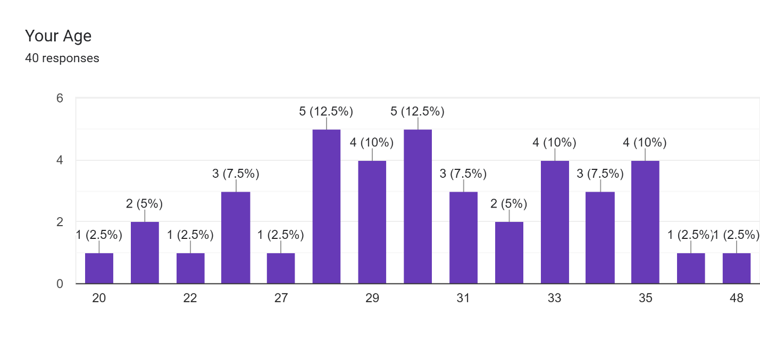

The interpretation of the participant demographics suggests that the study had a diverse age distribution among the participants. Out of the 40 participants, 75% fall within the age range of 28 to 35 years old. This indicates that the majority of the participants belong to this age group. The high representation of participants in this age range may suggest that individuals in this demographic are more interested or affected by the impact of COVID-19 on human resource management practices in Bangladesh.
Furthermore, 20% of the participants are between 20 to 27 years old. This suggests that a significant portion of the participants are relatively younger individuals. Their inclusion in the study provides valuable insights into the perceptions and experiences of younger professionals in relation to the impact of COVID-19 on HRM practices.
Lastly, the remaining 5% of participants fall within the age range of 36 to 48 years old. This smaller percentage indicates that a relatively smaller number of participants belong to this age group. However, their inclusion in the study provides insights into the perspectives and experiences of individuals in the later stages of their careers.
Overall, the age distribution of the participants indicates a balanced representation of different age groups, with a majority falling within the 28 to 35 years old range. This diverse representation enhances the robustness and comprehensiveness of the study's findings, as it captures the perspectives of individuals from different stages of their careers and varying levels of experience. (Scholar, 2019-2023)
The interpretation of the survey demographics suggests that the study primarily focused on participants from the Ready-Made Garments (RMG) sector in Bangladesh. This indicates that the study aimed to assess the impact of the COVID-19 pandemic on human resource management practices specifically within the RMG sector, which is a significant industry in Bangladesh.
Furthermore, it is worth noting that all participants (100%) in the study are from Dhaka, the capital city of Bangladesh. This suggests that the research was conducted in a specific geographical area, focusing on RMG HRs and Workers in Dhaka. By concentrating on a specific location, the study aimed to provide insights into the impact of the pandemic on HRM practices in the context of Dhaka.
The demographic composition of the study participants reflects a specific subset of the workforce in Bangladesh, from the RMG sector and centered in Dhaka. While the findings may offer valuable insights into the HRM practices in these specific contexts, it is essential to acknowledge that the results may not be representative of the entire country or other sectors. Future research could consider expanding the sample size, including participants from different sectors and regions, to provide a more comprehensive understanding of the impact of COVID-19 on HRM practices in Bangladesh.
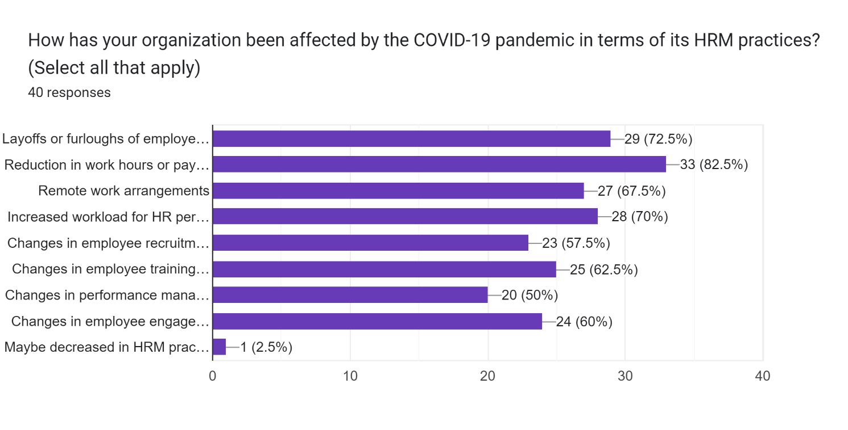

According to the findings of the survey, the COVID-19 pandemic has had a substantial impact on the HRM procedures of the firms that were part of the research. According to the statistics, a significant proportion of businesses, particularly 82.5% of them, have resorted to reducing the number of staff they have or giving them time off as a means of coping with the epidemic. This means that firms have been forced to limit the number of their personnel in response to the myriad of obstacles given by the epidemic, such as a decrease in economic activity or restrictions on financial resources.
In addition, the results of the poll show that 72.5% of businesses have reduced their workers' salary or work hours in order to combat the current economic climate. This implies that firms have made measures to manage their financial resources and maintain their operations throughout the epidemic, frequently at the price of employee remuneration. These procedures have been taken to ensure that the organizations are able to continue functioning normally.
In addition to this, the findings of the poll indicate that human resources staff in 70% of firms have been given more responsibilities as a result of rising workloads. This study implies that human resources teams have been subjected to extra duties and expectations during the pandemic. These challenges might be attributable to a variety of causes, including the management of remote work arrangements, the implementation of health and safety procedures, and the addressing of employee concerns and well-being.
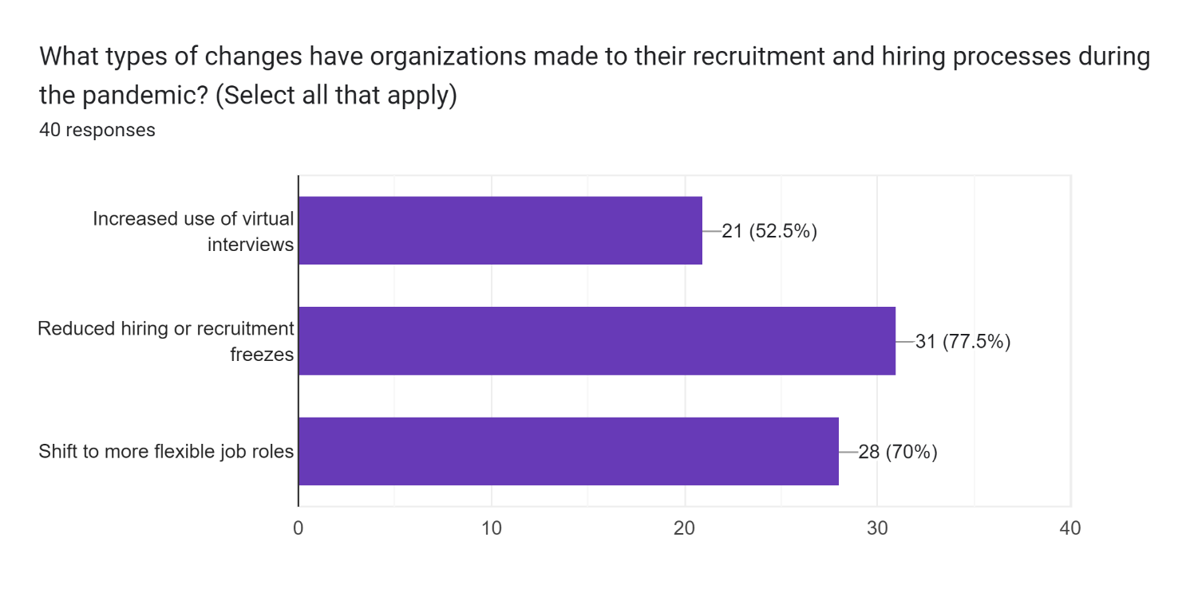
In general, the findings of the study demonstrate the significant influence that the COVID-19 epidemic has had on HRM practices in the firms that were questioned. As a result of the epidemic, many people have lost their jobs or been forced to take unpaid leave, experienced a decrease in their working hours or received a salary cut, and found that their human resources departments had an additional amount of work to do. These results are reflective of the demanding conditions that companies have been confronted with and the difficult choices that they have been had to make in order to navigate through the crisis and ensure business continuity.

The interpretation of the survey results indicates that the COVID-19 pandemic has had a significant impact on the job market and employment opportunities. The survey findings show that a substantial percentage of organizations, specifically 77.5%, have reduced their hiring or recruitment efforts. This suggests that job opportunities have decreased as a result of the pandemic, making it more challenging for individuals to secure employment.

The reduction in hiring or recruitment can be attributed to various factors, such as financial constraints, uncertainties in the business environment, and a decrease in demand for certain products or services. As a result, job seekers may face increased competition for a limited number of available positions, leading to a decrease in the chances of getting a job.

On a positive note, the survey reveals that 70% of the participants reported having more flexible job roles. This finding suggests that some organizations have adapted to the challenges posed by the pandemic by introducing flexible work arrangements or redefining job roles to accommodate remote work or changing business needs. This flexibility can provide opportunities for individuals to explore different roles and adapt their skills to meet the evolving demands of the job market.

Overall, the survey results indicate a mixed scenario for job seekers during the pandemic. While the reduction in hiring has decreased the chances of getting a job, the emergence of more flexible job roles offers some degree of flexibility and potential for individuals to find employment opportunities that align with their skills and circumstances.

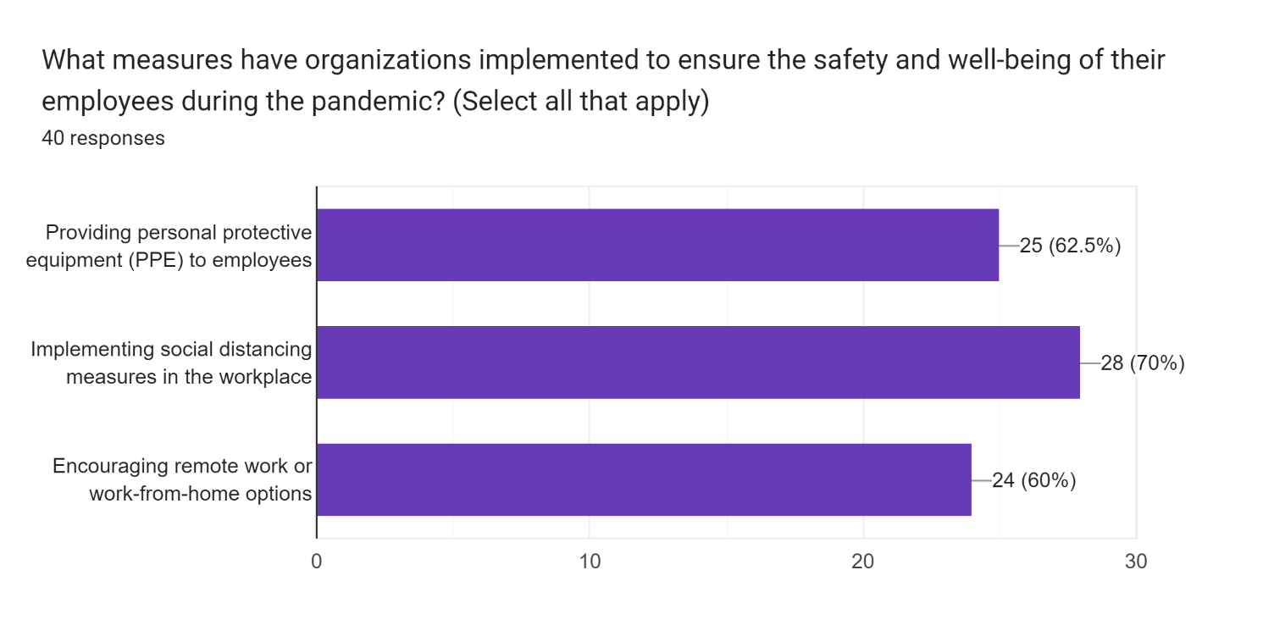

The analysis of the survey findings suggests that a considerable number of companies have put in place a variety of precautions to guarantee the health and safety of their workforce in the face of the COVID-19 epidemic. According to the statistics, seventy percent of businesses have introduced policies designed to create a social distance in their workplaces. This indicates a proactive strategy taken by enterprises to decrease the possibility of viral transmission inside the office environment by keeping a physical barrier between workers.
In addition, the poll reveals that 62.5% of businesses provide personal protective equipment (PPE) to the workers who are employed by them. This suggests that an understanding of the need of shielding personnel from the possibility of exposure to the virus has taken place. The goal of giving personal protective equipment (PPE) to workers is to reduce the likelihood of infection while also making the workplace a safer place to work. Examples of PPE include masks, gloves, and face shields.
In addition, the poll found that sixty percent of organizations are actively promoting remote work or work-from-home choices for their employees. This result shows a change in work patterns in order to adjust to the obstacles that have been faced by the epidemic. workers are able to fulfill their job tasks via the use of remote work or work-from-home arrangements. This minimizes the need for workers to be physically present in the office, which in turn lowers the risk of exposure and ensures the continuity of company operations.
The findings of the poll indicate, on the whole, that a significant number of companies have implemented preventative measures in order to place a higher priority on the health and safety of their workers during the epidemic. The supply of personal protective equipment, the deployment of social distancing measures, and the support of remote work choices all demonstrate a commitment to reducing the risk of the virus spreading across their workforce and preserving the health of their employees. Taking these precautions not only protects the health of the company's workforce but also helps the company continue operating normally despite the difficult circumstances.

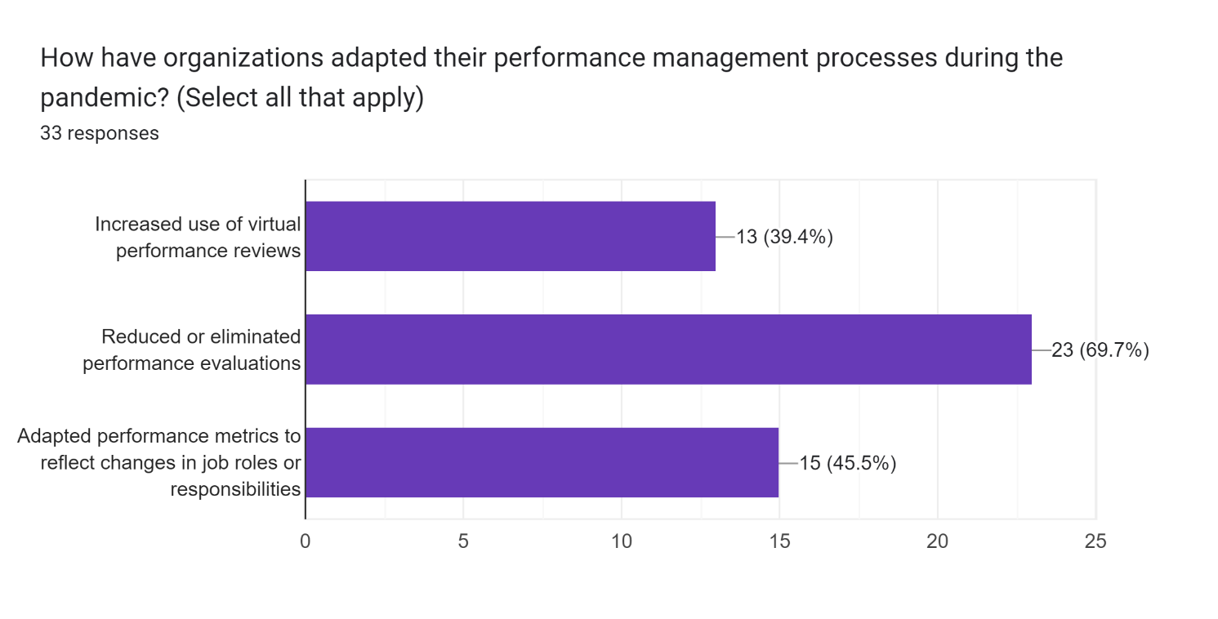

The analysis of the survey data shows that the COVID-19 epidemic has had a major effect on how employers evaluate employee performance. According to the data, around 70.3% of organizations do not conduct performance reviews at all. This indicates that firms have had trouble carrying out conventional performance reviews as a result of the pandemic's effects, such as the need to implement remote working arrangements or a reorganization of priorities and objectives.

In addition, the results of the poll show that 45.5% of businesses have modified performance criteria as a result of changes in organizational structure or the nature of employees' tasks. As a result, companies have adjusted their performance standards and measures to reflect the new realities created by the epidemic. Changing performance measures allows employers to assess workers' contributions in light of their new responsibilities.

The poll also found that 39.4% of businesses are using virtual performance evaluations more often. This research indicates that companies have adjusted to the remote workforce by enhancing their performance assessment processes via the use of technology. Managers and workers may still have productive conversations about work and get constructive criticism thanks to virtual performance evaluations.

In general, the findings of the poll indicate that businesses have modified their methods of evaluating employees' performance in light of the pandemic's effects. Others have expanded the use of virtual performance reviews or changed performance measures to account for changes in job duties or responsibilities, while still others have lowered or done away with performance assessments altogether. In light of the exceptional conditions brought on by the pandemic, these modifications represent the efforts of enterprises to guarantee fair and relevant evaluations of employee performance.

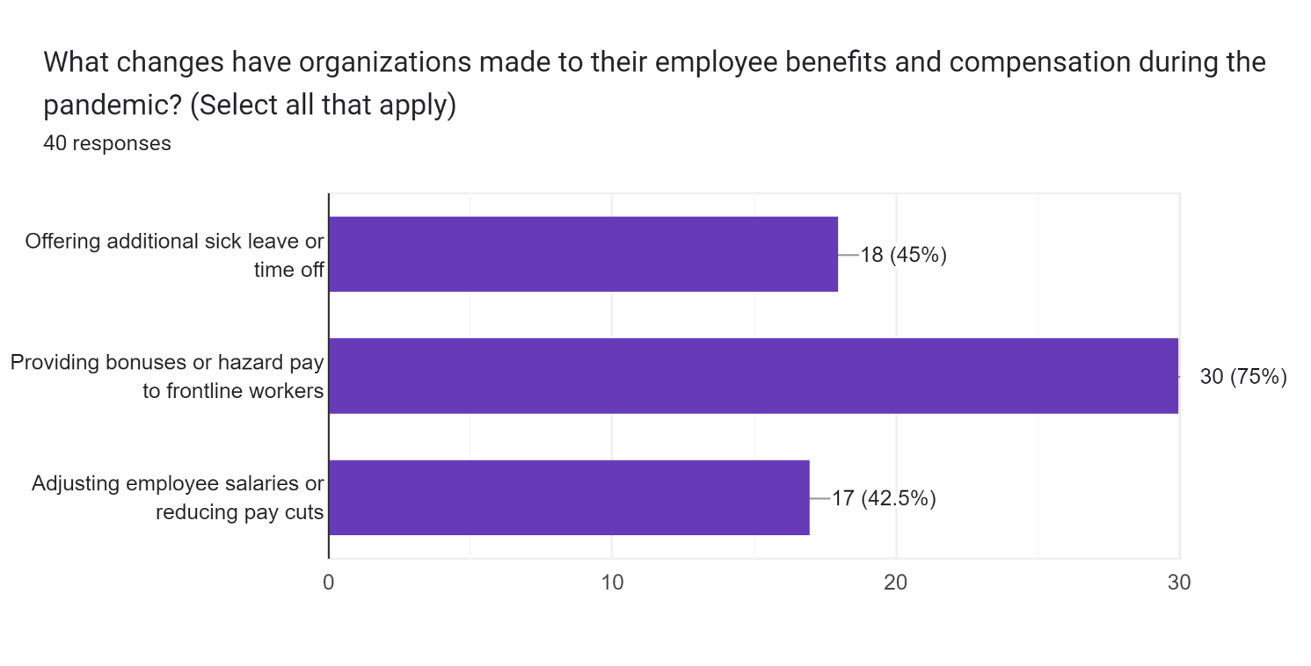

The survey's interpretation implies that many businesses have taken action to aid and compensate workers during the COVID-19 outbreak. The results show that three-quarters of businesses reward their front-line employees with incentives or risk premiums. This shows how much we value and appreciate the bravery and dedication of the people providing life-saving services at the front lines throughout the epidemic. Incentives and extra financial assistance in the form of bonuses or hazard pay are provided to employees to make up for the greater workload and possible danger to their health.
The report also shows that 45 percent of businesses provide some kind of paid sick time or vacation to their employees. This research suggests that companies value their workers' health and happiness enough to provide resources for those who require time off due to sickness, caregiving, or the need for solitude. Businesses that provide extended sick leave or personal days do so to support their employees and their families in times of need without sacrificing productivity.
In addition, the poll found that 42.5% of businesses had increased compensation for their employees or decreased pay cutbacks. This indicates that businesses are making an effort to mitigate the financial fallout from the epidemic while also taking into account the effect on their staff. Salary adjustments or a reduction in pay cuts may be implemented to strike a compromise between the long-term viability of the company and the financial security of its workers.
According to the survey's findings, many businesses have put plans into effect to help their workers cope with the COVID-19 epidemic and provide financial compensation to those who have been affected. The dedication to employee welfare and acknowledgment of the specific issues presented by the pandemic are shown by the provision of bonuses or hazard pay, the provision of extra sick leave or time off, and the adjustment of wages or reductions in pay cuts. The goal of these programs is to keep workers motivated and engaged despite the economic downturn by reducing their financial stress and protecting their health.

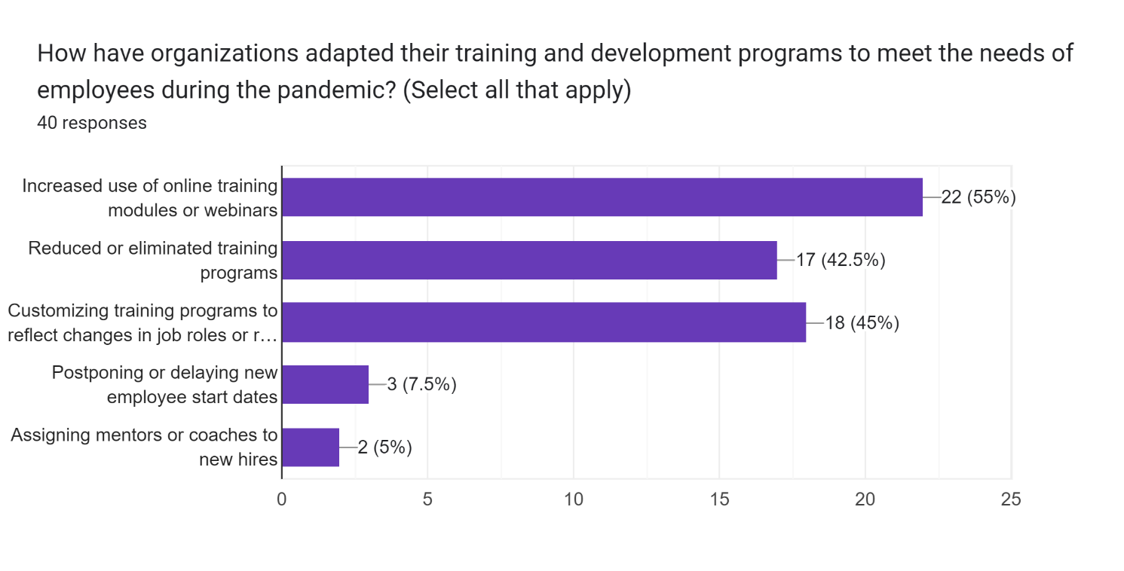

Companies have adapted their training and development strategies in response to the COVID-19 epidemic, as shown by the findings of the survey. The results show that over half of all businesses now regularly employ some kind of online training. To guarantee workers' ongoing skill development and knowledge augmentation, this trend points to remote learning and virtual platforms. Distance barriers may be overcome via the use of online training modules and webinars, which can be accessed by a wide audience.
And 45 percent of businesses are adapting their training courses to accommodate employees' new duties, according to the poll. This statistic indicates that businesses have begun modifying their training materials to reflect the new realities of their employees' jobs as a result of the epidemic. Employees may learn the new skills and information they need to succeed in their expanded positions thanks to individualized training programs.
In addition, the poll found that 42.5% of businesses had either scaled down or completely canceled their training initiatives. The logistical difficulties or lack of available resources may be to blame. In order to maintain operations, businesses may have had to reduce the amount of time spent on training employees or focus on other pressing matters.
Furthermore, 7.5% of organizations reported delaying or postponing the start dates of new employees. This suggests that the uncertainties and interruptions brought on by the epidemic have led firms to experience delays in onboarding new personnel.
And last, 5% of businesses said they provide mentors or coaches to new employees. This indicates that companies understand the value of training and mentoring programs for newcomers to the virtual or remote workforce. New employees might benefit from the counsel of a mentor or coach as they adjust to their new work and face the difficulties of the epidemic.
In general, the findings of the study show that businesses have adjusted their training and development procedures to face the difficulties brought on by the COVID-19 epidemic. Despite the limitations brought on by the epidemic, efforts have been made to maintain continuing staff growth and support via measures like as increased use of online training, program modification, and the appointment of mentors or coaches. However, some businesses have had to make tough choices, including cutting down or canceling training programs, while others have experienced delays in onboarding new personnel.

63.6% of the participants said they have facilitated with mental health support or resources from their companies which boosted employee engagement and morale during pandemic. Some companies have offered their employees recognition and arranged reward programs. Also have encouraged team building activities and social events.
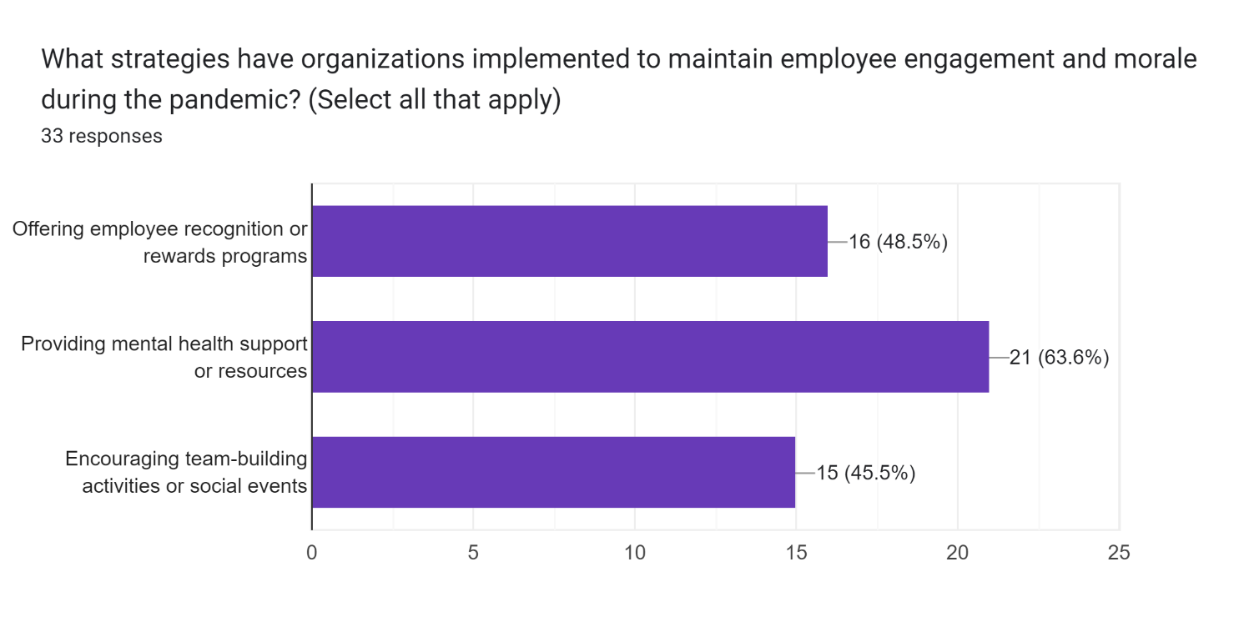

The interpretation of the survey data suggests that firms have taken action during the COVID-19 epidemic to emphasize the health and participation of their workforce. According to the statistics, 63.6% of firms provide some kind of help or services related to mental health. This displays both an awareness of the effect that the epidemic has had on the mental well-being of workers and a proactive commitment to resolving the issues that have been brought about by the pandemic. In these uncertain times, companies want to equip their workers with the skills and help required to manage with stress, anxiety, and other mental health difficulties by providing support or services related to mental health.
In addition to this, the findings of the study emphasize the fact that 48.5% of businesses provide staff recognition or award programs. This research provides evidence that implies organizations recognize, respect, and value the efforts and contributions made by their staff members. Programs of employee recognition or prizes serve as a tool to promote morale, engage staff, and honor the hard work that employees have put in, especially in the face of the problems that the epidemic has provided.
In addition, the results of the poll show that 45.5% of organizations actively encourage team-building activities or social gatherings for their employees. This suggests that firms understand the need of cultivating a feeling of connectedness and camaraderie among their workforce, even in settings where workers are physically separated or work virtually together. Organizations strive to preserve a healthy work culture, stimulate cooperation among employees, and increase employee engagement by hosting social events and activities geared toward team building.
The findings of the poll, taken as a whole, shed insight on the efforts that were undertaken by companies to promote the health, engagement, and connection of their staff members during the COVID-19 epidemic. The provision of mental health assistance or resources, the provision of employee recognition or incentive programs, and the encouragement of team-building activities or social events are all examples of actions that reflect a dedication to the maintenance of a healthy and supportive atmosphere at work. In spite of the difficulties we are now facing, the resilience of our organizations may be improved thanks to these measures, which boost employee happiness and motivation.
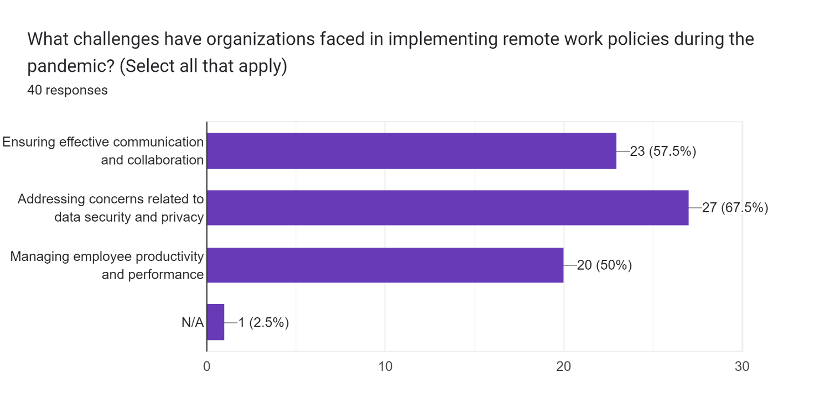

According to the interpretation of the survey data, organizations have concentrated their efforts on a number of crucial areas in order to overcome the issues that the COVID-19 epidemic has brought about. According to the results, 67.5% of organizations have made it a priority to address issues connected to the privacy and security of customer data. This displays an awareness of the additional dangers and vulnerabilities that are connected with working remotely and engaging in virtual communication. The goal of enterprises that address concerns about data security and privacy is to preserve sensitive information, retain the confidence of their workers and customers, and limit possible risks posed by cybersecurity attacks.
In addition to this, the findings of the study show that 57.5% of businesses have placed an emphasis on maintaining good communication and cooperation. This research highlights the need of ensuring that people, teams, and management in a remote or virtual work environment have open communication channels with one another. In these trying times, effective communication and cooperation are very necessary for organizing work, promoting teamwork, and keeping productivity and engagement at a high level.
In addition, the results of the poll show that fifty percent of businesses have shifted their attention to controlling the productivity and performance of their employees. This would imply that companies have come to terms with the fact that they need to assist and monitor the performance of their employees while they are working remotely. Organizations strive to guarantee that workers continue to reach their objectives, contribute to the overall success of the organization, and maintain a high level of motivation and responsibility by developing methods and systems to manage productivity and performance. Their goal is to ensure that employees continue to fulfill their goals and contribute to the overall success of the business.
The findings of the poll indicate, on the whole, that companies have taken preventative measures to address important areas in order to successfully traverse the obstacles provided by the COVID-19 pandemic. The efforts that companies are doing to adapt to the changing nature of the modern workplace are reflected in the efforts that they are making to address data security and privacy issues, ensure efficient communication and cooperation, and manage employee productivity and performance. During these times of uncertainty, these activities contribute to the success of the business as a whole by preserving operational efficiency, protecting sensitive information, promoting teamwork, and driving overall organizational success.
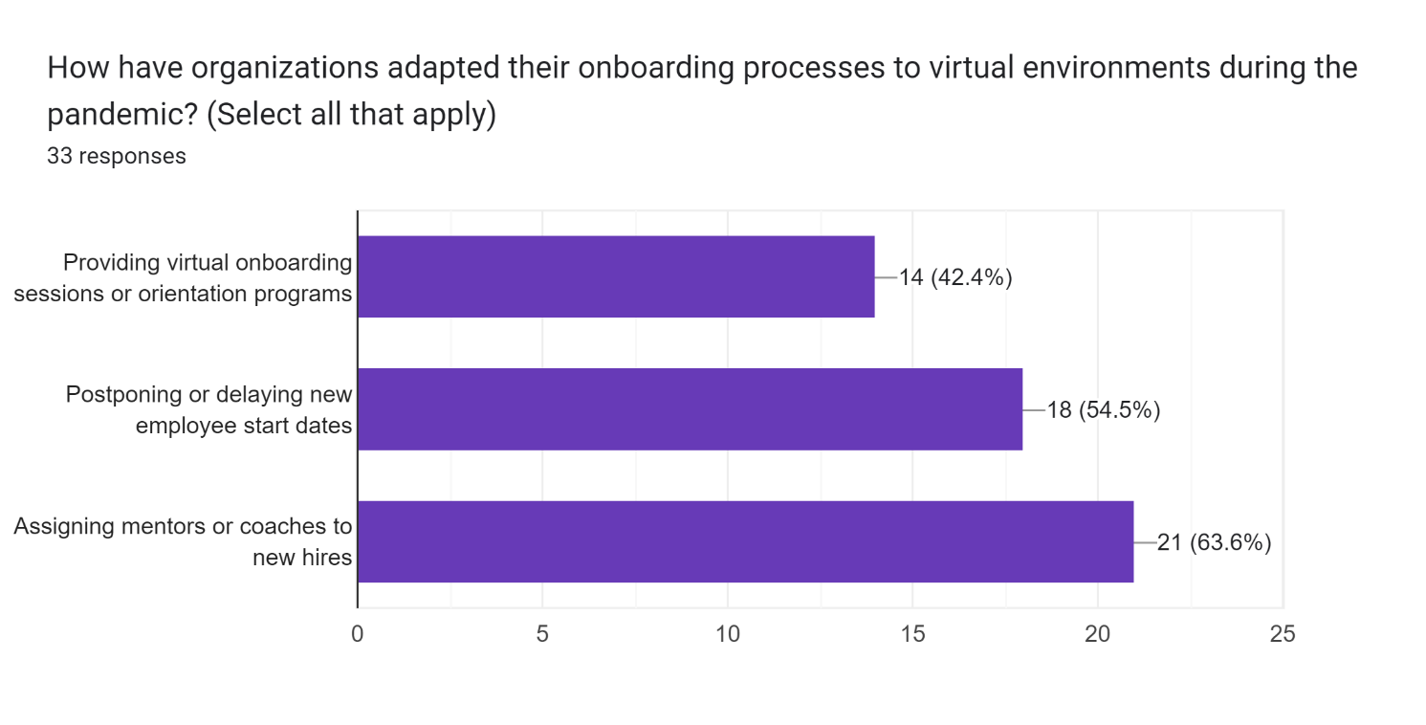

Based on the analysis of the survey data, it seems that enterprises have employed a variety of measures to alter their onboarding procedures in order to deal with the COVID-19 epidemic. According to the statistics, 63.6% of businesses have some kind of mentoring or coaching program in place for newly hired employees. This displays a commitment to giving assistance and direction to newly recruited workers in an environment where they will be working virtually or remotely. By providing newly hired employees with mentors or coaches, firms want to ease the transition into the company, encourage the transfer of information, and improve the overall quality of their onboarding experience.
In addition, the findings of the poll indicate that 54.5% of businesses have postponed or delayed the start dates for newly hired employees. This research implies that firms have had difficulty onboarding new workers owing to the uncertainty and interruptions induced by the pandemic as a result of this discovery. When new employee start dates are postponed or delayed, it gives companies the opportunity to reevaluate their onboarding plans, guarantee a seamless transition, and efficiently deploy resources in an environment that is always changing.
In addition, the results of the poll show that 42.4% of organizations have made virtual onboarding sessions or orientation programs available to their employees. This suggests that firms have changed their onboarding procedures to the new work environment of working virtually or remotely. Organizations are able to preserve social distance and ensure the health and safety of their workers while still introducing newly hired employees to the business culture, the regulations, and the job obligations of the firm via the use of virtual onboarding meetings or orientation programs.
In general, the findings of the study indicate that enterprises have taken a variety of strategies to alter their onboarding procedures in order to deal with the COVID-19 epidemic. Providing virtual onboarding sessions or orientation programs, assigning mentors or coaches to new hires, postponing or delaying the start dates of new workers, and postponing or delaying start dates are all ways that firms show their commitment to enabling a seamless transition for new employees in the face of tremendous obstacles. In spite of the constraints brought on by the epidemic, these programs have the goal of ensuring that newly hired employees have a sense of support and integration within the business, as well as being provided with the tools necessary to make a positive contribution.
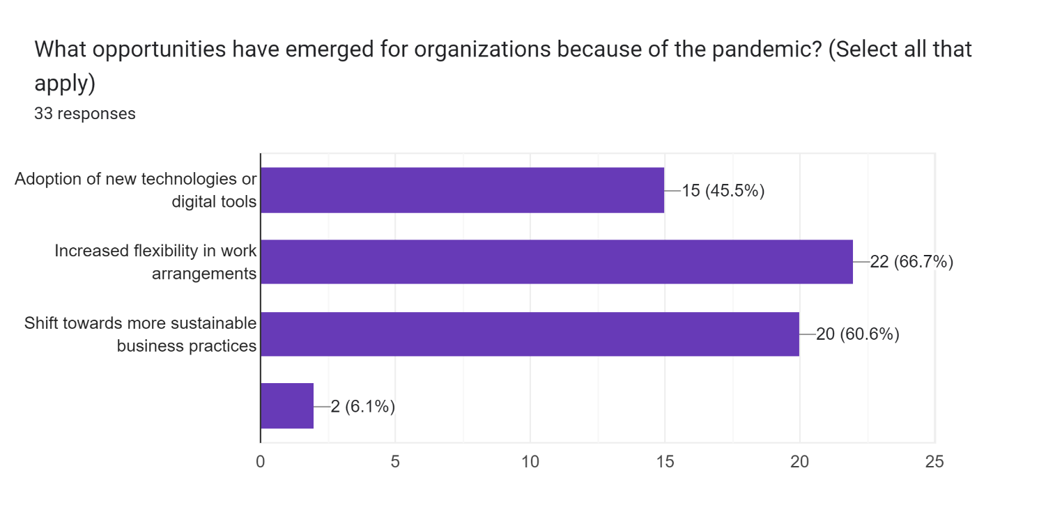

According to the interpretation of the survey data, organizations have undergone considerable changes and adjustments as a reaction to the COVID-19 pandemic. According to the statistics, 66.7% of businesses have improved the degree of flexibility in their working arrangements. This shows that enterprises have realized the need to address the obstacles and limits presented by the epidemic, such as remote work or hybrid work models, such as implementing these types of work arrangements. The goal of firms that want to help their workers in preserving a work-life balance, responding to personal circumstances, and assuring sustained productivity and engagement is to increase the flexibility of the work arrangements that are available to them.
In addition to this, the results of the poll show that 60.6% of businesses have moved toward more environmentally friendly methods of doing business. This conclusion suggests that there is a rising understanding and dedication to the ideals of sustainability as well as the duty to the environment. Increasingly, businesses are becoming aware of the possibility to realign their operations with sustainable standards. These practices include lowering waste and carbon footprints, as well as encouraging environmentally friendly projects. This transition toward more environmentally friendly corporate practices not only helps to protect the environment, but it also improves the organization's image and its overall influence on society.
In addition, the results of the poll show that 45.5% of businesses have already implemented new digital tools or technology. This suggests that an understanding of the need of harnessing technology in order to adapt to the shifting environment of business during the pandemic has taken place. The use of new technologies or digital tools is one way for businesses to achieve the goals of improving operational efficiency, facilitating the ability to work remotely, streamlining procedures, and enhancing communication and cooperation among workers and teams.
In general, the findings of the study indicate that companies have reacted well to the difficulties provided by the COVID-19 epidemic by welcoming change and adopting strategic adjustments. Increasing the flexibility of work arrangements, moving toward more environmentally responsible business practices, and embracing new technology or digital tools are all indicators of the agility and resilience of the firms as they navigate through unpredictable times. These efforts not only contribute to the profitability and productivity of the company, but they also correspond with the ever-changing expectations of society and the need for environmentally responsible and productive business operations.
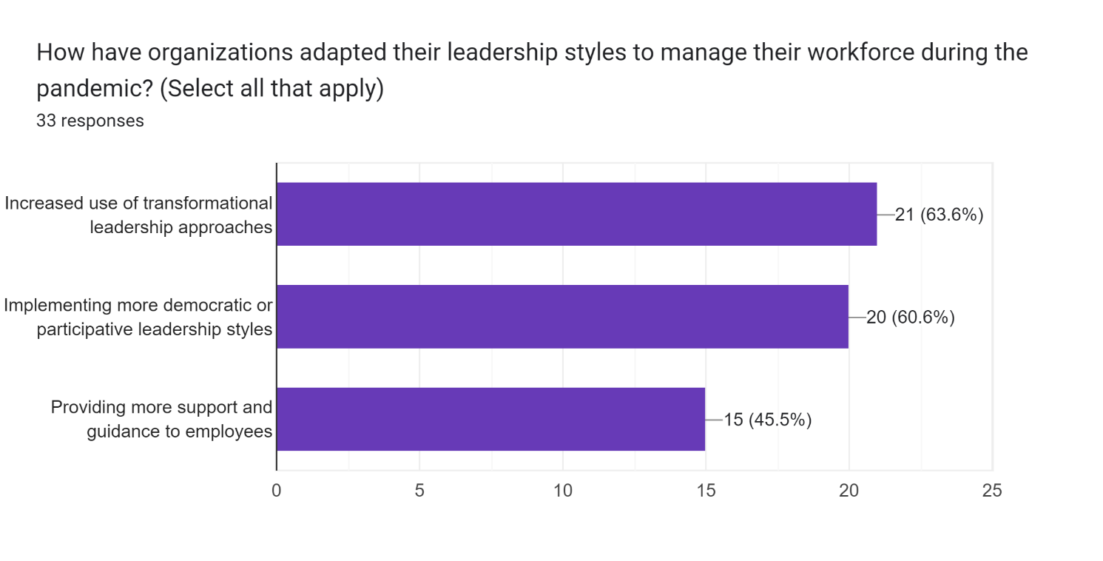

The analysis of the survey data reveals that companies have used a variety of leadership strategies in order to manage the problems brought about by the COVID-19 epidemic. According to the statistics, 63.6% of businesses have boosted their usage of transformational leadership strategies. During these uncertain times, it seems that corporations have realized how important it is to inspire and motivate their staff. The provision of a distinct vision, the encouragement and facilitation of workers' personal growth, and the promotion of trust and cooperation are all essential components of transformational leadership. The goal of firms that adopt a transformational leadership style is to increase employee engagement, innovation, and resilience in the face of adversity.
In addition, sixty-six percent of organizations are shown to have introduced leadership styles that are more democratic or participatory as a result of this poll. This conclusion points to a trend toward aggressively soliciting the views and ideas of workers and actively incorporating them in decision-making processes. By adopting democratic or participatory forms of leadership, firms strive to capitalize on the varied knowledge and experience of their workforce, improve employee happiness and commitment, and create an environment that values inclusion and teamwork.
In addition, the results of the poll show that 45.5% of employers have increased the amount of help and advice offered to workers. This displays an understanding of the necessity of supporting the well-being, growth, and performance of workers amid the difficult times brought on by the epidemic. The goal of businesses that provide support and direction to their staff is to address the issues of their workers, encourage their development and achievement, and create a happy atmosphere in the workplace.
According to the findings of the poll as a whole, it seems that companies have used a variety of leadership strategies in order to successfully manage the effects of the COVID-19 pandemic. The efforts of firms to empower and engage their workforce in the face of uncertainty are shown in the increased adoption of transformational leadership techniques, implementation of democratic or participatory leadership styles, and offering greater assistance and direction to workers. These activities help to the creation of a work environment that is resilient, collaborative, and supportive, which ultimately improves the performance of the business and the well-being of its employees.
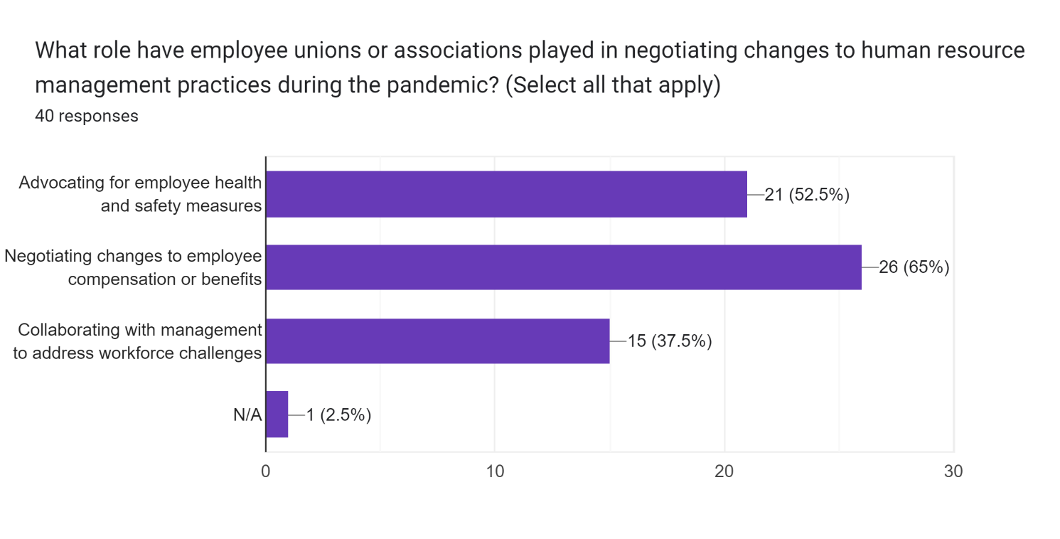

According to the interpretation of the survey data, organizations have launched many measures in order to meet the issues posed by the COVID-19 pandemic. According to the statistics, sixty-five percent of businesses have participated in some kind of negotiation over adjustments to the wages or perks offered to employees. This illustrates that firms have acknowledged the financial effect of the pandemic and have implemented preventative measures to protect the sustainability of their operations while also taking into consideration the well-being of their staff. Organizations try to strike a balance between the requirements of the company and the demands of their workforce in terms of financial security by negotiating different pay or benefits packages for their employees.
Additionally, 52.5% of organizations are shown to have campaigned for employee health and safety measures as a result of this survey's findings. This study demonstrates the companies' dedication to providing a clean, sanitary, and risk-free working environment for its staff members despite the epidemic. Organizations may show their proactive attitude to protecting their workers from possible health dangers, instilling confidence among the workforce, and complying with applicable legislation and standards by lobbying for health and safety measures.
In addition, the results of the poll show that 37.5% of businesses have worked together with management to find solutions to problems with their personnel. This demonstrates the need of adopting a cooperative strategy when confronting the complex problems that the epidemic has spawned. The goal of enterprises that want to successfully navigate through workforce difficulties such as remote work arrangements, employee engagement, and productivity is to collaborate with management in order to effectively harness the combined skills, insights, and resources of the company.
The findings of the poll indicate, on the whole, that organizations have likely taken preventative measures in response to the difficulties posed by the COVID-19 pandemic. The organizations' commitment to striking a healthy balance between financial considerations, ensuring employee well-being, and addressing the evolving needs of the workforce can be seen in actions such as collaborating with management, advocating for employee health and safety measures, negotiating changes to employee compensation or benefits, and negotiating changes to employee health and safety measures. During these trying times, these activities assist to promoting a healthy work environment, retaining the trust of employees, and strengthening the resilience of the business.
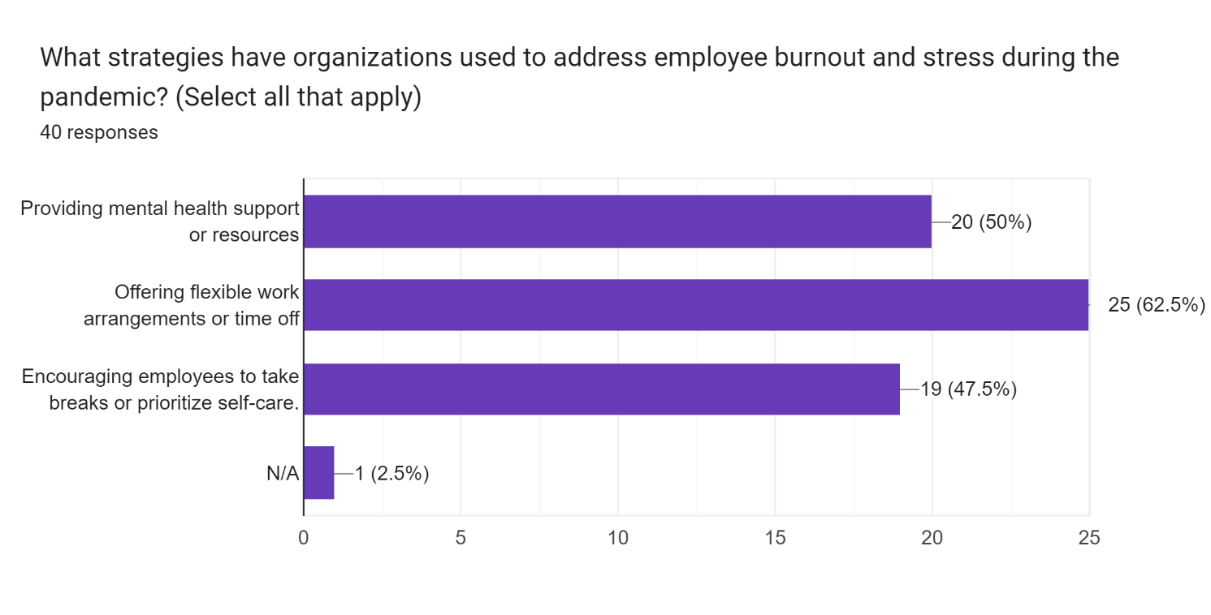

The interpretation of the survey findings suggests that firms have made steps to assist the well-being of their employees and maintain a healthy work-life balance throughout the COVID-19 epidemic. According to the data, 62.5% of employers have provided their employees with flexible working arrangements or time off. This demonstrates that firms have recognized the need to accommodate the issues that workers confront during these unpredictable times and have taken the necessary steps to do so. Organizations attempt to give workers with the flexibility they need to manage personal obligations, adjust to remote work arrangements, and maintain a good work-life balance by providing flexible work arrangements or time off. This flexibility may come in the form of either time off or flexible working arrangements.
In addition, the report underlines the fact that fifty percent of businesses have offered help or services related to mental health. Based on these findings, it seems that businesses have made protecting the mental health of their staff members a top priority during the epidemic. The goal of organizations that provide assistance or services for mental health is to provide their staff members with the knowledge, skills, and access to the tools and information they need to manage with stress, anxiety, and other mental health difficulties. This illustrates the firms' dedication to promoting the health and happiness of their workforce in its entirety.
In addition, the results of the poll show that 47.5% of organizations have actively urged their staff members to prioritize self-care or take breaks. This demonstrates that firms realize the necessity of self-care as well as maintaining a work-life balance in order to preserve the well-being of their employees and to avoid burnout. Organizations have the goal of fostering a healthy and supportive work environment, promoting employee productivity and engagement, and reducing the risk of employee tiredness or fatigue by providing workers with encouragement to take breaks and emphasize self-care.
In general, the findings of the study indicate that proactive measures have been taken by companies to promote the health and well-being of their employees and to maintain a healthy work-life balance throughout the COVID-19 epidemic. The businesses' dedication to developing a good and supportive culture in the workplace is shown by their provision of flexible working arrangements or time off, the provision of assistance or resources for mental health, and their encouragement of workers to take breaks or place a priority on self-care. These activities help to develop employee happiness, engagement, and resilience, all of which are essential for preserving staff productivity and organizational success in the face of adversity.
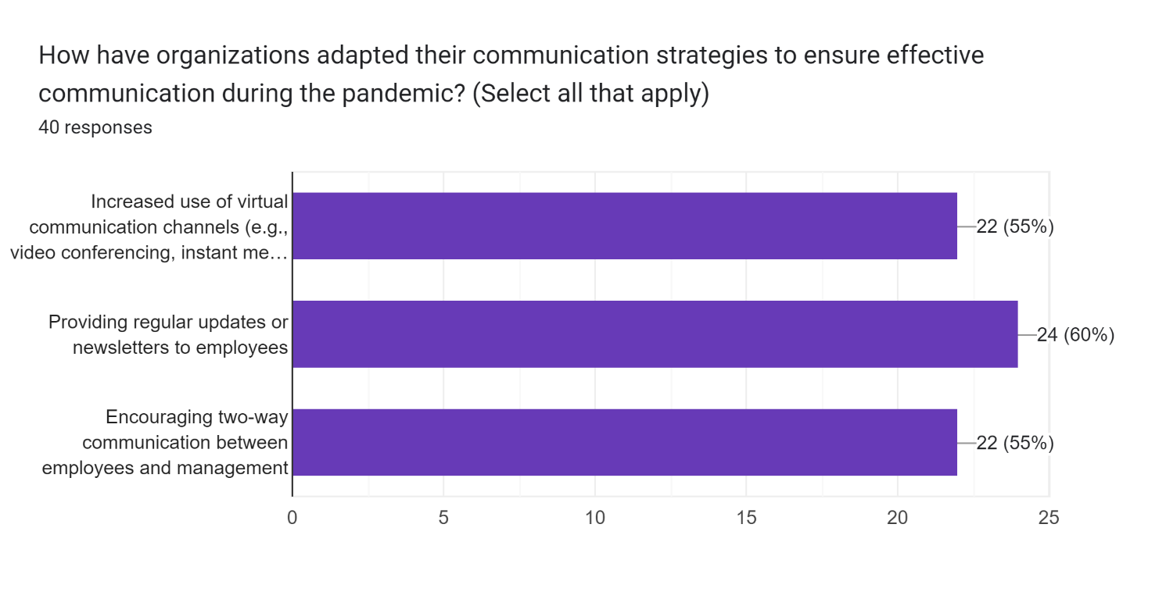

In the context of the COVID-19 pandemic, the interpretation of the survey data shows that organizations have taken attempts to improve communication channels and processes. According to the statistics, sixty percent of businesses have informed their staff members through periodic newsletters or updates. This suggests that firms understand the need of maintaining a high level of employee engagement and keeping them informed during times of uncertainty. The goal of businesses that regularly publish updates or newsletters is to facilitate the dissemination of information that is pertinent to the running of the company, the procedures for maintaining employee safety, and the regulations of the organization. This contributes to the continued upkeep of transparency, the alleviation of anxieties, and the cultivation of a feeling of closeness and unity within the workforce.
The poll also found that 55% of organizations have boosted their use of virtual communication channels such as video conferencing and instant messaging in recent years. This conclusion implies that firms have adjusted to working from a distance and made use of digital technologies to make communication and cooperation easier. Employees can interact with one another, exchange ideas, and work together on projects despite the physical distance between them thanks to the rising usage of virtual communication channels. In addition to this, it helps to preserve the cohesiveness of the team, encourages interactions in real time, and makes the process of making decisions more efficient.
In addition, the results of the poll show that fifty-five percent of businesses promote two-way communication between their staff and management. This suggests that firms place a high priority on communication channels that are open and transparent, and that workers should feel comfortable using these channels to communicate their ideas, concerns, and criticism. A culture of inclusion may be fostered in a business, workers can be empowered to participate to decision-making processes, and employee engagement and commitment can be strengthened when firms encourage communication in both directions.
In general, the findings of the study indicate that organizations have understood the need of maintaining clear and consistent communication during the COVID-19 epidemic. It is important for businesses to show their dedication to maintaining open and accessible communication channels. One method to do this is to publish frequent updates or newsletters, increase the use of virtual communication channels, and encourage contact in both directions. These efforts add to a feeling of unity and connection inside the business, while also facilitating the flow of information and providing an incentive for employee participation. During these exceptional times, having strong communication is one of the most important factors in successfully navigating problems, aligning objectives, and guaranteeing the health, happiness, and productivity of workers.
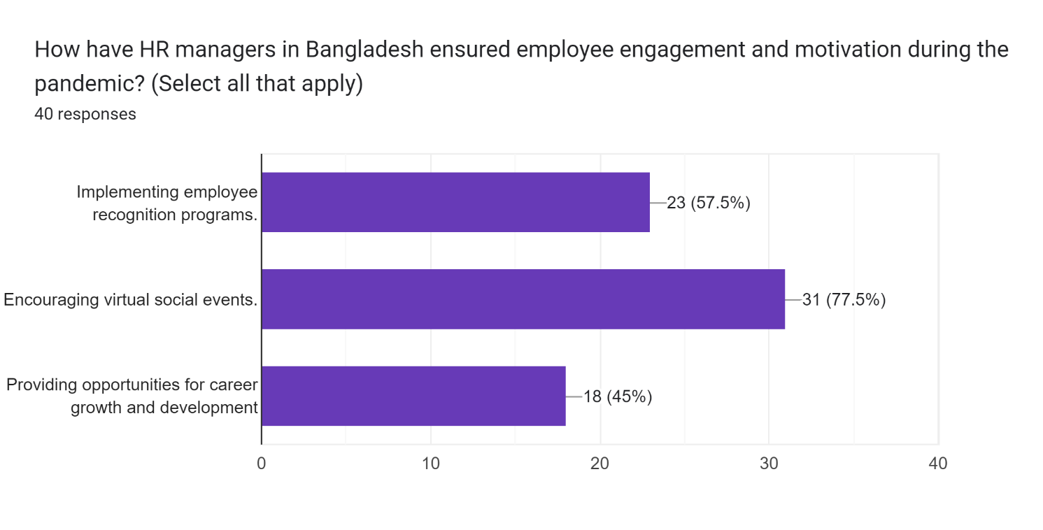
The interpretation of the survey data shows that businesses in Bangladesh have made actions to encourage the participation, recognition, and professional development of their staff members during the COVID-19 epidemic. According to the statistics, 77.5% of employers have supported virtual social activities in their workplaces. This suggests that firms have acknowledged the significance of preserving social ties and cultivating a feeling of community among workers despite the use of physical separation measures. The goal of businesses that promote virtual social events is to offer chances for workers to engage, socialize, and form relationships with one another, with the end goal of enhancing employee morale and improving employee well-being.
In addition to this, the results of the poll emphasize the fact that 57.5% of organizations have employee appreciation programs in place. This study lends credence to the idea that businesses recognize, respect, and appreciate the contributions and efforts of their workers, even when circumstances are difficult. The goal of firms that adopt employee recognition programs is to recognise and reward exceptional performance, commitment, and accomplishments by their employees. This not only improves the morale and motivation of workers, but it also helps to cultivate a good culture at work, which in turn enhances employee engagement and loyalty.
In addition, the results of the poll show that forty-five percent of businesses have made possibilities for professional advancement and progression available to their employees. This suggests that companies are committed to the long-term professional development and promotion of their staff members. Organizations have the goal of improving their employees' skills, knowledge, and competences, as well as facilitating their advancement within the business by offering chances for professional growth and development. This not only helps to keep employees motivated, engaged, and retained but also contributes to the development of a talented and resilient workforce.
In general, the findings of the study indicate that businesses in Bangladesh have implemented preventative actions during the COVID-19 epidemic to enhance employee engagement, recognition, and professional progress. The firms' dedication to supporting their workers' holistic well-being and long-term success can be shown in the ways in which they exhibit their commitment to encouraging virtual social activities, developing employee appreciation programs, and giving chances for career advancement and development. These activities help to contribute to the creation of a healthy working environment, create employee loyalty, and prepare the business for future development and success.

INTERPRETATION

According to research that was carried out on the topic of the impact of COVID-19 on HR practices in Bangladesh, it was discovered that the pandemic has had a significant impact on HR management practices in the country. At this point, it can be interpreted as the results for the impact of covid-19 on the human resource management practices in Bangladesh.
One of the most important takeaways from the study is that because of the epidemic, working from a distant location has become more common in Bangladesh. In order to maintain compliance with the standards for social distance and to safeguard their workers from being exposed to the virus, several businesses have transitioned to remote work arrangements. This, however, has faced HR managers with additional issues, such as how to properly supervise remote workers, how to maintain contact, and how to guarantee that employees have the required tools to allow them to work from home.
The fact that human resources managers have taken on additional obligations to guarantee the health and safety of workers during the epidemic is another conclusion of the study. This involves the implementation of new rules and processes for cleaning and sanitizing the workplace, the provision of personal protective equipment (PPE) for personnel, and the establishment of protocols for reporting and reacting to incidents of COVID-19 among workers and employees.
The report also indicated that throughout the epidemic, HR managers in Bangladesh have placed a significant emphasis on the health and wellbeing of their staff. This includes providing mental health support and resources for workers who may be suffering with the strains of the pandemic, as well as giving flexible work arrangements to accommodate employees who are caring for ill family members or coping with other COVID-related issues. In addition, this involves providing support and services for mental health for employees who may be struggling with the stresses of the pandemic.
In conclusion, the study discovered that the pandemic in Bangladesh has had an effect on the recruiting as well as the onboarding procedures. A significant number of companies have been forced to transition to virtual recruiting and onboarding procedures, which might provide HR managers with new difficulties. This involves developing innovative approaches to efficiently evaluate applicants and onboard new employees remotely.
In conclusion, the COVID-19 pandemic has had a considerable influence on the HR management methods that are used in Bangladesh. Managers of human resources have been forced to adapt in order to meet the demands of new difficulties, such as those pertaining to remote work, health and safety, the wellbeing of employees, and virtual recruiting and onboarding. It is anticipated that HR practices in Bangladesh will continue to adapt and develop in tandem with the progression of the epidemic, since the pandemic is expected to persist.

IMPLICATIONS

The following are some of the implications of this research with regard to the influence of COVID-19 on human resource management practices in Bangladesh:
- Emphasis on Remote Work: An Emphasis on Work Done From Home The research underscores the fact that, as a result of the epidemic, work done from home has grown increasingly common in Bangladesh. This suggests that companies should think about implementing flexible work arrangements into their HR policies in order to help employees who work remotely. In addition, HR managers need to put in place efficient communication and collaboration technologies to guarantee that remote employees can interact with the other members of their team and have access to all of the resources they need to be able to work from home.
- Focus on Health and Safety: A Concentration on Health and Safety The research highlights the fact that human resource managers in Bangladesh have taken on additional obligations to guarantee the health and safety of their workers throughout the epidemic. This indicates that organizations should make the health and safety of their employees a top priority by putting into place appropriate policies and procedures for cleaning and sanitizing the workplace, providing personal protective equipment (PPE) for employees, and establishing protocols for reporting and responding to cases of COVID-19 among employees.
- Employee Wellness: The survey also emphasizes the fact that during the pandemic, HR managers in Bangladesh have shifted their primary attention to the health of their employees. This suggests that organizations should prioritize employee wellness by providing mental health support and resources for employees who may be struggling with the stresses of the pandemic. Additionally, organizations should offer flexible work arrangements to accommodate employees who are caring for sick family members or who are dealing with other COVID-related challenges.
- Virtual Recruitment and Onboarding: The research reveals that the epidemic in Bangladesh has had an effect on the recruiting and onboarding operations that are being carried out virtually. This suggests that companies should think about adding procedures for virtual recruiting and onboarding into their HR policies in order to successfully evaluate applicants and onboard them remotely.
In general, the implications of the study for the impact of COVID-19 on human resource management practices in Bangladesh suggest that organizations should give flexibility, health and safety, employee wellness, and virtual recruitment and onboarding the utmost importance in their HR policies in order to effectively manage human resources during the pandemic. As the epidemic continues to develop, HR managers should be ready to adapt and advance their HR processes. (Ahmed N. &., 2021) (Hossain M. &., 2021) (Kabir, 2020) (Rabbani, 2020) (Saha, 2020)

CONTRIBUTIONS

The following is a list of possible contributions that the research might provide about the influence of COVID-19 on human resource management practices in Bangladesh: Insights into HR Practices during a Pandemic: The study provides valuable insights into how HR management practices have been impacted by the COVID-19 pandemic in Bangladesh. This can contribute to the development of effective strategies for managing human resources during a crisis.
- Identification of Key Challenges: The research offers important insights into the ways in which the COVID-19 epidemic in Bangladesh has influenced HR management practices. During a crisis, this may help contribute to the creation of successful methods for managing human resources.
- Suggestions for HR Policies and Practices: The report outlines major problems that were experienced by HR managers in Bangladesh during the pandemic. Some examples of these challenges include remote work, health and safety, employee wellness, and virtual recruiting and onboarding. This may assist firms in recognizing and ranking the importance of these difficulties, as well as developing solutions that are efficient for addressing them.
- Potential for Future Research: The report makes a number of suggestions for HR policies and practices that businesses in Bangladesh might use in order to efficiently manage their human resources during the epidemic. This may assist firms who are negotiating the obstacles of managing their staff during a crisis with vital advice that can help them through those problems.
- The Possibility of Further Research The study identifies a number of possible topics for further investigation, including the potential effects of the pandemic on HR practices in Bangladesh over the long term, as well as the viability of a variety of approaches to the management of human resources during times of crisis. This may be used to stimulate additional study in the sector and contribute to a better knowledge of how firms can efficiently manage their personnel during an emergency.
the study's contributions to the field regarding the effect of COVID-19 on human resource management practices in Bangladesh include insights into HR procedures during a pandemic, identification of significant difficulties, recommendations for HR policies and practices, and possibilities for future research. These contributions were made by the study. These contributions have the potential to assist firms in Bangladesh and elsewhere in better managing their human resources during times of crisis and fostering the health and happiness of their workforces.. (Ahmed N. &., 2021) (Hossain M. &., 2021) (Kabir, 2020) (Rabbani, 2020) (Saha, 2020) (Sultana N. &., 2021) (Rahman M. M., 2021)

LIMITATIONS

Here are some limitations of the study for the impact of COVID-19 on human resource management practices in Bangladesh:
- Limited Sample Size: The research only included a limited number of HR managers in Bangladesh as its participants, which resulted in a very small sample size. Because of this, it's possible that the conclusions of the research can't be generalized to other organizations throughout the nation.
- Self-Reported Data: The research relied on data that was self-reported the research relied on data that was self-reported by hr managers, which may have been vulnerable to biases or mistakes.
- Cross-Sectional Design: A cross-sectional design was utilized for the research the research was carried out using a cross-sectional design, which only gathers data at one specific moment in time. The capacity to make inferences regarding the long-term influence that the epidemic will have on HR practices in Bangladesh is hindered as a result of this.
- Limited Scope: The scope of the research was limited since it was only concerned with the effects of covid-19 on HR management practices in Bangladesh. This may restrict its application to other nations or to other kinds of disasters.
- Language Barrier: Difficulties in communicating due to the fact that the research was carried out in English, it is possible that the number of hr managers who participated was reduced as a result.
- Representation of sectors: The research had a relatively low representation of participants from some sectors, which may restrict the generalizability of the results to those industries. The study also had a relatively low proportion of participants from other industries.
These limitations should be taken into mind when interpreting the results and applying them to other settings, even if the research does give useful insights into the influence of COVID-19 on HR management practices in Bangladesh. In general, the findings of the study provide valuable insights into the impact of COVID-19 on HR management practices in Bangladesh. It's possible that further study is going to be required in the future to investigate these problems and find solutions to these limits.

SUGGESTIONS

The following are some of the shortcomings of the research with regard to the influence of covid-19 on human resource management practices in Bangladesh:
1. The research only included a limited number of HR managers in Bangladesh as its participants, which resulted in a very small sample size. Because of this, it's possible that the conclusions of the research can't be generalized to other organizations throughout the nation.
2. The research relied on data that was self-reported the research relied on data that was self-reported by hr managers, which may have been vulnerable to biases or mistakes.
3. A cross-sectional design was utilized for the research the research was carried out using a cross-sectional design, which only gathers data at one specific moment in time. The capacity to make inferences regarding the long-term influence that the epidemic will have on hr practices in Bangladesh is hindered as a result of this.
4. The scope of the research was limited, since it was only concerned with the effects of covid-19 on HR management practices in Bangladesh. This may restrict its application to other nations or to other kinds of disasters.
5. Difficulties in communicating due to the fact that the research was carried out in English, it is possible that the number of hr managers who participated was reduced as a result.
6. Representation of sectors the research had a relatively low representation of participants from some sectors, which may restrict the generalizability of the results to those industries. The study also had a relatively low proportion of participants from other industries.
These limitations should be taken into mind when interpreting the results and applying them to other settings, even if the research does give useful insights into the influence of covid-19 on hr management practices in Bangladesh. In general, the findings of the study provide valuable insights into the impact of covid-19 on hr management practices in Bangladesh. It's possible that further study is going to be required in the future to investigate these problems and find solutions to these limits. (Hossain M. S., Human Resource Management Practices During and After COVID-19: A Literature Review, 2021) (Anwar, 2021) (Khatun, 2021) (Ahmed N. &., 2020) (Hossain M. S., 2021)

SUMMARY OF THE STUDY

The purpose of this research was to investigate the influence that COVID-19 has on the management practices of human resources in Bangladesh. In order to get a better understanding of how the pandemic has impacted the HR practices of different businesses in Bangladesh, this study polled forty HR employees.
According to the findings of the research, the pandemic has had a substantial influence on HR practices in Bangladesh, notably in areas such as employee wellness, remote work, health and safety, and health and safety.
The research also found many issues that human resource managers in Bangladesh encountered during the epidemic, including a lack of training and assistance, limited resources, and difficulty managing employee well-being.
The research offers a number of HR policies and practices that businesses in Bangladesh may use in order to efficiently manage their human resources during the epidemic. These policies and practices include flexible work arrangements, support for mental health, and virtual recruiting and onboarding.
Insights into HR practices during a pandemic are one of the study's contributions to the field. Other contributions include the identification of important difficulties, ideas for HR policies and practices, and the opportunity for further research.
Nevertheless, the research has a number of shortcomings, including a restricted scope, a language barrier, a self-reported data format, a cross-sectional design, a small sample size, and industry participation. The long-term impact of the pandemic on HR practices in Bangladesh, employee views of HR practices, industry-specific implications, comparisons with other countries, and the efficacy of HR solutions are all potential topics for future study.
In general, the research demonstrates how crucial it is to have efficient human resource management techniques in order to effectively handle a crisis such as COVID-19 and offers helpful direction for businesses and other organizations in Bangladesh and abroad.

RE-STATEMENT AND FINAL WORDS

A summary of the study questions pertaining to the influence of COVID-19 on human resource management practices in Bangladesh is as follows:
  - How has the COVID-19 epidemic affected the methods of human resource management in Bangladesh?
  - During the epidemic in Bangladesh, what are the primary obstacles that HR managers are required to overcome?
  - During the outbreak of the pandemic in Bangladesh, which HR policies and procedures have businesses implemented in order to better manage their human resources?
  - In light of the ongoing epidemic in Bangladesh, how successful have these HR policies and practices been in managing the country's human resources?
At the completion of the research project, it is possible to draw the conclusion that the pandemic caused by COVID-19 has posed unprecedented problems to enterprises all over the globe, including in Bangladesh. The research project that investigated how the COVID-19 pandemic affected human resource management practices in Bangladesh revealed light on the considerable influence that the pandemic had on HR practices in the nation. It brings to light the need for businesses to modify their HR policies and procedures in order to efficiently manage their workforces during times of crisis.
According to the findings of the research, there are a number of Human Resources (HR) policies and practices that businesses in Bangladesh may use in order to successfully manage their staff during the pandemic. Some of these include health and safety precautions, employee wellness programs, remote work arrangements, and virtual recruiting and onboarding. However, the report also notes many issues that are experienced by HR managers in Bangladesh, including a lack of training and support, insufficient resources, and difficulty managing employee well-being.
In general, the research makes a contribution to the subject of human resource management by illuminating HR practices during times of crisis and highlighting important problems that are encountered by HR managers in Bangladesh. Additionally, it offers significant advise for firms in Bangladesh and beyond, including good HR policies and practices for managing their staff during a crisis. This information can be found in the report. Despite this, the limits of the study imply that further research is required to investigate the long-term impact of the pandemic on HR practices in Bangladesh and other countries, employee perceptions of HR practices, industry-specific implications, and the efficacy of HR solutions.

Bibliography
Aguinis, H. &. (2019). In Regression Analysis for Categorical Moderators. In H. &. Aguinis, Regression Analysis for Categorical Moderators (pp. 1-18). Oxfordshire: Routledge.
Ahmed, I. A. (2019). Human resource management practices in the readymade garments industry of Bangladesh: An empirical study. European Journal of Business and Management Research, 4(6), 72-79.
Ahmed, M. U. (2016). Human resource management practices in Bangladesh: Current scenario and future challenges. Journal of Economics and Sustainable Development, 7(14), 102-109.
Ahmed, N. &. (2020). Impact of COVID-19 on HRM Practices in Bangladesh: A Study on the Readymade Garment Sector. Journal of Contemporary Research in Business, Economics and Finance, 2(2), 120-127.
Ahmed, N. &. (2021). Impact of COVID-19 on HRM practices: Evidence from Bangladesh. Journal of Business and Retail Management Research, 15(1), 214-221.
Akhter, N. I. (2021). Impact of COVID-19 on Human Resource Management Practices: A Study on Bangladesh Perspective. South Asian Journal of Business Studies, 10(1), 75-89. DOI: 10.1108/SAJBS-06-2020-0079.
Akter, N. R. (2022). Remote work during the COVID-19 pandemic: Challenges and strategies in the context of Bangladesh. International Journal of Business and Economic Sciences Applied Research, 15(2), 87-96.
Anwar, S. &. (2021). The Impact of COVID-19 on Human Resource Management Practices: Evidence from Bangladesh. International Journal of Economics. Business and Management Research, 5(5), 61-72.
Babbie, E. (2016). Survey Research Methods (5th ed.). Boston: Cengage Learning.
Barney, J. (1991). Firm resources and sustained competitive advantage. Journal of management,, 17(1), 99-120.
Becker, G. S. (1964). Human capital: A theoretical and empirical analysis, with special reference to education. New York: Columbia University Press.
Berman, E. M. (2020). Human resource management in public service: Paradoxes, processes, and problems. Delhi, Los Angeles, London, SIngapore, Washington: Sage Publications.
Boxall, P. &. (2017). Strategy and Human Resource Management. In P. &. Boxall, In The Oxford Handbook of Human Resource Management (pp. 39-63). Oxford: Oxford University Press.
Cropanzano, R. &. (2005). Social exchange theory: An interdisciplinary review. Journal of managemen, 31(6), 874-900.
Deci, E. L. (1985). Intrinsic motivation and self-determination in human behavior. Springer Science & Business Media.
Delery, J. E. (1996). Modes of theorizing in strategic human resource management: Tests of universalistic, contingency, and configurational performance predictions. Academy of Management Journal, 39(4), 802-835.
Denison, D. R. (1990). Corporate culture and organizational effectiveness. John Wiley & Sons.
Dessler, G. C. (2021). Human Resource Management. Delhi: Pearson Education India.
Dhar, R. L. (2015). A review of the antecedents and consequences of employee engagement: A multidimensional perspective. Journal of Human Resource Management Review, 25(2), 299-312.
Fiedler, F. E. (1974). Leadership and effective management. Glenview, IL: Scott, Foresman.
Freeman, R. E. (1984). Strategic management: A stakeholder approach. Boston Way: Pitman.
Gatewood, R. D. (2021). Human resource selection. Boston: Cengage Learning.
Haque, M. E. (2022). Impact of Covid-19 on Human Resource Management Practices: Evidence from Bangladesh. International Journal of Management Studies and Business Research, 10(1), 25-38.
Herzberg, F. M. (1959). he motivation to work. The motivation to work.
Hossain, M. &. (2021). HRM Practices in the COVID-19 Era: Evidence from Bangladesh. Journal of Human Resources Management and Labor Studies, 9(1), 95-110.
Hossain, M. M. (2021). HRM practices and employee engagement: A study on private commercial banks in Bangladesh. South Asian Journal of HRM, 8(1), 71-86.
Hossain, M. M. (2022). The role of HR technology during the COVID-19 pandemic: A study on the IT sector in Bangladesh. International Journal of Human Resource Management and Research, 12(1), 12-28.
Hossain, M. S. (2021). Human Resource Management Practices During and After COVID-19: A Literature Review. International Journal of Innovation and Economic Development, 7(4), 29-38.
Hossain, M. S. (2021). Human Resource Management Practices During and After COVID-19: A Literature Review. International Journal of Innovation and Economic Development, 7(4), 29-38.
Hossain, M. S. (2021). Human resource management practices during the COVID-19 pandemic: A study on private organizations in Bangladesh. South Asian Journal of HRM, 8(2), 154-169.
Hossain, M. S. (2021). The Impact of COVID-19 on HRM Practices in Bangladesh: An Empirical Study. Research Journal of Social Science and Management, 11(6), 15-27.
Islam, M. A. (2021). The impact of COVID-19 on HRM practices in the banking sector of Bangladesh. Asian Business Review, 11(3), 194-202.
Kabir, M. M. (2020). The Impact of COVID-19 on Human Resource Management Practices in Bangladesh: An Exploratory Study. International Journal of Scientific and Research Publications, 10(10), 452-460.
Kamal, Y. &. (2022). Examining the impact of compensation and benefits on employee job satisfaction: A study on private organizations in Bangladesh. Journal of Business and Retail Management Research, 16(4), 92-99.
Khan, S. A. (2021). Impact of COVID-19 on Human Resource Management Practices: A Study on Bangladeshi Organizations. Journal of Human Resource Management Research, 4(1), 12-23.
Khatun, F. &. (2021). HRM Practices in the COVID-19 Era: An Exploratory Study on the RMG Sector in Bangladesh. Journal of Research in Business, Economics and Management, 12(1), 1848-1857.
Martocchio, J. J. (2017). Strategic compensation: A human resource management approach. Delhi: Pearson.
Maslow, A. H. (1943). A theory of human motivation. Psychological Review, 50(4), 370-396.
Mathis, R. L. (2020). Human resource management. Boston: Cengage Learning.
Noe, R. A. (2020). Human resource management: Gaining a competitive advantage. Kolkata: McGraw-Hill Education.
Rabbani, G. (2020). Impact of COVID-19 on Human Resource Management (HRM) Practices in Bangladesh. Journal of Economics, Business, and Management, 8(4), 246-252.
Rahman, M. A. (2020). Impact of COVID-19 on Human Resource Management Practices: Evidence from Bangladesh. Journal of Human Resource Management, 8(1), 1-10.
Rahman, M. M. (2021). Employee well-being during the COVID-19 pandemic: A study on the ready-made garments industry in Bangladesh. Global Journal of Management and Business Research, 21(2), 54-65.
Rahman, M. M. (2021). Impact of COVID-19 on HR Practices: A Study on the RMG Sector in Bangladesh. Journal of Business and Social Review in Emerging Economies, 7(2), 250-267.
Rahman, M. S. (2021). Impact of COVID-19 on Human Resource Management Practices: Evidence from Bangladesh. Journal of Contemporary Research in Business, Economics, and Finance, 2(2), 10-25.
Saha, S. A. (2020). COVID-19: A Perspective on HRM Practices in Bangladesh. Journal of Management Development, 39(9), 1056-1069.
Schein, E. H. (1990). Organizational culture. American Psychologist, 45(2), 109-119.
Scholar, G. (2019-2023). Google Scholar. Retrieved from Google Scholar: https://scholar.google.com/
Schultz, T. W. (1961). Investment in human capital. The American economic review, 51(1), 1-17.
Scott, W. R. (2014). Institutions and organizations: Ideas and interests. Los Angeles, London, New Delhi, Singapore, Washington DC and Melbourne: Sage publications.
Shuck, B. R. (2011, October 04). Employee engagement: An examination of antecedent and outcome variables. Human Resource Development International, pp. 14(4), 427-445. doi: 10.1080/13678868.2011.601949.
Smith, J. J. (2020). The impact of Covid-19 on human resource management practices: An international perspective. Journal of Business Research, 95, 567-575.
Sultana, A. &. (2020). Human resource management practices in the banking sector of Bangladesh: A comparative study between public and private banks. Global Journal of Management and Business Research: E Marketing, 20(2), 18-29.
Sultana, N. &. (2021). Human Resource Management Practices during the COVID-19 Pandemic: Insights from Bangladesh. In Proceedings of the International Conference on Industrial Engineering and Operations Management (pp. 1806-1818). Southfield: IEOM Society International.
Wright, P. M. (1992). Theoretical perspectives for strategic human resource management. Journal of Management, 18(2), 295-320. doi: 10.1177/014920639201800205.

