INTERNSHIP REPORT
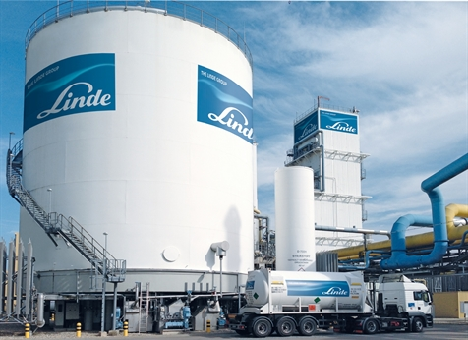
Report of Internship
“Talent Management Process Applied by Linde Bangladesh Limited”
Submitted To
Dr.Md. Shariful Alam
Associate Professor
School of Business & Economics
United International University

Submitted By
Hamida Mowlud Mahal
ID: 111152123
Date of Submission: 22.11.2019


Letter of Transmittal

November 22, 2019
Dr. Md. Shariful Alam
Associate Professor
School of Business & Economics
United International University, United City, Madani Avenue, Badda, Dhaka 1212

Subject: Submission of the internship report titled “Talent Management Process Applied by Linde BD”
Dear Sir,
With due respect, this is an internship report on "Linde Bangladesh Limited Applying Talent Management Process" that you have recruited me to get a brief idea of ​​the talent management process. I have done my best and have given my best effort to collect relevant and necessary information in the talent management process. I have collected information from the website of Linde Bangladesh Limited and my senior who is on the Talent Management team. I submit my internship report for your genial tribute & thank you for your continuous support & direction.
If you have further queries regarding the report, please let us know.

Thank you
Sincerely Yours
___________________
Hamida Mowlud Mahal
ID: 111152123

Acknowledgment

At first, I would like to thanks the Almighty ALLAH for the countless blessings that he has given me. I have made this report on “Talent Management Process Applied By Linde Bangladesh Limited” which has discussed in this overall report. I would express my gratitude to my honorable faculty, Dr. Md. Shariful Alam for giving me the opportunity to prepare this report on this topic.

Last but not the least; I would like to thank Talent Management Manager Ahmed Fuad and Reward Management Manager Sufia Akter Wahab of Linde Bangladesh Limited and the other members of the talent management team for their remarkable contribution in preparing this report. Their insights, counsel, and guidance helped me a lot. Without their help, this report would not indeed possible. And thankfully, I am very glad to successfully complete internship report of mine on “Talent Management Process” and I also learn a lot of things like- “what is talent management process”, “how a company attracts talent”, “how a company measure and compensate talent to retain them”, “succession plan”, etc. The knowledge that I have gathered and stored has a great impact on my career choices and has helped me to understand what the requisition for success in the corporate world is. This report helps me to gather a lot of experience.

I have discussed here how Linde Bangladesh limited creates attractions, providing compensation, and continuation of their talent and some advantage and disadvantage of their recent process. I hope this report makes a very clear understanding of the organization Linde Bangladesh limited to you.

Executive Summary

Talent management refers to recognize a person's innate ability, personality & offering him a correct job. This is a greeting to both the company and the employees. Salute the company to increase productivity and efficiency; A good link between individuals' creation and business goals; Taking on valuable staff; Low turnover; Bench strength increases and is a good fit between people's work and skills. Benefits employees from higher incentives and commitment; Career development; Increase knowledge and contribute to company goals; Sustainable recognition and job satisfaction
Talent Management has the capacity to learn and improve in the face of new challenges. Talent management is about future prospects than the past track records. Then talents can be calculated in terms of the specific characteristics, like- the eagerness to take hazards and acquire information from the wrong things, a moderate (but not very higher) level of goals and competition, the capacity to concentrate about the 'bigger image' problem, and their individual strengths, restrictions, and so on. Therefore, to get the good workplace, the strategy is to ensure its success In order to set the altitude in several talent management processes is important for us to have a chance. This national process identifies talent, aligns with strategic goals to identify talent, retention, future leadership of the industry, compensate for extraordinary performance of all its role in the organization, develop a career with appropriate training, managing information, compensation, continuation planning, etc.

Table of Content:
Contents
“CHAPTER- 1 1
INTRODUCTION” 1
1.0. The Talent Management: 2
1.1. Origin about this Report: 3
1.2. Statement of the Problem: 3
1.3. The Objective of this Study: 4
1.4 Scope of the Study: 5
1.5 Limitation of the Study: 5
1.6. (A).The Methods of Data Collection Techniques of this Study: 6
1.6. (B): Sampling: 7
1.7. Abbreviations: 7
“CHAPTER-2 8
COMPANY PROFILE” 8
2.0. Company Overview: 9
2.1. Introduction: 9
2.2. (A). Mission Statement: 12
2.2. (B). Vision Statement: 12
2.3. Values: 12
2.4. Principles: 13
2.5. The Activity done by the Organization: 14
2.6. Organogram: 15
2.7. Goods and Services: 17
2.8. Future Plan: 18
“CHAPTER- 3 20
LITERATURE REVIEW” 20
3.0. How to Attract Talents in Linde Bangladesh Limited: 21
3.1. The Ways Linde follows to Compensate the Talents: 25
3.2. The Ways Measure Talents in this Company: 30
3.3. Talents Retain in this Company: 31
“CHAPTER- 4 36
ANALYSIS & INTERPRETATION” 36
4.0. Graph & Tables: 37
4.1. Interpretation: 44
“CHAPTER- 5 45
RECOMMENDATION & CONCLUSION” 45
5.1. Recommendation: 46
5.2. Conclusion: 47
Appendix 48
Bibliography 48

“CHAPTER- 1

INTRODUCTION”

1.0. The Talent Management:
In my entire report, I discuss the talent management process very soon. It is a process that involves observing a person's underlying skills, characteristics, identity and proposing him/her a suitable career. Every human being has an uncommon expertise that is perfect for a particular work profile. In another way, any other area will cause discomfort and difficulty. Establishing the correct candidates with vision and charity is the job of management, specifically in the HR field. A bias suitable will result in more recruiting, continuing and other jobs. Talent management is favorable for both the company & staff members. A company advantage with expanded production and capacity, from the best harmony between individuals' force and company ambitions; very important staff actions; the decline of turnover; growth the power of the bench and organize a good adjustment between people's work and experiences. Employees profit from greater encouragement and assurance, path improvement and considered to company goals, saved encouragement and job achievement.

Nowadays, in a highly competing world, where modification is the only necessary explanation, it is valuable for a business to establish the ultimate essential elements of all - human assets. In this globalized world, only human assets can give an industry a competitive deadline because with the new tradition arrangements, technology can quickly be moved from one place to other and there is no deficiency of sources of less money. However, this is the highest quality personnel which is very strong for identification.

Ability indicates the performance to acquire and inspire in the face of different demands.. Ability is more than future inquires rather than the previous track record. It is figure out that talent is concerned in specific characteristics, such as taking a hazard and learning from wrong things, an acceptable (but not very higher) level of targets, efforts & competition, problem of being estimated as the ability to focus on the 'bigger image' and their individual strengths, disadvantages, and so on known about the impact on.

It is necessary to build at an important level to assure the success of different talent management processes. Here the growth includes talent description, definite monitoring and evaluation, skills management, work and learning management, career improvement, payment, succession planning and so on. There is a amount of profit for talent management, like- support, employee commitment, and output engagement, coordinate strategic targets for identification the future leadership of the business, a practice of superiority and more.

1.1. Origin about this Report:
This report has been prepared for an internship report to achieve the requirements of the BBA program at “United International University”. This proposed topic of this report is "Talent Management Process Implemented by Linde Bangladesh Limited". The reason is for acquire some actual skills by doing work in a real working culture. My internship administrator is Mr. Ahmed Fuad the talent management manager and the faculty advisor Sir Dr. MD. Shariful Alam

1.2. Statement of the Problem:
According to the recent talent management strategies used in every firms, about 84% of employees left their positions in office for no reason other than salaries: However, 72% of directors think employees left for pay-related reasons which is actually not true. And there are six main causes employees left a company. Talents realize the job or work culture is not like what they thinking suitable for them. Their expectations and reality are not matched. The 6 other reasons are given below:
- There is no matching between the job and the person.
- There are very little advice and feedback.
- There are too few growths and advancement opportunities.
- Employees feel markdown and unrecognized.
- Employees feel stress from overwork and have a work-life imbalance which makes them puzzled.
- There is a very low portion of trust and confidence in senior leaders.
All of these things are highly dependent on managing talent.

1.3. The Objective of this Study:

Practical Guidelines of the BBA is the essential part, I am trying my level best for publish Linde BD real-life experience on “Talent Management Process)”here.

For preparing this report, I received various information about Linde Bangladesh Limited. From the information collected, I have been able to understand that this organization has a huge contribution in this country. I hope my reports will convention the needed requirements for the BBA program & give a diaphanous picture of the core activities and efforts of other MNC organizations in BD. The actual goal of the internship program is to find real-life business situations for business graduates so that I can apply my theoretical education to real-life situations as well. It helped me a lot as an intern to finish my four-year academic studies with a real business problem. For this specific report, the particular objectives are:

- There is no similarity between work and person.
- Advice has very few suggestions and feedback.
- There is very little chance of growth and progress.
- Employees feel marked down and unaware.
- Employees feel stressed from too much work load and have a work-life imbalance that makes them shiver.
- There is a very little part of confidence and confidence in senior leaders. These things are very much depended on Talent Management.

1.4 Scope of the Study:
The report deals with the Talent Management Process in terms of theoretical point of view and practical use. The study will permit learning about the talent identify, compensate, retain, modern techniques and models used to make it more efficient. The study will help to learn the practical procedures followed by various leading companies. Moreover, the study will help to split between the practice and the theories that direct to realize how the company can be improved in their Talent Management Process.

1.5 Limitation of the Study:
Each study has some limitations. Thus, there are very minor limitations of this study that restrict research analysis. The research is very helpful to me in finding the limitations of the study. The minority of limitations of the study are shown below:
- Time allocation for completing the entire study is very short and restricted. For that reason, I cannot briefly mention all the activities of the organization.
- The lack of temporary information in the company is the most important obstacle. This thing creates some problems for me in collecting data.
- No previous studies have been performed in this section, so a very few amounts of documents are available. This thing creates some difficulty in gathering the information I need.
- Some participants were afraid to give private info, and some others reveal little interest in this national practice and some of the target organizations avoided voluntarily providing information. Because they think that if they provide me with information, they may face some issues or problems with their work from managing the organization.

1.6. (A).The Methods of Data Collection Techniques of this Study:

For collection the information easily and convenience and for the reason of my internship, I chose to work in the field of HR in this company. I determined to target the talent management process. As I worked there, this was a source of all the necessary pieces of information for Linde Bangladesh Limited. Some of the pieces of information will also be collected from my caregiver. They help me to find out the mandatory information and complete my report.

Methodology:
To judge the current talent management process at Linde Bangladesh Limited, I have used various methods for data collection. Basically, I used two types of data for this reason.
1. Basic Information
2. Subordinate information

The strategies of Data Collection:
- Basic Information: This report is generated using basic information. It was collected from a group of people who belong to this industry. The following information is used to collect basic data. These are given below:
- Face-to-Face Communication: I have collected data through face-to-face communication with Linde Bangladesh Limited Director, Supervisor, and Executives.
- Survey Methods: I personally went to Lind in each department and did a survey about their views on the talent management process. And I am very fortunate as all the sections help me a lot from which I have asked for the survey.

Subordinate Information: The secondary information sources, which are published material. I have collected the second information from the following sources:
- Linde is the personal division of Bangladesh Limited in the official documents of various types.
- Some published research reports, books, journals, articles and their websites.
- Different types of official documents.
- File study, magazines, and books of talent management process.

1.6. (B): Sampling:

- Population: “Linde has a corporate staff of 56 in Bangladesh's corporate office. I took on all management employees for doing this survey”.
- Units of Sample: “Linde Bangladesh Limited has 9 separate departments where these employees work very well. These categories- “Human Resource and Admin, SEQ, CS, Finance, Procurement, Sales and Marketing, Operations, Distribution and IT”.
- Frame of the Sample: “Of all the departments, I selected the HR and Administrator and Procurement section where I get the bulk of my work and & staff is very flexible in sharing information with me”.
- Design of Sampling: “I prepare a questionnaire for a general survey. I put both negative and positive questions in this questionnaire, leaving a blank space to know the actual facts about the current process and further suggestions for developing the process”.
- Size of the Sample: “Out of all 56 staff, I liked 50% of the total for analysis”.
- Questions for the Research: “I would like to submit the question paper I used for my survey by attaching it here for your wish”.

1.7. Abbreviations:

“Human Resource Management” = HR
“Customer Service” = CS
“Safety, Health, Environment & Quality” = SHEQ
“Information Technology” = IT

“CHAPTER-2

COMPANY PROFILE”

2.0. Company Overview:
With the modest presence, later, in the beginning, the products of Linde BD are now part and parcel of all organization and financial activities in BD. Currently; the company's turnover exceeds 4.94 billion.
Linde Bangladesh Limited is a member of The Linde Group who has been present in Bangladesh for over 50 years with the continuous expansion of activities and business.
As one of the leading multinational companies in this gas trade, this company has three large areas/establishments in Tejgaon, Rupganj, and Shitalpur in Bangladesh. Also, it has 19 sales centers serving more than 35 customer base across the country. The company is now-a –days able of producing 86 tons of liquid ASU gas every day and 23,500 mT welding electrodes every year. Its products sheet and services contain liquid and gaseous oxygen and nitrogen, argon, acetylene, carbon dioxide, dry ice, refrigerant gas, lamp gas, and other gases, medical oxygen, nitrous oxide, Entonox, treatment equipment and accessories, etc. Includes gas and pressure identification welding equipment and accessories, identification welding training and services.
Linde BD giving assurance of the quality of their products. Their purpose is to assure the optimal circumstances for the health, safety, and environment of their employees, consumers and collaborator.

2.1. Introduction:
With a focus on technology, Linda Group has more than 130 years of history built on the freshness of heritage. The company's founder, Carl von Lind, invented refrigeration technology and began a process of air separation. Today, Lindsay Bangladesh limits the world's top leading industry in gas and engineering resolutions.
Linde BD, is representative of the group of linde, has contributing to the development of the nation as a silent associate. Over the years, Linda Bangladesh Limited, an active built-in the environment with quality of jobs, reflects on its employees for more than 50 years with the continuous expansion of operations and business.
Linde sells its products to more than 35000 customers, from a wide spectrum of industries ranging from chemical and petrochemical to steel. About 5 teams of Linde BD's trained, motivated and professional members conduct 24-hour operations in three major locations across the country to assist their customers.
At Linde Bangladesh Limited they are committed to the quality of our products and services. Their aim is "to ensure the health, safety and optimum conditions of the environment for employees, customers, and stakeholders". The organization is bound in the Organogram Appendix.
The Board of Directors shoulders responsibility for the welfare of the company and the interests of the shareholders.

Board of Directors:

Linde acts as an Employer: The main vision of Linde is “To become the leading global gases and engineering group, admired for our people, who provide innovative solutions that make a difference to the world”.

1. People Excellence: Linde takes up arms to the highest-performance organization in each aspect. This needs exceptional people who are loyal and encouraged to achieving their perception of becoming the number 1 global gases and engineering company, applauds for their people who make a distinction to the earth. Public Excellence is always at the top of their program. It surround all conditions of individual’s performance, improvement and, of course, acceptance. In Linde, they observe individual’s Excellence as a high achievement for them as an organization and for each individual. People who are prepared to take on new challenges are the heart and soul of a successful business, specifically in the demanding and fast-changing world in which they operate. The willingness to continuously learn, change and improve is what they want to see in their employees. They mirror this with a comprehensive suite of development opportunities to unleash the potential and abilities of each employee. Human Resources, with the right set of tools, systems, and processes in place, is a key enabler to drive this agenda. This spreads from management career planning to highly specialized technical career paths. As a truly global company, they value our cultural and gender diversity. It serves as a vibrant geniture ground for innovative and creative thinking. They nurture this potential, which gives a decisive competitive edge in delivering solutions that add extra value to all types of customers. “People Excellence” is a core material of the culture and spirit they have created at The Linde Group says, “Excellent people who strive for high performance and are proud to be part of a great company”.

2. Company Culture: The Linde Group combines an enduring tradition with continuous improvement, innovation and best -performance execution and requests for both the industry and its employees. Their vision is “To become a leading gas and engineering company acclaimed for the world's leading people.”
In line with Linde’s values ​​and principles, an important on a performance mindset and personal improvement is deeply held in the culture of the business. Here at Linde, each of them is dedicated to achieving their shared vision and the values ​​and principles that they already set for themselves.
Always following their code of ethics and compliance is the most important part of their organization's culture. They treat every employee and the environment both with integrity and give respect. So while we are living with our business responsibility, security and sustainability are both key priorities for us.
3. Leadership Competencies: Their leadership skills emphasize Linde's commitment to the core principles of security, integrity, stability, and respect. They define our day-to-day activities and help us achieve our target of becoming a leading and famous company.
4. Linde Worldwide: Linde Group is a leading gas and engineering company with approximately 48,000 employees operating in over 100 countries worldwide. At Global Projects, we all have the opportunity to work with people from many cultures and make our lives valuable.

2.2. (A). Mission Statement:
“We live our mission of making our world more productive every day. Through our high-quality solutions, technologies, and services we are making our customers more successful and helping to sustain and protect our planet”.

2.2. (B). Vision Statement:
“We’re committed to fulfilling our vision to be the best performing global industrial gases and engineering company, where our people deliver innovative and sustainable solutions for our customers in a connected world”.

2.3. Values:
The 4 Values of Linde are given below:
- Excel To Passion: Linda is committed to achieving superior quality excellence and celebrating that success. Lindsey is very aware of the satisfaction of their customers. They always strive to give the best service to their customers.
- Innovation for customers: Lindy has recently followed some new ways to add more value for both internal and outside consumers and clients for achieving benefit in the market.
- People Empowerment: People are given space to provide and develop. Everyone has the opportunity to benefit both their own careers and companies.
- Prosperity through Diversity: Diversity contributes to rich collaboration and solutions are enhanced. They build good relationships with their customers by enriching cooperation and solving all problems.
The new 5 values of Linde BD which are newly added are the following:
- Safety: “Linde put safety first. They believe all incidents are preventable and their goal is no harm to people, communities or the environment. They continuously work to improve their safety culture and performance worldwide”.
- Integrity: “Linde always strives to achieve its goals ethically and with the highest integrity. They expect transparent and respectful interactions between management, employees and their business partners consistent with their Code of Business Integrity”.
- Inclusion: “They embrace diversity and inclusion in order to attract, develop and retain the best talent and build high-performing teams. Bty hearing all voices and benefiting from diverse opinions, thoughts and perspectives they achieve their full promise and potential”.
- Community: “Linde is committed to improving the communities where we live and work. Their charitable contributions, along with employee volunteerism, support initiatives that make an important and sustainable contribution to our world”.
- Accountability: “Linde holds themselves accountable for their performance, individually and collectively. They focus both on what they accomplish and how they accomplish it and they are committed to delivering on individual and company goals”.

2.4. Principles:

- Safety: Linde Bangladesh Limited always get around harming both people and society. They maintain the safety rules and they encourage all the time to follow and maintain the safety rules to everyone at any place and any time.

7 safety principles that Linde group followed and they also encourage all the people to follow those principles. The 7 principles are given below:

- “All incidents and injuries are prevented”.
- “HSE (Health, Safety & Environment) is the line management accountability”.
- “We are responsible for own safety and that of others around us”.
- “Our employees and contractors are obliged to stop a job or refuse to perform it if it cannot be performed safely”.
- “All HSE (Health, Safety & Environment) incidents must be reported and leanings were taken from them.
- Our commitment to and efforts in safety will yield a result”.
- Acting safely is a condition of our employment and supply contracts.
- Integrity: The actions of Linde are genuine, impartial and moral for all employee. They always o their every activity very carefully and properly. The first and foremost priority is their customers. So, their actions are very much honest, Fair and ethical to all their customers.

- Resect: Every person wants to be treated with appreciation.

- Sustainability: Linde is looking only on their current success but rather than their responsibility for the next generations

2.5. The Activity done by the Organization:

Official Responsibilities of this Company:
Official responsibility in the sentiment of environmental and social sustainability is a major preference for this company. They feel a strong sense of duty close to all of their stakeholders: business associates, employees, the society at large and the environment. This commitment propagates across every one of their business fields and locations.

“Safety, Health, Environment & Quality” (SHEQ): Effective management of safety, health, environment, and quality (SHEQ) is a key for Linde and is entrenched in their business culture. They have a vision for SHEQ: “At the Linde Group, they do not want to harm people or the environment.” The vision monitoring their actions in all issues that are relating to SHEQ and encourages them to make the correct decisions, take the actual measures and behave in a responsible appearance. It assures that at Linde BD, “people always come first”.

Not harming the environment means more than just adhering to the fair guidelines and internal business standards. It involves actively doing everything possible to mitigate any environmental damage resulting from their business activities. That is why Linde, as an organization, is committed to decreasing its carbon footprint by developing efficiency and using their assets in a responsible way. They always think about their customers

2.6. Organogram:

Figure 1: “Graphical content of employment of Linde Bangladesh Limited in the market”.

Figure 2: “Talent Management from an “HR” point of view”.

2.7. Goods and Services:
The industry's main steps include creating & therapeutic or medical gas production, logistics and welding products, equipment and accessories. The company also leases the cylinders used by customers and vacuum-insulated evaporators installed in the customer bounds.

Gases: Linde has the capacity to produce different kinds of necessary industrial gases in Bangladesh. It has both liquid and condenses formulations. It runs on the fire suppression system – Carbon dioxide (which is used in soft drinks mainly).

hard goods: hard goods is the highest-paid and manufactured product in Linde Bangladesh Limited. The whole manufacture leads to growing and powerful content requirements among customers in the industrialized sector. In this section, highly important items- welding, electrodes, “GPMS-(General Purpose Mild Stainless steel)”, “SSP-(Stainless Steel)” and Cast Iron. Different types of “Welding Electrodes” are shown below:

- Mild steel all-purpose Electrode:

- “Ferro Speed”
- “Zodiac Universal”
- “Bolwel”
- “Ferro craft 7016”
- “Ferro craft 11”
- “HandCraft 650B”
- “Ferroweld 1”
- “FerroCraft 61”
- “Ferroweld 2”
- “MANGCRAFT”
- “Vortic Marine”
- “Bolarc 1400”
- “Bolcraft”
- “Duroid 350R”

- Stainless Steel Electrodes:

- “STAINLESS CRAFT 308L-16”
- “STAINCRAFT 309 Mo”
- “STAINCRAFT 316L – 16”
- “STAINCRAFT 308-16”

- Cast Iron Electrode:

- “FERROLOID 1”

Health Care: The unit of healthcare business target primarily on producing medical gas and treatment equipment. Most of the services from this department are managed by hospitals and treatments. In terms of business activity, proportionally hard products make up 75% industrial gas 15% ultimately healthcare the remaining 10%.

2.8. Future Plan:
The next plans of BD preparing the processes of talent management are the following:

- ”Heightened competition for skilled workers”.
- “Very low levels of employee engagement.”
- “Very important for creating succession planning.”
- “Acknowledgment about the high cost of turnover.”
- “Ensuring the retirement of the baby boomers properly.”
- “Offshoring and outsourcing trends.”

It wants modern reasoning and a modern mission to earn all activity's success. These aspects along with the need to adjust people straight with corporate targets- are driving the company's human resource to drive a new talent mindset at the company from guideline setting, cost decline, process adaptability, and hazard management.
An important dissimilarity of progress of the distinct between strategic HR and strategic talent management. The human resource officers of the transaction are supervisory upwards. Talent management is the logical process that provides better personnel for the job.
The advanced model – alternative and be responsible for the processes, forms, and agreement, the human resource becomes a strategic facilitator of talent management processes that authorize managers and employees while establishing business value. With this perspective, talent management can be explained as the implementation of strategies or systems designed to increase the processes of hiring, expand and retaining people with the skills and tendencies required meeting current and future industrial needs.

“CHAPTER- 3

LITERATURE REVIEW”

3.0. How to Attract Talents in Linde Bangladesh Limited:
Linde Bangladesh Limited generally following some ways to attract talents. The 5 main ways that they followed to attract the talents are discussed briefly:
- Industrial Attachment Program
- Technical Sessions.
- Job Fair
- Referred
- Trainee Catalyst Program
Industrial Attachment Program: An event where realistic knowledge is supply by doing a variety of industry trips. Linde Bangladesh Limited regularly arranges this national industrial affiliate program. It always provides its employees the opportunity to gain more knowledge about the changing industry which helps their employees to adapt to change very precisely and beautifully in the future. To gain new industrial centers, new tools, new technologies, and new processes, recent changes such as programmed programs are seen. Generally, this is done all day or 1/2 depending on the nature of the program. Sometimes these programs take 4/5 days depending on the demand.
Technical Sessions: A session where promising and qualified employees are given some different types of technical aspects. Linde Bangladesh Limited often arranges different types of technical sessions to enhance their growth in the workplace and also in the growth of their employees. Regularly Linde BD has given training on group security issues, SAP, leadership skills, discipline and guarantee, quality directorate systems, consumer’s service, project management skills, identification quality management and so on. This company organizes some whole-day session in which the elected staff attends for gaining a broad knowledge of the specific topic which is very helpful to the staff. Sometimes some sessions will be set up for multiple days in mainly the corporate office. For these sessions, they generally hire skilled trainers from a foreign country to have a successful session. These sessions are arranged in Shitalpur, and Rupganj factory.
Job Fair: A program where employers, recruiters, and universities are given the necessary information regarding a challenging position to potential employees. Graduates and post graduates from the university seem to be well-equipped to handle workplace challenges. These are often only fitted in theoretical aspects & lacking in application section. Lindy is regularly trying to use a fresh candidate which is also practical. For that reason, they regularly try to attend diverse job fairs or course programs to get some aptitude candidates for their company. In mostly, they attend many university career fairs to obtain some new candidates and they recruit these new graduates to various positions in the organization because Linde wants to develop by the fresh idea of having the person. They always participate in such programs with their existing interns to give interns practical lessons about how people can actually manage them.
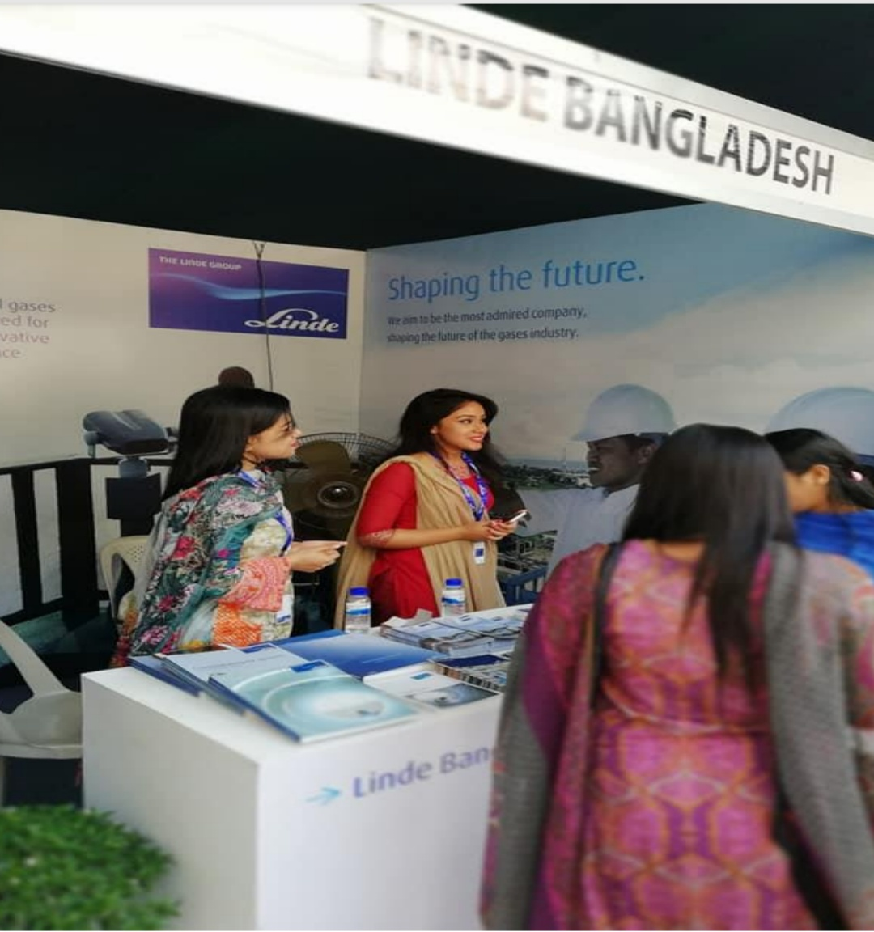
A picture from a career fair at “Independent University Bangladesh” where Linde Bangladesh Limited participates.

Referred: This is a process where the potential employees draw through the references. Basically, this reference is made through the internal staff, not the externals. Also, hiring new employees is now becoming more difficult and difficult in developing countries, where the HR department has to choose from thousands of applications for a handful of activities. Finding the correct person for the correct job becomes a very challenging process when there is only so little time. It also involves a very heavy cost to hold the recruitment and selection development for such a giant population of applicants. In most cases, in order to decrease costs, the upper administration offers this national reference in the recruitment of particular candidates so that they can recruit their loved one or acquaintance. Apart from this national reference, the competitions during recruitment are very limited because the person mentioned is extremely focused in front of the interview board which is very time-consuming. In Linde, this thing is often overlooked. Referred staffs are highly attracted to the management and their numbers are huge.

Trainee Catalyst Program: It is a program where employees rotate between various departments at various times to see which category and which designation is appropriate for that employee. In Linda, there is a 12-month catalyst program where employees are very closely monitored, and from that consideration. Linda places the responsibility on the employee's rotation to various departments and positions, ensuring that the bigger picture (growth and professionalism) assures. There will always be a hand in support.

Figure 03: Linde Bangladesh follows the ways of attracting talent.

Attracting the Best Talent for the Company:
There is one more challenge. The best available talent is not simply inspired by the company's name and reputation. They have a new set - such as challenging work, a supportive work environment and independence from bureaucratic structures. So, Linde is trying to focus on the matter right now and also doing her best activities by attracting her best talent.

3.1. The Ways Linde follows to Compensate the Talents:

At Linde, they follow no special tactics to compensate its employees. However, there are certain conditions that are strictly followed, such as WPPF, gratuity, bonus and more.
However, in some instances, they offer two benefit systems between employees. They are-
- “KEB (Key Employee Benefit)”.
- “Reward & Recognition System”.
Four awards under the Reward & Recognition System. They are given below:
- “Spot Award”.
- “Excellence award”.
- “Safety Spot Award”.
- “Long- term Service Reward”.

KEB (Key Employee Benefit): The key employee benefits are those extraordinary benefits that employees are provided by the company to join, continue in the organization for a long time. In Linde, employees are given a large sum of money (financial benefits) to retain. Health insurance is one of them. 100% of Medical, Dental, and Eye insurance is covered by this company. They are also given job security to their employees if the employees are also loyal to the company.

Rewards for the Recognition: These rewards and recognition are provided both in a group and individually. Constantly it can be an economical reward (like-money, presents, gift vouchers, and other financial presents) or sometimes it can also provide a non-monetary reward (like-rewards, accreditation, distinguishing recognition). These things on the basis of 4 categories.

1. Spot Award: This award is given for a specific task or program or project which will remain up to the mark. Only extraordinary performances deserve such type of award. The performance of each employee of different departments has been monitored by their line managers and then each department’s head nominates some employees to receive the award who actually deserves this award. And the best one rewards after a certain judgment. The employee is given a financial benefit which is £ 200 and accreditation.
Here is a sample on the next page:
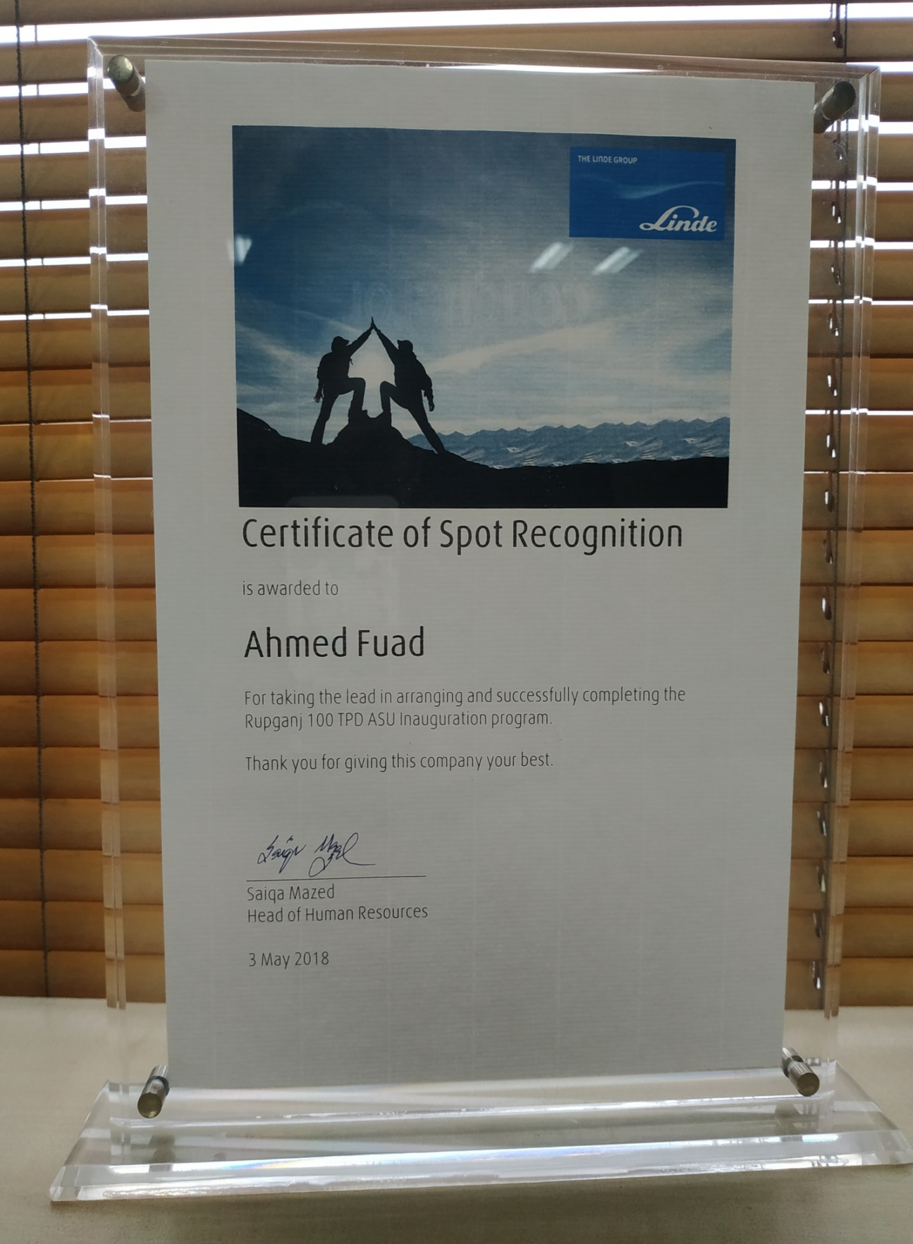
Certificate of spot identification
2. Excellence Award: This award is given in accordance with some of Lind's listed criteria and guidelines. He/she who has acted in this manner will be rewarded with 500 pounds.

Award Category | Exemplary characteristics of an application
1. Customer Focus | - Develop the experience of the customer.  - Provide all the customers the best products.  - Avoided customer loss & achieve confidence.  - Customer-generated solutions and services are improved.  - To facilitate doing business with Linde BD.
2. Process of Excellence | - The new process has been introduced and naturally changed which has a positive collision for both the company and it’s customers.  - Achieve measurable effects.  - The sustainable character for the benefits.  - A systematic but realistic approach.  - Roll-out classified and supported.
3. Execution ability | - Productivity measures that provide profit and margin improvement are implemented.  - Profit contributions over the expectations.  - Pro-effective arranged headwinds.  - The company has been established to ensure sustainable results.  - The results are delivered on actual time on the exact budget.
4. Excellence of People | - The “ONE” who made the difference.  - Defendant’s or entrepreneurial or “can do” attitude.  - Very active to identify the needs for the change and follow up to make sure the changes occur.  - Beyond the barriers to success.
5. Safety | - Exemplary SHEQ Leader/Team ("Visible Perceived Leadership”).  - Most developed Performance by the employee in the Country.  - Demonstrate of the SHEQ compelled by Linde BD.  - Demonstration of a continual SHEQ program.  - Having movement on the share of BOP (Communication).

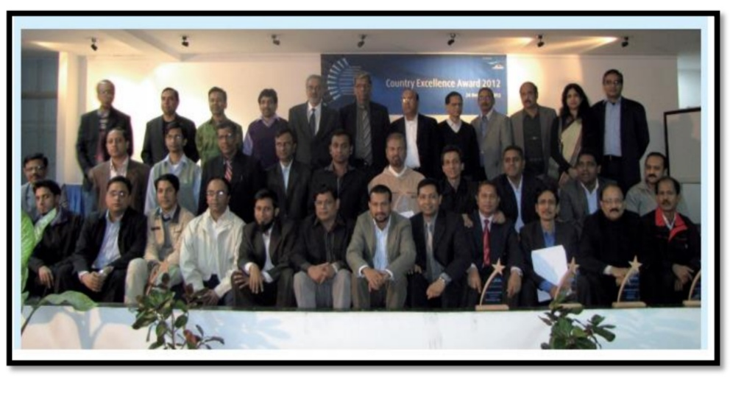.
An image of the top performers receiving the Country Excellence Award in 2017.
3. Safety Spot Award: Linde BD is a company that is very conscious of its safety and security issues. Protection for them always comes first rather than other factors. This company is also very conscious of every topic; from starting working at the workplace to the safety of each worker to the complete work. So, whenever an employee performs exceptionally well with all the safety maintenance rules and regulations (SHEQ standards), they are being rewarded. It can be both financial and non-financial rewards. So, by providing this award, Linde BD is always encouraged to look after the safety of their employees and to always follow and maintain safety rules.
4. Long- term Service Reward: Long-term service awards are considered one of the most extensive forms of identification because Linde rewards their employees for their loyalty and sincerity to the business. The intention of the Linde Long –term Service Reward is to analyze those employees who have dedicated themselves to this service authority for 10 years or more than that, to meet certain qualifications and requirements. Such as:
• “Traditional rewards, gifts vouchers, prize bonds, a voucher for travel and brand-named luxury products”.
• “To encourage and engage their employees while reinforcing the message of rewarding loyalty, employers must offer an award that is meaningful to the individual”.
A sample of Long –term Service Reward is given below:

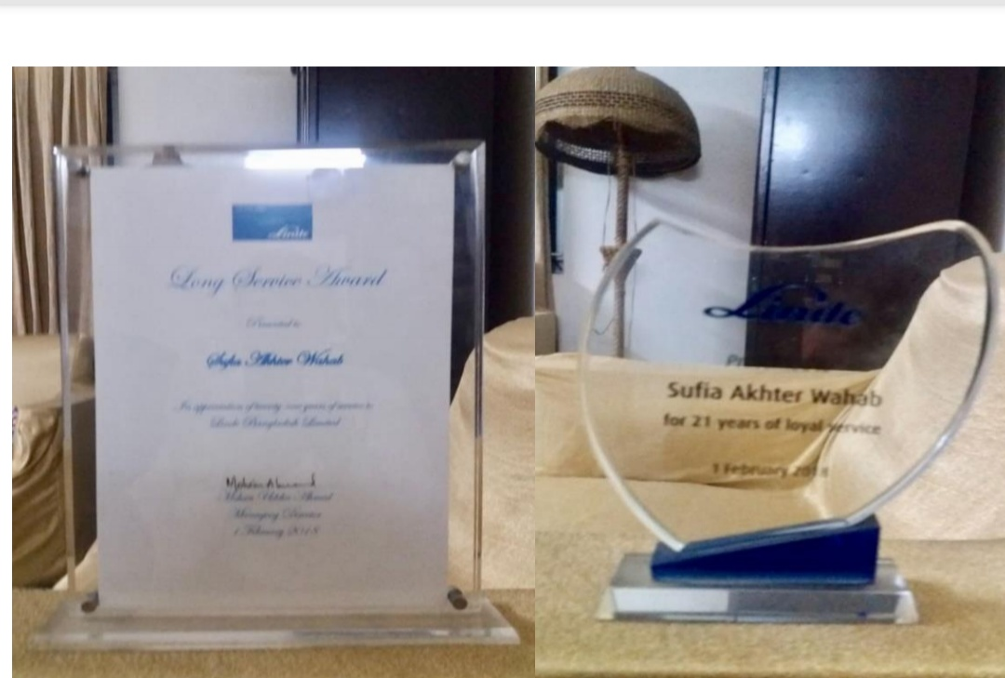

Long Service Rewards Certificate and Awards

3.2. The Ways Measure Talents in this Company:

Process of Performance Management: To measure the performance of every employee, Lindy always tries to adopt qualitative methods. It consist of a human attention which is done by the HR manager to avoid any statistics or metrics. Some human resources experts spend their time observing employees and recording data about their behavior, work practices and the barriers they can overcome to effectively perform their jobs. They spend time silently because if they tell them that they monitor employees, they will change their work style to influence HR professionals. To remove bias in reporting, there will be three managers (Reward and System Manager, Talent Management Manager and Assistant Admin Manager) to check out the performance of every employee.

KPI (Key Performance Indicator): A KPI (Key Performance Indicator) is a judgment of whether an employee, team, or business system has achieved the desired performance target or goal. So, to measure talent, sometimes Linde BD gives it’s employees with specific propose related tasks or goals. By the number of acquisitions, (sales targets) they are grading to know their level of growth and how profitable they are for this industry.
An example of a performance statement from their measurement book:
Accountability | Afterwards completing the Sales activities (Customer Care).
Standards | 70% Poor, 70-79% Satisfactory, 70-89%- Good, 90+%- Excellent.
KPI | Response to their annual customer satisfaction report.
Goal | Expansion the percentage of customer fulfillment about the goods and services.
Target | Achieve an average of 85% over the next quarter with the customers which are Linde tries to achieve all the time very honestly and sincerely.

HR always struggled to provide accurate instructions and measurement of any data about an employee that is collected and figure out from a given job or project. Opposite skills and principles are used as work indicators. They also give appropriate feedback to employees' acts and achieve a specific ambitions so that they are inspired to work better in the future.

3.3. Talents Retain in this Company:

Incidental implementation of “Talent Management in Linde BD” that is followed by Linde in the following ways:

Performance Appraisals

Career Planning

Coaching & Improvement

Continuation Planning for Future

Maintaining current employees are the most important for Linda because, in the form of training and development, the company could have already spent the least. Now, if the company is looking for a replacement employee, it involves a lot of expenses - such as hiring, training costs, and hiring costs.
Also, it takes some time for the new employee to adjust to the new work environment. During this period, employee productivity will come down. The HR department needs to fit the new employee to the appropriate role of the organization. In addition to financial loss to the company and the disruption of their day-to-day operations, the ratio contributes to the transfer of knowledge, which are a great loss and negatively affects the organization.
Being an MNC, Linde maintains some lead strategies, some rules, and supply instructions that are working to maintain the higher authority on management and most will not raise staff salaries. Here are some active Linde practices that are used to keep employees happy and without being employed elsewhere as part of their organization.
Training & Mentoring: Through different kinds of training programs, employees embellish their values. Through training, employers help employees achieve goals and ensure they have a clear idea about their work needs.
A mentoring program involving a goal-based response system provides a structured system for building strong relationships within an organization and is a solid foundation for employee retention and growth. A consultant program aims to develop specific competencies by providing someone higher experienced in the discipline with lower experienced someone in a related field, provides performance feedback and plans to develop a personalized career.
Introduce a Positive Culture of the Organization: An organization should establish a set of values as the basis of a culture such as honesty, excellence, vision, respect, and teamwork. An organization that creates the right culture will benefit when it comes to attracting and retaining a good employee.
Use Communication to Establish Reliability: Linde is a flat organization but no facts what the size of the industry, communication is central to establishing and maintaining reliability. Most of the employers get communication to “flow up” through a staff advising council (or related group) that require and/or gain employees’ assessments and new ideas and passes them on to top level management. It’s also necessary for employees to know that the employer is really listening and responds to employee input.

Show Gratitude through Compensation & Advantages: Offering things like promotion, ambitious salaries, long term service reward, bonus, provident fund and health insurance (inpatient & outpatient) and paid time off sends a powerful message to employees about their importance at the organization. The rewards given to employees must be meaningful in order to impact their perception of the organization and therefore have a marked influence on its retention efforts. Moreover, if an organization promises a reward, it should keep that promise.

Inspire Referrals & Recruits from within: Providing referrals to current employees can help reduce the confusion of job expectations. Current staff can actually describe the location and environment of a person and the person he or she is referring to. Another way that an employer can reduce the impact of turnover is by current employees already discovering that they are quite fit within the organization.

Provide Growth Opportunities: A company should provide software (SAP) or other tools to help employees increase their burden from their own careers and increase their efforts to set goals. It is necessary to provide employees with capable job challenges that will expand their information to their field. According to correct Management, employees are more likely to be employed in the job and dedicated to an organization that invests in them and their career improvement.

Create Employee sense Important: If employees feel themselves responsible for the results of their work, gain valuable ideas for their job, take advantage of their skills and receive recognition for their contributions, they will be extra miles.
.

Less Stress from overworking & build work-life Balance: It is important to combine work/life benefits with the needs of employees. This can be in the form of non-transitional work schedules (such as a brief workweek, telecommuting, and flextime) or extra holidays. When the work-life balance is properly structured, both the employee and the employer are present. For example, employers will feel more productive in the workplace because employees will be less stressed, healthier and thus more productive. Encouraging employees to set work/life goals, such as spending more time with their kids, communicating that you truly want their work to have a life outside of life and a healthy work/life balance.

Foster Trust & Confidence in the Senior Leaders: Build strong relationships with staff from the beginning to build confidence. Employees must believe that higher management is competent and the company will succeed. An employer needs to inspire this confidence and be able to make decisions that reinforce it. The employer cannot say one thing and do another. Linde believes that no employer should talk about quality and then push employees to work more in less time. In addition, employees need to be involved and motivated by creating policies that exempt employers from the authoritarian style of management.
Succession Planning from the senior Leaders to their Juniors: In Linde's succession plan, it seeks to develop the talent of replacing executives, leadership or other key employees in another role, leaving the company, retiring, retiring, or dying. The planning transform is to construct a talent pipeline of continuity that will hold the organization going without any hindrance if inevitable personnel changes. Succession planning evaluates the needs of employees and creates long-term goals and strategies to manage these gaps through leadership development, while succession planning ensures the availability of the right kind of management team at the right time and in the right place, providing continuous organizational vitality and energy.
Linde's HR department is generally the main driver of succession planning, sometimes also referred to as a replacement plan, though top leadership and support of other stakeholders are critical to success. For this, HR's action plan needs to be properly developed on an individual basis for all anticipated needs and key positions in the immediate front year. Business plans must be inspected to determine the impact on management requirements. Succession planning is an important task for top management. In fact, direct responsibility goes from the senior executive and the top management group.

Continuation planning needs to reflect long-term organizational targets .and strategies. Lindsay always considered, not only for the design and implementation of the plan, but also to maintain the process over time. As a strategy and goal change, Linda likewise needs to hire and develop staff, and her future success requires a well-crafted cross-training that will require the organization's unique knowledge and skills to succeed. This process is critically important to the success of the organization as the individuals identified in the plan will be responsible for ensuring that the organization is able to cope with future challenges. These ‘high potential’ candidates must be carefully selected and then provided with training and development that gives them the skills and skills they need for the business environment tomorrow.

This is more important for Linda, because of her high potential, one day she will become the leader of the company. This is why your organization needs to include extensive education opportunities for their development. Individuals should also be exposed to as many environmental conditions as possible so that they can get a good idea of ​​what they need to be successful in the company.

Figure 04: Employee satisfaction from every work related to the retention process.

“CHAPTER- 4

ANALYSIS & INTERPRETATION”

4.0. Graph & Tables:

Introduction of Data Study: The term study measures growth about split complex components into common factors while figuring out the explanation and the explanation that express or exclude the meaning of creative work.
Analyze and interpretations are done the whole, by category and through questionnaires. This analyze and interpretations will surely help for future strategies. Analyze and explain results are given below:

Figure 05: Employee's Satisfaction Amount.

This pie-diagram shows in Linde, 42% Bangladeshi employees are extremely talented in the process of talent management, 28% satisfied, 24% good, 6% dissatisfied. Therefore, it can be said in the department of finance, talent management is an adequate process for employees as well as industry.
To make it even clearer I am showing the total image separately (sections).
1. Business Department (Medical Gas, Industrial Gas & Hard goods)
2. Finance Department
৩.Procurement Department
৪. HR & Admin Department

- A Survey in the Business Department

Options | Responses | Percentage
Yes | 75 | 75
No | 25 | 25

Figure 06: Primary Data Survey Questionnaire
The pie-diagram above shows that 75% of the employees in the purchasing department are highly and 25% are not highly affiliated with the talent management process. As such, we can say in the business department talent management is a viable process for employees as well as organizations.
- A Survey in Finance Department:

Options | Responses | Percentage
Yes | 85 | 85
No | 15 | 15

Figure 07: Primary Data Survey Questionnaire

In the finance department, we can note that 85% of the employees responded 'yes' to the fact that they were exposed to their talent at Linde. And 15% of employees are answering 'no'. This means that talent management is very effective in this department.

- A Survey in Procurement Department:

Options | Responses | Percentage
Yes | 60 | 60
No | 40 | 40

Figure 08: Primary Data Survey Questionnaire

The pie-diagram above shows that 60% of the collection department employees are in the talent management process. Where 40% of employees are not with the existing process, we can say in the purchasing department, talent management is not as satisfying as other departments. So, the talent management process needs to be worked out more rigorously here.

- A Survey in HR & Admin Department:
Options | Responses | Percentage
Yes | 95 | 95
No | 05 | 05

Figure 09: Primary Data Survey Questionnaire

In HR & Admin department, we can observe that 95% of employees are answering ‘Yes’, they are getting exposure to show their talent in Linde. And 05% of employees are answering ‘No’, means a talent management process act outstanding in this area.

Employee performance before implementing Talent Management concept:

Departments | Best | Worst
Procurement | 3 | 2
Hard goods | 12 | 4
Finance | 15 | 5
Industry | 6 | 4
Gases | 9 | 3
HR & Admin | 3 | 2

Figure 10: The situation of the staff before implementing the talent management process.
Employee performance after implementing talent Management Concept:

Departments | Best | Worst
Procurement | 4 | 1
Hard goods | 4 | 2
Finance | 17 | 3
Industry | 9 | 1
Gases | 2 | 2
HR & Admin | 5 | 0

Figure 11: Situation of employees after the implementation of the talent management process.

In the two diagrams above, we can compare all the categories of performance before implementing the concept of talent management and then implementing the concept of talent management. We can note that after implementing the concept of talent management all the performance departments are developing.

4.1. Interpretation:
In my survey, I used data from 68 employees through face-to-face conversations and the lowest amount of my general observation. In my entire survey, I have a fond memory of the organization where each worker lives in a healthy environment and works without any overload pressure. They seem to be very friendly when working with and talking to each other in the workplace. Following Linde Bangladesh, the current talent management process is a very dynamic, robust and transparent process. The HR department handles the entire process very smoothly, successfully and effectively. Every single employee is very friendly with their current Talent 5 management process. They revealed that the various training and workshops that help Lind improve their effectiveness through programs and awards are spectacular. Most employees express that they want to work here until retirement, and one of the captivating scenes the organization has been working on is each employee's work for more than 3 years. An employee who worked here for nearly 2 decades revealed that the whole process was still evolving because Linda had always wanted her staff. Taking care of the welfare and being valued.
So, all I can say is that every employee Linda is very happy with the talent management process.

“CHAPTER- 5

RECOMMENDATION & CONCLUSION”

5.1. Recommendation:

- An organization will have to have created a research process to escape talent drain.

- HR division will have to collaborate more and more and also disclose inbound employees because the HR department is the heart of an organization. Almost every problem's solution is found out in the HR department.

- Execute different tasks to motivate employees for work because distinct employees cannot perform with the encouragement they just do it because the industry pays for them. If the organization arranges various types of motivational tasks for the employees than the employees gain more and more benefits for the organization which helps the organization held its position in the market.

- The reward must be given for every excellent performance that is done by the employees. If the organization has done so the employees are getting motivated and they are working more and more hardly which generated more profits and benefits for the organization.

- For employees relaxation, the number of fun programs or picnic must be expanded. By arranging these kinds of programs refresh all the employees' mind and the next day they are working with the fresh mind and create another standard of their work to make the company benefitted and profitable.

5.2. Conclusion:

Basically, all organizations face intense race, limited assets, and rapid mechanical changes. This thing indicates that managing the organization's obligation in such a way that it not only guarantees its actual continuity but also ensures their long-term expected expansion. Yet, in any business, in an extremely competing surrounding and in a developing economy, only the qualified will last and this is proven all the time.
Talent management for the HR community is a favorable circumstance for an HR specialist to flourish in their field of ​​proficiency and career. A capable HR community helps build an active public service. The goal of talent management is too improved recognize our people in the HR community so we can support experts and career improvements and categorize particular rights and ambition with HR's field targets. We also want to make sure that as a community all our people have the momentum to develop so that we meet the future needs of the community and the government and our clients. This first wide selection of communities provides a foundation for ensuring continuity of leadership, knowledge transfer and continuity of service. The early implementation resulted in many important human resource priorities and strategies, performance management, leadership and management development, attraction and retention, employee education and development and culture, all of which are supported by HR strategies for the HR community. An important next step in the process is the implementation of a talent management plan for the HR community. Individually, community members and their managers need to work together to advance individual career development plans. The HR community must promote a talent management mindset, are committed to supporting development as a specialist group, and harmonize talent management in the field of day-to-day business. Linde follows some steps for the betterment of the company. The steps are following-

- Recruitment: We figure out that it helps to assure the right people are engaged in the company.
- Retention: It is find out that helps the company to establish and complete work that honor and reinforce all the representative.
- Employee Improvement: Talent Management provide regular unofficial and official culture and improvement for all the employees.
- Performance Management: Talent Management is a particular process that nurtures and supports performance, including feedback/measurement to the employees.
- Workforce Planning: It uses to make planning for the business and common changes, including the older workforce and present/future skills about the employees.

Appendix:
- “The Questionnaire of Survey”
- “Hall of Fame (Linde Talent Magazine)”
- “Organogram of Linde BD”

Bibliography:
- https://www.google.com/search?q=Pictures+of+linde+bangladesh+limited&source=lnms&tbm=isch&sa=X&ved=0ahUKEwiG7pqozfPkAhWiW3wKHWjADB8Q_AUIEigB&biw=1280&bih=913#imgdii=iffbchvOZX4tNM:&imgrc=oPz_mxJclbnZgM:
- https://www.google.com/search?q=Pictures+of+united+international+university&tbm=isch&source=iu&ictx=1&fir=QC4gXYYOYG6HEM%253A%252CAcniy97apgKa2M%252C_&vet=1&usg=AI4_-kQQaMNDDR7r46WHt4MpAL45e0YCCQ&sa=X&ved=2ahUKEwibhKnDz_PkAhV98XMBHVTICSEQ9QEwAXoECAYQBg#imgrc=VfpAN_fds8FQ0M:&vet=1
- http://www.linde.com.bd/en/about_linde_bangladesh/index.html
- http://www.linde.com.bd/en/about_linde_bangladesh/management/index.html
- http://www.linde.com.bd/en/images/Linde%20BD%20AR15%20eng_tcm391-260929.pdf
- http://www.linde.com.bd/en/images/Linde%20probaho%20January%202013_tcm391-90072.pdf
- https://www.google.com/search?q=Pictures+of+linde+bangladesh+limited&source=lnms&tbm=isch&sa=X&ved=0ahUKEwikoZPq6YzlAhXl8HMBHWdCAOsQ_AUIEigB&cshid=1570543529803187&biw=1280&bih=913#imgrc=YU4M08jk5uZCnM:
- Talent Management Handbook by Lance A. Berger & Dorothy K Berger.
- Internship Report of Humaira Tasnuva.

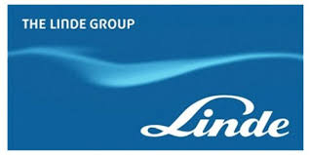
Questions to Improve Processes:
This questionnaire includes bureaucracy, salary/rewards, performance management, career mobility/development, transparency, clear expectations/goals, motivation/recognition, development opportunities/coaching and how Linde’s employees feel about their culture, values and psychological safety.

Employee Name: ……………….. Department: …………………..
Gender: …………………………. Duration of employment: …….

Serial No | Statement | Very Satisfied | Satisfied | Good | Moderate | Bad
1. | Do you feel this organization’s processes help or hinder your work?
2. | Do you feel that the salary and the other benefits are fairly distributed to every employee?
3. | Do you feel that you can develop your career at Linde Bangladesh Limited?
4. | Does your line manager help you to set effective goals or targets?
5. | Do you have the knowledge that how your work contributes to the organization’s overall objectives?
6. | Do you feel comfortable giving feedback to your team?
7. | Do you feel that if you can suggest new ideas/question ways of doing things to your team they listen properly your ideas/ questions carefully and work on that?
8. | Do you feel there is sufficient transparency in company-wise decision-making processes?
9. | Do you feel Linde’s present performance management process is effective for both the organization and the employees?
10. | Do you have the exact knowledge that what’s expected of you at your work?
11. | Does your manager provide you with the proper coaching and guidance when you need it?
12. | Do you receive enough praise and recognition for your achievements from both your line managers and the organization?
13. | Do you feel your voice is heard and respected in this workplace?
14. | Do you feel that we all are living our company values and mission?
15. | Would you recommend to the future generation that Linde BD as a great place to work?

