INTERNSHIP REPORT
ON
Bulk Recruitment Process of Munshi HR Solutions Limited (MHSL)


INTERNSHIP REPORT
On
Bulk Recruitment Process of Munshi HR Solutions Limited (MHSL)
Submitted To
Nasrin Akter
Assistant Professor
School of Business and Economics
United International University
Submitted By
Md. Aminul Islam Pappu
ID – 111 171 090
School of Business and Economics
BBA Program, Major in HRM
United International University
Date of Submission: August 19, 2022


UNITED INTERNATIONAL UNIVERSITY

Letter of Transmittal
August 19, 2022
Nasrin Akter
Assistant Professor,
Department of School of Business and Economics
United International University.
Subject: Submission of Internship Report on “Bulk Recruitment Process of Munshi HR Solution Limited (MHSL)”.
Dear Miss,
I am submitting my internship report, which is titled “Bulk Recruitment Process of Munshi HR Solution Limited (MHSL)” for your consideration which is a prerequisite for the Bachelor of Business Administration degree, and it contributes toward the degree completion requirement.
Hopefully, this report will meet all of your expectations and requirements. I would be really grateful if you would approve my internship report.

Md. Aminul Islam Pappu
ID – 111 171 090
BBA Program, Major in HRM
School of Business and Economics
United International University

Declaration of the Student
This is to certify that the report paper submitted by Md.Aminul Islam Pappu as an impartial fulfillment of the requirement for the degree of Bachelor of Business Administration from United International University is a record of candidates own work carried out by me under your supervision. The report is titled "Bulk Recruitment Process of “Bulk Recruitment Process of Munshi HR Solution Limited (MHSL)” that is a different piece of work that has never before been presented for the purpose of attaining a degree or being evaluated for conformance.
Md. Aminul Islam Pappu
ID – 111 171 090
BBA Program, Major in HRM
School of Business and Economics
United International University

Acknowledgement
To begin, I would like to thank Allah, the most high, for providing me with the fortitude and calm necessary to complete this assignment before the deadline. The internship report is a mandatory component of the BBA curriculum since it provides students with the opportunity to get hands-on experience in their chosen field. A portion of my internship was completed at Munshi HR Solution Limited (MHSL).
I would like to convey my deepest thanks to my academic supervisor, Nasrin Akter, Assistant Professor, School of Business Economics, United International University, for her time, assistance, and advice in completing my internship report.
I would like to express my appreciation to Jannat Jahan (Senior Executive, Recruitment and HR Operation) and Mr. Shariar Khan (Executive Recruitment and HR Operation) for their role as my supervisor at Munshi HR Solution Limited (MHSL) and for the helpful feedback and direction on several HR related activities.
I owe a debt of gratitude to each and every officer and employee of the Munshi HR Solution Limited (MHSL) who, despite the enormous amount of work they had to do during this time period, were willing to cooperate with me in every way possible. In conclusion, I feel obligated to note the amazing working atmosphere that throughout our internship term allowed me to participate in and witness a great deal of the activities that were taking place.

Table of Contents

Executive Summary vii
Chapter 01: Introduction
1.1 Introduction of the Report 2
1.2 Origin of the Report 2
1.3 Objectives of the Report 3
1.3.1 Primary Objective 3
1.3.2 Secondary Objectives 3
1.4 Scope of the Report 3
1.5 Methodology of the Report 4
1.6 Limitation of the Report 4
Chapter 02: Literature Review
2.1 Bulk Hiring 7
2.2 Advantages of Bulk Hiring 7
a) Cost Savings 7
b) Company Branding 7
c) Tech Enabled Optimization 7
2.3 Difference between Bulk Recruitment and Traditional Recruitment 8
a) Sourcing 8
b) Assessing the Applicants 10
c) Interview and Selection 10
2.4 Challenges of Bulk Recruiting 11
a) Time Constrain 11
b) Talent Reach and Sourcing 11
c) Talent Quality 12
d) Missing out of Potential Candidates 12
e) Excess Stress and Pressure 12
f) Communication and Coordination 12
2.5 Strategies to Successfully Execute Bulk Recruiting 12
Chapter 03: Overview of the Organization
3.1 About Munshi HR Solutions Limited 16
3.1.1 Mission 17
3.1.2 Vision 17
3.1.3 Core Values 17
3.1.4 Services 18
3.1.5 Top Clients of Munshi HR Solution Limited 23
3.1.6 Organizational Hierarchy at MHSL 23
3.2 Human Resource Division (HRD) at MHSL 25
Chapter 04: Analysis and Findings
4.1 Bulk Recruitment System at Munshi HR Solution Limited 28
4.1.1 Process of Bulk Recruitment 28
4.2 Findings 33
Chapter 05: Recommendations and Conclusion
5.1 Recommendations 35
5.2 Conclusion 36
References 37
Appendix 38
Exhibition A: Formulating Job Circular for Pvt. Commercial Bank by MHSL 38
Exhibition B: Participate at BICC as a BPO Recruiting Agency 39
Exhibition C: Participate on Campus Recruitment at National Job Festival at UIU 39

List of Figures
Figure2.1: Advantages of Bulk Recruitment Process 8
Figure2.2: Advantages of Bulk Recruitment Process 13

Figure3. 1: Core Values of Munshi HR Solution Limited 18
Figure3. 2: Organization Chart of MHSL 24
Figure3. 3: Hierarchy System of HRD at MHSL 25

Figure4.1: Bulk Recruitment Process at Munshi HR Solution Limited 29

List of Tables
Table2.1: Traditional Recruitment and BULK Recruitment 9

Executive Summary
The process of headhunting is comparable to that of candidate profiling. Every single company operates inside an industry where it faces competition from other businesses that operate in the same field. If a company is searching for candidates to fill a position in the FMCG business, that company would almost certainly hunt for those candidates inside the FMCG industry.
Munshi HR Solution Limited (MHSL) is dedicated to being the world's premier supplier of HR Management services, with a specialization in Recruitment, Foreign Secondment, Payroll, Manpower Outsourcing, and Training & Skill Development. Their clients benefit from highly refined human resource management, which is both effective and efficient. The companies' primary services are meant to aid their customers' main business operations by means of the formation of professional partnerships and the provision of innovative Business Process Outsourcing (BPO) solutions. The professionals at MHSL are adept at "headhunting" applicants who possess the specific, in-demand abilities that businesses want. Their headhunters know a wide range of influential people in a variety of fields, allowing us to better serve their clients and customers and earn their satisfactions. It is the responsibility of an employment agency to facilitate connections between unemployed people and businesses looking to fill open positions. As a result, they contribute to the first stage in the process of developing a positive connection between an employer and an employee.
A comprehensive overview of the bulk recruiting process and of the services provided by Munshi HR Solution Limited (MHSL) has been discussed and analyzed in this report. At Munshi HR Solution Limited (MHSL), they use tried-and-true methods of hiring and customer service. If there is a need for mass hiring, MHSL has a seasoned project manager on staff to oversee the operation. They provide the most efficient and effective service for fitting the client's specified job profile.

CHAPTER 01
INTRODUCTION

Introduction of the Report
In order to remain competitive in an ever-changing environment, every firm in every industry will need to implement a distinctive blend of survival strategies. The vast majority of businesses nowadays make use of a variety of HRIS systems in their day-to-day operations in order to improve the efficacy and effectiveness of their operations. Even some businesses begin the process of company transformation in order to get an edge over their rivals in the marketplace. The purpose of this report is to provide an overview of the operations carried out by Munshi HR Solution Limited. Within the framework MHSL, the purpose of this report is study on the procedure for hiring new employees, the supporting management, and the working environment. The study and analysis have been concentrating on the bulk recruiting process that Munshi HR Solution Limited management consultancy is going through in order to provide its customers with a higher level of service.

Origin of the Report
BBA students at United International University are required to participate in the university's internship programme once they graduate. An internship's primary goal is to introduce a student to the professional world. As an intern, the greatest difficulty was putting academic principles into practical application. Having an internship is like getting a taste of the actual work. These are the fundamental objectives of the Internship Program:
- Practical understanding of work responsibilities
- To experience the actual business world.
- To contrast the actual scenario with the knowledge gained at the Academy.
- To meet the BBA program's requirements.
This report was prepared as a requirement for the completion of the BBA degree at United International University. It is the outcome of a three-month long internship programme that was carried out in approach Munshi HR Solution Limited. As a consequence of this, this report is based on the "Bulk Recruitment Process of Munshi HR Solution Limited." This report also contains information on the many services that Munshi HR Solution Limited provides, in addition to providing an overall summary of the company.

Objectives of the Report
This report was prepared based on two objectives, which are as follows:

Primary Objective
- The primary objective of this report is to provide relevant information regarding the practices of Bulk Recruitment conducted by Munshi HR Solution Limited via the HR Department as well as to provide recommendations.

Secondary Objectives
- To have a comprehensive understanding of the activities that are currently undergoing on inside the HRM department of the selected business company.
- To gather information and insights regarding to the organization's Recruitment & Selection function.
- To integrate the theoretical understanding with the practical application of the Recruitment and Selection process at Munshi HR Solution Limited as closely as attainable.

Scope of the Report
To a certain part, this report is a case study, since it depicts the actual situation faced by the selected organization. Consequently, the basic features of the data by this report are limited. The primary goal of this paper is to provide readers with hands-on knowledge of business research processes. The report's purview extends to encompass a variety of HRM-related topics, such as the processes of hiring new employees and evaluating existing ones. Human resources (HR) practices of Munshi HR Solution Limited were required coursework for me to complete in order to get an appreciation for the workings of the business world in its actual context. It is thus outside the scope of this study to offer targeted suggestions or recommendations other than to relate the observed and form a conclusion, and the report does not go deeply into the HRM operations of the selected organization.

Methodology of the Report
The study follows a methodical process, from determining the subject through writing up the results. Data identification and collection were essential; the data were then sorted, processed, evaluated, and presented systematically to extract the key insights. The study's entire methodology, including its steps and rationale, are detailed.

Sources of Data
Information is gathered from both primary and secondary sources.

Primary Sources of Data:
- Inspection of the structure of the organization.
- Discussion with employees, staffs and supervisors of the organization who are concerned in HR activities.

Secondary Sources of Data:

Journals, articles, books

Websites and internet
Primary data I gathered information using the observation approach as well as through direct connection with the authorities. The websites of Munshi HR Solution Limited, along with other connected websites and papers, were searched for secondary sources of information.

Limitation of the Report
Depending on the quantity of practical knowledge used to compile this report. However, there was certain material connected to the study that was deemed insufficiently private to be shared with the outside world. The limited amount of time available was another issue. In the instance of the study, the sample size was rather low since it was unable to do an analysis on a big sample within the allotted amount of time. My task was only scheduled to last for a total of three months. However, this amount of time is insufficient to conduct an accurate and thorough analysis. Some assumptions have to be made in order to account for the limited amount of information available. As a result, the report might include some errors that were made by the author. In spite of the various constraints, I made a concerted effort to provide the report to the best of my ability.

CHAPTER 02
LITERATURE REVIEW

Bulk Hiring
The term "bulk hiring" describes the coordinated efforts to find, evaluate, and bring aboard a large number of potential new employees. What this means is that many people are contacted about openings at once (Debi, 2022)
When hiring in large quantities, it is common to conduct screenings, interviews, and decisions rapidly. In-house application and offer letter processing. The fundamental objective of recruiting in mass is to amass a large pool of candidates whose skills are a good fit for the needs of the company (Decker, 2021).
The term "bulk hiring," sometimes known as "mass recruitment," refers to the process of screening, short listing, and recruiting people on a wide scale within a shorter amount of time depending on the needs of a business (Farndale, 2021).

Advantages of Bulk Hiring
Organizations have been resorting to massive recruiting for three key reasons. Among them are:

Cost Savings
The strategy of mass hiring has made it possible for businesses to significantly reduce their spending. When recruiting in bulk, you may avoid spending money on unneeded advertising and administrative, in addition to reducing the cost of applications and personnel. This eventually results in a significant reduction in the expenses associated with employment (Debi, 2022).

Company Branding
When there are a large number of people applying for a job, it boosts the company's chances of getting some good word of mouth advertising. Job-seekers have a habit of signing up and making an impact on a company as soon as they happen onto the brand. Companies gain a great deal from infrequent brand promotion in this connection between job-seekers and recruiters (Decker, 2021).

Tech Enabled Optimization
Bulk hiring throws up gates for enterprises to access technologies in the market that addresses their recruiting pain points. Companies may now pre-screen applicants, schedule interviews, and conduct mass interviews with ease thanks to modern technology. This not only saves recruiters time but also decreases hiring expenses (Decker, 2021).

Figure2.1: Advantages of Bulk Recruitment Process

Difference between Bulk Recruitment and Traditional Recruitment
There are a number of key differences between regular recruiting and mass hiring that have summarized a few of the distinctions below, along with some suggestions for how businesses might effectively address them in the recruiting process:

Sourcing
Traditional Recruitment: The conventional method of recruiting involves the hiring managers making the job announcements themselves. Putting up adverts for jobs that are presently available in order to pique the attention of potential candidates who meet the requirements after which, the vast majority of the time, a manual search and recruiting of the person are carried out (Debi, 2022).
Bulk Recruitment: Partnering with job sites in bulk recruiting is one option for recruiters interested in applicant sourcing (Debi, 2022). Companies have other options available to them that may improve the effectiveness of their sourcing, including the following:
- Inquire among the staff members about possible referrals.
- Making advantage of the pool of applicants from the past
- By organizing recruitment campaigns on campus
- Keeping tabs on the matrices with the use of various software solutions in order to get better results
- Utilize several screening technologies in order to speed up the process.
In conclusion, it is possible to achieve success in volume recruiting via the appropriate use of job portals in addition to other strategies. Additionally, data-driven candidate sourcing is helpful when it comes to the sourcing process.
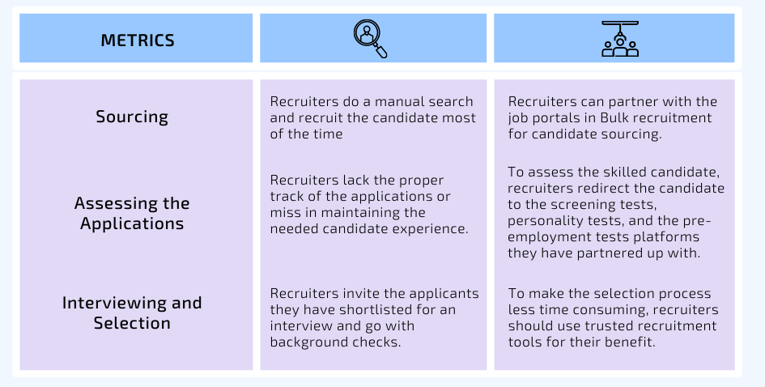
Table2.1: Traditional Recruitment and BULK Recruitment

Assessing the Applicants
Traditional Recruitment: When recruiting in the conventional manner, the level of depth and complexity in the applications is ignored. Recruiters either do not keep an accurate track of the applications or do not adequately maintain the necessary applicant experience (Debi, 2022).
Recruiters perform initial screenings using applicant resumes and technical questions to determine who will go on to the next round. Candidates who fit the job description will have the opportunity to participate in an interview. After then, recruiters will utilize whatever data they have and go with their gut sense, rather than vetting candidates for the necessary skills required for the post (Debi, 2022).
Bulk Recruitment: In order to determine the qualified applicants you need via bulk recruiting, you will need to collect a greater number of applications. Employer branding and benefits packages are two tools that may be used by recruiters in order to get candidates to submit their resumes. In addition, the use of digital solutions allows recruiters to provide a more positive experience for candidates (Debi, 2022).
For the purpose of evaluating the qualified applicant, recruiters lead the applicant to the screening tests, personality tests, and pre-employment exams that are hosted on the platforms with which they have formed partnerships. The outcomes of this evaluation will provide them with data-based findings on the candidate's abilities and perspectives (Debi, 2022).
In conclusion, the process that the applicant goes through is both expedited and fair, and recruiters need to be engaged in the other procedure that the picked candidate goes through.

Interview and Selection
Traditional Recruitment: A short listing application is the next step for recruiters and hiring managers after the first screening. The following candidates have been invited for an interview after being shortlisted. This interview might take place in person or be conducted by video. The majority of hiring managers nowadays want to conduct interviews in an organized format. After that, the candidate is put through many different stages of the interview process. At each stage, the applicant's behavioral characteristics and their technical prowess are put to the test. Each interviewer gives a briefing to the recruiting manager, including their suggestions and the grade they gave the interview in their interview scorecard. Before making their final selection, businesses do background checks (Debi, 2022).
Bulk Recruitment: When making several hires at once, recruiters often do not have the time to personally interview each candidate. When screening a large number of candidates, it is common practice to conduct interviews in groups and have panel discussions. Some businesses now conduct one-way taped interviews with candidates in order to get a better sense of their abilities and interests. Interviews are an important part of the hiring process, and hiring managers should take part in them (Debi, 2022).
Utilizing reliable recruiting technologies to its advantage may help recruiters cut down on the amount of time needed for the selection process. For instance, such tools may assist in the creation of all the reports in order to facilitate choosing in a more expedient manner (Debi, 2022).

Challenges of Bulk Recruiting
However, there are a number of obstacles to overcome when recruiting in bulk. Because of these obstacles, the recruiting process may become less rigorous. Among these difficulties are the following:

Time Constrain
The process of mass recruiting comprises several time-consuming activities, such as talent searching, bulk resume sorting, and mass interviews, which frequently place a lot of demand on both your time and resources (Decker, 2021).

Talent Reach and Sourcing
When it comes to formulating a clear plan to advertise job opportunities during large volume recruiting, recruiters often have a great deal of difficulty. This is particularly true for recruiters who are lacking the necessary expertise and resources for conducting bulk recruitment (Decker, 2021).

Talent Quality
Inadequate resourcing might lead recruiters to candidates with low-quality skills and expertise that do not meet standard requirements. This often causes the process of recruiting to be delayed (Decker, 2021).

Missing out of Potential Candidates
The process of recruiting a large number of people is often drawn out and laborious. Candidates often get exhausted after going through rounds of interviews for better analysis, and as a result, they are unable to demonstrate their full potential at the conclusion of the process. This often results in the company losing out on qualified applicants who may be able to fulfill their needs (Decker, 2021).

Excess Stress and Pressure
Candidates and recruiters alike are subject to strain and stress due to the chaotic nature of the process, which involves an enormous amount of effort and collaboration. Candidates have anxiety about meeting workers with the appropriate level of confidence, while recruiters often experience anxiety about losing out on the proper talent while attempting to manage the enormous amount of work (Decker, 2021),

Communication and Coordination
When recruiters don't get back to candidates quickly, it might leave a bad taste in their mouths about the company. In addition, recruiting is a frenetic procedure that calls for everyone on the recruitment team to work together. Miscommunication might slow down the whole procedure. Consequently, when it comes to massive recruiting, communication breaks down between internal and external parties (Decker, 2021).

Strategies to Successfully Execute Bulk Recruiting
- Build a Strong Team for Sourcing
The recruiters may get access to a broader pool of prospects by forming a partnership with a team that can assist them in doing so. With this group, the firm will be able to expand its reach and make important relationships in the industry.

- Lead Candidate to the Single Platform
After making the announcement of a job opening on every available channel, businesses should monitor the ensuing applications. You may improve your applicant selection process by integrating this application flow with your current ATS (Applicant Tracking System).
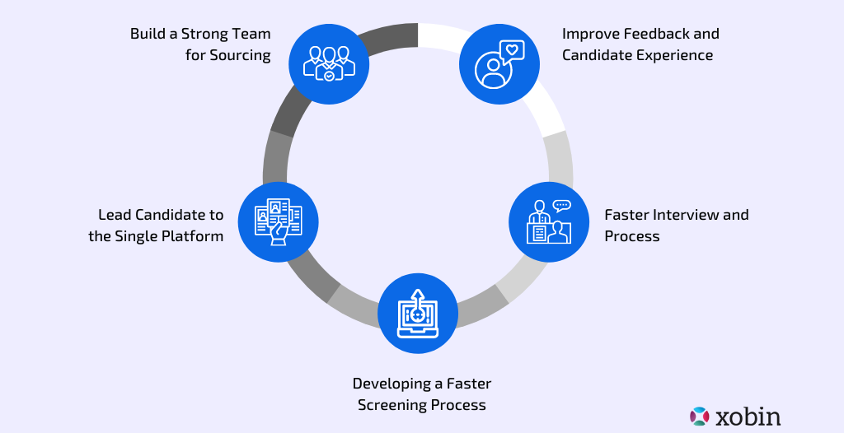
Figure2.2: Advantages of Bulk Recruitment Process
- Developing Faster Screening Process
Companies should improve their screening procedures to reduce the time they spend on each applicant. Using AI (Artificial Intelligence) or screening tools is the most effective technique to speed up the process. These artificial intelligence tools will analyze applications and candidate skills to determine rankings. To find the most qualified employees, businesses should team up with online evaluation tools and use AI.
- Faster Interview and Process
When it comes to bulk hiring, there is a narrow line to walk between screening applicants and maintaining the prospects' interest in the position over the long term. On the other side, applications that are too lengthy could make the recruiting process take longer. Therefore, you should refrain from asking any questions that aren't absolutely necessary and crucial to success, and instead focus on those.
- Improve Feedback and Candidate Experience
Keep a good reputation as an employer by impressing job seekers with all they can expect from you. Therefore, be confident and direct in your communication, and take the time to provide constructive criticism and input. Candidates are interested in knowing what happens next in the employment process and receiving feedback after an assessment interview.
With the right evaluation methods and the most positive recruiting process, a company may improve its reputation in the marketplace. If you go about it the proper manner, you may locate the talent you need quickly, which can boost your business's future prospects.

CHAPTER 03
ORGANIZATION OVERVIEW

About Munshi HR Solutions Limited
With the goal of providing world-class workforce solutions to local and global enterprises, Munshi HR Solutions (MHRS) Limited, a subsidiary of MUNSHI, was founded. MHRS is a one-stop service provider for all category enterprises, offering complete HR Solutions to meet their needs. They deal with candidates who are looking for growth, performance, and satisfaction in their careers.
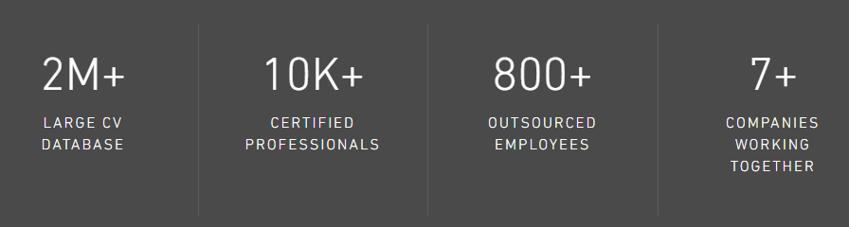
MHRS is working hard to become the most reliable HR Management service provider in the world, with a focus on Recruitment, Foreign Secondment, Payroll, Manpower Outsourcing, and Training & Skill Development. Their customers get management of their human resources that is not just effective and efficient but also highly developed. By forming professional alliances and providing cutting-edge Business Process Outsourcing (BPO) solutions, the purpose of their services is to be of assistance to the core business activities of clients’ company.

According to Raquib Mohammad Fakhrul Rocky, Managing Director, MHRS Limited, when you work with us at MHRS, we will assist you in calculating every demand, locating the appropriate people, cultivating the appropriate talents, and operating faultlessly like never before. You'll be able to concentrate on your core competencies thanks to the effective design, efficient implementation, and consistent delivery of the Human Resource Solutions and services that we provide. Regarding this particular point, we do not consider you to be a simple customer, but rather a vested strategic partner instead. Give yourself permission to focus on the areas in which you excel. We'll take care of everything else.
Although the majority of company owners are in agreement that their staff are their most precious asset, some of them find that the numerous tasks of HR departments are too difficult and complex to keep in-house. You will be able to save time and focus on the most important aspects of your company when you outsource the HR functions to MHRS. Your ability to address changing business circumstances, increased product demand and expanding technology will be enhanced. Your company's performance will improve, while the cost of sustaining non-revenue producing back-office costs will be reduced.

Mission
- They are determined to minimize HR operating expenses and Increase HR`s efficiency by offering quality services for local and worldwide Organizations.

Vision
- To emerge as Bangladesh's preeminent provider of human resource management services to domestic and international clients, with a market share of at least twenty percent.

Core Values
- People: Munshi HR Solution Limited, they are concerned about the well-being of our employees and the impact that their working conditions have on their life. They see them as unique people deserving of their confidence and assistance in order for them to realize their ambitions in both their professional and personal lives. They value the contributions made by each member of their team, as well as those made by their customers and potential customers. They are grateful to each one of them for placing their faith in their competence and expertise.
- Integrity: Acting in a way that is honest and fair in order to develop goodwill and trusted connections in the marketplace and beyond. They are aware that there is a distinction between doing things correctly and doing the things that need to be done.
- Client Satisfaction: To provide the utmost contentment for their customers is one of their most important fundamental values. They strive for complete customer fulfillment by paying close attention to their clients' requirements and acting accordingly. They prosper grateful to their entrepreneurial spirit and their ability to react quickly, taking prudent risks when required.

Figure3. 1: Core Values of Munshi HR Solution Limited

Services
- Head Hunting

Human resource (HR) functions are now embedded inside most companies, but a growing number of companies are turning to external providers to handle these tasks. Non-transactional HR procedures, including as recruiting, selection, and training, are increasingly being outsourced as the rate of HR outsourcing increases. There are many different types of recruitment and selection services offered by MHRS:
- CV Database
- Head Hunting
- Talent Acquisition
- Background Verification
- Selection Process Facilitation
- Application Screening & Sorting
Munshi HR Solution Limited is a frontrunner in the executive search and management recruitment industries. EMC's mission is to be a strategic partner to its customers by helping them develop their human capital via a systematic approach to hiring. In order to help clients achieve their goals, the company first determines the ideal candidate's profile in terms of education, experience, and other personal characteristics, and then, using the utmost discretion and professionalism, locates and assesses the candidates who have the necessary skills and experience for the position. Long-term partnerships with both clients and talent are a priority for them, and they strive to have the best resume database in the industry.
Munshi HR Solution Limited is aware of and appreciates the significance of a company's human resources in achieving its goals via coordinated and effective business performance. First, you have to seek for and employ the suitable individuals, and then you have to manage those individuals so that they can assist you in achieving the overarching objectives of your company. The following services are offered by the management consulting company Munshi HR Solution Limited:
- Talent Recruiting: entry level recruitment, mid & senior-management level recruitment
- Programs for Performance Management: Creating an Efficient Performance Program Vision and Tools, and Training Key Management to Ensure a Seamless Implementation
- Reward and Recognition Program: Creating an Exciting and Cost Effective Reward and Recognition Program, Such as "The Checkered Flag," and Managing the Program on a Day-to-Day Basis.

- Foreign Secondment
The capacity to rapidly and affordably shift staff across national borders and regional boundaries is one of the benefits you have as a result of your status as a multinational corporation. Mobility on a global scale comes with its own set of obstacles. The realities are that human resources professionals need to be able to deal with issues pertaining to taxes and social security, requirements for work permits and visas, employment legislation, pension plans, and remuneration in numerous countries. When we recruit employees from other countries to work for your firm, we take care of all of the necessary overseas secondment services, including the following:
- All Kinds of Visa (E, E1, B, FE)
- Payroll Process
- TIN Generation
- Work Permit Process
- Tax Return Submission
- Foreigner Visa Extension
- Home Ministry Clearance
- Bank Account Management
- Foreign Secondment

All that is required of you on our end is that you email us the specifics of the variable each month. From this point on, our team of operational specialists will see to it that all of the essential measures are taken. The following is a list of the services that Manpower Outsourcing provides:
- Payroll HR Audit
- Benchmarking
- Research
- Survey
- Offshore Outsourcing

- Secondment Services
- Retirement Benefit Analysis
- Exit Management
- Training
Training and development play a significant part in the expansion and success of our company since they enable us to guarantee that our workers have the appropriate set of skills, knowledge, and capacities to carry out the responsibilities to which they have been allocated. Their services for training and personal development include the following:
- Training Needs identification
- Training Needs Analysis
- Setting Up Training Objectives
- Designing & Implementing Training Program
- Feedback Collection & Evaluation
The training and workshops provided by Munshi HR Solution Limited are tailored to the individual needs of each customer. They provide one-of-a-kind seminars and workshops. Through the use of games and simulations, they place an emphasis on a more hands-on method of education. This has a multiplicative effect on learning. In order to help people retain information from workshops and develop the motivation to put it into practice. Munshi HR Solution Limited provide a wide range of training and workshop options to their customers, each tailored to their individual goals and objectives. Every one of their seminars and workshops is designed specifically for clients’ needs. They place a greater emphasis on experiential learning, which might take the form of games or simulations. This makes learning much easier and more effective. The training and workshop programs of Munshi HR Solution Limited are listed below:

- Effective Communication & Presentation Skills
- Energizing Performance at Workplace
- Behavioral / Soft Skill Training
- Counseling techniques
- Training of Trainers
- Negotiation Skills
- Managerial grid
- Leadership & team building ⎫
- Sales and selling techniques
- Action-centered leadership
- Customer satisfaction & care
- Customer experience management
- Customer Relationship Management
- Performance Management System
- Project Management
- Excellence through micro-planning
- Effective managerial habits
- Personal Effectiveness
- Management of Change
- Conflict Management
- Essential Business Etiquettes
- Disciplinary Procedure
- Interviewing Skills
- Time Management
- Improving Work Culture
- Coaching and Mentoring Skills
- Personal growth & effectiveness
- Value building

- Organizational Development

They are committed to the development of the business community. In order to accomplish this goal, they assist businesses in becoming high-performance workplaces by assisting them in improving their processes, cultivating their people, and honing their leadership and management skills. They are entirely dedicated to assisting you in achieving your company objectives and will customize our services to meet your requirements exactly. Whether you're a start-up, scale-up, small or medium-sized enterprise, or a multinational corporation, they are convinced that our team can assist your business in the following ways:
- Increase Profits
- Reduce Costs
- Get the Best from Your Talent
- Create Great Leaders and Managers
- Background Verification

Employers' reliance on professional pre-employment screening services is on the rise, and failing to implement these checks might pose significant risks to your business. In the final stages of any hiring process, whether it is for a temporary, permanent, or contract position, the successful applicant will be granted access to a wide range of secret and proprietary materials and information. As a result, doing a comprehensive background check on an applicant is now an essential step in the hiring process. These comprehensive background checks consist of:
- Employment History Checks
- Educational Documents Verification
- Professional License Verification
- Reference Verification
- CV Validation
- Address Verification
- Civil & Criminal Checks
- ID Verification
- Credit History

Top Clients of Munshi HR Solution Limited




Organizational Hierarchy at MHSL
Personnel assignments in the top team management are determined by the following criteria:
- The Chairman of Munshi Group
- Managing Director (MD) Independent Consultant
- Head of Operations at Munshi HR Limited
- Chief Operating Officer of MHSL
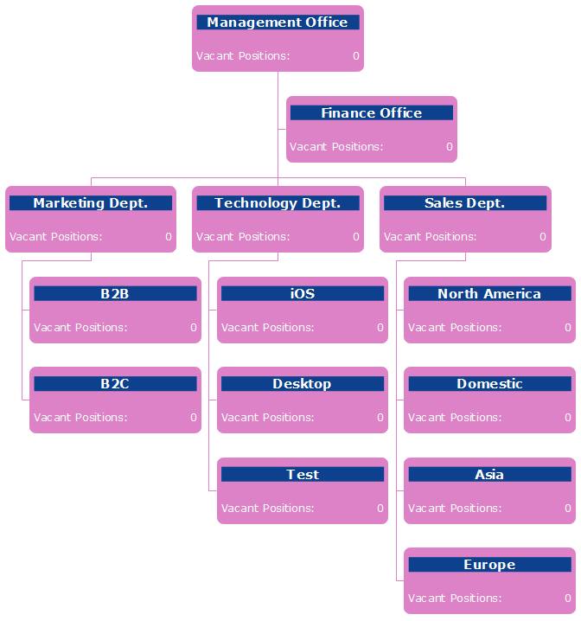
Figure3. 2: Organization Chart of MHSL

Human Resource Division (HRD) at MHSL
In order to ensure that the Human Resource Division of Munshi HR Soultion Ltd. is able to function in an efficient manner, the whole HR Division has been separated into two distinct sections. These items are:
- Corporate HR
- HR and Admin Corporate HR
Human resources in a corporation serve a similar function to that of a moderator. Corporate Human Resources is responsible for all company-wide matters. Problems with recruiting and retaining employees, as well as establishing effective lines of contact with the business world, are included. They maintain open lines of contact with the business world and work hard to cultivate positive relationships with corporations.
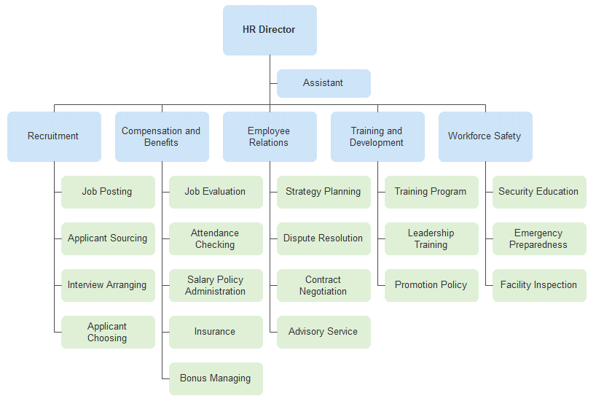
Figure3. 3: Hierarchy System of HRD at MHSL
Human Resources and Administration: HR and Administration handles all administrative and personnel issues for the plant. Additionally, the HR and Admin department is responsible for guaranteeing regular attendance, managing payroll on the plant grounds, assuring occupational health and safety, educating employees, and providing process support to corporate HR.

CHAPTER 04
ANALYSIS AND FINDINGS

Bulk Recruitment System at Munshi HR Solution Limited
It is a method of hiring that allows businesses to fill a large number of positions in a very short amount of time. They use a variety of strategies in order to satisfy the demands placed on the available labor. The use of different ads, the organization of various recruiting campaigns, doing campus hiring, participating in job fairs, and so on and so forth are all examples of these kinds of tactics.
When a firm wants to acquire a significant number of applicants within a certain amount of time, they will often engage in what is known as a high volume recruiting initiative. Therefore, customers outsource the project to specialized recruiting service providers so that the burden in HR and the other departments of the firm will be reduced. A High-Volume recruiting project is essentially any hiring initiative that includes between 5 and 500+ staff members, all at once. This definition covers the vast majority of hiring projects. In this particular field, there are a relatively limited number of recruiting organizations who are able to provide. It is not just a matter of numbers; quality is also an important consideration since the learning curve for new recruits is steep, and these individuals need to get off to a strong start in their new roles. Regardless of whether it is an internal or external job, the selection process has to be very thorough in order to guarantee that the appropriate candidates are hired.
A project of this kind would almost always need assistance and support from the client's Recruitment and HR staff in order to be successful. Managing large quantities of curriculum vitae, interviews, assessment centers, reference checks, and all of the administration that has to take place in order to fill positions for more than 350 employees is a substantial and demanding task. With this level of knowledge, Munshi HR Solutions Limited (MHRS) has specialized Project Managers that focus on this particular area. Back office support personnel are used to dealing with volume, and as a result, they have the capacity to expeditiously complete high-volume projects.

Process of Bulk Recruitment
The following diagram illustrates the steps involved in the bulk recruiting process:

Figure4.1: Bulk Recruitment Process at Munshi HR Solution Limited
- Getting Requirement from the Client
The process of bulk recruiting at MHSL begins with gathering the requirements from the end of the client organization.
Before they go out and explore the market for the best candidates for the clients, they first get familiar with their business, the atmosphere in which they operate, and the positions they are trying to fill. MHSL will make it their business to get familiar with clients’ firm and the way in which the function fits into the structure of clients’ organization o firm or business.
- Job Description
They may go away and devise a strategy for a recruiting drive so that clients are aware of the specific steps that will be used to locate the members of their team who are the best fit. Following a thorough briefing session with the client explaining the company's history, culture, structure, market status, stability, development, and future objectives, MHSL starts the recruiting process by honing down on the precise job description and the applicant description from the client. The following are some of the components that make up a job description at MHSL (Exhibition A):
- Job Title and designation,
- Objectives,
- Duties & Responsibilities,
- Required skills, preferred knowledge and experience,
- Employment conditions and
- Deadline of Application.

- Headhunting:
In this section, Munshi HR Solutions Limited (MHRS) details a recruiting method that they believe is the best suitable for the brief. Beginning with doing an industry study and ends with the creation of organization maps from which suitable candidates may be headhunted, the process begins. One company has shown interest in holding a career fair, another in holding a campus recruiting event, and so on. The process of selecting applicants is decided upon, and the specifics of that process are contingent on the needs of the customer.
In the event that Munshi HR Solutions Limited (MHRS) is conducting campus recruiting or participate or in job festivals at university campus (Exhibition B and C), the following method is followed:
- Screening CV and Resume: The initial step in the process is reviewing the resumes and CVs that have been submitted. The only people who go on to the written exam are those who make the cut from this pool.
- Conducting Written Test: Following the review of the resumes, they will need to compile the questions for the written exam in accordance with the specifications provided by the customer. The customer will provide a set of evaluation criteria for the written exam, and those criteria must be adhered to in order to choose applicants for the group discussion who will go on to the next round. The knowledge about the necessary areas was assessed by the written exam that was taken. The applicants' overall score on the written exam will determine whether or not they are invited to participate in the preliminary interview.
- Group Discussion: During the group discussion, there will be a variety of evaluators providing feedback to the applicants. At this stage, they evaluate the applicants based on a variety of characteristics, including their values, analytical abilities, presenting skills, and so on.
- Face to Face (F2F) Interview: Whenever they go out to find potential candidates, we conduct in-depth interviews with the prospects that show the most promise of becoming successful employees. They use a method of conducting interviews that is based on competencies and is tailored particularly for each project. These interviews are carried out in a setting that is not official, and the duration of each interview is normally about thirty minutes. During these interviews, we pay close attention to each applicant and thoroughly evaluate them in light of the primary criteria that were outlined in the brief. They place a high priority on work experience, competency, and compatibility with the job-expectations, candidate's personality, and the capacity to adapt to the company's culture.
- Shorting List of Potential Candidates: Following the conclusion of the interviews, they will develop a shortlist of those applicants who, in their opinion, have the best opportunity to fulfill the client's mandate. They compile and deliver a detailed report on each of the applicants who made it into the shortlist. This report contains a two-page description of each candidate's qualifications for the position.
- Client Interview: They set up a meeting between the customer and the applicant in a formal or casual setting, and after the meeting, they relay the feedback from both the client and the candidate to the other side.
- Concluding the Assignment: They provide the customer with guidance on how to formulate an offer and present it to the ideal applicant. Their role is to serve as a go-between for the customer and the candidate in order to facilitate the negotiation of a compromise that is satisfactory to both parties.
- References: They collect references from the applicant and provide a reference check report to the customer as per their request. Interviewing previous employers is a great way to get a feel for a candidate's work ethic, professionalism, and fit for the role. A background check allows you to double-check the candidate's claims from their résumé and interview. Clients may verify internal applicants by talking to their boss or previous coworkers.
It is necessary to get in touch with the candidate's current or most recent direct superiors. It is important to get the candidate's permission before contacting their references, particularly if the candidate's present company is going to be contacted. It is not unheard of for an applicant to feel uneasy about the organization speaking to a present employer in the course of the hiring process. The applicant is responsible for choosing someone other than their present employer to interview with if they are unable to do so with their current boss (work colleague, for example). Only contact references who can attest to the applicant's abilities in their previous jobs, unless the candidate is a recent college graduate or high school graduate who has never had a job. It is recommended to examine at least two references; however, the more checks that are done, the better.
- Candidate Counseling: They give counseling to the applicant in the form of preemptive written and verbal communication and assistance in order to ensure a high ratio of offer acceptance. This counseling covers topics such as resignation, relocation, and counter offer negotiations.
- Life Time Relationship: They are of the opinion that this is the beginning of a lifelong partnership between the candidate, the customer, and Munshi HR Solutions Limited (MHRS). They make it a point to maintain communication with both of the parties involved for an indefinitely long length of time.

Findings
During my time working as an intern at Munshi HR Solutions Limited (MHRS), some certain issues with the recruiting process have been found that need to be addressed and resolved. However, the challenges associated with mass recruiting change depending on the kind of project being worked on. The following are examples of some of the problems:

Communication Problem with Candidates: In the event of mass recruiting, Munshi HR Solutions Limited (MHRS) is required to choose a call centre to make interview appointments with the applicants. As a result of this, there is often a breakdown in communication between the customer and the applicant.

- Maintenance of Data Base: When the number of individuals being recruited is quite high, it is particularly challenging to manage the database. In addition, the structure of the databases used by the various projects is not always the same. It differs according to the needs of each individual customer. The upkeep of the database also takes up a significant amount of time.

- Sourcing of Potential Candidates: The most challenging aspect of bulk recruiting might vary greatly from project to project since applicant sourcing can be so challenging.

- Fixed Timeline: When it comes to recruiting in bulk, we are required to adhere to a certain deadline, which may be one of the most significant barriers to doing great work at times. Since bulk recruiting requires us to find a very large number of candidates, doing so within a constrained amount of time is a very challenging task.

CHAPTER 05
RECOMMENDATIONS AND CONCLUSION

Recommendations
Based on the analysis, the following suggestions for Munshi HR Solutions Limited (MHRS) have been listed below:
- To begin, in order to fix the communication issue, the project manager has to provide a comprehensive and crystal clear briefing on the project to all of their workers. It is necessary for him or her to provide an overview of the mode of communication and the message that should be conveyed.

- In the event that the database has to be maintained, Munshi HR Solutions Limited (MHRS) should delegate this responsibility to a person who is really involved and excited about this line of work. Because maintaining a big database may at times become tedious for employees, which increases the likelihood that mistakes will be made during such times. Therefore, in order to create a database that is free of errors, they need to employ somebody who is highly active in this task.

- It would be beneficial for Munshi HR Solutions Limited (MHRS) to broaden their network in all of these areas. Because only effective networking can assist in the recruitment of superior candidates in a more condensed amount of time.

- Since the customer has specified a time constraint, they are unable to go above it; thus, the work process here at Munshi HR Solutions Limited (MHRS) needs to be sped up. In addition to this, they may establish their own database so that in the event that there is a vacancy, they can immediately discover the ideal applicant from among their own records.

Conclusion
The number of Bangladeshi employment agencies is expanding rapidly. The industry is reliably expanding the availability of high-skilled employment. Human resources consulting firms make significant contributions to improving the quality of the hiring process in many ways. As a frontrunner in the HR consulting sector, the business plays an important role in both the local and national economies. Human resource management's unrelenting effort and commitment are crucial to any organization's success. The task of human resources managers has grown considerably more challenging in today's ever-changing business climate, where companies must compete in worldwide as well as local markets despite unfavorable situations. Creating plans in a changing environment calls for careful scrutiny of the current state of affairs and a firm adherence to the organization's guiding principles.
In this report, I have done all in my capability to determine the Bulk Recruitment & Selection procedure that Munshi HR Solutions Limited (MHRS) uses. I hope this information will be useful. In my report, I strive to comply with the methods, procedures, and systems that are followed by the organization and the providing of the information have been included that I gained from the HR course that I took. To ensure the continued development of this sector, the businesses now operating within it need to place a greater emphasis on providing products and services of a high standard. The government of Bangladesh should also show great effort and cooperation in order to facilitate the growth of the enterprises.

References

Aboutt Company. (n.d.). Retrieved from Munshi HR Solution Limitted: https://munshihr.com/
Debi. (2022, April 18). Bulk Hiring: How to Plan and Master it. Retrieved from Xobin: https://xobin.com/blog/guide-to-master-bulk-hiring/#What_is_Bulk_Hiring
Decker, P. J. (2021). Organizational performance as a function of recruitment criteria and effectiveness. Personnel Journal, 52(10), 885- 891.
Farndale, E. S. (2021, September 24). What is Bulk Hiring and How has AI Accelerated the Process? Retrieved from Birbal: https://www.cronj.com/birbal/what-is-bulk-hiring-and-how-has-ai-accelerated-the-process
VALUES. (n.d.). Retrieved from Munshi HR Soultion Limited: https://munshihr.com/about-us

Appendix

Exhibition A: Formulating Job Circular for Pvt. Commercial Bank by MHSL
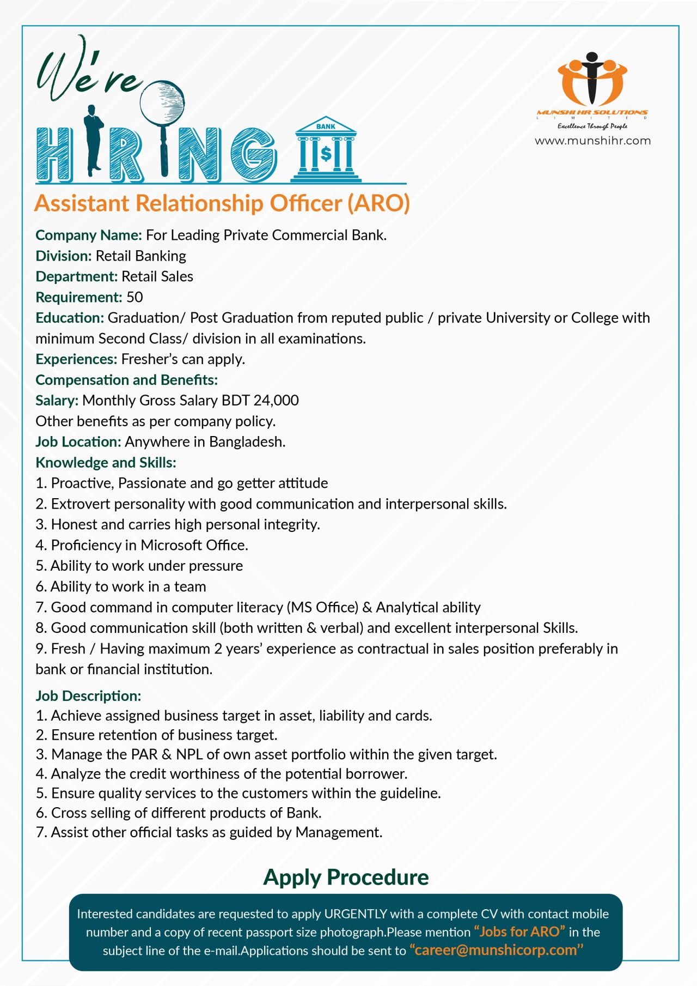

Exhibition B: Participate at BICC as a BPO Recruiting Agency
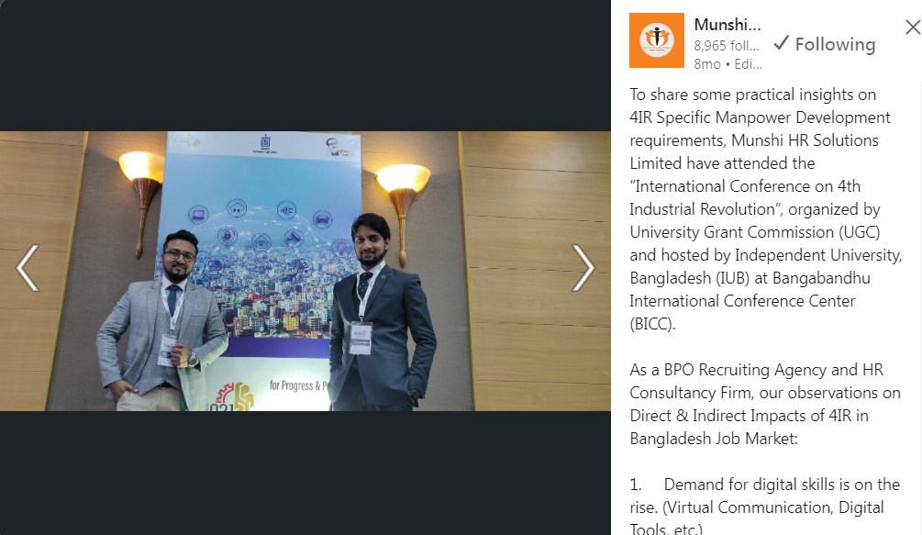

Exhibition C: Participate on Campus Recruitment at National Job Festival at UIU


Debi. (2022, April 18). Bulk Hiring: How to Plan and Master it. Retrieved from Xobin: https://xobin.com/blog/guide-to-master-bulk-hiring/#What_is_Bulk_Hiring
Debi. (2022, April 18). Bulk Hiring: How to Plan and Master it. Retrieved from Xobin: https://xobin.com/blog/guide-to-master-bulk-hiring/#What_is_Bulk_Hiring
VALUES. (n.d.). Retrieved from Munshi HR Soultion Limited: https://munshihr.com/about-us

