


BSCIC Industrial Area, Enayethnagar, Shashangaon, Fatullah, Narayanganj
www.fakirapparels.com
Internship Report
On
Accounting Information System in RMG Sector

Submitted By:
Sumiya Akhtar Mahi
Student ID: 111 202 064
BBA in Accounting
School of Business & Economics (SoBE)
United International University

Internship Supervisor:
Dr. Mofijul Hoq Masum, FCMA
Associate Professor-AIS
School of Business & Economics
United International University
Cell Phone: 01558965046
Email: masum1984du@gmail.com

Date of Submission: 01 November, 2024

Letter of Acknowledgement
I would like to express my sincere gratitude to Dr. Mofijul Hoq Masum, ACMA, Associate Professor-AIS, School of Business & Economics, United International University, for his constant guidance, support, and valuable feedback throughout my internship journey. His expertise and mentorship were instrumental in the successful completion of this report.

I am also grateful to the team at Fakir Apparels Ltd., where I had the opportunity to gain practical insights into the HR and Accounting departments. Special thanks to my colleagues and supervisors who supported my learning process during the internship.

Finally, I would like to extend my appreciation to my family and friends for their encouragement and unwavering support.

Sincerely,
Sumiya Akhtar Mahi

Letter of Transmittal
01 November, 2024

Dr. Mofijul Hoq Masum, FCMA
Associate Professor-AIS
School of Business & Economics
United International University
Madani Avenue, Dhaka, Bangladesh

Subject: Submission of Internship Report

Dear Sir,
I am pleased to submit my internship report titled “Internship Experience at Fakir Apparels Ltd. Accounting Information System in RMG Sector” as part of the requirements for my Bachelor of Business Administration (BBA) degree at United International University.

This report is based on the practical experience I gained during my internship at Fakir Apparels Ltd. from July 2024 to September 2024. I have attempted to present the key learnings, challenges, and contributions I made in the HR and Accounting departments. This report is an original work and has been prepared under your valuable supervision.

I sincerely hope this report meets your expectations, and I am available to discuss any questions or clarifications you may have.

Thank you for your guidance and support throughout this internship.

Yours sincerely,
Sumiya Akhtar Mahi
Student ID: 111 202 064
BBA in Accounting
United International University
Table Of Contents
Letter of Acknowledgement III
Letter of Transmittal IV
Executive Summary 1
1. Introduction 2
1.1 Introduction 2
1.2 Introduction to the Field of Internship 2
1.3 Background of the Study 3
1.4 Rationale of the Study 4
1.5 Limitations of the Study 4
2. Objectives of the Study 5
2.1 Broad Objectives 5
2.2 Specific Objectives 5
3. Methodology of the Study 5
3.1 Data Design 6
3.2 Sample Design 6
3.3 Analytical Tools 7
4. Overview of the Company 7
4.1 Mission & Vision of Fakir Apparels Limited 7
4.2 History of Fakir Apparels 8
4.3 Board of Directors 9
4.4 Core Functions of the Company 10
4.5 Products 10
4.6 Key Clients 10
4.7 Five Years Financial Performance of FAL 11
4.8 SWOT Analysis of Fakir Apparels Ltd. 35
5 Findings and Analysis of the Study 37
5.1 Operational Efficiency and Manufacturing Capabilities 37
5.2 Corporate Social Responsibility (CSR) Initiatives 39
Recommendations 40
Internship Experience 41
Completion Certificate 42
Appendix 43

Executive Summary
This report presents an in-depth overview of my internship experience at Fakir Apparels Ltd. where I engaged in a comprehensive exploration of the Accounting Information System (AIS) within the Ready-Made Garments (RMG) sector. Conducted from July to September 2024, this internship provided hands-on exposure to the HR and Accounting departments, allowing me to apply my academic knowledge in a real-world context. The report begins by detailing the objectives and methodology of the study, followed by an overview of Fakir Apparels Ltd., one of Bangladesh's prominent RMG exporters. Special focus is given to the company’s dedication to Corporate Social Responsibility (CSR), environmental management, and social compliance initiatives, which illustrate its commitment to sustainable and ethical practices. A swat analysis examines the company’s strengths, such as its large workforce and significant export capacity, while highlighting potential challenges, including industry competition and reliance on imported raw materials. The report further explores Fakir Apparels Ltd.'s Human Resource Management (HRM) strategies and development programs, which focus on succession planning, employee skill enhancement, and comprehensive training programs for all levels of staff. Additionally, significant events, such as the annual picnic and internal fashion shows, are highlighted as examples of the company’s vibrant organizational culture. ISO certifications are also discussed, showcasing Fakir Apparels Ltd.'s compliance with international standards in quality management, environmental sustainability, and occupational safety. The report concludes with an assessment of how this internship has reinforced my skills in accounting, HR practices, and industry-specific management strategies, equipping me with valuable competencies for my future career. This internship experience has been instrumental in bridging the gap between academic theories and industry practices, providing a well-rounded perspective on the operational intricacies of the RMG sector and the critical role of accounting information systems in supporting business objectives.

Key words : Accounting Information, Human Resource, Corporate Social Responsibility

1

1. Introduction

1.1 Introduction
This internship report presents a comprehensive analysis of my professional journey and experiences during my internship at Fakir Apparels Ltd. The internship was a requirement of my Bachelor of Business Administration (BBA) program at United International University and provided a practical application of my academic knowledge in a real-world corporate environment. My placement in the HR and Accounting departments allowed me to gain hands-on experience and insights into the operational dynamics of a major player in the apparel industry. The report outlines my core responsibilities, detailing the specific tasks and projects I undertook and the significant contributions I made to various initiatives within the company. Additionally, I discuss the skills and competencies I developed during this period, including analytical and interpersonal skills essential for working effectively within a corporate team setting. Through this internship, I was able to bridge the gap between theoretical concepts and their practical application in HR and Accounting functions, which helped me understand organizational processes more deeply and prepare for future roles in the business world.

1.2 Introduction to the Field of Internship
The field of this internship falls within the Ready-Made Garments (RMG) sector, one of the most vital and impactful industries in Bangladesh’s economy. As a cornerstone industry, RMG has been instrumental in shaping the country’s economic trajectory, emerging as a primary source of employment and a substantial contributor to the national GDP. The sector not only generates significant export revenue but also strengthens Bangladesh's presence in the global marketplace as a key supplier to major international apparel brands. This industry provides jobs to millions, many of whom are women, making it not only an economic powerhouse but also a vehicle for social and economic empowerment in Bangladesh.

My internship took place at Fakir Apparels Ltd., a leading company in this sector known for its integrated operations and commitment to quality. The focus of my internship was in the Human Resources (HR) and Accounting departments, which are both essential for maintaining operational efficiency and supporting the company’s strategic goals. The HR department is critical in managing and developing the workforce, which is central to productivity in this labor-intensive industry. From recruitment and training to employee relations and performance management, HR ensures that Fakir Apparels Ltd. has a skilled and motivated workforce capable of meeting production demands and quality standards.

The Accounting department, meanwhile, plays a vital role in sustaining the financial health of the organization. This department manages financial reporting, budgeting, and cost control, ensuring that resources are allocated effectively and that all financial activities comply with regulatory standards. In a highly competitive and margin-sensitive industry like RMG, precise financial management is essential for maintaining profitability and achieving long-term growth.

Together, the HR and Accounting departments at Fakir Apparels Ltd. contribute to a stable, sustainable, and scalable business model, allowing the company to meet its production targets, uphold financial accountability, and foster a positive work environment. My internship within these departments provided insights into how these functions operate in tandem to support the company’s growth, resilience, and contribution to Bangladesh's economic landscape.

1.3 Background of the Study
This internship was undertaken as part of an academic requirement for my Bachelor of Business Administration (BBA) program, aiming to bridge theoretical knowledge with practical, hands-on experience in a real-world setting. The internship provided an invaluable opportunity to apply classroom concepts to the dynamic environment of Fakir Apparels Ltd., one of Bangladesh’s prominent companies within the Ready-Made Garments (RMG) sector. This experience not only fulfilled an essential component of my academic curriculum but also allowed me to gain deep insights into the complexities and operational intricacies of the industry.
Throughout my time at Fakir Apparels Ltd., I was immersed in the daily operations of the Human Resources (HR) and Accounting departments. By observing and participating in departmental activities, I gained a nuanced understanding of how these core functions drive the company’s success. In the HR department, I learned how the team manages talent acquisition, employee relations, and performance management, all while ensuring compliance with labor laws and fostering a positive workplace culture. This experience shed light on the crucial role HR plays in retaining skilled employees, enhancing productivity, and supporting organizational goals in a labor-intensive industry like RMG.
In the Accounting department, I observed how financial data is meticulously recorded, analyzed, and reported to ensure accurate budgeting, cost control, and financial compliance. This exposure highlighted the importance of financial transparency and accountability in maintaining the company’s profitability and operational stability. Through my engagement with the accounting team, I developed a clearer understanding of how financial metrics and reporting practices contribute to data-driven decision-making, budget forecasting, and resource allocation.
The experience also allowed me to explore the challenges inherent to the RMG industry, including regulatory compliance, wage management, and labor rights issues. It underscored the importance of balancing productivity with ethical practices, which is essential for sustaining both employee welfare and corporate reputation. This internship, therefore, provided a practical extension of my academic learning, enriching my understanding of how theoretical principles are applied to tackle real-world challenges and helping me appreciate the strategic role that HR and Accounting play in supporting a company’s growth and sustainability.

1.4 Rationale of the Study
Choosing Fakir Apparels Ltd. for my internship offered the opportunity to gain hands-on experience in one of Bangladesh's most prominent sectors. The goal was to deepen my expertise in HR and Accounting processes and familiarize myself with industry-standard practices. This internship provided a valuable learning platform, equipping me with skills and insights essential for a future career in business management within the apparel sector or similar industries.

1.5 Limitations of the Study
Despite the wealth of learning opportunities, this internship had certain limitations. Time constraints posed a challenge, as the program’s duration limited the depth of analysis in some areas. Additionally, access to certain proprietary data was restricted, which limited my scope in fully assessing certain operational details. Nonetheless, these challenges did not detract from the substantial learning and valuable experience I gained through the internship.

2. Objectives of the Study

2.1 Broad Objectives
The broad objective of this study is to gain a comprehensive understanding of the HR and accounting functions within Fakir Apparels Ltd. This objective aims to bridge the theoretical knowledge acquired during my BBA program with real-world practices and applications in the apparel industry, specifically focusing on HR processes and accounting practices. The ultimate goal is to enhance my practical skills and knowledge in these areas, equipping me for a future career in a corporate environment.

2.2 Specific Objectives

Observe and understand the payroll process, including employee salary calculation, tax deduction, and benefits management, thereby gaining insight into how employee compensation is managed within an organization. Explore the recruitment and selection process within the HR department, learning about candidate sourcing, screening, interviewing, and selection procedures. This includes understanding the role of recruitment in organizational growth.

Study the data management techniques employed by the HR department, including employee records, attendance tracking, and performance monitoring, and to understand how data-driven decisions support HR strategies. To gain insights into the financial reporting and analysis practices within the accounting department, focusing on understanding financial statements, budgeting, and financial performance analysis. Identify common challenges in HR and accounting faced by the apparel industry and understand how these are managed within Fakir Apparels Ltd. Evaluate how digital tools and software are integrated into HR and accounting processes to streamline workflows and increase efficiency within the organization.

3. Methodology of the Study
The methodology section outlines the approach and methods used to gather, analyze, and interpret data for this study. The methodology is designed to ensure a structured approach that aligns with the objectives of the study, allowing for a comprehensive examination of HR and accounting functions at Fakir Apparels Ltd.

3.1 Data Design
The data design for this study incorporates both primary and secondary data to provide a holistic understanding of HR and accounting functions at Fakir Apparels Ltd.

Primary Data Collection
- Observations: Observed the daily functions of HR and accounting departments, including payroll processing, recruitment, and financial reporting, to understand workflows and processes in a real-world setting.
- Discussions with Supervisors: Engaged in discussions with supervisors to understand the strategic importance of HR and accounting functions within the organization.

Secondary Data Collection
- Company Documents: Reviewed company documents, such as employee handbooks, payroll policies, and financial reports, to gain insight into the formal processes and policies governing HR and accounting functions.
- Industry Reports: Consulted industry reports on the apparel sector to understand broader HR and accounting trends, challenges, and best practices relevant to Fakir Apparels Ltd.

3.2 Sample Design
Sampling Technique:
A purposive sampling technique was used to select specific employees and supervisors from the HR and accounting departments for interviews and observations. This technique allowed the study to focus on individuals with a strong understanding of departmental operations, ensuring relevant and high-quality information.

Sample Size:
The sample size consisted of 10 employees from the HR and accounting departments, including HR managers, payroll officers, accountants, and data management personnel. This sample was chosen to provide a balanced view of both HR and accounting functions within the organization.

3.3 Analytical Tools
To analyze the collected data effectively, a combination of qualitative and quantitative analytical tools was used.
Qualitative Analysis:
- Content Analysis: Used to interpret information gathered from interviews, discussions, and observations. Content analysis helped identify key themes and insights into HR and accounting practices.
- SWOT Analysis: Conducted to assess the strengths, weaknesses, opportunities, and threats related to HR and accounting processes at Fakir Apparels Ltd.
Quantitative Analysis:
- Descriptive Statistics: Used to analyze data related to employee performance, payroll, and financial performance. Descriptive statistics provided a clear understanding of patterns and trends in HR and financial data.
- Charts and Graphs: Tables, pie charts, and bar graphs were utilized to visualize data related to payroll, recruitment, and financial performance. Visual representations facilitated easy interpretation of complex data and helped convey findings effectively.

4. Overview of the Company

4.1 Mission & Vision of Fakir Apparels Limited

Mission:
* Enhance employee competencies, enabling them to adopt and excel in world-class manufacturing practices and processes.
* Create opportunities for professional growth and development for all employees.
Surpass the quality standards of top global brands, with a strong commitment to sustainability requirements.
* Foster a culture of innovation in product development and all operational processes.
Build and strengthen partnerships with suppliers, treating them as integral to the company’s growth.
* Fully utilize Information and Communication Technology (ICT) by implementing tools like ERP, EPM, BI, and exploring Industry 4.0 to significantly improve efficiency.

Vision:
"To redefine conventional garment manufacturing by leading in innovations in design, processes, and practices that drive our progress towards a sustainable future."

4.2 History of Fakir Apparels
Fakir Apparels was founded in 1998 and is situated in an industrial zone in Narayanganj, approximately an hour from the capital city of Dhaka. The roots of Fakir Enterprises trace back to the 1960s, when the founder, Al-Haj Yusuf Ali Fakir, began trading textile raw materials and fabrics. Decades of accumulated knowledge, experience, and passion laid the foundation for Fakir Group and the creation of Fakir Apparels as a prominent player in the
Ready-Made Garments (RMG) sector.

Over the past two decades, Fakir Apparels has achieved an annual growth rate of around 15%. Today, the company’s operations span from vertically integrated knits manufacturing to woven (cut-to-ship) operations, housed within a single compound. The company employs a team of 11,000 people, with a male-to-female ratio of approximately 13:7.

The Knits Division includes 140 sewing lines and produces over 150 million units of knit garments annually, supported by in-house textile mills that generate 55 tones of knit fabric each day. In 2018, Fakir Apparels expanded into woven manufacturing, with 25 production lines that create over 2 million units annually. The woven division offers a wide range of products, including washed bottoms, padded jackets, heavy technical outerwear, coats, and sportswear.

Fakir Apparels exports its products to over 45 countries, with key markets in Europe, North America, the Middle East, and Asia.

4.3 Board of Directors

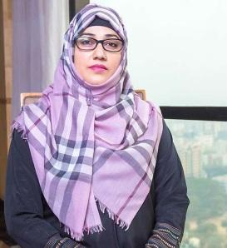
Chairman
Salma Zaman
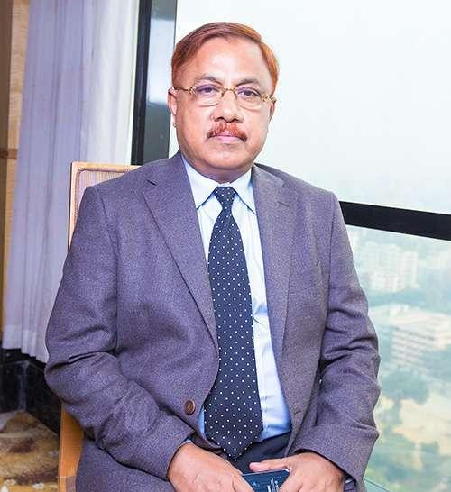
Managing Director
Fakir Maniruzzaman

Deputy ManagingDirector
Fakir Nafizuzzaman

Director Director
Monjarin Zaman Fakir Rafsanuzzaman

4.4 Core Functions of the Company
- Knitting
- Woven Manufacturing
- Printing & Embroidery
- Dyeing & Finishing
- F.A.D.S (Fashion Apparel Design Studio)
- F.T.S. Lab (Fabric Testing and Standardization Laboratory)

4.5 Products
Fakir Apparels manufactures a wide range of apparel, including menswear, womenswear, and kidswear. Their product lines are known for quality, functionality, and adherence to high standards. Through rigorous "Total Quality Control," the company ensures "Total Customer Satisfaction." Fakir Apparels has in-house printing, washing, and embroidery facilities, allowing them to customize designs extensively.

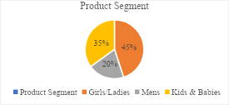
Fig-(1) of 4.5
Key products include dresses, jumpsuits, t-shirts, tanks, camisoles, sweat dresses, shorts, leggings, sweatshirts, and more for women. For kidswear, Fakir Apparels manufactures onesies, jumpsuits, t-shirt sets, shorts, hoodies, sweatshirts, and capes, covering sizes from preemies to pre-teens. The company ensures that all children's wear meets international quality standards, focusing on fabric softness and garment safety.

4.6 Key Clients
- Fakir Apparels Ltd.'s key clients include:
- H&M: A top supplier to Fakir Apparels
- Esprit: An international fashion brand that has awarded Fakir Apparels as a top global supplier and best strategic partner
- Inditex: A Spanish multinational clothing company that owns brands such as Zara, Bershka, and Massimo Dutti


Fig-(2) of 4.6

Other clients of Fakir Apparels Ltd include:
Primark, C&A, S. Oliver, POP, O'Neil, Gerry Weber, Marc'O Polo, Mango, Arket, and &Other Stories.

4.7 Five Years Financial Performance of FAL

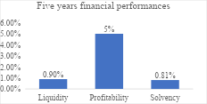
Fig-(3) of 4.7
Analysis of Historical Financial Performance:
Liquidity (0.90%):
A liquidity ratio of 0.90% suggests that FAL has maintained its ability to cover short-term liabilities but with a slight margin below the ideal benchmark (typically above 1). This indicates that while FAL has been able to meet its short-term obligations, there may be limited buffer for unexpected financial pressures.
The company’s investments in sustainability, compliance, and employee welfare might have impacted its liquidity, channeling cash into long-term growth strategies rather than maintaining high liquidity levels.
Profitability (5%):
A profitability ratio of 5% is moderate and shows that FAL has been generating profit, although it may not be at an exceptionally high level. This indicates stable profit margins, possibly bolstered by its vertically integrated production model and advanced technological use.
The profitability could be attributed to cost-saving initiatives such as energy and water conservation and the efficient in-house facilities for printing, dyeing, and embroidery.

Solvency (0.81%):
A solvency ratio of 0.81% indicates that the company has a reasonable level of long-term financial stability but is below the preferred benchmark of 1. This suggests that FAL's liabilities are significant compared to its total assets, possibly due to its ongoing investments in infrastructure, sustainability programs, and certifications.
Despite this, maintaining near-stable solvency shows that the company is committed to leveraging its assets for growth and expansion while managing its debts.

Projected Current Financial Performance:
Given these historical trends, the current financial performance of FAL can be estimated with some assumptions:

Liquidity:
It is likely that FAL's current liquidity remains around the same level, potentially slightly improved due to strategic financial management and continued cost-saving initiatives. However, any substantial increase may be constrained by ongoing investments in new technologies and compliance.
Projected Liquidity: ~0.90% to 1.00%

Profitability:
FAL's profitability may experience a slight increase if the company continues to optimize its operations through enhanced production efficiency and technological adoption. Continuous export growth and expanding global market reach should positively impact revenue and profits.
Projected Profitability: ~5% to 6%

Solvency:
The solvency ratio might show slight improvement as FAL leverages its investments for revenue growth. The company’s strong export base and sustainability measures could attract more international clients, contributing to asset growth and a better debt-to-asset balance.
Projected Solvency: ~0.81% to 0.85%
5. Corporate Social Responsibility (CSR) Initiatives
Fakir Apparels is committed to the welfare of its employees and the surrounding community. Key CSR initiatives include:
- Donations to local mosques, madrasahs, and other social causes.
- A fund to support workers and their families during times of financial need.
- Provision of milk, fruit, and eggs to pregnant workers to ensure proper nutrition.
- Eid-ul-Adha bonuses of Tk. 500 for each worker to purchase meat.
- Annual Hajj sponsorships for employees.
- A Zakat fund to support all workers.
- Monthly "Best Employee" recognition to motivate staff, with winners displayed on a dedicated recognition board.
- Paid paternity leave of 6 days for male staff members.
- Scholarships for school-going children of workers from the company’s financial assistance fund.
- Birthday celebrations for workers with flowers and chocolates.
- Daily allowances of Tk. 40 per worker for Iftar during Ramadan.
- Installation of pure drinking water facilities for the local community.
- Organization of tree-planting programs to benefit the environment.
- Provision of sanitary napkins for female workers to promote hygiene and well-being.
6. Environment Management Systems (EMS)
Fakir Apparels Ltd (FAL) is deeply committed to environmental sustainability, embodying this value in all aspects of its operations. Aligned with the company’s vision, FAL upholds its role as an environmental leader by establishing policies that not only ensure a safe and healthy workplace but also actively protect natural resources and promote conservation. The company is dedicated to creating a sustainable future that supports the well-being of upcoming generations.

To meet the stringent environmental compliance standards of the Ready-Made Garment (RMG) industry, FAL has implemented a comprehensive Environmental Management System (EMS). A specialized monitoring body has been established to ensure that all policies and decisions prioritize environmental protection, waste minimization, and resource optimization.

6.1 Key Components of the EMS
- Policy & Procedures: Comprehensive environmental policies and procedures have been implemented to support safe, sustainable operations.

- Targets & Objectives: Clear environmental targets and objectives guide FAL’s initiatives towards achieving measurable sustainability outcomes.

- Environmental Aspect & Impact Analysis: Detailed analysis is conducted to understand the environmental aspects and impacts of each process, ensuring responsible resource use and waste reduction.

- Management Review: Regular management reviews assess EMS effectiveness, aligning environmental practices with the company’s long-term sustainability goals.

- Internal Audits & Training: Periodic audits and training programs are conducted to ensure compliance with environmental standards and enhance employee knowledge on sustainability practices.
- Awareness Training on Environment: Awareness programs are provided to employees to foster a culture of environmental responsibility and promote sustainable practices across all levels.
- Certifications: FAL holds ISO 14001:2015 certification, affirming its adherence to international environmental standards, along with ISO 13485 certification, which reflects its commitment to quality and safety in production.

- Chemical and EMS Policies: Comprehensive chemical and EMS policies are in place to control and reduce the use of hazardous substances, ensuring safe handling and disposal.

- Environmental Sustainability: FAL is continuously working towards enhancing its environmental sustainability by adopting innovative practices and minimizing ecological footprints.

- Joint Collaboration: FAL collaborates with industry partners and environmental organizations to drive collective sustainability efforts.

6.2 Green Initiatives at Fakir Apparels Ltd.
- Green ETP (Effluent Treatment Plant): FAL has invested in a green effluent treatment plant to ensure that wastewater is treated and discharged responsibly, reducing water pollution.
- Green Building: The company has incorporated green building practices, such as energy-efficient design, to reduce the carbon footprint of its facilities.

- Green Landscaping: Sustainable landscaping practices have been adopted to improve biodiversity and create a healthy environment around the factory premises.

- Green Machinery: FAL uses environmentally friendly machinery, which consumes less energy and minimizes emissions, contributing to a more sustainable production process.

- Energy Conservation: FAL has implemented energy conservation measures, including the use of energy-efficient lighting and machinery, to reduce power consumption across operations.

- Water Conservation: Water-saving technologies and practices are in place to reduce water usage and promote sustainable water management throughout the production process.

7. Chemical Management Systems at Fakir Apparels Ltd (FAL)
Fakir Apparels Ltd (FAL) has established a comprehensive Chemical Management System (CMS) to ensure the safe handling, storage, use, and disposal of chemicals, minimizing risks to employees, the environment, and the broader community.
The CMS adheres to international and local standards, reflecting FAL's commitment to sustainability and responsible chemical management.

7.1 Areas of Focus
FAL’s chemical management focuses on adherence to buyer-specific codes of conduct, compliance with local laws, and best practices in sustainable manufacturing.

7.2 Chemical Management Requirements
To meet industry and buyer standards, FAL ensures all chemicals are managed in line with strict regulations. This includes monitoring and controlling restricted substances through policies, procedures, and staff training.

Buyers' Code of Conduct (COC): FAL aligns with buyers' requirements by maintaining policies to monitor and control restricted substances, with trained staff to effectively implement these measures.
Local Laws and International Guidelines: FAL follows guidelines such as the ZDHC (Zero Discharge of Hazardous Chemicals) and ILO Chemical Convention-170, along with Bangladesh laws, to manage chemical procurement, handling, storage, usage, and disposal in an environmentally responsible manner.

7.3 Practices at Fakir Apparels Ltd.

FAL’s chemical management practices include:
Policy & Commitment: FAL has a written chemical management policy endorsed by senior management, as per ZDHC guidelines, clearly stating where and how the CMS is implemented.

Compliance with Regulations: FAL updates its Chemical Inventory List (CIL) monthly, ensuring alignment with buyers’ Manufacturing Restricted Substances List (MRSL). The company communicates all MRSL and Restricted Substances List (RSL) requirements to suppliers and collects declaration letters from them to confirm compliance.
8. Social Compliance
Fakir Apparels Ltd is committed to upholding high standards of social compliance, ensuring that ethical principles are embedded across the organization. Through a dedicated sustainability team, FAL maintains compliance with buyers' Codes of Conduct (COC) and the legal requirements of Bangladesh, creating a safe, sustainable, and fair working environment.

8.1 Goals and Objectives
The sustainability team at FAL focuses on developing a sustainable and ethical business environment. By monitoring data, assessing risks, and evaluating the overall supply chain, the team ensures long-term profitability and responsibility for all stakeholders.

Sustainable Business Practices: FAL’s sustainability team aims to go beyond compliance by fostering business practices that support long-term sustainability, social well-being, and environmental stewardship across the supply chain.
Proactive Approach: The team proactively aligns with sustainability goals, driven by a belief in ethical and sustainable business performance that extends throughout the supply chain.

8.2 Certifications and Standards
FAL is committed to maintaining and enhancing social compliance standards and has received several key certifications, including:
- BSCI (Business Social Compliance Initiative)
- WRAP (Worldwide Responsible Accredited Production)
- GOTS (Global Organic Textile Standard)
- OCS (Organic Content Standard)
- OEKO-TEX (Certification for safe textiles)
- ISO 14001:2015 (Environmental management) and ISO 18001:2007 (Occupational health and safety)

In addition, FAL aims to implement the SA 8000 standard, further strengthening its commitment to social responsibility and ethical business practices.
9. Utility Data At FAL

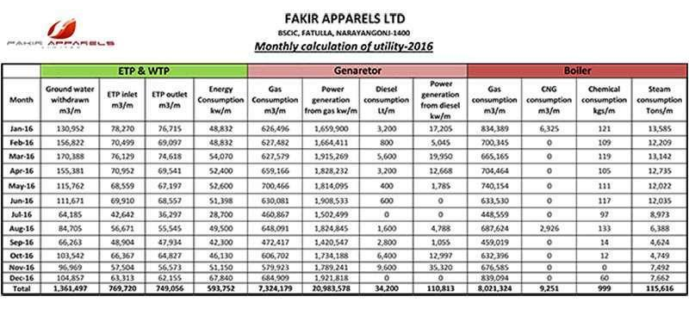
Fig-(4) of 9
10. Joint Collaborations
Fakir Apparels Ltd (FAL) has formed strategic partnerships with several organizations and initiatives to enhance its sustainability practices, improve working conditions, and boost productivity.
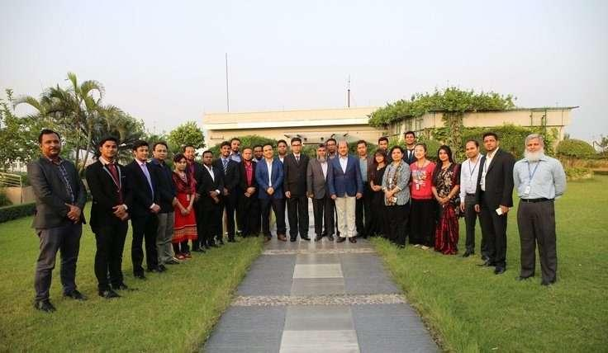
Fig-(5) of 10

These collaborations underscore FAL's commitment to social responsibility and operational efficiency in the ready-made garment (RMG) sector.

Better Work Bangladesh: FAL participates in this program, a joint initiative by the International Labour Organization (ILO) and the International Finance Corporation (IFC), aimed at reducing poverty by promoting decent work opportunities in Bangladesh.

Partnership for Cleaner Textile (PaCT): To improve energy efficiency in its textile operations, FAL has implemented this program, focused on reducing energy consumption and environmental impact.

Swedish Textile Water Initiative (STWI): A buyer-recommended project (initiated by Asmara), STWI focuses on reducing energy usage within the facility to promote sustainability.

Improving Productivity through Action Research (IPA): Sponsored by IFC through Better Work Bangladesh, this project focuses on empowering women in production roles within the RMG sector, enhancing work progression and productivity.

CPI2 (Carbon Performance Improvement Initiative): In partnership with the brand s.Oliver, FAL is involved in this customer-recommended project to reduce overall energy consumption across its operations.

11. Compliance Facilities
Fakir Apparels Ltd provides a range of compliance facilities that ensure the well-being of its employees and adherence to industry standards, fostering a supportive and safe working environment.

- Medical Center: FAL operates a fully equipped medical center within its complex, offering comprehensive healthcare services to ensure better health and safety for all employees.

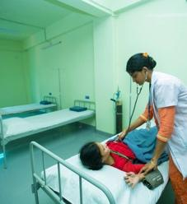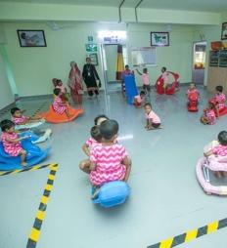
Fig-(6) of 11

- Day Care Center: A modern, well-furnished child care facility is available to support working mothers, providing a safe and nurturing environment for their children during work hours.

- Environmental Impact Analysis: FAL conducts environmental impact assessments to identify and manage the environmental aspects of its operations, focusing on minimizing adverse impacts and promoting sustainable practices.

- Chemical Management System (CMS): FAL has established a robust CMS to monitor and control the use of chemicals in its facilities, ensuring compliance with local laws and buyer requirements.

12. Policies and Commitment
Fakir Apparels Ltd. has implemented a comprehensive set of policies to ensure a safe, ethical, and compliant work environment. These policies reflect FAL's dedication to maintaining high standards in areas such as anti-discrimination, labor practices, and environmental responsibility.

- Policy & Commitment to Chemical Management: FAL complies with buyer requirements by implementing policies for monitoring and controlling restricted substances, supported by staff training programs. The organization follows ZDHC guidelines, including written CMS policies from senior management, and adheres to the ILO Chemical Convention-170 and Bangladesh law to minimize environmental risks associated with chemical use.

- Commitment to Compliance Standards: FAL maintains a monthly updated Chemical Inventory List (CIL) as per buyer-specific Manufacturing Restricted Substances List (MRSL). The company ensures ongoing compliance by communicating MRSL and Restricted Substances List (RSL) requirements to suppliers and collecting declaration letters confirming adherence.
13. Key Policies at FAL
To uphold ethical standards and comply with regulations, FAL has introduced various policies across multiple aspects of workplace conduct and operations. Some of the main policies include:

- Anti-Harassment & Anti-Discrimination Policy: Ensures a respectful and inclusive workplace, free from harassment or discrimination.

- Anti-Abuse Policy: Establishes guidelines to prevent abuse and ensure a safe working environment.

- Child Labor & Juvenile Employment Policy: Prohibits child labor and establishes guidelines for employing young workers in compliance with local laws.

- Forced & Prison Labor Policy: Prohibits forced labor and ensures that all employees work freely and voluntarily.

- Freedom of Association Policy: Supports employees' right to freely associate and participate in collective bargaining.

- Grievance Policy: Provides a structured process for employees to raise grievances and ensures fair resolution practices.

- Recruitment Policy: Outlines guidelines for ethical recruitment practices, covering both direct and indirect suppliers.

14. Supporting Documents
FAL maintains various records and documents to reinforce its policies and compliance efforts. Key documents include:

- ACCORD Report Graph Chart: Compliance performance metrics related to building safety and labor rights.

- Adyan Fair Price Shop: A facility offering affordable essential goods to employees.
- Best Practices Documentation: Guides on best practices in compliance, safety, and quality.

- Beyond the Law Activities: Initiatives that exceed compliance requirements, reflecting FAL’s commitment to social responsibility.

- Family Planning Corner: Resources and support for employees regarding family planning.

- Fire Equipment Information: Details on fire safety measures and equipment available within the facility.

- Integrated Management System (IMS) Policy: An overarching policy covering quality, environment, and occupational health and safety standards.

- Internal Audit Plan: Schedules and procedures for internal audits to ensure ongoing compliance.

- Quality Policy: FAL’s commitment to maintaining high-quality standards in its products and services.

- SMETA 2-Pillar Audit 2020 CAPR: Audit report on social compliance and ethical trade practices.

- Social Compliance Policies: FAL’s standards for ethical and responsible business practices.

- Welfare Facilities & Fire Safety Compliance: Provisions for employee welfare and compliance with fire safety regulations.

- WRAP Certification (Gold): Reflects FAL's achievement in social compliance, covering the period from 2019 to 2020.
15. Human Resource Management at Fakir Apparels Ltd
The Human Resource Department at Fakir Apparels Ltd. (FAL) plays a critical role in aligning the organization’s workforce with its strategic vision, mission, and objectives. Our approach to Human Resource Management (HRM) transcends traditional administrative functions; we view HRM as a vital business partner integral to the company’s success.

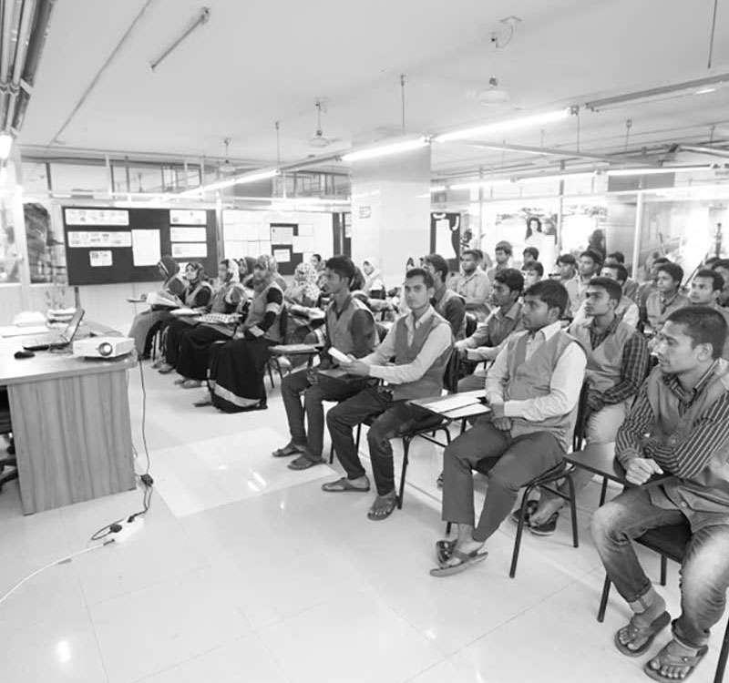
Fig-(7) of 15

15.1 Attracting Talent
To achieve our strategic goals, we actively seek to attract talented and energetic individuals who not only possess the necessary skills but also align with our organizational culture. We implement targeted recruitment strategies, leveraging various channels to reach potential candidates. This includes campus recruitment drives, online job portals, and industry networking events, ensuring a diverse and skilled talent pool.

15.2 Developing Employees
Once talent is onboarded, our focus shifts to their continuous development. At FAL, we invest in comprehensive training and development programs designed to enhance employees’ skills and knowledge. This includes both formal training sessions and mentorship initiatives that encourage personal and professional growth. We believe that ongoing development is essential for maintaining a motivated workforce that can adapt to the dynamic nature of the apparel industry.

15.3 Maintaining Workforce Engagement
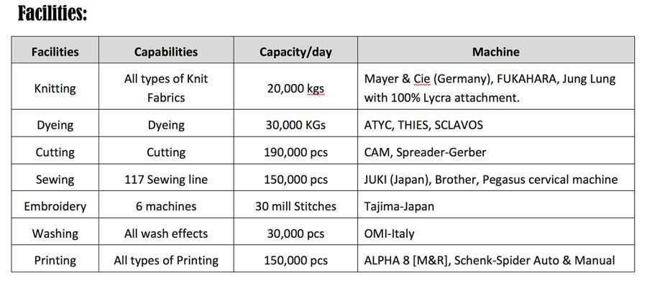
Fig-(7) of 15.3

We understand that our employees are our most valuable asset and the key drivers of our growth and development. Therefore, we place significant emphasis on employee engagement and retention strategies. This involves creating a supportive work environment that fosters collaboration, innovation, and open communication. Regular feedback mechanisms, such as performance appraisals and employee surveys, help us gauge satisfaction levels and identify areas for improvement.

15.4 Strategic Alignment
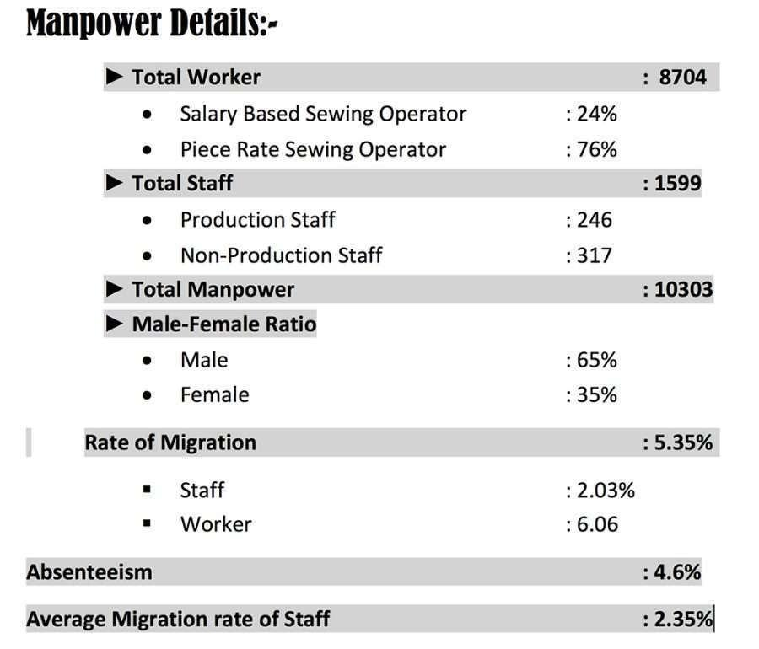
Fig-(8) of 15.4
At Fakir Apparels Ltd, HRM is not merely a function; it is embedded in the fabric of our business strategy. We work closely with leadership to ensure that our human resource initiatives align with the overall organizational goals. This partnership allows us to respond swiftly to changing business needs, ensuring that we remain competitive in the marketplace.

16. Strategic Human Resources at Fakir Apparels Ltd
16.1 Corporate Committees
At Fakir Apparels Ltd. (FAL), we emphasize a structured approach to human resource management through various corporate committees that guide our HR practices. These committees include:

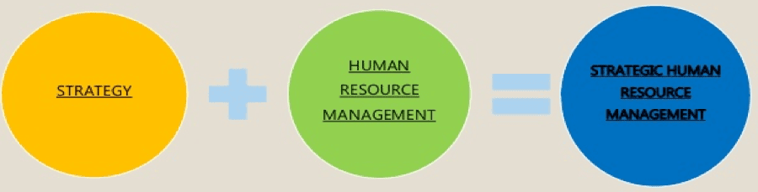
Fig-(9) of 16.1

- Management Committee: Responsible for overseeing the overall strategic direction of the company and making high-level decisions regarding HR policies and practices.
- Appraisal Committee: Focuses on performance evaluation processes, ensuring that employees are assessed fairly and that feedback is constructive.
- Worker Participation Committee: Engages employees in decision-making processes, fostering collaboration and enhancing workplace morale.

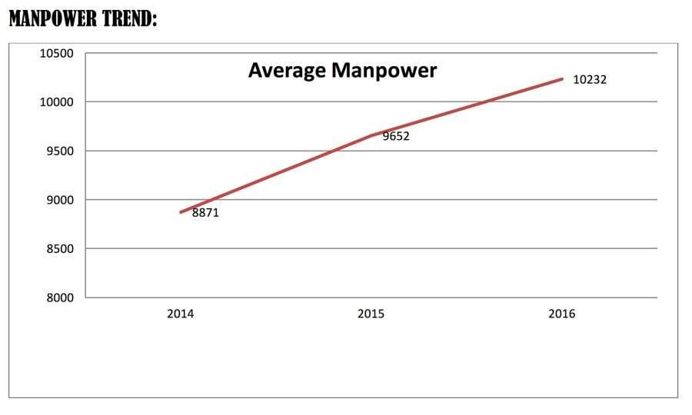
Fig-(10) of 16.1

These committees encompass typical HR functions such as hiring, discipline, and payroll management. Moreover, they promote a collaborative work environment that aims to boost employee retention, enhance job satisfaction, and maximize the mutual benefits of employment.

16.2 Strategic HR Goals
Fakirs Apparels Ltd. has established several strategic HR goals to align our human resource practices with organizational objectives:

Goal 1: Organize Effective HR Policies and Procedures Develop and implement comprehensive HR policies that reflect best practices and ensure compliance with regulations.

Goal 2: Follow Competency-Based Recruitment Processes Adopt a competency-based recruitment approach for all levels of designations, ensuring we hire candidates who possess the skills and attributes necessary for success.

Goal 3: Implement a Learning Management System (LMS) Address training needs as part of career mapping for employees, helping them achieve their career goals while enhancing leadership competencies at all levels.

Goal 4: Motivate and Retain Talented Employees Create initiatives aimed at motivating and retaining innovative employees who contribute to our organizational success.

Goal 5: Architect a Human Resources Information System (HRIS) Develop a cutting-edge HRIS to streamline HR processes, improve data management, and enhance overall efficiency.

16.3 Corporate HR Practices
The HR practices at Fakir Apparels Ltd. are designed to enhance employee effectiveness and engagement. The HR team actively stays informed about the latest developments in the HR field and collaborates with a robust network to implement innovative solutions tailored to our organizational needs. Key practices include:

- Recruitment: Utilizing competency-based recruitment strategies to ensure we attract the right talent.
- Career Planning: Providing career planning resources for both workers and staff to facilitate professional growth.
- Learning and Training: Offering skill-based learning and training programs for employees at all levels to enhance their capabilities.
- Key Performance Indicators (KPIs): Aligning individual KPIs with departmental and company goals to ensure accountability and performance tracking.
- Performance Appraisal: Implementing KPI-based performance appraisals for management staff and KSA-based appraisals for non-management employees to foster transparency and fairness in evaluations.
- Succession Planning: Developing effective succession plans for key positions to ensure continuity and organizational stability.
- Wages: Committing to fair wages that meet living standards for all employees.
- Enterprise Resource Planning (ERP): Leveraging a cutting-edge ERP system and HRIS to optimize HR processes.

16.4 HR Practices
Fakir Apparels Ltd promotes fair labor management practices through various HR initiatives, including:
- Analyzing workplace issues and providing effective solutions.
- Fostering cooperation among employees to build a collaborative culture.
- Conducting training programs to enhance employee skills and capabilities.
- Ensuring compliance with company regulations and policies.
- Implementing strategies for employee retention and increasing overall efficiency.
- Prioritizing safety and security within the workplace.

16.5 Employee Benefits Policies
To enhance employee satisfaction and well-being, Fakir Apparels Ltd. has established a comprehensive set of employee benefits policies, which include:
- Mobile Phone Policy
- Canteen Policy
- Festival Bonus Policy
- KPI-Based Performance Appraisal Policy
- Promotion Policy
- Leave Fare Assistance (LFA) Policy
- Uniform Policy
- Staff Loan Policy
- Car Scheme
- Separation Policy with Benefits
- Iftar provisions during Ramadan
- Discounts on food items such as milk, eggs, vegetables, and chicken
- Hajj facility for employees

16.6 Career Planning
Career planning at Fakir Apparels Ltd. is designed to help employees gain a deeper understanding of their needs, values, and personal goals. This is achieved through a three-step self-assessment process that includes:
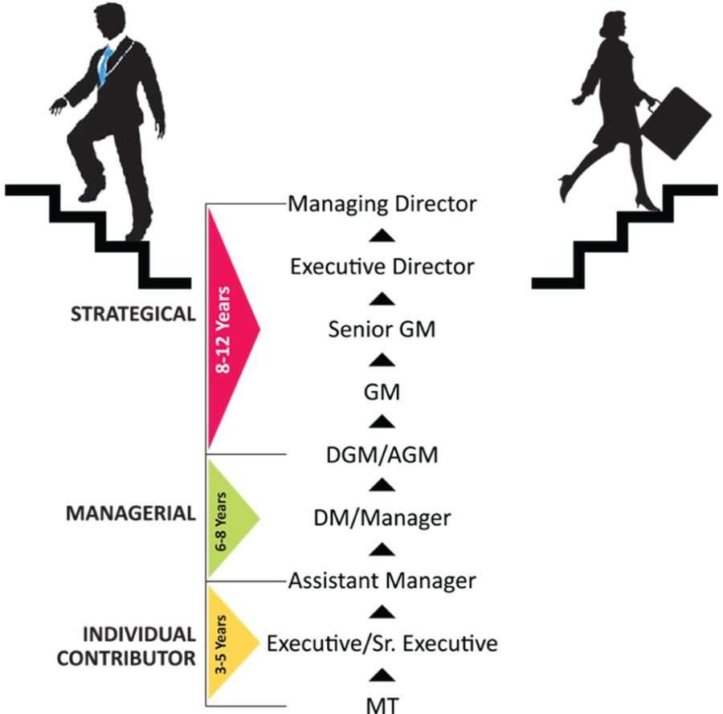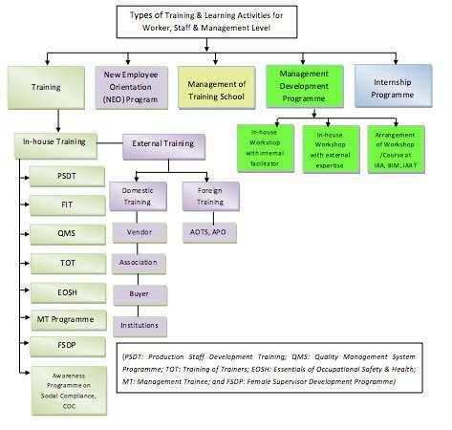

Fig-(11) of 16.6
- Identifying skills and interests.
- Organizing work-related needs.
- Clarifying personal values.

This comprehensive approach to career planning ensures that employees can navigate their career paths effectively, aligning their aspirations with the opportunities available within the organization.

17. Training & Development at Fakir Apparels Ltd.
The Training & Development activities at Fakir Apparels Ltd. (FAL) are designed to align with organizational objectives by providing comprehensive training and learning programs that enhance employees’ knowledge, skills, and attitudes. These initiatives support the effective implementation of FAL’s Talent Management Strategy and contribute to the overall career development of our workforce.

17.1 Skill Development Center (SDC)
Fakirs Apparels Ltd. has established a Skill Development Center (SDC) to develop and implement programs aimed at equipping sewing machine operators with the necessary knowledge and skills. The SDC focuses on upgrading the competency levels of all operators according to the National Technical & Vocational Qualification Framework (NTVQF) Level-1.
This initiative also addresses industry needs for multi-skilled operators, ensuring that our workforce remains competitive and capable.

17.2 Mega Employee Development Programs
Succession Management Program
The Succession Management Program at Fakir Apparels Ltd. is a systematic and intentional effort to ensure leadership continuity in key positions. This program focuses on retaining and developing intellectual and knowledge capital for the future while encouraging individual advancement within the organization.
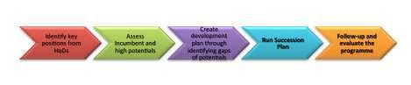
Fig-(12) of 17.2

17.3 Management Trainee (MT) Program
Our Management Trainee Program is designed for recent graduates or postgraduates from renowned universities and institutions. This program aims to develop young staff members into future managers at Fakir Apparels Ltd. Recognizing our employees as valuable human capital, the program offers training for entry-level management staff across various departments. The primary goal is to cultivate committed, result-oriented, and self-motivated successors who can contribute effectively to the company.

17.4 Factory Improvement Training (FIT) Program
Inaugurated on February 9, 2017, the Factory Improvement Training (FIT) Program focuses on enhancing the skills of factory management and production staff, including floor supervisors, production managers, and general managers, along with 120 workers. The training covers critical topics such as:
- Production & Productivity
- Capacity Definition & Planning
- Process Selection, Planning & Analysis
- Facility Layout & Scheduling
- Inventory Management
- Work Study
- Predetermined Motion Time System (PMTS)
- Waste Management

17.5 Female Supervisor Development Program (FSDP)
The Female Supervisor Development Program (FSDP) is tailored for internal certified trainers who are multi-skilled female operators, quality inspectors, or newly promoted trainee supervisors. This program provides guidance through on-the-job training, focusing on the skills, knowledge, and attitudes essential for supervisors performing specific assignments.

17.6 Training of Trainers (TOT) in Different Levels
To create in-house facilitators across various cross-functional areas and to enhance the operation of the Management Trainee (MT) Program, internships, and Production Staff Development Training (PSDT), Fakir Apparels Ltd. organized two batches of a Training of Trainers (TOT) program on July 30-31 and August 1, 2016, followed by another on August 20-22, 2016. Out of 32 participants, 26 successfully became certified trainers, further strengthening our internal training capabilities.

18. Memorable Events at Fakir Apparels Ltd.
18.1 Annual Picnic
The Annual Picnic of Fakir Apparels Ltd was held on March 25, 2017, at Green View, and it proved to be a significant gathering for the company. This event brought together a total of 1,550 participants, including employees ranging from Supervisors to Assistant Managers.
The picnic featured a variety of activities aimed at fostering team spirit and camaraderie among employees. Notable highlights of the event included a cultural festival that showcased diverse talents within the workforce, the “Employee of the Year” awards recognizing outstanding contributions by employees, and a raffle draw that added an element of excitement to the festivities. This annual gathering not only provided an opportunity for relaxation and enjoyment but also strengthened the bonds among colleagues and promoted a positive work culture within the organization.

18.2 Fashion Show
Fakir Apparels Ltd frequently organizes fashion shows to showcase the latest designs from the Fakir Design Studio. These events serve as a platform for fashion designers to debut their upcoming clothing lines, typically aligned with the Spring/Summer and Fall/Winter seasons. Fashion shows are pivotal in the apparel industry, as they set the stage for emerging trends and styles.
During these shows, designers highlight their creative visions and innovative concepts, which play a crucial role in shaping consumer preferences. Fakir Apparels Ltd.'s fashion shows not only demonstrate the company's commitment to creativity and excellence but also enhance its visibility in the competitive fashion market.

19. ISO Certifications
Fakir Apparels Ltd has achieved various ISO certifications, reflecting its commitment to maintaining high standards in quality management, environmental management, and occupational health and safety.
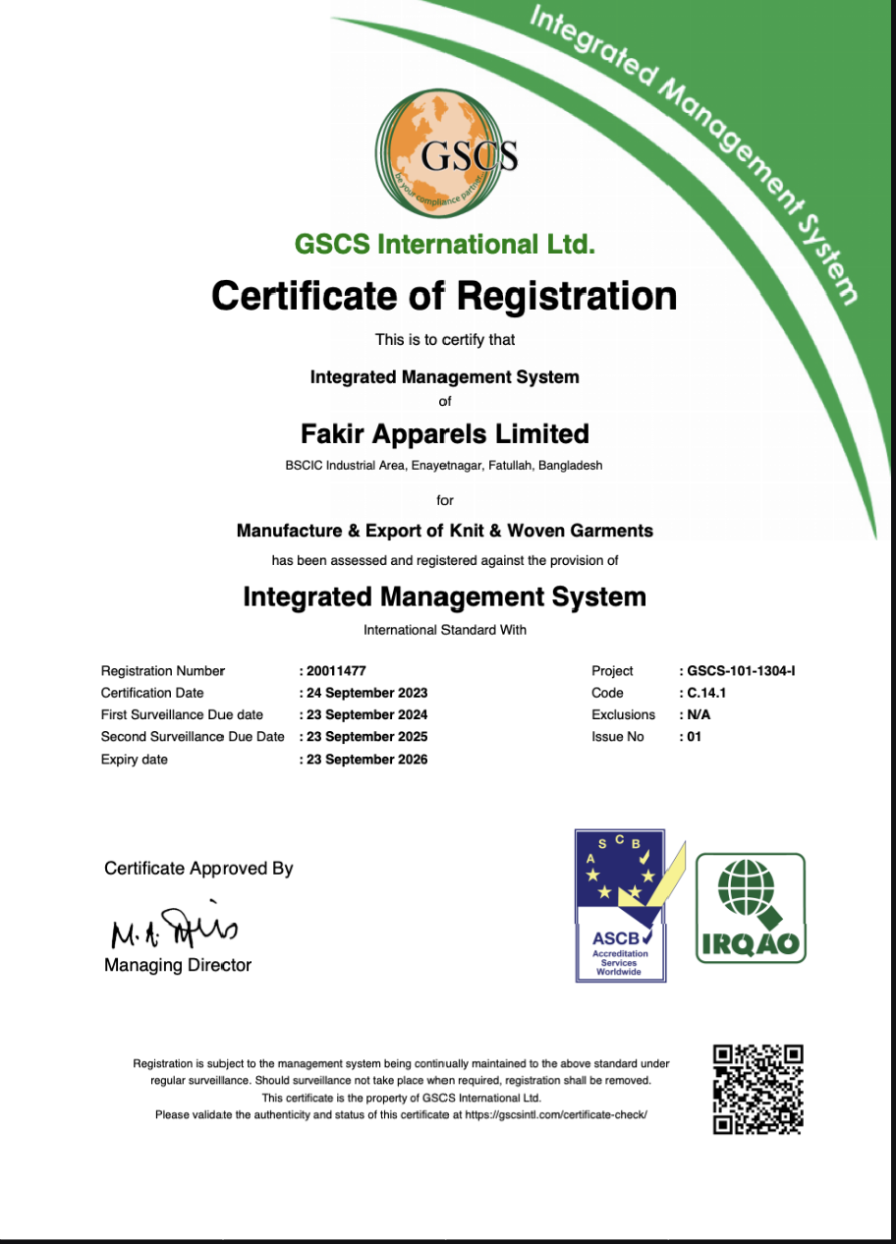
Fig-(13) of 19

These certifications signify the company's dedication to continuous improvement and adherence to international best practices. By obtaining ISO certifications, Fakir Apparels Ltd. demonstrates its ability to consistently deliver products that meet customer expectations and regulatory requirements. This commitment not only enhances the company's reputation but also builds trust among clients and stakeholders in the global marketplace.

20. Accounting Information System (AIS) at Fakir Apparels Ltd.
The Accounting Information System (AIS) at Fakir Apparels Ltd. (FAL) is a sophisticated and integral tool designed to manage the company’s financial operations effectively, streamline expense tracking, and support strategic decision-making. This system enables FAL to handle its vast accounting data efficiently, with features that provide accurate, real-time financial reporting, payroll management, and data analytics that are essential in today’s competitive RMG sector. Below are the key elements of AIS at Fakir Apparels and how each contributes to the company’s operational success.

20.1 Financial Data Management
AIS at FAL collects, processes, and stores large volumes of financial data, including transactions, invoices, and expense records. This system allows different departments to input data, which is then centralized and organized for easy access and review. By consolidating this data in one platform, FAL ensures that financial information is up-to-date, readily available for analysis, and secure. This centralized approach minimizes errors and enhances transparency, as authorized employees can retrieve accurate data for various financial reports.

20.2 Payroll Processing
Payroll processing is a crucial function within FAL’s AIS, as it handles the salaries, bonuses, and benefits of thousands of employees. The AIS automates payroll calculations based on factors such as employee attendance, overtime, and bonuses, reducing the time required to process payroll and eliminating errors from manual calculations. By generating automated pay slips, tax documents, and compliance reports, the AIS ensures FAL adheres to local labor laws and maintains accurate payroll records. This efficiency is essential in a labor-intensive sector like RMG, where payroll management is a major operational component.

20.3 Financial Reporting
The AIS supports FAL’s strategic financial planning by generating a variety of financial reports, including income statements, balance sheets, and cash flow statements. These reports provide management with insights into the company’s financial health, helping identify areas of strong performance as well as areas that may require cost control or improvement. Financial reports generated by the AIS are customizable, allowing managers to view specific data metrics or time periods. This adaptability facilitates effective financial planning, budget allocation, and future investments, contributing to FAL’s long-term growth objectives.

20.4 Expense Tracking and Cost Control
AIS at FAL includes features for tracking expenses across various departments, from raw materials procurement to logistics and administrative costs. The system categorizes expenses, providing detailed analysis on spending patterns. This helps the finance team in monitoring budget adherence and identifying potential areas for cost reduction. Accurate expense tracking is critical in the RMG industry, where profit margins can be narrow, and cost control directly impacts competitiveness. By managing expenses efficiently, FAL ensures sustainable growth and competitive pricing for its products.

20.5 Compliance and Audit Readiness
The AIS at FAL is designed to support regulatory compliance by securely storing financial records and maintaining audit trails. Automated features, such as tax calculations, VAT documentation, and internal audits, help ensure that FAL complies with local and international financial regulations. The AIS also maintains detailed transaction histories, which are essential for external audits. This readiness for audits is crucial for FAL, as compliance with both local and international standards builds trust with stakeholders and reduces the risk of financial penalties.

20.6 Decision Support and Data Analytics
Finally, the AIS includes advanced data analytics tools that aid in strategic decision-making. By analyzing historical data and projecting trends, AIS helps managers at FAL make informed choices about investment, production scaling, and market expansion. The system’s analytics can reveal patterns in expenses, revenue growth, and department-specific financial performance. Decision-makers can use this information to identify opportunities for revenue growth, assess risks, and set future financial goals based on data-driven insights.

4.8 SWOT Analysis of Fakir Apparels Ltd.
Strengths:
- Large Workforce:
Fakir Apparels Ltd. benefits from a substantial and skilled workforce, which enables the company to efficiently manage its production processes and meet the demands of various clients. This large pool of talent contributes to the company’s ability to maintain high productivity levels and respond swiftly to market changes.

- One of the Largest Exporters: As one of Bangladesh's leading exporters in the apparel industry, Fakir Apparels Ltd. has established a strong presence in international markets. This status not only enhances the company’s visibility but also strengthens its bargaining power with global buyers and partners.

- Government Support: The company enjoys support from the government, which has implemented policies to promote the growth of the apparel sector. This backing includes various incentives, such as export credits, tax exemptions, and infrastructural development, which contribute to the company’s operational stability and growth potential.

- Large-Scale Production Capacity (55.2 million Units): With a production capacity of 55.2 million units, Fakir Apparels Ltd. can fulfill large orders and cater to diverse client needs. This capability positions the company as a reliable partner for both local and international clients seeking high volumes of quality apparel.

Weaknesses:
- High Competition: The apparel industry is highly competitive, with numerous local and international players vying for market share. This intense competition can lead to price wars and decreased profit margins, putting pressure on Fakir Apparels Ltd. to continuously innovate and enhance its offerings.
- Company Reputation: Maintaining a strong reputation in the market is crucial for the company’s long-term success. Any issues related to quality, labor practices, or environmental impact can adversely affect its reputation, resulting in lost customers and reduced sales.

- Dependence on Imported Raw Materials: Fakir Apparels Ltd. relies heavily on imported raw materials, which can lead to vulnerabilities in the supply chain. Fluctuations in global prices, exchange rates, and trade policies can impact production costs and profit margins.

- Lack of Technological Advantage: The company faces challenges due to a lack of advanced technological capabilities compared to some of its competitors. This limitation can hinder its ability to innovate and improve efficiency, ultimately affecting its competitiveness in the global market.

Opportunities:
- Adaptation of Advanced Technologies: The integration of advanced technologies, such as automation and digitalization, presents significant opportunities for Fakir Apparels Ltd. to enhance productivity, reduce costs, and improve product quality. Embracing Industry 4.0 technologies can lead to operational efficiencies and better market positioning.

- Eco-Friendly & Sustainable Practices: There is a growing consumer demand for eco-friendly and sustainable products. Fakir Apparels Ltd. has the opportunity to develop new product lines that align with sustainable practices, thereby attracting environmentally conscious customers and enhancing its brand image.

- Financing from Banks and Other Parties: The availability of financing options from banks and financial institutions can facilitate expansion initiatives and support new projects. Securing funding will enable Fakir Apparels Ltd. to invest in technology upgrades, capacity expansion, and workforce development.
- Expanding into New Markets and Exploring New Products: By entering new markets and diversifying its product offerings, Fakir Apparels Ltd. can reduce dependency on existing markets and mitigate risks. Exploring emerging markets and developing innovative apparel lines can drive growth and increase market share.

Threats:
- Similar Products and Competitive Pricing: The presence of similar products from various competitors, often at lower prices, poses a threat to Fakir Apparels Ltd.’s market position. Price sensitivity among consumers may force the company to reconsider its pricing strategies to remain competitive.

- Global Supply Chain Disruptions: Events such as natural disasters, pandemics, or geopolitical tensions can disrupt global supply chains. These disruptions may affect the availability of raw materials and logistics, potentially hindering production schedules and delivery timelines.

- Trade Restrictions and Tariffs: Changing trade policies, tariffs, and restrictions can impact the cost of exporting products and accessing foreign markets. Increased tariffs on exports may reduce profitability and limit the company’s competitive edge in international markets.

- Political and Economic Instability: Political unrest or economic fluctuations in the countries where Fakir Apparels Ltd. operates can adversely affect business operations. Instability can lead to uncertainty in market conditions, impacting consumer behavior and investment decisions.

5 Findings and Analysis of the Study

5.1 Operational Efficiency and Manufacturing Capabilities
Fakir Apparels Limited has demonstrated exceptional operational efficiency through its vertically integrated manufacturing system, which includes both Knits and Woven divisions. The Knits division, equipped with 140 sewing lines, produces over 150 million units of knit garments annually and is supported by an in-house textile mill that generates 55 tones of knit fabric per day. The Woven division, launched in 2018, has expanded the company’s capabilities to include products such as washed bottoms, padded jackets, technical outerwear, and sportswear, producing over 2 million units annually. This comprehensive, integrated approach enables Fakir Apparels to control the entire production process, streamline operations, and meet global market demands efficiently.
Technological Integration and Innovation
Fakir Apparels has embraced advanced technology, incorporating ERP (Enterprise Resource Planning), EPM (Enterprise Performance Management), BI (Business Intelligence), and Industry 4.0 elements to enhance productivity and streamline processes. The ERP system plays a pivotal role in supporting operational and financial tasks, such as managing foreign currency exchange and letter of credit (L/C) processes, which are essential for international transactions and raw material procurement. By integrating currency tracking into the ERP, the company can mitigate exchange rate risks, improve cash flow management, and ensure accurate financial reporting.
Key ERP reports include:
- Free Costing Report: Facilitates detailed cost analysis and helps in strategic pricing decisions by breaking down production expenses.
- Yarn Issue Report: Tracks the allocation and usage of yarn in the manufacturing process, ensuring accurate inventory management and efficient resource utilization.
- Main Fabric Booking Report: Assists in monitoring fabric orders and allocations, providing real-time insights into fabric availability and production planning.
These ERP capabilities allow Fakir Apparels to optimize resource allocation, enhance process efficiency, and maintain accurate financial records, thereby strengthening overall operational management.
Quality Control and Customer Satisfaction
Fakir Apparels prioritizes "Total Quality Control" as a cornerstone of achieving "Total Customer Satisfaction." The company’s in-house facilities for printing, washing, and embroidery ensure that it can deliver high-quality, customized garment designs that meet stringent international quality standards. ERP integration aids in maintaining consistent quality by enabling quality control checks at various production stages and by facilitating data-driven adjustments based on customer feedback.
The company’s robust technological infrastructure allows it to maintain comprehensive oversight of the production process, from the initial stages of yarn issuance to the final fabric booking and quality checks. This, combined with efficient currency and L/C management, positions Fakir Apparels as a trusted partner in the global apparel market, serving clients across more than 45 countries.

5.2 Corporate Social Responsibility (CSR) Initiatives
CSR activities
The company's CSR activities reflect a deep commitment to employee welfare and community support. Fakir Apparels offers various welfare programs, including nutritional support for pregnant workers, financial aid for the Eid festival, Hajj opportunities, paternity leave, scholarships for workers’ children, and birthday celebrations for employees. These initiatives not only promote a positive workplace culture but also enhance employee motivation, loyalty, and morale. In addition, the company’s contributions to the local community, such as providing drinking water, sanitary napkins, and supporting tree plantation programs, underscore its commitment to social responsibility.

Global Market Reach and Export Strategy
Fakir Apparels has established a robust export network, with its products reaching over 45 countries in Europe, North America, the Middle East, and Asia. This global presence is a testament to the company's strategic approach in catering to international markets. Their adherence to stringent quality standards and commitment to innovation has helped them build strong relationships with top brands worldwide. Fakir Apparels’ vertical integration model and control over every stage of production have given them a competitive edge in meeting global client expectations.

CSR Summery
Fakir Apparels Limited is a well-established and reputable company in the garment manufacturing industry. Over two decades, it has demonstrated a strong commitment to innovation, quality, and social responsibility. The company’s vertical integration strategy, technological adoption, and focus on employee welfare have positioned it as a competitive player in the global market. Fakir Apparels' efforts toward sustainability, employee welfare, and customer satisfaction have reinforced its reputation as a reliable and socially responsible manufacturer.

Recommendations
Enhancing Technological Integration
Fakir Apparels should continue exploring new technologies, such as artificial intelligence (AI) and machine learning, for further process optimization and predictive maintenance in production. This can lead to a higher level of automation and potentially reduce operational costs.

Expansion of Sustainability Efforts
While Fakir Apparels has a strong commitment to sustainability, it could further enhance its green initiatives by exploring renewable energy sources, such as solar power, for its manufacturing facilities. The company may also consider using more sustainable raw materials and eco-friendly packaging to appeal to environmentally conscious consumers.

Employee Development and Skill Enhancement
Continuous training and skill development programs can empower employees to adapt to new technologies and industry trends. Fakir Apparels could offer training in areas like digital tools, production techniques, and quality control to further increase workforce productivity and engagement.

Product Innovation to Cater to Changing Consumer Trends
To stay ahead in the competitive global market, Fakir Apparels should focus on continuously innovating its product line to cater to changing consumer preferences. Investing in research and development to create new designs and functional fabrics (e.g., moisture-wicking, antimicrobial, etc.) can enhance product offerings and attract new clients.

Strengthening Client Relationships and Market Diversification
Fakir Apparels could benefit from strengthening its existing relationships with international clients and exploring new markets. Developing a strong marketing strategy that highlights the company's commitment to quality and sustainability can help expand its customer base and increase brand recognition.

Internship Experience
My internship experience at Fakir Apparels Limited provided me with invaluable insights into the garment manufacturing industry, corporate accounting information and corporate operations, HR practices.

Overview of Responsibilities
During my internship, I worked closely with the HR and Accounting departments, which allowed me to gain hands-on experience in managing employee welfare programs, assisting with financial data management, and understanding operational processes.
I was involved in data analysis and observed various stages of production in both the Knits and Woven divisions, gaining a well-rounded understanding of the company's operations.

Learning Outcomes
This experience enhanced my skills in data analysis, corporate accounting, and teamwork. I had the opportunity to use software tools like Excel and ERP systems, which deepened my understanding of data management and process optimization. Observing quality control measures and how the company meets international standards helped me appreciate the intricacies of maintaining high-quality products in a fast-paced manufacturing environment.

Challenges and Problem-Solving
One of the main challenges I faced was adapting to the large-scale and fast-paced nature of the manufacturing process. It was initially challenging to keep up with the technical aspects of production, especially in understanding complex machinery and production workflows. However, I overcame this challenge by seeking guidance from colleagues, conducting independent research, and taking notes on various processes. Additionally, managing time effectively while balancing tasks across departments was a valuable learning experience.

Professional Growth
My internship at Fakir Apparels contributed significantly to my professional development. It helped me understand the corporate structure of a large manufacturing company and the importance of teamwork, communication, and efficiency. I developed a greater appreciation for corporate social responsibility, learning how a company’s commitment to employee welfare and community support can create a positive work culture. This experience has strengthened my career aspirations in the apparel industry, and I am now more confident in my abilities to contribute to similar organizations in the future.

Completion Certificate

As a formal recognition of the successful completion of my internship at Fakir Apparels Ltd, I was awarded an Internship Completion Certificate. This certificate acknowledges the skills, experience, and insights I gained while working in the HR and Accounting departments from July 2024 to September 2024. The experience contributed significantly to my professional growth, providing practical applications of my academic studies in real-world scenarios.
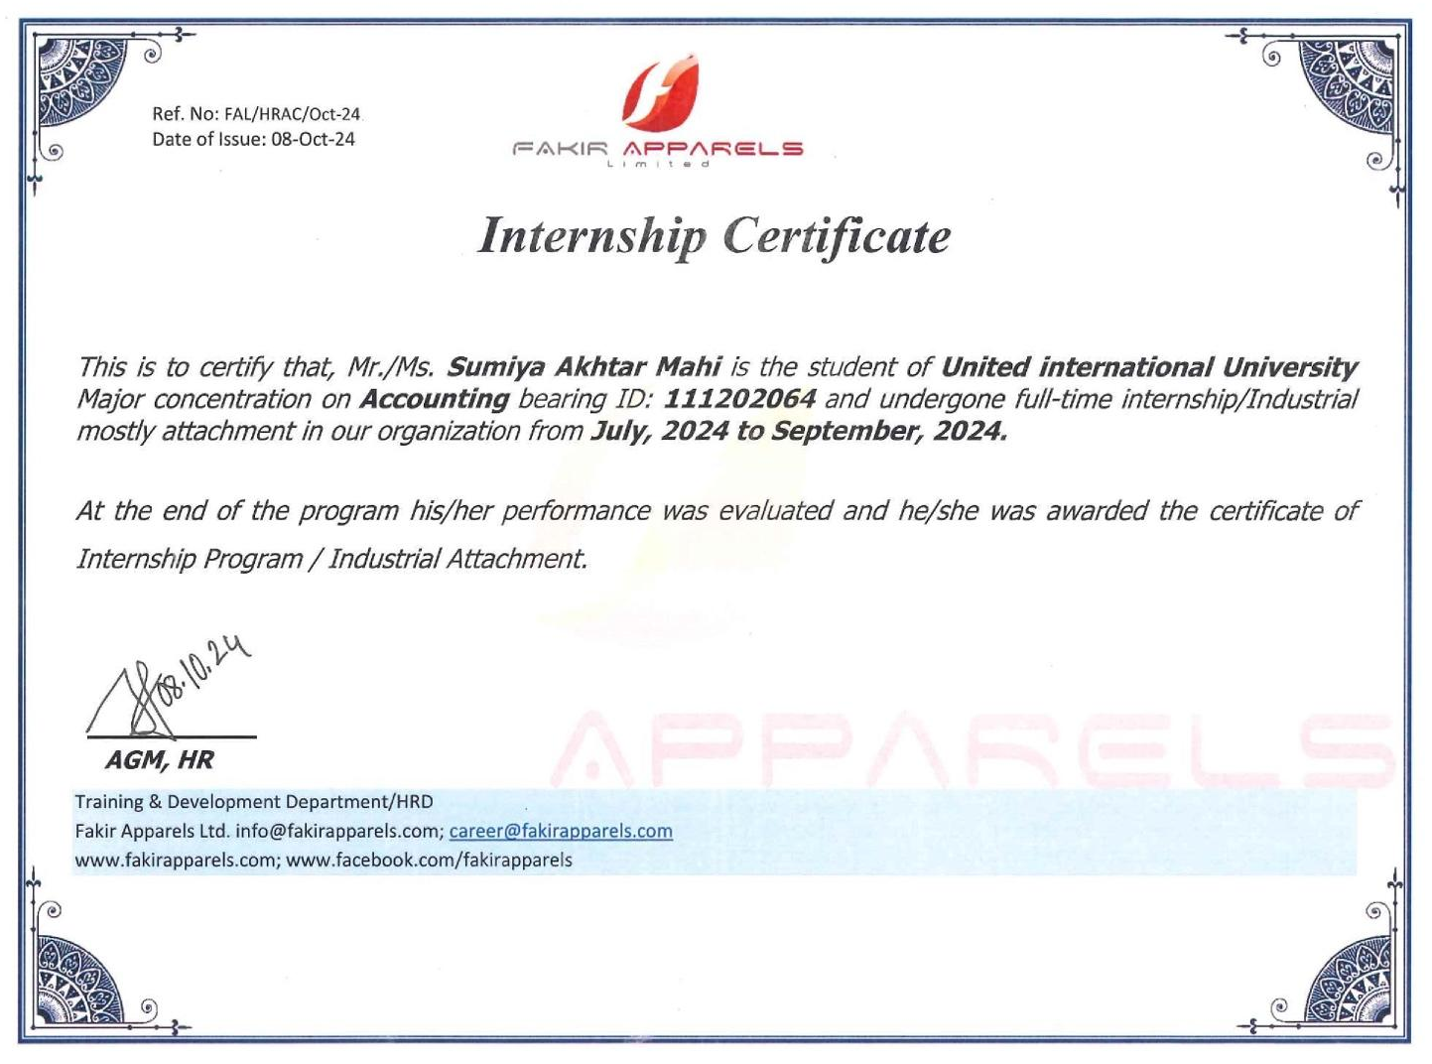
Fig-(14) of 25.4

Appendix
- Fakir Apparels Ltd. Internal Training Documents, HR Department, 2024.
- Fakir Apparels Ltd. Financial and Compliance Reports, Accounting Department, 2024.
- https://fakirapparels.com
- https://fakirapparels.com/products/
- https://fakirapparels.com/about-us/
- https://www.ifrs.org/groups/international-accounting-standards-board/
- https://www.icab.org.bd/page/iasb-the-international-accounting-standards-board

