

AFBL
Internship Experience

Prepared by
Afrashim Anowar Misha
ID: 111 191 018



School of Business and Economics
United International University

AFBL Internship Experience

Internship Report

Submit to:
Dr. Mohd Hasanur Raihan Joarder
Professor
School of Business and Economics
United International University

Submitted by:
Afrashim Anowar Misha
ID: 111 191 018
School of Business and Economics
United International University

Date of Submission: November 17, 2023

Letter of Transmittal

To
Dr. Mohd Hasanur Raihan Joarder
Professor
School of Business & Economics
United International University

Subject: Submission of Internship Report

Dear Sir,
With all due respect, I'm pleased to inform you that I have finished writing my report on my internship experience with AFBL. I can learn more about Akij Food & Beverage Limited's performance and how they add value for their clients thanks to this specific report. I have examined information and statistics to determine Akij Food & Beverage LTD's performance. To examine the performance, I have created charts. I also examined how they cater to their clientele.
Lastly, I want to express my sincere gratitude for all of your kind words and for taking the time to assist me in writing this report. I've done everything in my power to compile this report. Without a doubt, I benefited from this experience to reach a higher level. I would be happy to address any questions you may have about any aspect of this report.

Sincerely yours,

Afrashim Anowar Misha
ID: 111 191 018
School of Business and Economics
United International University

Acknowledgment

I want to start by expressing my gratitude to Almighty Allah for giving me the mental and physical fortitude necessary to complete this report. I am appreciative to the persons who helped me with this report as part of it. I owe a debt of gratitude to Dr. Mohd Hasanur Raihan Joarder sir, who served as both my internship report adviser and instructor. He gave me this assignment and provided me with invaluable guidance throughout. He enabled me to successfully finish this report. Without his assistance, I could not have completed my report. I express my gratitude to my office supervisor as well.
Senior Manager of Akij Food & Beverage LTD's Operational Excellence Department, Md. Abdul Hai Bhuyan, sir. He has also been really helpful in providing me with all of the details I needed to complete my report. In addition, I would like to express my gratitude to everyone in the office who provided me with various pieces of information that I needed to finish the report. I also want to express my gratitude to everyone who assisted me in getting ready. Without their help, ideas, and involvement, this report would not have been possible.

Executive Summary

In 2006, Akij Food and Beverage Ltd. (AFBL) was founded and quickly rose to prominence in the food and beverage sector. Part of the Akij Group, established in 1950, the company has experienced a remarkable transformation from its early emphasis on necessities to become a prominent global conglomerate that exports goods to 26 countries.
The variety of products offered by AFBL includes drinking water, fruit drinks, milk products, carbonated drinks, snacks, and more. Among the well-known brands are Frutika, Farm Fresh, Clemon, and Mojo. The company's vision is to be a modern conglomerate operating both locally and internationally, with a focus on becoming the top food and beverage brand.
The company's leadership, headed by Sk. Nasir Uddin and overseen by Sk. Bashir Uddin highlights a dedication to professional acumen, social responsibility, and high-quality products. AFBL is a group with 26 units, over 50,000 employees, and a project valued at $70 million. It has accomplished 25 significant national milestones and exports goods to 26 nations. With empowered workers and cutting-edge technology, the company continuously produces high-quality products that benefit society to are sustainable. At AFBL, the hiring procedure is methodical and includes submitting manpower demand forms, having the talent acquisition team evaluate them, and working with HR to support new positions. To thoroughly assess possible candidates, the selection process consists of written exams, practical operation tests, and panel interviews.
Resilience and flexibility are demonstrated by Akij Food & Beverage Ltd., which has grown into a major player on the international scene while upholding a strong commitment to sustainability, innovation, and quality. The business is expanding under the visionary leadership of the Akij Group, satisfying the ever-changing needs of its clients and making a constructive impact on the communities it serves.

Table of Contents
Letter of Transmittal I
Acknowledgment II
Executive Summary III
CHAPTER 01: INTRODUCTION 5
1.1 Background of the Report 6
1.2 Objectives of the Report 10
1.3 Motivation of the Report 10
1.4 Scope of the Report 10
1.5 Limitations of the Report 11
1.6 Methodology of the Report 11
CHAPTER 02: COMPANY PREVIEW 12
2.1 Overview and History 13
2.2 Product Mix 18
2.3 Operational Network of Akij Food and Beverage Ltd. 19
2.4 SWOT Analysis 20
CHAPTER 03: RECRUITMENT & SELECTION PROCESS 22
3.1 Recruitment Process of Employees 23
3.2 Selection Process of Employees 24
CHAPTER 04: TRAINING PROCESS 26
4.1 Training Process of the Employees 27
CHAPTER 05: COMPENSATION & APPRISSAL 30
5.1 Compensation process of AFBL 31
5.2 Appraisal Process of AFBL 33
Chapter 06: Internship Experience 35
6.1 Position, Duties & Responsibilities 36
6.2 Skills Applied 37
6.3 New Skills Developed 37
6.4 My Internship Experience in AFBL 38
CHAPTER 07: CONCLUSIONS 41
Reference 43

CHAPTER 01: INTRODUCTION

1.1 Background of the Report
Overall History of Food & Beverage Ltd.
Food & Beverage Ltd. has an impressive background, The late 19th century saw the emergence of a group of aspirational businesspeople who recognized the potential in the expanding market for convenient and varied food and beverage options. In 1890, they decided to work together to form Food & Beverage Ltd.
When the company first started, it concentrated on making necessities like beverages and canned goods to meet the demands of a world that was industrializing quickly. Food & Beverage Ltd. expanded its product line over time to include a variety of snacks, ready-to-eat meals, and creative beverages as a response to shifting consumer preferences and trends.
The company persevered through the hardships of both World Wars, helping with the war effort by giving soldiers food and rations. Food & Beverage Ltd. contributed significantly to the post-war global economic recovery by bringing novel and practical food options that suited the fast-paced, mid-20th-century lifestyles.
Food & Beverage Ltd embraced globalization in the second half of the 20th century and grew its market share globally. The business kept up with the times, adopting new technology and adapting to the shifting needs of its customers.
Food & Beverage Ltd. has made progress in recent years in addressing sustainability issues and encouraging healthier options in its product line. Additionally, the business has led the way in implementing cutting-edge food technologies, such as sophisticated food processing techniques and biotechnology.

Food & Beverage Ltd. is still a major player in the sector as of my most recent knowledge update from January 2022; it is always coming up with new ideas and adjusting to the rapidly changing global food and beverage market. To learn about the most recent advancements in their intriguing journey, I'd advise looking through more recent sources.


History of Food & Beverage in Bangladesh
Bangladesh's Food & Beverage Ltd. has a long history reflecting the expansion and advancement of that nation's food and beverage sector. The company was founded in 1965 to satisfy the local market's growing need for high-quality food and beverages.
Food & Beverage Ltd. initially concentrated on manufacturing necessities to meet the demands of the Bangladeshi populace. The business's dedication to quality and innovation helped it become well-known very quickly. Food & Beverage Ltd modified its product line to reflect Bangladesh's changing social and economic landscape and consumer preferences.
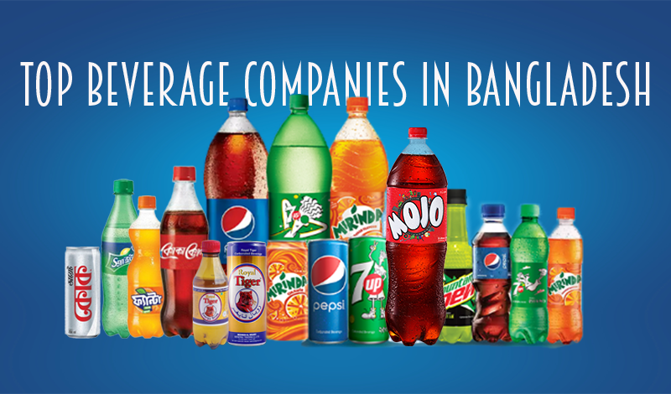
The company was vital in supplying food items during economic downturns and crises, strengthening the resilience of the country. Food & Beverage Ltd. rose to national prominence over several decades of development and expansion, thanks to its wide variety of food and drink offerings.

Food & Beverage Ltd. kept investing in updating and integrating cutting-edge technologies into its production facilities as Bangladesh evolved into a more industrialized and urbanized society. This improved productivity and made it possible for the business to launch a wider range of goods to satisfy the needs of a more varied customer base.
Food & Beverage Ltd. in Bangladesh has probably been concentrating on sustainability and taking note of consumer trends that are health-conscious in recent years. The company might have emphasized ethical sourcing and production methods and released products that cater to shifting dietary preferences.
You can find up-to-date and comprehensive information about Food & Beverage Ltd in Bangladesh by reading through the most recent news articles, press releases, or official statements from the company.

1.2 Objectives of the Report
I reported on my internship experience at Akij Food & Beverage Ltd. And I analyzed and highlighted many topics. And the objective is-
- Analyze Akij Food & Beverage Ltd. and their services for the customers and also their growth.
- Analyze the industry of the Food and Beverage sector and its growth in Bangladesh and worldwide.
- Review the internship I have done at Akij Food & Beverage Ltd.
- Analyze how they are adopting the new things, and serve the customers by that.

1.3 Motivation of the Report
Akij Food & Beverage Ltd. has been growing in its products/services they serve to increase the number of customers. For further customer satisfaction, they will serve the customers their services. Hence, this report focuses on Akij Food & Beverage Ltd. and its industry.

1.4 Scope of the Report
In Akij Food & Beverage Ltd. I was doing my internship in the Operational Excellence sector. There was a lot of scope for me, how to finish tasks within time and as quickly as possible. And also know about the food and beverage industry.
The Scope of this report is to provide a more in-depth analysis of Akij Food & Beverage Ltd's HR strategies and activities, as well as advertising methods, to grow the business and organizational performance with potential profits and revenue.
This study looked into the reasoning behind the organization's participation in the various actions it takes to manage its customers. Furthermore, the study seeks to shed light on the question of whether or not the organization's efforts to retain customers are successful. This study attempts to identify all of the functions performed by the marketing department as well as potential areas for development. Furthermore, the research examines competitors from the customers' point of view.

1.5 Limitations of the Report
A large percentage of well-known businesses safeguard the privacy of their proprietary information. They would rather keep their information private, and AKIJ also wants to achieve this goal. Most of the time, I had to make do with incomplete information. Even though doing so presented a challenge in the context of the report's writing, despite this, I was able to gather enough information for my report to be instructive because I was making a deliberate effort to find other food and beverage company reports.

1.6 Methodology of the Report
Two separate types of sources provided the data for this investigation and study. The following details are provided:
Primary Sources
Communicate and discuss through social media with AFBL employees and other employees employed by FMCG companies.
Secondary Sources
• Articles, journals, and newspapers related to the food and beverage industry.
• Books and blogs about the idea of marketing strategies and competitive situation analysis.
• The AKIJ Group and AKIJ Food and Beverage Limited Annual Reports.
• AKIJ Food and Beverage Limited's website

CHAPTER 02: COMPANY PREVIEW

2.1 Overview and History
Overview and History of the Company
Akij Food and Beverage Ltd. (AFBL) started its journey in 2006. AFBL manufactures a wide range of Snacks and beverages for both National and international markets alike. AFBL is a project worth $70 million & is founded by the parent company Akij Group.
AFBL is a part of the Akij Group founded by Sk. Akij Uddin in 1950. This group of industries is growing and the latest number of units is 26. These units have a workforce of more than 50,000. They have 25 major national achievements so far. The group is chaired by Sk. Nasir Uddin and Sk. Bashir Uddin is its Managing Director. Sk. Shamim Uddin is the Director of AFBL.
AFBL is one of the leading Food and Beverage Companies in the country and manufactures a wide range of food and beverage products like carbonated beverages, fruit drinks, and other food products for both local and international markets. It has a powerful global presence – exporting products in 26 countries.
AFBL is striving to be a sustainable business by consistently producing quality products with empowered & motivated employees with state-of-the-art technology where society will benefit.
AFBL has a wide range of products of soft drinks, fruit drinks, energy drinks, molted drinks, drinking water, milk & milk-based products, chips, mango bars, and pickles brands. AFBL encourages local small and medium-level farmers by contract farming for milk from Pabna and Rajshahi and mango from Rajshahi and Chapainawabganj.
AFBL has achieved many recognitions and certifications over the years. It has achieved the Best Brand Award 4 times. National and international certificates like BSTI, HALAL, ISO, and HACCP prove the quality of the company. AFBL produces the best quality food products with locally produced & imported raw materials and by using state-of-the-art technology types of machinery that have been imported from world-famous brands like Tetra Pak, Krones, Alfa Laval, Sipa, etc. (Akij Venture, 2000)
Innovation, Teamwork, Integrity, Customer Focus, Trust, and respect are the values of AFBL that guide achieving the vision “to be the most respected food and beverage company in Bangladesh by a commitment to quality”.
AFBL has a reputation of being involved in a good number of Corporate Social Responsibility (CSR) activities and maintains its reputation with banks, other financial institutions, Govt. agencies.
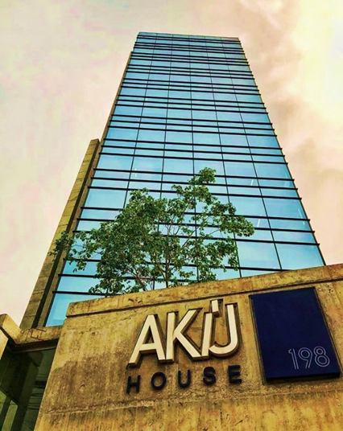
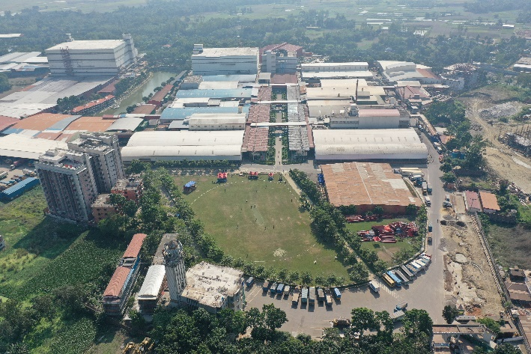
Figure 1
AFBL Factory at Dhamrai
Figure 2
AKIJ House - Corporate Head Quarter of AFBL

Company Milestone

2000 | Incorporated as a private limited company
2006 | Start of Commercial Operation
2006 | Started Production of Mojo & Lemu with 0.5 million Ltr/Day Capacity
2006 | No.1 Brand in Energy Drink Category, ‘Speed’ was Launched
2007 | Clear Drinks Brand ‘Clemon’ and Mineral Water Brand ‘Spa’ were Launched
2008 | Renowned Fruit Drinks Brand ‘Frutika’ was Launched
2015 | ‘Frutika’ won the ‘Best Brand Award’ in the Juice Category
2017 | Production Capacity to 1.4 million Ltr/Day
2018 | ‘Speed’ won the ‘Best Brand Award’ in the Carbonated Beverage Category
2019 | ‘Speed’ won the ‘Best Brand Award’ in the Carbonated Beverage Category
2020 | ‘Speed’ won the ‘Best Brand Award’ in the Carbonated Beverage Category
2021 | ‘Speed’ won the ‘Best Brand Award’ in the Carbonated Beverage Category
2021 | AFBL got ‘ISO 9001:2015’ Certification
2021 | AFBL got HACCP Certification from SGS Bangladesh
2022 | AFBL got Halal Certification from DSR International Inspection and  Certification
2022 | AFBL got GMP Certification from SGS Bangladesh

Company Mission:

- We will strive to be a sustainable business: That is, ensure consistent development and financial success through creativity and organizational ability.

- Through consistent quality products: Through offering food products that are healthy, fresh, and meet international standards.

- Employee that is empowered & motivated: That means to develop and keep motivated and committed employees.

- Technology that is state-of-the-art: suggesting carrying on with an appropriate technological border over competitors.

- Society That Is Benefitted: means improving food and nutrition for the general public, fostering the creation of high-quality jobs, and bolstering the country's economy.

Company Vision
To be the most contemporary conglomerate: Locally and globally, Bicycle manufacturing company of the country.
To be the leading food and beverage brand that consistently outperforms expectations in terms of product quality, social responsibility, and professional acumen, while also showing creativity and administration to AFBL's customers.
About Akij Food and Beverage Limited (AFBL), the late Mr. Sheik Akij Uddin stated, “We will develop and present those excellent products in the market that we and our family will consistently use; we won't simply deliver items for the customers in the market and let our family consume other overseas products."

Company Objective
The following are the aims and objectives of this company:
- To anticipate customer needs and meet their demands by producing products that meet international standards.

- To create an effective nationwide sales and distribution network that will deliver our goods directly to customers' doorsteps.

- Achieving profitability goals by surpassing annual sales and revenue targets.

- Finding and using modern manufacturing equipment and/or manufacturing partners is a sign of a firm commitment to quality

- To achieve market leadership by involving consumers in inventive, creative, and successful marketing communications.

- Exporting our goods to other nations to earn foreign exchange.

(Akij Venture, 2000)

2.2 Product Mix
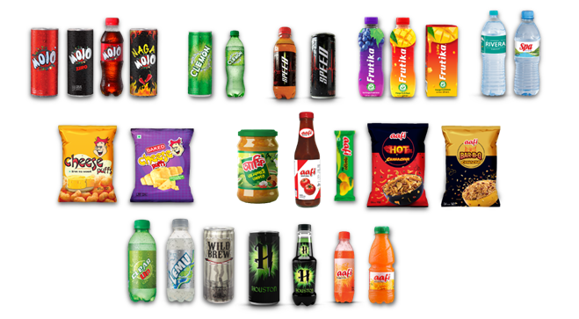
The modern machinery that AFBL has access to has been purchased from top European companies, including Canada, Germany, Italy, and other nations. Additionally, the company provides the best materials for its final products. The management of AFBL is headed by some of the leading figures in the sector, whose knowledge and abilities have been refined through years of involvement in forming the competitive environment of the nation's Fast-Moving Consumer Goods (FMCG) sector. For more than fifteen years, AFBL has been offering the best products to Bangladeshi customers. From drinks to snacks, AFBL consistently develops items that win over admirers and well-wishers. Below is a list of AFBL's products:

- Beverages: Mojo, Clemon, Clear Up, Clearly Lemon, Lemu, Twing, Speed, Houston, Wild Brew.
- Fruit Juices: Frutika (Mango, Grape, Orange), Aafi (Mango, Orange, Litchi).
- Milk Products: Farm Fresh (Milk, UHT milk, Ghee, Butter, Yogurt), Farm Fresh Flavored Milk (Mango, Chocolate, Elachi, Laban), Shake Milkshake (Chocolate, Kheer, Vanilla), Yummy Lacchi.
- Drinking Water: Spa, Rivera,
- Snacks and Others: Aafi (Chanachur, Puffed Rice, Mango Bar, Sauce, Mango Pickle), Cheese Puffs Chips, Sipit Instant Powder Drink, Home Makers Mustard Oil, Happy Times Jam. (Akij Food & Beverage Limited (AFBL), 2000)

2.3 Operational Network of Akij Food and Beverage Ltd.
The mouthfeel, flavors, and brand names of AFBL's premium products are all distinctive qualities. AKIJ Food and Beverage Limited provides a variety of foods and oils to its clientele as part of its regular business operations. AKIJ Food & Beverage Ltd is known for its exceptional quality, having supplied millions of meals each day to a wide range of food service establishments across the country.

All aspects of business management, including marketing tactics, supply chain logistics, customer service, quality assurance, and operational budgeting, must be mastered by managers overseeing food and beverage operations. These skills are essential for managing a company's service delivery and customer experience for it to survive. (Akij Food & Beverage Limited (AFBL), 2000)

2.4 SWOT Analysis
The company's internal and external environments must be thoroughly analyzed for the strategic planning process. A SWOT analysis is a technique for assessing the opportunities, threats to the external environment, weaknesses, and strengths of a company. Using a SWOT analysis, an organization's initial resources and capabilities may be more appropriately matched to the competitive environment. It therefore functions as a tool for creating and choosing a plan.
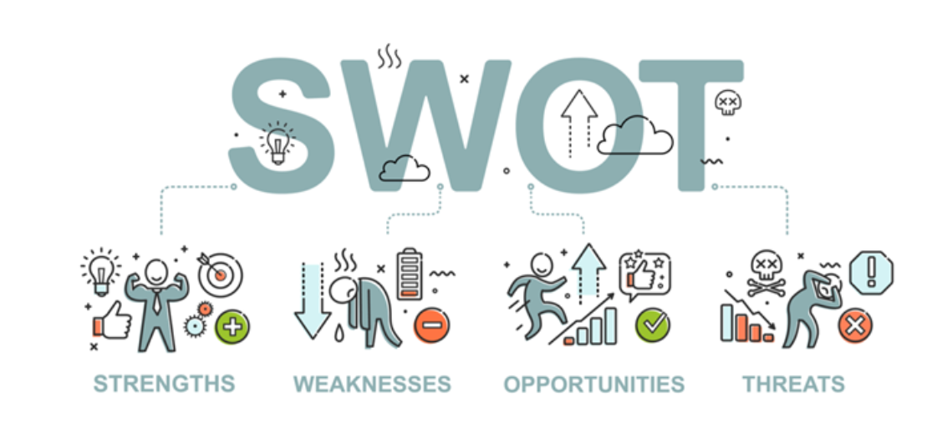
Strength
- Quick Establishment of Brands like SPEED, MOJO, FRUTIKA
- Quality of the Products
- Strong Distribution Networks and Operations in the Supply Chain
- Following Unique Promotional Campaigns
Weakness
- Insufficient Budget for the Advertising and Promotion Program
- Limited Brand Awareness
- Lack of Trade Promotional Programs
- Lack of Digital Marketing Activities

Opportunities
- Huge Profitability in E-Commerce and Online Delivery Services
- Attain Maximum Market Share in Refreshing CSD Drink
Threats
- New Entrants Company
- High Competitiveness in the Food and Beverage Sector

Some New Entrance Companies in Bangladesh's Food and Beverage Industry

- New Zealand dairy
- Kazi Agro Limited
- Eon Foods Limited
- Intra Food & Beverage Limited
- Dan Foods Limited
- Dynasty Food and Beverage

Some Major Competitors in Bangladesh's Food and Beverage Industry

- Square Food & Beverage Limited
- ACI Food & Beverage Limited
- PRAN Food and Beverage Limited
- IFAD Multi Products Limited
- Bashundhara Food & Beverage Limited
- City Group

(Akij Food & Beverage Limited (AFBL), 2000)

CHAPTER 03: RECRUITMENT & SELECTION PROCESS

3.1 Recruitment Process of Employees
Every Divisional, Departmental Head, and Line Supervisor will submit an authorized Manpower Demand form and accept it to the talent acquisition team if a vacancy occurs. The team responsible for talent acquisition will present a rationale in opposition to the labor request. The recruiting staff will make an effort to determine whether or not a new hire is necessary for that role. If current employees can perform the new task, there won't be a new recruitment proposal. If a change is deemed necessary, the relevant authority will work with HR to get the updated organizational chart approved by management, along with the appropriate justification for the new vacancy. All Divisional / Departmental Head(s)/line supervisor (s) will assist the HR department in the recruitment, selection, and placement procedure.
Precautions
When choosing candidates, the talent acquisition team should exercise great care. They have no right to join any of their relatives. In addition, they guarantee that the entire process will be finished in 45 to 50 days from the date of receipt of the request.
Manpower requisition
Step 1
The Divisional / Departmental Head(s) / Line Supervisor(s) will fill out the Manpower Requisition Form, indicating the primary responsibilities, Job Specification, and other information as needed, whenever a job vacancy occurs in any division or department.
Step 2
Obtain management approval (for a new position), seek HR assistance if necessary, and submit the paperwork to the HR department along with the approved organogram so that it can be processed further. The authorization process for requests will follow the AFBL authority matrix.
Step 3
Divisional / Departmental Head(s)/ line supervisor(s) will prepare and finalize the job description in consultation with HR (if needed).

Sourcing
The Talent Acquisition team will gather candidate profiles from a variety of sources, including internal job postings, referrals from staff and management, university or other institutions, direct contact, references from outside consultants, headhunters, advertisements in national newspapers, and, where appropriate, online job postings and advertisements.
Shortlisting
Step 1
At first talent acquisition team will sort out the application according to the job description and specifications.
Step 2
Then talent acquisition team will sort out the applications with consultation of the Head of the concerned department/division in line with the job specification and job description.

3.2 Selection Process of Employees
Step 1
The interview panel will comprise at least two (02) personnel one will be from the HR Department and another one from the concerned department.
Step 2
Invite the potential candidates after preliminary short-listing of the applications for written test and/or interview and/or practical operation test.
Step 3
Conduct written tests and/or oral interviews and/or practical operation tests as required depending on the position being interviewed for, on the scheduled date with the combined collaboration of the HR department and Divisional /Departmental Head or representatives nominated by the concerned Divisional / Departmental heads and nominated person from Audit/Finance department. For the position of below manager, any member from the HR department nominated by CPO will be on the interview board. For the position of manager and above CPO will be in the interview board.

Step 4
The interview panel will evaluate the candidate based on the role s/he will be required to play and the criteria as prescribed in the assessment form, after that the interview panel will jointly select the candidate primarily.
Step 5
Conduct the 2nd/final interview session with the consultation of the departmental head and management.
Step 6
HR will take final approval as per the AFBL authority matrix.
Reference Check
Check and verify references and original certificates of the candidate(s), work experience, last employment status, and all other relevant papers, which will be kept in the personal file of the candidate(s).
Salary Negotiation and Final Selection
Talent Acquisition team will inform and call the selected candidate for negotiation with him regarding designation, salary, job location, and date of joining in front of the Divisional /Departmental Head or representatives nominated by the concerned Divisional / Departmental heads and nominated person from Audit/Finance department.
After the successful negotiation, HR will issue an offer letter and appointment letter to the candidate upon the completion of selection formalities.
After joining formalities
At the time of joining new joiner will fill up all official papers/forms on acceptance of the appointment letter.
Ensure that the admin department will arrange (SIM card, Laptop, Modem, etc.) and finally training department will conduct an induction/orientation program to orient the new joiner with the organization and the ERP.

CHAPTER 04: TRAINING PROCESS

4.1 Training Process of the Employees
The training will flow in the bellow mentioned sequence-
Phase A: Training Need Assessment (TNA)
Phase B: Budgeting
Phase C: Training Calendar
Phase D: Training Implementation
Phase E: Training Evaluation
Training Need Assessment (TNA):
The HR department will distribute the TNA form to the HODs to collect the Training needs of their respective Department members. After getting their feedback HR will analyze the needs. HR will also collect the Training needs from the yearly Performance Appraisal Process. Performance appraisal system highlights the strengths and weaknesses in the employee performance and eventually leads to the design of a training program based on the identified needs. If any crucial competency/skill gap is realized suddenly by HR or other departments while conducting the business, HR will consider and take initiatives to plan and implement that training on an ad hoc basis. For this ad hoc training form will be used to give requisition.
Training Budgeting:
The HR department will make a yearly budget once in a financial year as per training needs. While making the budget, HR will consider standard training hours per employee, TNA, etc. The budget should be need-focused. HR will get approval from relevant management and finalize the training budget. Budget utilization will be done as per the approved Authority Matrix.
Training Calendar:
Based on the need analysis and identification of any performance gap amongst the employees and also based on identified development needs HR will design a Training calendar & prepare a Training budget and obtain Management approval. After that HR will notify the Training Calendar to the respective HODs.

Training Implementation:
As per the approved Training Calendar HR will arrange internal and external training programs as follows:
Internal Training: It is given to the employees after analyzing the gap in existing skills/knowledge in comparison to the competency required to perform the current job effectively. Gaps are generally detected by the line managers through discussion/ interview and also through TNAs. This type of training is delivered by in-house competent employees having fair knowledge about the training subject. Internal trainers may include the following:
- Trainers who are already employed by AFBL as training experts.
- Existing employees who have certain expertise in a required field and who are willing to contribute to the company’s skill development.
- Heads of Departments or personnel who have relevant experiences.
External Training: External training is given to the employees who were recommended by the line manager/HODs for improvement of any particular area identified during the annual performance appraisal interview session or through TNA. The trainees are selected as and when any invitation is received from different training institutes through email or even circulars from newspapers/websites. Based on the training title the employees who await in the training list are selected based on the individual requirements. External trainers may include the following:
- Listed training agencies
- Unlisted renowned training agencies
- Certified trainers
The participant will be selected by the HR team based on the TNA and their performance appraisal. The HR will consult with the HODs before sending them to the training/workshops. The HR may also consider service competence, regular performance, KPI, service length/experience, or educational background in participant selection.
Training Initiation: Training can be initiated in the following ways:
- A training can be initiated according to the training calendar.
- A training can be initiated on special requirements. This special requirement can come from the Directors, the HODs, the Head of the Training Team, or any responsible personnel. For this, an Ad hoc Training Requisition Form will be used.
Evaluation of Training:
All training imparted to any employee will be evaluated by the department itself in coordination with HR. HR will evaluate the internal as well as external training program to determine whether the purpose for which it was imparted to him/her has been accomplished. A training evaluation form shall be used for the purpose. External training evaluation will be done as per the following processes:
- Trainers Evaluation: In the training process HR will collect each employee's opinions and performance of the trainer of the training from each participant. After assessment of the evaluation form which will be carried out by the HR department confidentially, the improvement areas of the trainer shall be found out. The improvement areas will be shared with the trainer/s as well as the line manager for his/her knowledge. The trainer/s will be given external training for the TOT as and when any opportunity from training institutes comes. For this, a trainer evaluation form will be used.
- Participants Evaluation: All participants of the training program shall be evaluated regarding their active participation during the training program. The evaluation shall be done by the trainers/ department head for assessment of their post-training performance at least for a period of the next three (03) months. If no improvement is found within this period the line manager shall arrange a meeting with the employee and give him/her feedback regarding his/her performance. In the session, he/she will counsel the employee to be more careful about performing better in the future. His/her performance will be assessed once again within the next 03 months. If no improvement is found, the employee shall be subjected to appropriate action as per policy. For this, a participant evaluation form will be used. (Akij Group, 1945)

CHAPTER 05: COMPENSATION & APPRISSAL

5.1 Compensation process of AFBL
Compensation is what an employee receives in exchange for his/her physical and mental efforts, and in exchange keeps contributing to the company. Compensation does not represent only monthly salary but a wide range of benefits and services which may either be in cash or kind included in the total compensation package. AFBL intends to pay rewarding and competitive salaries to attract, retain, and motivate competent and skilled employees at all levels of the organization.
Salary
Basic Salary:
Basic salary is an important part of an employee's salary. It is paid monthly along with other admissible allowances such as house rent, medical allowance, and conveyance allowances in applicable cases. The basic will be 50% of the total salary.
Salary Deduction:
In some situations, deductions can be from the basic salary of the employees. The areas of deduction are as follows:
    - Due to absence without proper authorization
    - For damage or loss of property/goods expressly entrusted to the employee under his/her custody; or loss of money (theft, fraud, dishonesty) for which he/she is accountable.
    - For adjustment of advances or overpayment, if any
    - Employee's provident fund.
    - Unauthorized leave adjustment
    - Late Attendance
    - Due to income tax payable by the employees
    - Penalty if any
    - Any other deductions in consultation with the employee

House Rent Allowance:
House rent is another component of the pay structure. The amount is expected to allow employees to rent a reasonable but standard house matching the status of the employees. House rent will be 50% of the basic.
Medical Allowance:
Medical allowance is paid to the employee at a fixed amount and the monthly payment is made at 25% of basic. This medical allowance is in addition to hospitalization or on-duty accidental benefits, if any.
Conveyance allowance:
Conveyance allowance is paid to the employee at a fixed amount and the monthly payment is made at 25% of basic.
Festival Bonus:
Two annual festival bonuses per year each equivalent to one month’s basic salary. The festival bonuses are paid at the time of Eid-ul-Fitr and Eid-ul-Azha. However, if team members of other religions request for bonuses to be paid during their major festival, the request may be honored. Team members who are on the payroll of AFBL on the day the bonus is payable, are eligible for this payment. Bonus is payable if the employee is permanent and completes 3 months from the date of joining to the effective date of the festival. Such a date is announced by the HR department based on the best-estimated govt calendar. Those who have completed 3 months of his/her job but have not been confirmed will be eligible to receive 25% of their total salary. Bonus will be paid at least 15 days ahead of the estimated festival date. (Akij Venture, 2000)

5.2 Appraisal Process of AFBL
The annual performance appraisal form will be sent by the HR department to all eligible management-level employees and departmental heads directly via email at the beginning of July for the Annual Performance Appraisal.
However, the HR department will provide hard & soft copies of the annual performance appraisal form to respective departmental heads to complete the annual performance appraisal of non-management employees and return to the HR department by the end of July.
The performance appraisal form for the management level consists of the following sections:
- Performance rating against target vs. achievement
- Observable behavior rating against employee’s displayable behavior or AFBL core values.
- Observable competency rating against employee’s exhibited set competencies.
- Personal development plan
- Next year’s action plan which will be described in Balance Score Card (BSC) structure.

The performance appraisal form for the non-management level consists of the following sections:
- Set work skill and work behavior & competencies to perform that specific role
- For Non-Management Employees, performance appraisal is to be held once a year.
- For Management Employees, performance appraisal is to be held once a year.

Contents of the Performance Appraisal and their markings are:
- KPI Marking (Target Vs. Achievement): 70
- Behavioral Marking: 10
- Core competencies Marking: 20

Work instructions for using the annual performance appraisal form are prepared separately to provide clarity of this process and clear instructions on how to fill the form and on which standard an employee would be evaluated.

Step-1
Upon receipt of the performance appraisal form, the supervisor will provide the PMS Evaluation Form to the employee at least 48 hours before the meeting. The employee will fill in his/her competencies and commitment to behavior.
Step-2
The individual employee will appraise himself/ herself, on the given dimensions. This is to provide the employee a chance to state without any inhibition/reservation, his competencies and behavioral commitment. The employee should have a rationale for his/her self-assessment.
Step-3
The Appraiser will review the above assessment and based on his/her observations rate the employee. In case the supervisor disagrees with the self-rating given by the employee, then the Appraiser will give a rationale in writing for the differences of opinion clearly in a separate sheet.
Step-4
Discussions shall be held between the employee and the supervisor for career development planning, identification of training needs, job rotation, etc.
Step-5
The appraiser will then forward the performance appraisal form to the HR Department to calculate the final ratings.
Step-6
Based on the consolidated rating HR Department shall undertake a career plan.

Chapter 06: Internship Experience

6.1 Position, Duties & Responsibilities
Position: Intern at Akij Food & Beverage Ltd. Operational Excellence Department.
Duties & Responsibilities:
Creating SOP (Standard Operating Procedures):
As an intern, I'll be involved in the development of detailed, step-by-step guides outlining how specific tasks and processes should be carried out within Akij Food & Beverage Ltd. This involves working closely with various departments to understand their workflows and translating that into clear and comprehensive SOPs.
Entering New Policies:
My responsibility extends to documenting and inputting newly established policies into the master data file.
Updating SOP and Business Documents:
Change is constant, and my role includes staying on top of it. Regularly reviewing and updating existing SOPs and other business documents ensures that they remain relevant and aligned with the company's evolving needs.
Master Data File Maintenance:
Managing the master data file involves not just data entry, but also creating a system that allows for easy retrieval of information. I'll need to organize the data in a logical and accessible manner, making sure that the master file is a reliable source for anyone seeking information on procedures and policies.
Soft and Hard Copy Management:
In the digital age, maintaining electronic records is crucial, but the importance of physical copies should not be overlooked. I'll be responsible for the proper storage and organization of both digital and hard copies, ensuring that the documents are easily retrievable and comply with any regulatory requirements.
Excel File Management:
Excel will be a key tool in my arsenal. I'll use it not just for data entry but also for analysis. This might involve creating spreadsheets that provide insights into trends, compliance, or any other key metrics that the organization deems important.

6.2 Skills Applied
I've seamlessly integrated academic expertise, showcasing a strategic application of business knowledge. Proficient use of MS Office tools is evident, with a focus on crafting meticulous documents and efficient data management. The inclusion of diverse extracurricular skills underscores a dynamic approach, enhancing collaboration and contributing uniquely as an intern.

6.3 New Skills Developed
I've gained expertise in Microsoft Planner for streamlined task management. I've also honed my skills in crafting SOPs, organized work activities more efficiently, improved teamwork and communication capabilities, and successfully addressed various organizational needs.
Microsoft Planner Proficiency:
This skill involves mastering the use of Microsoft Planner, a tool for organizing and managing tasks collaboratively. It signifies my ability to navigate digital platforms for efficient task tracking and completion.
Creating SOPs:
The ability to craft Standard Operating Procedures (SOPs) showcases my talent in creating detailed, clear, and standardized guidelines. This is crucial for ensuring consistency and efficiency in various processes within the organization.
Efficient Work Activity Organization:
I improved my organizational skills suggesting a more systematic approach to managing work activities. This might involve better prioritization, time management, and overall optimization of tasks to enhance productivity.
Teamwork Enhancement:
The improvement in teamwork skills reflects my capacity to collaborate seamlessly with colleagues. This could include effective communication within the team, understanding and leveraging each team member's strengths, and contributing to collective goals.
Communication Capabilities:
Enhanced communication skills indicate an ability to convey information clearly and effectively. This is crucial not only for creating comprehensible SOPs but also for fostering positive interactions within the team and across the organization.

6.4 My Internship Experience in AFBL
During my three-month internship at AFBL, I had the privilege of working in the Operational Excellence Department, where I gained valuable insights into corporate culture and developed essential skills for my future career. The experience was diverse, exposing me to various aspects of office work, team collaboration, business branding, and HR activities, providing a well-rounded understanding of the corporate environment.
Being involved in daily office life taught me the practical aspects of workflow management and effective communication. Collaborating with team members on various projects honed teamwork skills and emphasized the importance of collective efforts to achieve organizational goals. Participation in human resources activities provided insight into the human side of the corporate world. I have actively promoted a positive work environment, from our hiring process to our employee development initiatives.
My internship at AFBL was a transformative experience that gave me a comprehensive overview of the company's operations and provided me with a set of skills that I hope to continue in my future endeavors. I am truly grateful for the support and opportunities given to me over the past three months.
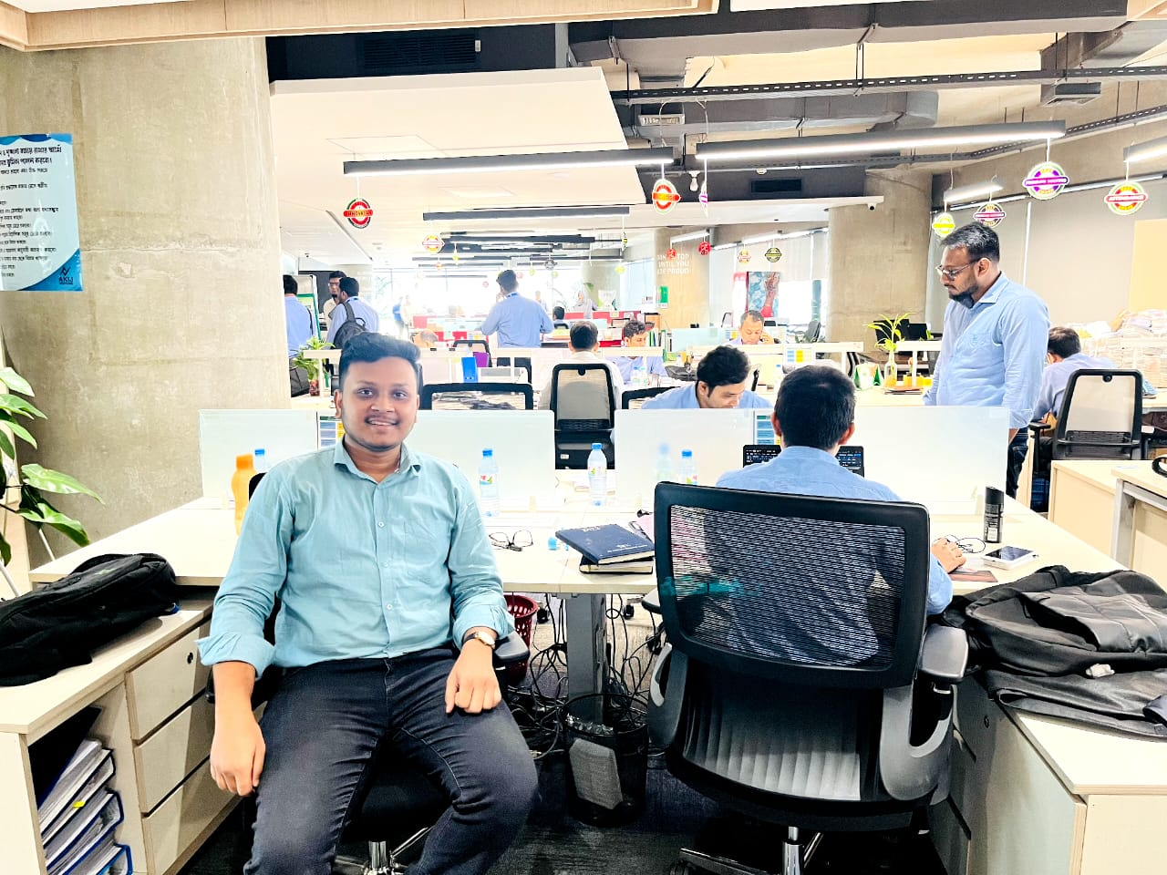
Figure 3 In Akij Venture Head Office

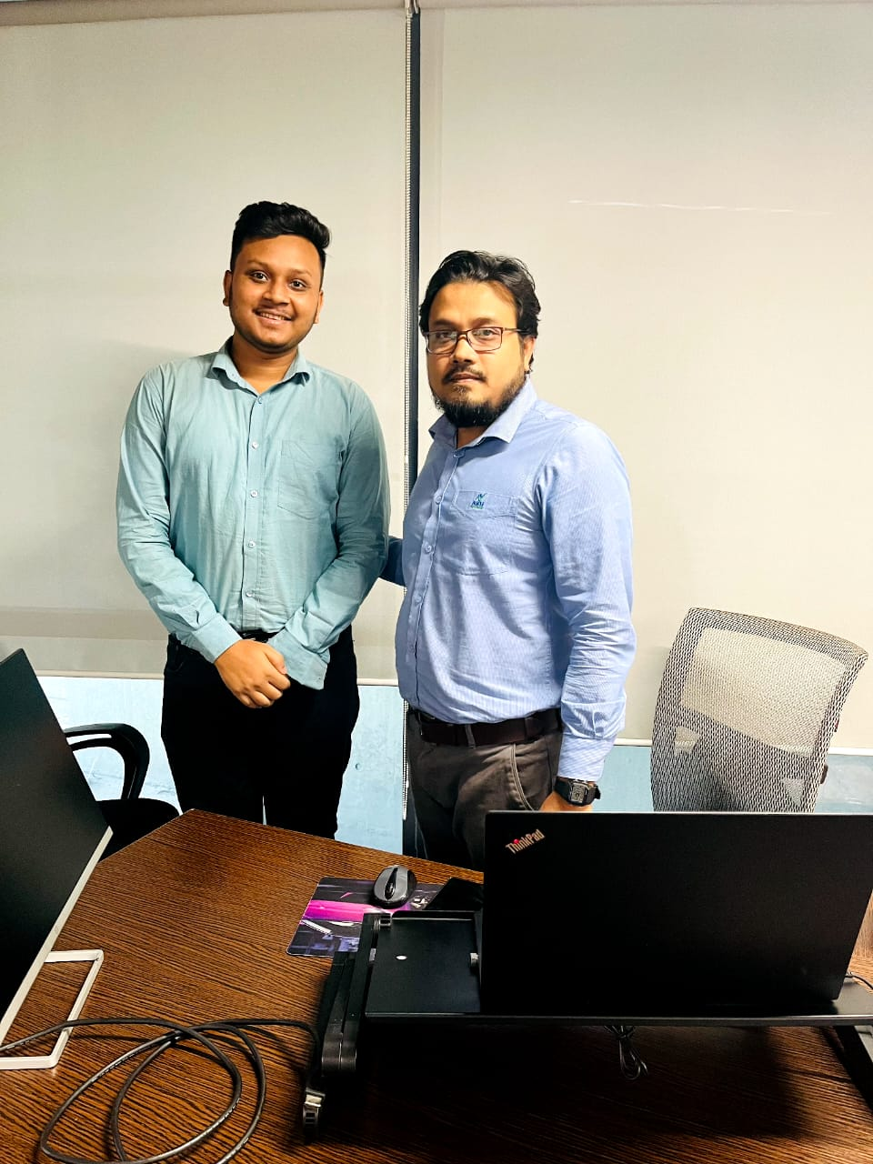
During my internship at Akij Food and Beverage LTD, I had the opportunity to work under the guidance of Mr. Abdul Hai Bhuyan, Senior Manager of Operational Excellence. Mr. Hai has proven to be a valuable mentor who not only provides outstanding operational expertise but also actively shares his knowledge of company culture and work dynamics.
Figure 4 With Mr. Abdul Hai Bhuyan, Senior Manager of the Operational Excellence Department.

His insights on professional development were particularly impressive, giving me valuable suggestions for navigating the profession and providing guidance for the next steps in my training. His willingness to share his experiences and provide constructive feedback greatly contributed to my personal and professional growth during the internship. I am deeply grateful to Mr. Hai for the time and effort he has invested in my development and believe that the insights gained under his leadership will undoubtedly shape my future endeavors.
I would like to express my sincere gratitude to Mr. Abdul Hai Bhuyan for his unwavering support, guidance, and positive impact on my internship experience. I am truly fortunate to have the opportunity to work for such a knowledgeable and encouraging person.
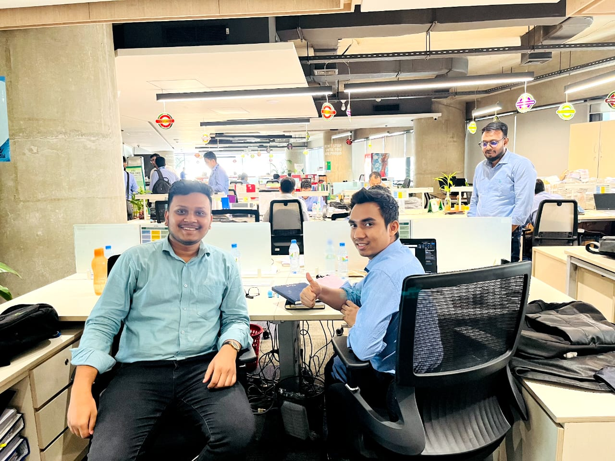
Figure 5 with Mohammad Yeasin Ullah, Assistant Manager of the Operational Excellence Department

CHAPTER 07: CONCLUSIONS

Conclusions
My three-month internship in the Operational Excellence Department at Akij Food and Beverage Ltd. has been a life-changing and rewarding experience. under the direction of Mr. Abdul Hai Bhuyan, Senior Manager. The company's impressive rise from a local to an international player, exporting goods to 26 countries, is indicative of its dedication to innovation, sustainability, and quality. AFBL's wide selection of goods, which includes popular names like Frutika, Farm Fresh, Clemon, and Mojo, demonstrates its flexibility in responding to the constantly shifting demands of the market. AFBL's thorough recruitment process emphasizes written exams, practical exams, and panel interviews, reflecting the company's commitment to selecting the best candidates. As an intern, I was able to actively contribute to the company's operational efficiency by maintaining master data files, creating standard operating procedures (SOPs), and inputting new policies. During my internship, I acquired several useful skills such as: For example, easily using Microsoft Planner, creating SOPs, organizing work tasks effectively, improving teamwork and communication skills, and responding to organizational needs. These skills, along with my experience in teamwork, business branding, regular office work, and human resources activities, have given me a comprehensive understanding of the business world. Mr. Abdul Hai Bhuyan's guidance has been crucial to my growth both on a personal and professional level. His observations on corporate culture, career development, and operational excellence had a lasting impact on him. I am truly grateful for the support, guidance, and positive impact he had on my internship experience.
Last but not least, my internship at Akij Food and Beverage Ltd. has given me real-world experience and given me a strong respect for the company's dedication to adaptability, resilience, and having a positive influence on the communities it serves. Motivated by the principles and goals of Akij Food and Beverage Ltd. and the Akij Group as a whole, I am excited to apply the knowledge I have gained and make a significant contribution to my future undertakings.

Reference

Akij Food & Beverage Limited (AFBL). (2000). https://www.akijfood.com/
Akij Group. (1945). https://akij.net/
Akij Venture. (2000). https://www.akijventure.com/

