Customer satisfaction in the online Medicare service: A case study on Olwel Bd LTD

Afia Tasnim

This report is submitted to the School of Business and Economics, United International University as a partial requirement for the fulfillment of Bachelor of Business Administration Degree.

Customer satisfaction in the online Medicare service: A case study on Olwel Bd LTD

Submitted By
AFIA TASNIM
ID: 111 141 045
BBA Program
School of Business & Economics,
United International University

Supervised by
Dr. Kawsar Ahmmed
Associate Professor
School of Business & Economics
United International University

Date of Submission
April 9, 2019

Letter of Transmittal

April 9, 2019

Dr. Kawsar Ahmmed
Associate Professor
School of Business & Economics
United International University
Madani Avenue, Badda, Dhaka -1212

Subject: Submission of Internship Report

Sir,
It is a pleasure to take the opportunity to submit this report, which has been prepared as per the requirement of Internship. This report has been created in accordance to your requirements as well as the requirement of the host organization.
The internship program, which is of three months, helped me to learn a lot. It also enabled me to gain practical knowledge on dealing with customers and to perform different tasks using specialized software. This report is based on an overview of the organization and the experience I have gained during my internship program at Olwel.
Despite the difficulties I faced while preparing this report mainly due to time constraints, I have tried to be as critical and analytical and the information provided are accurate to the best of my knowledge.

Sincerely,
AFIA TASNIM
ID: 111 141 045

Acknowledgment

First of all, I would like to thank Almighty Allah for giving me the strength to complete my internship with attachment to Olwel for three month period. I would like to thank Almighty for guiding me for the timely completion of this internship report. I would also like to thank my parents for their continuous support during the toughest three months of my undergraduate life without which I would be unable to successfully complete my internship.
Next, I would like to thank all the people who had significant contribution in helping me throughout my internship and in fulfilling the requirements for the internship program at United International University. Firstly, I would like to thank my faculty advisor Dr. Kawsar Ahmmed for guiding me and helping me continuously for the past three months for the successful completion of my internship.
I would like to thank my Supervisor, Mr. Rabiul Alam Rabi, Business Development Manager for supervising me and providing various key information and giving me the path to write a fruitful report and to give a great guidance to me to make a faithful report and it is really very pleasure to me that he makes a correction of my report and give the correct solution always. I also thank him it was a great opportunity to do internship in Olwel Bd Ltd. I always felt that I was under guidance of highly qualified and experienced personnel. The experiences I have gathered will be very beneficial in my career.

Executive Summary

The purpose of this report is to show an analysis of the online Medicare service in relation to service quality and customer satisfaction. Taking Olwel Bangladesh Limited as a case company, this report provides a clear understanding of service quality, customer satisfaction, and online service dimensions.

Olwel Bangladesh Limited is one of the companies which provides treatments at home, ambulances service, medicine delivery, medical test from home. This is a company which has an ideal vision to make hospital service into a comfortable platform. It is a trusted brand for ensuing as a quality service provider. This report is designed based on real corporate experience and theoretical knowledge.

The report focused on the actual performance of Olwel Bangladesh Ltd, online service quality, and how to improve customer satisfaction. Several variables are taken as a standard to judge the service quality and customer satisfaction of Olwel Bangladesh Ltd. Additionally, through service quality dimensions, Olwel Bangladesh Ltd’s service quality is also examined. Based on the evaluation several recommendations are forwarded with more emphasis on promotion including the radio, television, poster and outdoor advertising and through other strategies that will help to increase their service sales.

Keywords: Medicare service, online service quality, customer satisfaction, Olwel Bd Ltd

Contents
Letter of Transmittal i
Acknowledgment ii
Executive Summary iii
CHAPTER 01 3
Introduction 3
1.1 Introduction to the Report: 4
1.2 Research Aims: 4
1.3 Research Objectives: 4
1.3.1 Broad Objective: 5
1.3.2 Specific Objective: 5
1.4 Scopes of the report: 5
1.5 Methodology: 5
1.5.1 Primary sources: 5
1.5.2 Secondary sources: 6
1.6 Limitation of the Report: 6
CHAPTER 2 7
Organizational Overview 7
2.1 Background of the Organization: 8
2.2 Corporate Information of the organization at a glance: 8
2.3 Mission and vision of Olwel: 11
2.4 Fundamental Departments of Olwel: 11
2.5 Olwels present product and services: 11
2.5.1 Primary services: 12
2.6 Why should choose Olwel: 12
CHAPTER 3 13
Internship Experience 13
3.1 JOB RESPONSIBILITIES AS AN INTERN IN OlWEL BD LTD: 14
3.1.1Actual Task: 14
3.2 Guideline of 3 month work 14
3.2.2 Secondary learning: 15
3. 3 Main Objective: 15
3.4 The most potential place for campaign: 16
3.5 Second most potential place for activation: 16
3.6 Achievement: 16
CHAPTER: 4 18
Evaluation of Customer Satisfaction at the Olwel Bd Ltd 18
4.1 Customer Satisfaction 19
4.2 Reasons Why Customer Satisfaction Is Important: 19
4.3 Services Marketing: 20
4.4 Factors impact on customer satisfaction: 21
4.4.1 Loyalty programs: 21
4.4.2 Commitment: 21
4.4.3 Perceived switching cost: 22
4.4.4 Customer Engagement: 22
4.4.5 Employee Engagement: 23
4.4.6 Customer trust: 25
4.4.7 Post Purchase Behavior: 26
4.4.8 Payment option: 26
4.4.10 Product & Place: 27
4.4.11 Take Customer Advice (and Credit Them for It): 27
4.5 Customer Satisfaction: 28
4.6 Service quality: 28
4.7 Relationship between Service Quality and Patient/Customer Satisfaction: 28
4.8 Implementation of Service Gap Model in Olwel: 32
4.9 Five Dimension of service Quality of Olwel 35
4.10 Recommendations 40
4.11 Conclusion 41
References 42

CHAPTER 01

Introduction

Introduction to the Report:
This report is an Internship Report ready as an obligation for the achievement of the BBA program of the Bachelor of Business Administration (BBA), UNITED INTERNATIONAL UNIVERSITY. The key area of the internship is to provide a job experience to the students and a chance for conversion of academic beginning in real life situation. Undergraduates are positioned in creativities, organizations, research institutions as well as development projects. The program concealments a period of 12 weeks of organizational accessory and 2 to 3 weeks of report finalization work. After the achievement of four-year academic BBA program, the period of my organizational part was, by policy 12 weeks, starting from November 12, 2018. I was placed in Olwel Bd Ltd, Dhaka for the internship program. As a requirement for the completion of the program, I need to submit a report, which includes “Customer satisfaction in the online medicare service; A study on the Olwel bd ltd." Basically, the report is made based on primary data, secondary data and information about the company. The procedure and findings of the study are mainly exhibiting my volume for some creative and original approach to solving practical problems in today’s business. The report has been prepared in partial fulfillment of the requirement for the degree of Bachelors of Business Administration (BBA) at UIU (United International University), one of the best and largest Private University in Bangladesh. The present report has been prepared on the basis of experience obtained throughout the internship period. My area of specialty is marketing and the area for this study is especially Olwel, Corporate office: House#13A/3A(2), (Beside Panam Residant School),Block#B, Babor Road, Mohammadpur, Dhaka-1207.

1.2 Research Aims:
The aim of my research is knowing about "Customer satisfaction in the online Medicare service; A study on the Olwel bd ltd."

1.3 Research Objectives:
The Research objective of the report can be viewed in two forms:
- General or Broad Objective
- Specific Objective

1.3.1 Broad Objective:
The Broad objective of this report is "Customer satisfaction in the online medicare service; A study on the Olwel bd ltd."

1.3.2 Specific Objective:
Specific objective is to gather information from probable sources and analyze the selected scopes sited below the following aspects:
- To analyze the stages of Sales development strategies of Olwel.
- To analyze the sales performance of Olwel.
- To analyze the advertising and related activities.
- To find out the pricing strategy.
- To find out Olwel advertising strategy.
- To know the Customer Satisfaction of Olwel Bd Ltd.

1.4 Scopes of the report:
The scope of the report covers the organizational overview and structure, background, objectives, basic functions , marketing promotion, competitor analysis, service marketing for market research of international management with unique through the Sales and Marketing department of Business development of Olwel Bd Ltd. And for that reason, that information was very much restrictive within the organization as this brand are going a very much completive Brands. I am really pleased to all the member of all departments for constant assistant and inspiring me during Internship period.

1.5 Methodology:
Methodology is the procedure, strategy or technique for perception, review and examination. For smooth and exact investigation everybody needs to pursue a few guidelines and guideline. The investigation relegates were collected from two sources:

1.5.1 Primary sources:
- I have collected the primary data by interviewing different executives of Olwel.
- Practical desk work.
- Face to Face conversation with sales representative, Distributors, Area Sales Manager and Zonal sales manager etc.
- Direct observations by dealing with B to B and B to C sector.

1.5.2 Secondary sources:
- Files & Folders.
- Daily work (Containing my activities of practical orientation in Olwel.)
- Various Field visit.
- Website.
In my report I tried to minimize the usage of secondary data as much as possible. I have used secondary data only in the cases where it was not possible for me to use primary data.

1.6 Limitation of the Report:
Olwel is really a great place to gain practical knowledge. Though I have given best effort to prepare this report, but during my report, I had to face some difficulties. They are as follows–
- The main problem that I found in doing this report is inaccessibility of information because much information is confidential.
- As we know that the internship’s duration is only 3 months. This is a very small time for doing any kind of study, which was not enough.
- While doing an internship, in many parts of my inquiry, my performance was stuck by some lacking in experience.
- As I have done this type of report for the first time so it was difficult to organize the report in a simple manner.

CHAPTER 2

Organizational Overview

2.1 Background of the Organization:
Olwel is a Finland based startup working in Bangladesh. We are coming up with an essential doorstep healthcare service for patients who prefer to receive medical consultation at their home. It has started his business from 17th November 2017. From the day of its inception Olwel is serving to minimize the hazard related to health problem/sickness.
Olwel's service will be ideal for patients with movement difficulties and anyone who wants to avoid the traffic jam and the long queues at a doctor’s office. Olwel is providing its service through sending doctor to the patient’s doorstep on their demand. It has its own doctor panel of almost 50 skilled GP doctors. Olwels doctors have graduated from top most medical institute/college of Bangladesh. Maximum doctors have their minimum 3 years to 18 years experiences. Doctor either have finished their post-graduation or, are in their courses from different university. Recently Olwel is hiring doctors to make their panel of 200 doctors.

Logo:
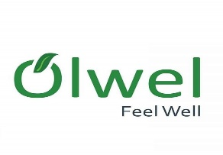

2.2 Corporate Information of the organization at a glance:
Company Name | Olwel BD LTD.
Nature of business | Service
Founded | 2017
Location
  Registered Office: House 185, Lane 2, New DOHS, Mohakhali, Dhaka - 1206.
  Corporate office: House#13A/3A(2), (Beside Panam Residant School),Block#B, Babor Road, Mohammadpur, Dhaka-1207.
  Sub office: Mirpur 6, Dhaka
Headquarters | Dhaka
Phone | 9887041
Hotline number | 09666766000
Facebook Page | www.facebook.com/olwel.feelwell
Website | www.olwel.com
E-mail | contact@olwel.com
Logo | 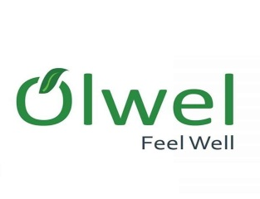
Management Team | - M.M Aftab Hossain  CEO  X-Post-Octoral resercher  KTH Royal Institute of Technology,Sweden  - Mojahedul Hoq. Abul Hasnat  CTO  X-CTO Therap Services, LLC  - Dr. Salahuddin Feroz  Director of Medical Services  MBBS(DMC),MD(Nephrology), BSMMU  - Abdullah Faiz  CCO  Director,B2B Product & Marketing  Banglalink Digital Communications Ltd.  - Aminur Rashed Khan  COO  Customer Solution Architect  Nokia Network  - M W A Farhad  Co-founder
Advisory Panel | - Vilho Jonsson  Founder & Principal  Innovation Evangelist, Curlabs Project Leader, Innovation project Tele2  - Johan Backman  Founder & Principal  Change Evangelist, Curlabs Program Officer Tele2 Hackney Tele2  - Khurshida Khanom  Professor and Head,  Dept.Health Promotion & Health Education, Bangladesh University of Health science.  - Nima Jokilaakso  Project Manager Digital Health, Swecare Foundation CEO, Jokiaakao and Company AB Ambassador, Rockstar Accelerator.  - Tapio Siik  Advisor,Aalto start-up centre Mentor, Vertical Accelerator Angel Investor Partner,Nokia Growth Partners.
Partners | - Thyrocare  - URAL EMS  - ePharma  - Aaito University

Table 2.1: Corporate Information of Olwel

2.3 Mission and vision of Olwel:
To take desire healthcare services at doorstep through our dedication, hard work and quality service. From the first day of its inception Olwel is providing its highest effort to make its beneficiaries happy with our services. We have started our journey from Mirpur, Mohammadpur and Dhanmondi zone bearing in mind to expand our services in whole Dhaka city as well as whole Bangladesh and even abroad.

2.4 Fundamental Departments of Olwel:
- Administration Department
- Financing and Planning
- Commercial Department
- MIS
- Training and Development
- HR

2.5 Olwels present product and services:

- Doctors at home: By placing a request throw phone or mobile application and an M.B.B.S. doctor will be there at Patients address in a short time.
- Medicine home delivery: For medicine patient have to show prescription for medicine delivery to patients home.
- Sample collection for diagnosis: Patient have to call Olwel for sample collection or small tests and Olwel will send a lab technician to patients home.
- Ambulance service on demand: In emergency case anyone can request for ambulance to pick patient up from their home.

2.5.1 Primary services:
- Home Visit Doctor: Place a request via phone or mobile app and an M.B.B.S. doctor will be there at your address in a short time or call a doctor office/ home is an essential doorstep healthcare service for non-emergency sickness.
- Great Doctors: We have locally and internally trained physician, who serves with patience and compassion.
- Other services: We collect samples for investigation, deliver reports and medicine and provide ambulance support.
- Extended Support: Call center follow-up service and dedicated account manager for our corporate client.

2.6 Why should choose Olwel:
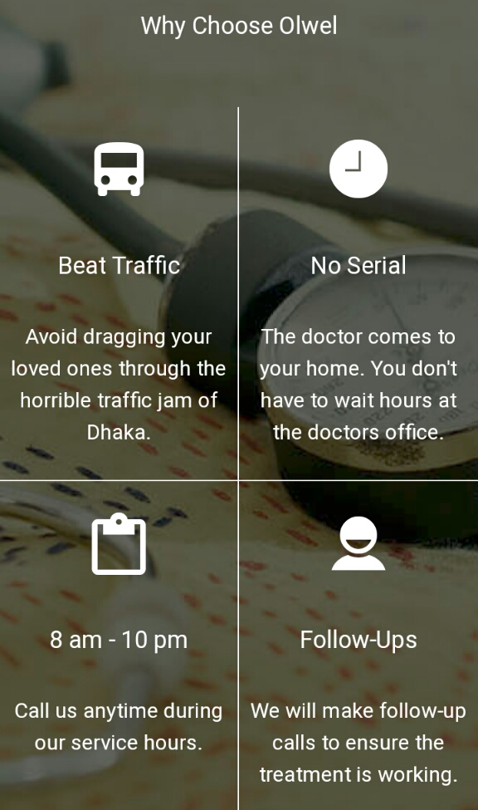

CHAPTER 3

Internship Experience

3.1 JOB RESPONSIBILITIES AS AN INTERN IN OlWEL BD LTD:

3.1.1Actual Task:
This report has done based on the requirement for competing the internship program. The primary objective of this report is getting the real life practical knowledge. For completing internship three credit course fulfillment I joined Olwel BD Ltd as an internee on the 12th November 2018. I worked here for three months in marketing department. In this time I have learn lots of things. They were very helpful and friendly.

3.1.2 INTERN KPI:
I have done my Internship program at Olwel Bd Limited which is situated at Corporate office: House#13A/3A(2), (Beside Panam Residant School),Block#B, Babor Road, Mohammadpur, Dhaka-1207,Bangladesh from 12th November to 12th February 2019.I worked in sales and marketing department. During internship, I worked both in office and went to field work under the supervision of Md Rabiul Alam Rabi, Business developer. They have opportunities of internship students for working. So my principle object was to comprehend there arrangement of working in the marketing division.
The place we have covered during field work:
- University
- College
- School
- Private Company
- Public Company
- Did activation on several place
- Did fair on "Bangabandhu International Conference Center"

3.2 Guideline of 3 month work

3.2.1 Primary learning:
In primary learning I learn some basic things like:
- Know about culture of organization
- How to behave with Colleagues, Customers and others.
- How to make a good relationship with another.
- How to manage time
- In Business conference how to deal with clients
- Contact with company’s employees and others
- Know about rules & regulations of company and law.
- What the sales department does.

3.2.2 Secondary learning:
- Collected information of the offices located in Agargaon office area.
- Introduced our services to the staffs employed by those Gov. Offices.
- Collect some data from those employees in details.
- Tried to convert those offices as our valued customer.
- Found some opportunities to work as a partner.
- Found some places to arrange any awareness program.
- Contact with the main person of IDB (special desk) and shop owner association. Try to convince them regarding our services and collect permission so that we can arrange some awareness campaign in this premise.
- Bangla Academy: Met with the DG of bangla academy and convey services. Know the procedure in details if we want to take part in the "ekushe boi mela".
- National Museum: Meet with the concern (DG) and convey our services. And to let them know we want to arrange a awareness program.
- Rest: to know the details if we want arrange fair or other campaigning.
- Took necessary action to organize activation program.
- Collected information of the offices/school/colleges and universities
In details located in this area.
- Introduced our services to those organizations and their staffs.
- Collected some data from those organizations in details.
- Tried to convert those offices as our valued customer.
- Contact with the targeted distribution channels.

3. 3 Main Objective:
- To build a business relation with some corporate offices.
- To build a business relation with some institution (School, college, university etc)
- To build awareness to targeted distribution channels.
- To build awareness among the mass people through some events, activations.
- To create some business campaigning ideas as well as to convert those ideas in business.
- Propose some business model which will be helpful for olwel.
- To create some promo campaign model based on the practical experiences gather from field work.
- To know how a call center executive do their daily jobs. And find some tricks to improve our services.
- To know how our CC colleagues are working.
- To know how a corporate presentation can be prepare on jobs done in internship period.

3.4 The most potential place for campaign:

- Institutions:
As my perception I think institutions are most effective place for getting new customer. Because there are so many scope for doing campaign by which thousands of people can know about Olwel. By giving 10-15 minute speech on any meeting of any institute can give us potential customer as well as we can educate our customer about Olwel.

3.5 Second most potential place for activation:

- Government office:
Government offices are second most potential place for activation. Because by doing activation in government offices we can get some upper class customer for long time.

3.6 Achievement:
- Feedback about Olwel: We have got some important information by which we can identify the needs and wants of our customer.
- Potential customer: By doing the activation and market visit we have got some loyal customer.
- Creative idea: By going lots of places we have gather lots of creative ideas for improving our services.
- Gather a brief summary of customer perception: By doing the activation we could knew about the customers’ perception about Olwel.
- Important data from people: We have collected data from potential customer which data will help us for future development.

CHAPTER: 4

Evaluation of Customer Satisfaction at the Olwel Bd Ltd

4.1 Customer Satisfaction
Customer satisfaction is a term which mainly uses in advertising. It is a proportion of how things and administrations provided by an organization meet or outperform client need. Consumer loyalty is characterized as "the quantity of clients, or level of complete clients, whose revealed involvement with a business, its administrations (evaluations) surpasses indicated fulfillment of needs and wants."
As per Hansemark and Albinsson (2004) "fulfillment is a general disposition towards an item supplier or a passionate response to the contrast between what clients expect and what they really get with respect to the satisfaction of a need".

4.2 Reasons Why Customer Satisfaction Is Important:
We can never ignore the importance of customer satisfaction. There are lots of factors for getting success of a business, customer satisfaction is one of them. It’s essential to identify this factor and task on improving for the purpose of making our customers more loyal and turn them into a brand ambassador. If we don't care about customer satisfaction then we can't expect that they will care about our product or service. This is truth that sooner we face it, the better we will perform.
- A Loyal customer is a treasure we should keep and hide from the world:
According to the research customer who is loyal is worth up to ten times much from their first buy. Even some research says that it is six-seven time more expensive than current customer. Service companies know it better than other so they don't face extra problem for going far for customer who is not more satisfied. It can be more expensive but also difficult to retain the existing customer.
- They can stop being our clients in a heartbeat:
It is not impossible that clients easily switch their favorite brands. It happens for customer service. If customers don't get feedback they can be dissatisfy. And gaining customers trust takes a business up to many positive experience.
- Also, It is all about the money:
Customer satisfaction is affected with revenue. A brand can be affected by customers’ feedback in both positive and negative way. They can create us customer value. Satisfy customers won't focus on our competitor service or product. They will also recommends our product. If we can fulfill their requirement and deliver high quality service they will be loyal customer. It will increase the revenue.
- Customer satisfaction is a factor that helps us stand out of the competition:
In spite of the fact that our clients won't like us on the off chance that we give terrible product or service, our rivals will. Competitor always waits for our one wrong move. Being set up for their incitements isn't sufficient on the off chance that we don't have the foggiest idea how to manage the negative kickback.
- Extraordinary client experience can take our image places:
We can't ignore the customer satisfaction. We should keep it mind while planning our targeting and positioning activations. Satisfied customer always share those things more on social media. They will comment with our post and will leave some beautiful ideas.

4.3 Services Marketing:
In the marketing field service marketing, most of concept came from service industries like, transportation, banking, health care & hospitality. As this traditional services have involved & became more competition so online Medicare service is so much effective for customer.
- Olwel Traditional services marketing:
Olwel follows traditional marketing mix which is composed of the four Ps: product, price, place (distribution), and promotion. There are main variables for decision making any marketing plan.
- Olwel Expanded mix for services marketing:
As service is intangible sometime customer wants to find tangible cue for helping them to know about the nature of the service. Example: The appearance of treatment. There are 8 PS: Product, place, promotion, price, people, physical evidence, process.

- Customer satisfaction:
Customer satisfaction is the thing by which we can measure customers’ attitude towards product or service or brand. Success is depend on customer link to business. Customer satisfaction and quality management should be incorporated in long run goal of any business. A business can creat plan for customer satisfaction. An easy way to know about customers is survey on customer satisfaction and do what they want makes customer satisfaction

4.4 Factors impact on customer satisfaction:

4.4.1 Loyalty programs:
In customer paradox of customer loyalty shows an attitude phenomenon which can be affected by customer relationship management such as the popular loyalty is increasing. However research says that loyalty in repeat purchase is possible by passive acceptance of brand. For this perspective the demand‐enhancing capability of steadfastness programs is more restricted than may be trusted. Surveys three alternate points of view on steadfastness, and relates these to a structure for understanding client that incorporates client brand responsibility, client brand acknowledgment and client brand purchasing. Utilizations this structure to dissect the demand‐side capability of reliability programs.
Olwel always tries to maintain customer relation management by doing these type of loyalty program. By making their customer loyal they increase their customer satisfaction. Olwel does programs so that customer get our service on their customer need. This programs make Olwels new customer to understand about the service.

4.4.2 Commitment:

Client commitment is currently viewed as a key variable in promoting connections. The article explores the jobs played by various types of responsibility in the connection among customer and their service provider. It was discovered that when customer commitment depends on shared qualities, it has a consistently positive effect on client reliability. At the point when client commitment depends on exchanging expenses and reliance, it affects client dedication. Furthermore, it was found that there were critical collaborations between these two types of responsibility on client dedication.
On the off chance that we are to comprehend the job of client responsibility, we should have a strong comprehension of the idea of duty present in the relationship. These discoveries have vital interaction for the advancement and the executives of administration connections since it isn't really the situation that more client duty is better for either the specialist organization or the client.
Olwel always tries to fulfill their commitment. They promise to serve their patient within 30-40 minute after appointment. They always observe their patients at least 20 minutes as they made commitment with customer. They always do follow up after 3-7 days of any treatment. With Olwel, three things are ensured - patients convenience, care and comfort. Olwel promises experience with olwels doctors brings patients comfort as they are really care of patient.

4.4.3 Perceived switching cost:

It is a commercial center reality that marketing manager now and then incur exchanging costs or switching cost on Olwels clients, to restrain them from abandoning to new supply. To address that issue, some study analyzes the directing impacts of switching costs on customer faithfulness through both fulfillment and saw esteem measures.
The directing impacts of switching costs on the relationship of client reliability and consumer loyalty and saw esteem are noteworthy just when the dimension of consumer loyalty or saw esteem is better than expected. Olwel always tries to retain their customer by making their customer understand about Olwel so that customer don't switch to other service company.

4.4.4 Customer Engagement:

By customer engagement Olwel increases customer’s encouragement and interaction and create their business by shearing their experience. And by this Olwel gets customer satisfaction. By strong strategy of customer engagement Olwel creates customer satisfaction with loyalty and brand growth. Value creation happens for customer engagement and for this satisfaction of customer is increasing. Olwel follows three customer strangers by which they make loyal customer for customer satisfaction.
Following:
- Customer experience: It has importance for Olwel because customer experience gives business & markets a path for increasing satisfaction. Olwels patient experience makes patient involvement in different level like emotional, physical, sensorial, and spiritual. Response of customer or patient conducts direct, indicate contact of a customer. By customer direct interaction occurs when purchase is initiated. Advertisement, news reports, word of mouth or criticism etc. is defend indirect contact.
- Humanize brand: it's significant that Olwels customers want to inform about their needs and wants. Within this concept for creating customer acknowledgement of Olwel with human and ground level of understanding. It’s a matter by which customer can trust Olwel. It's a way by which Olwel can get success of brand and get the satisfaction of customer.
- Social Media: It's a platform where Olwel is able to help the customers on level of customer satisfaction & many ways for engagement. It's the reason to become popular around the Bangladesh among business. Social media is a popular platform for customer engagement. It is included in Instagram, Twitter, and Facebook etc. which are most popular stage. Olwel uses all social media by which they get customer and they also use combination media. It’s a best idea to use different ones so that they can get the success. They also invest on which media is more benefited for them.

4.4.5 Employee Engagement:

A company does right when company’s customer and employees both are happy. Olwel knows the importance of customer satisfaction and employee engagement. And it can be happed when both has strong connection. By the customer experience delivery a business can get 80% of customers and their customer will pay for service more and more and will create superior customer value. Doctors' activity fulfillment is essential in conveying fantastic therapeutic administrations to patients.
As employee engagement influences customer satisfaction so we can say that positive customer experience equal to employee engagement. Olwel always tries to make their employee happy so that customer can be satisfied. Olwel makes the employees satisfy so that they can give the best service to the patient. Employee engagement always affects Olwels bottom line.
Customers who are satisfied can increase engagement also. It makes olwels employee motivated. Olwel also get negative experience of customer and they also learn from the failure. So in this case manager and supervisor recognize stories of customer satisfaction.

Olwel follows these strategy for employee engagement by this model:
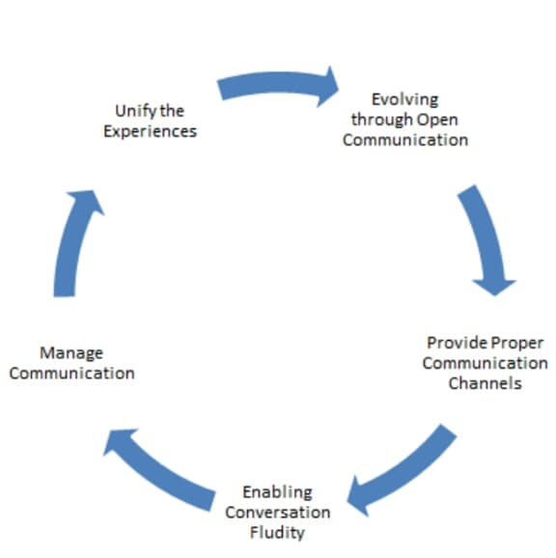

- Unify the Experiences: Olwel does survey for knowing the customer experience which is affecting by employee engagement or not.
- Evolving through open communication: Open communication or face to face communication is followed in the office of Olwel in any meeting so that they know about the main problems of organization. In this meeting every employee can share their idea and experience for developing their service. Often olwel gives reword who gives best idea.
- Providing Proper Communication Channels: Some employee wants to give their feedback by face to face communication and some employee wants to give their opinion in written. So for this Olwel available some channels by which employee can share their ideas or opinion.
- Enabling Conversation Fluidity: Whichever channel employees choose, they have to ensure about the fluidity. The opinion must be non-frustrating for another employee of Olwel. It will have to be ensured that there are no barriers.
- Manage Communication: It's the most important step in this process. Managers check the all entire process that this process is correctly working or not. They should ensure that it serves the ideal reason and isn't being utilized adversely.

4.4.6 Customer trust:
What a positive behavior a company gets is the customer truth. It comes from when customer understand that we will fulfill their needs and respect them and offer best service. Customer trust not only make a customer loyal but also make highest satisfaction.
Olwel follows these techniques for increasing trust of customer:
- Provide an amazing customer experience:
A good experience of customer makes them to repeat consumption of service. So Olwel always makes contact with customer by SMS, phone calls, website, Facebook page, Instagram and face to face visit in several campaign. They train their team for making some decision for customer needs & make a positive relation with them.
- Invite customers to review:
Olwel always focuses on existing customers and future potential customer also and let them leave feedback by phone call and they do calls to customer after received olwels service. They always do follow up calls, message and by online also.
- Use interactive content:
It's a new model of marketing. By this Olwel builds a phenomenon for customers for participating in learning information on attractive form. They gain trust in message, and believe are able to help them.
- Respond to negative reviews:
Olwel takes the time for responding to online review, even negative responses also. It is also an activity about experience of customer and makes the negative one to positive.
- Deliver quality:
Olwel never delivers less which they promised to the customer. For long term trust they always try to maintain the quality of service. Once customers trust the service and company they reach the high level of trust and be a loyal customer. Best quality makes the trust strong. It increases loyalty, trust, sales and customers recommend other for our service. So Olwel has to ensure the trust by maintaining quality and make customer satisfaction.

4.4.7 Post Purchase Behavior:
Post purchase behavior means the final stage of process of customer decision when we can identify whether customer is satisfied or not satisfied. How customers feel about the service always influences whether he/she will take the service again or not. Olwel always focus on this because a customer always influences other people to get the service. So Olwel make follow up message and follow up calls after any patient take service from us. It can be 3-7 days and sometimes the calls are done after 1-2 months and by this Olwel make satisfaction of customer.

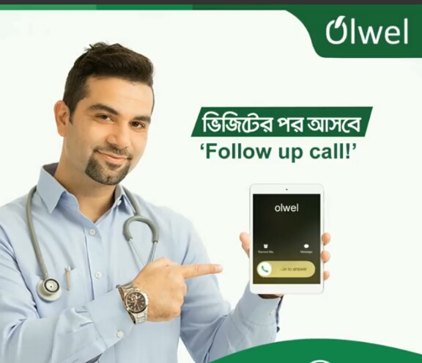

4.4.8 Payment option:
Olwels customers have the right to choose payment agency option. By paying Bkash customer can get 10% discount on total payment. They can pay by cash also. By this option customer can pay by cheques or credit cards by doing contact in the office. By this Olwel manages this payment system for the benefit of customer and they for this they will become more satisfied.
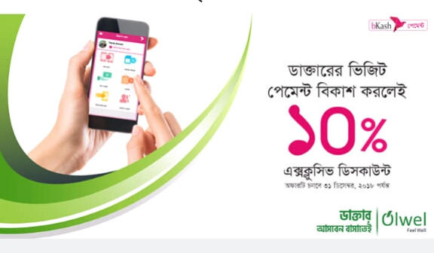

4.4.9 Word of mouth:
Passing a information to one to another person by oral communication means Word of mouth. Olwel always tries to make their customer satisfied so that if they will be happy for our service, they will talk about this to another person and will recommend other to get the service when they want. Story telling is one of common form now a days for word of mouth communication where one person tells a story to other about a real phenomenon which was happened. A company is valueless where word of mouth is absent. When a customer become fully satisfied and get the full superior customer value they will always recommend the service.

4.4.10 Product & Place:
Product and place are the two variables of Olwel which have very big influence on satisfaction of the customers. If the quality of their service is not up to mark and the price of the product is not match with the quality of their service then the customers become dissatisfied. As well as if the service is not convenient then customers will also be dissatisfied. So from that we can say both have very big influence on satisfaction of the customers of Olwel.

4.4.11 Take Customer Advice (and Credit Them for It):
To keep Olwels customer faithful to Olwels image is to always improve. Rather than simply passing by the numbers, or our gut, give figuring a shot what customers need straightaway. They make survey with a couple of the thoughts we have been reasoning about and send it out through Olwels blog, web-based social networking records, and email.
Continuously leave space for customers to make recommendations that olwel didn't list, and they constantly offer some sort of impetus for taking part in the survey. Regardless of whether it's only an opportunity to win something little like a gift voucher or early access to the new element, it will have an immense effect in the quantity of individuals who really take an interest. On the off chance that olwel end up rolling out an improvement or refresh dependent on customers’ criticism, give them acknowledge for coming up for the thought. Olwel declares it through the majority of its advertising channels, and send them something to demonstrate our appreciation.

4.5 Customer Satisfaction:
Customer satisfaction is a felling which is internal feeling of individual. The feelings provide dissatisfaction or satisfaction result from assessment by any organization to customer anticipation. Company tries to improve service just for satisfying their customer for higher satisfaction of customer which will lead to the customer loyalty.

4.6 Service quality:
Quality in a service business has turned into a proportion of the degree to which the service gave meets the customers desires. Organizations have discovered that so as to build benefits and piece of the overall industry, they should give much consideration to support quality. Service quality has turned into a key vital factor for organizations to separate their items & service from different contenders by utilizing service quality as a procedure that customers assess. Numerous specialists recommend that clients survey service quality by looking at what they feel a vender should offer and think about it against the merchant's genuine service execution.
The impact on customer satisfaction of service quality has been constructed by various fields. In research found that the relationship between service quality & customer or patient’s satisfaction is positively related. A patient becomes satisfied when their desire is fulfilled by healing facilities.

4.7 Relationship between Service Quality and Patient/Customer Satisfaction:
Customer satisfaction & service quality is the relation of cause and effect for each other and maintain a role of decisive for existence and in competitive market technology leads a high role for gaining success. If the perceived quality of service is high than that can increase consumer satisfaction.
In Olwel they make customer satisfaction by improving quality of their service. For this reason they follow the service quality gap model to remove the gap for getting the higher satisfaction. The Gap model consists of two parts:-
- The customer gap
- The provider gap

4.7.1 The Customer Gap
The gap between customer expectation and customer perception towards a company's service is called as customer gap. Customer expectation means what a customer expect for the service they are getting according available resources. And they influenced by family, personality, cultural background, advertisement, demographic, experience with same type of products and available information in online. Customer perception refers subjective matter which is based on interaction of customer with service. The strategy, quality service for any specific product or service should be clear in understanding of targeted market. To close this gap, olwel tries to understand of customer needs and expectation.

Customer Expectation
Perceived Service

4.7.2 The Provider Gap
GAP 1 – The listening gap: Listening gap refers the gap between customer expectation and company understanding of that expectation of service.
In many firms a primary cause is not meeting with customer expectation that is customer gap.
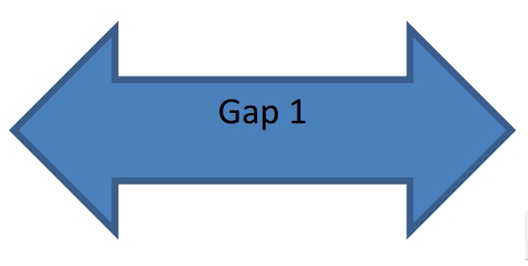
Strategies which olwel follows for closing the listening gap:
- They listen their customer in multiple way as like customer research and employee interaction.
- They maintain relationship by meeting and understanding customer needs over time.
- Olwel act and know what customer expect from the experience of a service failure.

Gap 2: The design and standard gap: The design and standard gap means concentrated with forming customer expectation into actual designs. And they developing the standard for measuring service operations for customer expectation.


Strategies which olwel follows for closing the design and standards gap:
- Olwel introduces new service development which is well defined practices with innovation.
- Through service Olwel understand their total customer experience
- Service operation by customer is measured - defined rather than olwel’s pre-defined standards.
- In providing service of olwel they incorporate physical evidence

Gap 3: The service performance gap
If the discrepancy is exist between actual service delivery & customer driven service design then the service performance gap can be closed. Even when guideline is present to perform service well and treat customer high quality performance of service is not called as certainty. By using appropriate resources like system, people and technology the standard must be maintain.



Strategies which olwel follows for closing the service performance gap:
- Olwel maintain this by aligning their resources like training, hiring and rewords for delivering excellence service.
- By make customer understand and perform effective way olwel define roles of customer
- Olwel uses effective technology and appropriate aid for performance of service.
- They maintain fluctuation in demand & supply.

Gap 4: Communication Gap:
If any firm done everything for closing the three gaps for ensuring service quality but there is still be a failure to meet the expectation of customer because if communication is not exist service will not meet with what will be delivered. So the final communication gap has to be closed. Communication gap focuses contrast on service delivery and external communication through pricing, advertisement or other forms of promotion.


Strategies which olwel follows for closing the communication gap:
- Olwel develops converting strategies for service marketing, competitive price, quality service and sends those message to the consumer.
- Olwel maintain effectively the customer expectation by the experience.
- For the communication which is internal they develop mechanisms for avoiding over promising. And they ensure delivery successful.
- They manage their brand image.
- Communicate with customer by giving regular follow up calls.

4.8 Implementation of Service Gap Model in Olwel:
4.8.1 The Customer Gap
Olwels patients are considered as customers and providing satisfactory services are major concerns.
Customer Expectations: Some factors influencing Customer Expectations:
  - Word of mouth: Word of mouth is the major form of sharing information person to person trough oral communication. Olwels patients are satisfied and they spread good things about the service. Patients share information to the people close such as colleagues, friends, family etc.
  - Personal needs: If patient gets desire level of service they will be happy. But as some amount of departments available, so patient can be dissatisfied. So some patient complains to get right amount of attention.
  - Past experience: Past experience of patient is an important part service. Most of olwels patient compare recent service with past service which makes satisfaction of customer.
Major customer Expectations:
- Doctors pay full attention to complains: Patients of Olwel expect full attention so that doctors will listen to their problem with empathy. They have a belief that if doctors are listening carefully, they will be cured.
- Patients expect proper treatment: Patient of Olwel expect proper checkup for all types of sickness. Proper treatment makes good and healthy future.
- Caring attitude: Patient expects from doctor of Olwel caring attitude and not only that they expect all level of benefits by which they will feel good. Caring attitude makes patient comfortable, sense of reliability and trust. So that patient will be satisfied.
- Economic charges: Olwels patient expects economic charges for visiting doctors. They want a fair rate visit. So for regular patient Olwel offers discount card by which patient will get 10% discount on per visit. So that they can afford all cost of treatment.

4.8.2 Customer perception:
  - Moderate health services: Olwel gives good level of service of their patient. This service will touch marginal level of satisfaction. Few patient are not fully satisfied
  - Costly investigations: Some of investigation like blood test are higher then clinics. Some patient may not afford the expense.

4.8.3 Provider Gap
➢ Gap 1: Listening gap: In olwel there is exist gap between expectations of patient about service and the services is given by olwel.
  - Lack of adequate, formal and friendly behavior: Patients are so sensitive towards that they should treated carefully. But sometimes may busy and they miss the proper suggestions & attention to them. For this patient can feel hesitate for sharing their problem. Friendly attitude makes patient become comfortable.
  - Lack of female doctors: Women of Bangladesh are very conservative and shy. Patients want female doctors for female patients for checkup. Olwel has little numbers of female doctor.
  - No Emergency: No emergency situation has been handled in Olwel. The service for emergency like trauma, accident etc. are not handled by Olwel.

➢ Gap 2: The service design and standards gap: Customer driven standards are different from conventional performance standards that a company establishes. These problems are reflected in gap 2, the difference between company understanding of patient expectations and development of patient driven service designs and standards.

  - There is no ambulances of own: They have no ambulances of own. So it can customer feel less trust towards Olwel.
  - They have no own pharmaceutical shop: They just delivery medicine from third party. So patient feels dissatisfy.
  - Few departments present for service: Olwel has few department like they only has medicine and gynecologist. But absence of other departments such as surgery, eye etc. absence.

➢ Gap 3: The service Performance gap: This is the difference between development of customer driven service standards and actual service performance by the company's employees. Standard can be balanced by appropriate resources like system, people, and technology.
  - Lack of modern technology: They have less technology in investigation of diseases to give reports.
  - No available doctor for all time: Olwel said that their doctors are always available in all time but sometimes doctors are appointed on the same time to other patient.

➢ Gap 4: Communication gap: The communication gap means the difference between service delivery and serve provider’s external communications. The difference between real and promised service can widen customer gap.
- Delay in providing reports: Some time they provide report delay. As a result customers become dissatisfy for delay and become annoyed and they lose their patience.
- Long Wait in Reception Area: Time is significant. When patient have to wait longer than 30-40 minutes for arriving the doctor to home, they become upset.
By removing these gaps of Olwel, they ensure the quality and close the gap for making the customer satisfaction in this market place.

4.9 Five Dimension of service Quality of Olwel

4.9.1 Service Quality
To achieve competitive advantage its most essential for giving attention on service quality, the reason is customer consciousness about quality so it's essential to provide higher service quality which is better than competitor. Service provider can separate itself by conveying fantastic service more than that of its rivals since capacity of service company rely upon how reliably it offers some benefit to its customers, while best strategy to hold customer is rely upon their quality. Service quality is characterized as the distinction between customer desire and their recognition about the service experience.
At the end of the day, if suppliers get these measurements right, customers will hand over the keys to their faithfulness. Since they'll have gotten service greatness. As indicated by what's essential to them?

The five SERVQUAL dimensions are:
- TANGIBLES- Appearance of equipment, personnel, physical facilities, communication materials etc.
- RELIABILITY- Ability to do the task what company has promised for service accurately and dependably
- RESPONSIVENESS-Willingness for helping consumer and provide quick service.
- ASSURANCE- Courtesy and Knowledge of employees & their ability for convening belief and confidence.
- EMPATHY-Caring, individualized attention that company provides its customers.

5 dimensions for customer care for customer satisfaction:

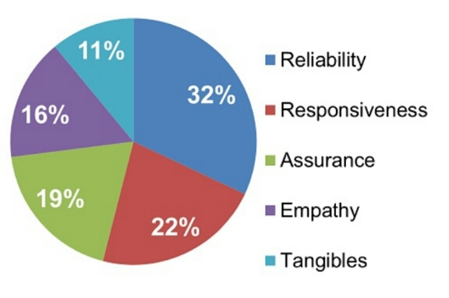

4.9.2 Reliability
Reliability is most significant factor which is directly related to provide service problems of customer, Delivering services at the right time what was promised and keeping blunder free records of every action. Besides, unwavering quality is about precise request satisfaction as exact statement, exact record, precise in charging, and keep up their guarantee.
In Bangladesh, reliability of the supplier is frequently seen as low for different reasons, as like many doctors recommend various types of unnecessary medical tests, not only that but also there is irregular supply of drugs for hospitals.
- Olwels doctors don't recommend any unnecessary medical test as they promise to their customer.
- Olwel always provide regular supervision.
- They always provide correct treatment at the first time.
- They always keep in mind what they were promised to serve their customer like they promise their customer to do treatment after 30-40 minutes after getting calls of patient.
- They promise to give respectful attitude and guide patient with appropriate advice and medication.
Patient needs to rely on olwels service. They esteem that dependability. This is it. It's multiple times more critical to be dependable than have gleaming new uniforms.
Does not mean we can have ragged uniforms and only be reliable. Service providers have to do both. But provider’s first and best efforts are better spent making service reliable.

4.9.3 Responsiveness
Responsiveness is another dimension of service quality to exceed customers’ expectation. It’s the willingness and readiness of employees to serve timeliness. It also includes knowing the attention OD safety and individual attention to customer given by employee. It’s a vital term of satisfying customer’s expectation which will make customers delight and increase their trust for the organization.
- Olwel respond promptly when patient need or expect as a customer.
- Olwel always available equipment what patient required.
- They diagnose of diseases quick as customer need.
- Olwels doctors prescribe drugs which will be easier to find.
- This company does work with the responsiveness of doctors, the greater the satisfaction of patient.
- Arrive doctor to the spot on time
- Olwels call center track wait times of patient. They track the response time of responsiveness
- Service the patient without serial
Holding up multi day to restore a call or email doesn't make it. Regardless of whether patients are incessantly moderate in returning to olwel, responsiveness is multiple/fifth of their administration quality evaluation.

4.9.4 Assurance
Assurance is the knowledge of employees and their ability for inspiring,trust and confidence. In healthcare institutions assurance refers the friendly & polite staff/doctors/nurses, comfort of interior, financial advice and knowledgeable management team to account information.
Knowledge, skill and courtesy of the doctors can provide a sense of assurance that they have the patient's best interest in mind and that they will deliver services with integrity, fairness and beneficence. For a service that is largely credence based, where customers are unable to evaluate the quality of the services after purchase and consumption, the sense of assurance that is engendered can greatly influence patient satisfaction.
In the health care system, assurance is embodied in service providers who correctly interpret laboratory reports, diagnose the disease competently, provide appropriate explanations to queries, and generate a sense of safety. Nurses also play an important part in providing additional support to patients’ feelings of assurance by being well-trained and by addressing their needs competently. Thus, the greater the perceived assurance from the health care providers, the greater will be the satisfaction of patients.
- Olwels doctors knowledge and skill can provide assurance that they know patients interest
- Olwel deliver service with integrity beneficence and fairness.
- This company correctly diagnoses medical test reports, diagnose the disease fully, provide exactly explanations of queries & generate a sense of safety.
- Olwel expected to be expert of the service they’re delivering.
Research says it's significant to communicate the customer or patient. If company is highly skilled but customer doesn't see this, their confidence as a service provider is lower.
Olwel raise customer awareness by:
- Olwel does awareness by free treatment in some organization.
- They make campaign for create awareness
- They create awareness by giving small statement in any school meeting.
- They make activation in several public place.
- They do fair for health awareness.

Since company should communicate with their expertise & rivals before they do the work. It can be done in various way that are repeatedly watch by customer,
Such as
- Show industry certificates on badges, patches or catches worn by representatives.
- On letters, emails & reports include certification logos.
- Into newsletters, posters & handouts put certifications.
Company can help to manage customer expectations by communicating competencies & influence service quality assessment in advance.

4.9.5 Tangibles
Tangibles means the appearance of physical facilities, equipment, personnel, written materials which are also major dimension to make customer delight and ownership of the company's brand image.
For satisfaction of patient Olwel provides satisfactory service. Generally good tangibility like equipment, physical facilities, personnel etc. create positive impression. It influences olwels customer. In Bangladesh most of health care services ignore the attribute for patient satisfaction. So olwel always focus that which elements affect to customer behavior for attenuating customer satisfaction because better tangibility provides greater patient satisfaction.
Though it is less important than other dimensions but sometime appearance make patient trust.
Olwel wants to make employee uniforms, appearance, equipment, work areas like service officers, closets etc look good. Olwel keep it mind that tangibles makes reliability and responsiveness also.

4.9.6 Empathy
The attention of individual, caring which is given to the patient of olwel refers empathy. It means keeping self on another shoe. This determine is fully dependable on the emotional view for making customer that we care our patient or customer. This term provides quality service on customer expectation which a patient want and their perception toward service which they receive. SERVQUAL is being applied by some researcher for measuring quality of service of Olwel.
Olwel provides empathy and understand their patients’ problem & their need are being influenced for patient. Like this Olwels patient wants to olwel that the doctor will be attentive and doctor will understand patient’s problem. Olwel gives patient personal care and not only has that also provided mental support to patient. By this olwel shows empathy to patient. More empathy makes the patient more satisfied.
Patient may not feel that service providers care about them. Then it hurts customer behavior of service quality.

For example:
- Olwel doctors provide treatment and listen patients’ problem carefully.
- Doctors keep a smile during checkup.
- Gives mental support.
- Gives more time to patient so that patient feels good
- Ask to patient if they can do anything else for patient
- They provide comfort by handling patient request with priority and resolve as soon as possible.
- The patient doctor relationship will not end with one visit. They do follow up calls from olwels call center and ensure the effectiveness of advice and imitation further action if necessary.
- Gives treatment with patience and compassion.
- Gives respectful attitude with caring.
Customer’s appraisals include desires and perception over each of the five SERVQUAL measurements. Olwel need to work at all five, yet stress them arranged by importance. We have to follow the dimensions which ones rework.

4.10 Recommendations

- Olwel should improve quality of their services for customer satisfaction.
- Olwel should increase the number of doctors and staff for providing adequate services for customer or patient.
- For many diseases are increasing so the departments should be extended.
- Fees must be charged reasonable and economical.
- Specialist doctor should be hired.
- In the community survey of patient satisfaction should be studied for effective way to know the patient satisfaction level.
- For the stability of olwel in competitive market for both patient satisfaction and service quality must be considered together.
- An annual planning schedule can be created for determining the whole year work plan.
- Olwel should do campaign for educating their customer and more people know about Olwel.
- Schools and Government offices are the best places for campaigning because we can reach our targeted customer.
- They should give discount several discount on several occasion to regular customer.
- They will have to focus on promoting their apps along with hotline numbers. As very few people know about our apps.
- Package making (baby, old people, and pregnant woman) can be easier for getting segmented customer base.

4.11 Conclusion

At the end of our internship as a Marketing intern I think Olwel is giving a unique service in Asian culture. If they can go in a good strategy they can achieve the goal and can make a brand position in market place. They can get first mover advantage by proper marketing. The purpose of the report was to identify the factors, dimension, and services quality of the services by which olwel makes their customer satisfied. At the end of the report I tried to conduct the administration which olwel does for their patient satisfaction.

References
Ali, M. (2014). Factors Affecting Medical Service Quality. Tehran University of Medical Sciences, School of Public Health. Tehran: Iranian Journal of Public Health. Retrieved February 2014, from https://www.ncbi.nlm.nih.gov/pmc/articles/PMC4450689/?fbclid=IwAR0NZkz-CkueJ5mW2HDbJ4jyvdch1g1nD9cDWZlWoij1pXhuJp_SdG4Au7c
Andaleeb, S. S. (2019). Patient satisfaction with health services in Bangladesh. Oxford Academic, 22(4), 263-273. doi:10.1093/heapol/czm017
Australian Government Department of Human Services. (2018). Customer Satisfaction. Retrieved November 2, 2018, from Australian Government Department of Human Services: https://www.humanservices.gov.au/organisations/about-us/annual-reports/annual-report-2017-18-html/part-4-customer-engagement-and-feedback/customer-satisfaction?fbclid=IwAR26cWOt0NSV_ZCbGXlbutWWDYsv8Mp96sj71JsmHMk14ZBSrEM_EWSTEQU
Hussain, M. M., & Raihan, M. M. (2015). Patients’ Satisfaction with Public Health Care Services in Bangladesh: Some Critical Issues. ABC research house, 2(5), 126. doi:10.18034/mjmbr
Islam, M. Z. (2019). Doctors waiting to see you. Retrieved March 18, 2018, from The Daily Star: https://www.thedailystar.net/business/olwel-doorstep-healthcare-service-in-bangladesh-doctors-waiting-to-see-patients-1549807
Kabir, F. R. (2018). New Era of Digital Health Service in Bangladesh. BRAC University, BRAC Businesss School. Dhaka: Telenor Health. Retrieved September 3, 2018, from http://dspace.bracu.ac.bd/xmlui/bitstream/handle/10361/10690/13204075_BBA.pdf?sequence=1&isAllowed=y
Nohr, L. E. (2007). Croatian Island Telemedicine System Project: Public Health and Technical Evaluation. Norwegian Centre for Telemedicine University Hospital of North Norway. Retrieved March 29, 2007, from https://ehealthresearch.no/files/documents/Prosjektrapporter/NST-rapport_2007-08_Croatian_Island_Telemedicine.pdf
Oxford Academic. (2019). Health Policy and Planning. Retrieved March 11, 2019, from academic: https://academic.oup.com/heapol/article/22/4/263/620111?fbclid=IwAR0lz_vpKal8ADZ6vjP_eV_-UmCwkHhax4LjltrH4emrw74Y-Fywm4marbM
Sanjeewa, G. &. (2017). Patient Satisfaction with Health Care Services Delivered at the Out Patients Department-Case Study-at Teaching Hospital Karapitiya Sri Lanka. Health Care: Current Reviews, 5(2). doi:10.4172/2375-4273.1000193
Satisfaction With Medicare Advantage Plans Remains Stable, but Opportunities Remain. (2006-2018). Retrieved june 22, 2018, from AJMC: https://www.ajmc.com/focus-of-the-week/satisfaction-with-medicare-advantage-plans-remains-stable-but-opportunities-remain?fbclid=IwAR39kVuLg87zthkGCZmPxcER6YwvMem6HO3yvJnWOe_wt2JZMohcLNHuY0E

