
United International University
Internship Report
On
Service Management of A.H. Khan & Company as a 3rd Party Service Partner of Grameenphone Ltd. for SME Market

Submitted To

Muhammad Hasan Al-Mamun
Assistant Professor
School of Business & Economics
United International University

Submitted By
Md. Imtiaz Hossain
ID Number: 111-141-450
BBA Program
School of Business and Economics

Submission Date- November 07, 2021

Letter of Transmittal

November 07, 2021
Muhammad Hasan Al-Mamun
Assistant Professor
School of Business & Economics
United International University

Subject: Submission of internship report on “Service Management of A. H. Khan and Company as a Third Part Service Partner of Grameenphone Ltd. for SME Market”

Sir,
It is my pleasure to submit the internship report, which is done as a part of academic Curriculum, to you for your kind evaluation. The report is prepared on “Service Management of A. H. Khan and Company as a Third Part Service Partner of Grameenphone Ltd. for SME Market”. I have put my best effort in preparing this report and to make it a worthy one.
If any confusion arises or any further explanations are needed, I will be readily available to explain the matters to you.

--------------------------------
Name: Md. Imtiaz Hossain
ID: 111-141-450
BBA Program
School of Business &Economics
United International University

Acknowledgement
I would like to pay my gratitude to Almighty Allah for giving me the ability to work hard for completing the report. I am also grateful to my parents for loving, taking care of me and supporting my efforts.
I would like to express my heartiest thanks to my supervisor, Muhammad Hasan Al-Mamun, Assistant Professor, School of Business and Economics of United International University, for his continuous, proper, and perfect guidance, inspiration, affection , encouragement and valuable suggestions for making this report. I would like to thank all the honorable faculty members who taught me.
I am extremely grateful to everyone who helped me in conducting my research by taking time out of their busy schedules to discuss with me on the various issues.
Finally, I want to thank the users/subscribers of A H Khan & Company and Grameenphone who helped me in making this report by patiently fulfilling the questionnaires. Without them I never would have been able to complete my project report successfully.

Executive Summary
Mobile telecommunication companies are playing a key role for the communication in the present world. In the mobile telecommunication industry of Bangladesh, Grameenphone has become a leading company. Creating a superior image in comparison to the competitors is a difficult task. Grameenphone has created a superior image in comparison to the other operators. The main objective of this report is to evaluate the service management of A.H. Khan & Company as a 3rd party service partner of Grameenphone Ltd. for SME Market. Small and medium enterprises (SMEs) are treated as the engines of growth and drivers of innovation worldwide. They play a significant role in driving economic growth and generating jobs. SME Business Sector will play a major role in bridging the urban-rural income gap and contribute towards inclusive growth. A.H Khan & Company and Grameenphone jointly established business in SME with A.H Khan & Company selling Grameenphone Products in SME sector. As a 3rd party partner of Grammeenphone, A.H khan & Company pursued the marketing objectives of Grameenphone in the SME market and A.H Khan & Company is also found to be engaged in increasing Grameenphone’ Market share in the SME market.
Based on the analysis, several crucial factors are identified which have the impact on service management of A.H. Khan & Company as a 3rd party service partner of Grameenphone Ltd. for SME Market. The notable factors include network coverage, customer service, pricing, internet service, and employee behavior. The users of Grameenphone in the SME market think that billing rate of Grameenphone is high though they are found to be quite satisfied with the level of services provided by Grameenphone. Based on the study results several recommendations and conclusion are given at the end of the report for the purpose of improving the performance of Grameenphone in the SME market.

Keywords: SME Business, Grameenphone

Table of Contents
Chapter -1 1
Overview of the Report 1
Introduction 2
Constraints facing SMEs 2
Objectives of the Term Paper 4
Methodology 4
Limitations 5
Chapter -2 6
Company overview & Literature Review 6
About A.H. Khan & Co. 7
Our Strengths 7
Our Values: 7
Mission 8
Vision 8
Sister Concerns 8
A. Sales promotion service (SPS) 8
B. Pavel Traders 8
C. 3S ASSOCIATES 8
Our Patrons 8
1. British American Tobacco (BATB) 8
2. Coats Bangladesh 8
3. New Zealand Dairy 9
4. CavinKare 9
5. Lafarge Holcim 9
6. Grameenphone 9
7. GlaxoSmithKline 9
8. BKash 9
9. Marico 9
10. Syngenta 9
11. LG Butterfly 9
12. Linde Bangladesh 9
13. HEMAS 9
14. Berger 10
15. Honda 10
16. Social Marketing Company (SMC) 10
Marketing Mix of SME Business sector at A H Khan & Company and Grameenphone: 10
✓ Product 11
✓ Price 11
✓ Place 11
✓ Promotion 11
Products and services of Grameenphone Ltd: 11
Nishchinto: 11
Bondhu: 12
Djuice: 12
Smile: 12
Online customer service: 13
Offline Customer Services: 13
Literature Review 14
Customer satisfaction 14
Chapter-3 16
SME Business Sector of Grameenphone 16
Business Solutions Offer 17
The Largest and Finest Network of the country: 17
International Coverage: 17
Clear and Convenient Billing: 17
Package Features: 18
M. Centrex Service: 21
Grameenphone Smart Security 23
SEEMO Smart Security” Powered by Grameenphone 23
Audio Conference 24
Team Tracker 26
Vehicle Tracking 27
Lite Vehicle Tracking Service 28
Benefit of Vehicle Tracking Service – Lite 28
Standard Vehicle Tracking Service 29
Chapter-4 31
SWOT Analysis of Grameenphone 31
Chapter 5 34
Findings & Conclusion 34
Positive aspects 35
Negative Findings 36
Recommendations 36
Conclusion 37

Chapter -1

Overview of the Report

Introduction
Small and medium enterprises (SMEs) are treated as the engines of growth and drivers of innovation worldwide. They play a significant role in driving economic growth and generating jobs. In Bangladesh, the sector is actually changing the face of the economy. SMEs are playing a vital role for the country's accelerated industrialization and economic growth, employment generation and reducing poverty. SMEs now occupy an important position in the national economy. They account for about 45 percent of manufacturing value addition, about 80 percent of industrial employment, about 90 percent of total industrial units and about 25 percent of the labor force. Their total contribution to export earnings varies from 75 percent to 80 percent. The industrial sector makes up 31 percent of the country's gross domestic product (GDP), most of which is coming from SMEs. The total number of SMEs in Bangladesh is estimated to be 79,754 establishments. Of them, 93.6 percent are small and 6.4 percent are medium. The 2003 Private Sector Survey estimated that there are about 6 million micros, small and medium enterprises, with fewer than 100 employees. About 60 to 65 percent of all SMEs are located outside the metropolitan areas of Dhaka and Chittagong. The country's SME sector has created 15 lakh jobs between 2009 and June 2014. Now, private and foreign banks disburse Potential of SME. Every year about 2 million young people join the country's workforce. Half of them find jobs at home or abroad. So, it has become a challenge to create more jobs so that the rest can be employed. SMEs can be an answer to the problem. The target of achieving double-digit growth hinges largely on the performance of the small and medium enterprises. In a labor surplus country like Bangladesh, SMEs can play a substantial role in providing the impetus to the development of the modern manufacturing sector and the job creation outside the agriculture and informal sectors. In Bangladesh, people exhibit lesser ability in processing capital and machinery. SMEs are labor intensive but relatively low capital intensive. For a developing country like Bangladesh, SMEs are a cost effective way towards the reduction of unemployment. Since Bangladesh has not yet displayed adequate performance in large-scale industries that are predominantly owned and operated by public bodies, the country can solve its unemployment situation by encouraging SMEs. Seasonal and disguised unemployment can also be solved to a substantial extent by SMEs. SME can reduce the urban migration in the capital and other major cities, increase cash flow in rural areas, and thereby enhance the standard of living of the rural people. SMEs are widely distributed all over the country which means developing SMEs will play a major role in bridging the urban-rural income gap and contribute towards inclusive growth. In a way, inclusive growth can only be achieved through a vibrant SME sector in a country like Bangladesh.
  - Constraints facing SMEs
Lack of capital support, modern technology and inability to market products and maintain product quality, lack of skilled technicians and workers, high bank interest rates, inadequate supply of gas and electricity, unavailability of appropriate infrastructure facility, inadequate policy reforms, law and order situation and frequent strikes. It is important to understand the operational strengths and weaknesses of the SME sector for pragmatic policy making and Effective implementation of these policies. The central bank has been at the forefront of SME development in Bangladesh. The government has rightly identified SMEs as the priority sector for transforming Bangladesh into a middle-income country. In line with government's thrust, BB has been instrumental in designing and implementing SME sector development initiatives as part of its development financing agenda. BB has shown the world that a central bank can successfully manage its traditional role of monetary authority while playing the complementary role of development driver. BB has already become the role model in SME financing in the international arena within a span of only five years. Its initiatives are being studied by other central banks of the world. The central bank is regularly receiving delegates from other central banks who are looking at the country' success stories. In the past, a very insignificant amount of loans went to the SME sector although promises were aplenty. Ever since assuming office as the 10th central bank governor in 2009, Atiur Rahman has been spearheading SMEs financing in the country.
Rahman's passion for SMEs earned him the nickname 'SME Governor'. Due to banks' serious involvement in agriculture and SMEs, domestic demand has gone up significantly, helping the country avoid the onslaught of global financial crisis. Bangladesh Bank has not only opened a new department for promoting SME financing, but has made it mandatory for all banks to open a separate department for SME clients. The banks have responded positively. Some even opened SME branches. The central bank has launched target-based credit activities for banks. Between 2010 and 2013, about 18.35 lakh SMEs got loans to the tune of BDT 262,340 crore. Loans of nearly BDT 100,000 crore are going to SMEs every year. BB has launched a number of refinancing schemes involving BDT 2,100 crore from its own fund as well as funds from development partners.
The central bank is also promoting cluster-based SME credit programmers to tap the regional economic potential. Among the clusters, there is sewing and handicraft in Jamalpur; handicraft, flower farming and processing industries in Jessore; handloom in Moulvibazar; handloom, cane and bamboo craft in Sylhet; handloom in Tangail; light engineering in Bogra; garments in Syedpur; khadi in Comilla and Chandpur; and jamdani in Narayanganj. Uniquely, SMEs are also geographically widely distributed. So they offer a good prospect for geographic diversification of the economy. In this sense, SMEs are an important driver of inclusive growths well Conclusion. The country needs to encourage the adoption of modern technology in SMEs so that their products can compete with those of the competitors.
Banks and non-banking financial institutions need to have a tailored and explicit strategy for SME banking in order to build a solid banking policy to facilitate sound growth and profitability in SME banking, as well as to have better credit evaluation mechanisms, product design, marketing skills, and knowledge of customer and product profitability. For smooth and sustainable development of SMEs all over the country, more emphasis should be given to develop SMEs at district and upazila levels to arrest the rising flow of population to cities “Regionalism in Asia led by global value chains (GVCs) and free trade agreements has increasingly put the spotlight on SMEs. Now more than ever, SMEs in Asia have the opportunity to engage in international trade given the falling barriers to trade and fragmentation of production whereby the manufacturing of final goods is spread over firms located in several countries, each one undertaking an individual task of the overall process. Firms no longer need to have the expertise to export to a modern market; instead, they can simply support the value chain as suppliers of intermediate inputs in the form of parts and components, and act as subcontractors several levels below the ultimate buyer. Increased internationalization through trade and participation in GVCs provides SMEs in Asia the opportunity to achieve economies of scale, expand market share, and increase productivity. SMEs in Bangladesh should see whether they could be part of this new phenomenon. It is worth noting that SMEs that invest in technology and those with high labor productivity are more likely to be part of the GVC. Bangladesh needs to maximize the benefits derived from the SME sector, as this sector plays a pivotal role in promoting and sustaining the industrial as well as overall economic growth.

Objectives of the Report
The main objective of this report is to evaluate the service management of A.K. Khan & Company as a third party service partner of Grameenphone Ltd for SME market. The study also intends to evaluate the customers’ perceptions regarding various aspects of the services as they were provided with the help of the A.K. Khan & Company.

Methodology
This report is the outcome of my three-month long internship program. My in-hand experience and observations will definitely go into category of the primary data used for the study. A survey was also conducted to assess the customers’ perceptions regarding various aspects of the services provided by Grameenphone with the assistance from A. K. Khan & Company. The results of the survey are presented in the findings and analysis section of the report with due importance.
The secondary data used in this study include the company websites, internal data repository, annual and other financial reports.

Limitations
This report has the following limitations.
- As a third party service partner, A.K. Khan and Company does not have the full access to the data of Grameenphone Ltd. Therefore I also didn’t have the access to the aforementioned data.
- The survey instrument was dated and is not in the habit of regularly being updated
- Limited time is another limitation that definitely plagued the study.
- Primary data are not available enough

Chapter -2

Company Overview

About A.H. Khan & Co.
A.H.Khan & Co. was the vision of late Mokshad Hossain khan in 1964. The company started its operations with transport business in a minimum scale. At present, A.H.Khan& Co. is the leading and largest logistic company in Bangladesh providing the best and classified supply chain services to its customers. We provide standard as well as innovative supply chain solutions enabled by the secured transportation, infrastructure and leading edge technology. We have strong network through road and river for providing Transportation – Inland Shipping – Distribution – People Outsourcing – Warehousing Solutions.
A.H.Khan & Co. manages customers supply chain on the national scale and hence is the perfect partner for multinational and larger national companies. Providing value to our customers is their top most priority and their employees achieve this by working with full dedication and efficiency. With over 55 years of experience A.H.Khan & Co. maintains corporate culture and professional work environment. They have highly skilled and experienced workforce. For strong and sustainable relation, they are the key partner to their valued customers keeping in mind that the global supply chain industry is dynamic and quite complex A H Khan & Company operates by using modern software networks and security surveillance system. They take pride in saying that they are the first certified 3PL company and even pioneers of “Green Warehousing” in Bangladesh (co., 2021).

Strengths of the A. H. Khan and Company
- On time delivery to all points (even during political unrests & natural calamities)
- Catering to ad Hoc requests (Special Crisis Situation/Unscheduled Needs)
- Maximizing Load ability
- Regional Warehouses and Offices around the country to cater clients’ local needs.
- Application of Alternative Mode of Transport during natural calamities and political unrests (using Barges and Train)

The Values of the Company:
They try to provide their customers all the services that meet all mutually established requirements in a safe manner, every time. Providing hassle-free services for customers, suppliers and fellow employees is their top most priority.
- Do their jobs right the first time
- Know their customers’ needs and expectations.
- Hire above average, customer-oriented employees.
- Perform their jobs in a safe environment.
- Take pride in their work and in the image of our company.
- Act with integrity in all endeavors.
Mission: To continuously provide quality services to our customers by doing things right the first time, with a quest is to be competitive, profitable and admired (Co., A.H. Khan & Co. , 2021).
Vision: To be regarded as a world-class logistics company in the field of supply chain management (co., 2021).

Sister Concerns
- Sales promotion service (SPS): Sales Promotion Service (SPS) is a sister concern of A H Khan & Co. The company initiated its journey in 1988 providing employee outsourcing service to different multinational companies in Bangladesh. SPS is the first company to introduce the concept of contractual merchandisers and brand promoters in Bangladesh. At the moment, it is proving distribution service to MNCs in the FMCG and Telecommunications sector. Furthermore, it is even providing Inland Shipping service to Cement Manufacturers. During its 30 years of business experience, the company has achieved its goals as well as established growing reputation and faith.SPS at the moment is the valued distributor of British American Tobacco Bangladesh Ltd for the Old Dhaka, Keraniganj, Nawabganj, Ati Bazar and Munshiganj markets. The company is also the valued distributor of Grameenphone (Norway’s Telenor Group) for the Old Dhaka and Mushinganj markets. Furthermore, it provides inland shipping services to LafargeHolcim and even employee outsourcing services to LafargeHolcim and even employee outsourcing services to Coats Bangladesh Ltd (Co., A.H. Khan & Co. , 2021).
- Pavel Traders: Pavel Traders started its journey by providing Handling services to various multinational companies. Currently it is also providing distribution service in the mobile banking sector.

- 3S ASSOCIATES: 3S Associates is a company providing various consultancy, monitoring, advisory solutions. It has a skilled team of people who has experience in commercial, regulatory and legal services.

Patrons of the Company

- British American Tobacco (BATB): British American Tobacco is the leading cigarette manufacturer in the world which is headquartered in London, UK. Since 1964, BATB has always been one of the key clients of A H Khan & Co. and its sister concerns. The services provided to BATB are: Transportation, Handling, Warehousing, and Employee Outsourcing. Furthermore, Sales Promotion Service (SPS) a sister concern of A H Khan & Co has been a valued Distributor of BATB for the Old Dhaka, Keraniganj, Nawabganj, Ati Bazar and Munshiganj markets (Co., A.H. Khan & Co., 2021).

- Coats Bangladesh: Coats Group PLC is a British multinational company and it is the world’s largest manufacturer and distributor of sewing thread and supplies, and the second-largest manufacturer of zips and fasteners. In Bangladesh, A H Khan & Co has been proving transportation service to Coats since 1990 and at the moment it its sister concern, Sales Promotion Service (SPS) is also a key employee outsourcing and handling partner of Coats.

- New Zealand Dairy: New Zealand Dairy is a FMCG giant selling famous brands like Red Cow and Diploma. Since 1995, A H Khan & Co has been proving transportation service to New Zealand Dairy.

- CavinKare: Headquartered in Chennai, India, CavinKare is one of the largest FMCG manfucatures in South East Asia. Brands like Chik and Meera Shampoos are under CavinKare. Since 2000, A H Khan & Co has been providing transportation service to CavinKare Bangladesh

- Lafarge Holcim: LafargeHolcim is a Swiss multinational company that manufactures building cement and other building materials. Since 2007, Sales Promotion Service (SPS), a sister concern of A H Khan & Co has been a key employee outsourcing partner of LafargeHolcim and is also providing river transportation for carrying clinkers

- Grameenphone: Grameenphone (GP) is a subsidiary of Norway’s Telenor Group and it is the largest telecommunication company in Bangladesh. Since 2007, Sales Promotion Service (SPS), a sister concern of A H Khan & Co has been a valued Distributor of Grameenphone for the Old Dhaka and Munshiganj markets

- GlaxoSmithKline: GlaxoSmithKline (GSK) is a FMCG giant headquartered in London, UK. Famous brands under GSK include, Horlicks, Sensodyne, Eno, Glaxose D etc. Since 2014, A H Khan & Co has been providing transportation service to GSK.

- BKash: Bkash is a mobile banking service run by Brac Bank Bangladesh where International Finance Corporation-IFC (member of the World Bank Group) and Bill & Melinda Gates Foundation are also equity partners. Since 2015, Pavel Traders, a sister concern of A H Khan & Co has been a valued distributor of Bkash for the Jatrabari, Ati Bazar and Ashulia markets

- Marico: Headquartered in Mumbai, India, Marico is an consumer goods manufacturer focusing primarily in the health and beauty segment. Famous brands under Marico include: Parachute, Safola etc. Since 2016, 3S Associates, a sister concern of A H Khan & Co has been providing Anti Counterfeit and Anti Illicit trade solutions

- Syngenta: Syngenta is a Swiss based multinational company producing agrochemicals and seeds. Since 2016, A H Khan & Co has been providing transportation service to Syngenta Bangladesh.
- LG Butterfly: LG is an electronics giant and is headquartered in South Korea. In Bangladesh, it manufactures with the help of its local partner Butterly. Since 2017, A H Khan & Co has been the key warehousing vendor for LG Butterfly

- Linde Bangladesh: Linde plc is an Irish multinational chemical company and it is the world’s largest industrial gas company by market share. Since2017, A H Khan & Co has been providing transportation service to Linde Bangladesh.

- HEMAS: Hemas is an Srilankan conglomerate primarily focusing on FMCG and Health care. Brands like Kumarika hair oil includes in their portfolio. Since 2017, 3S Associates, a sister concern of A H Khan & Co has been providing Anti Counterfeit and Anti Illicit trade solutions (Co., A.H. Khan & Co. , 2021).

- Berger: Berger is a paint manufacturing company headquartered in Kolkata, India. Since 2018, A H Khan & Co has been providing transportation service to Berger Bangladesh.

- Honda: Honda is the world’s largest motorcycle manufacturer. In Bangladesh, it operates in a single industry segment under a joint venture between Honda Motor Company Limited, Japan and Bangladesh Steel and Engineering Corporation (State Own Corporation) under The Ministry of Industry, The Peoples Republic of Bangladesh forming Bangladesh Honda Limited (BHL). Since 2019, A H Khan & Co has been proving transportation service to Honda Bangladesh.

- Social Marketing Company (SMC): Social Marketing Company (SMC) is one of the largest social enterprises in Bangladesh where the Government of People’s Republic of Bangladesh, United Nations Foundation and USAID are also strategic partners. Famous brands under SMC include SMC OR Saline, Zinc, Moni Mix, Joya Sanitary Napkins etc. Since 2019, A H Khan & Co has been proving warehousing and handling service to SMC.

Marketing Mix of SME Business sector at A H Khan & Company and Grameenphone:
The marketing mix refers to the set of actions, or tactics, that a company uses to promote its brand or product in the market. The 4Ps make up a typical marketing mix - Price, Product, Promotion and Place. However, nowadays, the marketing mix increasingly includes several other Ps like Packaging, Positioning, People and even Politics as vital mix elements.


- Product: refers to the item actually being sold. The product must deliver a minimum level of performance; otherwise even the best work on the other elements of the marketing mix won't do any good.
- Price: refers to the value that is put for a product. It depends on costs of production, segment targeted, ability of the market to pay, supply - demand and a host of other direct and indirect factors. There can be several types of pricing strategies, each tied in with an overall business plan. Pricing can also be used a demarcation, to differentiate and enhance the image of a product
- Place: refers to the point of sale. In every industry, catching the eye of the consumer and making it easy for her to buy it is the main aim of a good distribution or 'place' strategy. Retailers pay a premium for the right location. In fact, the mantra of a successful retail business is 'location, location, location.
- Promotion: this refers to all the activities undertaken to make the product or service known to the user and trade. This can include advertising, word of mouth, press reports, incentives, commissions and awards to the trade. It can also include consumer schemes, direct marketing, contests and prizes.

Products and services of Grameenphone Ltd:

Nishchinto:
Grameenphoneoffers Nishchintowhich is the default Consumer prepaid price plan. Every new consumer prepaid connection is a Nishchinto connection. The opportunity to make any local voice calls, with a call rate of 21.5 poisha per 10 second is given to every consumer (Grameenphone, Grameenphone , 2021).
- New Connection Fee: TK.100
- GP to GP: .45 poisha/10 second
- GP to Others: .88 poisha/10 second
- FnF: N/A
- Pulse: 10 second
- SMS: 50 poisha / S
Features:
This package contains 10 Second pulses.The package of Bondhu, Smile &Djuice can be migrated to this package. In order to migrate, customer can write “N” and send SMS to 4444. Or just dial *121*1*6*2#. Customer of this package can also migrate to the other prepaid price plans of Grameenphone i.e. Bondhu&djuice. 5% Supplementary Duty (SD) + 15 % VAT inclusive of SD will be applicable for all charges + 1% surcharge on base tariff.

Bondhu:
This package offers the highest number of F&F numbers. The users of this package can talk to their near and dear ones at the lowest rate. Grameenphone allows each Bondhu customer a total of 18 F&F numbers. With 10 second pulse facility, Grameenphone offers each Bondhu customer the privilege of calling to 1 GP-GP Super F&F at only 5.5 poisha/10 second. In addition, 17 (maximum) any operator F&F are available at 11.5 poisha/10 second
Features:
- Customer can have 18 F&F numbers in total
- Customers can get 1 GP-GP super F&F
- 17 (maximum) GP-GP F&F or GP-Other operator F&F in any combination
- At 5.5 poisha/10 second users can make Calls to GP-GP Super F&F numbers
- At 11.5 poisha/10 second users can make calls to GP-GP F&F numbers
- Calls to other operator F&F number at 11.5 poisha/10 second
- Customers can make All GP-GP calls (excluding F&F calls) at 27.5 poisha/10 second.

Djuice:
“New djuice price plan from Grameenphone Ltd. is designed with the Youth in mind. It addresses the most relevant elements of atypical Youth lifestyle: Community, F&F!Eachdjuie customer is allowed the freedom of talking at a flat tariff of only 11.5 poisha/ 10 second all day & night with your community (djuice-djuice). Furthermore, you can enjoy 10 F&F numbers to any local mobile number at only 11.5 poisha/ 10 second.Inadditions, Users can talk to any GP or other operator number at only 27.5 poisha/ 10 second” (Grameenphone, Grameenphone, 2021).
Features:
- Price: BDT 100
- Pulse: 10 Seconds
- A subscriber can also migrate to the other prepaid price plans - Bondhu and Nishchinto.
- 10 FnF numbers
- Calls to F&F numbers at 11.5 poisha/ 10 second
Note: 5% Supplementary Duty (SD) + 15 % VAT inclusive of SD will be applicable for all charges + 1% surcharge on base tariff.

Smile:
Grameenphone offers the customers SMILE prepaid connection which gives to customers more freedom, more opportunities and more reasons to smile. With 10 second pulse facility, users/customers can talk to all of their friends at 28 poisha/10 second and also speak with 3 GP-GP F&F numbers at only 11.5 poisha/ 10 second.

Features:
- Number of FnF: 3
- 5% Supplementary Duty (SD) + 15 % VAT inclusive of SD will be applicable for all charges + 1% surcharge on base tariff.
- Customer service:

Online customer service:
- Customers can click on “How May We Help You” button at the bottom right corner of this page to get Live Chat Customer Service.
- Email at insta.service@grameenphone.com can be sent for any assistance.
- Grameenphone Facebook fan-page: https://www.facebook.com/grameenphone can used to get the service. Customers can post their queries on Grameenphone’s fan-page wall or send messages to experience instant online service.
- Neel –The GP Genius:This is ‘Neel’, a guide to the right talk-plan, internet package, activation process and the answer to all the queries customers in an ever-friendly avatar.

Offline Customer Services:
GP helps its customer by giving the following information:
- New Connection Purchase:To buy a new connection, customers have to go to Grameenphone Center, or Retailer outlet.
  - Documents required:Grameenphone accept National Identity Card (NID) and its photocopy (Passport in case of the foreigners/diplomats). They accept Passport or Driving License (at only GPC) for purchasing a new SIM if the customers do not have NID.One copy of passport sized photograph. Name, Phone and NID number of an Identifier (this is Optional for diplomats and foreigners).
  - SIM Replacement:Contact Point: GPC, GPCF, GP Express
  - For individual subscription - Bio-metric verification (Mandatory). SIM replacement form must be filled up after successful Bio-metric verification.
- For corporate subscription - To replace or change SIM card, key contact person needs to send an application in letterhead pad / fill up SIM replacement form with proper company seal and valid sign & come to any GPC, GPCF, GP Express (Selected branch)
- SIM Replacement Charge for Prepaid: BDT 100
- SIM Replacement Charge for Postpaid: BDT 100
- Contact Point: GPC/F, Grameenphone Express, 121.
- Documents required: After Bio- Metric verified requested number will be bar from GPC, GPCF & Grameenphone Express. After Verify Mobile Number information (like, FNF number, Last recharge etc.) 121 will execute bar request. Price & charge is not applicable.
- Store Locator:Customers can use ‘store locator to find the closest GP sales and customer service center and get service quickly and easily.

Chapter-3

SME Business Sector of Grameenphone

Business Solutions Offer
From our experience on serving the corporate market for last 15 years along with the group experience from operating in 13 countries in the Asia and Europe, we learned how mobile voice communication helps an organization to manage and increase operational speed and efficiency. A wide spread uninterrupted network with clear voice quality is essential for an organization, be it in urban, semi-urban, rural or deep-rural area. A non-established call can cause a huge loss, from customer dissatisfaction to financial loss; even it can cause complete loss of a client and business forgiven. We have also learnt that the modern business environment requires access to communication in mobility, be it nationally or globally. We have learnt that how communication gets cascading error and how a single communication from Management to Employees can change the total mindset of an organization and generates enthusiasm towards achieving the goal (Grameenphone, Grameenphone, 2021).

The Largest and Finest Network of the Country:
Grameenphone maintains the largest and finest network coverage of the country with more than 13,500+ Base Stations around the country. We cover 99.1% of population and 94.57% of land area that enables you to communicate with your all kind of branches, stakeholders etc be it your colleagues, supply chain members, or even friends, families and relatives. To provide you the experience of an uninterrupted communication a team of about a thousand qualified engineers and technicians are working in a 24X7 basis to keep the network up and running with unbitten quality. To ensure the coverage in your office premises we take initiatives to improve network quality if required. We offer you EDGE/GPRS/3G/4G enable network coverage and still relentlessly working for even improvement of the network to provide even better quality and upgraded technological services. From our commitment towards nature we are converting our network to a green network through energy efficiency.

International Coverage:
With the changed landscape of business environment, we offer you global coverage with our International Roaming service that helps you to carry the same number around the world. We offer “One Country One Rate” for International Roaming service to avoid bill shock and establish clarity on billing. We offer detailed bill for this service by default. Currently we offer International Roaming facility to 123 countries.

Clear and Convenient Billing:
We believe in clarity of billing as we believe in long time business relationship with our clients. For our post-paid offers, to avoid bill shock, we offer clarity on billing through detail bills, both for company and for individual as and when required. In addition to provide you bill on time we offer e-bill. To ensure your ease on bill payment we accept payment through flexi-load, Scratch card, cheque, or even payment to banks and online payment gateway. We also offer invoices printed in Bangla according to the need of the client.
Uninterrupted After Sales Service: To ensure smooth after sales service we will assign an Account Manager for your company along with our regular after sales services consists of Call Center, Online Customer Care and shops like Grameenphone Centers, Service Touch Points all around the country.

Package Features:
- Flat Tariff: To fulfill your desire of a tensionless and easy to calculate telecom expenditure, we offer you a simple flat tariff all through the day. Your team can communicate fearlessly and can avoid bill shock through this extra simple tariff plan.
- Free Stuffs: Every pack of Business Solutions comes to you with some exciting free stuffs. Please see the free stuffs designed for you in the tariff chart.
- Free Access Fee: As business client, we offer free access fee for your postpaid subscription. Access fee is applicable only for the VAS.
- Promotional Offers: Besides the regular offers the subscribers will be able to enjoy the time to time promotional offers targeting this product.
- Price Quotation: To avail all the facilities provided by Grameenphone, we offer you the following price for your esteemed organization.
Feature | Operator/Activity | Tariff (BDT)
Start Up Price |  | 200
Free Stuffs | Data: 200 MB [1 Month Validity]  SMS: 300 [1 Month Validity]  Free Miss Called Alert  Free Call Back | Free of Cost
24 Hour | To any operator | BDT 88.0 Per Min [10 Sec Pulse]
Office Talk (CUG) | To all Business Solutions Postpaid Subscribers using same package | BDT 0.45 Per Min [10 Sec Pulse]
SMS (160 Characters) | To any operator | 0.5
International SMS (160 Characters) | To any country | 2.5
Push-pull SMS | To any port | 2
MMS | To other operator (Selected) | 3
MMS | To Port | 5
International MMS (Selected Country) |  | 15
Itemized Bill |  | 100
- International Roaming: international Roaming charge will be done as per the charging of foreign operator.
Notes:
- All the charges are excluding applicable Supplementary Duty & VAT: 10% Supplementary Duty (SD) +15 % VAT on price (inclusive of SD) +1% Surcharge
- This offer is valid for 15 Days from the date of the offer is given
- No security deposit is required for the above mentioned subscription
- Mode of Payment: Cash/PO/DD in favor of Grameenphone Ltd. before delivery
- Mode of Delivery: After payment, within 72 hours, products would be delivered, unless Grameenphone Ltd. specifies a timeline for delivering

- Internet Price Plan
Pack Details | Validity (Days) | Regular Price  (includes all charges)
1.5GB | 31 | 240
2.5GB | 31 | 353
3.5 GB | 31 | 448
6GB | 31 | 609
12GB | 31 | 1211
18GB | 31 | 1594
30GB | 31 | 2550

- Bulk SMS
“A Customer Friendly Bulk SMS solution that understand you need”

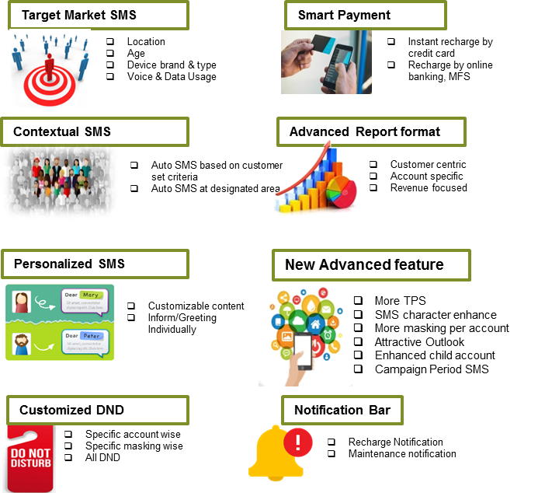

- Quotation for Bulk SM
Please select suitable tariff plan for your customers from tariff plan documents
Count of SMS in Single Bill Cycle | Charge (BDT)/SMS
1 to 24,999 | 0.50/SMS
25,000 to 50,000 | 0.45/SMS
50,001 to 100,000 | 0.38/SMS
100,000+ | 0.30/SMS

Note:All the charges are excluding applicable Supplementary Duty & VAT: 10% Supplementary Duty (SD) +15 % VAT on price +1% Sur Charge
- Terms and conditions:
- Price quoted is net and not deductible.
- The offer is valid till 15 days from the submission date unless Grameenphone Ltd. decides to change.
- VAT, Taxes & Levies will be applicable as per government rule.
- Mode of Payment: Cash/PO/DD in favor of Grameenphone Ltd. before delivery
- Mode of Delivery: Corporate Bulk SMS customized solution that requires some back end configuration (i.e API based). Thus, it will take no less than 3 working days for implementing such a customized network solution for a Business Client.
- Client cannot send any SMS that are abusive, anti-government or anti-religious believes through this platform. Clients will be solely liable for such non-compliant SMS and if not, customers will be held liable for this through BS agreement.
- Masking/CLI Sender ID will be only applicable in GP-GP numbers and for the other operator numbers; the Virtual MSISDN will be displayed.
- Client cannot re-sell this SMS to other third party companies.

M.Centrex Service:
Grameenphone M. Centrex Service is a One Central Phone Number Solution that ensures Mobility and Business Efficiency. It is a highly customized solution to meet your organizational needs to provide a seamless communication experience.
- Major Features:
- HD Voice Quality
- Welcome Message
- Interactive Voice Response (IVR)
- Call Attendant
- Call Hunting
- Short Number Dialing
- Web Portal for Administrative Management

- Some of the key benefits of this service are:
- No additional hardware or connectivity needed
- Efficient customer support & responsiveness
- Extremely easy to operate
- Enhanced efficiency and profitability of business entity
- Cost effective Solution at ZERO investment
- Employee mobility and availability at the same time
- One unified umbrella of voice communication- consolidated offer of both mobile and PBX solutions from single service provider
- Easy Product Installation with no need for maintenance all the year round

- Slab Based Charging:
Slab (#Users) | Monthly Fee(BDT)/User | Dial In Charge (BDT)
10-100 | 200 | 0.45
101-250 | 175 | 0.45
251-500 | 150 | 0.45
500+ | 150 | 0.45

Notes:
- 10 Second Pulse
- All the above prices are quoted excluding applicable government charges (VAT, SD, SC & etc.)
- Child numbers fee will be charged on monthly basis for the full month. Any cancellation will be effective from next month onwards
- Monthly fee will be charged for the full month for any new inclusion of the child number in the middle of the month. No partial charging policy is available


Grameenphone Smart Security
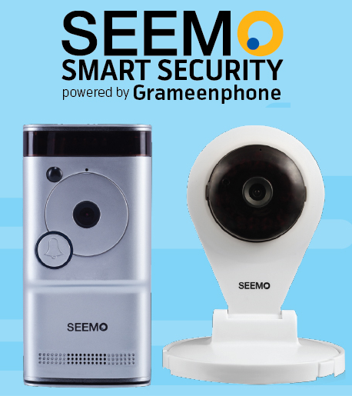

SEEMO Smart Security” Powered by Grameenphone
Grameenphone brings “SEEMO” - country’s first Smart Security Brand, which is dedicated to make your safety & security easier. SEEMO Smart Doorbell and Indoor Camera allow you to speak with anyone at your front door through a built in speaker and microphone.
- Product Features

HD Video
See your visitor in HD (720p)

Motion Sensor
Track any motion in front of your door

2-Way Communication
2-way audio &one-way video means you can enjoy a full conversation

Cloud Storage
Records and stores every photo and video in the cloud

Instant Alerts
Get instant alerts whenever someone presses the bell or motion is detected

Live Monitoring
Monitor your front door at any time by starting the video from the app

- Pricing Details:
Item | Regular Price  (BDT) | Promotional Price* (BDT)
4G Router | 7,999/= | 5,999/=
Indoor Camera | 7,999/= | 5,999/=
Free 7 Days or 5GB Cloud backup | 7,999/= | 5,999/=
6 Months EMI Facility | 7,999/= | 5,999/=
Insurance Coverage of BDT 1Lac | 7,999/= | 5,999/=
M2M Data Pack  (10GB/20GB/30GB/50GB/100GB) | BDT 800/1200/1500/2000/3500 | 25% Discount

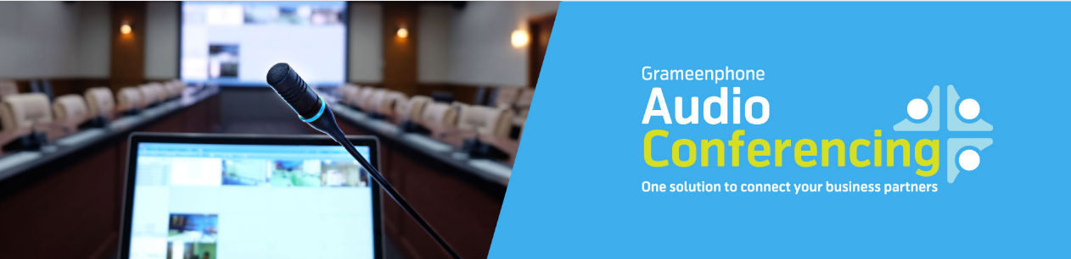
Audio Conference

“Grameenphone Audio Conferencing is a highly scalable carrier-grade solution designed to meet even the most demanding large-party needs such as investor calls, partner briefings and employee town halls in a toll-quality manner. Customized features such as roll-call, dial-outs, lecture mode, mute/unmute and many others could be seamlessly added to make the overall conferencing experience highly professional and engaging for participants”.

- Business Benefits
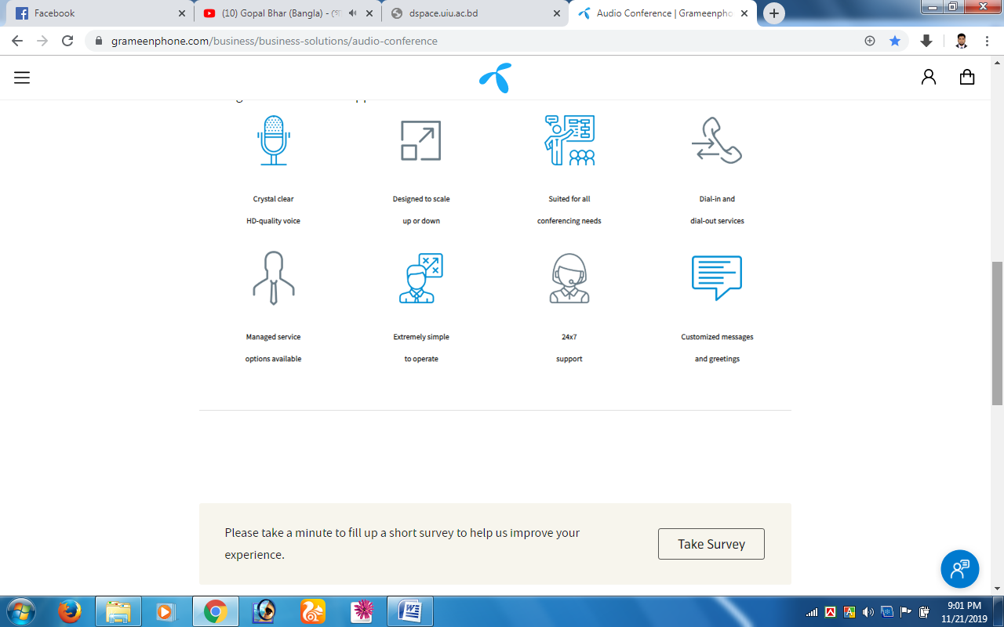
“Our solution enables businesses to conduct on-demand conference calls anytime, anywhere. Be it meetings, trainings, brainstorming sessions, team calls Grameenphone Audio Conferencing service is designed to scale and support all kinds of needs”
Grameenphone Audio Conferencing services are available in standard and managed-service options. While the standard offering suffices for most of the conferencing needs, our operator-assisted managed audio services are crafted for structured events like Investor Relations calls media briefings and more.
- UNMATCHED GLOBAL COVERAGE
- Unmatched global coverage
- Dial-out availability
- Connect to any local/international number
- HIGHLY CUSTOMISED FEATURES
- 24x7 support
- Roll-calls for structured conferencing needs
- Mute/unmute the attendees during a call cast
- SUPERIOR MANAGED SERVICES
- Controlled Q&A sessions so that one attendee speaks at a time
- Calls can be extended seamlessly, without any interruption
- USER-DRIVEN OPEX MANAGEMENT
- Email and SMS notifications
- Host has the option to limit the number of participants
- Dial-outs could be disabled to avoid calling to high-cost routes
- Conduct on Demand Conference Calls
- Conduct instant conference calls high quality and professional audio conference service anywhere, anytime with 24x7 supports.

Team Tracker
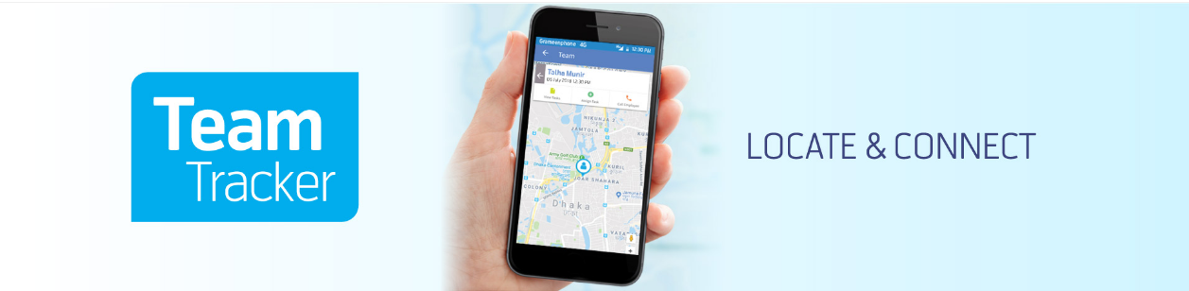

Grameenphone Team Tracker is one of the enterprise solutions for business organizations across the country. The Team Tracker determines the location of the employees from their cell phone and uses this location to provide additional services like tracing employee location with halt summary, assigning or modifying tasks with instant notification on SMS, generating reports, assisting in the supervision on tasks, employees, customers, etc.
Team Tracker is a new value-added solution for the Business Market. This solution willhelp bring about efficiency to the value chain of organizations having field employees. Managing field operations & directing field employees towards the business success has always b een a concern for field managements like National & Regional Sales Managers, Area Managers & Distributors. With the services of Grameenphone Team Tracker, organizations can now locate its employees, assign tasks to them digitally & also receive task updates electronically. The system is robust enough to handle data for even a thousand employees.
- Features of the Service:
- real-time overview of outdoor employee movements on the map
- Location based task delegation and proactive workload allocation
- Instant task status update
- Business Reports generation on Employee Location & Task status based on organizational hierarchy
- By using this solution, a company is expected to gain:
- Faster Actions
- Excellent planning and precise workforce management
- Efficient workload assignment to lead to greater employee satisfaction
- Cost Efficiency
The end result is, a company is expected to enjoy higher productivity in field operations in terms of enhanced sales volume and prompt customer service. All these benefits will help the company to have a competitive edge in the market.To avail this service, companies have to provide monthly service fee of BDT 300 per employee. 'Task Assign' SMS charge is BDT 1.00 per SMS and 'Task Update' SMS charge from mobile phone is BDT 2.00/per SMS. Business houses will be able to enjoy up-to 50% discount on monthly service fee based on volume purchase.

Vehicle Tracking
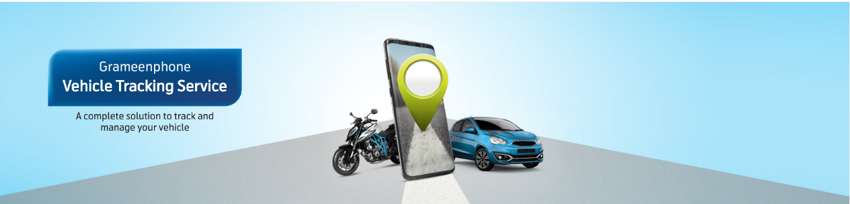
Vehicle Tracking Service (VTS) will provide you with round the clock security and tracking of your vehicle using satellite GPS & GSM communication. Using GP VTS, you can see your vehicle’s position, speed, and engine status on a map. The information will be visible in your own mobile app and website. Grameenphone has three (3) VTS packages- Economy, Lite and Standard. Grameenphone VTS requires a tracking device to be connected to your vehicle. GP VTS will further allow you to have customized setting for your vehicle like- go-no go area, notification for crossing speed limit and many more features. Grameenphone VTS turns your vehicle into a smart vehicle (Grameenphone, Grameenphone , 2021).
- Insurance Benefits
Grameenphone has introduced ‘Accidental & General Life Insurance’ as a free benefit to both new and existing Vehicle Tracking Service subscribers. This means existing and new subscribers of VTS will be able to avail the coverage benefits without having to pay any additional fees (other than regular monthly fees). For details & forms, please view the "Insurance Benefits" tab below.
- Maximize your workforce:
Don’t just manage your fleet. Optimize with GP VTS - Innovative, affordable and easy to use. GP VTS combines the powerful features and cost efficiencies of Global Positioning Systems (GPS) & GSM technology to help you:
- Manage your fleet more efficiently.
- Reduce fuel and labor costs.
- Lower maintenance costs.
- Increase productivity.
- Enhance customer satisfaction.
- Improve safety, reduce risk and lower insurance costs.
- Monitor and protect non-powered assets.
- Drive your fleet performance.
- GP VTS also provides valuable information to help identify and correct driver behaviors that infiltrate your business and impact your bottom line, including:
- Speeding
- Excessive idling
- Route and schedule compliance
- Travel outside authorized areas
- Unauthorized use of company vehicles
- Increase accuracies and efficiencies

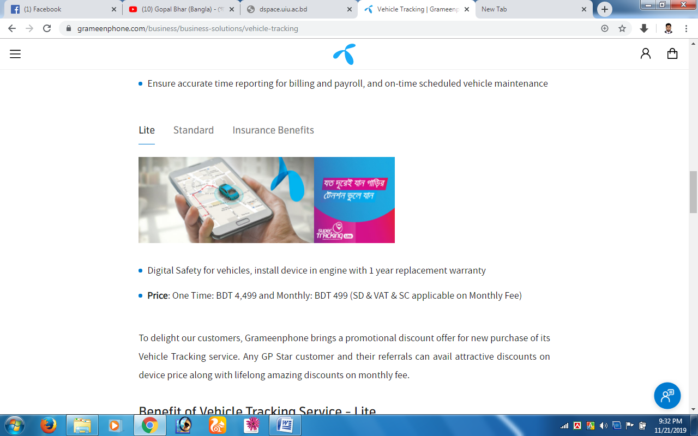
Lite Vehicle Tracking Service

- Digital Safety for vehicles, install device in engine with 1-year replacement warranty
- Price: One Time: BDT 4,499 and Monthly: BDT 499 (SD & VAT & SC applicable on Monthly Fee) To delight our customers, Grameenphone brings a promotional discount offer for new purchase of its Vehicle Tracking service. Any GP Star customer and their referrals can avail attractive discounts on device price along with lifelong amazing discounts on monthly fee.

Benefit of Vehicle Tracking Service – Lite
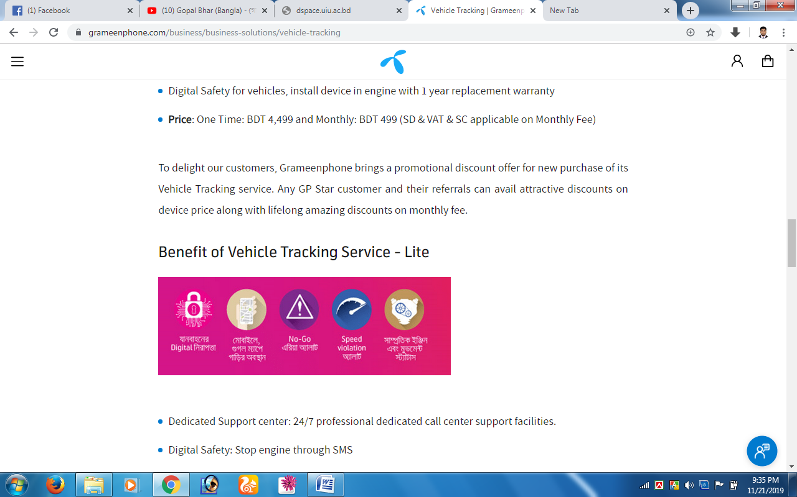

- Dedicated Support center: 24/7 professional dedicated call center support facilities.
- Digital Safety: Stop engine through SMS
- Tracking on the go: Vehicle location, using mobile app (Android & IOS), web & SMS
- Engine Movement Status: Status of vehicle engine-on move, still and last update
- Over speed Alert: Set speed limit for vehicle to run and any violation shall be notified through alerts
- Geo-fence violation alert: Setting go or no go area for vehicle and any violation will be reported through alerts
- SOS Alerts: For any emergency support - SOS button sends out exact location for immediate rescue. After user presses SOS button in the VTS, VTS device will send out the location and SOS alarm to the present number via SMS & e-mail.
- Battery removal Alert
- Enhanced customized & dynamic software.
- Features of Vehicle Tracking Service – Lite
- Historical tracking report (Up to 3 Months)
- Speed analysis report
- Multiple alert option: SMS & E-mail
- Expense monitoring option
- Multiple Vehicles tracking solution
- Different kind of report can be provided. For example - travel distance report, trip report, trip count report, halt report, expense report, all alert report, etc.
- Unlimited Geo-fence with rescheduling facilities.
- Necessary reports can be generated in excel and pdf
- Driver profile viewer option
- Live Alarm viewer option
- Alarm resolve report
- Trip count report
- Trip list report
- Trip wise travel distance report
- Trip wise historical report
- Expenditure report
- Fuel consumption report (based on travel distance)
- Regular updates to software.
- More than 1500,000++ POI in map with reverse geo coding

Standard Vehicle Tracking Service
- Vehicle Safety, install device in engine with 3 years’ replacement warranty
- Price: One Time: BDT 8,250 and Monthly: BDT 696 (SD & VAT & SC applicable on Monthly Fee) To delight our customers, Grameenphone brings a promotional discount offer for new purchase of its Vehicle Tracking service. Any GP Star customer and their referrals can avail attractive discounts on device price along with lifelong amazing discounts on monthly fee.

- Benefit of Vehicle Tracking Service - Standard
- Dedicated Support center: 24/7 professional dedicated call center support facilities.
- Digital Safety: Stop engine through SMS
- Tracking on the go: Vehicle location, using mobile app (Android & IOS), web & SMS
- Engine Movement Status: Status of vehicle engine-on move, still and last update
- Over speed Alert: Set speed limit for vehicle to run and any violation shall be notified through alerts
- Geo-fence violation alert: Setting go or no go area for vehicle and any violation will be reported through alerts
- SOS Alerts: For any emergency support - SOS button sends out exact location for immediate rescue. After user presses SOS button in the VTS, VTS device will send out the location and SOS alarm to the present number via SMS & e-mail.
- Battery removal Alert
- Enhanced customized & dynamic software.

- Features of Vehicle Tracking Service – Standard

- Historical tracking report (Up to 3 Months)
- Speed analysis report
- Multiple alert option: SMS & E-mail
- Expense monitoring option
- Multiple Vehicles tracking solution
- Different kind of report can be provided. For example - travel distance report, trip report, trip count report, halt report, expense report, all alert report, etc.
- Unlimited Geo-fence with rescheduling facilities.
- Necessary reports can be generated in excel and pdf
- Driver profile viewer option
- Live Alarm viewer option
- Alarm resolve report
- Trip count report
- Trip list report
- Trip wise travel distance report
- Trip wise historical report
- Expenditure report
- Fuel consumption report (based on travel distance)
- Regular updates to software.
- More than 1500,000++ POI in map with reverse geo coding
Chapter-4

SWOT Analysis of Grameenphone

Strength
- Grameenphone has the best network coverage because all the 64 districts of Bangladesh are covered by 4G network coverage first from all other providers in Bangladesh.
- Grameenphone has a large amount of market share.
- By boosting network capacity and extended coverage to new and often remote areas in Bangladesh, Grameenphone has achieved a strong brand image.
- As Grameenphone has ensured the best network coverage and is providing superior value to the customers/users, Grameenphone has able to make a loyal customer base.
- It is financially strong.
Weakness
- Call rate offered by Grameenphone is more than the call rates which are offered by other providers in Bangladesh.
- Since GP has a huge network cost so GP cannot be able to decrease its call rate. It has become their weakness.
Opportunity:
- Grameenphone has just introduced 5G SIM. It has not introduced all over the country. It should spread all the districts of Bangladesh. It is an opportunity for Grameenphone.
- Grameenphone can also do diversification
Threat
- Bangladesh is now in political instability. National election is going to be held. There are lots of conflicts between present govt. and other political parties of Bangladesh.

Chapter 5

Findings & Conclusion

Positive aspects
GP target is all about bringing quality in life to customer. This is a never-ending commitment. It does not just happen. They make it happen through innovation, extending the product category, using high quality technology and environment friendly machineries.
- 40% users of Grameenphone are satisfied and 42% are somewhat satisfied with the network coverage of Grameenphone.
- 45% of the users/subscribers are somewhat satisfied with the package price for various packages.
- 49% of the users are somewhat satisfied with the prepaid packages offered by Grameenphone.
- 20% users are satisfied and 39% are somewhat satisfied with the bonus talk time/SMS
- 37% of the users/subscribers are somewhat satisfied that they do not face any types of overcharging issues.
- 42% users of Grameenphone are satisfied and 32% users are somewhat satisfied with the sound quality of Grameenphone when they talk over phone.
- 63% of the users/subscribers are somewhat satisfied that Calls never disconnects during the conversation.
- 18% users are satisfied and 32% are somewhat satisfied with the internet service of Grameenphone.
- 43% of the users/subscribers are somewhat satisfied that the service rate of caller tunes, missed calls, call blocks service and others are reasonable. But it is not a good thing that 39% users are neither agree nor disagree with this.
- 0nly 33% the users are somewhat satisfied and 41% users are neither agreeing nor disagree that Grameenphone provides value added services which enrich their lifestyles.
- 70% of the users are satisfied that the service hotline of GP is easily accessible.
- 20% users of Grameenphone are satisfied and 50% are somewhat satisfied that they get the service quickly from the helpline.
- 58% of the users are satisfied that the Customer service managers carefully give attention to their problems. But 30% users are neither agreeing nor disagree that the Customer service managers carefully give attention to their problems.
- 62% of the users are satisfied that Grameenphone tries to increase social awareness in Bangladesh. In this matter 23% users are neither agreeing nor disagree.
- 30% users of GP are very satisfied and 39% are satisfied that Grameenphone customers Care Centers are widely available.
- 66% of the users are satisfied that Grameenphone has prompt online customer service assistance.
- 30% users of Grameenphone are very satisfied and 40% are satisfied that Grameenphone informs to me about Grameenphone promotional offers through SMS which is helpful.
- 56% of the users are satisfied with the service of Grameenphone.18% users are neither agreeing nor disagree.
- 60% of the users are satisfied and they would still be connected with GP if other operators come to me with the same offer. But 20% users are neither agreeing nor disagree.

Negative Findings
- 24% users are dissatisfied with the additional features of Grameenphone in comparison to other operators. And 36% users are neither agreeing nor disagree.
- 20% users said that they would not be connected with Grameenphone if other operators come to them with the same offer.17% users are neither agreeing nor disagree.
- 26% users are dissatisfied with the service of Grameenphone. But 18% users are neither agreeing nor disagree.
- 40% users are not satisfied with the overcharging issues of Grameenphone.23% users are neither agreeing nor disagree.

Recommendations
- The Network towers should be allocated according to volume of users.
- Need to increase the capacity with up-growing subscribers.
- Grameenphone needs to invest more for increasing the capacity.
- Arranging some kinds of awareness programs for the subscriber about unnecessary network traffic.
- Grameenphone should increase the capacity of server according to the subscribers’ increasing rate.
- More awareness programs should be arranged regarding those basic features.
- All the subscribers should be given all the basic features of Grameenphone.
- GP should try to arrange some awareness program regarding less price sensitivity
- The product distribution system should be more flexible and soft.
- GP should be more efficient and market oriented. To do this, Forecasters of GP should be more efficient.
- Price of different packages should be decreased according to the level of subscribers’ expectation.
- Grameenphone should arrange some programs to create positive perception regarding the price of different packages.
- Need to arrange some awareness program to reduce unnecessary practice (Like- miss call tendency) on network.
- The customer managers should behave more friendly with the subscribers.
- Smooth access of 121 hot lines should be provided to get service.
- Grameenphone should train their employees well to make them more efficient.
- Grameenphone should deal with complaints accurately and effectively.
- Treat customer that they are your boss.
- The employees of customer care can apologize personally when customers are not fully satisfied.

Conclusion
Grameenphone Ltd. is serving both rural and urban customers across Bangladesh, where mobile telephony is a major driver of socioeconomic development. The company always tries to provide the power of digital communication which enables everyone to improve their lives, build societies and secure a better future for all. Grameenphone has been a pioneer in bringing innovative mobile-based solutions to Bangladesh. It will be difficult for GP to keep the current market share intact if Grameenphone does not increase the level of customer satisfaction. Therefore, I recommended some course of action I believe that if Grameenphone follows these recommendations, it will enable them to achieve a sustainable distinct competitive advantage and operates smoothly with loyal customers/users. The management and employees of Grameenphone need to think about the customer requirements, desire and expectation and should work according to this. They should build a strong relationship with the customer by offering best service they can. Offering their best services; they can meet the customers’ expectations. If the service of Grameenphone exceeds the customers’ expectation the customers/ users will become delighted or pleased. They need to set goal to make the customer fully satisfied by improving all the lacking they have.

References
co., A. K. (2021, January 20). A.H. Khan & co. Retrieved from www.ahkhan.com: https://www.ahkhan.com/about-us/company-overview/
Co., A. K. (2021, January 23). A.H. Khan & Co. Retrieved from A.H. Khan & Co. web site: https://www.ahkhan.com/about-us/our-partners/
Co., A. K. (2021, January 21). A.H. Khan & Co. . Retrieved from A.H. Khan & Co. web site: https://www.ahkhan.com/about-us/mission-vision/
Co., A. K. (2021, January 20). A.H. Khan & Co. . Retrieved from A.H. Khan & Co. web Site: https://www.ahkhan.com/about-us/sister-concerns/
Grameenphone. (2021, february 10). Grameenphone. Retrieved from Grameenphone web site: https://www.grameenphone.com/personal/plans-offers/prepaid-postpaid-packages/djuice
Grameenphone. (2021, February 15). Grameenphone. Retrieved from Grameenphone web site: https://www.grameenphone.com/business/business-solutions
Grameenphone. (2021, February 10). Grameenphone . Retrieved from Grameenphone web site: https://www.grameenphone.com/personal/plans-offers/prepaid-postpaid-packages/nishchinto
Grameenphone. (2021, February 15). Grameenphone . Retrieved from Grameenphone web site: https://www.grameenphone.com/business/business-solutions/vehicle-tracking

