

AN INTERNSHIP REPORT ON

The Human Resource Management Practices in Social Islami Bank Limited

11th January 2019
UNITED INTERNATIONAL UNIVERSITY
DHAKA, BANGLADESH
An Internship Report on
The Human Resource Management Practices in Social Islami Bank Limited
SUPERVISED BY
Ms. Yeasmin Islam
ASSISTANT PROFESSOR,
SCHOOL OF BUSINESS AND ECONOMICS
UNITED INTERNATIONAL UNIVERSITY

PREPARED BY
Aklima Khatun
ID: 111 142 117
BBA PROGRAM
UNITED INTERNATIONAL UNIVERSITY
UNITED INTERNATIONAL UNIVERSITY
Letter of Transmittal
28th November, 2019
Ms. Yeasmin Islam
Assistant Professor,
Faculty of Business and Economics,
United International University

Subject: Submission of Internship report on the HRM Practices in Social Islami Bank Limited.
Dear Madam,
In accordance with the requirements to complete the internship program, I have prepared this report on "The Human resource management practices in Social Islamic Bank Limited". The report focuses on the essential functions of human resource management and is prepared on the basis of the HR lessons learned from my undergraduate courses at United International University.

This internship program gave me academic and practical experiences. I learned the organizational culture and gained experience in banking and human resources practices.
I will be highly obliged, if you have been kind enough to receive the report and give me your valuable opinion, I have tried to follow the guidelines provided. It would be my pleasure if this report were useful and informative to you.

Sincerely Yours,
Aklima Khatun
ID:111 142 117
BBA Program
United International University

Acknowledgment
At the beginning of the report, I want to thank my Almighty Allah for all the blessings and my beloved parents who supported me all the way to come to this stage of my life.

This internship report brought me a lot of experience and knowledge. As an intern, I learned a lot, including banking, human resources activities, organizational culture, etc. I would like to thank my internship supervisor as well as my course faculty, Ms. Yeasmin Islam, Assistant Professor, Faculty of Economics and Business, United International University for helping me by sharing the report outline and encouraging me all the time to complete the internship report.

I also want to show my gratitude to my head of operations, Md. Mominul Alam, SIBL Vatara branch and Md. Abdullah Harun, manager of the SIBL, Vatara branch for helping me to complete this report. They helped me with various information to complete it.

I thank all the employees of SIBL who also helped a lot during my internship. They all helped me provide practical knowledge about banking and I had the pleasure of working with them.

I really appreciated the internship period at SIBL. I hope you can help me in the future in my professional life. And I would like to thank each and every person who helped me to prepare this report.

Executive Summary
The Internship report represents 3-month experiences on HR practices in Social Islami Bank Limited, Vatara Branch. The study is conducted to provide a clear idea of ​​SIBL's banking activities and their human resources practices. The SIBL was created on July 5, 1995, and started its activities on November 22. Social Islami Bank Limited began its journey in 1995. However, the aim of preparing this report is to analyse the SIBL's human resource practices during the available time and management effectiveness. The main objective of the report was to generate a practical understanding of Social Islami Bank Limited's human resource practices. This study is divided into four chapters and based on the practical experiences from SIBL. The first chapter is based on the introduction of the report, which includes topics such as the backgrounds, objectives, methodologies, and limitations of the study. The second chapter presents a short history of the banking and Social Islami Bank Limited (SIBL). It also includes all banking activities and operating processes. The description of the product and service is also presented in this chapter. Chapter three includes the general human resource management practices of Social Islami Bank Limited. In this chapter, the study focuses on the general human resources management practices of SIBL, on the activities of the human resources department and on the behavior and results of collaborators in this sector. Chapter four describes the human resource SWOT analysis that describes internal (Strengths & Weaknesses) and external (Opportunities and Threats) environment of SIBL’s HRD. This chapter also contains the main findings of the analysis of HRM Practices performed by SIBL. Finally, chapter five indicates the recommendation and summarizes the study with a conclusion. The core findings of the reports shows that the ways Social Islami Bank Limited planning, recruit & select, train, appraise and compensate its employees through the human resource department.

Key words: Human Resource, Recruitment and selection, Training and Development, Social Islami Bank
Table of Contents
Chapter One: Introduction of the study
1.1 Background of the Report 2
1.2 Origin of the Report 2
1.3 Rationale of the study 3
1.4 Scope of the study 3
1.5 Objectives of the study 3
1.6 Methodology of the Study 4
1.6.1 Information analysis methodology: 4
1.6.2 Data collection Methodology 4
1.7 Limitations of the relationship 5
Chapter Two: Organization Overview of SIBL
2.1 The evolving landscape of private banks in Bangladesh 7
2.2 History of Social Islami Bank Limited 8
2.3 Overview of Social Islami Bank Limited (SIBL) 8
2.3.1 Banking Vision 9
2.3.2 Banking Mission 9
2.3.3 Values 10
2.4 Organizational hierarchy of SIBL, Vatara Branch 11
2.5 Products and services of Social Islami Bank Limited 11
Chapter Three: Human Resource Practices of SIBL
3.1 Human Resource Management 14
3.2 Human Resource Planning 14
3.3 Recruitment and Selection 15
a. Identify and prioritize tasks: 16
b. Candidate Objective: 16
c. Candidate Category: 16
d. Employment Source: 16
e. Qualified Employers: 17
f. Evaluate candidates: 17
3.3.1 Medium of Recruitment Advertisements 17
3.3.2 Example of Recruitment advertisement 18
3.3.3 Selection Process of SIBL 18
3.4 Training and development 19
3.4.1 The Process of Training followed by SIBL 21
3.4.2 The Steps of Training and Development in SIBL 22
3.4.3 Training methods in SIBL Training School 22
I.External vocational training (Off-the-job) 22
II.Internal vocational training (On-the-job) 23
3.5 Performance evaluation 23
3.6 Compensation 25
a. House Rent Allowance: 25
b. Ceiling for Furniture: 26
c. LFA (Leave Fare Assistance): 26
d. Allowance of the probationary officer: 26
e. Car loan schemes: 26
f. Bonus/incentive: 26
Chapter Four: SWOT Analysis on HR of SIBL
4.1 SWOT Analysis 29
4.1.1 Strengths 29
4.1.2 Weaknesses 30
4.1.3 Opportunities 30
4.1.4 Threats 31
Chapter Five: Recommendation and Conclusion
5.1 Recommendations 33
5.2 Conclusion 34
Reference
Appendix

CHAPTER ONE
INTRODUCTION



1.1 Background of the Report
The report is a pre-requirement of achieving the Bachelor of Business Administration (BBA) certificate from United International University. To obtain the certificate, each student has to go through an internship program, where they have to work in an organization and while working inside the organization, they have to prepare an internship report.
It was a great opportunity to get a chance to work as an intern in Social Islami Bank Limited. While working in the human resource department of SIBL, it was observed that there are no major differences in the real life HR practices with the theoretical HR concepts. Therefore, the study is prepared to disclose the HR practices of Social Islami Bank Limited.

1.2 Origin of the Report
Today, the banking system plays an important role in economic life and here is no doubt the worldwide banking system is changing rapidly due to competition, globalization, technology, and deregulation. As part of the organization, human resources management can also cope with the impact of an evolving banking environment.
Human resources management is now a great challenge to support organizations by providing the perfect human resources for the right positions in the shortest possible time. It is very difficult to motivate them to work to use different human resources practices.
Properly planning the design of human resources practices and plans is a task that requires more attention and improvement. Equal opportunities and supply are also essential. During my internship at Social Islami Bank Limited, it was a lucky chance for me to know how SIBL motivates its employees to use different types of human resources practices. In addition, choosing human resources practices and attracting employees to use them over time is a challenge.

The internship program at Vatara Brunch of SIBL helped to understand organizational behavior throughout the corporate environment. The internship experience includes the SIBL's human resources practice work. In this regard, the title of the study is selected to analyze and present how Social Islami Bank Limited (SIBL) conducts its Human Resources Management practices to submit my internship report.

1.3 Rationale of the study
Like other emerging market economies, commercial banks in the Bangladeshi economy will face increasing competition in the coming days. The banking industry is facing diversified risks with the coming financial complexity. Human resource management is the management of the people working in the organization. They can be field agents, coordinators, employees, managers, project managers. Because organizations are led by these people, they are considered "assets". Just as a bank uses funds to manage projects, it must also use these "assets" to manage the organization. Having a dedicated organizational team is not enough. Fundamentally, an organization will not be able to achieve its goals unless the team is properly managed, motivated, and executed. The process of managing, motivating, and executing personnel involves the creation of systems, including construction plans and policies. These systems are part of human resources management.

1.4Scope of the study
The purpose of the report is to share all the information about the human resources practices of Social Islamic Banking Limited during my internship. The report will provide detailed information about Social Islami Bank Limited so that any reader can theoretically understand the bank and its services, etc. A study like it on human resources practices on Social Islami Bank Limited can help students and teachers to understand how banks recruit and select candidates. This knowledge can help students when they look for work or compare what I share with the knowledge for their HR courses. The final recommendation will help the SIBL's human resources manager (if deemed useful) to improve the SIBL human resources process and activities.

1.5Objectives of the study
Human resource management in an organization is very important because employees are the most important resource, and if managed properly, it will always generate revenue and show the reputation of the organization.
Similarly, the objectives of the report are important because they provide a summary of the basis of the report. The goals of my report are:

- General objectives
1. To prepare an internship report based on the practices of human resource management through a practical bank from Bangladesh.
2. To satisfy the requirements to complete the BBA course at United International University.

- Specific objectives
1. To analyse the HRM practices of Social Islami Bank Limited.
2. To prepare a SWOT Analysis on human resource management practices of SIBL.
3. To suggests a few recommendations for the improvement of the HRM practices in Social Islami Bank Limited.

1.6Methodology of the Study
The report methodology usually shows the theoretical analysis of the methods that are used in the report. It contains two-part. One is the Data analysis Methodology and Data collection Methodology.

1.6.1 Information analysis methodology:
The report is being prepared using exploratory research techniques where both qualitative and quantitative methods are utilized to analyse the primary and secondary information and the information is presented here by using MS WORD and MS EXCEL.

1.6.2 Data collection Methodology
The report is made of using information from two sources. The sources are:
- Primary Sources:
- Through the practical work experience as an intern.
- Through formal and informal communication with the bank’s personnel

- Secondary Sources:
- Through Annual reports of Social Islami Bank Limited
- Articles/ leaflets of Social Islami Bank Limited
- Office files
- Working papers

1.7Limitations of the relationship
The officials were very cooperative, but they were too busy giving me time to understand the concept. They also face a highly competitive environment based on money-related activities. Each activity has some restrictions. During my reporting process, I have to face some usual restrictions. These are:

- The first limitation is that I have not provided a complete description of Social Islami Bank's activities as a shortage of time. I had to compensate for the quality due to time constraints, which seemed to be the most serious limitation.
- Another limitation of the report is the lack of access to updated data and information on the various activities of Social Islami Bank's policy of not disclosing certain data and information for any reason, which can be very useful.
- The third limitation is the clients and officials were too busy to allow me much time for interviews.
- Last but not least, the lack of intellectual reflection and analytical ability to make it perfect.

CHAPTER TWO
ORGANIZATIONAL OVERVIEW OF SOCIAL ISLAMI BANK LIMITED

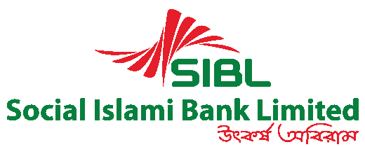

2.1 The evolving landscape of private banks in Bangladesh
Until 1982 there was no private commercial bank in Bangladesh when Arab-Bangladesh Bank Ltd. Private commercial banking started in the country. Five more commercial banks were formed in 1983 and have started a moderate growth in banking financial institutions. Despite the slow growth of multiple independent targets, the growth of branches of National Commercial Banks (NCBs) was relatively strong in the period 1973-83. Their numbers increased in 4603 in 1986-83.

Financial sector reforms progressed in 2006 to strengthen regulatory and oversight structures for banks, but at a slower pace than expected. Since 2002, the overall health of the banking system has improved, gross marginal debt has increased from 20% to 5%, and Net decentralized loan (minus provision) has increased from 8% to 21%. This has led to significant improvements in the profitability index. Although Private Commercial Banks (PCBs) have historically recorded the lowest %% recording rate, the position of the four National Commercial banks (NCBs) remains weak and shows a high default of 20%. The risk-weighted capital index of NCBs has a large capital deficit of only 0.5% (June 2006), compared to the required 9%. For risk-weighted PCBs, the equity index was 10%. Bangladesh Bank issued a series of discretionary guidelines in 2006 and the first quarter of the year 2007.

In addition, the recent government decision to create three more NCBs besides the silver bank sales initiatives is likely to change the competitiveness of the banking sector. Bangladesh Bank implemented the Basel II capital agreement and Basel III was responsible for implementing the third capital agreement. In addition, the recent legislation on microcredit regulation for the control of microcredit companies was an important step in 2006. Banks' Camel rating has gradually improved since the year 2009, Bangladesh Bank updated the rating model by integrating the market risk and new model known as Camel Rating.

Modern banks play an important role in the economic development of a country. Banks provide the necessary funds to manage the various programs underway in the process of economic development. They are collecting huge amounts of savings from people scattered all over the country who used to be idle and unproductive in the absence of banks. These dispersed amounts are collected, grouped and made available to trade and industry to meet requirements. Bangladesh's economy is one of the most underdeveloped economies in the world. One reason may be your poor banking system. The government, as well as several international organizations, have identified that the underdeveloped banking system poses some obstacles to the process of economic development. Therefore, they strongly recommended reforms in the financial sector. Since the beginning of the year, the Government of Bangladesh has taken steps to reform many financial sectors to create the financial sector, as well as the banking sector, the implementation, and implementation of this transparent reform program, and several companies are involved. Such as the IMF, World Bank (WB), and so on.

2.2 History of Social Islami Bank Limited
Social Islami Bank Limited (SIBL) is a banking company registered under the Companies Act of 1994 with its Head office located in 6 Dilkusha C/A, Dhaka, Bangladesh. The bank started its activities on November 22, 1995, as a bank with a banking license issued by the central bank. Social Islami Bank Limited is a new capital-producing bank with authorized capital and paid-up capital at 20 and Tk 2015 million and $ 683 million as of December 20, respectively. Currently, there are 5 banks across Bangladesh. The bank conducts all kinds of banking transactions to help promote the trade and commerce of the country. Social Islami Bank Limited services are also available for entrepreneurs to create new companies and BMREs for industrial units. To provide an international trade service to its customers, it has established extensive banking relationships with domestic and foreign banks and domestic and foreign financial interests. From the beginning, SIBL has worked with the philosophy of serving citizens as an exemplary and unique financial home. The main purpose of SIBL is to make a profit by taking responsibility for providing financial support for the development of commercial and industrial sectors of the country. 2014 should be a golden year for SIBL. By adopting a new strategic commercial policy, SIBL will do everything to encourage activity in all sectors of operations so that the bank can achieve its business goals.

2.3 Overview of Social Islami Bank Limited (SIBL)
Social Islamic Bank Limited (SIBL) was created on July 5, 1995, following the dedicated commitment of a group of established Bangladeshi entrepreneurs and internationally renowned figures. The bank launched a commercial operation on November 22, 1995, with a clear manifesto to demonstrate the particular operational importance of economic, banking and financial activities as an integral part of the Islamic life code. Aimed at poverty, SIBL is in fact a concept of banking methods of the participatory sector of the 21st century. In the formal commercial sector, this bank would offer, among other things, the most recent banking services through the opening of several types of deposit and investment accounts, commercial financing, delivery of guarantee letters, in the opening of letters of credit, the collection of invoices that affect national and international transfers, the rental of equipment and durable consumer goods, the purchase of rent and the instalment of capital goods, investments in social housing and property management, participatory investments in various industrial, agricultural, transport, education, and health projects, etc. In the non-formal non-corporate sector, this would involve, among other things, the Waqf cash certificate and the development and administration of the properties and trust funds of Waqf and Mosque.

2.3.1 Banking Vision
Social Investment Bank Limited began its journey with the idea of ​​a participatory Islamic banking model of three sectors of the 21st century:

- Voluntary sector: mobilization of social capital through Cash WAQF and others. Finally, our vision of "reducing the level of poverty", which is one of the main themes of the Association's association protocol, with the promise of working together for a united society, is fundamental.
- Formal sector: Commercial banking with the latest technologies.
- Informal sector: microcredit and microenterprise program for family empowerment.

2.3.2 Banking Mission
The mission of Social Islami Bank Limited is to attract and retain high-quality human resources, empower real poor families and create local income opportunities and attract and retain customers through financial services. High quality fast, accurate and satisfactory and with the latest technology. Islamic banking products and services that allow the bank to obtain the best returns.

2.3.3 Values

- Advancement
The mentality and eyes of SIBL employees are always open to developing personal satisfaction to further improve the benefits of customer administration.
- Safety
Customers need to feel safe with each of our items and administration - we continue to guarantee it.
- Responsibility
Being responsible can be trustworthy or even more doubtful - with SIBL loyalty there.
- Straightforwardness
In all protests, there is a direct sound that produces faith - SIBL gets in the way.
- Technique
Today's life is technically subordinate - We continue to seek the latest developments to offer our customers the best gift in simplicity.
- Religious-ness
The SIBL has made financial progress as the happiness of religious morality
- Efficiency
Efficiency makes every job impeccable: SIBL is committed to being completely satisfied with it.
- Integrity
Frankly, it is always suggested by all sacred writings: the SIBL adheres to this incentive throughout our administration.
- Flexibility
Flexibility requires better understanding and greater satisfaction: we seek quality.

2.4 Organizational hierarchy of SIBL, Vatara Branch
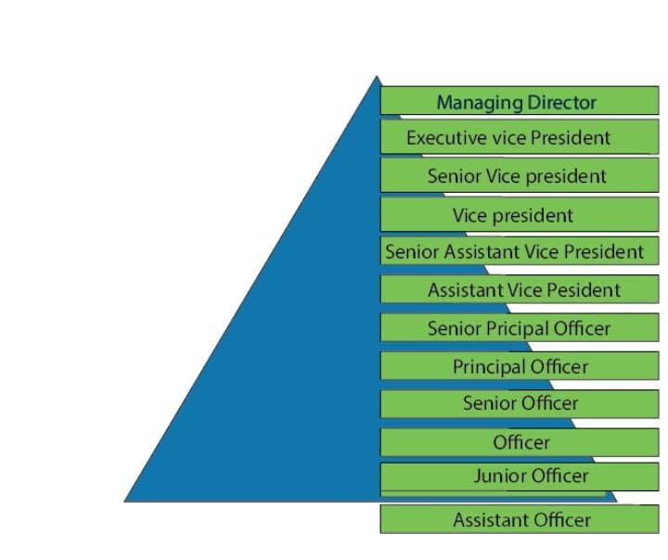
Chart 2: Organizational Hierarchy of SIBL

2.5 Products and services of Social Islami Bank Limited
Products and services represent an important part of a company's profitability. This plays a very important role in any business. The products and services of Social Islami Bank Limited are listed below:

Chart 3: Products and services of SIBL

CHAPTER THREE
HUMAN RESOURCE MANAGEMENT PRACTICES BY SOCIAL ISLAMI BANK LIMITED

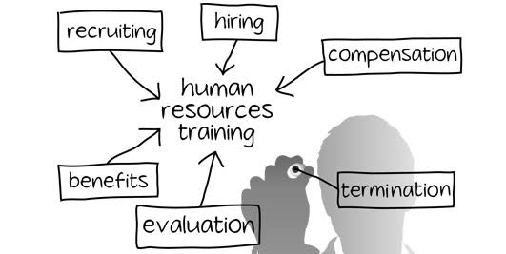

3.1 Human Resource Management
Human resource management (HRM) is a term used to describe a formal system designed to manage people within an organization. The responsibilities of an HR manager fall into five main areas: Planning for Human Resources, Recruiting and selecting the eligible employees, training and develop the human resources, evaluating the performance of the Human Resources and arrange compensation and benefits for them. In short, the goal of HRM is to maximize productivity by maximizing the efficiency of a company's employees. Although the pace of change in the business world is accelerating, this order is unlikely to change fundamentally. As Edward L. Gubman pointed out in Business Strategy Magazine, "The primary goal of human resources is to always acquire, develop and retain talent; align employees with organizations and become partners in the organization. The three challenges will never change."

Until recently, the Human Resources Department (HRD) of the organization was often not accepted as corporate level, though its function was to split it together and cherish it as one of the greatest human resources. However, in recent years, people's understanding of the importance of managing human resources towards the overall health of the organization has greatly improved. This recognition of the importance of human resource management extends to small businesses because they often face management problems even when they do not have the required human resources. That can have a decisive impact on people's health. As Irving Berstiner explains in the Small Business Handbook, "hiring the right people and training them well can often mean the difference between reducing the minimum standard of living and growing a business continuously." Differences in staffing problems make no difference between big and small companies. Anyone can find them in all companies, regardless of size of the business”.

3.2 Human Resource Planning
Human resource planning usually allows Human resource managers in SIBL to forecast the future so that they can continue to supply qualified employees. That's why it's also called workforce planning. This process is also used to help companies assess their needs and plan ahead to meet those needs. The human resources planning of SIBL is flexible enough to meet the challenges of short-term staffing while adapting to the changing conditions of the long-term business environment. HRP first assesses and examines current human resource capabilities.

HRP challenges include changing forces, such as employees who are sick, promoted or on vacation. HRP guarantees it as well as the best acquisitions between workers and jobs, avoiding shortages and excess labor. To achieve the SIBL's objectives, the Human Resources Department usually plan the following actions:

Chart 4: HR planning of SIBL

One of the most important decisions a business can make is to assess HRP. After all, companies can only do it. If employees are hired and best practices are implemented, the differences between product lenses and products will bring benefits.

3.3 Recruitment and Selection
The recruitment and selection process is one of the most important aspects of human resources managers in Social Islami Bank Limited. The level of execution of an organization depends on the efficiency of its hiring capabilities. SIBL has created and adopted a registration methodology to achieve the best of their association and utilize their resources in an ideal way. An efficient and realistic hiring process needs to be organized to take advantage of it slowly and to gain great power of application. To define an efficient and cost-effective registration system, the procedure must cover the supporting elements:

Identify and prioritize tasks:
While the preceding conditions continue to arise at different levels of each organization, it is an almost continuous process. It is difficult to fill all the positions in a timely manner. Following these concepts, it is necessary to distinguish between positions that require quick thinking and action. To maintain the nature of admission activities, the opportunities (focusing on all positions in the same position or focusing first on core occupations) are effective.

Candidate Objective:
The process of registering candidates is interesting only if the association can usefully understand the candidates can meet the desired hope requirements. This also applies to support parameters:

  - Required Performance Level:
Different systems are needed to recruit the best staff and artists centrally.

  - Required Level of Experience:
The system must be clear regarding the level of experience required by SIBL. Candidate experience can range from new entrants to experienced specialist.

Candidate Category:
Technology must clearly identify the target competitors. It can belong to the same organization, belong to a single category, includes the unemployed, the organization's best animation producer, etc.

Employment Source:
The method must present unique recording sources (external and internal). What are the next few uses and sources of centralized recording? Expert referrals are one of the best channels for early admission.
.

Qualified Employers:
Experts registered for management meetings and other selection practices are specially organized and have experience coordinating activities. When meeting and selecting candidates, they must take into account the actual parameters and capabilities (for example, social, specific, etc.).

Evaluate candidates:
Unique parameters and methods to handle these, that is, the entire selection strategy, need to be organized in advance. It looks like a series of specific meetings, interviews with human resources, formal exams, psychological tests, etc.

3.3.1 Medium of Recruitment Advertisements

Chart 5: Recruitment Advertisement Medium

3.3.2 Example of Recruitment advertisement
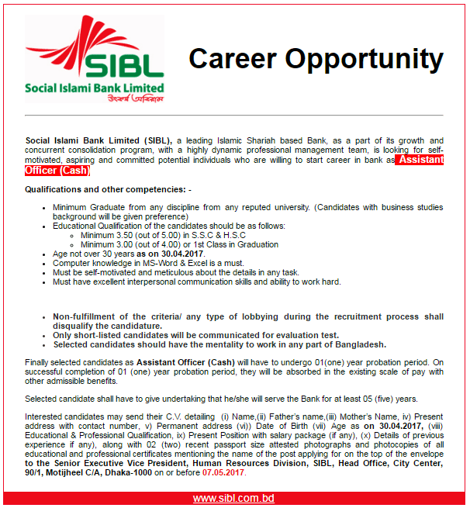

3.3.3 Selection Process of SIBL
Selection is usually a series of obstacles or stages. Social Islami Bank Limited (SIBL) follows its own established selection process to select the appropriate candidates. In this process, each of the steps is successfully removed before the requester proceeds to the next.

The selection process for Social Islami Bank Limited (SIBL) begins with the selection of CVs available for a particular job.

Chart 6: Selection process of SIBL

After the classification of the interview, the bank's human resources staff classifies the candidate eligible for the position and is invited to take the written exam. In the written test of Islami Bank Bangladesh Limited, several tests are required.
Curriculum selection is made to determine unwanted or unqualified applicants. It is essentially a classification process in which the necessary information is obtained from candidates about their education, skills, and experience.

3.4Training and development
With the specific purpose of maintaining a specific advantage in the commercial market, each organization should devote its human resources to training and the development of representatives. Human Resource Development (HRD) focuses both on the training of representatives for their current jobs and on the creation of skills for their future jobs and functions. Human resources development activities include; training of administrators, directors, and groups; educational expense reimbursement programs; customer service training; performance management; training in anticipation of provocation; a review of 360-degree analysis (feedback system of multiple evaluators) and professional training. The 360-degree training approach is briefly discussing below

360-degree reviews: a 360-degree evaluation is an evaluation tool that gives representatives the opportunity to get feedback on the performance of managers, collaborators and, in addition, external advisors, such as suppliers and customers. The 360-degree evaluation process also allows SIBL to understand the performance and capabilities of future leaders and decide on employee improvement needs.

Human resources are the basis for the rapid and managed improvement of any association. SIBL understands the sense of human resources than can help to improve the banking services if they are properly trained. The exemplary and competent human resources team is the key to the association's relentless progress. The predominant human resources is an essential source of benefits. To attract a group of capable human resources and create brand frameworks, banks must understand and execute human resources frameworks, human resources agreements and exercises that create the skills and practices of workers like The bank must lead. The bank tried to guarantee extreme performance with minimal capital. Therefore, quality jobs are selected every year with the large school base at all levels of the bank to make quality administrations to their clients. SIBL opened 11 (eleven) new branches in 2015 and became a bank of 111 branches. Therefore, a decent amount of time has been invested in the registry of experienced bankers. In addition, the procedure to recruit the evidence and the intern for the bank was initiated. The general quality of the bank's work was from 2130 to 12.31.2017. The SIBL is a representative association designed for well-being. Consequently, the bank administration tries to reliably find all possible solutions that it considers useful to improve the aptitude and efficiency of its representatives. It has its own special training institute, which made the preparation of 1,270 workers beautiful one year ago. Important bankers, researchers and other wealthy people were invited to provide their addresses. Also, 431 no. Representatives have been sent to the Bangladesh Bank Training Academy, the Bangladesh Bank Administration Institute, the Bangladesh Bank Association, the Bangladesh Currency Dealers Association, and the Central Sharia Board for the Islamic Banks of Bangladesh and Many other supposed foundations of the nation to prepare against 510 steps in 2018. In this sense, we see that the representatives who have been prepared are doing great execution. In addition, during the year under review, the Islam Social Bank Training Institute provided 4 (four) teaching classes at the Institute for a total of 102 n. Noble officials and 27 training, seminars and seminars on various contemporary issues identified with the management of an account of commercial enterprises amounted to 839 n. Several officials and administrators were interested. Here are some graphics:
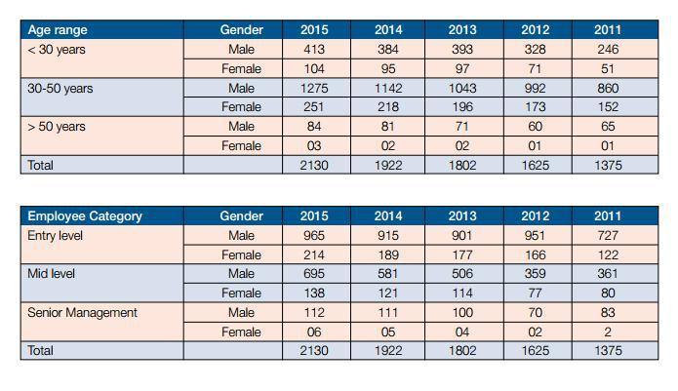

3.4.1 The Process of Training followed by SIBL
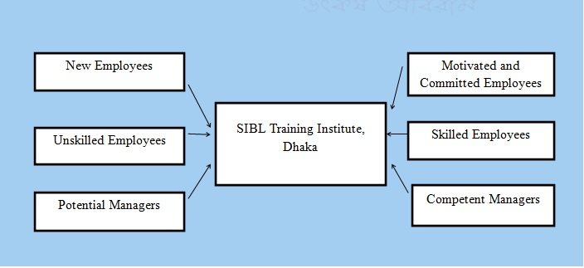
Chart 7: Training Process of SIBL

3.4.2 The Steps of Training and Development in SIBL

Chart 8: Steps in Training Process

3.4.3 Training methods in SIBL Training School
Social Islamic Bank Limited has its own training facility in Dhaka, called the SIBL Training School. The training institution follows two training methods:

External vocational training (Off-the-job)
External vocational training methods are:
- Simulation exercise: training is really about performing the job. This includes reviewing cases, simulations, and collection discussions.
- Monthly meetings: meetings are designed to convey interpersonal strategies or critical thinking skills.
- Training through Film and Video: Use multimedia content for specific skills that are difficult to present with other training methods.
- Training through Case Study: Give students a case study and influence them to show that it's fantastic. The case studies will clarify the theoretical concepts.
- IT training: IT is the most important thing at work. Delegates must take all innovative measures to make IT training so critical.
- University-related programs: Some universities organize programs and require staff to give alternative motivational speeches. Then organize sending representatives to develop their interpersonal skills.
- Outdoor seminars: send workers to seminars. We facilitate many university writing courses and require them to attend this course.

Internal vocational training (On-the-job)
In these training methods, work is at the heart of the training plan. This training program is called "cleaning training". The process of a vocational training program is as follows:
- Follow-up: give a positive understanding at the beginning.
- Employee preparation: place employees in the required training plan. Link to an assessment of apprenticeship requirements.
- Instructor preparation: instructors isolate sensitive areas to develop lesson plans and select training procedures.
- Exam results: it is necessary to communicate any previous progress to the employees and understand their tendencies and motivations. I should start acting.
- Ask for an activity: ask the employees for general activity with simple instruction of what makes things obscure and problematic. Make changes based on location. Ask to describe the progress of each activity.

3.5 Performance evaluation
A performance appraisal program is one of the main reasons for observing operational performance, motivating employees and improving organizational policy. Monitoring the performance evaluation that goes through the performance evaluation module when employees know that the organization is monitoring their performance and will be rewarded, they automatically do their best for the organization. When employees receive awards or rewards for their work, trust improves. An effective performance appraisal program will help the organization achieve its goals and targets. Not only will the training requirements be identified and addressed during the performance assessment review, but hidden talents can also be identified.
Through the followings ways Social Islami Bank Limited is conducting its performance evaluation:
  - Weighted checklist method: The weighted checklist method describes the performance appraisal method in which the appraiser knows the job evaluation in which managers prepare a list of effective and ineffective behaviors of the employee by work and is written descriptively.

  - Critical incident method: the critical incident method for performance evaluation is the one in which the manager writes a positive and negative attitude of the employees during their work period.

  - Balance scorecard: The balanced scorecard describes in which direction the expected result is achieved. The complete dashboard translates the organization's mission and vision statement into a set of objectives measuring performance.

  - Graphical rating scale: The graphical rating scale is a scale in which managers measure only the performance level of employees. It is the oldest and most used form in the evaluation method.

  - Coupling comparison analysis: The coupling comparison analysis is a very important way to clarify the importance. A range of possible options is listed. Each of the options is compared to each of the other options. The results of the method are counted and the option with the highest score is the preferred option for evaluation.

  - Behavioural assessment scales: The behavioural assessment scale method describes a performance assessment focused on specific behaviours or establishes indicators that define actual or ineffective performance. A behavioural rating scale is a combination of the rating scale and critical incident techniques of employee performance appraisal.

  - Test evaluation method: The test evaluation describes the strengths and weaknesses of an employee's behaviour. Trial evaluation is a non-quantitative method. The trial assessment is used with a graphical assessment scale.
  - Best - worst appraisal method: The performance appraisal method is used to assess employee performance from best to worst. Managers will compare one employee to another instead of comparing each standard measure.

  - Forced distribution of the rank: Forced distribution of the rank is a method in which the performance evaluation is carried out by employees of rank but in order of distribution of forces.

  - 360 Degree Performance Assessment: 360 Degree Performance Assessment is a feedback system or process that employees receive in confidence. This feedback is taken from each employee and subordinate couple working together.

  - Management by objectives (MBO): Management by objectives is a process in which managers and employees set a target for a specific period and assess performance and reward them according to their results.

3.6 Compensation
Employee compensation refers to all forms of compensation or premiums granted to employees and derived from their use. Hence, allowance means what the employee receives in exchange for his job.
The benefits are indirect financial payments made to employees. They may include life and life insurance, vacations, pensions, educational plans and discounts on products or commercial cases.
Compensation and Allowances of the Employees in SIBL are:

House Rent Allowance:
    - 50% of Basic pay from FAVP to VP
    - 50% of Basic pay from officer to JAVP
    - 50% of Basic pay from SVP to DMD

Ceiling for Furniture:
- AVP Tk. 150,000/-
- SAVP Tk. 175,000/-
- VP Tk. 200,000/-
- SVP Tk. 225,000/-
- EVP Tk. 275,000/-
- SEVP Tk. 325,000/-
- DMD Tk. 400,000/-

LFA (Leave Fare Assistance):
❖ LFA pay after completion of a 1-year confined service.

Allowance of the probationary officer:
a. The officer on probation: Tk. 15000/- (consolidated).
b. Probationary officer: Tk. 20,000/- (consolidated)
(To be absorbed as FEO offer satisfactory completion 1-year service)

Car loan schemes:
a. AVP to SEVP: Car will be provided as par the Bank's existing car loan scheme.
b. DMD to MD: One full-time car with fuel, driver & maintenance expense. In addition, 1 car provided as per rank. Existing car loan scheme.

Bonus/incentive:
Every employee gets 1+1 =2 Festival Bonus in a year, which is 100% of the basic salary. Besides this, they also get incentive bonus that is given on the profit of the Bank, generally, they get 4-8 incentive bonus, which is Also 100% of their basic salary
Several Types of Leave in Social Islami Bank Limited (SIBL)
- Ordinary leave (with full payment)
- Casual leave
- Maternity leave
- Leave on half pay
- Special disability leave
- Advance leave
- Leave without pay
In SIBL there is a trust fund, compensation is determined based on the nature of the case. SIBL offers treatment services to its staff. There are two doctors at the employee headquarters. For example, if someone needs open-heart surgery, they will receive taka for treatment.

CHAPTER FOUR

SWOT ANALYSIS ON HUMAN RESOURCE OF SOCIAL ISLAMI BANK LIMITED

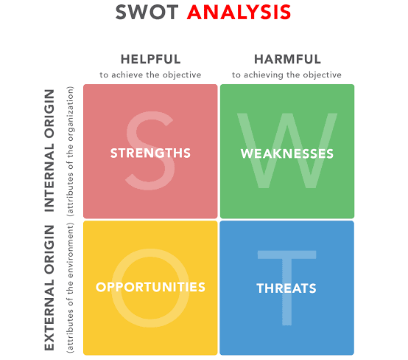

4.1 SWOT Analysis
A human resources SWOT analysis considers internal and external factors that can boost or impede human resources functions within an organization. The acronym SWOT stands for Strengths, Weaknesses, Opportunities, and Threats. This analysis is an essential step that a company can take to help accelerate the company's transition from reactive to proactive mode to improve human resources strategy and function. A SWOT analysis is designed in the following based on the Human Resource Practices of Social Islami Bank Limited.

4.1.1 Strengths
Strength is the positive internal factor that a company can use to fulfill its mission, goals, and objectives.
They may be included:

- Own Training centre: SIBL has its own training center that is very good for an organization and that can reduce the cost of training and its core training is very effective for both employees and organizations.

- Rich HR department: The human resource department of SIBL is well organized. It preserve all of its employee information in particular folder and all information are well documented.

- Special skills and knowledge: The employees working inside the organization have come through the SIBL performance appraisal process. Therefore, it can be said SIBL holds special skills and eligible human resources.

- Customer satisfaction: Throughout the years, SIBL has established customer satisfaction by providing superior services through effective human resources in an Islamic way that touches its customers.

- Positive public image: SIBL is very popular among Bangladeshi commercial banks as it offers low charges for their services and continuously improving its banking products and services.

4.1.2 Weaknesses
Weaknesses reflect the internal negative factors that prevent or restrict the achievement of the company's mission and objectives. They may be included

- High employee turnover rate: It is observed that a lot of employees leave the organization because of too much work pressures at Social Islami Bank.

- Lack of equipment: HRM practices of SIBL suffer because several of its staff doesn’t have the required equipment as well as the technical expertise to process the employment actions.

- Lack of Digital HR technologies: SIBL's human resources department does not have the technology needed to process the employment process and most of the HR work is performed manually, resulting in a human resources department that is unable to perform its duties.

- Insufficient recreational activities: There is almost no recreational activities are performed for the employees, where employees can relax from the work pressures.

4.1.3 Opportunities
The opportunities are the external option a company can use to fulfil its mission. The opportunities for SIBL are:

- Expanding the workforce: There are a lot of educated unemployed human resource are there who are looking for jobs in Bangladesh. SIBL can expand its business as the human resources are easily available.

- Advance technologies and equipment: Human resource can acquire a lot of advance technologies and equipment to improve its personnel performance in SIBL.

- Opening Part time work shift: As there are a lot of job applicants, Social Islami Bank Limited can reduce its work pressures of its existing employees by dividing the responsibilities with the part time employee.

4.1.4 Threats
- Training costs may increase: Higher competition among Bangladeshi banks is increasing or adding new services that require the training of existing staff to be effective. Because of this and the daily improvement of advanced technology, current human resources practices performed by SIBL may obsolete at any time and may incur additional costs for future training.

- Other banks may offer competitive Human Resource benefits: the commercial banks are offering very competitive compensation plan for their employees. Not having a flexible compensation and reward plan, Social Islami Bank may lose its old employees in coming days.

- Lack of Islamic banking knowledge: Most of the new employees now-a-days are found to expert in traditional banking system and unaware of the Islamic banking activities. They may find it very hard to absorb the Islamic banking rules and guidelines which can turn into the loss of quality services.

- Human Resource Restrictions of Bangladesh Bank: The Government of Bangladesh and Bangladesh Bank may impose or increase any restrictions on human resources that may create layoffs for employees in SIBL's human resources department.

CHAPTER FIVE

RECOMMENDATIONS AND CONCLUSION



5.1 Recommendations
SIBL is one of the major banking institutions in Bangladesh. As an intern, it is difficult for me to recommend Social Islami Bank Limited. Human resources add more value to modern organizations. I found some information that needs improvement in the recruitment and selection section from the HRD activities.
- Bank selection and selection processes are not computerized. Banks should use human resources management software to make this selection and selection process to facilitate this process.
- SIBL prepares a procurement budget only once a year at the beginning of the year. When a bank needs to hire new employees, it must do so on a regular basis.
- Employee orientation is one of the most common situations in Bangladesh. Many people find this system available. Therefore, internal resources must have the same importance when recruiting external resources. Through it, new talents in skills, talents, efficiency, etc. will be introduced into the business.
- As far as hiring is concerned, there is no separate HR staff. Banks must assign employees who only recruit and select human resources functions.
- Sometimes, after following the correct selection and selection process, reliable employees are not hired. Therefore, before hiring a bank, you need to check the employee's work experience to resign.
- SIBL has never used a contracting agent for outsourcing. Sometimes it is advantageous for a bank to use a recruitment agency because it helps to find the right candidate.
- To measure efficiency, banks can launch other tests. How candidates should stay in the room for a while, and there will be a team to monitor their behaviour in it. Therefore, your cooperation mentality can be reflected.
- SIBL spends a lot of money on advertising when recruiting outside employees. Banks need to promote employees and can design a training program to improve their capabilities. This can reduce your outsourcing budget.
- Similarly, SIBL should install human resources software to facilitate the selection process. HRIS software simplifies the selection of CVs or available applications sent via the Web.

5.2 Conclusion
The human resources department is the most private and secure department in SIBL. Here, as an intern, there were limited access to study information that often didn't allow to obtain information that is too confidential for the bank. Therefore, in the study, all the information provided allowed me to accept it. Although SIBL applies modern human resource policies, some improvements can be made in some areas. The bank can examine the points that discussed in the recommendations section of the study.

The study on human resources management practices of the Social Islamic Bank Limited (SIBL) has shown that people are the most valuable resource for the organization's progress. To develop these valuable resources, many factors are involved. Recruitment and selection procedures play an important role. In addition, to improve the effectiveness of the organization, recruitment and selection procedures are essential. Dynamic and adequate initial training procedures are needed. Performance appraisal is a key analysis that evaluates the performance of employee’s work who completes the training program and finally the compensation and rewards should be proper so that employees never lose their commitment to their work responsibilities. All the human resource functionscan help the organization achieve its final objectives.

Reference

Armstrong, Michael (2006). "Human capital management". A Handbook of Human Resource Management Practice. Gale virtual reference library. Kogan Page Publishers.
Armstrong, Michael (2009). Armstrong's handbook of human resource management practice. Armstrong, Michael, 1928- (Eleventh ed.). London: Kogan Page. ISBN 9780749457389. OCLC 435643771.
Davis, Robert; Carnovalis, Michael (2018-05-13). "The HR Function's Compliance Role". Corporate Compliance Insights.
Johnason, P. (2009). HRM in changing organizational contexts. In D. G. Collings & G. Wood (Eds.), Human resource management: A critical approach (pp. 19–37). London: Routledge.
Noor, A. and Begum, K.A. (2016) ‘recruitment and selection process of SIBL’. Interview 28 November 2019
Radhakrishna, A., and R. Satya Raju. "A Study on the Effect Of Human Resource Development On Employment Relations." IUP Journal of Management Research 14.3 (2015): 28-42. Business Source Complete. Web. 25 Nov. 2019
SIBL (2018) Available at http://www.siblbd.com/home/selection_process (Accessed: 26 Nov. 2019).

Appendix

A Questionnaire on
HUMAN RESOURCE MANAGEMENT PRACTICES OF
SOCIAL ISLAMI BANK LIMITED

A. PLANNING
1. How many roles are being played by human resources, in the decision making of HR planning programs?
2. How do you plan for the numbers you need in the future? Describe the planning process?

B. RECRUITMENT AND SELECTION PROCEDURES.
3. What are the sources of recruitment policies?
4. What criteria/knowledge are you looking for in the recruiting process?
5. What criteria do you prefer for medium and high-level rentals?
6. How many steps does your company follow in the selection process?
7. Do you organize an orientation program for newly appointed staff?

C. TRAINING AND DEVELOPMENT.
8. How well trained are your staff?
9. How have you measured the training program to be successful?

D. PERFORMANCE EVALUATION
10. What are the main tools used to measure performance?
11. How many days of the year did you measure your employee's effectiveness?

E. COMPENSATION
12. What kind of compensation are you offering? Is it external or individual?
13. How did you pay your employees?
14. How satisfied are your employees with their compensation in these competitive market situations?

