
PROJECT REPORT
Daraz Bangladesh





Project Report on
Customer Satisfaction of Daraz Bangladesh

Submitted to:
Dr. Seyama Sultana
Associate Professor
School of Business & Economics
United International University

Submitted by:
Salman Farsi
ID: 111162086
School of Business & Economics
United International University

Date of Submission: 31st December, 2021

LETTER OF TRANSMITTAL

Date: 24.02.2021
Dr. Seyama Sultana
Associate Professor
School of Business & Economics
United International University
Subject: Submission of Project Report

Dear Madam,
I am here by submitting my Project Report which is a requisite for the completion of BBA program. It is my immense pleasure to submit my project report for your kind approval.
The report is based on E-commerce industry in Bangladesh and the title of the report is “Customer satisfaction of Daraz Bangladesh”. In order to prepare this report, I have used different primary and secondary data. I have tried to give accurate and latest information in this report. This report has enhanced my knowledge and I have got valuable insight into the problems that e-businesses in Bangladesh are suffereing from.While preparing this report, I maintained all the guidelines you have given me.
I would like to request you to receive my report and provide your valuable judgment on it. I hope this report will meet your expectation. If any explanation is required, I would be glad to clarify that. At last, thank you for your valuable guidance throughout my project period.
Sincerely Yours
Salman Farsi
ID: 111162086
School of Business & Economics

Student’s Declaration

I hereby declare that this project paper entitled “Customer Satifaction of Daraz Bangladesh” is an original work which has been prepared to submit to United International University as a part of BBA degree requirement. This paper has been composed during Fall 2021 Trimester. I, Salman Farsi, bearing ID: 111162086, have written this paper under the supervision of Dr. Dr. Seyama Sultana Associate Professor School of Business & Economics, United International University. All the information provided in this report is authentic and has collected from trustworthy source. The quotes of other writers have been mentioned with proper citation and acknowledgement. This Project work has not been prepared in part or as a whole for any other purpose. I take the full responsibility for every information, references provided in this report.

Salman Farsi
ID: 111162086
School of Business & Economics

Acknowledgement

In the name of Allah, the most merciful and compassionate

The topic “Customer Satisfaction of Daraz Bangladesh’ seems to be very interesting to me. To complete all the activities of the report from taking survey to presenting data, I have got immense support from some individuals. In this section of the report, I’d like to express my gratitude to those who have really been supportive to me throughout different stages of my report writing.

I am very thankful to the project supervisor, my honourable course faculty, & Assistant Professor of United International University, Dr. Seyama Sultana for her guidance, assistance, and continuous supervision. Without her kind support and motivation, the completion of this project report would have been near to impossible in this short period of time.
I would also like to thank the people who have participated in the survey and wasted their valuable time helping me. The video tutorials of some renowned Youtube channels have greatly helped me

Furthermore, I want to remember my parents on this auspicious moment as they have always inspired me to continue my study with sincerity and patience.

Abstract

The failure of the most promising e-commerce company in Bangladesh- Evaly has surprised the entire country. Evaly was often regarded as the amazon of Bangladesh. However, the dream of making this company into a giant one like Amazon, Alibaba is now broken. But how come this bold initiative failed. After evaly had been forced to change their business policy by the government because of the alleged anomalities, other e-businesses soon got into trouble. The famous e-companies like Alishamart, E-orange shut down their operation. People have already lost trust in e-business in Bangladesh. In this circumstance, Daraz – one of the leading e-business in Bangladesh is running their business quite well; however, the complaints regarding Daraz’s product category, delivey system, and payment method, behaviours of customer and delivery personnel are not uncommon. This study aims to determine Daraz customers’ satisfaction level and the areas of their dissatisfaction. Based on a review of the literarure on factors of online customer satisfaction and theories of customer satisfaction, a survey was conducted taking a random sample of 50 people. Analysis of the responses demonstrated that Daraz customers consider ceratain variables when they choose which e-sites they should purchase from. The results also indicate what factors they give more priority as they have ranked the factors. After the analysis of the problems, some suggestions have been proposed which can be helpful to improve the gratification of Daraz customers.

 | Table of Content
 |  | Page Number
Letter of Transmittal |  | i
Student’s Declaration |  | ii
Acknowledgement |  | iii
Abstract |  | iv
Table of Content |  | v
 | Chapter one: Introduction
1.1 Background |  | 2
1.2 Objective |  | 2
1.3 Research Questions |  | 2
1.4 Methodology |  | 3
1.5 Limitations |  | 4
1.6 Audience |  | 4
 | Chapter two: Literature Review
2.1 Customer Satisfaction |  | 4
2.2 Factors of Satisfaction |  | 5
2.3 E-business in Bangladesh |  | 6
2.4 Types of E-business |  | 6
2.5 Prospects and Challenges |  | 8
2.6 Company Overview |  | 9
2.7 Business Model |  | 10
2.8 Marketing Mix |  | 11
2.9 SWOT analysis |  | 13
2.10 Literature Survey |  | 13
 | Chapter three: Methodology
3.1 Introduction |  | 16
3.2 Research Design |  | 16
3.3 Sampling Procedure |  | 16
3.4 Questionnaire |  | 17
3.5 Data Collection |  | 17
 | Table of Content
Page
Number
3.6 Ethical Consideration |  | 17
 | Chapter Four: Data Analysis
4.1 Demographic Analysis |  | 19
4.2 Identifying Variables of Satisfaction |  | 20
4.3 Ranking of Variables |  | 21
4.4 Measuring the level of Satisfaction |  | 22
4.5 Analysis of the Findings |  | 29
 | Chapter Five: Recommendation & Conclusion
5.1 Recommendation |  | 30
5.2 Conclusion |  | 31
 | Appendix
6.1 Questionnaire |  | 33
6.2 Survey Responses |  | 35

Chapter 1:

Introduction



Chapter 1: Introduction

  - Background of the study
The internet first came in Bangladesh on 4 June 1996. At the very beginning, the use of the internet was restricted to only sending and receiving emails to and from abroad and in that year, there were only 2 ISPs in the country. However, with time, the screnario had changed. The following years witnessed tremendous growth in the usage of internet. Now, according to the data revealed by Bangladesh Telecommunication Regulatory Commission (BRTC), the number of internet users stood at 111.875 million at the end of December, 2020. With the increased use of the internet, lots of e-commerce businesses have been established. And these e-commerce sites have a huge number of customers. Although there are a large number of online shoppers in Bangladesh, the service of most of these businesses is still questionable. Customers often make lots of complaints against e-commerce sites. The scams of some top e-sites have fuelled people’s doubt about this new form of business. Therefore, this is really important for online sellers to understand the level of satisfaction of customers. An in-depth customer insight will help an online business to clearly identify the determinants of customer satisfaction and earn the trust of people.
1.2 Objective of the study
The objectives of this research are given below:
- To determine the level of satisfaction of Daraz customers
- To identify the variables of e-satisfaction
- To get an idea of Daraz customers purchsing behaviour
- To find out the extent of loyalty of Daraz customers
- To explore the reasons behind the customers’ satisfaction and dissatisfaction
- To recommend some possible solutions to the existing problems of Daraz

1.3 Research Questions

The purpose of this paper is to find out the answers of the following research questions:

- How much satisfied are the customers of Daraz?
- How can the company improve the satisfaction of the customers?

1.4 Methodology
In this study, the customer’s experience of using Daraz app has been analyzed. An inductive approach using a qualitative method has been utilized. A survey has been conducted to take the responses of Daraz users. Along with that, different news reports have been used. After that, the collected data was analyzed and lastly, a final counclusion has been drawn.

Strategies Data Generation &
Experience & Motivation
Methods Data analysis
Survey
&
Interviews
Quantitative
Design & Creation
Research
Question
Observation
Qualitative
Literature
Review
Questionnaires
Experiment
Conceptual
Framework
Documents
Case Study

Action Research

Ethnography

Figure: Model of research process

1.5 Limitations of the report
While preparing this report, the research conductor encounters several problems which has affected the quality of the report to lesser extent. Some of these limitations are as follows:
- Finding the regular users of Daraz was the biggest challenge. Many individuals were found who had the experience of purchasing from Daraz but their purchase frequency was not adequate enough to be selected in the survey. So it took huge time to select 50 frequent users of Daraz.
- There was an impact of Covid19 across the country. Getting to people was not easy. Thus the sample size has to be limited.
- This research was written within a specific deadline. The deadline pressure poses a great challenge to produce a quality report.

1.6 Audience
The audiences of this project paper are those who are involved in e-commerce industry in Bangladesh. Also the people who work at Daraz Bangladesh can be benefitted by this report. This paper will also be a good help for future researchers and students

Chapter 2: Literature Review

2.1 Customer Satisfaction


One of the most important considerations for every business is to determine its customer’s satisfaction. Without having the proper understanding of customer satisfaction, no business can make progress. Since the last 2 decades, many companies in the world have consistently been working to find out the characteristics of organisations which satisfy customers. Therefore, no less than fifteen thousand write-ups have been published on the topic of customer gratification (Peterson and Wilson, 1992). Different marking researchers have defined customer satisfaction in different ways. According to Philip Kotler, a famous American Professor, “ Customer satisfaction is a person’s feeling of pleasure or disappoinment, which resulted from comparing a product’s perceived performance or outcome against his or her expectations” ( Philip Kotler, 2000). Another two marketing researchers- Hansemark and Albinsson stated that satisfaction is the positive customer experience towards a service provider (2004). If an organisation wants to please its customers, that organization must fulfill the needs and wants of its customers (La Barbera and Mazursky, 1983). Kotler further defined the term as the felt deprivation of a customer (Kotler, 20000).
2.2 Factors of Online Customer Satisfaction
In a recent research by the faculty of Technology Management and Technopreneurship, Universiti Teknikal Malaysia Melaka, it was revealed that three factors impacted online shoppers and they are product quality, brand and shopping experince. Shopping experice is the feelings or impression that a customer develops during his or her visit at the store. If the shoppers are pleased with the product or service they purchase from online shops, they are highly likely to share their experince on different social media platforms (Nelson, 2012). Brand, on the other hand, is the identity of a company.A positive brand image is like an asset. It helps customers to make purchasing deceision very easily. The customers who have no complaint against the company generally try to create a relationship with that brand (Chiu, Huang& Yen, 2010). Likewise, product quality also plays a very important role. The quality of the product is basically the features of the product that serves a customer’s needs and wants. Product quality determines whether a customer wll be satisfied or dissatisfatied. According to John, Mowen & Michael, product quality is the evaluation of customers (Haslinda Musa, August 2015). In China, around 400 online business entrepreneurs participated in a research and revealed that there are as many as 8 determinants of customer gratification, including website design, security, information quality, payment method, e-service quality, product quality, product variety, delivery service. Website design is the appearance of the site and high customer satisfaction is positively related to the design of the website (Cho and Park, 2001). Security is one of the main concerns for many shoppers. While creating account, they have to provide many personal information which they don’t want to be stolen or misused by others. One resarch finding is that there is an inverse relationship between security risk and purchase intention (Wright, 2016). If the information provided in the website is reliable, then it helps customers to perceive low risk Kateranttanakul (2002).
2.3 E-business in Bangladesh
While e-business in Bangladesh has existed for last two decades, it is still suffering from many different problems. The broadbrand internet service has not reached every corner of Bangladesh yet. However, the number of internet users is increasing tremendously and therefore, there is a very good prospect of this sector in Bangladesh. According to e-cab- the regulatory body for e-businesses In Bangladesh, around 750 eisites are currently running their businesses and there are 8000 pages on Facebook which are involved in online businesses. Many physical stores have finally come to understand the value of virtual existence. So they have created Facebook page by which they demonstrate their products. Moreover, many businesses have entered into an agreement with e-businesses like Daraz where they can showcase their products.
2.4 Types of E-businesses in Bangladesh
There are 4 kinds of e-businesses in Bangladesh such as-
- Business-to-Business (B2B)
- Business-to-Consumer (B2C)
- Consumer-to-Consumer (C2C)

B2B: B2B businesse is product buying and selling between two different businesses. In a report published by BRTC, it has witnessed that there are now 2000 B2B e-sites in Bangladesh.Around 45000 facebook-outlets are delivering around 25000 products through B2B. Some of the top B2B businesses are bgmea.com.bd, bizbangladesh.com eWorldTrade, Evaly, Bagdoom.com, Priyoshop etc.
B2C: The products are directly sold to consumers. The products include any consumer electronics, clothings & fashion, home décor, and so on.Most of the e-commerce businesses are in this form. Some B2C businesses are ajkerdeal.com, bdbazar.com, daraz.com, bajna.com.
C2C: In such forms, consumers directly contact with other consumers. The parties involved in such business are not professional entrepreneurs. They mostly sell their unused products most of the times. The instances of these forms of businesses include bikroy.com, clickbd etc.
2.5 Prospects and challenges of e-commerce in Bangladesh
As Bangladesh is now a developed country and it has huge population, people of Bangladesh have become consumerist. They spend a great deal of time online and make purchases. By the end of the year, the e-commerce is likely to grow to 3 billion dollars. This growth has been stimulated by the approval of digital payment method by Bangladesh Bank and the increased use broadband internet. However, during the pandemic, this sector witnessed huge growth. In a survey, it has been found that the amount of online sales has been risen by approximately 70% (Pau, 2020). Most of the people of Bangladesh prefer online shopping because they find it convenient. Due to traffic jam in Dhaka city, it has become very difficult for people to go market. By giving order from online shops, they can save time (Md Altab Hossin, 25 August 2018).

Thare are a number of challenges the e-businesses are facing. Among these problems are:
- Poor delivery system- In spite of the fact that Bangladesh now has a better road infrastructure, it is still suffering from underdeveloped delivery system. Still, the delivery system is heavily reliant on courier system which has not been modernised yet. The promise of prompt delivery can only be kept within city areas but outside Dhaka, people often get products late. The developed countries have already introduced artificial intelligent delivery system. The cheap packaging of products is another concern. Businesses use such kind of packaging which sometimes make the food inside rotten in case of delayed delivery.

- Digital literacy- Although the number of smartphone users has risen over the years, digital literacy is still a major problem. Many people, especially people of rural areas do not know how to use different apps or smartphones properly. Their lack of knowledge has made the use of the internet very restricted.

- Digital Payment- Online payment was the biggest problem in Bangladesh even in the last decade. However, this prpblem has been solved to some extent with the introduction of different online payment methods and their approval by Bangladesh Bank. The developments came as a form of digital wallet, smart cards as well as transaction infrastructure such as electronic payment gateway.As the procedure electronic payment has become easier, it has stimulated the growth.Nevertheless, the problem still exists. Different mobile banking service provider sometimes charge the customers. Even the incident of harassing customers in the name of security is also evident (Mostafa Shabuj, Wed Sep 8, 2021 ).

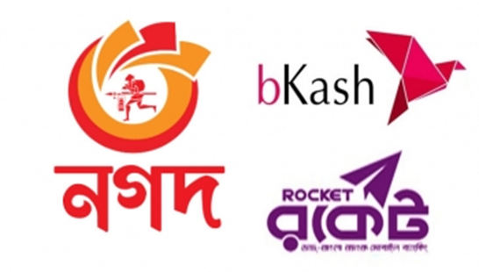

- Lack of infrastructure- Many e-sites have failed to develop proper infrastructure. Many of them do not even have warehouse. As a result, when they receive order, they source it from anywhere and then supply them to the customers. This make the delivery process lengthy. Such delay often makes online shopping less attractive to people (Saeed, Aug 31,2021)

- Weak government body- To build Bangladesh as a digital country, the government has created E-CAB in 2015. Since its inception, this organisation is trying to establish displine in the online market. But in many cases, it has been seen that this government body has failed to control the activities of many top e-sites. Even this organization has limitation in its power. This association currently has 750 members. Still a large number of sites are not registered by this association and therefore, they are out of supervision.

2.6 Company Overview
Daraz Bangladesh Limited is a leading e-commerce company in Bangladesh with 30,000 sellers, 500 brands and 5 million consumers. It started its operation in Bangladesh in 2015 and its headquarter is at Gulshan, Dhaka. The company offers products of all categories and has become a reliable and trustworthy online marketplace for Bangladeshi online shoppers. Within the vulnerable digital market environment in Bangladesh, this company became a role model for all other e-commerce sites in Bangladesh.
Daraz Bangladesh is a subsidiary company of Rocket Internet. Rocket Internet deals in online retailing business. Apart from Bangladesh, Daraz has operation in some other south-asian countries as well, including Bangladesh, Sri Lanka, Myanmar, and Nepal. However, in May 2018, the company was acquired by another e-commerce giant Alibaba Group (STAR, 2018). Thanks to the involvement of Alibaba with Daraz, the Bangladeshi online customers have been able to purchase any foreign product without the need of paying shipment and custom charges. After Alibaba had purchased Daraz, the company expressed its desire to lay out 59 million dollar in Bangladesh so that the e-commerce infrustructure can be developed, particularly warehouse and sorting center.
Daraz has all categories of products such as- electronic devices, TV& home appliances, health& beauty, babies & toys, groceries & pets, home & lifestyle, women’s fashion, men’s fashion, watches & accessories, sports and outdoor, automotive & motorbike and so on.
Mission
The company’s mission is to become world’s largest e-commerce platform outside USA and China. The company identifies new business models, untapped markets and entrepreneurs. Nurture them and try to establish the business.

Vision
Their vision is to capture the maximum share of consumer online shopping expenditure in the market.

Daraz app layout
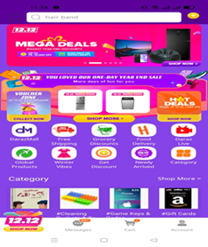

2.7 Daraz Buisness Model
In the traditional retailing business model, manufacturers sell the ptoducts to the retailers at wholesale price and retailers then sell the products to the customers at retail price. The difference beween the wholesale and retail price is the profit of retailers. However, this business model is becoming obsolete. Now the new business model is online market place or direct-to-consumer retail. Daraz follows this model

In marketplace model which Daraz follows, Daraz acts as a middleman between seller and customer. The identity of sellers are rigorously checked and then they are selected.The selected sellers can showcase their products on Daraz. Daraz takes care of its customers by offering 100% purchase protection policy. They also offer 100% authentic product and they have secured their payment system in many ways. The rule is such that if a seller successfully delivers a product, Daraz releases the money. Darz earns commission from this transaction.

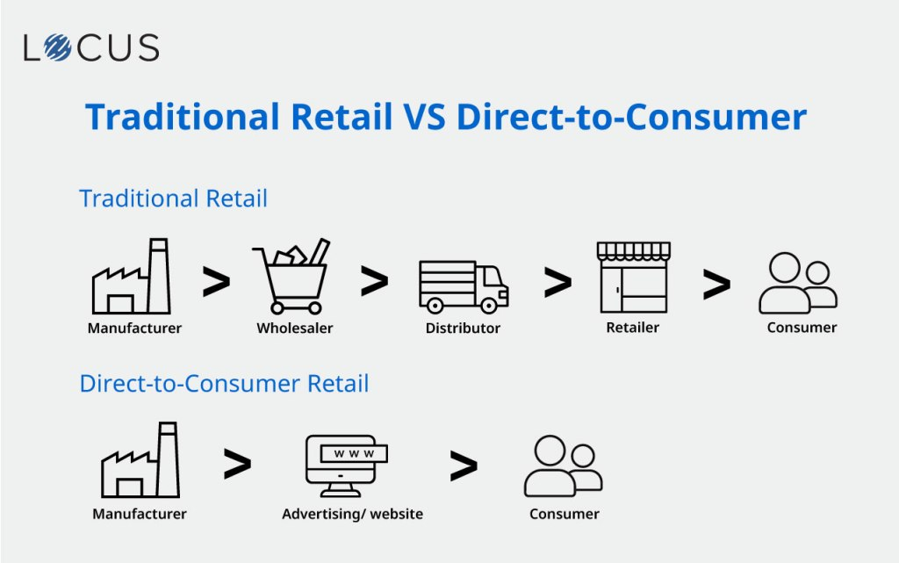
2.8 Marketing Mix of Daraz
The professor of Harvard Business school of America- Neil Borden, marketing mix is just the mixture of four inputs and these inputs make up a company’s marketing system. The classification of marketing mix was first developed by the professor McCarthy. He suggested that based on different industry, marketing manager can develop different strategies or approaches under each of the 4ps.

Price
Daraz always set fair prices for its products. It has become very hard for the company to assign price for a product as other e-sites have adopted competitive pricing stategy. It gives discount and cash back to its customers as well. Daraz express does not charge any extra money for customers on certain products.

Product
Daraz itself does not have to either manufacture or import products. It just allow other traditional businesses to showcase their products on Daraz sites. In return, Daraz earns a certain amount of commission. Daraz has all types of products. The most famous categories are:
Place
Daraz is an online marketplace. They have no such physical store from where they sell their products directly to customers. However, Daraz has several hubs from where the product is delivered to customers. These hubs have ensured faster delivery. In Dhaka, Daraz hubs are located at several location.
- Badda
- Banglabazar
- Baridhara
- Chawkbazar
- Dhanmondi 7
- Hatirpool
- Jigatiolla
- Malibag
- Mirpur 60 feet
- New Market
- Savar
- Paltan
- Uttara
- Tongi
Promotion
On different occasions, Daraz carries out promotional campaigns to attract new games. They also give discounts, offers to entice customers. Some of their promotional activities are given below:
Daraz fashion week: This campaign is specially designed for those who are passionate about latest design. The customers can get many discounts, vouchers and many more offers. But there is a condition that theb customers will have to share their purchasing experice on the fan with caption #DFW 2021.

11.11 campaign: The most recent popular campaign was 11.11 in which there were many alluring deals such as 1 taka game, 11 taka mystery box. In this campaign, the company created “Daraz squard” with four hunderd Customer service executives (CS) and partner support executives (PSC). The tagline for this campaign was “always here for you”. There was an issue resolution team as well to handle any complaints lodged by customers. To provide quality service, they introduced a chatbot only for this campaign namely “DAZ”.

2.9 Daraz SWOT analysis
A sowt analysis is a combination of an organization’s strengths. Weaknesses, opportunity, threats. This type of analysis is really helpful for business leaders to take rational business decision.
External Environment: The situation which exists outside the organization is referred to as external environment. A company cannot control external environment. One of the examples of external environment is political situation. Opportunities and threats are two external factors of SWOT analysis.
Macro environment- Macro environment has bigger effect. The country’s economic condition, technological forces, demographic forces, ecological forces are factors of macro environment.
Micro environment- Suppliers, customers, intermediaries, and even competitors fall into micro environment.
Internal Environment: This is the organization’s inner environment. Some of the elements of internal environment are layout of the website, office employees, supply-chain managemet etc.

Daraz SWOT analysis
s | W | T | o
- Partnership with popular brands  - User friendly website design  - The entry fee of new sellers and commission on sales are the revenue sources  - Fast delivery through Daraz Express  - B2C business model of Daraz enables the  company to offer low price and maintain direct relationship with customers  - It accepts both online transaction and COD ( cash on delivery)  - Strong logistic support inside Dhaka creating multiple hubs | - Registration fee is a barrier for new sellers to get entry to the website  - Lack of own quality assurance department  - Lack of strict monitoring and consequently, the presence of deceptive sellers  - Only a few brands and sellers exist | - Aggressive marketing policy of other e-businesses  - Possible entry of international giants  - Internet speed  - Government policy  - Growing mistrust in e-businesses among Bangladeshi people | - Growing internet users  - Loyal customer base  - Poor internet security can attract hackers  - Helps consumers increase product awareness

Table 2.1: Daraz SWOT analysis
2.10 Literature Survey
(Ashraf, 2017): This study shows a significant number of customers are dissatisfaied with the services of Daraz. The areas of dissatisfaction are mostly delivery man’s behaviour, customer care responsiveness, Product similarity and many more. The author recommends dealing with honest seller, creating own delivery team, being more attentive to customer’s complaint etc.

(Nobin, 2016): The result of this paper shows that there are several issues in the e-commerce industry in Bangladesh. These issues are late delivery, Poor customer service, Poor after sales service, poor quality products, and more price than offline shop etc.

(Karim, June,2020): This study was conducted by a Bangladehi student studying in China. The author wanted to investigate Daraz’s shortcomings and find out the way Daraz can improve its customers’s satisfaction. The research was done through qualitattive approach. The finding was poor product quality, delivery period, weak pricing policy, fraud retailers, and lack of pickup points and many more. It was recommended to upgrade customer service, improve delivery system, being aware of cyber crime.
(Ahmed, 2020): This study explains the factor which are responsible for customer preference. It also analyzes why preferences change. According to the research, the factors involving customer preference are convenience, pricing policy, quality, online trust, information, variety, discount offer etc.
(Ahmed, An Investigation into Customer Preferences for, 2020): This study was conducted to check which factors consumer experience of online shopping in pakistan.The factors affecting the customer satisfaction of Daraz consumers are quality, pricing policy, online trust, income, information, variety.
(M.Nisar, 2017): The result of this study was that there is a direct relationship among e-service quality,e-satisfaction and e-loyalty. It also shows that customer satisfaction has an impact on consumer spending.
(Lin, 2007): This study investigates the impact of user-friendly website design to increase e-satisfaction and the result was positive. Through hypothese trsting, it has been proven that website design, interactivity, informativeness, security, responsiveness are positively related to customer satisfaction.
(Swaid, 2007): This study aims to find out the dimensions e-commerce service quality. Some of the dimensions are website usability, information quality, reliability etc. It also suggests that customer satisfaction and customer retention are related

2.11 Research Gap
As described in the above literature review section, a lot of researches have been conducted to find out the factors that can satisfy e-commerce users, to analyze e-commerce service quality dimensions. There are only a few researches about Daraz- which is one of the largest e-sites and has set good example with ideal marketing practice in the market.

Chapter 3:

Methodology



Chapter 3: Methodology

3.1 Introduction
This is a descriptive type of research and the objective of this research is to find out customer satisfaction level of Daraz. Descriptive research is mainly used to describe the characteristics of any population. The research data has been analyzed with a qualitative analysis. The questions given to the respondents are close-ended. These questions are easy to understand and use.
3.1 Research Design
Research design is a methodical, well-organized procedure utilized by a researcher or a scientist to carry out a scientific study. It is a comprehensive coexistence of already identified elements and any other information or data leading to a reasonable end result. There are three types of research design explanatory, exploratory and descriptive. Exploratory research is conducted for large-scale research where many resources are needed and risk is high. It is also referred to as pilot research. No result can be reached through such research work. Explanatory research, on the other hand, explains the reason behind a particular problem. It is also termed as cause and effect research. Descriptive research describes the characteristics of a sample, population, organization or product etc. In other words, they are used to describe various aspects of a phenomenon.
Both qualitative and quantitative research have been used to determine the level of satisfaction of Daraz customers. Customer’s responses were recorded through survey queationnaire and then analyzed them through quantitative measure with descriptive statistics and frequency analysis. Afterwards, the research findings were analyzed.

3.2 Respondents & Sampling Procedure
The participants of this survey research are the students of different universities in Dhaka. The individuals in the population has been selected very carefully. Only the students who are a regular user of Daraz and their frequency of purchase is high has been chosen for this survey. The survey was conducted in both online and offline. In offline, at first an introduction about the survey was given and then a printed question was given. The respondents filled the form and gave it back to the research conductor.
5 point likert scale has been used in this research. The 5 points are:
1= strongly disagree; 2= Disagree; 3= Neutral; 4=Agree; and 5= strongly agree

3.3 Research Questionnaire
To complete the research process, a questionnaire was developed. The statements included in the questionnaire have been selected very carefully. Many of these statements have already been used in many past researches. However, some statements have been included. There were 20 statements in total. The survey questionnaire was divided into 2 sections. The first section was all about demograpgic information and the section actually measured the satisfaction level. These statements reflect the experiences the customers gather using this app. Likert scale was utilized in this paper so that the attitude of the respondents can be measured.

3.4 Data Collection
Data from both primary and seconday sources were collected. Apart from that, some books, different websites, journals, newspaper, research paper were utilized to get secondary data. A total of 50 responses were recorded by the hard copy of questionnaire.

3.5 Ethical consideration
The participants have been made aware of the consequences of this study so that they can express their free opinion. They have also been informed that they can exit anytime from the survey. Some of my friends helped me to take survey. All the information given in this paper has been collected from the authentic sources.

Chapter 4:

Data Analysis and Findings


4.1 Gender distribution of the surveyed population

Gender-Male or Female
 |  | Frequency | Percent | Valid Percent | Cumulative Percent
Valid | Male | 36 | 72.0 | 72.0 | 72.0
Valid | Female | 14 | 28.0 | 28.0 | 100.0
Valid | Total | 50 | 100.0 | 100.0
Table 4.1: Gender distribution table

F1: Pie Chart- Gender Distribution- Male or Female

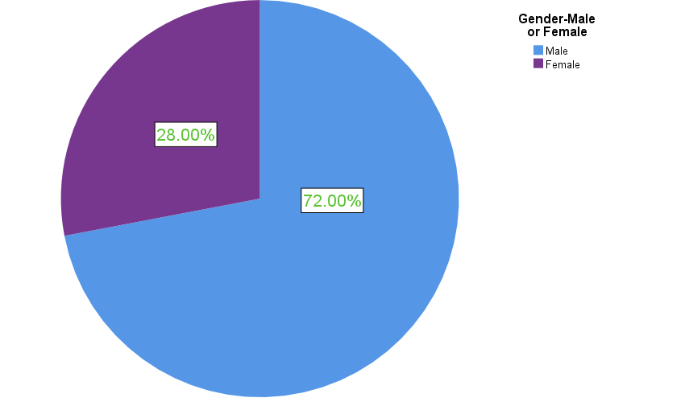

A total of 50 individuals attended this survey. Among them, 36 were male which is 72% of total population and 14 were female which is 28% of all respondents. Among the participants, 42% were students and the rest 58% were engaged in many different professions. Basically, the young students were given priority in this research because their exposure to the internet is hgher than others. According to age-group, 17 were from the youngest group- 18 and 25 years, the majority 23 belonged to 26-31 age group and only 10 were 32 or above age group

In this survey, 50 individuals attended. 48% strongly agreed and another 48% only agreed with the statement that they are a regular user of Daraz app. 2 out of 50 participants were neutral in this statement. So it is clear that almost all of the individuals taking part in this survey are frequent users of Daraz app.

4.1 Identifying Customer Satisfaction Variables

Likert  Scale | Payment Procedure | Promise fulfillment | Product description | App  design | Pricing | Product  image | Product  variety | Customer Care | Refund Policy | Delivery  time | Ordering Proces | Delivery  Personnel  Behaviour
Very important | 29 | 42 | 35 | 33 | 38 | 25 | 34 | 31 | 40 | 45 | 28 | 32
Important | 11 | 7 | 7 | 12 | 12 | 17 | 10 | 13 | 10 | 5 | 12 | 11
Neutral | 5 | 1 | 6 | 5 |  | 8 | 6 | 6 |  |  | 10 | 7
Less important | 5 |  | 2
Unimportant
Total  responses | 50 | 50 | 50 | 50 | 50 | 50 | 50 | 50 | 50 | 50 | 50 | 50

Table 4.2: Identifying variables

The survey participants were given a total of 30 variables which might affect them. These variables have been found from different past researches on e-commerce satisfaction. The above 12 variables received the highest number of responses and customers said that they consider all these variables with great importance when they choose which e-commerce site to buy from.

4.2 Ordering of important factors
Ranking of Customer Satisfaction Factors
Factors | Frequency | Percentage | Ranking
Payment Procedure | 5 | 10%
Promise fulfillment | 15 | 30% | 1st
Product description | 0
App interface | 4 | 8%
Pricing | 6 | 12% | 3rd
Product image | 0
Product variety | 2 | 4%
Customer care | 4 | 8%
Refund Policy | 4 | 8%
Timely delivery | 10 | 20% | 2nd
Ordering Process
Delivery Personnel behaviour | 0
Total | 50 | 100%

Table 4.3: Ranking of variables
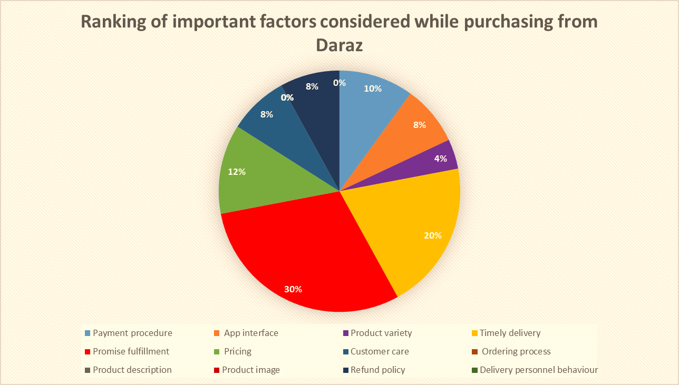

After identifying the factors which satisfy a customer, they have been asked to rank. The result shows that maximum people feel promise fulfillment (30%) is very much important to them. The next top priority for them is timely delivery (20%). They want their prouct to be delivered in time. This is obvious that while some other e-businesses attract huge criticism regarding delivery timing and promise fulfillment, for Daraz users these two factors are top priority.
4.3 Measuring the level of satisfaction

Table 4.3.1 : I get all types of products on Daraz

 |  | Frequency | Percent | Valid Percent | Cumulative Percent
Valid | Strongly disagree | 1 | 2.0 | 2.0 | 2.0
Valid | Disagree | 4 | 8.0 | 8.0 | 10.0
Valid | Neutral | 6 | 12.0 | 12.0 | 22.0
Valid | Agree | 15 | 30.0 | 30.0 | 52.0
Valid | Strongly agree | 24 | 48.0 | 48.0 | 100.0
Valid | Total | 50 | 100.0 | 100.0

Interpretation: In terms of product availability, the highest 24 pesons expressed their full satisfaction, rating it as strongly agree. This is followed by 15 individuals who marked the statement “agree”. The rest of the values are not significant. Thus, in this statement, most of the respondents reacted positively. Daraz users want products of all categories and they remain happy when they donot need to find out any product other than Daraz.

Table 4.3.2: The pictures of the product are clear and vivid

 |  | Frequency | Percent | Valid Percent | Cumulative Percent
Valid | Strongly disagree | 11 | 22.0 | 22.0 | 22.0
Valid | Disagree | 26 | 52.0 | 52.0 | 74.0
Valid | Neutral | 7 | 14.0 | 14.0 | 88.0
Valid | Agree | 4 | 8.0 | 8.0 | 96.0
Valid | Strongly Agree | 2 | 4.0 | 4.0 | 100.0
Valid | Total | 50 | 100.0 | 100.0

Interpretation: When it comes to the clarity of the picture, 26 persons being surveyed said the picture was not clear and this was the highest number, 11 people strongly believe that the picture is not clear at all. The statement is supported by only a few people. The pictures displayed on Daraz app are a big barrier of their satisfaction.

Table 4.3.3: I can easily communicate with the seller through this app

 |  | Frequency | Percent | Valid Percent | Cumulative Percent
Valid | Strongly disagree | 14 | 28.0 | 28.0 | 28.0
Valid | Disagree | 19 | 38.0 | 38.0 | 66.0
Valid | Neutral | 9 | 18.0 | 18.0 | 84.0
Valid | Agree | 5 | 10.0 | 10.0 | 94.0
Valid | Strongly Agree | 3 | 6.0 | 6.0 | 100.0
Valid | Total | 50 | 100.0 | 100.0

Interpretation: This statement was given to the partcipants to check the accessibility of the seller through the app. As many as 19 people disagreed with the statement. !4 more people showed strong negative reaction to it. 9 people showed their moderate attitude towards it. So this response indicates the problem of communication with the app. In open discussion, the respondents said they did not any reply from the seller. Even sometimes, the sellers didn’t pick up the phone or the number given was invalid.

Table 4.3.4: The design of Daraz app is user friendly

 |  | Frequency | Percent | Valid Percent | Cumulative Percent
Valid | Strongly disagree | 1 | 2.0 | 2.0 | 2.0
Valid | Disagree | 2 | 4.0 | 4.0 | 6.0
Valid | Neutral | 3 | 6.0 | 6.0 | 12.0
Valid | Agree | 26 | 52.0 | 52.0 | 64.0
Valid | Strongly Agree | 18 | 36.0 | 36.0 | 100.0
Valid | Total | 50 | 100.0 | 100.0

Interpretation: More than 50% participants (26) consider the app as user friendly.The 36% also strongly feel it. So there is no issue with the existing app.

Table 4.3.5: The product delivered to my doorstep from Daraz was similar to the product which I saw on the app

 |  | Frequency | Percent | Valid Percent | Cumulative Percent
Valid | Strongly disagree | 10 | 20.0 | 20.0 | 20.0
Valid | disagree | 30 | 60.0 | 60.0 | 80.0
Valid | Neutral | 5 | 10.0 | 10.0 | 90.0
Valid | Agree | 4 | 8.0 | 8.0 | 98.0
Valid | Strongly agree | 1 | 2.0 | 2.0 | 100.0
Valid | Total | 50 | 100.0 | 100.0

Interpretation: 30 people didn’t agree with this statement and 10 more people strongly felt that. The people after the survey revealed that in the app, the color of the product looks bright but after the delivery, they don’t find similarity in the color. So it is obvious that the app has failed to give the proper understanding of color and size to the customers.

Table 4.3.6: Product description provided in the Daraz app is really helpful

 |  | Frequency | Percent | Valid Percent | Cumulative Percent
Valid | Strongly disagree | 21 | 42.0 | 42.0 | 42.0
Valid | Disagree | 14 | 28.0 | 28.0 | 70.0
Valid | Neutral | 10 | 20.0 | 20.0 | 90.0
Valid | Agree | 4 | 8.0 | 8.0 | 98.0
Valid | Strongly Agree | 1 | 2.0 | 2.0 | 100.0
Valid | Total | 50 | 100.0 | 100.0

Interpretation: As per product description, more than one-fourth of the surveyed people think the description is not enough. Nearly 30% also disagreed with the statement. So product description is not clear. In the discussion session, people said the description is not written in perfect language. They have difficulty understanding the product.

Table 4.3.7: The behaviour of delivery personnel is good

 |  | Frequency | Percent | Valid Percent | Cumulative Percent
Valid | Strongly disagree | 13 | 26.0 | 26.0 | 26.0
Valid | Disagree | 28 | 56.0 | 56.0 | 82.0
Valid | Neutral | 7 | 14.0 | 14.0 | 96.0
Valid | Agree | 1 | 2.0 | 2.0 | 98.0
Valid | Strongly Agree | 1 | 2.0 | 2.0 | 100.0
Valid | Total | 50 | 100.0 | 100.0

Interpretation: Among 50 people, 28 ones rated the behaviour as not good. The 13 other hold the same view expressing their strong disapproval of the statement. Therefore, it can be interpreted that the behaviour of delivery boys are not up to the mark and it causes dissatisfaction among customers.

Table 4.3.8: I got my ordered product in time
 |  | Frequency | Percent | Valid Percent | Cumulative Percent
Valid | Strongly Disagree | 5 | 10.0 | 10.0 | 10.0
Valid | Disagree | 6 | 12.0 | 12.0 | 22.0
Valid | Neutral | 5 | 10.0 | 10.0 | 32.0
Valid | Agree | 7 | 14.0 | 14.0 | 46.0
Valid | Strongly Agree | 27 | 54.0 | 54.0 | 100.0
Valid | Total | 50 | 100.0 | 100.0

Interpretation: When asked about delivery timing. Most of the participants showed their satisfaction. 27 persons strongly agreed and 7 others agreed with the statement. Compared to many other e-sites, Daraz is doing well in this case.

Table 4.3.9: I could contact with customer care when I faced any problem
 |  | Frequency | Percent | Valid Percent | Cumulative Percent
Valid | Strongly disagree | 7 | 14.0 | 14.0 | 14.0
Valid | Disagree | 26 | 52.0 | 52.0 | 66.0
Valid | Neutral | 11 | 22.0 | 22.0 | 88.0
Valid | Agree | 5 | 10.0 | 10.0 | 98.0
Valid | Strongly Agree | 1 | 2.0 | 2.0 | 100.0
Valid | Total | 50 | 100.0 | 100.0

Interpretation: This statement was given to analyze the responsesiveness of customer care service of Daraz. 52% couldn’t agree with the given statement, which is the highest. 7 out of 50 people strongly disagreed with it saying that customer care was unreachable when they encountered any problem.

Table 4.3.10: Customer care represntative was responsive and behaved well with me

 |  | Frequency | Percent | Valid Percent | Cumulative Percent
Valid | Strongly disagree | 1 | 2.0 | 2.0 | 2.0
Valid | Disagree | 7 | 14.0 | 14.0 | 16.0
Valid | Neutral | 9 | 18.0 | 18.0 | 34.0
Valid | Agree | 12 | 24.0 | 24.0 | 58.0
Valid | Strongly Agree | 21 | 42.0 | 42.0 | 100.0
Valid | Total | 50 | 100.0 | 100.0

Interpretation: About the behaviour of customer care personnel, the highest number of people (42%) accepted that they have received friendly behabiour from them.This is followed by 12% more people who agreed with the statement. The other figures are not considerable.

Table 4.3.11: I could solve my problems communicating with customer care

 |  | Frequency | Percent | Valid Percent | Cumulative Percent
Valid | Strongly disagree | 6 | 12.0 | 12.0 | 12.0
Valid | Disagree | 28 | 56.0 | 56.0 | 68.0
Valid | Neutral | 4 | 8.0 | 8.0 | 76.0
Valid | Agree | 9 | 18.0 | 18.0 | 94.0
Valid | Strongly Agree | 3 | 6.0 | 6.0 | 100.0
Valid | Total | 50 | 100.0 | 100.0

Interpretation: Whether customer care was able to give solution or not, in this statement, 28 people said no. 6 others strongly disagreed with it. It is clear that customer care has limitation to provide solution to the customers.

Table 4.3.12: I could change the faulty product delivered to me

 |  | Frequency | Percent | Valid Percent | Cumulative Percent
Valid | Strongly disagree | 21 | 42.0 | 42.0 | 42.0
Valid | Disagree | 18 | 36.0 | 36.0 | 78.0
Valid | Neutral | 4 | 8.0 | 8.0 | 86.0
Valid | Agree | 5 | 10.0 | 10.0 | 96.0
Valid | Strongly Agree | 2 | 4.0 | 4.0 | 100.0
Valid | Total | 50 | 100.0 | 100.0

Interpretation: The maximum 21 opnined that they failed to get back the faulty product and got a new one. 18 people also expressed the same feelings. So the process of returning the wrong product is not very difficult for the customers of Daraz.

Table 4.3.13: I get reasonable price through Daraz

 |  | Frequency | Percent | Valid Percent | Cumulative Percent
Valid | Strongly disagree | 1 | 2.0 | 2.0 | 2.0
Valid | Disagree | 2 | 4.0 | 4.0 | 6.0
Valid | Neutral | 8 | 16.0 | 16.0 | 22.0
Valid | Agree | 29 | 58.0 | 58.0 | 80.0
Valid | Strongly Agree | 10 | 20.0 | 20.0 | 100.0
Valid | Total | 50 | 100.0 | 100.0

Interpretation: In terms of price, the majoriry of participants believe they get fair price from Daraz. 29 individuals gave agree and 10 others responded the statement with strongly agree.

Table 4.3.14: Daraz gives good discount on products

 |  | Frequency | Percent | Valid Percent | Cumulative Percent
Valid | Strongly disagree | 2 | 4.0 | 4.0 | 4.0
Valid | Disagree | 1 | 2.0 | 2.0 | 6.0
Valid | Neutral | 8 | 16.0 | 16.0 | 22.0
Valid | Agree | 14 | 28.0 | 28.0 | 50.0
Valid | Strongly Agree | 25 | 50.0 | 50.0 | 100.0
Valid | Total | 50 | 100.0 | 100.0

Interpretation: In case of discounts, only a few people expresssed dissatisfaction. It is obvious that customers of Daraz find discount policy satisfying.

Table 4.3.15: The payment system of Daraz is hassale-free

 |  | Frequency | Percent | Valid Percent | Cumulative Percent
Valid | Strongly disagree | 3 | 6.0 | 6.0 | 6.0
Valid | Disagree | 2 | 4.0 | 4.0 | 10.0
Valid | Neutral | 6 | 12.0 | 12.0 | 22.0
Valid | Agree | 18 | 36.0 | 36.0 | 58.0
Valid | Strongly agree | 21 | 42.0 | 42.0 | 100.0
Valid | Total | 50 | 100.0 | 100.0

4.4 Analysis of the findings
In this paper, some variables which are related to e-satisfaction have been used among Daraz users to find out their satisfaction level. These variables are payment procedure, discount, setting price, customer care service, delivery time, daraz app and so on. Several major problems have been identified with this survey. The issues are:
- The regular customers face several problems in the app. They have problem with the description of product, picture of the product and even the layout of the app itself. These problems make the customers feel irritated and they switch to other competitive sites.

- In this research, people also showed their dissatisfaction towards Daraz customer care service. The customer care fails to provide instant service. They sometimes misbehave with customers. Their contact adresses cannot be reached and many more.

- No big issues were found in delivery timing, pricing strategy and in payment system. The customers are positive about these factors.

Chapter 5: Conclusion and Recommendation

Recommendation
Undoubtedly, Daraz is doing well compared to many other e-companies. However, there are so many areas in which Daraz have to focus on. In order to improve the service, Daraz can consider the following issues:
- Daraz needs to establish a quality assurance department for every product caregory so that faulty products can easily be identified.
- Daraz needs experienced content writer who can help sellers write the description of the products they want to showcase.
- Some training sessions can be arranged for the sellers so that they can learn how to take pictures properly and what equipment they should have in taking good pictures.
- The hiring process of customer care representative should be made stricter. The people with high level of tolerace should be selected. They must undergo several training sessions.
- Daraz has to be aware of the deceptive sellers. Many sellers are involved in many fraudulent activity. These sellers must be brought under punishment.
- There is a lack of service recovery in Daraz. Whenever there is any service failure, the company should provide prompt action for recovery. This is the way to retain the customers.
- Many renowned brands have already started to appear online and provide services like other e-businesses while keeping their physical existence intact. This is a challenge for Daraz. They should continue their effort to bring all renowned brands under their platform.
- Outside Dhaka, Daraz does not have own logistics support team or Daraz express DEX. They rely on other delivery companies. They can consider creating district-based hub and establishing own delivery team for major districts.
- The website and app interface should be more user-friendly and convenient.
- Daraz needs to be careful about its pricing policy. Offering extremely low price can attract customers in the short-run but in the long run, it will put the company at huge risk.

Conclusion
The e-commerce industry in Bangladesh is very promising. However, in recent times, this indusry is going through a very rough time as some big players have been accused of being involved in anomalities. The reason is very simple and it is that they have failed to understand what actually motivates customers or what customer wants most. This report has been prepared on Daraz- which is one of the top players. The purpose was to give an insight into the factors that affect the purchasing experience and behaviour of Daraz customers. Morever, it has been attempted to find out the areas which are the main causes of dissatisfaction of existing customers. Several past researches have been analyzed to identify the factors which are important to customers. Taking part in a survey, some regular users express their attitude on these factors. The results indicate the significance of some factors which a prospective customer consider while purchasing from Daraz. Daraz certainly needs to address the issues to increase the level of satisfaction and to prevent their customers from switching to other brands.

References

Haslinda Musa, F. A. (August 2015). Factors Affecting Customer Satisfaction towards Online Shopping. Research Gate.
Md Altab Hossin, M. N. (25 August 2018). Development dimensions of e-commerce in Bangladesh: scope, challenges and threats. International Conference on Information Management & Management Science, (pp. 42–47).
Pau, T. C. (2020). E-Commerce: A significant step towards ultimate. Retrieved from https://mblbd.com/assets/corporate/senior/E-commerce.pdf
STAR, D. (2018, MAY 9). Alibaba buys Bangladesh largest e-commerce site daraz.com.
Wright, A. I. (2016). Security Risk and Social Presence in E-commerce . Butler Journal of Undergraduate Research.
Mostafa Shabuj, A. M. (Wed Sep 8, 2021 , September Wednesday). Customers suffer as Nagad blocks accounts alleging suspicious transactions. Daily Star.
saeed, Q. T. (Aug 31,2021). E-commerce in Bangladesh: prospects and challenges. NEWAGE S.
Ashraf, S. S. (2017). “Barriers in growth of Daraz Bangladesh from customer’s point of view. Retrieved from http://dspace.bracu.ac.bd/xmlui/bitstream/handle/10361/8717/10204114_BBA.pdf?sequence=1&isAllowed=y
N North China University of Technology obin, K. H. (2016). Customer satisfaction of E-commerce
Nisar, T. M., & Prabhakar, G. (2017). What factors determine e-satisfaction and consumer spending in e-commerce retailing?. Journal of retailing and consumer services, 39, 135-144.
Lin, H. F. (2007). The impact of website quality dimensions on customer satisfaction in the B2C e-commerce context. Total Quality Management and Business Excellence, 18(4), 363-378.

Appendix

Survey Questionnaire: Customer Satisfaction of Daraz Bangladesh
- Name:

- Age group: ○ 18-25 years ○ 26-31 years ○ 32 or above

- Gender: ○ Male ○ Female d. Profession: ○ Student ○ Others

Please provide your opinion in the following statements where 1= Strongly Agree; 2= Agree; 3=Neutral; 4=Disagree; 5=Strongly Disagree

Consumer Behaviour Statements | 1 | 2 | 3 | 4 | 5
1. I get all types of products on Daraz
2. Product description provided in the Daraz app is really helpful
3. The pictures of the product is clear and vivid
4. I can easily communicate with the seller through this app
5. The design of Daraz app is user friendly
6. The product delivered to my doorstep from Daraz was similar to the product which I saw on the app
7. The behaviour of delivery personnel was good
8. I got my ordered product in time
9. I could contact with customer care when I faced any problem
10. Customer care represntative was responsive and behaved well with me
11. I could solve my problems communicating with customer care
12. I could change the faulty product delivered to me
13. I get reasonable price through Daraz
14. Daraz gives good discount on products
15. The payment system of Daraz is hassale-free

Survey Responses

