Poultry Trade Management Software: Business and Accounting Solution

Mohammad Ali Sadiq
Student Id: 012211019
Course Code – CSE 6000
Course Name- Project

A Project
in
The Department
of
Computer Science and Engineering



Presented in Partial Fulfillment of the Requirements
For the Degree of Master of Science in Computer Science and Engineering
United International University
Dhaka, Bangladesh

Approval Certificate

This project titled "Poultry Trade Management Software: Business and Accounting Solution” submitted by Mohammad Ali Sadiq, Student ID: 012211019, has been accepted as Satisfactory in fulfillment of the requirement for the degree of Master of Science in Computer Science and Engineering on 13-Aug-2022.

Board of Examiners

1.
______________________________ Supervisor
Dr. Hasan Sarwar
Professor
Department of Computer Science and Engineering (CSE)
United International University (UIU)
Dhaka-1212, Bangladesh

2.
______________________________ Examiner
Prof. Dr. Mohammad Nurul Huda
Professor and Director, MSCSE
Department of Computer Science and Engineering (CSE)
United International University (UIU)
Dhaka-1212, Bangladesh

3.
______________________________ Ex-Officio
Prof. Dr. Mohammad Nurul Huda
Professor and Director, MSCSE
Department of Computer Science and Engineering (CSE)
United International University (UIU)
Dhaka-1212, Bangladesh

Declaration

This is to certify that the work entitled “Poultry Trade Management Software: Business and Accounting Solution" is the outcome of the research carried out by me under the supervision of Professor Dr. Hasan Sarwar.

________________________________________
Mohammad Ali Sadiq
Student ID: 012 211 019
MSCSE Program
Department of Computer Science and Engineering (CSE)
United International University (UIU)
Dhaka-1212, Bangladesh

In my capacity as supervisor of the candidate’s project, I certify that the above statements are true to the best of my knowledge.

________________________________________
Dr. Hasan Sarwar
Professor
Department of Computer Science and Engineering (CSE)
United International University (UIU)
Dhaka-1212, Bangladesh

Abstract
Our main objective is to assist those involved in the Agro sector by providing them with access to software applications and technology tools. As most of them are not highly educated, are struggling to maintain their transactions and are financially weak. They need easy, simple, low-Price software. And our main goal is to develop this kind of software. To meet the requirements, we planned to add some features in our existing POS software. Our existing POS software is functional. Currently in market there are some demands of organization. After analysis we took decision to add those features in our software application

Acknowledgement

Introduction 6
Background and Literature Review 7
Feature………… 9
Project FlowChart 9
Product Screen 19
Report List 64
Database Design 64
Conclusion 68
Appendix A 69

Chapter 1

Introduction
Although Bangladesh has developed in information technology, there is huge people are out of the IT facility. We have an Agricultural sector like Poultry, Fish Cultivation etc. A huge number of people are engaged directly in farming. In these sectors, there are some businessmen who provide food, chicks, medicine to our farmers mostly in credit. And later they buy chicken after grow up the chicken. Both the businessman and farmers are not educated enough and they face problem in their business. They need an easy, low price system to calculate and keep their business information properly.
For fish farmers they have different Projects .Start time and End time are different on those projects. And they need to keep transaction information separately for each project. The same farmers have different projects. They are not interested in keeping a separate calculation system for their business. But they want to keep transaction information with the businessman who provides food, medicine etc when they buy in credit. In this case it will be helpful if they receive a transaction SMS for each transaction.
Tradesoft is a software which will be used for Trade. It is used to track sales, purchase, collection, Payment for any Trade or business . Inventory Management is also available in this software. This system offers a better way to organize a company's inventory information compared to a spreadsheet or paper. Some new feature has been added in the existing Tradesoft software to manage agro based business more easily.
In the contemporary landscape of business operations, the significance of an efficient and feature-rich Point of Sale (POS) system cannot be overstated. For poultry businesses, efficient management of diverse processes such as feed production, egg, and milk handling, and maintaining strict inventory control is paramount. This project aims to address these challenges by introducing a series of essential features to the existing POS system, specifically tailored to meet the unique needs of the poultry industry.

Chapter 2

Background and Literature Review
The existing POS software, while functional, lacks the necessary features to cater to the specific requirements of poultry businesses. For instance, the absence of manufacturing support for categorizing products into raw materials, ready products, half-ready products, and agro-based products poses challenges in the intricate processes involved in poultry operations. The inability to track product expiry and efficiently manage stock levels might lead to wastage and compromise the quality of poultry products. Recognizing these gaps, this project endeavors to enhance the existing POS software, introducing features that are particularly beneficial for poultry businesses.

The proposed additions include comprehensive project-wise tracking, warehouse optimization, barcode integration, product expiry tracking, optional unit additions, manufacturing process support, group-wise product search, cheque management, and SMS notifications. By specifically addressing the unique needs of the poultry industry, the enhanced POS system aims to provide poultry businesses with a versatile and adaptive solution, fostering efficiency, transparency, and improved customer satisfaction in the context of poultry product transactions.

Research in the field of poultry business management emphasizes the crucial role of advanced POS features. Features such as project-wise tracking and manufacturing process support have been identified as instrumental in optimizing feed production, egg, and milk handling (Author, Year). Barcode integration is highlighted as essential in ensuring accurate pricing and inventory management, particularly beneficial for diverse product portfolios in poultry businesses (Author, Year). The significance of real-time transaction updates through SMS notifications in poultry sales is documented for enhancing customer communication and trust .

In the specific context of the poultry industry, the literature reveals a growing trend towards incorporating advanced technologies in POS systems. Features such as barcode generation and manufacturing process support are recognized as integral components of technologically advanced POS solutions, aligning with the evolving needs of modern poultry businesses (Author, Year).

By reviewing existing literature, this project aims to draw on the insights and experiences documented in the field, informing the development and implementation of advanced features in the enhanced POS system tailored to the poultry industry.

Chapter 3

Feature
In our proposed software below feature will be added
- Project wise Facility
- warehouse/Rack Feature
- Barcode Generation
- Product Expiry Information
- Product Optional Unit Add
- Manufacture /Production
- Group wise Product search
- Cheque Manage
- SMS Send

Project FlowChart
The existing tradesoft software works according to below flowchart.
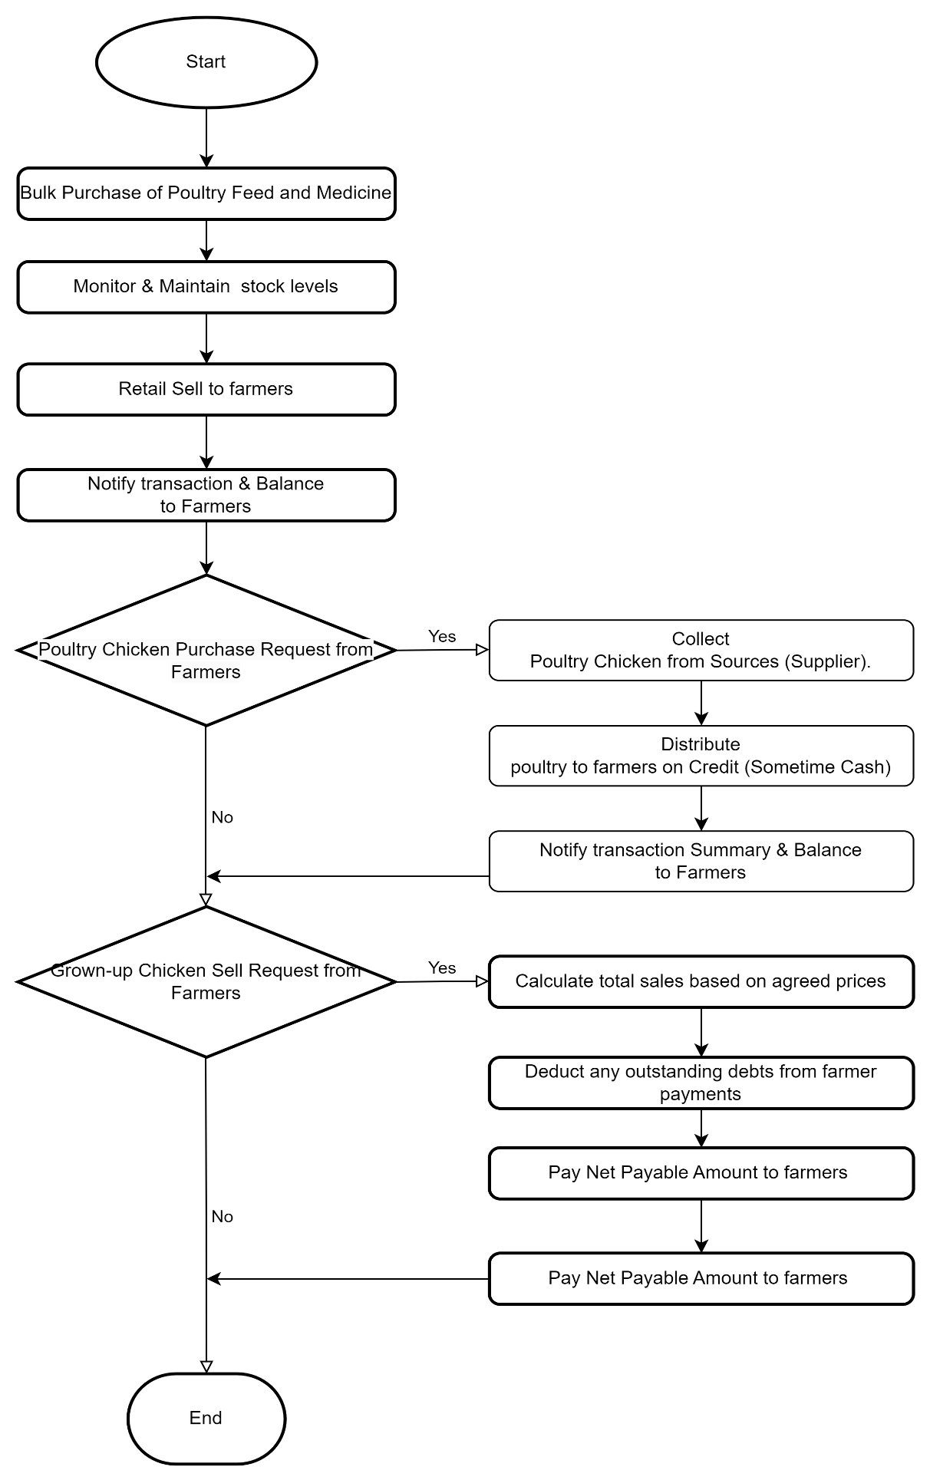

. In the masters project new nine featured added. in below feature wise flowchart is given.
For the masters Project below option is added

Project wise Feature:
In this feature , at first the user will configure different Projects. Configuration flowchart is as below
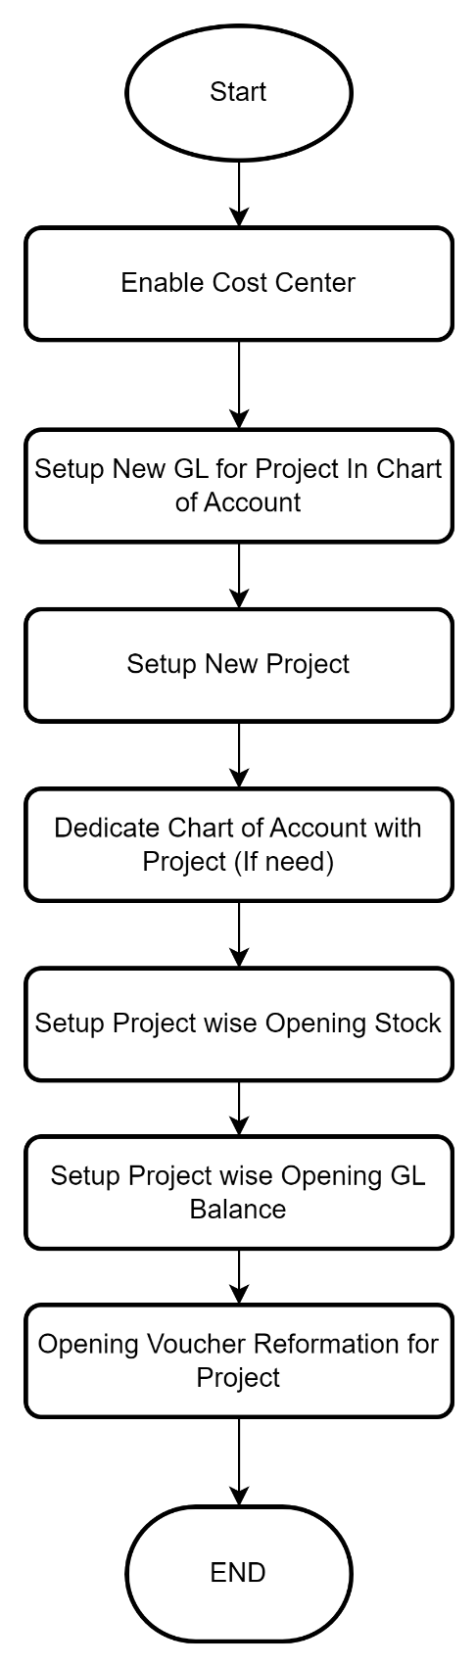
After configuration complete, For every operational entry (sales, Purchase , Collection,Payment income expense etc) user must select project. Flowchart is as below
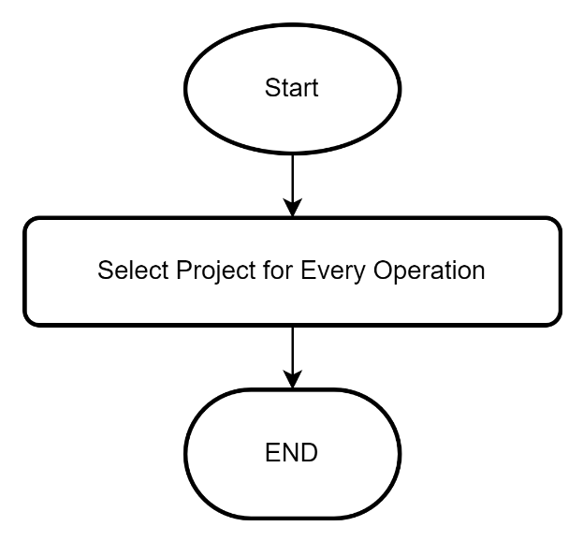

Warehouse feature:
In this feature warehouse wise product inventory will be managed. This feature’s flowchart is as below
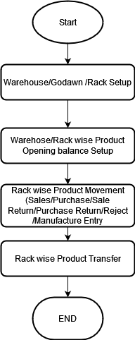
Barcode Feature:
Barcode feature will be work in tradesoft software according to below flowchart
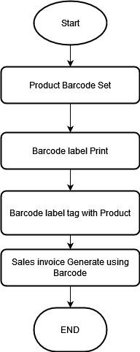
Product Expiry Information:
To reduce wastage and increase customer trust product expiry information feature keeps a great role. we planned product expiry information feature like below flowchart
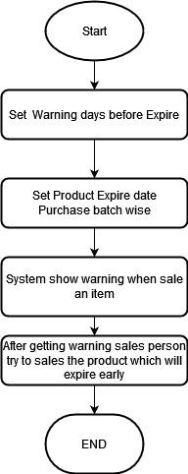

Product Optional Unit
For customer-centric transactions organization need different Unit. For example they purchase in ag and sale in piech. In our proposed software Product Optional unit work as like following flowchart.

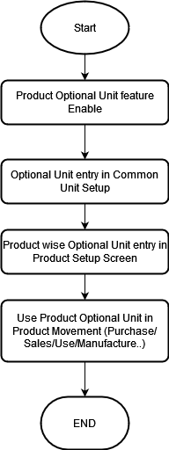
Manufacture Feature:
In the poultry Business , Some organizations need to produce feed. They use simple calculation .
In our software Manufacture feature ‘s flowchart is as below.

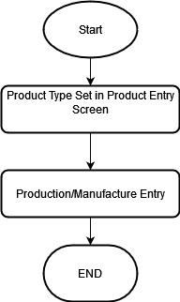
Group wise Product Search:
Sometimes Business organizations do not have the same medicine that customers want . but have the same group medicine . In that case Group wise product search features will be helpful. In our application , the Group wise Product search feature will work according to the flowchart below.
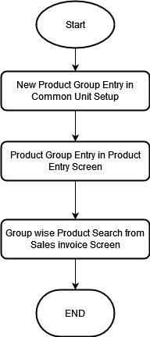
Cheque Management Feature :
Customer sometimes do transaction by Cheque instead of cash.In our propose plan cheque Management feature will work according to below flowchart
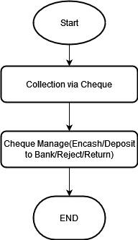
SMS Feature :
In our application SMS feature will be work according to below flowchart
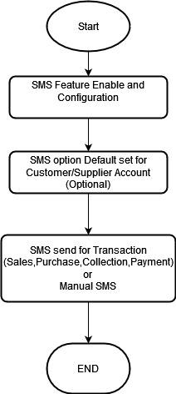

Product Screen
- Project wise Feature: for Project wise feature below screen is modified
1.1. In Setting A new Option “Cost Center” has been added. Its value is yes or No. If it set yes then the Project feature will be enabled.
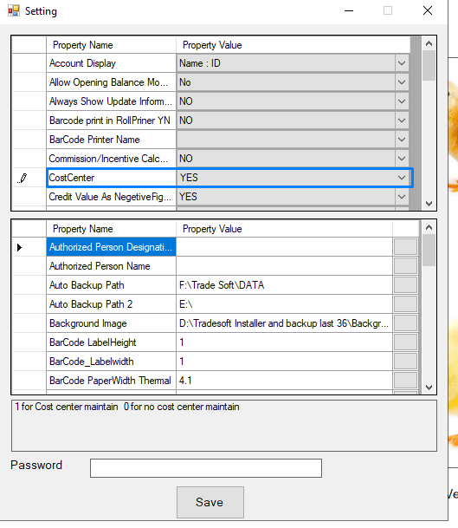

1..2 In the ChartofAccount new Account need to open for each Project.
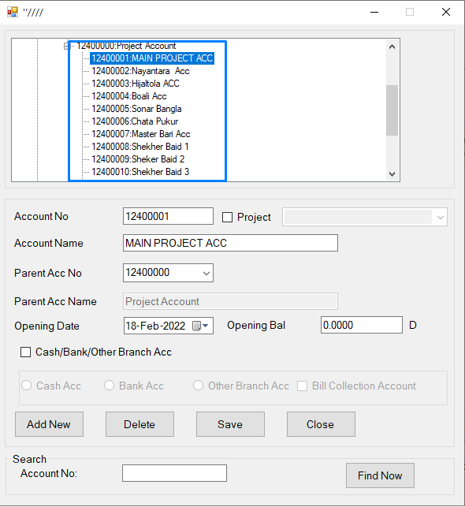

1.3 In the Project Setup screen New Project will be set. Each project there is a Project account.
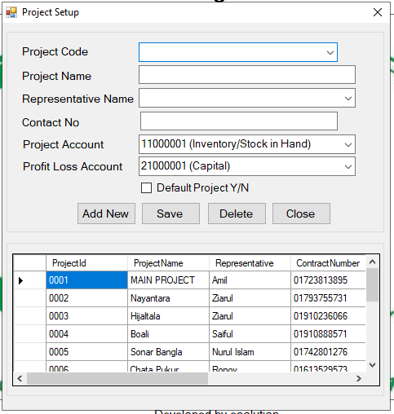
1.4 If user want to dedicate any account with a project then it can be dedicated in Customer Setup,Supplier Setup,Contact Setup and ChartofAccount Screen. In these screen a new field project has been added. Screens are as below.
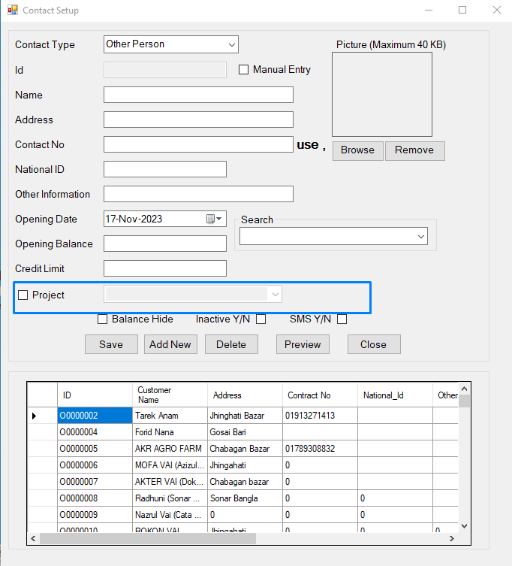
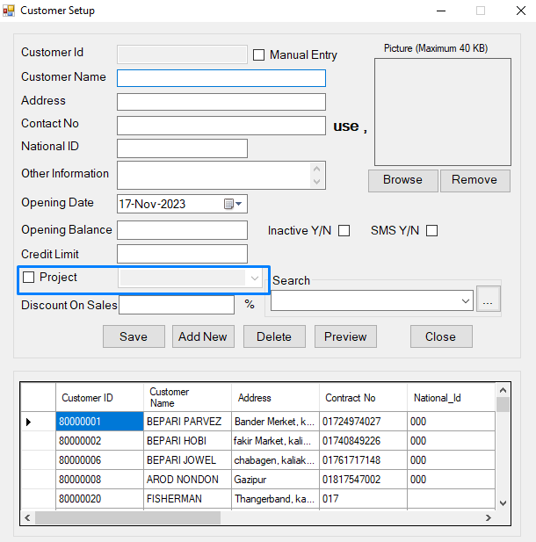
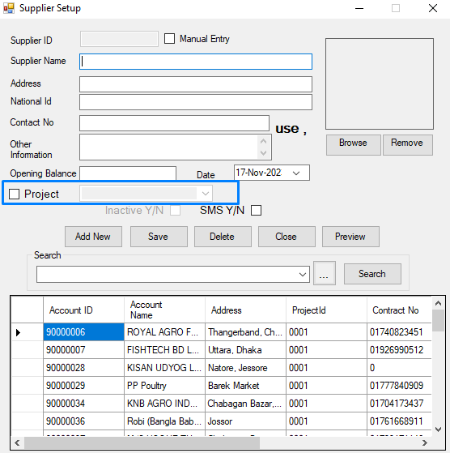

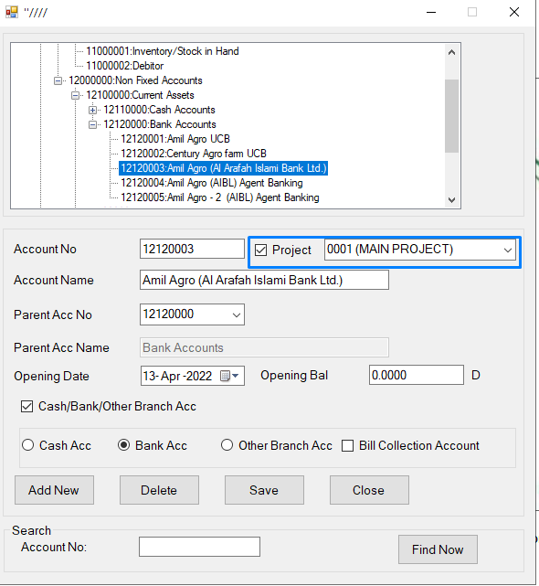

1.5 If user wants to dedicate any product with a specific product then it will be done by the Product Setup screen. A new field “Project ” has been added in the Product Setup Screen. Screen is as below.
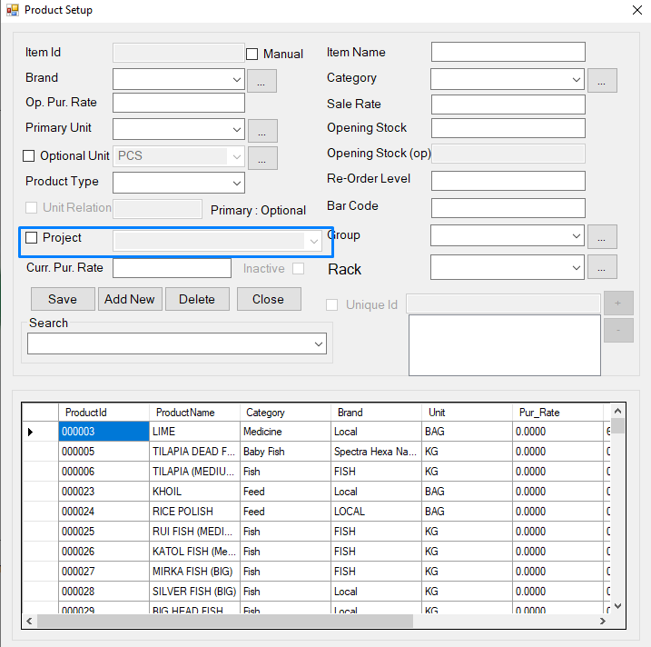

1.6 Project wise Opening Stock Setup
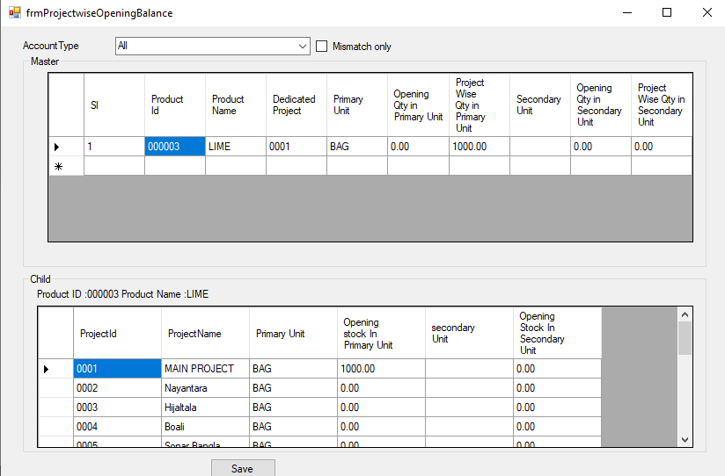

1.7 Project wise Account Opening balance is set in the following screen
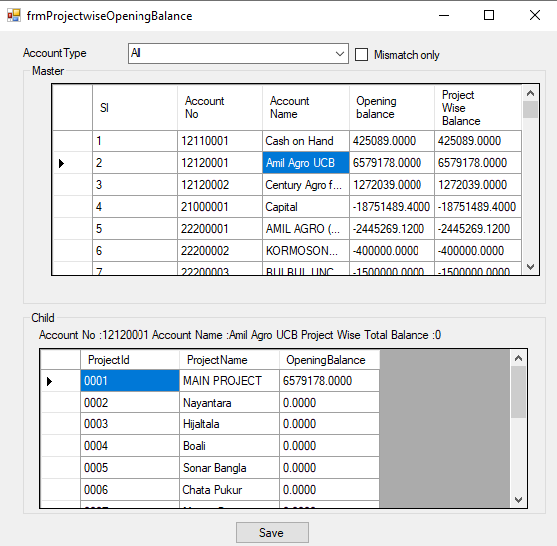

1.8 For Every Operation Project need to be selected.
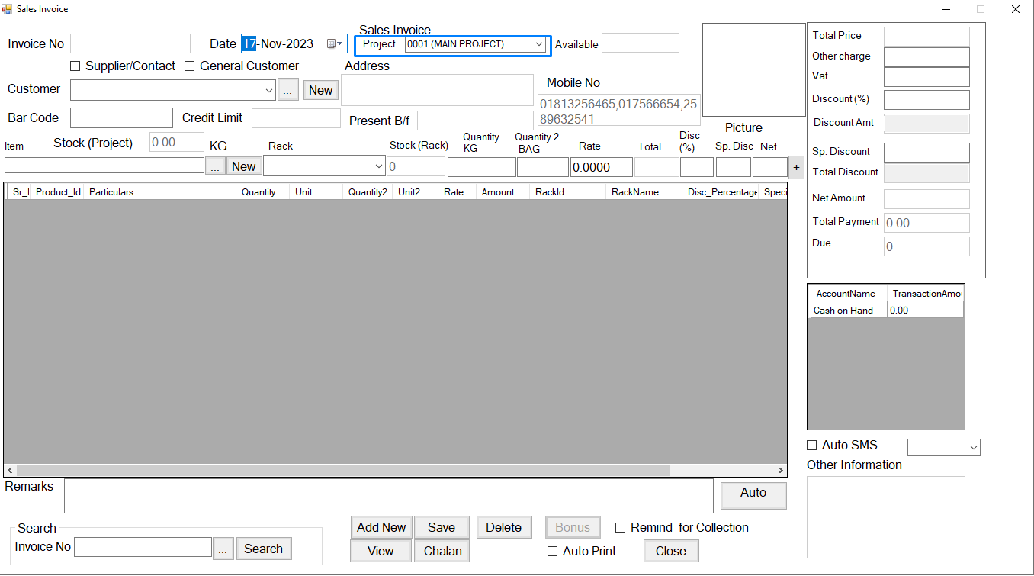

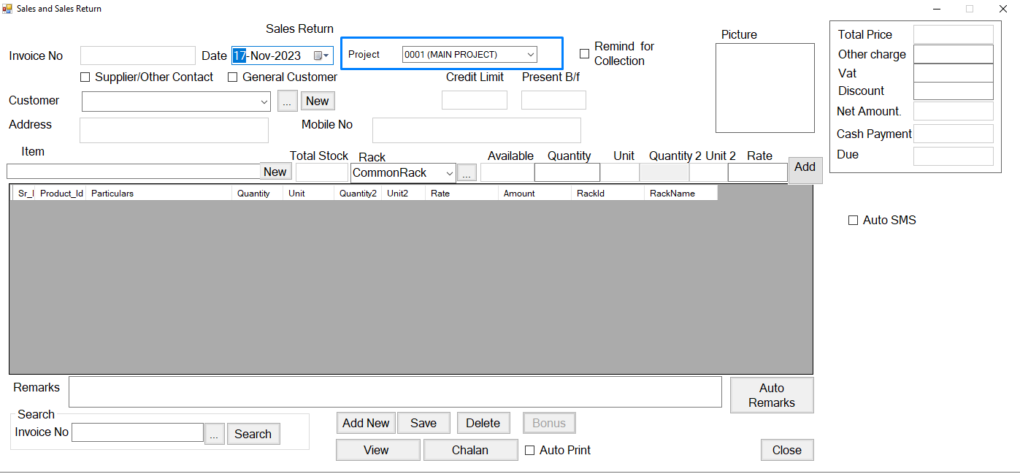

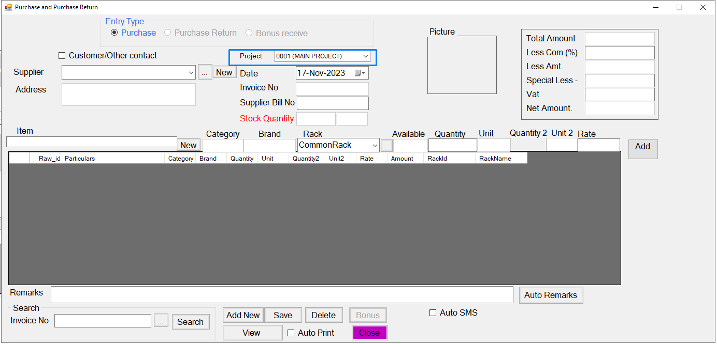

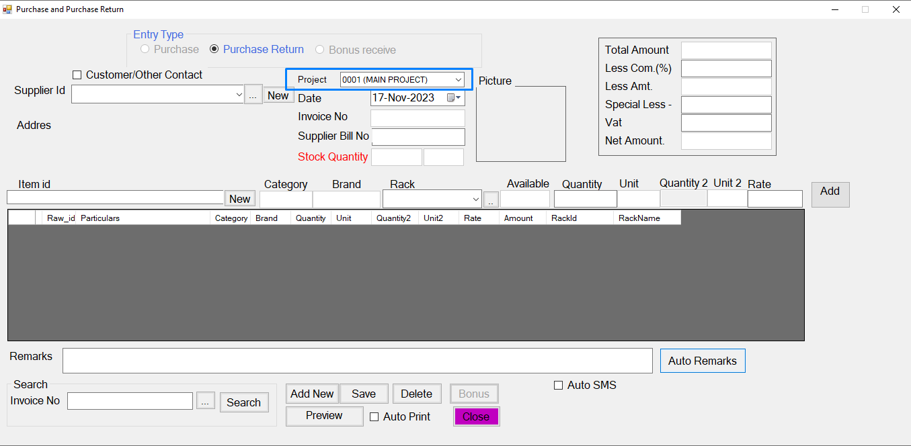

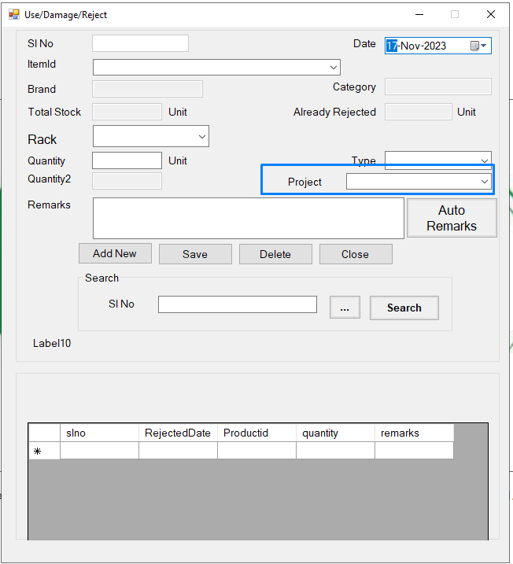

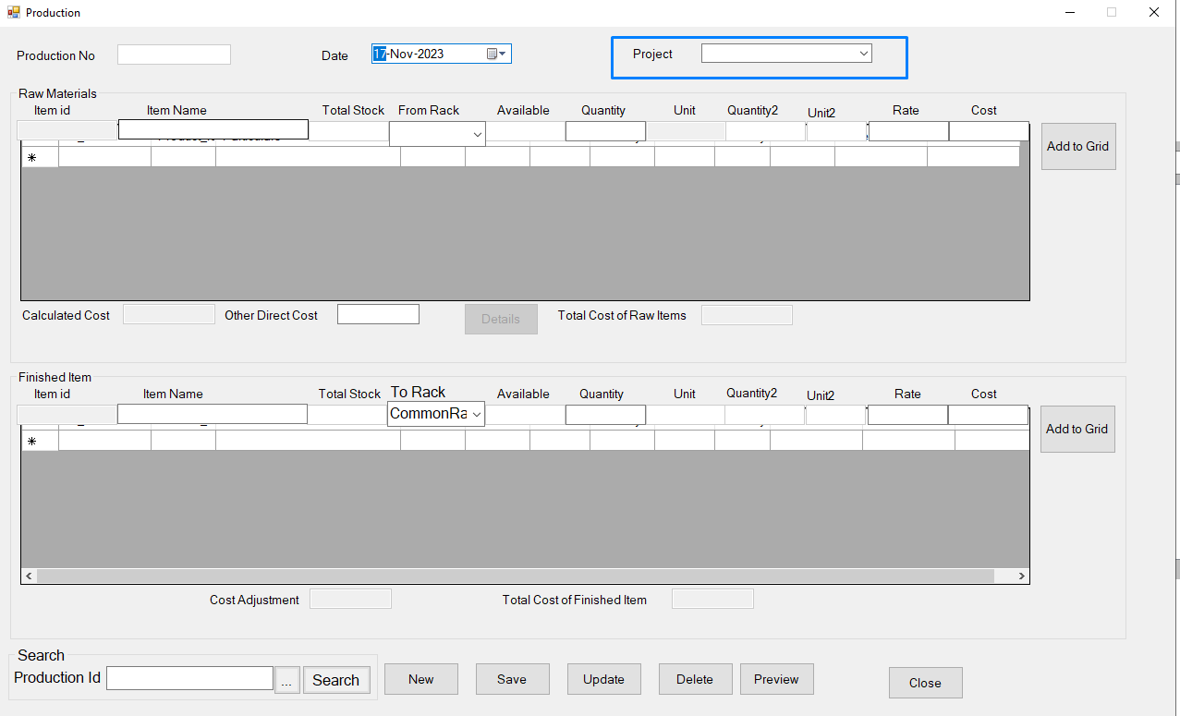

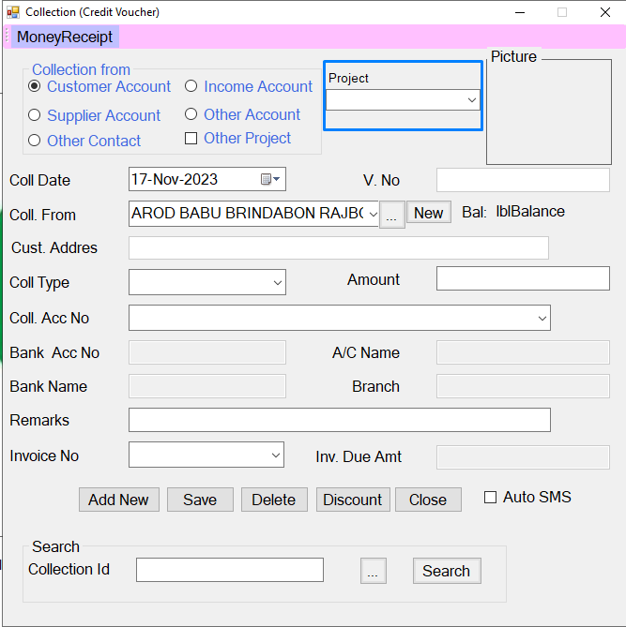

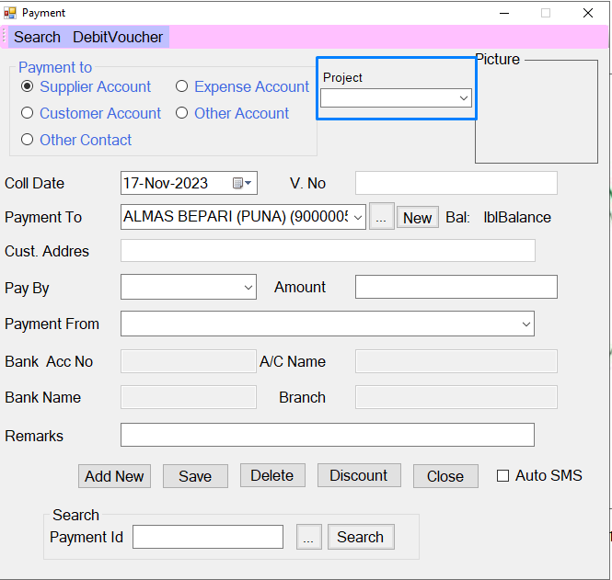

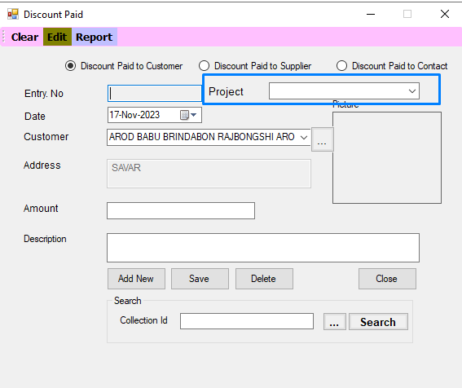

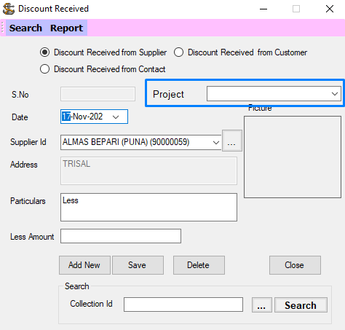
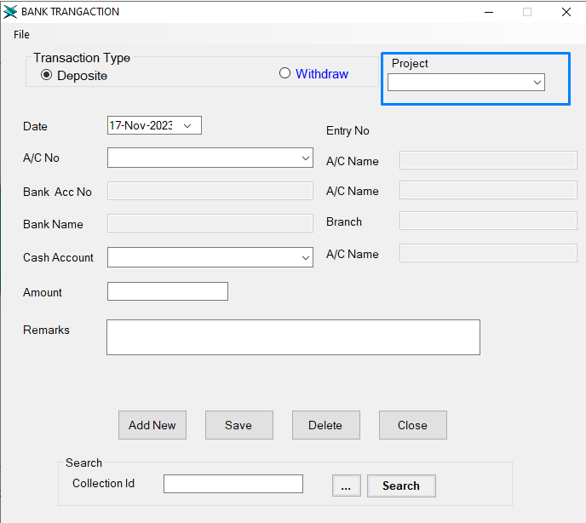

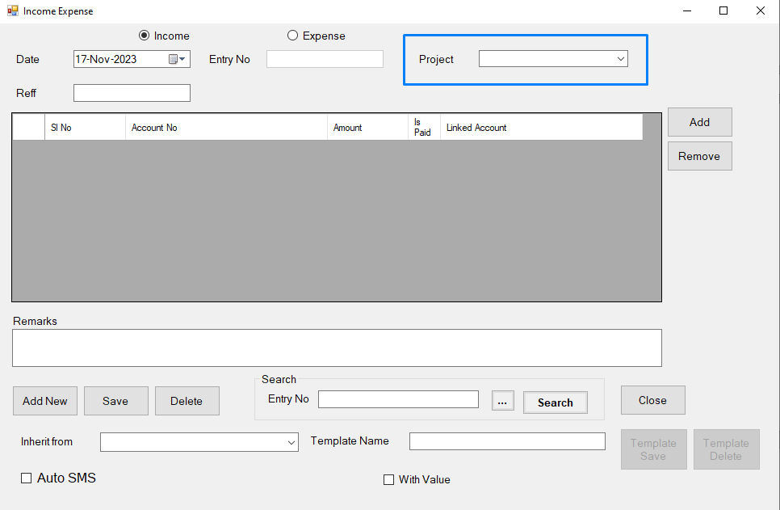

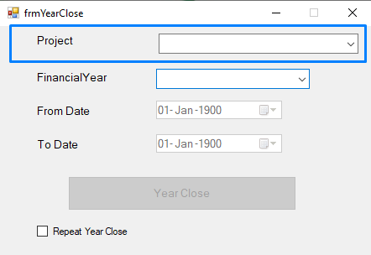

1.9 Report : All the Accounting Report (Transaction Report, Ledger Report, Trial balance,Income Statement and balance Sheet ) Reports can be previewed with Project wise or without Project wise.

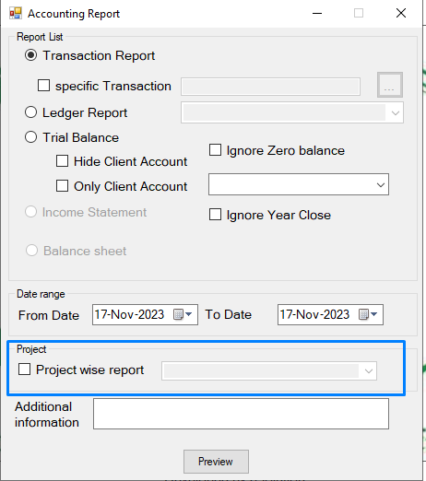

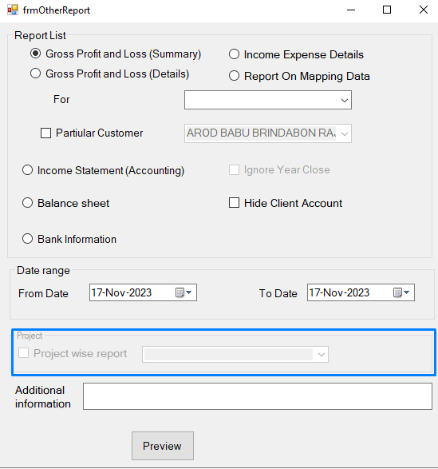

warehouse/Rack Feature :
for warehouse below screen are modified
2.1 New Rack Setup in Common Unit Setup Screen
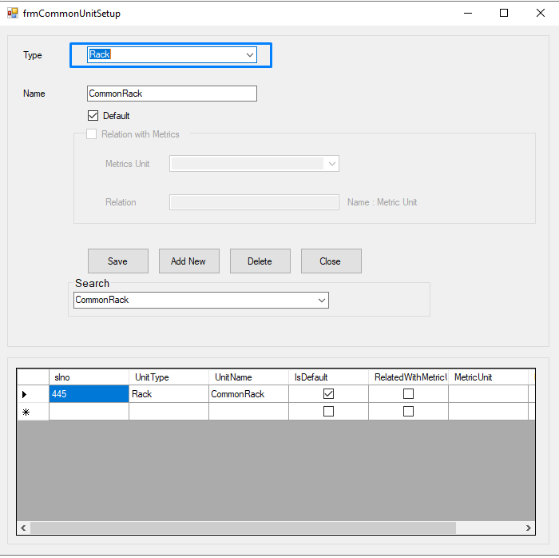
2.2 Product Setup screen Rack set for Opening Product Stock

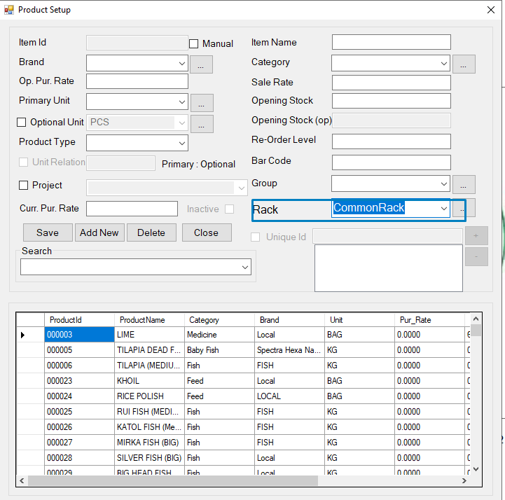
2.3 If the opening Product stock is in multiple rack then in the Rack wise Product opening Screen Rack wise product is set.

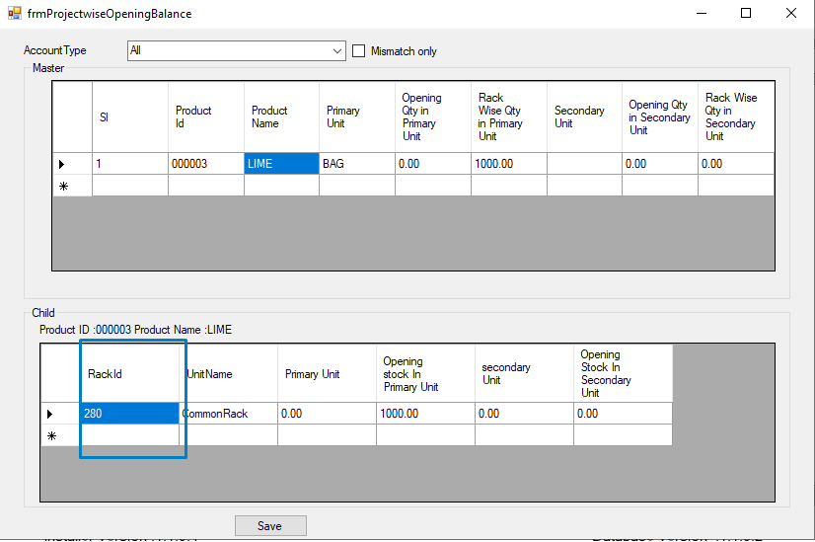

2.4 : In the product movement (Sales, purchase , Sales Return , Production ) Rack setup is mandatory
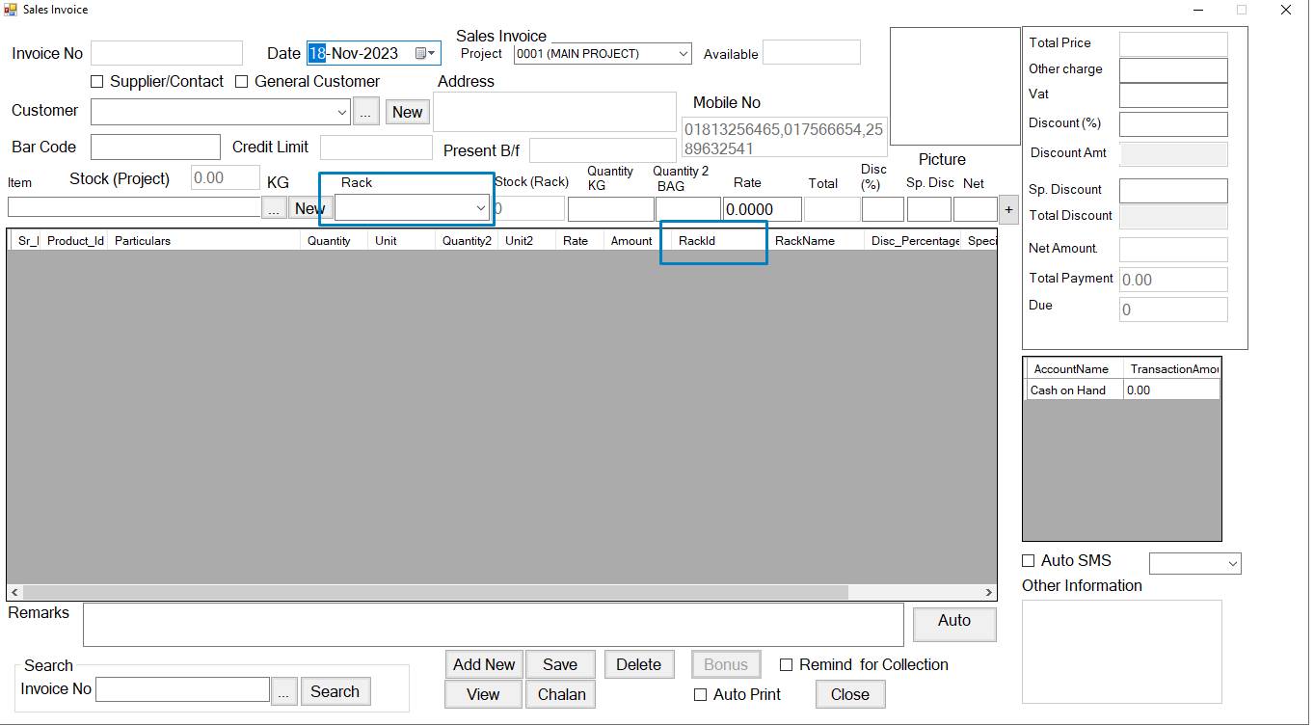
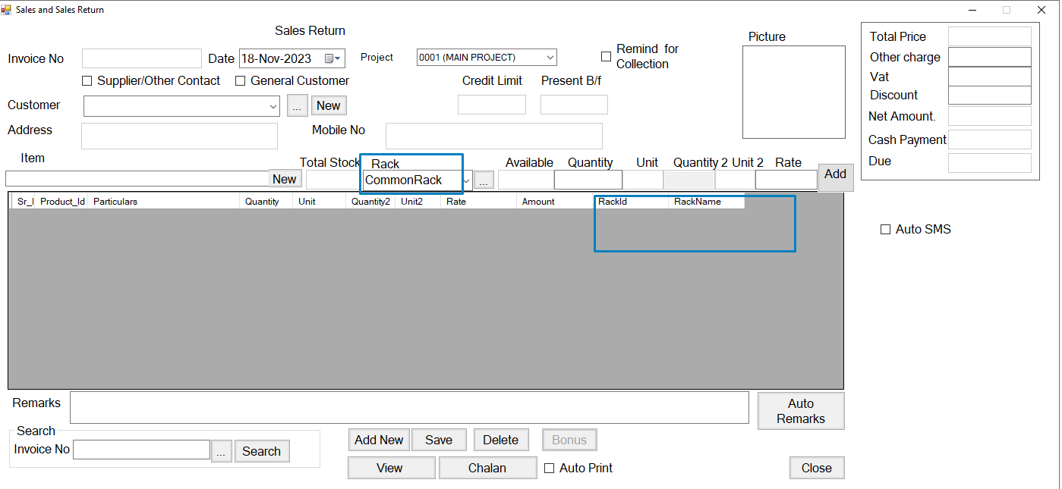

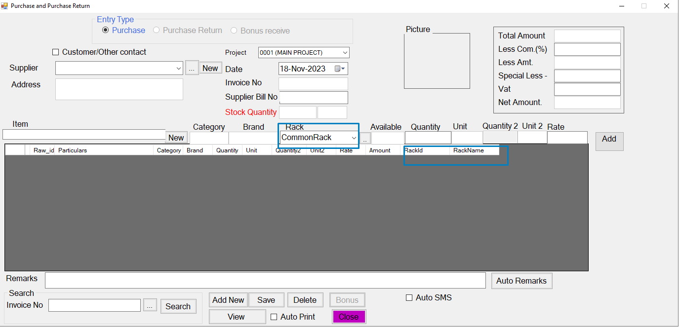

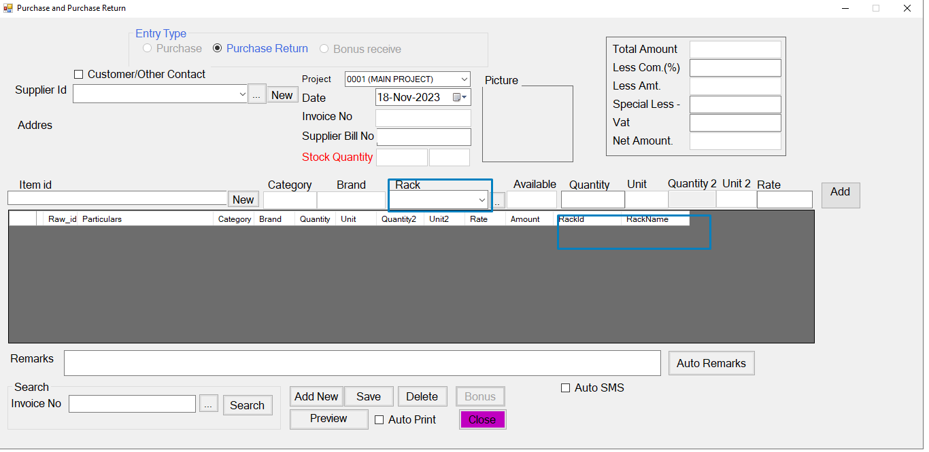
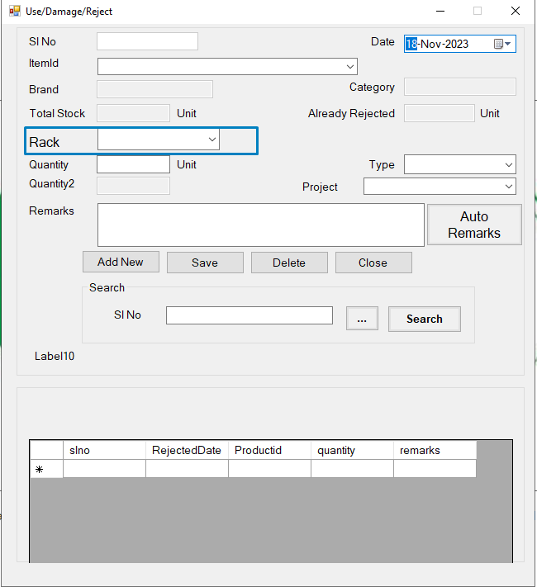

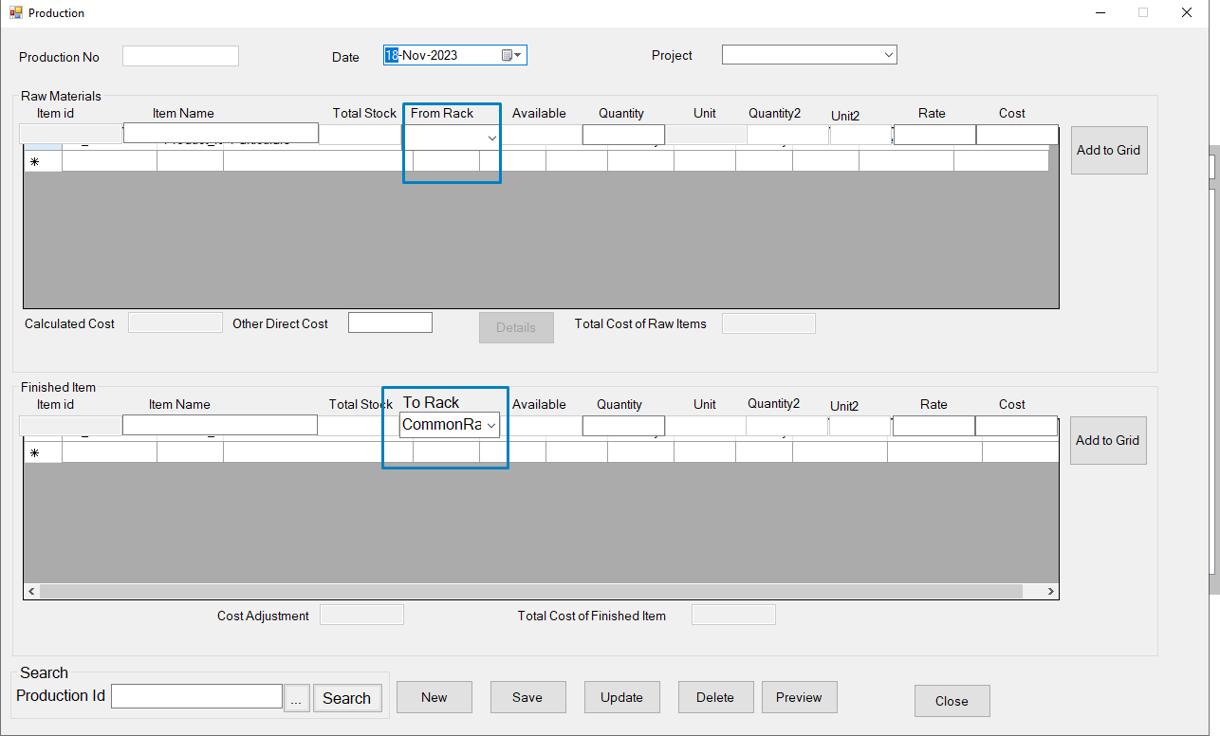

3. Barcode Feature:
For Barcode below screen are modified

3.1 In Product Setup Screen barcode is Set for each product
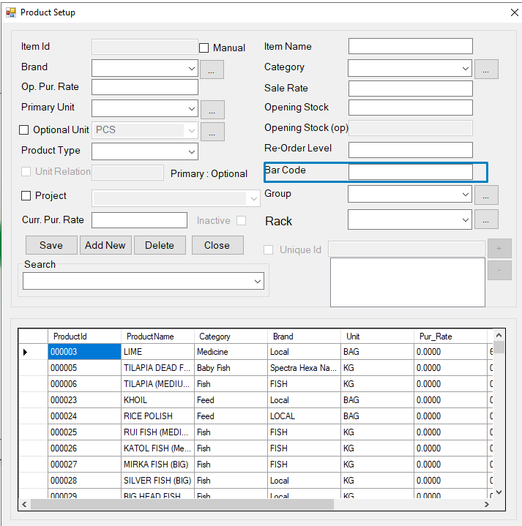

3.2 Barcode is printed from the Barcode Print screen

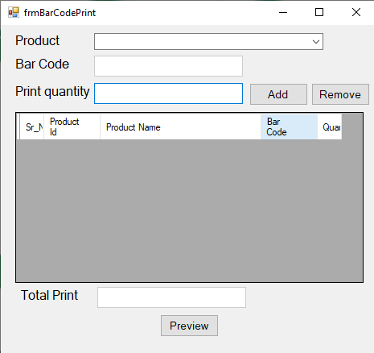

3.3 Barcode is used when Sales invoice is generated
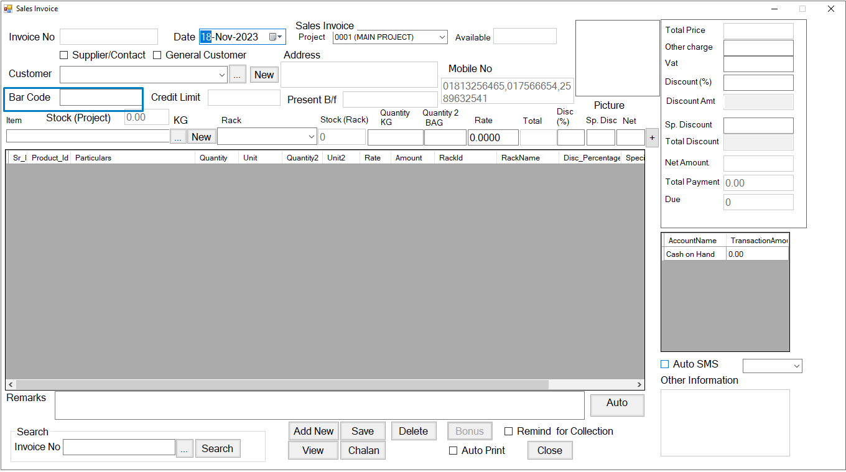

4 . Product Expiry Information
For Product Expiry Information below screen are modified

4.1 In Setting it will set how many days before of expire date system will give warning for expire.
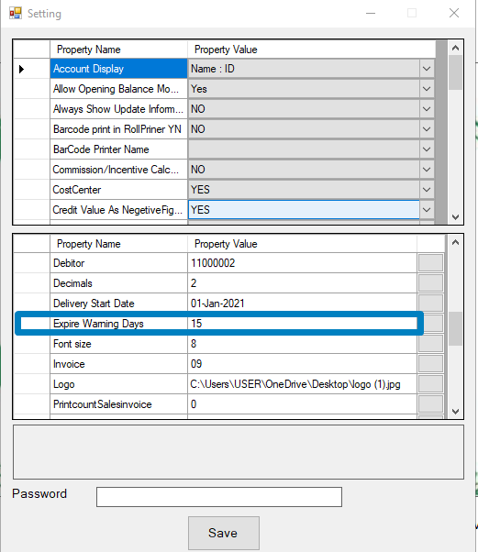

4.2 For every in entry of Product user will input product Expire information according to the batch in the Product Expire information Screen.

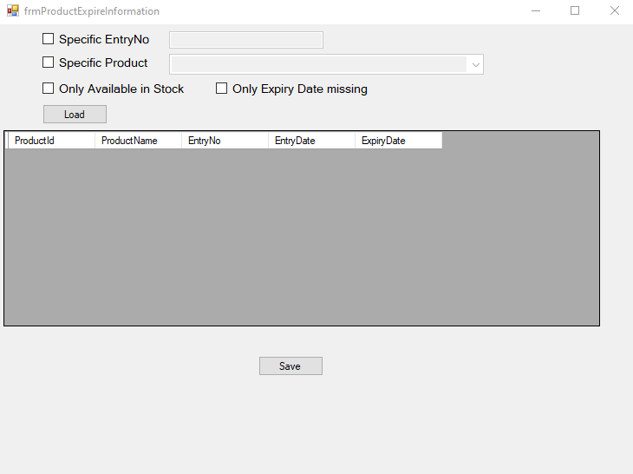

4.3 When sales system m will show the item in red color if there is any product that will e expire in next Expire warning days.

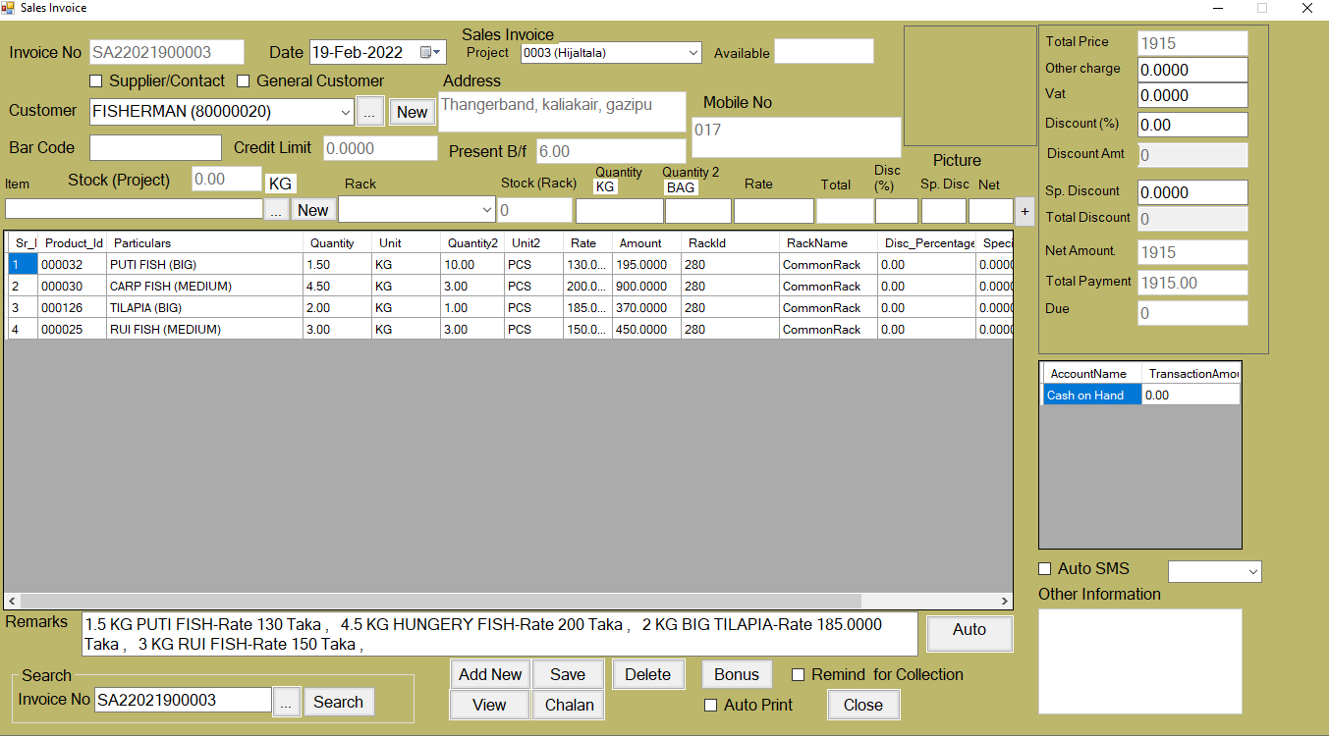

5. Product Optional Unit
for product Optional Unit below screen are modified
5.1 In Setting user will enable Product Optional Unit feature.
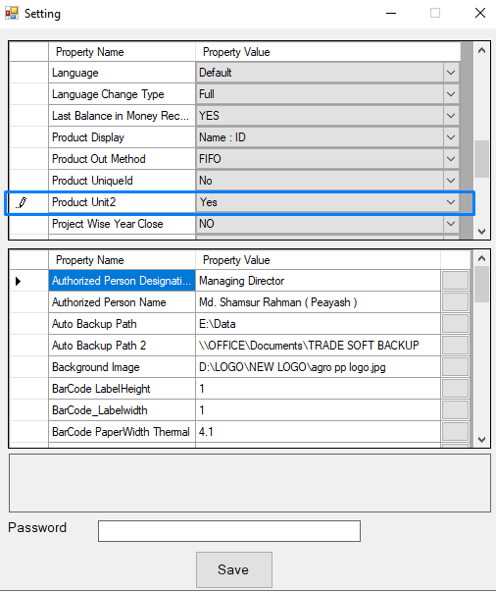

5.2 In Common Unit Setup user will input New Optional Unit. 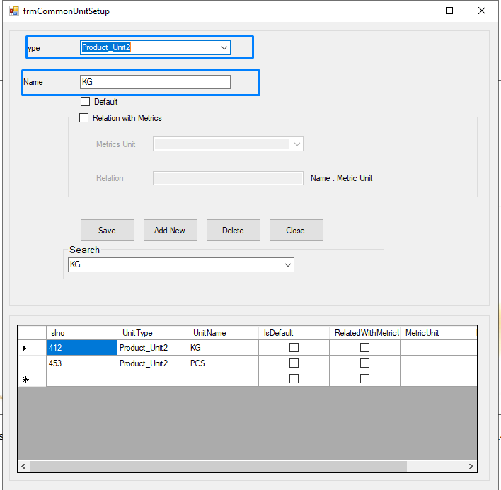

5.3 In Product Entry Screen user will input Product Optional unit information
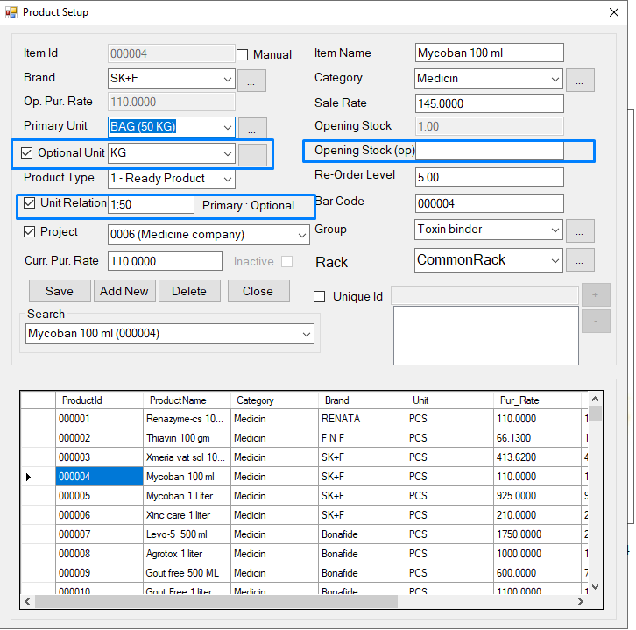
5.4 In Product Movement (Sales , Purchase Use, Manufacture Product Optional Unit will be used. 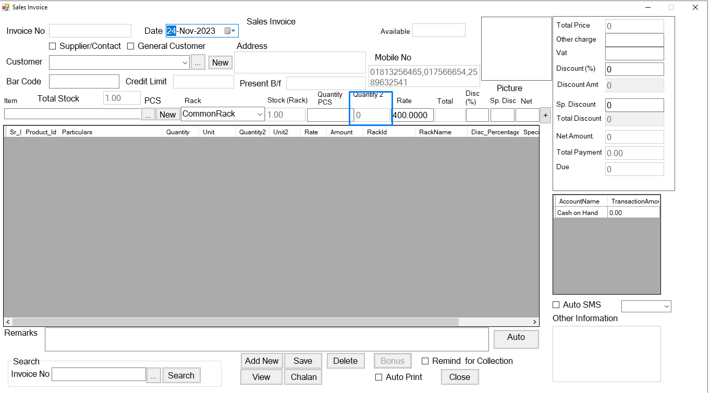

6. Manufacture Feature
For Manufacture below screen will be modified
6.1 In Product Entry Screen User will input the product type which will be used in Production/Manufacture screen.

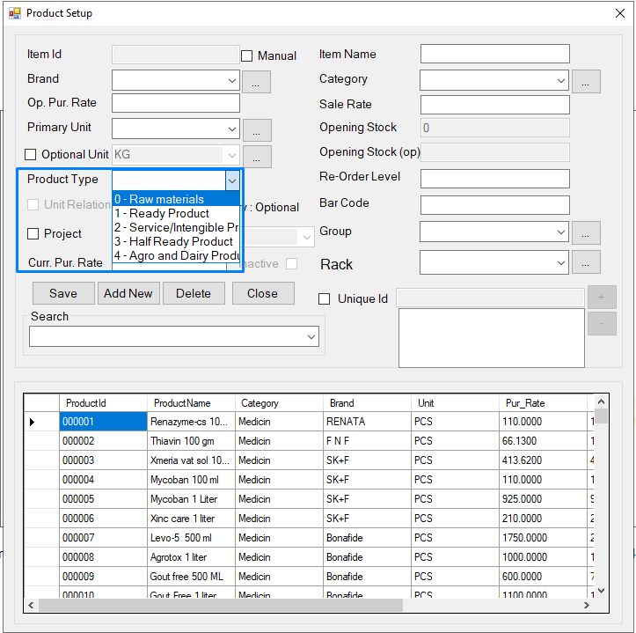

6.2 In Manufacture Screen User will input Manufacture/Production information

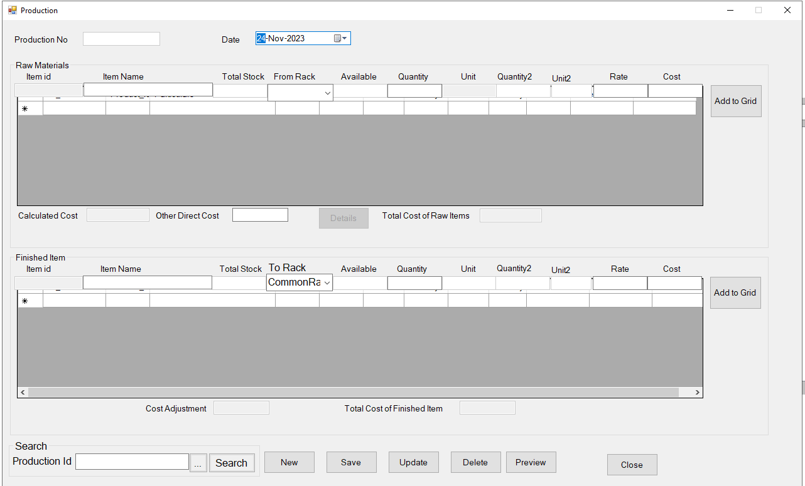
7. Group wise Product Search:
7.1 Group wise product Search screen
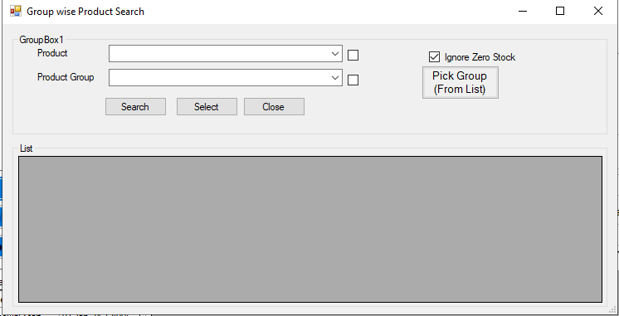
7.2 : In Product Setup screen Group option has een added

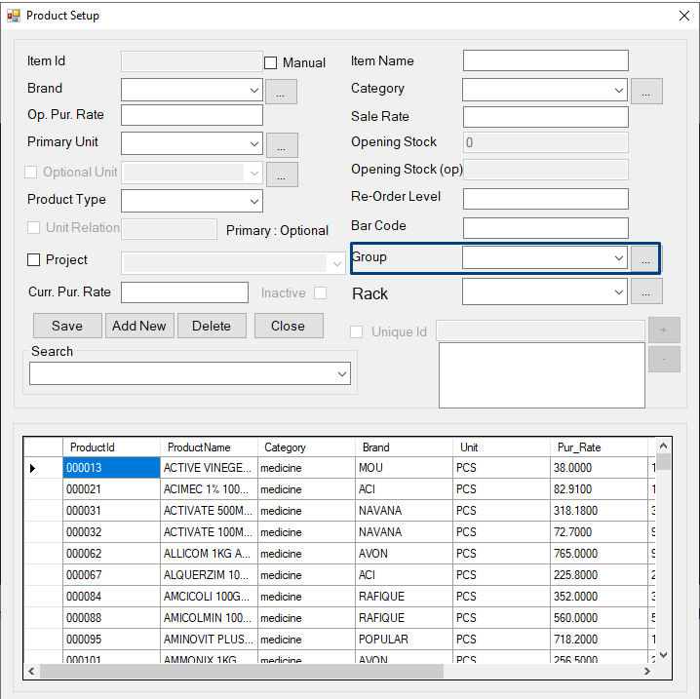

8. Cheque Manage

For Cheque Manage below screen are modified
8.1 When Collection Collection Type should be Cheque. Cheque related other information need to be inputted.

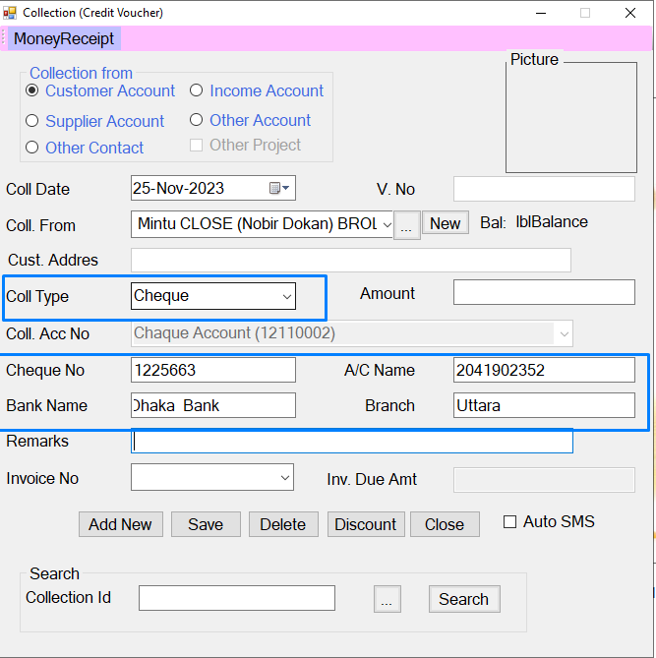

8.2 : In Cheque Manage Screen Cheque Encash\Deposit to bank or Cheque Return \Dishonor will be inputted

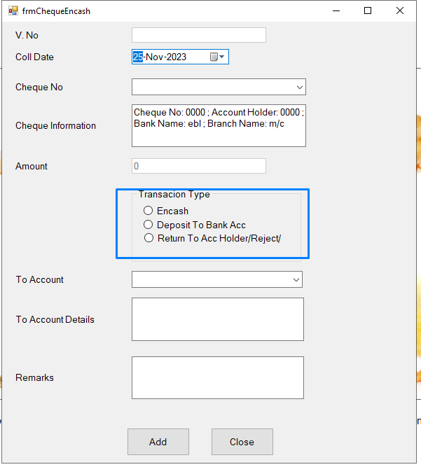

9. SMS Feature :
For SMS feature below screen is modified
In Setting SMS Feature need to on and related configuration is set
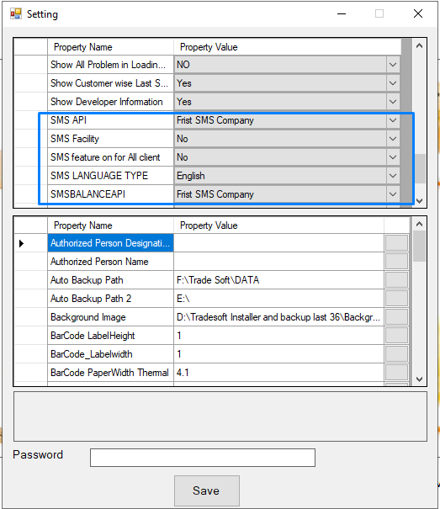
9.1 In Customer/Supplier /Contact entry screen SMS can e default set for specific Customer. It is optional.

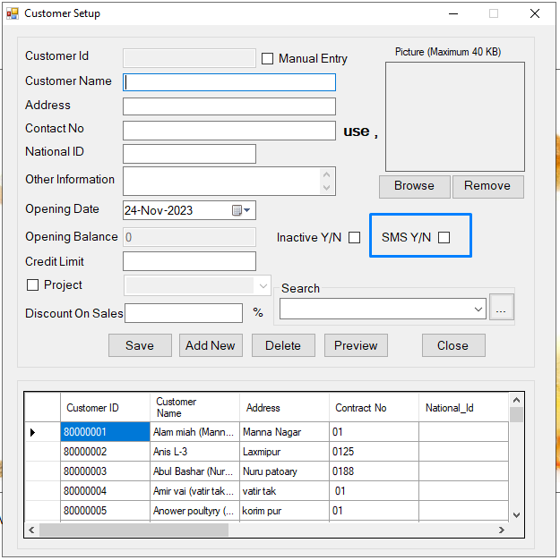

9.2 In Transaction (Sales , Purchase ,Collection,Payment ) SMS will automatically send to a related person.
9.3. There is a Manual Sms sending screen also.

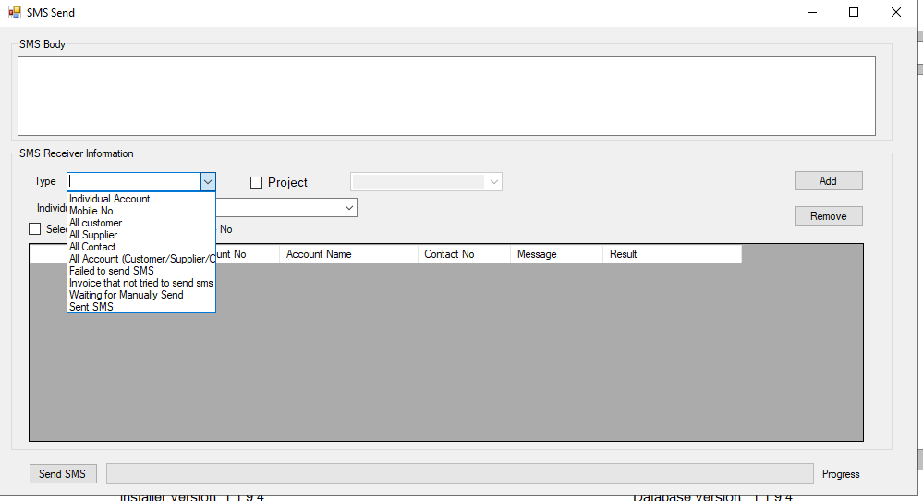

Report List

Report details are as below.
Accounting Report
1. Transaction Report
2. Ledger Report
3. Trial Balance
4. Income Statement
5. Balance Sheet
6. Report on Mapping Data

User Generated Report

17. Rack Wise Product Closing Stock
18. Rack wise Product Stock Mismatch
19. Project wise Stock Mismatch

Database Design

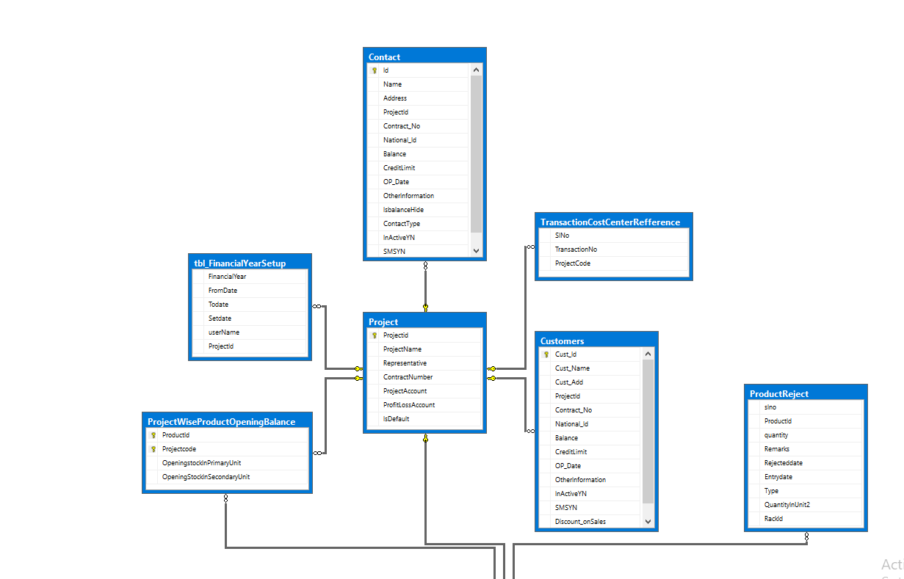

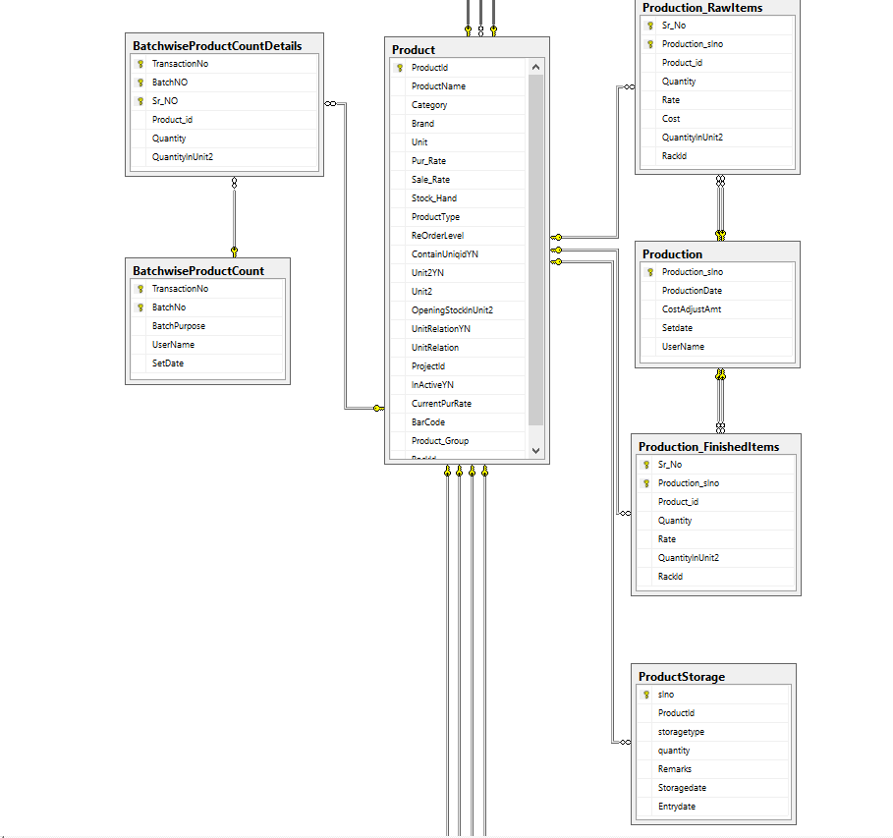

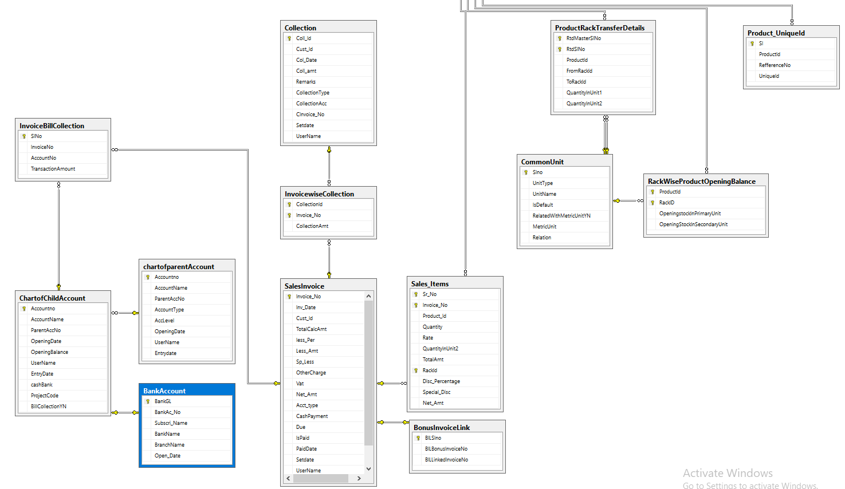

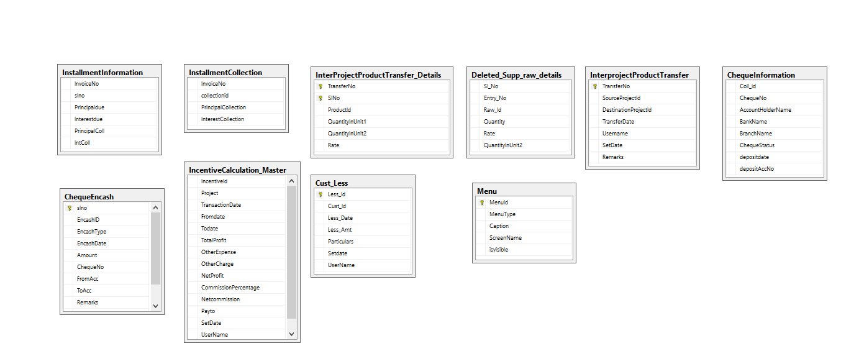

Chapter 5

Conclusion
In conclusion, the enhancements made to the existing Point of Sale (POS) system represent a significant leap forward, particularly in addressing the intricate needs of the poultry business. The poultry industry, with its unique challenges in feed production, egg and milk handling, and varied product categories, demands a tailored solution for efficient management. The implemented features, including project-wise tracking, warehouse optimization, barcode integration, product expiry tracking, optional unit additions, manufacturing process support, group-wise product search, cheque management, and SMS notifications, collectively contribute to the transformation of the POS system into a comprehensive toolset for poultry businesses.

The inclusion of manufacturing process support facilitates the meticulous handling of raw materials, ready products, half-ready products, and agro-based products, streamlining the complexities of poultry operations. This not only ensures precision in production but also aids in preventing stockouts and optimizing inventory control. The barcode integration significantly reduces errors in transactions, expedites checkout processes, and supports diverse pricing strategies, crucial for poultry businesses managing a wide range of products.

The project's focus on warehouse optimization and product expiry tracking addresses critical challenges in poultry inventory management. Efficient tracking of stock levels across multiple locations ensures scalability and order fulfillment efficiency. Simultaneously, the ability to manage product expiry information not only reduces waste but also instills customer trust by ensuring the freshness and quality of poultry products.

The incorporation of group-wise product search, cheque management, and SMS notifications elevates customer communication and transparency in poultry transactions. Customers can easily find alternative products within the same group, outstanding balances are managed seamlessly through cheque processing, and real-time SMS updates provide transparency, fostering trust and loyalty among poultry business customers.

Appendix A
Type or paste your appendices here. Appendices are a place to organize and include all of the “extra” material that is important to your research work but that is too detailed for the main text. Examples can include: specific analytical methods, computer code, spreadsheets of data, details of statistical analyses, etc. But, these materials do not speak for themselves. There should be a reference to these materials from the main chapters (complete details included in Appendix A) and there should be some text at the beginning of each appendix to briefly explain what the information is and means that is included in that appendix.

