Internship Report on
Walton Internal Audit Process

Sumaya Sultana

This report is submitted to the School of Business and Economics, United International University as a partial requirement for the degree fulfillment of Bachelor of Business Administration
i

Walton Internal Audit Process

Submitted to:
MS. Zinnatun Nesa Assistant Professor
School of Business and Economics

Submitted by: Name: Sumaya Sultana ID: 111 201 220
Major: Finance



United International University
School of Business & Economics

Date of Submission: 04/08/2025

Letter of Transmittal

August 2, 2025 MS. Zinnatun Nesa
Assistant Professor, SoBE School of Business & Economics United International University Madani Avenue, Dhaka
Subject: Submission of Internship Report on “Walton Internal Audit Process”.

Dear Ma’am,
It is my pleasure to submit an internship report entitled “Internal Audit Process of Walton BD” to you with due respect, which has been prepared in partial fulfillment of the requirements of the Bachelor of Business Administration (BBA) program from United International University.
This is a report with the aggregation of my overall knowledge and experience in the Walton Group BD. This report is based on my 6 months of working experience and contains the audit process that the internal audit of Walton has been following. I did my best to endeavor to keep the most accurate, relevant information possible.
Thank you for your guidance, constructive feedback, and ongoing support in this journey.
I trust you will receive this report in a spirit of goodwill.

Sincerely yours,
…………
Sumaya Sultana
ID: 111 201 220
School of Business and Economics (SoBE) United International University

Certification of Similarity Index

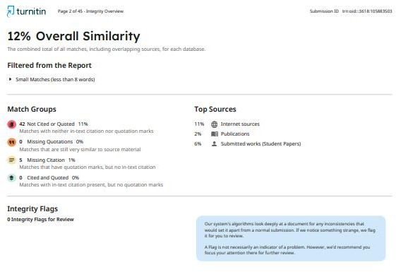

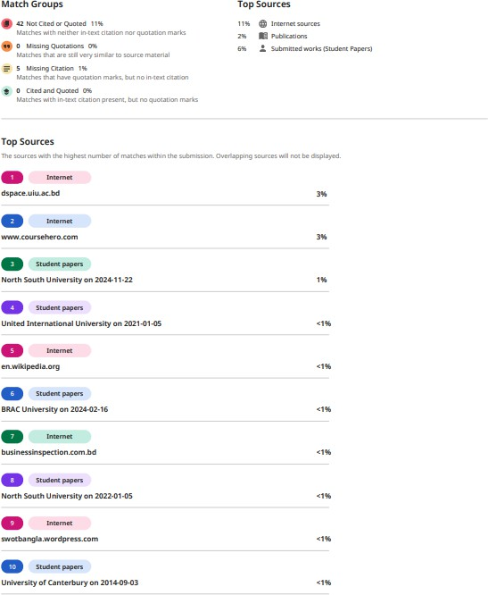

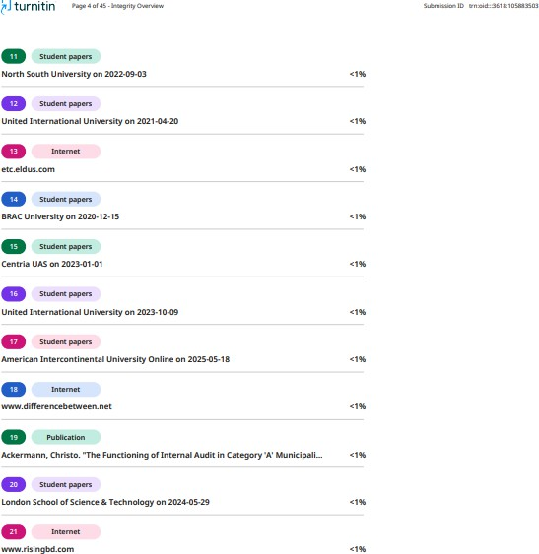

Declaration of the student

I, Sumaya Sultana, hereby declare that this report on “Walton Internal Audit Process” is fully prepared by me and submitted as a part of the academic requirement for the degree of Bachelor of Business Administration (BBA).
I am also confirming that this report has been prepared based on my research, findings and experiences while working as an intern at Walton BD. This report doesn’t contain any previously published material or written by a third party. I am ensuring that this report has not been submitted for any other university, degree, or any other academic purpose.

……………………… Sumaya Sultana ID: 111 201 220
Department of Business Administration United International University
……………………… MS. Zinnatun Nesa Assistant Professor, SoBE
Department of Business Administration

Acknowledgment

First, I would like to express my cordial gratitude to my honorable internship supervisor Ms. Zinnatun Nesa Ma‟am. She has allowed me to complete an Internship Report on “Walton Internal Audit Process" and her continuous support and supervision. Without her constant help and guidelines, it would not be possible for me to complete this report. Also, the Department of Internal Audit & Compliance and the Department of HR gave me the opportunity to complete my internship in their company and I really appreciate that.
I am thankful to the head of the Internal Audit & Compliance Department, Mr Yeasin Sir, who helped me and guided me during my internship period. I would like to thank Mr. Mohon Uddin Siddque who is the Dept. head of the Department of Internal Audit & Compliance. He also helped me in my fieldwork. They have supported me from the very first day of my internship day. During my internship period, I got helpful advice from many people in the Union Group. They shared their experiences & their valuable ideas to me so that I can make this report and I can do better in my Job life. I really appreciate them for helping me to make this report. They showed me how to use the information in my report. I am glad that I got the opportunity to work among those experienced persons. I am really thankful to all those people who helped me during my internship period

Executive Summary

This research explores Walton Plaza's internal audit and compliance structure, carefully examining its crucial role in guaranteeing operational effectiveness, strong risk management, and strict regulatory adherence in Bangladesh's vibrant retail electronics industry. The renowned retail chain Walton Plaza, which is a part of the prestigious Walton Group, has developed an advanced internal audit system that is carefully planned to support its overarching business objectives, foster an accountable culture, and unwaveringly uphold stakeholder trust. The study emphasizes how the business has carefully implemented a risk-based audit methodology, which is essential for assuring complete regulatory compliance, maximizing operational efficiency, and maintaining financial accuracy. The careful application of established audit procedures, complete compliance checklists, regular and in-depth reviews, and ongoing employee training programs are examples of key operating practices. I gained extensive practical knowledge in key areas such advanced data analysis techniques, systematic compliance monitoring, and practical auditing procedures during my intense internship in the Internal Audit and Compliance Department. In the end, Walton Plaza's strong internal auditing system greatly improves organizational transparency, proactively reduces possible risks, and establishes a model for Bangladesh's cutthroat electronic retail market. This study demonstrates how Walton Plaza's steadfast commitment to internal auditing not only increases operational efficiency and transparency but also painstakingly sets a new standard for auditing practices throughout Bangladesh's electronics sector.

Table of Contents

Letter of transmittal i
Certification of Similarity Index ii
Declaration of the student v
Acknowledgment vi
Executive Summery vii
Table of Contents viii
List of Figures x
Chapter 1: Introduction 1
  - Background of the report: 1
  - Origin of the report 1
  - Rational of the report: 2
  - Methodology: 2
  - Scope and limitation of the report 3
Chapter 2: Company Overview & Industry Preview 4
  - Company Analysis 4
    - Company Background 4
    - Key People 5
    - Mission 6
    - Vision 6
    - Values 6
    - Corporate Culture 7
    - Objectives of Walton 7
    - Way of Business Operation 7
    - Products/Services Offered by Walton 7
    - Operational Units of Walton 10
    - SWOT Analysis of Walton Group 12
  - Industry Analysis 14
    - Industry Scenario of Electronic Manufacturing Retail Company 14
    - Size, Trend, Maturity of Industry 15
    - SWOT Analysis: 16
Chapter 3: Internship Experience 19
  - Knowledge Acquired 19
  - Audit Procedure Experience 20
  - Skill Development: 21
Chapter 4: Theory of Audit Process & Internal Audit Process 22
  - Audit Theory 22
    - Definition & root of auditing 22
    - GAAS (Generally Accepted Auditing Standards): 22
    - Types of Audits 23
    - Difference and relation Between Internal Audit & External Audit 23
    - Audit Process 24
  - Internal Audit Theory 26
    - Define Internal Audit: 26
    - Internal Auditor: 27
    - Internal Audit process: 28
    - Internal Audit & Agency Problem 29
    - Walton Internal Audit 29
    - Chain of Command of Internal Audit department 32
Chapter 5: Session with Internal Audit Personnel 35
Chapter 6: Conclusion & Key Factors 39
  - Findings 39
  - Recommendations 40
  - Conclusion 42
References 43
Appendix 45
Session Checklist: 45
Evidence of Session and permission to use the above information 45

List of Figures

Figure 1: History of Walton 5
Figure 2: Alhaj SM Nazrul Islam the founder and his five sons 6
Figure 3: Managing Director of Walton (SM Mahbubul Alam) 6
Figure 4:Product Offered by Walton 8
Figure 5: Organizational Structure of Walton 9
Figure 6: Fixed asset schedule of a Plaza 31
Figure 7: Yearly performance Graph 32
Figure 8: Organogram of Internal Audit 34
Figure 9: Walton conference 2019, Gazipur 38

Chapter 1: Introduction

Background of the report:
Internal audit and compliance are critical components of an organization's governance framework, ensuring operational efficiency, financial accuracy, and regulatory adherence. As businesses grow and diversify, maintaining robust internal controls and compliance mechanisms becomes increasingly essential to mitigate risks, enhance accountability, and safeguard the organization's reputation.
Walton Plaza, a prominent retail chain in Bangladesh, operates in a highly competitive and regulated environment. With its extensive range of consumer products and services, the company requires a well-structured internal audit and compliance system to monitor its operations effectively. This system ensures that the organization adheres to its internal policies and external regulatory requirements while achieving its strategic objectives.
The study on Walton Plaza‟s internal audit and compliance framework is conducted as part of an internship program to understand the company's governance practices, identify gaps, and explore opportunities for improvement. The focus lies on evaluating the effectiveness of the internal audit processes, risk management strategies, and compliance measures implemented by the company.
By examining Walton Plaza‟s approach, this study aims to contribute valuable insights into how internal audit and compliance frameworks can support businesses in maintaining transparency, operational efficiency, and regulatory conformity in a dynamic business environment. This study also serves as a learning opportunity for the intern, providing practical exposure to real-world corporate governance practices.

Origin of the report:
This report is a process to complete BBA in finance under the School of Business & Economics, United International University. I completed my internship in Walton BD under the Department of Internal Audit & Compliance. It was a 6 month‟s‟ time period of the process. I made this report on the basis of the knowledge that I have gained from

Walton BD (Under their plaza section) while I was an intern. I think my internship report will fulfill the condition that is required to complete the Bachelor of Business Administration.

Rational of the report:
An auditor examines financial records of every fiscal year of an organization. We will learn from this report how an auditor audits an organization‟s operation and financial matter. This report will reflect the procedure they maintain and the odds they face during audit. This report will guide a proper knowledge about a standard audit.

Methodology:
I used a mix of research methods for this report, mainly focusing on what I saw and learned firsthand.

Primary Data Collection:
    - Direct Observation: As an intern, I watched daily operations, meetings, and audits, learning how things are done in practice.
    - Active Participation: I helped with tasks like checking documents, analyzing data, and doing "mystery shopper audits (BIB audits), which gave me a deep understanding of each step.
    - Informal Talks: I had regular discussions with senior auditors and team members, which helped me understand processes and challenges.
    - Formal Talk: I had a session with the Deputy Department Head, during which I got information.

Secondary Data:
    - Company Documents: I looked at available company reports and audit checklists to understand their official procedures.
    - Online Sources: I gathered information about the Walton Group's history and business from their websites.
    - Academic and Industry Materials: I read articles about auditing and the retail industry to put my observations into a broader context.

Scope and limitation of the report:
Scope: I am in the Internal Audit & Compliance department, so I got the first-hand knowledge and experience about auditing and audit reports, and procedure. Through I learned that an audit report is a very important document for an organization. And there are some procedures for the preparation of an audit report.

Limitation:
    - Confidentiality: I couldn't access all sensitive financial details or internal audit reports due to company privacy rules.
    - Limited Management Insight: I mostly interacted with my direct supervisors, so my understanding of top-level audit strategies might be less complete.
    - Specific Focus: My work mainly focused on retail plaza audits and sales. I had less exposure to auditing other areas like manufacturing or supply chain.

Chapter 2: Company Overview & Industry Preview

Company Analysis

Company Background
Walton Group has started its journey at 1977 and the founder, S.K. Nazrul Islam had taken the step of starting such brand. Walton is known as the largest multinational electrical & electronics manufacturing Corporation in Bangladesh. S.K. Nazrul Islam started his career by starting a small business. But after liberation war, he initiated a new company called R.B. group by selling imported products (Television). In 2008, they started manufacturing refrigerator by their own and selected a new name called “Walton Group” for that company. After few years at 2017, S.K. Nazrul Islam died and his eldest son S.M Nurul Alam Rezvi took over the responsibility as a chairman of the company.
Walton established their factory for the first time at 2017 with only a compressor manufacturing building at Chandra, Gazipur, and Dhaka. In 2018, they add up a computer assembly plant. They started exporting local laptops in Nigeria for the first time in the history of Bangladesh. And gradually they started exporting different products in different countries like mobile set, refrigerator et cetera.
Walton as the first Bangladeshi giant manufacturing plant attained the rights of more than 50-years old reputed three European electronics brands and its production plant, a trademark, patent, design and software. After that, at 2022, Walton group initiated to develop a research and development center in South Korea.
The core reason behind the fast success of Walton Group is variation of products, customized design of different products as per demand of various customer segment.

Walton & Marcel together raised to be a popular and trusted brand because of their product line, quality, policies, reasonable pricing, strong distribution network, after sales services et cetera. Both brands took the significant place in the electrical manufacturing industry. They got a major market share for their different products. Their most popular product is refrigerator which has 75% share in refrigerator market.

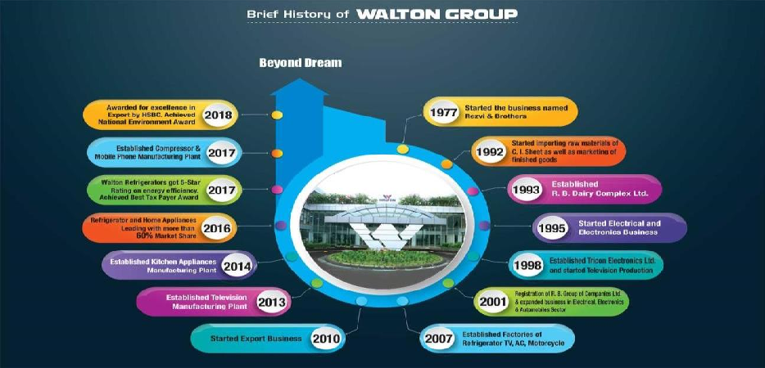

Figure 1: History of Walton

Key People

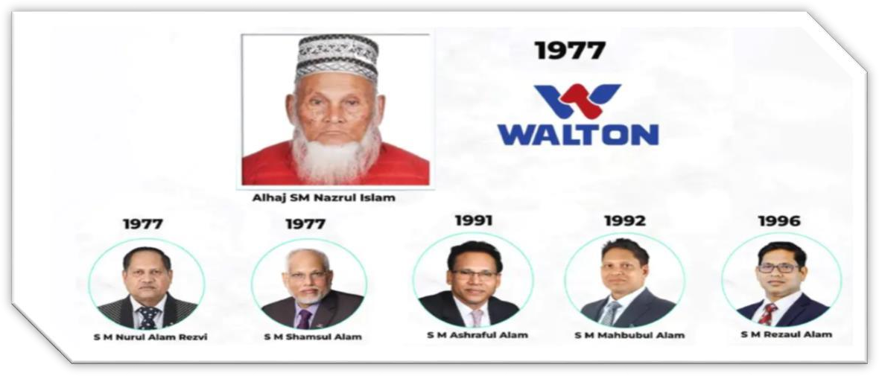

Figure 2: Alhaj SM Nazrul Islam the founder and his five sons

Figure 3: Managing Director of Walton (SM Mahbubul Alam)

Mission
Being updated and innovative with the changing demand of the market and consumer behavior. Responding to the changing customer demand by inventing new features, updating quality and services maintaining top standards.

Vision
Achieve the position of being the leader of the Electrical industry in Bangladesh and take place within the top 5 global electrical brands, and hold the position with sustainability.

Values
      - Consider all the stakeholders as family.
      - Customers are the major component.
      - Standard innovative brilliance.
      - Popular brand image and demand. Forwarding quality assurance.

Corporate Culture
      - Work in a team while showing respect to all teammates.
      - Updated and motivated.
      - Be socially responsive.
      - Try to find out own efficient level, Be intuitive and ingenious. Try to be helpful and kind to others.

Objectives of Walton
      - The ultimate objective of Walton is to increase more market shares by providing diversified and good quality products to customers which will provide a sustainable service.
      - Try to become the leader in electronics industry.
      - Try to achieve more profitability.
      - Good corporate citizenship.
      - Enhancement with sustainability.

Way of Business Operation
      - Walton follows 3 ways for their business process. These are-
      - Corporate Network
      - Showroom Network
      - Dealer network

Products/Services Offered by Walton
      - Walton Hi-Tech Industries manufactures a wide range of products in different models, colors, designs, shapes, sizes, and prices. All the products served by Walton are mainly divided into six major categories. The six categories are:
      - Refrigerator & Freezer
      - Air Conditioner
      - Television
      - Electronic Appliances
      - Home Appliances
      - Elevator



Figure 4:Product Offered by Walton

After manufacturing these products by Walton Hi-Tech, they sell these products to Walton Plaza. Finally, Walton Plaza distributes to dealers, sub-dealers, other distributors, international distributors, exclusives and final consumer.

Organizational Structure:

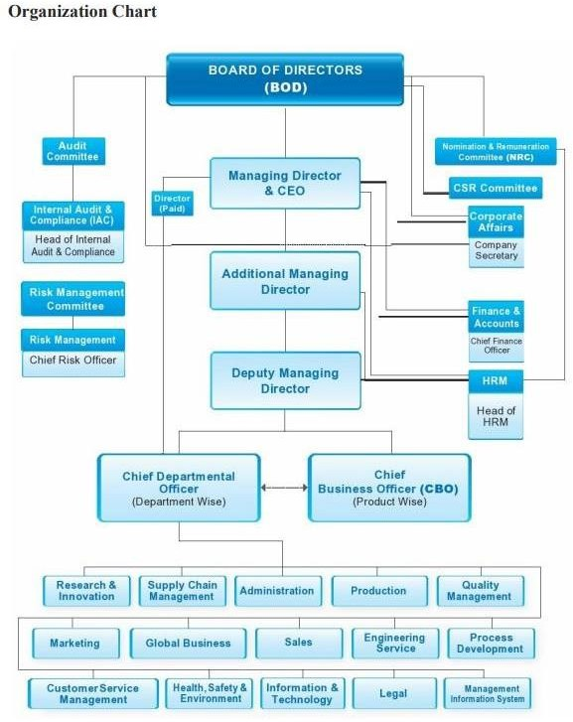
Figure 5: Organizational Structure of Walton

Operational Units of Walton

Human Resource Department
The HRM department is placed on the ground floor in the corporate office. Every type of process and workings related to recruitment, training, salaries, leave procedure et cetera handled by this department. The department head Md. Faysal Ahmed ensuring smooth process of recruitment and best candidate selection for every position. The employees of this department basically monitor each and every worker movement, their performance, increment, capability et cetera.

Marketing & Sales department
The marketing and sales department is also located on the ground floor of corporate office. This is a very huge and diversified department. Under this major department, there are some subdepartments. Those are admin, branding, online monitoring, strategic business development et cetera. Under this department, employees of sales department work on selling products and circulating information related to products, offers to enhance sales number of their products. They work outside of office for these activities and get some allowances for these duties. In branding, they involved in all the advertisement, settlements, media related promotion, social platform promotion of products et cetera. Basically, they handle all the aspects of 4 Marketing Mix (Product, Price, Place, Promotion) through these sub-departments under marketing department.

Supply-Chain department
This is a very important and key department because as a manufacturing company, Supply-chain plays a vital role for overall operational process. Under this department, there are sub-departments such as corporate purchase zone, inventory maintenance, and procurement et cetera. In this department, they keep in track all the raw-materials, inventory, stock, office supplies. They count all the products, their condition, safety stock, number of raw-materials needed for next production and update the data in software on a daily basis. The supply-chain department always try to reduce costs in

internal process which will result in low production costs per unit of products. This helps Walton to offer their products at reasonable price and increasing the quantity of selling products. There work depends on the production process and other relevant thing in the Walton factory.

Research & Development
In this sector, the engineers and researchers work for products development. They research for updated technology, new design, features, market demand and so on. They try to invent something new which will provide a top-notch service with new updated features, looks aligned with changing market demand. The engineers of Walton always try to refine existing products by researching, updating designs, experimenting, testing and so on which will help to add more demand and curiosity in consumer‟s mind. That results in higher unit of sales of products and increases more profitability.

Finance & Accounts department
There is various work done by this department. This is one of the major and vital department because all of the operational work depends on funding and this is the department which is maintaining fund related decision. As Walton group divided into two major sectors (Walton Plaza & Walton Hi-Tech), there are two Finance & Accounts departments for both plaza & Hi-Tech. They perform task such as:
- Tax and Vat management
- Financial strategic planning
- Financial modelling
- Investment and capital related decision making
- Fund management for each operation
- Employee fund management
- Reducing cost and increasing profitability
- Financial reporting
- Provident fund management

Internal Audit & Compliance department
As like Finance & Accounts department, there are two Internal Audit & Compliance department for plaza & Hi-Tech. Through this department, they ensuring risk minimization, fraud minimization, checking accounts of every dealer and customer and overview the risk related to money, stock, products everything. The sectors or sub- department under this department are:
- Risk management
- Bill verification
- Inspection of Walton Plaza/Hi-Tech
- BIB (Behavioral Intelligence Branch) of Walton Plaza
- Audit of Walton Plaza/ Hi-Tech
- Accounts verification
- Stock, cash & product verification unit in every Plaza.

External Audit & Compliance Department

External auditors check the inspect clients whether any discrepancies happened or not. Apart from these main and leading departments, there are also many more departments in Walton Group. Every department maintain their own roles very efficiently. That is one of the vital reasons for the success of Walton Group.

SWOT Analysis of Walton Group
SWOT analysis is basically a measurement framework by which anyone can measure a company‟s competitive position in market compared to others and helps to establish strategic planning for further development of this company. SWOT analysis consists of 4 components Strengths, Weaknesses, Opportunities and Threats. Among this 4 components, Strengths and Weaknesses measures a company‟s internal situation and performance. Strengths determined a company‟s specialized area and by focusing on this area the company can grow faster. On the other hand, Opportunities and threats measures a company‟s competitive position in market compared to competitors in the market. It depends on the competition presented in the market. Each and every company has some positive and negative side; Walton has some as well.

Strengths:
      - As Walton is manufactured most of their raw materials by their own in the factory, they have manufacturing cost advantage.
      - Labor cost efficiency.
      - The hire policy helps to enhance sales of the products.
      - Comprehensive product range.
      - Clear knowledge about the market and customer segment.
      - Accessibility to each type of customers because of wider local presence.
      - Higher technology-based manufacturing.

Weaknesses:

      - Lack of use of updated technology.
      - Lack of high skilled workers.
      - Unable to cover higher income group of customer segment.
      - Downcast quality hardware.
      - Lack of proper monitoring of everything.
      - Fewer customer service center to provide customers after sales services.

Opportunities:

      - Have the opportunity to access in the export market.
      - The increasing market demand for electronic products.
      - The number of populations is increasing.
      - Now-a-days everyone is binding to lead a software-based life.
      - Invention of new products.
      - Walton has the opportunity to select workforce from a huge group of unemployed people. It results in best employee selection.
      - Bangladesh GDP growth is also increasing. That means the buying power is also increasing of our population, this is a significant opportunity for Walton.

Threats:
      - There is huge competition in the current market.
      - The exchange rate fluctuation of foreign currency.
      - The political issues happen in our country. Recently, one group of people destroy one of the Walton Plaza located at Chandra, Gazipur, Dhaka because of political issues.
      - Continuous growth of technology.
      - Changing demand and preferences of customers.
      - Easy access of new competitors in the electronics market.
      - Unethical behavior by others hampers Walton‟s reputation.

Industry Analysis

    - Industry Scenario of Electronic Manufacturing Retail Company: Bangladesh's manufacturing and retail industries have evolved significantly over the past decade, with companies like Walton, Vision Electronics, and Singer Bangladesh focusing on consumer electronics and home appliances. These companies face challenges such as raw material costs, logistics, supply chain management, and global brand competition. They are also embracing digital retail models, such as online sales platforms and e-commerce strategies. Key industry characteristics include technology adoption, local sourcing, quality control, and e-commerce. Consumer preferences for energy-efficient appliances, smart home technologies, and affordable products have surged. Government policies, such as tax incentives and subsidies, have encouraged local manufacturing, while economic fluctuations impact pricing and profitability.

Size, Trend, Maturity of Industry:

Size: The industry is large and has had significant growth in the last ten years. According to recent estimates, the consumer electronics business in Bangladesh is valued at billions of dollars, with televisions, air conditioners, and refrigerators accounting for a sizable share of the market. The biggest local manufacturer, Walton, is an important contributor to the GDP of the nation through both exports and domestic sales. Together with Vision Electronics and Singer, who continue to have substantial market positions, especially in the category of reasonably priced appliances, Walton alone commands a sizable portion of the consumer electronics and home appliance markets. The industry is still smaller, though, than multinational manufacturing behemoths like Samsung and LG, who control the premium product markets.
Trends: Bangladesh's consumer electronics and home appliance production and retail sector is being shaped by a number of significant trends:
- Digital Transformation & E-Commerce: As internet usage and mobile commerce increase, there is a swift transition to online retail. E-commerce platforms are being adopted by businesses such as Walton and Singer, which facilitate direct product purchases from websites.
- Adoption of Smart Technology: There is a growing need for energy-efficient devices, smart TVs, and refrigerators with Internet of Things capabilities. In response to rising international markets and local demand, local manufacturers are coming up with innovative ways to incorporate these characteristics into their goods at competitive pricing.
- Sustainability: Eco-friendly goods and energy-efficient equipment are becoming more and more important as environmental consciousness grows. In addition to providing products with lower energy use and greener technologies, the sector is gradually embracing more sustainable manufacturing techniques.
Maturity of Industry: The Bangladeshi consumer electronics and home appliance industry is in a growth phase, moving from a relatively early stage to becoming a competitive player in regional markets. While some firms, such as Singer Bangladesh, have a long history and are regarded as mature brands, Walton, is still developing powerhouses that are continuously growing.

- Established Players: Companies such as Singer Bangladesh, which has been in business for decades, have matured, relying on strong brand recognition, long- term client connections, and a retail presence throughout Bangladesh. However, it confronts growth constraints as it competes with more aggressive domestic and foreign rivals.
- Emerging Leaders: Companies like Vision Electronics and Walton are still growing. Specifically, Walton is rapidly growing its export business and domestic market share, demonstrating that it is in a quick growth phase with a strong focus on innovation. The industry as a whole becomes more competitive and dynamic as a result.
- International Competition: Although Bangladesh's industry is expanding, it still confronts difficulties competing with multinational behemoths. The industry is comparatively less developed globally, but it is mature in terms of local demand and manufacturing capability.

SWOT Analysis:

Strength:
- Strong local Manufacturing Base: Walton has established a significant manufacturing presence in Bangladesh, which allows it to produce high-quality electronics and home appliances at competitive prices. Local production reduces dependence on imports, helping to lower costs and provide affordable options for consumers. The local sourcing of components allows companies like Walton to maintain competitive pricing, helping them capture a larger share of the domestic market.
- Brand Recognition and Market Leadership: In the domestic market, Walton, Singer, and Vision Electronics are well-known brands. For instance, Walton is a market leader in television and refrigerators, making it a popular option for Bangladeshi customers. Given its lengthy history in Bangladesh, Singer continues to enjoy high levels of brand loyalty, particularly among elderly consumers.

- Growing Domestic Market: The demand for consumer electronics and home appliances has increased in Bangladesh due to the country's expanding middle class and rising disposable incomes. The market for appliances and electronic devices keeps growing as more homes purchase these items. The market is growing as a result of urbanization and growing customer access to contemporary retail channels, such as internet shopping.

Weakness:
- High dependent on Raw material: Businesses continue to rely significantly on imported raw materials (such as metals and electronic components) notwithstanding the trend toward local manufacture. Because of this reliance, manufacturers' cost structures are impacted by currency changes and disruptions in global supply chains.
- Intense Competition from Global Brands: Bangladesh's high-end electronics market is dominated by international brands like Samsung, LG, and Sony. Local producers find it difficult to compete when it comes to high-end product offers and cutting-edge technologies, particularly Vision Electronics and Singer.

Opportunity:
- E-Commerce growth: E-commerce has a lot of potential thanks to the expansion of digital platforms, rising smartphone usage, and improved internet connectivity. These channels can be used by local manufacturers, particularly Walton and Singer, to attract younger, tech-savvy consumers and boost online sales.
- Rising Demand for Energy-Efficient and Smart Appliances: The need for energy-efficient appliances is growing as environmental concerns and energy costs rise. Local businesses can capitalize on this trend by providing smarter and more environmentally friendly devices, such energy-efficient air conditioners, smart TVs, and refrigerators with Internet of Things capabilities.

Threats:
  - Price volatility for raw materials: Due to the foreign sourcing of numerous components (including metals, circuit boards, and microchips), manufacturers may be at risk with regard to production costs and profit margins due to fluctuations in global commodity prices and shortages of raw materials.
  - Consumer Preferences Are Changing: Because consumer preferences are changing so quickly due to technological advancements and environmental concerns, producers need to constantly innovate in order to remain relevant. Products could easily become outdated if they don't adjust to shifting consumer demands (such as eco-friendly products or appliances with AI built in).

Chapter 3: Internship Experience

My six- moth internship at Walton Plaza‟s Internal Audit and Compliance department was a crucial step between by academic studies and professional life. I actively participated in various audit, and audit activates, which gave me a depth first-hand understanding of how corporate auditing works in real world. Especially in manufacturing & Retail industries. This Experience turned textbook theories into practical knowledge.

Knowledge Acquired:
During this internship period, I learned verse of knowledge about internal audit:

    - Audit procedures: I understood Walton plaza‟s complete audit process by joining the audit team as an auditor. From planning, checking for compliance, monitoring cash, documentation findings, inventory audit, behavioral audit and reporting.
    - Behavioral Auditing (BIB): I took part in surprise visit and mystery shopper audit where secretly evaluated showroom staff‟s customers service and behavior, learning how to score their performance.
    - Cash Monitoring: Cash monitoring is a huge part of audit, where I have to count the physical cash of Walton Electric Solution plazas, and take detail information of their account receivable and expenses.
    - Voucher Verification and Bill Verification: In bill verification & Voucher verification, I checked the bill from different accounts and verified it whether it have any mischief or invalid bills. Also check the accuracy according the law.
    - Hire Purchase audit: I learned how to examine customer payment histories and assess credit teams for installment sales.
    - Error Detection & Data analysis: I sued analytical methods to review reports and data, improving my ability spot inconsistencies or missing information.

Audit Procedure Experience:
    - Audit Planning Participation: I helped gather initial data reviewed past audit report, contributing to setting the scope and goals for upcoming audits. I observed how senior auditors prioritized areas based on risk and past issues, and how audit schedules were created.

    - Risk Assessment Application: I learned to use risk assessment checklist and participated in discussion about control weaknesses. I analyze past cases of memo error and unauthorized “revert resale” which helped me understanding risk indicators and focus on vulnerable areas.

    - Direct Fieldwork and testing: This were a highly engaging part of my internship. I visited Walton Plaza showrooms, where I verified sales transactions, including both cash and installment purchase, by cross-checking physical memos with digital records in POS and ERP systems. I also helped physically inspect inventory and reconciled stock counts with official logs. My participant in behavioral intelligence brace audit involved acting as a customer to evaluate service quality and staff behavior, meticulously documenting and scoring observations against Walton benchmarks.

    - Repot Preparation Contribution: I helped prepare draft audit reports by organizing collected evidence, summarizing findings and formatting the report using MS Excel and Word. I observed how these findings were presented to management and how action plans were developed.

    - Follow-up Tracking: I assisted in tracking follow up actions by keeping checking of unresolved issues. I also participated in calls document reviews to ensure that past recommendations were implemented and controls improved. This process showed me how critical follow-up is continuous improvement.

Skill Development:

Technical Skill:
Company Systems: I become good at using systems like POS, WCRM, EBS, HRMS for data analysis and verification.
- Microsoft Excel & checklist: I improved my advanced excel skills for data tracking and reporting, and become skilled at using audit checklists.

Analytical Thinking:
- Attention to Detail: I developed a keen eye for detail when reviewing transactions and data.
- Risk Identification: I got better at finding risks and suggesting ways to control them and improve processes.

Regulatory Awareness:
Compliance: I gained a clear understanding of audit rules, ethical standards, and legal compliance in the retail sector.

Professional Conduct and Time Management: The internship also shaped my professional conduct and time management:

Adaptability: The Audit environment was dynamic, requiring me to think quickly and adapt to new challenges, like unexpected problems or complex data issues.

Time Management: I learned to balance field inspections, repot preparation, and meeting under tight deadlines, significantly improving my ability to prioritize tasks.

Team work: Working closely with senior auditors and fellow interns taught me the importance of team harmony and respecting different viewpoint.

Responsibility & Discipline: I learned to complete tasks accurately and on time following company rules and audit standards which built a strong sense of accountability.

Chapter 4: Theory of Audit Process & Internal Audit Process

Audit Theory

Definition & root of auditing:
Audit is a systematic process of a company‟s financial statements, process, operation to ensure accuracy, compliance, and reliability. The aim of auditing is to ensure that the information presented has errors or is efficient. An audit is a precise and independent assessment of an undertaking's data, claims, documentation, actions, and displays (financial or otherwise) in order to achieve a certain goal. In any auditing, the auditor observes and recognizes recent ideas offered to him or her for inquiry, obtains evidence, evaluates it, and then defines his or her judgment, which is delivered in his or her audit report.
During 1960s the concept of auditing had been coming up. Experts had invented the theory that could be used to study of an array of subjects such as financial accounts. People in general agree that the key components of the framework, even though at that time some individual might disagree on how to apply some basic concepts. After that the framework has been accepted in many countries and known as GAAS (Generally Accepted Auditing Standards).

GAAS (Generally Accepted Auditing Standards):
The auditing Standard Board had established a guideline which is Public Company Accounting Oversight Board followed. The Sarbanes-oxley act 2002 established by Public Company Accounting Oversight Board followed for the benefit of supervising public limited company audits and related matters to investor interests and maintain public interest in the creation of independent audit reports. The Standard which had been issued by PCAO is called GAAS. American Institute of Certified Public Accountants Members who owned the institute‟s license are followed the standard.
The Auditing Standard has divided into General standard, Standards of field work, and Standards in Reporting.

Types of Audits:
Audit conducted in two ways Internal Audit, and External Audit.
Internal Audit: Internal audit supports an organization‟s internal controls, risk managements and operational effectiveness for carried out smooth cycle on the behalf of the business. They tend to seen as a value- adding function that aims to ensure the company‟s betterment from the inside out. The Internal Audit ensure the operational improvement, risk reduction, internal compliance maintenance, and reporting to internal stakeholders.

External Audit: Independent third-party firms are conduct external audits, which generally take place to confirm the accuracy of financial statements for the public, external audits, and regulators. Usually required, these audits are carried out in keeping high professional standards.

Difference and relation between Internal Audit & External Audit:
The main difference between internal audit & external audit can be founded in their goals, area of responsibility, and reporting obligations. Company‟s management appointed internal audit departments evaluate how well its governance, manage risk, and assess internal control. On the other hand, external auditors are appointed by the shareholders to offer an unbiased assessment of the organization financial statement, which published in every accounting year as public information of the company‟s financial position.
Despite these difference, Internal audit and External audit have some supporting connection. In order to better understanding of the company‟s internal control systems and to guide their own audit planning, external auditors may take into account the work of internal auditors. Both of the function can coordinate effectively by sharing information‟s. It also minimizes duplication of efforts and improves quality of audit. In result, the organizational accountability and transparency increases.

Audit Process:



Planning
Collecting Evidence
controlling
Review & Report

Planning the Audit:
Proper organization of work and oversight of audit procedures help to ensure the process is effective and efficient. GAAS “Standards of field work” approach recommend auditors to develop a detailed and through audit plan. This step enhance cost efficiency, reduces the errors or miscommunication, and enables the collection of reliable and relevant audit evidence.
Planning supports in the achievement of any planned goal by giving a guideline of actions to follow. This procedure begins with assessing operations and finding options for improvement. Achieving success involves visualizing the goals that one wants to have and mapping the required process to get the desired goal. Planning gives the insights required to make effective decisions about the order and how to structure the elements for resource allocation.
As Bangladesh Standard audit, standardizing paperwork for the client‟s plan documentation is important. The documentation is created in keeping with the audit strategy and based on the auditor‟s audit experience. Planning for audit included Identify risk in the business, Business nature, Analytical review, and Test of control.

Collecting Evidence:

Collecting Evidence: In order to generate knowledge about the accuracy of financial statement or the effectiveness of internal controls, an auditor gather evidence. The evidence constitutes the foundation for their judgments and supports the validity of the audit report. Moreover, this evidence serves as the basic for all audit findings decisions, ensuring they are founded on verified information rather than assumptions. Auditors can detect and assess potential inaccurate risks by gathering evidence, allowing them to adjust their audit procedures more effectively. This approach is also essential for keeping professional auditing standards and increasing the validity of the audit report.

Controlling:

At this stage, all the planning is documented. This phase required fieldwork, in which all assessments and audited companies are examined. These assessments are used to analyze the evidence gathered, which is then documented, and risk evaluations and materiality estimation take place. At this point, two types of risk assessment are possible, and both follow the standards established by Audit procedure.
At first, as comprehensive risk assessment, the company‟s commercial and regulatory environment was thoroughly examined. Managerial integrity and business uncertainty correlated. Analysis findings may help better understand how risky the entire effort is. The second risk assessment is conducted to determine` the actual level of risk linked with the involvement.
A risk assessment has two primary objectives. This tool is designed to determine whether the whole audit program technique can be bypassed based on the audit characteristics. It can be used to assess the impact of all conceivable risk on a certain portion of the financial statement.

Review and report:

The auditor‟s examination and opinion is the last phase in the audit process. The management of the audited company reads the complete report and offers feedback on the issue they found. During this conversation, some the proceeds might arise. The management then express their thoughts, and any issue that are unresolvable are forwarded to a partner at a CA firm. After reviewing audit, the auditor makes a decision. The checklist auditors practice is
- Peer completion - the audit was successfully completed.
- The auditing standards reviews questionnaire and the internal control system questionnaire.

Internal Audit Theory

Define Internal Audit:

Giving management a fair appraisal or tracking of internal operations is goal of internal audit. Internal auditors review and evaluate plans frameworks, and reports to directors and management regarding the sufficiency and efficiency of the components of the accounting and internal control system. Every system, process, procedure, function, and activity within the company must be evaluated by internal auditors.
Internal audit generally needed in large companies. It helps management to get organizational objectives. Companies done the work either by internally staff who only designated for this job or contracted out to an outside group. Internal audit is a well- known process that ensure sound corporate governance.

Internal Auditor:

An internal auditor is personnel within a company who examines and evaluates its financial operations, internal controls, risk management, and governance the processes. Unlike external auditors, internal auditor is a person from the company whose goal to achieve effective and efficiency on the behalf of the company.

Key roles an Internal Auditor:

      - Identify possible operational or financial risk.
      - Verify that the business follows with internal policies, law, and regulations by conducting compliance checks.
      - Assess the efficacy and efficiency of internal systems and procedures.
      - Inquire on unusual conduct and assist in stopping fraud.
      - Report results to the management of his observation and provide practical suggestions.
      - Verify that suggestions have been practicing in an order and having an effect on business.

Internal Audit process:
The Internal Audit department offers the company financial audit, compliance audits, operational audits, Procurement Audit, consulting service and special investigation.

Financial Audit: A financial audit evaluates the accuracy and completeness of accounting transactions and reporting. Checking that a unit‟s financial activity is accurately represented in financial reports and that the financial reports are backed up by accounting and other financial records is the aim of this type of audit.

Compliance Audit: It determines the degree of compliance to the laws, regulations, policies and procedures of the firm, the manufacturer company‟s, the governments.

Operational Audit: In this examine the department‟s use of resources and procedures to determine whether goals and objective are being achieved as effectively as possible. An essential component of operational audits is the assessment of the unit‟s internal controls environment for regulating and reducing inherent risk.

Procurement Audit: This type of audit done for evaluate the independence, truthfulness, and fairness of the departments

Consulting Service: Internal audit can provide management advice and support on issues related to accounting systems, internal control protocols and employee integrity. Experts might also provide guidance on initiatives aimed at rethinking policies, procedures, and systems.

Special Investigation: Special investigation is conducted in response to complaints against company that are received by the corporate office over the company‟s internal and external sources. Charges are prioritized and investigated based on an assessment of the possible harm to the business.

Internal Audit & Agency Problem:
Conflicts of interest between two parties in a principal-agent relationship five rise to the agency problem. Principal is the one who assigns tasks (owner of the business) and Agent is a person who acts as the principal‟s representative, such as executives or management of a business.
A principal can experience one kind of internal expenses a result of agency problem, which is called agency cost.
In order to reduce the agency problem, the conflict of interest between shareholders (principals) and management (agents), the internal audit function is essential. By offering impartial monitoring and accountability, internal auditors assist in ensuring that management's decisions are in the best interests of shareholders. By routinely examining business operations and financial records and making sure management complies with set laws and regulations, they foster openness and financial integrity.

Walton Internal Audit

Walton Internal Audit Department Plaza play a crucial role in hole companies. Walton is basically an electronic manufacturing retail-based company. Their authorized plazas are the main based point where they basically sale products and control customer market and internal audit ensure the effectiveness, efficiency and integrity of these 780 plazas‟.
This department conducts frequent audit, at least once in a year of each plaza. Auditor selected as a three-member team to cover a hole area. Auditor who selected as a team set in an order, one of them will be the team leader who will plan the whole audit, and rest of the two will assist and follow the team leader.
In an audit the variety of operational, financial sectors are cover which detect control deficiencies, asses compliance with internal rules, external regulations and recommend corrective actions.
In a result, the protection of asset, operational efficiency, and improvement in the financial growth are assured. The internal Audit team than construct every as a repot which reflect every financial and regulatory information and compare with the previous situation.

Pre-Audit Activity of Walton:

- Aduit Schedule plan – Planning the work and when the audit will be done.
- Hire customer Versification, Dealer/corporate dealer verification - By calling and collecting the information from the pos ensure the accuracy of the document the plaza has given.
- Last year report analysis – The performance of a plaza in previous year.
- Financial data analysis (Business profit loss / Account receivable, account payable)
- Old Stock Analysis – How much product the inventory contains with old product. How long they are not being sold.

Audit Activity of Walton:
  - Cash Count – check physical cash present in that time and how much due they have for that month.
  - Inventory check – Inventory product count as it matches with the POS information
  - Conformation of Account receivable and Account Payable – Confirming that the information they updated in the software has accurate documents.
  - Overstock Analysis (last 12-month stock check)
  - Voucher Check – Weather every bill has sign of the manager
  - Hire customer document – Each customer document should have separate file with their personal information and nominee‟s personal information. Personal Information means National ID photocopy, address, photo, Pervious hire information)

Post- Audit of Walton:

  - Summary of the Report
  - Report making
  - Reporting to the managerial

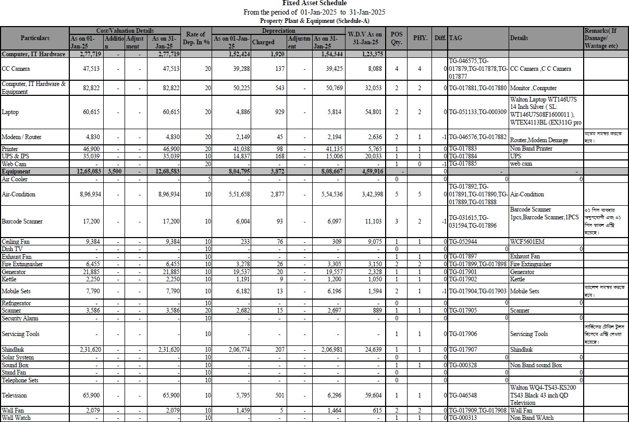
Figure 6: Fixed asset schedule of a Plaza

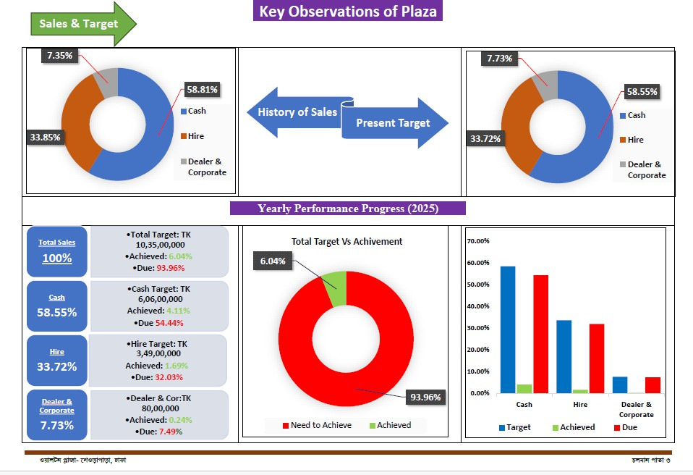
Figure 7: Yearly performance Graph

Chain of Command of Internal Audit department

All reporting came upward to the head of department through deputy head of department in internal audit & compliance. The command and high-level decisions are provided by department head. He plays a crucial role in departments harmonious environment and overseas the entire department member.
After department head, the chain of making strategic decision and assists overall departmental management came up to the deputy department head. Who directly supervise the core branches: BIB, Audit, and Inspection.

BIB (Behavior Intelligence Branch):

The duty of behavioral intelligence branch is to ensure by audit that each of the branch follow the 12 BIB rules. BIB Audit is directed by appointed additional director. Under his supervision all the intern learns how to go for surprise audit. Intern how attended BIB

audit follow the instruction is given by the supervisor and reported updates to him. Here interns are likely to involve in investigation, research, and analysis tasks.

Audit: The audit department basically work in two section, pre-audit and post audit.
- Pre-audit department: Pre-audit ensure the proper planning, mitigate risk and execution of audit. The pre- audit team actually conduct the audit. Generally, audit conduct with three-member team. Pre-audit team directed by an auditor (Additional Director). Instruction and planning of the audit is provided by him. As the team leader assistant there is one deputy director and one intern added in the team. When there are too many plazas to visit team divided and one future manager join from another plaza and assist additional director. At that time audit deputy director and intern form one team and deputy director take the position of team leader.
- Post – Audit: Post audit is the part when auditor finishes all the field job and start the preparation of reporting. It‟s directed by the same team, deputy director summarizes the whole audit, and assist the team leader in report making.
The final reporting of this department handed by the additional director to the Deputy head and Head of department.

Inspection: The Inspection department verifies compliance standard and compliance accuracy. Ensure all of the plaza are following the instruction which is set by the company & government and regulate according to the requirement. Moreover, during audit if any plaza caught with and mischief, the inspection department thoroughly investigate the situation and came up with a decision with the consultancy of managerial body.
Generally, this team is directed and assist by a senior deputy director and assistant deputy director and constantly reported every think with Deputy head and HOD.

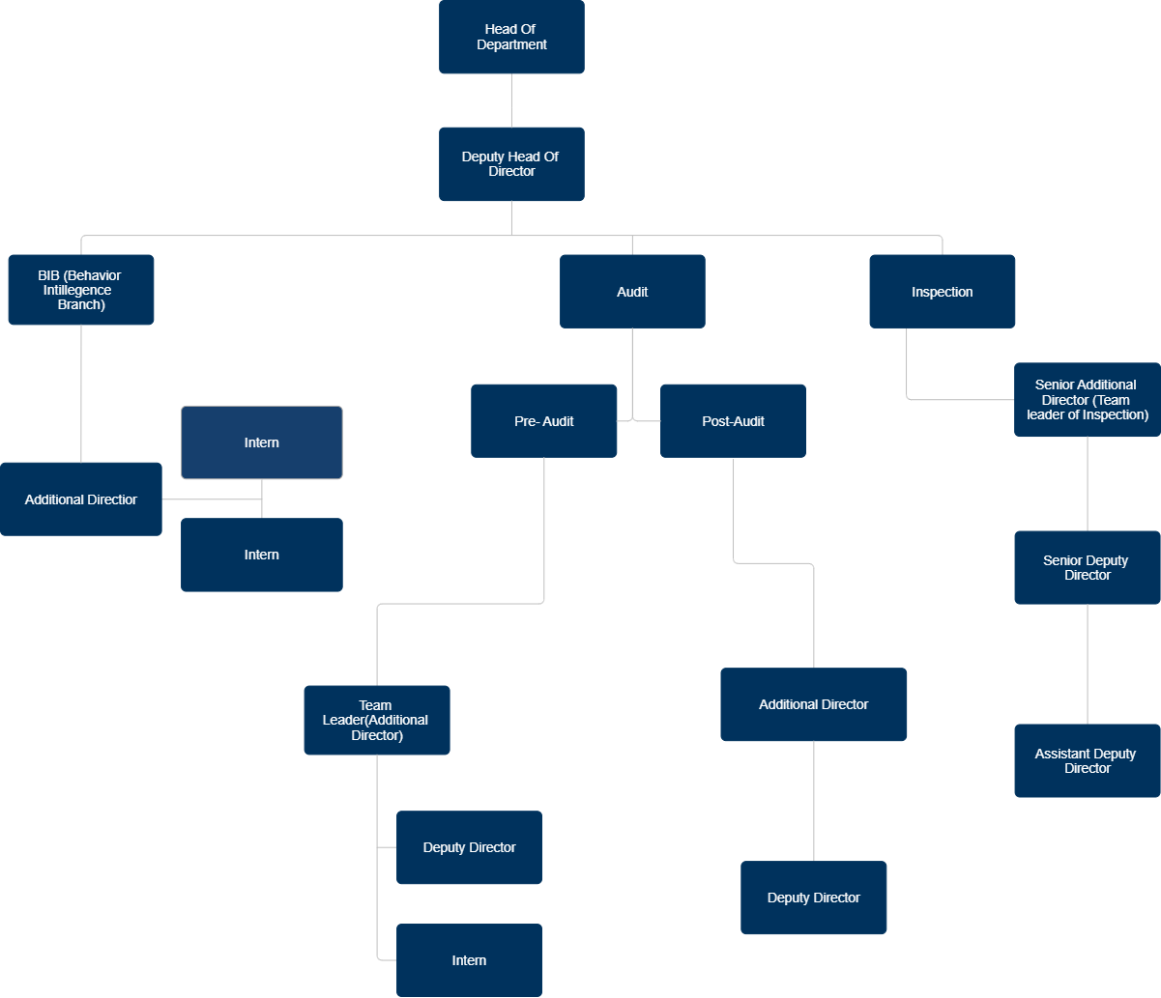

Figure 8: Organogram of Internal Audit

In conclusion, Internal audit and compliance is set up with well-defined framework and generate effective administration and supervision. Each branch has clearly defined task and responsibility to full-fill, and the departments managerial body has good control over the department member and actives.

Chapter 5: Session with Internal Audit Personnel

The person whom I took interview is the deputy department head (Md. Mohan Uddin Siddique) of Internal Audit & compliance. He was the supervisor of me for my entire internship journey. The key information I get to know from the interview are written down below:
Sir has been in the Walton group since 2010. It‟s 14 years of experience in this company. He joined as a deputy director. At that period, Walton didn‟t Hi-tech, Plaza and Digitech segments. In 2017, the company decided to make a separate department for plaza internal audit and compliance. In 2020, he had chosen as the department deputy head.

Key responsibility:

- Analyze internal control weakness and repair those,
- identify root cause of accounting error & control weakness for financial fraud,
- Audit recommendations implementation,
- Preparing Organizing and Maintain Audit Program as per Annual Audit plan,
- Determine internal audit scope and develop annual plans Support HOD for develop Audit strategy and any other assignment assigned by HOD,
- Develop company policies for better internal control,
- Prepare Follow-up Report by audit findings and recommendations,
- Prepare monthly Report of IACD (WP),
- Maintain all administrative issues of the department.

“In your opinion, what is the importance of the Internal Audit Department?”:
According to the sir‟s speech, the major importance of the department:

- Risk management: Internal audit provides the independence of assuring that risks that plaza has been facing that can be mitigate and control in an effective manner. Plazas activates play they vital role in Walton group business, identifying the risk like sale decrease, increasing of old stock in inventory, dishonesty of employees, default customer increase control by the internal audit. Internal audit takes steps for

preventing these problems and keep a constant follow up if there is any improvement in the result it can be seen.

- Operational Efficiency: Auditor audit each plaza and search for their operational inefficiency. In this case, Walton internal audit department use POS (point of sale) to ensure transaction. According to Walton plaza‟s policy every asset, transaction, inventory, details of customer and dealer should be updated in the POS software by the plaza manager. If there any problem in operational actives, during audit auditor can detect the problem and bring the solution easily. For example: In a plaza of banshee area, during audit inventories

- Fraud Prevention: Internal Audit is a department that can take every department and plaza‟s information access. Also, it has a designated department for inspection. If an auditor can guess any faulty behavior, they dare to take immediate action. After that inspection department also thoroughly investigates the situation.

“How has your experience in the internal audit team been throughout your journey?”:

"My experience at Walton has been incredible throughout my journey. On the first day of my job, a visit to the factory‟s audit was required, which was done alongside the corporate team. The main focus of the role was ensuring that compliance was being followed properly. However, after the departments were separated, the work was limited to the corporate office.

It has been said that the best part of being an auditor is the respect and acknowledgment received from the work. Additionally, auditing provides the opportunity to travel all over Bangladesh. Along with these positive experiences, handling conflicts and fraud is also a part of the job. It is emphasized that making the right decision in a situation like an audit is critical, as audits are essential for identifying problems and providing opportunities for improvement.

“Throughout the time, what are the common issues faced during an audit?”: According to the Deputy Head, “The most common problem he had faced throughout the whole time in audit was that the plaza staff who are responsible in collecting money from the customer misused his duty job by not depositing the money in plaza and not giving the customer any recite”. Previously in some plazas, staff has collected money and didn‟t deposit the full amount of the money that customer had paid. During the audit auditors has identified plaza managers has involvement in this crime.
In Gazipur, Manager who is fully responsible for a plaza‟s entire actives build personal relationship with dealers and for personal benefit they sold product outside the company‟s policy. Because, due to company‟s policy if a plaza reaches the targeted sales the plaza‟s staff get lumpsum amount of incentive on the sales. Even to not being caught during audit so they give access dealer to use plaza‟s storage and stock the product. In that case they thought, when the auditor will count in stock, they will not notice the shortage, also the dealer and manager can sale those products with good profit.
In Mymensingh, Manager and accountant had used plaza‟s fund in their personal use and flee with the money.
There are so many cases audit has find through the time and always came up with a solution.

“Could you please mention the action you have taken to solve those problems?”: For those problem the audit team along with sir has taken some major step as a solution. Like previously, auditors only check and confirm balance when they are auditing in a plaza, but when they common problem arise and auditor find many mischiefs of staff. The department came up with double verification technique. For double verification they add customers details in POS and start verifying customers payment by call. Also, they make sure that every customer should collect the recite, so they make banners and put awareness information in it and set it in every plaza. Moreover, for each payment they start to send confirmation massage in customers numbers.
In terms of controlling crime like building personal relationship with dealer for extra benefit, A new policy invented for every plaza manager, in every two years to three

years the manager will be change to another plaza, and another new policy made each plaza have to enter daily transaction details in POS, no plaza can hold more than 50000 taka as physical cash. So, every day accountant has to submit the cash in head office account by bank.

“Is there any remarkable good effect that has been shown previously?”: The events he highly mentions, as an example of improvement, in the Walton conference 2019, Gazipur received the best performance award.
The number of crimes has decreased. Also, as an effective result in auditor‟s report has shown. The improvement is visible in the plaza‟s performance and also in number of plazas. Currently, Walton has 780 active plazas all over Bangladesh.

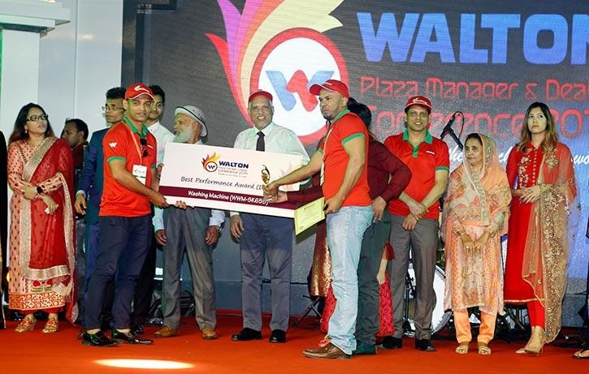

Figure 9: Walton conference 2019, Gazipur

Chapter 6: Conclusion & Key Factors

Findings

Based on looking closely at how Walton Plaza manages its Internal audits, here are the main things we found:
Clear and organized Audit Steps: We saw that Walton Plaza has a very clear and organized way of doing internal audits. They follow specific steps: careful planning, checking for possible risks, doing the actual check by visiting stores and looking at documents, writing detailed reports, and then making sure that suggested fixed are put into place. This structured approach means they check things properly and always follow good practices in the manufacturing retail business.
Better Rule Following and Accurate Money Records: Walton Plaza‟s Internal audit team really helps them follow rules and keep their money records accurate. By doing regular checks, using special lists, and focusing on areas key to finding and correcting mistakes. This active checking helps the company sticks to its own rules and government laws, making their financial Information more reliable and easier to understand across all their stores.
Finds Risks Early and Makes operations Transparent: Internal auditing at Walton Plaza is very important for finding and dealing with risks early, which also makes the company much more open about how it operates. The audit helps improve how risks are controlled and makes everyone accountable. It also makes the company‟s operation much clearer to see, setting a good example for transparency in Bangladesh‟s electronic manufacturing retail sector.
Opportunities to Improve audit with new tools: Even though Walton plaza‟s current audit system is strong, the internship showed ways it could be even better. We noticed that using advanced computer analysis tools and possible AI could help them find fraud and predict problem even stronger and ready to future challenges, including if the company expand globally.

Recommendations
To help Walton Plaza's internal audit work even better, here are some suggestions:
    - Use Smart Tools (Al & Analytics): Start using advanced computer programs and Al to find possible fraud or problems before they happen. These tools can automatically spot unusual patterns in sales or inventory, making audits faster and more focused on big issues.

    - Learn from Global Best Practices: Regularly compare Walton Plaza's audit methods with those of top companies worldwide. This means looking at international audit standards and learning new ways to audit that are used globally. This helps Walton's audit team stay current and ready if the company expands internationally.

    - Boost Cybersecurity Audits: Since Walton relies heavily on online systems, it's crucial to improve how they check for cyber risks. This could mean hiring experts in cybersecurity audits or training current auditors in areas like network security and protecting customer data. Regular checks are needed to guard against cyber threats.

    - Share Knowledge Across Departments: Create ways for the audit team to share what they know with other departments like marketing or supply chain. This could be through special training or short work exchanges. When everyone understands each other's work better, audit plans can be more practical, and suggestions will be easier to put into action.

    - Improve How Audit Success is Measured: Besides just tracking problems found, also measure how much value the audit team adds. For example, track how much money was saved, how quickly reports are finished, and how satisfied other departments are with the audit services. This helps show the audit team's true impact and helps them improve themselves.

    - Include Green and Social Audits (ESG): Start checking how Walton Plaza performs in environmental protection, social fairness, and good company management (ESG factors). This not only matches global trends but also helps avoid reputation damage and shows the company cares about more than just profits.

    - Smarter Inventory Checks: improve audit methods for managing inventory. especially for products that are not selling well. This means looking closely at how fast products sell and how accurate sales forecasts are. Working with sales and supply chain teams can help move old stock through special offers, reducing losses and saving money.
By using these recommendations, Walton Plaza's internal audit team can become an even stronger and more active partner, helping the company grow sustainably.

Conclusion

The internship at Walton Plaza showed me how vital internal auditing is for a company's success. It's not just about checking boxes; it's about making sure the company runs smoothly, honestly, and stays competitive. Walton Plaza's internal audit process is well- organized and thorough, covering everything from planning and risk checks to reporting and making sure changes happen. This commitment helps keep their finances accurate, makes sure rules are followed, and constantly improves how they do business.
What stood out was how Walton Plaza uses technology and special "behavioral audits (like mystery shoppers). These methods help them understand not just numbers, but also how their staff interacts with customers. This proactive approach, combined with their focus on identifying risks and following up on suggestions, shows that audits are a key part of their success. It builds trust with customers and helps Walton stay a leader in the electronics industry in Bangladesh.
Looking ahead, Walton Plaza needs to keep improving its audit methods, especially as the market changes quickly. Using advanced tools like Al, learning from global best practices, and boosting cybersecurity will make their audit team even stronger. By doing this, Walton Plaza can make sure its strong operations and good management continue to support its growth and uphold its reputation as a trusted brand.

References
Abedin,S.Z.,(2020). „Walton Bangladesh: A brief history‟. Risingbd. Retrieved from https://l.facebook.com/l.php?u=https%3A%2F%2Fwww.risingbd.com%2Fenglish
%2Fed ucation%2Fnews%2F743%3Ffbclid%3DIwAR0huC4w- OHuGTx6_zJSGdyR6CkTm03_OZbfGwliS5IRASJMQd5RBLx4b4&h=AT0D_L0k 46TwxyTK-aD- 0wxe9PPyEpTj1nmux4XrrAE1VKygEYFQM4Wy4J3vcFvedz0OyHN3U_sQrITFp askwvDUkomcHw7bPS82wlg14LkVVqhFEtwSySuqy3VMMpHspmSEx4dy5iGA
Anik,A.M.,(2021). History And Rise of Walton: Bangladesh‟s leading electronics and tech giant.Business Inspection. Retrieved from https://l.facebook.com/l.php?u=https%3A%2F%2Fbusinessinspection.com.bd%2Fhistor y-and-rise-of-walton-bangladeshs-leading-electronics-and-tech-
giant%2F%3Ffbclid%3DIwAR1zRpB3SvZbyz9neNQ5y5SKlmNSaFSS4MWNMU eMmNd dKtz2XbF3J3E1mws&h=AT1rCKr4XQ8aQyX8PGQn5qgndelHzq8fs- gCzjUUrp4SKO9ZGJ2TVaUcVaS3A40DJjHY0rCkPy7G1Ffn3vT5rVZ6fd5SvFGc ZR0TA bKoWmhfssjTw8qjqhUZT6NzblPCeWuf5A
Sattar,S.B.,(2023). Markrting Strategy of Walton Bangladesh. The Strategy Watch. https://l.facebook.com/l.php?u=https%3A%2F%2Fwww.thestrategywatch.com%2F mark eting-strategy-of-walton-
bangladesh%2F%3Ffbclid%3DIwAR1bDYkoUFohpGxaT9JtMCUJb6QPNBjkqaH XsC HR0D-
UM9UGPyO3dgiQSzQ&h=AT1rCKr4XQ8aQyX8PGQn5qgndelHzq8fsgCzjUUrp4 SKO9ZGJ2TVaUcVaS3A40DJjHY0rCkPy7G1Ffn3vT5rVZ6fd5SvFGcZR0
TAbKoWmhfssjTw8qjqhUZT6NzblPCeWuf5A
TrippleEe (2016). Swot Analysis of Walton BD. Swot Bangla. Retrieved from https://l.facebook.com/l.php?u=https%3A%2F%2Fswotbangla.wordpress.com%2 F2016
%2F06%2F22%2Fswot-analysis-of-walton- bd%2F%3Ffbclid%3DIwAR2VpLJi7c5SOSlU5Q4c7EIhRt7BV3xE9QLvCvVX1YF u0K ZHDgOL79dQavU&h=AT1rCKr4XQ8aQyX8PGQn5qgndelHzq8fs- gCzjUUrp4SKO9ZGJ2TVaUcVaS3A40DJjHY0rCkPy7G1Ffn3vT5rVZ6fd5SvFGcZ R0 TAbKoWmhfssjTw8qjqhUZT6NzblPCeWuf5A

Walton Group. (1977). Retrieved from https://l.facebook.com/l.php?u=https%3A%2F%2Fwaltonbd.com%2F%3Ffbclid% 3DIw
AR1yBaZCPi_fsuV_fIwvPcPLPkkdjCbnLfPBzKyh8woq5ZpAKfUgShkqBws&h=A T3o Eifq3u70nrmk7EVITZenNPd7g4Ukn5Dog2OBYtDgR2MJuPxmCAe6sPItT6O6U1 Je5U
76EVZNUKbG87zq9KZQRGc2BN09RdTXofhP3MScfwYNgD4tmsgeUN80n1qE8 hE0 nWTycP5Lhic

Brylow, W. (2018). Five Elements of an Effective Audit Planning Process.
URL: https://misti.com/internal-audit-insights/five-elements-of-effective-audit- planning

Best plaza and dealer award: Gazipur
https://www.risingbd.com/english/Walton-to-produce-more-user-friendly- innovative-appliances/60221

Appendix

Session Checklist:
- Could you please introduce yourself & tell me about the Key Responsibilities?
- In your opinion, what is the importance of the Internal Audit Department?
- How has your experience in the internal audit team been throughout your journey?
- Throughout the time, what are the common issues faced during an audit?
- Could you please mention the action you have taken to solve those problems?
- Is there any remarkable good effect that has been shown previously?

Evidence of Session and permission to use the above information:
