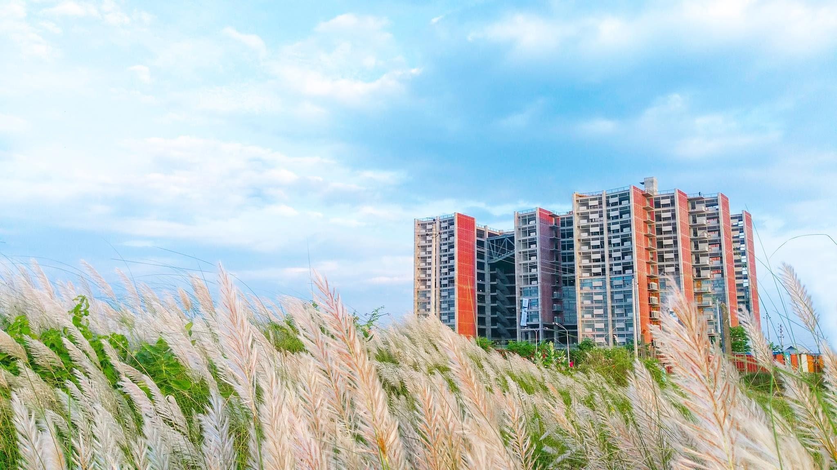

Internship Report on

Financial Performance Evaluation of Al-Arafah Islamic Bank

Submitted To: Dr. James Bakul Sarkar
Associate Professor
School of Business & Economics
United International University

Submitted By: Arafath Hossain
ID: 111-163-142

Letter of Transmittal

02 January, 2023
Dr. James Bakul Sarkar
Associate Professor
School of Business & Economics
United International University
Subject: Internship Report on “Financial Performance Evaluation of Al-Arafah Islamic Bank”
Dear Sir,
As I completed my internship report, So I would like to submit it to you which is on the topic “Financial Performance Evaluation of Al-Arafah Islamic Bank”that you have assigned as a crucial need for completing the internship program. By giving me this report you have provided me the opportunity to research the topic & gain both bookish knowledge & practical experience. I found this study to be engaging, practical, and educational, and I made an effort to create an accurate and trustworthy report in my best interests.
While I sincerely hope it will contribute to painting a clear picture of the overall situation of "Financial Performance Evaluation of Al-Arafah Islamic Bank," I am also sufficiently optimistic to believe that you will recognize the significance of this study for the entire team that I have included in it. I appreciate all of your inquiries, and I respond to them honestly.
Yours sincerely,
________________
Md. Arafath Hossain
ID: 111-163-142
United International University

Acknowledgement

I wanted to start by expressing to god my sincere thanks for granting me the courage and composure to finish the task in the allotted time. For my study, I used resources from a variety of sources that dealt specifically with project assessment and implementation. Numerous authors whose ideas and contributions to this report have influenced my thought are expected to owe me a tremendous intellectual debt.
My supervisor, Dr. James Bakul Sarkar, Associate Professor, School of Business & Economics, United International University, has provided me with all the advice and support I've needed, and I would like to sincerely thank him for that. His sincere, persistent, helpful, and invaluable counsel and encouragement to write original reports enabled me to address all the issues that came up while I was studying and to successfully finish the AIBL internship program.
The theoretical information acquired in educational institutions is thought to be validated by practical experience in the field. I was chosen to begin my internship at Al- Arafah Islamic Bank Limited in order to finish the comparison of the two. It felt like the fulfillment of a long-cherished dream.
At last, I want to share my gratefulness to my family whose support encourages me to do the internship & prepare this report on time. Without having their support it was not possible to stay stand in this position.

Table of Contents
Letter of Transmittal 2
2
Acknowledgement 3
Executive summary 7
Introduction 9
Organizational Background 11
Vision 12
Mission 12
Objective 13
Commitments 13
Distinctive attributes of AIBL 14
Hierarchy of AIBL 15
Al-Arafah Islamic bank products & services 15
Objective of the study 18
Primary objective 18
Secondary Objective 18
Methodology of the study 20
Primary sources 20
Secondary sources 20
Scope of the study 20
Literature Review 23
Analyzing the Financial Performance 23
Al-Arafah Islamic Bank Investment summary 25
Investment Process of AIBL 25
Objective & Principal of Investment 26
Source of fund 26
Primary Source 26
Secondary Sources 27
Mechanism & Modes of Investment at AIBL 28
Bai-Mechanism 29
Share Mechanism 30
Ijara Mechanism 30
Investment growth 31
Amount of total deposits at Dhanmondi Branch 34
Amount of total investment in the Dhanmondi Branch 35
Investment in Murabaha Scheme 36
Investment in Bai Muajjal Scheme: 37
Investment in HPSM Scheme 38
Investment in Quard Against MTDR 39
Findings of the study 40
Recommendation & Conclusion 43
Recommendation 43
Conclusion 45
References 46
Appendix 48

Chapter-1

This Part Covers:
Only executive summary where I tried to give overall idea of the report.

Executive summary

Banking system is the backbone for economic development of any country. Big number of money supply is circulated by banks. Flexibility of money flow in banking sector can impact to improve other sectors such as agriculture, Industrialization and to maintain steady financial condition. Al- Arafah Islamic bank is one of the leading banks among all Islamic banking. Removal of interest rate system makes Islamic bank popular to the people of Bangladesh. As many people in Bangladesh are religious mind people. Basically in this report I have tried to enlighten financial performance evaluation of Al-Arafah Islamic bank. In this regard I have divided this report into 10 chapters. At first, I started with this executive summary where I am discussing the overview of full report. Then comes the introduction where I have discussed about Al-Arafah Islamic bank & my purpose of doing this report. Then comes the organizational background which consists of ins & out of AIBL including mission, vision, objective, commitments, special features, and their products & services. Afterward I have included objective of the study that consists of both primary & secondary objective. Then comes methodology of the study which includes types of data such as primary & secondary data & small discussion about it & scope of the study. Then the main part is literature review where the main topic of the report has been discussed which is financial performance evaluation of AIBL. Moreover, I also discussed many financial aspects of AIBL Dhanmondi branch. Then comes my finding that I observe during my 3 months of internship period. Last but not the least recommendation & conclusion based on the whole report. Finally completed the report by giving references & appendix.

Chapter-2

This Part Covers:
The main introduction of the report which consist of both organization overview & concerned topic

Introduction
Al-Arafah Islami Bank Ltd. is a banking organization with limited liability that was established in the People's Republic of Bangladesh. They believe that success depends on Islamic ideology. Al-Arafah Islami Bank Ltd was founded (registered) as a private limited company on June 18, 1995, with the motive of following the path instructed by Allah and the road exhibited by His Rasul (SM). The official opening took place on September 27, 1995. The authorized capital of AILB was 15,000 million, and the paid-up capital was 10,649.02 million as per the date of December 2021. The Bank is sponsored by eminent Islamic scholars and upright businessmen from the nation. Indigenous stockholders own the entirety of the paid-up capital.(Hussain, 2017)
The bank is determined to make a significant contribution to the national economy. It has 201 branches nationwide where 4247 employees are working and the number of shareholders are 19146 as of December 2021, and has made a significant contribution to the socioeconomic growth of the nation.(AIBL financial statement, 2021)
As a part of completing my internship program, I am doing it in Al-Arafah Islamic Bank at Dhanmondi branch. During this internship period, I have worked with several departments in AIBL Dhanmondi branch though I was assigned to work with general banking. From my experience of working with AIBL I tried to focus on all those aspects, especially on the topic of the financial performance evaluation of Al-Arafah Islamic Bank.

Chapter-3

This Part Covers:
Organizational background where reader will get the info of the organization its mission, vision, objective, products & services & so on

Organizational Background

As major players in financial intermediation, banks, and other financial institutions support the expansion of the economy as a whole. The central bank, nationalized commercial/specialized banks, private banks, foreign banks, and other non-bank financial institutions make up Bangladesh's current financial system. The Al-Arafah Islami Bank Ltd. is the commercial bank on which this report is based.
Al-Arafah Islamic Bank which is a banking organization recognized by the Companies Act of 1994 has its main office at Peoples Insurance Building, 36, Dilkusa Commercial Area, Motijheel, Dhaka 1000. The Bank began operating on September 27, 1995.
Al-Arafah Bank is a shariah bank that does not charge interest, and as such, operates very differently from other commercial banks. The bank role as per the company act of 1994, however, governs how the bank must provide all commercial banking services. It operates under the musharaka, baimurabaha, bai-muajjal, and hire purchase transactional principles. The bank's Shariah Council constantly monitors the bank's operations to make sure they are carried out in accordance with Islamic law.(Amir, 2015)
In a time when the banking environment is changing so quickly, as today, AIBL has a strong combination of knowledge and expertise that is conducive to producing strong development. The AIBL is dedicated to making a substantial contribution to the national economy. With 201 branches, it has positively contributed to the socioeconomic development of the nation. Over the years, it consistently turned a profit and declared a healthy dividend. The bank's prosperity depends on providing top-notch customer service while incorporating new goods and technology. To meet customer needs, the bank offers a wide range of expertly crafted products and services.

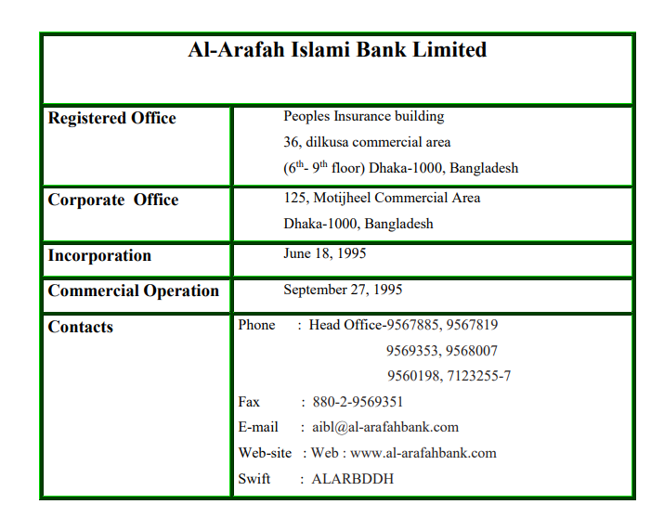

Vision
- Rise as a pioneer in Islamic Banking
- Help to grow the national economy significantly.
- Create an economy with interest-free transactions.

Mission
- Attain contentment of Almighty Allah not only in the world but also afterlife.
- Enhance shariah-based banking practices in Bangladesh.
- Meeting the variety of demands of its consumers by offering a selection of items at a price that is competitive, utilizing appropriate technology, and offering prompt service.
- Providing a great experience in customer service.
- Keeping a high standard for ethical corporate conduct.
- Keep growth in balance
- Make a constant and aggressive return on shareholders' equity.
- Bring in cost-effective, creative banking.
- Hunt and keep qualified human resources.
- Provide employees with compensation that is competitive.
- Steadfast dedication to the expansion of the national economy.
- Finance Micro & SME projects more.

Objective
Al-Arafah Islami Bank Ltd. is committed to meeting the needs of its clients, ensuring their satisfaction, and winning their business. All of AIBL's operations will be conducted in accordance with Islamic law. As a result of its consistent growth and ongoing performance, AIBL has now established a reputation as one of the nation's top private banks. Important objectives of AIBL are given below:
- All of AIBL's operations are performed in accordance with Islamic Shariah using an interest-free approach.
- Different investment methods are allowed by Islamic Shariah.
- To provide a fairly reasonable rate of return on its depositors, the bank's investment revenue is divided among the Mudaraba depositors according to a ratio.
- Its objectives are to achieve justice and equity across the board for all economic activity as well as to implement a financial system that prioritizes wellbeing.
- It extends cooperation to the low-income, defenseless, and destitute group of people in order to engage their economic support, especially in rural areas.
- It is essential for creating jobs and developing human resources, especially for young people who are unemployed.
- Through investment operations, particularly in the less developed areas, it seeks to meet the country's goals of balanced growth and development.

Commitments
- Our modern Islamic banking is customer-focused, and we are growing soundly and steadily in both deposit mobilization and quality investment to maintain our position as the top Islami bank in Bangladesh.
- To provide retail, small- and medium-sized businesses, as well as corporate clients, with financial services that are touched by our hearts through our branches all around the nation.
- Our business initiatives are created to meet the clients' evolving commercial and industrial needs.

Distinctive attributes of AIBL
- The Islamic Sharia governs the bank's overall activities, and profit is the permitted substitute for interest.
- The bank's investment philosophy adheres to various methods that are sanctioned by Islamic law based on the Quran and Sunnah.
- AIBL is dedicated to developing a banking system that prioritizes social welfare, economic inclusion of the underprivileged, and the creation of job opportunities.
- The Bank invests money in various Halal businesses in accordance with the needs and desires of the society and the nation as a whole. The Bank is dedicated to establishing an economic system that prioritizes social justice and equitable wealth distribution.
- Through an investment program, it is committed to making improvements in rural areas that are undeveloped in order to ensure the balanced socioeconomic growth of the nation. The depositors are partners in the bank's investment revenue, according to the Mudaraba system. The Mudaraba distributors received 70% of the investment revenue during the period under review.
- To provide consumers with better services while upholding the Islamic values of brotherhood, peace, and fraternity and fostering institutional cohesion.
- The Bank supports both commercial and charitable endeavors concurrently. Among those mentioned are the AIBL Library and Al Arafah English Medium Madrasah.
(AIBL profile, 2022)

Hierarchy of AIBL
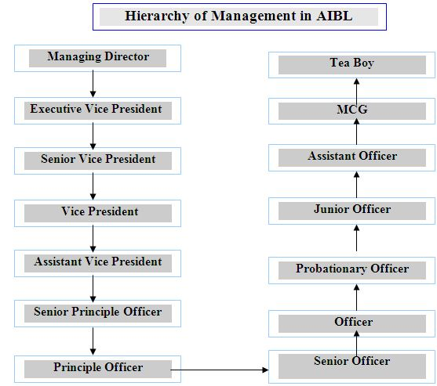

Al-Arafah Islamic bank products & services
In order to satisfy their customers, Al-Arafah Islami Bank #imited offers a variety of products and services. As a result, AIBL has made significant strides in all areas of its operations in a short amount of time, including deposit mobilization, credit management, remittance handling, and foreign exchange and trade. Customers can choose from a wide range of products and services offered by AIBL, which are shown below:
General Banking activities
- Current account
- Savings account
- Short-term deposit
- Fixed term deposit
  - 1 month
  - 3 month
  - 6 month
  - 12 month
- Foreign currency account
Foreign Exchange
- L/C (letter of credit) issue
- L/C advice
- Foreign documentary bill purchase
- Foreign documentary bill collection
- Bill of negotiation
- Foreign remittance
Services of the Bank
- ATM card service
- Online service
- Locker service
- In addition to all of these services they also offer services like cash management, wire transfer, ACH transaction, balance inquiry, fund transfer loan sanction etc.(Amir, 2015)

Chapter-4

This Part Covers:
Mainly objective of the study where there are both primary & secondary objective

Objective of the study

Primary objective
The primary objective of the report is to complete the requirement of the internship topic that is assigned by my honorable internship supervisor. Moreover, as it is one of the necessary requirement to complete my under graduate degree that’s why I have prepared this report.

Secondary Objective
- Gather experience from overall bank operation.
- Observe banking environment & their working style.
- Observe what problems are they facing.
- Recommend some suggestions for the problem that I observed.
- Identify both strengths & weaknesses that they have.
- Analyze the financial performance evaluation for my report.
- Strengthen my CV to make a career in the banking industry.
- Utilize my study in the practical field.

Chapter-5

This Part Covers:
Methodology of the study where there are information primary & secondary data & scope of the study

Methodology of the study
The report is done based on varieties of sources. In addition to that, I tried use both of my academic knowledge & real-life experience that I earned by doing the internship at AIBL. I evaluate financial performance of AIBL on the basis of different dimensions that I learned by doing courses in accounting & finance. Apart from this I use both primary sources & secondary sources to make this report:

Primary sources
- Prepare questions to ask.
- One to One communication with employees
- One to One communication with customers
- Observe daily bank operations.
- Visit various departments of the bank to collect information.
- From my experience of banking work.

Secondary sources
- Use the bank website to collect information.
- Annual bank report of 2021.
- AIBL Dhanmondi branch's different financial statements.
- Use the internet to collect information.
- AIBL releasing documents and pdf
- Audit report.

Scope of the study
I worked in AIBL Dhanmondi Branch as an intern for 3 months that started on 4th October 2022 and ending on 4th January 2023. But because of the limitation of time & scope of work I did not get much information. In spite of this, I tried to include as much information as possible. Moreover, most of the employees were very busy during banking hours so it was tough in many cases to talk with them. In addition to that some scopes that assist me to experience more about all over banking are
- Good working environment.
- Helpful mentality of colleagues.
- My communication skill
- Information which is available on the internet.
- Access to bank documents.

Chapter-6

This Part Covers:
The literature review which is the main part of this report which is based on financial performance evaluation of the concerned bank

Literature Review

Analyzing the Financial Performance

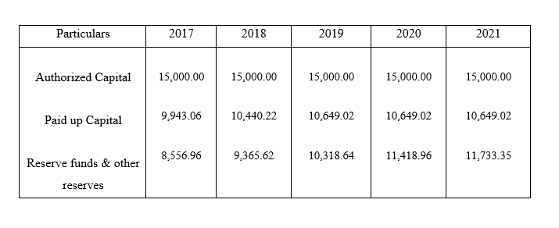
5 Years Capital position of Al-Arafah Islamic Bank
Source: Annual Report of Al-Arafah Islamic Bank 2021 (Figures in Million)

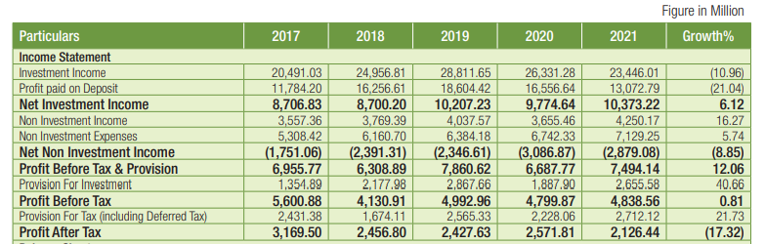
Progress at a Glance (2017-2021):

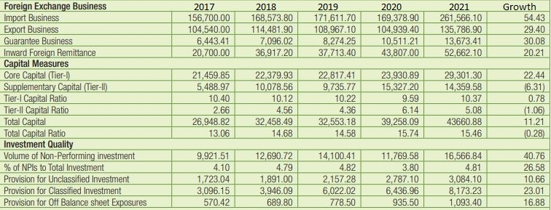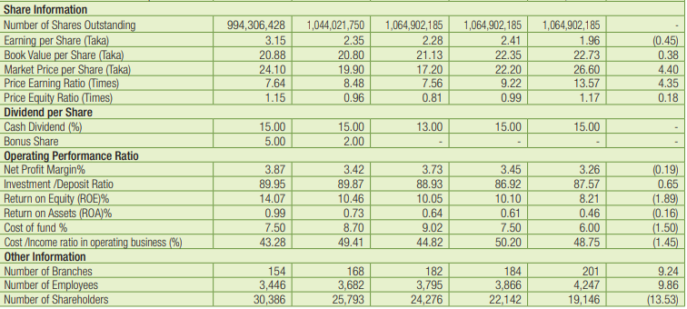
The financial statement of Al-Arafah Islamic Bank is attached here which is collected from their annual report 2021. From the financial statement of Al-Arafah Islamic Bank, we can compare & analyze the financial performance based on those financial data. For ease of comparing & understanding, we are comparing 2021 & 2020.
Initially, if we look at the investment income of 2021 there is decrement of 10.96% than 2020. It also impacts their profit paid on deposit which reduces by 21.04% in 2021 than 2020. Gradually if we look at the first part of the financial statement we can see all the increments & decrements in the growth. When it comes to profit after tax it reduces by 17.32% in 2021 than 2020.
- Foreign Exchange Business: If we analyze the foreign exchange business of Al-Arafah Islamic Bank all of their business units made great progress in 2021 than in 2020. Import business grows by 54.43%, Export business grows by 29.40%, Guarantee business grows by 30.08%, and inward foreign remittance by 20.21%. So we can say that overall they did good business in 2021 than 2020 in the foreign exchange business.
- Investment quality: By analyzing the investment quality part from their statement it also seems to be great as all the elements such as volume of non-performing investment, % of NPI to total investment, Provision for Unclassified Investment, Provision for Classified Investment and Provision for Off Balance sheet Exposures all increases by great numbers.
- Share Information: Now if we look at the share information, at first we can see there is low EPS in 2021 than in 2020 which means shareholders got lower returns in 2021. Moreover, as book value per share increases, it means stocks were perceived as more valuable. Again as market value per share increases, it means the share was attractive to the customers. In addition to that price earnings ratio & price equity ratio both increased by 4.35% & 0.18% respectively which is a good sign for the bank.
- Operating Performance ratio: In OPR, for net profit margin, there was a decrement of 0.19% in 2021 than in 2020 which means there were problems with their cost structure. But the deposit ratio increases. On the other hand, ROE & ROA both decreased which means the bank was unable to efficiently use the capital invested by shareholders and the bank was not able to make maximum use of its assets for getting more profit respectively.
- Other Information: Moreover in the other information we can see that there was an increment in both the number of branches & the number of employees. But the number of shareholders decreased which is a bad sign.
(Fahad, 2022)

Al-Arafah Islamic Bank Investment summary

Investment Process of AIBL
The act of allocating money with the hope and expectation that the owner would receive a profit is known as investing. Money can be used to invest in either financial or real assets. Real investment occurs when resources are utilized to purchase current and fixed assets for use in a manufacturing process or for trading purposes. Investments in money can take various forms, such as deposits in a bank account, the purchase of Mudaraba Savings Bonds, or stock in a corporation. The owner of surplus savings, if he is unable to invest in real assets, has no choice but to invest his money in financial assets because Islam forbids hoarding savings and imposes a 2.5% yearly tax (Zakat) on savings.(Afia Sultana, 2017)
AIBL plays a very important role in the case of Investment. AIBL collects deposits in accordance with the Al-Wadeah and Mudaraba principles and invests the funds in accordance with sharia-based mechanisms and investment strategies.(Ahmed, 2016)

Objective & Principal of Investment
- Strictly invest money in conformity with Shariah principles.
- Carefully evaluating & judging all kind of investment activities & proposal before the approval.
- Make investment considering social & economic development of the country.
- Enhance potential investors through active and beneficial participation.
- Make funding for various development program in order to hasten the society's sustainable social-economic growth.
- Instead of giving cash money they invest in the form of goods & commodities.
- Must stay away from even very profitable investments in industries that are against Islamic Shariah and bad for society.

Source of fund
AIBL, Dhanmondi Branch gather fund from reserves, and funds raised by borrowings from IBG account. However, the majority of its operating revenues come from the various types of deposits that are accepted according to the Islamic principles of Al-Wadeah (safe custodianship) and Mudaraba (trust financing). The AIBL Dhanmondi Branch has the option to raise money from both "Primary" and "Secondary" sources. Those are described below:

Primary Source
- Reserve: Every Islamic bank must also hold a reserve fund, according to Bangladesh bank. An Islamic bank must transfer a specific percentage of its net income to the reserve fund each year, after proper provisions have been made for Zakat and taxes before any dividend is announced, in order to amass sufficient reserves.
- Liquid Asset: Every Islamic bank must also maintain a minimum level of liquid assets at all times to cover its deposit liabilities, which are expressed as a specific percentage of the deposits as may be preserved from time to time by notice in writing from the central bank.
- Borrowingfrom IBG: As member banks, Islamic banks are allowed to borrow money from the central bank, which serves as the lender of last resort, to cover short-term liquidity shortfalls.
- Inter-Bank Borrowing: According to the principle of reciprocity, Islamic banks have established interest-free fund agreements with both domestic and foreign institutions. Normally, Islamic banks maintain excess cash with a few particular banks, as per prior arrangements. These banks can also deposit interest-free compensating balances with Islamic banks as needed. The periods for which funds were placed are changed if the balances are not equal.

Secondary Sources
Mobilization of Deposits: Islamic banks' primary duties are to raise deposits and support business owners financially. Such needs are addressed by Islamic banking. It mobilizes common people's money in accordance with Islamic Shariah. The following are the methods Islamic banks use to mobilize savings:
- Al-Wadeah Account: Deposits are made to Islamic banks' Al-Wadeah accounts. This account is comparable to interest-based banks' demand deposit accounts. This kind of deposit account does not earn interest from conventional interest-based banks. Additionally, depositors are free to withdraw all or a portion of the money they have deposited in this account. The phrase "AL-Wadeah" refers to a financial deposit that enables someone to claim the money in the account, with the bank acting as trustee to protect and store the money. Depositors feel secure leaving their money with the bank as a result since the bank guarantees to return it upon request. Depositors in Al-Wadeah accounts do not assume the risk of losses, hence they are not entitled to any profits from the use of their funds by investors. However, because the bank assumed all of the risk, it is entitled to all gains, if any.
- General Mudaraba Account: The checking account of an interest-based bank differs from the account of Islamic banks. In a mudaraba, one partner provides the capital while the other controls the company by putting in labor and time. Both parties share the venture's profits at a ratio that was decided upon at the time of contracting. The financier, however, is fully liable for any losses that might occur under this agreement. The business's financier is referred to as Sahib al Mal, Rabbul Mal, or the owner of the capital, and the management is referred to as Mudarib, or the entrepreneur.
- Term Mudaraba Account: Different varieties of Mudaraba Term Deposits are given to Islami banks by depositors. Typically, the deposits are made for terms of 1, 3, 6, 12, 24, or 36 months.
- Special Mudaraba Account: The deposit is known as a "Special Mudaraba Deposit" when it is received by an Islamic bank for investment in a particular company, industry, or project.

Mechanism & Modes of Investment at AIBL
Al-Arafah Islami Bank invests in non-profit Halal businesses while adhering to Shariah law. As AIBL conducts its business in accordance with Islamic law, its investments are free of interest because, as we all know, interest is forbidden in Islam. However, making money by purchasing and selling is legal. AIBL presents various investing modes based on Islamic law. The bank distributes its funds in one of three general ways. Which are:

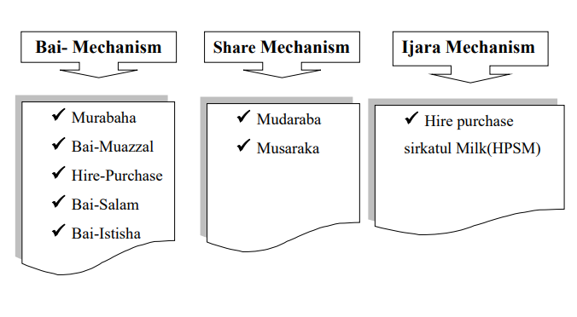

Bai-Mechanism
- Bai-Murabaha: The Arabic words that make up the terms "Bai-Murabaha" (Bai and Ribbun). The words "Bai" and "Ribbun" refer to purchases and sales, respectively, and "Bai-Murabaha" denotes a sale with an agreed-upon profit. A contract between a buyer and a seller known as a "bai-Mudaraba" can be characterized as one in which the seller sells the buyer a certain set of items at cost plus an agreed-upon profit that is due in cash on any specified future date in a lump amount or in installments. The profit markup can be set as a fixed amount or as a percentage of the cost of the items.
- Bai-Muazzal: The English words "Bai" and "Muazzal" are derivations of the Arabic word "Baiun." The words "Baiun" and "Azl" both denote the act of buying and selling something, respectively. "Bai-Muazzal" refers to a sale for which payment is due at a specific future date or within a specific time frame. It is, in essence, a credit sale. A contract between a buyer and a seller known as a "bai-Muazzal" is one in which the seller sells the buyer a specific set of goods (permitted under Islamic Shariah and local law) for a cost plus an agreed-upon profit, which the buyer will pay in cash, as a lump sum, or in installments, at any specified future date. The seller has the option to sell the things he has purchased in accordance with the buyer's order and specifications.
- Bai Salam: The words "Bai" and "Salam" are Arabic in origin. Bai salam is the combination of the words bai, which denotes advance sale and purchase, and salam, which means sale and purchase. The term "bai salam" refers to a contract between a buyer and a seller wherein the seller sells in advance to the buyer certain commodities or products that are allowed by Islamic law and local law at an agreed-upon price payable upon execution of the said contract, and the commodity (ies) or product(s) is/are delivered in accordance with the specification, size, quality, and quantity at a later date in a specific location.
- Bai-Istishna: The word "Istishna," which signifies industry or manufacturing enterprise, was used to create the word Istishna. Istishna refers to products made after placing an order with a producer. Isteshna'a is a contract between a manufacturer/seller and a buyer under which the manufacturer/seller sells specific product(s) after having manufactured them, if allowed by local law and Islamic Shariah, at an agreed-upon price payable in full up front or in installments over a specified time period or on/within a specified future date based on the buyer's order.

Share Mechanism
- Mudaraba: One of the meanings of the Arabic word served as the basis for the phrase "Mudaraba." The Arabic word "Mudaraba" refers to business travel. A mudaraba is a profit-making partnership in which one side contributes finance and the other contributes expertise and labor. Shahib al-Maal is the source of capital, while Mudarib is the source of talent and labor.
  - It is referred to as the Islamic system's optimum mode.
  - It is not only exceptional but also the beauty of Islamic investment.

- Musharaka: The Arabic word "shirkat" or "sharikat" is the source of the word "musakara." Shirkat or Sharikat is Arabic for collaboration or sharing. The actual meaning of Musharaka is hence sharing, however it has a more restricted sense than Shirkat. A specific kind of Shirkat is now referred to as Musharaka in the literature on Islamic banking. Shirkat is a term used in Islamic fiqh literature to describe the joining of two or more estates in such a way that one cannot be distinguished from the other. However, even when there isn't a real confluence of estates, the name "Shirkat" is still used to refer to contracts because they are the catalyst for one. According to legal terminology, it denotes the association of two or more people with a single enterprise. It is the collaboration of two or more people or organizations.

Ijara Mechanism
Hire Purchase Under shirkatul Melk (HPSM): A unique kind of contract known as a shirkatul Melk contract is a hire-purchase agreement. Actually, it is a combination of three contracts: the sale, the ijara, and the shirkat. Shirkat is Arabic for alliance. Shirkatul Melk translates as to jointly possess. The contract is known as a Shirkatul contract when two or more people contribute equity, buy an asset together, own it collectively, enjoy the benefits in accordance with the agreement, and incur the loss in proportion to their individual equity.
(Fahad, 2022)

Investment growth
The investment of Al-Arafah Islamic Bank increased by 6.12% in 2021 than to 2020. And the amount increased from 9,774.64 (million) taka to 10,373.22 (million) taka. There is diversification in their investment portfolio which covers broad areas of business such as RMG, textile, edible oil, ship scrapping, steel and engineering, chemicals, pharmaceuticals, cement, telecommunication, construction, health care, real estate, education, transport, and consumer investment programs. In addition to taking the necessary steps to turn the categorized Investment into performing assets, AIBL has intensified efforts to increase the recovery rate of disbursed investment. As a result, the bank's classified investments could be kept at a low level that was well below the norm for the country. As of 2021, it was 1.14 percent in AIBL. The construction of high-quality assets is the bank's primary objective, and while approving commercial, trade, and project investments for various clients, it grades risks appropriately.(Jannat, 2021)
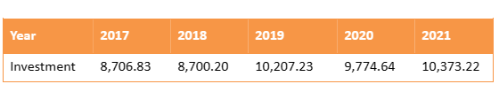
Chart: 1:

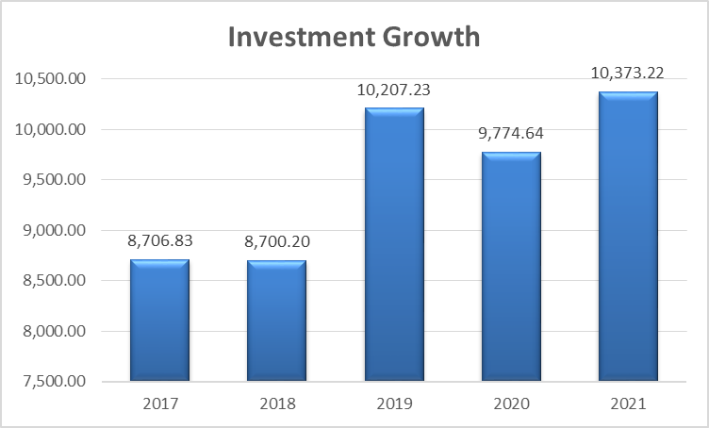

Graph: 1 Investment growth

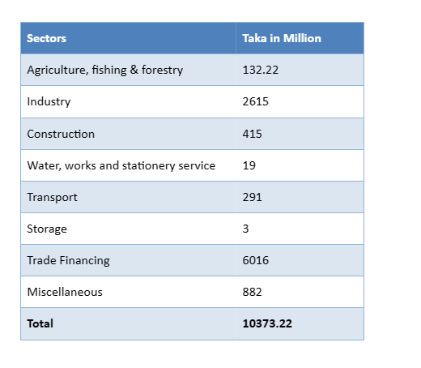

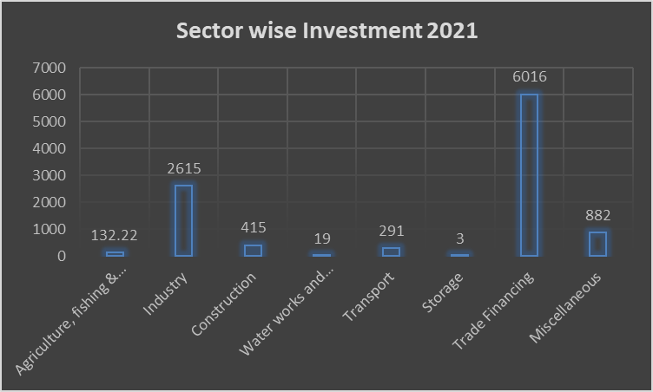

Graph: 2, Sector-wise investment 2022

Financial overview of AIBL Dhanmondi Branch
Different types of investment & number of Clients at Dhanmondi Branch

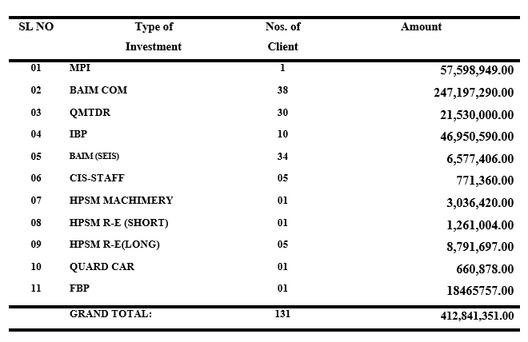

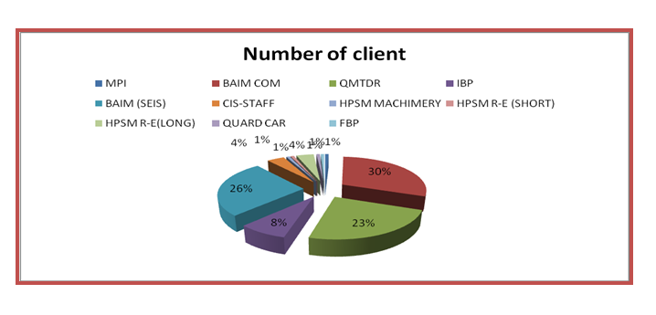

Graph: 3, Number of Clients

Amount of total deposits at Dhanmondi Branch

Year | 2019 | 2020 | 2021
Deposits | 180,648,275.74 | 458,220,957.80 | 729,201,218.56

Table: 3-year total deposits of Dhanmondi Branch

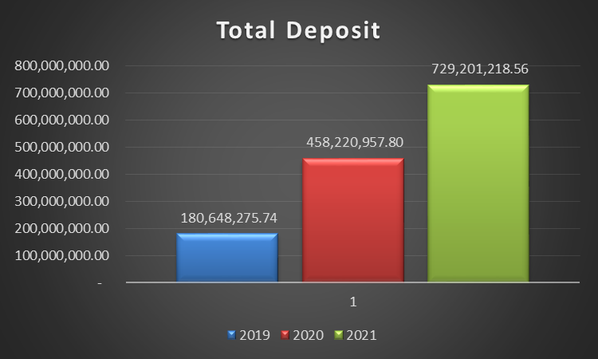

Graph: 4, Total Deposit

By looking at the graph, we can see that in 2019 Al-Arafah Islamic Bank Dhanmondi branch received 180,648,275.74 taka and in 2020 they received 458,220,957.80 taka and finally in 2021 they received729,201,218.56 taka. So, it is observed that there is an increment in their total deposit gradually every year.

Amount of total investment in the Dhanmondi Branch

Year | 2019 | 2020 | 2021
Investment | 33,804,750.00 | 79,113,281.00 | 179,496,239.57

Table: Total investment of Dhanmondi Branch
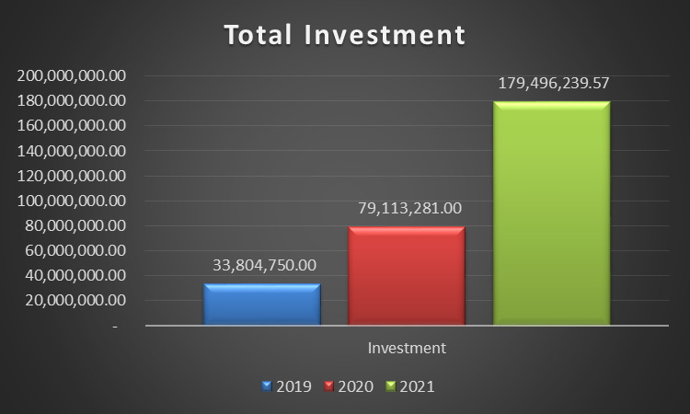
Graph: Total investment of Dhanmondi Branch

By looking at the graph we can see that in 2019 Dhanmondi branch total investment was 33,804,750.00 taka and in 2020 it was 79,113,281.00 taka and in 2021 it was 179,496,239.57 taka. So, there was a gradual increment every year.

Investment in Murabaha Scheme

Year | 2019 | 2020 | 2021
Murabaha  Investment | 3,433,571.60 | 8,078,992.00 | 14,399,737.25

Table: Dhanmondi Branch Murabaha Scheme investment

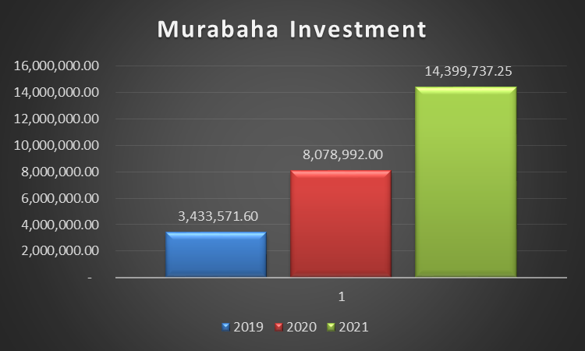

Graph: Murabaha Investment in Dhanmondi Branch

By looking at the graph we can see that in 2019 Dhanmondi branch total Murabaha investment was 3,433,571.60 taka and in 2020 it was 8,078,992.00 taka and in 2021 it was 14,399,737.25 taka. So, there was a gradual increment every year.

Investment in Bai Muajjal Scheme:

Year | 2019 | 2020 | 2021
Bai Muajjal  Investment | 6,059,244.00 | 14,138,236.00 | 28,799,474.50

Table: Dhanmondi Branch Bai Muajjal Scheme investment

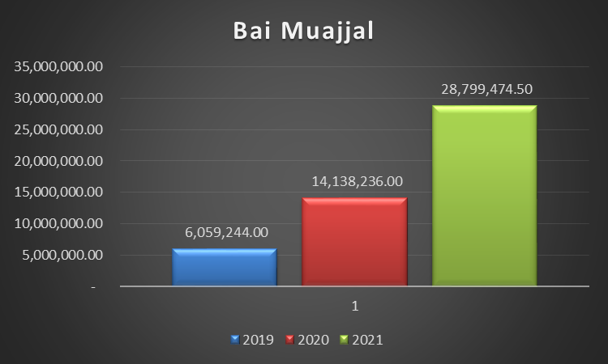

Graph: Bai Muajjal Investment in Dhanmondi Branch
By looking at the graph we can see that in 2019 Dhanmondi branch total Bai Muajjal investment was 6,059,244.00 taka and in 2020 it was 14,138,236.00 taka and in 2021 it was 28,799,474.50 taka. So, there was a gradual increment every year.

Investment in HPSM Scheme
Year | 2019 | 2020 | 2021
HPSM  Investment | 11,077,394.40 | 19,939,309.92 | 29,908,964.88

Table: Dhanmondi Branch HPSM Scheme investment

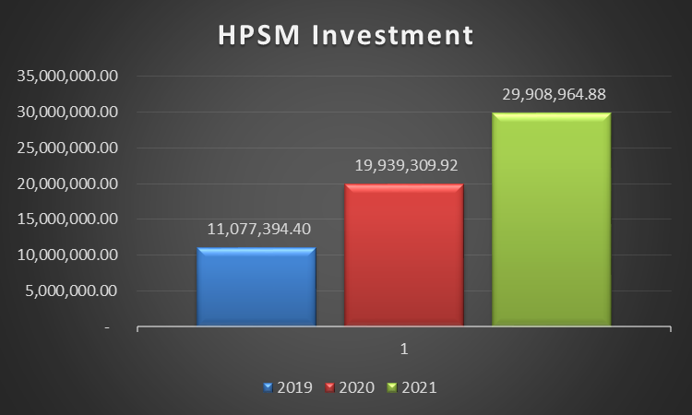

Graph: HPSM Investment in Dhanmondi Branch
By looking at the graph we can see that in 2019 Dhanmondi branch total HPSM investment was 11,077,394.40 taka and in 2020 it was 19,939,309.92 taka and in 2021 it was 29,908,964.88 taka. So, there was a gradual increment every year.

Investment in Quard Against MTDR

Year | 2019 | 2020 | 2021
Quard Against MTDR Investment | 18,252,000.00 | 29,203,200.00 | 40,300,416.00

Table: Dhanmondi Branch Quard against MTDR investment

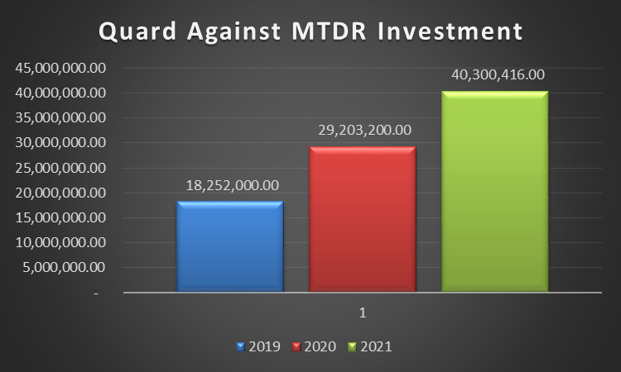
Graph: Dhanmondi Branch Quard against MTDR investment

By looking at the graph we can see that in 2019 Dhanmondi branch total Quard car investment was 18,252,000.00 taka and in 2020 it was 29,203,200.00 taka and in 2021 it was 40,300,416.00 taka. So there was a gradual increment every year.

Chapter-7

This Part Covers:
The observation & findings that I experience during my Internship period.

Findings of the study

Backdated in technology: AIBL is not updated in technology. There are many other banks that are very advanced in technology & enhancing their technology as per the demand of the market. But on the other hand, AIBL is not much concerned to update its technology with market demand. As a result, they are losing their customers.
Knowledge gap between customers & bankers: There is a knowledge gap between customers & bankers. There are many customers who are not familiar with the Islamic banking system or the schemes that Islamic banks have.
Management Problem: When providing loans to their customers, the management of AIBL does not assume any risk. They make decisions very slowly. They occasionally miss out on current opportunities because they make decisions slowly.
Dependency: There are too much lag & dependency in the work of AIBL. Branch offices must obtain clearance from the main office for each and every task. Every branch office is strictly under the jurisdiction of the main office. Their reliance on the headquarters slows down their operations.
Marketing & Promotion: Al-Arafah Islami Bank Limited's weak points include advertising and promotion. The marketing efforts of AIBL are ineffective. Other banks employ superior marketing techniques.
Negative operating performance ratio: If we compare the operating performance ratios of AIBL between 2020 & 2021 then we can see there is negative ratios of most of them such as negative profit margin, negative return on asset & negative return on equity.
Dissatisfaction among employees: The primary reasons for employee unhappiness are the lack of promotion opportunities and extended probationary periods. Another source of unhappiness is a tardy pay raise.
Protracted investment procedure: Lending is a fairly drawn-out process in the Islamic banking system. However, it takes longer with AIBL because branch managers cannot make loans. Managers must submit a proposal to the corporate office for each loan. The management is unwilling to take any chances.
Not having a personal loan: Personal loans are not offered by AIBL because doing so is prohibited by the Islamic Banking System. However, personal loans are very common in other institutions because they have such high-interest rates.
Credit Recovery System: The majority of the time, the borrowers default on their loan payments. The Islamic Banking System forbids interest, hence the bank is not permitted to charge interest for an extended period of time. They only keep the money specified in the contract.
Low Investment Ratio: In AIBL, the investment-to-deposit ratio is very low. Like other banks, AIBL is currently unable to assume the risk. The AIBL management doesn't take investing risks.
Investment in Halal business: AIBL does not finance the hotel industry. However, this company offers a high rate of return. AIBL primarily invests in the buying and selling of goods. They also make real estate investments.
LC for Halal Products: Energy drinks, CDs, VCDs, and DVDs are among the products that AIBL does not open LC for. Other banks, however, recently opened these kinds of LC and made significant profits.
Purchases no savings bonds: Some local and foreign savings bonds have high return rates. Given that it violates the guidelines of the Islamic Banking System, AIBL does not purchase these.
Power of Manager: The manager of any branch of AIBL does not have the authority to grant any loans to customers without Head Office approval. The management has the authority to make modest loans in other banks, nevertheless.
Loan-related to house & construction: Corporate Branch of AIBL no longer offers loans for house construction. However, there are a lot of customers for house building loans in Corporate. Additionally, it is relatively simple to recover from a house-building loan.
(Saifullah, 2010)

Chapter-8

This Part Covers:
Last part of the report that consist of my recommendation based on my research & observation and the conclusion.

Recommendation & Conclusion

Recommendation
- To give its clients better services, AIBL ought to employ the most recent developments in banking technology. Additionally, it will draw in clients from foreign banks.
- AIBL should run an advertising effort to cultivate a positive reputation with the public. To draw customers, they need to run an aggressive marketing effort.
- The AIBL shall provide several loan types to its own employees as soon as their employment is confirmed. They will perform better as a result of this financing. This loan's interest rate must be lower than that of other banks.
- The management needs to decide right away to grab the chances that are available.
- If some perks are not provided, the employee's attitudes won't be stable.
- The investment ratio should rise at AIBL. Given the large amount of idle money in each branch, they should now take a risk when providing loans to their customers.
- The AIBL management should increase employee wage raises more frequently. Additionally, the probationary term ought to be shortened. The workers would be inspired to work hard for the company.
- Every step should not be dependent on Head Office. They ought to let the branches operate separately.
- Managers of AIBL should have the power of giving small loans to the clients. It is very important for banks to increase their investment.
- Lending is a fairly drawn-out process in the Islamic banking system. AIBL needs to take action to streamline the loan system. Customers dislike drawn-out processes, hence.
- House Building Loan should be started by AIBL, Corporate Branch. since there are many customers who need a house construction loan. Additionally, it is relatively simple to recover from a house-building loan.
- Customers of AIBL, Corporate Branch should have access to lockers. Some customers now require locker service to safeguard their priceless documents and precious jewelry.
- The Corporate Branch of AIBL needs to create a Foreign Exchange Department. For all branches, this department is now absolutely necessary. This department makes it difficult for the Corporate Branch to draw in worthwhile clients.
- AIBL can pursue a diversified strategy in expanding its current line of business. The management can consider options of starting merchant banking for minimizing the risk and getting more returns they should prepare portfolio management.
- The AIBL, Corporate Branch, may focus on modest and short-term loans as well. Because there are numerous consumers of modest and short-term loans in the corporate sector.
- AIBL should focus on the operating performance ratio to improve.
- The customer is required to pay back the funds in the specific branch where the loan was obtained. When a consumer wants to pay the installment on time, they should do it in this manner. Sometimes, a person's inability to communicate forces them to default. It would be better for them if AIBL allowed customers to make payments at any of its branches.

Conclusion
In every nation, the banking industry contributes significantly to economic activity. The same is true of Bangladesh. Economic growth and financial development are intertwined. Because of this, private commercial banks are important players in this situation.(Davis, 2004)
The report focuses on the financial performance evaluation of Al-Arafah Islamic bank under general banking. In addition to financial performance evaluation, other aspects of general banking have been covered in this report such as products & services of AIBL, the Hierarchy of AIBL, different account types & their descriptions. Moreover, as I completed my internship at the Dhanmondi branch of AIBL. So I tried to enlighten some financial aspects of my branch.
Shariah and Islamic banking are combined in a unique way by Al-Arafah Islami Bank Ltd. Al-Arafah Islami Bank Ltd. is a significant non-government commercial bank for economic growth. It has been crucial in the fight to end Bangladesh's unemployment crisis. This business benefits its 19147 owners as well as its over 4247 employees. However, the majority of people in our nation are misinformed about Islamic banking, particularly Al-Arafah Islami Bank Ltd. & other Islamic banks. They are unable to distinguish between how Islamic banks operate and regular commercial banks because they lack a thorough understanding of Islamic banks' operations and investment strategies.

References
Afia Sultana, M. N. (2017). Financial Performance Analysis of Islamic Bank in Bangladesh: A Case Study on Al-Arafah Islami Bank Limited. Research gate, 17.
Ahmed, R. (2016, February 20). Internship Report on Al-Arafah Islami Bank Ltd. Retrieved from Assignment Point: https://assignmentpoint.com/internship-report-on-al-arafah-islami-bank-ltd/
AIBL financial statement. (2021, 31 December). Retrieved from AIBL: https://www.aibl.com.bd/financial-statement/
AIBL profile. (2022, November 30). Retrieved from AIBL: https://www.aibl.com.bd/about-us/aibl-profile/
Amir, M. E. (2015, May 15). Internship Report on “General Banking system of Al-Arafah Islami Bank Ltd. Retrieved from Academia: https://www.academia.edu/26989264/Internship_Report_on_General_Banking_system_of_Al_Arafah_Islami_Bank_Ltd_
Davis, S. (2004). An investigation of the effect of Balanced Scorecard implementation on financial performance. Science Direct, 135-153.
Fahad, S. H. (2022, April 10). AIBL-Financial-performance-analysis. Retrieved from Course Hero: https://www.coursehero.com/file/141449287/AIBL-Financial-performance-analysisdocx/
Hussain, R. (2017, November 4). Internship Report on General Banking of Al Arafah Islami Bank. Retrieved from Assignment point: https://assignmentpoint.com/internship-report-on-general-banking-of-al-arafah-islami-bank/
Jannat, M. (2021, December 28). A REPORT ON FINANCIAL ANALYSIS OF AL-ARAFAH ISLAMI BANK LIMITED (AIBL). Retrieved from IUB academic repository: http://dir.iub.edu.bd/
Saifullah, M. (2010). Superiority of Conventional Banks & Islamic Banks of Bangladesh: . International Journal of Economics and Finance, 4.

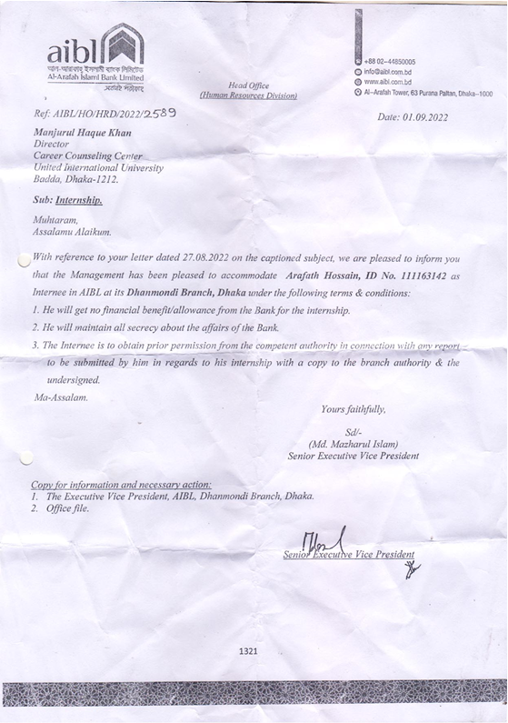
Appendix

