Internship Report

On

Financial Performance Analysis of SIBL



Financial Performance Analysis of SIBL

Course code: INT 4399

Submitted To
Mohammad Musa PhD (MMs)
Professor
School of Business and Economics
United International University

Submitted By
Amina Haque
ID: 111 161 088
School of Business and Economics
United International University

Date of Submission

Letter of Transmittal

December 31, 2020
Mohammad Musa, Ph.D., (MMs)
Professor,
School of Business and Economics (SOBE),
United International University,
Badda Dhaka 1212,
Subject: Submission of Internship Report on Social Islami Bank Limited.

Respected Teacher,
I'm satisfied to notify you that I have arranged the report on "Financial Performance Analysis of SIBL" according to your directions. I have assembled inside and out information had pragmatic involvement with the previous three months and communicated them through examination.

I endeavored to satisfy the reason for this report. I'm guaranteeing that I will be there when any explanation or clarification is required concerning this report. I trust that this report will justify your endorsement.

Sincerely yours,
Amina Haque
ID: 111 161 088
SOBE
United International University

Acknowledgment

In the first place, I like to offer my significant much appreciated to All-powerful Allah for gift me the knowledge and persistence expected to finish the investigation.
I would be charmed to pass on my heartiest appreciation to Mohammad Musa, Ph.D., (MMs), Professor, UIU for his huge bearing and canny exhortation. Without his offer assistance, it would not have been conceivable to total this report. I offer thanks to him for allowing me to pick this point and provide his guidance and backing which draw out an aftereffect of this report. I esteem his patient direction and an enormous help.
I have a wealth of gratitude for making. While setting up this report my director from Social Islami Bank Limited Kazi Obaidul Al Faruk (Senior Executive Vice President of SIBL) gave critical information and valuable comments on every one of the sections of this report. Much appreciation goes to Md. Aminur Rahman (Officer Project Accounts) whose exhortation and backing smoothened the way for this report.
There may be a few blemishes in this paper, despite my sincere endeavors. For any unintended mistakes, I apologize.

Abstract
This study focuses on the financial performance of Social Islami Bank. Data is collected through secondary sources for quantitative analysis. For quantitative analysis, 11 years of data has collected by which financial performance will be evaluated. For measuring financial performance a few techniques have followed like horizontal analysis, vertical analysis and ratio analysis. According to this analysis, major findings has drowned which will help the stakeholders in case of decision making. Beside this, necessary recommendation is also provided by this study.
Keyword: Islami banking, performance, Financial, SIBL, Bangladesh

Table of Contents
Letter of Transmittal iii
Acknowledgment iv
Abstract v
Chapter 01
Introduction 1
Background of the Report 2
Scope of the Study 2
The objective of the Study 3
Literature Review 4
The methodology of the Study 5
Limitation of the Study 6
Chapter 02
Overview of Social Islami Bank (SIBL) 7
Background of Social Islami Bank Limited 8
Mission of Social Islami Bank 9
Vision of Social Islami Bank 9
Values of Social Islami Bank 9
Functions of Social Islami Bank 10
Corporate Structure of SIBL 11
Shareholder Structure of SIBL 12
Products & Services of SIBL 13
Chapter 3
Internship Experience 14
Internship at SIBL 15
Description of my job at SIBL 17
Critical findings and recommendations 19
Chapter 4
Quantitative analysis 20
Horizontal Analysis of Income Statement of SIBL 22
Horizontal Analysis for Balance Sheet 25
Vertical Analysis of Income statements 29
Vertical Analysis for Balance Sheet 31
Chapter:5
Ratio Analysis 35
Liquidity Ratio 36
Efficiency ratio 38
Profitability Ratio 41
Solvency Ratio 45
Market Value 50
Chapter: 06
Findings, Recommendation and Conclusion 54
Findings 55
Recommendation 56
Conclusion 56
References 57
Appendix 57

Chapter 01

Introduction of the Report

Background of the Report
This report is basically the output of my understanding in three months of internship period. After participating all the exam and necessary courses of BBA, this is the way by which we can use our theoretical knowledge in case of practical activities. With the help of my supervisor in SIBL I have completed my internship after gaining plenty of experiences and knowledge. According to that experience and knowledge I have tried to evaluate the financial performance of Social Islami Bank Limited.
For this paper, I have designed a few things for analysis. I will have analyzed data of 10 years of Social Islami Bank. Additional 1 year of data is taken for base year in case of Horizontal Analysis. By the analysis, this report will draw the financial performance of Social Islami Bank Limited which will help the stakeholders of SIBL incase of decision making. Company valuation is very much important. As financial statements don’t reflect the actual condition of the bank or any financial institution, financial performance can give a better idea of actual condition of that financial institute. That is why, I have decided to do the financial performance analysis for my internship report.

Scope of the Study
There are many scopes of the study which are given below:
- Clarifying probable profit calculating process.
- Distinguish the difference between Commercial banking and Shariah based banking.
- Understanding Shariah based banking accordingly.
- Activities like CSR or Zakat fund and usage of them.
- Contribution of Social Islami Bank in the economy of Bangladesh.

Objective of the Study

Social Islami Bank Limited is one of the best Islami Shariah-based banking systems in Bangladesh. Social Islami Bank Limited is exceptionally good place of banking activities. As a shariah bank, their banking activity or financial activity is really interesting. That is why this study will have focused on financial activities. So, this study has some objective which are given below:
- Primary Objective: Evaluating financial performance of Social Islami Bank for last 10 years is the primary objective of this study.
- Secondary Objective:
- Identifying the workings, contributing, and monetary exercises of Social Islami Bank.
- Analysis of financial statement properly.
- Identifying Shariah based activities accordingly.
- Measuring the influence that SIBL contains in case of economic activities.
- Making a final statement regarding financial performance of SIBL.
- Measuring those factors which must significantly impact on the financial performance of SIBL.

Literature Review
This study is based on the financial performance of Social Islami Bank Limited. For analyzing purpose, vertical, horizontal and ratio analysis has been done. There are lot of papers are available regarding commercial banks. But in terms of Shariah based bank of Bangladesh, study or article is very limited. We have analyzed a few recent papers regarding financial performance of the bank. Finding after analyzing those a few assumptions are given below.
According to (Akter & Aklema, 2019) liquidity state of Social Islami Bank is by and large amazing. According to the investigation, we can acknowledge that Social Islami Bank will need to achieve adequate current assets to require care of current liabilities afterward on time moreover.
As indicated by (Rofe, 2018) it used proportion investigation for viable assessment of liquidity position, asset the board condition, advantage and market worth, and commitment incorporation situation of the SIBL for execution appraisal. It explores the bank's use of its assets and control of its expenses. It chooses the more vital incorporation of liquid assets for transitory liabilities. It gauges SIBL as rule adequacy and execution. The procuring and benefit of the financial area have likewise improved as of late and it is for the most part estimated by Net productivity execution, Return on Assets, and Return on Equity. Subsequently, the financial area would assume an indispensable part in the advancement of the country and productive and sound financial administration would lead the nation to arrive at the most elevated pinnacle of accomplishment.
As indicated by (Hossain, 2017) Social Islami Bank Limited's proportion was fluctuating from 2012 to 2016. At any rate, in 2016 the proportion of the current proportion was lessened. These exhibits that Social Islami Bank Limited has improved its capacity to deal with its transient responsibility. In the wake of exploring the Activity proportion of Social Islami Bank Limited. It has been seen that there’s an upward example in Social Islami Bank Limited 's Add up to Resource Turnover and Speculation to Deposit Ratio. From 2012 to 2016, the bank couldn't diminish its costs through and through. Along these lines, it might just be said that the functioning activity of Social Islami Bank Limited 's is getting awful.
As per (Zaman, 2018) Jamuna Bank Limited has been working with uncommon assurance and fighting greatly with Government arranged banks, neighborhood business banks close by the worldwide banks as well. Jamuna Bank Limited reliably endeavored its level best to perform financially well. Dismissing attempting to do well in specific perspectives Jamuna Bank Limited managed certain money-related issues every so often. A part of the issues were-preposterous horrible advances, absence of advances and advances, lack of cash in hands as a result of vault limit, etc These issues animate chance to time on account of money related stoppage, credit cost difference, rising capital market, expanding in the money market, and so forth Fighting with all of these issues and matching various banks each second the bank is endeavoring to improve to best. If this thing continues, we believe that Jamuna Bank Limited will become impressively more later on.

Methodology
This study is based on quantitative analysis. Information is collected through secondary sources. This kind of information has been collected from different sources. Workers meet to portray the hone of execution, control, checking and reimbursement, and comprehensive investigation of the existing records. For auxiliary information, the collection strategy has been done from Social Islami Bank Limited’s Yearly Report.
- Official website
- Recognized articles
- Certain brochures and related papers
Research design: Descriptive
Research Instrument: Vertical, Horizontal and Ratio analysis

Limitation of the Study

We all know that SIBL was recorded in 2005. Due to inaccessible information, this study is not linked with the data of 2005-2009 which might have a very good impact on this study. Due to COVID-19, primary data collection procedure has become more complex. That is why, primary data is not collected for this study which is the biggest limitation for this study. Essential information might display a more viable circumstance of the monetary execution of SIBL Constrained. Due to time limitations, this paper cannot contain further valuation which can bring more precise information.

Chapter 02

Social Islami Bank Overview

Background of SIBL

SIBL was started their operations in 1995. Social Islami Bank Limited has 168 branches. They are doing their banking activities with 3125 workers. They have 65 sub-branches which are accessible to serve the managing an account benefit to the individuals of Bangladesh. SIBL isn't as it were great at keeping money action but moreover, SIBL has been performing a bounty of exercises related to CSR.
As indicated by the authority site of SIBL, it had Issued IPO and recorded it in DSE in 2000. Social Islami Bank presented web-based financial offices in 2004 and in 2005, it was recorded in CSE. In 2007, It gave the first right offer and in 2009, it gave second right offer. Like 2010, 2011 was additionally an exceptionally astounding year. In this year, a simultaneous review situation was presented, the third right offer was given and their 75th branch was set up. Around there, a green financial window and school banking were set up also. It presented its 125th branch in 2016. In 2015, it presented specialist banking in 2015. In 2018, SIBL dispatched web banking and got a worldwide rating. Along these lines, Social Islami Bank Limited is becoming quick and consistent.
As a shariah based banking, Social Islami bank is doing better. SIBL isn't sufficient in productivity proportion. From the vertical and level examination, we have seen that their income is high. Simultaneously their costs are high too. The decrease of resources over the years involves incredible worry for SIBL at this moment. The association has less complete resources than its advantage cost with the goal that it cannot quickly arrive at its transient commitments or pay back its method of support. Over the year the aggregate sum of the store has expanded consistently. SIBL was much proficient to keep a decent wellspring of financing as they had the option to stand firm on a steady footing all through the last 10 years. Their Higher authority must be more conscious to increase efficiency in case of banking activity.

.

Mission of SIBL

Missions of SIBL is given below:
- Social Islami Bank Limited has the mission of reasonable & adjusted development techniques.
- Social Islami Bank Limited is focusing on precise, quick, and agreeable client support.
- Creating openings for nearby pay openings for the neighborhood and enabling individuals of country regions.
- Shareholders' value ought to be returned accordingly.
- Revolution in case of advancement in financial items.
- Three sector banking model adoption is one of the most significant mission of SIBL.

Vision of SIBL

Vision of SIBL is to be one of the best Shariah Based banking in Bangladesh.

Values of SIBL
Like other Shariah based bank, SIBL has some values which are given below:
- Efficiency in consumer loyalty
- Coping with revolution of technology.
- Accountability and transparency in terms of banking activity to grow trust among clients.
- Flexibility in case of changing environment.
- Openness for adopting new rules and regulations.
- Giving priority in case of security aspect.

Functions of SIBL
Like other banks, SIBL has some functions. They are given below:
⮚ Share market management and maintaining accordingly.
⮚ Maintain individual investment properly.
⮚ Collecting and maintaining foreign currencies properly.
⮚ granting and monitoring loans appropriately.
⮚ Maintaining good money circulation.
⮚ Purchase and buy financial security to maintain economic stability.

Corporate Structure of SIBL

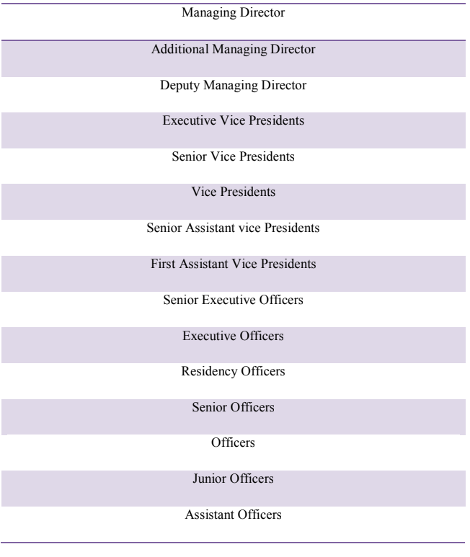

Shareholder Structure of SIBL

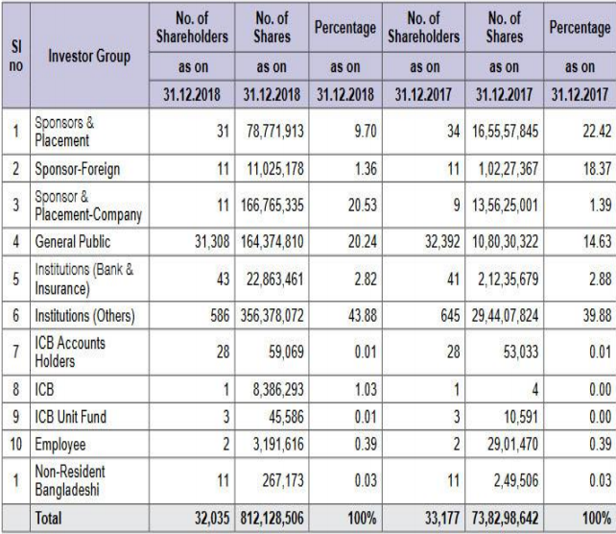

Products & Services of SIBL
The products and services of SIBL are as follows:
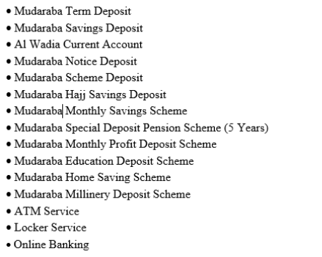

Chapter 3

Experience of Internship

Internship at SIBL
Internship at Social Islami bank was really amazing. I can use my theoretical knowledge in case of practical workings in this internship period. I have done lot of activities in this internship periods. They are given below:

- Opening different accounts like AWCD, SSP, MMPDS, MSD
- Identification of issue of cheque
- Cheque conveyance
- Client’s Account Statement
- Modifying Client information
Opening account: Opening bank account is one of the main activities that I have done in my internship period. It was really interesting. I had come to know different people by opening account. At first, I have collected national identity card and 3 copies of photo of account holder and nominee. Beside that I have collected different documents like driving license, TIN etc. for more security and I try to identify their source of earnings. According to this information, I have filled the form accordingly.
Requisition of Cheques: We all know that check requisition is one of the most important activities in general banking. It is little bit sensitive as well. Beside this, there are lot of activities like inwards and outwards. I had to handle those appropriately. For checking signature and other sensitive issues I had taken help from the Ababil software of SIBL.
At first, I had taken the checks from the clients then I tried the condition of the check whether it is acceptable or not. Then with the help of the Ababil software I had identified the requirements of accepting checks and give my supervisor for further procedures.

Account Explanation to Client: Different clients need differ data regarding their accounts. I had identified different accounts and provide clients different data or information. Beside this I have edited or upgrade data.
Different Documents Scanning: In general banking activities, I needed to do scanning different documents appropriately. When I opened different account, I needed different sensitive documents from clients. At first, I have collected those from customer, scanned them appropriately and keep them or post them accordingly.
Data section of Customer: Different clients need differ data regarding their accounts. I had identified different accounts and provide clients different data or information. Beside this I have edited or upgrade data where necessary.

Description of my job at SIBL

My job was general banking at SIBL. There are many responsibilities that I have done in case of general banking activities. I have learned so many things by doing those activities. Those are given below:

Learned from General Banking and Department:
We realize that the beginning stage of all banking operational exercises is General Banking.
- I found out about opening certain records and different types of records.
- I additionally found out about different sorts of highlights that are vital while opening records, for example, the public ID card or visa mark of the client's photo customer, candidate subtleties, chosen one photography, and so on
- I found out about the issuance of money books and different types of checkbook issuance.
- I chipped away at different sorts of clearing things during the entry-level position period, for example, the substance of the clearing interaction, the kinds of clearing records, and so forth.
- SIBL manages different types of contact components on different occasions, for example, business letters, gatherings, and reports. In this way, I think about the strategy for business correspondence, as well.
My ability in the use hypothesis to genuine work conditions are inherent in this temporary position to adapt to the new climate and like relational connections.
I was unable to do the genuine exercise in all divisions because of time and spending limitations. I attempted to gather information/data from the accompanying sources around there:
- Practical occupations in work areas
- Conversation with the official up close and personal
- Direct Findings straightforwardly
- Conversation up close and personal with client
- Browsing on the SIBL site.

Different Parameter on work demonstration

Investment works are fundamental and take a ton of periods to accomplish as financial backers need to manage any factor to satisfy clients and acquire the pay of the banks also.

In general, the administrator or top of the branch is liable for any choice taken by the bank. Officials mostly follow his suggestions to effectively complete their work.

The different definitions of work, like the arrangement of records, proclamations, compensation sheets, the conversation of any reports, and the arrangement of thoughts, are fundamentally the obligation of general banking. They have been accomplishing some significant work concerning the assortment of money by acquiring checks, data about the PC helped account, offering revenue on the venture.

Findings and Recommendations
- There are fewer quantities of money getting and assortment corners than clients. Clients will in general stand by a great deal of time in line before any celebrations, which additionally causes customer dissatisfactions.
- The bosses are likewise occupied at work, in this way, while they decide to utilize it, they have insufficient opportunity to bring to the table data to clients or understudies.
- Due to the neighborhood broadband connection, helpless web access additionally causes issues. To perform errands productively, the association isn't generally fast.

Chapter 4

Analysis

Horizontal Analysis

Horizontal analysis is very much important to know the actual condition of an organization. In this analysis, information or data of one years is considered as a base year. According to this base year, several years of information has evaluated and comparison is done accordingly. By this, how much changes have come in this information is evaluated. It helps in case of decision making. There are two types of horizontal analysis. They are:
Absolute Comparison:
Comparing absolute money amounts of certain items over a few times is one way of ding flat examination. Cash in hand after a bookkeeping period, for occurrence, perhaps differentiated with other bookkeeping periods. This approach is valuable in deciding the merchandise that is advancing the foremost.
Comparison of Percentage:
Within the moment strategy of horizontal analysis, rate contrasts are compared over a few times for a few items. For comparison, the outright money wholes are deciphered into rates.

Horizontal Analysis of Income Statement of SIBL
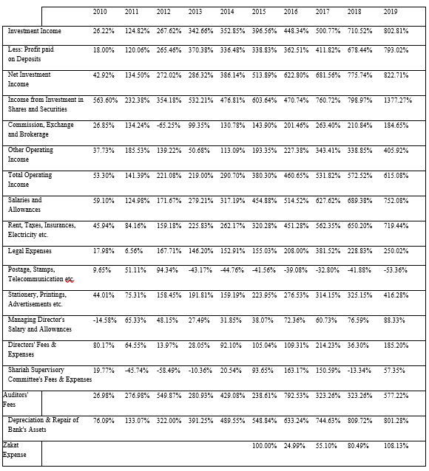
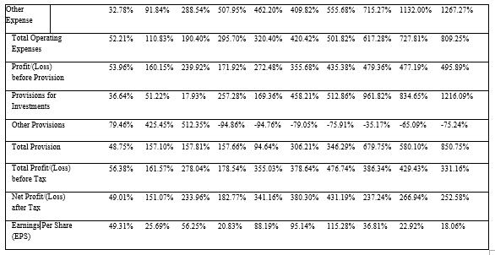
Explanation & Description:
Investment Income: Investment income has increased immensely in last 10 years. In horizontal analysis, we have taken the year 2009 for the base year. According to that we have done the analysis of 10 years (2010-2019). In 2010, investment income was 26.22% of the base year and in 2019 it was 802.81% of the base year. From here, we can say that investment income has increased tremendously.
Total Operating Income: Total operating income is also increased a lot with investment income. In 2010, operating income was 53.30% of the base year and in 2019 it was 615.08% of the base year. From here, we can say that investment income has increased a lot.
Total Operating Expense: OE has additionally expanded a parcel. Operating expense was high in terms of operating income. We can see the chart where salaries of employees were really high of SIBL which could be the main factor of increased operating expense. It hits directly to the profitability of SIBL. Higher authorities of SIBL should take some necessary steps to prevent their high expense. For this, they can lessen their number of employees.
Total Profit/(Loss) before Tax: It is seen that in 2019 add up to benefit some time recently assets were 331.16%. So, it was not that much expanded in agreement with salary and cost. It had a great move till 2016, but after that, it begins to drop. But, still, it’s a solid condition of add up to benefit some time recently assess.
Total Profit After Tax: Due to high operating expenses, net profit after tax has been very less in accordance with investment income. SIBL has a good range of operating or investing income but they cannot utilize that and convert that into a good profit after tax due to high rate of operating expense.
EPS: we have seen the two phases of SIBL in terms of EPS. It was advanced in really good shape up to 2016. At that point, it begins to drop. The reason behind usually the increment of cost and depreciation of resource.

Horizontal Analysis for Balance Sheet
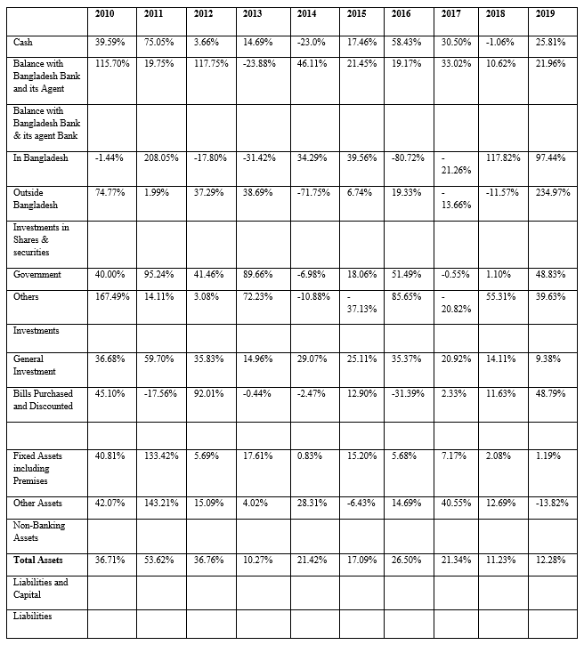
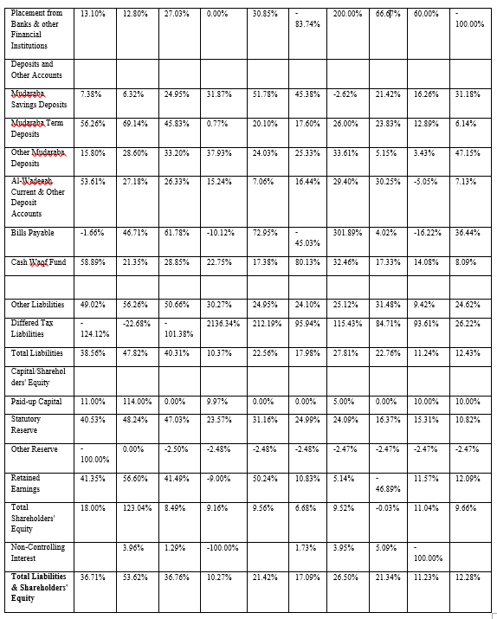
Explanation and Description:
Total Asset: The condition of total asset is not that much good. In case of current asset, cash and items related to cash equivalents has reduced a lot over the last 10 years according to total asset. In 2010, cash was 39.58% of base year where in 2019 it has reached to 25.81%. That is why, SIBL has lost its most liquid able assets over the year. One of the main reasons could be the increasing investment over the years. Over the last 10 years, fixed asset has decreased a lot according to total Asset. It is so alarming. Because we know that fixed asset maximization should be the goal of any organization. In 2010, total asset was 36.71% of base year where in 2019 it has reached to 12.28%. That is why, the condition of total asset is not good. SIBL has lost its asset continuously in last 10 years.
Total Liabilities & Shareholders' Equity: Current liabilities has increased a lot in last 10 years. Especially other liabilities have increased tremendously in terms of total liabilities. Increasing liabilities is not a good sign for kind of organization because it increases risk. It is expected that, as liabilities have increased a lot in last 10 years, shareholder’s equity has reduced simultaneously. Common stockholders should worry about the condition of the shareholders’ equity. In 2010, total shareholders equity was 36.71% of base year where in 2019 it has reached to 12.28%. Retained earnings has decreased a lot over the last 10 years which is the main reason of the reduced condition of shareholders’ equity.

Vertical Analysis
The entirety utilized by the investigator is net deals income on the pay articulation whereas it adds up to resources on the adjust sheet. This strategy, too known as component rates, to the examination of money-related explanations, produces common, huge money-related explanations. It is simple to compare common estimate adjust and income explanations with more than 26, whether for a single trade or through numerous businesses over a long time.

Vertical Analysis of Income statements

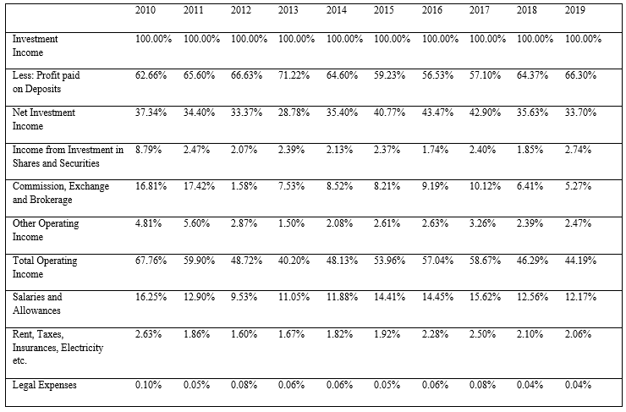

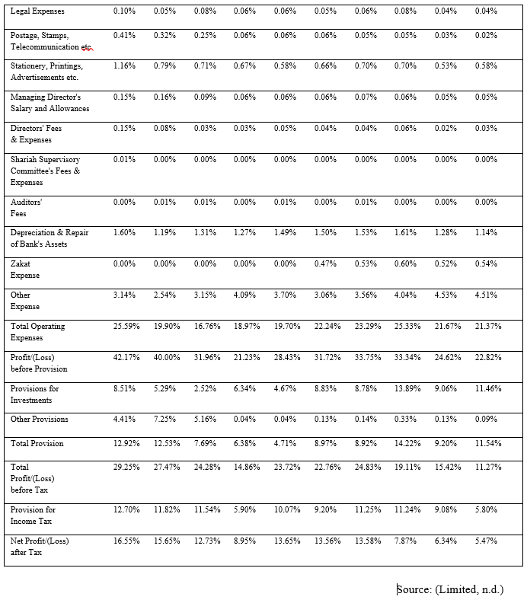

Explanation & Description:
Total Operating Income: Total operating income has reduced a bit over the last few years. One of the main reasons could be the reduction of commission of brokerage. In 2009, it was 16.18% on the other hand in 2019, it was 5.27% of investment income.
Profit paid on Deposits: Fluctuation has been seeing in this section in last 10 years according to revenue. But a huge amount of profit has paid on deposits in terms of investment income. In 2009, profit paid on deposits was 62.66% on the other hand in 2019, it was 66.30% of investment income. So, SIBL has given a healthy amount of profit to the depositors.
Total Operating Expenses: Operating expense was high in terms of operating income. We can see the chart where salaries of employees were really high of SIBL which could be the main factor of increased operating expense. It Should be minimized.
NPAT: Due to high operating expenses, net profit after tax has been very less in accordance with investment income. SIBL has a good range of operating or investing income but they cannot utilize that and convert that into a good profit after tax due to high rate of operating expense.

Vertical Analysis of Balance Sheet

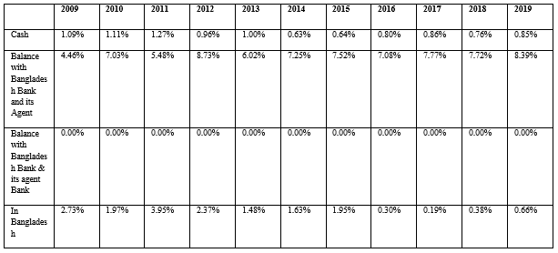

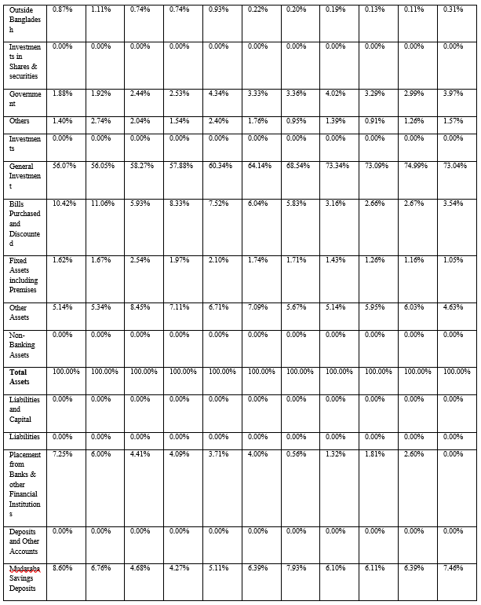

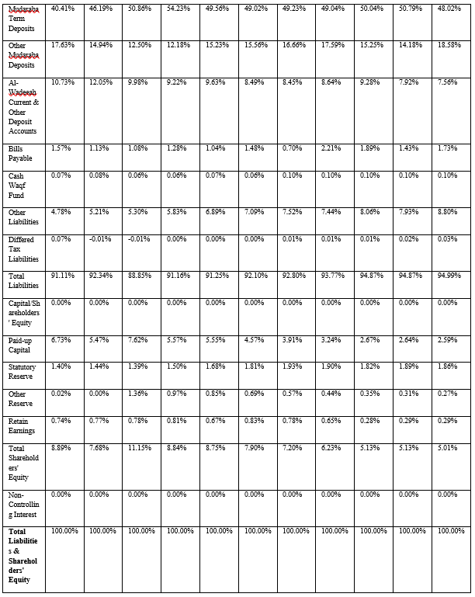

Fixed assets: Over the last 10 years, fixed asset has decreased a lot according to total Asset. It is so alarming. Because we know that fixed asset maximization should be the goal of any organization.
Current Assets: In case of current asset, cash and items related to cash equivalents has reduced a lot over the last 10 years according to total asset. In 2010, cash was 1.09% of total asset where in 2019 it has reached to 0.85%. That is why, SIBL has lost its most liquid able assets over the year. One of the main reasons could be the increasing investment over the years. In 2010, general investment was 56.07%% of total asset where in 2019 it has reached to 73.04%.
Current liabilities: Current liabilities has increased a lot in last 10 years. Especially other liabilities have increased tremendously in terms of total liabilities. Increasing liabilities is not a good sign for kind of organization because it increases risk.
Shareholders’ Equity: It is expected that, as liabilities have increased a lot in last 10 years, shareholder’s equity has reduced simultaneously. Common stockholders should worry about the condition of the shareholders’ equity.

Ratio Analysis
We computed proportions concurring to 5 measurements which are:
- Ratio of Liquidity
- Ratio of Efficiency
- Ratio of Profitability
- Ratio of Solvency
- Ratio of Market value

Ratio of Liquidity
Cash Ratio: Cash ratio is very much important for any kind of liquidity analysis. It describes the ability of an organization to pay short term obligations by cash. It is better to have 1 in case of cash ratio.
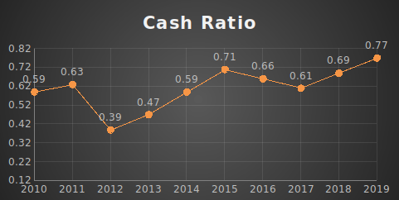
In the graph, we have seen that cash ratio was less in 2012. Otherwise, it has fluctuated over the years. In 2010, the ratio was 0.59 and in 2019 it has reached to 0.77. So, it has increased little bit in last 10 years. It is the liquidity indicator of a firm.

Current Ratio: Current ratio is very much important for liquidity ratio analysis. It indicates the ability of a firm for the payment of short-term obligation by current assets. 1 is good outcome of the this ratio.

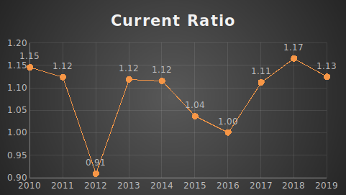

In the graph, we have seen that current ratio was less in 2012. Otherwise, it has fluctuated over the years. In 2010, the ratio was 1.15 and in 2019 it has reached to 1.13 So, it has decreased little bit in last 10 years. It is the liquidity indicator of a firm.

Investment Resources to Total Assets: The speculation asset to resources proportion may be a calculation that demonstrates how much more the capital consumption of the company is comparable to the shareholders’ equity.
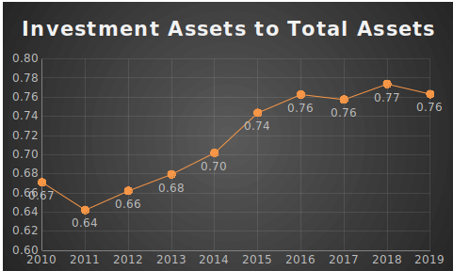
In the graph, we have seen that Investment Assets to total assets ratio was less in 2010 and 2011. Otherwise, it has increased over the years. In 2010, the ratio was 0.67 and in 2019 it has reached to 0.76. So, it has increased little bit in last 10 years. It is the liquidity indicator of a firm.

Ratio of Efficiency
Total turnover of Assets: The resource turnover proportion is the way of measuring the productivity of a company's resources to produce income or deals. It compares the full sum of deals or incomes to it add-up to resources.

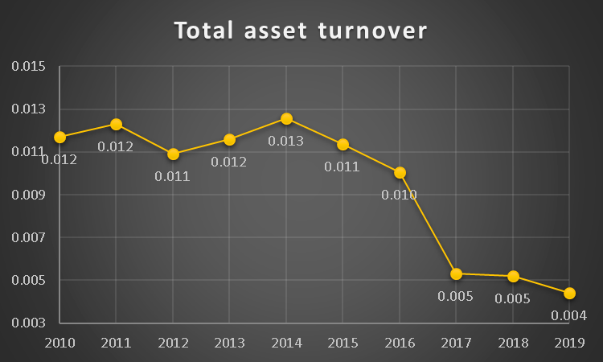

In the graph, we have seen that total asset ratio was less in 2017,2018 and 2019. Otherwise, it has fluctuated over the years. In 2010, the ratio was 0.012 and in 2019 it has reached to 0.004. So, it has decreased little bit in last 10 years. It is the efficiency indicator of a firm.
Equity to fixed assets ratio: Financiers and different loan specialists utilize the "value to fixed resources" proportion generally. Banks use it to see the amount of the fixed resources of the firm are now financed by obligation. A low "value to fixed resources" proportion of a bank has not used its credit to boost its fixed resources and consequently the lenders have a sense of safety. Since in case of a liquidation, the leasers have the earlier option to guarantee their resources first.

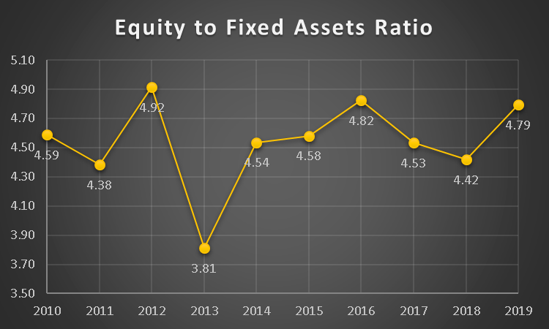

In the graph, we have seen that equity to fixed assets ratio was less in 2013. Otherwise, it has fluctuated over the years. In 2010, the ratio was 4.59 and in 2019 it has reached to 4.79. So, it has increased little bit in last 10 years. It is the efficiency indicator of a firm.

Fixed assets to Equity ratio: Fixed asset to equity is an indicator of efficiency of a firm. How much fixed they have converted in accordance with equity is the measure of this ratio. So, it is very important for both investors and other stakeholders.
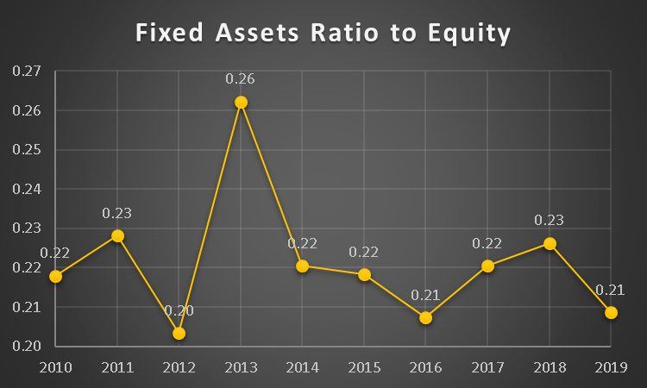

In the graph, we have seen that fixed assets to equity ratio was less in 2016 and 2012. Otherwise, it has fluctuated over the years. In 2010, the ratio was 0.22 and in 2019 it has reached to 0.21. So, it has decreased little bit in last 10 years. It is the profitability indicator of a firm.

FA/TA (Fixed Assets to Total Assets): A settled resource to add up to resources measures by separating settled resources with add up to resources. That decides the parcel of settled resources within the add-up to the resource of the firm.
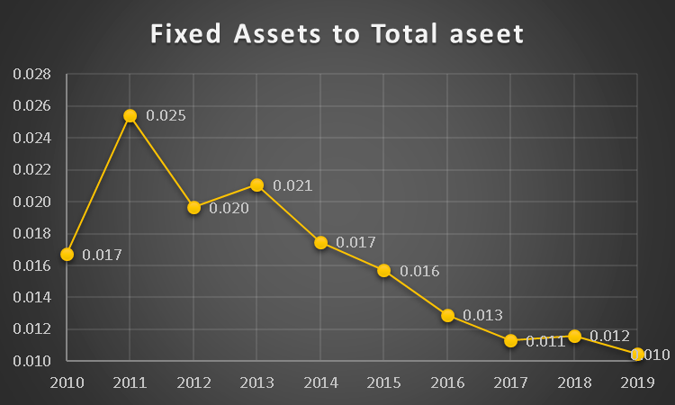
In the graph, we have seen that fixed assets to total asset ratio was very less in 2016, 2017,2018 and 2019. Otherwise, it has fluctuated over the years. In 2010, the ratio was 0.017and in 2019 it has reached to 0.010%. So, it has decreased little bit in last 10 years. It is the efficiency indicator of a firm.

Ratio of Profitability
Return on Common Equity: Return on common equity is a very good ratio to identify the profitability of a firm. It describes the amount of money is common stockholders are getting from investment. It is very much important for both common shareholders and other stakeholders.

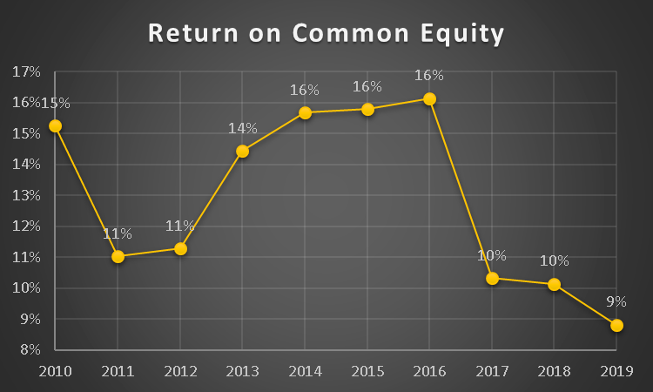

In the graph, we have seen that return on common equity ratio was less in 2019. Otherwise, it has fluctuated over the years. In 2010, the ratio was 15% and in 2019 it has reached to 09%. So, it has decreased in last 10 years. It was in a good shape until 2016. In 2016 it has reached at 16%. It is the profitability indicator of a firm.

ROA: It is a method of estimating how productive an organization is comparative with its absolute resources. A chief, financial backer, or investigator can get a thought concerning how proficient an organization's administration is at utilizing its resources to produce income.

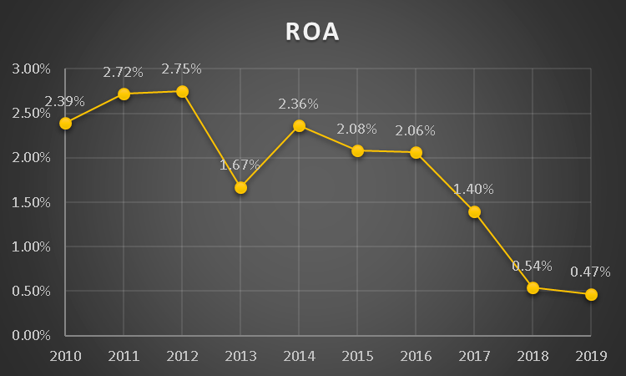

In the graph, we have seen that Return on assets ratio was less in 2018 and 2019. Otherwise, it has fluctuated over the years. In 2010, the ratio was 2.39% and in 2019 it has reached to 0.47%. So, it has decreased a bit in last 10 years. It is the profitability indicator of a firm. Return should be increased according to total asset.

EPS: EPS means earnings per share. It is calculated by total earnings divided by outstanding shares. The more the EPS is the better. Firm should increase EPS to attract investors and maintain money circulation within the firm.

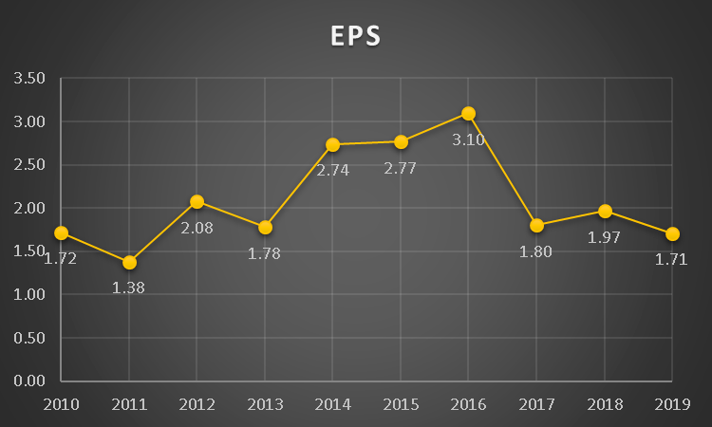

In the graph, we have seen that EPS has fluctuated over the years. In 2010, the ratio was 1.72 and in 2019 it has reached to 1.71 So, it has increased little bit in 2016 which was 3.10. It is the profitability indicator of a firm.

Cash deposit ratio: Money Deposit proportion is the method of estimating a bank loan out of the stores it has prepared. It assists financial backers with perceiving the amount of a bank's center assets are being utilized for loaning. It can likewise be characterized as Total of Cash close by and Balances with central bank separated by Total stores.

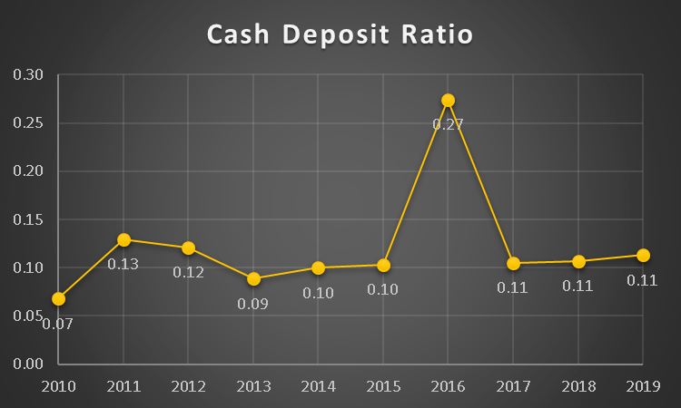
In the graph, we have seen that cash deposit ratio was high in 2016. Otherwise, it has fluctuated less over the years. In 2010, the ratio was 0.07 and in 2019 it has reached to 0.11. So, it has increased little bit in last 10 years. It is the profitability indicator of a firm.

Profit Margin of Pretax: It is utilized to quantify the working productivity of an organization. It reveals to us the level of deals that have transformed into benefits or, as such, how much benefit the organization has produced for every taka of the offer before deducting charges. The more fruitful the organization is, the higher the pretax overall revenue.

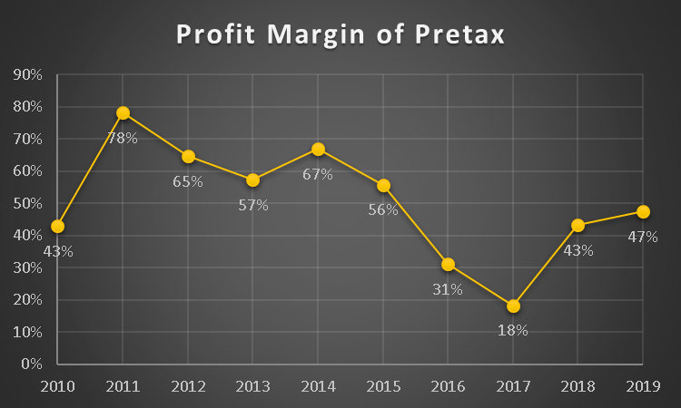
In the graph, we have seen that profit margin of pretax ratio was less in 2016 and 2017. Otherwise, it has fluctuated over the years. In 2010, the ratio was 43% and in 2019 it has reached to 47%. So, it has increased little bit in last 10 years. It is the profitability indicator of a firm.

Ratio of Solvency
Debt Ratio: Debt ratio is very much important in case of identify the solvency of a company. It is calculated by total debt divided by total assets. So, how much debt is available against total asset is measured by this ratio. That means it calculates the condition of leverage of this firm.
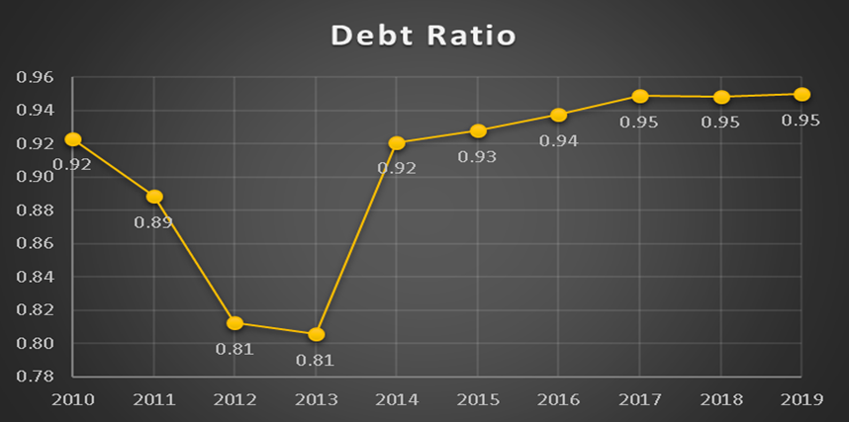

In the graph, we have seen that debt ratio was less in 2012 and 2013. Otherwise, it has increase over the years. In 2010, debt ratio was 0.92 and in 2019 it has reached to 0.95. So, it has increased little bit in last 10 years. It is the solvency indicator of a firm.

D/E Ratio (Debt Equity Ratio): This ratio is very much important. By this ratio, we can learn how much debt is available according to the equity. The more the ratio is, the riskier the firm is for investment. On the other hand, less debt increases the tax payable as well. That is why, firm should follow a strategic fit for balancing debt equity ratio.
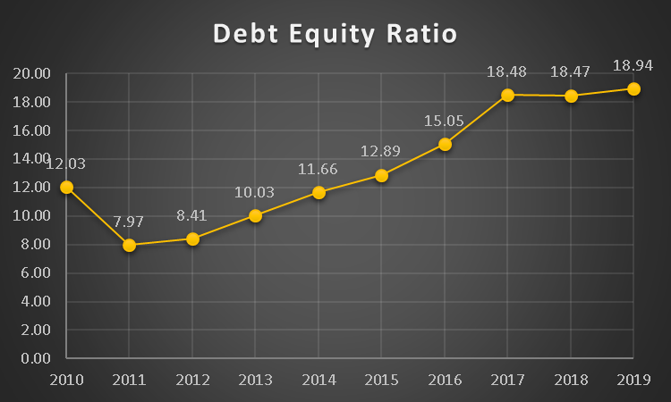

Debt equity ratio is very much important for any organization. But debt is increasing every year constantly for SIBL. We can see in the graph that in 2010, debt equity ratio was 12.03 and in 2019 it has become 18.94 which was pretty much alarming for SIBL.

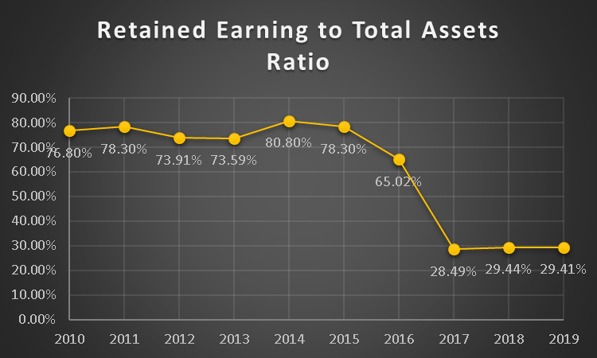
Retained Earnings to Total Assets Ratio: Retain earnings to total assets ratio is very much important. In case of financing, it has a great impact. Many important decisions of stakeholders depend on this ratio. 100% is the ideal state of this ratio.

We have seen in the graph that retain earnings to total assets ratio was good until 2016, but after that it has fallen massively. In 2010 it retained earnings to total assets ratio was 76.80% and after the 10 years, in 2019 it has reached to 29.41%. So, from here we can say that due to high payment from retained earnings a huge change has come after 2015-16.
Investment to Deposit Ratio: This ratio shows which measure of the store is utilized as a venture. It is determined by complete speculation partitioned by all-out stores.

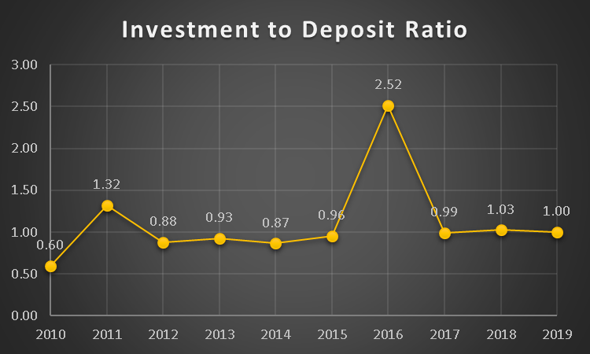

According to the graph, SIBL has constant investment to deposit ratio except 2016. That means, SIBL has maintained a certain amount of investment from deposit every year.

DSCR: Debt Service Coverage Ratio is an estimation of whether a firm is adequately competent to pay current obligation commitments by the accessible income. It is determined by networking pay isolated by absolute obligation administration.

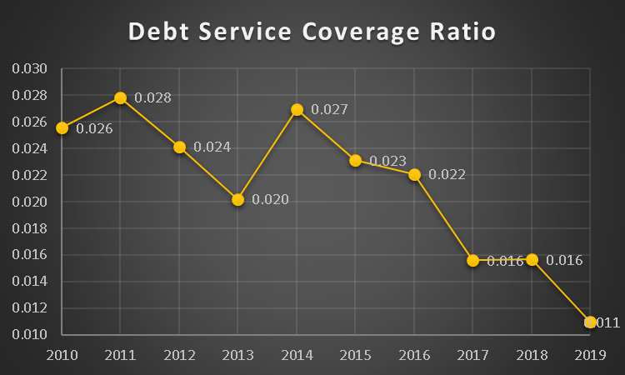

So, Debt Service Coverage Ratio continuously reducing over the last 10 years. In 2010, it had 0.026 and in 2019 it had become 0.011. According to it, we can say their CA is increasing a lot which slows down the debt service coverage ratio. So

Current Liabilities to Net Worth Ratio: This ratio shows the dependence for payment of debt by the equity. Higher ratio of current liabilities to net worth ratio indicates the pressure on the future cash flow.

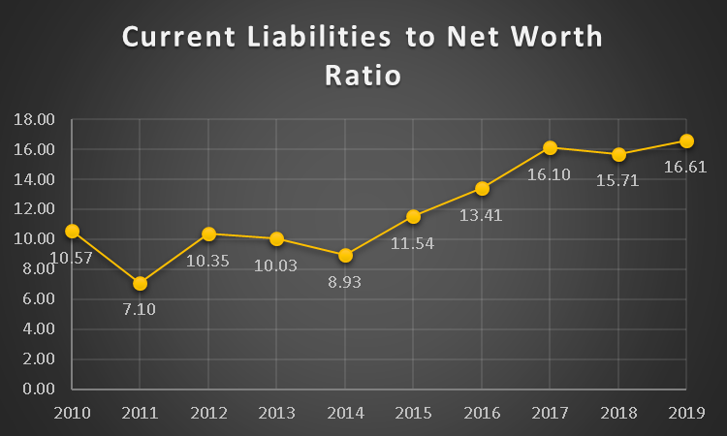

So, according to CL to total assets proportion, CL is more than total assets. It means, their assets are mostly acquired by current liability. Over the last 10 years, it has increased a lot constantly. In 2010, they had 10.57 ratio of CL to net worth where it has reached to 16.61 in 2019.

Value of the Market

DCR (Dividend Coverage Ratio): It is a monetary marker that discloses to you how often an organization's working income can cover the profit. It is determined by the organization's income from activities partitioned by all-out profit. A profit inclusion proportion under 1 proposes that the organization can't deliver its profit utilizing incomes acquired from business action. In the present circumstance, the organization will not be reasonable over the long haul.

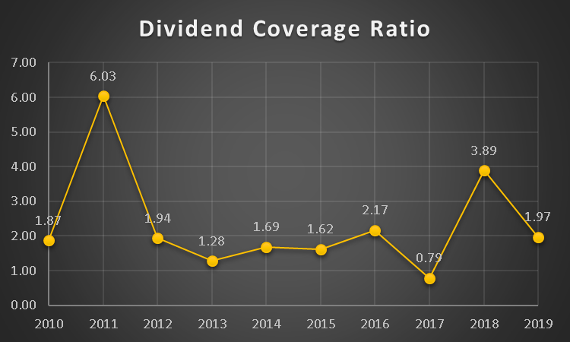

In the graph, we can see that DCR is fluctuating in the first 3 years and last three years of this 10 years’ analysis. In the middle years, it was quite stable.

Equity Multiplier: Basically, equity multiplier measures the risk of an organization. It analyzes the company based on percentage of equity and debt condition of the firm.
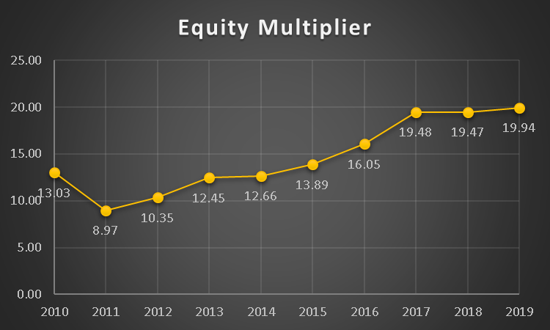

So, from the graph we can say that equity multiplier is high by big margin of SIBL. Which means, they are lot of depended on the leverage, so it is very much risky for Social Islami Bank.

DPS: Dividend Per Share is a significant measurement as it permits the financial backer to decide the measure of money, they will get based on shares they hold. On the off chance that the organization has higher DPS, it implies the organization has additional cash in the wake of holding the income to pay their financial backers.

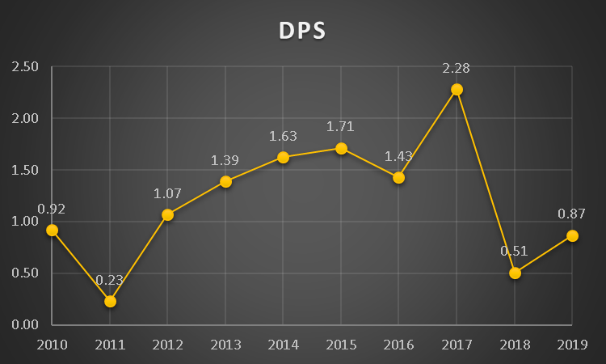

So, DPS ratio that has given above is not that much high. In 2017 it had highest DPS of 2.28. Then it had fallen a lot in 2018.

Dividend Payout Ratio: It addresses the level of the organization's profit paid out to investors as profit. It is determined by isolating the absolute profits by the organization's net gain or DPS/EPS.

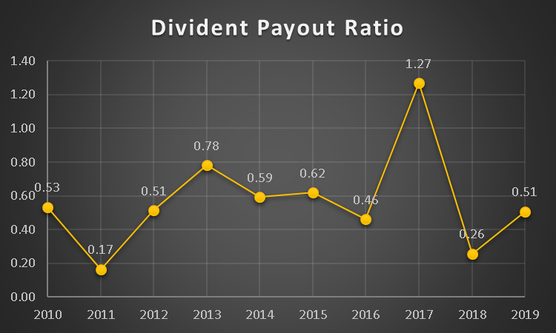
Overall, dividend payout ratio is very fluctuating over thew last 10 years. In 2017, it had reached 1.27 but ultimately is has come down to 0.53 in 2019 and it had 0.53 in 2010.

Price-Earnings Ratio: The stock is viewed as underestimated when its cost is low compared with the measure of cash the organization procures, instead of contrasted with the cost per portion of comparable organizations. Hence, we need a typical estimation (P/E proportion) to look at among organizations. It just thinks about a stock's cost to its organization's income or benefit.
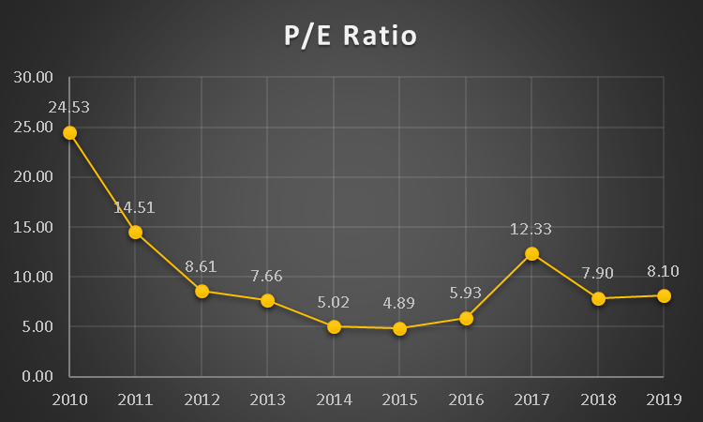

After 2010, we have seen that their P/E ratio is surprisingly low. Though it has increased a little bit in 2017 but overall, it has reduced drastically after 2010 and it has reached at 8.10 in 2019 from 24.53 in 2010.

Chapter: 06

Findings & Conclusion

Findings
According to analysis there are many findings which are given below:

- The organization had all good liquidity ratio to satisfy its liabilities.
- In last ten years, investment income has increased a lot, but they could not utilize those income properly and could not make a good profit out of it due to huge operating expense.
- The association has less complete resources than its advantage cost with the goal that it cannot quickly arrive at its transient commitments or pay back its method of support. Over the year the aggregate sum of the store has expanded consistently. SIBL was much proficient to keep a decent wellspring of financing as they had the option to stand firm on a steady footing all through the last 10 years. Bank was not in a superior situation regarding net revenue.
- SIBL’s overall financial performance was good until 2016, after that its performance has reduced a lot.
- Creating benefits from investor's value is poor.
- Even however all out resource returns have been raised; the level of absolute resource returns is so low.
- As we have mentioned earlier that their operating income is high. One of the main reasons for that is high level of salary to it’s employees.
- Current liabilities are developing more than the net-working pay.

Recommendation
As per analysis, recommendations are given below:

- Net resources have decreased step by step; they ought to be expanded.
- Salaries and remittances are high. Subsequently, their costs are high. It ought to be limited however much as could be expected.
- The level of complete resource returns ought to be high as per absolute resource return.
- The company's capacity to create benefit from investor's value Should be high.
- Price to profit proportion ought to be high. For this, fundamental advances ought to be taken.
- current liabilities ought to be becoming not exactly the net-working pay.

Conclusion
So, we can conclude the whole report in two parts. Firstly, SIBL has very good financial performance till 2016 after that their financial performance is decreasing continuously. As their operating income is high and fixed assets are declining over the years, their financial performance is not doing well. The measure of held income has been decreased a great deal to take care of the tremendous bills payable. Shockingly, it has a decent measure of stream of income or pay. However, SIBL couldn't make a decent measure of benefit out of it. As indicated by proportion investigation, they have great liquidity. They are moderate at dissolvability and market esteem proportion. Be that as it may, SIBL isn't sufficient in productivity proportion. From the vertical and level examination, we have seen that their income is high. Simultaneously their costs are high too.
The decrease of resources over the years involves incredible worry for SIBL at this moment. Higher administration should consider the big picture and find important ways to expand the measure of resources and productivity straightaway.

References

Limited, S. I. (n.d.). Islami Bank Bangladesh Limited Annual Report. Retrieved from Islami Bank Bangladesh Limited: https://www.siblbd.com/about/financialreports
Akter, & Aklema. (2019, 02 01). Financial Performance Analysis of Social Islami Bank Limited. Retrieved from UIU Institutional Repository: http://dspace.uiu.ac.bd/handle/52243/835
Assignment Point. (2020, 06 13). Performance Analysis of Social Islami Bank Limited. Retrieved from Assignment Point: https://www.assignmentpoint.com/business/banking/performance-analysis-social-islami- bank-limited.html
Hossain, R. (2017, November 07). Evaluation of Financial Performance of SIBL. Retrieved from Slideshare: https://www.slideshare.net/100004072344872/evaluation-of-financial- performance-of-sibl-81697103
Rofe, M. K. (2018, August 12). Financial Performance Evaluation – a Study on Social Islami Bank Ltd. Retrieved from SCRIBD:
https://www.scribd.com/document/397968808/Financial-Performance-Evaluation-a-Study-on-Social-Islami-Bank-Ltd-2019
Zaman, A. (2018). Financial Performance Analysis of Jamuna Bank LTD. Dhaka: BRAC University.

Appendix
Balance Sheet
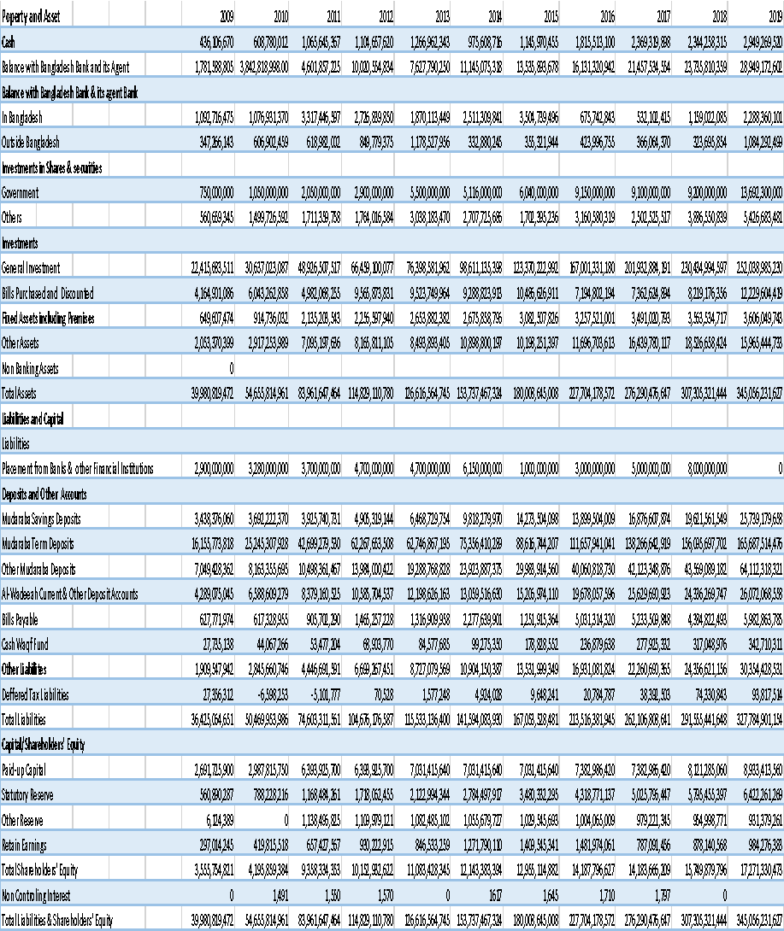

Income Statement


