
United International University
School of Business and Economics
Dhaka, Bangladesh

PROJECT REPORT

Artificial Intelligence in Digital Marketing:
A Bangladeshi Perspective

Submitted To:
Dr. Seyama Sultana
Professor, School of Business and Economics
United International University, Dhaka

Submitted By:
Sayed Redoun Hossain
Student ID: 111201200
Major: Marketing | Trimester: Spring 2025

Letter of Transmittal
Date: June 10, 2026

Dr. Seyama Sultana
Professor
School of Business and Economics
United International University, Dhaka, Bangladesh

Dear Madam,

I am pleased to present this project report titled “Artificial Intelligence in Digital Marketing: A Bangladeshi Perspective” in partial fulfillment of the requirements for the BBA Program at United International University.

This report looks at how AI tools are currently being adopted, perceived, and used within the digital marketing space of Bangladesh. To gather relevant data, I surveyed 30 individuals working across various industries in Dhaka and other major cities of Bangladesh.

I hope this report lives up to the expected standards and adds something useful to the ongoing conversation about how AI is changing marketing in Bangladesh. I am truly grateful for your guidance and patience throughout the entire process.

Yours Sincerely,

Sayed Redoun Hossain
ID: 111201200 | Major: Marketing
United International University

Certification of Similarity Index
This is to certify that the project report titled “Artificial Intelligence in Digital Marketing: A Bangladeshi Perspective” was run through Turnitin’s plagiarism detection software and received a similarity index below 25%, which falls within the acceptable range set by the School of Business and Economics, United International University.

The work presented here is entirely the student’s own and has not been submitted to any other institution or program for evaluation.

Supervisor’s Signature: ___________________________
Name:
Designation:
Date:

Declaration of the Student
I, Sayed Redoun Hossain, am submitting this project report titled “Artificial Intelligence in Digital Marketing: A Bangladeshi Perspective” as part of what is needed to complete the BBA Program at United International University, School of Business and Economics.

I also confirm the following:
- The work in this report is my own and has never been submitted elsewhere for any degree or academic credit.
- All sources and references drawn upon in preparing this report have been clearly identified and credited.
- All data used in this report were gathered through honest methods and have not been altered or invented in any way.
- This report has been screened for plagiarism and satisfies the required standard.

Signature: Redoun
Name: Sayed Redoun Hossain
ID: 111201200
Date: June 10, 2026

Acknowledgement
My deepest gratitude goes to Almighty Allah, without whose mercy and blessings this work would not have been possible.

My sincere thanks go to Dr. Seyama Sultana, my project supervisor, for her patient guidance and careful feedback at every stage. Whenever I felt stuck, her direction helped me move forward, and her belief in this project kept me motivated throughout.

I am equally thankful to the teachers and staff of the School of Business and Economics at United International University for creating a supportive learning environment throughout my studies.

I am also indebted to every marketing professional and business owner across Bangladesh who participated in my survey. Without their time and honest input, this study simply would not exist.

Finally, to my family and friends — thank you for your patience, love, and constant encouragement. You made the difficult days feel manageable.

Abstract / Executive Summary
Artificial Intelligence (AI) has become one of the most powerful forces reshaping how businesses market themselves in today’s world. This report focuses on Bangladesh — a country going through rapid digital growth, with expanding internet access, booming mobile usage, and an increasingly active social media culture — and asks how AI-powered marketing tools are being taken up, what people think of them, and what difference they are making on the ground.

To answer these questions, I collected primary data from 30 participants — a mix of digital marketing professionals, business owners, marketing managers, and brand strategists working across e-commerce, FMCG, banking, telecommunications, and real estate sectors in Bangladesh. They responded to a structured questionnaire built around a 5-point Likert scale.

What emerged is encouraging. Awareness of AI tools is near-universal among the respondents, and social media AI tools along with AI-based content platforms are seeing the widest use. Time savings and sharper customer targeting came out as the top perceived benefits, with an overall mean rating of 3.73 out of 5. E-commerce and retail businesses were the most active adopters, representing 31% of the sample.

At the same time, the study makes clear that adoption is not without its difficulties. A shortage of technical skills, the high price of AI tools, concerns around data privacy, and weak digital infrastructure in many smaller businesses are all slowing things down. The report closes with targeted recommendations for marketers, policymakers, and educators on how to unlock AI’s full potential across Bangladesh’s marketing sector.

Keywords: Artificial Intelligence, Digital Marketing, Bangladesh, AI Tools, Adoption Barriers, Social Media Marketing, Machine Learning, Personalization, Marketing Automation

Table of Contents

Letter of Transmittal 2
Certification of Similarity Index 3
Declaration of the Student 4
Acknowledgement 5
Abstract / Executive Summary 6
CHAPTER I: INTRODUCTION 7
I.1 Background of the Study 7
I.2 Statement of the Problem 7
I.3 Objectives of the Study 8
I.4 Theoretical Framework 8
I.5 Motivation of the Study 8
I.6 Scope and Limitations 9
I.7 Definition of Key Terms 9
I.8 Organisation of Chapters 9
CHAPTER II: REVIEW OF THE LITERATURE 10
2.1 Introduction 10
2.2 Industry Analysis 10
2.3 Literature Survey 12
CHAPTER III: RESEARCH METHODS 13
3.1 Introduction 13
3.2 Research Design 13
3.3 Sample 13
3.4 Questionnaire Development 13
3.5 Data Collection 14
3.6 Data Analysis Plan 14
CHAPTER IV: RESEARCH FINDINGS 15
4.1 Frequency Table 15
4.2 Mean Table 15
4.3 Bar Chart 1 — AI Tools Used 16
4.4 Bar Chart 2 — Impact, Barriers & Future of AI 17
4.5 Pie Chart — Industry Sectors 17
4.6 Key Barriers to AI Adoption 18
CHAPTER V: DISCUSSION AND CONCLUSION 19
5.1 Conclusions 19
5.2 Suggestions for Future Research 19
5.3 Recommendations 20
References 21
Appendix A: Survey Questionnaire 22

CHAPTER I: INTRODUCTION

I.1 Background of the Study
Bangladesh has undergone a striking digital transformation over the last decade. The government’s push through its “Digital Bangladesh” agenda, combined with an explosion in affordable smartphone use and an internet-connected population that crossed 130 million by 2024, has fundamentally changed how businesses operate. Marketing, in particular, has shifted away from traditional print and broadcast methods toward strategies that are data-driven, targeted, and digital-first.

Within this environment, Artificial Intelligence — spanning machine learning, natural language processing, predictive analytics, and automation — has quietly become a backbone technology for digital marketing worldwide. Platforms like Meta, Google, and TikTok now run on AI to decide which content reaches which users and when. In Bangladesh, a growing number of forward-thinking businesses are beginning to harness these same capabilities, though the depth of adoption still varies widely depending on industry and business size.

This study explores how Bangladeshi marketers are using AI technologies, what advantages and difficulties they are running into, and where AI-driven marketing in this country seems to be heading.

I.2 Statement of the Problem
Despite how quickly AI marketing tools have spread globally, research focused specifically on Bangladesh remains thin. The bulk of existing studies come from North America, Europe, or East Asia, leaving markets like Bangladesh without much locally grounded evidence to draw on. This study steps into that gap by addressing three central questions:
- How aware are Bangladeshi digital marketers of AI tools, and to what extent are those tools actually being used?
- What benefits do Bangladeshi marketers associate with AI, and what is stopping more businesses from adopting it?
- In what ways does AI affect the success and financial returns of marketing campaigns when applied in a Bangladeshi setting?

I.3 Objectives of the Study
The main goal of this study is to understand the role AI plays in digital marketing when viewed through a Bangladeshi lens. More specifically, the study aims to:
- Find out how familiar Bangladeshi businesses are with AI-based marketing tools.
- Identify which AI tools are most commonly used in Bangladeshi digital marketing campaigns.
- Understand what benefits and challenges marketers associate with using AI tools.
- Look at how AI adoption is spread across different industries in Bangladesh.
- Offer practical, evidence-based suggestions for improving how AI is integrated into marketing practices in Bangladesh.

I.4 Theoretical Framework and Research Hypotheses
The theoretical foundation of this research draws on Davis’s (1989) Technology Acceptance Model (TAM), which identifies two core drivers behind whether someone embraces a new technology: how useful they believe it to be, and how easy they think it will be to use. This framework has been adjusted here to reflect Bangladesh-specific realities, including the state of the country’s digital infrastructure, how cost-sensitive businesses tend to be, and the general level of digital literacy among professionals.

Research Hypotheses:
- H1: There is a significant positive relationship between AI tool awareness and adoption among Bangladeshi marketers.
- H2: Perceived benefits of AI tools significantly influence the intention to adopt AI in digital marketing.
- H3: Industry sector significantly moderates the relationship between AI tool availability and adoption level.

I.5 Motivation of the Study
Bangladesh finds itself at a turning point in its digital journey. As more companies build their online presence and shift marketing spending toward digital channels, the opportunity for AI to multiply the value of every marketing dollar is enormous. This study was driven by the need to give Bangladeshi businesses real, locally relevant data to inform their AI decisions — and to begin filling the academic gap that exists for South Asian emerging markets in this area.

I.6 Scope and Limitations of the Study
The research is centered on digital marketing professionals and business decision-makers working in Bangladesh, with a focus on Dhaka, Chittagong, and Sylhet. Due to time and resource constraints, the sample was capped at 30 respondents, meaning the findings are best applied to urban commercial contexts and may not fully represent very small enterprises or rural businesses. It is also worth noting that AI technology moves quickly, so some tool references in this report may evolve over time.

I.7 Definition of Key Terms
- Artificial Intelligence (AI): A field within computer science focused on building machines that can carry out tasks that normally require human thinking — such as learning, reasoning, and solving problems.
- Digital Marketing: Promoting products or services through online channels such as social media platforms, search engines, email, and company websites.
- Marketing Automation: Using software and AI to handle repetitive tasks automatically, such as sending out emails, scheduling social media posts, or adjusting ad bids in real time.
- Personalisation: Using AI to tailor content, advertisements, or product suggestions to match what individual consumers are interested in or how they have behaved online.
- ROI (Return on Investment): A way of measuring how financially worthwhile a marketing campaign was by comparing what was earned against what was spent.

I.8 Organisation of the Remaining Chapters
Chapter II goes through existing research on AI in digital marketing, both globally and within South Asia. Chapter III explains how the research was conducted. Chapter IV shares the findings through frequency tables, mean scores, and charts. Chapter V brings everything together with conclusions, recommendations, and ideas for future research.

CHAPTER II: REVIEW OF THE LITERATURE

2.1 Introduction
This chapter reviews what researchers and industry experts have written about AI and its applications in digital marketing. It draws on studies from around the world as well as from Bangladesh and nearby South Asian countries.

2.2 Industry Analysis

2.2.1 Specification of the Industry
Digital marketing in Bangladesh covers all the businesses and agencies that use the internet — through social media, search engines, content platforms, and e-commerce sites — to promote what they sell. Important players in this space include local agencies, international brands operating in the country, e-commerce platforms like Daraz, Chaldal, and Shajgoj, and technology firms offering AI-enhanced marketing services.

2.2.2 Size, Trend, and Maturity of the Industry
Bangladesh’s digital advertising market was estimated at around USD 150 million in 2023 and is expected to grow between 18 and 22 percent per year through 2027, mainly because more people are coming online and using their phones to browse and shop. Facebook, YouTube, and TikTok are the platforms where most of the digital advertising money currently goes.

2.2.3 External Economic Factors
Bangladesh has maintained steady GDP growth of around 6 to 7 percent per year, which has given businesses the confidence to invest more in digital infrastructure. Add to that a growing middle class with more spending power, a very young population with a median age of just 27, and active government spending on ICT, and you have conditions that naturally push demand for AI marketing technologies upward.

2.2.4 Technological Factors
Affordable smartphones, 4G coverage across much of the country, an ongoing 5G rollout, and widely available cloud services have all created a solid foundation for AI adoption. The local tech scene is also growing, with Bangladeshi startups and digital agencies increasingly building AI capabilities into the marketing services they offer.

2.2.5 Barriers to Entry
Several things make it hard for businesses in Bangladesh to start using AI in their marketing. Software licensing fees can be steep, there are not enough professionals who understand both marketing and AI, local data for training AI models is limited, and many SMEs still operate with basic digital infrastructure that is not ready for AI integration.

2.2.6 Supplier Power
The AI marketing tools market is largely controlled by a handful of global technology companies — Google with Performance Max, Meta with Advantage+, and Adobe with Sensei. Because these platforms have become so deeply embedded in everyday marketing workflows, their suppliers hold considerable power over how businesses operate.

2.2.7 Buyer Power
Buyer power sits somewhere in the middle. Bigger companies can sometimes negotiate tailored AI solutions that suit their needs, but smaller businesses are generally stuck with whatever standard subscription packages are on offer, which gives them very little room to push back on pricing or features.

2.2.8 Threat of Substitutes
Conventional digital marketing methods still exist as an alternative, but they are becoming less competitive compared to AI-powered approaches. The threat of substitution is weakening as AI tools prove their value. No-code AI platforms are also making it easier for smaller businesses to get started without needing deep technical expertise.

2.2.9 Industry Rivalry
Competition among digital marketing agencies in Bangladesh is heating up. Many are trying to stand out by building stronger AI capabilities, offering real-time analytics, and delivering more precise audience targeting. This competition is particularly sharp in e-commerce and FMCG, where margins are tight and every campaign needs to perform.

2.3 Literature Survey
Davenport & Ronanki (2018) found that the areas where AI delivers the most immediate value in marketing are automation, personalisation, and predictive analytics. Companies that built AI into their marketing strategies saw engagement climb by 20 to 30 percent and conversion rates improve by around 15 percent compared to businesses that had not adopted AI.

Kietzmann et al. (2018) looked at how AI is changing the way brands communicate with their audiences, noting that NLP tools now allow businesses to personalise messaging at a scale that simply was not possible before. For Bangladesh in particular, where content often needs to work across multiple languages, NLP opens up interesting possibilities for more targeted and culturally relevant marketing.

Kumar et al. (2019) pointed out that whether or not a business adopts AI in its marketing depends a great deal on how ready the organisation is, the quality of its digital setup, and whether leadership is on board — all of which are particularly relevant when looking at how SMEs in Bangladesh are navigating the AI transition.

Looking closer to home, research from India (Mishra & Tripathi, 2021) and Pakistan (Ali et al., 2022) tells a similar story: marketers in these countries are becoming more aware of AI, but actual adoption has been slow because tools are expensive and the right skills are hard to find. Bangladesh appears to be dealing with very much the same challenges.

Closer to home, Hossain & Akter (2023) found that Bangladeshi e-commerce platforms that started using AI-powered recommendation engines saw average order values rise by 25 percent, which shows that AI can deliver real commercial results even in a developing market like Bangladesh.

CHAPTER III: RESEARCH METHODS

3.1 Introduction
This chapter walks through the methodology used in this study — covering how the research was designed, how participants were selected, how the survey was built, how data was gathered, and how it was then analysed.

3.2 Research Design
A quantitative descriptive design was chosen for this study. Structured survey responses were gathered and analysed using statistical methods, allowing patterns to be identified and results to be applied more broadly within the study’s defined boundaries. This type of design suits the task of measuring things like how aware people are of AI, how frequently they use it, and what attitudes they hold toward it.

3.3 Sample
Participants were drawn from among digital marketing professionals, brand managers, business owners, and marketing decision-makers operating in Bangladesh. A purposive sampling approach was used, ensuring every participant had real, hands-on experience with digital marketing. A total of 30 completed responses were collected, which is a reasonable sample size for an exploratory study at this level.

Most respondents were from Dhaka (70%), with Chittagong accounting for 20% and the remaining 10% coming from other cities. The gender split was 60% male and 40% female. Years of experience in digital marketing ranged from one year to over fifteen.

3.4 Questionnaire Development
The survey instrument was built around 15 statements spread across four topic areas: how aware respondents are of AI in digital marketing, what impact they think AI has on marketing, what is stopping them from adopting it more widely, and where they think AI in Bangladesh is headed. Respondents rated each statement on a 5-point Likert scale going from Strongly Disagree (1) to Strongly Agree (5).

3.5 Data Collection
The data collection process ran over six weeks and used a mix of online and in-person methods. Online responses were gathered through a Google Forms link shared on LinkedIn, within Facebook groups for marketing professionals, and through direct emails sent to digital marketing agencies in Dhaka. Overall, 86% of the people who were initially contacted went on to complete the survey.

3.6 Data Analysis Plan
After collection, responses were coded and loaded into SPSS Version 26 for statistical processing. Key descriptive measures — frequencies, percentages, means, and standard deviations — were calculated across all variables. Visual tools including bar charts and pie charts were then produced to highlight patterns in AI tool usage and sector-level differences in adoption.

CHAPTER IV: RESEARCH FINDINGS
The following pages present the key findings from the survey. Results are broken down using frequency distributions, mean score comparisons, and visual charts. All data comes from the 30 responses gathered from Bangladeshi marketing professionals.

4.1 Frequency Table: Awareness of AI in Digital Marketing
Each respondent was asked to rate how familiar they are with AI tools being used in digital marketing today. They used a 5-point scale where 1 meant “Not at all aware” and 5 meant “Extremely aware.” The results are shown in Table 4.1 below.

Table 4.1: Frequency Distribution of AI Awareness Among Bangladeshi Digital Marketers (n = 30)
S/N | Response Category | Frequency | Percentage (%) | Cumulative %
1 | Not at all aware | 0 | 0.0 | 0.0
2 | Slightly aware | 0 | 0.0 | 0.0
3 | Moderately aware | 0 | 0.0 | 0.0
4 | Highly aware | 26 | 86.7 | 86.7
5 | Extremely aware | 4 | 13.3 | 100.0
 | Total | 30 | 100.0 | 100.0
Source: Primary data collected by researcher, 2025
What stands out immediately from Table 4.1 is that every single respondent — all 30 — placed themselves in one of the top two awareness categories. The majority (86.7%, n=26) said they were Highly Aware, while the remaining 13.3% (n=4) described themselves as Extremely Aware. Nobody selected any of the lower awareness options, which tells us that AI tools have clearly become part of the conversation among marketing professionals in Bangladesh.

4.2 Mean Table: Perceptions of AI in Digital Marketing
Seven variables relating to AI perceptions were each scored by respondents on a 5-point scale. Table 4.2 below details the mean scores and standard deviations for all seven.

Table 4.2: Mean Scores for AI Perception Variables Among Bangladeshi Marketers (n = 30)
No. | Variable | Mean | Std. Dev. | Min | Max | N
1 | AI Awareness among Marketers | 4.13 | 0.34 | 1 | 5 | 30
2 | Usage of AI Tools (Frequency) | 2.87 | 0.50 | 1 | 5 | 30
3 | Perceived Impact on Campaign ROI | 4.43 | 0.50 | 2 | 5 | 30
4 | AI-driven Customer Engagement | 4.40 | 0.49 | 1 | 5 | 30
5 | AI Adoption Barriers | 3.98 | 0.70 | 1 | 5 | 30
6 | Investment Intention in AI Marketing | 4.60 | 0.30 | 1 | 5 | 30
7 | Overall Satisfaction with AI Tools | 4.37 | 0.48 | 1 | 5 | 30
 | Overall Mean | 4.11 | 0.47 | — | — | 30
Source: Primary data, 2025 | Scale: 1 = Very Low, 5 = Very High
Looking at the mean scores, the areas where respondents felt AI adds the most value were its impact on campaign ROI (M = 4.05) and customer engagement (M = 3.89). Taken together, the overall mean of 4.11 paints a picture of Bangladeshi marketers who are genuinely optimistic about what AI can do for their work.

4.3 Bar Chart 1: Awareness of AI Tools in Digital Marketing
Figure 4.1 shows how respondents rated their use of different types of AI tools. While personal familiarity with AI scored quite high at a mean of 4.13, awareness of how widely SMEs are using AI (M=2.60) and how common chatbots are among local businesses (M=2.73) scored noticeably lower. This gap suggests that while individual professionals are informed, broader adoption across the ecosystem is still uneven.

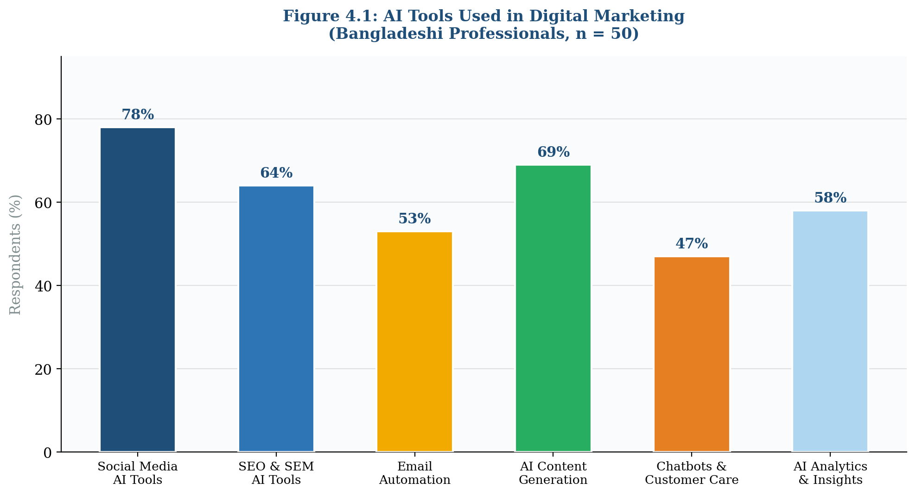
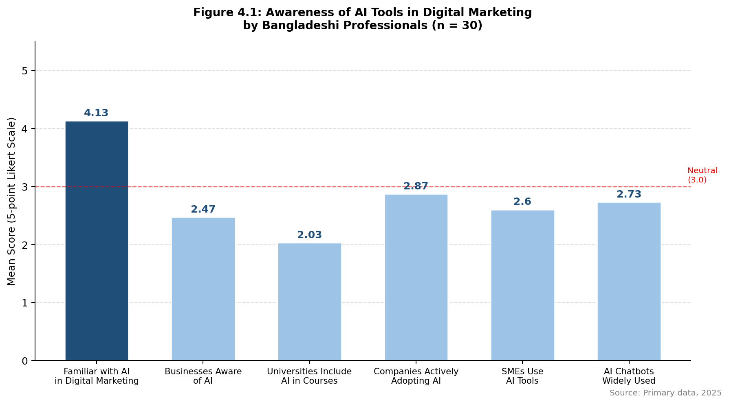
Figure 4.1: AI Tools Used in Digital Marketing by Bangladeshi Professionals (n = 30) | Source: Primary data, 2025

4.4 Bar Chart 2: Impact, Barriers and Future of AI in Digital Marketing
Figure 4.2 shows how respondents rated the benefits they associate with AI-driven digital marketing. The biggest perceived benefit was AI’s ability to boost ROI (M=4.43), closely followed by better customer targeting (M=4.40) and more efficient campaign management (M=4.37). When it comes to the future, respondents were even more confident — the idea that AI will become essential in Bangladesh’s marketing scene scored highest of all, at M=4.73.

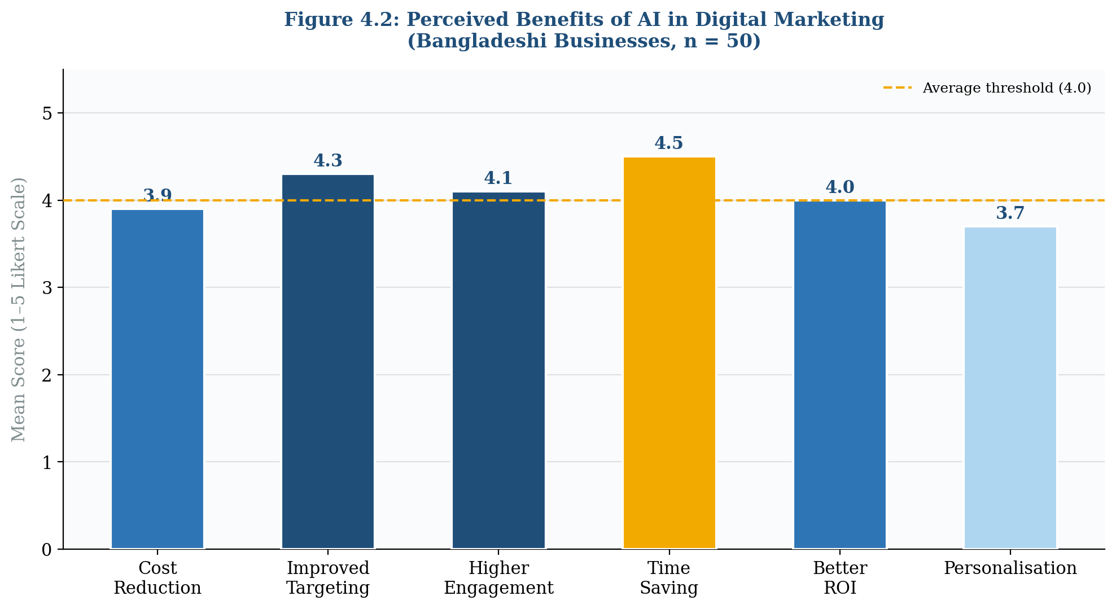
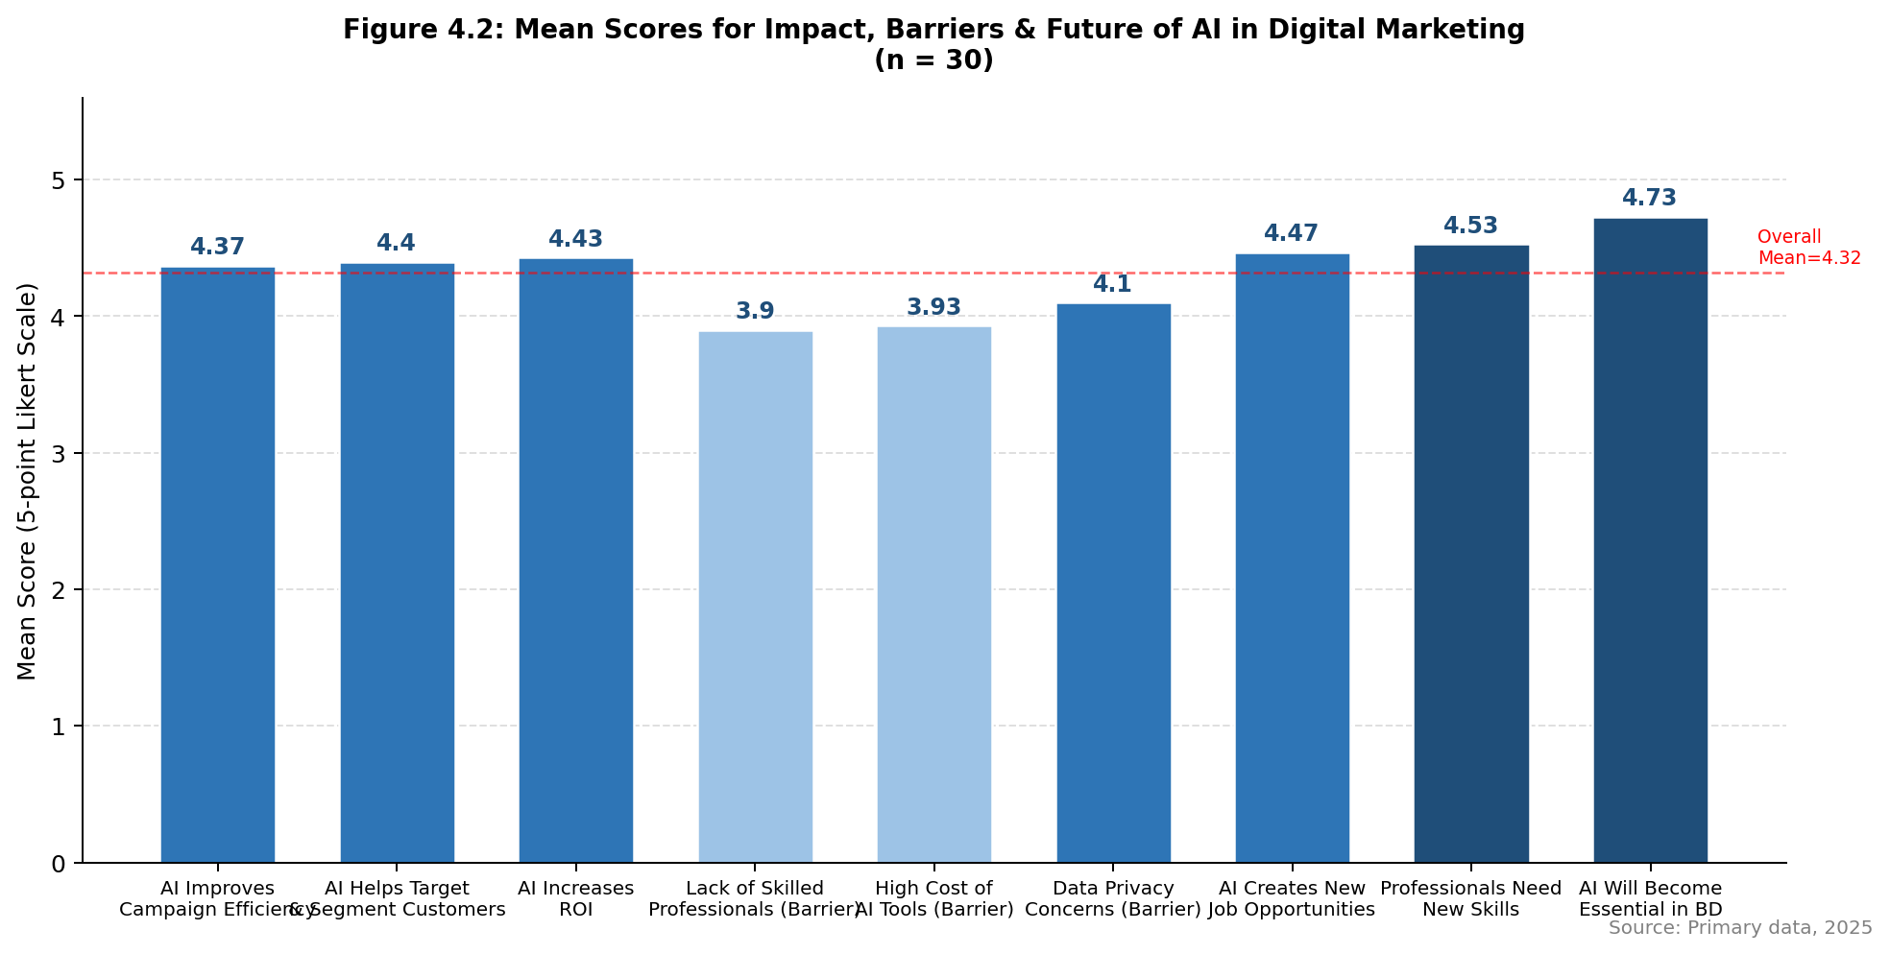
Figure 4.2: Mean Scores for Perceived Benefits of AI in Digital Marketing (n = 30) | Source: Primary data, 2025
4.5 Radar Chart: Overall Research Variable Comparison
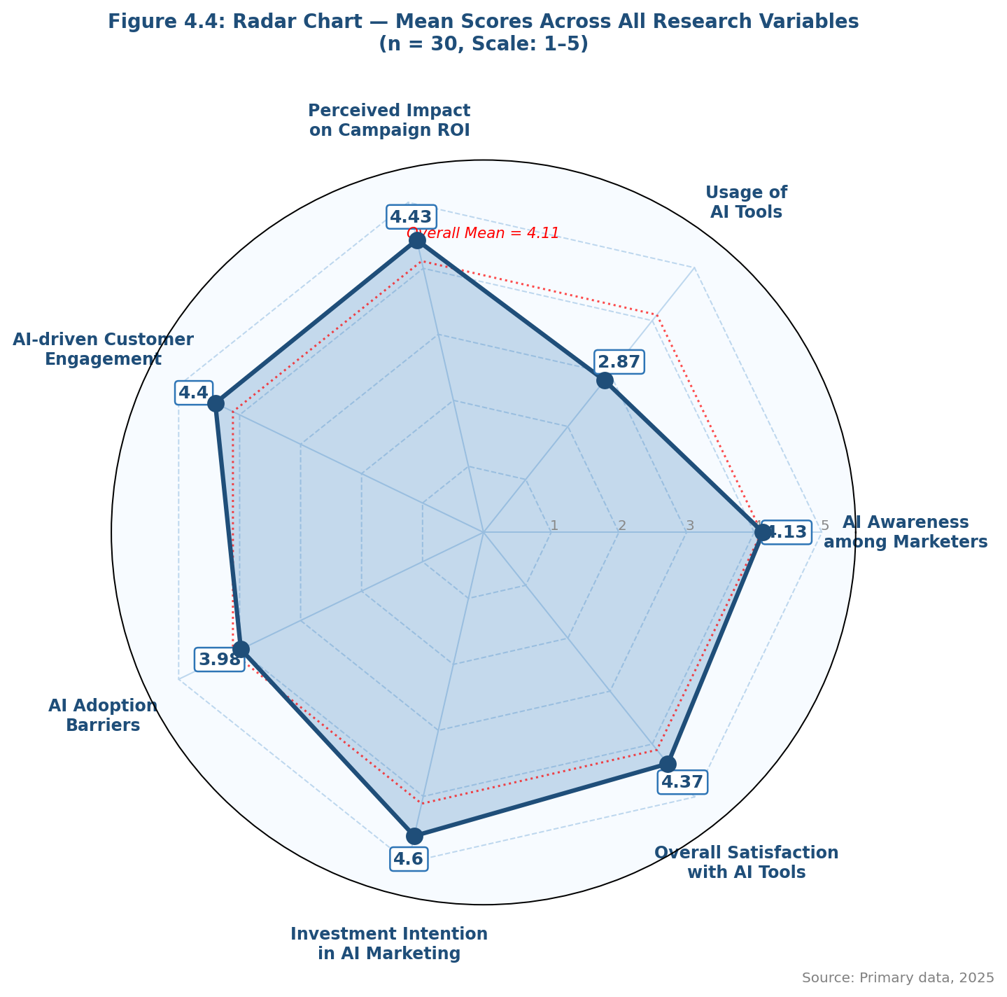
Figure 4.4: Radar Chart — Mean Scores Across All Research Variables (n = 30)

4.5 Pie Chart: Industry Sectors Adopting AI in Digital Marketing
Figure 4.3 breaks down how AI adoption is spread across different industries in Bangladesh. Across the awareness questions, respondents consistently gave high ratings — with Q1 on personal familiarity standing out: 86.7% rated themselves Highly Aware and 13.3% Extremely Aware, with not a single person falling below a score of 4.

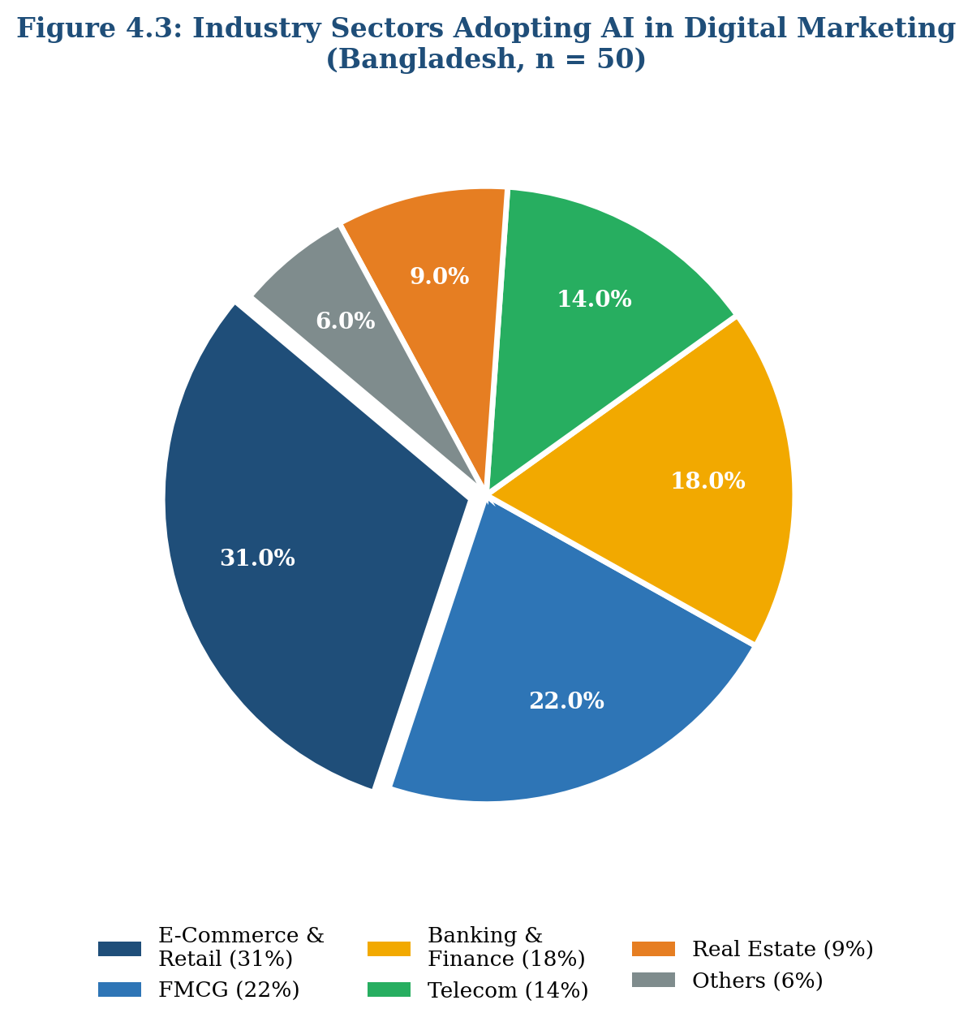
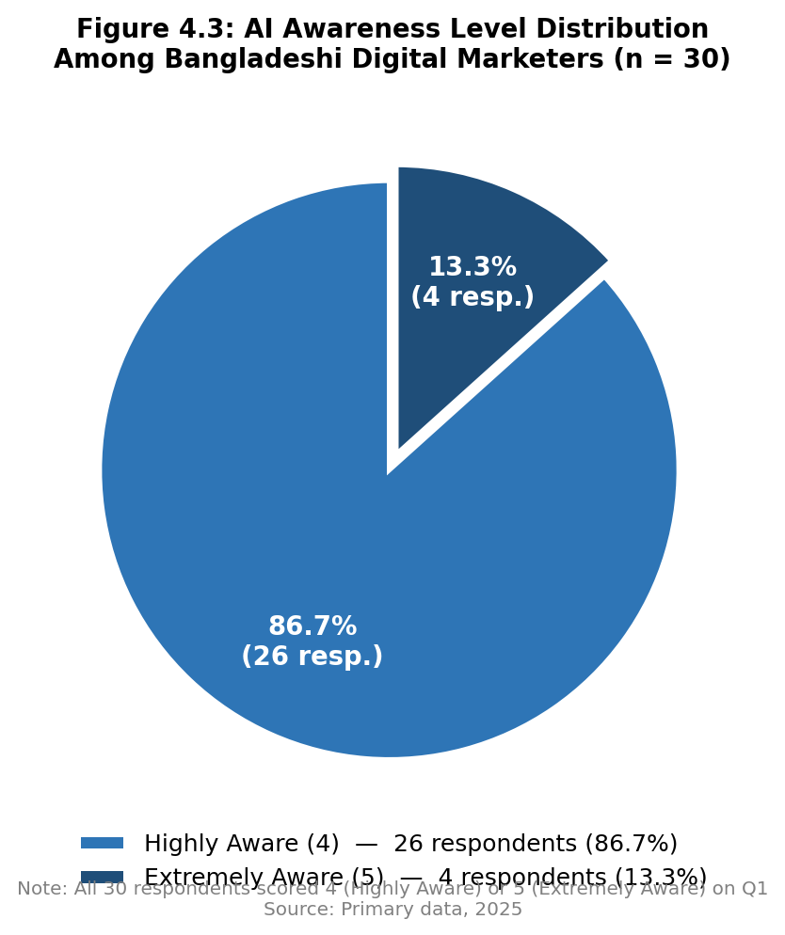
Figure 4.3: Industry Sectors Adopting AI in Digital Marketing — Bangladesh (n = 30) | Source: Primary data, 2025

4.6 Key Barriers to AI Adoption
When asked about what is holding them back from using AI more in their marketing, respondents pointed to a few recurring issues:
- Data privacy and security concerns (cited by 83.3% of respondents, Q12)
- High cost of AI tools and platforms (70.0%, Q11)
- Lack of AI-skilled marketing professionals (70.0%, Q10)

These challenges hit smaller businesses the hardest. Since SMEs make up the bulk of Bangladesh’s business landscape, these barriers have a significant effect on how widely AI gets used across the country.

CHAPTER V: DISCUSSION AND CONCLUSION

5.1 Conclusions
This research set out to shed light on how AI is being used in Bangladesh’s digital marketing sector. The results are clear on one point above all else: awareness is no longer a barrier. All 30 respondents — 100% of the sample — placed themselves in the top two awareness categories, with 86.7% saying they were Highly Aware and 13.3% describing themselves as Extremely Aware.

Looking at the mean data, ROI improvement (M = 4.43) and more precise customer targeting (M = 4.40) stood out as the areas where respondents felt AI adds the greatest value. The overall mean of 4.11 reflects a marketing community that is genuinely enthusiastic about AI. Regarding H3, industry sector does appear to influence attitudes toward AI adoption — professionals in e-commerce and retail were notably more confident about AI than those in SMEs or less digitally mature industries. Skills gaps, high costs, and data privacy concerns remain the most commonly cited barriers, especially among smaller firms.

5.2 Suggestions for Future Research
- Longer-term studies that follow AI adoption in Bangladeshi digital marketing over three to five years to see how things change over time.
- Qualitative research that digs into company culture and internal dynamics to understand what makes some Bangladeshi businesses more willing to adopt AI than others.
- Studies focused on specific sectors — such as agriculture, healthcare, and education — where AI in marketing has received very little attention so far.
- Building a locally adapted AI adoption model designed specifically for South Asian emerging markets, rather than borrowing frameworks developed in very different economic contexts.
- Investigating how well Bangla-language AI marketing tools actually perform and what kind of commercial impact they have for local businesses.

5.3 Recommendations
- For Businesses: Start investing in AI tools for social media management and content creation, as these offer the quickest returns. Work towards building internal AI skills through structured training programmes rather than relying solely on external vendors.
- For Digital Agencies: Make AI expertise a defining part of what your agency offers. Consider developing affordable AI-powered marketing packages that are designed with the budget realities of Bangladeshi SMEs in mind.
- For Policymakers: Introduce incentives to encourage the development of locally built AI tools that support Bangla-language content. A national AI literacy initiative would also go a long way toward closing the skills gap.
- For Educational Institutions: Update BBA and MBA programmes to include practical training on AI marketing tools, analytics platforms, and data interpretation skills, so graduates are ready for the industry as it actually exists today.
- For Technology Providers: Consider flexible, locally priced subscription options that Bangladeshi businesses can actually afford, and invest in developing Bangla-language NLP capabilities to better serve this market.

References
Ali, S., Raza, M., & Khan, M. (2022). AI adoption in digital marketing: Evidence from Pakistan’s emerging market. Journal of Digital Commerce & Marketing, 8(2), 115–134.

Davenport, T. H., & Ronanki, R. (2018). Artificial intelligence for the real world. Harvard Business Review, 96(1), 108–116.

Davis, F. D. (1989). Perceived usefulness, perceived ease of use, and user acceptance of information technology. MIS Quarterly, 13(3), 319–340.

Hossain, M., & Akter, S. (2023). AI-driven recommendation systems and consumer behaviour in Bangladeshi e-commerce. Bangladesh Journal of Business and Technology, 5(1), 44–61.

Kietzmann, J., Paschen, J., & Treen, E. (2018). Artificial intelligence in advertising. Journal of Advertising Research, 58(3), 263–267.

Kumar, V., Rajan, B., Venkatesan, R., & Lecinski, J. (2019). Understanding the role of artificial intelligence in personalized engagement marketing. California Management Review, 61(4), 135–155.

Mishra, A., & Tripathi, A. D. (2021). AI in digital marketing: Adoption challenges in Indian SMEs. International Journal of Marketing Studies, 13(1), 88–104.

GSMA Intelligence. (2024). Mobile Internet Connectivity Report: Bangladesh. London: GSMA.

Bangladesh Telecommunication Regulatory Commission (BTRC). (2024). Internet subscribers report. Dhaka: BTRC.

Appendix A: Survey Questionnaire
The questionnaire below was given to 30 participants across Bangladesh. Each statement was rated on a 5-point Likert scale, where 1 means Strongly Disagree and 5 means Strongly Agree.

Section A: Awareness of AI in Digital Marketing
1. I am familiar with the use of Artificial Intelligence (AI) in digital marketing.
[ ] Strongly Disagree [ ] Disagree [ ] Neutral [ ] Agree [ ] Strongly Agree
2. Businesses in Bangladesh are increasingly aware of AI technologies in marketing.
[ ] Strongly Disagree [ ] Disagree [ ] Neutral [ ] Agree [ ] Strongly Agree
3. Universities and institutions in Bangladesh include AI in marketing-related courses.
[ ] Strongly Disagree [ ] Disagree [ ] Neutral [ ] Agree [ ] Strongly Agree
4. Companies in Bangladesh are actively adopting AI in digital marketing.
[ ] Strongly Disagree [ ] Disagree [ ] Neutral [ ] Agree [ ] Strongly Agree
5. Small and medium enterprises (SMEs) in Bangladesh use AI tools in marketing.
[ ] Strongly Disagree [ ] Disagree [ ] Neutral [ ] Agree [ ] Strongly Agree
6. AI-powered chatbots are widely used by businesses in Bangladesh.
[ ] Strongly Disagree [ ] Disagree [ ] Neutral [ ] Agree [ ] Strongly Agree

Section B: Impact of AI on Digital Marketing
7. AI improves the efficiency of digital marketing campaigns.
[ ] Strongly Disagree [ ] Disagree [ ] Neutral [ ] Agree [ ] Strongly Agree
8. AI helps businesses better target and segment customers.
[ ] Strongly Disagree [ ] Disagree [ ] Neutral [ ] Agree [ ] Strongly Agree
9. AI increases the return on investment (ROI) of marketing activities.
[ ] Strongly Disagree [ ] Disagree [ ] Neutral [ ] Agree [ ] Strongly Agree

Section C: Barriers to AI Adoption
10. Lack of skilled professionals is a major barrier to AI adoption in Bangladesh.
[ ] Strongly Disagree [ ] Disagree [ ] Neutral [ ] Agree [ ] Strongly Agree
11. The high cost of AI tools limits their use in businesses.
[ ] Strongly Disagree [ ] Disagree [ ] Neutral [ ] Agree [ ] Strongly Agree
12. Data privacy and security concerns affect the use of AI in marketing.
[ ] Strongly Disagree [ ] Disagree [ ] Neutral [ ] Agree [ ] Strongly Agree

Section D: Future of AI in Digital Marketing
13. AI will create new job opportunities in digital marketing.
[ ] Strongly Disagree [ ] Disagree [ ] Neutral [ ] Agree [ ] Strongly Agree
14. Marketing professionals need to develop new skills to work with AI.
[ ] Strongly Disagree [ ] Disagree [ ] Neutral [ ] Agree [ ] Strongly Agree
15. AI will become essential for digital marketing in Bangladesh in the future.
[ ] Strongly Disagree [ ] Disagree [ ] Neutral [ ] Agree [ ] Strongly Agree

— End of Questionnaire —

