

Internship Report on
“General Functions of Human Resource Management and Its Practices In eGeneration Limited”


Subject of the Report: “General Functions of Human Resource Management and Its Practices In eGeneration Limited”
Trimester: Spring 2019

Submitted to:
Professor Dr. Mohd H R Joarder
Director
Institute of Business & Economic Research (IBER)
United International University

Submitted By:
Nazmus Saadat Hasib
Id: 111 151 344
Major in Human Resource Management
School of Business & Economics
United International University
Date of Submission: 30th October, 2019.
Letter of Transmittal
30th October, 2019
Professor Dr. Mohd H R Joarder
Director
Institute of Business & Economic Research (IBER)
United International University
Subject: Submission of internship report on “General Human Resource Management Functions and its Practices In eGeneration Ltd.”
Dear Sir,
With due respect and immense gratification, I am hereby submitting my internship report on General functions of Human Resource Management and its practices In eGeneration Limited that you had assigned me earlier as it is a must requirement of the internship program. The report has been completed by the information which I had gathered from the major courses of Human Resource Management that I had completed throughout my BBA program as well as from my internship period in eGeneration Limited. The entire study was very beneficial and insightful for me that I must admit.
I tried my level best to write a report which is concurrent with the credible theoretical knowledge of Human Resource Management and covers the practical aspects of the organization in which I had completed my internship as well. Moreover, I will highly appreciate any kind of queries that you might have or any types of criticism and suggestions that will enable me to learn more and enrich my knowledge. Lastly, I hope that you will be inclined to consider the mistakes I may have done unintentionally in the report in the spite of my best.

Sincerely,
Nazmus Saadat Hasib
Id: 111 151 344
School of Business and Economics, UIU
Acknowledgement
At this point, I want to take the opportunity to thank those human beings to show my heartfelt gratitude, whose cooperation and guidance was important to bring this report in light.
My earnest acknowledgement goes to Professor Dr. Mohd H R Joarder, Director of Institute of Business & Economic Research (IBER), United International University. Other than that that there are some individuals from eGeneration Limited, whom I want to point out cordially and thank them. Mr. Ahsan H Aminur, Manager, Public Relations & Communications; Ms. Shamsia Tabassoum, Senior Manager and lastly Mr. Anamul Haque, Manager, Human Resource Department of eGeneration group would be those particular individuals I was talking about. It is my intention to also show my full-hearted thankfulness to the management team of chairman’s office and the employees of eGeneration Limited, as their support had made this report successful and comprehensive one.

Executive Summary
If anyone involves in a conversation regarding the Information Technology (IT) industry in Bangladesh, eGeneration Limited would be a shiny part of that individual’s conversation, since it is one of the leading Bangladeshi IT organizations operating at the moment. Due to much contemplation as the company understands the significance of Human Resource Management, it has proficient HR professionals supervising HRP, recruitment and selection, training and development, compensation management and legal compliance regarding personnel. Human capital acquirement begins from personnel requisition that has been done through yielding suitable candidate pool and selecting the appropriate ones for the organization on a methodological manner. Making employees skillful, more competent, and developed to further personal and organizational achievement are something that has been taken care of by providing apt training and development programs arranged by HR department. Employees’ performances are evaluated once a year following the Management by Objectives (MBO) and Ranking method, where such evaluations attained from performance management stand extremely useful in times of rewarding employees, promotion and providing customized development plans. Furthermore, it has established its policies and practices according to, or in some cases exceeding the minimum benchmarks determined by the law of Bangladesh. However, the organization still should introduce some necessary policies for the betterment of its own employees, such as, providing overtime allowance, retirement plans, fulfilling a fire hazard free work environment and many more. Lastly, eGeneration Limited having such goodwill in terms of legal compliance, should be more obedient and sincere to the laws so that effective and smooth organizational operations can take place and the organization can head toward nothing but success.

Table of Contents
Chapter 1: Introduction 1
1.1 Inauguration 2
1.2 Background of the Report 2
1.3 Significance of the Report 2
1.4 Objective of the report 3
1.5 Methodology of the Report 3
1.6 Scopes of the report 4
1.7 Limitations of the report 4
Chapter 2: Organizational Profile 6
2.1 Overview of the organization 7
2.2 eGeneration at a glance 8
2.3 Area of Expertise 10
2.4 Clients and Business partners 11
2.4.1 Clients 11
2.4.2 Business Partners 12
Chapter 3: HR Planning, Recruitment and Selection 13
3.1 Essential Definitions 14
3.1.1 HRM 14
3.1.2 HRP 14
3.1.3 Job Analysis 15
3.1.4 Recruitment 15
3.1.5 Selection 15
3.1.6 Recruitment vs. Selection 15
3.2 Significance of Proper Human Resource Planning, Recruitment and Selection 17
3.3 Recruitment scenario and Selection Process at eGeneration Ltd. 20
Chapter 4: Performance Appraisal and Management 27
4.1 What is Performance? 28
4.2 Performance Appraisal and Performance Management 28
4.2.1 Definition of Performance Appraisal 28
4.2.2 Definition of Performance Management 29
4.2.3 Difference between Performance appraisal and Performance management 29
4.3 Factors influencing performance 31
4.3.1 Variable 1- Ability 32
4.3.2 Variable 2- Motivation 32
4.3.3 Variable 3- Work Environment: 34
4.3.4 Variable 4- HRM Practices: 35
4.4 Analysis of the Interrelatedness between Job Performance and its’ Variables 36
4.4 Importance of Performance Management 37
4.4 Measuring Approaches of Performance 40
4.6. Mentionable Performance Appraisal Methods 41
4.5 The way it is done in ‘eGeneration’ 44
Chapter 5: Training and Development 46
5.1 Defining Training and Development 47
5.2 Significance of Training and Development 48
5.3 The training process in the format of ADDIE Model 50
5.3.1 Analysis Phase 50
5.3.2 Design Phase 51
5.3.3 Development Phase 52
5.3.4 Implementation phase 52
5.3.5 Evaluation Phase 52
5.4 Available Methods of Providing Training 52
5.4.1 On the job training 52
5.4.2 Off the job training 53
Chapter 6: Compensation Management 56
6.1 What is Compensation Management? 57
6.2 Types of compensation 57
6.2.1 Intrinsic Compensation 57
6.2.2 Extrinsic Compensation 58
6.3 Necessity of effective compensation management 60
6.4 Compensation Management in eGeneration Limited 62
Chapter 7: Implementation of A few important Labor Laws and Workforce Environment in eGeneration Limited 63
7.1 Appointment letter and ID card 64
7.2 Working Hours 64
7.2.1 Weekly holiday 64
7.2.2 Daily and weekly working hours 65
7.2.3 Interval for rest and meal 65
7.3 Extra-allowance for overtime 66
7.4 Leaves 66
7.5 Health and Hygiene 66
7.5.1 Portable water 67
7.5.2 Cleanliness 67
7.5.3 Washrooms 68
7.6 Maternity Benefit 68
7.7 Safety 68
7.7.1 Precaution as to fire 69
7.7.2 Fencing of machinery 69
7.7.3 Hoists and Lifts 69
Chapter 8: Analysis, Findings and Recommendations 70
8.1 SWOT Analysis 71
8.2 Findings 72
8.2.1 Positive Findings- 72
8.2.2 Negative Findings- 72
8.3 Recommendations 73
8.4 Conclusion 74
Appendices 75
References 75

Chapter 1: Introduction

1.1 Inauguration
In present world, business has been booming since industrial revolution, so has the competitions among organizations. Companies had taken numerous measures to cope with the changes and challenges, side by side, they had been introduced many new things, methods and ways to do better in tomorrow than today or yesterday. Human Resource Department is also a very reasonable addition following that necessary urge to the path of smooth business operations. Human Resources Management’s functions and its accurate practices can unburden an organization from abundant missteps and make it run in a wholesome way.
In this report which has been the result of a four month internship period in eGeneration Ltd., which is mainly one of the leading IT firms of Bangladesh, the general functions of Human resources along with its practices in this mentioned organization will be elaborated.

1.2 Background of the Report
The main reason for which this report is done on the HR functions and its practices is because of the mandatory requirement of Bachelor of Business Administration (BBA) program of United International University.
This report and its concurrent presentation contain 3 credits of the total 123 of credits needed to accomplish the BBA program successfully.
Other than that, the report would be abundantly beneficial for me to review the theoretical learnings that I had obtained from different courses of BBA and the practical knowledge I had acquired throughout my internship; and this is why I am going to complete the report putting my best effort into it.

1.3 Significance of the Report
- Academic significance:
- This report is academically contributed for my BBA program.
- This report will help any concerned party to do obtain a better understanding of eGeneration Limited’s business operations and mainly its Human Resource related practices.
- Practical significance:
- This report would be helpful to get an idea in the case of any future development in the HR department of this particular IT firm, where it could be easily recognized as a profound series of elaborative feedback.
- Employees of eGeneration can be benefitted by this report.
- Students those who are studying Human Resource Management can benefit from the report.

1.4 Objective of the report
In relation to the significance to make the report a successful one, some objectives are set to determine which tasks have to be done. Hence, the objectives of this report are as follows:
- To familiarize with the organization in particular, eGeneration Limited, and its business operation and activities
- To elaborate Human resource planning, recruitment and selection and their correlation along with the real scenario in eGeneratin.
- To discuss about the performance appraisal and management part of HRM and established practices in the organization.
- Identifying the methods and process of training and development of the employees.
- To get a solid idea about Compensation management and how do they do it in eGeneration Ltd.
- Identifying some major industrial and labor laws that need to be discussed in the context of eGeneration Limited and their extent of implementing those.
- Analyzing the companies concurrent HR policies and practices and look out for the major findings; and suggesting suitable recommendation if possible.

1.5 Methodology of the Report
Methodology is the process of collecting information and data for the purpose of making decisions, whereas in this case I have used that to make a successful report. Proper working procedure helps to capture the right things during study periods and finally fulfills the objectives of the report.
All the information and data that comprised the report were collected from both primary sources and secondary sources:
- Primary Sources:
- Face to face interviews with the Senior Manager and Manager of the HR department of eGeneration Limited.
- Formal and informal conversation with the personnel.
- Discussion sessions with other senior officers as well.
Secondary Sources:
- Annual reports of eGeneration Group
- Prospectus, brochures, pamphlets and leaflets of the organization.
- Requisition forms of HR department
- Company website and internet database
- Newspaper and magazine articles
- Textbooks

1.6 Scopes of the report
This report has been prepared by extensive cooperation of the employees of the organization, and every conversation with them regarding the company and its operations had provided me with fruitful information. Moreover, working side by side the personnel of HRD and other departments was worthwhile in an actual manner, since it had accorded me a great opportunity to obtain an in depth knowledge about the organization and its operations.

1.7 Limitations of the report
There were several limitation in the play, while preparing the report and make it wholesome. Discussable limitations are as follows:
- Time constraints were a major facts of limitation as original internship period was of 3 month period, though it was extended for another 2 months. However, attending offices from 9.00 a.m. to 6 p.m. does not give adequate time to go in depth within this short period of time.
- Lack of human resource practices for not being a very big organization as it has somewhat less than 200 employees working at the moment.
- In some cases Human Resource Department was hesitant to provide information, because of difficulty in accessing sensitive data and information, especially regarding compensation.
- Non-availability of some necessary information in written form. Such as: HR Policy and Guidelines Manual.
- Confidentiality was a major limitation as it had been interrupting with the collection process of information.

Chapter 2: Organizational Profile

2.1 Overview of the organization
eGeneration Ltd. is one of the leading information technology consultancy firms in Bangladesh which provides its IT consultancy services to some significant departments of the People's Republic of Bangladesh, projects-funded from international development agencies, NGOs and private sector partners. However, it is the very first listed software company in Bangladesh that had went for IPO in February, 2018.
One thing that must needs to be clarified is eGeneration Ltd. is a sister concern of eGeneration Group, where it is the umbrella organization of other concerns like www.bagdoom.com, country’s leading ecommerce portal for lifestyle products; gemsclip.com, country’s one-stop solution for office stationaries; and the most obvious one, eGeneration Ltd of course, a leading technology firm for enterprise solution.
eGeneration believes in mobilizing the right people, skills and technologies with its comprehensive understanding of diverse business verticals and wide resources so that it can help organizations to enhance their performance and transform cost burdens into competitive edge.
The organization envisions to play a global role so that the local IT industry can enhance its footprints and strengthen its standing in global arena. eGeneration believes that, in its noble journey of impacting the human society through invisible power of information technology, it needs collaboration and partaking of local and international partners in a mutually beneficial understanding. Thus, beside local partners, eGeneration is connecting with Global IT leaders such as: TROY Group, Inc., an internationally renowned company for document and print security solution; Invigo Offshore Sal, a leading solution provider for mobile device management, fraud detection, IMEI registration having operations in more than 70 countries; Cloudly, a Silicon Valley based cloud solution provider.
eGeneration also believes industry and academia collaboration is a must to encourage home grown technologies through research and development. Recently eGeneration has signed a technology research agreement with University of Dhaka (DU), Shahjalal University of Science & Technology (SUST), United International University (UIU) to collaborate research and development in new and emerging technologies. Similar agreements are in process with other public and private universities.
2.2 eGeneration at a glance
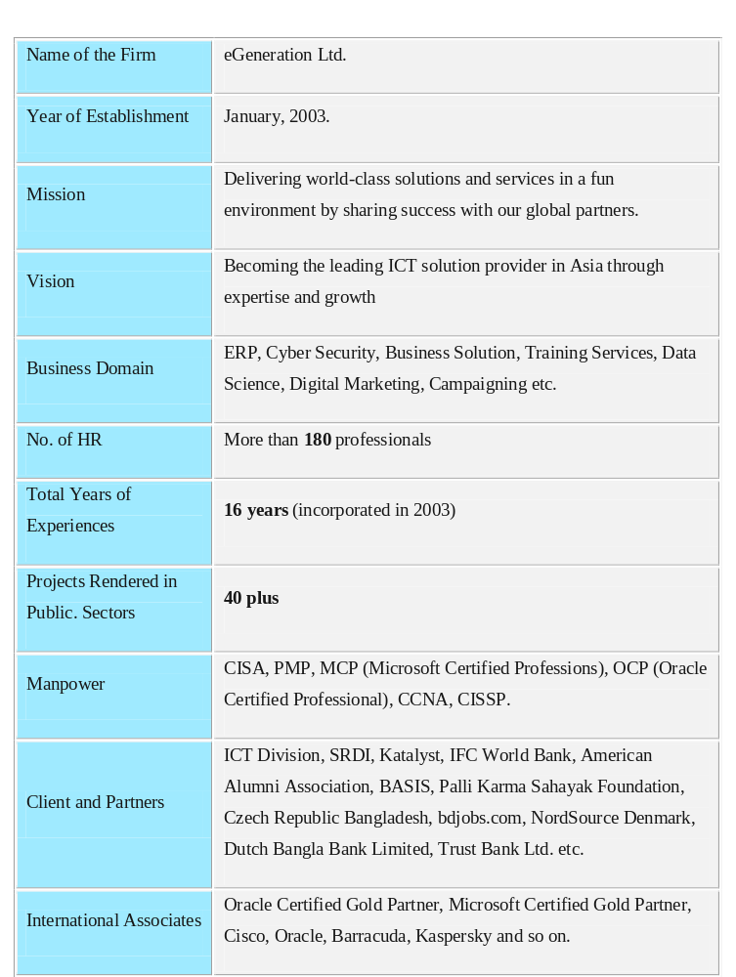
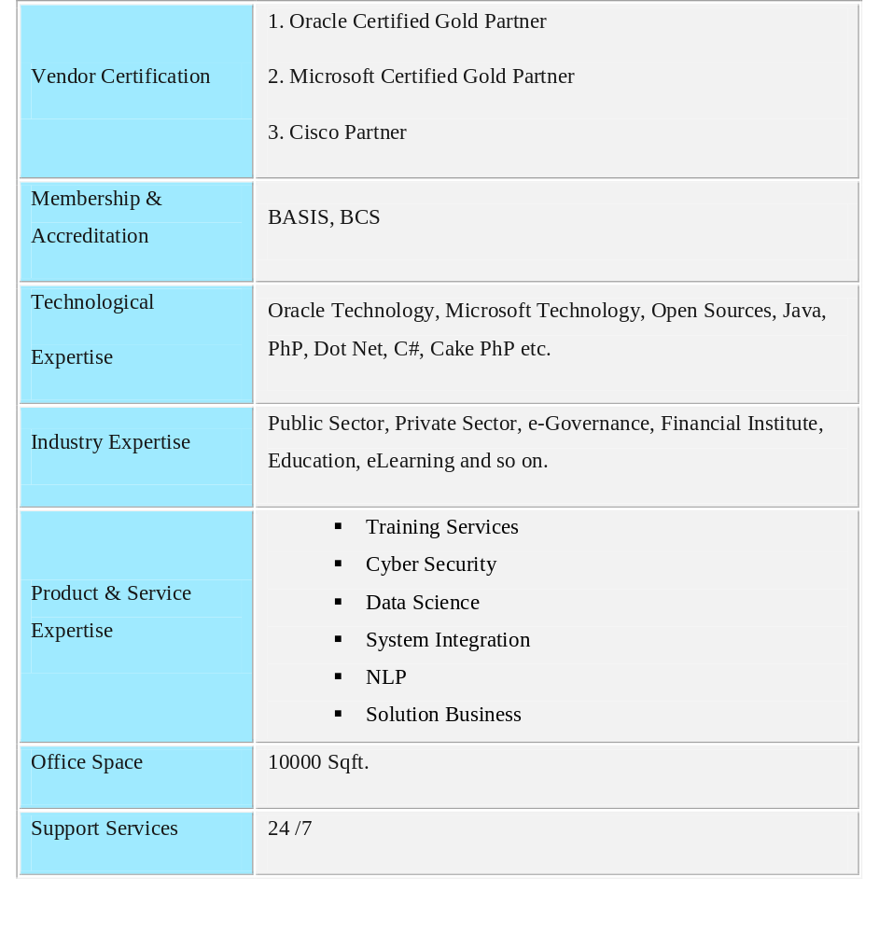
Table: eGeneration at a Glance

2.3 Area of Expertise
An emerging company, eGeneration Ltd. has its business focus in the broad areas of Training, Cyber and Information Security, Natural Language Processing (NLP), Data Science, System Integration etc.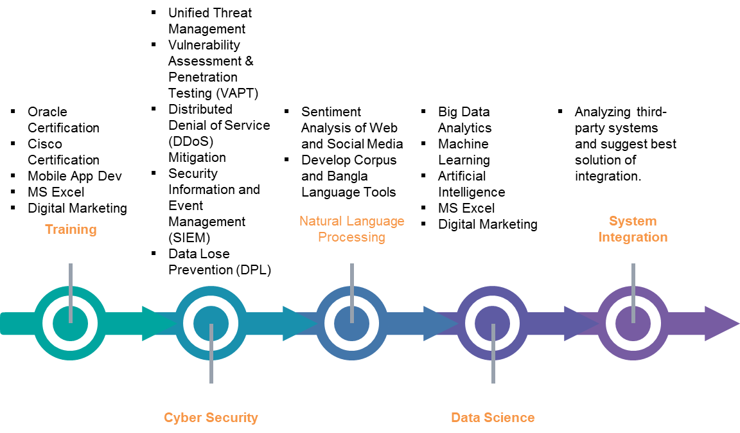
Figure-2: Area of Expertise

2.4 Clients and Business partners

2.4.1 Clients






















2.4.2 Business Partners


Chapter 3: HR Planning, Recruitment and Selection

3.1 Essential Definitions
3.1.1 HRM or even for better understanding Strategic HRM must be the one to define first before continuing the journey throughout its functions and practices. “Strategic HRM is the management of HR philosophies, policies, and practices to enable the achievement of the organizational strategy.” (Belcourt, McBey, & Hong, 2017-2018)
So, it seems that Human Resource Management can be identified as an umbrella term that comprises of those three things mentioned in the earlier definition. If they are elaborated very briefly, those would be:
- HR philosophies specifying the values of HR which inform the policies and practices of the organization.
- HR policies directing and compelling the development of certain practices, such as proving priority to employees’ welfare at all costs.
- Specific HR practices such as selection, training and development, compensation and a few more.
3.1.2 HRP can be defined at this point as we now have a basic understanding of HRM. ‘Human Resource Planning’ is considered as the mother of all functions of Human Resource Management. Hence, HRP is the first and one of the foremost functions of HR management, and to define HRP, an integral part of it which is planning can be expressed in advance. In simple words, Planning is somewhat of a process of thinking some necessary activities beforehand to attain a goal or a set of goals. Thus, “Human resource planning (HRP) is the continuous process of systematic planning ahead to achieve optimum use of an organization's most valuable asset—quality employees.” (KENTON, 2019)
Moreover, some very important steps of the HRP are as follows:
- Analyzing the present labor demand
- Forecasting labor demand of future
- Analyzing present labor supply
- Forecasting the labor supply of future
- Balancing projected labor supply and demand
So the synopsis is that HRP is effectively analyzing the present demand and supply of human capital and predicting its future trend so that an optimum level of stability or balance can be made to support the organizational goals. Following the application of proper human resources planning, recruitment and selection take places sequentially.
3.1.3 Job Analysis is the process of identifying the attributes and contents of a job, and the specific requirements to perform that job. So, if this definition is closely observed, any individual would notice two parts of ‘Job Analysis’, which are, firstly, job description: depicting the job title, duties, key responsibilities and accountabilities, special demands and other criteria describing the job; and the second part is job specification, which is mostly about the qualification, knowledge and ability that an individual will be needing to carry out the job in discussion.
More or less, Job analysis is something that needs to be conducted before proceeding towards recruitment and selection as it has its fitting significance. Job analysis clarifies any job in discussion to both the employer and employees.
3.1.4 Recruitment is the process of creating a pool of aspirant applicants for jobs. It can be created from both the internal sources and external sources depending on the necessity at suitability of the company.
3.1.5 Selection is the process of hiring suitable and appropriate candidates from the applicant pool created in the earlier stage of recruitment. In this stage, applicants might go through some interviews, tests, medical checkup, referential checkup and other sorts of aptitude tests arranged by the organization to select the right person for the position.

3.1.6 Recruitment vs. Selection
There are some very distinctive characteristics of recruitments and selection, though some who do not have sufficient knowledge about HRM sometimes confuse these two terms as one, hence, the dissimilarities are presented in the table to be in view:

Topic | Recruitment | Selection
1. What is it? | Creating a pool of candidates is mainly its concern. | Identifying suitable candidate/s for the right position is its concern.
2. Focus | Recruitment pays great attention to collect CVs, and whom to be called for selection process. | Selection is concerned about examining applicants and verifying whether someone is perfect for the job or not.
3. When it is to be conducted | Recruitment is conducted for the convenience of selecting employees, thus it is done prior to selection process, and after job analysis and manpower requisition. | Selection can only take place when recruitment is already complete, thus it comes after recruitment.
4. Sources | Organization mainly does recruitment from two sources, which are: internal sources and external sources. | Recruited applicants are the main source of selection process.
5. Tools | Job circular on various platforms is the main tool for recruiting employees. Publishing advertisements on different platforms, such as: newspapers, company websites, job sites, university career counselling centers are some of the commonly used tools of recruitment. | Different aptitude tests are the tools to select employees, for instance: written tests, psychological condition and strength determination tests, analytical ability or in some cases IQ tests, telephone interviews and face to face verbal or oral interviews.
6. Applicants’ responsibilities | In recruitment process, applicants’ responsibilities are somewhat limited to sending application and CV in time through the correct medium properly | In selection process applicants are responsible to attend the aptitude tests arranged by organizations if they are really expecting jobs.

3.2 Significance of Proper Human Resource Planning, Recruitment and Selection
When the main goal of HRP is to appoint the right people at the right place at the right time, it can be also said that HR planning is concerned about providing candidates those are best suit as per the company’s needs. Thus, proper speculation about the required number of employees against specific job positions is vital to minimize the human capital cost, further increasing the effectiveness of companies’ overall operations, productions and profit.
Later, yields the necessity of recruitment based on the HR planning and HR requisition or manpower requisition in other word. Job analysis is something that also needs to be discussed here based on which job circular would be manifested in the recruitment process. Hopefully, a profound pools of candidates would yield if the recruitment process is conducted successfully.
Finally, the right people would only be selected and that depends on the reliability, validity and effectiveness of the selection process. Selecting right people cannot be made possible if the planning was not done ahead. So, it seems that HRP is again significant to make the selection process and methods effective and customized on the basis of company’s need.
However, to better understand the significance and to perceive it properly, some of the most necessary points are discussed as follows:
1. Determining HR demand:
The forecasting process of HRP helps an organization to obtain clear idea about the demand for personnel in terms of number and obligatory skill competencies. (Belcourt, McBey, & Hong, 2017-2018, p. 126) It also comes handy for deciding on how the requirements will be met. Here, organizations’ subunits submit the net personnel requirements by which Overall demand of personnel can be identified.
2. Ascertaining HR Supply
Forecasting is also a useful tool of HR Planning that help to examine and determine the way of fulfilling the anticipated future requirements of personnel. There are mainly two sources: internal and external. Organization mostly use both of the sources to promote loyalty in the current workforce and recruiting outside individuals to obtain competencies not possessed by the current workforce. (Belcourt, McBey, & Hong, 2017-2018, pp. 126-127)
  - Internal supply refers to the workforce that are already employed and can be retrained, promoted, transferred, and so on to meet the ascertained future HR requirements.
  - External Supply refers to the potential employees who are getting trained, working in other companies, in a transitional stage, between jobs or unemployed. In short, these portion is the potential employees and can be appointed and added to the company’s workforce to meet the personnel requirements.
3. Determining Net HR Requirements:
In earlier stage although HRP manifested its significance by determining HR demand and ascertaining HR supply separately, however, it does not limit its responsibilities just yet. Forecasting process also determines the Net HR requirements as well. The method of calculating is somewhat basic that is illustrated by the following equation:
  - External Supply = Current workforce size (replacement or normal losses % per year + change % per year); meaning that external supply that is necessary to hire is equivalent to the current workforce size multiplied to the replacement percentage per year, in addition to current workforce size multiplied to the change percentage per year. In this equation, replacements are the normal losses occurred due to retirements, terminations, voluntary turnover, promotions, transfers, and longtime leaves. On the other hand, changes are the overall size of the workforce to its new future level based on organizational desire. (Belcourt, McBey, & Hong, 2017-2018, p. 129)
4. Impeding HR Shortage:
Proper HR Planning helps to impede HR shortage in an organization. HR shortage states the scenario where forecasted HR demand requirements cannot be met by the use of present employees. (Belcourt, McBey, & Hong, 2017-2018, p. 130)
Hence, the ultimate tool here that solves the crisis are recruitment, selection and compensation plans to attract external supply of HR. Thus, recruitment can help significantly to overcome the shortage of necessary personnel and skill competencies.
6. Prevents HR Surplus
Competent application of HR planning can also saves the organization from the hassle of being overflowed by employees or in more accurate term HR surplus. HR surplus is the exact opposite scenario of HR shortage where present employees and competencies of them exceed the actual HR demand requirement, which is really unnecessary.
So, accurate forecasting under the umbrella of human resource planning can actually favor any organization beforehand to avoid such hectic circumstances. However, some tools of HRP might be useful as well, if this type of scenario is manifested anyway, which are: job sharing, work-sharing, imposition of attrition and imposing hiring freeze. (Belcourt, McBey, & Hong, 2017-2018, p. 130)
7. Ensures Smooth Organizational Operations
It is evident that any organization can operate smoothly when there is no HR shortage or HR surplus. An organization can benefit from the proper HR planning that yields the existence of compatible amount of needed skill competencies and exact number of Human resources indicating nothing but only the essential human capital to be present.
8. Minimizing Organizational Costs
Apt use of HRP is very helpful and necessary as well to ensure that the organizational human capital costs are at its optimal level, where HR effectiveness and efficiency are at its maximum. HR surplus for instance can be very expensive for any organization, where HR shortage hampers the production for sure. Hence, both can increase the company’s costs and overall expenditures. However, if the stand of HRP has adequate strength then it can only yields the minimization of overall costs of the organization.
9. Yielding Production and Overall Profit
If HR planning, recruitment and selection are done aptly, then the probability for that company of gaining profit increases dramatically. Since it is expected that when HR demand requirement is fulfilled effectively, the productivity will rise as well with the help of suitable personnel and their competencies. Thus, resulting an expected profit is also predictable.
10. Stable Workforce Environment
Last but not the least, employers, employees and all the other interrelated stakeholders of organizations would be profoundly just to hope to establish a stable workforce environment, and HR planning can evidently help these parties to achieve that particular goal that is undoubtedly important.

3.3 Recruitment scenario and Selection Process at eGeneration Ltd.
eGenaration undoubtedly realizes the important of HR Planning, effective recruitment and selection process. Let’s see the sequential steps of recruitment and selection process of eGenaration at a glance in the figure:

Final Selection
Interviews
(Possibly two interviews)
Written exam or exams
Sorting CVs that are suitable for the job
Collecting CVs from sources:
- Internal sources
- External sources
- Advertisement
- Internet
- Career fair
- Universities
HR personnel Requisition
Acceptance of offer letter and joining procedure
Reference Check
Offer letter
Figure-4: Recruitment & Selection Process at eGeneration Ltd.

1. HR Personnel Requisition: As it is shown in the above figure, HR requisition is the first and foremost step of recruitment and selection process in eGeneration, where every department in charge or team leader has the right and encouragement to submit HR requisition as per that department’s or the team’s necessity. Later, HR department verifies the validity of that request by determining whether the request is just or not. The personnel requisition form of eGeneration Limited looks like as follows:
Figure-5: eGeneration Limited’s HR Personnel Requisition Form
2. Sources of Recruitment: After the requisition is complete and sanctioned, HR department focuses on recruitment and they use two sources:
- Internal Sources of recruitment
- External Sources of recruitment
Internal sources are the employees are the employees who are already employed. Internal notice may advertised in eGeneration to encourage employees, where promotion or assigning individuals on new tasks or projects might take place only if their competencies match the job specification. Three types of employees are mainly consider in internal recruitment, which are:
- Full Time- the permanent employees.
- Contractual- workers working under six months to one year contract.
- Interns- who are working monthly basis can also be recruited if shown competency.
External sources refer to the collection of applications and CVs from outside of the organization. The sources are discussed in brief as follows:
- Advertisements on local newspapers, social platforms, own company’s career website, business journals are popular mediums for eGeneration Ltd.
- Job sites such as www.bdjobs.com, www.careerjet.com.bd, www.chakri.com, www.everjobs.com.bd are some of the examples of job websites where eGeneration posts job advertisement as well. Specially, www.bdjobs.com provides the facility by which applicants whose profiles are a match can apply easily.
- Employee referrals are also falls under consideration as existing employee has the advantage of knowing employees who will better suit the organization.
- Universities are one of the great sources for applicants as some the universities and mainly their career center that were established to help students to find better career keersiep tabs of any newly created vacancy. eGeneration Ltd. also fathom the trend of recruiting directly by visiting and arranging sessions in prestigious universities in Bangladesh, especially in Dhaka.
- Career or job fairs are also utilized by the organization to collect CVs and applications from the participants of those events. eGeneration Ltd. had attended in the job fairs to be mentioned and many more in past:
  - IBA Career Fair 2017
  - Tech Job Fair in Jessore (2017)
  - Job Fair-2017 in Rajshahi etc.
- Third party organizations such as various renowned HR consultancy firms are the ones whose service is sought if necessary. This sort of organizations are extremely specialized in employment related materials like recruitment and selection, hence they are useful in terms of the regarding issue.
3. Screening: At this stage, eGeneration having required amount of CVs of applicants tend to screen those. Thus, after sorting out the CVs only the selected ones, seemingly suitable for the organizations are contacted through telephone calls, short message service (SMS), emails or in most cases with the combination of all. Later, if they agree to participate in the selection process, applicants attend the tests or interviews as per the schedules set by the company.
4. Written Exams: Candidates go through the written exam which is a very important part of selection. Depending on the situation candidates may require to attend multiple written tests if necessary. However, the test is also called as “General Ability & Psychometric Test” in eGeneration Ltd.
- General ability is concerned with the availability of general competencies or skill set of the candidates
- Psychometric Test is one sort of physiological evaluation by which the behavioral sides of candidates are checked.
5. Interview: HR department of the organization is entitled with a separate room which is designed mainly for the purposes of taking interviews. Face to face competency based structured interview sessions are extremely used to select employees as it is an abundantly viable way to test the candidate. The standard Interview Assessment Form along with probing questions are supplied by the HR Department.
The number of interviews and interviewers in any particular interview often vary depending on situation and necessity. Preliminary interview and final interview are common in most of the cases.
All of the interviews are taken by HR, although competent members or the head of the department of the particular department for which the selection process is going on may join the panel sometimes. However, interview for any key position such as AGM or Executive Vice Chairman is something which is considered with utmost delicacy, hence, the presence of Managing Director or other members of senior management can be highly expected.
6. Final Selection: If the incumbents pass and come through all the aptitude tests mentioned above, then it would be the appropriate time to make the final selection. HR department consider a few additional things at this stage.
    - Terms and conditions of the organization
    - Compensation and benefit
    - Joining procedure and timeline.

7. Checking Reference: Finally being selected HR Department might check the references provided by the candidate for added satisfaction prior to making an offer.
8. Appointment or Offer Letter: Conducting reference check, if the response is found satisfactory and everything presumes alright; then with the approval of Managing Director, eGeneration Ltd. issues appointment letter making an offer for the candidate to join in the organization and be a part of its family.
6. Final Selection: There are some standard procedures to follow to join the organization as an employee.
First and foremost, however, it is needless to say that the incumbent is required to accept the offer letter by signing it and a copy of the signed document would be submitted into eGeneration Ltd. in order to join the organization.
Moreover, an incumbent has the responsibilities to fill up some forms for the later convenience, such as:
- HRIS form to access the installed information system of HRM
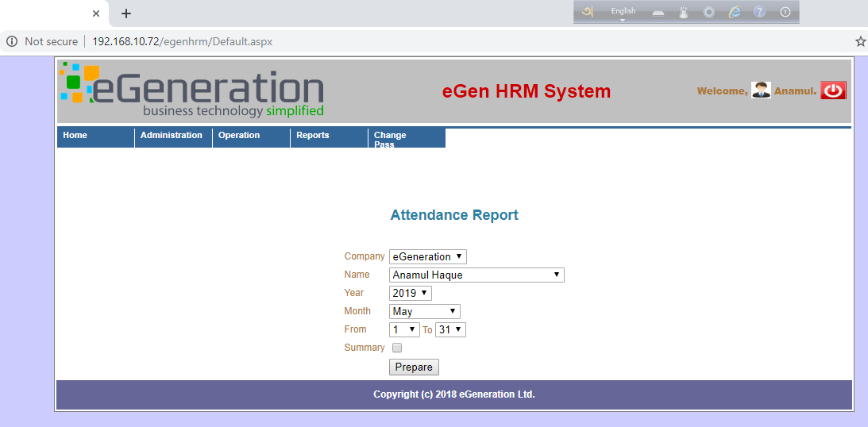
- ID Card Form- consisting of the name, incumbent number, blood group, emergency contact number, address of the employee and such information.
- Declaration form
- Dutch Bangla Bank Limited Account Opening Form or another consistent form detailing the existing account, since eGeneration provides salary via DBBL.

Completing all the above mentioned stages would indicate towards the completion of the prevailing recruitment and selection process of eGeneration Limited.

Chapter 4: Performance Appraisal and Management

4.1 What is Performance?
According to the definition provided by John P. Campbell of University of Minnesota in 1993: “Job performance relates to the act of doing a job. Job performance is a means to reach a goal or set of goals within a job, role, or organization, but not the actual consequences of the acts performed within a job.” (Campbell, 1993)

4.2 Performance Appraisal and Performance Management

4.2.1 Definition of Performance Appraisal
Performance appraisal means simply evaluating the performance of employee. It measures, whether the performance is up to the mark or not. Performance appraisal is the systematic description of an employee’s strengths and weakness. Performance appraisal is an important component of performance management. Performance appraisal is the first step for doing other HRM practices. Performance appraisal is the mainly an annual review of an employee’s overall contributions to the company. Performance appraisals, also called annual reviews. Through appraisal of performance we can evaluate an employee’s skills, achievements and growth, or lack. Companies use performance appraisals to give employees performance feedback. Performance appraisal also helps employees and their managers to create a plan for employee skill development through additional training and increased responsibility. Some authorities said about performance appraisal-
According to Heyel, “Performance appraisal is the process of evaluating employees’ performance and qualification of the employee in terms of the requirements of the job for which he is employed”. (Xavier, 2015)
According to Dr. Mohd H R Joardar Sir, “Performance appraisal is one of the pillars of all other human resource management initiatives like recruitment, compensation, training, benefit, opportunity etc”.

4.2.2 Definition of Performance Management
Performance management is a continuous process of identifying, measuring and developing the performance of individuals and teams and aligning performance with the strategic goals of the organization. Performance management defines interaction with an employee at every step. Performance management is like a cycle. This cycle include planning, checking in, then give them review. Performance appraisal is the activity and set of processes that aim to maintain and improve employee performance in line with an organizations’ objectives. Performance should be managed holistically, throughout the range of HR activities and processes. Some authorities said about performance management –
According to Brumbrach, “Performance means both behaviours and results. Behaviours emanate from the performer and transform performance from abstraction to action. Not just the instruments for results, behaviours are also outcomes in their own right- the product of mental and physical effort applied to tasks – and can be judged apart from results”. (Brumbrach, 1998)

According to MC Bain, “Performance and its importance have become all pervasive in all aspects of modern life. We have all become susceptible to falling under the influence of performance in our ways of looking at things and people, as well as our ways of behaving. The notion of performance has become of central importance for our perception of our activities, our self-perception and self-worth and our understanding of the world.”
(Bain, 2004)
A performance management process sets mission and objectives and rewarding system which is making the employee and the organization understand the importance of a specific job in realizing outcomes.

4.2.3 Difference between Performance appraisal and Performance management
The Performance appraisal and Performance management play a crucial role, as the success of the organization is combined effort of all the employees and the entrepreneur. An organized way of evaluating performance and potential of employees for their future growth and development is known as Performance Appraisal and the complete process of managing the human resources of the organization is known as Performance Management. Performance appraisal is a part of Performance management. Performance management is the whole system which completes total thing. Mainly without performance appraisal anyone cannot establish performance management. Performance appraisal and performance management both have some differences in-between them. The differences are given below: (Aguinis, pp. 3-4)
Performance Appraisal | Comparison | Performance Management
1) Performance Appraisal means the analysis of an employee's performance and their caliber for future growth and development. | Meaning | 1) Performance Management is the management of human resources in an organization.
2) Quantitative Aspects | Focused on | 2) Qualitative Aspects
3) Rigid | Nature | 3) Supple
4) Individualistic | Approach | 4) Holistic
5) Human Resource Department | Owned by | 5) Managers
6) Retrospective | Corrections | 6) Prospective
7) It is a system. | What is it | 7It is a process.
8)Operational tool | Type of tool | 8) Strategic Tool
9)Annually | Conducted | 9)Continuously
10)Inflexible | How is it | 10)Flexible
To sum up, it can be said that the term of performance appraisal and performance management are completely different. However, they are not opposed with one another because performance appraisal itself is a part of performance management. In this way, we can say that performance management is a bigger term that involves some steps.

4.3 Factors influencing performance
Speaking about job performance of employees, it is a fact that performance is depended on some of its variables which are: ability, motivation, work environment and HRM practices. So, when the before discussing about the variables or components that influences employee’s performance, first- it would be better to look back on the definition provided earlier about what performance really is.
If we breakdown that definition, we can get two things which are very clear; first- performance is just act of doing a job, and second- the consequences of doing the job is not performance. Since, act of doing a job is performance, hence, it can be also said in a more simplified manner that the behaviors that employees manifest at work are their performance. However, the result or consequences of their behaviors are not performance. On that account, it can be perceived that only behaviors are performance, not the outcomes of it.
Two additional features of performance can be found: performance is evaluative, and it is multidimensional.
On the basis of individual and organizational effectiveness, performance can be judged as positive, negative, or neutral. Behaviors can be valued based on whether the behaviors make a contribution towards the accomplishment of individual, unit, or organizational goals or not. So, behaviors’ value according to its contribution to the effectiveness can be assessed, if some benchmark or standard behaviors are established. Later, those behaviors can be simply evaluated comparing to the standard behaviors, and can be labelled as outstanding, significantly exceeds standards, fully meets standards, doesn’t fully meet standards and unacceptable.
Performance is multidimensional, meaning that various kinds of performance or behaviors can be shown by an employee which have the aptitudes to either advance or hinder organizational goals. Those different kinds of behaviors could be for instance: works with others within or outside of the unit, helping others to accomplish their job, sharing necessary information when needed, sharing and utilizing resources properly and so on. Showing these types of behaviors by employees in a manner that develops effective work environment, builds consensus among employees, and constructively manages conflict is desired by every corporation.
Finally, there is something that needs to be said about performance that it is not always observable or measurable. Since, when there are direct links between performances and results, performance management system relies on the measures of results. In these cases, if result is positive, then it is also assumed that appropriate behaviors were shown.
For instance, taking the example of a newspaper delivery person, whose appropriate job related behavior is to deliver the newspapers to his or her assigned specific region. So, in this occation, if subscribers of the newspapers of that area got newspapers on their doorsteps for last seven days, it is obvious that the newspaper delivery person was successful for the last seven days at demonstrating his or her behavior properly.
4.3.1 Variable 1- Ability
Ability is one of the individual characteristics of job performance, which refers having the aptitude to do the job. Under ability there are two types of knowledge, which are: declarative knowledge and procedural knowledge.
Having the declarative knowledge means possessing the information about facts and thing regarding job. This includes the given task’s requirements, labels, principles and goals. To demonstrate, when a brain surgeon knows his or her job requirements, objectives, ethics, goals and other necessary information that is needed to perform surgery, such as: patient’s physical condition; it can be said that the surgeon has the declarative knowledge necessary to perform a surgery.
However, only having the declarative knowledge doesn’t make an employee fully able to do his or her job. One other set of knowledge that is procedural knowledge is also required to have. It is a combination of knowing what to do and how to do it practically. It includes having the cognitive, perceptual, physical, motor and interpersonal skills. So, following the example demonstrated earlier, the surgeon needs to have physical, cognitive and motor skills mostly, along with knowing the procedures and how to perform that surgery in reality.
Therefore, if an employee has both of these two kinds of knowledge, declarative knowledge and procedural knowledge, only then, it can be said that he or she has the ability to do the entitled job.
4.3.2 Variable 2- Motivation
Motivation is another one of the individual characteristics that determines job performance. Motivation comes from the word ‘motive’ which means to needs, desire or wants or drives within the person. It is a process to drive a person to work to achieve the desirable goals.
“Dispirited, unmotivated, unappreciated workers cannot compete in a highly competitive world.” – Francis Hesselbein.
So, by saying that, an employee will lack appeal of working and will not give the full effort toward workforce, when he or she is out of motivation. Therefore, motivation is needed at many levels to fully utilize employee performance. Motivated employees are inclined to be more productive than a non-motivated employee. We think that to increase employee performance, motivation on employee must be nurtured by the organizations. Everyone faces a dip in motivation now and then and constantly maintaining high levels of motivations can be challenging. If it is delivered accurately then the desired actions and goals can be accomplished by the employees.
There are some processes to keep the balances equal; as one of the most important factors of motivation is recognizing employees’ effort on workforces. Suppose, in a company, an employee gave moderate level of efforts to a particular work, and at the same time multiple employees do that work as well, but gave less efforts. In this situation, if his efforts on work is not recognized enough and appreciated accordingly, then it will directly decrease his motivation, thus effort. Motivation can be provided by revaluing his effort on work.
Another one of the crucial necessities is to make employees enthusiasts. It is often seen that many organizations tend to drop loads of paper works to employees just based on their skills, when other humane factors were not considered properly. Although, employees tend to complete those somehow, it results poorly. Making work enthusiastic to employee makes it attainable and easy to do as well. Happiness or satisfaction is another significant component of motivation. At the end of the day, if employees are happy with their jobs, they are more motivated to provide their best effort in future. This is why, organizations must need to be aware of whether employees are satisfied or not. An employee might not be happy relating to personal problems like marriage, relationship issues or mentally, and organization should know how to make them happy through process.
As we can see, the combination of declarative knowledge and procedural knowledge is not enough when the motivation is missing. Let’s take an example of a disabled person who has high principles and interpersonal skills necessary to his job well. He is eligible to do his work which is to go sites to sites to monitor production area using wheelchair, then could be a bit difficult for him to do the job which leads to less effort choice. But if company motivates his behavior and gives him the mobility support via using therapy sessions and advanced transportation, then it will boost his will of work.
4.3.3 Variable 3- Work Environment:
Other than ability and motivation, there are two variables of performance; work environment is one of them. In present modern era one of the main challenges for a business is to satisfy employees in order to cope up with the evolving environment and to achieve success and remain in competition. The good working environment is so important for maximizing the level of job satisfaction and job performance. Many businesses fail to understand that the importance of working environment for employee job satisfaction and job performance thus face a lot of difficulties during their work. Employees should meet the performance criteria to ensure the quality of their work.
For any organization, employees need a good working environment that allows them to work freely without any problems that may restrain them from performing up to the level of their full potential. Job Satisfaction is the essential component for employee motivation and encouragement towards a better performance. Mainly, the good working environment is a condition that encourages employees to admit that they are satisfied or happy with their jobs. It is beneficial for firms to provide flexible working environment to employees where they feel their opinions are valued and they are a part of the organization.
Working environment consists of safety to employees, job security, good relations with co-workers, recognition for good performance, motivation for performing well and participation in the decision making process of the firm. There are some important factors that fall within the working environment such as wages, working hours, autonomy given to employees, organizational structure and communication between employees and management that may affect job satisfaction.
In working environment, hygiene and motivation factors are also most crucial things. Since hygiene factors can’t cause of satisfaction but they can change dissatisfaction or short term motivation.
Safety is another important component to employee motivation especially when it comes to working environment. It is employees’ right to demand safer working environment so that their life aren’t threatened, and the life expectancy of employees remain intact.
To sum up, the better the working environment is; it will lead to increased level of job performance. Working environment greatly influences employee satisfaction, which in turn directly affects employee turnover rates. Knowing how to use a positive work environment to increase employee satisfaction and reduce turnover is a key to developing a high-performance workforce.

4.3.4 Variable 4- HRM Practices:
HRM practices on employee’s performance plays an important role. Researches on the interrelatedness in-between Human Resource Management (HRM) practices and Employee Performance have been conducted in developing countries. The most relevant HRM practices are recruitment and hiring, training and development, performance appraisal and management, career/succession planning system, employee participation, conflict management, and compensation system.
HRM practices are a process of attracting, motivating, and retaining employees to ensure the survival of the organization through producing needed performance. These types of practices are designed and implemented in such a way that human capital plays a significant role in achieving the goals of the organization. HRM practices such as, training and development, performance appraisal, fair compensation system encourage the employees to work better in order to increase the organizational performance.
The successful organizations consider the HRM practices as a crucial factor that directly affects the employee’s performance. Human Resource (HR) practices are vital for development of organizations. HRM practices include recruitment of the staff, selection techniques, market oriented training, performance enhancement, adequate exchange system, social security appraisals and planned strategic needs. Human resources are the sources of achieving competitive advantage because of its capability to convert the other resources for say: money, machine, methods and material into output. In existence of fine HRM practices, better level of job satisfaction can be gained which ultimately improves organizational performance.
It is said earlier that one of the main goals of Human Resource Management (HRM) practices is to increase the performance of organizations’ employees. HRM practices motivate employees to perform individually as well as in teams. Job design and autonomy are considered in HR practices as opportunities to perform better. HR practices forge a psychological contract between employer and employee that in turn affects the perceptions and experiences, necessary to obtain high level of performance and productivity, and ultimately profit for organizations. Since, Human Resource Management (HRM) practices have a positive role in increasing the employee’s performances; therefore the organizations should implement these practices properly to achieve the desired goals. Organizations should utilize a variety of reward and recognition programs to drive behavior that promotes high performance. (Aguinis, pp. 89-91)
4.4 Analysis of the Interrelatedness between Job Performance and its’ Variables: There are obvious interrelations between job performance and its variables which were discussed above. The simplest way of clarifying this would be to say that “no performance can be achieved, if any one of the variables remains missing.” This statement can also be shown in form of an equation:
“F (performance) = Ability × Motivation × work environment × HRM practices”
In this equation, where the variables of performance are in multiplicative form indicates that, even if one of the variables goes missing, then the performance would be zero.
Therefore, to achieve performance, availability of all the components or variables is a must. Moreover, obtaining high level of performance is possible only in the scenarios, where all the variables are present in improved, increased, or uplifted manner. No performance is possible to obtain in case all the mentioned variables are not present. (Aguinis, p. 91)
For better understanding, some example can be demonstrated:
- Take the scenario where an Employee Mr. X doesn’t have declarative and procedural knowledge to work as a pilot. In this case, having motivation or other necessary variables is entirely meaningless.
- Now, think about Mr. X when he lacks of motivation to provide necessary effort or highly demotivated to work at present. So we can’t expect any performance from him.
- Consider Mr. X with ability to work as a pilot and he is even highly motivated to perform as well. But, performance can’t be expected from him if he isn’t simply provided with an aircraft to fly.
- Consider, the airline with which Mr. X will presumably work on didn’t establish important HRM practices, for say, hiring and recruiting, training for the pilots, workforce planning, performance appraisal etc. In this case performance from a pilot might not possible as the airline didn’t even start hiring yet.

Last but not least, the presence of each and every variable, ability, motivation, work environment and HRM practices; have to be present in order to produce some level of performance. Each variable is important as if it remains absent, nothing but zero level of performance would be the outcome.

4.4 Importance of Performance Management
There are a plenty of contributions of performance management in an organization which eGeneration recognizes and values. However, the company needs some improvement regarding this issue which would be included in the recommendation part of this report.
Therefore, some considerable significance of performance appraisal and management are as follows:
1. Increased level of Motivation
It is evident that anybody would be motivated toward future excellent performance providing that their retrospective performances are disclosed to them. Having the knowledge about one’s performance and recognition of previous successes widens the path of future excellence. Thus, receiving feedback has its significance.
2. Self-esteem is increased
It is one of human beings basic desire to be appreciated and recognized, and obtaining accurate feedback can certainly have the ability to serve the purpose. Hence, employees’ self-esteem would have a boost. Moreover, it is needless to say that workers having confidence and self-esteem is vital to the organizational success as well.
3. Managers gain insight about subordinates
Performance appraisal and management system is a profound way for managers and superiors to gain a new insights into the person being appraised, which is undoubtedly crucial. Managers can certainly build better relationships with subordinates knowing their capacity, capability, personality, preferences, strengths, weaknesses and overall performances for the matter of fact.
4. The job definition and criteria are clarified
Performance appraisal can be a blessing in situations where employees are not clear about their job duties and definition, which is detrimental to the possibility of performing well.
Since, performance appraisal being responsible for providing the necessary understanding of the criteria needed to perform the job in discussion successfully, it can evidently help employees to have the clarity regarding the issue.
5. Self-insight and development are enhanced
Employees can obtain better understanding about themselves and the activities which are of value to them going throughout the progress gained by performance appraisal.
6. Personnel actions are more fair and appropriate
Providing valid information is one of the strong suits of performance management. Thus, it can be helpful to merit increases, promotions and transfers, as well as terminations.
Hence, it is easily understandable that administrative actions and activities are positively affected by personnel appraisal which results in fair and credible personnel practices.
7. Organizational goals are made clear
Individuals inside the organization can certainly obtain some concrete understandings of their jobs and its effects on organizational success. Thus, they realize the importance of achieving individual goals knowing that by fulfilling it, unit and organizations goal will be also fulfilled.
Therefore, performance management’s role in making the goals clear is nothing but a justified opinion.
8. Employees become more competent
Having feedback on a continual basis can make the employees more competent than they were in retrospective, since it yields the opportunities to take corrective measures time to time and developed within.
9. Obtaining better protection from lawsuits
As performance management systems are most likely to collect data and keep it in a documented way, it is also beneficial to compliance with regulations that decreases the probability of exposure to litigation.
10. Effective and timelier differentiation between good and poor performers
Identification of good and poor performers is something that can be achieved by performance management systems. Also, it encourages supervisors to address performance problems on a timely basis, before the problem is too hectic and costly to be remedied.
11. Positive changes within organization
In terms of any necessary changes within organization, performance management systems can be a useful tool. It is used to align the organizational culture with the goals and objectives of the organization to make change possible, providing that organizational direction is established.
Delivering necessary training and also rewarding the employees for improved performance so that they have both the knowledge and the motivation to improve product quality and customer service can be achieved through establishment of proper performance management system.
(Aguinis, pp. 4-7)

4.4 Measuring Approaches of Performance
There are three approaches that can be used to measure performance; the behavior, results, trait approaches.
- Behavioral Approach: This points directly to the persons’ actual work behavior rather than a trait like his or her personality. For example, it can be focused to seek information as to the employee works alone on all projects, on most projects or about half of projects. Similarly, whether he or she teams up with others on major projects or works alone in all of them. When these behavioral patterns are coupled with performance rating, appraisal is enhanced. In behavioral Approach emphasizes what employees do and does not consider employees’ traits or the outcomes resulting from their behavior. The behavior approach to performance management focuses on specific behaviors that
An employee engages in. Aguinis suggests that using a behavioral approach is appropriate when there is not a clear link between behaviors and results, outcomes of performance are far away in the future, and results are not in the control of the employee. (Aguinis, pp. 95-96)

- Result Approach: When there is a clear link between employee behaviors and an outcome, a results approach may be more appropriate. The results approach focuses only on the end result of employee actions (e.g. mistakes made, machine parts produced, sales per month). This approach tends to be more objective than the other approaches, and it is appropriate under a number of circumstances. A results approach is ideal when employees have the skills need to complete work tasks, and they can recognize and correct inaccurate behaviors. This approach also works when employees improve over time. This may incentivize them to improve their skills and develop expertise in order to achieve the desired results. Additionally, the results approach works well when there are several ways to get to the desired approach. Sales people can use many different approaches to making sales, and not all ways are needed by each individual. The results approach allows knowledgeable employees to use their information and resources to obtain the desired performance in a more autonomous way. (Aguinis, pp. 96-97)
- Trait Approach: A third approach is to measure employee traits during the review cycle. Traits are relatively unchanging characteristics of an individual, such as personality or intelligence. The idea is that there is a relationship between some traits and performance, such as extraversion and leadership performance. However, this may be problematic for PM systems because traits are relatively stable and not in control of the employees. It is difficult to justify giving employees lower scores because they are introverted. Employees are less likely to see this process as fair. Additionally, having a desired trait does not mean that the employee will use it to perform better at work. Capability does not equal performance. Therefore, the trait approach to measuring performance is rarely warranted. The exception might be if the organization is going through major structural changes, but the organization should have a clear justification for using traits backed by HR and the legal department. In almost all cases, employers can use behavioral and results approaches to evaluate employees. (Aguinis, p. 99)
Organizations may also be interested in using multiple methods in their PM systems. For example, a results approach may be more applicable to Starbucks district retail managers, who focus on setting and achieving sales goals quarterly goals, than for baristas, who focus on making drinks and engaging with customers. The approach used should be considered for each position being evaluated in the PM system.

4.6. Mentionable Performance Appraisal Methods
There are above 15 methods of measuring performance of the employees, though a selective few are to be discussed in this part for the benefits of the reader:
1. Behaviorally Anchored Rating Scale (BARS)
It is one of the absolute modern methods of performance appraisal, where behaviors of employees can be measured and both qualitative and quantitative results can be found, as it compares employee performance with preset behavioral checklist that are anchored to numerical ratings.
A and employee’s attendance to be measured to some behaviors, for examples: very unsatisfactory, unsatisfactory, neutral, satisfactory, highly satisfactory on a scale of 1-5, where 1 would be given for very unsatisfactory level of attendance and 5 would be for highly satisfactory level.
2. Management by Objectives (MBO)
MBO is also highly used tool to measure performance based on the preset objectives, goals or plans that are either fixed by employer, manager, employee or any combination of these parties or combining all of them.
The major advantage of this is that it saves expenditures and time as both of them are very crucial for any organization anyone can think of. Questions may arise, how can it saves time and money? Well, it is undoubted that employees are already aware of about their objectives, hence allowing them to have the chance to against which they would be compared. Other than that, organization do not need to provide constant feedback, since employees are continuously self-introspective.
3. Rating Scale
This method is somewhat similar to the grading system followed by academic institutions, however, it can be very effective sometimes. Supervisors or managers rate the employees’ performances on a set standard against some objectives, and they are expected to meet a basic score, falling which can result in sending those certain employees to improvement training.
4. Essay Evaluation
It is one of the unstructured, however, commonly used method of performance appraisal consisting of a written report by the supervisor covering an employee’s strengths, weaknesses, attitudes and behaviors towards the job duties. Its unstructured nature give space to include the descriptions in detailed form where necessary.
5. Critical Incident Method
An employee’s exceptionally effective or ineffective performances are documented in this method to use it to appraise later. Such incidents or critical behavior is something which is inclusive in almost every job. Thus, documenting those is descriptive form is the main concentration point of this method of performance appraisal, and the supervisor is responsible to conduct such acts.
6. 360 Degree Feedback
360 degree performance appraisal method is about providing feedbacks from everyone at the workplace, mostly by the direct superior, peers and subordinated. Furthermore, it includes self-appraisal as well since the employee himself or herself manifests his or her version of their performance of workplace.
Therefore, a combination of feedback from all the sources mentioned is beneficial to not only help the employees toward further developments but the organization side by side.
7. Paired Comparison System:
Comparative systems of measuring performance is actually a method of measuring behaviors, which implies that employees are compared to one other. If a simple rank order system is used, employees are simply ranked from best performer to worst performer. (Aguinis, p. 115)
In paired comparison, supervisors systematically compare the performance of each employee against the performance of all other employees. The number of pairs of employees to be compared is computed by the following equation:
n(n- 1)/ 2
8. Relative Percentile Method
Another type of comparison method is the relative percentile method. This type of measurement system asks raters to consider all ratees at the same time and to estimate the relative performance of each by using a 100-point scale. The 50-point mark on this scale (i.e., 50th percentile) suggests the location of an average employee about 50% of employees are better performers and about 50% of employees are worse performers than this individual. (Aguinis, p. 115)
Relative percentile methods may include one such scale for each competency and also include one scale on which raters evaluate the overall performance of all employees.

9. Assessment Centre Method
A new type of method is assessment center method whereas its concentrations are onto testing the candidates on socially related situations. This includes many in-basket exercises such as role-play, work group, behaving in various simulations.
It is highly effective to provide with the insight of an individual’s personality on different dimensions such as openness, ethical standard and morality, tolerance level, adaptability and so on. However, assessment center method being an effective one, sometimes has a major drawback of creating unhealthy competitions among employees and peers, which is not expected.
10. Human-Resource (Cost) Accounting Method
It is a method which has practical concerns such as costs and profitability in abundance. Elaborating it in the simplest term would need to say that it compares the cost of retaining the individual and the monetary benefits gained by the organization by that certain incumbent.
Hence, comparing the CTC or cost to company for an employee against the revenue and profit the individual employee generates is the main methodology used in this scenario.

4.5 The way it is done in ‘eGeneration’
eGeneration Limited’s way of performance appraisal and managements are not that complex. Furthermore, the particulars and their descriptions are obtained from the questionnaire answered by HR manager MR. Anamul Haque and are provides as follows in the table below to the purpose of easy understanding in a better manner:
Particulars | Description
The performance appraisal methods used in the organization: | - MBO or Management by Objectives  - Rating Scales  - Essays
How often does appraisal take place? | Once in a Yearly basis
In which dimensions, it is measured? | Both-  - Qualitative and  - Quantitative
Responsible Department: | Human Resource Department for obvious reasons as they have the particular jurisdiction.
Who rates the employee? | - Supervisors  - Individual selves
Main goals of Performance appraisal: | - Employee retention  - Providing training where necessary  - Control the performance gap
Results after conducting appraisal of incumbents’ performances: | - Obtaining appropriate feedback  - Promotion or pay rise where necessary  - Motivation among employees
Does the performance appraisal methods already introduced in eGeneration Ltd. meet the satisfactory level or need any additions or improvements? | No, as it should and can adapt some other effective methods as well
Is there any further preference and recommendation from HR manager | Yes, HR manager strongly believes of introducing the 360 degree feedback method as it is able to provide a bird view of the employees’ performances, and he also hopes to add that it would be added in near future.

Chapter 5: Training and Development

5.1 Defining Training and Development
Training is basically organized by organizations which is concerned with preparing the employees with necessary knowledge and skills to perform their job duties effectively, whereas development is more of a learn and grow process for individuals so that they can move forward to their bright career path.
Although training and development are somewhat similar terms to one another, however it would not be fair to say that these do not have a few basic differences. The comparison are as follows to provide a better understanding of training and development.
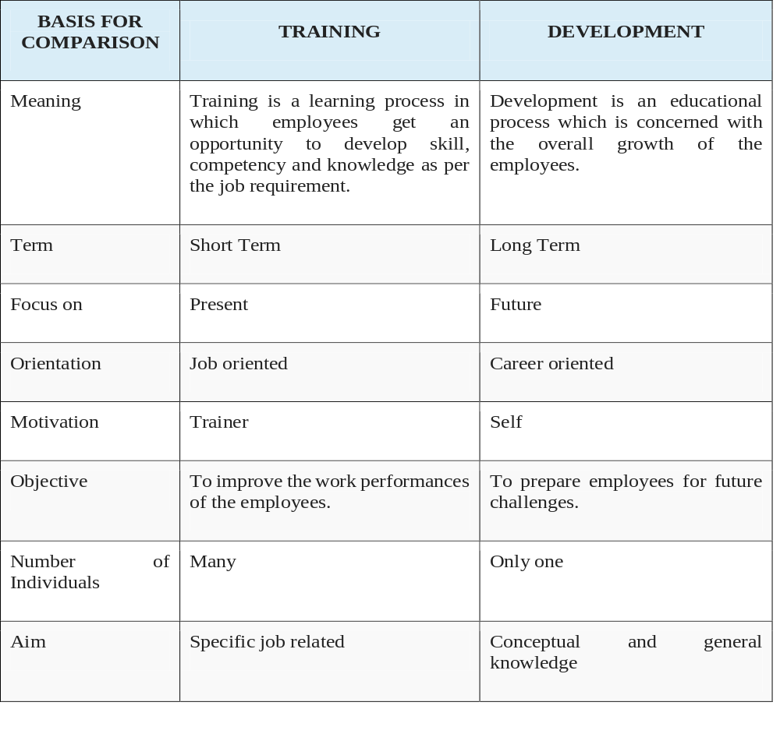

5.2 Significance of Training and Development
There is no doubt that providing training programs to employees and presenting them the proper opportunities so that they can grow and gear ahead toward betterment in their career path is one of the major responsibilities of any organization. Furthermore, the particular department for arranging training and providing employees with appropriate necessary guideline, instructions, knowledge and skills is HR department for concrete reason, as it is one of the most important functions Human Resources Management.
Thereby, let’s go through some of the things to better understand the importance of training and development without further due:
- Better utilization of resources
It is of no doubt that only trained professionals can use the organizational resources in the most effective and efficient manner, therefore, ensuring the optimum utilization of resources such as: financial, intellectual, technological, physical and other sorts of resources.
- Orientation and improvements of organizational culture and climate
Training is able to present a decorative insight of the organaizational culture and overall climate to the employees, especially introductory training period or orientation is crucial for the new ones.
Other than that, it can help organization to obtain any expected change by providing necessary guideline and training to employees.
- Increased level of productivity and profit
Trained individuals tend to be more productive than those with no training for obvious reason. Thus, it can achieve higher level of productivity, resulting more profitability.
- Addressing weaknesses and improving
Every employee has some sort of area of weakness, which can be identified and strengthened by training. In most cases, training is essential to cover up the skill gap or control activities by taking corrective measurements which are identified in the TNA or training need analysis of the analysis part of the training process.
- Maintaining consistency
Consistency throughout the organizational employees and units in terms of goal can be obtained by training. Expectations and procedures within the organization are something to be aware of, where robust training could be beneficial to achieve that.
- Development of employees
Employees can be benefitted as most of the organizations have numerous development programs for the employees. It is tough to find an organization with no development program where there is at least a robust HR department.
Training programs can improve employees to develop skills and competencies which are often not vital to the recent job duties but the future ones so that employees will have a bright future.
- Healthy work environment
Proper training has the ability to increase the health and safety issues of a work environment, for instance- employees with fire safety training are apt to decrease the probability of fire hazard.
Moreover, other safety issues can also be provided through training that are abundantly significant, ensuring a sound work environment.
- Increases employee retention rate
If there are better opportunities available for employees to further development, they will be inclined to continue their career at the same organization. Therefore, suitable training and development programs can literally demotivate employees to leave the organization that results in increased level of retention rate or reduces employee turnover rate.
- Technological adaptability
The emerging competition is of true nature in business world, where organizations must keep pace with the evolving technology to compete and providing technological training is the only way for the survival of the company contemplating the scenario.

5.3 The training process in the format of ADDIE Model
The ADDIE model is the model conventionally used by the instructional designers and training developers, which is a generic process of training. There are five phases—analysis, design, development, implementation, and evaluation— which represent a dynamic, flexible guideline for building effective training and performance support tools. It is perhaps the most common design model of training, frequently practiced in organizations.
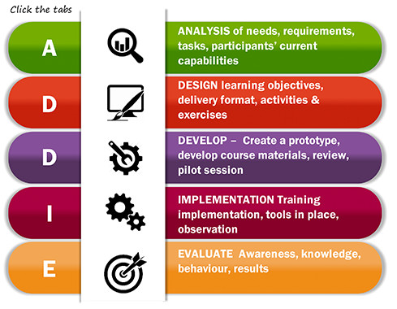
Figure-6: ADDIE Model
Explanation of the ADDIE Model’s five phases are as follows
5.3.1 Analysis Phase
In the first phase, the instructional challenge of the course is detailed, objectives are established and issues such as learner skill level are identified. The analysis phase is often referred to as the Training Needs Analysis (TNA).
Training audience and their characteristics, availability of certain competencies, expected behavioral outcome, constraints learning, individuals responsible to provide training program, timeline of the training to be provided—are some of the crucial questions addressed in this very first phase of training model.
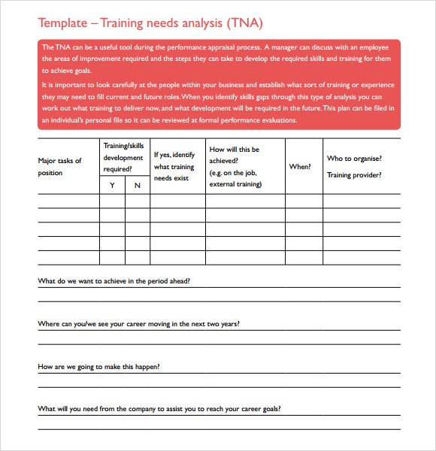
Figure-7: A sample template of TNA form collected from the internet

5.3.2 Design Phase
This phase is concerned with designing the training to be provided, hence, identification of learning objectives, assessment instruments, exercises, content, subject matter analysis, lesson planning and media selection are its jurisdiction. Design phase should be abundantly systematic and specific, meaning that strategic objectives of the training has to be planned accordingly and each materials need to be prepared with great attention to details so that training can be executed successfully.
5.3.3 Development Phase
The creation and assembly of the content assets that were constructed in the design phase is the main concern of the development phase. The training program is reviewed and revised in this stage according to any given feedback.

5.3.4 Implementation phase
This phase is regarding on the actual delivery of the training. The procedures of training for both facilitators and attendees were established in retrospective phases which are to be implemented in this phase. The decisions made in the design phase will influence how this is actually carried out. However, sometimes a pilot test of training is the best way to determine and avoid the possibilities of any unexpected problems.
5.3.5 Evaluation Phase
Last but not the least, it will be determined whether the training program was wholesome in the evaluation phase. Feedback from the previous phases are to be considered here to identify the effectiveness of training, hereby deciding the area which needs to be revised or put in the design face again. Evaluating whether the training program was successful in terms of achieving the preset goals of analysis phase and by TNA is the vital concern here.

5.4 Available Methods of Providing Training

5.4.1 On the job training
It is the kind of employee training at the place of work while employees are doing the actual job. Usually a professional trainer (or sometimes an experienced employee) serves as the course instructor using hands-on training.
5.4.1.1 Job rotation: eGeneration provides on the job training named as Job Rotation. This type of training involves the movement of the trainee from one job to another. The trainee receives job knowledge and gains experience from each of the different job positions. Though this method of training, it is common to train employees for performing jobs other than they are doing currently. It is an excellent method for broadening an individual’s exposure to company operations. Job rotation can turn a specialist into a generalist. Now, eGeneration Limited implements two types of Job rotation: horizontal job rotation and vertical job rotation:
In horizontal job rotation trainees can be rotated from job to job at the same organizational level. This method gives an opportunity to the trainee to understand the problems of employees on other jobs and respect them. It is also known as breath training.
Vertical job rotation is nothing but promoting a worker into a new position (usually temporary)
5.4.1.2 Assistant to position: Employees with demonstrated potential are often given the opportunity to work under a seasoned and successful manager. So, the trainee is placed under a particular supervisor who functions as a coach in training the individual. The supervisor provides feedback to the trainee on his performance and offers him some suggestions for improvement. Often the trainee shares some of the duties and responsibilities of the coach and relieves him of his burden.
We can present the example of Mr. Ahsan H Aminur, manager, public relations and communications; being an upper level manager he mentors others prudent managers of the organization time to time.
5.4.1.3 Committee assignment: Under the committee assignment, group of trainees are given and asked to solve an actual organizational problem. The trainees solve the problem jointly. It develops team work. It can provide an opportunity for the employee to take part in decision making, learn by watching others, and investigate specific organizational problem that has given.

5.4.2 Off the job training
Off the job trainings are the training that are provided when the regular work activities of employees would be stopped. e has some the popular off the job training for the purpose of development of their employees:
5.4.2.1. Classroom lectures: Classroom lectures are the most commonly used traditional ways of providing training. This is simply the formal lecture courses provided by a trainer, coach or teacher.
5.4.2.2. Seminar: A large number of people can attend to a seminar and learn from it. eGeneration had organized multiple seminars in past in order to share knowledge and develop the behavior and overall performance of the employees.
5.4.2.3. Simulation training: Under this method an imaginary situation is created and trainees are asked to act on it. For e.g., assuming the role of a marketing manager solving the marketing problems or creating a new strategy etc.
Simulations are very useful in training employee on actual work experience. For example: HR executives may have to face an artificial conflict resolution scenario and learn by demonstrating their abilities.
5.4.2.4 Programmed Instruction: The programmed instruction technique can be in the form of programmed tests and manuals, video displays, or some type of computer based training. The materials included are highly organized, and in logical sequences that needed the trainee to respond. Trainee can get instant feedback whether his or her respond is correct or not.
5.4.2.5. Vestibule training: Mostly this method of training will be used to train technical staff, office staff and employees who deal with tools and machines. Employees learn their jobs on the equipment they will be using, but the training is conducted away from the actual work floor by bringing equipment or tools to certain place where training is provided, but not work place. Vestibule training allows employees to get a full feel for doing task without real world pressures. Additionally, it minimizes the problem of transferring learning to the job.
Vestibule training is provided to employees when new or advanced equipment or tools introduced in to the organization to do a particular job by using them. For this purpose, such equipment is brought to a separate place to give demonstration and train how to use and that handle it by employees safely.
5.4.2.6 Outdoor (wilderness/survival) training: The primary focus of such training is to teach trainees the importance of working together, as a team. These types of training generally consist of major psychological, emotional along with physical challenges. For example: mountain climbing, baton race, paint ball games, passing obstacles, surviving a week in the jungle etc. eGeneration Limited can send their executives and managers in the types of training to see how they react to difficulties and overcome those.
5.4.2.7 Role play: In this case also a problem situation is simulated asking the employee to assume the role of a particular person in the situation. The participant interacts with other participants assuming different roles. The whole play will be recorded and trainee gets an opportunity to examine their own performance.
5.4.2.8 Business games: According to this method the trainees are divided into groups and each group has to discuss about various activities and functions of an imaginary organization. They will discuss and decide about various subjects like production, promotion, pricing etc. This gives result in co-operative decision making process.
5.4.2.9 In basket: The employees are given information about an imaginary company, its activities and products, HR employed and all data related to the firm. The trainee (employee under training) has to make notes, delegate tasks and prepare schedules within a specified time. This can develop situational judgments and quick decision making skills of employees.
Last but not the least, these training methods mentioned and described in the above parts exist in eGeneration Limited at some extent, more or less, except “simulation training and outdoor or wilderness training”. Moreover, the organization sometimes take the service of other third party firms that helps to train its employees when necessary.

Chapter 6: Compensation Management

6.1 What is Compensation Management?
Compensation management is one of the major functions of Human Resource Management, where providing employees the fair return of the contributions they make in organizations is the fundamental concern.
Compensation represents both the intrinsic and extrinsic rewards employees receive for performing their jobs. Intrinsic compensation reflects employees’ psychological mindsets that result from performing their jobs and extrinsic compensation includes both monetary and nonmonetary rewards. (Martocchio, p. 5)
Hence, it can be said that the total cash and non-cash payments that an individual gets from their workplace in exchange for their performed works are that individual employee’s compensation.

6.2 Types of compensation

6.2.1 Intrinsic Compensation
This type of compensation refers to the critical psychological states of employees after fulfilling their job activities. As per the theory, enhancement of employees experience is achieved when their jobs in concern are highly rated on five dimensions: (Martocchio, p. 6)
- Skill variety is something that can be related with another immensely familiar term, which is job rotation. So, skill variety is the extent of the job’s requirement that makes the employee to perform various tasks and gain different abilities, skillset, competencies and talents. It makes the job more meaningful to individual performing it.
- Task identity is the extent to which the job empowers the employee to perform an entire job from the beginning to end. The job seems more significant to the person that he or she perform it with effectiveness.
- Task significance is the magnitudes to which a job has effects, possibly positive ones on other human being and their life. A doctor, a nurse or a teacher would be a perfect example to illustrate this for instance. The person finds the job worthwhile and performs it with more delicacy.
- Autonomy is the magnitude of liberty, independence and confidentiality a person is provided in choosing the way and method while performing the job. It presents the opportunity to experience the responsibility for work outcomes.
- Feedback is important to employees as they are able to gain realistic insight about the result of their performed job activities. They are appreciated for good performance, and provided with knowledge that can be used for correctional changes in future performances.

6.2.2 Extrinsic Compensation
Many of the extrinsic compensation available to provide the employees in return for their job performance are discussed bellow:

6.2.2.1 Core compensation
Base pay is another name for core compensation. Base pay is the main monetary part of payment that employees get for performing their jobs, which is recurring— meaning that employees are liable to obtain this as long as they are employed on the job. Two types of Based pays are there:
- Hourly wage: Hourly pay or wage is something that employees get for each hour of their work.
- Annual salary: Earning money regardless of the actual hours of work done something which can be referred to as salary. Employers calculate salary on an yearly basis, thus it is called as annual salary.

6.2.2.2 Adjustment to Core compensation
1. Cost of living adjustments (COLA)
Cost of living adjustment are the periodic increase of the base pay due to the inflation in the economy so that employees can lead their life in a way, where their standard of living remain same. It protects employees from the reduction of their purchasing capabilities.
2. Seniority pay
Seniority pays are the periodic increase of the base pay of employees in relation to their service time. So, it is assumed as per the human capital theory that employees develop more skills, talents and competency and become more competent over time, hence, not adding growth in their reward with time will be destructive to further retention of employees.
3. Merit pay
In part, it motivates higher achievers and others as well since, rewarding performers according to their performance level or, result or, outcome of the performance is what merit based pay is about.
4. Incentive
When employees are rewarded partially or completely for meeting any preset job objective, it can be referred to as incentive pay, however, the term variable pay also states the same. Incentive pay is based on the attainment of standard which was predetermined on the basis of some formula or in a broader term organizational goal. It fluctuates on the extent to which the standard has been met.
5. Person focused pay
Person focused pays are given to employees in relation to the knowledge learned, skills gained and talents opted. Mostly, it is something that is provided for successfully obtaining specific curricula.

6.2.2.3 Discretionary Benefits
Some nonmonetary benefits are often given to employees by companies on a discretionary basis, such as programs like- paid time off, protection in form of insurance and various services.
1. Health Insurance
Health insurance or medical insurances are benefits given at the expense of the company to the welfare and protection of the employees.
2. Disability Insurance
Jobs which are risky and hazardous such as, firefighting, working in saw meals or other risky factories that increases the probability of injuries and disability put employees in a critical position. Disability insurance is provided mainly in this type of risky jobs to ensure security to employees who invest themselves in such parlous nature of jobs.
3. Life insurance
Sometimes organizations contribute to the life insurance of employees which is helpful to promote security toward employees’ lives. It gives them a perception of holding a high regard.
4. Retirement plans
Retirement plans such as pension and gratuity are something that ensures the future of the employees in their elderly life, when they are somewhat incapable to work anymore. Retirement plans are considered as some kind of blessing as it helps employees at their later life.
5. Paid time off
Paid time off programs, such as maternity and paternity leave, academic sabbatical are some of the profound examples of this category of benefits.
6. Accommodation and enhancement
Accommodation is a fundamental need for every human being, where employees are not exempt to this theory. Hence, employees are often provided with accommodation facilities from organizations they work for.
Other than that enhancement like tuition reimbursement, day care assistance to employees and their families, schools and colleges for employees’ children are also provided depending on the organizations and their own policies.

6.3 Necessity of effective compensation management
- Image Building:
Employees or human capital are the most valuable resources that an organization could have. Now, if anyone perceives that an organization does not value its personnel to the fair standard and reward them accordingly, it cannot be contemplated that the individual would foster an profound image of that particular organization.
Moreover, it is wise to promote fair treatment and compensation management can be immensely helpful toward providing that which would ultimately result in the increase of the organizational asset named “Goodwill”.
- Attract Talents:
Providing that an organization have fair and upstanding compensation system prevailing, it is of no doubt that competent human resources would be attracted to join the workforce as employees and be a proud new member.
Moreover, organization with effective compensation management are at an advantage in times of recruiting, thus, assisting to the purpose of reaching net HR capital requirement.
- Motivate and Retain Staff:
Not only effective compensation management helps to attract new talents, but to keep intact the remaining number of employees as well. Employees are evidently more motivated in situations where they are rewarded accordingly. Hence, it is beneficial for the employee to continue their career in the same environment, rather than facing a change and moving to another organization.
Finally, organizations can also attain reduction in employee turnover rate, which is crucial to the purpose of achieving short-term and long term goals and objectives.
- Reward Valued Behavior:
Employees tend to perform in a better manner when their performance are appreciated accordingly. Speaking about that, fair reward is one of the best possible way to manifest appreciation; thus, effective compensation management is necessary.
- Administratively Efficient:
Achieving the conditions where every organizational functions and operations are constantly on a smooth trip is a dream from any organization. Effective compensation management can undoubtedly broaden the opportunity for such achievement.
- Ensure Equality:
Ensuring equality in every possible way is always expected from any active organizations with a diversified workforce. Furthermore, it is often a legal based requirement to ensure equality, such as payment of the male and female employees. Where, compensation management is robust, compliance with such honorable and necessary law is possible to attain with an ease.

6.4 Compensation Management in eGeneration Limited
The eGeneration Limited provides fair compensation to its employees. Their compensation and benefits packages contains as such:
- Base pay or monthly salary.
- Annual festival bonuses, which are given twice in a year.
- Bonuses on occasion on the basis of excellent performance.
- Incentives as of attaining pre-established targets, especially for sales teams.
- Medical insurance for all.
- Maternity benefits for female employees at present.
- Free snacks and lunch at the expense of the organization.
Unfortunately, as to maintain the discretion and confidentiality, intensive information and specifics were not provided.

Chapter 7: Implementation of A few important Labor Laws and Workforce Environment in eGeneration Limited

As per Section 1-subsection (3) of The Bangladesh Labour Act, 2006 stataes that “Save as otherwise specified elsewhere in this Act, it extends to the whole of Bangladesh”, hence eGeneration Limited being an Information technology (IT) and consultancy firm operating in Bangladesh is bound to follow the appropriate sections which are applicable to them. (The Bangladesh Labour Act, 2006, p. 9)
Therefore, some very common and otherwise important sections would be discussed to elaborate the conditions of existence of such laws in the organization.

7.1 Appointment letter and ID card
As per section 5, employers are bound to provide an appointment letter in times of employing any employees and afterwards they will have to provide an identity card bearing a photograph of the individual to each of the employee.
(The Bangladesh Labour Act, 2006, p. 22)
Speaking about that, since it was mentioned in the last part of recruitment of eGeneration Limited in this report, it is known information that eGeneration fosters such law and comply with it.
They do not make any candidate without providing an offer letter or in more formal term an appointment letter. Furthermore, it is their policy to make candidates fill up a form containing the name, future incumbent number, blood group, emergency contact number, address of the employee and such information.
Hence, it is to be believed that this is followed according to the law in a better manner.

7.2 Working Hours
There are some laws regarding working hour in commercial or business establishments, and a few of the vital ones are as follow:

7.2.1 Weekly holiday
Any shop, commercial or industrial establishment employees are entitled to get at least 1.5 days of weekly holiday, whereas the minimum limit of weekend is of 1 day for a factory according to section 103. (The Bangladesh Labour Act, 2006, p. 63)

- In eGeneration Limited, instead of the 1.5 days of weekly holiday, they provide 2 holidays per week for the benefit and relaxation of the employees and for the benefit of the organization as well, since it is evidently helpful to increase the working spirit of employees, thus, productivity.
- The weekly holidays are on Friday and Saturday in eGeneration Ltd.

7.2.2 Daily and weekly working hours
According to section 100 and 102, the ordinary daily working hour of an adult worker is of 8 hours where, it is 48 hours weekly. (The Bangladesh Labour Act, 2006, pp. 62, 63).
- In eGeneration Limited, it is not the standard amount of time that an employee works is not 8 hours in a day though, since their office hour is of 9 hours starting from 9 a.m. to 6 p.m. in a day. However, they have special permission granted by Government for implementing such conduct, since their ordinary weekly working hour does not exceed the 48 hour limit, and providing that they offer 2 days of weekly holidays. As per easy calculation it is 45 hours for working 9 hours in 5 days in a week.

7.2.3 Interval for rest and meal
The mandatory interval period that employers are liable to provide to workers as per section 101 are presented as follows:
Duration of Work (in a day) | Interval Time
More than 5 hours | 1 hour
More than 6 hours | 0.50 hour (30 minutes)
More than 8 hours | 1 hour  Or,  Two interval of 30 minutes
(The Bangladesh Labour Act, 2006, pp. 62-63).
- Complying with the law, eGeneration Limited has a policy of providing at least 1 hour of interval or break time so that employees can rest, have their meal or complete their midday prayer.

7.3 Extra-allowance for overtime
According to section 108, every employee working in an organization is entitled to be paid twice for the overtime at the rate of the individual’s basic wage and dearness allowance and ad-hoc or interim pay, if any. (The Bangladesh Labour Act, 2006, p. 64).
- However, it is very unfortunate that eGeneration Limited does not comply with this particular law. I found it very offensive that they urge the employees to work overtime in the name of work load, which is very common in the scenario of the organization. Even employees do not have the courage to ask for their fair payment of overtime as company do not provide any extra allowance for this particular purpose.

7.4 Leaves
There are certain leaves that employees are eligible to obtain as per law, and eGeneration Limited sanctioned them lawfully. Section115, 116, 117, and 118 are the leave related ones, which are to be presented in the table in the briefest manner possible:
Title of the leave | Descriptions
Casual Leave | 10 days/ a year
Annual Leave | 1/18 working days
Sick Leave | 14 days in a year
Festival Leave | 11 days in year
(The Bangladesh Labour Act, 2006, pp. 67, 68 & 69).

7.5 Health and Hygiene
It must be admitted that the organization keeps special care to the health and hygiene of the employees some, thus, some examples are given for instance:

7.5.1 Portable water
Drinking water is that necessary fluid which is fundamental to all living species. It keeps our body hydrated, quenched our thirsts, and additional to that boosts our metabolism which is helpful to work with concentration.
It is that much significant which takes its place under the section 58 of Bangladesh Labour Act, 2006. This particular sections states that employees has to be provided with pure drinking water, and if the number of employees exceeds 250 provision shall be made for cooling the drinking water during summer.
- It was my observation that there is plenty of availability of portable drinking waters for the employees employed.
- Some personnel hired from HandyMama fill up the individual water bottles of every employees in each morning of the working days.
- They refill the bottles or water pots with gratitude as many time as an employee requests, and the stuffs are very helpful regarding this matter.
- Employee can have drinking water by themselves from the food station (lunch room) and from water filters set as well.

7.5.2 Cleanliness
- eGeneration Ltd. is very concerned of the fact that the dirt and refuge of the floors, work-rooms, passages, corridors, and staircases of any establishment should be removed daily by sweeping. (The Bangladesh Labour Act, 2006, p. 42)
- They have separate crews recruited from the firm HandyMama, a professional cleaning and handyman service providers.
- All of the walls are white washed or color washed at least once in a year, where minimum requirement is of 14 months.
- They repaint or re-varnish the walls and backgrounds once in every 3 year as per law dictates in section 51(b). (The Bangladesh Labour Act, 2006, p. 43)

7.5.3 Washrooms
It is mandatory to have and maintain adequate amount of washrooms in any establishment where at least 50 personnel are employed, whereby separate washrooms would be provided and maintained for women if there is at least 25 female employees. (The Bangladesh Labour Act, 2006, p. 60).
eGeneration have enough facilities of washrooms for both the male and female employees.

7.6 Maternity Benefit
First of all, let’s see what are the minimum but must requirements to fulfill to provide maternity benefits to female employees according to The Bangladesh Labour Act, 2006. The gist of section 45, section 46, and section 47 are as follows:
Section 45 & 46: Employer can not knowingly engage a female employee and a female employee shall not work for 8 weeks prior to the birth of a child and another 8 weeks after the birth of a child.
Provided that a woman shall not be entitled to such maternity benefit unless she has worked under the employer, for a period of not less than 6 months immediately preceding the day of her delivery. Moreover, no maternity benefit shall be payable to any woman if at the time of her confinement she has 2 or more surviving children, but in that case she shall be entitled to the leave to which she would otherwise be entitled. (The Bangladesh Labour Act, 2006, p. 40)
Section 47: A woman should inform her employer either orally or in writing and the employer should also acknowledge the matter with proper importance and permit the concerned woman to absent herself from work. If she doesn’t give any notice she must do it within 7 days of her giving birth of the child.
- It is a matter of fact that eGeneration had recently introduced Maternity Benefit for females as per law and thinking of providing paternity benefit such as: paid leave to male incumbents as well.

7.7 Safety
Ensuring the safety of the employees in workplace is a vital concern of any renowned organization. Employees can only work and contribute in achieving the individual, unit and organizational goals when a safe and sound work environment exists in the scenario. Hence, some important laws and compliance are as follows:

7.7.1 Precaution as to fire
It is of no doubt that fire can cause situations as hazardous as possible. Therefore, to avoid such circumstances there are laws under section 62 of Bangladesh Labour Act, 2006.
This section states that every establishment has to have at least one alternative staircase and necessary means of firefighting equipment. It also focuses on having emergency exit door in times of fire.
Unfortunately in eGeneration Limited’s present corporate office the alternative staircase connecting all floors is missing, although they have fire clearance certificate from fire department.
However, the organization has sufficient firefighting equipment in place, mainly fire extinguishers.

Picture: A sample of eGeneration’s fire extinguisher.

7.7.2 Fencing of machinery
Being an IT company, machinery such as electrical parts of the server, and especially the electric generator are sufficiently fenced.

7.7.3 Hoists and Lifts
The lift of eGeneration is examined time to time at least once in every six months by an expert mechanic to keep it fine tunes, which is also a requirement by law. (The Bangladesh Labour Act, 2006, p. 49)

Chapter 8: Analysis, Findings and Recommendations

8.1 SWOT Analysis
Strengths  - Having competent manpower or human capital.  - Being one of the leading IT organization in Bangladesh.  - Association with some renowned global organizations, such as Microsoft, Oracle and a few more.  - Only licensee partner of Microsoft in Bangladesh.  - Proficient HR Department.  - Office location is in a very prominent place and easily commutable for mostly everyone, which is in Gulshaan-1. | Weaknesses  - It is still a medium size company in terms of employee number, as it does not even exceed 200 (around 180 employees).  - In the era of technological revolution, the organization is relatively new in the field of information technology business, which was only established in 2003.  - Only a team of 5 people that manages the whole HR department.
Opportunities  - There are numerous magnitudes of opportunities available in the IT sector as technology is evolving day by day.  - eGeneration is looking forward to some lucrative business contracts and projects from its clientele, including government that will be extremely beneficial to boost the company’s overall brand value and image.  - Entering into new business area consistent with Information Technology. | Threats  - Facing detrimental situation in case the country faces any economic recession.  - Pernicious competitions among competitors.  - Not being able to adapt with the upcoming technological change in future.

8.2 Findings
I must admit that going through the experience of the internship program, I have gathered some findings about the HR department of eGeneration Limited, which will be unjust if I do not mention those, as it is mostly the last part of the report. Furthermore, as some findings are crucially positive, some are not. Hence, both the positive and negative findings are provided sequentially:

8.2.1 Positive Findings-
- eGeneration Ltd. realizes the significance of HRP profoundly well that it is the substantial part of other HR functions.
- The recruitment and selection process is effective to fulfill the personnel need quite efficiently.
- They established MBO and Ranking Scale to evaluate their employees’ performances.
- Employees’ compensation, promotion, need for skill and competency development are at some extent depend on performance appraisal.
- They provide proper orientation to new employees.
- Other necessary training programs are arranged following the TNA and remaining steps of training process where needed.
- Employees are provided fair and customized compensation and benefits consisting of, salary, bonuses, incentive, medical insurance and a couple of others.
- They comply with most of The Labour Act of Bangladesh, such as issuing appointment letter and identity card to employee in time of joining.
- Employees get 2 weekly holidays which exceeds the minimum legal requirement of 1.5 days holiday for commercial and industrial entities.
- eGeneration Ltd. has a sound work environment which is neat and clean.
- They have fire clearance certificate from fire department having necessary firefighting equipment available in the workplace.
- Introducing maternity benefits for females is one of the latest upgrade in eGeneration.

8.2.2 Negative Findings-
- Their prevailing performance appraisal system is somewhat insufficient considering the significance of it.
- Performance appraisal is conducted only once in every year that indicates toward the sporadic nature of it.
- There is no 360 degree feedback system available in the organization.
- eGeneration limited do not disclose compensation related information labeling it as confidential, whereas in theory it is employees right to share the knowledge if they want to, which can result in more empowerment for them.
- They do not provide any retirement plan, such as pension or gratuity, which is a legal requirement by law.
- Employees are not entitled to gain extra allowance for overtime making it one of the major negative findings I have observed so far. It is a dreadful act, which is totally unacceptable from such a promising ompany.
- Emergency staircase is nonexistent in the infrastructure of eGeneration Limited’s corporate office, however fire clearance license was issued by the Fire Service Department.

8.3 Recommendations
- Introducing the practice of providing extra allowance for work extended to the ordinary daily working hour, or overtime work is a must. It is a point on example of deception toward employees and their right by which the organization is also breaking the law (section 108) consistently.
- They can introduce 360 degree performance appraisal method as soon as possible since the current performance management scenario is not up to the mark.
- Providing feedback on a continuous basis is something that they should follow, not only conducting appraisal of employee performance once a year.
- They should introduce gratuity, pension or in broader term retirement plans as it not only be a compliance to the law but, help the organization to retain skillful employees as well as attract new talents.
- Modifying the infrastructure if possible by any means would be a great thing, where there will be emergency staircase in case of any unexpected fire hazard, increasing safety to incumbents.

8.4 Conclusion
Last but not the least, anyone can be right on point stating that eGeneration Limited is undoubtedly a promising business organization operating in the field of Information Technology. Although it has a plenty of way to go, however, it can always take inspirations from its previous milestones, achievements, and success stories.
Moreover, I want to conclude by manifesting my hope and desire after being a part of it almost for 5 months that HR department will be nothing but only helpful for attaining new achievements for the organization in future.

Appendices

References
- Aguinis, H. (n.d.). Performance Management (3rd ed.). Pearson.
- Bain, M. (2004).
- Belcourt, M., McBey, K. J., & Hong, Y. (2017-2018). Strategic Human Resources Planning (Fifth ed.). CENGAGE Learning.
- Brumbrach. (1998).
- Campbell, J. P. (1993).
- KENTON, W. (Ed.). (2019, April 20). Retrieved from https://www.investopedia.com: https://www.investopedia.com/terms/h/human-resource-planning.asp
- Martocchio, J. (n.d.). Strategic Compensation: A Human Resource Management Approach (6th ed.).
- The Bangladesh Labour Act, 2006. (n.d.). In A. A. Khan, Bangladesh Labour & Industrial Law (p. 9). Dhaka: Udayan Library.
- Xavier, J. V. (2015). A Study on the Effectiveness of Performance Appraisal System and its Influence with the Socio-Demographic Factors of the Employees of a Manufacturing Industry in Tamil Nadu. International Journal of Research in Management & Business Studies, 1.

