Project Report
On
Evaluating Brand Trust:
A Comparative Study on Selected Smartphone Brands

SUPERVISED BY
Muhammad Hasan Al-Mamun
Assistant Professor
School of Business and Economics
United International University

PREPARED BY
Rifat Sultana Riya
ID: 111 132 144
BBA Program
School of Business and Economics

DATE OF SUBMISSION
18 – 07 – 2018

Project Report

On

Evaluating Brand Trust:
A Comparative Study on Selected Smartphone Brands

Letter of Transmittal
18 July 2018
To,
Muhammad Hasan Al-Mamun
Assistant Professor
School of Business and Economics
United International University

Subject: Submission of Thesis report on Evaluating Brand Trust: A Comparative Study on Selected Smartphone Brands
Dear Sir,
I am pleased to inform you that as the partial requirement of fulfillment of my BBA Program I have completed my project thesis. I am submitting the thesis report on Evaluating Brand Trust: A Comparative Study on Selected Smartphone Brands. By this report I have got the opportunity to experience and apply my theoretical expertise, ideas and communication skilled and bridge them with the real world of practical experience, which will be good start for my future professional career.
I am submitting the report for your kind perusal and acceptance. It would be pleasure for me if this report can serve its purposes and I will be available to explain your queries, if you feel necessary.
Thanking you and looking forward to receive your cordial approval of your submission.

Sincerely yours
Rifat Sultana Riya
ID: 111 132 144
Abstract

This report intended to examine the brand trust in the context of smart phone handset industry in Bangladesh. The pervasive use of mobile phone in our life is now taken for granted. We can do almost everything with our phones.
For the purpose of examining the brand trust across three brands (iPhone, Samsung, Huawei), a survey was conducted with a self-administered questionnaire following a non-probabilistic sampling technique with the sample size of 60.
Cronbach alpha values for each of the constructs (brand trustworthiness, brand attachment, and brand equity) were found to be in the acceptable range (all above .70). The constructed lower diagonal correlation matrix showed statistically significant relationships among the aforementioned constructs. It has been found that both brand trustworthiness and brand equity vary across all the brands considered in the study. But brand attachment was not found to vary across the brands. It has also been found that brand trustworthiness and brand attachment both have impact on the brand equity. The changes in the brand equity can be explained by changes in both brand trustworthiness and brand attachment by 65.90%. But higher relative contribution from brand trustworthiness is found due to higher beta value.

Key Words: Brand Trust, Smart Phone Handsets

Table of Content

1 Introduction 7
1.1 Topic in Hand 7
1.2 Context of the study 9
2 Industry Overview 10
2.1 Historical Evolution of Smart Phones 10
2.2 Review of Selected Brands 12
3 Literature review 16
4 Objectives and Methodology 18
4.1 Objectives of the Study 18
4.2 Methodology of the Study 18
5 Findings of the study 20
5.1 Sample Characteristics: 20
5.2 Reliability Analysis of the Constructs Used in the Study: 23
5.3 Item Evaluation: 24
5.4 Relationship among the Constructs: 30
5.5 Variation in Brand Trustworthiness across Brands: 31
5.6 Variation in Brand Attachment across Brands: 32
5.7 Variation in Brand Equity across Brands: 32
5.8 The Impact of Brand Trustworthiness and Brand Attachment on Brand Equity: 33
6 Appendix 35
6.1 Questionnaire sample for iPhone 35
6.2 Questionnaire sample for Samsung 36
6.3 Questionnaire sample for Huawei 37
7 Future Research Scope 38
8 Conclusion 39
9 References 40

Introduction

Topic in Hand

The topic of the thesis is on ‘Evaluating Brand Trust: A Comparative Study on Selected Smart Phone Brands’. So first we know what brand trust is and how it is working for organization and customers.
For a brand it is harder than anything to be trusted as a brand from target audiences of that brand. But so many brands are doing well in that field. Brand trust is very important for the brand and also for the customers because a brand’s future lying on it to a great extent. When a brand can create satisfaction in customer mind then it is easier to be more trustworthy brand. Nowadays researchers and marketers greatly focused on brand trust and the process of creating such trust in the minds of the target customers because brand trust increases the brand value and equity. There are some strategies which brands marketers follow to become trusted in customer mind. Like-
- Be available to their target customer
- The product should be reliable to customer
- Always transparent about themselves and recognized by people be a honest brand
- If customer understand that they are valuable to the brand than they are attached to the brand. So feel the customer they are valuable for them
- Always maintain consistency about the quality.

Many author told many things about brand trust. Brand trust is at the heart of customer–brand relationships Brand trust positively inﬂuences important outcome variables such as brand loyalty (e.g., Chaudhuri and Holbrook (2001), brand commitment (e.g., Chaudhuri and Holbrook (2002), and purchase intention (e.g., Lacey (2007).

In a better way we understand brand trust if we look for an example. There are so many example of brand trust in world wide. Amazon is a worldwide ecommerce service where people can find any type of product easily. It is a good example for brand trust. Because they have a goodwill among the people and also they supply good quality products within the time they showed. That’s the reason people like them and they could manage to become a trusted shop in online.
Brand communication also improve the brand trust through brand satisfaction. In a study it shows that there is a positive relationship between the brand communication and brand satisfaction which can strong the relationship with the brand trust. According to Forbes “Brands must treat trusts like gold”. For that reason brand should develop their trusts using digital marketing and understand what consumers want from their trusted brands.

Context of the study

For the brand trust evaluation in smart phone brands I am choosing three brands which are popular in our country. They are-
- iPhone
- Samsung
- Huawei
These three brands are much popular in our country and they have also a certain level of brand trust in smart phone brands. In this study I am evaluating these brand’s trust and how people trusted their product and use their products in their daily life. There are so many study on brand trust and it’s an ongoing process because we have lots of brands in our market and people buy them and use them and also sometime feel attached to them and from all these things trust is born in people’s mind. That is why researchers study on how much the brands are trusted and how much people are connected with them.
In my thesis paper the three smartphone brands are popular but they have also a tough competition in the market. Because their service providing style is almost same and often people are confused which phone they will buy. So for evaluating them I am going through a survey which mainly indicate what brand people like most of which are more trustworthy.

Industry Overview

Historical Evolution of Smart Phones

In this era smart phones changes our life so fast. The world is in our hand because of smart phones. We can do maximum our work with the help of smart phone. This is a life changing device. Without a smart phone we could not imagine our life for a second.
Smart phone is a wireless network device where it can handle large call volumes and it is improve day by day by adding more functions. It works as like our PC’s. There are so many things by using the smart phone like, Facebook chatting to video call, email checking to food ordering variety of tasks are done with it.
The world first smartphone made by IBM in 1994 and it called IBM Simon. The Simon was the first device to feature telephone and PDA system. Simon also featured many applications and services including email, calendar, calculator, address book, world time clock, notepad and multiple on-screen keyboards, and even the ability to send and receive faxes. It lasted for the market for a six month and sold 50,000 units.
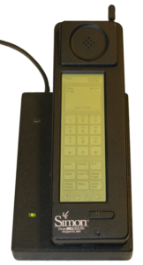

After that in 1996 Nokia introduced the Nokia 9000 communicator. It was one of the first smartphone in the market. It was better than Simon and included graphical web browser.
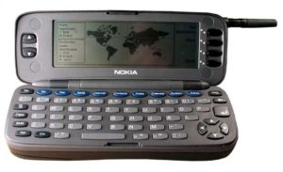
In the year 1999 Sony Ericsson Company introduced Ericsson R380 and it was the first official smartphone in the world. It was also the first mobile device to use Symbian OS. That operating system would continue to dominate the market until the very last quarter of 2010. This company introduced lots of smart phones over the past years and also a popular smart phone brand in his time.
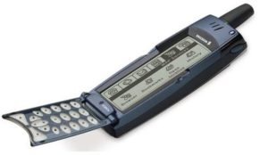

Day by day the smartphone concept updated and in 2002 Blackberry was introduced after that Samsung then iPhone etc. also launched. These phone company upgraded many feature in their smart phone. Until 2008 Symbian, Blackberry etc. operating system used most but when Google introduced Android operating system it was break all the records. And still now android is most popular operating system in the smartphones. Then iOS introduced by Apple. In this era smartphones are not for calls and messages but also have internet, video calling, picture capturing and many more things done. Now we can look forward how future phones updated and how many features added.

Review of Selected Brands

- iPhone

This smartphone designed and marketed by Apple Inc. in 2007. From then it is very popular smartphone worldwide. The software uses in iPhone is iOS software. This phone is a game changer in mobile industry. iPhone’s success has been credited with helping Apple most valuable publicly traded companies. It is very powerful device and operate so smartly also it looks good and capable to do so many things. According to Forbes’ annual study Apple is the top most brand value straight seven years. iPhone is a device which is using all-purpose like it is using by kids because they have lots of feature for kids, uses for business purpose and also for personal use. Apple make products which people love to use. It highly focused on approaches, quality and overall user experience that means it’s a high ended category product.
People love to use iPhone because it’s better than any other phone and also the beautiful looking. There are so many facts why people love the iPhone brand most. They are-

- It is faster than any other phone and when someone operating a big file in their phone it works smoothly as any other android phone. It has a bionic chip inside and that is reason for working smoothly.
- iPhone first introduced the 3D touch display and also it has a face ID app which is more efficient than any other face ID app.
- The iOS software update in iPhone very quickly rather than any android software and customer also satisfied for their fast updating program.
- IPhone offering the best app in their app store and customers are provided the service by the iPhone center.
- If someone using Mac in their home than iPhone is beautifully run with the Mac and also get the extra benefit from that.

- Apple pay is the most popular method for making mobile payments rather than any other android pay and it is very easy to use.

- There is a family sharing feature in iPhone where up to six people can share iTunes, iBooks, sharing photo album and maps. It is a very useful app for keeping eye on kids.

- Apple has the best support and help center where anyone can sort out their problem. It has a huge database, websites, useful articles, live chat and also meet the genius from the Apple Genius Bar by getting an appointment.

- The iPhone customers love their product and charged premium because of the design and aesthetic hardware and software and also the new innovation.

These are some reason people love the iPhone brand and stick to it because they are delightful to the service of iPhone and also the product as well.

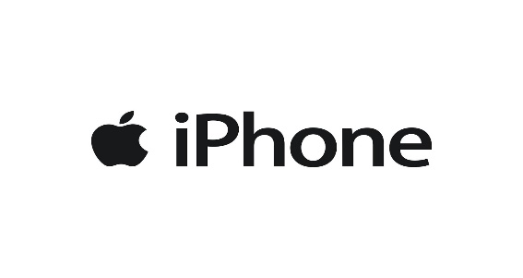

- Samsung

Samsung is a South Korean company and headquarter is in Seoul. In 1938 Lee Byung Chul established the Samsung as a trade company. After that its electronic industry run in late 1960s. But it is globalized by their mobile phone. The maximum revenue earned with the help of Samsung mobile phone and electronics. Like Apple’s Samsung offers budget category smartphone to some serious high-end products. Many people use this smartphone brand for so many reason.

- Now a day’s people are very conscious about brand and what they are using. Sometimes people are stick to a brand they are using for so many years. And exactly happen to the Samsung.

- For choosing iPhone there are limited category’s and design also but in Samsung there have been a wider range of collection and also a budget friendly smartphone.

- People love the Samsung display because it is bright and colorful.

- Its phone’s camera is good and budget oriented and people taking pictures, selfies and videos.

- It has an excellent service after selling the product and the service available anywhere in the world. It also gives warranty on devices.

- Another one people like it most because it has installed android software in the phone.
So that’s are some facts people using this brand and like the brand.

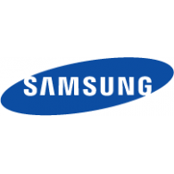

- Huawei

It is a Chinese multinational networking and telecommunication company which is located in Shenzhen, Guangdong. It is the largest telecommunication equipment manufacturer. Huawei was founded in 1987. From July to September 2017, Huawei surpassed Apple and became the second largest smartphone manufacturer in the world after Samsung. It mainly focused on manufacturing phone switches but it expanded its business building telecommunication networks and consulting service on equipment outside in China. According to Forbes’, “Huawei is the world’s number three smartphone and it’s a serious contender of Apple and Samsung. Huawei is not a fake or shit product now. It may be cheap but it’s a wonderful phone inside.” Last year it launched Huawei P8 and it’s a mind blowing product said by the users. Some reason people using this phone –

- Its battery is good and its design also a better than any other Chinese phone.
- The P8 is similar to iPhone 6s and also in a reasonable price.
- It is 4G enabled phone and it performed well and also the downloading speed is also very smooth.
- It offers one year warranty protection.
- It is a super smart phone with in a reasonable price rather than Samsung and iPhone.
- For running multiple apps the P8’s processor works wonderful and don’t slow the phone.
- The camera function also provide high service with 13 megapixel sensor and that uses four pixel.

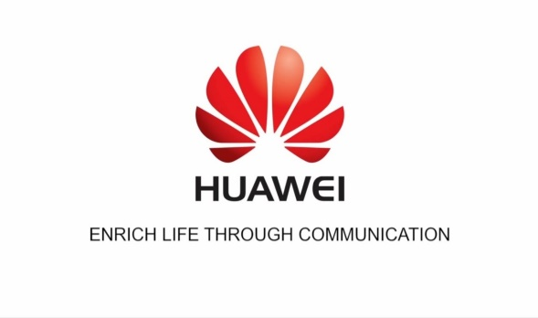

Literature review

In my report I am largely indebted to an article which was published in April 2015 by Nicole Koschate-Fisher/Susanne Gartner named Brand Trust: Scale Development and Validation. They provided a good overview and antecedent’s outcome of brand trust.
In this article they have four empirical studies which are mainly developed the brand trust scale, validity, verifying the reliability, evidence, relationship and so on. In 2011 there also a brand trust literature published which mention in this article. There are so many dimensions related to the brand trust like multidimensional concept, performance dimensions etc. also included interpersonal concept, ability of customer, competence, behavior and so on. There are so many authors describe brand trust in a different way but the concept is almost same however they differentiate in another way.
So many articles, research and surveys on the basis of brand trust. Many author wrote about it and told to the people what brand trust is actually. Brand trust mainly related to the customer and the company’s product where customers are invested. If the product may satisfying the customer’s mind than it’s a trustable product and people buy more. So it’s a very important concept in the business world.
For trusting a band customer satisfaction is more considerable than any other thing. When people trust a brand it will be much benefited thing to the company than any other thing. Like- company have a good image in public, they charge premium for their reliabilities, they also innovated more things for grabbing customers and finally also profitable than previous. And also customers have some outcomes too- their attachment to the brand increases, they want to pay more for a good product and many more things.
According to author Elena Delgado‐Ballester, “brand trust is rooted in the result of past experience with the brand and it is also positively associated with brand loyalty which in turn maintains a positive relationship with brand equity”. So brand equity is tied up with brand trust into a relation based market asset. Brand equity mainly describes the value of having a well-known brand name, how it can generate the simple revenue of a well-known brand and recognition of a brand than a less known brand.

An American marketing professor, Kevin Lane Keller developed a brand equity model which is known by Customer Based Brand Equity (CBBE) Model or Keller’s brand equity model. The concept of brand equity model is to build a strong brand that shape the customers think and feel about the brand. When a brand has a strong brand equity it helps to attract the customers. For that reason brand trust increased in customer mind and their satisfaction level goes on high. On the other hand, competitors who have weaker brand equity lose their customer. In Keller’s brand equity model there are four steps contain six building blocks which is showing by a pyramid;

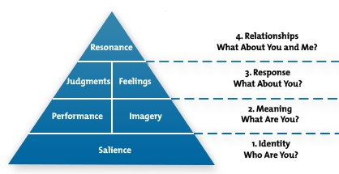

These four levels create a strong brand compare to the others that’s why to improve the brand trust among the customer’s mind brand equity model helps a lot. This brand equity model can hold the customers in long run if organization use it for their development. So, brand equity is important element in marketing for higher the brand trust ratio in the market as well in customer mind.

Objectives and Methodology

Objectives of the Study

The project thesis is intended to satisfy the following specific objectives:
- To develop an historical outline of the evolution of smart phones.
- To review the historical background of the selected brands, namely, iPhone, Samsung, and Huawei.
- To examine the reliability of constructs considered in this study, namely, brand trustworthiness, brand attachment, and brand equity. Cronbach alpha value will be calculated for each of these constructs for the purpose examining the reliability of these constructs.
- To examine the relationships among the previously mentioned constructs. For this purpose, a lower-diagonal correlation matrix will be constructed and duly interpreted.
- To see if brand trustworthiness varies across the three brands considered in this study.
- To see if brand attachment varies across the three brands considered in this study.
- To see if brand equity varies across the three brands considered in this study.
To examine the impact of brand trustworthiness and brand attachment on brand equity.

Methodology of the Study

The methodology of the study can be explained in terms of the following aspects:
- Sampling Process and the Sample Size
- Data Collection Process
- Research Instruments Used
- Analyses to be conducted

- Sampling Process and the Sample Size:
Non-probabilistic sampling technique was used. Respondents were selected on the basis of the convenience of selecting them. So, more specifically convenient sampling was used in this study. The sample size used in this study is 60 in number. All the respondents were residing in Dhaka city during the time of interview.

- Data Collection Process:
Self-administered questionnaires were used to collect the data. Each respondent was given a set of three questionnaires designed to measure brand trustworthiness, brand attachment, and brand equity of three different brands.

- Research Instrument Used:
The research instrument used in the study in mainly based on Evaluating Brand Trust: A Comparative Study on Selected Smart Phone Brands. The research instruments used are attached in the appendix in the form of questionnaires.

- Analyses to be conducted:
Descriptive statistics were used to make a profile of the respondents. Cronbach alpha values were calculated for the purpose of measuring the reliability of the constructs considered in the study. Three one-way ANOVAs were conducted to see if brand trustworthiness, brand attachment, and brand equity varies across the brands. A multiple regression analysis was conducted to examine the impact of brand trustworthiness and brand attachment on brand equity.

Findings of the study

Sample Characteristics:

Characteristics of the respondents are presented below in terms of the following characteristics:
- Gender
- Education
- Profession
- Average Monthly Family Income
- Brands
Now these five characteristics describe with their frequency table:

- Gender

 |  | Frequency |  | Percent |  | Valid Percent | Cumulative Percent
Valid | Male | 30 | 50.0 |  | 50.0 |  | 50.0
 | Female | 30 | 50.0 |  | 50.0 |  | 100.0
 | Total | 60 | 100.0 |  | 100.0

In this table the frequency of male is 30 and female is 30 which is equal amount. And the cumulative percent of male is 50% and female is 100%.

- Education

 |  | Frequency | Percent | Valid Percent | Cumulative Percent
Valid | Bachelor | 42 | 70.0 | 70.0 | 70.0
Valid | Masters or equivalent | 18 | 30.0 | 30.0 | 100.0
Valid | Total | 60 | 100.0 | 100.0

Here shows that the frequency of bachelor is 42 and master or equivalent is 18 which is mainly 70% and 30% of the education characteristics.

- Profession

 |  | Frequency | Percent | Valid Percent | Cumulative Percent
Valid | Student | 21 | 35.0 | 35.0 | 35.0
Valid | Service Holder | 20 | 33.3 | 33.3 | 68.3
Valid | Business | 13 | 21.7 | 21.7 | 90.0
Valid | Others | 6 | 10.0 | 10.0 | 100.0
Valid | Total | 60 | 100.0 | 100.0

In this table shows that there are four category of profession (student, service holder, business and others). Where student is 35%, service holder is 33.3%, business is 21.7% and others is 6%.

- Average Monthly Family Income

 |  | Frequency | Percent | Valid Percent | Cumulative Percent
Valid | 30,000 or below | 2 | 3.3 | 3.3 | 3.3
 | 30,000 - 60,000 | 11 | 18.3 | 18.3 | 21.7
 | 60,000 - 90,000 | 26 | 43.3 | 43.3 | 65.0
 | 90,000 - 1,20,000 | 17 | 28.3 | 28.3 | 93.3
 | Above 1,20,000 | 4 | 6.7 | 6.7 | 100.0
 | Total | 60 | 100.0 | 100.0

The average monthly family income have five category. Where the percentage of 30,000 or below is 3.3%, 30,000-60,000 is 18.3%, 60,000-90,000 is 43.3%, 90,000-1, 20,000 is 28.3% and above 1, 20,000 is 6.7%.

- Brands

 |  | Frequency | Percent | Valid Percent | Cumulative Percent
Valid | iPhone | 20 | 33.3 | 33.3 | 33.3
 | Samsung | 20 | 33.3 | 33.3 | 66.7
 | Huawei | 20 | 33.3 | 33.3 | 100.0
 | Total | 60 | 100.0 | 100.0

In this table there are three brands iPhone, Samsung and Huawei and their valid percentages are respectively 33.3%, 33.3% and 33.3% because all the brand’s frequency is 20.

Reliability Analysis of the Constructs Used in the Study:

Here Cronbach Alpha value will be calculated and interpreted for each of the constructs used. According to Institute for Digital Research and Education”, “Cronbach’s alpha is a measure of internal consistency, that is, how closely related a set of items are as a group. It is considered to be a measure of scale reliability. A "high" value for alpha does not imply that the measure is un-dimensional”.

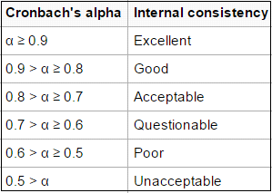

Here the Cronbach Alpha value calculated for the construct brand trustworthiness is found to be 0.7404, which is deemed to be acceptable.
The Cronbach Alpha value calculated for the construct brand attachment found to be 0.8084, which is good according to the chart.
Then the Cronbach Alpha value calculated for the construct brand equity found to be 0.7875, which means it is acceptable if we follow the chart.

Item Evaluation:

Now each of individual items of all the constructs used in this study will be evaluated and interpreted in terms of the following two types of approaches:
- Graphical Evaluation
- Descriptive Statistics

They are describing below with the detail information,
- Graphical Evaluation

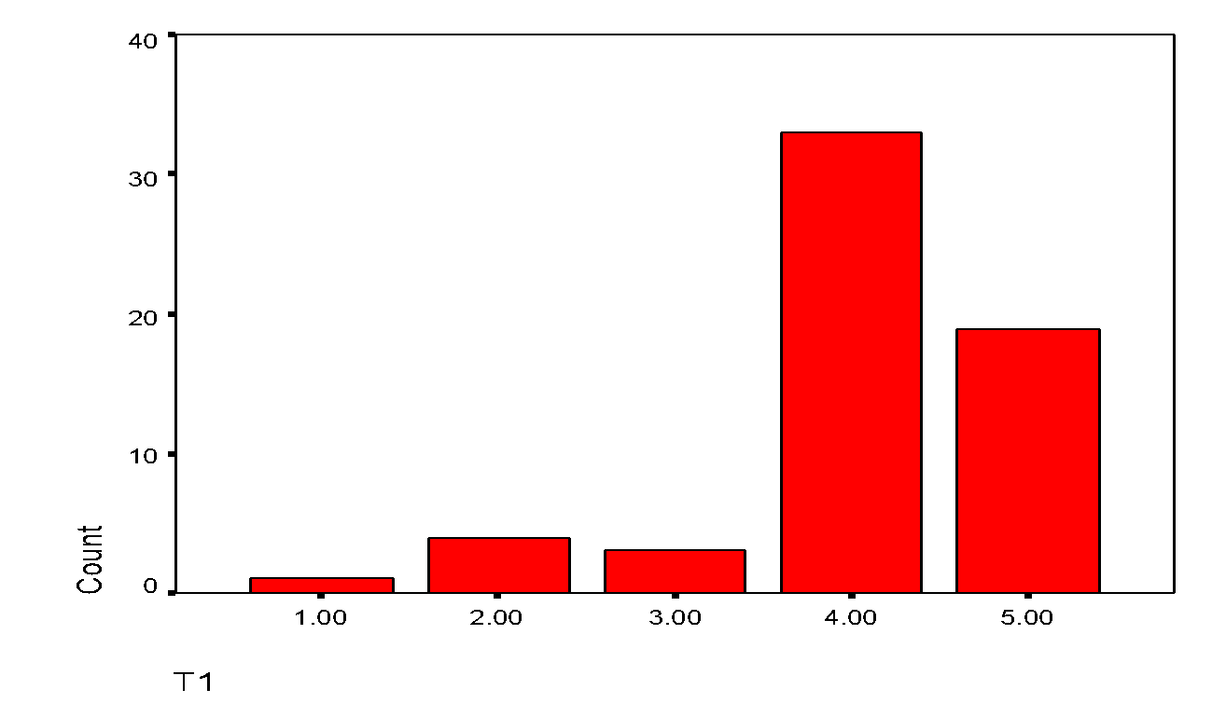

The item is found to be rightly skewed. Therefore the item is not found to be normally distributed.
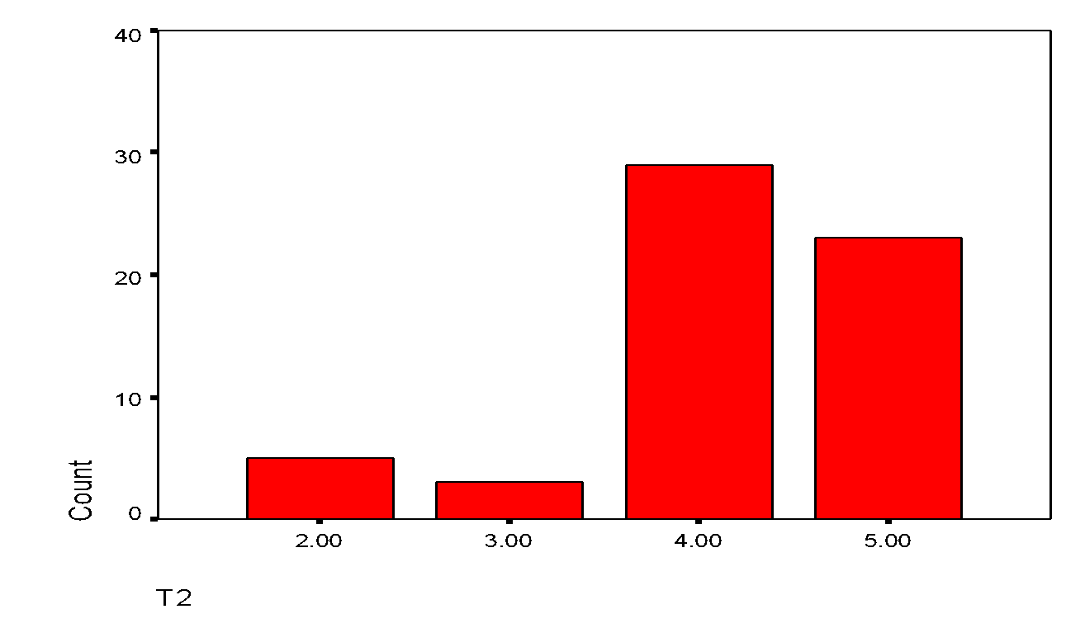
The item is found to be rightly skewed. That’s why the item is not found to be normally distributed.
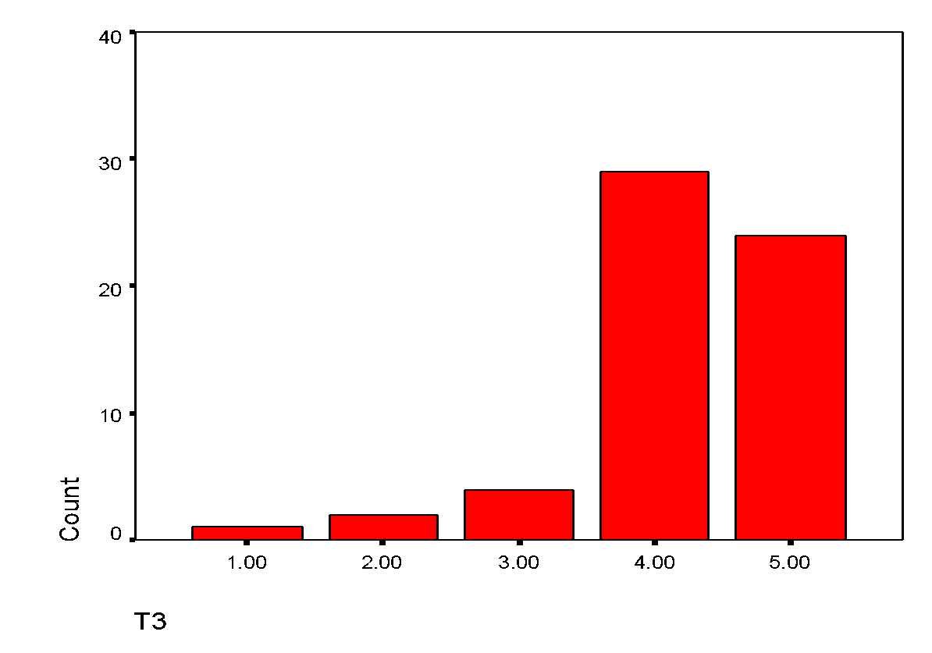
This is also a rightly skewed graph and it is not normally distributed.

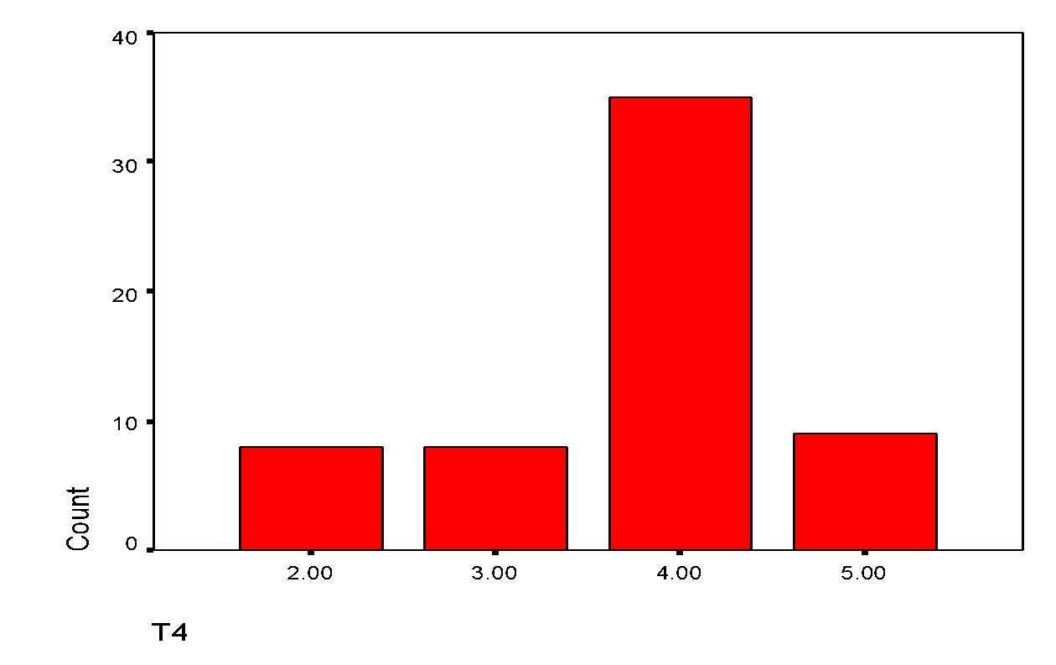

Again it’s a rightly skewed and not a normally distributed item.

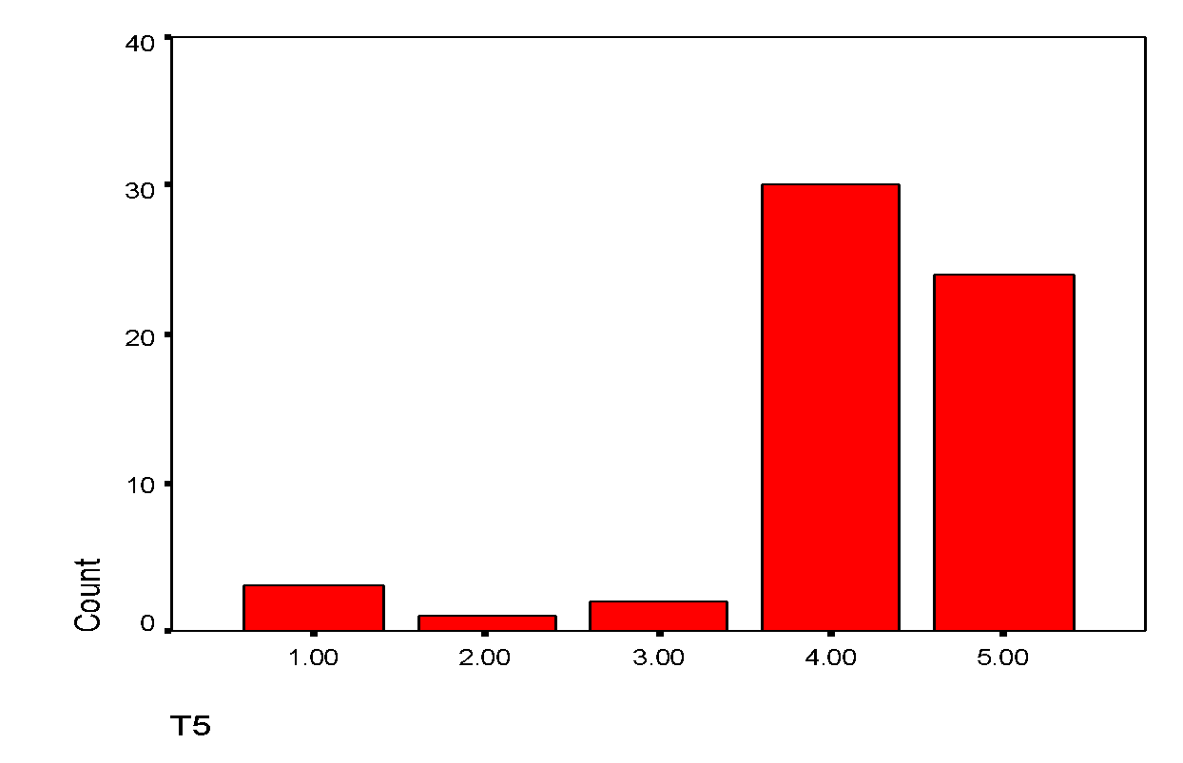
The item is found to be rightly skewed. That’s why the item is not found to be normally distributed.
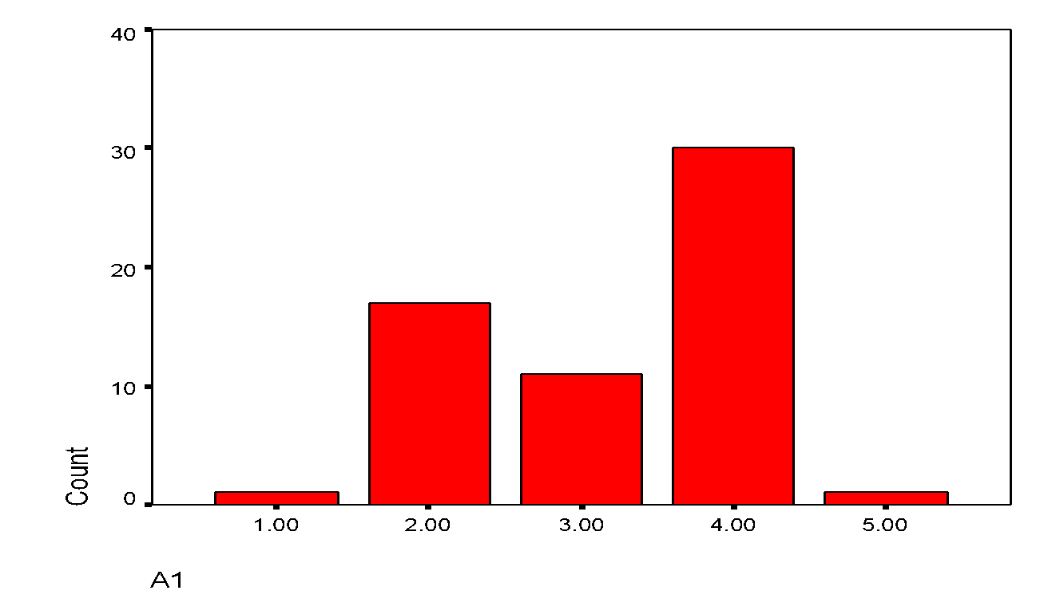
This is neither rightly skewed nor left skewed. So, this is not a normally distributed item.

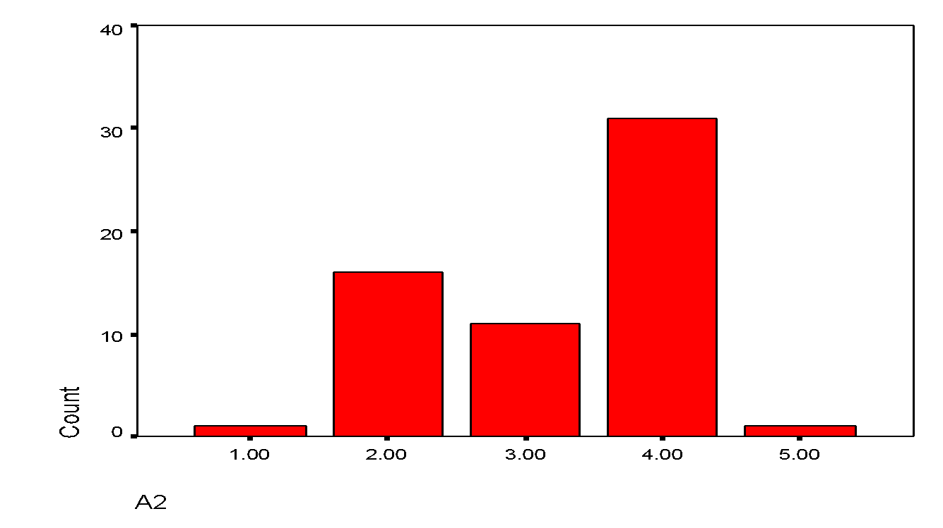

This is neither rightly skewed nor left skewed. So, this is not a normally distributed item.

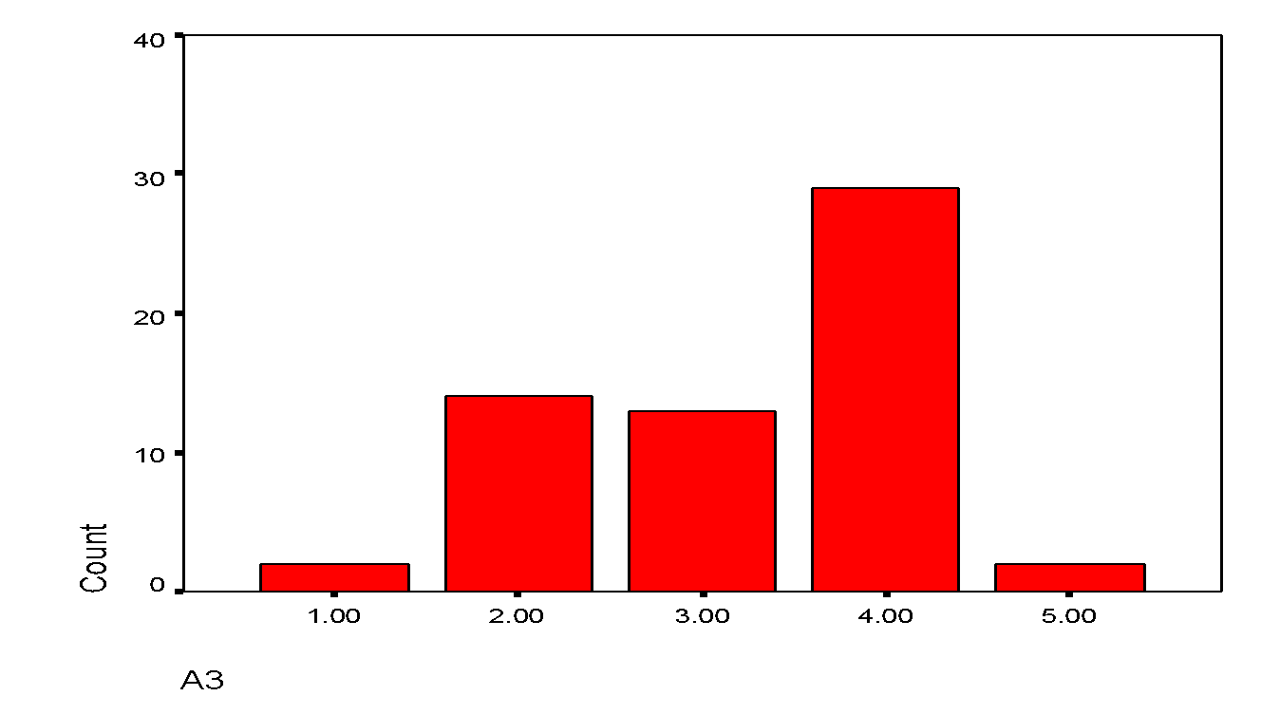

Again the same situation, not exactly rightly skewed or left skewed. So, it’s not normally distributed.
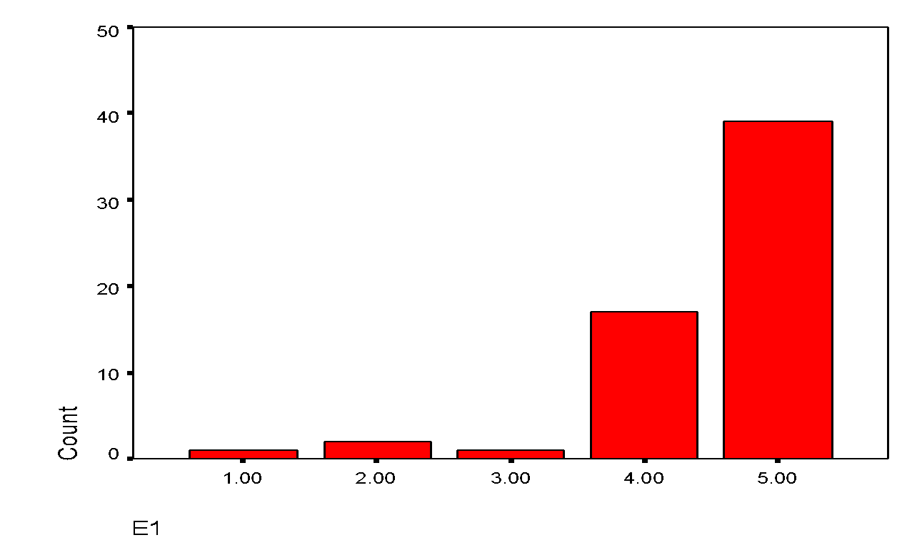
This is a rightly skewed graph and it is not normally distributed.

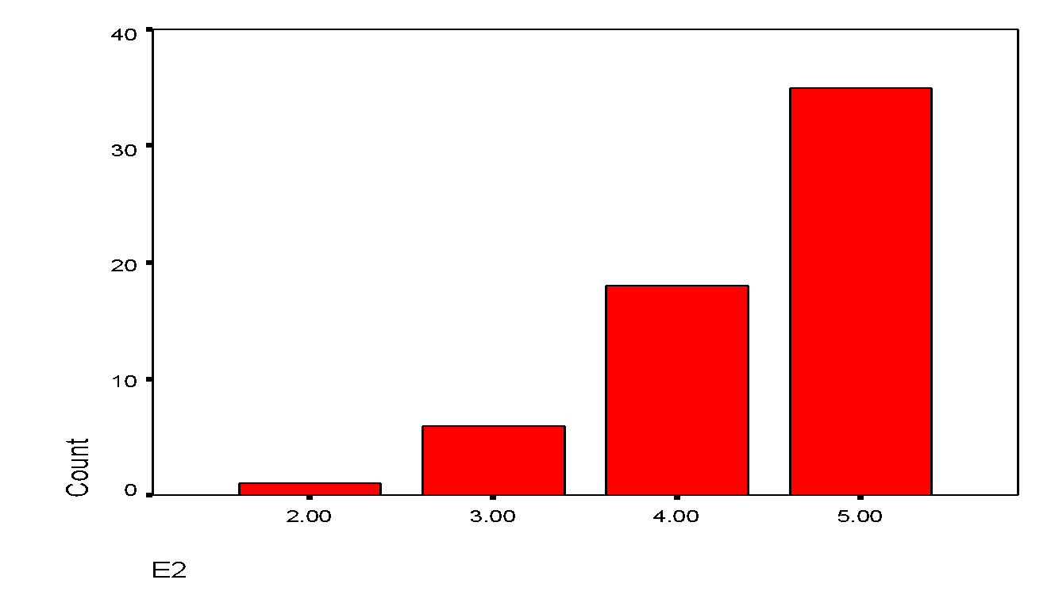
This is also a rightly skewed graph and it is not normally distributed.

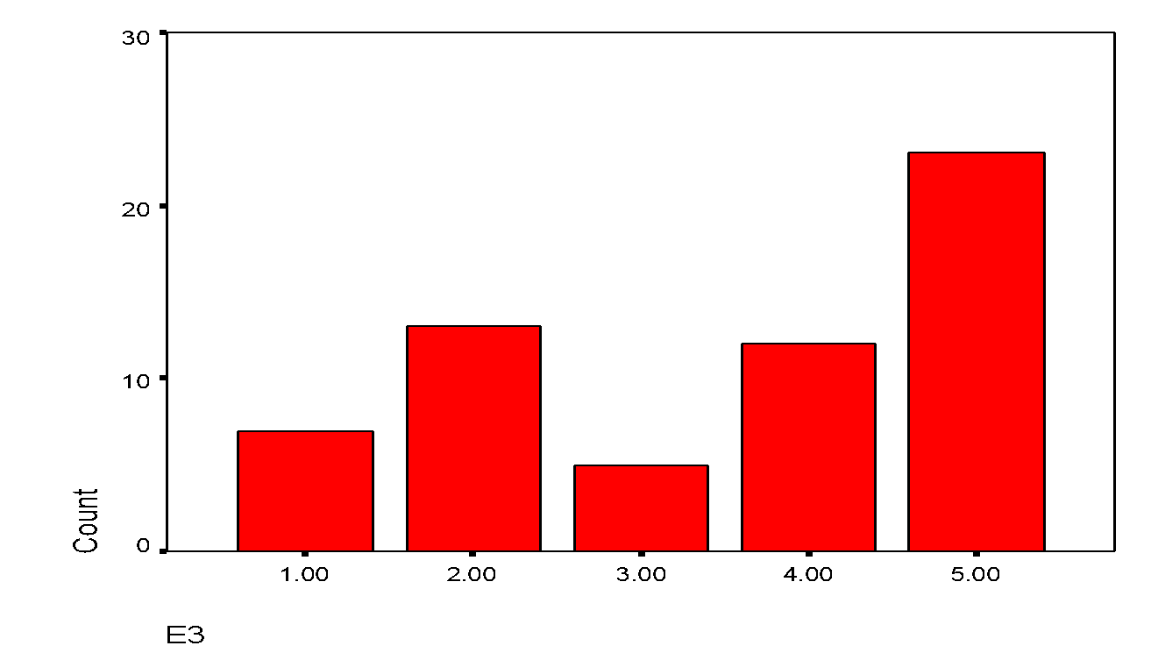
This is neither rightly skewed nor left skewed. So, this is not a normally distributed item.

- Descriptive Statistics

 | N | Minimum | Maximum | Mean | Std. Deviation
T1 | 60 | 1.00 | 5.00 | 4.0833 | .88857
T2 | 60 | 2.00 | 5.00 | 4.1667 | .86684
T3 | 60 | 1.00 | 5.00 | 4.2167 | .84556
T4 | 60 | 2.00 | 5.00 | 3.7500 | .87576
T5 | 60 | 1.00 | 5.00 | 4.1833 | .96536
A1 | 60 | 1.00 | 5.00 | 3.2167 | .94046
A2 | 60 | 1.00 | 5.00 | 3.2500 | .93201
A3 | 60 | 1.00 | 5.00 | 3.2500 | .96770
E1 | 60 | 1.00 | 5.00 | 4.5167 | .83345
E2 | 60 | 2.00 | 5.00 | 4.4500 | .74618
E3 | 60 | 1.00 | 5.00 | 3.5167 | 1.47857
Valid N (list wise) | 60

Here only one item’s (E3) standard deviation is higher than others, which is 1.47857.

Relationship among the Constructs:

The relationships among the constructs can be summarized in the following lower diagonal correlation matrix:
Constructs | Brand Trustworthiness | Brand Attachment | Brand Equity
Brand Trustworthiness | 1
Brand Attachment | .301(*) | 1
Brand Equity | .769(**) | .478(**) | 1

In this table the correlation between brand attachment and brand trustworthiness is .301(*) which means 95% confidence interval. Then the correlation between brand equity and brand trustworthiness is .769(**) that means 99% of confidence interval. And the last correlation between brand equity and brand attachment is .478(**) which also indicate the 99% of confidence interval.

Variation in Brand Trustworthiness across Brands:

Considering the three brands, the following hypothesis can be developed and tested here:
H₀: µ₁ = µ₂ = µ₃
H₁: µ₁ ≠ µ₂ ≠ µ₃
Here,
F value = 27.521
Level of Significance = .05
Associated P Value = .000
Here null hypothesis will be rejected because associated p value is less than assumed value of significance.
The rejection of null hypothesis means that brand trustworthiness varies across the brand. Brand trustworthiness is highest for iPhone (mean value = 4.6000) followed by Samsung (mean value = 4.1000) and Huawei (mean value = 3.5400).

Variation in Brand Attachment across Brands:

Considering the three brands, the following hypothesis can be developed and tested here:
H₀: µ₁ = µ₂ = µ₃
H₁: µ₁ ≠ µ₂ ≠ µ₃
Here, F value = 1.855
Level of Significance = .05
Associated P Value = .166
Here null hypothesis will be accepted here because associated p value is greater than assumed value of significance.

Variation in Brand Equity across Brands:

Considering the three brands, the following hypothesis can be developed and tested here:
H₀: µ₁ = µ₂ = µ₃
H₁: µ₁ ≠ µ₂ ≠ µ₃
Here, F value = 63.169
Level of Significance = .05
Associated P Value = .000
Here null hypothesis will be rejected because associated p value is less than assumed value of significance.
The rejection of null hypothesis means that brand equity varies across the brand. Brand equity is highest for iPhone (mean value = 4.9333) followed by Samsung (mean value = 4.3833) and Huawei (mean value = 3.1667).

The Impact of Brand Trustworthiness and Brand Attachment on Brand Equity:

For the purpose of examining the impact of brand trustworthiness and brand attachment on brand equity a multiple regression analysis was conducted.

- Overall Hypothesis:
For the purpose of testing the overall hypothesis, the following SPSS-generated outputs can be referred to:
Model |  | Sum of Squares | df | Mean Square | F | Sig.
1 | Regression | 31.247 | 2 | 15.623 | 54.985 | .000(a)
1 | Residual | 16.196 | 57 | .284
1 | Total | 47.443 | 59

The regression of null hypothesis means that there is a statistically significant impact of Brand Trustworthiness and Brand Attachment on Brand Equity.

- Partial Hypothesis:
For the purpose of testing the partial hypothesis, the following SPSS-generated outputs can be referred to:
Independent Variables | T-Value | Sig. (P-Value) | Hypothesis Test Result
Brand Trustworthiness | 8.475 | .000 | Rejected
Brand Attachment | 3.334 | .002 | Rejected

Dependent Variable: Brand Equity

Now it can be concluded that both Brand Trustworthiness and Brand Attachment have significant impact on Brand Equity.

- Strength of Association:

Here the Strength of Association will be measured here by multiple R²= .659. So the changes in brand equity can be explained by the changes in both brand trustworthiness and brand attachment by 65.90%.

- Relative Contribution of Each Independent Variable:

Now for the purpose of determining the relative contribution of each independent variable, the following SPSS-generated outputs can be referred to:

Independent Variables | Β (beta value) | Relative Contribution
Brand Trustworthiness | .688 | Higher relative contribution from brand trustworthiness due to higher beta value.
Brand Attachment | .271

Appendix

Questionnaire sample for iPhone

An Academic Survey

(Examining the relationships among Brand Trustworthiness, Brand Attachment, and Brand Equity)

Name (optional):

Phone Number (optional):

Gender: Male Female

Education: SSC or below HSC Bachelor Masters or equivalent professional degree or above

Profession: Student Service Holder Business Others

Average Monthly Family Income: 30,000 or below 30,000—60,000 60,000—90,000
90,000 –1,20,000 above 1,20,000

Please indicate your level of agreement with the following statements regarding use of various tools of Facebook. Where 1 = highly disagreed, 2 = disagreed, 3 = neutral, 4 = agreed, and 5 = highly agreed.

SN | Statements | 1 | 2 | 3 | 4 | 5
T1 | iPhone delivers what it promises
T2 | iPhone’s product claims are believable
T3 | iPhone has a name you can trust
T4 | iPhone is committed to delivering on its claims
T5 | iPhone has the ability to deliver what it promises
A1 | I feel bonded with iPhone
A2 | I feel connected to iPhone
A3 | I feel attached to iPhone
E1 | iPhone is a strong brand
E2 | iPhone is a well-known brand
E3 | iPhone is a unique brand

Questionnaire sample for Samsung

An Academic Survey

(Examining the relationships among Brand Trustworthiness, Brand Attachment, and Brand Equity)

Name (optional):

Phone Number (optional):

Gender: Male Female

Education: SSC or below HSC Bachelor Masters or equivalent professional degree or above

Profession: Student Service Holder Business Others

Average Monthly Family Income: 30,000 or below 30,000—60,000 60,000—90,000
90,000 –1,20,000 above 1,20,000

Please indicate your level of agreement with the following statements regarding use of various tools of Facebook. Where 1 = highly disagreed, 2 = disagreed, 3 = neutral, 4 = agreed, and 5 = highly agreed.

SN | Statements | 1 | 2 | 3 | 4 | 5
T1 | Samsung delivers what it promises
T2 | Samsung’s product claims are believable
T3 | Samsung has a name you can trust
T4 | Samsung is committed to delivering on its claims
T5 | Samsung has the ability to deliver what it promises
A1 | I feel bonded with Samsung
A2 | I feel connected to Samsung
A3 | I feel attached to Samsung
E1 | Samsung is a strong brand
E2 | Samsung e is a well-known brand
E3 | Samsung is a unique brand

Questionnaire sample for Huawei

An Academic Survey

(Examining the relationships among Brand Trustworthiness, Brand Attachment, and Brand Equity)

Name (optional):

Phone Number (optional):

Gender: Male Female

Education: SSC or below HSC Bachelor Masters or equivalent professional degree or above

Profession: Student Service Holder Business Others

Average Monthly Family Income: 30,000 or below 30,000—60,000 60,000—90,000
90,000 –1,20,000 above 1,20,000

Please indicate your level of agreement with the following statements regarding use of various tools of Facebook. Where 1 = highly disagreed, 2 = disagreed, 3 = neutral, 4 = agreed, and 5 = highly agreed.

SN | Statements | 1 | 2 | 3 | 4 | 5
T1 | Huawei delivers what it promises
T2 | Huawei’s product claims are believable
T3 | Huawei has a name you can trust
T4 | Huawei is committed to delivering on its claims
T5 | Huawei has the ability to deliver what it promises
A1 | I feel bonded with Huawei
A2 | I feel connected to Huawei
A3 | I feel attached to Huawei
E1 | Huawei is a strong brand
E2 | Huawei is a well-known brand
E3 | Huawei is a unique brand

Future Research Scope

Now a day’s brand trust increased the attention of research management practice and also there is a huge scope in this sector. Because nor both customers and companies are aware about bran trust. This situation develop the objective of the business.
The organization want to know how much people trust their brand and how the market condition is. That’s why they spend a lots of money on the research. It also helpful to innovate new things for customer. There are so many articles about the brand trust and brand loyalty. It is a benefited sector for the marketers and also they gain the trust easily from the customer if they serve them better.

Conclusion

So I think brand trust is an important concepts in every sector of marketing. Smartphone companies are the best example for that. If their product is good, service is good and people are satisfied with that then they stick to the same product and repurchase again. Also there is a lots of future research scope in this area it shows so many journals and articles. For holding the trust in people’s mind it’s a big challenge to the marketers and for that they need to introduce something new, something more attractive to the people. If they do so customers are stick to the brand and also shows loyalty to the brand.

References

- Chaudhuri and Holbrook (2001); Delgado-Ballester, Munuera-Alemán, and Yagüe-Guillén (2003). Belaid and Behi (2011).
- Nicole Koschate-Fischer (Professor of Marketing, GfK-Chair of Marketing Intelligence), Susanne Gärtner (Postdoctoral Researcher, GfK-Chair of Marketing Intelligence).
- https://www.entrepreneur.com/article/289167
- http://www.mobileindustryreview.com/2016/10/the-history-of-the-smartphone.html
- http://www.thewindowsclub.com/evolution-of-smartphones-history
- https://www.tomsguide.com/us/iphone-is-better-than-android,news-21307.html
- https://www.techradar.com/news/7-reasons-why-do-people-love-apple-products
- https://en.wikipedia.org/wiki/Samsung
- https://www.gadgetbytenepal.com/reasons-people-buy-samsung-phone
- https://www.emeraldinsight.com/doi/abs/10.1108/10610420510601058
- https://www.mindtools.com/pages/article/keller-brand-equity-model.htm
- https://www.forbes.com/sites/steveolenski/2014/03/04/in-brands-we-trust-why-brands-must-treat-trust-like-gold/#571b370a7c20

