General Banking Activities of Dhaka Bank Ltd.

Rainak Zabin

This report is submitted to the school of Business and Economics, United International University as a partial requirement for the degree fulfillment of Bachelor of Business Administration

General Banking Activities of Dhaka Bank Ltd.

Submitted to:
Dr. Md. Sariful Alam
Associate Professor
School of Business & Economics
United International University

Submitted by:
Rainak Zabin
111 143 031

School of Business and Economics

United international university

29th August, 2020

Letter of transmittal

29th August, 2020
Dr. Md. Sariful Alam
Associate Professor
School of Business & Economics
United International University

Subject: Submission of internship report on General banking of Dhaka Bank ltd.

Dear Sir,
With great pleasure I am presenting my final internship report on “General banking activities of Dhaka Bank Ltd. “.I have completed my 3 month internship period in Dhaka Bank Ltd.
It was very challenging to work in a banking sector due to huge pressure of clients at Dhaka Bank, as they are very reputed for their valuable services. I tried to use my learning from my educational life to cope with the real life experience. I tried to observe every action happened and learn unique things. I also followed your guidance and I am very grateful towards you for your support.
I will be very happy to answer any queries regarding making of the report. I will also be grateful if you could give me some valuable feedback on my effort.

Sincerely your student,
Rainak Zabin
ID: 111 143 031
Bachelors of Business Administration

Student Declaration

I, Rainak Zabin declare that this internship report is originally prepared by me and based on my working experience in Dhaka Bank Limited. I uniquely prepared this report only for my academic requirements.
This report is prepared for only academic purpose and has not been submitted elsewhere for any other purpose.

Rainak Zabin
ID: 111 143 031
School of Business & Economics
United International University

.

Acknowledgement

With many peoples support I have finally completed my internship report. I have worked hard to collect all the data. I am really very thankful to the people who helped me to complete my internship journey and made it smooth. Firstly, I will like to thank my internship advisor, Dr. Md. Shariful Alam sir for his unconditional support. Without his unconditional support it will be very difficult for me to complete this report. My experience of working in Dhaka Bank Ltd. was so good that thanking few people would be less. Still I will love to mention few important peoples name who’s support and love made me think to take banking as a future career. I would like to thank the Operation Manager of the Branch Humaira Halim, Trainee officers Sifat Habib, Safiqul Alam, Sadia Afreen, Nasrin Sultana. They taught me every single details of different working process and also how to adjust in a banking environment. Also I will thank my intern friends who’s help was great on my tough times.

Abstract/ Executive summary

Internship is in the requirements of my BBA program at United International University. So, I have done my 3 month internship in Dhaka Bank Ltd. I tried to use my academic knowledge and I also learned so much from the banking environment. I gained a lot of corporate life knowledge which will be a great help to my future career. Every working day was a new experience for me, as this was the first time I was working in a bank so everything I learned was exiting and valuable for me. I also tried to gather knowledge by asking about every topic to my co-workers as it was important for me to know all the terms and definition of banking process. I tried to include all the knowledge and information I have gathered in this report. I also explain my working process and what responsibilities I was given. I also observed few issues and I also have suggestions for them which I included in the recommendation part. I added my every finding in this report and also included the reference links at the end of this report.

Table of contents for Internship
Table of Contents
Letter of transmittal 2
Student Declaration 3
Acknowledgement 4
Abstract/ Executive summary 5
Table of contents for Internship 6
List of Figures 8
List of Tables 8
List of Abbreviation 9
CHAPTER I: INTRODUCTION 9
I.1 Background of the Report 9
I.2 Objectives of the Report 10
I.3 Motivation of the Report 10
I.4 Scope and limitations of the Report 11
Scope: 11
I.5 Definition of Key terms 12
CHAPTER II: COMPANY AND INDUSTRY PREVIEW 12
2.1 Company Analysis 12
2.1.1 Overview and history 12
2.1.2 Trend and growth 17
2.1.3 Customer mix 19
2.1.4 Product/service mix 20
2.1.5 Operations 21
2.1.6 SWOT analysis 24
2.2 Industry analysis 27
2.2.1 Specification of the industry 27
2.2.2 Size and maturity of the industry 27
2.2.3 External economic factors 28
2.2.4 Technological factors 28
2.2.5 Barriers to entry 29
2.2.6 Threat of Substitutes 29
2.2.7 Industry rivalry 30
CHAPTER III: INTERNSHIP EXPERIECNE 30
3.1 Position, duties, and responsibilities 30
3.2 Training 31
3.3 Contribution to departmental functions 31
3.4 Challenges: 32
3.5 Skills applied 33
3.6 New skills developed 33
3.7 Application of academic knowledge 34
CHAPTER IV: CONCLUSIONS AND KEY FACTS 35
4.1 Recommendations for improving departmental operations 35
4.2 Key understanding 35
4.3 Conclusion 35
Reference 36

List of Figures

- Management committee members…………………………… pg no. 14
- Departments……………………………………………………… pg no 14
- Functions of the general department……………………………pg no. 16
- DBL GO application……………………………………………….pg no. 18
- Dhaka Banks 2019-2018 profit margin………………………….pg no. 18
- Dhaka Banks Achievement…………………….…………………pg no.19
- Dhaka Banks Shareholding position……………………………. pg no. 20
- Dhaka Banks Islami Banking account ………………………….pg no. 22

List of Tables

- Dhaka Bank 2019 result Summary……………………………………………………….………..pg no. 19
- Division wise employee distribution…………………………………. pg no. 20

List of Abbreviation

- DBL: Dhaka Bank Limited
- FDR: Fixed Deposit Receipt
- SME: Small and Medium Enterprise
- IT: Information Technology.
- CA: Credit Approval.
- GB: General Banking.
- STD: Short Term Deposit.
- IFC: International Finance Corporation.

CHAPTER I: INTRODUCTION

Background of the Report

I wrote this report with my hard earned experience and the accumulated information. Though this report is a requirement still I feel so blessed while writing this as I have a very good experience while working on my internship period. Working in bank was a journey with lots of challenges which I overcome and learned a lot of things. Dhaka Bank Limited is a very popular organization in banking sector with their renowned services. I was very impressed with their behaviors towards clients and employees.
Without a good economy a country will face so many troubles and people’s life will be in disaster so having good economy is a must for a country. Banks plays a huge role in this and we can say that Dhaka Bank Limited is a very good contributor in our countries economy.

Objectives of the Report

First objective of making this report is to complete my internship requirements given by my department and University. The core objective is to explain the working process and performance evaluation of Dhaka Bank Limited.
Other objectives:
➢ To use theoretical knowledge in real-world.
➢ To censoriously and accurately witness the purposes of general banking.
➢ To gain practical experience.
➢ To understand how different departments of the branch works.
➢ To see the strength and weakness of the bank.
➢ To realize in which sector the bank is working with suitable efficiency.
➢ To find out the problems of the bank and suggesting the method to solve.
➢ To evaluate the existing performance and making future calculations.

Motivation of the Report

I will divide the motivation of making this report in to two parts. First motivation is my Course advisors dedication towards this Report and support. Second motivation is my real life experience in the bank. Words will be less for the real life experience I have gathered. I learned how a organization is running , how peoples are facing challenges and managing everything with their talent how everyone is helping each other. Work place is another family towards everyone their which motivates me for working more and more.

Scope and limitations of the Report

Scope:
This study will show the industry holders of Bangladesh a clear view of banking sector and specifically the details of Dhaka Bank Ltd. General people will also understand the banking sectors. The students will gain some knowledge about banking sectors and also learn from my internship experience. Other things every one will get to know is-
- Overview of bank scenario.
- Credit management and facilities.
- Comparison and difference between Dhaka bank and the other banks.
- Critically analyzed Dhaka Banks efficiency.
- Management system of bank.

Limitations:
- I was working there as an intern so I wasn’t able to enter every places and collect few data so it was a limitation for me.
- Confidential information was also a limitation as no organization will share their profit or costing details properly with anyone. Also their internal confidential information is also secret and they will not allow anyone to know those information.
- Little time duration like 3 months period is another limitation. For this limitation I am not able to add more details which may help to make this report a little bit elaborated one. As in a work place like bank it was very difficult for me to even have a single free time. There was huge work pressure so between these 3 month I tried my best to gather information.

Definition of Key terms

- Definition of General Banking
General banking department performs the core functions of banks, operates day-to-day transactions of banking operation. Each day it receives deposits from customers and meets their demand for money. It opens new accounts, issues cheque books, issues credit/debit cards etc.

CHAPTER II: COMPANY AND INDUSTRY PREVIEW

Company Analysis

Overview and history

Dhaka Bank is a dream project of few entrepreneur friends. Dhaka Bank was incorporated as a Public Limited Company on April 6, 1995. The company started banking operations on July 5, 1995.
Now it is one of the leading banks in Bangladesh and people have faith on them. Their services are well known and they gained a huge amount of industrial and also general clients.

- Their Current Management Committee members are-

- They have few departments mentioned below-

- Consumer Department:
- Handle customer enquiry.
- Giving over the phone services.

- Human Resources Department:
- Manage top level, mid-level and low level employees.
- Selection and interview processing.
- Managing internal system.

- Information Technology Department:
- Helping software issues.
- Managing Internet banking.
- Managing Security cameras.

- Audit Department:
- Observe every branches transaction details.
- Check vouchers yearly.
- Observe spending. .

- Retail and Sales Department:
- SME banking.
- Convince people to buy services.

- Foreign Department:
- Import and Export section.
- Issue, advice documentary credits.
- Foreign remittance section.

- Cash Management Department:
- Receive deposits.
- Payment clients.

- With growing old Dhaka Bank also has few commitments which are-
- Patience
- Focus
- Goal
- Experience
- Loyalty
- Care
- Sincerity
- Foresight
- Punctuality
- Trust
- Knowledge.

- Functions of the general banking department:

- Management of Cash:
- Receive Deposit.
- Making payment to the client.
- Manage the vault of the branch.
- Maintaining Accounts:
- Opening new accounts.
- Closing client account.
- Preparing Vouchers:
- Preparing every day voucher.
- Counting everyone’s voucher.
- Take authorized signature.
- Issuing cheque book, card etc.:
- Issue new cheque book and deliver on time.
- Issue credit/debit card.
- Operating customer service:
- Giving bank statement.
- Solving account issues.
- Call clients and inform them about any update.

- Ethical Principles:
- Dhaka Bank follows our countries law and regulations.
- They reject corruption.
- They avoid compromised gifts.
- They solve client’s complaints very quickly.
- They keep safe the confidentiality of the clients.

- Customer Charter:
- Service- Dhaka Banks service is always excellent. They are well known for their services. They always try to satisfy their clients with prompt services.
- Respect- They always respects their clients and never give a chance to complain about their behavior. They handle every situation very calmly in busy time also which is very rare to see in other busy banks branches.
- Integrity- Their work and service is very promising. Consistency of work and integrity towards clients are very good.
- Excellence- Their service is outstanding when it comes to customer satisfaction. Even the top level management also tell the mid-level employees to give outstanding service.
- Confidence:
- In a changing environment DBL can still lead the competition.
- They can create sustainable value for their business.
- Proper collection of products and services to meet financial needs.
- Excellent team work to bring out optimum work place benefits.

- Sustainability of the bank:
- 273932 transactions happened last year through DBL GO app.
- Agri-loan received by 173 clients.
- 87 training programs took place last year.
- Transactions happened by ATM was 845038.
- Accounts facilitated with internet banking were 21212.
- Accounts facilitated with mobile banking were 284650.

Trend and growth
Dhaka Banks growth was very fast and their progress is appreciated by everyone. They collaborated with few brands to give their clients discounts. They also launched their Mobile application named “DBL GO”, which is now trending.
As shown in the picture their app is available in Android &Apple both devices.
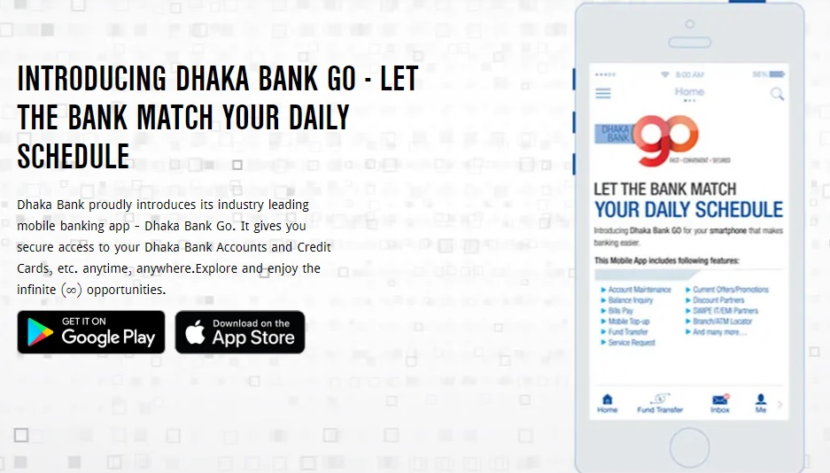
- Their growing profit margin is given below-

- Dhaka Bank also achieved Best Issuing Bank in South Asia by IFC.
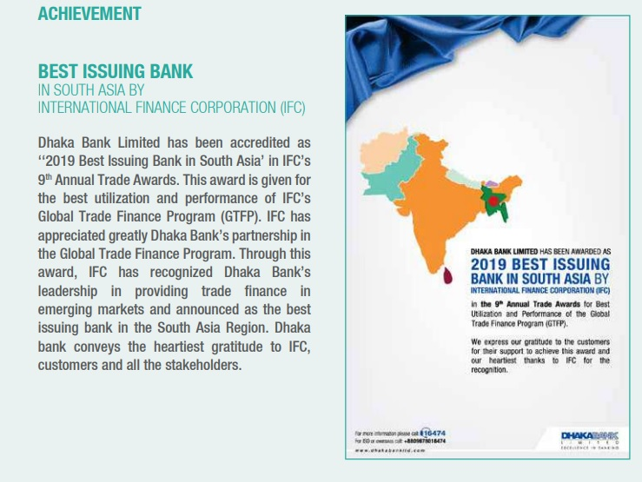

- Dhaka Banks 2019 result summary-
Segmented Result of 2019 | On-Shore | Off-Shore | Islamic Banking
Operating income | 9815 m | 638 m | 346 m
Operating profit | 5243 m | 591 m | 265 m
Asset | 247768 m | 20909 m | 11813 m
Liabilities | 247768 m | 20909 m | 11813 m

- Recently whatsapp banking is trending in Dhaka Bank as they have introduced this digital service last year. Clients will be able to check their account balance and recent transaction through whatsapp messenger.

- Growing employee recruitment and growing branches is another growth for Dhaka Bank. Employee distribution of recent year-
Division | No. of Branch | Male employee | Female Employee
Dhaka | 54 | 1030 | 400
Chittagong | 28 | 260 | 30
Sylhet | 6 | 62 | 6
Barisal | 1 | 10 | 2
Khulna | 4 | 31 | 8
Rajshahi | 10 | 94 | 5
Rangpur | 3 | 26 | 6
Mymensingh | 3 | 37 | 4
Total | 109 | 1550 | 461

- Their shareholding position comparison of 2019 & 2018-
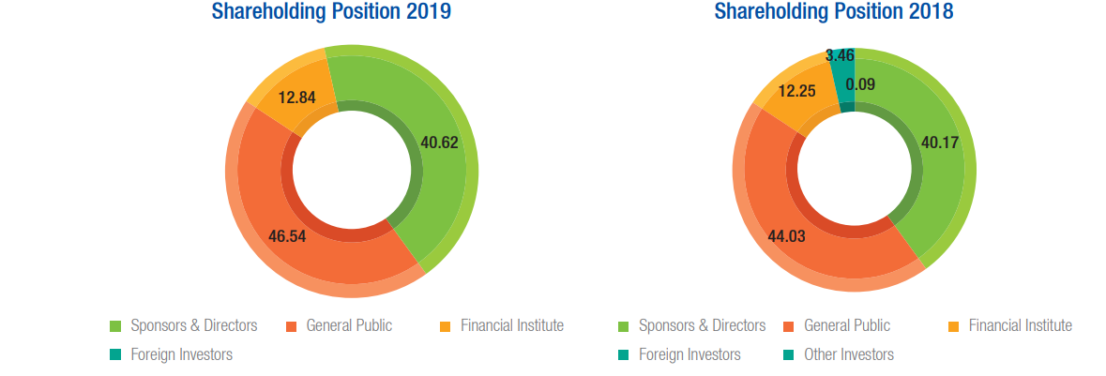

Customer mix

They have different types of clients. Usually Business owners, Industrialists are their main target. But as they are well known for their services so they also have local area based clients from any profession. They don’t accept random general people who don’t have any known person from the bank. They strictly follow these rules for their bank which makes them unique.

Product/service mix

Currently they are offering these services:
Account:
➢ Current Account
➢ Savings Account
➢ Fixed Term deposit account (FDR)
➢ Short Term Deposit (STD/DPS)

Loan:
- Car loan for account holders.
- Vacation loan for employees and clients.
- Home loans for clients and employees.
- Personal Loan.

Other services:
- SME banking and internet banking.
- Gift Cheque services.
- Locker services.
- Debit/Credit card services.

Dhaka Bank also Have Islamic Banking section. Investment and profit details given below-
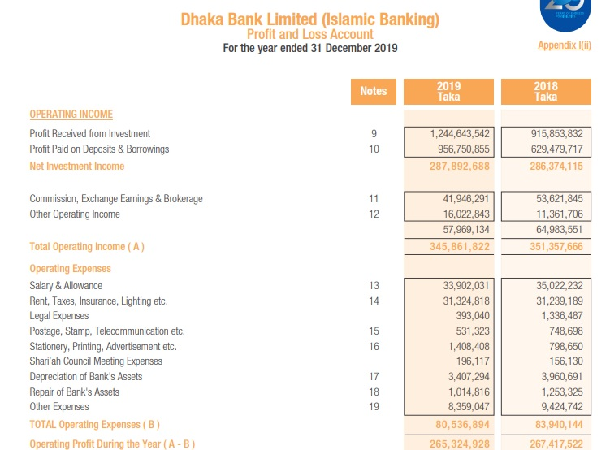

Operations

Their operational payment of local funds is of 2 types:
a) Inward Remittance: Inflow of cash in foreign currency by the income of the people who lived other countries.
b) Outward Remittance: Outward Remittances not only embrace remittance but also sales of foreign currency by Drafts, TT, MT, Travelers cheque however additionally includes payment against imports into Bangladesh currency credited to non-resident Bangladeshi monetary unit accounts of foreign banks or convertible Bangladeshi monetary unit account.

Two forms are used for Outward payment of foreign currency such as: IMP Form: All outward remission on account of imports is completed by this kind T.M Form: For all alternative outward remittances type T.M is used.
* non-public remission
*Family remission Facility
a) Foreign nationals operating in Bangladesh approvingly of the govt might remit through a licensed dealer 500th of remuneration of leave remuneration as additionally actual savings and allowable person advantages. No previous approval of bank is important for such remittance.
b) Remittance of moderate amounts of interchange for maintenance abroad of members of the family (spouse, children, parents) of Bangladesh nationals are measure allowed by Bangladesh Bank on written request supported by certificate from the Bangladesh mission within the involved country.
remittance of Membership Fees/Registration Fees: licensed dealer might remit while not previous approval of Bangladesh Bank, membership fees of foreign skilled and scientific establishments and costs for application registration, admission, examination (TOEFL, SAT, IELTS etc.) In reference to admission into foreign academic establishments on the idea of written application supported by demand notice/letter of the involved establishment.
Education: previous permission of Bangladesh Bank isn't needed for releasing interchange in favor/on behalf of Bangladesh students learning abroad or willing to yield abroad for studies. licensed dealers shall permit exchange facilities for this purpose in keeping with the subsequent drill:
1) Application punctually filled in by the student as per prescribed format of Bangladesh Bank.
2) Original and photocopy of admission letter issued by the involved establishment in favor of the coed.
3) Original and photocopy of estimate with reference to annual tuition fee, board and lodging.
4) Incidental expenses etc. issued by the involved establishments.
5) Attested copies of academic certificates of the individual and
6) Valid passport.
Travel: non-public travel quota claim of Bangladesh nationals is about at US$3000/ annually for visit to countries apart from SAARC member countries and Asian country, Quota for SAARC member countries and Myanmar is US$1000/ for travel air and US$500/ for travel land route. Authorized dealers might unleash above travel quota while not previous approval of Bangladesh Bank subject to observation and satisfaction of following points:
1. The intending traveller could be a client of the bank or is sufficiently acknowledge to the AD Bank or the intending traveller has paid relevant Travel Tax. The intending traveller features a valid passport.
2. The bank ought to verify and satisfy itself that any interchange discharged for an earlier travel was used with the journey being really undertaken or was punctually enchased unutilized.
3. The intending mortal is in possession of confirmed air price ticket for journey to be undertaken which the supposed journey to be undertaken not later than two weeks when the date on that exchange is issued.
4. The quantity releases is supported on the passport and air price ticket of the traveller with indelible ink, with the signature and therefore the name of this branch decorated within the passport and price ticket.
5. In every case of unleash of interchange for travel abroad, photocopies of first six pages of the passport s and therefore the page recording endorsement of interchange and photocopies of the pages of price ticket showing name of the traveler, route and date of journey and endorsement of interchange beside the relative T.M. form ought to be sent to Bangladesh Bank beside monthly returns.
* Health & Medical: Dhaka Bank limited, native workplace while not prior approval of Bangladesh Bank might unharness interchange up to US$10,000/ for medical treatment abroad on the idea of the advice of the medical board found out the top directorate and therefore the price estimate of the foreign clinic.
Applications for unleash of exchange surpassing US$10,000/ ought to be forwarded beside supporting documents to Bangladesh Bank for previous approval.

SWOT analysis

Strength:

- Strong top level management:

Their top level management is very strong in case of decision making in serious situation. Their management team is well established and managed by very talented persons. Each person’s work experience and reputation is very good. A talented team is working great for DBL.

- Employee bonding:
Dhaka Banks employees have close bonding with each other. Even they have very strong bonding with other branches employees. They also communicate with out of Dhaka employee’s friends to maintain bonding which is really appreciable and benefit for the organization. Many employees don’t change their workplace as they have good relation with the colleagues though their salary is low.

- Well established Mobile Application:
Dhaka bank launched their mobile application named DBL go which is well established and clients are happy with the application services. As the clients can check their monthly balances, debited and credited amount easily over the phone and they don’t need to go to the bank. Which is very efficient for the clienyts.as many other bank still don’t have mobile application facilities.

Weakness:

- Failure of monitoring courier services:

They can’t monitor the traveler services that are committed to delivering mails and documents. huge quantity delivery failures are being stacked up at branches. For this, the distant documents of L/C cannot reach at right place at right time. So, the bank ought to have some management over its couriers and guarantee correct delivery of mail and documents.

- Discourage small entrepreneurs:

DBL provides import loans to most of its clients who are solvent. however they typically don't need to finance minor entrepreneurs whose monetary standing isn't clean to them.

- Scarcity of innovative product:

Because of the competitive market, Dhaka Bank needs to come back with new services. Lack of new service options its difficult to be strong in the market.

Opportunities:

- Include new services:
Dhaka bank has opportunities to gain more clients and popularities by introducing new services like new MasterCard facilities. They have industrial clients and business clients those are absolutely fond of travelling internationally so it will be a great service for them.
- Opening branches and ATM booths:
They have opportunities open like gaining area based local clients as they are already opening new branches in different areas so if they start to open branches like Dutch Bangla Bank then they will gain a huge range of clients. If they increase branches then automatically ATM booths will increase. Even they can open more ATM booths in every area that clients get more benefits.

Threats:

- New Banks
New approaching private banks are serious threats to the prevailing banking network of DBL: it's expected that within the next few years additional industrial banks can emerge. If that happens the intensity of competition can rise additional and banks can need to develop ways to contend against and win the battle of banks.

- Similar merchandise are offered by different banks

Now-a-days totally different foreign and private banks also are providing similar style of products with an nearly similar margin of profit. So, if all competitors fight with a similar weapon, the natural result's declining profit.

- Default Loans

The problem of non-performing loans or default loans is incredibly minimum or insignificant. However, this downside could rise within the future thus; DBL should stay wakeful regarding this downside in order that proactive ways are taken to attenuate this downside.

- Industrial worsening

Bangladesh is economically and political unstable country. Flood, draught, cyclone, and recently additional act of terrorism became an identity of our country. alongside inflation, state conjointly creates business wide recession. These caused descending pressure on the capital demand for investment.

- Risk factor:

There are also few risk factors for banks. Like-
- New account/loan applicants can give faulty documents for which later bank can get into legal troubles.
- Loan providing risks are there like few people take loans from the bank and later leave the country without repaying it so then banks gets into trouble.
- Contact verification risk is also there as people change their contact number and do not inform the bank about the change.

Industry analysis

Specification of the industry

About the Banking industry of Bangladesh-
As a developing country to promote the economic growth Bangladesh encouraged the banking industry from past so many years. As a result the banking industry of Bangladesh had achieved a very good reputation in banking sector and we achieved economic growth in our country. The market is expanding and people are taking loans from banks and starting their own business. So, we can say our countries banking industries future is also bright.

Size and maturity of the industry

Size-
The size of the banking industry is huge in our country. Banking industry is very competitive now a day. There are a lot of banks in our country but not every bank is successful. Dhaka Bank has its own reputation and place in banking industry.
Maturity-
All banks in our country have their own maturity level. Maturity level of Dhaka bank is in a good position. We can say it is matured now. As they have a lots of branch and high level clients. Their profit range is also very high.

External economic factors

Decrease in investment:
People aren’t investing now days as suddenly the economy is slower than other time. So Dhaka bank should increase their interest rate then people might fill interest to fixed deposit their money.
Government Rules Issue:
Due to government new rules and regulations people don’t feel safe to invest. Tax rate is also very high and interest rate of “National Saving Certificate” is getting lesser so general public aren’t interested as they were before.

Technological factors

Dbl go:
Technologically Dhaka bank is advance and better than few other banks. They have their own application named DBL go. Their app is well established and clients like their application and service. Being technologically advance creates a good
Software:
Their software system is good and their IT department is very responsive so that if any branches face any difficulties they can contact with them over the phone very easily.

Barriers to entry

Barrier for new entry:
Banking industry is very competitive now days. So for a new entry it’s really hard to compete with the reputed banks. Older banks have much more experience and client trustworthiness. For a new comer it will be very difficult to gain those things at first.
Barriers for Dhaka Bank:
Though Dhaka Bank holds a good reputation still few other banks have few services on which people trust them blindly. For example EBL Master card for international uses. In this topic Dhaka Bank yet didn’t introduce any services to their clients. So it will be a barrier to introduce new card for international use and gain the trust of people.

Threat of Substitutes

Ab Bank:
Ab bank is the new threat for Dhaka bank as they have similar cards option like Dhaka bank and their savings accounts have high interest rate which attracts clients more. So Dhaka bank may loose few clients if they don’t increase their savings account interest rate.
Dutch Bangla Bank:
Dutch Bangla Bank is another threat to Dhaka bank because they have lots of ATM booth available in every area of Bangladesh. They also have lots of branches available and agent banking is also available in different areas.

Industry rivalry

South East Bank:
Their FDR interest rate is higher than Dhaka Bank so clients may move towards South East Bank from Dhaka Bank easily. Also employee facilities and salary range is much higher than Dhaka Bank. So Dhaka Bank also may lose their trained employees as they can switch to the better options.
City Bank: City Bank has more facilities for the employee and clients both as comparison in Dhaka Bank. Also they have more ATM booth then Dhaka Bank.

CHAPTER III: INTERNSHIP EXPERIECNE

Position, duties, and responsibilities
Position:
In Dhaka Bank I was appointed as an Intern.
Duties:
There were lots of duties and I was learning each day from everyone.
- My duties as an intern was asking clients about which matter they have come to the branch and how can we help them, then show them the right desk.
- Receiving calls from client from clients and try to solve the issue.
- Call clients to inform them about their Cheque book or Card arriving.
- Complete daily photocopies.
- Scan client important documents.
- Help older clients with their writings.
- Writing Pay orders.

Responsibilities:
- Complete everyday voucher and collect everyone’s signature on the voucher.
- Organizing Files and documents daily.
- Arranging Cheque books.
- Completing the locker file details.

Training

There was no official training for interns. But every day I learnt from each and every one from the office. They tried their best to teach me how to work in a banking environment and handle every situation. They also teach me about each and every document. Like how to write pay order, deposit slip, gift voucher, daily voucher etc.

Contribution to departmental functions

- General banking department:
General Banking has the top duty as there is a lots of clients daily who come to solve their issue.
- Helping new clients in Account opening.
- Writing pay-order, deposit slip etc.
- Receiving calls from clients.
- Call clients to inform them about their issuing Cheque book or Card arriving.
- Complete daily photocopies.
- Scan client documents.
- Complete everyday banking voucher and collect everyone’s signature on the voucher.
- Organizing daily Files and documents.
- Arranging Cards and Cheque books.
- Take clients signature for locker visiting.
- Helped clients to issue new cheque books.
- Helped clients to issue new debit, credit, visa card.
- Cash department:
- I helped the cash department with their voucher collecting.
- Helped with the daily printing and photocopy documents.
- Collect and deliver clients their card details.
- Foreign Department:
- Scanning important documents.
- Organizing files.
- Handling clients document and cash between the foreign and cash department.

Challenges:
- Memorizing banking terms and documents was a huge challenge for me. As there was a lots of forms, documents and codes so it was very important to memorize all of those. It took few days but I memorized all of those.
- Writing pay-order forms without any mistake. It was a tensed situation as pay-order is a very sensitive issues and has to be written clearly and without any mistakes. So it was very important to learn and practice in rough paper before write it in the main age.
- Maintain the healthy lifestyle was also a challenge. Public banks follows strict rules about their lunch times but in private banks giving service is most important so due to excessive pressure I was never able to maintain my lunch time and few times I got sick.
- Another challenge was standing maximum time because for interns there was no specific desk and there was always clients coming with their issues so standing all day long created leg issues for me.
- Handling many clients at once was a challenge because every client is in hurry always so handling them and solving everyone’s issue was challenging.

Skills applied

Communication Skills:
My communication skills were good with people due to my University experience. So in banking environment I also used my skill and communicate with more people from different department and create connection with them. My skills definitely developed more with the experience I gained in my internship time.
Marketing Skills:
How to convince people is one of the top marketing skills. In banking environment I developed my skills more and applied my knowledge to convince clients more. Clients were happy with me as my conversation with them pleased them to trust on the service and in to the bank also.

New skills developed

Managing documents:
Documents are very important for banks. Audit people visit the branches once in a year and check all the document so it was really challenging to organize those documents and manage them time to time. So I developed this skills during this time.

Handling Clients:
Sometimes clients are uncontrollable when they have issue with the banking services. Handling clients on that moment is a top challenge. I developed these skills because there were issues daily and I learnt how to deal with them.

Application of academic knowledge

Understanding Consumer behavior:
In my major marketing course “Consumer Behavior” I learned how to understand consumer behaviors. So I applied my knowledge and tried to understand why few clients behave in a certain way. In a banking sector you have to even understand the fraud behaviors also. Well behaved clients are not always the good one. So understanding their certain behaviors towards services was also important. Like few people came to the bank to open account with a bad intention so you can’t just go with their looks. Even relatives of account holder can also do fraud by asking someone else account details without authorization letter. So I applied my skills and understand every good or bad situation.

Brand Value:
Creating brand value in front of people is very important for any business. So I applied my skills and tried to show the banks brand value in front of the clients by telling them about our valuable services.

CHAPTER IV: CONCLUSIONS AND KEY FACTS

4.1 Recommendations for improving departmental operations

The bank’s branches contain chairs which are really not suitable for a long time sitting job. As results every employee faced back pain & shoulder pain. So they need to change their chairs for employee’s health & safety.
- Their desk and desktops position is not right for employee’s eye position so it creates a lot of pressure in everyone’s eye. They need to change their desk height.
- Their marketing strategy need to get improved to get more clients.
- Clients have to go to specific areas to find a ATM booth which is really annoying for them So they need to implement more ATM booth in different areas.
- Few branches don’t have canteen system which creates impact on employee’s daily lifestyle and health. So they should give the facilities in every branch.
- Their cards options are limited yet so they should introduce more credit card, master card options.
- Their salary range is still below compare to other banks which is a reason for their higher employee turnover rate.

Key understanding
- How banking system works.
- How to handle clients.
- How to communicate over phone with clients.
- How to issue cheque book , pay order etc.
- How to give bank statements.
- How to issue debit card.

Conclusion
Banks demand in our country is increasing day by day as people are relying on banks. For our countries economic growth banks are important organizations now. Dhaka Bank Limited is popular among industrialists, business holders and also normal people. Their employees behaviors towards clients are really good and clients are very impressed with their services. I am grateful to had opportunities to work with them I tried to sum up my experience here and show the banking sectors works in details.

Reference

• Annual Reports of Dhaka Bank Limited. (Five years).
• Web site of Bangladesh Bank. www.bangladesh-bank.org
• Web site of Dhaka Bank ltd. www.dhakabankltd.com
• Interview with the GB In-charge of Dhaka Bank Limited, Corporate Branch.
• Britannica.com
• Marketing Research, 10th Edition, Stanley F. Stasch, Ph. D
• http://www.dhakabankltd.com/board_directors.htm
• http://www.dhakabankltd.com/products_services.htm
• http://www.dhakabankltd.com/fs_report.htm
• http://en.wikipedia.org/wiki/Dhaka _Bank

Annual Reports
Annual Report of DHAKABANKLTD 2014
Annual Report of DHAKABANKLTD 2015
Annual Report of DHAKABANKLTD 2016
Annual Report of DHAKABANKLTD 2017
Annual Report of DHAKABANKLTD 2018

