

UNITED INTERNATIONAL UNIVERSITY

Final Term Paper Based on

“Internal Audit process of GREENLAND TECHNOLOGIES LIMITED”

Submitted to
Mofijul Hoq Masum
Assistant Professor
School of Business & Economics
United International University
Submitted by
Mohammad Arifur Rahman
ID: 111 151 133
Date of submission: 25/05/2019

Letter of Transmittal

Date: 25/05/2019
To
Mofijul Hoq Masum
Assistant Professor
School of Business & Economics
United International University

Subject: Submission of the Internship Report
Dear Sir,
I beg most respectfully, I would like to submit the report of my internship which is based on “Internal auditing. I completed my three months internship from Greenland Technologies Ltd. Company as a junior internal auditor. This report prepared by me and me collect data from several source. I try to fulfill all the objects which you recommended.
I there for pray and hope that you will accept this report. I prepare this report with all relevant data and information.

Thank you
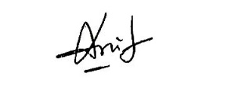

Acknowledgement

Firstly I would like to thank Allah for everything. Internship is the last stage of graduation degree. This the opportunity to meet with corporate world, corporate people and also corporate environment. A student can learn so many practical things from a company which will help his/her future.
I also would like to thank my supervisor faculty Mofijul Hoq Masum sir. Without his guideline I was not able to prepare this report properly. Sir, gave his valuable time to me for preparing this report. Without his support and supervising this report would not be the quality report.
Finally I would like to thank my official superior Mr. Tarek Nath (Deputy Manager of Internal Audit department). He helped me to introduce with the process of work and work related activities.
This person supervising me in office to do all the task properly and also helped which task I do not know. I completed my full internship program with his guidance and support.

Executive Summary

Greenland Technologies Ltd. is a part of GETCO Group of company. Greenland was a small company and started with one salesman. After their glorious success this company become a midsize company. In our country Greenland Technologies Ltd. has a reputation in their industrial sector. Their main business is import agricultural products from abroad and sale this product’s to the rural famers. They also have cleaning machineries and accessories for house and office.
This Company sale their agricultural products on account and after that they collect installment with interest. On the other hand, they sales cleaning machines and accessories direct by their showroom and also online by DarazBD.com.
Greenland Technologies Ltd. is the profitable company, their net profit margin says that. They continuously generate profit in every year. By this profit margin they are able to contribute in our economy. Within few years they will be able to become the market leader with their strong financial support.
This Company has some experience employees who knows how to run an organization with profit and how to move forward. GTL has almost 220 employees and everybody is responsible for their responsibility. They think this is their own company and accomplish their task with high attention.
Company has several departments for different operations. Top management control all the department and all department supervise by superior. Top management select goal and create strategies and employees are responsible to accomplish the task to achieve the goal by using created strategy.
Greenland Technologies Ltd. believe in better solution for any relevant problem. That’s why they import machineries and accessories for better solution of agriculture and cleaning. They always bring modern technologies machineries which is more useful for the customers.

Table of Contents
Letter of Transmittal 2
Acknowledgement 3
Executive Summary 4
Introduction 6
1. Introduction of the topic 6
2. Introduction of the Greenland Technologies Ltd. 6
3. Objective of the report 7
4. Rational of the study 7
5. Scope of the study 8
6. Limitations of the study 8
Methodology of the Study 9
Data design 9
Background of Greenland Technologies Ltd. and Industrial Perspective 10
Industry Scenario 10
Historical Background of the organization 11
Vision Statement 11
Mission Statement 11
Management and focus of the Greenland Technologies Ltd. 12
Operational activities of the Greenland Technologies Ltd. 13
Departments of Greenland Technologies Ltd. 13
Online distributing product line of GTL 16
SWOT analysis of the company 28
Financial Ratio Analysis of Greenland Company 30
Liquidity Ratios 30
Activity Ratios 32
Debt Ratio 35
Profitability Ratios 36
Findings and interpretation 41
Recommendations 42
Conclusion 43
Appendix 44
Reference 45

Introduction

Introduction of the topic

Internship is the most important part of a student life in the time of ending graduation. By Internship a student introduce himself with the corporate world. It is a huge opportunity to know corporate world, how corporate people work, how they spend their valuable corporate time. Actually this is the time to see the actual working world.
I worked three months for Greenland Technologies Ltd. as an Intern. I worked there as a junior Internal Auditor. I learned so many things from this organization. I worked in the field of customer cross checking which is BAS 505, Inventory counting which is BAS 02 and I also worked for Accounts department. My organization supervisor Mr. Tarek Nath (Deputy Manager, Audit department, Greenland Technologies Limited) and my institutional supervisor Mofijul Hoq Masum, Assistant Professor of United International University.

Introduction of the Greenland Technologies Ltd.

Greenland Technologies Ltd. is a part of GETCO Group of company. Greenland was a small company but after their glorious success this company become a midsize company. In our country Greenland Technologies Ltd. has a reputation in their industrial sector. Their main business is import agricultural products from abroad and sale this product’s to the rural famers. They also have cleaning machineries and accessories for house and office. The Company started with one salesman and now they become a midsize company with their success.
This company Created in 2011. But in 2011 they did not start their operating activities. They started their organizational activities in 2013.
Greenland Technologies Ltd. has around 220 employees in their company, 8 showrooms in all over the country and 2 big warehouses. They also have computer, printer for their employees in every office and showrooms. Company provides motorcycle to their employees who work outside of the Head office. GTL has experience employees who knows how to operate a business smoothly and also how to generate profit for the organizational growth.
Greenland Technologies Ltd. Company sale their agricultural products on account and after that they collect installment with interest. On the other hand, they sales cleaning machines and accessories direct by their showroom and also online by DarazBD.com.
This Company believe in better solution for any relevant problem. That’s why they import machineries and accessories for better solution of agriculture and cleaning. They always bring modern technologies machineries which is more useful for the customers.

3. Objective of the report

Main objective
Evaluating the financial performance of GTL based on their financial data and procedure of management and also how to sale their agricultural product to the farmers and cleaning products to probable customers by using strategies.

Specific objective
- Identification the importance of agriculture product in the agricultural sector.
- Understanding the economic performance of GTL in different field
- Knowing the process of selling, leasing and installing process of agriculture products.
- To know about the company’s effectiveness and weakness in all segments.
- Knowing the customers need and serve them better solution.

Rational of the study

Internship is an opportunity to know about the corporate world. How corporate people work, how they spend their valuable time, how they takes challenging task in every day. By internship a fresher can prepare himself for the corporate world. I learn so many things form the internship like risk management of the installment, customers balance cross checking (BAS 505), Inventory counting (BAS 2) and also work for Accounts department.

5. Scope of the study

Whereas GTL is a private company they do not disclose their financial information. I collect the data and relevant information by searching in the internet, collecting information form the company’s website, personal interview with superior. By this process I Collect information to prepare this report.

6. Limitations of the study

Three months I work for GTL Company as a junior Internal Auditor. It is less time to learn anything properly. But I tried my best to fulfill my responsibility under pressure. Greenland has a friendly working environment to work with the superior. I also work for Accounts department and they treat me very well. Every company has some rules and regulation that’s why I face some limitation in the time of preparing this report.
- Proper search is not possible for the time limitation.
- Company do not disclose their financial report. It’s a limitation to collect financial data.
- External people like an intern is not able to find data and documents which is prohibited by the company.
- GTL is a private company that’s why they maintain some internal rules and regulation and I am not beyond this terms.

Methodology of the Study

Data design

To prepare my report I collect and use two types of data. Which are
- Primary data and
- Secondary data
Greenland Technologies is a private company in our country. That’s why they do not disclose their financial information. I collect the data and relevant information by searching in the internet, collecting information form the company’s website, personal interview with superior. By this process I Collect information to prepare this report.

Background of Greenland Technologies Ltd. and Industrial Perspective

Industry Scenario

Background of the Greenland Technologies Ltd.
Greenland Technologies Ltd. is a part of GETCO Group of company. Greenland was a small company and started with one salesman. After their glorious success this company become a midsize company. In our country Greenland Technologies Ltd. has a reputation in their industrial sector. Their main business is import agricultural products from abroad and sale this product’s to the rural famers. They also have cleaning machineries and accessories for house and office. The products are:
- Karcher
- New Holland
- Jungheinrich
- INGCO
- And also import accessories of machine.
Greenland Technologies Ltd. is the profitable company and their net profit margin shown that. They continuously generate profit in every year. By this profit margin they are able to contribute in our economy. Within few years they will be able to become the market leader with their strong financial support. Company has some experience employees who knows how to run an organization with profit and how to move forward. GTL has almost 220 employees and everybody is responsible for their responsibility. They think this is their own company and accomplish their task with high attention. Company has several departments like Accounts department, Finance department, IT department, Service department and other department also. Top management control all the department and all department supervise by superior. Top management select goal and create strategies and employees are responsible to accomplish the task to achieve the goal by using created strategy.
Greenland Technologies Ltd. believe in better solution for any relevant problem. That’s why they import machineries and accessories for better solution of agriculture and cleaning. They always bring modern technologies machineries which is more useful for the customers.

Contribution in economy
GTL is a profitable company and they continuously growing up. This company create a huge impact in our national economy by providing better solution in agriculture and cleaning. They contribute in economy by their financial growth. GTL believes in better solution of any problem which they can solve and they also believe that they are able to provide farmers a better agricultural solution by providing them modern technologies equipment. Company generates profit by selling company’s products. Greenland Technologies Ltd. can become the market leader by providing quality products and services with reasonable price.

Historical Background of the organization

Vision Statement

- Providing best import quality products.
- To become the leader of the market by capturing the maximum market share.
- Making existing product verity.
- Providing quality full after sales service.

Mission Statement
We are transparent in all our business dealings. We are accountable to our team members, customers and shareholders for achieving our goals while protecting our reputation and assets. Veneration: We provide a safe and healthy environment for our team members. We treat all people with dignity and honor.

Management and focus of the Greenland Technologies Ltd.
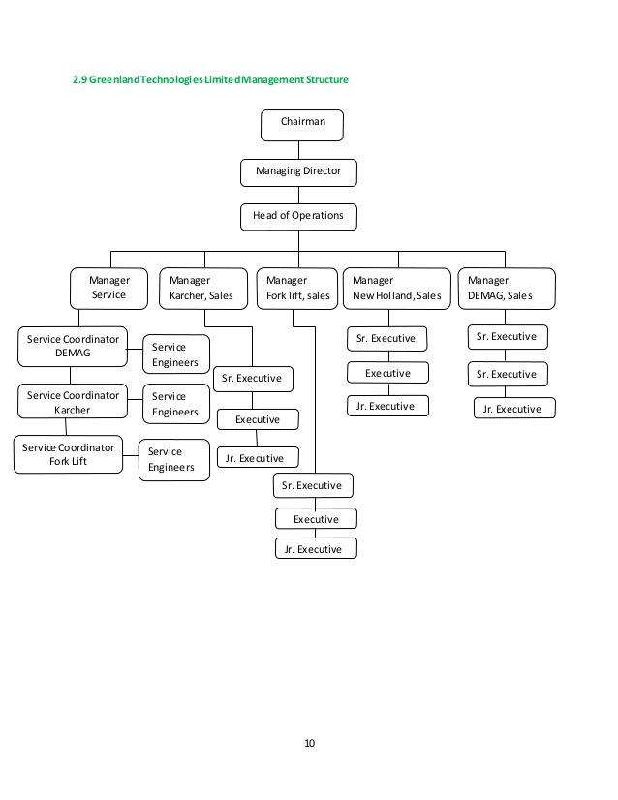

Operational activities of the Greenland Technologies Ltd.

Departments of Greenland Technologies Ltd.

- Sales Department
- Service Department
- Finance and Accounts Department
- HR and Admin Department

SALES DEPARTMENT
Greenland Technologies Ltd. has several kinds of products for several sector. For agriculture sector they import machineries (like tractor, power tiller) from abroad which are high quality product and sale the product to farmer by installment or direct sale. The Company sale this machineries by their showroom or sub dealers. They have 25 sub dealers all over the country for selling their products. The Company also have industrial equipment which they mainly sale from Dhaka and Chittagong office.

SERVICE DEPARTMENT
GTL provides after sales service to their customers. The Company has a group of team in every showroom which are combined 2-3 peoples and they are supervised by an engineer. Those peoples have to serve several districts. This group have their own logistic tools, motorcycles and tab which are provided by the company.
In industrial service the Company have two service departments under industrial service division.

- KARCHER
GTL has KARCHER service center in their own Head office in Dhaka. This KARCHER machineries directly audited by engineers of KARCHER Germany office. KARCHER engineers comes in every year in our Head office for visit. The service team of GTL employees are trained by KARCHER Singapore office.

- JUNGHEINRICH
GTL has JUNGHEINRICH service center in their own Head office in Dhaka. This JUNGHEINRICH machineries directly audited by engineers of JUNGHEINRICH Germany office. JUNGHEINRICH engineers comes in every year in our Head office for visit. The service team of GTL employees are trained by JUNGHEINRICH Singapore office.

FINANCE AND ACCOUNTS DEPARTMENT
The company has several qualified Chartered Accountant (CA) with more than ten years’ experience in accounting and finance and they have this level of capacity to take responsibility to run this department. This department take care of the whole company’s accounts and financial activities. This department also maintain the relationship with banking and non-banking financial institutions. This is one of the most crucial department of the company for their growth and survival in the market.

HR AND ADMIN DEPARTMENT
The Company has more than 10 years experienced HR who take care of this department. This department take care of company’s administrative functioning, human resource and security of the company and so on. Administration department is the backbone of any organization. This department provides an effective link between company's one department to other departments and it ensures the smooth flow of information from one part to the other and also ensures the smooth running of our company.
SALES SUPPORT DEPARTMENT
GTL has a highly professional Call center which helps to sale the products and also to build a good relation with customers. The Company also take customers feedback from their customers by calling them or in the time of selling company’s products. If customers has any queries about the company or product the instantly provide based on customer need.

R&D and BUSINESS DEVELOPMENT DEPARTMENT
Greenland Technologies Ltd. engages Research and Development (R&D) activities by connecting with corporate or governmental innovation aiding in commercialization of new products. R&D department of the company always try to developing new products for our emerging market and also try to bring variation on existing products. GTL always want to bring the better solution of any problem which they can solve by their products. That’s why the small company become a midsize company by giving their best.

IT DEPARTMENT
GTL has their own IT Department. IT is responsible for providing the infrastructure for automation. This department implements the governance for the use of network and operating systems.

CORPORATE SOCIAL RESPONSIBILITY
Greenland Technologies Ltd. contributes in various Corporate Social Responsibility (CSR). The Company works over the years which include the cleaning of Shahid Minar and various statues and memorabilia within the Dhaka University Campus. We have also put forward a mammoth task of cleaning entire Bashundhara region right after Eid-Ul-Azha.

Online distributing product line of GTL
GTL has several brands products which they import from other countries. This product they distribute by online (like Daraz BD) and also offline through their showroom and agents.
Product and service line of GTL
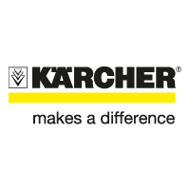
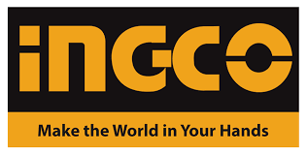
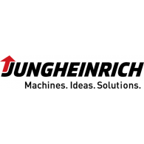
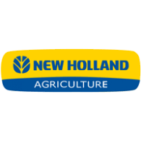
Greenland Company has several kinds of Karcher products which are completely imported.
Home & Garden
Cleaning Solution from Germany

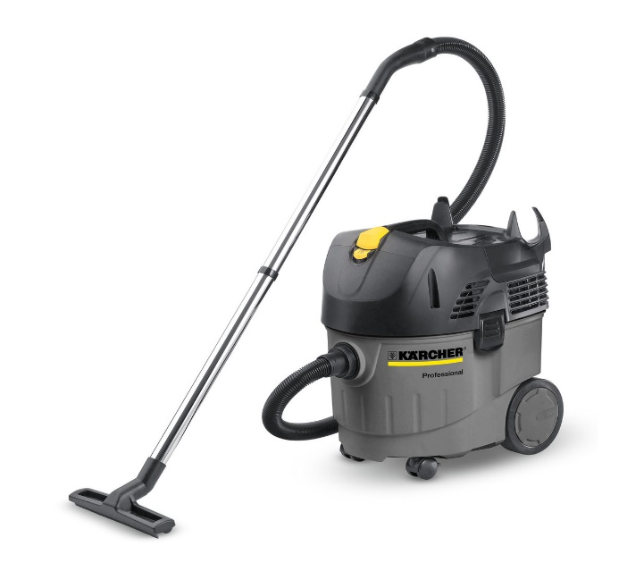
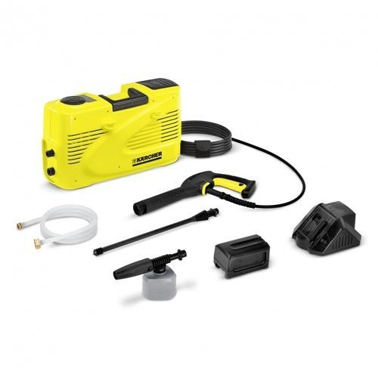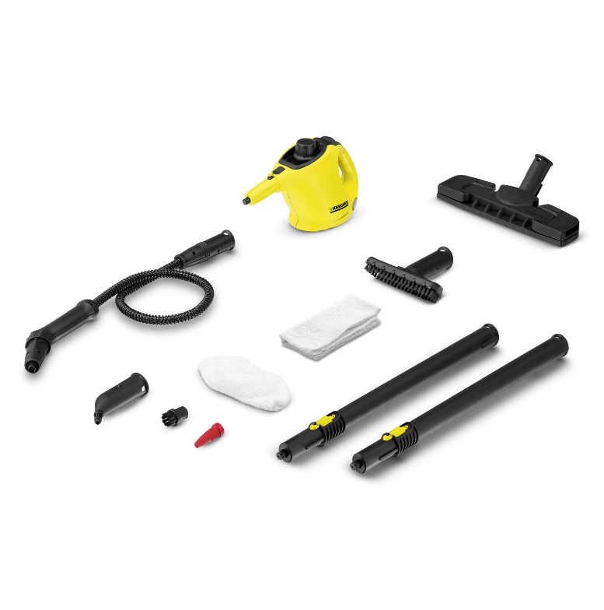
Karcher
Industrial cleaner
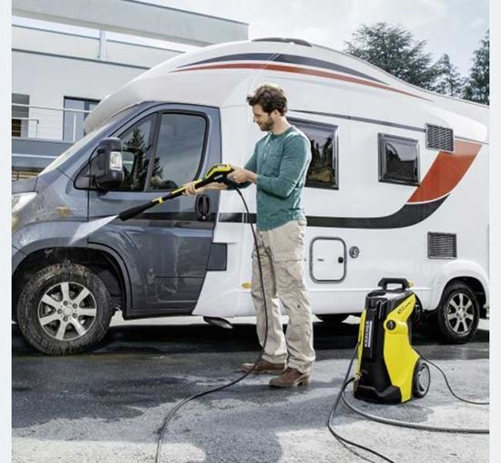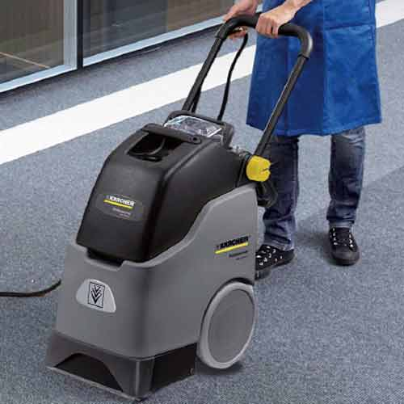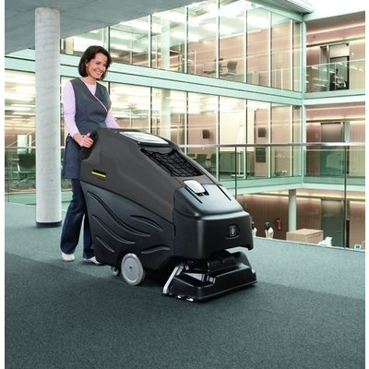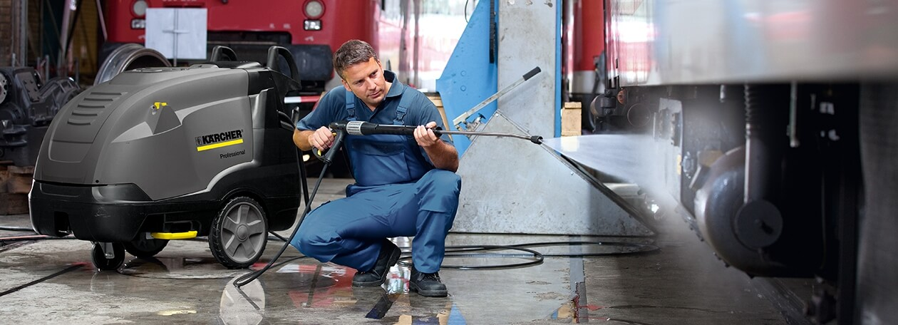

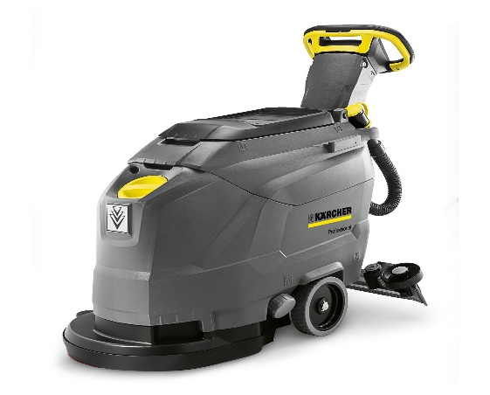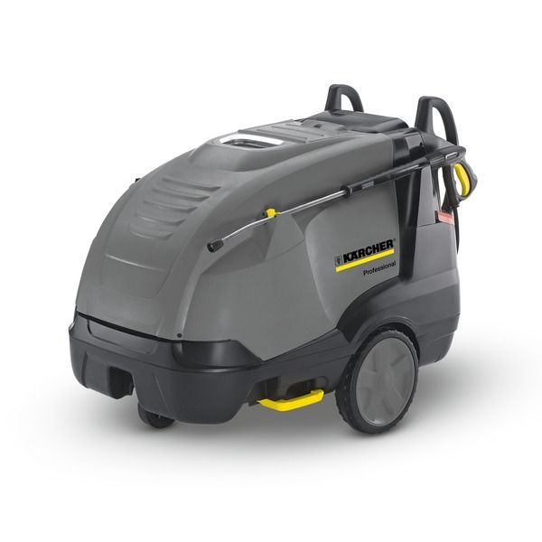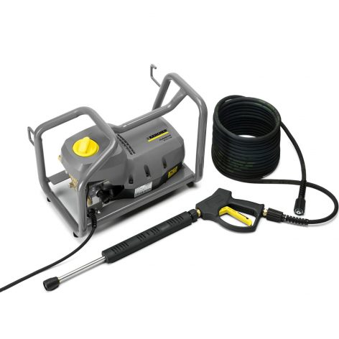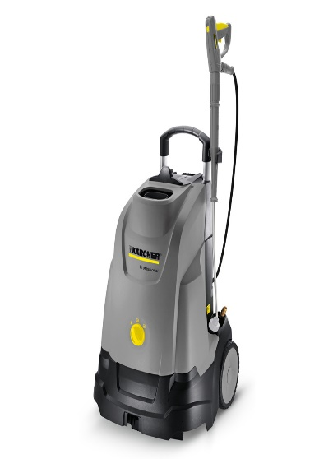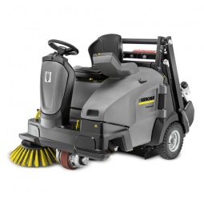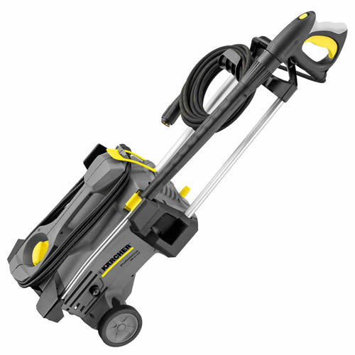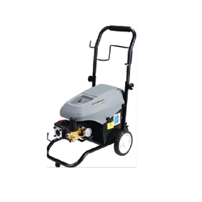
Water Purifier
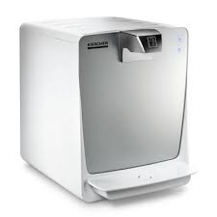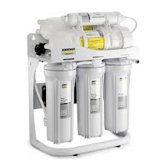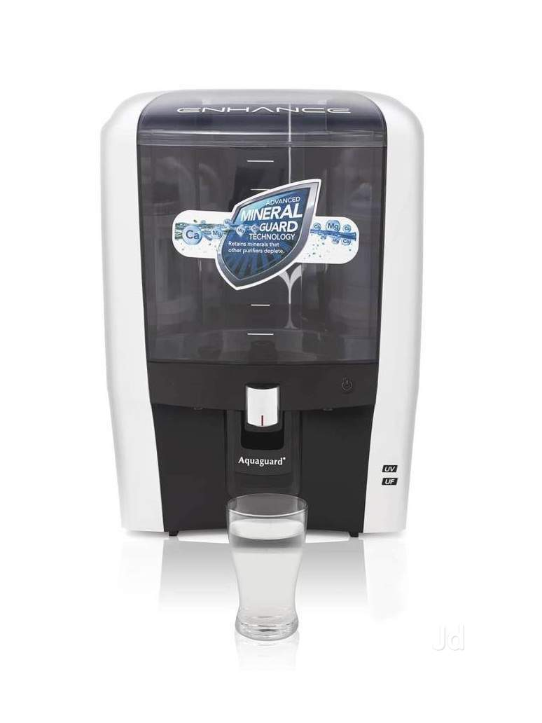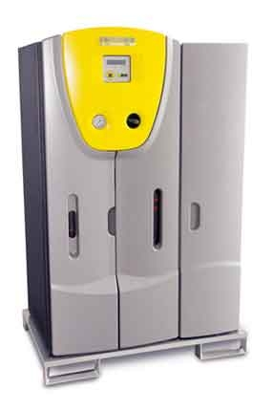
Air Purifier
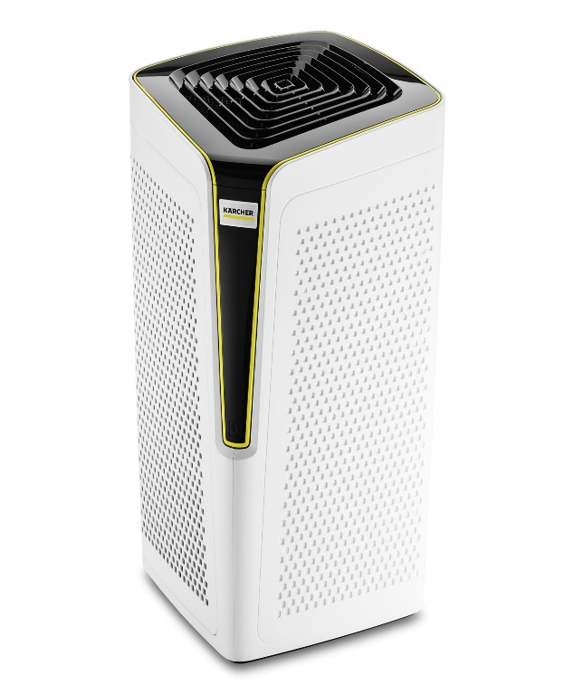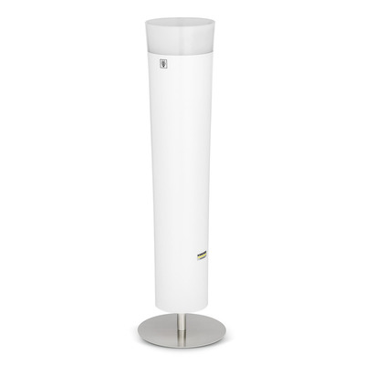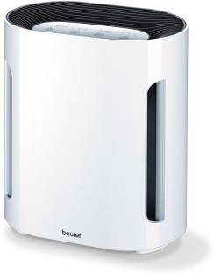

The company has INGCO Power tools, Power tools accessories, Welding machine, Generators, Hand tools & Hardware, Measuring tools & Safety products, Small constructions machine, Air tools, Water pumps & Garden tools.
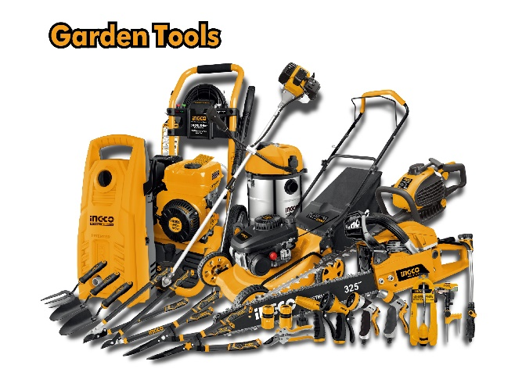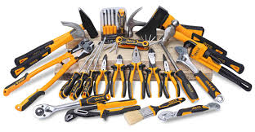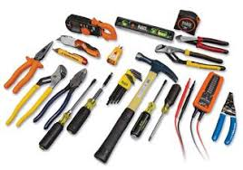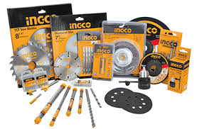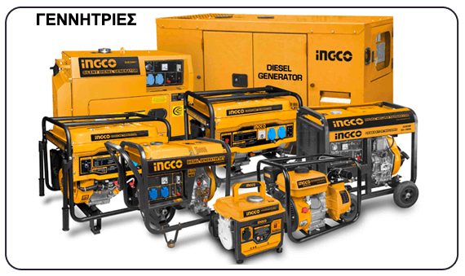

Greenland also has JUNGHEINRICH products to hold material equipment’s.
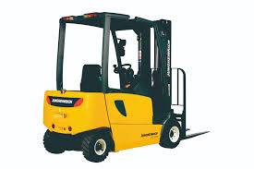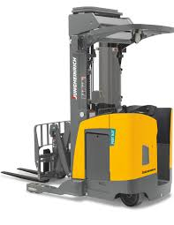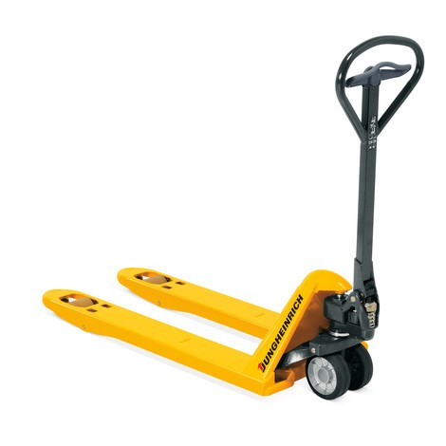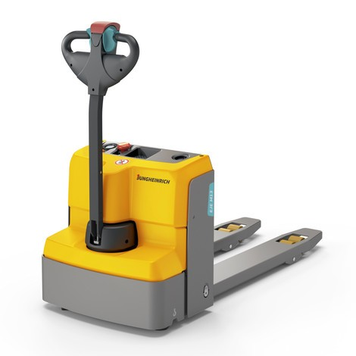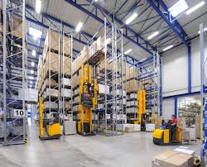
The main business of Greenland Company is sell tractor and tractor’s accessories to the customers on credit. Further they collect their selling price with interest by installment. All the tractor’s they import from the other country.
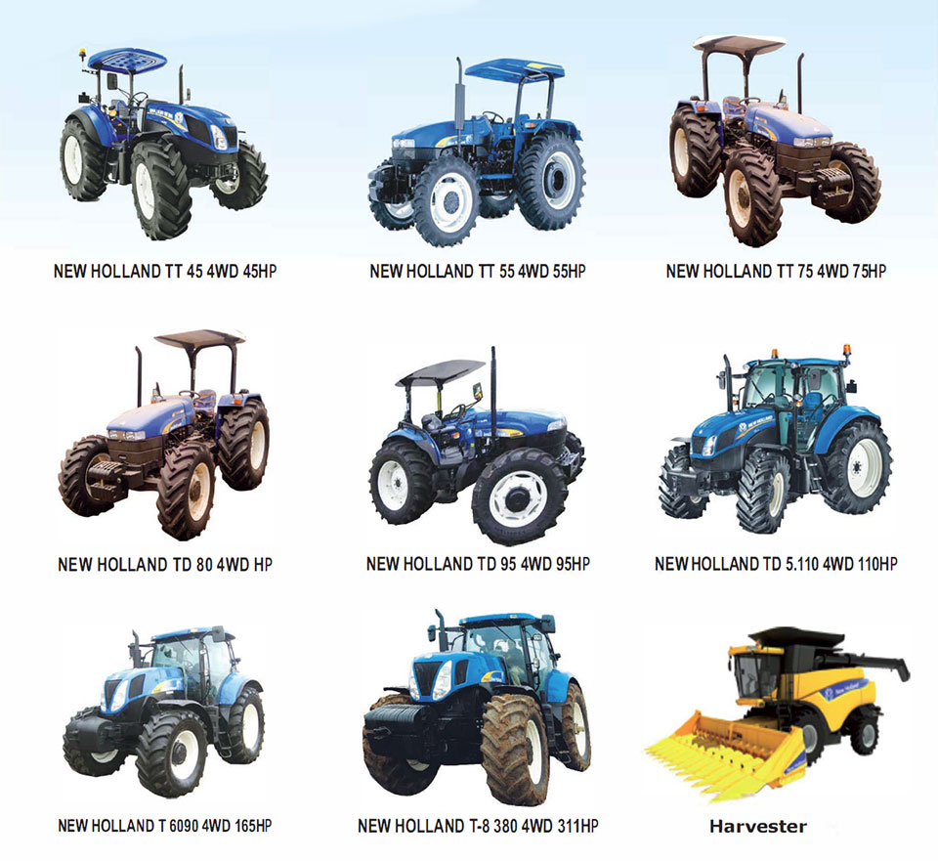
The company also has Power tiller and accessories.
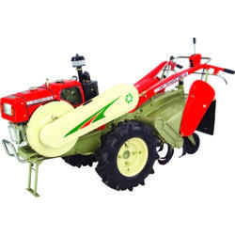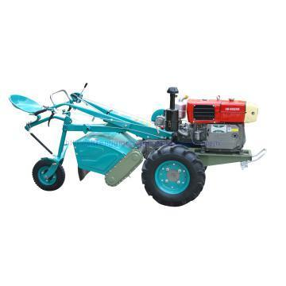

Greenland Company has several earth moving equipment


SWOT analysis of the company

SWOT analysis is an essential part of an organization. SWOT analysis help a company to know their strength and opportunities for move on and it also tells about the weakness which the Company need to overcome and their threats which comes from their competitors.

Four parts of SWOT analysis of GTL:
Strengths:
- Greenland Technologies Ltd. has goodwill in the market
- The Company is small but they have better financial position than their competitors.
- They are able to understand the customers need and provide them in an efficient way than other competitors do.
- Experience is always an asset. That’s why the company grow up every day because they have experienced employees.
- Company uses modern technologies for their operating activities.

Weaknesses:
- GTL does not have more experience about import.
- The Company does not have enough experience about lease financing
- For their management line up they are not able to take immediate (quick) decision.
- GTL is a small company. They have lack of experience in their distribution channel.
- Employee turnover rate is high in this company.
Opportunities:
- The Company has an opportunity to grow their business by providing better agriculture solution.
- Providing best and fast service the company can become the market leader.
- ROI is substantial
- GTL can expand their business by making variation on their existing products.
- By getting more market share they can become the market leader.
- The Company can add value with imported products.
- Advertising and targeting the Target customer
- In our country govt’ always co-operative with the agriculture related business.
- By understanding farmers need company can serve best solution about their problem.

Threats:
- In our country economic condition is not that much good.
- Whereas the Company import products from abroad there is threat in supply.
- If govt’ change their any policy it will be a big problem for the Company.
- There is possibility of product quality variation in the time of import.
- Selling product on installment is always a risk.

Financial Ratio Analysis of Greenland Company

If anyone see the financial ratio about an organization then this person will be able to understand about the performance of the organization. That’s why I did some financial ratio based on the company’s financial statement.

Liquidity Ratios

In liquidity ration we have two ratios those are:
- Current Ratio
- Quick Ratio (Acid Test Ratio)

Current Ratio = Current Assets / Current Liabilities

Greenland’s 2013-2016 Current Ratio:

Interpretation: In this graph, we can see that, current ratio was so low in 2013 which was 1.27. But after that their current ratio increasing in every year which were 1.29 in 2014, 1.31 in 2015 and 1.53 in 2016 by increasing their current assets.

Quick Ratio = (Current Assets - Inventory) / Liabilities
Greenland’s 2013-2016 Quick Ratios:

Interpretation: In 2013 quick ratio result was 1.05 of GTL. But after 2013 their quick ratio increase in 2014, 2015 and 2016 which is 1.07, 1.08 and 1.27. Company’s current assets, current liabilities and inventory also increases those years. That’s why their ratio increases in every year.

Activity Ratios

- Inventory Turnover:
(IT) Inventory-Turnover Ratio = Cost of goods sold / Inventory
Greenland’s 2013-2016 Inventory Turnover Ratios

Interpretation: From the graph we can see that in 2013 and 2014 turnover ratio was constantly increased from 3.41 to 3.86. In this time, maybe the Company was not able to sale their products. But in 2015 company was able to increase their ratio which was 4.78 which are known as standard one. In 2016 company’s ratio was fallen 4.25.

- Average Collection Period:
Average Collection Period = (Accounts Receivable / Total sales) * no. of days
Greenland’s 2013-2016 Average Collection Period:

Interpretation: In collection side GTL is the good one. Because their collection period is not standard enough. From 2013 to 2015 they continuously improving their collection period except 2016.
- Average Payment Period:
Average Payment Period = (Accounts Payable / Annual Purchase) * no. of days
Greenland’s 2013-2016 Average Payment Period

Interpretation: GTL Company continuously improve their payment period. It is a positive sight of the company which will be helpful in the future to get discount. Their current payment period is the standard one.
- Total Asset Turnover Ratios
Total Asset Turnover Ratios = Sales or Revenue / Total Assets
Greenland’s 2013-2016 Total Asset Turnover Ratios:

Interpretation: Greenland was able to produce 86 paisa by using tk. 1 in 2013. In the time of 2014 and 2015 the company was able to generate more profit then before. But in 2016 the ratio slightly decreased from 1.21 to 1.18.

Debt Ratio

- Debt Ratio
Debt Ratio = (Total Liabilities / Total Assets) * 100
Greenland’s 2013-2016 Debt Ratios:

Interpretation: GTL Company took a high financial risk in 2013. In this time their debt ratio was so high. After that the company was able to reduce their debt ratio in every year. That’s why their debt ratio in 2016 is lower than other years.

- Times Interest Earned Ratio:
Time Interest Earned Ratio = (EBIT / Interest) * 100

Interpretation: From the graph we can see that, in 2013 the company’s interest earned ratio was 2.97. After 2013 their interest earned ratio increased in every year till 2015. But in 2016 there was a huge fall of ratio which was 2.25 times. It could be happened decrease of the company’s income.

Profitability Ratios
In profitable ratio there are three types of ratios those are:
- Gross Profit Margin
- Operating Profit Margin and
- Net Profit Margin

Gross Profit Margin
Gross Profit Margin = (Gross profit / Sales or Revenue)
Greenland’s 2013-2016 Gross Profit Margins:

Interpretation: in 2013 GTL was able to generate 38% GP. Which means they got 38 paisa instead of 1tk investment. After that year, their GP decreased next two years for some extra expense. But in 2016 the company again comeback

Operating Profit Margin
Operating Profit Margin Ratio = Operating profit / Sales or Revenue

Interpretation: In the graph we can see that, OP gradually increased from 2014 to 2016. In 2013 to 2014 there was a slight decreased which was 15.12 to13.78. But after this yearthe company was able to overcome the circumstance.

Net Profit Margin
Net Profit Margin ratio = Earnings available for common stock holders / Sales or Revenue
Greenland’s 2013-2016 Net Profit Margins:

Interpretation: From the above we can see that, GTL has NP ratio of 6.52%, 6.34%, 7.64% and 7.20% in the year of 2013, 2014, 2015 and 2016 respectively. The Company was able to continuously increase their net profit margin.

Return on Asset (ROA)
Return on Asset ratio = Net Income or Earning available for common stock holders / Total Assets
GTL’s 2013-2016 Return on Asset:

Interpretation: GTL Company has 5.59% and 6.07% return on asset in 2013 and 2014 respectively. But after 2015 their ROA ratio increased rapidly which was 9.23% and 8.48% in the years of 2015 and 2016. From 2015t to 2016 there was a slightly decrease of ROA which was 8.48%. 8.48% means Greenland able to produce tk. 8.48 against using tk. 1.

Return on Equity Ratio (ROE)
Return on Equity Ratio = net income or earning available for common stockholder’s / shareholder’s equity
Greenland’s 2013-2016 Return on Common Equity (ROE):

Interpretation: In 2013 the ratio was 46.62%. After that year ratio was slightly decreased in 2014. After 2014 ratio again increased in 2015. In the year of 2016 ROE again fall down which was 42.41%. GTL shareholder’s earned 42.41 paisa against tk. 1 which they invested in this company.

Findings and interpretation

After calculating lots of ratio about the company I find that this company has a great future which means they will become market leader by using their employee’s experiences, lots of innovation from Research & Development department, using strategies which generates by the company’s top management. An external person can understand about the company’s financial position after seeing the ratio of the company. This company believe better solution of any problem and bring the better solution about any problem. The Company respect their clients and customers ideas which they taken by consumer’s feedback and they also respect about the customer’s problem. Greenland Technologies Ltd. has better financial position that’s why they can expand their business by
- Increasing their showroom over the country
- Increasing dealers
- Bring more innovative products with lower price
- Going to the customers door for knowing their needs and then serve them the best solution than other competitors do.
- Making variation on their existing products
- Improving service quality
Net Profit Margin of the company shown that company has good sales. That’s why their NP increasing in every year. The Company can takes more strategies and steps for more sale. Whereas they are products oriented company that means their profits depends on products sale. Their Current ratio, Quick ratio, Net Profit Margin, ROA, ROE every ratio is good enough to take a better position in the market and move on forward which means spread the business.

Recommendations

- Greenland should give more importance on their sales
- Employees need more well training for better performance.
- Their main business is sale products on credit. That’s why they should give more importance in the time of collecting installment.
- GTL is a midsize company for their growth they need better financial form now.
- Company expect more from their senior which means experienced employees. That’s why experienced employees need to perform high.
- To become a market leader company need to maintain their standard level of quality of their product with lower price.
- Greenland Technologies Ltd. believe in better solution that’s why they have to be perfect for any problem for giving better solution.
- Company need to concern about farmer’s problem and give them easiest solution.
- GTL can spread their business by investing their other business from which they earn better profit.
- They can add value with their imported products like packaging and so on.

Conclusion

Greenland Technologies Ltd. is a small business which is the sister concern of GETCO Group. It was established in June 2011 and the company provide agricultural products for agricultural better solution of farmers. This Company also provide better solution about cleaning for house and corporate world both. This Company believe in better solution of any problem that’s why they import products from abroad and sell the products within the country. The Company bring modern products which means modern technologies for any kind of agricultural and cleaning problem. Main business this company is sale on credit to the farmers of agricultural products. They are in good position in market with goodwill. After analyzing all the data and ratio I find that GTL has golden opportunity to become market leader and also expand their business. Because this company has better financial position than their competitors and also they have good sales.
I have been worked three months for Greenland Technologies Ltd. as an intern. In this time, I learned so many things in the time of working. This internship increase my knowledge about actual work. By this program I have been met with actual corporate world. Now I have this three months working experience in my career.

Appendix

- GTL= GREENLAND TECHNOLOGIES LIMITED.
- TDS= TAX DEDUCTED AT SOURCE.
- GM= GENERAL MANAGER.
- PAT= PROFIT AFTER TAX.
- PBT= PROFIT BEFORE TAX.
- PBIT= PROFIT BEFORE INTEREST TAX.
- SE= SHAREHOLDERS EQUITY.
- R&D= RESEARCH AND DEVELOPMENT.
- NP= NET PROFIT.
- GP= GROSS PROFIT.
- ROA= RETURN ON ASSET.
- CA= CURRENT RATIO.
- ROE= RETURN ON QUITY.
- IT= INVENTORY TURNOVER RATIO.
- BBA= BACHELOR OF BUSINESS ADMINISTRATION.
- UIU= UNITED INTERNATIONAL UNIVERSITY.
- BD= BANGLADESH.
- TO= TUROVER.
- VAT= VALUE ADDED TAX.

Reference

Books:
- A Handy Guidebook by Charles K. Vandyck
- Financial Management by M Y Khan & P K Jain
- Principles of Managerial Finance by Gitman Financial Ratio Analysis

Publications:
Annual Report of Greenland Technologies Limited (2013 to 2016).

Internet:
- https://greenland-bd.com/
- https://www.investopedia.com/

