

AN INTERNSHIP REPORT ON

MEASURING EMPLOYEE SATISFACTION ON CARDS AND ADC OPERATION OF DHAKA BANK LIMITED

15th August 2020
UNITED INTERNATIONAL UNIVERSITY
DHAKA, BANGLADESH
AN INTERNSHIP REPORT ON
MEASURING EMPLOYEE SATISFACTION ON CARDS AND ADC OPERATION OF DHAKA BANK LIMITED

SUPERVISED BY
MD KAZIMUL HOQUE
ASSISTANT PROFESSOR
SCHOOL OF BUSINESS AND ECONOMICS
UNITED INTERNATIONAL UNIVERSITY

PREPARED BY
ZANNATUL RAIYAN
ID: 111 143 190
BBA PROGRAM
UNITED INTERNATIONAL UNIVERSITY

UNITED INTERNATIONAL UNIVERSITY
Letter of Transmittal

To
Md. Kazimul Hoque
Assistant Professor,
School of business and economics,
United International University
Subject: submission of internship report on “measuring employee satisfaction on cards and ADC operation of Dhaka Bank Limited”.

Dear Sir,
I am here to present to you the report "measuring employee satisfaction on cards and ADC operation of Dhaka Bank Limited", based on your suggestion to prepare as part of the internship report. I have worked in card operations and ADC departments of Dhaka Bank LTD. During the internship program, while I have worked at Dhaka Bank Limited, I have done my best to follow your instructions to fulfill all this report's requirements.

As we all know, employee satisfaction is extremely essential for an organization like Dhaka Bank Limited because it depends on the productivity of the bank. If our employees are satisfied, they will perform well at the best time and bring more profits. Satisfied employees are also more likely to be creative and innovative and can deliver groundbreaking discoveries, allowing services to actively develop and change over time and market conditions change.

However, the entire report is based on some of my experiences in designated banks; in the internship program of the Dhanmondi branch of Dhaka Bank, I tried to provide everything I learned.

Therefore, I will be very encouraged, if you accept this report and provide your valuable remarks.

Sincerely yours,
Zannatul Raiyan
ID: 111 143 190
BBA Program
School of business and economics,
United International University

Acknowledgement

First of all, I express my deep gratitude to Omnipresent and Almighty Allah who helped me to complete the four years long BBA Program. At the same time, I am thankful and happy to have completed this study within a certain period of time. The report would never have been completed without the necessary practical knowledge, the help of many online PDF paperwork, online articles, blogs, and other library facilities of UIU. The study has improved my knowledge of measuring job satisfaction. Therefore, I want to thank all those kind individuals who supported the study and provided their valuable time & effort to encourage and guide me to complete this report.

In particular, I want to express my special gratitute to my course faculty and internship supervisor, Md. Kazimul Hoque, Assistant Professor at United International University (UIU), for his motivation, kind supervision, valuable guidelines, and recommendations.

I was assigned as intern at Dhaka Bank Limited from November 3, 2019, to January 31, 2020. During this time, I had found DBL members and management very cooperative and supportive. They assisted me by given numerous information, suggestions, and guidelines. I thank the director of DBL Bank Dhanmondi branch for his collaboration and essential assistance.

Last but not the least, I would like to thank Zannatul Tazrin and Ms. Humaira from the Dhanmondi branch as they also finished the three-month internship with me. I would also like to thank all the other employees in the CARD and ADC departments.

Executive Summary

Employee satisfaction is a term that is widely used in the human culture industry to describe employee dissatisfaction or degree of dissatisfaction with aspects such as work culture, environment, salary, compensation, work pressure, experience Employee satisfaction, etc. Employee satisfaction is a vital measurement to help decide the general well-being of the association. That is the reason numerous organizations utilize standard reviews to gauge employee satisfaction and track satisfaction patterns all through the climate. High satisfaction implies employees are content with the manner in which bosses treat them. The determination of this internship report is to determine the level of satisfaction of the employees of Dhaka Bank Limited. The survey reported that highly satisfied employees have a tendency to achieve higher productivity regardless of their job title and salary level and ensuring employee safety and satisfaction can lead to increased sales, lower costs, and increased profitability. To analyse employee satisfaction and to identify the reasons for employee dissatisfaction so that the bank can take precautionary measures, an employee satisfaction survey questionnaire is prepared. It is mainly used to analyse employee satisfaction in the work environment. The survey indicates the degree to which employees agree or disagree with the answers they give to the survey. The survey found that overall employee satisfaction was positive for the bank, but also found some unsatisfactory reasons. Most of the employees are dissatisfied with the current working days, salary, and compensation structure of the bank. Thus, several recommendations have been shared in the final chapter of the study to improve and compensate payroll packages, including career balance, work-life balance, work stress reduction, stress, and flexible work time restructuring.
Table of Contents

Introduction
1.1 Background of the study 2
1.2 Scope of the Study 2
1.3 Objectives of the study 2
1.3.1 Primary Objectives: 2
1.3.2 Secondary Objectives: 3
1.4 Methodology of the study 3
1.4.1 Sources of data: 3
a. Primary sources Data: 3
b. Secondary source data: 3
1.4.2 Data collection methods: 3
1.4.3 Design of the questionnaire: 4
❖ Sampling method: 4
❖ Target population: 4
❖ Interpretation of the survey: 4
1.5 Limitations of the study 4

Organizational Overview
2.1 Background of Dhaka Bank Limited 6
2.1.1 Mission 7
2.1.2 Vision 7
2.2 Product and services of Dhaka Bank Limited 7
2.2.1 Retail Products and services of DBL: 7
2.2.2 Other SME and Loan Products and services of DBL: 7
a. SME Loan Products 7
b. Non-Funded Loan 8
c. SME Deposit Products 8
d. Refinance Scheme 8
2.3 Organizational Organogram 9

Literature Review
3.1 Concept of employee Satisfaction 11
3.2 Importance of measuring employee satisfaction 11
3.3 Methods of measuring employee satisfaction 12
a. Employee survey questionnaires 12
b. Staff suggestion box 12
c. Face-to-face feedback opportunities 12
d. Pulse survey 13
e. Arranging an exit interview 13

Findings and Analysis
4.1 Demographic Information 15
4.2 Descriptive Analysis 15
4.3 Graphical Presentation and differentiation of satisfaction between gender and job experience 18
4.4 Findings of the survey: 34

Recommendations and Conclusion
5.1 Recommendations 37
5.2 Conclusion 39

Appendix
6.1 Reference 40
6.2 Survey Questionnaire 42

Chapter One: Introduction



1.1 Background of the study
The submission of internship or project report is a pre-requisite of achieving the Bachelor of Business Administration (BBA) from United International University (UIU). Students must complete the internship program while completing all BBA courses designed to theoretically improve their professional skills. Students taking part in the internship must join the institution as interns and work in this institution for three months. This program helps us to improve our practical knowledge about the real work environment. During the internship, students will also need to prepare an internship report based on the area of ​​their research focus, which summarizes the internship experience that many employers need to complete in their institution. The internship report is extremely important because it can inform our internship supervisor about the knowledge we have learned and the skills and opportunities we have applied. Realizing all the benefit, I had chosen internship and got selected in Dhaka Bank Limited’s Card and ADC section as an intern. Therefore, I have selected to prepare my internship report on “Measuring Employee Satisfaction on Cards and ADC operation of Dhaka Bank Limited”.

1.2 Scope of the Study
This is a mandatory requirement for BBA students at United International University to complete the internship program, and this topic was assigned by my internship supervisor. The research opportunity is to learn about employee satisfaction related to the DBL card and the ADC department. The report contains the background, structure, functions, and performance of Dhaka Bank Limited. As I work in a branch office, I have the opportunity to learn about the elements that help measure employee satisfaction throughout the questionnaire that is listed in the appendix. The analysis and findings of the study are based solely on the opinions of 46 respondents currently working at the Dhaka Bank Ltd. branch in Dhanmondi.

1.3 Objectives of the study
This study’s objective is to gain appreciable knowledge of practical banking and related knowledge that I have acquired through abstract training, university education, and various documents of Dhaka Bank LTD.

1.3.1 Primary Objectives:
- To evaluate the level of satisfaction of Dhaka Bank employees.
- To analyse the factors that influence employee job satisfaction.
- To classify the factor that progresses the level of employee satisfaction.

1.3.2 Secondary Objectives:
- To provide a brief description of the Dhaka Bank Ltd. and its history.
- To make the study useful for the DBL to do more research on the level of employee satisfaction with social protection measures.
- To make the study useful for the DBL to identify the area of ​​dissatisfaction with the work of employees.
- To make the study useful to take a managerial decision for the Bank.
- To provide satisfaction overview based on work experience and gender perspective.

1.4 Methodology of the study
The investigation requires an orderly methodology from the determination of the subject to the arrangement of the final report. To get the components and information of the report and finalize the internship report, I worked in a couple of steps. The general methodological process is presented below.

1.4.1 Sources of data: This study has been prepared by primary and secondary data that were readily available from the Cards division of Dhaka Bank Ltd.

Primary sources Data:
- Formal conversation with bank employees
- Survey.
- From practical experiences working as an intern

Secondary source data:
Here, the secondary sources are the permanent and printed sources of information.
- Dhaka Bank website
- Procedural manual published by Dhaka Bank ltd.
- Related website.
- Linked magazines
- Annual report.

1.4.2 Data collection methods:
- To collect data about Dhaka Bank Limited, the interview method was used. Interviews were conducted with officials from the Dhaka Bank Card Division.
- To collect information on employee satisfaction, an online questionnaire was prepared on Google Forms and distributed through the various social media platforms.

1.4.3 Design of the questionnaire:
The questionnaire is prepared following the Likert-type survey and the type of questionnaire administered by declaration structure and used to carry out a survey of employee job satisfaction in order to 'acquire primary data.
- Sampling method: a convenience sampling method was applied to select the sample. Total 46 employee’s responses are collected randomly who working on several positions in Dhaka Bank Limited.

Target population:
- All employees of the Dhaka Bank Card and ADC business unit
- Sample size: there are 46 respondents selected randomly who are working in different position in the bank.
- Interpretation of the survey: The survey is prepared on Google Forms as it is a convenient way to collect employee responses. It also helps employees respond when they are released from their job responsibilities. However, as mentioned earlier, the survey is prepared using Likert scale methods, the responses will be separated into two parts to identify the factors of satisfaction and dissatisfaction. Statements that are marked both agree and strongly agree are considered satisfactory factors. On the other hand, statements that are mostly marked by respondents who disagree, strongly disagree, or even marked as neutral will be considered as unsatisfactory factors. Here neutral is considered under the unsatisfactory factor because we know that employees who are satisfied will easily agree, and marking neutral means that they have something to say but do not want to mention or do not agree with the statements.

1.5 Limitations of the study
While preparing the report, I have to go through several difficulties that minimizes the report’s actual offerings to its readers. This key limitations are listed below:
- The bank staff being very busy, they could only give me very little time.
- Some respondents were not helpful in providing adequate information.
- No specific data were found. Employee satisfaction is measured through the questionnaire's overall responses.
- The report doesn't illustrate the overall employee satisfaction of Dhaka Bank Limited, rather it reflects only the Card and ADC section's employee satisfaction.

Chapter Two: Organizational Overview

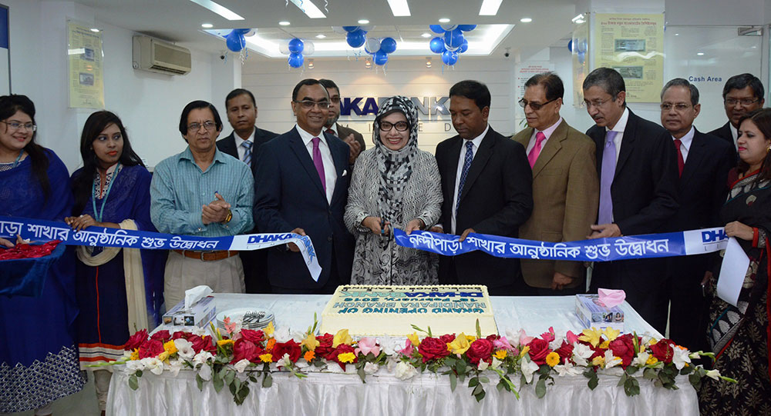

2.1 Background of Dhaka Bank Limited
Bangladesh's economy has developed quickly since the mid-1990s. Modern and horticultural turn of events, worldwide exchange, the convergence of settlements from ostracizing Bangladeshi specialists, neighborhood and unfamiliar interest in development, correspondences, energy, preparing organizations of food and administrations. It denoted the start of a period of monetary movement. Urbanization and way of life changes related to monetary advancement have spurred the interest for banking items and administrations to help new organizations and productively channel customer speculation. A gathering of eminent business people from the nation over met up to address this issue and established Dhaka Bank Limited in 1995.

Dhaka Bank Limited (DBL) was established under the Company Act 1994. The Bank began the procedure on July 5, 1995, with the approved capital of Tk. 1,000 million and paid-in capital of Tk. 100 million. The currently approved capital of the bank is Tk. 10,000 million. The bank's settled up capital was in Tk. 7,223 million as of December 31, 2017. The Bank's investors' value (capital and stores) as of December 31, 2017, is equivalent to Tk. 15,828 million. As of December 2017, the bank has 100 branches, including 2 Islamic bank offices, 3 SME administration focuses, 56 ATMs, 20 ADMs, 2 seaward banking units, 1 booth and 6 branches in Dhaka Bank Protections Limited all through the nation and a broad organization of reporters around the globe. The Bank intends to open different branches in the coming days to grow the specialist organization.

Also, DBL is providing a total scope of banking and speculation administrations for private and corporate customers, upheld by forefront innovations and a group of exceptionally energetic experts. As a basic piece of the duty to greatness in the banking business, Dhaka Bank Limited presently offers the full scope of constant web-based banking administrations at all of its branches, ATMs, ADMs, and web banking channels. Also, banking is the favored decision in the banking business for easy to understand and customized administrations, front line innovation, arrangements custom-made to business needs, worldwide reach in business and trade, and an exceptional yield on speculation.

2.1.1 Mission
The mission of DBL is to become the country's leading financial institution, backed by the latest technology, to provide high-quality products and services and a group of motivated staff to provide excellent banking services.

2.1.2 Vision
We are inspired by distant stars. Our vision is to make every banking transaction the norm for an enjoyable experience. Our commitment is to meet the needs of your business by providing precision, reliability, fast delivery, advanced technology, and tailor-made solutions, in order to meet your business needs and achieve a high return and return on investment at a global scale. Furthermore, our staffa, product categories and procedures are consistent to encounter the needs of our demanding clients. Our primary goal is to provide quality that truly reflects our vision which is excellence in banking service.

2.2 Product and services of Dhaka Bank Limited

2.2.1 Retail Products and services of DBL:
The retail products of Dhaka Bank Limited are listed below:
- Current Account | - Fixed Deposit Receipt (FDR) | - Savings Builder Account
- Savings Account | - Gift Cheque | - Kotipoti Deposit Plan
- Bundle Savings Account | - Deposit Pension Scheme | - Lakhopoti Deposit Scheme
- Joma Savings Account | - Special Deposit Scheme | - Students’ Ledger
- Short Notice Deposit | - Deposit Double Scheme | - Shopno Jatra
- Car Loan | - Credit Card | - Locker Services
- Home Loan | - Debit Card | - Aspire Card

2.2.2 Other SME and Loan Products and services of DBL:

SME Loan Products
- Continuous Loan
- Demand Loan
- Term Loan
- 1st Time Borrower (Suchona Loan)
- Women Enterprise Loan (Oditiya Loan)
- Supply Chain Finance (Bills to Cash)
- Dairy Loan
- Commercial House Building Finance
- Loan by Deposition of Title Deed (Easy Loan)
- Loan for Tender/Bid/Auction Participation
- Loan for Work Order Finance

Non-Funded Loan
- Secured Loan
- Lease Finance
- Islamic Credit

SME Deposit Products
- Current Deposit Account-SME
- Mudaraba FD Plus (SME)
- FD (Plus) SME

Refinance Scheme
- Bangladesh Bank Refinance Scheme
- Loan to BDT 10 Ac. Holder
- Agri. 4.00% Loan
- Green Banking
- SME Foundation Arrangement (Shoe Manufacturing Cluster, Rajshahi)

2.3 Organizational Organogram
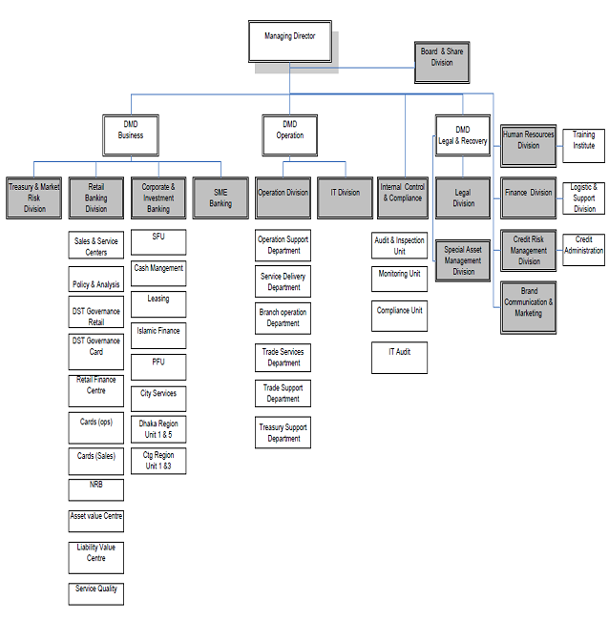
Chart: organogram of Dhaka Bank Limited

Chapter Three: Literature Review



3.1 Concept of employee Satisfaction
Employee satisfaction is a wide term utilized by the human resources industry to depict the level of employee satisfaction or satisfaction with things like their job, the experience of their employees, and the associations they work for. It can help to decide the general strength of an association, which is the reason numerous associations utilize occasional surveys to gauge employee satisfaction and track satisfaction patterns all through the job. An elevated level of satisfaction demonstrates that employees are happy with the manner in which their manager treats them.

Employee satisfaction is regularly utilized conversely with employee commitment; In any case, while commitment is a factor that influences in general satisfaction (and the opposite is likely likewise evident), the two are not the equivalent. Satisfaction, while significant for maintenance, isn't really an indicator of execution, while commitment, which demonstrates an employee's enthusiasm for their work, in addition to other things, is straightforwardly identified with execution. Preferably, satisfaction results from material factors, for example, rewards and advantages, just as less substantial components, for example, responsibility, acknowledgment, and solid initiative. In the event that an association neglects to handle the two sides of the condition, it might find that it has an agreeable group of physically fulfilled employees who are substance to do just what is important to remain in business or a group of exceptionally dedicated employees function admirably on the grounds that they search for new open doors in organizations that are additionally willing or ready to meet their material necessities.

3.2 Importance of measuring employee satisfaction
Employee satisfaction is viewed as one of the principle measures to survey the overall air of the working environment. Measuring employee satisfaction can likewise help decide their requirements and inspirations, and how the business can enable them to develop. Fulfilled employees who are content with the work environment (counting the executives, organization culture, and workplace) are bound to draw in with the organization. The more joyful the employees, the better the efficiency and productivity of the association.

In this manner, measuring employee satisfaction is fundamental for employees to remain cheerful and perform at the most elevated level. Here, fulfilled employees are the individuals who are faithful to their association and continue on even in the direst outcome imaginable. They don't work without quality, but since they fantasy about taking their association to another level. Employees should be excited about their work and it is just when employees are happy with their job and the entire association that they will be energetic. Employee satisfaction will make a positive working environment. The main advantage of measuring employee satisfaction is that employees scarcely consider stopping. The subsequent advantage is that employees accept that the organization has a drawn out view for them, so they strive to guarantee that the association accomplishes higher pay. In addition, fulfilled employees are bound to adjust and manage pressure than discouraged employees.

3.3 Methods of measuring employee satisfaction
Managers can contact employees in a number of ways to measure their work satisfaction level. These include:

Employee survey questionnaires
By sending questionnaires to employees, it aims to measure their satisfaction and involvement in specific aspects of the business. Topics can include leadership, communication, workplace culture, compensation, learning and development, and other factors that are important to employees. Before conducting a survey, managers should use the initial survey as a benchmark. When they take measures to address the pros and cons shown in this survey, they can compare the results with future surveys to see if these measures are effective. These surveys should be conducted every 6-12 months.

Staff suggestion box
Sometimes employees are too scared or dissatisfied to talk face-to-face, and the employee survey doesn't cover what they need to say or the next survey is too far away. There is a locked suggestion box where employees can make comments and opinions to managers anonymously, which is a big compromise. Then, management can present ideas on ideas that employees are missing in the workplace and even make some innovative tips to help the company become the preferred employer.

Face-to-face feedback opportunities
Communication between managers and their teams is generally poor, which leads to less satisfaction and engagement. When these managers received the results of the employee satisfaction survey, they were shocked that they didn't realize there was a problem. Without intervention, this is a cycle that will be repeated. By meeting regularly with employees, listening to their opinions and getting in-person feedback, managers can identify key employee issues on site in real time and can quickly take corrective action. The annual performance review where employees and supervisors meet one-on-one is another good opportunity to get this feedback in person.

Pulse survey
These methods aren't as in-depth as employee satisfaction benchmark surveys, but they are a good way to track employee satisfaction. The pulse survey should contain five to ten questions about employees' working feelings and give them an opportunity to say if they think certain changes are needed. These impulse surveys don't take long to complete, so managers can send them out more frequently than basic surveys.

Arranging an exit interview
When employees leave, for various reasons. Sometimes they are tied to their life, other times, because they have found better jobs elsewhere. This is by far one of the most important opportunities to determine what managers are doing well and what they can't do in business. Employees who leave usually feel they have "nothing" and can be cruel, honest, and not cautious when making comments. Conducting exit interviews can help managers find out why they are leaving so that managers can make improvements to retain senior management.

Chapter Four: Findings and Analysis



4.1 Demographic Information
Demographic Analysis denotes to a particular set of methods for developing population estimations for age, gender, and work experience as administrative documents to be used to assess the quality of the study survey.
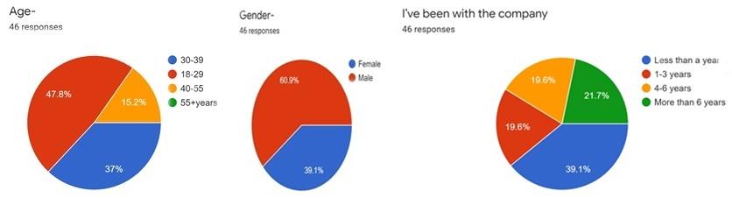
In the survey of this study, out of a total of 46 respondents, 28 are male and 18 female. Most of the employees (22) are aged between 18 and 29, 17 are aged between 30 and 39 and the remaining (7) are aged between 40-55. The job description varies from employee to employee as the survey collects all types of position responses. Furthermore, out of 46 employees, 18 of the employees are working less the 1 year (39.1%), 10 employees working over 6 years, 9 employees working for 1 to 3 years and the rests 9 employees are working for 1-6 years.

4.2 Descriptive Analysis
Descriptive analysis is vital in steering a survey analysis. This analysis gives us the distribution understanding of our data, assists us to classify associations between variables, preparing us for further investigation analysis.
The survey was prepared on Google Forms as it is a convenient way to collect employee feedback. After preparing the survey questionnaire, the link of the survey was sent through social media and emails to all employees and staffs of Dhaka Bank Limited so that they can response in the survey in their convenient time. However, as mentioned above, the survey was prepared using the Likert scale method and divided the responses into two parts to determine the satisfaction and dissatisfaction factors. Statements marked as agree and strongly agree are considered satisfactory factors. Conversely, statements marked by disagreements, strong disagreements, and even neutral respondents will be considered unsatisfactory factors. Here, neutrality is seen as an unsatisfactory factor, because we know that satisfied employees will easily reach an agreement, and marking neutral means they have something to say but don't want to mention or disagree declaration.
Statements | Strongly Disagree | Disagree | Neutral | Agree | Strongly Agree
- The company clearly conveys its mission and vision to its employees | 2 |  | 12 | 25 | 7
- I’m satisfied with the working environment of the company- | 1 | 3 | 6 | 25 | 11
- I am satisfied with job location- | 0 | 1 | 7 | 24 | 10
- I am satisfied with the present working hour | 1 | 10 | 13 | 17 | 5
- I am satisfied with the existing salary structure of the company | 3 | 13 | 12 | 16 | 2
- I am satisfied with the compensation I get & I think it matches with my responsibility | 2 | 10 | 14 | 18 | 2
- I am happy with my work responsibilities | 1 | 3 | 16 | 20 | 6
- I feel comfortable in carrying out my responsibilities | 0 | 8 | 11 | 20 | 7
- I am satisfied with work relationships with the people around me | 0 | 4 | 11 | 23 | 8
- I am satisfied with various activities in the firm & love participating in them | 0 | 3 | 12 | 26 | 5
- I am happy with our overall job security | 0 | 2 | 10 | 27 | 7
- I am satisfied with the given right to put forward my opinions | 0 | 3 | 15 | 21 | 7
- I am satisfied with the leaders in my workplace as positive role models | 0 | 5 | 14 | 23 | 4
- I am satisfied with the present performance appraisal policy of the company | 0 | 5 | 15 | 22 | 4
- I am happy with the recognition and rewards for my outstanding | 0 | 5 | 16 | 18 | 7
- I am satisfied & able to maintain a healthy balance between work and family life | 0 | 9 | 13 | 18 | 6
- I am satisfied and think I've been awarded right set of duties, as per my ability | 0 | 3 | 14 | 24 | 5
- Fulfilling my responsibilities give me a feeling of satisfaction & personal achievement | 0 | 3 | 10 | 25 | 8
- I am satisfied with the leave policy of the company | 2 | 5 | 13 | 20 | 6
- I am satisfied employee assistance policy (e.g.- transport) of the company | 1 | 5 | 14 | 21 | 5
- I am satisfied with long term benefit & insurance policies of the company | 1 | 4 | 8 | 28 | 5
- I experience personal growth such as upgrading skills and learning other tasks apart from your regular to-dos | 0 | 6 | 8 | 28 | 4
- I’ve had enough training to solve customer issues | 0 | 3 | 11 | 27 | 5
- I know who to go for a solution , If something unusual comes up | 1 | 3 | 9 | 29 | 4
- I’m agree with the fact that job cause an unreasonable amount of stress in life | 0 | 5 | 13 | 22 | 6
- I’m satisfied with the lunch benefit | 1 | 4 | 16 | 19 | 6
- I am satisfied with the maternity benefits |  | 1 | 17 | 24 | 4
- I’m satisfied with the company image | 1 | 1 | 10 | 24 | 10
- I’m satisfied with group insurance | 1 | 7 | 13 | 22 | 3
- I’m satisfied with their whole HR policies and systems | 0 | 6 | 14 | 23 | 3

4.3 Graphical Presentation and differentiation of satisfaction between gender and job experience
This part illustrates the survey findings in pie charts. Each pie charts are provided contains its interpretation with differentiation of satisfaction between the male and female respondents and satisfaction separately based on employees job experience.
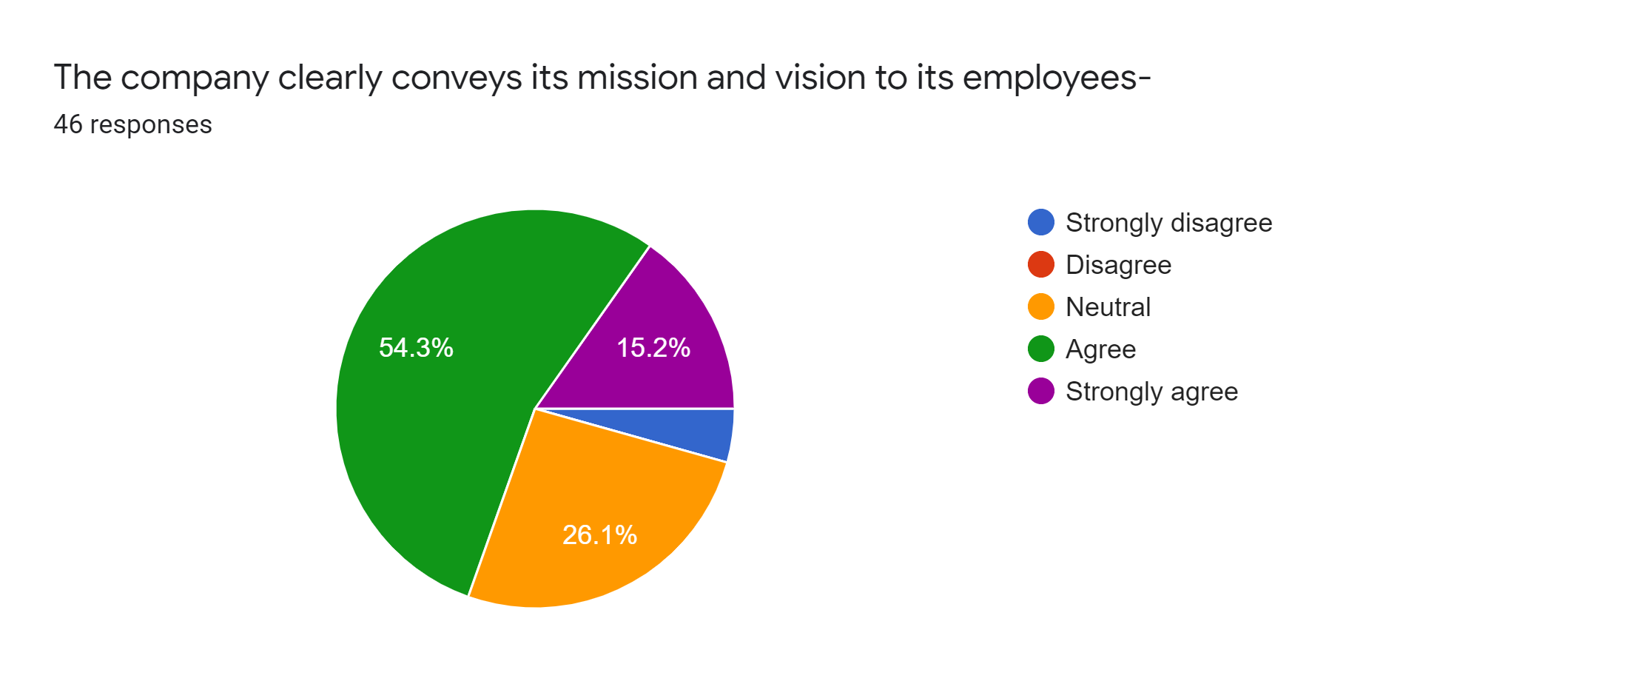
Interpretation:
Out of 46 employees, 54% agreed and 15.2% are strongly agreed that their company clearly conveys its mission and vision to its employees. 26.1% or 12 employees were neutral here and out of these 12 employees 8 are from less than 1 year job experience. Moreover, 2 employees who have strongly disagreed are also have less than 1 year job experience. Therefore, it can be said that mostly employees who have below 1 years of job experience are not satisfied in this statement. Additionally, male employees are more satisfied compared to female employees as most of the male employees either agreed or strongly agreed with this statement.

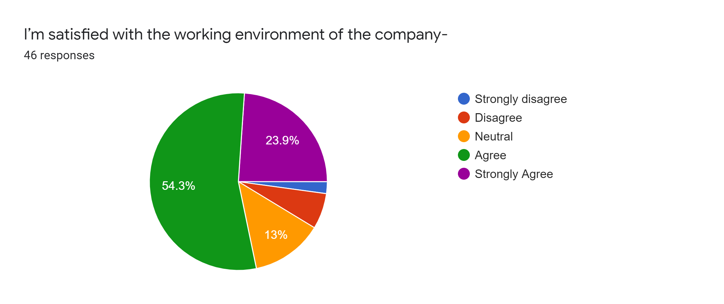
Interpretation:
Out of 46 employees of Dhaka Bank Limited, 54.3% agreed and 23.9% strongly agreed with the statement. The statement also evaluates that mostly the employees who are working more than 1 year in the bank, are more satisfied than the employees who are working less than a year. The satisfied female percentage is higher as 13 out of 18 female employees responded they agree with the statement. On the other hand, only 19 male responded that they are agree in this statement.
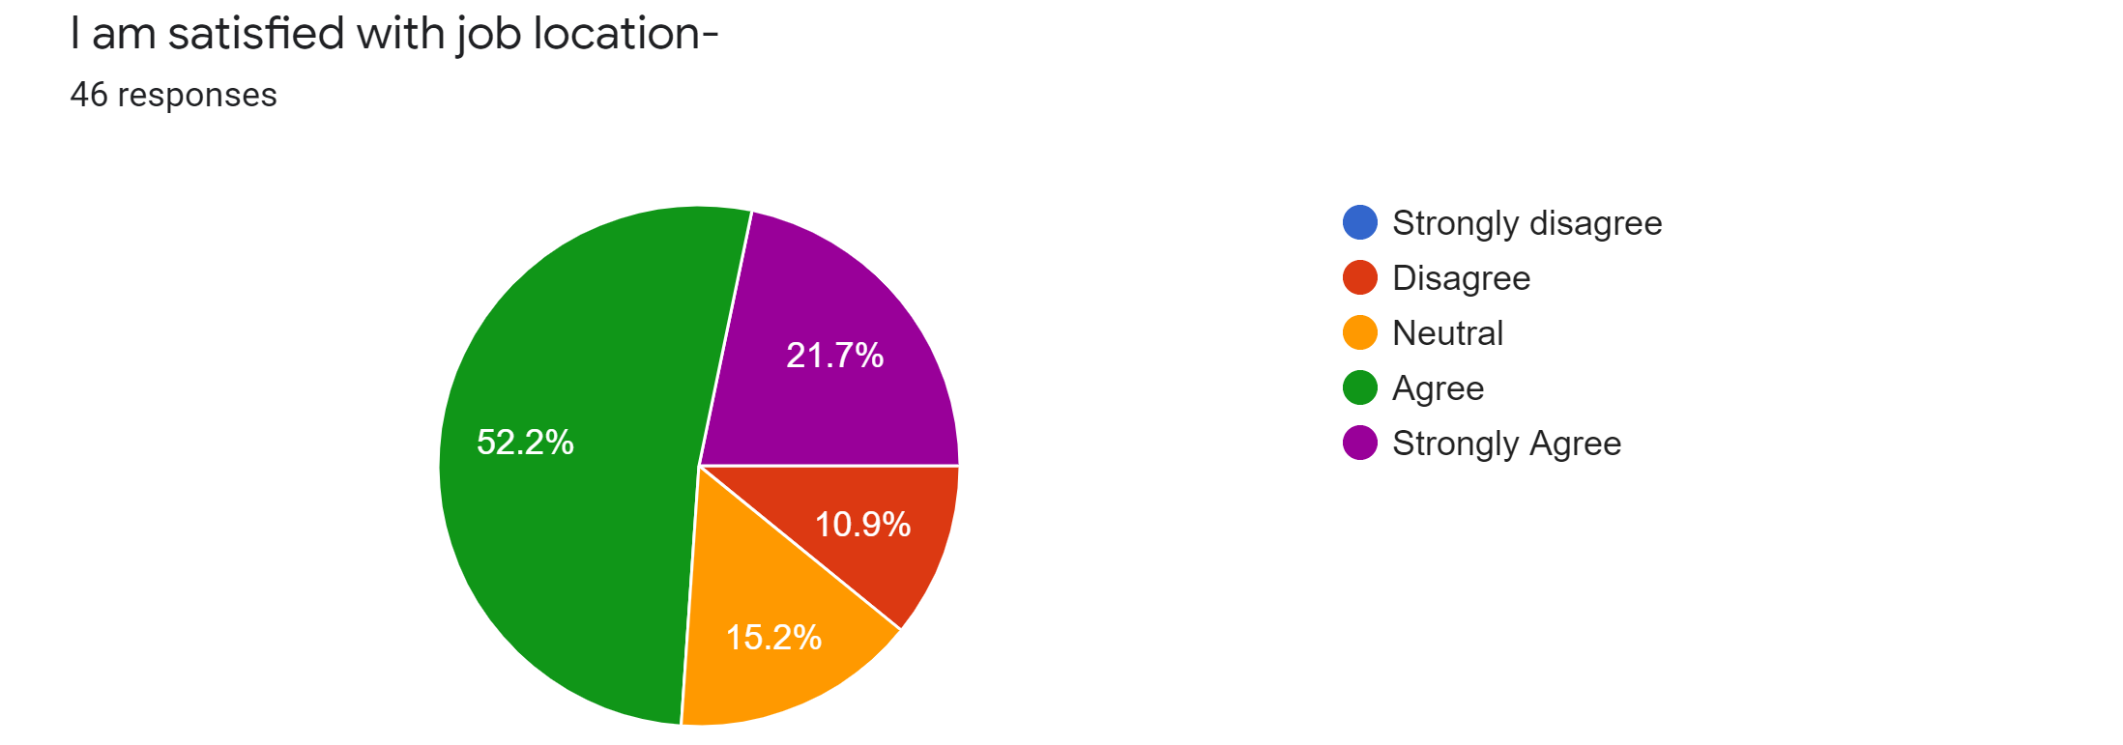
Interpretation:
Job location is an important satisfaction factor, mostly for females in Bangladesh. Out of 46 respondents, 52.2% agreed and 21.7% strongly agreed with their job location, however, 10.9% or 5 respondents also disagreed and 15.2% or 7 respondents were neutral also.
After analysing the satisfaction level based on gender, it is found that only 10 female employees are satisfied out of 18 female employees while 24 male respondents were satisfied with their job location. Mostly the employees who are working in Dhaka Bank for 4-6 or more than 6 years are found satisfied compared to the new employees.

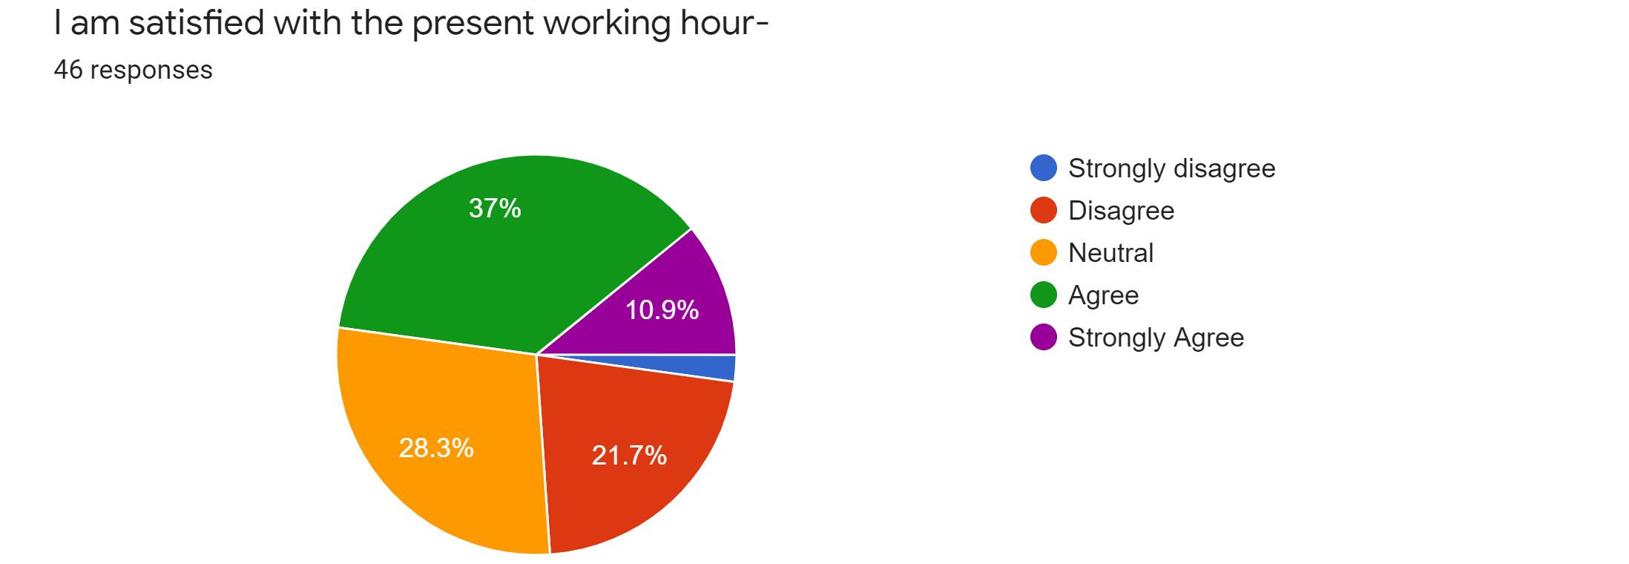
Interpretation:
In Dhaka Bank, job duties start from 9.30 A.M. to 5 P.M. There are a launch break at 2 P.M to 2.45 P.M. However, to identify whether employees are satisfied with this long 8 hours of job responsibilities, this statement were added. It is found that out of 46 employees, 37% agreed and 10.9% strongly agreed with the statement while mostly disagreed. The employees working less than 1 year are much dissatisfied with their present working hour.
A total of 12 female employees have marked neutral and disagree shows that female employees are much dissatisfied compared to male employees with their working hour.

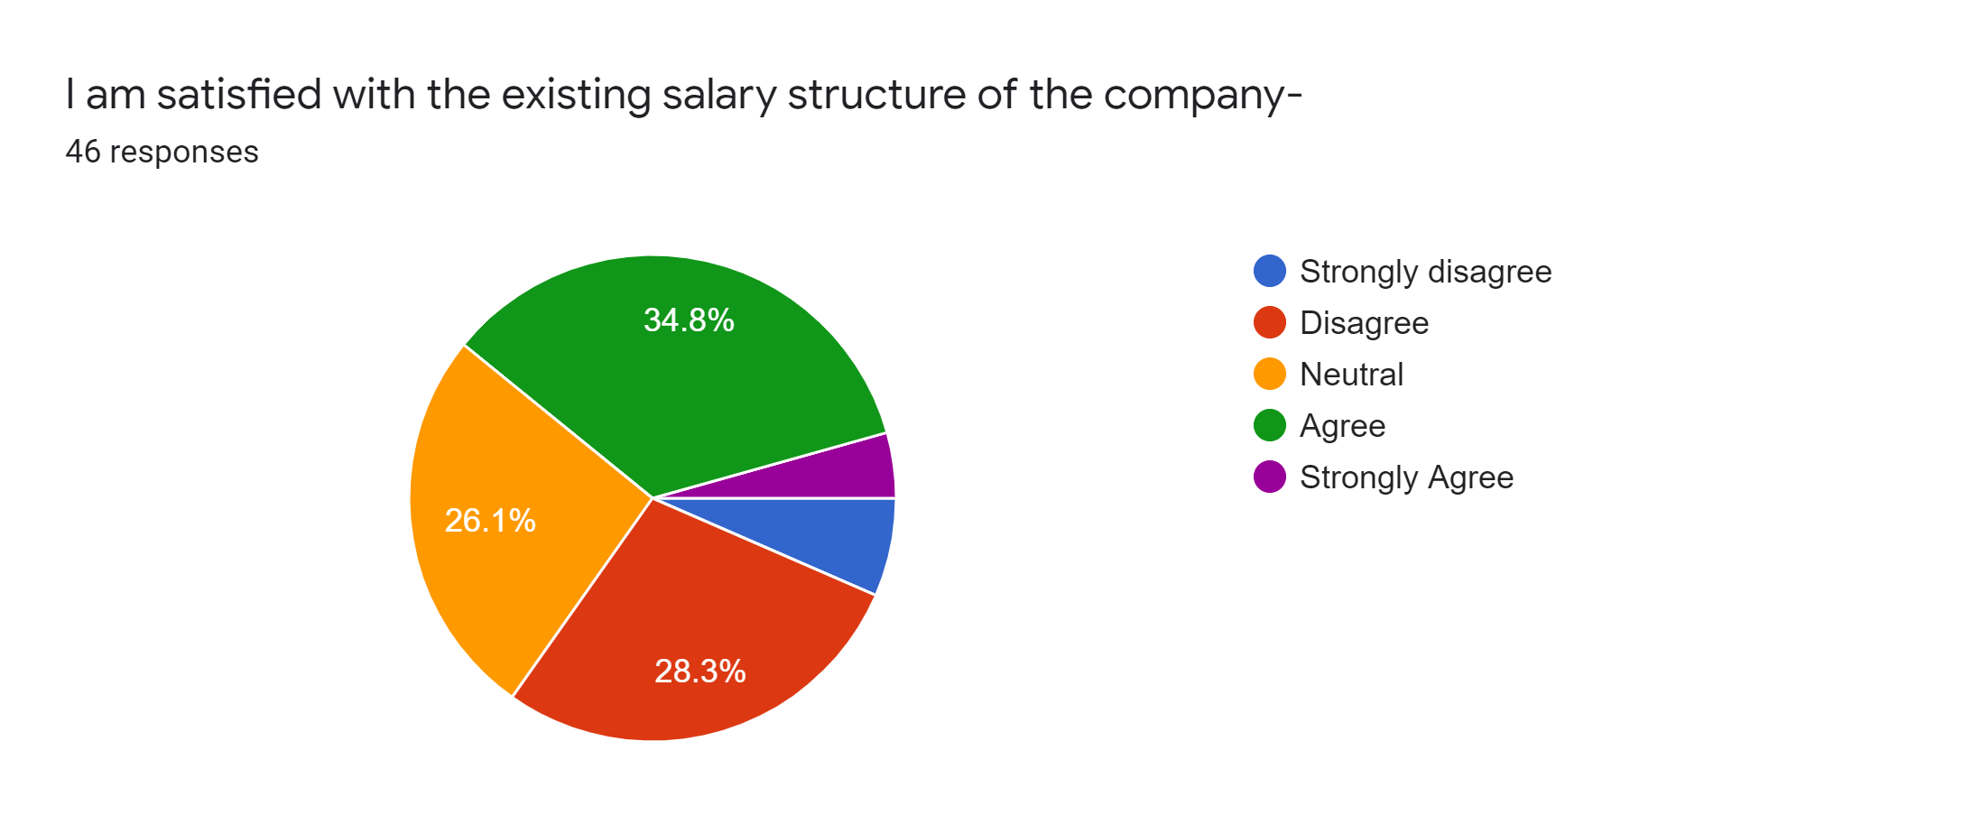
Interpretation:
Most of the employees are found dissatisfied as only 34.8% or 16 employees agreed and only 2 employees strongly agreed that they are satisfied with their salary structure.
Based on job experience, a total of 23 employees whose job experience is below 1 year or 1-3 years have marked either neutral or disagreed.
Based on gender, male employees are less satisfied compared with female employees with their present salary structure in Dhaka Bank Limited.

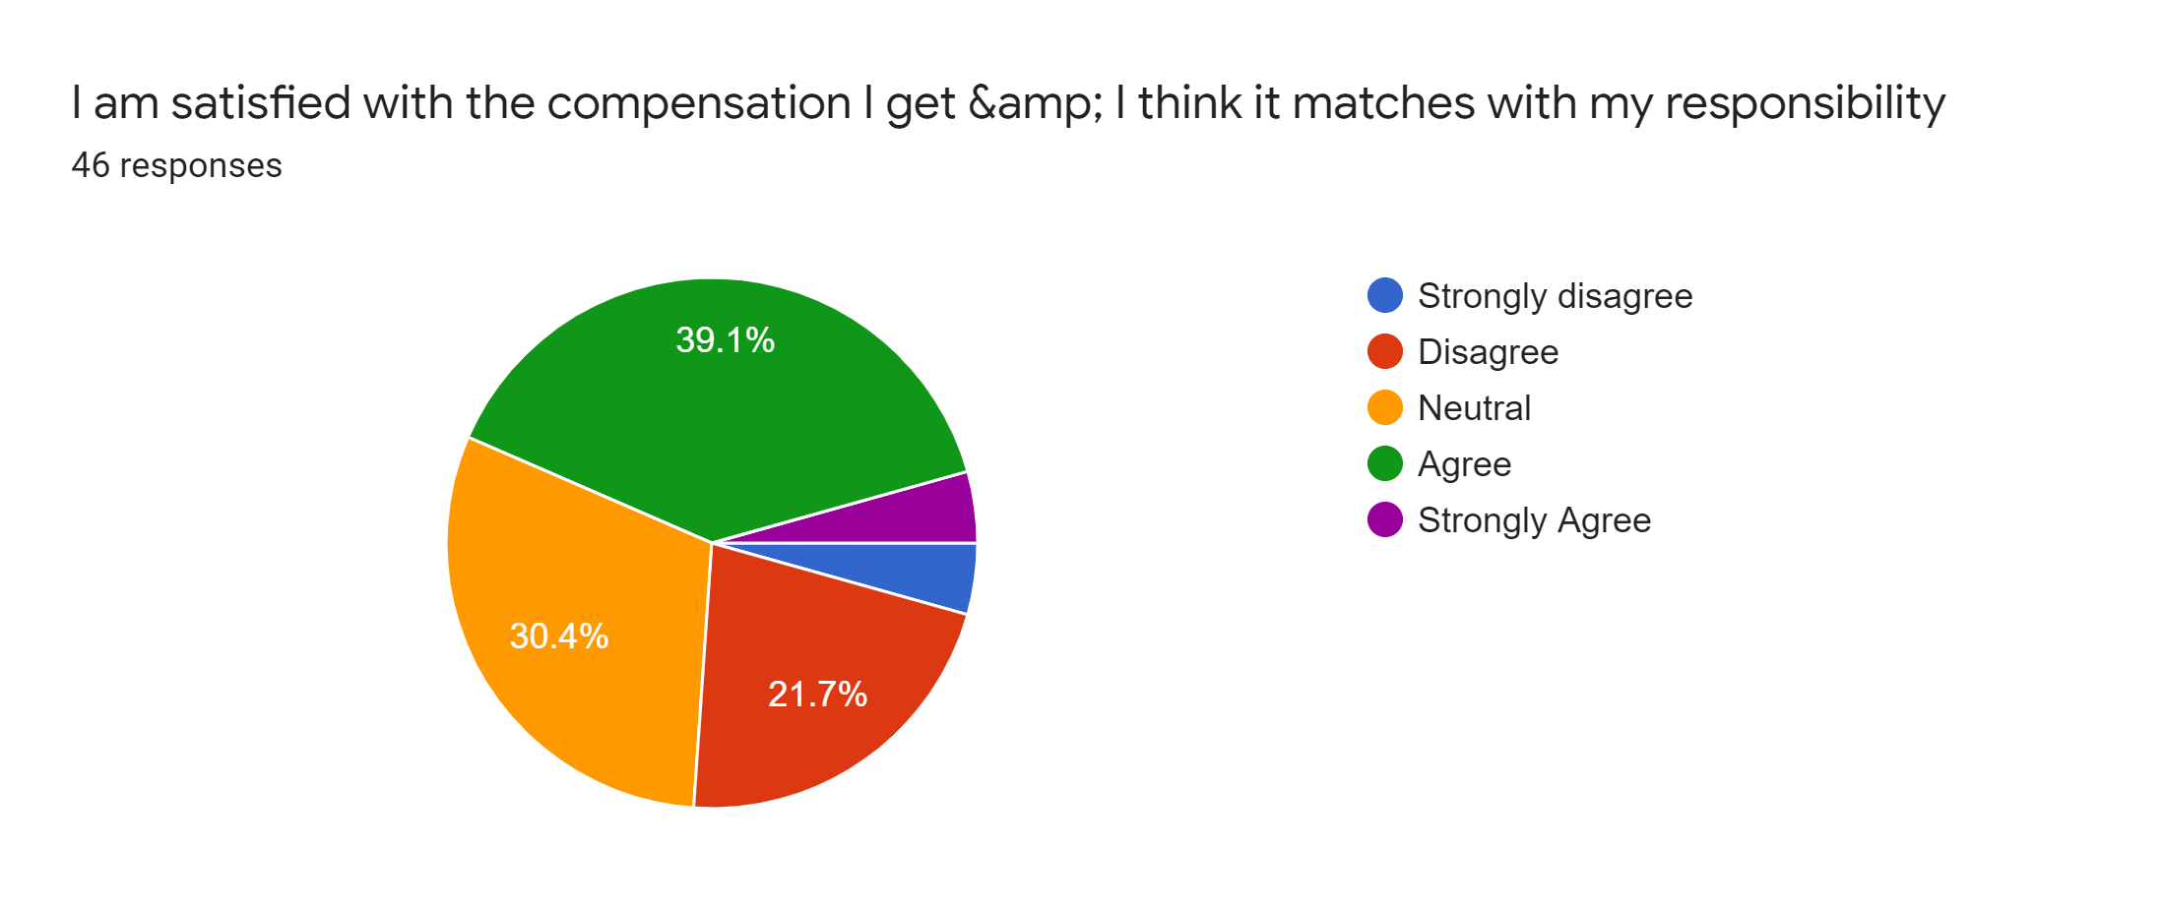
Interpretation:
Most of the employees are not satisfied with the compensation they get as they think it doesn’t matches with their responsibility. Out of 18 employees whose job experience is below 1 year, 15 marked that they are not satisfied. However, the employees who are working for 4-6 years are found mostly satisfied. Additionally, mostly females employees are found satisfied compared to the male employees.
Interpretation:
Most employees are dissatisfied with the compensation they receive because they believe it is not in line with their duties. Among the employees with less than 1 years of work experience, and who have 1-3 years job experience are more dissatisfied than the old employees as most of the employees who have worked for 4-6 years are satisfied. Also, compared to male, most female are satisfied with the present compensation package of Dhaka Bank Limited.

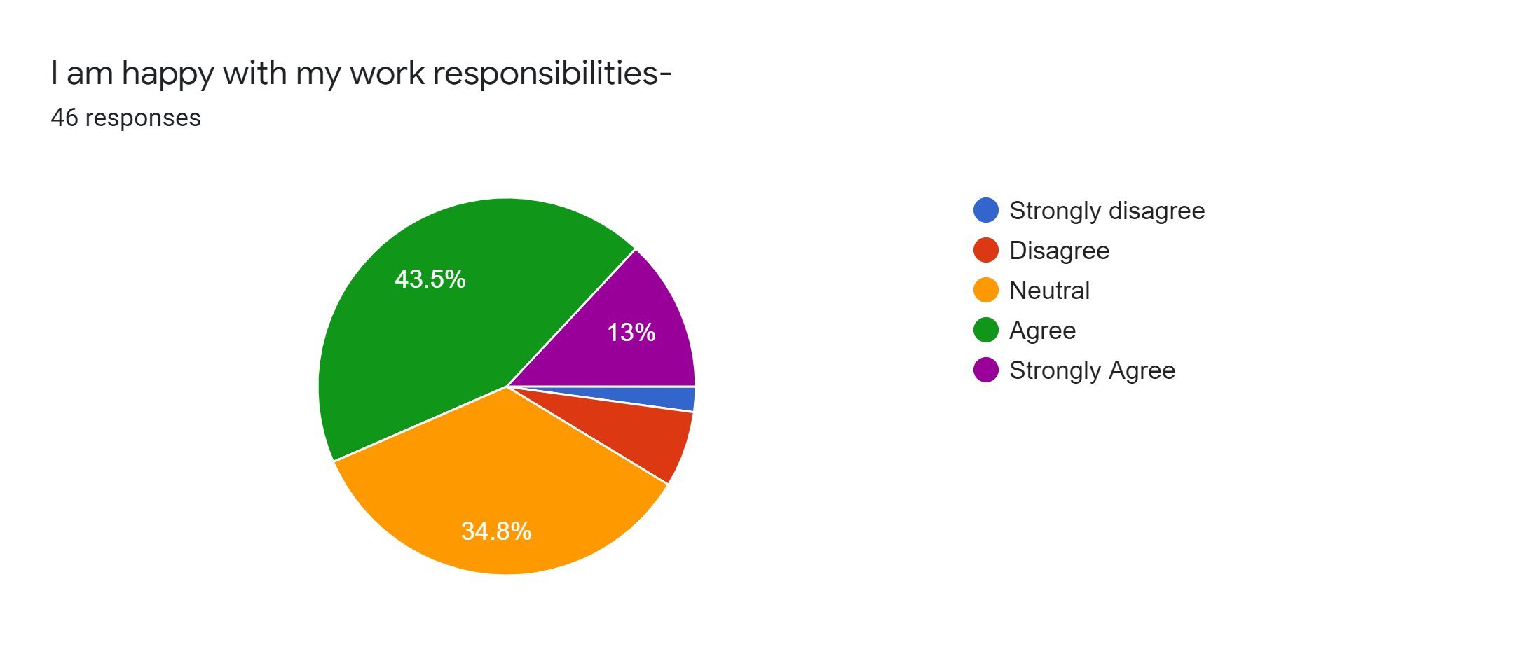
Interpretation:
Most of the employees are found satisfied as out of 46 respondents, 43.5% agreed and 13% strongly agreed with the statement. Junior employees who have job experience of 1-3 years are less satisfied compared to senior employees. Male employees are more dissatisfied than female employees with their work responsibilities.

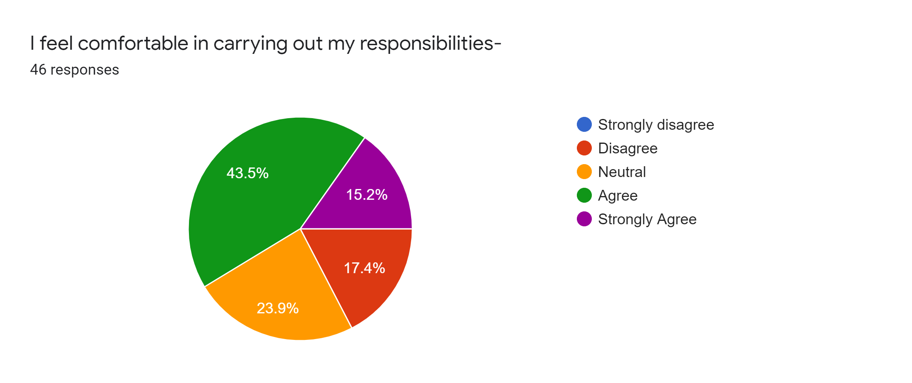
Interpretation:
A total of 60% employees either agreed or strongly agreed with the statement that shows most of the employees are comfortably performing their responsibilities. Among the 5 stages of job experience, 1-3 years of experience holders are found mostly dissatisfied than the old employees. Mostly male are found dissatisfied than the female employees in carrying out their responsibilities.
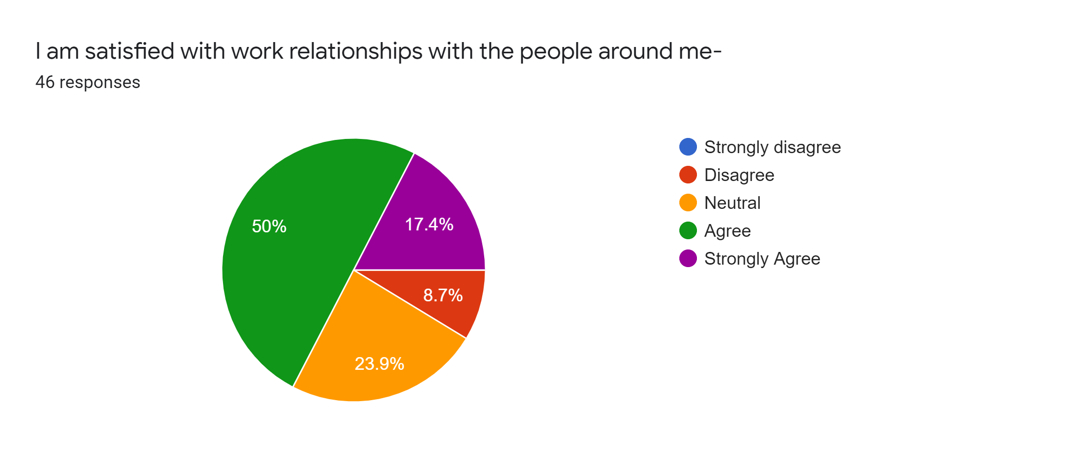
Interpretation:
In total 67.4% employees agreed with the statement. Mostly dissatisfied employees based on job experience are the employees who have 1-3 years of job experience and satisfied employees are who have 4-6 years of job experience. Mostly female candidates have shown dissatisfaction compared to male candidates.
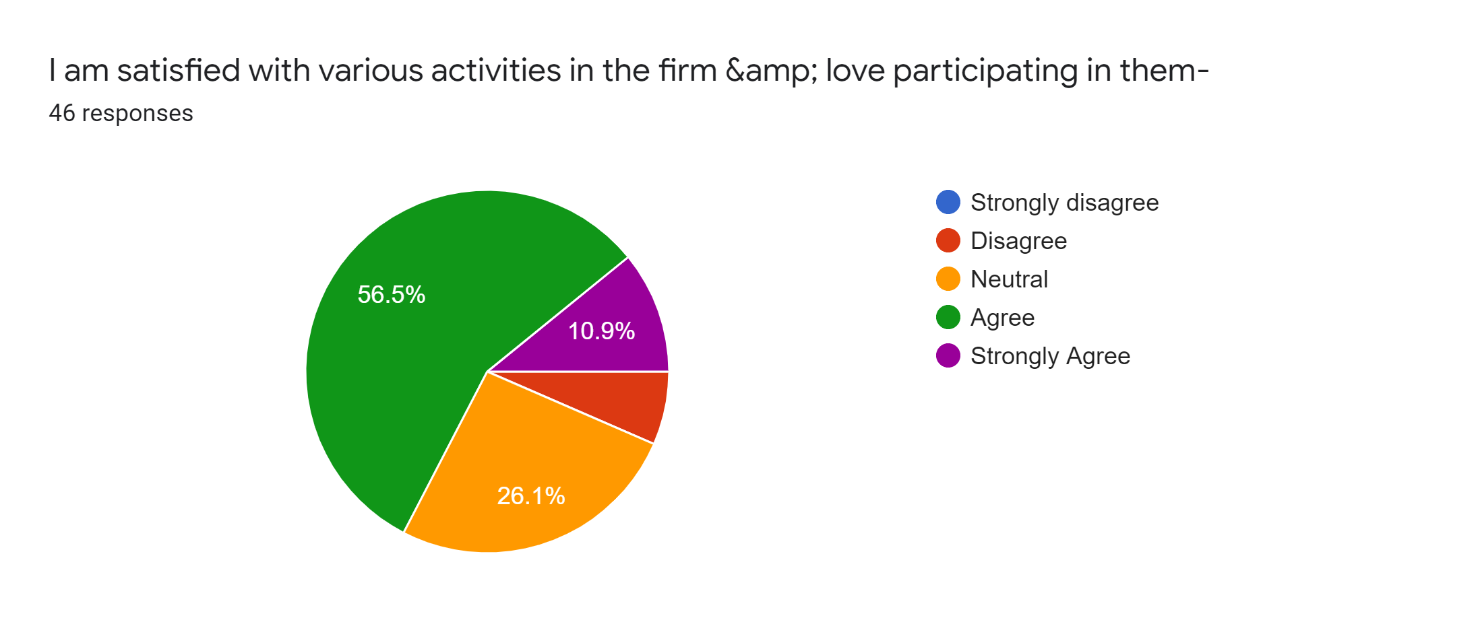
Interpretation:
In total of 67.4% have either agreed or strongly agreed with the statement. The senior employees who have job experience of 4 to above 6 years are mostly satisfied. Mostly female candidates are satisfied with various activities in the bank and love to participate compared to female candidates.
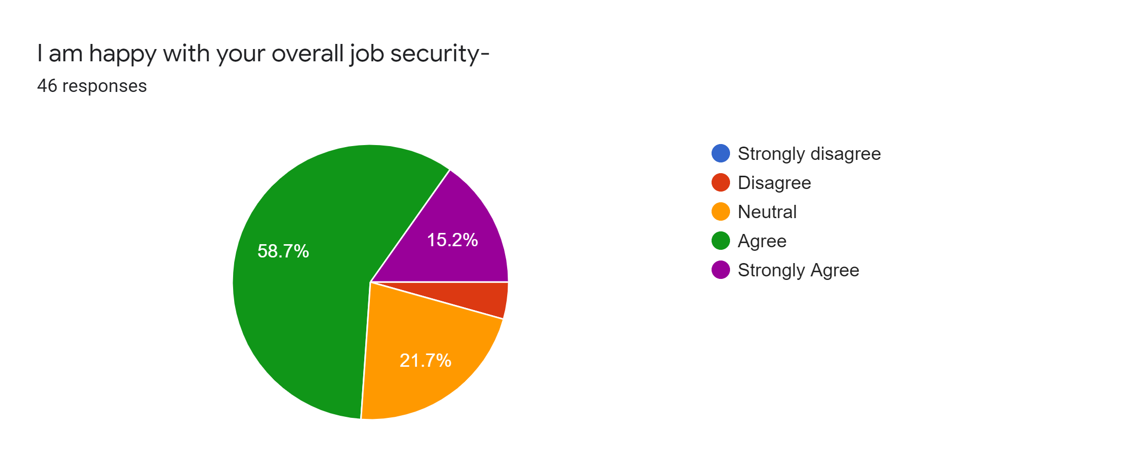
Interpretation:
The statement added to identify whether employees are satisfied regarding job security issues. It is found that 58.7% or 27 employees agreed and 7 employees strongly agreed with the statement that indicates most of the employees are satisfied with their job securities. Based on job experience, it is found that the employees who holds work experience of below 3 years are mostly worried or unsatisfied with their job security compared to older employees. The male employees are found mostly dissatisfied with their jobs than female employees.
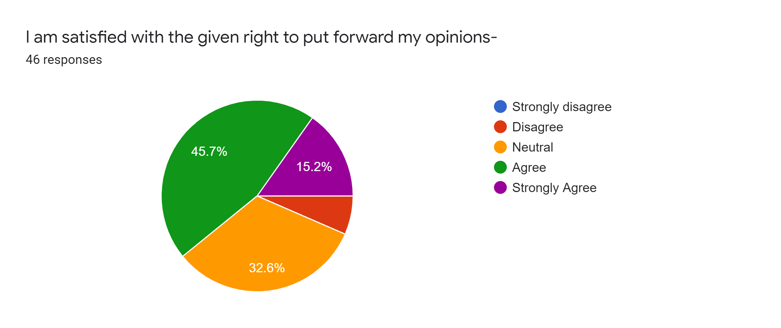
Interpretation:
The statement added because opinion sharing can improve team productivity and increase motivation. Employees feel motivated if they have more easily access sharing their opinion. However, out of 46 employees of Dhaka Bank Limited, 45.7% or 21 employees agreed and 15.2% or 7 employees are strongly agreed that refers that Dhaka Bank Limited given them right to put forward their opinions. According to job experience, the employees who marked disagree have lower that 3 years of experience. The female employees mostly marked disagree refers that female employees are mostly dissatisfied compared to male employees.
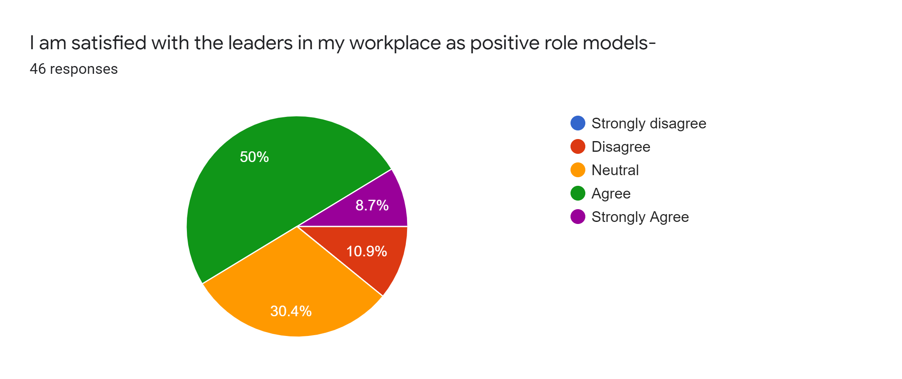
Interpretation:
50% agreed and 8.7% strongly agreed on the statement that shows satisfaction with the leaders as positive role models. Mostly junior employees shows the satisfaction. Mostly senior employees marked neutral. From the gender perspective, Male employees mostly marked agree that shows male employees mostly believe their leaders reflect positive role model compared to female employees.
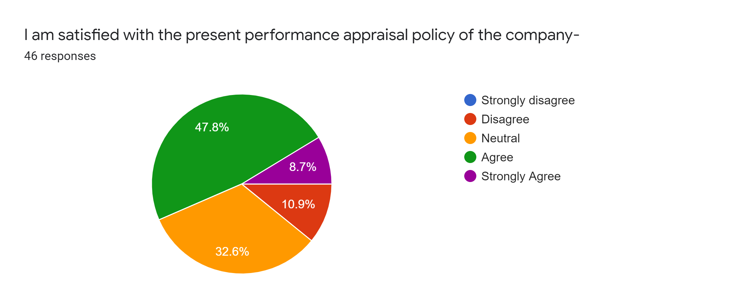
Interpretation:
Mostly employees are satisfied with the present performance appraisal policy of the company as 47.8% marked agree and 8.7% have marked strongly agree. The employees who have over 4 years of experience are mostly agreed in percentage compared to below 3 years of experience holders. Female employees are more satisfied with the present performance appraisal policy than male employees.
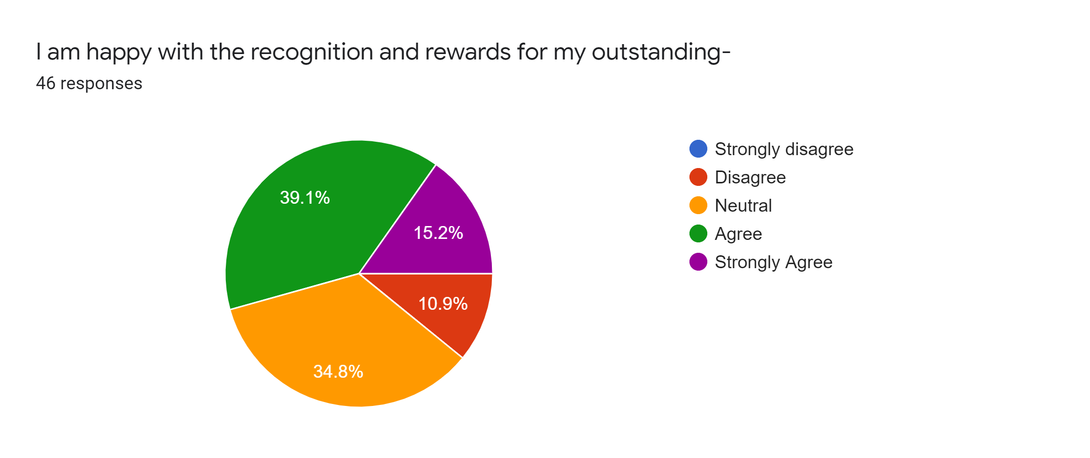
Interpretation:
Both satisfaction and dissatisfaction levels are almost equal in the statement as in total 54.3% employees either agreed or strongly agreed while 10.9% disagreed and a large portion of employees (34.8%) are remained neutral. From job experience perspective, junior employees are dissatisfied than the employees over 3 years of work experience. From gender perspective, male employees are more dissatisfied than female employees.
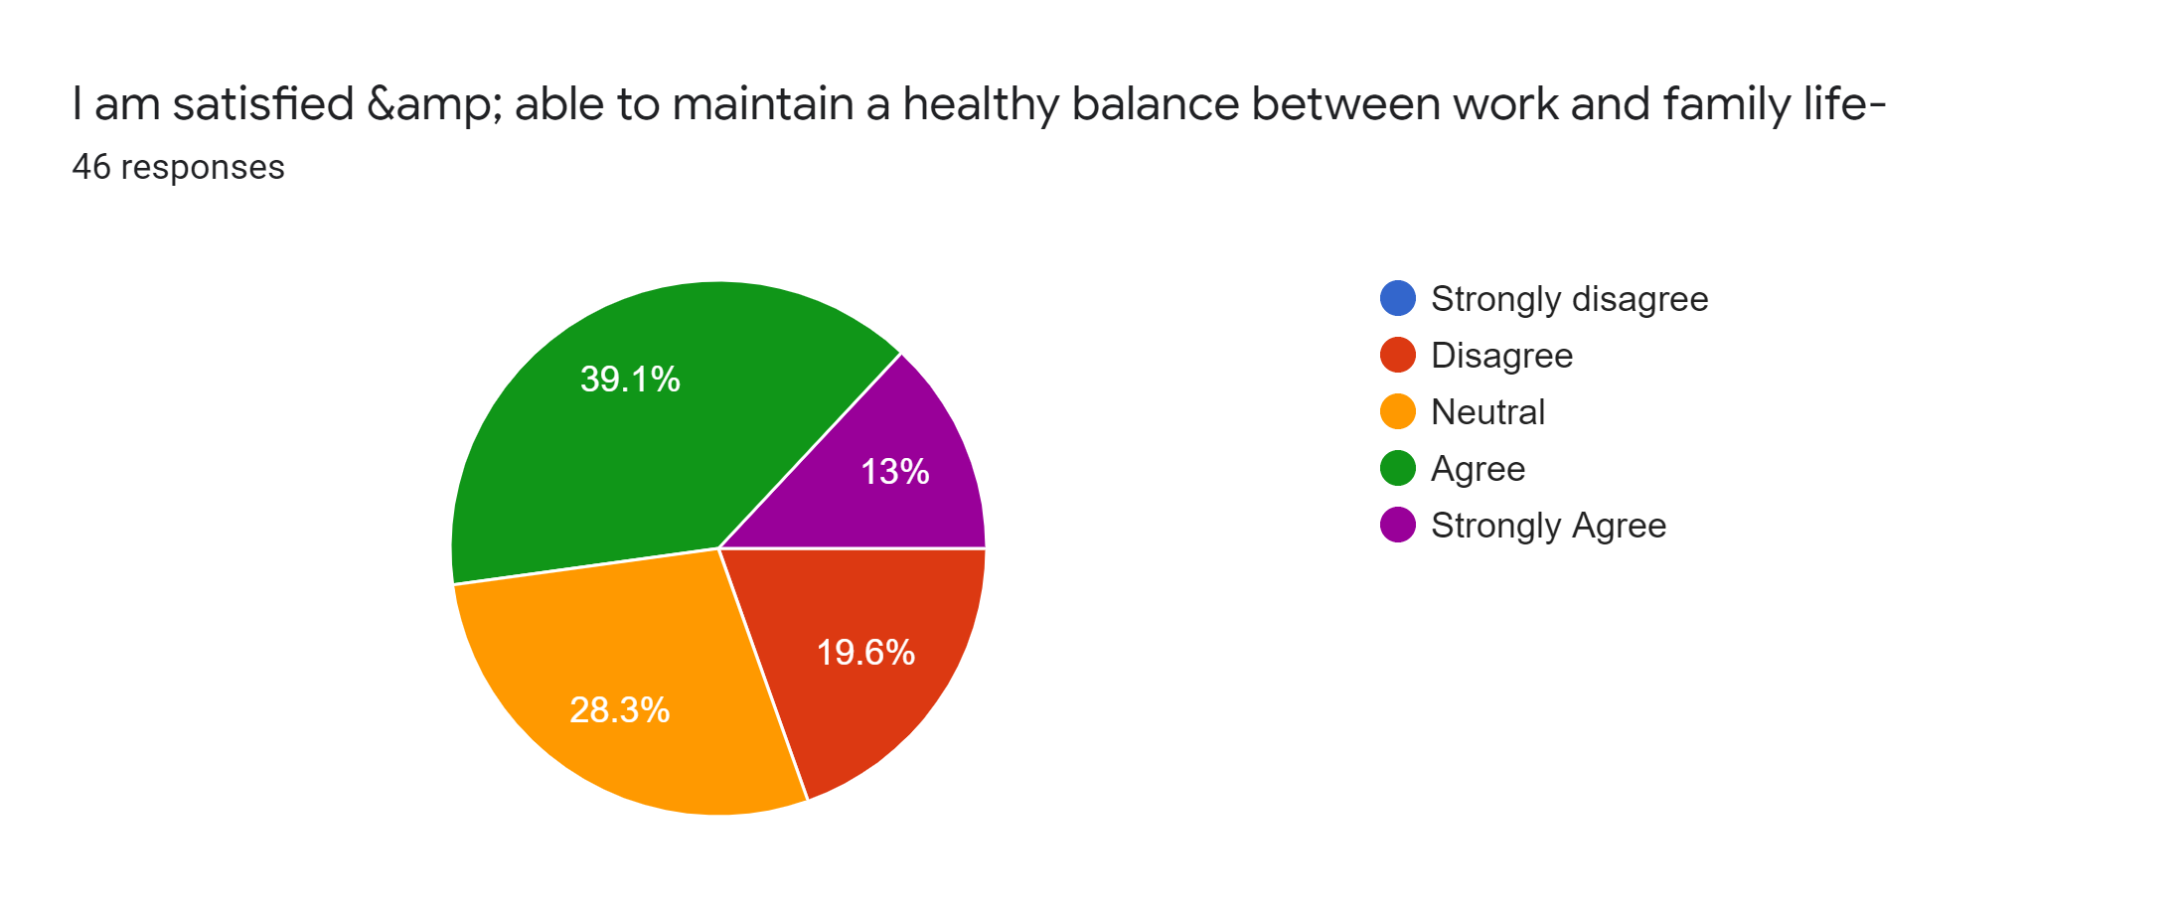
Interpretation:
Work-life balance is an important aspect of a healthy working environment. Maintaining a work-life balance can help reduce stress and prevent burnout. Therefore, the statement is added and found that in total 52% employees are agreed that they are able to maintain a healthy balance between work and family life while rest of 48% employees either disagreed or neutral. From work experience perspective, the employees who have more than 3years of job experience are mostly dissatisfied in this statement. Female employees are most dissatisfied here compared to male employees.
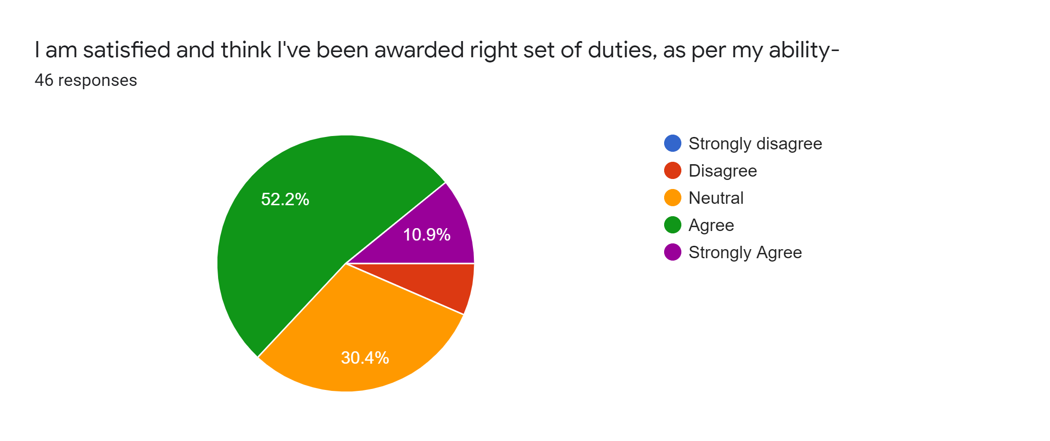
Interpretation:
Mostly (63.1%) employees are agreed as 52.2% are agreed and 10.9% are strongly agreed. The employees are, over 3 years of experience, mostly satisfied than the junior employees. From the gender perspective female employees are more satisfied than male employees.
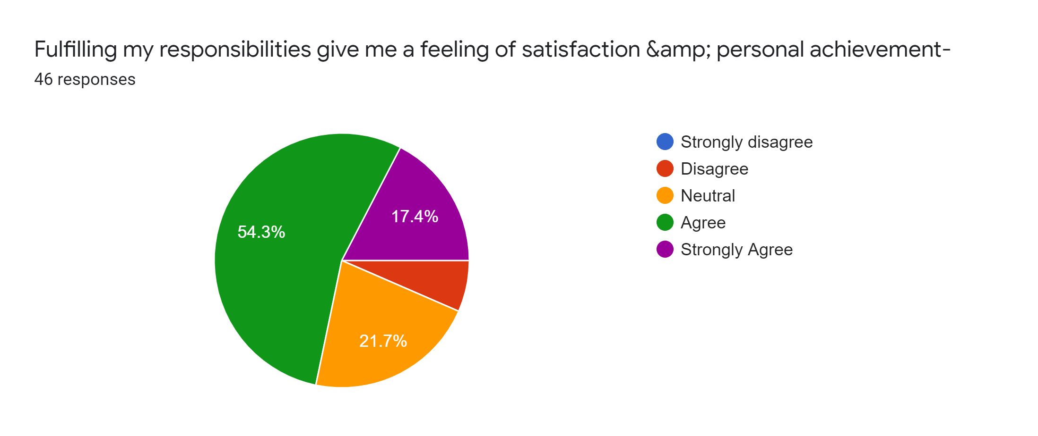
Interpretation:
Employee satisfaction increases employee productivity and increased productivity means more service and value for customers. The statement added here is used to determine whether employees are satisfied after performing their duties well. It is found that most of the employees are satisfied and mostly employees have less than 1-3 years of experience are satisfied than other groups. Male employees are more satisfied than the female employees in terms of fulfilling their duties and personal achievements.

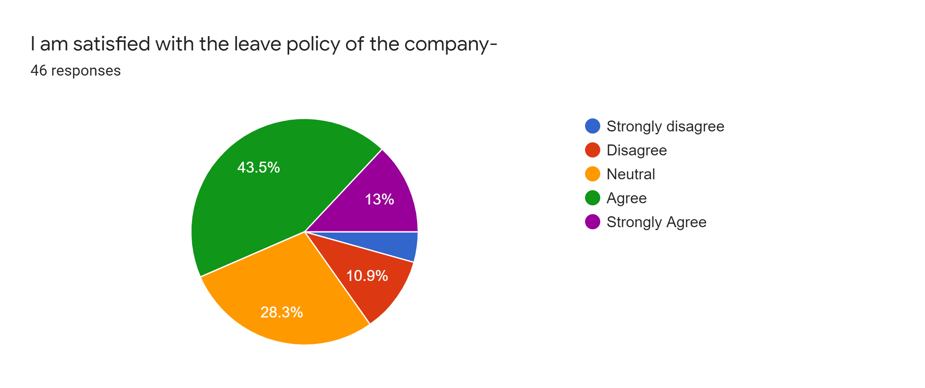
Interpretation:
Most of the employees are satisfied with the leave policy of Dhaka Bank Limited. The employees who have over 3 years of experience mostly marked agree compared to junior employees. Male employees are dissatisfied than the female employees regarding the leave policy of the bank.

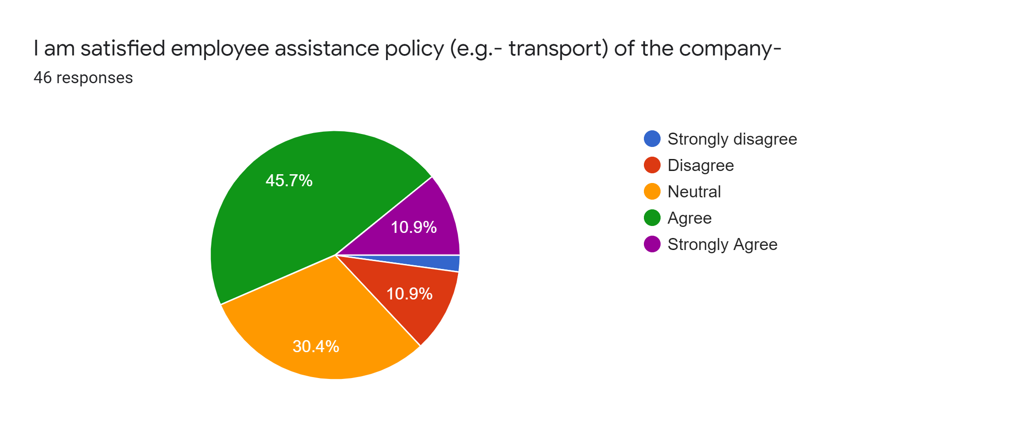
Interpretation:
Mostly employees of Dhaka Bank are satisfied with the employee assistance policies such as transport facilities of Dhaka Bank Limited. 54.7% employees agreed and 10.9% are strongly agreed with the statement. Only few are disagreed or neutral with the statement and among them female employees and senior employees who have over 4-6 years of employees are mostly dissatisfied.

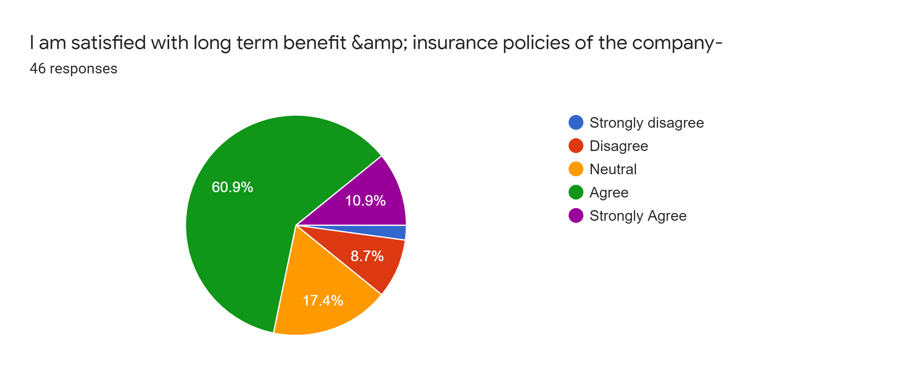
Interpretation:
Out of 46 employees responded in the survey, 60.9% agreed and 10.9% strongly agreed that they are satisfied with long term benefit such as pension and insurance policies of the Dhaka Bank Limited. The employees are more satisfied in this statement are over 3 years of work experience. Male employees are mostly satisfied than the female employees.
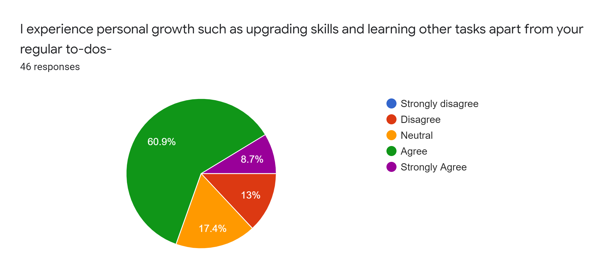
Interpretation:
Out of 46 employees, mostly are satisfied with personal growth opportunities of the bank as 60.9% have marked agree and 8.7% employees marked strongly agree. Only 13% employees have marked disagree and 17.4% marked neutral here. Out of 13% disagree employees, junior male respondents are higher than the female or senior employees.

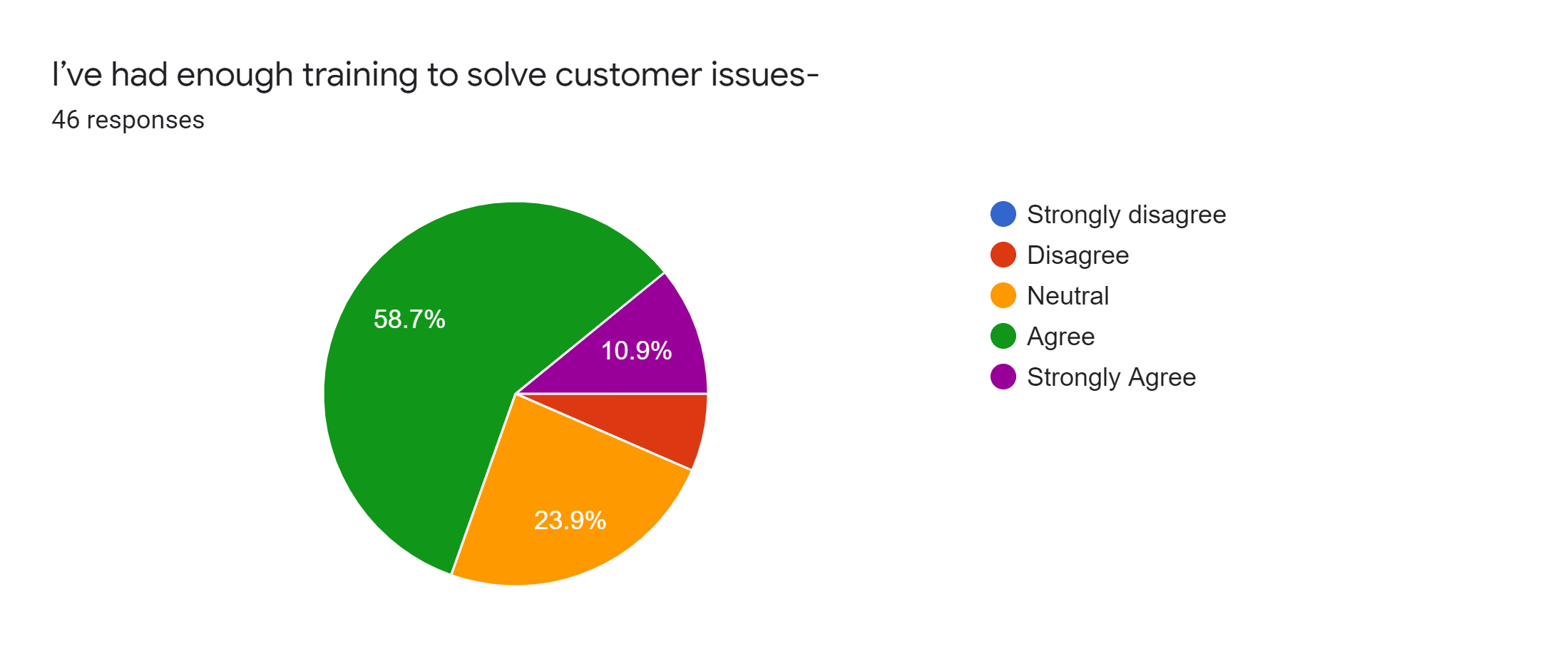
Interpretation:
58.7% or 27 employees have marked agreed and 10.9% or 5 employees have marked strongly agreed on the statement that refers most of the employees are satisfied with their training to solve customer issues. Only 6.5% or 3 disagreed with the statement, out of them mostly have 1-3 years of work experience and are female.

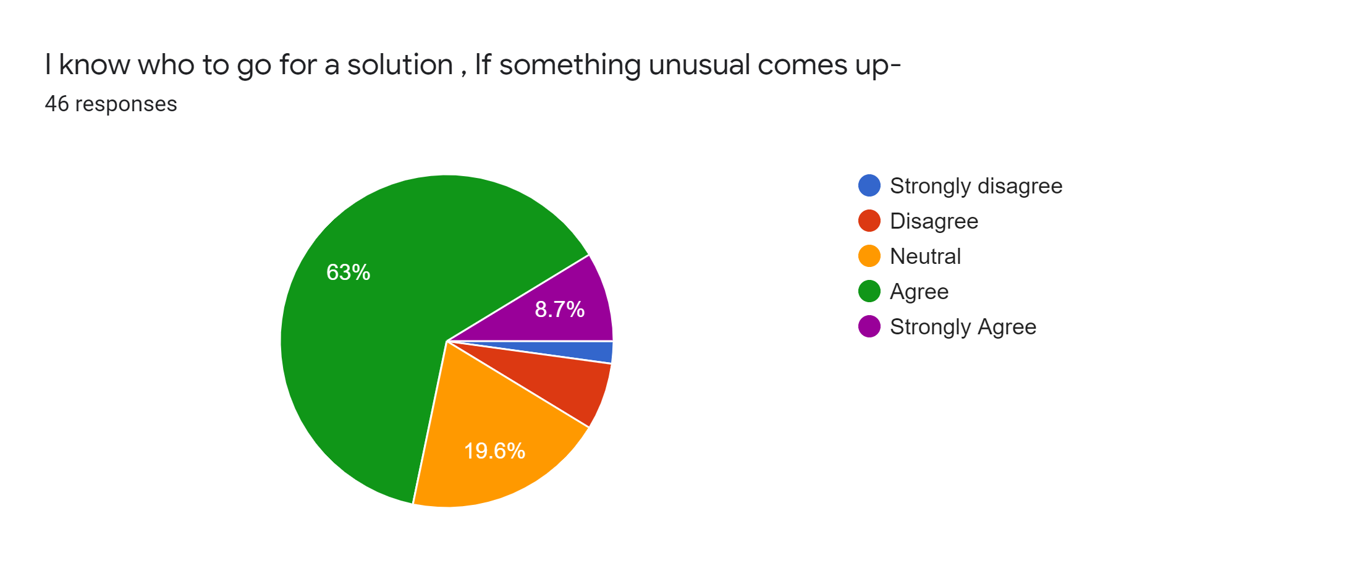
Interpretation:
63% or 27 employees have marked agree and 8.7% or 4 employees have marked strongly agree that refers most of the employees know who to ask for solutions if any unusual issues arrives. Only 1, male and below 1 year of experience, employee marked strongly disagree and 6.5% or 3 employees have marked disagree where 1 is junior female and 2 are junior male employees who have less than 1 years of experience.

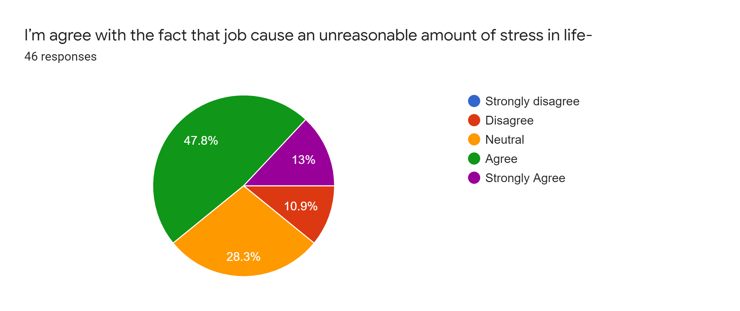
Interpretation:
Most of the employees agreed that their job causes an unreasonable amount of stress in life that reflects dissatisfaction. Out of 46 employees, 47.8% agreed with the statement and 13% strongly agreed. Among the ratio of male and female which is 28:18 or 14:9, mostly male employees along with 1-3 years of work experience have marked that their job causing unreasonable amount of stress in their daily life.

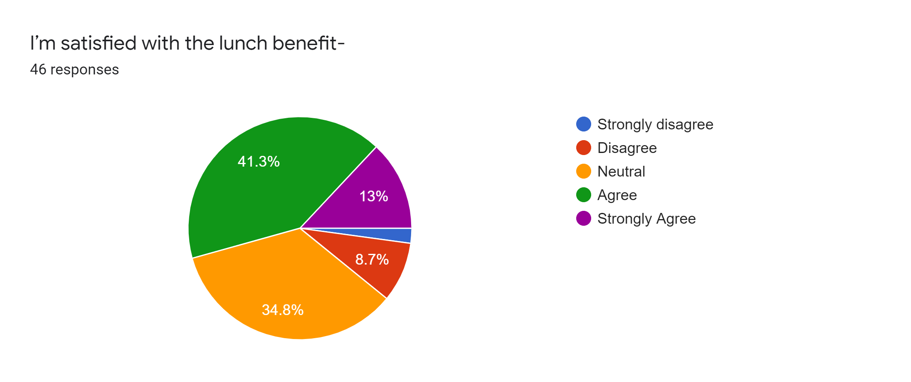
Interpretation:
Dhaka Bank provides lunch each day and a significantly small amount of money is deducted from each employees every months. To identify whether employees are happy with their lunch option, this statement were added. The pie chart illustrates most of the employees are satisfied with the lunch benefits. The few employees (8.7% or 4) who have disagreed, mostly from the 4-6 years of work experience. From gender perspective, most of the disagreed employees are male.

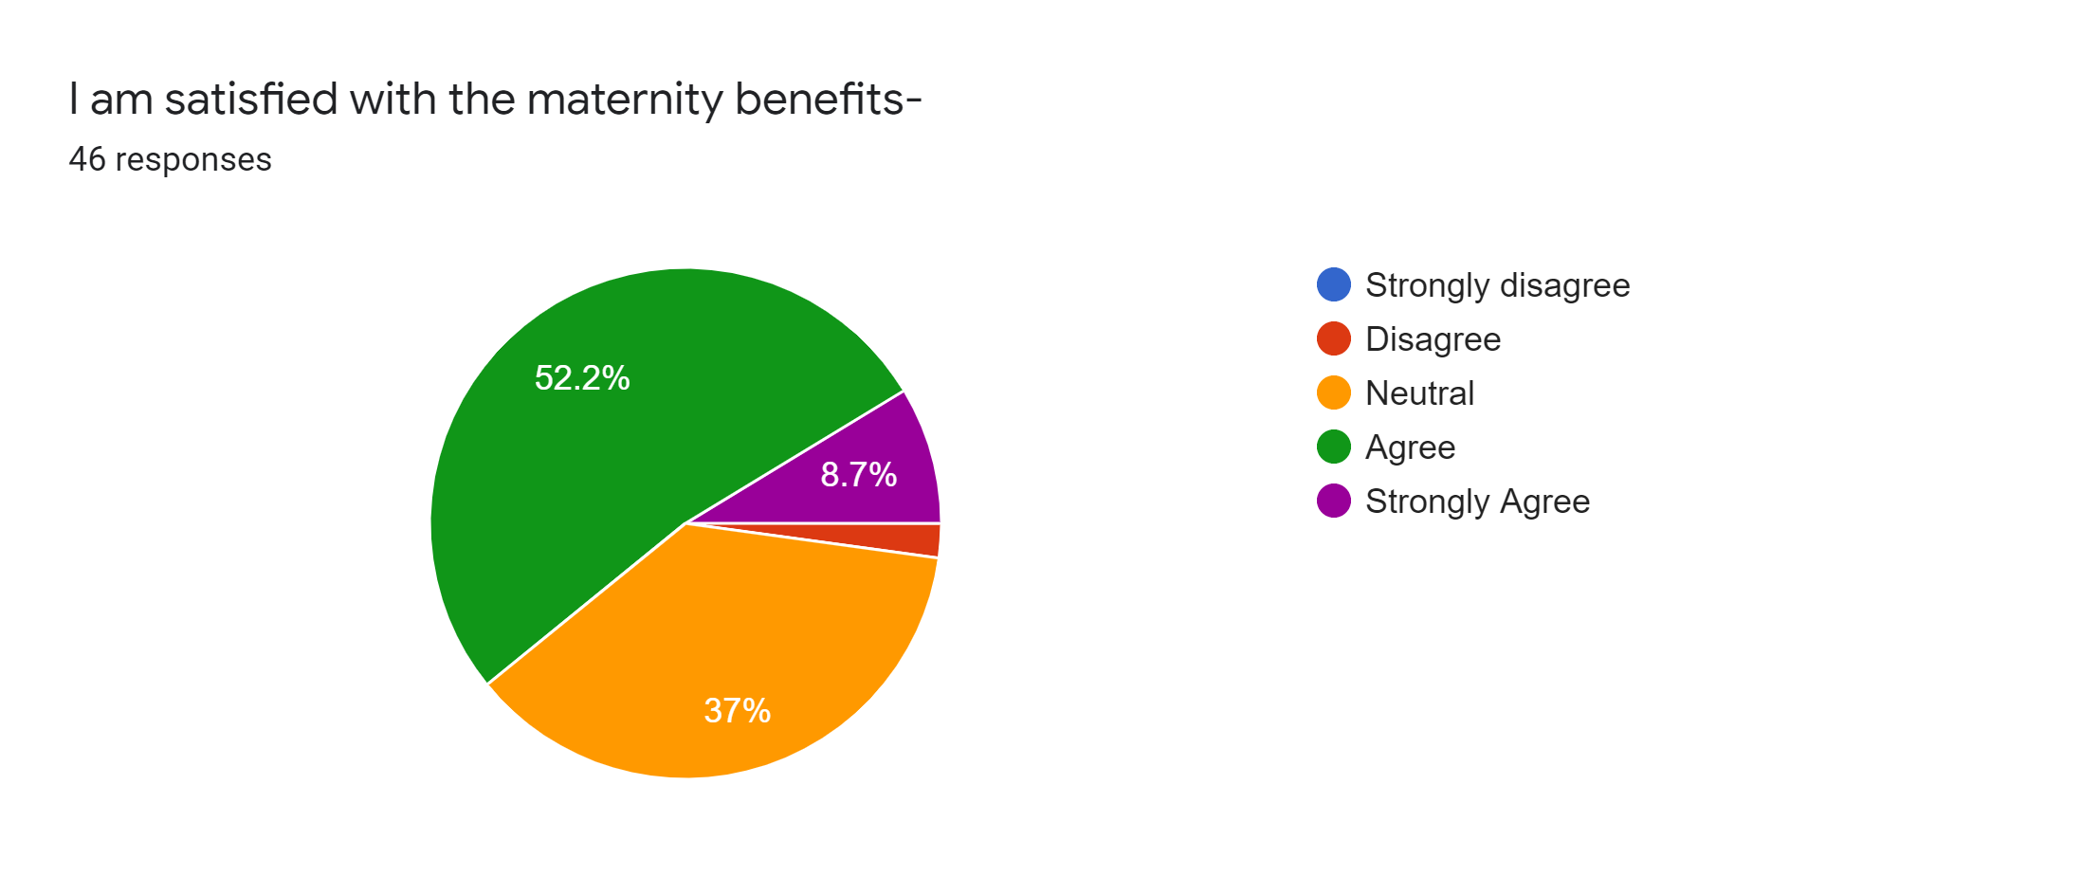
Interpretation:
Maternity leave states to the period of paid leave. It can be referred to as vacation time approved for delivery and caring for a newborn baby. Out of 46 employees, mostly agreed with statement. Significant portion of female employees agrees with the statement refers they are satisfied with the maternity policy of Dhaka Bank Limited. However, a large proportion of male employees who have 4-6 years of work experience have marked neutral and disagree in this statement.
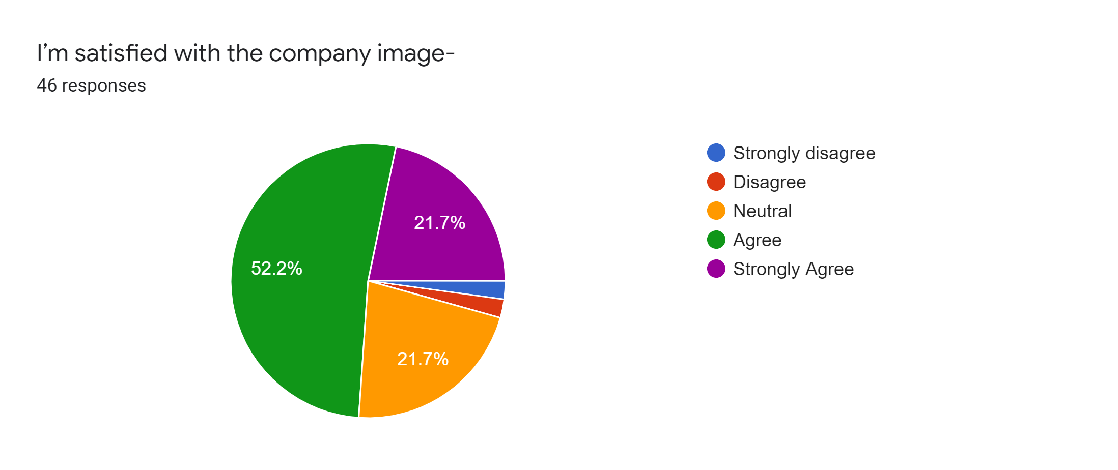
Interpretation:
About 70% of the employees shows their satisfaction on this statement. The large proportion of employees who have either marked neutral, disagree, or strongly disagree have less than 1 years of experience and mostly are male in gender.

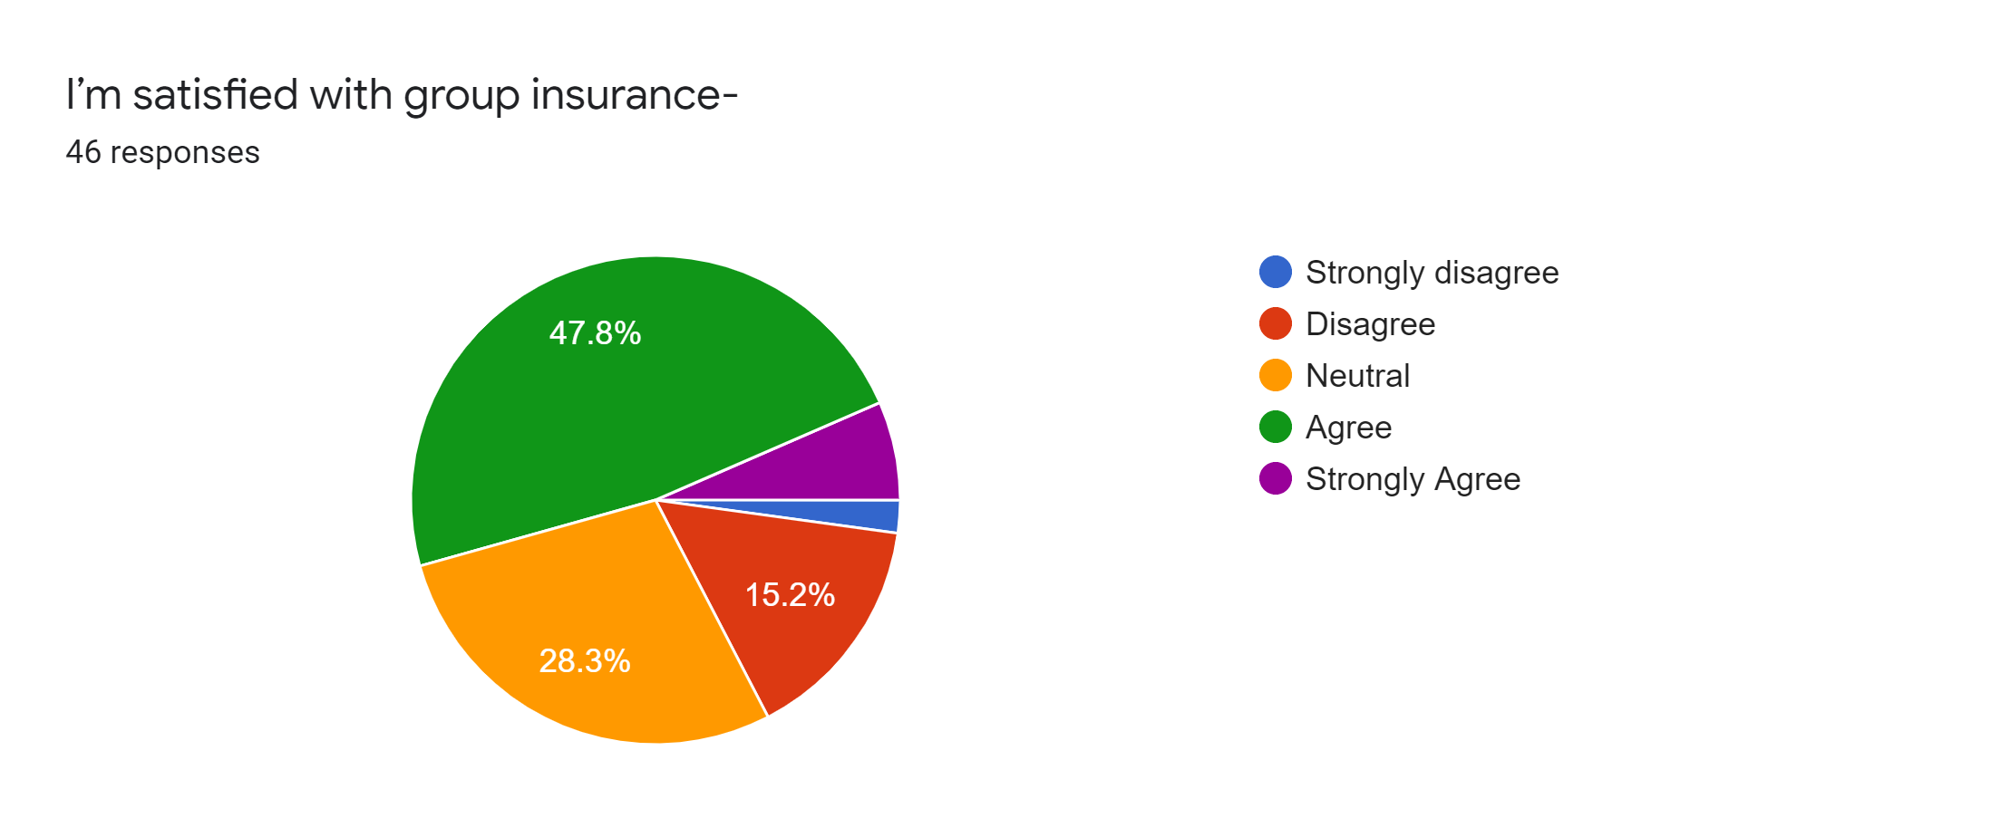
Interpretation:
Dhaka Bank provide group insurance facilities from beginning of the third year of joining of an employee. In this statement, the percentage of satisfied employees and the percentage of dissatisfied employees are quite similar, though the satisfaction level is higher in 4%. However, mostly the junior and male employees have marked disagree and neutral as their group insurance will start in 1 or 2 years later.
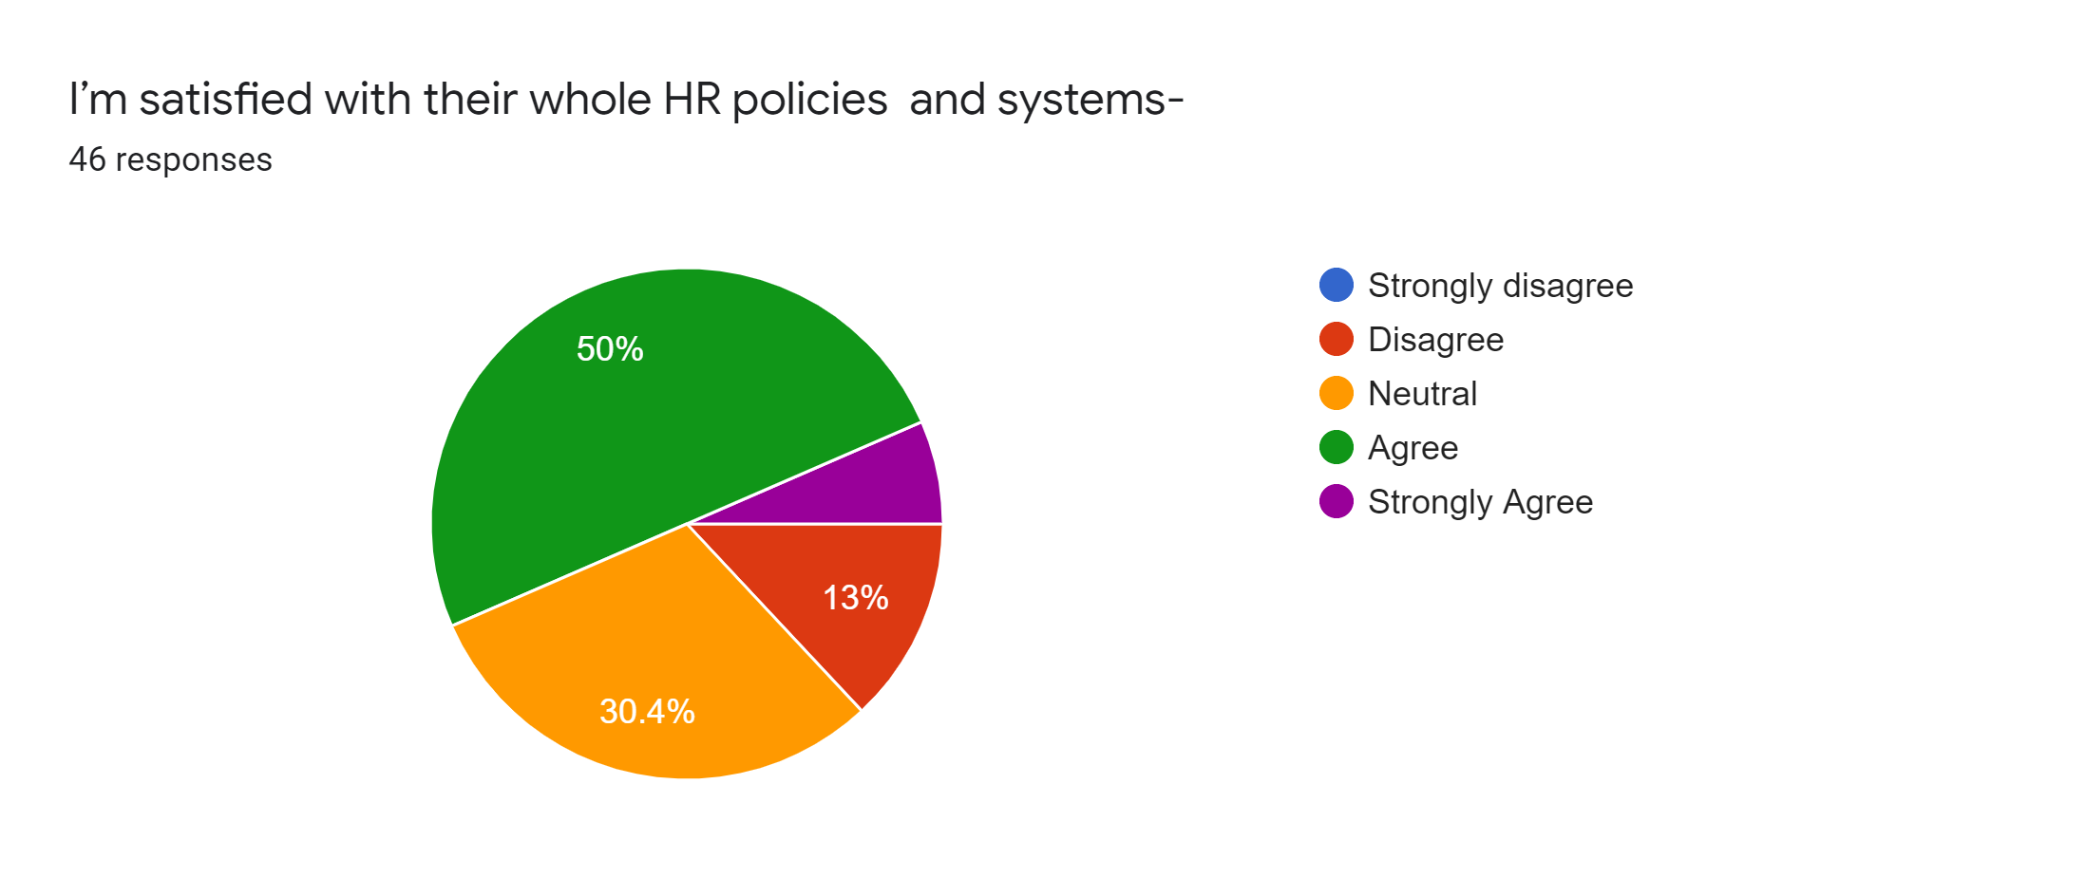
Interpretation:
Most of the employees of Dhaka Bank shows satisfaction as 50% or 23 employees have marked agree and 6.5% or 3 employees have marked strongly agree. It refers most of the employees are satisfied with their HR policies and systems. The employees who are disagreed or neutral, are mostly male employees and have less than 1 years of work experience at Dhaka Bank Limited.

4.4 Findings of the survey:
Throughout the survey, a total of 30 satisfaction relevant statements were given to identify the satisfaction or dissatisfaction factors in Dhaka Bank Limited. It is found that out of 30 statements, only 3 are found where employees are dissatisfied which refers that majority of the facilities that Dhaka Bank Limited provides to its employees are successful. However, the dissatisfactory factors are listed below to help Dhaka Bank Limited to improve their employee satisfaction level.
- From the work experience perspective, it is found that employees who have less than 1 year to 3 years of experience are mostly dissatisfied with various issues of Dhaka Bank Limited compared to the older employees who have more work experience than the junior employees. Therefore, it can be said that the employees who have over 3 years of work experience are more satisfied than the fresher’s or junior employees.

- From the gender perspective, the male employees are found more dissatisfied than the female employees of Dhaka Bank Limited.

- Most of the employees out of 46 are not satisfied with the present working hour of Dhaka Bank Limited as a total of 24 respondents showed dissatisfaction where 1 marked Strongly Disagree, 10 marked Disagree and 13 preferred to stay neutral. Though 17 respondents agree with the statement and 5 respondents strongly agreed with the statement.

- Most of the employees out of 46 are not satisfied with the existing salary structure of Dhaka Bank Limited as a total of 28 employees shows dissatisfaction in the survey where 3 respondents marked strongly disagree, 13 marked disagree, and 12 marked Neutral. Though, 16 agreed and 2 strongly agreed with the statement.

- Most of the employees out of 56 are not satisfied with the compensation packages provided by Dhaka Bank Limited. Moreover, they think the packages doesn’t match with their responsibilities. A total of 26 employees shows dissatisfaction in the statement where 2 strongly disagreed, 10 disagreed, and 14 marked neutral, although 18 agreed and 2 strongly agreed with the statement.

Chapter Five: Recommendations and Conclusion



5.1 Recommendations
Throughout the employee satisfaction study, Dhaka Bank Limited's employee dissatisfaction components are basically recognized as the effect of disappointed employees who can move from high turnover and low profitability to loss of salary, and customer support. While the bank's mind-set, mission, and qualities are critical to progress, human resources are a bank's most important resource. Therefore, the bank's human resources, its employees, have to be completely attached and happy with Dhaka Bank to continue working.

Recommendations to improve the dissatisfied factors identified from the survey findings are as follows:

- To improve the present working hour
The increasing importance of competition and technological progress has forced organizations to become more competitive, requiring employees with higher skills and multitasking ability to keep up with lower operating costs. Therefore, in the age of globalization and competition, employees often face challenges in achieving good results and spending most of their time at work. Organizations that do not provide employees with opportunities to reconcile their work and private life may face growing dissatisfaction and low productivity employees, and will slowly burn to death (Gupta, 2016). According to the OECD Index (2017), working long hours will harm employees' health, jeopardize safety, and lead to stress. It has also been observed that in OECD countries, an average of one-eighth of employees work more than 50 hours per week, while 62% of OECD employees work full time or about 15 hours of personal care and leisure.

In addition, Work overload occurs because individuals' excessive work demands exceed their capabilities, which hinders the normal progress of work. Heavy workload indicates work pressure from employees, leading to serious health problems and an imbalance between work and family life. Previous researchers have found that there is a negative correlation between excessive workload and employee well-being (Kumarasamy, Panggil, Isa, 2015; Kinman & Jones, 2008; Astin & Astin, 1999). Shah, Jaffari, Aziz, Ejaz, Ul-Haq, Raza (2011) report that large organizations assign a large number of tasks to employees more frequently in a limited time. This type of assignment can put pressure on employees and motivate them to engage in professional and personal life.

Furthermore, flexible work options are actually the rule in today’s financial institutions, but not the exception. This helps reduce the overall cost of the bank. This is a challenge, but it seems that employees and firms define flexible work hours in different shapes in their respective fields depending on the size, location and other factors of the company. An innovative employer can change the working hours of certain employees in a limited way.

Dhaka Bank Limited must consider the factors related to employee working hours (e.g. Work life balance, Work pressure, and Flexible working hours) and plan to restructure the working hours in accordance with the employees necessity to utilize their productivity and to retain them.

- To improve the existing salary and compensation structure
Dhaka Bank Limited is expected to restructure the salary structure of its employees because most of them are not satisfied. We know that maintaining a solid wage structure is essential for any organization. If the salary structure is not synchronized with the overall job market, the company may find that it pays employees too much and unnecessarily increases operating costs, or pays employees too little to attract and retain talent.
In order to restructure wages, Dhaka Bank Limited can consider the following steps:
- Regular Inspections or Inspections Relating to Specific Events: Typically, the Human Resource department of Dhaka Bank Limited should inspect the overall wage structure at least once every three to five years. The review should determine whether the facility still meets the needs of Dhaka Bank and the labour market.
- Arrange meetings with first-line managers to obtain relevant salary information: In some cases, first-line managers will bring salary structure issues to the attention of the human resources department. The insight of these managers is critical to determining whether there are problems with the salary structure. After all, front-line managers are more likely to hear from employees that they think they can make more money elsewhere before these employees leave the bank.
- Link the salary structure to the HR strategy and the market: In order to align the compensation structure to the company's objectives, connect the HR strategy to a clear salary compensation philosophy, which will provide a framework based on competitive market position and other factors, including regional economic conditions.
- Look extensively if necessary: Depending on the bank and its talent needs, the salary structure may need to reflect broader market forces. Especially in the national economy, companies can compete with entities across the country for talent. However, the level of competition may vary by location.
- Communicate the results with employees: Once the bank is ready to change the compensation structure, it is important to educate and communicate with employees about the changes. If the wage structure adjustment rises or falls, Dhaka Bank Ltd. must ensure that employees understand why this happened.

5.2 Conclusion
The study aims to analyse the employee satisfaction level of Dhaka Bank Limited. This study is also an internship requirement, therefore, in order to improve Dhaka Bank Ltd., the report aims to determine the Dhaka Bank employee dissatisfaction factors through employee satisfaction analysis. The study aims to report that employees with high job satisfaction, regardless of job title and salary level, tend to achieve higher productivity and ensure employee safety and satisfaction can increase sales, lower cost and higher profit. The "Employee Satisfaction Survey Questionnaire" was delivered to collect the response of the employees, which contained 30 statements to measure overall employee satisfaction with the bank and to determine employee dissatisfaction factors so that the bank can take preventative measures. The study found that overall employee satisfaction is positive for the bank, but only a few unsatisfactory factors were found. Most employees are dissatisfied with the bank's current working hours, salary, and salary structure. Therefore, to improve the working time of employees, including the balance of work and life, the reduction of pressure at work, the pressure, the reorganization of flexible working hours, and the increase of wages and compensation, are a few tips to share in the last chapter of the study.

Chapter Six: Appendix

6.1 Reference
(1) Annual Report (2019), Dhaka Bank Limited, Available at: https://dhakabankltd.com/ financial -statements -reports/
(2) Spector, P.E. (1997). Job satisfaction: Application, assessment, causes, and consequences. Thousand Oaks, CA: SAGE.
(3) Knapp, Paul R. and Bahaudin G. Mujtaba. (2010). "Designing, administering, and utilizing an employee attitude survey." Journal of Behavioral Studies in Business. Volume 2
(4) Moorman, R.H. (1993). "The influence of cognitive and affective based job satisfaction measures on the relationship between satisfaction and organizational citizenship behavior". Human Relations. 46 (6): 759–776. DOI: 10.1177/001872679304600604.
(5) Böckerman, Petri and Pekka Ilmakunnas. April 2012. "The Job Satisfaction-Productivity Nexus: A Study Using Matched Survey and Register Data." ILR Review. vol. 65 no. 2. 244-262.
(6) Hulin, C. L., & Judge, T. A. (2003). Job attitUdes. In W. C. Borman, D. R. Teigen, & R. J. Klimoski (Eds.), Handbook of psychology: Industrial and organizational psychology (pp. 255-276). Hoboken, NJ: Wiley.
(7) Thompson, E.R.; Phua F.T.T. (2012). "A Brief Index of Affective Job Satisfaction". Group & Organization Management. 37 (3): 275–307. DOI: 10.1177/1059601111434201.
(8) Gupta, S. (2016). Emotional intelligence and work-life balance of employees in the information technology industry. Arabian Journal of Business and Management Review, 6(3), 201.
(9) Hackman, J. Richard; Oldham, Greg R. (1 August 1976). "Motivation through the design of work: test of a theory". Organizational Behavior and Human Performance. 16 (2): 250–279.
(10) Kumarasamy, M. A. M., Pangil, F., & Isa, M. F. M. (2015). Individual, Organizational and Environmental Factors Affecting Work-Life Balance. Asian Social Science, 11(25), 111.
(11) Barnett, R.C. & Gareis, K.C. Reduced-hours job-role quality and life satisfaction among married women physicians with children. Psychology of Women Quarterly, 2000, 24, 358-64
(12) Shah, S. S. H., Jaffari, A. R., Aziz, J., Ejaz, W., Ul-Haq, I., & Raza, S. N. (2011). Workload and performance of employees. Interdisciplinary Journal of Contemporary Research in Business, 3(5), 256-267.
(13) Saari, L. M.; Judge, T. A. (2004). "Employee attitudes and job satisfaction". Human Resource Management. 43 (4): 395–407. CiteSeerX 10.1.1.390.5512. doi:10.1002/hrm.20032.
(14) Mount, M.; Ilies, R.; Johnson, E. (2006). "Relationship of personality traits and counterproductive work behaviors: The mediating effects of job satisfaction". Personnel Psychology. 59 (3): 591–622. doi:10.1111/j.1744-6570.2006.00048.x.
(15) Rain, J.S.; Lane, I.M.; Steiner, D.D. (1991). "A current look at the job satisfaction/life satisfaction relationship: Review and future considerations". Human Relations. 44 (3): 287–307. doi:10.1177/001872679104400305.
(16) Bowling, N.A. (2007). "Is the Job Satisfaction-Job Performance Relationship Spurious: A Meta-Analytic Examination". Journal of Vocational Behavior. 71 (2): 167–185. http://hdl.handle.net/
(17) About Dhaka Bank Limited. Available at: https://dhakabankltd.com/about-us/ https://dhakabankltd.com/msme-and-agri/
(18) An HR Glossary for HR Terms, Glossary of Human Resources Management and Employee Benefit, Available at Termshttps://www.bamboohr.com/hr-glossary/employee-satisfaction/
(19) Odembo S. A., (2013). Job satisfaction and employee performance within the telecommunication industry in kenya: a case of airtel kenya limited, Available at https://ir-library.ku.ac.ke/bitstream/handle/123456789/10135/Job%20Satisfaction%20and%20Employee%20Performance%20within%20the%20Telecommunication%20Industry%20in%20Kenya%20A%20Case%20of%20Airtel%20Kenya%20Limited.pdf?sequence=1&isAllowed=y
(20) Report of Bangladesh Bank (2016), General Banking Operation, Available at https://bdbankreport.blogspot.com/2013/09/internship-report-on-general-banking.html
(21) Wikipedia, Retrieved on 17th March, 2020, URL: https://en.wikipedia.org/wiki/Job_satisfaction.

6.2 Survey Questionnaire

A survey questionnaire on
EMPLOYEE SATISFACTION ON DHAKA BANK CARDS AND ADC SERVICE

Please answer the following question given below:
- Gender:
- Male
- Female

- Age:
- 30-39
- 18-29
- 40-55
- Above 55

- I have been working in the Dhaka Bank Limited:
- Less than a year
- 1-3 years
- 4-6 years
- More than 6 years

The table below contains statements indicating your overall satisfaction with Dhaka bank cards and ADC service as an employee. Please read each statement carefully and check (√) the box that best shows your opinion.

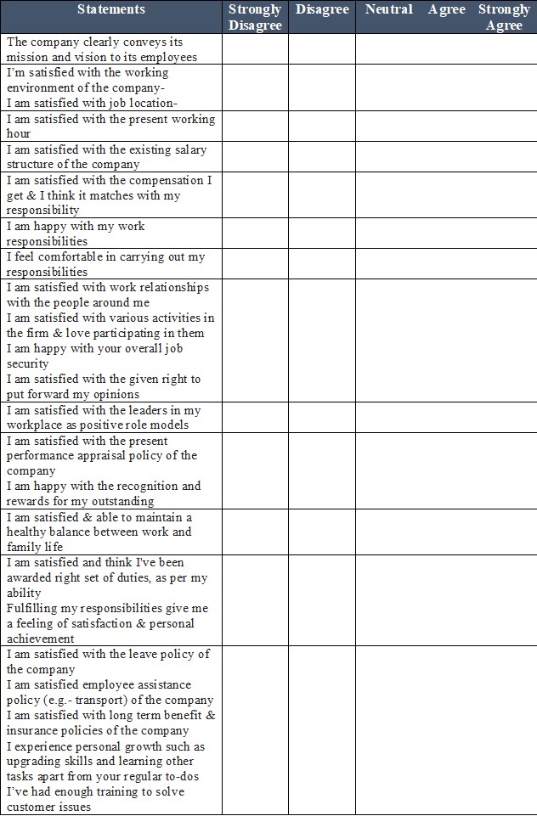

Survey Results:

