Internship Report
On
The Effect of Strategic Human Resource Management (SHRM) Practices on Organizational Performance: A Study on AB Bank Limited
Course code: INT 4399

Submitted To
Yeasmin Islam
Assistant Professor
School of Business and Economics
United International University
Submitted By
Mumu Sazzat
ID: 111 161 232
School of Business and Economics
BBA Program, Major in Human Resource Management
United International University
Date of Submission
April 25, 2022


Letter of Transmittal

April 25, 2022
Yeasmin Isalm
Assistant Professor
School of Business and Economics
United International University
Subject: Submission of Internship Report.
Dear Miss,
With due respect, I am submitting my internship report on “The Effect of Strategic Human Resource Management (SHRM) Practices on Organizational Performance: A Study on AB Bank Limited” which is part of the Bachelor of Business Administration degree and the INT course 4399.
I hope you find this report to be satisfactory. I would be really grateful if you would approve my internship report.

Mumu Sazzat
ID: 111 161 232
School of Business and Economics
BBA Program, Major in Human Resource Management
United International University

Declaration of the Student
I am Mumu Sazzat, student of Bachelor of Business Administration, major in Human Resource Management, United International University. I am completing my internship report under the supervision of Yeasmin Islam, Assistant Professor, Business and Economics at United International University.
I hereby declare that,
- The information included in this internship report is based on three months of practical experience at AB Bank Limited (Tangail Branch).
- The internship report on “The Effect of Strategic Human Resource Management (SHRM) Practices on Organizational Performance: A Study on AB Bank Limited” has been prepared by my original works and efforts.
- Without following any unethical ways, I have not prepared the report and this report is prepared for only academic purpose.

Mumu Sazzat
ID: 111 161 232
School of Business and Economics
BBA Program, Major in Human Resource Management
United International University

Acknowledgement
My sincere thanks to Allah for providing me with the strength and ability to complete my internship report and submit the report on time.
I would also like to express my gratitude to Yeasmin Islam, Assistant Professor, School of Business and Economics, United International University for all of her helpful guidance and support over my academic journey so far. Without her valuable guidance, assistance, and participation throughout the process, I would not have been successful in completing the report on time and with accuracy. In addition, I am happy about having the opportunity to complete my report under her supervision.
Finally, I would like to thanks to all employees and specially the HRD, Cash and Customer Service department of AB Bank Limited for their time and effort on participating in the interview sessions and conducting survey.

Table of Content

Executive Summary vii
Chapter 01: Introduction
1.1 Introduction of the Report 2
1.2 Rational of the Report 2
1.3 Objectives of the Report 2
1.3.1 Primary Objective 2
1.3.2 Specific Objectives 2
1.4 Methodology of the Report 3
1.5 Scope of the Report 3
1.6 Limitation of the Report 3
Chapter 02: Literature Review
2.1 Strategic Human Resource Management (SHRM) Practices 6
2.2 Organizational Performance (OP) 6
2.3 Relations between SHRM Practices and Organizational Performance 7
Chapter 03: Overview of the Organization
3.1 Overview of AB Bank Limited (ABBL) 11
3.1.1 Highlights 2020 11
3.2 Mission and Vision 12
3.3 Core Values 12
3.4 Strategic Priorities 12
3.5 Products and Services 13
3.6 Organogram of AB Bank Limited 14
3.7 Department of Human Resource Management & Development 15
3.7.1 Strategies of Management of Human Resources 15
3.7.2 Hierarchy System of HRD 16
3.8 Corporate Social Responsibility (CSR) 16
Chapter 04: Analysis and Findings
4.1 Data Collection and Analysis 18
4.1.1 Variables and Research Design 18
4.1.2 Data Collection and Analysis Plan 18
4.2 Analysis of Demographic Characteristics 19
4.2.1 Respondents of Gender 19
4.2.2 Employees’ Designation 20
4.2.3 Working Experience of Respondents 20
4.3 Descriptive Analysis 21
4.4 Analysis of Survey Data 25
Statement 01: Impartiality is maintained throughout the recruiting and selection procedures in the organization. 25
Statement 02: All appointments in this organization are selected on the basis of merit (i.e., the individual most qualified for the position is selected regardless of their academic qualifications). 25
Statement 03: The organization invests sufficient resources and energy on EEO (equal employment opportunity) awareness and recruiting. 26
Statement 04: In the organization, job opportunities and promotions for male and female are equivalent in terms of EEO. 26
Statement 05: Employees are motivated to accomplish more through the training of the organization. 27
Statement 06: Employee training and development contribute to the improvement of the overall performance of the organization. 27
Statement 07: Employee training and development aids the organization in attaining better productivity levels. 28
Statement 08: Employee training enables them to accomplish organizational objectives more effectively. 28
Statement 09: Performance evaluation systems contribute to the improvement of the organization's performance. 29
Statement 10: Employees are motivated by the organization’s performance evaluation system. 29
Statement 11: Employee performance is evaluated on the basis of predetermined organizational objectives. 30
Statement 12: The objectives of the organization are standard for evaluating its performance. 30
Statement 13: From the month of March of this year, the organization follows the current compensation policies that are provided by Bangladesh Bank (BB). 31
Statement 14: The organization’s compensation objectives are relevant to its overall performance. 31
Statement 15: In the organization, employees get pay rises depending on their performance on the job. 32
Statement 16: Individual rewards (or commissions) are available to employees who achieve certain levels of productivity, performance, or other specific performance outcomes. 32
Statement 17: From the month of March of this year, the organization follows the current employment security structure that is provided by Bangladesh Bank (BB). 33
Statement 18: The organization maintains healthy work-life balances for its’ all employees. 33
Statement 19: Employees have security and stability at their work. 34
Statement 20: The employees' termination rate in this organization is minimal compared to other private banks. 34
4.5 Findings from the Analysis 34
Chapter 05: Recommendations and Conclusion
5.1 Recommendations 37
5.2 Conclusion 38
References 39
Questionnaire 41

Executive Summary
Businesses nowadays face several hurdles. So they're coming up with solutions. Human resources are vital to a firm's success and competitiveness. Many researchers believe that an organization's success is dependent on people as much as systems. When people are seen as a vital resource, strategic HRM is more likely to be incorporated into strategic outcomes. Human resources are no longer seen as a discrete component of an organization's overall strategy for long-term competitive advantage. As a consequence, designing and administering an HR system or process around business requirements is inadequate. Managers must also consider the company's long-term goals. The strategic viewpoint of HR emphasizes HR's involvement in business performance. The main purpose of the study presented in this report is to understand how the factors of SHRM can affect the organizational performance of AB Bank Limited of Bangladesh.
The first chapter summarizes the study's objectives, scope, limits, and methodologies. The literature review is in Chapter two. This chapter will offer key literature on the topic of this study. The third chapter discusses about the AB Bank Limited's corporate profile, including product and service offerings, culture, and strategies of the HRD. The outcomes of this study were described in the fourth and fifth chapters, which focused on the effect of strategic human resource management practices on organizational performance at AB Bank Limited. On the basis of the study's findings, significant aspects such as recommendations and essential understandings have been provided in chapter five of the report. Finally, the conclusion part is presented in this portion of the report.

CHAPTER 01
INTRODUCTION

Introduction of the Report
Rapid global and technical changes have created a very uncertain and even disruptive business climate in today's world. Industries are trying for better strategies to enhance their adaptability to the complexity of a changing environment in order to survive and grow in the long run. Organizations all around the world are attempting to achieve competitive success via the strategic management of human resource management systems. As a result, workforce planning has never been more fundamental than it is now. As a result, new themes have evolved throughout the course of the operation, which have replaced some of the older ones. New thinking in this area is referred to as Human Resource Management (HRM), and it has a more proactive and strategic meaning than previous thinking in this area. Human resource management and business strategy are strongly intertwined. It may have a significant impact on corporate strategy in many instances. Management of strategic human resources is an important component of strategic management. This means that SHRM's major objective is to connect HR with the rest of the business. There are several reasons why it is important to see human resources as an investment rather than just another expense. The main purpose of the study presented in this report is to understand how the factors of SHRM can affect the organizational performance of AB Bank Limited of Bangladesh.

Rational of the Report
In this report, the effect of strategic human resource practices on organization performance at AB Bank Limited has been highlighted. This report is being prepared as part of a requirement for a Bachelor of Business Administration degree completion requirement under the supervision of Yeasmin Islam, Assistant Professor, School of Business and Economics, United International University.

Objectives of the Report
The objectives of this report are divided into two parts. The following is the sequence of activities:

Primary Objective

To analyze the influence of strategic human resource management practices on the organization's performance.

Specific Objectives
- To identify and analyze the factors of strategic human resource management that impact on organizational performance at AB Bank Limited.
- To provide recommendations to overcome the challenges of strategic human resource management practices that negatively impact on the organizational performance at AB Bank Limited.

Methodology of the Report
Data have been used in this study and analysis came from two different sources. The following are the details:

Primary Sources
Primary data may also be gathered in the following ways:
- Conversation and discussion with the employees of AB Bank Limited.
- An in-depth observation of the development of HR operations in AB Bank Limited (Tangail Branch).
- Conducting a Survey over 52 employees of AB Bank Limited.

Secondary Sources
The following secondary data sources were used to compile the report:
- Books and Journals which are related to the concept of SHRM activities and practices in the banking industry of Bangladesh.
- Annual Report and website of AB Bank Limited.

Scope of the Report
The analysis and study of the report are useful for policymaking and academic comparison. The study's results may help AB Bank Limited HR practitioners and management establish successful HR policies and regulations. This highlights the need of utilizing strategic human resource management practices to link with the organizational performance. The AB Bank Limited may benefit from the study's succession management suggestions. The organization may maintain appropriate personnel numbers, developing effective training programs, performance management, work life balances and compensation policy to successfully carry out AB Bank Limited’s goal of HRD.

Limitation of the Report
The process of obtaining data and compiling this report for the internship report was challenging. Several of them are listed below:
- A few employees of the company were doing the survey, and they seemed a bit perplexed. Employees are reluctant to participate in the survey because they are worried of the reactions of their colleagues and supervisors.
- The highest respondents declined to complete the survey in its entirety, stating a lack of time as their primary excuse.
- It was difficult to acquire thorough information due to the organization's constraints and limitations.

CHAPTER 02
LITERATURE REVIEW
Literature Review
An overview of previous studies on the issue area covered by this study is provided in this chapter. The following parts have been further separated into sub-sections in accordance with the objectives of the studies including:
- Strategic Human Resource Management (SHRM) Practices;
- Concept of Organizational Performance;
- Relations between SHRM Practices and Organizational Performance and
- The conceptual Framework based on Resource Based View (RBV) theory.

Strategic Human Resource Management (SHRM) Practices
The term "SHRM practices" refers to the decisions and activities related to human resource management at all levels of a business and the implementation of strategies intended to maintain a competitive edge (Dimba, 2010). Human resource management strategies may be built around four key areas, despite the fact that progress has been slow in pinpointing exactly specific HR practices are associated with greater organizational performance. Recruitment, training & development, compensation, and performance evaluation are some of the responsibilities of HRM (Armstrong & Baron, 2002).
HR strategies that regularly outperform the others should be adopted by all companies (Pfeffer, 1994). According to him, in all businesses, the application of management tactics such as selective hiring, incentive systems, job security, and employee engagement and participation in performance management, as well as training and development from within, leads to increased output and efficiency. Additionally, (Osterman, 2004) highlighted the efficiency-enhancing effects of a variety of contemporary working conditions such as job design, job rotation and quality circles, as well as quality management as a whole.
According to (Stone, 2005), when it comes to recruiting and retaining employees, traditional human resources management (HRM) focuses primarily on the recruitment and selection process; SHRM is more likely to focus on the HR planning and capability audits, employee recruitment, selection, training and development, career advancement; performance evaluations; compensation/benefit formulation.

Organizational Performance (OP)
Based on the work of (Norton, 1996), an organization's short-term success cannot be measured by typical financial metrics such as profit without considering the organization's long-term goals. According to (John A Pearce, 2005), traditional financial performance measures provide an inaccurate or incomplete picture of a company's current state and its potential for growth, and they argue that a company's qualitative performance measurements should be consistently improved and enhanced.
According to (Wangithi Waiganjo, 2012), a larger performance construct that includes non-financial indicators like effectiveness, efficiency, quality and business image is supported by these arguments. An organization's performance is assessed using the International Organization for Organizational Assessment (IOA), a framework that is used in Organization Performance Assessment (OPA). Organizational performance is defined as the balance between the organization's effectiveness, relevance, and efficiency as well as its financial viability (Kiiru, 2015). Organizational performance should be evaluated in light of the motivation, capacity, and other elements and forces described in the framework. The performance of a business should thus be evaluated using a number of metrics, such as customer happiness and financial leverage, depending on the demands of the firm (International Development Resource Centre , 2002). Organizational Performance is defined by the United Nations Development Program (United Nations Development Programme, 2011) and (Scott, 2003) as the degree to which a company reaches and surpasses its short-term goals or accomplishes its purpose.
Instead, performance management is a ratio based on the accuracy, timeliness, and value of service and program delivery that demonstrates how much money was spent in relation to how much output was created (Iqbal, 2019). Organizational relevance refers to a company's ability to meet the needs of its major stakeholders in the past, present, and future, as well as its ability to adapt to changing conditions and its surroundings. Imagination is the ability of the firm to come up with new and better ways of doing things (Md. Khasro Miah, 2013). In the short, medium, and long term, it is a company's ability to raise the money it requires to meet its operational demands and preserve financial viability.

Relations between SHRM Practices and Organizational Performance
Today's businesses face a wide range of issues. As a result, they're working to devise strategies for overcoming these obstacles. A company's 'human resources' are essential to the performance and ability to maintain a competitive edge. Many academics believe that an organization’s successful strategies are not just dependent on systems, but also on the contributions of individuals inside the business. According to Resource Based View (RBV) theory, organizations that see people as a critical resource in accomplishing common corporate objectives are more likely to integrate human resource management into their strategic outcomes. Here, it is important to note out that RBV had a considerable impact on the development of SHRM theories (Wright P. , 2001).
A company's human resources are no longer considered a distinct component of its overall strategy for achieving a long-term competitive advantage; rather, they are now considered a vital and inherent source of that strategy (Huselid, 1995). Because of this, it is not enough to simply build up and operate a human resources system or process based on the requirements of a business. Managers must also keep in mind that these consequences must be in line with their company's long-term strategic goals. Organizational success is dependent on human resource implications, which may be shown via a strategic perspective on human resources (Delery, 1996). An organization's ability to fulfill its objectives is enhanced by the strategic use of human resources, as (Wright P. M., 1992) argue. On the macro-organizational level, it's a look at the role and function of human resources management across the whole company (Butler, 1991). Human resource management and the strategic of Human Resource Management is not the same thing. When it comes to human resources, strategic human resource management (SHRM) involves more than simply concentrating on individual employees' performance. It also takes into account how the company's success is linked to its competitive advantage (Truss, 1994).
Strategic human resources management aims to incorporate human resources management into the strategic management process (Wright P. M., 1992). To put it another way, the primary goal of SHRM is to integrate human resource management with strategic management. A binary relationship between human resources and strategy may be described, which means that both have an influence on the other. The spending of human resources should be seen as an investment rather than a cost, due to the strategic significance of these expenditures (Truss, 1994).
Analyzing performance, we find that the way in which individuals and organizations have been evaluated has evolved throughout time in response to the external environment. We live in a competitive world where every company must measure and analyze its performance across a broad variety of measures. Customers' satisfaction and quality are now as important as profit and production in gauging a company's success as it was in the past.
The performance of personnel, departments, and organizations is measured in terms of both qualitative and quantitative aspects. To put it another way, it is a measure of how well an organization is able to accomplish its goals in a certain time frame (Porter, 1985). An individual's ability to deliver on his or her potential is directly related to how well that person is able to integrate with the organization's strategic goals. An organization's efficacy and efficiency may be better understood by measuring performance on a regular basis. Some of the primary goals of strategic human resources may be achieved via the use of performance management:
- Ensuring that firms' human resources execute at a high degree of efficiency.
- Providing opportunities for individuals to attain their maximum ability and potential.
- For individuals to be able to demonstrate off their personal strengths.
- To improve or alter the culture of an organization.

CHAPTER 03
OVERVIEW OF THE ORGANIZATION

Overview of AB Bank Limited (ABBL)
AB Bank Limited, founded on December 31st, 1981, is Bangladesh's first private sector bank. The Arab Bangladesh Bank, as it was formerly called, was established on April 12, 1982, with the goal of becoming Bangladesh's best-performing bank. By delivering long-term value for customers, shareholders, and employees, as well as the communities in which they operate, AB Bank has built a golden heritage and an envied legacy that can't be replicated by anyone else. Over the last 39 years, AB has maintained its commitment to become Bangladesh's technology-driven, creative bank. This new era of technological triumph necessitates the incorporation of online banking, SMS banking, cutting edge ICT and a state-of-the-art network solution, as well as 24/7 ATM service, in order for AB to thrive.
Since it was founded 39 years ago, AB has expanded its offerings around the globe. The bank's first branch opened in Karwan Bazar on April 12th, 1982, and it currently has 105 locations around the country, including one in Mumbai, India. The bank features a single Off-shore Banking Unit, a Custodial Wing, and 254 ATMs located around the United States. In addition, it has set up a subsidiary company in Yangon, Myanmar, and a representative office in Singapore.

Highlights 2020
Manpower
- Female 103
- Male 01
Alternative Delivery Channel
- SME Center 11
- Agent Banking Outlets 101 and ATM 254
Local Presence
- Conventional Branch 103
- Islami Banking Branch 01
- Islami Banking Window 52
- Off-shore Banking Unit 01
- Subsidiaries 04

Total Assets
2020 BDT 385,762 Million 2019 BDT 365,569 Million
Loans & Advances
2020 BDT 274,830 Million 2019 BDT 256,512 Million
Deposit
2020 BDT 290,719 Million 2019 BDT 279,458 Million

Figure3.1: Highlights of AB Bank (2020)

Mission and Vision
Vision
To be the best-performing bank in the country in terms of profitability

Mission
To set the standard for quality and perfection in creative banking

Core Values
- Compliance: In order to provide their clients with the finest financial assistance and business integrity, they adhere to all national regulations and goals.
- Customers: They offer the highest importance to their clients' requests, and through their continuous efforts, they ensure the highest level of customer satisfaction for them.
- Stock and Share Holders: They have begun to act prudently in order to provide the highest return to their stockholders.
- Team Members: They make sure that everyone who works for ABBL has a place to call home and can have a positive impact on the company's growth.

Strategic Priorities
- Increasing the Funding Sources
- Focus on Small and Medium-Sized Businesses (SME & Retail)
- Increasing Non-Funded Business Growth
- Expansion of the Network Through Agent Banking
- Restored emphasis on asset quality
- A complete conversion to a digital platform
- Increasing the cost-effectiveness of the organization

Products and Services
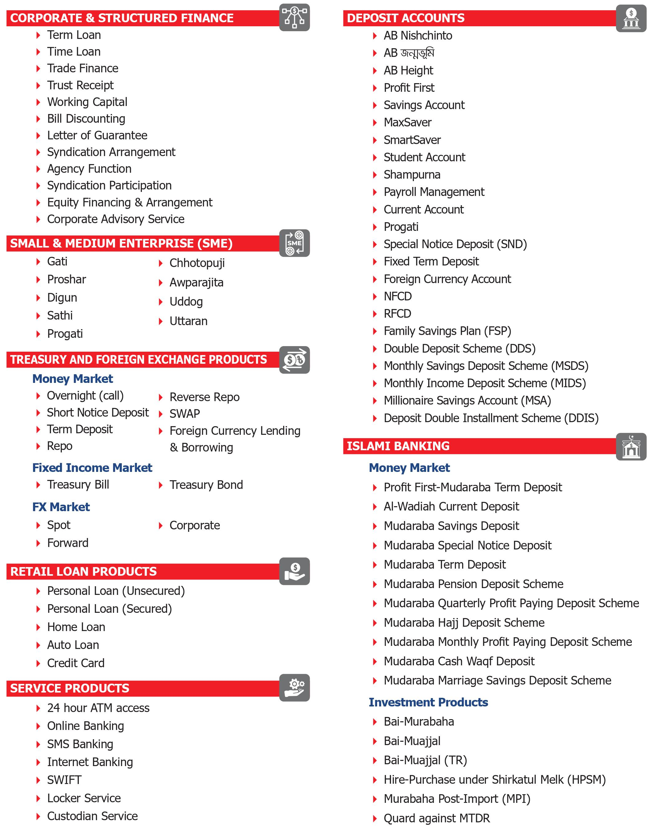
Figure3.2: List of Products and Services of AB Bank Limited

Organogram of AB Bank Limited

There are now seven board members, including the Chairman and Managing Director of the bank, on the AB Bank's current board. A bank's board of directors is divided into three committees, according to Bangladesh Bank Circular No. 11, issued on October 27, 2013, and detailing the "Formation and Responsibilities of Board of Directors of a Bank Company."The Board or Bangladesh Bank, as the case may be, sets the TORs for the Committees.
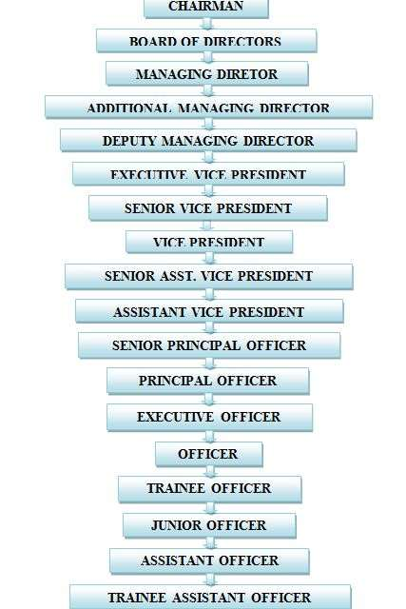
Figure3.3: Organogram of AB Bank Limited

Department of Human Resource Management & Development
AB Hr Department is responsible for ensuring that the Bank's employees have the competences and devotion necessary to offer exceptional services to the clients, as well as that the appropriate culture and environment are in place to allow this service delivery. Human Resources researches and develops methods for assisting its personnel in developing vital competencies while also acknowledging their viewpoints and allowing them to participate in and contribute positively to the Bank's performance. In order to maintain a diverse workforce, AB Bank has developed an atmosphere that is both secure and equal opportunity for all of its personnel.
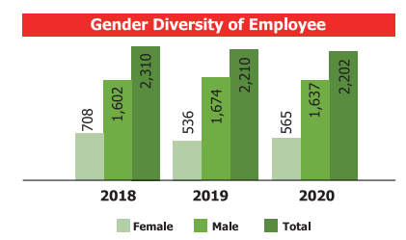

Strategies of Management of Human Resources
- Implement an effective Performance Management System, assign responsibilities to the appropriate individuals, and constantly keep the customer in mind to ensure a high-performance workplace culture.
- Implementation of Human Resources Systems and Practices.
- By working together as an integrated AB Family, they can raise awareness of their competitive edge.
- Performance may be improved by combining training and development.
- The following methods may be used to encourage the employees: providing them with monetary incentives for their efforts (such as a raise or a bonus), encouraging them to engage in company-sponsored events, and so on.
- Employees should have the opportunity to be inspired / contribute to the team if they desire to do so.
- Right-sizing and the Assessment Strategy are used to align human resources with the organization's purpose, goals, and objectives, as well as strategic plans and budgets.
- Identifying and succession planning for high-value personnel is a critical component of a business continuity strategy.

Hierarchy System of HRD
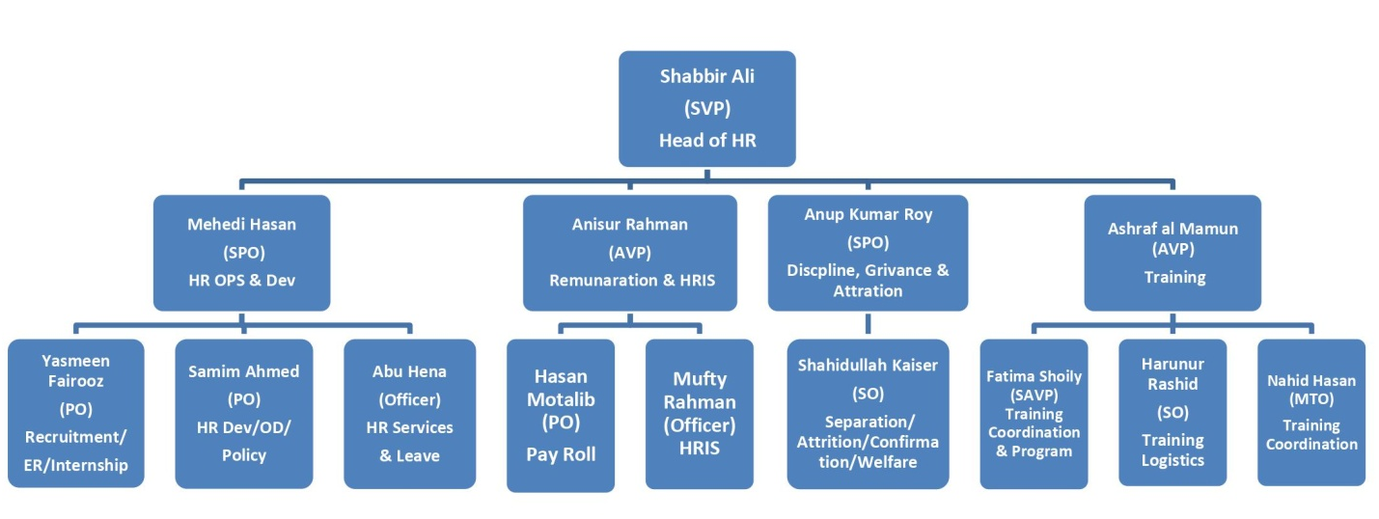
Figure3.4: Hierarchy System of HRD of AB Bank Limited

Corporate Social Responsibility (CSR)
AB believes that corporate social responsibility (CSR) is the most effective way to improve the lives of those who are less fortunate by providing them with basic necessities like food, health care, and education. As well as meeting the fundamental socioeconomic requirements of the country's underprivileged population, CSR, in the opinion of AB, may serve as a legitimate platform for addressing rising environmental issues. CSR's capacity to self-regulate a company's business model is one of its most crucial features. AB Bank attempts to give back to the community it serves in order to keep everyone satisfied. It has been active in a number of socially conscious initiatives for decades.
The Bank's mission is to promote the nation's rich artistic, cultural, and athletic legacy. In times of national crisis, the Bank has always been there for those in need and stood by their side.
As part of its commitment to corporate social responsibility, the Bank will make a contribution of BDT 17.01 core in 2020.

CHAPTER 04
ANALYSIS AND FINDINGS

Data Collection and Analysis
It has been discussed in detail in this chapter how the techniques and methods that have been employed to complete this research study were accomplished. The subject included areas such as variables and research as well as questionnaire design, factors and variables with regard to the topic's sample size, data collection, and data analysis, among others.

Variables and Research Design
The main purpose of the study presented in this report is to understand how the factors of SHRM can affect the organizational performance of AB Bank Limited of Bangladesh. In order to complete the analysis, it was required to utilize a number of independent variables, as shown in the figure Strategic Human Resource Management and Organizational Performance at AB Bank Limited.

According to Resource Based View (RBV), using the conceptual framework described below, it can depict the link between strategic human resource management practices and the performance of an organizations
Organizational Performance
SHRM Practices

- Employee Productivity/ Efficiency
- Innovation
- Customer Satisfaction
- Profitability

- Recruiting and Selecting Workforce
- Extensive Formal Training Programs
- Developmental Performance Appraisal
- Performance Base Compensation
- Employment Security

Figure 4.1: Conceptual Framework of SHRM and Organizational Performance

Data Collection and Analysis Plan
This study and the report have been analyzed based on the banking industry of Bangladesh. In order to compile this study, both qualitative and quantitative data has been obtained. The following two approaches were used to collect information:
- Conducting survey through Google Form and the employees of AB Bank participated on this survey.
- Books and journal articles from all around the globe are also included for analyzing in the topic of the study.
A standard-level questionnaire has been prepared to analyze the subject. As a means of obtaining data, the questionnaire was designed with five likert scores and 20 statements on it. And the survey was conducted at AB Bank Limited and 52 employees of them took part in the process. AB Bank Limited employees have been given access to a Google form through an internal connection.
Descriptive data analysis was conducted to analyze the variables of table, respondent-to-response ratio, and estimated the effect of Strategic Human Resource Management (SHRM) Practices on organizational performance of AB Bank Limited

Analysis of Demographic Characteristics

A total of 52 employees of AB Bank Limited from different departments took part in the survey.
- Sample Size (n) = 52

Respondents of Gender

Figure 4.2: Respondents of Gender
According to figure 4.2, more than half of the survey participants were female, with 35% men and 65% female. So, it can be said that Female > Male.

Employees’ Designation

Figure 4.3: Respondents’ Designation
A quick look at the results in Figure 4.3 reveals that of the 52 employees who participated in the survey, 37 had Trainee Service Officer positions (68%); 14 employees (26%) held HR Executive positions; 2 employees (4%) held manager of HR positions; and one (2%) held Trainer in HRD of AB Bank Limited.

Working Experience of Respondents

Figure 4.4: Working Experience of Respondents

A quick look at the results in Figure 4.4 reveals that of the 52 employees who participated in the survey, 42 had 0-1year experience at AB Bank Limited (84%); 5 employees (10%) held 2-4 years experience; 2 employees (4%) held 5 to 7 years experience; and one (2%) held 8 years or above experience.

Descriptive Analysis
The main purpose of the study presented in this report is to understand how the factors of SHRM can affect the organizational performance of AB Bank Limited of Bangladesh. A standard-level questionnaire has been prepared to analyze the subject. As a means of obtaining data, the questionnaire was designed with five likert scores and 20 statements on it. And the survey was conducted at AB Bank Limited and 52 employees of them took part in the process.
For analyzing the data and the topic of the study of the report, a descriptive table has been detailed below. Additional pie charts have been shown to speed up the decision-making process since the table alone isn't very enlightening.
Statement |  | Strongly  Disagree  (1) | Disagree  (2) | Neutral  (3) | Agree  (4) | Strongly  Agree  (5)
Strategic Human Resource Management (SHRM) Practices
Strategic Recruitment and Selection
01. | Impartiality is maintained throughout the recruiting and selection procedures in the organization. | (0) | (7)  13% | (5)  10% | (23)  44% | (17)  33%
02. | All appointments in this organization are selected on the basis of merit (i.e., the individual most qualified for the position is selected regardless of their academic qualifications). | (0) | (0) | (7)  13% | (34)  65% | (11)  21%
03. | The organization invests sufficient resources and energy on EEO (equal employment opportunity) awareness and recruiting. | (0) | (9)  17% | (6)  12% | (26)  50% | (11)  21%
04. | In the organization, job opportunities and promotions for male and female are equivalent in terms of EEO. | (0) | (0) | (3)  6% | (36)  69% | (13)  25%
Extensive Formal Training Programs
05. | Employees are motivated to accomplish more through the training of the organization. | (0) | (5)  10% | (0) | (37)  71% | (10)  19%
06. | Employee training and development contribute to the improvement of the overall performance of the organization. | (0) | (5)  10% | (0) | (37)  71% | (10)  19%
07. | Employee training and development aids the organization in attaining better productivity levels. | (0) | (0) | (0) | (42)  81% | (10)  19%
08. | Employee training enables them to accomplish organizational objectives more effectively. | (0) | (0) | (2)  4% | (31)  60% | (19)  36%
Strategic Performance Appraisal
09. | Performance evaluation systems contribute to the improvement of the organization's performance. | (0) | (12)  23% | (2)  4% | (31)  60% | (7)  13%
10. | Employees are motivated by the organization’s performance evaluation system. | (0) | (16)  27% | (4)  7% | (22)  36% | (18)  30%
11. | Employee performance is evaluated on the basis of predetermined organizational objectives. | (0) | (0) | (3)  5% | (38)  63% | (19)  32%
12. | The objectives of the organization are standard for evaluating its performance. | (0) | (6)  10% | (3)  5% | (32)  53% | (19)  32%
Strategic Compensation
13. | From the month of March of this year, the organization follows the current compensation policies that are provided by Bangladesh Bank (BB). | (0) | (0) | (0) | (45)  87% | (7)  13%
14. | The organization’s compensation objectives are relevant to its overall performance. | (0) | (0) | (0) | (41)  79% | (11)  21%
15. | In the organization, employees get pay rises depending on their performance on the job. | (0) | (6)  11% | (3)  6% | (30)  58% | (13)  25%
16. | Individual rewards (or commissions) are available to employees who achieve certain levels of productivity, performance, or other specific performance outcomes. | (0) | (0) | (0) | (21)  40% | (31)  60%
Employment Security
17. | From the month of March of this year, the organization follows the current employment security structure that is provided by Bangladesh Bank (BB). | (0) | (0) | (12)  23% | (37)  71% | (3)  6%
18. | The organization maintains healthy work-life balances for its’ all employees. | (0) | (13)  25% | (14)  27% | (25)  48% | (0)
19. | Employees have security and stability at their work. | (0) | (7)  13% | (2)  4% | (28)  54% | (15)  29%
20. | The employees' termination rate in this organization is minimal compared to other private banks. | (0) | (0) | (1)  2% | (36)  69% | (15)  29%

Analysis of Survey Data

Statement 01: Impartiality is maintained throughout the recruiting and selection procedures in the organization.

Figure 4.6

Statement 02: All appointments in this organization are selected on the basis of merit (i.e., the individual most qualified for the position is selected regardless of their academic qualifications).

Figure 4.7

Statement 03: The organization invests sufficient resources and energy on EEO (equal employment opportunity) awareness and recruiting.

Figure 4.8

Statement 04: In the organization, job opportunities and promotions for male and female are equivalent in terms of EEO.

Figure 4.9

Statement 05: Employees are motivated to accomplish more through the training of the organization.

Figure 4.10

Statement 06: Employee training and development contribute to the improvement of the overall performance of the organization.

Figure 4.11

Statement 07: Employee training and development aids the organization in attaining better productivity levels.

Figure 4.12

Statement 08: Employee training enables them to accomplish organizational objectives more effectively.

Figure 4.13

Statement 09: Performance evaluation systems contribute to the improvement of the organization's performance.

Figure 4.14

Statement 10: Employees are motivated by the organization’s performance evaluation system.

Figure 4.15

Statement 11: Employee performance is evaluated on the basis of predetermined organizational objectives.

Figure 4.16

Statement 12: The objectives of the organization are standard for evaluating its performance.

Figure 4.17

Statement 13: From the month of March of this year, the organization follows the current compensation policies that are provided by Bangladesh Bank (BB).

Figure 4.18

Statement 14: The organization’s compensation objectives are relevant to its overall performance.

Figure 4.19

Statement 15: In the organization, employees get pay rises depending on their performance on the job.

Figure 4.20

Statement 16: Individual rewards (or commissions) are available to employees who achieve certain levels of productivity, performance, or other specific performance outcomes.

Figure 4.21

Statement 17: From the month of March of this year, the organization follows the current employment security structure that is provided by Bangladesh Bank (BB).

Figure 4.22

Statement 18: The organization maintains healthy work-life balances for its’ all employees.

Figure 4.23

Statement 19: Employees have security and stability at their work.

Figure 4.24

Statement 20: The employees' termination rate in this organization is minimal compared to other private banks.

Figure 4.25

Findings from the Analysis
Several of the findings are mentioned below, and they are based on the effect of Strategic Human Resource Management (SHRM) practices on organizational performance at AB Bank Limited. According to the analysis, the following are some of the findings:
- The majority of respondents agreed that the organization always tries to identify and select the right personnel for the right task at the right time and that the overall strategic recruitment and selection process is good. But according to a few respondents, sometimes unconscious bias in the hiring process happens during the recruitment and selection process and the organization loses some potential candidates, which may impact the collection of talented human resources and the productivity of the employees within the organization.
- The majority of the respondents agreed that through their extensive formal training programs, employees are motivated to accomplish more of the objectives of the organization, which translates into a greater contribution to the organization's profitability and productivity. But according to a few respondents, sometimes the bank goes through a lengthy process of the training session which may impact the employee engagement at the workplace.
- In the case of performance evaluation system of the organization, cash collection division can be evaluated with numerical ratings. But, the human resources division of ABBL is not expressed numerically their job description, their performance are evaluated in a different way and for this present performance evaluation system, some employees of cash department are facing challenges to determining the actual profitability of the organization.
- Another issue is that majority of respondents claimed even after the COVID 19 pandemic situation returned to normal, the HRD of the organization are facing challenges to motivate the employees about improvements of self confidence and reducing the anxiety of the employees.
- In the case of compensation and employment security policy, organization follows the rules and regulations from March month of this year which has been provided by Bangladesh Bank.
- Few of the respondents said that, performance-based pay is tied to individual or companywide success for the reason employees who get this kind of pay rises are feeling more stressed and less satisfied with their jobs. Beside, after the epidemic is over, majority of respondents desire more flexibility, competitive pay, and a better work-life balance, according to them. Moreover, many indicated concerns that their desires and requirements may not be in line with those of their employers. Sometimes, they feel uncertain about their job and banking services.

CHAPTER 05
RECOMMENDATIONS AND CONCLUSION

Recommendations
The HRD of AB Bank Limited may take the following steps to aid in the development of strategic human resource management (SHRM) practices for the organization's increased performance:
- The HR managers of the organization need to "think broadly about how to simplify and standardize the process" when it comes to biases and recruiting. Starting with an understanding of what hiring prejudices are like discrimination on race, sex, and ethnicities and how they work is the first step. Organization should consider on educate and train their recruiters’ employees on this topic.
- In the case of lengthy process of training sessions, organization should develop their time frame module on training programs. They can arrange both online and offline training programs for their trainees.
- Peer evaluation, in which one employee evaluates the work of another, should be implemented in every department and division within the organization. Manager-only evaluations are less effective than peer reviews because they are conducted from a single point of view, whereas peer reviews are conducted from multiple points of view. The goal of providing employees with weekly feedback is to help them monitor their own performance and offer them with the tools they need to make progress as quickly as possible. In order to improve the effectiveness of performance evaluation, supervisors should provide immediate feedback whenever it is needed, rather than waiting for a predetermined amount of time.
- After the COVID 19 pandemic situation returned to normal, organization needs to focus on reshape of organizational cultural. Stress in the workplace can be minimized by putting out the effort necessary to foster an environment that encourages innovation, teamwork, and mutual respect among all members of the workforce. It's impossible for one person to establish a company's culture on his or her alone. It is imperative that the people in leadership positions implement the company's culture and create opportunities, team building engagements, and connections where this culture may be both exercised and appreciated.
- Flexible work schedules, priority career development, and family benefits (such as health care and child care) should be provided to both male and female workers in order to reduce their stress and increasing the productivity. Additionally, the organization should provide possibilities for job sharing with other employees so that workers may take breaks from doing additional tasks while still receiving enough compensation and benefits. Everyone's productivity will improve as a result of this break, as will the company's overall success.

Conclusion
Businesses nowadays encounter several challenges. So they're devising techniques to overcome these barriers. Human resources are essential to a company's success and capacity to compete. Many scholars feel that an organization's success depends not just on systems, but also on people contributions. Strategic human resource management is more likely to be integrated into strategic results when firms regard people as a crucial resource. Instead of being a separate component of an organization's overall strategy for long-term competitive advantage, human resources are now regarded an essential and fundamental source of that strategy. As a result, building and operating a human resources system or process based on business needs is insufficient. Managers must also bear in mind the company's long-term strategic objectives. The strategic perspective of human resources highlights the role of human resources in corporate performance.
According to the analysis and findings of the report, it can be concluded that if the HRD of AB Bank Limited can take proper steps on recruiting talented candidates, developing time frame of training programs, performance management system and immediate feedback of supervisors, motivation of employees, good work life balances and compensation policies that it can increase the performance of the organization.

References

Ahmed, M. R. (2020). HR Department Organization Structure & Function of AB Bank Limited. Bangladesh: East West University.
Armstrong, M., & Baron, A. (2002). Managing Performance: Performance Management in Action. London: CIPD.
Butler, J. F. (1991). Strategy and human resource management. South-Westerm: Cincinnati .
Delery, J. E. (1996). Modes of theorizing in strategic human resource management: Tests of universalistic, contingency, and configurational performance predictions. Academy of Management Journal, Vol.39, 802.
Dimba, B. (2010). Strategic Human Resource Management Practices: . Effects on performance, African journal of economic and management Studies, 12, 28-137.
Huselid, M. A. (1995). The impact of human resource management practices on turnover, productivity, and corporate financial performance. Academy of Management Journal, Vol. 38, 635.
International Development Resource Centre . (2002). Retrieved from IDRC: https://www.idrc.ca/en
Iqbal, A. (2019). The strategic human resource management approaches and organisational performance: The mediating role of creative climate. Journal of Advances in Management.
John A Pearce, I. (2005). Strategic Management: Formulation, Implementation, and Control in a Dynamic Environment. Journal of Management & Organization, 335 Pages.
Kiiru, D. M. (2015). Strategic human resource management practices and performance of parastatals in Kenya. Unpublished doctoral thesis. Kenyatta University.
Md. Jasim Uddin, A. (2020). Annual Report . Bangladesh: AB Bank Limited.
Md. Khasro Miah, M. F. (2013). Strategic Human Resource Management Practices and Its Impact on Sustainable Competitive Advantage: A Comparative Study between Western and Bangladeshi Local Firms. International Journal of Accounting & Business Management, 43-60.
Norton, K. a. (1996). The Balanced Scorecard: Translating Strategy into Action. Boston: Harvard Business School Press.
Osterman, P. (2004). Choice of employment systems in internal labour markets. Industrial Relations, 26, 46–67.
Pfeffer, J. (1994). The Human Equation: Building Profits by Putting People First. . Boston: MA: Harvard Business School Press.
Porter, M. E. (1985). Competitive advantage: Creating and sustaining suoerior performance. New York: Free Press.
Scott, W. R. (2003). Organizations: Rational Natural and Open Systems (5th ed.). Upper Saddle River, NJ: Prentice Hall.
Stone, R. J. (2005). Human Resource Management (5th Edition). John Wiley & Sons.
Truss, C. a. (1994). Strategic Human Resource Management: A Conceptual Approach,Vol.5, No.3. The International Human Resource Management, 663-686.
United Nations Development Programme, U. (2011). Human Development Report 2010. . New York: Oxford University Press.
Wangithi Waiganjo, E. M. (2012). Relationship between Strategic Human Resource Management and Firm Performance of Kenya’s Corporate Organizations. International Journal of Humanities and Social Science, 2 (1), 63- 68.
Wright, P. (2001). Human resources and the resource-based view of the firm. Journal of Management, 27, 701-721.
Wright, P. M. (1992). Alternative theoretical perspectives on strategic human resource management. Journal of Management, Vol.18, , pp.295-320.

Questionnaire
The Effect of Strategic Human Resource Management (SHRM) Practices on Organizational Performance – a case study on AB Bank Ltd
Dear respected respondent,
The following questionnaire is to collect information from the employees of AB Bank Limited about SHRM practices within the organization. Only academic research will be done using the information provided.
Employee’ Name:
Gender | Male |  |  | Female
Designation | TSO | HR Executive | HR Manager |  | Trainer (HRD)
Working Experience | 0-1 years | 2-4years | 5-7 years |  | 8years and above

Statement |  | Strongly  Disagree  (1) | Disagree  (2) | Neutral  (3) | Agree  (4) | Strongly  Agree  (5)
Strategic Human Resource Management (SHRM) Practices
Strategic Recruitment and Selection
01. | Impartiality is maintained throughout the recruiting and selection procedures in the organization.
02. | All appointments in this organization are selected on the basis of merit (i.e., the individual most qualified for the position is selected regardless of their academic qualifications).
03. | The organization invests sufficient resources and energy on EEO (equal employment opportunity) awareness and recruiting.
04. | In the organization, job opportunities and promotions for male and female are equivalent in terms of EEO.
05. | Employees are motivated to accomplish more through the training of the organization.
06. | Employee training and development contribute to the improvement of the overall performance of the organization.
07. | Employee training and development aids the organization in attaining better productivity levels.
08. | Employee training enables them to accomplish organizational objectives more effectively.
09. | Performance evaluation systems contribute to the improvement of the organization's performance.
10. | Employees are motivated by the organization’s performance evaluation system.
11. | Employee performance is evaluated on the basis of predetermined organizational objectives.
12. | The objectives of the organization are standard for evaluating its performance.
13. | From the month of March of this year, the organization follows the current compensation policies that are provided by Bangladesh Bank (BB).
14. | The organization’s compensation objectives are relevant to its overall performance.
15. | In the organization, employees get pay rises depending on their performance on the job.
16. | Individual rewards (or commissions) are available to employees who achieve certain levels of productivity, performance, or other specific performance outcomes.
Employment Security
17. | From the month of March of this year, the organization follows the current employment security structure that is provided by Bangladesh Bank (BB).
18. | The organization maintains healthy work-life balances for its’ all employees.
19. | Employees have security and stability at their work.
20. | The employees' termination rate in this organization is minimal compared to other private banks.

Md. Jasim Uddin, A. (2020). Annual Report . Bangladesh: AB Bank Limited.
Md. Jasim Uddin, A. (2020). Annual Report . Bangladesh: AB Bank Limited.
(Md. Jasim Uddin A. , 2020)
Ahmed, M. R. (2020). HR Department Organization Structure & Function of AB Bank Limited. Bangladesh: East West University.

