

An Internship Report
On
Analysing the Activities of Accounts Department: A Study on Expo Freight Limited (EFL)

Submitted To
Mofijul Hoq Masum
Assistant Professor,
School of Business & Economics
United International University

Submitted By
Md. Zahidul Hasan
ID: 111 172 028
United International University

Date of Submission:
22 March 2022

Letter of Transmittal

To
Mofijul Hoq Masum
Assistant Professor,
School of Business & Economics
United International University

Subject: Submission of Internship Report on ‘Analysing the activities of Accounts Department: A study on Expo Freight Limited (EFL)’.

Dear Sir,
I am happy to present my internship report on ‘Analysing the activities of Accounts Department: A study on Expo Freight Limited (EFL)’. This is my last part of the graduation requirement under BBA in Accounting at UIU. In this report, everyone will get how expo freight limited managing the accounts team. I have collected most of the related records, materials and am thankful to the accounts department in expo freight limited for helping to make the internship report.

Due to a time constraint, I did my best to gather the necessary information. I will be pleased to assist you if you require any other information.

Yours Sincerely,
Md. Zahidul Hasan
ID: 111 172 028
BBA in Accounting
School of Business & Economics
United International University

Acknowledgement

First and foremost, I remember Allah, since, without him, nothing is possible. As a result, I owe him gratitude. The timely completion of this report would not have been feasible without the assistance of some individuals whose inspiration and guidelines made it possible.

First of all, I would like to thank my honourable academic supervisor Mofijul Hoq Masum, Assistant Professor, School of Business & Economics, United International University. I am grateful to him for his constant support, supervision, and suggestions that were very much needed for the completion of this report. Then I am also thankful to Md. Armanuzzaman, the Deputy Head of the Accounts Department for his unwavering support and guidance during my internship. I would like to express my gratitude to Sumaiya, the Executive of Expo Freight Limited's Department of Accounts. In addition, she assisted me in my office work. From the first day of my internship, they have been supportive.

Several employees in Expo Freight Limited provided me with valuable guidance during my internship. They provided their useful insights and experiences to me so that I could write this report and improve my job performance. I am grateful for their assistance in preparing this report. They demonstrated how to use the data in my report. I'm grateful for the chance to work with such knowledgeable people. I am extremely grateful to everyone who helped me out during my internship.

Declaration

I, therefore, announce that this report titled “Analysing the activities of Accounts Department: A study on Expo Freight Limited (EFL)” is my unique work completed under the supervision of Mofijul Hoq Masum, Assistant Professor, Faculty of School of Business & Economics, in fulfilling the requirements for the Bachelor of Business Administration degree at United International University (UIU).
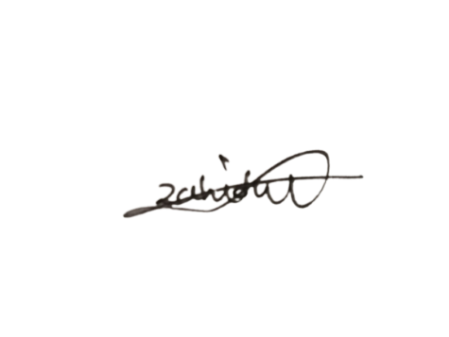

…………………………

Md. Zahidul Hasan
ID: 111 172 028
BBA in Accounting
School of Business & Economics
United International University

Executive Summary
The accounting department records the goods and services paid by the company and ensures that all business expenses are paid on time. It also typically tracks all scheduled payments in an organization, such as inventory, payroll, and other business-related expenses. The company that is being analysed in this report, Expo Freight Limited (EFL), is a leader in global supply chain solutions. EFL has provided air, sea, warehousing and other solutions to the international shipping community. The company offers an extensive menu of services and is backed by its network of offices and innovative facilities.

The purpose of preparing this report is to deliver a broad understanding of the activities conducted by the accounts department of EFL. Moreover, to mention specifically, the study focused on three objectives that are to analyse the way the EFL Accounts Dept records and processes its different accounting variables; to analyse how EFL Accounts Dept manages cash and payroll-related activities, and to analyse EFL Accounting's procedures for preparing internal and external reports.

To prepare the study exploratory research method has been followed it allows us to explore a specific issue where no previous information is rarely available. This study was prepared with information from both primary and secondary sources. The primary data of this study are found by face-to-face conversations and daily activities. Alternatively, secondary information is acquired from the EFL's personnel handbook, website, and related literature. Some remarks and suggestions have been made based on personal experience and results.

Some important practical findings are listed in the findings chapter of this report about the activities of the accounts department of EFL. To meet our first objective, several accounting variables are observed and their recording procedures are mentioned. To meet the second objective which is the ways to manage cash and payroll, it is found that Expo Freight Limited collects money from clients by offering aeroplane, ocean, warehouse, and distribution services, as well as customs brokerage, project logistics, and import services, and pays cash in four ways: wage payment, employee payment, other activities payment, and external payment. However, in terms of attaining the third objective, it is found that all financial transactions throughout the year are recorded in a computerized accounting system. For greater clarity, EFL's financial reports sometimes include narratives. Accounting theories, circumstances and norms are followed when preparing statutory financial reports. In financial reports, accounting dates for summarization, tabulation, and collection are shown. On the other hand, EFL prepares five financial statements: Balance Sheet, Profit and Loss Statement, Cash Flow Statement, Owner's Equity Statement and Notes to Financial Statements. On the other hand, EFL prepares two types of internal reports: monthly reports and annual reports.

Keywords: Accounting Department, Financial Statements, Cash Management, Payroll management.
Table of Contents

Chapter One: Introduction
1.1 Introduction 1
1.2 Background 1
1.3 Objective of the study 2
1.3.1 Broad Objectives: 2
1.3.2 Specific Objectives: 2
1.4 Scope of the Study 2
1.5 Limitation of the Study 2

Chapter Two: Methodology of the Report
2.1 Methodology of the Study 3
2.2 Research Design 3
2.3 Sources of Data 3
a) Primary Data 3
b) Secondary Data 3

Chapter Three: Organizational Overview
3.1 Background of Expo Freight Limited 4
3.2 Contribution to Economy 4
3.3 Vision 4
3.4 Mission 5
3.5 Operational activities of Expo Freight Limited 5
a. Finance & Accounts Department 5
b. HR Department 5
c. Import Management Department 5
d. Information Technology (IT) Department 6
e. Helpdesk 6
f. Credit Control 6
3.6 Services of Expo Freight Limited 6
3.7 Airfreight service 7
3.7.1 Types of Air Cargo 8
a. General cargo: 8
b. Special cargo: 8
3.8 Air services 8
3.9 Services area of air freight 8
3.10 Ocean Freight Service 9
3.11 Advantages of ocean freight 10
3.12 Ocean Freight containers 10
3.13 Activities of Accounts Department 10
3.14 Importance of proper Accounting practice 11
3.13 Swot analysis 12

Chapter Four: Findings of the Study
4.1 Introduction 14
4.2 The ways EFL accounts department record different accounting variables 14
4.2.1 Revenue Recognition 14
4.2.2 Freight Forwarding 14
4.2.3 Interest in the fixed deposits & Bank accounts 14
4.2.4 Expenses 15
4.2.5 Accounts Receivable 15
4.2.6 Redundancy & Gratuity Allowance for Employees 15
4.2.7 Cash & Cash Equivalents 15
4.2.8 Cashbook 15
4.2.9 Bankbook 15
4.2.10 Book of check registers 16
4.2.11 General ledger book 16
4.2.12 Clients' ledger book 16
4.2.13 Register of Wages 16
4.2.14 Pay Slip 17
4.2.15 Ledgers in Advance 17
4.2.16 Voucher Slip 17
4.2.17 Debit and Credit Voucher 17
4.2.18 Transfer and journal voucher 17
4.2.19 Money Receipt 17
4.2.20 Non-Current Asset Ledger 17
4.3 The ways EFL Accounts Department manages Cash and Payroll related activities 18
4.3.1 Cash management 18
4.3.2 Receipts 18
4.3.3 Payments 18
4.3.4 Payroll 19
4.4 The procedures of preparing internal and external reports by the accounts 20
4.4.1 Preparation of Financial Statements 20
4.4.2 Preparatins of Internal Reports 21

Chapter Five: Recommendations and Conclusion
5.1 Recommendations 22
5.2 Conclusion 22

Chapter Six: Internship Experience
6.1 Introduction 24
6.2 Run the Integration 24
6.3 Document Entry 24
6.4 Collect Debit and Credit voucher 25
6.5 Preparing Money Receipt 25
6.6 Document Release 26
6.7 Prepare Mushak-6.3 - Tax Invoice 28
6.8 Import update- Local 28
6.10 Gain and Loss Adjustment 29
References

Chapter 1: Introduction

1.1 Introduction
Through technical innovation, globalization aims to reduce geographical distances and create a close global community. An organization, whether international or multi-national, would have gone outside its national borders to enjoy the mutual benefit. This is named cross-border trade. For example, if we look at Bangladesh's garments industry, we can notice that it receives orders from the UK and the United States; and that it obtains the majority of its raw materials from China China (though Vietnam and China are both major direct competitors of Bangladesh's Readymade garments industry), and manufactures and exports its products. "Freight Forwarding" refers to the carrier we utilize to gather raw materials and transport finished goods. There are around 837 freight forwarding companies registered with the Bangladesh Freight Forwarders Association in our country (BAFFA). But Expo Freight Limited renowned logistics service provider company. They mostly serve as third-party logistics suppliers. Essentially a freight forwarder acts as an agent. Here, agents are always aware of the other country's import and export rules and regulations, as well as the techniques and paperwork used in international trade.

1.2 Background
The Bachelor of Business Administration program at United International University is designed to provide an outstanding balance of theoretical and practical skills. In consequence after the completion of academic theoretical exposure, students are sent to various firms to gain practical experience in various areas, which would help them to a good career prospect. United International University has undertaken a three-month internship program for its BBA freshman, which is an essential requirement of a bachelor's degree.

I wanted to do the internship to gain hands-on experience. Because our educational system is mainly text-based, the inclusion of a practical orientation course as an academic component is an outlier. It appears to be a "win-win" situation because both the educational institution and the organization benefit significantly from such a program. As a result, practical skill is an important part of professional development. The process creates networking opportunities for students, which may help students get a decent job. This procedure qualifies a student for employment. Internships provide a professional experience with a practical approach that leads to beneficial development in the professional field. In this consequence, I joined Expo Freight Ltd (EFL) under the supervision of Armanuzzaman, Deputy Head of Accounts Department. My experience included general accounting work on EFL.

1.3 Objective of the study

1.3.1 Broad Objectives:
The prime focus of this study is to know the functional activities of the accounts department within the EFL as a company and how the accounting activities and success affect their achievement for the company based on academic-related programs.

1.3.2 Specific Objectives:
- To analyze the way the EFL Accounts Department records and handles its different accounting variables.
- To analyze how the EFL Accounts Department manages cash and payroll related activities.
- To analyse the procedures of the preparation of internal and external reports by the EFL Accounts Department.

1.4 Scope of the Study
This internship report is based on my experience working with Expo Freight Ltd. It will also assist pupils in narrowing the gap between genuine and hypothetical knowledge. This report greatly aided my understanding of an organization's atmosphere and surroundings. As an intern at EFL, I have access to a variety of accounting-related work, file sorting, invoice preparing, Chaque and pay order receive, money receipt preparation, local and overseas receivable update, and so on. It was nearly difficult for me to understand all account-related tasks within a limited period as it was a giant Freight forwarding company.

1.5 Limitation of the Study
The first constraint is that limited time. In this circumstance, the scope and dimension of this internship report have been lessened. I was unable to devote enough time to my report writing because the deadline for submission was so short.

Chapter 2: Methodology of the report

2.1 Methodology of the Study
From topic selection to final report preparation, the study necessitates a systematic approach. To carry out the study, data sources had to be discovered and collected, then sorted, processed, interpreted, and presented systematically, with significant points selected. The general process of methodology has been mentioned below.

2.2 Research Design
It is an “Exploratory Research”, that in a nutshell reveals the overall accounts activities of Expo Freight Ltd. In this report, both primary and secondary data have been used.

I acquired primary data through personal interviews with EFL executives. I mostly talked to them verbally. To prepare this study, I gathered material from them as well as collected much information from the annual report, magazines, brochures, and manuals.

2.3 Sources of Data
There are two categories of data: (a) Primary Data. (b) Secondary Data

a) Primary Data
- Face facing meetings and conversations with senior and junior Officers.
- Discussion from daily activities.

b) Secondary Data
The following sources are:
- Expo Group's website
- Expo Freight Limited Review Annual Report
- Publication
- Newspaper
- Journal/ Article

Chapter 3: Organizational Overview

3.1 Background of Expo Freight Limited
Expo Freight Limited (Bangladesh) was established in 1993 and is a major provider of global freight forwarding and supply chain management solutions. EFL has a 50,000-square feet air freight hub in Uttara Abdullahpur, a quality control (QC) inspection facility in Chittagong, and distribution hubs around the country. Expo Freight is massively popular around the world for its flexible and personalized services such as airfreight, ocean freight, warehousing, and so on.

Expo Freight's financial integrity, discipline, and dependability have earned them a stellar reputation. Expo Freight Limited is part of a dynamic collection of firms that engage in a variety of activities like exports, imports, travel agencies, GSA for airlines, and garment manufacturing. IATA has classified it as Bangladesh's number one air freight forwarder.
EFL thinks that preserving and growing all of their attributes is critical to their growth and success, but maintaining harmony with their stakeholders is still their top priority. Their concept has delivered positive results, boosting their reputation among stakeholders and in the market, and they pledge to continue working relentlessly to secure the company's future success.

3.2 Contribution to Economy
Expo Freight Limited is a Bangladeshi freight forwarding firm. They import and supply things from a variety of nations, including China, Thailand, Singapore, Sri Lanka, India, and many others. Expo Freight Limited is primarily a two-sector company. One is importing high-end things, while the other is exporting them. They are enhancing the country's freight forwarding business by bringing in the different necessary equipment for diverse sectors. Our fish farmers have just introduced Biofloc, RAS technology, a revolutionary form of fish rearing. Expo freight limited has been importing the necessary materials since its inception. It also motivates young people by bringing new goods for ornamental fish breeding. As a result, many jobless persons can find work, lowering unemployment.

3.3 Vision
Expo Freight Limited believes that it will continue to strive for excellence, maintain its growth by strengthening its relationships with stakeholders, continue to expand internationally, and strive to write new chapters in Bangladesh's corporate landscape by achieving sustainable growth in a more efficient, planned, and skilled manner. Our astute vision to reach new heights and attain the highest levels of stakeholder satisfaction is the starting point for Expo's corporate excellence and leadership.

3.4 Mission
"Expo Freight Limited's mission is to continue moving forward with their employees and management by teamwork and facing any problem with a good teamwork, seeking to perform at a high level and establish their superior position in the corporate world, both locally and internationally."

3.5 Operational activities of Expo Freight Limited
The Chairman and Managing Director, as well as two additional directors, lead Expo Freight Limited. EFL networks are overseen by a Chief Operating Officer, who is in charge of the entire company's operations. The business is divided into numerous departments, including:

Finance & Accounts Department
This department is in charge of keeping track of the company's accounting. Members of the team also see to it that future funding for the company's expansion goes forward without a hitch. The department's primary task is to pay and collect payments from suppliers on time. This team is made up of six people and is based at the EFL Networks Corporate Office.

HR Department
The Human Resource Department (HRD) is in charge of managing employees inside an organization. The Department is in charge of hiring and ensuring that staff accomplishes or surpasses their goals. The HR department is also in charge of organizing employees across the organization and planning future projects that will involve them. Employee relations are handled by EFL's human resources department, which involves recording wages and reparation, recruiting new staff, and defining performance targets for staff. Human resources management coordinates employee relations policies and practices to ensure that they are following the organization's business goals and objectives.

Import Management Department
The import management department (IMD) controls local and overseas import procedures. The procedure starts with the opening of the L/C and finishes with the delivery of the goods. In addition, this division is also in charge of the C&F agent. This department appears to be the busiest in the organization, based on my observations.

Information Technology (IT) Department
Expo Freight Ltd.'s ICT department assists the company's computer users with tasks such as installing new software, recovering hardware flaws, updating hardware, and guiding the office staff on how to run current software. In addition, the company's website is managed by the information technology department. The company's official website is a business one that provides services to its customers. Above all, the ICT department ensures that the company's channels of communication with companies in other countries remain open. This mode of communication is largely utilized for international communication.

Helpdesk
Customers typically contact this department's workers for the first time. During office hours, this department provides customer service. To address customer service difficulties, this department collaborates with the other departments. The Senior Manager is currently in charge of a three-person team.

Credit Control
The department is in charge of mailing bills, following up with customers, and making sure that payments are made as soon as possible. The department also supervises and engages with clients to address payment-related issues.

3.6 Services of Expo Freight Limited
Freight forwarding is the medium of process or transporting goods from one place to another on behalf of importers and exporters across the world. In this case, the freight forwarder paly the role of a mediator between the client and transportation services, rather than physically involving itself. It may be something like
From the seller to the client
- From one warehouse to another warehouse
- From a shipping terminal to a port terminal
- The receiving end's port
- From one port to another

The freight forwarding party plays the coordination to send any goods. For this reason, NOC, checking LC, receiving BOL are necessary documents where the coordinating factors are appropriate rate, pick up, address, delivery date, trailer number, reference number, etc. If any caution is needed during danger, The route, product, size, code, weight, pallet, type, pieces, durability, and product codes will be kept as valuable records. The forwarding party must be cautious so that the drivers make no mistake while meets come up. All transportation services are used by a forwarding party where ocean freight, air freight, rail company, and trucking freight are considered as major services.

Freight forwarders provide a variety of services, including-
- International / Global Freight Forwarding
- Consulting of Freight Forwarding
- Insurance
- Services in the air and on the sea
- Storage and distribution
- Freight charters via air and sea
- Importing and exporting
- Distribution
- Documentation
- Report on the progress
- Inventory control is important.
- Clearance of customs

3.7 Airfreight service
Airfreight is the quickest mode of delivery. It is more expensive than the ocean, road, or train, and it takes less time. These commodities are transported from commercial and passenger aviation hubs to any area where planes

can land and take off. Airfreight is generally used to transport perishable and high-value goods. Biochemicals, lithium batteries, flammable chemicals, firearms, explosives, power banks, and UN-classified illicit products, on the other hand, cannot be transported by air freight.

3.7.1 Types of Air Cargo
a. General cargo: This cargo is commonly used to transport high-value products such as medications, jewellery, and electronic equipment. Airfreight is used to transport vegetables to other nations, in addition to perishable commodities like fruits and flowers, to ensure freshness and timeliness. It is more expensive, but it is safe and less time-consuming, which is the key benefit.

b. Special cargo: A standout feature is the temperature control system. Medicine and high-value perishable items are delivered here. It has a unique protective casing system with the necessary air conditioning.

3.8 Air services
Airlines provide various levels of service dependent on the cost. Such as-
- Differed service: This is a standard service with a slight delay in transit. The average transit time between the United States and Europe is 7-8 days. Because the rate is lower, the carrier will not be responsible for transit time.

- Regular Service: Deferred service has a somewhat lower transit time. The average transit time between the United States and Europe is 5-6 days. The price is a tad higher. This service handles the majority of the shipments.

- Premium Service: This is sometimes referred to as standard service. The transit time is slightly less than that of the Differed service. For the United States and Europe, the average transit time is 4-5 days. The carrier will not be held liable for any delays in transit.

- Express service: This is a service that the airline guarantees. They guarantee a specific transit time. The average transit time is two to three days. If they fail to meet, the airline will refund the money, he agreed TT. This service has a substantially higher fee.

3.9 Services area of air freight
Airfreight is mostly known for its good service and timeliness. Even though it is more expensive than any other mode of freight forwarding, consumers prefer it because of the appealing features it provides in their air shipment. It encompasses a wide range of services, including:

- Consolidation: A forwarder consolidates goods from multiple shippers merges them into a single shipment to save money.

- Ex-Work: The forwarder picks up the cargo at the shipper's yard and carries it to the destination airport, meeting all regulatory duties at the origin.

- Airport to Airport: The logistics company receives the cargo from the shipper and delivers it to the destination airport via the forwarder.

- Airport to Door: The shipping company collects the freight from the shipper at the airport, clears it at the departure airport, and transfers it directly to the consignee's designated shipping area.

- Door to Door: The party of forwarder picks up the cargo from the shipper's yard and ships it from the main airport then clear it at the air terminal, and transports it directly to the consignee's designated distribution centre.

- Charter flight: The shipping company organizes a charter flight to transport cargo that the forwarder was unable to ship owing to airport congestion or insufficient resources on regularly scheduled flights.

- Transhipment: To save money, a forwarder can use multimodal transportation.

- Warehousing & Distribution: Forwarder is a company that provides warehousing, packing, and distribution services.

3.10 Ocean Freight Service
Ocean Freight is the most widely utilized freight forwarding method in the logistic support industry. This Non-Vessel Owning Common Carrier (NVOCC) links the dots between ports in various countries, forming a robust global network.

3.11 Advantages of ocean freight
- Cost-effective: The key argument is financial efficiency. It is less expensive than air freight.
- Capacity: The Ocean has a much larger capacity than the air. Because it is container-based and has a flat surface, it can simply stack a large number of trailers one on top of the other without causing harm to the body.
- Reliable: Ocean freight transport is entirely dependable. It maintains an appropriate invigilation and security system in every sector, from pick-up to drop-off which makes it more dependable to its consumers.
- Environmental impact: It produces far less CO2 than air freight. Aside from that, the ocean freight forwarding committee is trying to reduce ocean pollution and find measures to ensure a freight forwarding system that is environmentally sustainable. It also emits less gasoline, which is great news.
- Variety of Products: It has unrestricted in the same way as air freight. It transports any lawful merchandise that fits into the trailer.

3.12 Ocean Freight containers
a. Container for dry freight: Typically used for garments (20', 40')
b. Container for dry High cube:: same kind of picture of RMG products (40', 45').
c. Reefer container & High cube reefer: Perishable items are stored in this container.
d. Open top container: Things that require the use of cranes, such as big machinery.
e. Flat rack and collapsible flat rack container: Used to convey objects with unusual dimensions. For example, a truck, a car, or a boat.

3.13 Activities of Accounts Department
Accounting's fundamental elements are the identification, measurement, and maintenance of financial communications about economic entities to stakeholders. Accounting is a type of information system that keeps track of things like sales profit scenarios, profit or loss, outstanding debt, assets, cash, and so on. An effective accounting system benefits every business. Financial accounting is the method that prepares the financial statement on the enterprise by both internal and external parties. These financial reports are used by investors, managers, creditors, unions, and government organizations. Managerial accounting, on the other hand, refers to the identification, measurement, and provision of monetary information required by the management system, as well as the control and evaluation of an organization's operations.

Accounting Cycle at Expo Freight Limited-

When the steps are finished, the cycle is restarted in the next period of accounting.

3.14 Importance of proper Accounting practice
Accounting practices are meant to be included in a company's accounting rules and procedures. It is made up of daily financial data records that are crucial for measuring and monitoring a company's economic operations. Accounting procedures refer to how accounting is used in a company on a day-to-day basis. Accounting records that are well organized and balanced are an important aspect of any firm, whether it is large or little, new or established. When things are financially shaky, proper accounting records can help determine what changes are made or what to eliminate to keep the firm growing and succeeding.

To preserve a solid record of business accounting, we need a strong accounting program as well as the proficiency to keep it organized and the latest. Attaining goals and forecasting future finances, daily accounting, and monetary information will need to be examined. Some of the most significant subjects at beginning of a business are where money is spent and how to save costs.

The accounts records of a corporation, which are kept on an accounts ledger, provide a precise summary of profits and losses in a monetary spreadsheet layout. Auditors can examine these financial reports to assess the business's accuracy and integrity. An accounting report also differentiates the success ratio of current business from previous progress by making use of account forms accepted by other organizations and bodies.

Above all, it is tremendously important to ensure that records accurately reflect on corporate operations and it is updated on regular basis. Maintaining records up to date regularly is considerably easier than trying to recall transaction data weeks or months later.

3.13 Swot analysis
a. Strength
- The reputation of the company
- Outstanding customer service
- A good relationship with clients
- Good Infrastructure
- A broad range of services
- Have a large number of branches in the world

b. Weakness
- Have a limitation of the financial resources
- A lack of qualified employees
- Getting poor inspirational schemes.
- Lack of opportunity job promotion.

c. Opportunity
- Expand the number of branches to hold market share
- Increase the number of exclusive services offered by the company
- Customers are more sensitive than ever before about the quality of services provided.

d. Threats
- The market is becoming increasingly crowded
- Increasing the value-added tax (VAT) and the tax on imported goods

Chapter 4: Findings of the report

4.1 Introduction
This chapter consists the findings based on the objectives of this study where ways of recording different accounting variables; cash and payroll related activities; and methods of preparing the internal and external reports are listed. As all these functions are conducted by the accounts department of Expo Freight Limited, it was easy for me to observe and interpret in this chapter.

4.2 The ways EFL accounts department record different accounting variables
The cycle of accounting is well maintained in Expo Freight Ltd. According to my observation, there are certain challenges such as EFL does not make ready a trial balance. A trial balance is a set of all the ledger's open accounts and their balances. After the posting of all adjustments, a trial balance should be prepared. As a consequence, making ready a financial report and auditing takes a huge time and is a difficult task at EFL. If Expo Freight Ltd makes the trial balance, adjusts the trial balance, and then closes the trial balance, the overall work is less time-consuming. The following ways are followed by the EFL accounts department to record different accounting activities.

4.2.1 Revenue Recognition
EFL, like other traditional organizations, sometimes preserves cash-based transaction records. Cash basis accounting is easy to maintain and understand, however, cash basis accounting has some drawbacks. It is difficult to determine net income in a given time using cash basis accounting since income on the cash basis is determined by the revenue collection and expenses. Moreover, revenue recognition and the matching principle are ignored on a cash basis. In short, cash-based financial reports violate generally accepted accounting rules.

4.2.2 Freight Forwarding
Freight forwarding of EFL is the strategic planning and execution of logistics for the worldwide transportation of commodities on behalf of shippers.

4.2.3 Interest in the fixed deposits & Bank accounts
Revenue is focused on basis of both cash & current and savings accounts.

4.2.4 Expenses
Expenses emerge from the distribution of goods and services to recipients under the project's goals and activities. The administrative costs of EFL are divided across several freight forwarding providers.

4.2.5 Accounts Receivable
The primary source of accounts receivable is the provision of services to customers. Accounts receivables are identified when they become due.

4.2.6 Redundancy & Gratuity Allowance for Employees
EFL Provides employee redundancy & gratuity funds basis on a one-month basic salary after completing a year of service for each permanent staff. According to accounting basis, provision is prepared monthly basis. Gratuities will be paid out when staff retires, and redundancy payments will be issued if an employee's employment with EFL is terminated due to redundancy.

4.2.7 Cash & Cash Equivalents
Cash and cash equivalents are defined as cash and bank balances, as well as un-pledged fixed deposits, from which bank overdrafts if any, are deducted in the statement of cash flows.

4.2.8 Cashbook
The company maintains all cash transactions by cash book. Any cash received, such as from a client, a withdrawal from one's bank account, a service charge, a loan from a bank, or a loan from another organization. After that, all cash costs are recorded. It is very important to mention that all transaction is recorded on the journal voucher.

4.2.9 Bankbook
All bank transactions are recorded in a bank book. In the same bank, the organization has two types of bank accounts. One is the current account and another is the SND account. The purpose of the current account is to keep track of small transactions. On the other hand, an SND account is to keep with big transactions. In bank reconciliation, bank books are extremely important. Customers regularly make deposits into the company's bank account. Banks frequently levy fees for online credit transactions. Bank books and bank statements are the key sources of data for bank reconciliation in this situation.

4.2.10 Book of check registers
The EFL Cheque Register Book plays a crucial role. This book keeps track of the information about the checks that have been received from clients. The date of the received cheque, the client's name, the bank's name, the cheque number, the amount of the taka, the drawing date, and the expiration date are all recorded in this register book. This book can also provide information to the account management department about the overall number of cheques, the total amount in taka, the number of cash cheques, expired cheques, and invalid cheques.

4.2.11 General ledger book
Date | Particular | Folio Number | Dr | Cr | Balance
01.01.2022 | Bank/ Cash | Voucher No. | xx |  | xx
There are a lot of account heads in the general ledger book. The majority of these are incurred at the expense of the organization. In this ledger book, usually, conveyance, office maintenance, bill, rent, legal costs, advertisement and recreation, wages, and tax account are recorded. Additionally, there is a sales account, which is the maintained ledger, where cash and on-account sales are recorded. Furthermore, the obtained account serves as a control ledger for the organization's local and imported purchases.
XY A/C

4.2.12 Clients' ledger book
The ledger book of clients maintains the record of their transaction history. If items are sold on credit to customers, the bill number is recorded. The number of clients such as total due outstanding, a specific client's total due, last date of payment, total advance sales, and so on is all listed in the ledger book for clients.
Date | Particular | Folio Number | Dr | Cr | Balance
01.01.2022 | Bank/ Cash/  Slaes/ Return | Bill Number/ Receipt no. | xx | xx | xx

4.2.13 Register of Wages
Salary is one of the most significant components of EFL operating costs. The Payroll or salary register is also mentioned in the payroll section.

4.2.14 Pay Slip
A payslip is a document that shows the specifics of an employee's salary. The payslip is printed in three copies: one for the employees, one for the counterfoil, and one for the office, which is archived separately.
The payslip format is as follows:

4.2.15 Ledgers in Advance
For carrying out different works, EFL must procure services for which have to pay advances to suppliers or its employees. All advances transactions are kept in the ledgers in advance. Advance ledgers are maintained through computerized.

4.2.16 Voucher Slip
All financial transactions are recorded in the voucher slip. There are include the company name, voucher number, preparation date, accounting code, customer signature, and so on. EFL has four types of vouchers such as debit, credit, transfer, and journal voucher.

4.2.17 Debit and Credit Voucher
All cash and bank payments are recorded in the debit voucher. On the other hand, all cash and bank receipts are recorded in the credit voucher.

4.2.18 Transfer and journal voucher
Transfer vouchers are used to cash transfers from one bank to another bank. On the other hand, all non-cash transactions are kept in the journal voucher.

4.2.19 Money Receipt
The money receipt is made out of cash or cheque. Money receipts are made in two copies. One is a customer copy and another is an official copy.

4.2.20 Non-Current Asset Ledger
Non-current Asset Ledger software is used to keep a record of non-current assets. The ledger includes group, subgroup, voucher number, date, price, depreciation, and location information for non-current assets. Different reports are available from the ledger. Asset Ledger Summary and Asset Details are the two most significant reports.

4.3 The ways EFL Accounts Department manages Cash and Payroll related activities

4.3.1 Cash management
The EFL Accounts Department is in charge of cash receipts and disbursements. Cash in hand, cash at the bank, pay orders, and drafts are all included in cash.
- Utilization of the voucher scheme
All payments and receipts must need approval through vouchers. All payments are made with debit vouchers, and all receipts are made with credit vouchers.
- Minimum handling cash
Cash receipts and payments are encouraged at EFL.
- Minimum cash keeping
BDT 100,000 is the minimum cash-keeping limit.
- All receipts recognization
All receipts are recognized right away by providing sequentially numbered receipts.
- Internal auditing method
Internal auditing method is in place to ensure that work is distributed in such a way that the work of one person is automatically examined by another.
- Bank reconciliation
For a variety of reasons, the bank statement balance may differ from the cash balance in the ledger. To explain the discrepancy, a reconciliation statement is created.

4.3.2 Receipts
Expo Freight Limited receives money from customers by providing airline, ocean, warehouse, and distribution services, as well as customs brokerage, project logistics, and import services.

4.3.3 Payments
There are four different types of EFL payments such as salary payment, employee payment, other activities payment, and external payment.

- Salary Payment
Payroll is one of the biggest payments made each month. EFL has a Payroll department that is in charge of payroll preparation.

- Employee Payment
Employee Payment is made when a member of an employee resigns, is terminated from EFL. To get the final payment, the staff must obtain approval from the in-charge department as well as other relevant departments. Gratuity, provident fund, and leave pay are all included with the final payout.

- Other Activities Payment
Travel allowance, overtime bill, and daily allowance are included with other activities payments. Employees create bills and submit them to their respective department heads for approval. The Treasury Department then makes the payment. A payment voucher is prepared by the accountant. The voucher is confirmed through the head of an accountant.

- External Payment
External payments are typically provided in exchange for materials and services purchased. Office rent, meals, fixed assets, and supplies are among them. Purchases are conducted by the "Procurement Manual's" guidelines. After the contract is completed, the supplier delivers a bill to the procurement department, which accepts it after appropriate verification.

4.3.4 Payroll
One of the major components of EFL's annual expense is payroll. The accounting department is in charge of the entire salary preparation and payment procedure.

- Payroll Ledger
Both manual and computerized payroll registers maintain the EFL. EFL keeps a complete payroll register that includes the following information:

- Gross Pay Elements
There are many items included in the gross pay components such as Basic amount, House rent, Utility, and Special allowance.

- Deductions
There are many items excluded from the gross salary such as provident fund, loan realization, transport, and income tax.

- Provident Fund
An employee who has been confirmed is eligible to join the EFL contributory provident fund. Non-faculty employees give 10% of their basic salaries each month, while faculty employees contribute 5%, which is matched by the organization.

- Festival Bonus
Every year, all permanent staff get a festival bonus twice. Those who have not completed one year, get the bonus pro-rata basis. The bonus is got to all employees fifteen days before the festivals.

The procedures of preparing internal and external reports by the accounts

4.4.1 Preparation of Financial Statements
The final product of the financial management system is the statements of financial reports. Throughout the year, all financial transactions are documented in the computerized accounting system. According to the stakeholder's necessity, the method facilitates accountants to create financial reports.

Additionally, all procedures and actions, including internal financial control, are handled through the accounts department. The EFL Accounts department helps in ensuring whether reporting and financial calculations comply with various accounting policies, accounting reports, and different financial analyses.

The financial reports have a detailed description of the data. Occasionally for better clarification, the financial reports also comprise narration. The statutory financial reports are prepared in compliance with the accounting ideas, conditions, and conventions. The accounting date of summarization, tabulation, and collecting is shown in the financial reports.

There are five statements included such as balance sheet, income statement, cash flow statements, owners equity statements, and notes to the financial statements. At the end of the period, the balance sheet expresses the financial situation of the organization, on the other hand, the income statement analyzes the outcome of the operation during the period. Reports are followed by a cash flow statement, during the period, funds provided and used through operational, investigating, and financial activities. At last, the retained earnings statement reconciles the retained earnings account's balance from start to finish.

Preparations of Internal Reports
Expo freight limited creates two kinds of internal reports: monthly reports and annual reports.
- Monthly report
The expenses and receiving money are shown from all sources through the monthly report. The cash book, bank book, and general ledger book are used to create a monthly report. At the end of each month's financial meeting, the monthly report is required.
- Annual report
At the end of each year, an annual report is created.
Chapter 5: Recommendations and Conclusion

5.1 Recommendations
Working at Expo Freight Ltd was a fantastic learning experience for me. During my internship, I learned a lot of new things. Following are some recommendations based on my limited knowledge and observation:

- Reduction of workloads is necessary
Expo Freight Ltd has a small number of employees in the accounts and finance department, but the workload is heavy. As a result, the department could expand its employees and divide the workload.

- By attaining new equipment and software
In the organization, customized accounting software is not advantageous. The organization should upgrade or add more new things to the software, as well as hire an expert operator, to save money, labour and time. Moreover, it is observed that employees require a faster laptop or computer with an easy-to-use operating system.

- Improve work efficiency
In today's busy work environment, we never seem to find enough time in the day to complete our assigned tasks. Constant meetings and lengthy to-do lists can make it extremely challenging to get all of our work done promptly. EFL's accounting department has been observed to be slow in carrying out business activities that require improved work procedures. When employees complete a task, a flood of endorphins is released, making them feel happy and relaxed. Management should be cautious with employees to provide new energy leases and finish what they started before moving on to the next chore on their to-do list.

5.2 Conclusion
Expo Freight Ltd is a rapidly growing freight organization. This posed additional challenges for all accounting employees, as the organization's accountability has grown immensely. The Accounts and finance department accepted the challenge and demonstrated their spirit by publishing the yearly Annual Financial Reports on schedule. Every aspect of the department is deserving of praise. In this research, I have done my best to figure out what are management accounting techniques and practices by Expo Freight Ltd. EFL use accounting information for their decision-making process and financial reporting describing the technique and mechanisms for utilising accounting information. In this study, I apply what we learned in accounting class and strive to adhere to the company's practices, procedures, and systems.

Chapter 6: Internship Experience

6.1 Introduction
I have done my internship at Expo Freight Limited. It’s a freight forwarding Company in Bangladesh. For the past three months, I had been employed as an accounting executive. I learned a great deal while working here. In this report, I will share some unique experiences.

6.2 Run the Integration
My office starts by running the integration. Without running the integration, employees of the accounts department cannot work because all customer names and codes are given in the integration. When this name and code showed in the system then all employees can start the work. A/R export, A/R import, A/P export & A/P import integration are be given to run the integration through SOL software.

6.3 Document Entry
Almost three hundred documents are to be given entry every day by SOL software. As a result, the Accounts department can know to have this document in this department. I can support the customer easily. If any documents are lost but the documents are being shown in the accounts department by SOL software then the accounts department has to take all the responsibility. So I always try to save the documents.
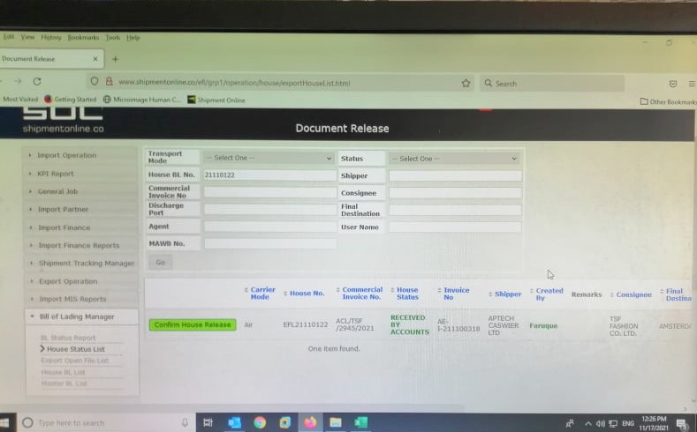

6.4 Collect Debit and Credit voucher
Almost one hundred twenty or thirty Debit and Credit vouchers are collected from the customer every day. All cash and bank payments are recorded on a debit voucher. This voucher is also known as a payment voucher. On the other hand, Cash and bank receipts are recorded on credit vouchers. It's also known as a receipt voucher.

6.5 Preparing Money Receipt
When receiving cash or cheque then a money receipt is prepared. For receiving a bill of leading, the customer gives cash or cheque. when the customer gives the cash, have to go to sage 300 ERP software after that go to the receipt batch list and create a new batch by adjusting the customer's cash receiving code for preparing the money receipt. On the other hand, when the customer gives the cheque, I have to check whether the money has been deposited or not in the account. If the money is not deposited, I give it back cheque to the customers. While money is deposited then I must go to the account and account number which customers had deposited the money in that account. Then I transfer the money to that account.

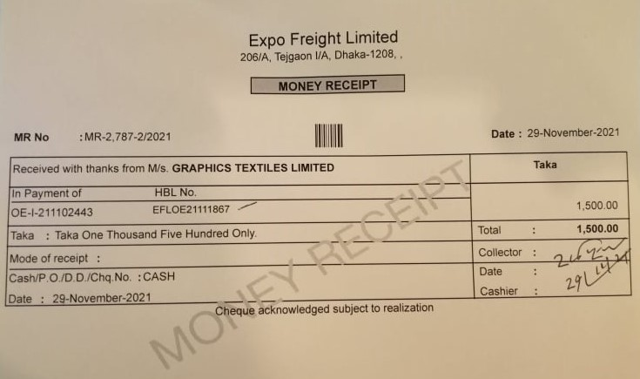
Money receipts are prepared in two copies. One copy is given to the customer and another copy receives by the office. In the money receipt, the shipper name, date, amount, batch number, transaction number, invoice number, and HBL number are given.

6.6 Document Release
After completing the money receipt, I adjust the bill of leading with the money receipt which customers under the bill of leading are paying the money. After giving the copy of the documents to customers then I have to show my release receiving copy through the SOL software which means that customers have taken the document of this number. For releasing the document have to go to the sol software. Then has to go bill of the leading manager and after having to go the house states list. In the next step, I have to go to the house bill number and enter that number. In the following step, have to click the confirm house release. Then this number will show the release. After clicking the document number, the shipper name, who creates the document, the consignee name, and when this document is done date, the printed date, the received data, and the release date will show.
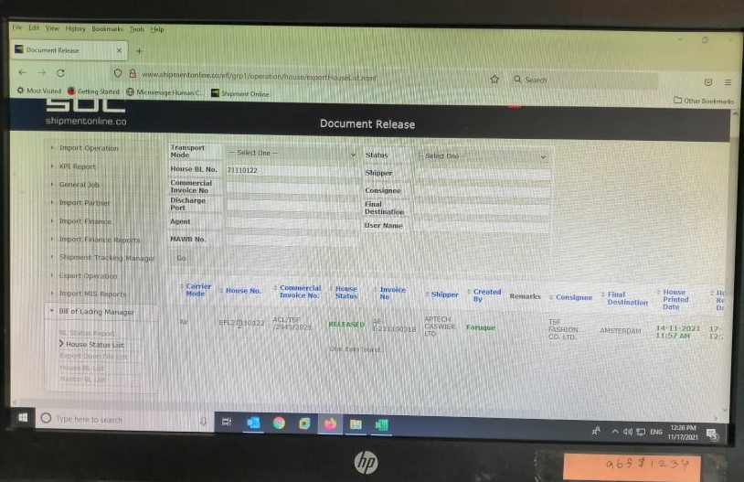

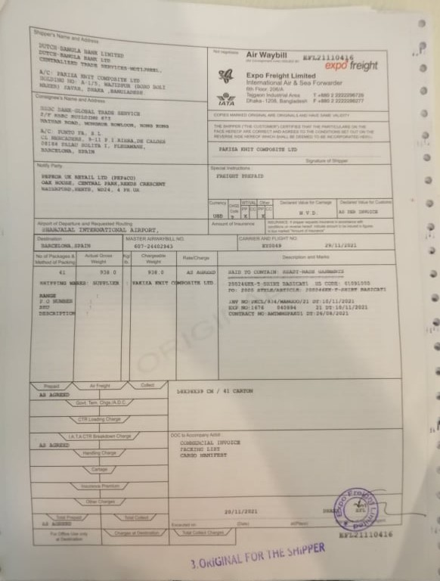
Air Bill of Lading

6.7 Prepare Mushak-6.3 - Tax Invoice
I prepare tax invoices through excel. When customers purchase goods then I prepare tax invoices. When the Customers give the invoice a copy to the invoice then I download it from the sol software and start doing the tax invoice. Importers and wholesalers buy goods using VAT Form-6.3 at the time of importation. The tax invoice contains adding the company name, address, BIN number, buyer's name, address, BIN number, invoice number, issue date, time, product or service design, unit of supply, quantity, unit price, total money, and tax rate. Companies that provide service or have charitable organizations do not have to pay taxes. The government does not collect taxes from them, it waives their taxes. Then 0% tax is mentioned in their company’s Tax invoice.
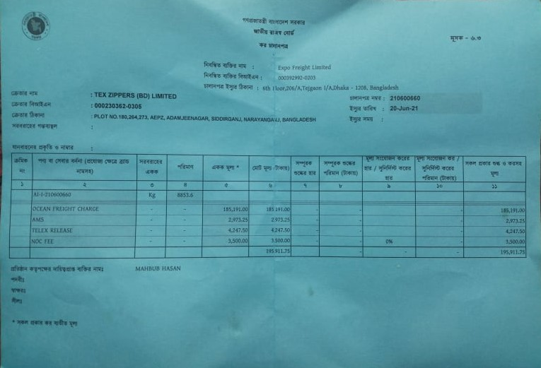
Tax Invoice

6.8 Import update- Local
All import BDT cheque is to do updates every day through sage 300 ERP software that has been deposited in the bank. Cheques that have been deposited in a bank must open the bank's code and provide an import update. When providing import updates, keep in mind the check number and whether or not the deposit date is correct. In addition, you have to keep in mind which month the cheque is because the check has to be matched or equalized with the USD rate of that month. After applying the rate, Many times the money does not match. Then, if more or less money appears, I must keep it and close the batch.

6.9: Book Update- Overseas
All import USD cheques must be updated every day through the Sage 300 ERP software that has been deposited in the bank. Expo fright limited USD cheque is deposited only at one bank. As a result, updating a USD check does not appear to be difficult. Because only one bank's code is required to update all deposit checks. There is also no issue with the rate factor in the USD check. When the invoices are applied, the majority of the cheque amounts are matched. When providing USD cheques updates, keep in mind the check number and whether or not the deposit date is correct. Many times the money of the USD cheques does not match. Then, if more or less money appears, I must keep it and close the batch.

6.10 Gain and Loss Adjustment
Some of the amounts of money are more or less after completing the local import update and international book update. As a result, profits and losses must be balanced through the use of debit and credit notes. If there is more money and the corporation makes a profit, I must produce a debit note and adjust the profit. After adjusting the profit, an invoice or debit note is created then applying it will match the amount of money. On the other hand, if there is less money, it is a loss for the company then I have to create a credit note and adjust the loss. After adjusting the loss, a credit note invoice is prepared, which is applied to the amount of money then it will do with matching the money.

References
Brewer, P. C., Garrison, R. H., & Noreen, E. W. (2018). Introduction to managerial accounting.
Adeniji, A. A. (2009). Cost accounting: A managerial approach.
(2022, February 10). Expo Group, Bangladesh. https://expogroup-bd.com
(2022, February 15). Expo Freight Ltd, Global. http://expogroup-bd.com
(2022, March 05). Expo Group Bangladesh. http://expogroup-bd.com/index.php/news-events/
First land-air cargo from Bangladesh leaves India. (2019, January 4). The Daily Star. https://www.thedailystar.net/city/news/first-bonded-cargo-bangladesh-leaves-india-1682821
Bonded cargo from Dhaka leaves Kolkata airport | banglatribune.com. (n.d.). Bangla Tribune. https://en.banglatribune.com/business/news/24741/Bonded-cargo-from-Dhaka-leaves-Kolkata-airport
The Financial Express. (n.d.). Expo freight launches weekly air service from Dhaka to NY. https://thefinancialexpress.com.bd/trade/expo-freight-launches-weekly-air-service-from-dhaka-to-ny-1526183159

