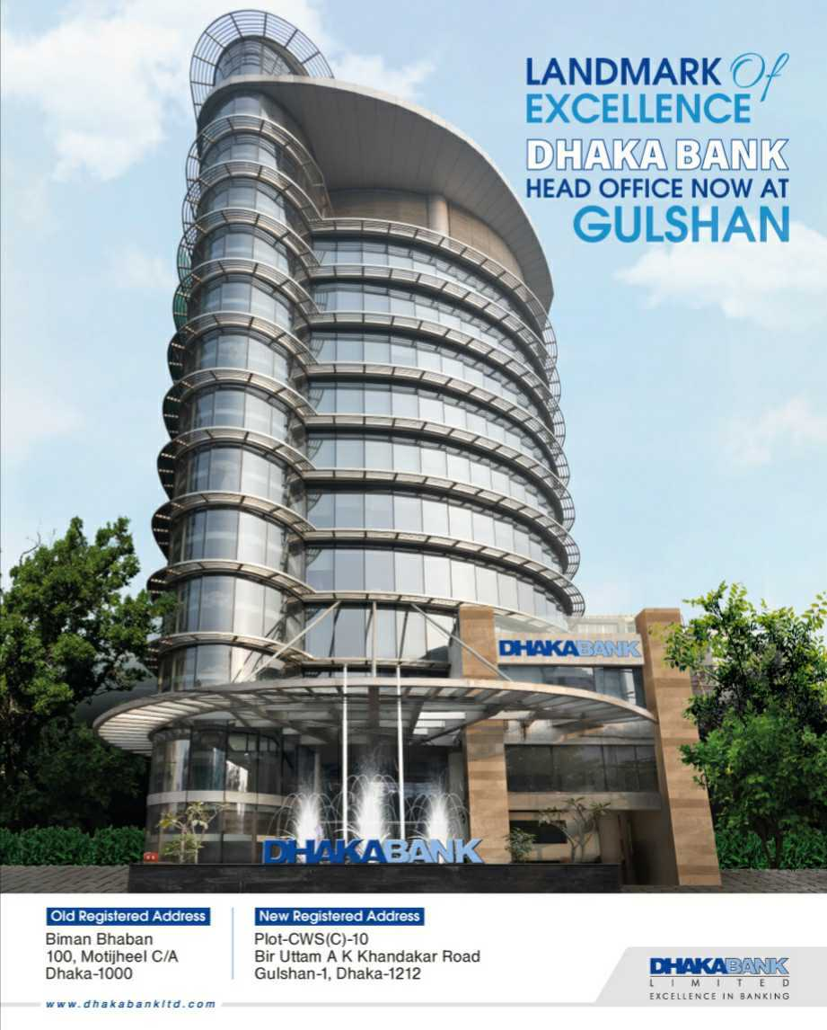
On
Recruitment and Selection Process of



INTERNSHIP REPORT


“Recruitment and Selection Process of
Dhaka Bank LTD”
Submitted To:
Prof. Dr. Mohd. Hasanur Raihan Joarder
Professor
School of Business and Economics
United International University
Submitted By:
Name: Farjana Akter Momo
ID: 111 152 010
Major: HRM
Summer 2021

School of Business and Economics
United International University
Date of Submission: May 24, 2021

Letter of Transmittal

To
Prof. Dr. Mohd. Hasanur Raihan Joarder
Professor
School of Business and Economics
United International University
Subject: The submission of Internship Report on Recruiting and selection process of DBL.

Dear Sir,

By outstanding consideration, I would comparable to notify you that I consume acquiesced my Internship Statement on the “Recruitment and Selection Procedure of Dhaka Bank” in accordance with your instructions. I expectation this article is both insightful and exhaustive.

I considered the analysis to be very fascinating, useful, and informative. I did my finest to write an effective and trustworthy paper. The research includes a thorough examination of the Recruitment and Selection process, as well as an examination of how it is carried out in the real world. We obtained this information from various outlets, including sites and real conferences with my Controller at "Dhaka Bank Limited."
I'd really like to express thanks you for your help and understanding with me, and I escalate the chance you've given me by appointing me to effort on this kind task.

Honestly Yours,

………………………...

Name: Farjana Akter Momo
ID: 111 152 010
SOBE, UIU

Acknowledgement

The positive end of the project is the result of many people's efforts and those who have taken the time and effort to voice their opinions and suggestions for improvement in the research. To begin with, I want to show gratitude the Enormous for the fortitude to work with restriction. We can't call anyone individually, though, due to space limitations. I am delighted to express my thanks to a large number of people who directly or indirectly contributed to the project's preparation for warm collaboration and support.

It is an honor to be appointed under the supervision of Prof. Dr. Mohd. Hasanur Raihan Joarder
Professor, School of Business and Economics, United International University. I am thankful to him for all of his help and advice in planning this project report. His useful advice and instructions greatly aided me in preparing this work in a well-organized way.

Then I want to thank my manager, Mrs Kazi Karima, for her close monitoring. Senior Human Resource Officer Division. I also want to thank Mr. Rezaur Rahman, Head of the HR, and 1. Md. Nistaque Ahmed, 2. Md. Shofiur Rahman, 3. Md. Kamrul Islam, 4. Md. Ayman, 5. Shahina Afroje
6. Nujhat Sharmin, to support me through my internship by providing guidance. Without their help and guidance this analysis may not have seen the daylight.

I would also want to submit a letter of reference from Dhaka Bank Limited, providing me with an opportunity to study for this renowned bank. Thank you especially for your support to the DBL Human Resource Detachment. The DBL has helped me to understand several aspects of my study, thanks to my expertise and knowledge.

Finally, I want to thank everyone who spoke about my work, gave me useful proof, critiqued me and praised me. It's not sufficient to acknowledge that I am very thankful for their contributions to the research. I want to thank everyone from the bottom of my heart.

Executive Summary

Dhaka Bank Limited has nothing like the rapidly expanding finance world, in which they have a "Banking Excellence" goal. One of the leading financial institutions in the world seeks creativity through a competent and well-trained staff with a varied occupation.

One of the most critical activities of any organization is HR operations. The HR division of Dhaka Bank is a great place to learn more about human capital. A superb team of HR administrators is responsible for all HR-related matters. Their diligent effort allows them to select good applicants. They uphold a genuine flow at the step of drafting and assortment. The reduced roll-up rate shows that the recruitment and recruiting phase of Dhaka Bank is an outstanding example.

The research focuses on the Institute of Human Resources. Given that the work demand at Dhaka Bank is significant for private commercial banks, highly skilled employees are needed who work hard, else the whole business would collapse. Such fancy people provide every firm with a huge problem.

The Human Resources Division will submit a general form to all other branches and divisions of the headquarters at the beginning of the year for the purpose of predicting future human capital demand in Dhaka Bank Ltd. (DBL). On the basis of the data collected from this method, the HR detachment estimate the staff requirement of the year. Then the HR Division trains and hires a variety of qualified and efficient staff of the bank. DBL uses both the drafting and assortment processes, nevertheless the procedure differs according to the nature of job since it is such a major organization.

A commercial bank's performance depends heavily on the quality of service offered to its clients. The efficiency of the service is determined by the skill and efficiency of the workers. Consequently, if the right person is hired for each job, DBL must be careful. Improve the recruitment and assessment phase of DBL. While DBL is well integrated in its overall method of recruitment and selection, space for development remains. It is necessary to upgrade both policy and practice.

Table of Contents
[Sidebar Title]
[Sidebars are great for calling out important points from your text or adding additional info for quick reference, such as a schedule.
They are typically placed on the left, right, top or bottom of the page. But you can easily drag them to any position you prefer.
When you’re ready to add your content, just click here and start typing.]
1.1 Introduction 1
1.2 Objective of the report 1
1.3 Scope of the study 1
1.4 Methodology 2
Primary data 2
Secondary data 2
1.5 Limitation of the study 3
2.1 Overview of Dhaka Bank Limited 5
2.2 History of Dhaka Bank Limited 5
2.3 Vision of Dhaka Bank Limited 6
2.4 Mission of Dhaka Bank Limited 7
2.5 CORPORATE VALUES OF DHAKA BANK 7
2.6 Functions of DBL 7
2.7 ACHIEVEMENTS 8
2.8 Goal of Dhaka Bank Limited 8
2.9 Strategic objective of Dhaka Bank Limited 9
2.10 Division of Dhaka Bank Limited 9
2.11 Branches of Dhaka Bank Limited 10
2.12 Organizational structure of Dhaka Bank Limited 11
2.13 STRATEGIC OBJECTIVE OF DBL 16
2.14 Ethical Principles of DBL 17
2.15 Overview of HRD of Dhaka Bank Limited 17
3.0 SUMMARY 20
3.1 OVERVIEW OF HR DIVISION 20
3.2 HRD OF DHAKA BANK LIMITED 21
3.3 HR VISION 21
3.4 HR STRATEGIC OBJECTIVES (2011-2021) 22
3.5 FUNCTIONAL STRUCTURE OF HUMAN RESOURCES DIVISION 22
3.6 Function of HRM 25
3.7 Generalized Selecting Method 32
3.8 Strategies of Staffing at Dhaka Bank Limited 35
3.9 Types of Recruitment at DBL 38
3.10 Recruitment Process of Dhaka Bank Limited 39
3.11 Selection Process of Dhaka Bank Limited 44
3.12 Recruitment & Selection Process Cycle of Dhaka Bank Limited 52
3.13 Recruitment & Selection Budget of Dhaka Bank Limited 53
3.14 Challenges and Constraints of recruitment and selection process of Dhaka 54
Bank Limited 54
3.15 Comparison steps between Dhaka Bank and other’s bank 55
4.1 SWOT Analysis of Dhaka Bank Limited 58
5.1 Internship Activity: 61
5.2 Personal Observation 62
5.3 Problems 62
References 68

Chapter 01
Introduction

1.1 Introduction
1.2 Objective of the report
1.3 Scope of the study
1.4 Methodology
1.5 Limitation of the study

1.1 Introduction

I need to complete my internship and report on my professional abilities as a fundamental requirement to the BBA degree. The thesis has been developed by a BBA program from the United International University's Department of Business Administration.
It offers an outstanding forum to produce brilliant ideas for each pupil. Since the banking industry is the leading player for our economy and offers a very pleasant environment for career development in our banking field, I have been focusing primarily on this type of financial institution since the start of my BBA program. . (Kundu, 2019)

1.2 Impartial of the report

The core purposes of the hands-on orientation sequencer in banks are as follows –

- In the direction of learn around the banking industry in Bangladesh.

- On the way to be aware of the HRMD’s duties.

- On the way to define DBL's Recruitment Procedure.

- On the way to apply hypothetical knowledge in a real-world setting.

- Too acquainted with the bank's operating climate.

- On the way to meet a portion of the BBA Program's requirements. (Fairuz, 2019)

1.3 Scope of the study

As an imprison, my repertoire was very incomplete and delimited. I passed concluded the data collection regulations for my research. Not all Dhaka Bank Limited transactions will be included in this report. This paper is focused on my assignments, findings and studies in the Dhaka Bank Limited human resources department during my internship program. (Islam, 2020)

1.4 Methodology

I used a variety of data collection and presentation approaches to learn about Dhaka Bank's staffing and assortment procedure. For this reason, I primarily used 2 kinds of data:

- Primary data

- Secondary data

Primary data: A significant number of primary data were used to establish this analysis. The bank is collected by a group of individuals. The following techniques are used for primary data collection. Here are a few examples.

- Direct interviewing: I used a well-designed questionnaire to gather information from the division manager and officers.

- Individual message: I collected data via personal contact with my boss and other bank officers.

- Opinion method: I gather knowledge by watching their habits.

Secondary data: Secondary references are documents that have been written or stored. I obtained subordinate information from the following websites-

- There are many kinds of government papers.

- Any academic reports, books, journals, and papers have been written.

- File research, as well as records on investment concept and experience (Nabi, 2016)

1.5 Constraint of the training

It is not easy to analyze an extensive method of recruitment and selection by a bank. In the other hand, I have been able to see or explain some of the important problems and other aspects, and as a young employee of the group I have not been able to. However, some of the shortcomings I found in this report are mentioned below:

- Private and Confidential Data: Recruitment and placement data from a bank's human resources division is perhaps the most private and confidential material. As a result, there is a plethora of details that was not disclosed and shown to the authorized official.

- Time Limitation: Time was of the essence in order to complete the analysis. It took a very short period to learn around an organization like Dhaka Bank.

- Inadequate Data: There is a scarcity of data around Dhaka Bank. There is no reproduced data obtainable to prepare the paper. Furthermore, due to the reluctance of the busy main personnel, gathering the requisite data became difficult. Employees are pressed for time in order to complete their tasks.

- Lack of Record: Owing to organizational constraints and limitations, a large-scale analysis was not feasible. Inadequate supply of proper written information to conduct a thorough investigation. In certain instances, current knowledge was unavailable. (Tabassum, 2019)

Chapter 2
Background of Organization

2.1 Overview of Dhaka Bank Limited
2.2 History of Dhaka Bank Limited
2.3 Vision of Dhaka Bank Limited
2.4 Mission of Dhaka Bank Limited
2.5 Corporate Values of Dhaka Bank
2.6 Functions of DBL
2.7Achievements
2.8 Goal of Dhaka Bank Limited
2.9 Strategic objective of Dhaka Bank Limited
2.10 Division of Dhaka Bank Limited
2.11 Branches of Dhaka Bank Limited
2.12 Organizational structure of Dhaka Bank Limited
2.13 STRATEGIC OBJECTIVE OF DBL
2.14 Ethical Principles of DBL
2.15 Overview of HRD of Dhaka Bank Limited

2.1 Overview of Dhaka Bank Limited

Bangladesh's main private sector bank is Dhaka Bank. They provide a wide range of facilities aimed at people, companies, international trading, foreign exchange, leases and financial markets. The bank is fully-equator with IT-standard business, connected banking, e-commerce, Internet Finance and SMS Funding – The bank launched Online Banking – It is one of Bangladesh's most rapidly developing private banks. Dhaka Bank Limited has chosen a banking solution for pleasant and customized services, state of the art technology, tailored business demands, worldwide trade and business footprint and large returns on investments to ensure quality. (Rahman, 2019)

2.2 History of Dhaka Bank Limited

Under the Companies Act of 1994, the bank was formed as a public limited company. On July 5, 1995, the bank began commercial operations with an approved capital of Tk. 1,000 million and a paid-up capital of Tk. 100 million.
The bank's current authorized capital is Tk. 10,000 million. As of December 31, 2017, the bank's Paid-up Capital was Tk. 7,223 million. As of December 31, 2017, the bank's gross equity (capital and reserves) was Tk. 15,828 million.
The bank has distinguished itself through its financial strength and operating expertise, establishing it as a potential industry leader in all key areas of banking in the region. In the year 2000, it was listed on the DSE and CSE. Dhaka Bank has a countrywide presence across a wider network of Branches, ATMs, ADMs, SME networks, and SMS banking, in addition to a long-standing relationship with the corporate sector. Dhaka Bank has a vibrant presence throughout the country with 104 branches, including 2 Islamic Banking Branches, 3 SME Service Centers, 57 ATMs, 20 ADMs, 1 Business Kiosk, and 2 Offshore Banking Units as of December 2021.
To meet the wants of the capital shop, the group formed a secondary business called Dhaka Bank, which has six branches across the country.

To meet the needs of the capital market, the bank formed a subsidiary company called Dhaka Bank Securities Limited, which has six branches across the country. We want to emerge from the heart of Bangladesh as a more powerful force in the sector we share. We remain committed to our goals of creating superior shareholder value as we evolve and develop into a banking veteran. The Company began its banking operations and is authorized to conduct the following forms of banking business:
- All types of commercial banking activities including Money Market operations.
- Investment in Merchant Banking activities.
- Investment in Company activities.
- Financiers, Promoters, Capitalists etc.
Two other branches of the bank are operated in accordance with Islamic Shariah, and their operations vary significantly from those of the non-Islamic branches. The bank is a publicly listed company for its general stock class on the Dhaka Bourse and Chittagong. Bangladesh central warehouse limited is another member of the Dhaka bank (CDBL). The company/bank does worldwide operations via a global network of foreign correspondent banks. (Islam A. , 2014)

lOMoARcPSD|256

2.3 Revelation of Dhaka Bank

The visualization of DBL is to make sure any transaction is a pleasant experience. The objective is to provide outstanding amenity through precision, trustworthiness, prompt transfer, front-line technology and custom-made industry requirements strategies, multinational trading and exchange footprint and high investment returns. Both their employees, products and processes are in tandem to meet their distinguished customers' high standards. DBL's aim is to get a clear picture. Its main objective is to provide content that represents our mission and excellence in banking. (Kundu, 2019)

2.4 Mission of Dhaka Bank

Dhaka Bank's goal is to remain the country's foremost financial institution, offering high-quality goods and services supported by cutting-edge technologies and a side of extremely committed employees to deliver Fineness in Banking.

2.5 COMMERCIAL STANDARDS OF DHAKA BANK

- Emphasis on Customer
- Honesty and Integrity
- Deference for the person in direct correlation
- Citizenship Responsible
- Integrity and responsibilities
- High moral environmental awareness

2.6 Functions of DBL
- DBL's principal role is to receive deposits from different clients via different accounts.
- Provides simple provisions for loans.
- Make a deposit of a bond.
- The Fund invests in profitable industries.

2.7 ACHIEVEMENTS

- Credential of Value from lCAB – 2008

- Bangladesh transmittal Awards - 2009

- Greatest Bank Award – 2009

- CSR Honor – 2009

- ICAB Nationwide Award for Best Obtainable Yearly Reports 2013

- Branding and Decorating Dhaka City Leadership Award - 2014 (1st Prize)

- Prize 2014 to SME Finance (Manufacturing Sector-friendly Bank of the year)

- 'Top Business Award 2014' ICMAB (3rd award)

- Bangladesh Bank accreditation for the School Finance contribution in the region of Chittagong – 2015 (2nd position)

- Best Promoter Award 2009 (awarded in 2015) (Rahman, 2019)

2.8 Goal line of Dhaka Bank

All of employees, products and systems satisfy our distinguished customers' high demands. Our dream is as the stars are to be remembered. Our primary objective is to provide content that represents our vision - Banking Excellence.

2.9 Strategic impartial of Dhaka Bank

DBL's primary impartial is to provide a service that reflects its mandate – Banking excellence. The strategic objectives of DBL include the execution of transparent, high-quality business activities within a legal and social framework dependent on market structures. There are also the following objectives:

- Provide consumers with goods that are often reliable, creative, and of high quality, as well as an outstanding distribution system.
- As a profitable, ever-growing enterprise, generate benefit with qualitative business and increase equal revenues to bondholders.
- As a private entity, subsidize to the prosperity of the state as part of the company's social obligation and be informed with climate, climate and clean land.
- Promote employee well-being by providing a competitive salary package and increasing employee satisfaction through recruiting, advancement, and job development.

- Fulfilling one's obligations to the government by paying all taxes and duties and adhering to all other laws. (Rozario, 2017)

2.10 Division of Dhaka Bank Limited

It would be very difficult to manage the system efficiently if the jobs were not arranged with their interrelationships in mind and were not assigned to a certain branch. There would be a haphazard scenario where there were no divisions, and the success of a certain section would not be calculated. Dhaka Bank Ltd has done an excellent job with this project. Dhaka Bank Limited (DBL) has the following divisions:
Dhaka Bank |  |  |  | Islamic Banking |  |  |  |  | Asset |  |  |  |  |  |  |  |  |  |  |  | Corporate Banking |  |  |  |  | Consumer Banking |  |  |  |  |  | Human Resources
 |  |  |  | Division & SME |  |  |  |  | Management |  |  |  |  |  | CRM Division
Training Institute |  |  |  |  |  |  |  |  |  |  |  |  |  |  |  |  |  |  |  |  |  | Division |  |  |  |  | Division |  |  |  |  | Division
 |  |  |  |  | Unit |  |  |  | Division
 |  |  |  | Business |  |  |  |  | Finance & |  |  |  |  |  | Research & |  |  |  |  |  | General Services |  |  |  |  |  | Cards & ADC |  |  |  |  | Cards & Business
Reconciliation Unit |  |  |  | Operations
 |  |  |  |  |  |  |  |  | Accounts Division |  |  |  |  |  | Development Unit |  |  |  |  |  |  | Division |  |  |  | Operations Unit |  |  |  |  |  | Unit
 |  |  |  | Division
Syndication & |  |  |  | CPC-Credit |  |  |  |  | CPC Trade |  |  |  |  |  | Information |  |  |  |  |  | Global Trade |  |  |  |  | Internal Control & |  |  |  |  |  | Risk Management
Structured Finance |  |  |  |  |  |  |  |  |  |  |  |  |  |  | Technology |  |  |  |  |  |  |  |  |  |  |  | Compliance
 |  |  |  | Operations |  |  |  |  | Operations |  |  |  |  |  |  |  |  |  |  |  | Services Division |  |  |  |  |  |  |  |  |  |  | Division
Unit |  |  |  |  |  |  |  |  |  |  |  |  |  |  |  | Division |  |  |  |  |  |  |  |  |  |  | Division
 | Retail Monitoring |  |  |  |  |  | Treasury Division |  |  |  |  | Legal Affairs |  |  |  |  |  | Engineering |  |  |  |  |  | Communications & |  |  |  |  |  | DBL Securities
 | Unit |  |  |  |  |  |  |  |  |  |  |  | Division |  |  |  |  |  | Division |  |  |  |  | Branding

2.11 Divisions of Dhaka Bank

The banking has 105 offices, 4 smalls to medium-sized businesses, 2 Islamic banking centers, 2 overseas banking units and a regional subsidiary and an international network. In the fiscal year to expand its network, the Bank plans to open more branches.

2.12 Organizational structure of Dhaka Bank Limited

Communication networks and reports are shown in the organizational framework. Each division head/department/unit in charge should ensure that employees who report correctly understand and respect the reporting relationship and flow of all communications as illustrated in the Organizational Matrix.

Board of Directors

There are four different wings to consist the organizational structure of DBL. They are

- Board: The corresponding owners select the Chairman and Members of the Board.
- Chairman: The Board of Directors appoints the Chairman. He holds Board meetings and ensures all Board decisions are carried out.

- Managing Director (MD): The Managing Director, who is now the Chief Executive Officer of the Bank, is approved by the Board and is accountable to the Chairman and the Board for all of the Bank's procurement.

- Management Committee (MANCOM): The Managing Director, Deputy Managing Directors, Heads of Divisions/Departments/Units from Head Office, and all other staff members who may be co-opted as requested and appointed by the Managing Director comprise MANCOM. MANCOM usually meets once a week to discuss and make joint decisions on the main topics facing the bank. (Badrul, 2004)

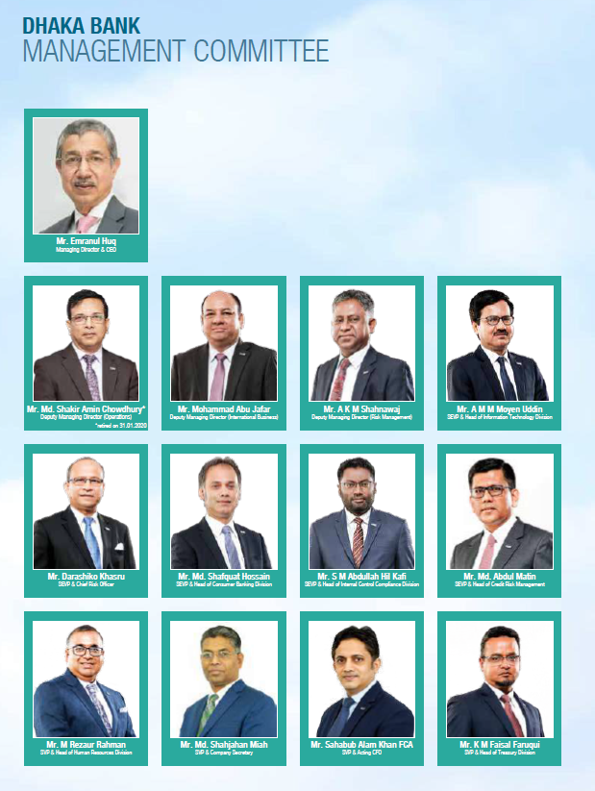

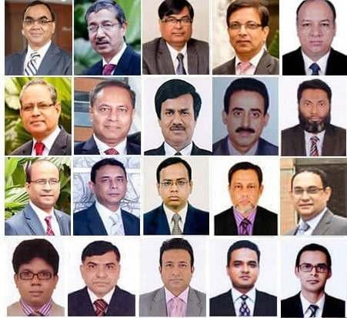

Products & Services of DBL

Figure: Products and Services of DBL

2.13 STRATEGIC IMPARTIAL OF DBL

- DBL's goals remain to perform open and superior commercial operations founded on marketplace mechanisms inside the legal and community frameworks outlined in its mandate and expressed in its vision.
- Customers' top priority is to provide them with consistently reliable, creative, and high-quality goods, as well as an outstanding distribution system.
- The company's mission is to produce value from quality business as a long-term, rising organization while still providing equal revenues to bondholders.
- As a private citizen, I am committed to the society, and as a corporate social responsibility, I am committed to contributing to the advancement of the country.
- Promote employee well-being by offering an attractive pay package and by boosting employee productivity by recruitment, growth, and career preparation.
- Strive to perform your responsibilities to the government by paying all taxes and obligations by adhering to all other laws.
- Concerned about the atmosphere and climate change, as well as a duty to make the homeland a green and clean soil. (Ahammed, 2012)

2.14 Ethical Principles of DBL

The following ethical principles are dedicated to DBL:
- Conform with the laws and guidelines of the region.
- Reject graft and bribery.
- Avoid tainted entertainment and gifts.
- Speak if some real, expected or future actions which may violate legislation and regulations is suspected.
- In compliance with the rules on anti-money laundering and other regulatory prudential provisions.
- Quick and equitable resolution of consumer issues.
- Keep our customers confidential and trustworthy.
- Provide justice and respect to our coworkers. Work in a strongly motivated team spirit. (Islam A. , 2014)

2.15 Outline of HRD of Dhaka Bank

Thanks to a team of committed, seasoned and dedicated staff, Dhaka Bank Limited's performance is very robust. The main focus is on pursuing bank results. The bank is dedicated to employing high-quality staff and as long as them with the incentive, exercise, job situation and payment plans they essential to carry out as best they can, as human capital are the most valuable asset. You appreciate the importance of making the bank a desirable workplace. At that end, they safeguard that staffs comprehend and recognize the corporate objectives and values of the bank. The bank indorses the reputation of its employees' robust principled values. You have to do so. (Kundu, 2019)

Chapter 03
Recruitment & Selection Process of Dhaka Bank

3.0 Instantaneous
3.1 Outline of HR Partition
3.2 HRD of Dhaka Bank Limited
3.3 HR Visualization
3.4 HR Planned Objectives
3.5 Efficient Structure of Human Resources Division
3.6 Purpose of HRM
3.7 Generalized Selecting Method
3.8 Strategies of Staffing at Dhaka Bank Limited
3.9 Types of Recruitment at DBL
3.10 Recruitment Process of Dhaka Bank Limited
3.11 Selection Process of Dhaka Bank Limited
3.12 Recruitment & Selection Process Cycle of Dhaka Bank Limited
3.13 Recruitment & Selection Budget of Dhaka Bank Limited
3.14 Challenges and Constraints of recruitment and selection process of Dhaka Bank Limited
3.15 Comparison steps between Dhaka Bank and other’s bank

3.0 SUMMARY

Recruitment, Selection & Hiring

The Dhaka Bank has a credibility in the banking sector in Bangladesh for bringing the most intelligent, clever and talented people. We are actively searching for new and promising graduates from various reputed universities in order to recruit talented young people to this Bank. Dhaka Bank organizes talent hunts to include the highest caliber among its employees across various contact networks. It encourages best talents and professionals to work in an outstanding atmosphere in which they can thrive. We offer on-the-job and off-the-job preparation by management training level to enable more young people to have better careers.

Dhaka Bank has a well-ordered rule of behavior and it does not allow workers to ask or approve any inducement that could run counter to their customer duties. Evaluation of their individual achievements is carried out against the goals and fundamental principles prescribed by the Bank.

In accordance with the annual workforce preparation in view of the bank's demands for turnover and extension, Dhaka Bank recruits new and seasoned staff permanently. We employed 222 employees this year. The rate of turnover of employees in 2021 is 4.79%. (Nabi, 2016)

3.1 OVERVIEW OF HR DIVISION

Human resources are one of the most important aspects of a new organization. In order to ensure quality excellence, the Banks need a competent and well qualified human resource staff. A secret to our success is nothing more than an intelligent, qualified and inspired team of staff. We have a good competitiveness in terms of our employee's dedication, qualified and loyalty to the Bank. We want to strengthen our long-term leadership. For this reason, we mix modern banks and creative tactics with conventional principles, including justice, confidence and professionalism. Our staff is the dominant factor of this endeavor, so we constantly improve and enhance our staff's skills and expertise through early training and other human resources programmed. (Islam A. , 2014)

3.2 HRD OF DHAKA BANK LIMITED

Workers remain the central properties of any association, one cannot organize deprived of them and with the growth of people's advancement to a greater degree of skill, ingenuity and satisfaction, the human resources are performed. It makes workers more accountable and therefore attempts to build an environment in which they contribute to the limits of their enhanced skills. It revenue that enhanced skills and chances for individuals through an operational efficiency straight increase.

Basically, the attitude to human resources means positive results for individuals. Dhaka Bank Limited often decides how many tasks and groups of employees are to be completed.

The establishment of the Bank's organization helps to determine employees' expertise, experience and capabilities. In order to ensure that suitable staff can fulfill the needs identified through the strategic planning phase. The banks agree that professional work is done by highly driven and challenging employees who have great service. (Rahman, 2019)

3.3 HR VISION

The value of high ethical principles of its workers is promoted by the bank. They must follow the specified encryption of ethics and are not and are not allowed to implore or consider any incentives that are probable to interfere with their responsibilities to clients.

3.4 HR STRATEGIC OBJECTIVES (2011-2021)

Corporate human resource planning is an essential aspect of strategic human resource policy and an organization's human resources division. HR strategic priorities aid in the fruitful alignment of human resource strategy with business planning, resulting in the achievement of the organization's vision, mandate, and business goals.
For the years 2011-2021, the Human Resources Division has set the following visionary strategic goals:
- Realign human resources in accordance with the revised visualization, task, and commercial strategy.
- Provide dangerous and critical workforce at altogether stages.
- Certify the wages and compensation are driven by the economy.
- Provide opportunities for job growth.
- Present credential schemes to ensure equal assessment of results.
- Make sure nation rules, administrative orders and corporate standards are respected.
- Dhaka Bank branding as the strongest working place for local banks.
- Reorganize the tasks of the HR department to motivate it.
- Automate and align the HR process with other usable services . (Rahman, 2019)

3.5 FUNCTIONAL STRUCTURE OF HUMAN RESOURCES DIVISION


- Human Resource Division

Resource | Compensation | Performance | Career
Resource | Management | Management | Development
Planning Unit | Management | Management | Development
Planning Unit | Unit | Unit | Unit

Figure: Functional structure of Human Resources Division
There are 12 HR employees working in HRD to carry out HR-related tasks. Both operations carried out by staff are overseen by the head of HRD and the SEVP.

Dhaka Bank Limited's Human Resources Division is comprised of four divisions. Each part has its own set of duties and everyday jobs. Several operations are used in the modules. The map below will help you understand it better:
Figure: Function of HRM

3.6 Function of HRM

HR managers do HRM work to achieve the organization's priorities and goals. Two categories of duties are assumed by HR administrators: management and operational. HR administrators are referred to as managerial roles as managers or directors of their own organizations. In reality, all managers fulfill these duties regardless of department. On the other hand, operational roles are basic tasks usually carried out by management of human resources for all departments. (Badrul, 2004)

Units in HR division

There are three units in Human Resource Division of DBL:

- HR Staffing
- HR Operation
- Training & Development.

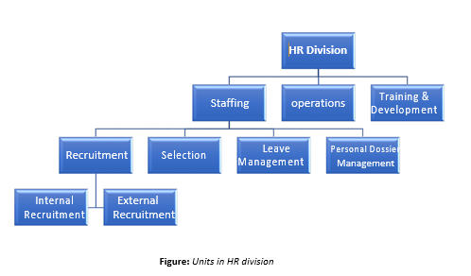

HR Staffing

One of the most important challenges for any organization is that of hiring – placing the best employees in the right place at the right moment. The work carried out should be as good a standard as that carried out by the people. (Ahammed, 2012)

In the HR recruiting unit three officers serve. The following operations was carried out

Definition of Recruitment

“The process of recruitment aims to discover and attract people capable of applying for work. Recruitment success does not just measure the number of requests received. "The ideal recruitment attempt attracts, according to Robins, a high number of qualified candidates who take up the position when they are offered. The skilled should draw a solid recruitment program and not attract the unskilled. This dual aim will decrease unqualified processing costs”.

“Recruitment is therefore the process by which a company finds its staff and is probably the most essential duty faced by every corporation. No company can work efficiently without the proper personnel. In order to succeed in the recruiting programmed, managers should work with workers on the definition of needs and openings. This recruitment might be place inside or externally .” (Fairuz, 2019)

Human resource recruitment refers to any administrative movement that is designed to affect:

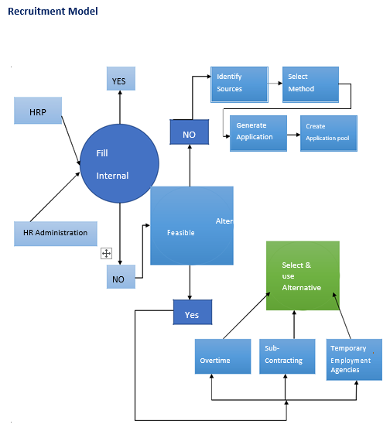

Recruitment

Types of Recruitment

A. Internal Recruitment

The principal methods are-

- Job Posting:

Posting work vacancy notices on corporate message boards is an important form of internal recruitment. It reminds workers of job opportunities and the necessary credentials, and it encourages eligible employees to smear. Notices are generally posted on business newsletters, on electronic newsletters or in the newspapers of companies. Qualifications and other evidence are based on data from job analyzes.
- Skill Inventories:

Using HRIS to choose the best fit applicant is possible, but this necessity be a safe and undisclosed source of inner candidates. This foundation provides sufficient yet appropriate employee detail.

- Nominations:

Employees who are interested in the posted vacancy should return to the HR Department and apply, based on a recommendation by a prospective boss. (Tabassum, 2019)

B. External Recruitment

Organizations rely on-

- Billboards
- Employee Recommendations/Endorsement:
- Civic or private appointment agencies
- Counting campus engaging
- Stand-in Activities:
- Uninvited Application

- Advertisement:
Want ad is a common way for an agency to announce to the public that it has a position. It explains the work, the incentives, and advises persons who are curious how to smear. It is the maximum widely used tool.

- Worker Referrals/Endorsement

Employee references may likewise have received additional precise reports near prospective jobs. The endorser therefore offers more realistic information about the job for the applicant than a recruiting firm or journal ads would provide.

- Employment Agencies

Certain specialist associations focus on the recruiting and jobs of people; they provide needed manpower to vulnerable businesses.

- Schools Colleges & Universities Recruiting
Lessons are a perfect way for prospective workers to be found. Employers submit college delegates to pre-screen candidates and create a bundle of graduate class applicants.

- Temp Agencies

When people are required on a temporary basis, organizations such as agencies may be a provider of staff. Temporary workers are particularly useful for conference short-term changes in HRM needs. It does not supply recruits. They are a basis of temporary jobs. The corporation employs the contract employees.

- Unsolicited Application

Profession hunters may go to the offices of renowned corporations on their own. Furthermore, without support from other means, candidates approach the company directly. (Nabi, 2016)

Selection

Selection of workers is the way to fit the correct work with the best men. It balance the corporate needs with the skills and credentials of the people. And accurate sorting can be carried out where there is effective mixing. If the correct option is selected for the job, the company will benefit from highly quality employee performance. By picking the right candidate, organizations will save time and money. The candidates are adequately screened during the interview period. Any prospective candidate requesting a vacancy is reviewed. However, since the recruitment process has two phases, it must be assessed and implemented.
Enrollment is seen as a positive tool because it promotes the application of more candidates. It produces a tarn of interviewees. It's impartial statistics collection. Assortment is an undesirable process, though, because unfortunate entrants are here excluded. Enrollment takes place before placement in the staffing phase. (Rahman, 2019)

3.7 Generalized Selecting Method

Assortment begins where conscription ends- with interviewee pool. Assortment goes concluded five steps:

- Screening Assessment Process
- Evaluative Assessment Process
- Contingent Assessment Process

- Selection Model

- Initial Screening: Systematic review of the applicant for jobs, interpretation of the resume is carried out here. This is the primary step in which an extensive candidate pool is given a short list.

- Secondary Screening: This phase entails the removal of unskilled staff as well as the selection of future vacant jobs. The first step in the selection process is to check. Various forms of tests are available. Checks depending on who the applicant is: we can quickly classify

- Mental abilities

- Engine and physical ability

- Personally, und interest

- Work expertise

- Cognitive Abilities

Cognitive assessments include basic cognitive skill tests as well as tests of particular learning skills such as memory and inductive intellectual.

- Motorized and Corporeal Aptitudes

The rapidity and precision of basic decision, as glowing as the speediness of finger, wrist, and arm motions, are all measured by motor ability. It consists of-

- Stromberg Dexterity test

- Minnesota Rate of Manipulation test

Test of physical abilities are also required. It includes-

- Variable force
- Changing electricity
- Coordination of bodies
- Robustness

- Personality & Interest

Personality tests test fundamental attributes, such as introversion, stability and optimism of a candidate's personality.

- Job Knowledge
These exams assess what an individual has experienced. It assesses work expertise in various areas such as finance, communications, human resources, and so on.

- Candidacy: This degree is the fundamental component of the work interview or sequence of jobs interviews based on an extensive evaluation of the qualification of the candidate. Individuals who successfully pass a battery of assessments and participate in multiple exercises are sent to an evaluation center of certain organizations to better evaluate their skills. Applicants who complete this stage are considered future workers.
- Corroboration: This period is anxious with checking the applicant's reference records. Due to the growing number of negligent recruiting incidents, companies must show caution when checking and reporting references.

- Final Selection: This is the level of decision-making. The applicant's knowledge is analyzed, as is the information collected by the agency. If the evidence is positive, a work offer is extended; otherwise, no job proposal is protracted. The initial employ offer is contingent on a corporeal test and a contextual check. A concluding career proposition is made if the candidate positively passes these two final hindrances. (Rozario, 2017)

3.8 Strategies of Staffing at Dhaka Bank Limited

Staffing is the method of recruiting, deploying, and maintaining an adequate quantity and efficiency of employees to have a beneficial influence on the organization's effectiveness, and DBL still strives to ensure this in certain measures. When they hire applicants, they often look for a good relationship between the candidate's qualifications and position characteristics, whether they fit or not. Basically, they often want to align the right worker for the right task. Furthermore, they place a greater focus on developing talent rather than gaining it. They have a dedicated recruitment and growth unit where they train current workers to aim to make them more effective at their jobs.

Every year, DBL conducts a business strategy review, which specifies the appropriate headcount for the following year. They then hire people based on the knowledge. DBL primarily maintains a plan-based HRP for a one-year time limit. They favor internal hiring for senior positions but prefer external hiring for entry/junior level or MTO/TCO positions. DBL has a total of 1668 staff (As of 31 Dec 2016). There are 9 employees in top management, 48 in senior management, 176 in middle management, 610 in junior rank, 722 in officer level, and 103 people employed as support staff in the bank. . (Rahman, 2019)

Employee Status In DBL

800
 |  |  |  |  | 722
700
700 |  |  |  | 610
600
500
400
300
300 |  |  | 176
200 |  |  | 176
200 |  |  |  |  |  | 103
100
100 |  | 48
9
0
0 | Top Management | Senior | Middle | Junior Level | Officer | Supporting staff
 |  | Management | Management


Recruitment Point

2 kinds of recruitment.

- Entrance level
- Sideways entry (Staffing of skilled person)
Entrance level:

There are 2 entrance level post for recruiting fresh graduates and post graduates.

These are:

  - Experimental officer Level

  - Trainee Associate Officer (TAO) Level

- Experimental officer Level
Since successfully completing a one-year probation term, probationary officers are confirmed as officers. Probationary officers are hired by a comprehensive written test administered by the IBA. Following the test, the highest scorers are invited to an interview with the management committee. Following the interview, they would expression an interview in obverse of the Board of Directors.

Advertisements for Probationary Officers are included in the daily newspaper as well as on the company's website. For Probationary Officers, only internet applications are accepted (PO). They must apply to bdjobs.com. DBL HR receives a database of CVs or resumes from bdjobs. The applicants' resumes are then shortlisted by the HR committee. Only those who have been shortlisted are invited to take the written test. The circulars have short-listing guidelines. There are some topics that can be avoided when making a short list.

These subjects are

- MBA (Major in Accounting, Finance, Marketing, HRM, MIS etc.)

- English

- Statistics

- Economics

- Mathematics

- CSE

- Development studies

2. Trainee Associate Officer (TAO) Level

The assistant officers of TAO have been appointed (AO). The TAOs hire on the basis of CVs. DBL administration typically took one written exam, followed by a Viva, for TAOs recruitment.
Lateral admission (recruitment of experienced person)

Seasonal bankers, regarded as lateral entrants, have the possibility. The lateral entry is known for the duration of service, occupational obligations, progressive past and other considerations. (Islam A. , 2014)

3.9 Types of Recruitment at DBL

DBL is engaged in two recruitment forms
- Annual hiring: according to the HR schedule last year
- Recruitments based on requirements: where an unexpected vacancy occurs. (Badrul, 2004)

DBL's recruitment pattern is highly variable. They sometimes hire more people based on their needs and projections, and sometimes they hire less people. DBL job recruiting status from 2008 to 2017 as seen below:

Year TO+TCO

 | MTO | Lateral Entry |  | Total Employee Joined
 | 38 | 32 |  | 104
 | 0 | 16 |  | 54
 | 38 | 53 |  | 248
 | 51 | 33 |  | 181
 | 75 | 36 |  | 247
 | 0 | 4 |  | 46
 | 56 | 15 |  | 109
 | 40 | 30 |  | 185
 | 48 | 25 |  | 222
2008 34

2009 38

2010 157

2011 97

2012 136
2013 42

2014 38

2015 115

2016 149

Employee Recruitment Trend Of DBL

300

250

 |  |  | 248 |  | 247
200 |  |  |  | 181 |  |  |  | 185 | 222
150 |  |  |  | 181
100
100 |  |  |  |  |  |  | 109
104 |  |  |  |  |  |  | 109
50
50 |  | 54 |  |  |  | 46
0
2008 |  | 2009 | 2010 | 2011 | 2012 | 2013 | 2014 | 2015 | 2016

3.10 Recruitment Process of Dhaka Bank Limited

Dhaka Bank's recruitment process begins when new hires are expected and ends when applications are received. It yields a pool of candidates from which new hires are chosen.

Dhaka Bank Limited is such a big enterprise that it takes a large amount of manpower every year to keep its activities at different levels running smoothly. Nevertheless, aimed at routine commercial activities, they need two types of personnel. Both are as follows:

- New alumnae

- Professional knowledgeable people

The recruiting procedure is then shadowed by the screening course, final interviews, decision making, and the formalities of the nomination. Dhaka Bank Limited recruit’s applicants using the following procedure:
  - Planning HRM and notification of vacancies
  - Qualifying Recruiter
  - Channels of Recruitment

- Personnel Planning and Vacancy Announcement

The Human Resource department at DBL is led by the Human Resource Manager. The human resource department receives requisitions for recruiting from every department or division of the organization, which starts the recruitment process. HRD makes decisions on roles that need to be filled by participating in staff preparation and forecasting. HRD sends a notice to all branches informing them of their personnel needs, and after receiving input from line managers, HRD makes a decision on the personnel vacancy. The following employee projections are given for the upcoming year 2018:

 | Requirement | Number
 | For existing branch/division of HO | 96
 | For proposed Branch (4 in 2018) | 40

Projected Attrition replacement | 50
Total Required in 2018 | 184

Category: Third Party Servicer Staffs (Required up to 31 December 2018)

*Third | Requirement | Number | party
 | For existing branch/division of HO | 24
 | For proposed Branch (4 in 2018) | 36
 | Total Required in 2018 | 60

Operating assistant, peon, cleaner and security guard are the contractors' staff.

In addition, HR managers and line managers work closely to define staff duties and responsibilities. (Islam A. , 2014)

2. Recruiters’ Qualifications

Management Trainee Recruitment Qualification:

- The applicant needs to receive Master's in the relevant discipline from a recognized university

Business Administration | Mathematics/Statistics
Bank Management | Public Administration
Economics | Development Studies
Engineering (EEE/Civil/Mechanical) | Computer Science/IT

- The applicant must be CGPA-equivalent to at least 3 first division.

- The age of the boy must be 30 years from now.

- The candidates had to be under 30 years old.
- Applicants must get a B.Sc. in commercial or business sciences from a prestigious university.
- Division 3 of CGPA must not be allowed.

3. Recruitment Channel

Dhaka Bank LTD hires its workers in two ways and that is -

- Internal Recruitment Channel

Existing workers are a valuable source of new hires. Internal candidates already know the informal group and have detailed knowledge about the formal procedures, whether for endorsements, appointment, or lateral work transfers. In particular, DBL only used this form of recruiting for special purpose experienced employee recruitment. DBL employs a closed recruiting strategy for this internal recruitment. External recruiting outlets include:

  - Job Rotation

  - Skill Inventories

Job Rotation: DBL hires new workers by work rotation from current employees. Since the organization requires multitaskers, they generate postings of individuals to other departments. They describe the job's responsibilities and qualifications, as well as how to apply.

Skill Inventories: DBL obtains accurate job certification details for vacant positions from current employees through HRIS. This company has a directory in which all forms of information about all workers is stored. When they need new hires, they then look at the website and see if they can find the details and then add in new workers based on their needs the necessity, they favor skilled candidates with solid skills and professional qualifications when recruiting for higher positions.

External Recruitment Channel: Maybe anything extraordinary requires work that cannot be fulfilled by internal capital. Under these cases, the HR department must look beyond the organization and DBL recruit’s management trainees or other junior and mid-level employees. For external recruiting in the DBL, a total of three methods are used, which exist directly or implicitly for various levels of recruitment. There are-

- Advertising: DBL's primary approach for incoming recruits is the advertisement process, which is intended for recruitment purposes. They place advertisements in reputable English and Bengali national newspapers. For hiring applicants, they use web ads on bdjobs.com and prothom-alo.job.com. The following is an example of a work advertising in the DBL's online protocol:

- Employee Referrals: DBL mostly adopts employee referral procedures for entry level employees, but not for trainee managers. These procedures are accompanied by existing employees referring to one new worker and further judgment being given to the new employee. This pattern is often used for junior candidate status.

- Walking CVs: Stroll are job applicants who reach HR in search of jobs and apply their resume. They are often asked to fill out an assessment questionnaire to assess their goals and skills. This are typically used for entry-level or contract positions; however, these types are not used for the recruiting of management trainees. (Nabi, 2016)

3.11 Selection Process of Dhaka Bank Limited

For any organization, hiring is crucial because it influences organizational effectiveness, recruitment and selection issues as well as legal obligations. Dhaka Bank Limited has a well-organized hiring system for all categories of employees, recognizing the value of diligent screening, although the mechanism varies depending on the task. The following discusses the comprehensive business screening process with an emphasis on DBL's management apprentices, external/internal applicants:

- Reception of Application: Following recruitment, DBL continues to hire, and commences after application forms are received and completed from the online forms of the Internet. It determines, after examining the completed information, which requestors may take the written analysis but first assesses the reliability of the information contained in the paper.

- Informing Candidates: After shortlisting CVs and selecting eligible applicants, the HR division calls the candidates to remind them of a written exam (entry level) or an interview (upper-level). For written exams, the bank sends admit cards via courier ten to fifteen days before the exam.
- Assessing Candidates through Written Tests: DBL is continually obsessed with keeping the best outlook. The candidates chosen undergo the aptitude test, which is a written examination, because they have been removed from previous procedures. The written examination evaluates the after:
  - Logical ability

  - Logical cognitive ability

  - Mathematical ability
The test questions are focused on mathematics and interpretation, with the extraction of information from the data and relationships between the clues of a specific problem. DBL usually carries out written entry-level testing, for example in trainee assistants and in MTO. The exam is taken by IBA from Dhaka University. The response scripts will be examined by the Examination Committee. Interviews based on their high scores are invited for candidates.

- Document Checks: The applicant essential apply photocopies of their school, college, and university diplomas. If the institution does not have the initial credentials, the bank may consider a probationer diploma, academic record, or mark sheet.

Interview: Applicants who pass the inscribed exam are invited to an interview. Candidates are notified of the interview period, date, and location at least 48 hours in advance. All interactions with the applicant, such as setting up an interview time and date, negotiating a job and pay, and so on, are handled solely by the HR recruiting staff.

In DBL, an interview board of at least three members is created, one from top management and the others from HR and functional departments. This first interview is referred to as the Preliminary Interview. When considering an applicant, Dhaka Bank Ltd looks for the following conditions or competencies:

- Appearance: Dress up, clothing, lingering, and touch with the eye.
- Interpersonal skills: communication function, expressiveness. communication skills.
- Trust: passion, personal sales
- Solidity: mindset of positive
- Creature: Dream of the box
- Client Delivery Capacity: Client Service Capacity
- Dedication: Basic awareness of work and any theory
- Faculty in management
- Capabilities planning and organization
- Loyalty/commitment: jobs and organization.

Based on all these conditions, the applicant shall be assessed on the assessment form: 1 = Poor; 2 = Outstanding; 3 = Good; 4 = Good.

Furthermore, the qualifying grade point for MTO is 40, while the qualifying grade point for other positions is 35. If a candidate receives 46-50 points, he or she is considered Outstanding; if a candidate receives 1-20 points, he or she is considered a mediocre candidate. The interviewer considers the following candidates based on this information:

- Job qualified
- Take a second option
- Unsuccessful

For both external and internal lateral entry applicants, DBL only conducts interviews and hires for appropriate or necessary positions depending on the results of the interviews. In this scenario, the applicants are evaluating based on:

- Job knowledge
- Degree of motivation
- Verbal competences
- the goodness
- Vision/Ambitus/Stableness
- Qualification as a university

Depending on all these, interviewers score Very Well, Good, Average and Below Average results for applicants. And these comments help the Committee to determine if the claimant is :

- Employee eligible
- May be taken into account for various positions
- Can be taken into account after 3/4 months
- In the employee's ability.

Take two rounds of interviews for every position at DBL. The Divisional director and upper management conduct the final interview. Any appropriate applicants emerge from this interview. The following DBL interview format forms are given for lateral entry and junior level positions:

- Reference Check: When an applicant is chosen for a role, HR checks the references he or she has provided. At least two sources must be provided by the applicant. If the applicant is new, he or she must have one reference from his or her educational institution. However, if the applicant has previously worked, one referral from the former company, preferably the boss, is needed. Subject to a suitable answer, a work offer would be made.
- Job Offer: Both permanent and temporary positions require permission from the MD, which is granted by the Head of Human Resources. If an applicant successfully advances to the final level, he or she will be offered a work offer following compensation negotiations, and upon accepting the job offer, the candidate will be sent for medical testing at a bank-selected diagnostics facility. For temporary employees, there is no pay negotiation. Individuals who enroll as MTO have a twelve-month probation term.

- Medical Test: At DBL, the work offer is conditional on passing a medical test administered by a diagnostic center designated by the bank. Candidates must obtain a medical letter from HR and attend the medical examination. This test was designed to assess a candidate's physical fitness to determine whether or not they are qualified to do the work. This stage also includes details on any infectious illnesses that the applicants may have and whether or not such diseases should be treated. On behalf of DBL, the Apollo Hospital in Dhaka configures the diagnostic examination. They investigate the following tests to assess the applicant's health and readiness for the work effort:

  - General physical examination (Such as blood pressure, breathing, pulse etc.)
  - Chest with X-Ray (Standard)
  - Routine urine/microscopic urine review
  - Check for Blood (Blood grouping, Hepatitis-B, Blood Sugar)
  - ECG / ECG

Appointment Letter: Finally, after the medicinal exam and orientation checks, the candidate's proposal letter was released. Following that, the applicant receives notification that he or she has been selected and must pick up the letter from HR. The selection letter outlines all of the job's terms and conditions.

- Acceptance of Offer Letter & Joining Procedure: There is also a method for entering. At the time of entry, the candidates approved the invitation letter by signing it. Then he or she must complete certain forms, such as,

  - Shape HRIS
  - Type of ID Card
  - A Bond for Five Years
  - Statement:

After completing all this formality, the candidate is a DBL member and starts work as a DBL employee.
- Induction/Orientation: Orientation is the final step in the process of DBL collection. Both new staffs should orientation curriculum and learn about the history, norms, rules and regulations of the company, so as to recognize the critics and expectations of the organization. Insertion makes an individual an important part of the company. A basic working out program for all newly employed employees will be put together by Dhaka Bank Training Institute. (Rozario, 2017)

Flow chart of internal recruitment process of DBL

Manager notifies HR of vacancy

3.12 Recruitment & Selection Process Cycle of Dhaka Bank Limited

It takes up to 62 days to complete a full recruiting process in the Human Resources Division. The 62 days in the following breakdown:

Figure: Recruitment & Selection Process Cycle of Dhaka Bank Limited

3.13 Recruitment & Selection Budget of Dhaka Bank Limited

DBL invests heavily in recruiting knowledgeable, adaptable, and competent employees. DBL is not obsessed about staffing costs at all; rather, it is concerned with recruiting the right workers at all times. DBL pays about 1 core per year on average on the total recruiting and selection process. Management recruitment consumes one-third of the spending. Trainee Cashier, Trainee Officer, and Trainee Officer.

Budget of Recruitment

70%


60%

50%

40%

30%

20%

10%

0%

TO/TCO MTO LETERAL ENTRY

3.14 Challenges and Constraints of recruitment and selection process of Dhaka

Bank Limited

DBL is now having difficulty finding qualified employees. It has put in a lot of effort and resources, but it still faces obstacles every year despite employing the most skilled and competent employees. The problems are caused by a variety of factors, which are listed below:

- Shortage of supply: Because of the poor quality of production, DBL employers are having difficulty recruiting skilled workers. Despite graduating a large number of graduates and postgraduates each year, banks are unable to find suitable applicants. On the other hand, some qualified applicants choose to move for a better quality of life rather than work in banks. From this vantage point, DBL's employers are not receiving the desired candidate.

- Cost: The cost of hiring and replacing employees is enormous, and it is that by the day. People with more skills and expertise usually need a higher degree of work. As a result of budget constraints, DBL recruiters occasionally struggle to find suitable candidates.

- Unable to choose appropriate candidates: DBL has a high staff turnover rate. The turnover rate is 4.79 percent, and as a result, they would hire a large number of workers per year. They are often under tremendous pressure to hire people on an immediate basis, and as a result, recruiters may sometimes struggle to choose the right applicant for the right job. Furthermore, a large number of recent graduates choose to begin their careers in multinational corporations or the government sector rather than the banking sector.
Initially, the international company offers opportunities for its workers to serve in many countries and communities, which improves the employees' work quality and productivity, as well as a generous pay plan. As a result, recent graduates are irrationally eager to begin their careers at global companies’ corporations.

- Big players are emerging: Here is a high request for successful applicants in the banking sector due to the vast number of banks open. Employee transfers from one bank to another are popular in this industry. As a result, banks face a significant obstacle in attracting and retaining talented applicants. (Fairuz, 2019)

3.15 Judgement steps between DBL and other’s bank

Figure: Comparison steps between Dhaka Bank and other banks

Chapter 4
SWOT Analysis of Dhaka Bank LTD

4.1 SWOT Analysis of Dhaka Bank Limited
- Strength
- Weakness
- Opportunities
- Threats

4.1 SWOT Analysis of Dhaka Bank Limited

Two opposing sides in any scenario. The Dhaka Bank has approximately controls, shortcomings and opportunities as glowing as approximately challenges. The following was highlighted:

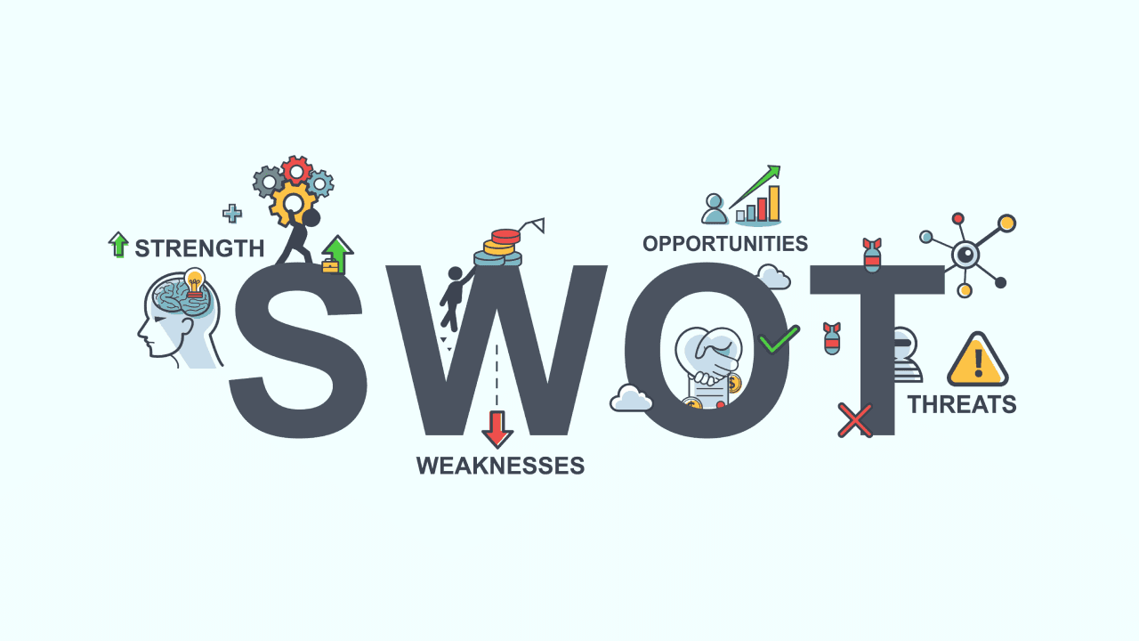
Strengths:

- DBL has a great brand image and identity in financial services for its clients and DBL staff have a robust sense of group. They are both identical excited about their tasks and self-motivated. And this kind of young people

- The entire working world of DBL is stimulated by fresh workers. The fact that the net profit increases steadily over the years is another promising development.
Weaknesses:

DBL has no clear promotion efforts across mass media such as TV, Radio. DBL does perform more CSR operations compared with other banks. DBL does. DBL needs less market variation in order to develop its new business lines, it will follow a diversification approach. DBL's wages are really fine, but other kinds of incentives do not exist.
Opportunities:

The repayment potential as evaluated by individual customer's DBL helps determine how much can be borrowed. Based upon the repayment capability of a customer, the entire lending mechanism has almost 100 percent recovery rate of DBL. This allows DBL to stay in the market for long periods with financial security & DBL equipment. Bangladesh, on the other hand, is a developed nation that satisfies the demands of the massive population, so that DBL is able to take advantage of customers by offering more services. Furthermore, DBL employs expert administrators to support its activity.
Threats:

The forthcoming international and private banks are posing major risks to the current DBL banking reseau: more commercial banks are predicted to appear in the years to come. Offering the same kind of goods at a nearly equal profit margin, various international and privately held banks often sell nowadays. Thus, the natural outcome is that both rivals compete with the same arm. In addition to all these trends in the industrial decline in the banking industry, rules and regulations are also a distressing danger. (Fairuz, 2019)

Chapter 5
Internship Experience

5.1 Internship Activity
5.2 Personal Observation
5.3 Problems

5.1 Internship Activity:

I was an internship for the HRD of Dhaka Bank Limited from December 2020 to March 2021. The Internship program, which would help me grow my potential career, gave me several chances to train and gain experience with actual banking activities. I have acquired a business background the internship scheme that I would not have gained in the classroom.
In addition to working in a Standard Bureau I have learnt to address the banking industry's problems, I have had the opportunity to apply skills derived from academic knowledge, I have tested a number of different areas for observing different roles and jobs in investment. Meanwhile my primary day, I have been able to perform a variety of tasks and duties. I drive closely with the professional growth staff, salary administration unit, and preparatory unit for capitals to help and advice on request, and to help with the needs of the on a regular basis.

Job Errands at Dhaka Bank:

- I secondhand to be responsible for the whole placement. Print and distribute an appointment letter to them along with intern placement. A directory of internship programs must be kept and run carefully. Moreover, internship certificates for those who already have finished their DBL internship have been prepared.

- For this cause, I helped my elders search the CVs for new hires and kept a directory. I called the candidates who were selected for the written test and instructed them to gather their examination cards. Later the written examination, after the authorized official reviewed the manuscript, the scripts were sent to myself and I had to create two different records: one for the applicants who approved the examination, and one for the applicants who unsuccessful and/or were not chosen. For this cause, I helped my elders search the CVs for new hires and kept a directory.

5.2 Personal Observation

- When selecting candidates, the HR Division is highly diligent and the procedure is very easy so that the best candidates can be selected.

- Since here is no bias in this method, there are more chances of being chosen without any backup.

- When they look for experienced candidates, they focus mainly on prior experience, educational history, duration of service, and so on, in order to choose the most appropriate experienced people.

- When they choose entry-level applicants, they look for initiative, creativity, and proposals that are relevant to the role.

- The speed and consistency of HRIS Software (SCALED) are subpar because the server's software is out of date.

5.3 Problems

Since DBL is a prestigious bank institution, a large number of people choose to work for Dhaka Bank. As a result, when a work opening is revealed, a vast quantity of resumes is put in the CV bank. Though, when it comes to shortlisting applicants based on evaluation criteria, a larger number of candidates meet the qualification conditions, but only a limited number of eligible candidates are chosen for the written examination. Both interested applicants are considered for the written examination, but HRM does not grant all qualified candidates the chance to take the written test. Only candidates chosen at random from among the eligible candidates would be able to take the written exam.

This, in my opinion, is not rational. Any suitable candidate should be given the opportunity to take the written exam. Furthermore, by picking candidates at random, the most qualified candidates could be ignored, posing a significant challenge to DBL. DBL will perform a written examination. On the other hand, DBL may get suitable workers for them in this manner; it can please the candidates when they are given the opportunity to test themselves.

The orientation program for new hires at DBL is not correct, and it is an unbalanced program since, until 2021, this program was only held twice—in 2020 and 2021. Furthermore, the program is just two hours long. The top executives deliver their very brief speeches here. However, this is insufficient for the newcomers. Since the staff come from a variety of professional backgrounds, they are unfamiliar with the bank's operations. How can workers begin their jobs with zeal if they are unfamiliar with the basic functions of the bank?

According to my view, the induction schedule should be extended to two days and scheduled every year. A broad overview of the work of banks, its goods and services, its goals and priorities, its organizational and commercial policies, its divisional roles, and its purpose, vision, cultures, and principles, among other things, must be included in the curriculum. It would be preferable if DBL organized a basic training curriculum to assist workers in gaining basic information about this Dhaka-bank.

The Dhaka Bank Ltd does not have a proper recruiting expenditure guideline in operation, which suggests that it is inadequate. It is acceptable if the recruiting budget meets the bill. However, if the allocation is insufficient, the resource planning team must request extra funds in a formal procedure and adequate justification, which slows the overall recruiting and selection process.

After this perspective, there must be an appropriate economical for recruiting and selection so that the progression is not disrupted in any method. If practicable, the Managing Director will consult with the Procurement Supervisor about the quantity of budget that will be expended. . (Ahammed, 2012)

Chapter 6
Recommendation & Conclusion

6.1 Recommendation
6.2 Conclusion

6.1 Recommendation

Afterward finishing this report, I gained approximately realistic knowledge of Dhaka Bank Limited's Human Resource activities. Now I'd like to make any suggestions that could help Dhaka Bank Limited develop its Human Resources practices. They are as follows:
- DBL Bank Ltd.’s training course is adequate, but not as realistic as intended. The most of the time, the apprentices are given theoretical hints. However, this is insufficient. They can also be given more realistic ideas.

- It would be preferable if DBL authorities placed a greater focus on their IT Division. Since their IT department is underdeveloped, their machine was hanged and did not function properly for the majority of the day.

- While Dhaka Bank is attempting to resolve a problem with their program (SCALED), they should take the issue seriously and resolve it as soon as possible.

- DBL faces job retention issues, but management can focus on total compensation and motivational policies. . (Fairuz, 2019)

6.2 Conclusion

HRM is constantly working toward draw out aptitudes, improve productivity, and satisfy all of the labor force's demands. In doing so, one of the foundations of HRM, recruiting and selection, works for both the organization and the employee.

Employees are the most important asset for the organization's development, according to the HR training." Many aspects contribute to the production of these important commodities. The most significant factor in this respect is the "Recruitment and Selection Procedure." To maximize an organization's competitiveness, an efficient and complex recruiting and selection process is needed. Dhaka Bank Limited has a progressive recruiting and screening process in place. Dhaka Bank Limited's human resource officers are also forced to go beyond contracts and regulations and contribute directly to the business's growth and performance.

Hiring and acquisition is an important human resources mechanism for attracting, obtaining and retaining qualified workers to meet the possible operational needs of the organization. The report's analysis shows positive as well as harmful behaviors which should be changed to employ staff efficiently. If this analysis is taken into consideration, DBL will be very helpful in converting its risks into power. . (Badrul, 2004)

References
Ahammed, M. S. (2012, 12 30). Overall HR activity of Dhaka Bank Limited. Retrieved from Institutional Repository: http://dspace.bracu.ac.bd/xmlui/handle/10361/5274
Badrul, M. S. (2004, 12 26). An Appraisal of Dhaka Bank Limited. Retrieved from DSpace Repository: http://dspace.ewubd.edu:8080/handle/123456789/1772
Fairuz, A. (2019, 12 21). Online banking system of the Dhaka Bank Limited. Retrieved from UIU Institutional Repository: http://dspace.uiu.ac.bd/handle/52243/1593
Islam, A. (2014, 01 22). Recruitment & selection process of Dhaka Bank Limited. Retrieved from Institutional Repository: http://dspace.bracu.ac.bd/xmlui/handle/10361/3125
Islam, M. N. (2020, 09 06). An Analysis of the General Banking Activities of Dhaka Bank Limited. Retrieved from UIU Institutional Repository: http://dspace.uiu.ac.bd/handle/52243/1869
Kundu, T. (2019, March 20). UIU Institutional Repository. Retrieved from Human Resource Management Practice: http://dspace.uiu.ac.bd/handle/52243/943
Nabi, M. N. (2016, 12 05). Human Resource Management Research. Retrieved from https://www.researchgate.net/profile/Md-Nabi-2/publication/320243761_The_Impact_of_Human_Resource_Management_Practices_on_Job_Performances_A_Case_Study_of_Dhaka_Bank_Pvt_Ltd_Bangladesh/links/59d726bca6fdcc52acaca2c0/The-Impact-of-Human-Resource-Management
Rahman, M. (2019, 05 11). Banking Industry & Dhaka Bank Limited. Retrieved from UIU Institutional Repository: http://dspace.uiu.ac.bd/handle/52243/1100
Rozario, J. S. (2017, 04). Credit risk management of Dhaka Bank Limited. Retrieved from Institutional Repository: http://dspace.bracu.ac.bd/xmlui/handle/10361/12355
Tabassum, M. (2019, 07 14). Performance Analysis of Dhaka Bank Ltd. Retrieved from UIU Institutional Repository: http://dspace.uiu.ac.bd/handle/52243/1226

