Internship Report on

Compensation Strategy of IDLC




Internship Report on
Compensation Strategy of IDLC

Prepared For
Yeasmin Islam
Assistant Professor
School of Business and Economics
United International University

Prepared By
Tahmida Hanif Tuli
ID: 111 151 015
Program: BBA
Summer, 2019
United International University

Date of Submission: October 30, 2019

Letter of Transmittal
October 30, 2019

Yeasmin Islam
Assistant Professor
School of Business and Economics
United International University

Subject: Submission of Internship Report on Compensation Strategy of IDLC

Dear Ma’am,

I am presenting my internship report on “Compensation Strategy of IDLC” that I have prepared to meet the requirements of my internship (INT 4399). This was a privilege of doing my internship report under your supervision. I have worked to follow your each and every instruction and make this report as revealing as possible I hope that I have been able to represent my hard work and dedication for this report and it will meet the level of your presupposition. It will be my pleasure to provide clarification for any of your query.
Thank you for your time and consideration.

Sincerely,

___________________
Tahmida Hanif Tuli
ID-111 151 015
School of Business & Economics
United International University

Acknowledgement
This is my internship report on “Compensation Strategy of IDLC” under the supervision of Yeasmin Islam, Assistant Professor, United International University. I am thankful to her for giving me the privilege in selection of the topic of the report and her continuous direction and counseling henceforth.
Her guidance has been the utmost help to me. I consulted with her so many times and she answered all the questions, I am also grateful to her for her patience towards me.
I am also thankful to Mr. Md. Mushfiq Alam Arko, Assistant Manager Human Resource, IDLC Finance Limited, for giving me his precious time and answering all my queries so spontaneously.

Executive Summary
Compensation system includes all the monetary and non-monetary benefits such as salary, bonus, increment, transportation benefits, accommodation facilities etc, that a company provides employees to value their service towards the company. This report includes both primary & secondary data. Primary data includes the interview of honorable Assistant Manager of HR and observation. And secondary data were taken from books, publications, online blogs and website, HR manual of IDLC. This report is to understand their pay system and point out the intrinsic compensation and an overall idea about the strategies that IDLC is using for their compensation. IDLC is the largest financial non-banking institution of Bangladesh. With four subsidiaries 1400 people is working under them. They are maintaining their strategies as a key to success with an above average salary system. They provide salary on the basis of exempt and non- exempt, geography the length of time, grade of rank, job family etc. They are also providing several types of awards to motivate employees and to giving them recognition. By using the ways of giving feedback, autonomy and other processes they provide employees intrinsic compensation. In Swot analysis the strengths, opportunities, weaknesses and threats of IDLC’s compensation system is providing. And then this report also includes some positive and negative findings. There are also some recommendations by using those recommendations the compensation system of them will be stronger. And the report ends with a conclusion about the whole compensation strategy of IDLC.

Table of Contents

CHAPTER ONE- INTRODUCTION 1
1.1 Background of the Report 2
1.2 Rationale of the Report 2
1.3 Scope of the Report 2
1.4 Objectives of the Report 3
1.4.1 General Objective 3
1.4.2 Specific Objectives 3
1.5 Methodology 3
1.51. Sources of the Information 3
1.5.1.1 Primary Sources 3
1.5.1.2 Secondary Sources 3
1.5.2 Data Collection and Analysis 3
1.2 Limitations of the Report 4
CHAPTER TWO- COMPANY PROFILE 5
2.1 IDLC Finance Limited 6
2.2 Foundation 6
2.3 Products of IDLC 7
2.3.1 Corporate Division 8
2.3.1.1 Corporate Finance 7
2.3.1.2 Structured Finance Solutions 8
2.3.1.3 Green Banking Solutions 8
2.3.2 Consumer Division 8
2.3.2.1 Deposits 8
2.3.2.2 Home Loan 8
2.3.2.3 Car Loan 9
2.3.2.4 Personal Loan 9
2.3.3 SME Division 9
2.3.3.1 Small Business 9
2.3.3.2 Supplier Finance 10
2.3.3.3 Medium Business 10

2.4 Subsidiaries 11
2.4.1 IDLC Securities Limited 11
2.4.2 IDLC Investments Limited 11
2.4.3 IDLC Asset Management Limited 12
2.5 Branches 12
2.6 Mission 13
2.7 Vision 13
2.8 Strategic Objectives 14
2.9 Organizational Chart 14
2.10 Management Committee 15
2.11 Sustainability 16
2.11.1 Green Finance 16
2.11.2 Corporate Social Responsibility (CSR) 16
2.12 Awards and Recognition 17
2.13 Human Resources Division 17
2.13.1 Structure 18
2.13.2 Wings 19
2.13.3 HR and Compensation Committee 19
CHAPTER THREE- COMPENSATION PRATICES 20
3.1 Human Resource Management 22
3.2 Strategic Compensation 22
3.3 Extrinsic Compensation 24
3.3.1 Salary Structure 24
3.3.1.1 Graded Structure 24
3.3.1.2 Job Family Structure 25
3.3.2 Pay Grades 25 3.3.2.1 Job Evaluation 25
3.3.3 Pay Ranges 27
3.3.4 Pay System 28 3.3.4.1 Merit Pay 28 3.3.4.1.1 Performance Appraisal in IDLC 28
3.3.5 Salary Increment 30
3.3.6 Bonus 31
3.3.6.1 Performance Bonus 31
3.3.6.2 Festival Bonus 32
3.3.7 Incentive Pay 32
3.3.8 Terminal Benefits 32
3.3.8.1 Gratuity 33
3.3.8.2 Provident Fund 33
3.3.8.3 Encashment Facilities of Annual Leave 34
3.3.9 Fringe Benefits 34
3.3.9.1 Leave Benefits 34
3.3.9.2 Allowances and other Privileges 35
3.3.9.3 Perquisites for Executives 38
3.3.10 Recognition Awards 38
3.3.10.1 Sport Award 39
3.3.10.2 Integrity Award 39
3.3.10.3 Long Service Award 39
3.4 IDLC HR System 39
3.5 Intrinsic Compensation 40
3.5.1 Skill Variety 41
3.5.2 Task Identity 41
3.5.3 Task Significance 41
3.3.4 Autonomy 41
3.3.5 Feedback 42
CHAPTER FOUR- ANALYSIS AND FINDINGS 43
4.1 SWOT 44
4.1.1 Strength 44
4.1.2 Opportunities 44
4.1.3 Weaknesses 45
4.1.4 Threat 45
4.2 Findings 49
CHAPTER FIVE- RECOMMENDATIONS AND CONCLUTION 47
5.3 Recommendations 48
5.4 Conclusion 48
RFERENCES
APPENDIX

CHAPTER-1

INTRODUCTION

1.1 Background of the report
This title of the report is “Compensation Strategy of IDLC”. Compensation system can be most attractive when employees choose organizations to work if the company is maintaining a flawless strategy. A perfect mixture of extrinsic and intrinsic compensation can give employees feelings of valuable for the company and also motivate them. Through compensation companies not also pays the value of the services and hard work of the employees but also share their profits with them. IDLC has an organized compensation system. As largest non-banking financial company of the country they has 40 branches, but with a largest amount of employees they are maintaining high valued compensation practices all of their branches. This report summarizes IDLC,s compensation strategies.

1.2 Rationale of the Report
This report on culmination has a ton to add to the business of non-banking money related foundations. At present in Bangladesh the nearby monetary foundations are confronting some choppiness in due to the absence of open certainty. A portion of the foundations with lower capital structure have just been exchanged and others are battling as well. In outcome, those foundations are additionally battling with obtaining and maintenance of their skilled employees. IDLC is the biggest NBFI of the nation and furthermore has the best abilities of the business as their employees. Subsequently, in such a period, this report about their pay methodologies can assist those associations with their HR practices and along these lines add to the general advancement of the budgetary division of the nation.

1.3 Scope of the Report
This report is about the Compensation Strategy of IDLC. The emphasis is on the monetary and non-monetary compensation and benefits offered to employees. This report is about mainly by the detail analysis of the IDLC Annual Report 2018, IDLC Annual Report 2017, IDLC Sustainability Report 2018, IDLC HR Manual and IDLC’s official website.

1.4 Objectives of the Report

1.4.1 General Objective
The major objective of this report is to describe the compensation strategies of IDLC Finance Limited.

1.4.2 Specific Objectives
- To understand the salary structure
- To recognize the pay grades
- To know the pay ranges
- To understand the pay systems in practice
- To know the composition of benefit package
- To point out the intrinsic compensations

1.5 Methodology
1.5.1 Sources of information
Both primary and secondary data sources were used during this study.
1.5.1.1Primary Sources-
- Interview
- Observation
1.5.1.2Secondary Sources-
- Website
- Books
- Publications
- HR Manual
- Newspapers
1.5.2 Data Collection and Analysis
Primary data were collected by-
- Interviewing Mr. Md. Mushfiq Alam Arko, Assistant Manager, HR
- Observing team members’ day-to-day activities
And the Secondary data were gathered by collecting information from-
- IDLC’s official website
- IDLC Annual Report 2015
- IDLC Annual Report 2016
- IDLC Sustainability Report 2018
- IDLC HR Manual
- Online Articles and newspapers
- A book on Strategic Compensation by Joseph J. Martocchio
Qualitative data analysis method was followed and a series of steps were accomplished to process the data that had been collected. Data has been collected from the available secondary sources, and then were confirmed from the interview. Then, data was ordered according to the report content.

1.6 Limitations of the report
Although the study has reached its point, there were some inescapable limitations.
- The secondary sources may carry some inaccurate or outdated information
- The time worked as a constraint as it is tough to collect each and every data and come up with a complete concept within such a short period.
- Due to confidentiality issues it was not possible to provide some of the information that could have enhance the report.
- In interviews it is sometimes hard to get proper information because, people may fail to recall any information or can provide biased information.

CHAPTER-2

COMPANY PROFILE

2.1 IDLC Finance Limited
IDLC Finance Limited is an Industrial Development Leasing Company of Bangladesh Limited (IDLC), is a Non-Banking Financial Institution with head office in Dhaka, Bangladesh. It is the greatest multi-item and multi-portion Non-Banking Financial Institution in the nation and furthermore is on the rundown of 20 biggest promoted organizations in the nation. As one of the loftiest budgetary brands in its industry, IDLC holds a differentiated and solid grasp in Corporate, SME, Retail and Capital Market fragments. The organization has 33 years of heritage in serving the business. Since 2012 IDLC has been getting reliably AAA long haul FICO assessment from The Emerging Credit Rating Limited (ECRL), in light of reviewed financials.

2.2 Foundation
In 1985 IDLC was established by the beginning of International Finance Corporation (IFC) of the World Bank. The company started with the collaboration of IFC and German Investment and Development Company, Korea Development Financing Corporation, Kookmin Bank, The City Bank Limited, Bangladesh Limited, Sadharan Bima Corporation and Aga Khan Fund for Economic Development. It is a first leasing company from then and IDLC got the license as a financial institution from Bangladesh Bank under the Act 1993.
They started their journey with five staff members but between these 33 years they has becomes the largest financial institution in the country. 1400 people are working as an employee for them and maintaining 45,000 clients at a time.

2.3 Products of IDLC
There are 4 parts of their products and services - Corporate Division, Consumer Division, SME Division and the Capital Market. There are various products and services under each of the divisions.
2.3.1 Corporate division
Under this division they provide standard services to the financial organizations. The products & services under each department are given bellow.
2.3.1.1 Corporate Finance
1. Lease Financing- Funds up to 100% of obtainment cost, advance term as per business necessity, tweaked reimbursement mode, and clarify documentation.
2. Working Capital Loan-They provides loan, reimbursement as stated by business cash cycle, uncomplicated corroboration and supple assured future package.
3. Term Loan Financing- Their loan limit as per business essential, structured repayment convenient loan term.
4. Commercial Space Loan- Suspension time satisfactory with business needs, flexible loan term, and credit is provided against three parties’ agreement.
5. Project Financing- Loan time depends on the cash flows, suspension based on project’s timeline, bundle product offerings loan amount maintained by standard of debt-equity.
2.3.1.2 Structured Finance Solutions
1. Project Finance and Loan Syndication- Provides customized solutions to all major commercial sections.
2. Foreign Currency Loan- Low-cost USD financing for the suitable projects.
3. Agency & Trusteeship- Proficient and qualified group for agency and trustee services which satisfy functions with the entire time of the transaction.
4. Project Feasibility and Business Planning- Conversion of business idea into a solid business plan, assesses the bankability, scanning the plan on all sides.
2.3.1.3 Green Banking Solutions
Under this Green Banking and Sustainable finance department they offer more than fifty products claimed by Bangladesh Bank Green Re-finance scheme.

2.3.2 Consumer Division
For this division they are offering retail financial services. It is primarily offering Car Loan, Home Loan, Personal Loan and Loans against Deposits.
2.3.2.1 Deposits
1. Flexible Deposits- Pliable loan period, competitive interest rates, no Account Opening fees, auto-renewal benefits.
2. Regular Earners Package- Competitive interest rates, fast Loan facility, online service and money transfer benefits.
3. Priority- Serving financial support and financial advice in a dependable and respected manner, with the amalgamation of first concern service, facilities and priority solution.
2.3.2.2 Home Loan
1. Apartment Purchase Loan- EMI option, transformation can be done from fixed interest rate to variable interest rate, Tri-Party consensus facility with a sound number of developers etc.
2. Affordable Home Loan- Particular service for middle income people, EMI option, and lower interest rates compared to regular rates
3. Home Equity Loan- Financing up to 75% of the cost of building (including registration), for 15-20 years term, EMI option etc.
4. Home Loan Shield- Coverage: from 50% to 100% of the total home loan based on loan period, client’s age, lowest single premium feasible, free of cost medical examination etc.
5. Construction Loan- up to 85% of the cost of building (including registration), up to 20 years term, EMI & Mortgage option, advisory services on technical aspects are available
2.3.2.3 Car Loan
1. New Car Loan- up to 80% of total value, up to 6 years loan term, EMI option, special discount on famed dealers, consulting services are provided if required.
2. Reconditioned Car Loan- financing up to 80% of the total value, up to 6 years loan term, EMI option, discounts on vehicle offered by listed dealers.
3. Pre-owned Car Loan- financing up to 80% of the total value, up to 6 years loan term, EMI option, discounts available on registered dealers, half or full allowance options, early allowance option.

2.3.2.4 Personal Loan
Purpose is to provide for purchase of customer durables, meeting financial accountability, marriage, education, domestic or foreign travel, medical treatment for self/family members and other needs. Also includes financing BDT 50,000 to BDT 10 Lacs, 1 year to 5 years loan term, competitive interest rates, advance settlement and EMI options.

2.3.3 SME Division
For industries like cement, steel, textiles, plastics, light engineering etc. this division is faithful to finance small and medium sized enterprises. Under this division they are offering working capital loan, broad range of services e.g. term loans to make easy expand customer need.
2.3.3.1 Small Business
1. SME Term Loan- Financing up to Taka 2 crore, 13 months - 60 months loan term, loan up to BDT 25 lac (without any guarantee), EMI option etc.
2. Women Entrepreneur Loan (Purnota)- 3 lacs to 25 lacs financing, 13 to 60 months loan term, up to BDT 50 lac at 9% interest rate, different non-financial services.
3. Revolving Short Term Loan- financing up to Taka 1 crore and 1 year loan term, suitable payment method, limitless drawdown within the agreement period.
4. Partially Secured Loan- Financing up to Taka 1 crore, 13 to 60 months loan term, pliable reimbursement etc.
5. Seasonal Loan- Loan up to 75 lacs Taka, up to 1 year loan term, EMI and periodic payment alternatives.
2.3.3.2 Supplier Finance
1. Factoring- Up to 80% of advance loan, financing period is for maximum of 180 days, payment assignment from the buyers, loan amount is anything according to sales (depending on management approval), loan term is 1 year from the penalty date.
2. Distributor Finance- For the distributors only, financing increases the capacity of lifting order in larger volume, enhances possibilities of becoming distributor of famed companies. And for corporations, reduces credit line and increases the numbers of distributors etc.
3. Work Order- Up to 60% of advance loan against justified orders, loan tenure is the business cash flow cycle, remittance assignment from the buyers, loan limit is any amount that rationalizes with the orders (depends on approval of the management), loan time period is 1 year from the penalty date.

2.3.3.3 Medium Business
1. Term Loan- Financing is as per needs, flexible loan term, and moratorium depending on project’ prerequisite, structured reimbursement procedure, interest rate is competitive.
2. Lease Finance- Extended financing, up to 5 years loan term, customized reimbursement method, competitive interest rate, flexible guarantee essential.
3. Commercial Vehicle Financing- Financing of broad range of passenger and cargo vehicle, single vehicle financing, fleet finance and finance under guarantee, loan term is from 12 to 60 months
4. Commercial Space Loan- Financing according to the of debt-equity structure, pliable loan term, structured reimbursement, interest rate is competitive.
5. Short Term Loan- Loan limit can be renewed, up to 360 days loan term, multiple drawdown and flexibility within the loan limit, competitive interest rate and security requirement, no charge on early remission.

2.4 Subsidiaries
The mother company, IDLC Finance Limited accomplishes its capital market operations through three of its subsidiaries below.
2.4.1 IDLC Securities Limited
IDLC Securities Limited started their journey on 2006. They are the stock dealers. They also work as a stockbroker. It is licensed by Bangladesh Securities and Exchange Commission (BSEC). BO account opening and trading is the regular work for them. As they do trading they are connected with other subsidiaries like IDLC Asset Management Limited. They are leading security brokerage of the country and offering greatest services to expand customers including local and foreign investors.
2.4.2 IDLC Investments Limited
In 1999 IDLC Investment Limited started the journey with the license from the Bangladesh Securities and Exchange Commission. It is offering Investment banking, Portfolio management, Margin loans and Securities research services to its customers including both corporations and individual clients. They basically help their customers all over the Initial Public Offering (IPO) procedure. They make sure quick and trouble free portfolio management for the clients to ease them in the capital market.

2.4.3 IDLC Asset Management Limited
IDLC Asset management Limited is also owned by IDLC Finance Limited. They got their asset management license on June 2016. They offer mutual fund to their consumers with an insurance coverage benefits in two ways SIP (Systematic Investment plan) and NON SIP (Non Systematic Investment Plan) with two funds Growth Fund and Balanced Fund. Their head office is in Dhaka and also offering alternative investment vehicles concentrated on private equity and venture capital space.

2.5 Branches
From the initiation IDLC has grown to its largest form over the years with its presence over 20 cities, running by 40 branches among which 16 are inside the Capital including Nandankanon, Dhanmondi, Mirpur, Uttara Branch etc. And there are other 24 branches outside Dhaka including Agrabad, Narayanganj, Comilla, , Savar, Bhulta, Kushtia, Sylhet, Khulna, Mymensingh, Chowmuhani, Rajshahi, Faridpur, Rangpur, Bogra, Jessore branch.

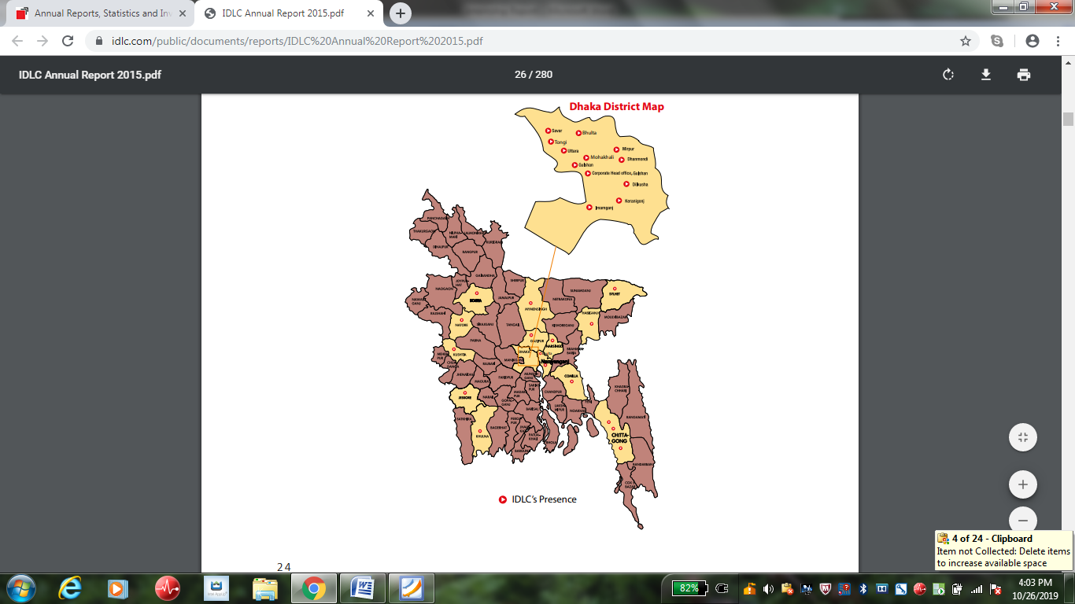
Figure 2.2: IDLC’s National Footprint

2.6 Mission
Their mission statement is “We will focus on standard growth, high ranking customer experience and sustainable business practices” this is IDLC’s mission statement.

2.7 Vision
IDLC’s vision is to be the best financial company of the country regarding which they are working hard.

2.8 Strategic Objectives
IDLC’s strategic objectives for the year 2019 and the next few years ahead are –
- Spreading and developing their flair pool
- Growing and expanding financing sources
- Maximizing dispersal points
- Enlarging sales and service potentialities in their client division
- Integrating capital market performance and lifting abilities
- Supportable spreading SME portfolio
- Internationally accepted corporate guidance and supportable business operations
- Completely leveraging the key platform

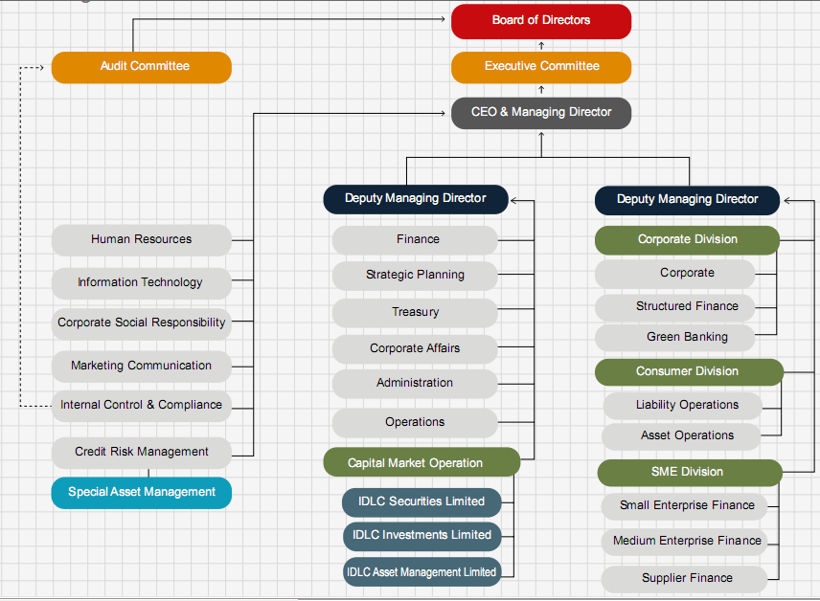
2.9 Organizational Chart

Figure: 2.11Organizational chart
2.10 Management Committee
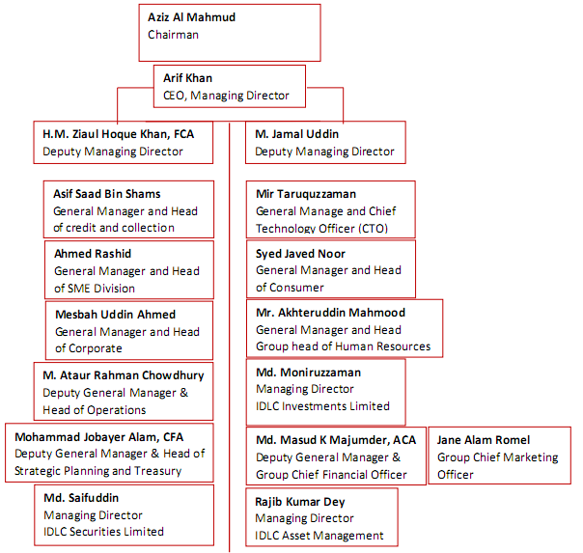
The chain of command of IDLC is presenting below. Chief Executive Officer (CEO) and Managing Director (MD) is the highest official of the company managing the entire organization with a management committee (ManCom) with the divisional head. Mr. Arif Khan is the current CEO and MD of IDLC. He has been holding this position since the year 2015.

Figure 2.4: ManCom of IDLC

2.11 Sustainability
IDLC try to create minimal negative effect both socially and ecologically. They does not share profits only with their stakeholders they try to create a positive impact with their policy their practices. IDLC has two aspects in sustainable business operations.

2.11.1 Green Finance
Brick companies are mainly responsible for producing Green House Gas in Bangladesh. According to research this gas is increasing day by day. IDLC has always been determined to use their resources for social benefits and also for stakeholders, but not only for their profit. IDLC is renewing its commitment by a number of covenants, such as-
1. Tunnel Kiln- IDLCFL is offering a loan of BDT 390.51 million to arrange an energy efficient ‘Tunnel Kiln’ brick project in Gazipur. Tunnel Kiln technology is one of the most well organized technologies to make sure low carbon emission. They have invested BDT 15.21 already for environment friendly brick industry.
2. Waste Recycling Plant- IDLC disbursed a loan of 5 million Taka to a plastic recycling factory in Narayanganj which produces accessories for school bags.
3. Solar Home System- IDLC has disbursed loans of BDT 4.5 million for two companies in Dhaka that import solar panels and accessories required to install solar panels.

2.11.2 Corporate Social Responsibility (CSR)
IDLC tried to create some values, they are-
- value for their stakeholders
- value for the environment and
- value for the community
IDLC is trying to take some initiatives to for their CSR (Corporate social Responsibilities)-
1. Khushir Kheya, The Happiness Marketplace- Through khushir kheya IDLC is creating volunteering chance in various places. They are contributing in various sectors of the country such as medical, education, cultural etc. through this.
2. Oditiya- Through Oditiya IDLC is offering scholarship opportunities only for females. This is an opportunity for low income background females for higher studies.

2.12 Awards & Recognition
IDLC is maintaining its reputation not only with national bodies such as ICAB and ICMAB, but also among institutions in the SAARC region. It won the First/Gold award consecutively for the 3rd time in 5th ICSB National award giving ceremony for Corporate Governance Excellence, 2017.
Also, IDLC has achieved many respected awards among which, ICSB National Award 2016- NBFI Category, ICMAB Best Corporate Award 2016- NBFI Category, Highest Taxpayer Award 2017- NBFI Category, Euromoney Awards for Excellence 2018 - 'Best Investment Bank in Bangladesh', 16th ICAB National Award for Integrated Reporting (among all listed companies) and SAFA Best Presented Annual Reports Awards 2016 are notable.

2.13 Human Resources Division (HRD)
IDLC HR believes that their human capital consists of the employees as well as their health and wellbeing, their, experience, innovation, expertise and their motivation. Therefore the concern of IDLC HR is on the below given aspects-
- Talent & Career Development.
- Rewards and Compensation
- Employee Well-being
- Working Environment
And their responses to ensure these aspects are-
- For team building they are concentrating in guiding the right talent for the right role.
- To create a jolly culture IDLC is giving a friendly environment to their employees.
- They are giving continues training to their employees for their development.
- They arrange career development programs. Through role playing they try to increase employee engagement.
- When they offer remuneration they choose right person for position, in this way they try to encourage employees and ensure sustainability.
2.13.1 Structure
IDLC is maintaining a structured Human Resources Division in place. The Head of IDLC human resources division is Mr. Akhteruddin Mahmood who joined IDLC back in 2017.

Figure 2.5: Structure of IDLC HR Division

2.13.2 Wings
IDLC is running several wings under the HR division, they are – “Organizational Development”, Reward and Compensation. The head of HR- Capital Market and Organizational Development is Mrs. Shamima Akter Lovely, Assistant General Manager, HR and Mr. Md. Asaduzzaman Khan is the head of Rewards and Compensation who is also the Senior Manager of Human Resources Division.
2.13.3 HR and Compensation Committee
IDLC has HR and compensation committee to maintain ethical HR practices also to run the organizational functions smoothly. This committee has some main motive including the guidance for the management to execute its corporate governance and oversight responsibilities in relation to establishing people management and compensation. This committee consists of total 9 members, which is headed by the CEO and MD of the organization. The composition of HR and Compensation Committee is given below-
Figure 2.6: IDLC HR & Compensation Committee

CHAPTER-3

COMPENSATION PRACTICES
3.1 Human Resource Management
For a successful organization Human Resource Management (HRM) is undoubtedly influential among all the other factors. Because human resource managers are actually running the system, maintaining each and every employees profile, developing the system and operating the system. For any kind of organizational change they work for the transformation and for final outcome. All the process they do either manually or electronically. Therefore proper management and good practices regarding this resource is crucial.
Now a day’s the organization’s structure and development is depending on Human Resource Management. HRM team manage the resources of the organization including some major areas -
- Compensation System
- Organizational Culture
- Organization Development
- Recruiting and selecting
- Training and development
- Relationship between employee and employer

3.2 Strategic Compensation
Compensation management is one of the major components of Human Resource Management. Compensation Management of any organization includes the salary, bonuses and not only monetary benefits but also non-monetary benefits such as recognition, motivation, accommodation etc. This compensation strategy varies organization to organization the approaches the philosophies of the managers is different for every organization. And here managers use compensation and benefits as a primary strategic tool to manage their human resources successfully and efficiently.

To elaborate, through a good Strategic Compensation is an organization can attract most talented employees it helps the organization to increase the sustainability of the employees. These talented employees will give their best to achieve the organization’s goal if they are satisfied with the compensation system. Now a day’s business environment is demanding innovating ideas and people who can work under pressure but facing inexperienced people. Also turnover rate is increasing. A high standard strategic compensation and reward system here is one of the most helpful ways to retain a company’s best performers and develop their talents and potentialities as they increase the company profits.

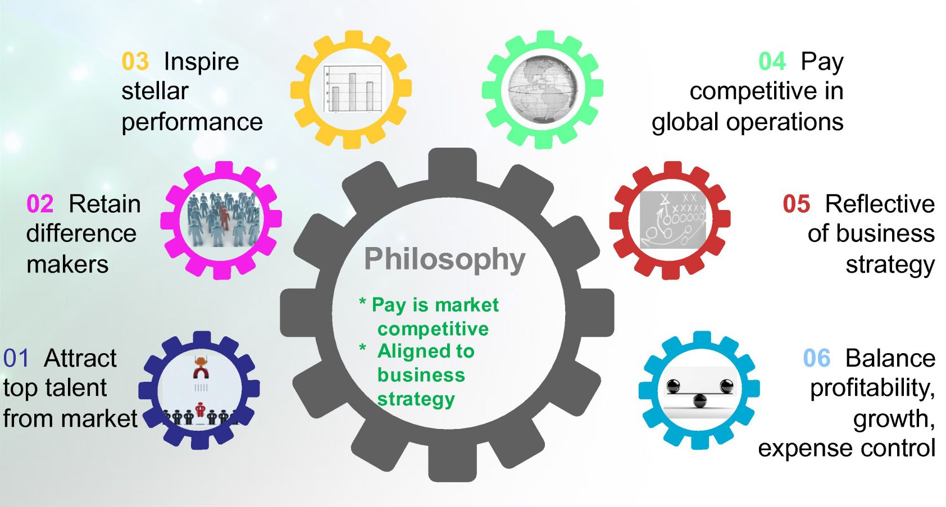
Figure 3.1: Strategic Compensation Approach

IDLC is using this approach for their success. They understand that a perfect combination of compensation and benefits will be the reason of the attraction of many talented and potential employees. This will also help them to create competitive advantage and also it will be beneficial for low turnover rate of employees and organizational development.

3.3 Extrinsic Compensation
Extrinsic compensation is basically a monetary value that organizations give their employees as a reward of their effort for the job but it includes some non-monetary rewards also. All the tangible and visible recompense are under extrinsic compensation. Monetary compensations are salary, bonus, remuneration, allowances, incentive etc. And non-monetary compensations are benefits like protection programs (e.g. medical insurance), services (e.g. day care assistance) etc. The discussion about different part of the extrinsic compensation is given below.
3.3.1 Salary Structure
Salary structure is the most common way to give recompense to an employee. Through salary organizations decide how much one employee is to be paid for their job. The pay varies from organization to organization. The most usual bases for salary structure are-
- Exempt and Non-exempt
- Geography
- The Length of Time
- Grade or Rank
- Job Family

IDLC has been more than one pay structure. Most of the companies do that, they use some common bases for different divisions.

3.3.1.1 Graded Structure
Under graded structure people receive their salary, bonuses and other benefits according to their rank in the company. According to employee grade and position they have also structured the Annual Performance Bonus (APB). As their policy different rank will have different salary structure. In the next section we will see the different pay grades of IDLC.

3.3.1.2 Job Family Structure
According to job family structure the division was created on skill, Competencies and activities. Each job family will have different salary structure. For example the sales team will receive different salary structure according to their job.

3.3.2 Pay Grades
Through pay grades companies decide how many benefits the employee will receive. Pay grades mainly prepare a structure for compensation by deciding the amount of pay obtainable at each step in the employment procedure. The pay grade is usually decides on the basis of the time the employee will give for the company, job responsibilities and the authority exercised by the position
The each pay grade of IDLC includes minimum or a small number of positions and in total there are 16 grades in IDLC Finance Limited.

3.3.2.1 Job Evaluation
Before deciding the pay grades, an organization has to conduct job evaluation first. Job evaluation is a structured way of determining the worth of a job in respect to other jobs in that organization. The purpose of the job evaluation is mainly comparison between jobs to set up pay grades thus, a rational salary structure
Before determining those 16 pay grades IDLC human resource team has done the job evaluation. But this year recently they have purchased a software for job evaluation titled International Position Evaluation through (IPE). This device is a global factor based approach that allows rapid, reliable and consistent measurement of positions’ worth and value to the organization across job families. This will certainly help IDLC to manage a better job evaluation in the future.

Figure 3.2: Pay Grades of IDLCFL

3.3.3 Pay Ranges
Upon Pay grades pay ranges are built. Pay ranges are built upon pay grades. Pay range includes a minimum pay rate, maximum pay rate and also a reference point or midpoint. The minimum and maximum points specify the acceptable lower and upper bounds of salary for a job within a specific pay grade. The midpoint or reference point is the market rate (the going rate for the job in the market).
HR personnel of IDLC specified these midpoints first, followed by minimum and maximum values. They address the midpoint or reference point as Market Compa (Compa-ratio). Through a market survey this Market Compa ratio was specified. The main motive of this survey was to the market average pay for each position in a pay grade. And then IDLC determined to set the midpoint of their pay scale higher than the market Compa. Because IDLC always was and still now is, the market leader in the Non Banking Financial Institutions industry, in terms of pay.

P 100
Pay Range
(P 70 to P 130)

Pay Grades

Figure 3.3: Pay Range of IDLC

IDLC HR refers to this Market Compa as P 100 (100%) of the pay ranges and denotes the other remarkable points of the range in percentage terms comparative to the reference point. As per the policy of IDLC, the salary band of each position here is P 70 (70%) to P 130 (130%) of P 100 or market Compa, telling that P 70 is the minimum and P 130 is the maximum point for each position. So, this is the pay range of each position in a pay grade in IDLC.

3.3.4 Pay System
Pay system is a method through it companies determine the basis an employee should be paid for a position. It also determines how an employee should earn. The bases are, job tenure, an employee’s experience, knowledge and skills necessary to complete a job. An organized pay system also prepares a fair and consistent method for specifying a pay rate. The most used pay systems are-
- Seniority Pay
- Longevity Pay
- Merit Pay

3.3.4.1 Merit Pay
Merit pay system is mainly depends on the employee performance. Under this system the employee will be paid based on his/her efficiency, job target and how effectively he is doing the job against some measurable criteria over a predetermined period of time. Merit pay system assumes that over time, employees’ compensation should be determined, at least in part, according to their job performance. In this system, employees obtain permanent merit increases based on their performance. So, measuring the job performance is the first thing to be done in this pay system.
IDLC previously followed Seniority Pay systems, but now they are into the practice of Merit Pay. Since Performance appraisal is the heart of merit pay system, below IDLC’s performance appraisal system is briefly discussed.
3.3.4.1.1 Performance Appraisal in IDLC
At the beginning of every year some objectives will be set for each employee of IDLC by their respective supervisors. The supervisors semi-annually review the performance of their subordinates and evaluate that whether those objectives have been met or not. While evaluating the objectives supervisors assess some predetermined subjective as well as objective criteria. And then finally at the end of the year, the managers rely on those performance indicators or criteria to decide whether an employee will receive a merit increase or not.
In IDLC the subjective and objective criteria are different for the salespeople and the Annual Performance Bonus (APB) positions. People with APB positions, are considered under APB Scheme, while the salespeople are considered under Sales Incentive Scheme (SIS).
In APB Scheme, an employee’s performance appraisal is done based on two criteria-
- ‘WHAT’ is achieved against the set objectives (objective criteria) and
- ‘HOW’ they are achieved (subjective criteria)
- Drives Result
- Support & Cooperate
- Takes Initiatives
- Walk the Talk
Depending on the above criteria supervisors annually asses the performance of an employee how if s/he could achieve the objectives assigned at the beginning of the year and rate the performance of that employee.
There are also subjective and objective criteria for the SIS. IDLC gives a target to their. But there is difference between SIS and APB’s performance appraisal. These are the performance ratings of Sales Incentive Scheme.

Figure 3.4: ESAU Rating for SIS

After the performance appraisal the rating will be seen in the time of Salary Increment. The employee who got the highest rating will be able to receive the highest increment. The employees will receive 10% salary increment if any employee gets 1A in the performance appraisal. The managing Directors can arrange a Special Increment for any employee for any specific task or for any extraordinary performance. If any employee gets poor rating in the performance they don’t receive any increment. Individual performance appraisal is also related with the Annual Performance Bonus. With the high ratings employees will receive high performance bonus and with low performance ratings employees will get low performance bonus or no bonus at all. Here is a discussion about these two concepts.

3.3.5 Salary Increment
Salary increment means increase of any employee’s salary. This increment also can be given with onetime payment. Companies give one time payments generally during a single pay period. In the time of annual increments usually employees receive a percentage increase in their permanent salary.
Every year IDLC reviews the salary once. Before that they do a market survey to understand the market condition. They present the salary increment proposal to the Board of Directors and they take the final decision. After the approval every employee can see the increment in their account on every July 1. As previous years also this year the HR team of IDLC allocated the salary increment. The market survey was done by an assigned HR team before that. An important matter about this increment is Managing Director can adjust the increment any time of the year for any Special reason or for any extra ordinary performer.
The Managing Director of IDLC also thinks about the salary adjustment before the increment if needed. They actually do this for Cost of Living Adjustment (COLA). Cost of living allowance is the amount that increases in the salary every year by the company after the estimation that how much anyone should need for his/her standard living. For inflation the prices for goods and services is getting higher over time. Thus, a COLA works against inflation to maintain the salary or annuity’s buying power. Consumer price index is the most common objective to estimate cost of living allowance. This year the adjustment for the cost of living has also done by the IDLC management in the increment.

3.3.6 Bonus
The financial compensation that employee receives above and beyond the normal payment expectations that is bonus. Bonus is the money that employees get as extra payment for their performance or for any special reason with their salary. An organization can give bonus to their employees to motivate them, to follow organizational rules, to increase sustainability, to show gratitude or to follow the government rules. There are two types of bonuses in IDLC.

3.3.6.1 Performance Bonus
Performance bonus is the additional amount that employee receives for good performance or for any specific of special task. Organizations give this bonus to employees for reaching a specific target or after completing any project. The amount is generally added with their salary after the completion of the task or project.Every year on 31St December IDLC gives performance bonus to employees. The amount of the bonus depends on the total profit of the year. The Broad of Directors decides the actual amount.
Performance appraisal is the most pivotal part of the performance bonus. This performance bonus is directly connected with the performance appraisal. The higher the rating the higher the bonus will be. And on the other hand employees who got poor performance rating will not receive any performance bonus. In the tables beneath, the amount (depending on the Board approval) entitled for performance bonus is shown for each category of performance rating where,
X= Basic Salary/Standard.

3A | 2A | 1A
3B | 2B | 1B
3C | 2C | 1C
3X | 7X | 10X
2X | 5X | 7X
- | 2X | 3X
Table 3.2: Performance Bonus (right) for each Performance Rating (left)

3.3.6.2 Festival bonus
All the permanent employees of IDLC receives festival bonus in Eid-ul-Fitr and Eid-ul-Azha equivalent to one month’s basic pay irrespective of their religion according to Bangladesh Labor Law. Whereas, each of the aforementioned occasions employees under HR Contract receives 50% of monthly consolidated pay as festival bonus.

3.3.7 Incentive Pay
The Compensation that awarded for results rather than for time worked that is Incentive pay. Incentive or variable pay fluctuate according to employees working standard it can be given individually or in the group of employees. Incentive pay system is extremely productive for salespersons. There are three types of incentive pay-
- Individual Incentives
- Group Incentives
- Company-wide Incentives
IDLC practices this incentive pay system only in their sales departments. In SEF department, at first they give a target to employees and if they reach the target they get the incentive. By every point of the target the incentive payment will be higher. If any employee meets the target he/she can be promoted for the performance. The HR team will give the employee the predetermined amount of disbursement for every point. If the employee can cross the disbursement point, the HR team gives him higher incentive than the previous one.

3.3.8 Terminal Benefits
Terminal benefits are the benefits that company gives their employees during the termination. In the time of recruitment these are the benefits that company promises and made the contract with the employees to give him/her in the time of retirement or termination. These benefits vary from company to company. The extent of these benefits varies according to company policies. Companies mostly use-
- Provident fund
- Leave Encashment
- Gratuity
- Assistance in finding a new job
- Extended health insurance coverage and.
3.3.8 Gratuity
When an employer gives an amount to the employee for the services rendered during the time of the job that is gratuity. Generally companies give gratuity during the time of retirement but after completing some conditions it can be given before the retirement.
The permanent employees of IDLC will receive gratuity in the time of retirement but only if the employee has completed five years with the company. All permanent employees of IDLC have the right to get to gratuity if the person completes at least 5 years of service with the company. On the basis of length of the service and the last basic salary the gratuity is paid by HRD following by the scale showing below.

Years of Service | Gratuity Payment
5 years or above, up to 10 years | 1 month basic
10 years and above, up to 15 years | 1.5 times basic
15 years or above | 1 times of basic

Table 3.3: Gratuity Payment Scale

3.3.9 Provident Fund
In provident fund employees contribute an amount from their monthly salary to their account and company also contributes for their employee, they handovers the money to employees in the time of retirement. From the beginning to the end of the job life the money turns into a huge amount that helps a lot to employees after the retirement.
By the “IDLC Employee Provident Fund Rules” the employee provident fund is governed. Following the rules every employee of IDLC after joining the company as a permanently every month they contribute 10% of their salary to the provident fund.. At the same rate, IDLC on its part also contribute towards their provident fund every month.
3.3.10 Encashment Facilities of Annual Leave
The amount of money that employee receives in exchange of the leaves did not taken by their time of employment that is leave encashment. Employees have the option to encash the amount during the job life, at the time of their retirement or when they are leaving the job. The policy of leave encashment is different for every company. In some company they provide those leaves in the next year.
In the time of the separation from the company IDLC provides 60 days annual leave encashment to the employee. On the basis of employee’s last basic salary this encashment is paid.

3.3.9 Fringe Benefits
Fringe benefits are the amount with the salary of employees by companies for their employee satisfaction. Any kind of benefits companies provides to their employees except salary in exchange of their service is fringe benefits. Accommodation benefits, lunch and snacks, health insurance, transportation service these are the common fringe benefits that companies use most. The fringe benefits that IDLC offers to their employees are-
3.3.9.2 Leave benefits
1. Annual leave- After completing one year an employee can get 25 working days annual leave. This leave will be credited into their leave account.
2. Casual Leave- An employee can have casual leaves up to 5 working days in a calendar year, but not more than 3 days (continuous) at a time. On IDLC Asset Management Limited employees apply for this leave and after the approval from their supervisor and line manager they get the leave. But if they face any kind of problem in online application section they directly contact with HR team & solve the matter.
3. Prolonged sick leave- In a calendar year, prolonged sick leaves can be availed as follows-
- First 30 days with full pay
- Next 30 days with half basic pay
- Above 60 days and up to 180 days without basic pay.
4. Maternity leave- During the pre pr post natal period up to 6 months a female employee can take maternity leave.
5. Paternity leave- An employee can have 5 days paternity leave but only up to his second child.
6. Study leave- IDLC will give employees paid study leaves but if only the study requires from the company. Even though the training or study is not sponsored from the company with the decision of managing directors the employee can have study leave without payment.

3.3.9.2 Allowances and other Privileges
1. Flexible working hours- IdLC has flexible working hours and only permanent employees can enjoy it. The office hours is 10 am- 6 pm in which 10- 4 is the core working hours. An employee have to present during this core working hour after that he/she can leave the office after informing the supervisor or immediate boss
2. Overtime allowance- Overtime allowance is only for some designations and they are, Assistant Officer, Junior Officer, Office Assistants, Support Officer and Drivers. They get paid for their overtime work and the payment is double from their basic salary.
3. House rent allowance- Employees receive house rent allowance according to their designation and location but IDLC does not give any accommodation facilities.
4. Furniture and household equipment allowance- From the grade of senior manager and above they receive furniture and household equipment allowances. For example, for furniture Senior Managers receive BDT 45,000 as an allowance.
5. Utilities- For utilities employees receive monthly allowance accordance to their designation.
6. Medical allowance and benefits- According to the grades permanent employees receive medical allowance. Some of the hospitals and diagnostic centers have an agreement with IDLC to give their employees discounts on treatments and customized health packages. From United Hospital Limited the employees of IDLC receive 20% discount in all type of test.
7. Hospitalization scheme- Under the hospitalization scheme if any permanent employees or their dependants get hospitalized or any major treatment then IDLC pays all the expenses.
8. Conveyance- For office purpose employees can use the office car just for the day but company does not provides any transportation facilities on the daily basis.
9. Transport allowance- Managers and above employees of receive monthly transportation allowance according to their designation. Managers get 22,000 taka monthly allowance for transportation.
10. Domestic travel allowance- For any office tour or during the time of travel for office purpose all the expenses will be paid by IDLC. For long period employees also get allowance per day.
11. Foreign travel allowance- When employees travel outside in the country all the expenses will be paid by IDLC including the visa fee, hotel expenses , air fare and they will also receive a daily allowance . For example Senior Managers get $122 as daily allowance.
12. Outstation allowance- Employees who leaves their hometown and IDLC send them in an unknown place (except Dhaka) for the job only they can enjoy this monthly allowance. Assistance officers get 5000 taka per month as outstation allowance.
13. Leave fare assistance- Every permanent employee gets the leave fare assistance. The amount is 2 times of basic for the Junior Officers, Drivers and Office Assistants and 3 times of basic for all the other employees.
14. Welfare fund- Employees may be granted a certain amount from the IDLC Employees’ Welfare Fund for any of the following circumstances-
- Serious sickness of the employee or his/her family members
- Educational expenses of the employee’s (Support Staff) spouse/daughter/son.
- Marriage ceremony of the employee (Support Staff) or his/her dependants
- Outstanding performance of an employee or his/her family members

15. Group life insurance- All the permanent employees are under this insurance scheme. If any employee expires in the time of his employment in IDLC, the nominee of that employee will receive up to 4,00,000 (Senior Manager) from his insurance scheme.
16. Educational aid- After completion of five years continues service an employee can put an application for educational aid for MBA or other professional degree from the listed universities by the management. But this education aid amount cannot be more than the amount mentioned in the IDLC HR Manual about this scheme.
17. Communication scheme- There is also benefits of having a separate SIM card from the company for all the permanent employees and also for the Permanent employees and also for the sales team to maintain the communications with the clients and other uses for office purpose.
18. Cell phone scheme- Employees get an amount to buy an updated cell phone from Management Trainee to higher position. Company also provides an amount to the employees as a mobile bill.
19. Housing loan- After meeting some conditions employees can apply for house loans with 15% equity investment and 20 years loan tenure. The highest amount of this loan cannot be more than the amount mentioned in the policy.
20. Personal loan- IDLC provides employees personal loan on a lower interest rate. The highest amount of the loan is BDT 500,000.
21. Motor bike loan- After reaching some standard only some employees of selected grades can apply for motor bike loan.

3.3.9.3 Perquisites for Executives
1. Executive Assistant- Executive Assistant is the person who has been hired in the CEO, s office to help the MD to maintain his works and schedule.
2. Support staff- Some support staffs are only for the cabin of the CEO and MD.
3. Club membership- Including Dhaka club, Uttara club the Managing Director and Deputy Director can have the membership of some other respected clubs.
4. Accommodation in luxury hotels- AGM to above grades can enjoy staying in luxury hotels during travelling to office purpose.
5. Company car- There will be a car with 24/7 driver for DGM to upper grades for their service.
6. Transport maintenance- From previously mentioned grades who are having the benefits of company car, they will receive an amount for the purpose of maintaining the car.
7. Car encashment benefit- IDLC offers an option to GMs and DGMs to choose between car and cash benefits. If they choose car then they will receive facilities of using a car with maintenance amount. And if they choose cash benefits then they will have a cash amount every month as a benefit.

3.3.10 Recognition Awards
Through giving awards companies can appreciate, motivate and also giving the recognition. An award can be a title, medal, or any trophy, certificate etc. IDLC organizes some recognition awards to appreciate their employee’s brilliant performance for the company.
They provides three types of awards-

3.3.10.1 Spot Award
The immediate award for any special contribution for day to day activities for the employees is familiar as a spot award. Spot award can be given for any of the activities given below-
- Exceptional task
- Specific event
- Project in a short time
- Outstanding efficiency
- Act of heroism

3.3.10.2 Integrity Award
To support the National Integrity Strategy IDLC is recently giving Integrity Award guided by Bangladesh Bank. This award is for motivation the employees to give their highest level of efficiency for company. If any employee gives his best effort with honest performance and behavior according to company rules then he can win certificate and prize money as an integrity award.
3.3.10.3 Long Service Award
The employees who are working In IDLC for so long this award is for showing a respect and appreciation to their continues service. They recently started giving this award. The employees who are giving service for 15, 20 or 25 years will receive this award. Company celebrates their long journey and to also create an example to other employees.

3.4 IDLC HR Systems
Management can store or process human resource information by using HR system as a tool. By using this software company can process data and manage data that helps to do their work effectively for human resource team.
The features IDLC HR system has-
- Employee Database
- Outside Payroll Items
- Monthly Salary Management
- Regular Employee Benefits
- Long Term Employee Benefits

Figure 3.4: IDLC HR System

- Loans and Advances
- Training and Development
- Leave Management
- Performance Management System
- Employee Attendance etc.

Through the HR system HR managers manage the extrinsic compensations that previously mentioned in this report including gratuity, loans and other facilities.

3.5 Intrinsic Compensation
Intangible, non-monetary rewards that companies provide employees to motivate them are Intrinsic Compensation. Intrinsic compensation proves how much an employee is worthy for the company. Intrinsic compensation ensures the psychological and emotional welfare of employees
IDLC HR recognizes the significance of this and compensates their employees in the following ways.
3.5.1 Skill variety
In some kind of job skill variety is needed Skill. Skill variety prefers the term where people need to show different types of skills, knowledge in their job. The duties and responsibilities of employees is almost same for day to day but there is also some positions where they will be given difficult projects, to fulfill those projects they need knowledge from various areas.
And also there job rotation for different grades. After 2 years they transfer the employees of some grades to another department.
3.5.2 Task Identity
Task identity refers the degree to which a person completes the whole job from the beginning to the end. As previously mentioned in this report, employees get new projects or assignments and they have to finish it within the given time period.
Every employee has to finish some certain works within a limited time period to maintain their Key Performance Indicator (KPI). When a new employee join the company HR team is responsible to open a new profile for him/her and provide emails to other employees about the joining within the day.
3.5.3 Task Significance
When the job creates an effect on other people’s lives or works that is known as task significance. As IDLC is the largest non banking financial institution each and every projects of them creates an impact on economy and also people’s lives. For this they are trying to be “financing happiness” for people. Every employee of them understands this value of their work and the effect of their job towards the country that is why they are working hard from the first day.
3.5.4 Autonomy
When company gives employees privilege, independence to let them decide how to do the job that is autonomy. IDLC ManCom always gives employees this space in the work place decides the way of their jobs by themselves. Supervisors has the right to discuss about it and ask about the progress about the work which method they will follow how they will finish it is totally depending on the employees.
3.5.5 Feedback
Feedback is comment that supervisors or employer provides the comments about the work after finishing it to the employee. In the middle of the year employees of IDLC get the feedback from their line managers about the works previously given to them.

CHAPTER- 4

ANALYSIS & FINDINGS

4.1 SOWT Analysis
Through the help of SWOT analysis organizations can have knowledge of overall situation of their company. They can find out their current advantages and also the upcoming drawbacks of the company. The swot analysis of IDLC’s compensation strategies is presenting below.

4.1.1 Strengths:
- The biggest strength of IDLC is their employee retention. They have arranged the salary structure so well that employee of every grade is satisfied with their salary and this helps them to increase their employee retention.
- IDLC’s transparent salary increment. The whole transparent performance bonus and increment system is the reason that their employee has trust on their employer. This is the second strength of IDLC’s compensation system.
- Their relationship with the employees is also strength of them. Each and every time they face any problem about compensation they have the right to talk with HR about it. And the HR team provides full information they describe the reason about their low increment their unapproved leave or any other problems about their benefits. The understanding between them and the employees is beneficial for their company.
4.1.2 Opportunities:
- As IDLC is using above average compensation system this is easy to attract new talented employees and this is an opportunity for them .The Strategic Compensation approach of IDLC has made the management swipe up their worries about employee attraction, retention and growth. IDLC follows market lead policy in terms of pay. That is why they have set the midpoint of salary ranges higher than the market average. This strategy certainly attracts market talents to IDLC.
- The internship remuneration is also above the market standard which attracts the fresh graduates to IDLC at first glimpse. This is a great opportunity for IDLC attracting the talented & fresh graduates by their compensation strategy can help them to find more qualified employees.
4.1.3 Weaknesses:
- The HR System of IDLC is not a very up-to-date one. Often the HR functions are hindered because of the limited capacity of the system to process a larger number of data at a time.
- Another weakness is their lengthy leave application process. When someone applies for leave they take so much time to approve them sometimes this can be the reason of demotivated employees.
4.1.4 Threats:
- As IDLC’s biggest competitor is IPDC. If IPDC offers better compensation strategy than IDLC then all the new market talents will be attracted by them this will be a biggest threat for IDLC’s compensation system.
- As the financial condition of country is not going so well. So many financial organizations are closed now during this period. In this situation employees are feeling insecure with their job. So IDLC is trying to make them satisfied with compensation. They are trying to gain their trust that IDLC will provide all the benefits and also it will survive even in the critical situation. So this is another threat for them. There is too much pressure on their compensation system. In this situation this is very easy to set wrong strategy for their compensation.

4.2 Findings
From all the data presented in the previous sections in this report there are some key findings -
- During the period of selecting pay ranges IDLC follows market lead policy.
- The conciseness about the importance of job evaluation and graded salary structure of the HR team.
- IDLC has a very organized and fair performance appraisal system.
- About promotion, salary and increment they hardy receive any complaints from the employees.
- Employees cherish the culture and work environment of IDLC.
- Sometimes when the employees of other branches try to communicate with HR they cannot give time for their own busy schedule.
- Sometimes employees get confused about the systems they are following to give them increment and calculating gratuity for lack of communication.

CHAPTER- 5

RECOMENDATIONS & CONCLUSION

4.3 Recommendations
From the previous discussion and my experience of internship I will like to mention some recommendation. This may helpful for the HR team for their perfect compensation system.
- They can start giving group incentive pay this will help to build good relationship between co workers and also will help to work as a team.
- To motivate team work they can start giving an award. For example after finishing the project or at the end of the year best team will receive the award.
- Considering a CPI they should implement COLA policy.
- As their HR system is not up-to-date they can use a new one to do their work without any disturbances.
- They can arrange a seminar or workshop for new employees regularly after some period to describe the leave policies the gratuity calculation policies to them for more fair and transparent System.
- To maintaining communication with the employees of other branches or employees from outside of the Dhaka they can update their communication medium and can start giving more time for them.

4.4 Conclusion
By using compensation system effectively companies can attract talented employees and also can motivate employees. That is why Strategic Compensation in an important tool for organizations. Compensation system is an important tool of Human Resource Management too. From this report we can understand that one of the main purposes of employees doing the job is compensation. And IDLC is using this strategy very efficiently to achieve their organizational goals. They have maintaining the strategy such a way they don’t think about for only their profit but also for the employee benefits. They have created a win-win situation in the workplace. Behind of IDLC’s success and good will there is their well balanced compensation management. This report is a briefly discussion about their compensation strategy.

References

- IDLC HR Manual
- Martocchio J. (Eds.) (2017). Strategic Compensation: A Human Resource Management Approach. Boston.
- IDLC Finance Limited. (n.d.). Retrieved August 2, 2019, from https://en.wikipedia.org/wiki/IDLC_Finance_Limited
- Catalysing Change, Driving Process. (2019). Annual Report 2018. Retrieved August 3, 2019, from https://idlc.com/public/images/uploads/B4ccX8QEtDymBTFXPIVn2O.pdf
- Engaging Communities, Spreading Happiness. (2018). Annual Report 2017. Retrieved August 3, 2019, from https://idlc.com/public/documents/reports/Annual%20Report%202017.pdf
- Creating Opportunities beyond the Act of Responsibilities. (2019). Annual Sustainability Report 2018. Retrieved August 3, 2019, from https://idlc.com/public/images/uploads/o440dQmzyi0bZNyPevdA8x.pdf
- Hammel, D. (2017). Strategic Compensation. Retrieved August 5, 2019, from https://www.evergreen.edu/catalog/offering/strategic-compensation-16761
- Pay & Salary Structures. (n.d.). Retrieved August 5, 2019, from http://www.ashworthblack.co.uk/pay-salary-structures/
- Cost of living allowance. (n.d.). Retrieved August 5, 2019, from http://www.businessdictionary.com/definition/cost-of-living-allowance-COLA.html
- Star Business Desk. (2017, January 2). New HR Head for IDLC Finance. The Daily Star. Retrieved August 14, 2019, from https://www.thedailystar.net/business/new-hr-head-idlc-finance-1339654
- Schofield, T. (n.d.). Job Pay Systems: Types and Examples. Retrieved August 16, 2019 from https://study.com/academy/lesson/job-pay-systems-types-examples.html
- Incentive Pay. (n.d.). Retrieved August 16, 2019 from https://www.mbaskool.com/business-concepts/human-resources-hr-terms/6862-incentive-pay.html

Appendix

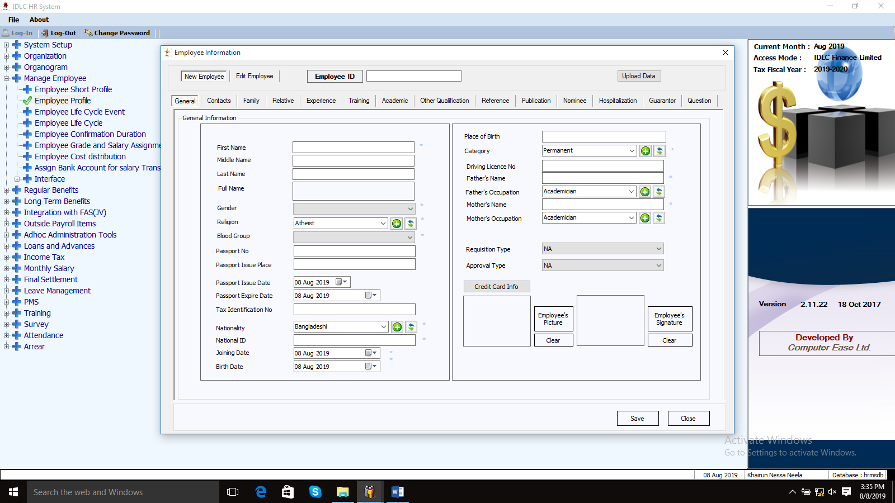
IDLC HR System

Questioner
- How do you calculate performance bonus?
- What are the fringe benefits IDLC giving to their employees now?
- How this company motivates employees?
- How many complaints HR receives about increment on average on a year?
- How do you communicate with the employees of other branches?
- What are the bases to calculate increment?
- According to you what can be the biggest threat for IDLC’s compensation system?

