

Online Banking: A Comparative Analysis of Some Selected Banks in Bangladesh


School of Business & Economics
UNITED INTERNATIONAL UNIVERSITY

Shahjadi Eva

Report Submitted To

The School of Business & Economics
United International University
in Fulfillment of Requirement for the Degree of
Bachelor of Business Administration

Online Banking: A Comparative Analysis of some Selected Banks in Bangladesh

Supervised By

Dr. Md. Shariful Alam
Associate Professor
School of Business & Economics
United International University

Submitted By
Shahjadi Eva
ID No. 111 121 107
BBA Program
Major In Marketing
School of Business & Economics
United International University

Letter of Transmittal

25th April, 2018
Dr. Md. Shariful Alam
Assistant Professor, SOBE, UIU
United International University

Subject: Submission of the project report on “Online Banking: A Comparative Analysis of some Selected Banks in Bangladesh”

Dear Sir,

With due respect, I would like to inform you that, it is a great pleasure for me to submit the project report on “Online Banking: A Comparative Analysis of some Selected Banks in Bangladesh” as it is a fulfillment of partial requirement to achieve BBA degree under the curriculum of United International University, Bangladesh.

To prepare this report, I have gathered what I believe to be the most complete information available. I have worked hard preparing this report and I hope that it will fulfill my degree requirement. I will always be available for answering any questions regarding this report.

So, I fervent requesting and hope that you would be kind enough to accept my report and oblige thereby. Though i have put my best efforts yet it is very likely that the report may have some errors and omissions, which are unintentional. So, I hope that the report will worthy of your consideration.

Sincerely yours

-----------------------------------------------

Shahjadi Eva
Id no. 111 121 107
BBA Program
School of Business & Economics
United International University

Certification

This is to certify that Shahjadi Eva, a student of BBA, ID – 111 121 107, under School of Business and Economics, United International University (UIU) has completed the project report titled “Online Banking: A Comparative Analysis of some Selected Banks in Bangladesh” as a part of requirement for obtaining BBA degree. She has tried her best to complete the report.
I wish all the best in her future endeavors.

Supervisor

_________________________________________
Dr. Md. Shariful Alam
Assistant Professor
School of Business & Economics
United International University

Honesty Statement

First of all, I would like to declare that this report is not a copy of another person’s report. The study is original in nature. I have tried my best to make this report as informative as possible. I also ensure that, this report has not been submitted to any other person earlier and will not be submitted to anybody in the future.

------------------------
Shahjadi Eva
Id no. 111 121 107
BBA Program
School of Business & Economics
United International University

Acknowledgement

(All praise to almighty Allah.)

Firstly, I would like to express my deepest gratitude to Almighty Allah for giving us the strength and the composure to finish the task within the schedule time. Secondly, without the help of many people, the preparation of this report would have not been possible. I would like to express my gratitude towards those people who helped me in preparing the project period.

This study is the outcome of the report writing program undertaken by the course and instructed by Dr. Md. Shariful Alam, PhD, Assistant Professor, SOBE, UIU for Summer 2017. I am indebted to them who have directly and indirectly assisted us in conducting the study. Specially, I am thankful to my honorable teacher Dr. Md. Shariful Alam because of his assistance gives us the opportunity to start our report promptly.

I was also indebted to the websites that indirectly helped me in completing my term paper specially collecting information. Finally, I owe a profound intellectual debt to my seniors for their part time help, assistance and valuable advice in thinking and developing of this report.

Thanks all from core of our hearts.

Executive Summary

This report is tailored towards describing and comparing online banking facilities of some selected banks in Bangladesh. Online banking or internet banking facilities is the demand of digitalized era. Internet banking enables any person having a relationship with the bank to carry out transactions at any corner of the world with just the help of a computer and internet system without being physically present at the bank premises. This has made the banking activities more fluent and faster than ever. Internet banking is also termed as virtual banking or online banking.
In Bangladesh, there are over fifty banks that are operating at present. Out of all these banks, a few are selected for the purpose of this report. Not all the banks offer the same online banking facilities. Some only offers basic services like account balance check and statement printing options, while the others offer fund transfer, bill payment, standing order and so on in addition to the basic online services. Also, there are some banks that haven’t introduced any internet banking facilities yet.
At first, data is gathered on the selected banks about their online banking offerings. After this data collection, a comparative analysis is shown in order to point out the difference in the services offered by those banks. From this analysis, one can easily trace the differences among the banks in terms of their internet banking offerings.

Table of content

Content | Page Number
Introduction | 01
Background of Study | 02
Methodology | 03
Limitation of the Study | 04
Literature Review | 05 - 06
Comparative Analysis of Online Banking of some Selected Banks in Bangladesh | 07 - 28
Findings of the Study | 29 - 30
Recommendation | 31
Conclusion | 32
References | 33

Introduction
Modern technologies have created wonders. With the help of these technologies, our normal day-to-day life has become much more convenient. To keep pace with the modern era, the banking sector has incorporated technologies so that it is easy for its customers to carry out banking activities. The advancement of computer programs, communication system and fast internet service has made it possible for the people to carry out banking activities and transaction without stepping inside the premises of a bank. People can now see their bank balances, transfer fund within and across banks, make payments, review statements and many other activities from any point of the world. Thus, internet banking has revolutionized the overall banking experience.

As such, the founder of Microsoft, Bill Gates (2008) stated that “banking is essential, banks are not”. What this means is traditional banking activities involving branch banking is now being replaced through internet banking. This added convenience is constantly attracting new users and customers to the banks with wide array of internet banking offerings.

In early 1980s, when the concept of Online Banking was introduced (Kalakota and Whinston, 1997). In this period, the small-scaled online banking activities were run through a particular program with distinct software which was provided to the customers. This program could be loaded into the computer. By the help of modem, telephone line and other internet technology, this software could connect the customer with the bank remotely over the internet. However, a few demerits blocked the advancement of online banking which includes the problem of internet availability and the cost associated with using one. In 1990s, as internet became less expensive than before and became available to the vast majority, online banking began to roll out to majority of the customers upon subscription. This attracted new opportunities as customers of the banks began to realize that internet banking is more convenient than traditional branch banking.

There might be a confusion among online banking, internet banking and PC banking that needs to be clarified. Quite often, we use both the terms online banking and internet banking to mean using of internet to accomplish various banking activities. So, it is safe to state that online banking is just a synonym of internet banking.

Background of the Study

Origin of the Report
Project report is a mandatory part of BBA program. As per its requirement, students have to gather practical experience by applying their text-book knowledge in the real-world situations and submit a report regarding their experience. This report is prepared for the same purpose which is to fulfill the requirement of completing the BBA program from United International University. This report will definitely help other students who want to know more about the comparative scenario of online banking sector in Bangladesh
Objective of the Report
The main objectives of this project report are as follows.
- Obtaining a clear idea about virtual banking
- Obtaining idea on the virtual banking system incorporated in various banks in Bangladesh
- Obtaining an overview regarding various virtual banking services of some selected banks in Bangladesh
- Comparing those banks in terms of their internet banking offerings

Methodology of the Study
Primary Data:
Primary data of this report includes data derived from bank representatives regarding the virtual banking services offered by respective banks.
Secondary Data:
Secondary data of the project includes the followings.
- Internet Blogs
- Bank Websites
- Various publications on internet banking
- Newspaper reports in this concern
- Other manual information or documents

Limitations of the Study
As like any other project report, this report also has a few limitations. Some of the limitations are listed below.
- Sufficient information relevant to the study was not readily available for use.
- Due to confidentiality purposes, the bank representatives were not allowed to disclose certain information.
- The representatives of the bank are always on a tight schedule. As much as they tried to help me, the nature of their workload did not allow sufficient time to talk about the topic with me. So, there is a chance that important information regarding the study has remained untold by the representatives.
In-depth analysis was not possible due to the reasons listed above.

Literature Review
Internet banking can perform a wide range of business activities without having to leave the house or being physically present at the premises. These includes bill payments, credit card bill payment, review of account activities, fund transfer between accounts in the same bank or across banks and so much more. The use of internet technology has added greater convenience in every step of banking activities.
Online banking can perform a set of activities which enables the customers of a financial institution to perform those banking transactions or activities with the help of a computer and internet connection. Thulani et al (2009) refer Internet Banking as systems that enable bank customers to get access to their accounts and general information on bank products and services through the use of bank’s website, without the intervention or inconvenience of sending letters, faxes, original signatures and telephone confirmations. It provides the scope for requesting banking information without being physically present at the counter of a bank. It also enables the accountholders of the bank to carry out conventional banking activities which include opening or closure of accounts, fund transfer between accounts of the same bank or different banks, electronic payment facilities and it has been evolving to add more and more features to it. Online banking has the power to connect the customer with the bank from any location worldwide and it can be access just by a personal computer and internet connection.

Internet Banking generally performs three types of functions which are termed as Transactional, Informational and Communicational.

- Transactional – Among the three functional types of internet banking, Transactional level is the highest level of internet banking. Transactional level enables customers to transfer fund within accounts of the same bank. A higher level of transactional function allows the customer to not only transfer fund within the bank, but also across banks within the geographic border and third parties as well. Third parties might include payment of bills for various platforms such as mobile bill, internet bill, WASA/DESCO bill etc. The payments are made in form of electronic fund transfer.
- Informational – This functional level of internet banking enables a customer to check the various internet banking services offered by the bank via the bank’s website. The customers can themselves sign up for the service upon verification by the authorized personnel.

- Communicative – This functional level of virtual banking allows limited interaction with the banking system such as account status, balance preview etc.

To keep up with the modern era, Banks in Bangladesh are moving forward towards adapting the virtual banking channels in order to make the banking activities easy and convenient. However, there is not standard level of virtual banking activities that are adopted by each of the banks. Some banks offer very limited virtual banking services while some offer intensive services tailored toward every section of the bank. Also, there are some which has not stepped into this service yet.
Comparative Analysis of Online Banking of some Selected Banks in Bangladesh
In this section, the internet banking services provided by some selected banks in Bangladesh are described. A comparative analysis is also provided at the later section of the report.
Out of all the banks in Bangladesh, 17 banks are selected for the purpose of this report. They are,
- AB Bank Limited
- Bank Asia Limited
- BRAC Bank Limited
- Citibank N.A.
- City Bank Limited
- Dhaka Bank Limited
- Dutch Bangla Bank Limited
- Eastern Bank Limited
- Exim Bank Limited
- HSBC
- IFIC Bank Limited
- Janata Bank Limited
- Mutual Trust Bank Limited
- Sonali Bank Limited
- Southeast Bank Limited
- Standard Chartered Bank
- Trust Bank Limited

AB Bank Limited
AB Bank started its journey in 1982 as the first private sector bank in Bangladesh. As part of their internet banking services, the bank offers a variety of online services. Either at work or at home, even while we are on the move, login to the account and do banking at our own convenience.
Features & Benefits
- Monitor Account Activity
- View Transaction History
- Balance Enquiry
- Mini Statement
- Linked Account Information
- View & Print Account Statement
- Transfer funds to any bank account within Bangladesh
- Pay utility bills e.g. Dhaka WASA
- Pay Post Paid or Pre Paid Mobile Phone bills of any operator

AB Bank introduced mobile and internet banking as part of their digital banking activities. Here, customers can avail different services sitting at home. The service includes –
- View Balance
- Mini Statement Request
- Check Linked Accounts
- Fund Transfer
- Mobile Bill Payment
- Utility Bill Payment
- Mobile Top-Up
These are the basic features that AB Bank offers to their clients through internet and mobile banking.
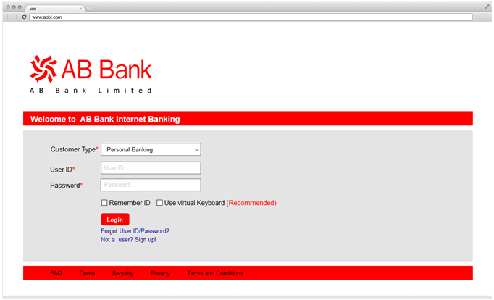

Bank Asia Limited
Bank Asia has adopted modern technologies in the banking services to facilitate its’ customers. These services include internet banking, ATM and Mobile banking. They have developed a secured and authentic web application through which they also provide a number of other services besides such as fund transfer, SMS notification for account activities, credit/debit card transaction history etc.
In the process of digitalization, they have launched internet banking which offers various services to the clients. Using the User ID and Pin Code, a client can log into the account and perform various activities. The service commonly includes –

  - View account history and transaction details
  - Account statement for specified period
  - Payment of bills
  - Fund transfer from one account to another within the bank or across banks
  - Currency rate queries
  - A well designed website to provide information on products and services offered by the bank
  - Transaction details and account statement to be provided through email
To use the services, following steps are needed as illustrated in the following figure.
- Go to: https://mybank.bankasia-bd.com
- Insert User ID
- Insert PIN Code
- Click "Sign in"


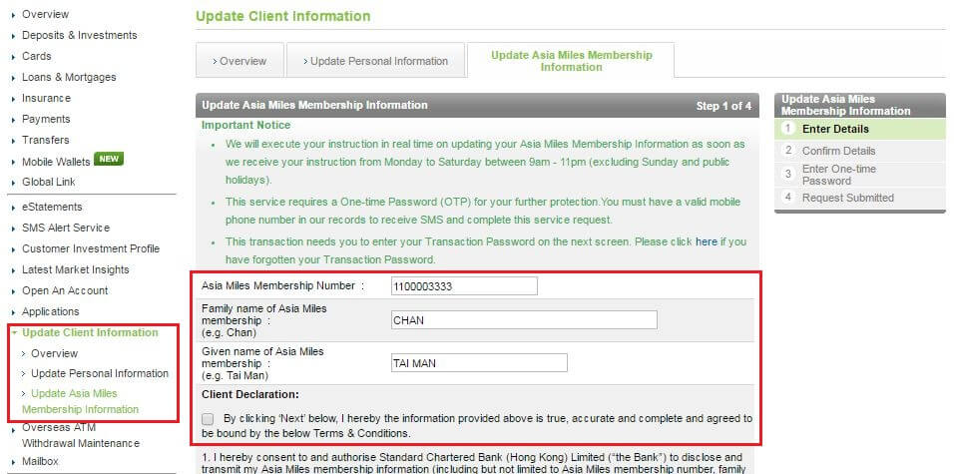
BRAC Bank Limited
BRAC Bank Limited was established in mid 2001 as a affiliate of BRAC which is one of the world’s largest non-governmental development organizations.
In light of online banking, BRAC Bank was the first to introduce e-commerce program for all VISA and MasterCard cardholders. It is a convenient medium to market products or service online. Through this process, a client can buy railway tickets and bus tickets online without going to the station and standing in line for hours. It also enables the clients to make BRTA payment. Airline tickets can also be bought as part of this program. Daily deal sites like akhoni.com, ajkerdeal.com, ajkeroffer.com is also brought under e-commerce program. Other facilities include hotel booking, grocery shopping, internet bill payment, tuition fees payment etc. facilitating both the cardholder and merchant.
BRAC Bank offers mobile banking as well. A client can avail the following services through mobile anytime anywhere.
- Account balance status
- Mini statement request
Apart from these, a customer is alerted in different situations like high value transaction, account status change, payment failure or cheque clearing failure. All these facilities are available for Grameenphone, Airtel, Robi and Banglalink users.

Secured Login
What's New*

Login ID
Password


Enter the code shown above (expire in 3 minutes):
Forgot Password/ ID locked?

As part of their commitment towards internet banking, they have made the internet banking services more secured and friendly than ever before. They introduced 2FA (Two Factor Authentication) Hardware and Software Token to generate OTP (One Time Password) for secured login and E-Signature to safeguard fund transfer. BRAC Bank is the first Bangladeshi bank, which has introduced E-Signature to protect our transaction from “Man-in-the-middle” attack. Moreover, new features of Internet Banking will make the feel “Cared and Prioritized” and extended transaction limits will add extra feelings to “Banking on our finger tips”. Wish customer a happy and secured banking with BRAC Bank.

In order to bring more security to the i-Banking experience, they have introduced the following changes and suggestions:
- Use of floating key pad while logging in specially if we use different workstation / public PC
- SMS & E-mail notifications are sent on the following occasions:
  - successful login into i-Banking
  - adding/updating beneficiary
- Use the OTP generated in the hardware/software token to access the i-banking session.
- The system will generate a e-signature through our hardware/software token to complete a transaction.
- i-Banking shows our last login attempt on our home page
- i-Banking has last 10 login history with the login attempt status
- i-Banking will prompt/alert us for password change on regular intervals
- Password should be alpha-numeric with minimum 8 or maximum 20 characters in length
- A daily limit has been imposed on each utility based services for bill payments
- New facilities include -
◦EFT ( Electronic Fund Transfer) from BRAC Bank Account to other banks accounts
◦BRAC University Tuition Fees
◦ALICO Payment
- 16221 as 24/7 hotline.
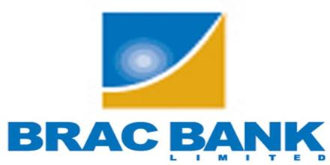

Citibank N.A
Citibank N.A. Bangladesh is a part of Asia Pacific region of renowned Citigroup. The bank is a pioneer one in Bangladesh having four branches. As part of their internet banking, Citibank introduced its automated e-alert system, in September 2009, which ensures secured financial information flow to its clients. Through this state-of-the-art service, account statements and transaction advises would be delivered instantly to the client's designated e-mail addresses. Also, Citibank introduced a number of exclusive internet banking services like CitiDirect Online Banking. CitiDirect provides with the account information to the respective accountholders which is accessible from any location at any time. Also, Citibank signed an agreement with Sonali Bank Limited for a new “Corporate Tax e-Payment” solution. Once the new system goes live, Citi’s clients will benefit by being able to pay taxes online.
For getting the internet banking service, Customers need to fill out the internet banking form with relevant information necessary and submit at the branch counter. Within a few working days, the branch will provide the customers with login ID and password in a protective format. Only the customers are to open the protective sheet to see the ID and password. With this ID and password, the customer can log into their account through the bank’s website. After the first login, the customer must change their password and add a few security questions. These questions will be asked in case the user forgets the password and needs a password recovery.
Through the internet banking portal, customer can view the account summary, details, balance check, print or view statements, apply standing orders and so on.

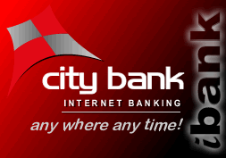
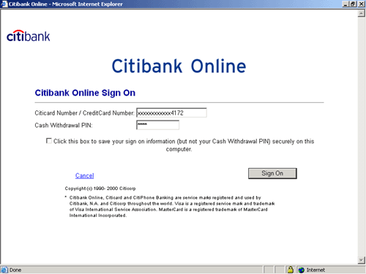

The City Bank Limited
City Bank Limited started its operation in Bangladesh in 1983. City Bank serves its customers at home & abroad with 86 branches spread over the country & about three hundred oversea correspondences covering the entire major cities and business center of the world.
City bank, as a part of digitalization, has introduced Citytouch – the internet banking solution. Citytouch can be downloaded onto consumers’ cell phones, ipads, tablet pcs and also on laptops, PCs and so on. Through this, clients can manage banking activities direcltly from any computer, tab or mobile handset 24hours a day, 7days a week. Citytouch offers the following services.
- Check the status of all the accounts
- Fund transfer across banks
- Payment of utility bills
- Standing instructions
- Cheque book request
- Purchase of travel tickets
- Location of ATM and branches.
- E-commerce

Dhaka Bank Limited
Dhaka Bank Limited is a scheduled bank that incorporated its operation on July 1995 with a target to play the vital role on the socio-economic development of the country. In the process of digitalization, Dhaka Bank has linked a contract with Department of Immigration and Passport in collaboration with four other banking partners for online fee collection of machine readable passports (MRP) and VISAs. Because of this linkage with the Department of Immigration and Passport, people can pay the MRP issuance or renewal fees through online without having to go to the office of respective authorities.

Dhaka bank Ltd. also process E – Statement for their clients which is actually a part of implementation of Green Banking Policy. Because of this E-statement, bank is able to cut their cost on printer, courier and paper. Customers are also benefitted as they can view the statement whenever they like through the online service.
Dutch-Bangla Bank Limited
Dutch-Bangla Bank Limited was incorporated as a public limited company in 1996. DBBL offers wide range of internet and mobile banking services as part of their digitalization process. Internet banking offers the following services.
Online service
- The customers can go through their account summery and details through online.
- Users can view or print his/her transaction activity for a specified period.
- Fund transfer from one account to another account within the bank has also been made possible through internet banking.
- Users can add, modify or delete standing instructions for fund transfer or bill payment facilities.
- Account statement request can be sent directly from the internet.
- Paying utility bills (like DBBL Credit Card Bills, Alico, Mobile, Tuition Fees etc.) online has also benefitted the customers.
- Cheque book request can also be made without going to the branch.
Apart from these, the customer is eligible to get information about the exchange rates, interest rates through this internet banking. The corporate clients of DBBL can initiate LC application, Bank Guarantee and can view loan limits and limits utilization from the online banking service.
In terms of Mobile Banking, the bank offers the following services.
  - Cash deposit
  - Withdrawals
  - Foreign Remittance
  - Mobile recharge
  - Fund transfer
  - Bill payment
  - View Balance
  - Salary Disbursement
These are the services that DBBL currently offers through their digital banking service.
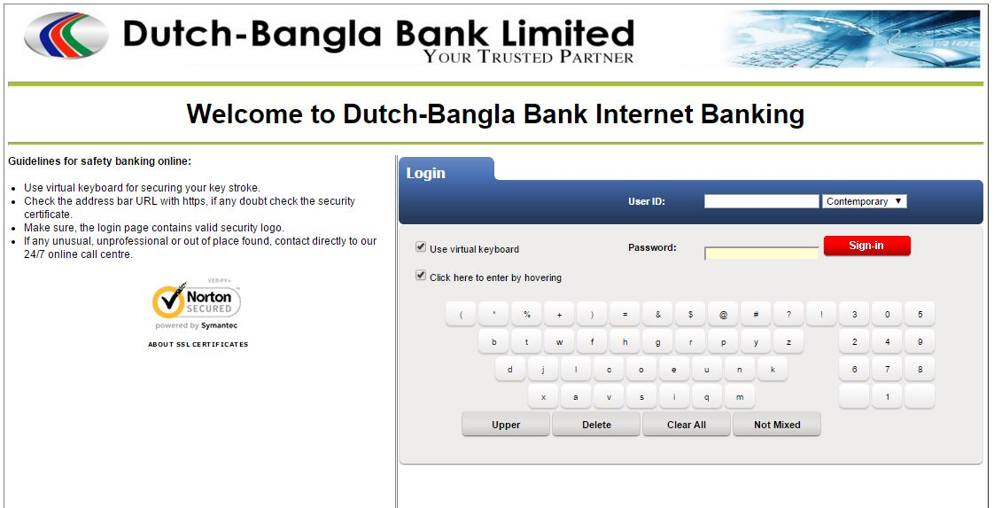
Eastern Bank Limited
The Eastern Bank Limited was formed as a public limited company incorporated in Bangladesh with primary objective to carry on all kinds of banking business in and outside the country. EBL had also taken over the business, assets and liabilities of Erstwhile Bank of Credit and Commerce International (Overseas) Limited branches in Bangladesh.
There are various types of online service available at the disposal of the customers of EBL. They can enjoy the online banking facilities right from the opening of the account. Also, they can set up the online banking facility later at any time if not used from the very beginning. Customers have to fill up a form and they are given an unique ID and password to access their account online.
Online service
The services offered are stated below.
- A details account summary can be seen from the online medium.
- Customer can also view details of Account like Account opening date, amount held (if any), unclear fund (if any), OD limit, net available balance etc.
- Statement of the account can also be printed or viewed here.
- To manage the loan taken from the bank, a customer do not need to go to the bank or talk to bank representative anymore. They can simply login to their account and view the crucial information relating to the loan account like opening date, installment size, installment due date, amount paid, interest paid and interest rate, total balance outstanding etc.
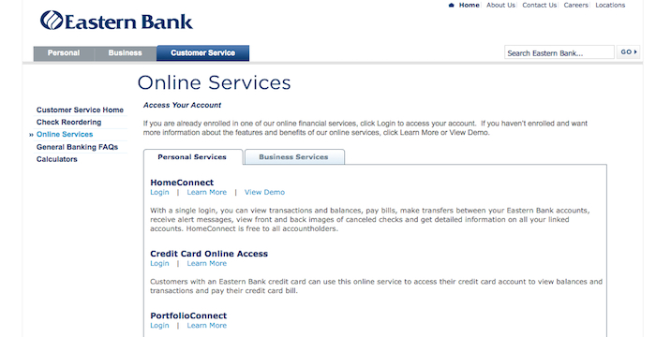
- Bill Payment –
  - Instant Mobile Recharge Service
  - EBL Credit Card Payment
  - BTCL, GP, Citycell, Banglalink, Airtel bill paymento Access Telecom Ltd. bill payment
  - Agni Systems Ltd. and Dekko Airnet Ltd. bill payment etc.
- Internal Transfer – transfer funds to other recipient’s/beneficiary’s account.
Exim Bank Limited
EXIM Bank started its operation in 1999. EXIM stands for Export Import Bank of Bangladesh Limited. To keep pace with the digitalization process, EXIM bank has started SMS Banking and Internet Banking facilities.
Customers can complete their registration at the branch to access the mobile banking facilities which provides round the clock information relating to the account status and other crucial information like deposits, withdrawals etc.
Their Internet Banking service provides our customers with the means to access their Exim Bank accounts via the internet. Customers will be able to inquire on their account balances, transactions, loan and term deposits information, bank statements, and transfer funds between Exim Bank accounts, (on request) in an efficient, simple and secure way.
Features & Benefits:
- Account history
- Transaction history
- Balance enquiry
- View statements

Online Payment:
- Fund transfer from accounts within the bank and also other banks
Contract Term Deposits:
- View updates on the date of maturity, interest rates, interest earned, amount payable at maturity and others.

Customer Service:
- Check status of issued cheques.
- New cheque book request.
- Stop cheque payments.
Online service:
Services offered through SMS banking are –
- Balance Enquiry
- Mini Statement
- Help Service
- Account Information

HSBC
The Hongkong and Shanghai Banking Corporation (HSBC) Ltd started their business in Bangladesh in 1996. Presently, HSBC is offering a wide range of banking products starting from retail banking, consumer banking, commercial banking, cash management, bill payments, online internet banking, mobile banking, trade services and many more.
HSBC’s internet banking facilities offer the following services –
- Access account 24/7
- View account history and transaction details
- Fund transfer between accounts
- Bill payments
- Add standing instructions
- Apply online for different products.
- Foreign exchange informatino
- E-statement
HSBC offers Phone Banking service that allows a client to perform the following banking activities.
- Check the balances on accounts
- Enquire the status of cheque issued, cancel/stop if necessary
- Foreign exchange information
- Details of transaction history
- Order a statement
- Cheque book request
- Online customer services
- Enquire about foreign exchange rates
- Enquire status of an issued cheque

IFIC Bank Limited
International Finance Investment and Commerce Bank Limited (IFIC Bank) was established in 1976. The objective of the bank was to work as a finance company in Bangladesh and also to set up joint venture banks and financial institutions in abroad.
Through IFIC Internet Banking, customer can conveniently and securely observe their account’s information from customer’s home or office 24/7 round the clock. The services offered are –
- Account status with necessary details
- Transaction history
- Account statement for specified period
- Utility bill payment
- Tuition fees payment
- International remittance
Apart from these, the internet banking also offers cheque book inquiry, interest rates inquiry and detailed product list and information services.
The bank also offers mobile banking services which includes cash-in, cash-out, fund transfer, insurance premium payment etc.

Janata Bank Limited
Like Sonali Bank, Janata Bank is a state owned commercial bank which was established in 2007.
Janata bank started providing online banking and internet banking services with a view to adopting the green banking concept and being environmentally sound. With the use of internet banking, Janata bank opts to lower the usage of paper and lower the rate of carbon emission. The bank has its own secured channel of websites which facilitates communications throughout the web.
Online Information Submission:
In order to properly monitor and evaluate the bank’s business, a web based application programme has been implemented which is named OMIS. Through this portal, all the branches of the bank submit all the relevant information regarding their day to day activities and business. It can be on a daily, weekly or monthly basis. It makes it very easy to evaluate the overall position of the bank and so, branches, management and relevant authorities can implement plans and make important decisions based on the evaluation.
Online service:
Janata Bank has introduced certain online services to their clients which now include checking their Current/Savings/STD account status, FDR account status, Loan account status, Advance account status. The bank is also planning to launch some additional features in near future which is likely to include L/C opening request, A/C opening request, Cheque Book issue request etc.

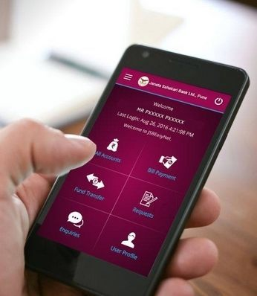

Mutual Trust Bank Ltd.
Mutual Trust Bank Limited started its operation as a public limited company in 1999. From time to time, the bank has offered numerous services to its customers to add convenience to daily life. It has already introduced internet and mobile banking. Internet banking offers the followings –
- Account opening form
- Order chequebooks
- Summary of accounts
- Access account statements
- Transfer funds to another account
- Pay utility bills
- Mobile Top-up
In terms of mobile banking, the bank has introduces a free mobile app for the smartphone devices which allows users to check their accounts. Clients can avail the following cutting-edge services –
- Account statement
- Fund Transfer
- Mobile Top-up
- Cheque book request
- Utility bill payment
- Credit card service and bill payment
Through the app, the customers can also locate MTC branches and ATMs.



Sonali Bank Limited
Sonali Bank inaugurated in 1972 under the Bangladesh Bank Order. It a fully state-owned commercial bank in Bangladesh.
Sonali Bank Limited and Metronet Bangladesh restricted signed an agreement on Thursday, May 28, 2009 for Online Banking Connectivity. Below the agreement, MetroNet command provides online connectivity to 53 undergrowth of Sonali Bank national in the first phase. Customers of the rank will be able to use the banking services and services through the online practice from any of these kindling.
Online services:
Sonali Bank has facilitated and simplified the payment of all types of fees and taxes of National Board of Revenue (NBR) through their online services. The NBR has signed an agreement with Sonali Bank Limited to create NBR-Sonali Bank ePayment Portal to facilitate the online payment of income tax, VAT and customs duty. Users must complete the registration process using their email and activate their accounts. Through this account, they can start making e-payments of income tax, VAT and customs duty.


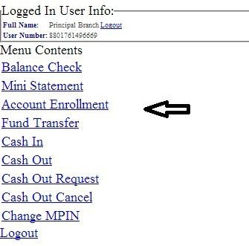

Southeast Bank Limited
Southeast Bank Limited is one of the fast growing private commercial bank. The Bank was established under Bank Companies Act 1991 and incorporated as a public limited company on March, 1995.
Like the other commercial banks, SEBL offers both internet and mobile banking facilities. Through the internet banking of SEBL, customers can check their account status, view account statements, transfer fund from one account to the other, pay utility bills, pay NSU and BRAC university tuition fees, request for a cheque book, create standing instructions and can open FDR account online. The bank is expected to launch mobile recharge service through internet banking soon.
Inquiry & Reporting Services:
1. Account Balance Inquiry
2. Account Statement View and Download
3. Account Information View
Customers can check their account status, statement and transfer funds via mobile banking.
Standard Chartered Bank
Standard Chartered Bangladesh is the oldest international bank in Bangladesh. As of today, SCB has 26 Branches & Booths, 97 ATMs and 19 Financial Kiosks in the country. The bank has its own branch in seven cities of the country – Dhaka, Cox’s Bazar, Chittagong, Khulna, Bogra, Sylhet, Narayanganj. The bank also has an offshore banking units inside Dhaka Export Processing Zone (DEPZ) at Savar and Chittagong Export Processing Zone (CEPZ).
SCB offers a wide range of services through its internet banking facilities. Obviously, a customer can check his/her account and credit card status and statement online. eStatement enables clients to receive monthly statement at their email for both banking account and credit card. Clients can apply for credit limit increase of the credit card through internet as well.
Instant fund transfer from SCB account to another SCB account can also be performed over the internet. Not only SCB account to SCB account, fund can be transferred to any BEFTN member bank account. However, there are certain limits of the fund that is to be transferred. Customers have the option to pay from SCB account to their credit card, however, it needs to be pre- registered. Paying utility bills is now made easier through the internet baking of SCB. Clients can pay bills of GP, Robi, Citycell, Airtel, Banglalink, DESA, DESCO, Dhaka Club, Chittagong Club, Banglalion and Qubee via internet banking. Tuition fees (Scholastica) can also be paid through internet banking. Clients can also create standing instructions to transfer funds between the banking account and credit card via internet banking.
Apart from these, internet banking also enables SCB clients to check status of chques issued, order duplicate statements, order new chequebook and card cheque etc.

Trust Bank Limited
Trust bank limited is also offering limited online services.
Trust Bank has inaugurated Trust Bank Mobile Money (TBMM) as part of their digitalization process. It is a prepaid account facility through which the customers of the bank can make transactions anytime at anywhere. The customers of the bank are able to transfer fund to anywhere in the country using the Pay-points through mobile.
Through the internet banking of Trust Bank, a client can just check their account status and view transaction statement.

Findings of the Study
The above summarizes the internet banking sector of the country. Internet banking has been adopted by the developed countries by offering services in the widest range possible. Bangladesh, being a developing country, might not be still able to offer as much as the developed countries in this concern. However, banks in Bangladesh are gradually offering the services with time. It is obvious that to add convenience in the life of the customers and to soften the loan on branch banking, internet banking or virtual banking has no alternative. Customers are highly benefitted as they can perform their desired banking transactions sitting at a cozy corner of their home or anywhere in the world.
The offerings of internet banking across banks in Bangladesh are not the same. There is no universal standard of offerings yet. Hence, some banks offer more, some banks offer less internet banking or mobile banking services. From our above discussion, it is very clear that state-owned banks offer a very limited service with regard to internet banking. Also, there are some state-owned banks that do not offer internet banking at all (i.e. Agrani Bank). Now, coming to the commercial banks, the offered services vary from bank to bank. Like state-owned banks, there are also a very few commercial banks that haven’t stepped into the digitalized era of banking.
From the discussion on the selected banks above, we get a clear understanding on the basic services provided through internet banking. Almost every bank that has adopted virtual banking offers some basic features that enables the customers to check the account status, check balance, view statement and so on. On a higher level, banks give their customers the option to transfer fund within and across banks, make payments of bill, create/modify/delete standing instructions etc. Thus, customers do not need to waste their valuable time on paying bill such as utility bills every month by going to the bank. They can rather pay the bills instantly with the help of internet banking that saves the time and effort for bill payments. Mobile bill payment and prepaid recharge is also enabled through the internet banking which is much more convenient than flexiload or topup services.
From our analysis, it is also evident that the foreign banks, having modern resources, are way ahead than any other local banks in terms of their internet banking offerings. SCB and HSBC has introduced a very wide range of internet banking services and constantly working on adding more and more services to it.
Few banks have gone a little further on virtual banking sector by adding their own mobile banking apps. Through this app, customer can perform various banking transactions and enquires. Mutual Bank, SCB, DBBL, City Banks are few of the banks who introduced app-based internet banking.
Following table summarizes the comparative overview.
 | Name of Banks | Virtual Banking Services
 | Name of Banks | Account Status | Check Account Balance | Statement | Fund Transfer (Internal) | Fund Transfer (Other Banks) | Bill Payment | Mobile Top-up | Mobile App
1 | AB Bank Ltd | ✓ | ✓ | ✓ | ✓ | ✓ | ✓ | ✓ | x
2 | Bank Asia Ltd | ✓ | ✓ | ✓ | ✓ | x | x | x | x
3 | Brac Bank Ltd | ✓ | ✓ | ✓ | x | x | x | x | x
4 | Citibank N.A. | ✓ | ✓ | ✓ | x | x | x | x | x
5 | City Bank Ltd | ✓ | ✓ | ✓ | ✓ | ✓ | ✓ | ✓ | ✓
6 | Dhaka Bank Ltd | ✓ | ✓ | ✓ | x | x | x | x | x
7 | Dutch Bangla Bank Ltd | ✓ | ✓ | ✓ | ✓ | x | ✓ | x | x
8 | Eastern Bank Ltd | ✓ | ✓ | ✓ | ✓ | x | x | ✓ | x
9 | Exim Bank Ltd | ✓ | ✓ | ✓ | x | x | x | x | x
10 | HSBC | ✓ | ✓ | ✓ | ✓ | ✓ | ✓ | ✓ | x
11 | IFIC Bank Ltd | ✓ | ✓ | ✓ | x | x | ✓ | x | x
12 | Janata Bank Ltd | ✓ | ✓ | ✓ | x | x | x | x | x
13 | Mutual Trust Bank Ltd | ✓ | ✓ | ✓ | ✓ | x | ✓ | ✓ | ✓
14 | Sonali Bank Ltd | x | x | x | x | x | x | x | x
15 | South East Bank Ltd | ✓ | ✓ | ✓ | ✓ | x | ✓ | x | x
16 | Standard Chartered Bank | ✓ | ✓ | ✓ | ✓ | ✓ | ✓ | ✓ | x
17 | Trust Bank Limited | ✓ | ✓ | ✓ | x | x | x | x | x

Recommendations

Internet banking in our country is not as vast as the internet banking services offered by many developed countries. Moreover, majority of the people in our country are reluctant to use online platforms for performing banking transactions. This is due to their lack of confidence in the system, lack of knowledge about use of computer and internet, and lack of trust over security issues. People need to be taught and made aware that internet banking has no security issues whatsoever if used on authorized platforms. They need to be made aware that it is as safe as conducting banking activities at the counter of the bank branches. As soon as they get over these security trust issues, more and more people will be attracted to reap the benefit of the internet banking facilities. Along with this, they need to taught about how to use these platforms effectively.
Our analysis does reveal that online banking offerings is not the same across banks. Some offer limited services, some offer wide range of services and some do not offer any internet banking activities at all. But to keep pace with the modern era, a number of banking services must be kept as a standard. Otherwise, people will still be reluctant to use the online banking services. Bangladesh Bank should come forward and take immediate steps to make a standard form of internet banking services mandatory for all the banks operating in the country with some basic features such as account status check, balance check and statement review. This basic option should be incorporated for all the banks so that people do not have to come to the branch for these enquires and make the branch level activities less crowded.
Bangladesh Bank also need to ensure proper security measures are taken for internet banking across all the banks. Without these security measures, internet banking can bring very adverse effect for both the bank and the customers.
Finally, proper awareness regarding the internet banking should be made among the people. They need to be made aware that these services exist and they do not need to go to the bank for every other services. A few banking activities can be made compulsory online and prohibited on the branch counter to promote the internet banking services.
Conclusion
Internet banking is the demand of this modern era. Without this, banking sector cannot make an advancement towards technological improvements within the sector. Internet banking has the potential to create new opportunities and scope with regard to the banking activities and services. Even though a very small percentage of people in our country actually uses the internet platform to operate their account, the number is now growing. In near future, many of the traditional branch activities will be removed from the branch level and people will be able to access them only on online. This will only be possible by spreading the knowledge of internet banking and its uses. Those who don’t use the platform simply because of security issues need to be taught and understood. Internet banking is the future of banking convenience. So it is for the best that people adopt this feature as early as possible.

References
(n.d.). Retrieved from Standard Chartered Bangladesh: www.sc.com/bd/
(n.d.). Retrieved from Soanli Bank Limited: www.sonalibank.com.bd/
(n.d.). Retrieved from Janata Bank Limited: www.janatabank-bd.com/
(n.d.). Retrieved from AB Bank Limited: www.abbl.com
(n.d.). Retrieved from Bank Asia Limited: www.bankasia-bd.com/
(n.d.). Retrieved from Brac Bank Limited: www.bracbank.com/
(n.d.). Retrieved from Citi|Asia Pacific|Bangladesh-Citigroup: www.citigroup.com/citi/about/countrypresence/bangladesh.html
(n.d.). Retrieved from Dhaka Bank Limited: www.dhakabankltd.com
(n.d.). Retrieved from Dutch-Bangla Bank: www.dutchbanglabank.com/
(n.d.). Retrieved from Eastern Bank Limited: www.ebl.com.bd/
(n.d.). Retrieved from Exim Bank|Home: www.eximbankbd.com/
(n.d.). Retrieved from IFIC Bank Limited: www.ificbank.com.bd/
(n.d.). Retrieved from Mutual Trust Bank Limited: www.mutualtrustbank.com/
(n.d.). Retrieved from Southeast Bank Limited: www.southeastbank.com.bd/home.php/
(n.d.). Retrieved from City Bank Limited: www.thecitybank.com/
(n.d.). Retrieved from HSBC Bank Limited: www.hsbc.com.bd/
(n.d.). Retrieved fromTrust Bank Limited: www.trustbank.com.bd/
Al, H. E. (2007). A COMPARATIVE ANALYSIS OF INTERNET BANKING .
Whinston, K. a. (1997). Retrieved from www.lfpdc.lsu.edu/publications/working_papers/wp54.pdf

