Internship Report

SWOT ANALYSIS OF IGLOO ICE CREAM AND MILK UNIT

SWOT ANALYSIS OF IGLOOICE CREAM AND MILK UNIT

Prepared for
Khandokar Mahmudur Rahman
Associate Professor & Director of BBA Program
School of business and Economics
United International University

Prepared by
Sayed Hasin Zaman
111 141 009

Submission date:
February 27,2019


United International University
Letter of Transmittal

February 27,2019
Khandoker Mahmudur Rahman
Associate Professor & Director of BBA Program
School of Business & Economics

Dear Sir,

Subject: Submission of report

I am happy to prepare and submit the report SWOT ANALYSIS OF IGLOO ICE CREAM AND MILK UNIT for your kind review. I have found the work quite interesting and valuable . I have put my best effort to prepare the report on time .
I tried to visualize all the areas related to this report. I also used your lecture to fulfill your requirements.
I respectfully hope that my assignment would meet your requirements . I will be happy to answer your question if you have any.

Sincerely,

Sayed Hasin Zaman
ID-111 141 009

Acknowledgment

I am paying my gratitude to the Almighty Allah because of whom I am being able to prepare this academic report. I earnestly pay my regards to the Almighty to put me into this success.
I would like to express my respect and heartiest gratitude to my course instructor Khandoker Mahmudur Rahman for his cooperation , which will be always remembered by me as without whom preparing this report was simply impossible .I will always appreciate his modest approach to make me understand the topic.

DECLARATION

I am Sayed Hasin Zaman, student of School of Business and Economic (Marketing) of United International University, Bangladesh, do hereby declare that the internship Repot on “SWOT ANALYSIS OF IGLOO ICE CREAM AND MILK UNIT” is an original work and has not been previously submitted for any degree, diploma, title, or recognition.

Sayed Hasin Zaman
________________
ID No: 111 141 009
School of Business and Economics
United International University

Table of Contents
Part Page
Executive Summery xi
1 BACKGROUND OF THE REPORT 8
1.1 Introduction..............................................................................................................................8
1.2 Topic of the report 8
1.3 Origin of the report 8
1.4 Background of the Report 9
1.5 Objective of the Report 9
1.6 Scope of the report 9
1.7 Methodology of the report.....................................................................................................10
1.7.1 Primary sources...............................................................................................................10
1.7.2 Secondary sources...........................................................................................................10
1.8 Limitation..............................................................................................................................10

2. Organization Part.........................................................................................................................11

2. 1Introduction................................................................................................................................11

2.2 Achievements & Recognition....................................................................................................13
2.3 Introducing IGLOO Ice Cream..................................................................................................15
2.5 Brand Quality and Achievements..............................................................................................15
2.6 Organgram of IGLOO Ice Cream..............................................................................................17

3 Project Part....................................................................................................................................18

3.1 SWOT Analysis.........................................................................................................................18

3.1.1 Strength...................................................................................................................................19

3.1.2 Weakness.................................................................................................................................22

3.1.3 Opportunity..............................................................................................................................25

3.1.4 Threat.................................................................................................................................... 26

4. Reference......................................................................................................................................27
Executive Summery

This report is about the whole scenario of SWOT analysis of IGLOO ice cream. In this report, I have tried to demonstrate threats and weakness IGLOO faces. I talked with the deputy manager of IGLOO ice cream and milk unit and brand team till the time of preparing this report and ended up. Strong distribution channel, challenges to maintain proper cold chain, the complains against dealer support, expensive row materials, high branding costs, have also been found out during my internship period . Although the demand of IGLOO is getting higher because of its synonymous taste and quality over decades but IGLOO is in threat to lose market share as many retailers are about to divert from IGLOO to other rivals due to lack of enough support from IGLOO. These dissatisfactions of retailers are being taken as opportunity by other competitors. They have started to offer more convenient services to the retailers. Despite having dissatisfaction, most of the retailers still want to do business with IGLOO .In terms of collecting information for SWOT a very short scenario I have tried to show .

BACKGROUND OF THE PROBLEM

1.1 Introduction

Bangladeshi ice cream industry is moving with a fastest growth rate. Emerging competitors are trying to grab the industry than ever before. Previously where the industry was dominated by only two or three producers, now there are plenty of foreign and some prominent local distributers of ice cream industries doing business in Bangladesh. For that reason, finding new scopes and strategies to build customer loyalty has become very essential for Igloo in order to maintain the leading position in the market. Igloo’s strong retail chain was established in order to maintain the leading position and serve quality.
Furthermore, Ice cream industries have thousands of potential retailers among which Igloo is working on building a long-term relationship with them. This Internship report specifically describes those activities of Igloo, the problems, opportunities and possible outcomes. Besides, the overall retail chain of this company have been discussed thoroughly.

1.2 Topic of the report

A topic has to be selected for the report. A well-defined topic reveals what is going to be discussed throughout the report. The topic has been assigned “SWOT ANALYSIS OF IGLOO ICE CREAM AND MILK UNIT”.

1.3 Origin of the report

In today’s world academic education is not enough to enable student compete with confidence and reach his/her goal without having experience of the outside world. The report which has given the opportunity to learn about a particular company's swot analysis.

1.4 Background of the Report

The internship program which is an essential part of the BBA program to complete the degree and helps to show a significant importance as it enables a student to familiar with the practical corporate activities. The student work closely with the people of an organization and learn about the functions of that organization. This program enables a student to develop his analytical skill and professional attitude. For the completion of this internship program, I have been placed in the “Abdul Monem Limited” as an internee for 3 months. This report would be base on-" SWOT ANALYSIS OF IGLOO ICE CREAM AND MILK UNIT”.

1.5 Objective of the Report

Internship program is a realistic and practical subject to understand the situation nearly. It is a career development activity help me to build my career. The internship program provides me the following things:
- To help me to complete my internship report .
- To have a clear view about Igloo Ice cream .
- To identify the strength, weakness ,threat and opportunity .
- To understand the sales process of the Best Ice Cream Brand of Bangladesh.
- To measure the quality of service provided by Igloo representatives.

1.6 Scope of the report

This report has been prepared through several discussions with the employee of Igloo Ice Cream and honorable supervisor. While preparing this report, I had a great opportunity to have an in depth knowledge of all the retail activities of Igloo Ice Cream.

1.7 Methodology of the report

I have prepared this report based on the first -hand experiences during my three month internship period at Igloo Ice Cream. In order to make this report, both Primary and Secondary Data has been used.

1.7.1 Primary sources
- Igloo Retail Survey 2018
- Face to face conversation with the Internship Supervisor
- Conversation with deputy manager of Igloo Ice Cream
- Direct observations

1.7.2 Secondary sources

These are the quickest source of collecting the necessary information. In this report, the information collected from indirect source is considered as secondary data sources. Information derived from internet such as articles, journals, websites and relevant sites are considered as the secondary data sources. Though, it was tough to find any internal report of Abdul Monem Limited for the confidential issue.

1.8 Limitation

In preparing this report few limitations were faced:

Lack of sufficient sources prevented verification of information

My report topic is completely different from the work I have done during internship period

Some information of the report may be considered confidential by the organization

2. Organization Part
2.1 ntroduction
Abdul Monem Limited (AML) is one of the leading diversified business conglomerates of Bangladesh. The core ideology of the company is-
“Touching Lives… Building Capabilities…!”

The organization was established in 1956 by one of the most successful entrepreneurs of the country, Mr. Abdul Monem. From the very beginning, Mr. Abdul Monem is acting as the Managing Director and Chairman of the organization and till now he is still strongly and successfully running it along with his two eligible sons working as the Deputy Managing Directors (DMD) of the company Mr.A.S.M. Mainuddin Monem and Mr. A.S.M. Mohiuddin Monem. .

Recently, A.S.M. Mohiuddin Monem, Deputy Managing Director of Abdul Monem Ltd, has recently received the best taxpayer award for 2017-18 given by the government.Mr.Monem, also the chairman of Service Engine BPO Ltd, has won the award for the fifth year in a row, the company said in a statement yesterday. (The Daily Star, 2018)
The organization is renowned for its construction business and major infrastructure projects for Bangladesh Government , World Bank ,ADB ,JICA etc . Approximately 30% government projects of Bangladesh are conducted by the company. For that reason, AML is considered one of the best construction companies of the country. Over the last few decades, AML has not only become country’s largest constructions company to deliver excellence in the field of modern infrastructures, it has also become the bottler of the most favorite beverage brand of the world, Coca-Cola, the producer of country’s number one ice-cream brand Igloo ,Igloo milk and other dairy products ,Igloo foods and snacks, producer of pharmaceuticals, manufacturer of auto bricks, bitumen and other construction materials. The company was awarded in 2015 for developing one of the first private Economic Zones(EZ) of the country called Abdul Monem Economic Zone (AMEZ) in Munshiganj on its own land of 216 acres.“AMEZ is the second economic zone in the private sector that obtained the final nod from Bangladesh Economic Zones Authorit
All these business units are built up with a view to utilizing the quality of the parent organization and to add to the national economy with a goal of increasing opportunities for the people. Despite the fact that, AML started as a family claimed business, it has changed into a multi-disciplinary current business bunch conveying an incentive to our clients. Thus, the need has been to concentrate on building capacities to implant quality and character in their people, business accomplices, partners and stakeholders bringing about strong and dynamic development of the company

The Company has more than 10,000 talented and highly skilled workforces which are the rock bottom of its strength and long-term success. Hence, the policy requires that they take responsibility for ensuring their safety and security as well as safe guarding their health and welfare. They also take great pride in contributing to the community and society as a whole through active corporate social responsibility and engagement.

The company’s ultimate focus therefore, is to use its valuable resources in order to create value- added products and services, which would contribute to the economic, social and environmental progress and prosperity of Bangladesh. Altogether, the organization aims to lead by paradigm and to learn from everyday experiences , it sets to high standards for its people at all levels and consistently meet them .

2.2 Achievements and Recognition

- The Best Tax Payer Award, Deputy Managing Director, Mr Mohiuddin Monem [November 2017-18]
- The President’s Industrial Award [May2016]
- The longest TAX and VAT payer award [December2016]
- IFAWPCA gold medal
- Business person of the year[2008]
- Commercially important person [2010, 2011 and2012]
- Excellence for business performance from Jamuna Bank ltd.
- Igloo- No.1 ice-cream brand by Bangladesh Brand Forum .

2.3 Introducing IGLOO Ice Cream

Igloo is the most popular impulse and take-home ice cream brand of Bangladesh. Igloo was established in 1964 as a business concern of Abdul Monem Limited and under its Ice Cream and Milk Unit. Since its beginning, Igloo has become synonymous for quality ice cream all across the country. Over the last 50 years, Igloo has developed over 100 different varieties of flavors, forms and shapes ice creams for a rich, unmatched experience to its consumers. Igloo is equipped with the most modern machineries, skilled human forces and it never compromises the quality. As the customer taste and preference is changing day by day, Igloo is always introducing new flavors to serve the consumer’s need .The official slogan of Igloo is ,‘A World of Great Taste’ which reflects company’s dedication to its customers to provide a delightful experience of taste and quality.

The new Integrated Marketing Communication (IMC) tagline of Igloo is-

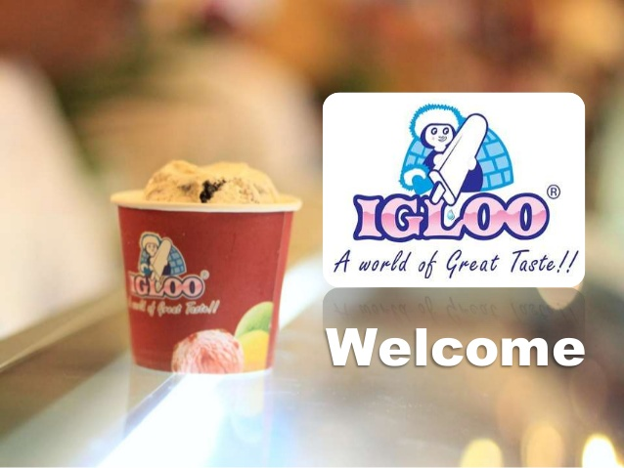

2.4 Brand Quality and Achievements
A brand must show a credible assurance of quality to the customers (Aaker, 1991). That is why Igloo never compromises with the quality of their products and it is considered the best ice cream brand of Bangladesh. Almost 95 percent raw materials are outsourced from Different European countries in order to provide the best possible quality to its customers . Although, initially Igloo milk was the supplier of the production, now the milk is imported from Australia and New Zealand. Chocolate, cream, flavors, etc. are sourced from Denmark. Not only the production ingredients are imported, the packaging materials are also imported for better quality packaging.

- Halal Certified: “Igloo Ice Cream” has been certified Halal by“BSTI”

- HACCP Certification: IglooIceCream has been certified by Hazard Analysis and Critical Control Points(HACCP)
.
- ISO Certified: Certified ISO 22000: 200, Food Safety Management system Requirements for any organization in the food chain.

- QCS (Quality Control System): Well-trained personnel and professionals have been appointed to ensure the quality of our product.

- Igloo has also been awarded as “The Best Ice Cream Brand” by Bangladesh Brand Forum (BFF) for four years in a row - 2013, 2014 , 2015 and 2018 .

2.5 Organ gram of IGLOO Ice-cream

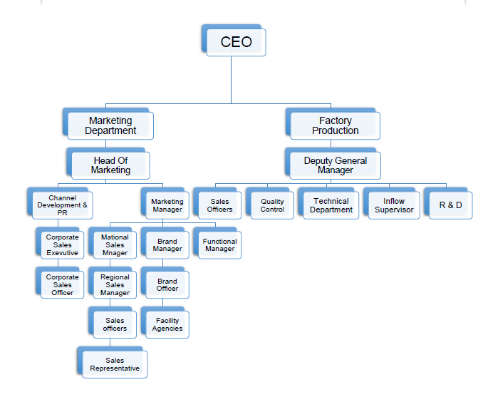

3. Project Part

3.1 SWOT Analysis

Strong Supply Chain | Dependence on Imported Materials
Imported Raw Materials | High Brand Cost
Strong Corporate Relations | Seasonal Business
Variety of Flavors | Excessive Marketing Costs
Home Delivery Service | High Turnover Rate
Customized promotion
Customized packaging

New Rivals in Industry | Corporate Sales Department
High Government Taxation | Gift Solutions
Premium Brands | New Products for Winter and Off  Season
Unavailability of Raw Materials | Scope of Improving Flavors and  Products
Changes in Climatic Conditions | Emphasizing on Digital Marketing

3.1.1 STRENGTH

1. STRONG SUPPLYCHAIN
Igloo has the largest ice cream supply network of the country. Due to its vast supply chain and distribution network, Igloo is available over 20,000 retail stores, super shops, and hypermarkets across the country. Igloo also has a huge number of corporate clients. Igloo has different depots in different locations of the country for better distribution. One of the largest depots of Igloo is located in Panthopath, Dhaka which is considered the central location of the city.. Division wise there main operating cities are Dhaka, Comilla, Chittagong. Strong distribution network as its products is available in difference district and upazilla. All over the country they try to reach with there products. Small town and developed villages there are availability of IGLOO ice cream. In dhaka city IGLOO has 8-10 depots for ice cream. In other cities they operate from deports for supplying ice cream.

2. IMPORTED RAW MATERIALS
Igloo is the only company that deepens almost entirely on imported materials for its productions. More than 95 percent of the raw materials are imported from Different countries around the world in order to provide the best possible quality to its customers.The main ingredient of Ice-cream is the milk which is imported from countries like Australia and New Zealand. Other ingredients such as Chocolate, cream, flavors, etc. are sourced from Denmark. Not only the production ingredients are imported, Igloo also imports the packaging materials for better quality packaging. All the materials are processed in automatic machine. the materials are maintained with hygiene factor. Quality full materials are used to make different flavors and outlook. A choc-bar name EGO which has double coating of chocolates which is fully premium quality some other sophisticated ice creams like Ice Cafe, Nutricks, peanut butter etc

3. STRONG CORPORATE RELATIONS
Igloo is the only Ice cream brand of the country which has a dedicated department only for corporate sales. The main task of this division is to maintain a good relation with the largest corporations of the country and support them with different corporate solution. Igloo is the first company that introduces Ice-cream as corporate gift solution which is a completely new idea for Bangladesh. In different corporate events & activation IGLOO presence as sponsor

4.VARIETY OF FLAVORS
Igloo has the highest number of product line with countless number of favors .The research and development of the Branding department of the company are always working on product innovation and continue improvements of tastes and flavors. The most common flavors of this category are- Vanilla, Strawberry, Chocolate and Mango. The products are-
▪ Cups (Vanilla, Strawberry, Chocolate and Mango)
▪ Chocbar
▪ Mini Choc
▪ Shell & Core
▪ Lolly- Lemon
The premium Products of this category are-
Cornelli Classic (Mini),Belgian Chocolate (Mini) , Belgian Chocolate , EGO ,MEGA , MACHO ,Ice Café (Paper Cup) , Nutricks (Paper Cup) , Peanut Butter Cream,Chocolate Fudge Brownie , Chocolate Milk Shake , Mango Milk Shake

5. HOME DELIVERY SERVICE
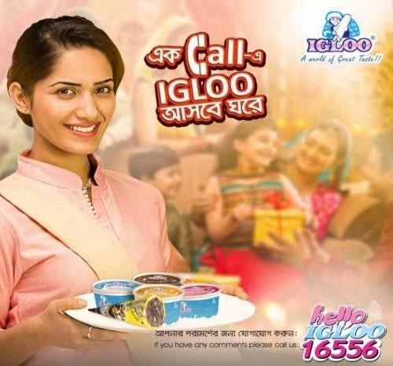
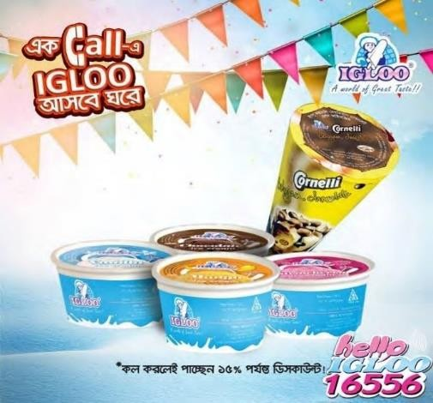
Igloo is the first brand to launch ‘Free Home Delivery Service’. This service is known as “Hello Igloo”. It inaugurated at the merge of 2016 which provides the customer the comfort of ordering from home.

In order to get this service,
- You need to call Hello Igloo (16556) number and place your order for your desired ice-cream.
- This service is completely free of charge.
- The minimum order quantity of the product should be BDT 400 in total.
- This service is identical to the catering service.
- Igloo also accepts orders for any big occasions like marriage ceremony or party programs.
- Igloo also provides customized lid sticker according to consumer demand for different occasions like marriages ,Gaye Holuds or birthday parties. Customized lid sticker can be such as “Shahin’s GayeHolud”.
- For the customized orders, you need to confirm the order 10 days BEFORE the deliveryday.
- Minimum order quantity should be 1000 pieces. Order time: Saturday – Thursday, 10 am to 6 pm, but for delivering, Igloo is prepared throughout the week including Friday.
- For regular product orders, the products will be delivered within 45 minutes order.
- Currently the service is available only in Dhaka city

6. CUSTOMIZED PROMOTION

Igloo Provides Customized branding facility to its clients on the Product Containers and the Caring boxes of the products. This gives the clients freedom to do Banding their own products or Brands with their desired gifts .With some terms and condition customer can design their desired products. It needs time and conditions.

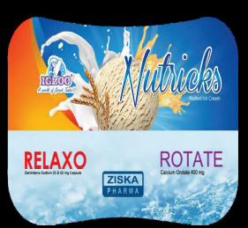
Source: Customized Level Branding Design made for Ziska Pharma
7. CUSTOMIZED PACKEGING
As a common customer, the first concern is how is Ice-Cream going to stay cold for long time. Keeping the temperature low to maintain the cold-chain is the biggest challenge for kind of products like ice cream. To solve this problem Igloo provides Customized Cork Sheets that maintains cold-chain up to 6 hours. Igloo also provides custom made poly bag for carrying the product conveniently.

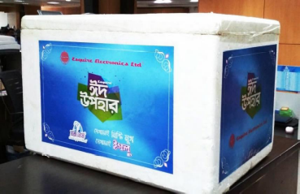
Source: A Customized Cork Sheet Box made for Esquire Electronics EID Camping
3.1.2 Weakness

1. DEPENDENCE ON IMPORTEDMATERIALS
Igloo is highly dependent on foreign ingredients for its production to ensure the quality and customer satisfactions .Any uncertainty in global economy and politics could affect the production process .Igloo as more than 95% raw materials are imported from different countries. For any kind of material changes it has to import. The continues changes of different flavors and segmentation Igloo needs to depend on foreign ingredients .If there is any scarcity of any particular ingredients in one country it has to stop the production or search for new country or other options. To maintain regular production process of vast numbers of ice cream Igloo has to follow up the raw material availability .

2. HIGH BRAND COST
Igloo spends a huge amount of money on its research and development department for product innovation and for introducing new products and flavors. Recently Igloo ice cream have operated a retail survey over 10000 freezers in Dhaka city. To maintain the high brand image this expensive survey done for forecasting the next plan for branding .

3. SEASONAL BUSINESS
Ice Cream business is completely a seasonal business. The production and sales of ice cream fluctuate on monthly basis throughout a year. There is a common perception in our consumers’ mind that ice cream should not be consumed in winter season. Based on the sales forecast, we can divide a year into 4 parts: Peak, Super-Peak, Off-Peak and Super Off-Peak. High cost and different policy has to use to maintain a grown up brand. As Igloo has vast options of ice creams which is tough to maintain in off season.

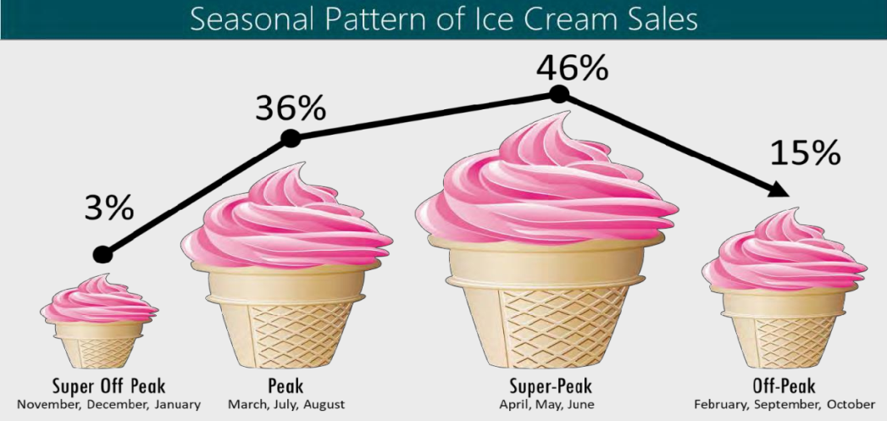
4. EXCESSIVE MARKETING COSTS
Due to increased competitions ,Igloo now has to invest more on marketing campaigns, which has also increased the total cost of the organization. Igloo mainly focuses on the outdoor media which includes banners, papered posters, danglers, painted displays, billboards, neon signs as its creative channels to convey its message to its target markets which contributes 65% of the total advertising expense. Igloo uses different channels of outdoor media in attracting its various segments. An extensive application of wall pestering was seen in its newly introduced item Kulfi for the mass level.
Newspaper coverage comprises of a 17% share of the total publicity expenses, which includes advertisement displayed in papers such as Daily Star, Prothom Alo, Bhorer Kagoj, Jonokantha and Ittefaq.All these marketing activities cost a lot annually

5. HIGH TURNOVER RATE
In any FMCG company, a major problem is high turnover rate of the employees. Igloo also suffers a lot. High turnover rate leads increasing recruiting and training cost for the new workforces. To train the new employee and whole recruitment process it needs higher costs.

3.1.3 Opportunities

1. CORPORATE SALES DEPARTMENT
Igloo is the first Ice cream brand that has a fully functional Corporate Sales department. The main job of this department is to maintain along-term relation with the largest corporations of the country. The quantity of sales is in bulk amount and the opportunity is very high for further improvement.

2. GIFTSOLUTIONS
Igloo is providing ice-cream as gift solution to its customers .Igloo has targeted different industries as their potential clients. One on these industries are Pharmaceuticals companies. As Pharmaceuticals are providing different gifts to their clients and doctors, Igloo is promoting ice cream as a gift solution to them.

3. NEW PRODUCTS FOR WINTER AND OFFSEASON
Although ice cream is a seasonal business, if Igloo could come up with some new idea of alternative products for winter which can be highly effective. For example, if Igloo brings a new ice cream, that turns into Coffee or Latte when make them hot, people would buy Igloo ice cream even in winter season.

4. SCOPE OF IMPROVING THE FLAVORS & PRODUCT
More and more rivals are joining in the industry every day. That is why Igloo should emphasize more on product innovations and invest more on research and development . More new flavors should be launched frequently in order to cope up with the competitions.

5. EMPHASIZE ON DIGITALMARKETING
We are living in the age of technology ,and social medias are playing vial role in our daily life .People spend more time on Social medias like Facebook and Instagram than TV, newspapers or Radios. That is why Igloo could increase the budget for Digital Marketing Campaigns to grab more audiences.

3.1.4 Threats

1. NEW RIVALS IN THEINDUSTRY
The biggest challenge for Igloo is the new Rivals in the industry in recent years .Previously ,Polar was the only major competitor for Igloo but now, the number has moved into 6 to 7. Some of these rivals have come to the market with huge investments and aggressive marketing strategies.

2. HIGH GOVERNMENT TAXATION
Increased TAX and VAT by government in budgets over ice cream and beverages could increase the cost and eventually the price of retail units of ice creams.

3. PREMIUM BRANDS
Premium brand like Bellissimo is bringing all-premium products. This could decrease the sales of premium products by Igloo and eventually Igloo might lose more market shares.

4. UNAVAILABILITY OF RAW MATERIALS
As Igloo is highly dependent on imported raw materials for their production, any uncertainty regarding the availability of those goods might hamper the production of Igloo.

5. CHANGES IN CLIMATECONDITIONS
Ice cream is considered as seasonal business as it is manipulated directly by the seasons and climates. In recent years, during summer excessive rainfall decreases the sales of ice cream.

4.REFERENCE

http://www.assignmentpoint.com/business/organizational-behavior/report-on-igloo-ice-cream.html

http://www.amlbd.com/ice-cream-unit/igloo/

http://www.amlbd.com/

Future Startup. (2017, November 28). ‘IGLOO, Ice Cream Industry In Bangladesh and Career: An Interview With G M Kamrul Hassan, CEO’. Retrieved from https://futurestartup.com/2017/11/28/igloo-ice-cream-industry-bangladesh-career-interview-g-m-kamrul-hassan-ceo-igloo/

Best Brand Award. (n.d). Bangladesh Brand Forum. Retrieved August 12, 2017, from http://bangladeshbrandforum.com/best-brand-award/

