Internship Report
On
Human Resource Practice at Apex Footwear Limited



Internship Report | 20th January 2020

Internship Report
On
Human Resource Practice at Apex Footwear Limited

Submitted to:
Nasrin Akter
Asst. Professor, School of Business and Economics,
UIU

Submitted by:
Mohammad Ahsan Habib
ID: 111 151 551

Date of Submission: 20- 01-2020


United International University

LETTER OF TRANSMITAL

20th January, 2020
Nasrin Akter
Asst. Professor,
School of Business and Economics
United City, Madani Avenue, Badda, Dhaka - 1212
Subject: Submission of Internship Report on “HR Practice in Apex Footwear ltd”.
Dear Ma’am,
I am very fortunate to have the opportunity to submit my internship report on the topic "Overall HR Practices at Apex Footwear Limited which has been given to me as a prerequisite for a Bachelor of Business Administration (BBA) degree. I tried to describe my experience in Apex footwear Ltd which I gained during my internship. I gave my best to gather the valid information. There may be some drawbacks due to some constraint, if you find such weaknesses, I would be grateful if you consider those constraints. I tried to convert my practical knowledge into a written format honestly and I am very thankful to you for supporting me during my internship.
If you understand my limitations, and approve the paper, it will be a great pleasure.

Sincerely,

Mohammad Ahsan Habib
ID: 111 151 551
School of Business and Economics
United International University

ACKNOWLEDGEMENT

First of all, I would like to thank Almighty Allah. Then I would like to thank my parents, faculties, colleagues. I would like to thank my supervisor Nasrin Akter, Assistant Professor, School of Business and Economics, United International University, for her valuable time, guidance, instructions, suggestions, and supports for preparing this report.
I am likewise extremely appreciative to the authority of Apex Footwear Ltd. for allowing me the chance to do my Internship at such a famous organization. As an intern in the Human Resources department, where I received some competencies to assist me evolve my future profession knowledge. I would like to thank the entire HR Department for making this report a lot extra informative by means of presenting the information required.

Executive Summary

The last stage of completing my graduation of four years is the internship I have done this trimester. Apex Footwear Limited has given me the opportunity for an internship in HR. In this internship period, I have perfectly carried out and accomplished several assignments and projects- i.e. managing HRIS; preparing reports on employee engagement; and various reports and documents of Apex Footwear Limited. Apex Footwear Limited has helped me gain several maneuvers related to the Human Resource department of Apex Footwear Limited which includes aid ex-employees to receive their original certificates and related documents, informing present applicants about their interviews and appointment letters, assisting with the HR associated executions and data entries of the information of the employees and so on.
Because of globalization, HR managers ' position is scarcely tougher and it is because HRM needs a well-thought-out interpretation combined with great optical discernment and decision-making. As HR executives long-term decisions that will have business impact. HRM as particular division which for the most part incorporates orchestrating, emolument policy, training and preparing ordinant dictation, worker cognations and so forth Apex Footwear Ltd.

Apex Footwear Ltd. is a well-known company in Bangladesh's Shoe Manufacturing Industries. In each of the corporate workplaces and factories it has achieved good HR practice. Apex Footwear Ltd's executive members have given special attention to their staff's activities including superior instruction, formulating policies, vocation opportunities, etc. I selected this famed company to conduct an analytical examination of its HRM exercise in order to enrich our theoretical knowledge of HRM with practical perspectives and running structures containing HRM.
Table of Contents
Chapter 1 – Introduction 2
1.0 Introduction 2
1.2 Objectives of the Report 2
1.2.1 General Objective 2
Specific Objectives 2
1.3 Scope of the Study 2
1.4 Methodology 2
1.5 Limitations 2
Chapter 2 – Literature Review 2
Chapter 3 – Organizational Overview 2
1.1 Company Profile 2
1.2 VISION 2
1.3 MISSION 2
1.4 Values 2
1.5 PRODUCT AND SERVICES 2
1.6 SHARE, PRODUCTION CAPACITY & COMPETITORS 2
1.7 ENVIRONMENT AND LABOR LAWS 2
1.7.1 Environment 2
1.7.2 Labor rules 2
1.7.3 Facilities 2
Chapter 4 – HR Practices 2
4.0 HR PRACTICE AT APEX FOOTWEAR LTD. 2
4.1 The Basic Functions of HRM 2
4.1.1 Recruitment 2
4.1.2 Employment Legislation 2
4.1.2 Discipline 2
4.1.3 Development 2
4.1.4 Rewards Systems 2
4.1.5 Training 2
4.1.6 Measuring performance 2
4.1.7 Motivation 2
4.1.8 Selection 2
4.1.9 Keeping and Maintenance of HR Inventory 2
4.1.10 Others Day to Day HR activities of Apex Footwear Ltd. 2
4.2 HUMAN RESOURCE DEMAND FORECASTING 2
4.2.1 Employee Forecasting 2
4.2.2 Recruitment 2
4.2.3 Recruitment Policies of APEX 2
4.3 Recruitment & Selection Process at Apex Footwear Ltd. 2
Source of recruitment: 2
4.3.2 HEAD OFFICE (EMPLOYEE) 2
4.3.3 STORE LEVEL (SALES FORCE) 2
5.0 TRAINING &ORGANIZATIONAL DEVELOPMENT 2
5.1 The training Process 2
5.2 NEEDS ASSESSMENT/NEEDS ANALYSIS 2
5.3 DETERMINING TRAINING OBJECTIVE 2
5.4 DESIGNING TRAINING PROGRAM 2
5.5 Evaluation 2
5.6 Others Training Conducting Issue 2
6.0 PERFORMANCE APPRAISAL 2
Uses of performance appraisal 2
Chapter 5 – HRIS at Apex 2
6.1 HRIS at Apex 2
Chapter 6 – Findings 2
6.1 FINDINGS OF THE STUDY 2
6.1 SWOT Analysis 2
6.2 Findings 2
6.3 Recommendation 2
6.4 Conclusion 2

Chapter 1 – Introduction

1.0 Introduction
Apex Footwear Limited (AFL) is an eminent leather footwear company and exporter to different continent including America, Europe and Asia. In leather sector, selling overseas of standard integrated products export has been established by Apex.
Public listed in 1993, AFL is the trade name of Apex footwear limited.
Apex is a part of retail part of AFL. It has earned success through export in International arena by providing high quality leather. By utilization of the expertise Apex gives high quality products to the Bangladeshi consumer as well.
It has more brands namely Venturini, Apex, Sprint, Maverick, Moochie, Nino Rossi, Sandra Rosa, Twinkler and School Perspicacious and one international brand i.e. Dr. Mauch – which have established the company in one of the most successful organization in the country.

1.2 Objectives of the Report

1.2.1 General Objective
The main purpose of this study is to have an evaluation of the human resources department's overall performance.

Specific Objectives
- To identify how processes of recruitment and selection can be carried out.
- Learning how many benefits Apex Footwear Limited employees receive • Learning the assessment process • Analyzing the training and development process in Apex Limited footwear.
- To get a brief idea about HRIS, how it helps to run the Division of Human Resources
- To know the HR affairs of a footwear making company.
- Identify some drawbacks related to current roles and the system and provide some recommendations to increase efficiency.

1.3 Scope of the Study

The report offers with HRM's function like Human Resource Planning, recruiting and selection process, training and development process, compensation management, employee relationship, performance evaluation, etc. The study will allow new techniques and structure applied to make it more efficient to learn about HRM issues. It would help to get some valuable information of the activities doing by the country’s leading footwear manufacturing organizations. The study will additionally assist differentiate between the system and the principles that drive the appreciation of how HRM process have to be elevated by means of the organization.

1.4 Methodology

Data collection Method: For gathering data I took help past reports, records and profoundly subject to perception. By observing and discussing I took many information and it was the main source of Information.
Essential Data: The essential information gathered from the following sources:
- Discussion with people from managerial level.
- Meeting with the officials involved in particular job.
Optional information:
- Reports published annually.
- Apex Footwear Ltd.’s website.

1.5 Limitations
There were limitations for gathering data which I have faced during the period of internship. I
- Time was major constraint.
- Some information cannot be disclosed.
- Strategies for operation and business were restricted. .
- Reluctant to give information which is confidential.
- As I was new to the corporate, with my limited knowledge I had to take time to understand everything.

Chapter 2 – Literature Review

HR deals primarily with the employees of the company, based on HR policies (Collings & Wood, 2009). Recruitment, performance evaluation, planning and compensation are the main concerns of human resources departments (Paauwe&Boon, 2009).
(Schuler, 1984) said about the six key practices of HRM. They are Training and Development; Compensation; Human Resources Planning, Staffing, including recruitment, selections, and socialization; Union – management relationships. According to (whatishumanresource.com), Training and Development is a structured program with different techniques designed via experts in a specific job. It has appeared as the most common and continuous undertaking for updating employee skills and understanding in accordance with the changing environment in any business enterprise. Optimizing costs with available sources has risen as a matter of priority for each and every organization, which can only be accomplished by enhancing employee efficiency and productivity, Doable only through the delivery of appropriate worker training and development that is based on it being assisted by professionals. (Armstrong , 2005) postulated that compensation management is an fundamental phase of HRM strategy to managing two people and as such two it helps the success of enterprise objectives and it is strategic in the feel that it addresses longer-term problems bearing on to how people ought to be valued for what they prefer to achieve; It is consequently integrated with different HRM functions, especially these worried with human resources development.
(Alan Price , 2007), in his work Human Resource Management in a Business Context, formally defines recruitment and selection as the process of retrieving and attracting able applications for the purpose of employment. He states that the process of recruitment is not a simple selection process, while it needs management decision making and broad planning in order to appoint the most appropriate manpower.
According to (Hedrickson, 2003), HRIS can be described briefly as integrated systems that are used to collect, store and analyze information about the human resources of an organization. According to (Tannenbaum , 1990), HRIS, one that acquires, stores, interprets, analyzes, collects and distributes information about the human resources of an organization.(Kovach, 2002) said that, HRIS HRIS's of as business tools that help to standardize the gathering of information about the employees of the company. According to (Parry, 2010), HRIS can serve as an important strategic method as it owns crucial data with management on recruitment and retention strategies that can be affiliated with the overall corporate strategy for accomplishing growths of organizational goals. Additionally, by using HR applications, a company can calculate the overall costs incurred per employee and its effects on the business as a whole. According to (Barkha Gupta, 2013), HRIS help a firm maximize the use of human resource and maintain competitiveness in its market the large organizations, human resource information systems (HRISs) provide the technology backbone supporting the complete body of human resource (HR) functions. In this role, HRISs play a critical part in the operation of each component of HR. Additionally, by integrating across business processes HRISs provide organizations with control, forecasting, and planning tools that supersede simple computerization of HR functions. For these reasons, effective use of HRISs in organizations contributes to overall organizational effectiveness. Human Resource Information System is a set of people, forms, procedures and data utilized to store, analyze, distribute and use the information of human resources. HRIS's aim is to supply correct records for the use of people making human resource-related decisions. The organization can use HRIS for human resource planning. New recruitments can be posted by way of HRIS as well as applications can be scanned and kept. HRIS additionally stores information about the employees’ participated in coaching and studying sessions. Performance appraisal, compensation, benefits, competences, and improvement plans are without problems maintained in HRIS. Employees can search for a new career inside the employer and be conscious of future training. HRIS allows managers to follow employee’s ́job performance and planned versus used hours for a sure assignment. HRIS gives a number of reports available. Typical HR software involve things such as record-keeping, recruiting, selection, training, worker retention and compensation.

Human resource management is a strategic approach to managing employment relation which emphasizes that leveraging people capabilities is critical to gain sustainable competitive advantage, this being achieved via a distinctive set of integrated employment policies, programs and practices (Bratton J and Gold J, 2003). The actual capital of the organization is the human abilities to utilize the human being as a capital. Each organization has too much cash to commence the business but have not professional bodies to use them at the right pace and at the right time. And HR is strategic partner of the business which runs with the business and takes the business towards the success (iftikar M).
The dynamic and competitive market climate has given the individuals and company new challenges. Without a well-trained and very well-prepared personnel, companies lose the competitiveness with domestic and international competitors leading to reduced economic success (Tomaka, 2001). The workplace in the company has had many challenges for the last ten years, such as intensified international and national competition, rapid technological and science developments, diversity of the workforce, broader use of information technologies etc.
(Ferner and Hyman, 1992). Human resource managers should realize all types of these concerns, and develop relevant strategies to assist their organization. Managing human resources is vital to the organization's accomplishment of its objectives and success (Pfeffer, 1994 Jackson and Schuler 2000, Barney, 1991). According to Tokesky and Kornides (1994), to show the importance of HR department to the employees, managers should try to show the relation between human resource management and organizational success.
HRM in effect is gradually being used to acknowledge the importance of employees as corporate assets. Employees therefore need to have a wide range of technological and interpersonal workplace skills and skills that enable them to work with advanced technologies and to operate optimally in modern high-performance organizations (Combs et al., 2006; Fernandez, 2001). The employees ' expertise, knowledge and experience are economic assets for the company, as the employees help the organization to be adaptable and efficient. Organizations that operate their HR department effectively have higher productivity rates, higher market value, and higher profitability and meet the needs of their shareholders, clients, consumers, workers and, eventually, society's needs (Schuler and Jackson, 1996).

Chapter 3 – Organizational Overview

1.1 Company Profile
Following the motto ‘’Honest Growth’’, Apex has established itself pioneered of export finished goods in the leather sector of Bangladesh. It owns 252 retail outlets, 217 wholesale dealers and 347 retail dealers in the country. It has achieved customer satisfaction through standard design and functionality. By making customer happy the company holds the share of 15% leather footwear export from Bangladesh.

1.2 VISION
The vision of Apex footwear limited is ‘’Honest Growth’’

1.3 MISSION
- To assure growth continuously.
- For our customers to become a vendor of choice.
- Creating value for our shareholders
- To proactively abide by global best practices & criteria.
- To be a responsible citizen of the company.

1.4 Values

- Gratitude
- Fairness
- Urgency
- Empowering
- Courageousness

1.5 PRODUCT AND SERVICE

Both footwear and non- footwear items for the customers are provided by APEX Footwear Ltd. For men, women and children they provide different categories of footwear items.

Footwear | Non- Footwear
Men’s Sandals, Ladies Men’s Shoes, Sports, Children, School, Canvas , Synthetic [Thong/ PVC/ EVA] | Accessories/ Leather Goods ,Socks.

1.6 SHARE, PRODUCTION CAPACITY & COMPETITORS

Share: Around 500 million taka is the initial investment of the project. Apex holds 100% of the share.
Production Capacity: 10,000 pairs per day and 15,000 pairs of complete shoe with its excellent production capacity in the years of 2007 and 2008 were produced by Apex.

Competitors: Titas Footwear Bangladesh, AIMCO Footwear Limited, Fortuna Shoes Limited, Shampan Shoes Limited, and Bay Emporium are major companies in Bangladesh competing with Apex.

1.7 ENVIRONMENT AND LABOR LAWS

1.7.1 Environment
The company has made headway Volatile Organic Compounds (VOC) free products in its production process. To make the premises greening, Apex has taken several initiatives for pollution free office environment. It has got “Green” Category approval by Environment Ministry.

1.7.2 Rules for Labor
Apex go through the plan developed by itself for training, employment, and career development with succession plan. Policies about employee rights and responsibilities and compensation are available in a hand book. It is refined as needed and incorporate to global compact.
- Rules regarding working hours are clear.
- It is guaranteed that job advertisement gets access to all capable candidates and to give the rights for Cooperative talks
- To reduce risk Apex follows the guideline of environmental and safety risk and they also have strict monitoring team.
- For listening the employee opinion it has a very good formal system. .
- The corporation selects its contractors based totally on a listing of criteria, such as a criterion concerning the availability of record.
- As there is a risk to employee labor under 18 years old, by hanging a notice board company ensures no employee under 18 cannot be recruited.
- The company purchase & Anti-Corruption policy is informed to both suppliers and partners.
- The company support the act of different countries against bribery and also the law of Bangladesh.
- In Governmental process, AFL invites staff to join in.

1.7.3 Facilities
AFL provides their employees with further facilities in following:
- Apex provides medical care facilities.
- Free Immunization for children of employee.
- Child care.
- For all workers Group Life Insurance Policy.

Chapter 4 – HR Practices

4.0 HR PRACTICE

4.1 HRM Basic Functions
HRM is a recent notion that brings priority to the management of the overall employee. The HRM handles workers in a way that provides companies with competitive advantages. This department's core functions include recruiting and selection, training sessions, performance evaluation, salary packages, employee encouragement for better performance, etc. HRM is the manager's responsibility at all stages. HRM's main operations are set out below:

4.1.1 Recruitment
- The first move prior to recruitment is to provide effective advertisement for the post.
- The Significant part is prepare job description.
- Lastly the person specification where the qualification of the candidates is outlined.

4.1.2 Employment Legislation
- This means giving the organizations ' workers equal opportunities regardless of age, gender, and disability.
- It also means ensuring the employees ' health and safety.

4.1.2 Discipline
- Organization ensures strict discipline in employee recruitment and dismissal.
- Implement HR protocols by informal or formal meetings, verbal warnings, grievance processes, etc. to deal with any kind of dispute.

4.1.3 Development
- This HR segment involves support
- They also emphasize the growth of people
- They often concentrate on the planning of succession or continuing professional development (CPD)

4.1.4 Rewards Systems
- The incentive packages include traveling abroad, different monetary packages.
- They strive to inspire workers by various incentives.

4.1.5 Training
- The training involves the growth by providing the necessary knowledge of any employees.
- Training helps workers with up-to-date and advanced knowledge. · Efficiency is also improved.
- It can be in-house or by coaches from elsewhere

4.1.6 Measuring performance
- Measuring performance is very significant aspects of HR
- Through performance appraisal of employees the strength and weakness are determined.

4.1.7 Motivation
- Motivation strategies are being followed to keep employees working smoothly and perfectly.
- Employees are rewarded on the basis of the methods of appraisal and if the results are positive, they will be influenced positively.
- Employees are inspired by the rise in compensation and benefits packages.

4.1.8 Selection
- It is a method to select the right candidates.
- Qualified applicants are being shortlisted and called for further procedure.
- Different skills are assessed by various tests such as psychometric test, aptitude test and presentation.

4.1.9 Sustaining and retaining HR Inventories
Human Resources Department maintain the record of the current employees and their information. Employee personal files that hold the details remain as HR inventory.

4.1.10 HR activities of the Company on Day to Day Basis
- Job description setting up and reviewing.
- Finding gap in competency and function.
- Key Performance Indicator is standardized.
- Planning for performance improvement.
- Succession Planning.
- Updating details in the program IFS, POS.
- Updating leave, and record the leave form.
- File creation for every employees of own information.
- Keeping record of ID used, giving token for Canteen.

4.2 FORECASTING DEMAND

4.2.1 Forecasting
Through predicting an organization will predict the number and types of workers it will need in future. When organization needs to increase production, demand forecasting is conducted to achieve business goals. This depends on the organization's future and growth strategy. This will show the following:
- When new production process goes on.
- Change in existing products mix.
- Sales projections / Future marketing.
- Changes in production process and technology.

4.2.2 Recruitment



4.2.3 Recruitment Policies of APEX
According to long term business plan recruitment plan takes place. By requisition from different department HR different initiates the recruitment process from the defining job description.
- Need to be fair
- Can not be biased on age, gender, disability, minority group.

Vacancy
Requisition
Publicity/ Sources
Recruitment Process
- Short-Listing
- Preliminary Interview
- Final Interview
- Selection
- Job Offer
- Joining
- Head Hunters
- Advertisement
- Campus/Job Fair
- Internet
- Internal circulation
- Job Grade
- Job Description
- Job Profile
- Qualification

4.3 Recruitment & Selection Process
4.3.1 Recruitment: As we know AFL runs retail business and currently it has 220 store all over the country so it requires hiring great number of employees.
Apex mainly follows two different method to hire their employees.
Recruitment For:

- Headquarter
- Store

Source of recruitment:

- Outside.
- Inside.

4.3.2 HEADQUARTER (EMPLOYEE)
IF best kinds of employees are selected or hired then the rate of turnover and absenteeism will be reduced and the company will be more productive. The candidates are selected after following process which is given below:

Short Final Final Employment
Listing Interview Decision
 Initial Selection Appointment
Interview Letter

1. Short listing: - The eligible ones are shortlisted then asked for joining the next step.
2. Initial Screening Interview: - The shortlisted ones are carefully judged to see if they are potential and best for the organization or not.
3. Final Interview: - In the final stage the interview continues with COO or MD of the company after a series of interview with HOD and executives.
For hiring sales force HR and retail department follows the below steps:
4. Selection: - After oral or in some cases written exams are taken for hiring them.
5. Final Employment Decision: - If the candidates are potential then final decision is given by the HOD for hiring.
6. Appointment Letter: - Then in the last step if the candidate passes then hired after providing with an appointment letter within a few days

In providing the letter of appointment, the HR department must ensure that certain issues such as,
1. Release Letter: The selected candidates need to provide release letter from the previous organization before joining at AFL to the HR department.
2. Certificates: The selected candidates must submit all their academic certificates to the HR department.
3. Reference Check: The references given at the CV is then checked to validate the information of the candidates.

4.3.3 STORE (SALES Person)







The procedure of recruitment for the sales force is given below:
Vacancy
CV Sorting
Interview
Appointment Letter

Internal Source
Apex also gives priorities to the internal junior officers to get promoted to the higher positions.
Based on performance assessment, internal candidates will be shortlisted.
Job posting CV short Listing Interview Appointment

Sources
There are a number of sources of recruitment. Through advertisements, online job portals, job circulations, CV drops, BD jobs etc. they get to choose their potential candidates.
Type of Interview (single, panel)
In Apex it is based on the determination of the requisite and management on which methods to be followed for interview sessions. It could be Single Interview or Panel Interview. AFL conducts interview through HR department, the executive and manager of recruitment department conducts first interview then GM of the company interviews at the final stage.

4.3.4 Candidates Background Check
Checking the Employees' history is a very important part of the HR department's recruiting or hiring. Apex footwear ltd. checks the background of the employees so that right person is hired for right people.
Resume: By analyzing the resume the educational experience and different role played in different extra co curriculum activities are checked.
Employment History: Previous work history is checked by the HR department.
Online checking: Apex footwear lt. checks the online profile of the employees like in LinkedIn, Facebook etc. They also checks the S.S.C and H.S.C certificates of the sales force on the websites.

5.0 TRAINING &ORGANIZATIONAL DEVELOPMENT

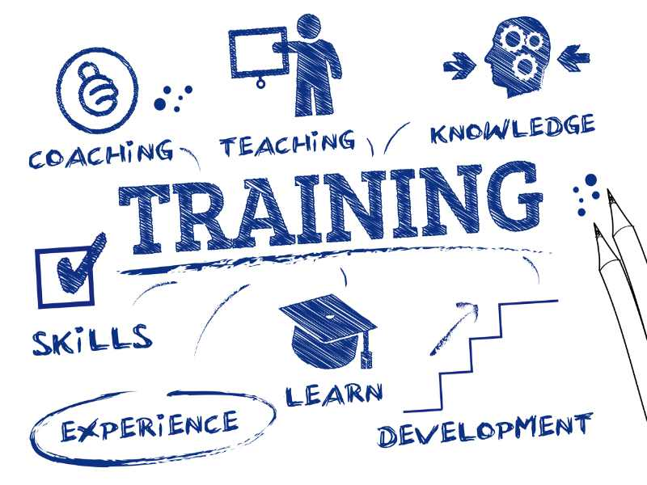

5.1 The Training Process
Success of the organization depends on the performance of employee. As Apex needs to give service to the customer frequently it has a bigger plan for the employees to do better by training and development. Apex footwear ltd. follows a five-step process. These are given below:
- Evaluation of requirement.
- Set purpose
- Training plan
- Implementing &
- Assessment

5.2 ANALYSIS of Requirement
By analyzing the performance of employees organization does need analysis and need assessment. Here, organization finds the gap between the skills employee has and the skill employee needs.
By following types of analysis organizational needs can be found:
Organizational Analysis: The Organizational analysis involves analyzing the organization itself. These includes long term and short term goals, organizational objectives, overall environment of the office etc.
Operations Analysis: This includes analysis of the operational side of the organization then based on that what is to be taught is determined.
Individual Analysis: This involves finding out of the employee’s weakness, knowledge level, skills needed for the job etc.

5.3 DETERMINING TRAINING OBJECTIVE
Apex provides different training and development program for which it defines the objective of the training which aims to fulfill the gaps the skill employee has and what the employee needs.

5.4 DESIGNING TRAINING PROGRAM
According to the outcomes of the analysis Apex Footwear Limited plans the training sessions.
1. For designing new training purpose verdicts on the following items are required for this purpose.
Responsibility of training and training program has to be shared between

- The top management
- The Employees department
- The line supervisors
- The workforces who should provide feedback and suggestions

2. Which types or methods of training needed to be given depends on the people we need to train. Doing this it is required the following things:
- Make preliminary decisions on who needs training.
- Assure staff that this training works perfectly.
3. The trainer is the important factor as well. Trainer has to have the knowledge on what is going to be delivered to the employees.
4. The allocation of resources is an integral part of the design process and it also involves supporting materials such as detailed syllabus, research notes, case studies, guides, brochures, etc.
This is known as the action phase of training. Here actual training is conducted. The trainer gives briefing about the entire training sessions. It is essential to clarify to the employee about the training sessions. The instructor or trainer should be clear in clarifying the contents

5.5 Evaluation
The ultimate phase of a training and development program is ‘evaluation’. This is one of the most significant phases in terms of calculating whether the trainer actually learned and objective of the training program was met or not.
In this step, the efficiency of training program is measured. The feedback generated through follow up, will help to reveal weaknesses. If there are any issues then the company will take the necessary steps.

5.6 Other Matters Relating to Training
Training Calendar: HR provides training calendar based on training needs. The changes are communicated between the departments.
Training Budget: Top management provides yearly budget to the HR department for arranging training and other programs. HR uses the budget effectively to ensure the utilization of the budget.
Past trainings record: Upon reviewing to the latest document, HR and the individual employee will maintain each employee's training history.
Training components: Resources are objects that are used in a training environment by instructors and learners. The components are outlined below:
1. Outline
2. Tools
They use many tech tools such as projector, sounds system, laptop etc. for the training purpose.

Training Method:
APEX offers the employees different types training which are mentioned below:
- Training for Knowledge about manufacturing
- Induction
- Advocacy training
- Stimulate training
- Orientation Training

Other than this AFL also send their employees to the external training sessions.
Benefits of Training To individuals
- Better decisions and solve problem effectively.
- Increase confident and personal development.
- Helps on emotional intelligence.
- Supply enhancement details.
- More insight.
- Increases recognition and job satisfaction.

For The organization
- Improved Job knowledge and skills.
- Creating a good image for the company.
- It helps in the interpretation and implementation of organizational policies.
- Productivity and quality of work are improved.
- Helps to reduce cost.
- Utilizing competent advising internally.

6.0 PERFORMANCE APPRAISAL

What is Performance Appraisal
Performance Appraisal is a systematic approach and regular of employee’s job performance.
It evaluates the skills, achievement and growth.

- Quality of performance
- Output measuring
- Output on time
- Attendance
- Teamwork

Methods of Performance Appraisal
- Graphic Rating Scale
- Checklist Method
- Critical Incident Appraisal.
- Behaviorally Anchor Rating Scale
- Management by objectives (MBO)
- 360 Degree Appraisal process

Apex is using rating scale for the performance appraisal.
Rating Scales: By following job rating scale organization evaluates numerical scales demonstrating job related task. Each one ranges from one to four. This combines the cumulative numerical scores and provides final decisions. It is done in two ways:
1. KPI based Appraisal – 70 (Based on KPI.)
2. Competency based Appraisal – 30 (Number is provided based on employee Competency.)

Who appraises Performance
Companies do appraisal for locating the potential employees inside the organization. It is reviewed annually.
In Apex Performance Assessment is performed on KPI basis. Apex does an assessment of performance twice annually. The Time is mentioned below:

June- July December
Field Force (Below Officer) Officer to Above

Department head (HOD) has set the KPI (Key Performance Indicator). Apex Footwear Ltd.'s HR Department maintains a performance appraisal form, and the form is filled out by the HOD. In this phase, KPI-based number 70 is given, and employee skill-based number 30 is provided.
In Apex evaluation is done primarily by the supervisor.

Uses of performance appraisal
The performance appraisal helps to monitor the organization success. Both manager and can review the change in the future performance and can keep the record. It also helps for employee promotion, transfer and rewards. Based on this, AFL takes the decision training and development program. Performance appraisal gives a structured process for an employee to approach the management for discussions, plan for the future, identify problems, and clarify expectations. It lets both manager and employee set up short-term and long term goals.

Chapter 5 – HRIS at Apex

6.1 HRIS at Apex
IFS AB (Industrial and Financial Systems) is a software company based in Linköping, Sweden, a multinational organization. The company develops and produces business enterprise software program for arena-wide customers who manufacture and distribute products, retain cash, and control service-oriented operations. IFS has 3,500 staff who support 10,000 global customers from a network of local workplaces and partner ecosystems.
IFS has been named as a leader in two of Gartner's Magic Quadrants: Field Service Management and ERP for product-centered midmarket companies.

Some illustrations of IFS AB software has given below:
Employee Information:

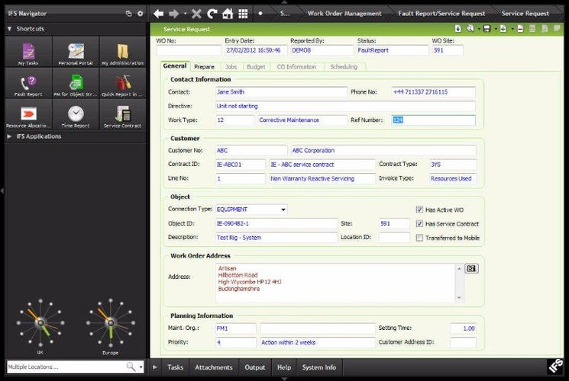

Supply Chain:

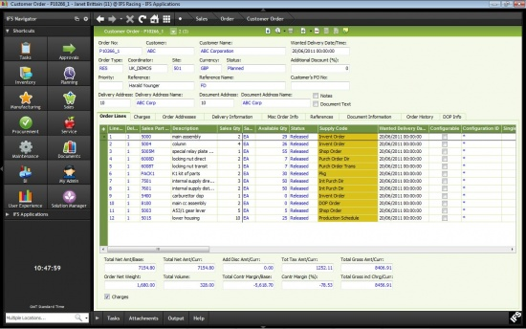

Purchase Requisition:

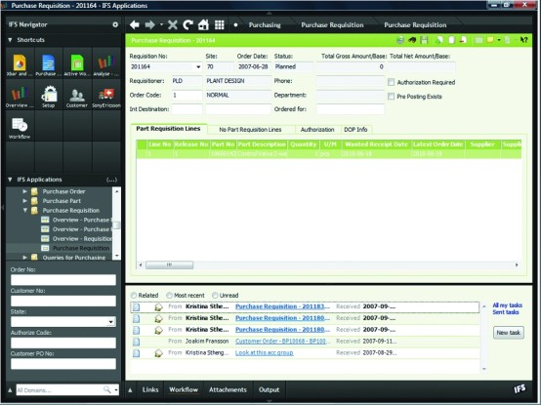

Order Management:

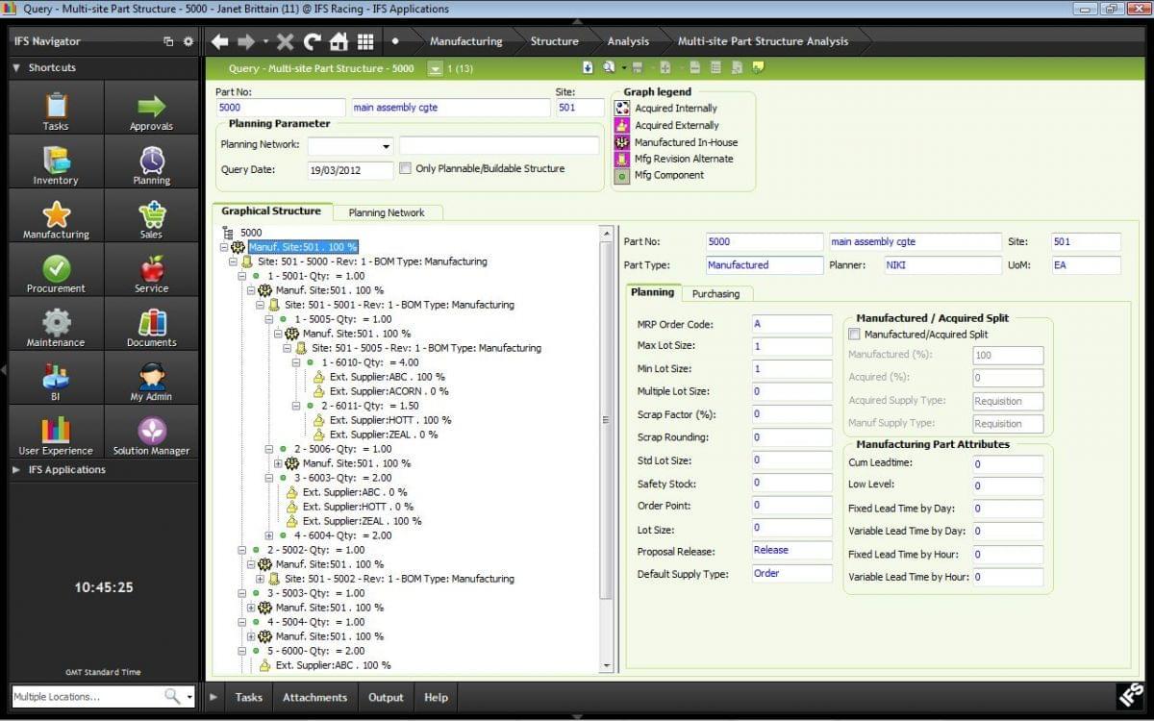

Recruitment Analysis:

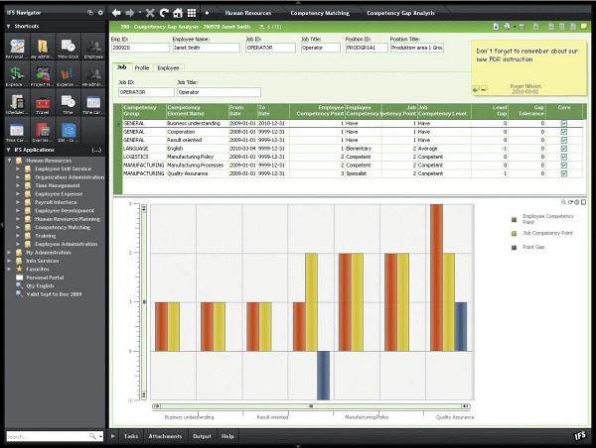

Chapter 6 – Findings

6.1 FINDINGS OF THE STUDY

6.1 SWOT Analysis
SWOT focuses on the firm's strengths, weaknesses, opportunities and threats if they are analyzed, the long-term running of the business would be successful.Apex Footwear Ltd.'s potential growth is primarily due to having a very limited number of competitors in Bangladesh as the only Footwear Company based on exports. It is now a key export Footwear company based in Bangladesh. Keeping this upward trend requires total dedication to understanding and fulfilling the customer's desire with the right combination of traditional administration, unwavering efficiency, enhanced creativity and professional and committed work.
Strength | Weakness
- 1. Strict enlistment and preference process for only having the absolute best employees.  2. Training programs for employees for being productive, more efficient and more effective | 1. Need more staff of HR  2. The training sessions are not adequate.
Opportunity | Threat
1. Raising the benefit package could lower the turnover rate. | 1. Due to lack of facilities the turnover in sales force is very high.

6.2 Findings

1. Apex faces problems in hiring appropriate individuals as sales force in some situations. Because they have no specific source of recruitment for the sales force, they are suffering from this problem. Apex needs a huge number of sales force in the running of the retail business. Recently, however, high turnover creates a business problem.
2. Moreover, new employees lack skills, so more time is spent on gaining knowledge and skills. With little paybacks, which generated more costs. But the training session held in apex isn't enough for the new employee to gain knowledge.

6.3 Recommendation
1. Sales force must be carefully trained to serve on a long-term basis.
2. To keep pace with new software and technology, Apex needs to plan additional worker training at all levels.

6.4 Conclusion
It was my first experience in corporate for a long time. Though I faced some challenges to adjust myself at first but over the time I was learning and enjoying the days at Apex. I got to see how a big company works. The proper execution of HR practice helps me to learn more form here. I got the chance to see the ERP software which is very important to know for working in big companies. Lastly, I would say, the experience and knowledge will help me for my HR career.

References
About Us . (n.d.). Retrieved from Apex: https://www.apexfootwearltd.com/About-Us/
Alan Price . (2007). Literature Review: Recruitment and Selection Process. Retrieved from UKESSAYS: https://www.ukessays.com/essays/business/literature-review-recruitment-and-selection-process-business-essay.php
Armstrong . (2005). Definition of Compensation and Benefits . TRANS Asian Research Journals , 41.
Barkha Gupta. (2013). Role Of HRIS In Companies In Current Scenario. Human Resource Information System (HRIS): Important Element of Current Scenario , 43.
Hedrickson. (2003). Definition of HRIS . Human Resource Information System (HRIS): Important, 41.
IFS Applications. (n.d.). Retrieved from Technologyadvice: https://technologyadvice.com/products/ifs-applications-reviews/
Kovach. (2002). Human resource information systems: a review and empirical analysis. Retrieved from Emerald Insight: https://www.emerald.com/insight/content/doi/10.1108/00483480610656702/full/html
Parry. (2010). Human Resource Information System (HRIS). Retrieved from Management Study Guide : https://www.managementstudyguide.com/human-resource-information-system.htm
Schuler. (1984). Understanding Human Resource Management in the Context of Organizations and Their Environments. Retrieved from Research Gate : https://www.researchgate.net/publication/275511428_Understanding_Human_Resource_Management_in_the_Context_of_Organizations_and_Their_Environments
Tannenbaum . (1990). Definition of HRIS . Human Resource Information System (HRIS), 41.
To be proactively compliant with global best. (n.d.). Retrieved from https://www.coursehero.com/file/p2lmh1jc/To-be-proactively-compliant-with-global-best-practices-standards-To-be-a/
whatishumanresource.com. (n.d.). Training and Development. Retrieved from whatishumanresource.com: http://www.whatishumanresource.com/training-and-development
Wikipedia. (n.d.). IFS AB. Retrieved from Wikipedia : IFS AB

